Geometry B.E.S.T. Instructional Guide for Mathematics

The B.E.S.T. Instructional Guide for Mathematics (B1G-M) is intended to assist educators with planning for student learning and instruction aligned to Florida’s Benchmarks for Excellent Student Thinking (B.E.S.T.) Standards. This guide is designed to aid high-quality instruction through the identification of components that support the learning and teaching of the B.E.S.T. Mathematics Standards and Benchmarks. The B1G-M includes an analysis of information related to the B.E.S.T. Standards for Mathematics within this specific mathematics course, the instructional emphasis and aligned resources. This document is posted on the B.E.S.T. Standards for Mathematics webpage of the Florida Department of Education’s website and will continue to undergo edits as needed.

Structural Framework and Intentional Design of the B.E.S.T. Standards for Mathematics

Florida’s B.E.S.T. Standards for Mathematics were built on the following.

- The coding scheme for the standards and benchmarks was changed to be consistent with other content areas. The new coding scheme is structured as follows:
Content.GradeLevel.Strand.Standard.Benchmark.
- Strands were streamlined to be more consistent throughout.
- The standards and benchmarks were written to be clear and concise to ensure that they are easily understood by all stakeholders.
- The benchmarks were written to allow teachers to meet students’ individual skills, knowledge and ability.
- The benchmarks were written to allow students the flexibility to solve problems using a method or strategy that is accurate, generalizable and efficient depending on the content (i.e., the numbers, expressions or equations).
- The benchmarks were written to allow for student discovery (i.e., exploring) of strategies rather than the teaching, naming and assessing of each strategy individually.
- The benchmarks were written to support multiple pathways for success in career and college for students.
- The benchmarks should not be taught in isolation but should be combined purposefully.
- The benchmarks may be addressed at multiple points throughout the year, with the intention of gaining mastery by the end of the year.
- Appropriate progression of content within and across strands was developed for each grade level and across grade levels.
- There is an intentional balance of conceptual understanding and procedural fluency with the application of accurate real-world context intertwined within mathematical concepts for relevance.
- The use of other content areas, like science and the arts, within real-world problems should be accurate, relevant, authentic and reflect grade-level appropriateness.

Components of the B.E.S.T. Instructional Guide for Mathematics

The following table is an example of the layout for each benchmark and includes the defining attributes for each component. It is important to note that instruction should not be limited to the possible connecting benchmarks, related terms, strategies or examples provided. To do so would strip the intention of an educator meeting students’ individual skills, knowledge and abilities.

Benchmark
focal point for instruction within lesson or task
This section includes the benchmark as identified in the B.E.S.T. Standards for Mathematics. The benchmark, also referred to as the Benchmark of Focus, is the focal point for student learning and instruction. The benchmark, and its related example(s) and clarification(s), can also be found in the course description. The 9-12 benchmarks may be included in multiple courses; select the example(s) or clarification(s) as appropriate for the identified course.

Connecting Benchmarks/Horizontal Alignment
in other standards within the grade level or course
This section includes a list of connecting benchmarks that relate horizontally to the Benchmark of Focus. Horizontal alignment is the intentional progression of content within a grade level or course linking skills within and across strands. Connecting benchmarks are benchmarks that either make a mathematical connection or include prerequisite skills. The information included in this section is not a comprehensive list, and educators are encouraged to find other connecting benchmarks. Additionally, this list will not include benchmarks from the same standard since benchmarks within the same standard already have an inherent connection.

Terms from the K-12 Glossary
This section includes terms from Appendix C: K-12 Glossary, found within the B.E.S.T. Standards for Mathematics document, which are relevant to the identified Benchmark of Focus. The terms included in this section should not be viewed as a comprehensive vocabulary list, but instead should be considered during instruction or act as a reference for educators.

Vertical Alignment
across grade levels or courses
This section includes a list of related benchmarks that connect vertically to the Benchmark of Focus. Vertical alignment is the intentional progression of content from one year to the next, spanning across multiple grade levels. Benchmarks listed in this section make mathematical connections from prior grade levels or courses in future grade levels or courses within and across strands. If the Benchmark of Focus is a new concept or skill, it may not have any previous benchmarks listed. Likewise, if the Benchmark of Focus is a mathematical skill or concept that is finalized in learning and does not have any direct connection to future grade levels or courses, it may not have any future benchmarks listed. The information included in this section is not a comprehensive list, and educators are encouraged to find other benchmarks within a vertical progression.

Purpose and Instructional Strategies
This section includes further narrative for instruction of the benchmark and vertical alignment. Additionally, this section may also include the following:
- explanations and details for the benchmark;
- vocabulary not provided within Appendix C;
- possible instructional strategies and teaching methods; and
- strategies to embed potentially related Mathematical Thinking and Reasoning Standards (MTRs).

Common Misconceptions or Errors
This section will include common student misconceptions or errors and may include strategies to address the identified misconception or error. Recognition of these misconceptions and errors enables educators to identify them in the classroom and make efforts to correct the misconception or error. This corrective effort in the classroom can also be a form of formative assessment within instruction.

Strategies to Support Tiered Instruction
The instructional strategies in this section address the common misconceptions and errors listed within the above section that can be a barrier to successfully learning the benchmark. All instruction and intervention at Tiers 2 and 3 are intended to support students to be successful with Tier 1 instruction. Strategies that support tiered instruction are intended to assist teachers in planning across any tier of support and should not be considered exclusive or inclusive of other instructional strategies that may support student learning with the B.E.S.T. Mathematics Standards. For more information about tiered instruction, please see the Effective Tiered Instruction for Mathematics: ALL Means ALL document.

Instructional Tasks
demonstrate the depth of the benchmark and the connection to the related benchmarks
This section will include example instructional tasks, which may be open-ended and are intended to demonstrate the depth of the benchmark. Some instructional tasks include integration of the Mathematical Thinking and Reasoning Standards (MTRs) and related benchmark(s). Enrichment tasks may be included to make connections to benchmarks in later grade levels or courses. Tasks may require extended time, additional materials and collaboration.

Instructional Items
demonstrate the focus of the benchmark
This section will include example instructional items which may be used as evidence to demonstrate the students’ understanding of the benchmark. Items may highlight one or more parts of the benchmark.
*The strategies, tasks and items included in the B1G-M are examples and should not be considered comprehensive.

Mathematical Thinking and Reasoning Standards
MTRs: Because Math Matters

Florida students are expected to engage with mathematics through the Mathematical Thinking and Reasoning Standards (MTRs) by utilizing their language as a self-monitoring tool in the classroom, promoting deeper learning and understanding of mathematics. The MTRs are standards which should be used as a lens when planning for student learning and instruction of the B.E.S.T. Standards for Mathematics.

Structural Framework and Intentional Design of the Mathematical Thinking and Reasoning Standards

The Mathematical Thinking and Reasoning Standards (MTRs) are built on the following.

- The MTRs have the same coding scheme as the standards and benchmarks; however, they are written at the standard level because there are no benchmarks.
- In order to fulfill Florida’s unique coding scheme, the 5th place (benchmark) will always be a “1” for the MTRs.
- The B.E.S.T. Standards for Mathematics should be taught through the lens of the MTRs.
- At least one of the MTRs should be authentically and appropriately embedded throughout every lesson based on the expectation of the benchmark(s).
- The bulleted language of the MTRs were written for students to use as self-monitoring tools during daily instruction.
- The clarifications of the MTRs were written for teachers to use as a guide to inform their instructional practices.
- The MTRs ensure that students stay engaged, persevere in tasks, share their thinking, balance conceptual understanding and procedures, assess their solutions, make connections to previous learning and extended knowledge, and apply mathematical concepts to real-world applications.
- The MTRs should not stand alone as a separate focus for instruction but should be combined purposefully.
- The MTRs will be addressed at multiple points throughout the year, with the intention of gaining mastery of mathematical skills by the end of the year and building upon these skills as they continue in their K-12 education.

MA.K12.MTR.1.1 Actively participate in effortful learning both individually and collectively.
Mathematicians who participate in effortful learning both individually and with others:
- Analyze the problem in a way that makes sense given the task.
- Ask questions that will help with solving the task.
- Build perseverance by modifying methods as needed while solving a challenging task.
- Stay engaged and maintain a positive mindset when working to solve tasks.
- Help and support each other when attempting a new method or approach.

Clarifications:
Teachers who encourage students to participate actively in effortful learning both individually and with others:
- Cultivate a community of growth mindset learners.
- Foster perseverance in students by choosing tasks that are challenging.
- Develop students’ ability to analyze and problem solve.
- Recognize students’ effort when solving challenging problems.

MA.K12.MTR.2.1 Demonstrate understanding by representing problems in multiple ways.
Mathematicians who demonstrate understanding by representing problems in multiple ways:
- Build understanding through modeling and using manipulatives.
- Represent solutions to problems in multiple ways using objects, drawings, tables, graphs and equations.
- Progress from modeling problems with objects and drawings to using algorithms and equations.
- Express connections between concepts and representations.
- Choose a representation based on the given context or purpose.

Clarifications:
Teachers who encourage students to demonstrate understanding by representing problems in multiple ways:
- Help students make connections between concepts and representations.
- Provide opportunities for students to use manipulatives when investigating concepts.
- Guide students from concrete to pictorial to abstract representations as understanding progresses.
- Show students that various representations can have different purposes and can be useful in different situations.

MA.K12.MTR. 3.1 Complete tasks with mathematical fluency.
Mathematicians who complete tasks with mathematical fluency:
- Select efficient and appropriate methods for solving problems within the given context.
- Maintain flexibility and accuracy while performing procedures and mental calculations.
- Complete tasks accurately and with confidence.
- Adapt procedures to apply them to a new context.
- Use feedback to improve efficiency when performing calculations.

Clarifications:
Teachers who encourage students to complete tasks with mathematical fluency:
- Provide students with the flexibility to solve problems by selecting a procedure that allows them to solve efficiently and accurately.
- Offer multiple opportunities for students to practice efficient and generalizable methods.
- Provide opportunities for students to reflect on the method they used and determine if a more efficient method could have been used.

MA.K12.MTR.4.1 Engage in discussions that reflect on the mathematical thinking of self and others.
Mathematicians who engage in discussions that reflect on the mathematical thinking of self and others:
- Communicate mathematical ideas, vocabulary and methods effectively.
- Analyze the mathematical thinking of others.
- Compare the efficiency of a method to those expressed by others.
- Recognize errors and suggest how to correctly solve the task.
- Justify results by explaining methods and processes.
- Construct possible arguments based on evidence.

Clarifications:
Teachers who encourage students to engage in discussions that reflect on the mathematical thinking of self and others:
- Establish a culture in which students ask questions of the teacher and their peers, and error is an opportunity for learning.
- Create opportunities for students to discuss their thinking with peers.
- Select, sequence and present student work to advance and deepen understanding of correct and increasingly efficient methods.
- Develop students’ ability to justify methods and compare their responses to the responses of their peers.

MA.K12.MTR.5.1 Use patterns and structure to help understand and connect mathematical concepts.
Mathematicians who use patterns and structure to help understand and connect mathematical concepts:
- Focus on relevant details within a problem.
- Create plans and procedures to logically order events, steps or ideas to solve problems.
- Decompose a complex problem into manageable parts.
- Relate previously learned concepts to new concepts.
- Look for similarities among problems.
- Connect solutions of problems to more complicated large-scale situations.

Clarifications:
Teachers who encourage students to use patterns and structure to help understand and connect mathematical concepts:
- Help students recognize the patterns in the world around them and connect these patterns to mathematical concepts.
- Support students to develop generalizations based on the similarities found among problems.
- Provide opportunities for students to create plans and procedures to solve problems.
- Develop students’ ability to construct relationships between their current understanding and more sophisticated ways of thinking.

MA.K12.MTR.6.1 Assess the reasonableness of solutions.
Mathematicians who assess the reasonableness of solutions:
- Estimate to discover possible solutions.
- Use benchmark quantities to determine if a solution makes sense.
- Check calculations when solving problems.
- Verify possible solutions by explaining the methods used.
- Evaluate results based on the given context.

Clarifications:
Teachers who encourage students to assess the reasonableness of solutions:
- Have students estimate or predict solutions prior to solving.
- Prompt students to continually ask, “Does this solution make sense? How do you know?”
- Reinforce that students check their work as they progress within and after a task.
- Strengthen students’ ability to verify solutions through justifications.

MA.K12.MTR.7.1 Apply mathematics to real-world contexts.
Mathematicians who apply mathematics to real-world contexts:
- Connect mathematical concepts to everyday experiences.
- Use models and methods to understand, represent and solve problems.
- Perform investigations to gather data or determine if a method is appropriate.
- Redesign models and methods to improve accuracy or efficiency.

Clarifications:
Teachers who encourage students to apply mathematics to real-world contexts:
- Provide opportunities for students to create models, both concrete and abstract, and perform investigations.
- Challenge students to question the accuracy of their models and methods.
- Support students as they validate conclusions by comparing them to the given situation.
- Indicate how various concepts can be applied to other disciplines.

Examples of Teacher and Student Moves for the MTRs

Below are examples that demonstrate the embedding of the MTRs within the mathematics classroom. The provided teacher and student moves are examples of how some MTRs could be incorporated into student learning and instruction. The information included in this table is not a comprehensive list, and educators are encouraged to incorporate other teacher and student moves that support the MTRs.

MTR | Student Moves | Teacher Moves
MA.K12.MTR.1.1  Actively participate in effortful learning both individually and collectively. | - Student asks questions to self, others and teacher when necessary.  - Student stays engaged in the task and helps others during the completion of the task.  - Student analyzes the task in a way that makes sense to themselves.  - Student builds perseverance in self by staying engaged and modifying methods as they solve a problem. | - Teacher builds a classroom community by allowing students to build their own set of “norms.”  - Teacher creates a culture in which students are encouraged to ask questions, including questioning the accuracy within a real-world context.  - Teacher chooses differentiated, challenging tasks that fit the students’ needs to help build perseverance in students.  - Teacher builds community of learners by encouraging students and recognizing their effort in staying engaged in the task and celebrating errors as an opportunity for learning.
MA.K12.MTR.2.1  Demonstrate understanding by representing problems in multiple ways. | - Student chooses their preferred method of representation.  - Student represents a problem in more than one way and is able to make connections between the representations. | - Teacher plans ahead to allow students to choose their tools.  - While sharing student work, teacher purposefully shows various representations to make connections between different strategies or methods.  - Teacher helps make connections for students between different representations (i.e., table, equation or written description).
MA.K12.MTR.3.1  Complete tasks with mathematical fluency. | - Student uses feedback from teacher and peers to improve efficiency. | - Teacher provides opportunity for students to reflect on the method they used, determining if there is a more efficient way depending on the context.
MA.K12.MTR.4.1  Engage in discussions that reflect on the mathematical thinking of self and others. | - Student effectively justifies their reasoning for their methods.  - Student can identify errors within their own work and create possible explanations.  - When working in small groups, student recognizes errors of their peers and offers suggestions.  - Student communicates mathematical vocabulary efficiently to others. | - Teacher purposefully groups students together to provide opportunities for discussion.  - Teacher chooses sequential representation of methods to help students explain their reasoning.
MA.K12.MTR.5.1 Use patterns and structure to help understand and connect mathematical concepts. | - Student determines what information is needed and logically follows a plan to solve problems piece by piece.  - Student is able to make connections from previous knowledge. | - Teacher allows for students to engage with information to connect current understanding to new methods.  - Teacher provides opportunities for students to discuss and develop generalizations about a mathematical concept.  - Teacher provides opportunities for students to develop their own steps in solving a problem.
MA.K12.MTR.6.1 Assess the reasonableness of solutions. | - Student provides explanation of results.  - Student continually checks their calculations.  - Student estimates a solution before performing calculations. | - Teacher encourages students to check and revise solutions and provide explanations for results.  - Teacher allows opportunities for students to verify their solutions by providing justifications to self and others.
MA.K12.MTR.7.1 Apply mathematics to real-world contexts. | - Student relates their real-world experience to the context provided by the teacher during instruction.  - Student performs investigations to determine if a scenario can represent a real-world context. | - Teacher provides real-world context in mathematical problems to support students in making connections using models and investigations.

Geometry Areas of Emphasis

In Geometry, instructional time will emphasize five areas:

- ) proving and applying relationships and theorems involving two-dimensional figures using Euclidean geometry and coordinate geometry;
- establishing congruence and similarity using criteria from Euclidean geometry and using rigid transformations;
- extending knowledge of geometric measurement to two-dimensional figures and three-dimensional figures;
- creating and applying equations of circles in the coordinate plane; and
- developing an understanding of right triangle trigonometry.

The purpose of the areas of emphasis is not to guide specific units of learning and instruction, but rather provide insight on major mathematical topics that will be covered within this mathematics course. In addition to its purpose, the areas of emphasis are built on the following:
- Supports the intentional horizontal progression within the strands and across the strands in this grade level or course.
- Student learning and instruction should not focus on the stated areas of emphasis as individual units.
- Areas of emphasis are addressed within standards and benchmarks throughout the course so that students are making connections throughout the school year.
- Some benchmarks can be organized within more than one area.
- Supports the communication of the major mathematical topics to all stakeholders.
- Benchmarks within the areas of emphasis should not be taught within the order in which they appear. To do so would strip the progression of mathematical ideas and miss the opportunity to enhance horizontal progressions within the grade level or course.

The table below shows how the benchmarks within this mathematics course are embedded within the areas of emphasis.

 |  |  | Proving & Applying Relationships and Theorems | Congruence and Similarity | Geometric Measurement | Equations of Circles in the Coordinate Plane | Right Triangle Trigonometry
 | Geometric Reasoning | MA.912.GR.1.1 | x |  | x |  | x
 | Geometric Reasoning | MA.912.GR.1.2 | x | x
 | Geometric Reasoning | MA.912.GR.1.3 | x | x | x |  | x
 | Geometric Reasoning | MA.912.GR.1.4 | x | x | x
 | Geometric Reasoning | MA.912.GR.1.5 | x | x | x
 | Geometric Reasoning | MA.912.GR.1.6 | x | x | x |  | x
 | Geometric Reasoning | MA.912.GR.2.1 |  | x
 | Geometric Reasoning | MA.912.GR.2.2 |  | x
 | Geometric Reasoning | MA.912.GR.2.3 |  | x
 | Geometric Reasoning | MA.912.GR.2.4 |  | x
 | Geometric Reasoning | MA.912.GR.2.5 |  | x
 | Geometric Reasoning | MA.912.GR.2.6 |  | x
 | Geometric Reasoning | MA.912.GR.2.8 |  | x
 | Geometric Reasoning | MA.912.GR.3.1 | x |  | x
 | Geometric Reasoning | MA.912.GR.3.2 | x |  | x | x | x
 | Geometric Reasoning | MA.912.GR.3.3 | x |  | x | x | x
 | Geometric Reasoning | MA.912.GR.3.4 |  |  | x
 | Geometric Reasoning | MA.912.GR.4.1 |  |  | x
 | Geometric Reasoning | MA.912.GR.4.2 |  |  | x
 | Geometric Reasoning | MA.912.GR.4.3 |  | x | x
 | Geometric Reasoning | MA.912.GR.4.4 |  |  | x
 | Geometric Reasoning | MA.912.GR.4.5 |  |  | x
 | Geometric Reasoning | MA.912.GR.4.6 |  |  | x
 | Geometric Reasoning | MA.912.GR.5.1 | x | x
 | Geometric Reasoning | MA.912.GR.5.2 | x | x
 | Geometric Reasoning | MA.912.GR.5.3 | x | x
 | Geometric Reasoning | MA.912.GR.6.1 | x
 | Geometric Reasoning | MA.912.GR.6.2 | x
 | Geometric Reasoning | MA.912.GR.6.3 | x
 | Geometric Reasoning | MA.912.GR.6.4 | x
 | Geometric Reasoning | MA.912.GR.7.2 |  |  |  | x
 | Geometric Reasoning | MA.912.GR.7.3 |  |  |  | x
 | Trigonometry | MA.912.T.1.1 |  | x |  | x | x
 | Trigonometry | MA.912.T.1.2 |  |  |  |  | x
 | Logic & Discrete Theory | MA.912.LT.4.3 | x
 | Logic & Discrete Theory | MA.912.LT.4.10 | x

Geometric Reasoning

MA.912.GR.1 Prove and apply geometric theorems to solve problems.

MA.912.GR.1.1

Benchmark
MA.912.GR.1.1 Prove relationships and theorems about lines and angles. Solve mathematical and real-world problems involving postulates, relationships and theorems of lines and angles.
Benchmark Clarifications:
Clarification 1: Postulates, relationships and theorems include vertical angles are congruent; when a transversal crosses parallel lines, the consecutive angles are supplementary and alternate (interior and exterior) angles and corresponding angles are congruent; points on a perpendicular bisector of a line segment are exactly those equidistant from the segment’s endpoints.
Clarification 2: Instruction includes constructing two-column proofs, pictorial proofs, paragraph and narrative proofs, flow chart proofs or informal proofs.
Clarification 3: Instruction focuses on helping a student choose a method they can use reliably.
Connecting Benchmarks/Horizontal Alignment
- MA.912.GR.1.2
- MA.912.GR.3.2, MA.912.GR.3.3
- MA.912.GR.5.1, MA.912.GR.5.2
- MA.912.GR.6.1, MA.912.GR.6.2
- MA.912.T.1.1
- MA.912.LT.4.3, MA.912.LT.4.10

Terms from the K-12 Glossary
- Angle
- Congruent
- Corresponding Angles
- Supplementary Angles
- Transversal
- Vertical

Vertical Alignment
Previous Benchmarks  - MA.3.GR.1.1  - MA.4.GR.1.1  - MA.8.GR.1.4  - MA.912.AR.2.1 | Next Benchmarks  - MA.912.NSO.3  - MA.912.T.2

Purpose and Instructional Strategies
In grade 3, students described and drew points, lines, line segments, rays, intersecting lines, perpendicular lines, and parallel lines. In grade 4, students explored angles and classified angles as acute, right, obtuse, straight or reflex. Students also solved real-world and mathematical problems involving angle measures. In grade 8, students solved mathematical problems involving supplementary, complementary, adjacent, and vertical angles and linear pairs formed by an interior angle of a triangle and its adjacent exterior angle. In Geometry, students prove relationships and theorems and solve problems involving lines, length of segments, and measure of angles, in degrees. In later courses, students will solve mathematical and real-world problems involving angles using trigonometry and converting between degrees and radians.

These are general considerations for MA.912.GR.1 (1.1 to 1.5):

Students should develop an understanding of the difference between a postulate, which is assumed true without a proof, and a theorem, which is a true statement that can be proved, and why theorems can be proved, and postulates cannot. Instruction includes the understanding that postulates or axioms are the starting rules, and all theorems are logical consequences derived from those postulates and valid rules.
For expectations of this course, students are not expected to memorize the names of the theorems, except for Pythagorean Theorem, Triangle Inequality Theorem, and Trapezoid Midsegment Theorem, as they appear in benchmarks and clarifications.
Instruction includes the connection to the Logic and Discrete Theory benchmarks MA.912.LT.4.3 and MA.912.LT.4.10. Students should interpret theorems in “if… then” form (conditional statement) and write the converse, the inverse, and the contrapositive. It is expected that students verify whether a conditional statement and its converse are both true, and if so, write the corresponding “if and only if” statement (biconditional). Students should verify that the contrapositive of a true conditional statement is always true. These statements are about definitions, relationships, properties, and theorems within the Geometry course.
Instruction makes the connections to the Properties of Operations, Equality, and Inequality and the Properties of Congruence when proving properties and theorems.
Students should differentiate the notions of equal and congruent and their corresponding notation, since equal is used in geometry for measurements (numbers) and congruent is used for geometric figures.
For example, $\overline{PQ}≅\overline{MN}$ means that the line segments are congruent and $PQ=MN$ that the line segments have the same length. Similarly, $∠ABC≅∠PQR$ means that the angles are congruent and $m∠ABC=m∠PQR$ that the angles have the same measure.
Students should develop the understanding that arithmetic operations can be performed with lengths of segments (e.g., $AB+PQ=7$) and measures of angles (e.g., $m∠1+m∠2=130°$), but not with geometric figures.
For example, $PQ+MN$ can be calculated, but $\overline{PQ}+\overline{MN}$ cannot.
Students should be able to explore and choose from multiple ways to organize their reasoning when proving properties and theorems, from informal to formal proofs. Students should develop the understanding of the terms statement and reason, their roles in geometric proofs, and how they must correspond to each other, and that a geometric proof is a carefully written argument that begins with known facts, proceeds from there through a series of logical deductions, and ends with the statement they were trying to prove. (MTR.2.1)
Examples of different types of proofs are pictorial or visual (e.g., constructions, dissections), two-column, flow (or flow-chart), paragraph (MA.GR.1), and by contradiction (MA.912.LT.4.8).
Instruction includes the use of hatch marks, hash marks, arc marks or tick marks, a form of mathematical notation, to represent segments of equal length or angles of equal measure in an image.
For expectations of this course, students should use the corresponding notation for points and lines (e.g., $P$, $l$, $\overset{⃡}{AB}$), congruent ($≅$), similar ($\sim$), perpendicular ($⊥$), parallel ($⊥$), and triangle (e.g., $∆ABC$).

MA.912.GR.1.1

- Instruction includes proving and using to solve problems all the statements in the clarifications, but instruction is not limited by that list. It also includes definitions such as collinear points, midpoint of a segment, angle bisector, segment bisector, perpendicular bisector, perpendicular and parallel lines, and postulates such as the Angle Addition Postulate, the Segment Addition Postulate, and the Linear Pair Postulate.
- Instruction includes the interpretation of statements (conditional, biconditional, all, not) about lines and angles.
- For example, the conditional statement “if corresponding angles are formed by two parallel lines cut by a transversal, then they are congruent” has a true converse, but “if two angles are vertical, then they are congruent” does not. Then, the statement “all congruent angles are not necessarily vertical” is true. The contrapositive “if two angles are not congruent, then they are not vertical” is true (contrapositives of true statements are always true). (MA.912.LT.4.3).
- Students should differentiate the definition of linear pair and the Linear Pair Postulate.
- For example, $∠A$ and $∠B$ are two adjacent angles whose non-common sides are opposite rays. $∠A$ and $∠B$ are or form a linear pair. A definition of linear pair used commonly states “a linear pair is formed by two angles adjacent and supplementary” and the linear pair postulate used commonly states “the measures of two angles forming a linear pair sum to $180°$.” However, sometimes the postulate is worded as “two angles forming a linear pair are supplementary.” There is no general agreement in the mathematical community.
- Students should differentiate the definition of midpoint and the Midpoint Theorem and use the definition to prove the theorem.
- For example, if $A$, $M$, and $B$ are collinear points, with $M$ between $A$ and $B$, then the midpoint of $\overline{AB}$ is defined as the point that divides $\overline{AB}$ into two segments of equal length, so $AM=MB$. The Midpoint Theorem states that if $M$ is the midpoint of $\overline{AB}$, then $\overline{AM}≅\overline{MB}$ (based on the definition of congruent segments).
- Instruction makes the connection to compass and straight edge constructions and how to use them to verify relationships and theorems about lines and angles.
- For example, the compass can be used to verify that any point on the perpendicular bisector of a line segment is equidistant from the segment’s endpoints (MA.912.GR.5.2).
- For example, the construction of the copy of an angle can be used to verify that corresponding, alternate interior, and alternate exterior angles are congruent, when two parallel lines are cut by a transversal (MA.912.GR.5.1).
- Instruction includes proving statements about segments and angles.
- For example, prove that if $A$, $B$, $C$, and $D$ are collinear and $\overline{AB}≅\overline{CD}$, then $\overline{AC}≅\overline{BD}$.
- For example, prove that if two angles are congruent, then their complements (or supplements) are congruent. Students are not expected to memorize the name of these theorems (Congruent Complement or Congruent Supplement Theorem).
- Problem types include those about lines and angles in mathematical and real-world contexts, with numerical values and algebraic expressions. Students should be able to evaluate the value of a variable under certain conditions and determine the length of a segment and the measure of an angle. Problems about parallel lines cut by a transversal can include more than two parallel lines or two sets of parallel lines.
- For example, given $A$, $B$, and $C$ are collinear, and $B$ is the midpoint of $\overline{AC}$, if $AB=3x-2$ and $AC=62$, what is the value of $x$?
- For example, what is the measure of $∠1$?
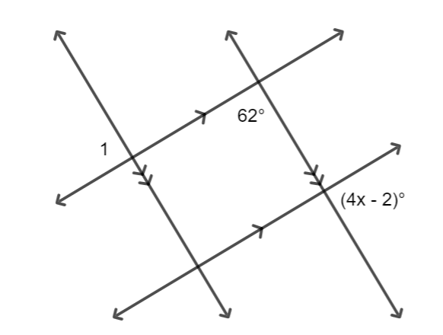
- Instruction includes the use of hands-on manipulatives and geometric dynamic software for students to explore postulates, relationships, and theorems.
  - For example, translucent paper (e.g., patty paper) can be used to explore angle pairs formed when two lines are cut by a transversal. Students can compare their findings when the lines are nonparallel with when the lines are parallel. This experience reinforces that the terms corresponding, alternate, same-side, consecutive, interior, and exterior are used to describe the location of pairs of angles when two lines are cut by a transversal. The relationships congruent and supplementary derive from the two lines being parallel. (MTR.2.1, MTR.4.1)
  - For example, geometric dynamic software can be included in the exploration of vertical angles and perpendicular bisectors.
- For expectations of this benchmark in its clarification, instruction includes the following proofs:
- Vertical angles are congruent (Vertical Angles Theorem).
Students should identify vertical angles and linear pairs given two intersecting lines and use algebraic manipulation, including properties of equality, to draw the conclusion that vertical angles have the same measure; therefore, they are congruent. Instruction includes clarifying that two angles are vertical if and only if they are a pair of opposite angles formed by two intersecting lines. The definition is not vertical angles are congruent. That is a theorem that can be proved (“if two angles are vertical, then they are congruent”), and the converse is not true.
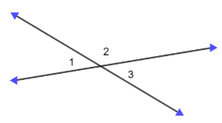
- When two parallel lines are cut by a transversal, alternate interior, alternate exterior, and corresponding angles are congruent, and consecutive interior (same-side interior) and consecutive exterior (same-side exterior) angles are supplementary.
Students should develop the understanding that when proving relationships between angles formed by two parallel lines cut by a transversal, one angle relationship needs to be given. It is common to use the Corresponding Angles Postulate or the Same-side Interior Angles Postulate to prove the other relationships, but there is no general agreement in the mathematical community.
  - For example, if it is given that same-side interior angles formed by parallel lines cut by a transversal are supplementary, then it can be proved that alternate exterior angles are congruent and other relationships.
  - For example, using the Corresponding Angles Postulate, it can be proved that alternate interior angles formed by parallel lines cut by a transversal are congruent and other relationships.
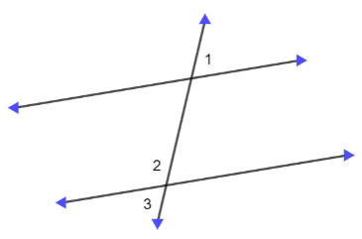
- Any point on the perpendicular bisector of a line segment is equidistant from the endpoints of the line segment.
Students should identify the triangles formed by the endpoints of the line segment, the midpoint of the line segment, and a point on the perpendicular bisector. Proving the two right triangles congruent (MA.912.GR.1.2), the segments joining the endpoints of the line segment to the point on the perpendicular bisector result congruent by the definition of congruent triangles (MA.912.GR.1.6).

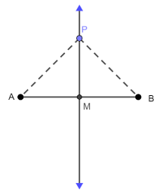

- Instruction makes the connection to the Pythagorean Theorem (grade 8) when proving the Perpendicular Bisector Theorem and solving problems involving the perpendicular bisector of a segment.
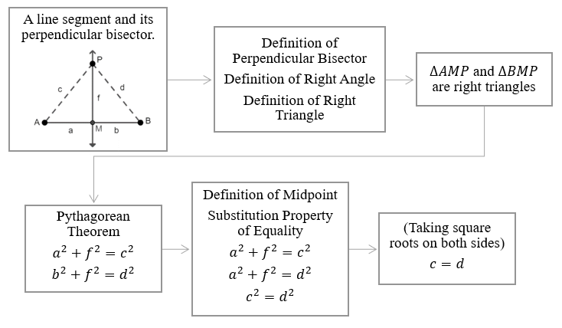
- Instruction includes proving statements about angles formed by two parallel lines cut by a transversal. Students should develop the understanding of the difference between assuming and proving or verifying a statement.
  - For example, to verify that $∠1$ and $∠2$ are supplementary, students should select a suitable location for $∠3$. In this case, $∠1$ and $∠3$ are vertical, have the same measure, and $∠3$ and $∠2$ are supplementary, add to $180°$. Using the Substitution Property of Equality, students can show $∠1$and $∠2$are supplementary.
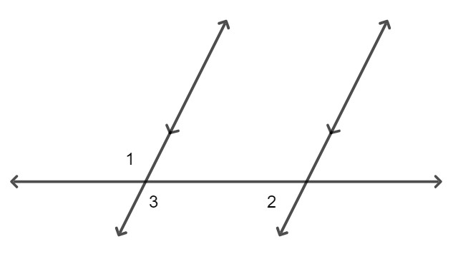

**The flow-charts in this section are not formal proofs. They are used to show the content connections within this course and previous courses.

Common Misconceptions or Errors
- Students may misuse the terms corresponding, alternate interior, and alternate exterior as synonyms of congruent. Similarly, students may misuse same-side interior and same-side exterior (consecutive interior and consecutive exterior) to imply the angles must be supplementary.

Strategies to Support Tiered Instruction
- Students should have practice with the vocabulary and the notation used when solving problems about lines and angles.
- For example, a graphic organizer or a foldable could be used for the definitions, descriptions, and notation of terms like complementary, supplementary, adjacent, vertical angles, and parallel and perpendicular lines.
- Teacher models how to write equations for the following statements: $A$ and $B$ are equal and $A$ and $B$ add up to $180°$. Students should have practice solving one-variable multi-step linear equations, including equations with the variable on both sides.
- For example, $\left(2x+30\right)+20=180$ or $3x-5=4x-80$.
- Instruction includes a progression of tasks for students to develop the understanding of a formal proof.
- For example, to prove vertical angles are congruent:
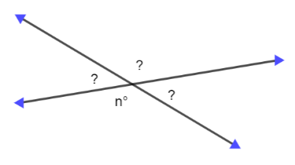
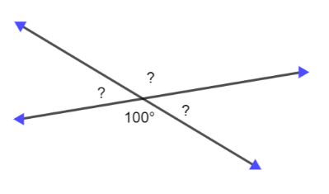
- Instruction should build the understanding of the relationship between angles formed by two parallel lines cut by a transversal using manipulatives, like patty paper, or tools, like the protractor.
- For example, students explore which angles are congruent (given parallel lines cut by a transversal) tracing one angle and using the patty paper to verify whether the other angles have the same measure.

- Teacher models how to use colors to mark congruent angles and segments in an image for a proof. Then, students should create a list of known statements and of statements that could be deduced using definitions and theorems. Using the lists, students should be able to identify one or two missing statements in a paragraph, two-column, or flow proof about lines and angles.
- Teacher models that these angles are congruent or supplementary if and only if two parallel lines are cut by a transversal.
  - For example, “$∠A$ and $∠B$ are congruent because they are corresponding,” instead of “$∠A$ and $∠B$ are congruent since they are corresponding angles formed by parallel lines cut by a transversal.”

Instructional Tasks
Instructional Task 1 (MTR.7.1)
A team of architects is designing a new public park in your city. The park will feature various intersecting paths, walkways, and recreational areas. To ensure the park's design is aesthetically pleasing and functional, the architects need to understand the relationships between angles formed by the paths and walkways.

You are part of a group of junior architects assisting the design team. Your task is to analyze the angle relationships formed by the intersecting paths and walkways in the park. You will explore how different angle pairs relate to each other and how they influence the overall layout and usability of the park.
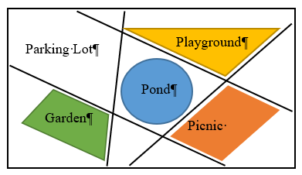
  - Label paths and walkways in the park and their intersections.
  - Measure and classify the angles formed by the intersecting paths and walkways.
  - Explore the relationships between different angle pairs (vertical, adjacent, corresponding angles, alternate interior angles, alternate exterior angles, same-side interior).
  - Determine how these angle relationships can inform the design of directional signage within the park.

Instructional Task 2 (MTR.2.1, MTR.4.1, MTR.5.1)
Part A. Given $\overline{AB}$, use a compass and straightedge to construct line $l$ such that line $l$ and $\overline{AB}$ form $90°$ angles and the point of intersection, $M$, is the midpoint of $\overline{AB}$.
Part B. Suppose that point $P$ lies on the line $l$, as shown below. What conjecture can be made about point $P$? Which endpoint of $\overline{AB}$ is closest to point $P$?
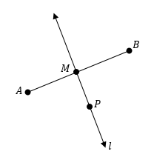
Part C. What if a point $Q$, different to point $P$, is added to line $l$? Which endpoint of $\overline{AB}$ is closest to point $Q$? How does this compare with your conjecture in Part B?
Part D. How can the compass and the straightedge be used to verify that $AC=BC$ for any point $C$ in line $l$, given that line $l$ is the perpendicular bisector of $\overline{AB}$? Explain your reasoning.

Instructional Task 3
Write a two-column proof that corresponds to the each of the following charts.
Chart 1
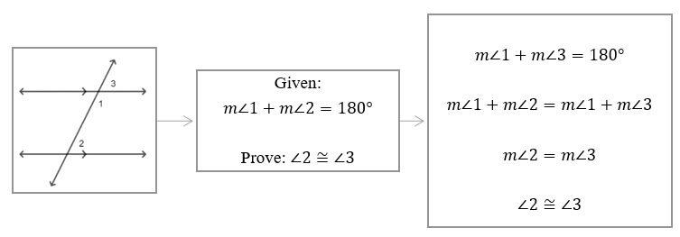

Chart 2
I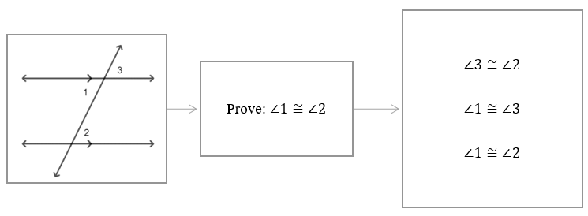

Instructional Items
Instructional Item 1
Two lines are cut by a transversal. The measures of a pair of alternate interior angles are $(3x-15)°$ and $(5x-40)°$. What is the value of $x$ that makes the two lines parallel?

Instructional Item 2
Two lines intersect at point $P$. If the measures of a pair of adjacent angles are $(2x+7)˚$ and $(x+23)˚$, determine the measures of the four angles formed by the intersection of the two lines.

Instructional Item 3
Based on the figure below, prove that $∠1≅∠2$ given that $a∥b$ and $c∥d$.
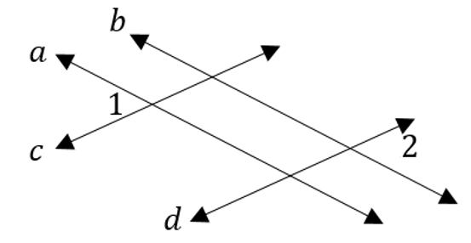
*The strategies, tasks and items included in the B1G-M are examples and should not be considered comprehensive.

MA.912.GR.1.2

Benchmark
MA.912.GR.1.2 Prove triangle congruence or similarity using Side-Side-Side, Side-Angle-Side, Angle-Side-Angle, Angle-Angle-Side, Angle-Angle and Hypotenuse-Leg.

Benchmark Clarifications:
Clarification 1: Instruction includes constructing two-column proofs, pictorial proofs, paragraph and narrative proofs, flow chart proofs or informal proofs.
Clarification 2: Instruction focuses on helping a student choose a method they can use reliably.

Connecting Benchmarks/Horizontal Alignment
- MA.912.GR.2.6, MA.912.GR.2.8
- MA.912.GR.5
- MA.912.T.1.1, MA.912.T.1.2
- MA.912.LT.4.3, MA.912.LT.4.10

Terms from the K-12 Glossary
- Angle
- Congruent
- Corresponding Angles
- Hypotenuse
- Right Triangle
- Similarity
- Triangle
- Vertical Angles

Vertical Alignment
Previous Benchmarks  - MA.8.GR.1.5  - MA.8.GR.2.1, MA.8.GR.2.2, MA.8.GR.2.4 | Next Benchmarks  - MA.912.NSO.3  - MA.912.T.1.8
Purpose and Instructional Strategies
In grade 8, students were introduced to the concepts of congruence and similarity. Students identified reflections, translations, and rotations as transformations that preserve congruence (same size and shape), and dilations as transformations that preserve similarity (same shape) but not necessarily congruence. In Geometry, students prove triangle congruence or similarity using Side-Side-Side (SSS), Side-Angle-Side (SAS), Angle-Side-Angle (ASA), Angle-Angle-Side (AAS), Angle-Angle (AA) and Hypotenuse-Leg (HL). Within this course, proving triangle congruence or similarity is used to solve mathematical and real-world problems (MA.912.GR.1.6). Triangle similarity is also used in this course when the trigonometric ratios are introduced (MA.912.T.1.1).
- Students should develop the understanding of which criteria (plural of criterion) can be used to prove triangle congruence and which to prove triangle similarity.
  - The criteria for triangle congruence are SSS, SAS, ASA, AAS and HL.
  - The criteria for triangle similarity are AA, SAS and SSS.
- Instruction includes the understanding that the order of the letters (or words) in SAS (Side-Angle-Side), ASA (Angle-Side-Angle), and AAS (Angle-Angle-Side) is intentional and identifies an angle included between two sides (in SAS), a side included between two angles (in ASA), or a side not included between two angles (in AAS).

- Instruction includes writing and interpreting congruence statements (e.g., $∆ABC≅∆PQR$) and similarity statements (e.g., $∆DEF\sim ∆STU$). From these statements, congruent or proportional sides and congruent angles can be determined given congruent or similar triangles (e.g., given $∆ABC≅∆PQR$, $\overline{AC}$ corresponds to $\overline{PR}$ and $\overline{AC}≅\overline{PR}$; given $∆DEF\sim ∆STU$, $∠F$ corresponds to $∠U$ and $∠F≅∠U$).
- Instruction makes the connection between congruence and similarity. Congruence is a special case of similarity, where the proportionality ratio is $1:1$ (in transformations, that is a dilation with $k=1$). That is, congruence implies similarity. Students should realize that if they have proved the congruence of two triangles, then they have also proved the similarity of those two triangles with a constant of proportionality of $1$. Students should evaluate “all” and “not” statements about congruence and similarity (MA.912.LT.4.10).

- For example, students determine whether the statement “all pairs of congruent triangles are also pairs of similarity triangles” is true (it is), and whether “all pairs of similar triangles are also pairs of congruent triangles” is true (it is not, necessarily).
- Teacher models that to prove Side-Side-Side (SSS), Angle-Side-Angle (ASA), Angle-Angle-Side (AAS), and Hypotenuse-Leg (HL) theorems depends on using a postulate. However, there is no general agreement in the mathematical community of which one to use (e.g. Corresponding Angles Postulate or Same-Side Interior Angles Postulate).
- Students should identify counterexamples to disprove the existence of Angle-Angle-Angle or Side-Side-Angle for triangle congruence (MA.912.LT.4.10).
- For example, given an isosceles triangle $ABC$ (vertex at $A$) and a point $P$ on $\overline{BC}$, triangles $ABP$ and $ACP$ have two pairs of congruent sides and one pair of congruent angles (not included between the congruent sides). The triangles are not congruent.
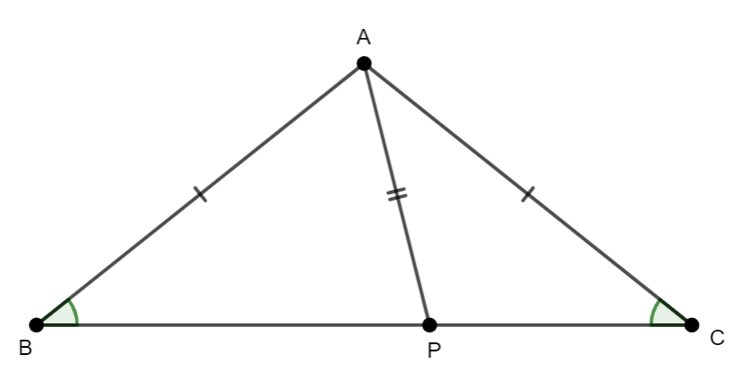
- For example, given triangle $ABC$, side $AB$ is extended and side $BC$ is copied with a compass and a straightedge. Triangles $CAB$ and $CAB'$ have two pairs of congruent sides and one pair of congruent angles (not included between the congruent sides). The triangles are not congruent.
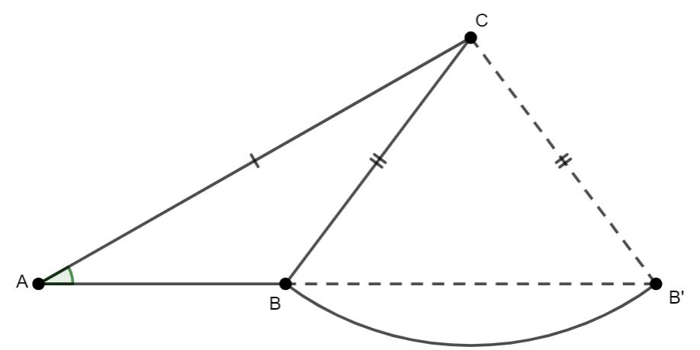

- For example, given triangles $ABC$ and $ADE$, with $\overline{DE}∥\overline{BC}$. The triangles have corresponding congruent angles (corresponding angles formed by two parallel lines cut by a transversal) and share a common angle ($∠A$). However, the triangles are not congruent.
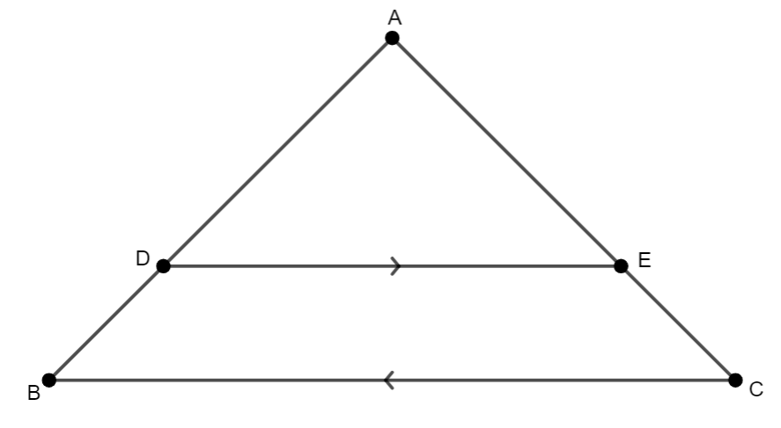

- Instruction includes Hypotenuse-Leg (HL) to prove two right triangles are congruent. Students should identify that HL is a special case of Side-Side-Side (SSS) and Side-Angle-Side (SAS), using the Pythagorean Theorem.
- Instruction makes the connection between the Triangle Angle Sum Theorem (MA.912.GR.1.3) and Angle-Angle (AA) for triangle similarity. This connection explains why Angle-Angle-Angle (AAA) is not commonly used to prove triangle similarity, and instead AA is. Students should explore the Third Angle Theorem, if two angles of a given triangle are congruent with two angles of another triangle, then the third angles of each triangle are also congruent (MA.912.GR.1.3).
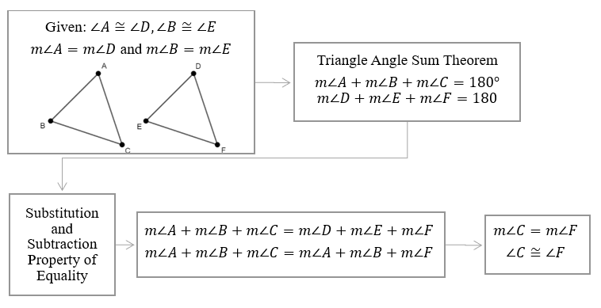

- Instruction makes the connection between triangle similarity and the Triangle Proportionality Theorem (MA.912.GR.1.6). There is no general agreement in the mathematical community about using Angle-Angle (AA) to prove the Triangle Proportionality Theorem, or vice versa. In some cases, Angle-Angle (AA) is considered a postulate and used to prove Side-Side-Side and Side-Angle-Side for triangle similarity.
- For example, the Angle-Angle (AA) similarity postulate states that two triangles are similar if at least two pairs of corresponding angles are congruent. The Side-Side-Side (SSS) similarity theorem could be proved as follows:
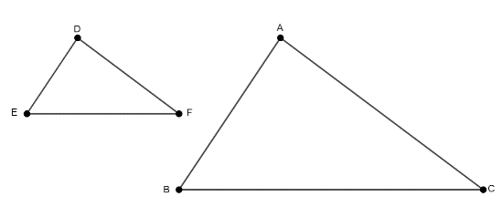
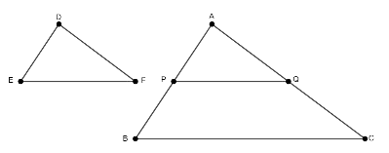

- Students should have practice comparing ratios (setting up proportions) to determine triangle similarity using Side-Side-Side (SSS) and Side-Angle-Side (ASA). To verify two triangles are similar by determining the proportionality of their sides, students should develop the understating that the lengths of the sides in each triangle should be ordered (e.g., from smallest to largest) to establish how to create the ratios.
- For example, given triangle $ABC$, with side lengths $3$, $6$, and $5$, and triangle $PQR$, with side lengths $27$, $45$, and $54$. Ordering the sides of each triangle, from largest to smallest, these are the resulting lists: $6$, $5$, $3$; $54$, $45$, $27$. Then, the ratios are $\frac{54}{6}$, $\frac{45}{6}$, and $\frac{27}{3}$ and it can be determined whether the sides are in proportion. If so, the similarity ratio of $∆PQR$ to $∆ABC$ can be found (in this case $9$) and the triangles are proved similar, so $∆ABC\sim ∆PQR$. Students should be able to find the similarity ratio of $∆PQR$ to $∆ABC$, that is $9$, and the similarity ratio of $∆ABC$ to $∆PQR$, that is $\frac{1}{9}$. The similarity ratio of $∆1$ to $∆2$ is the reciprocal of the scale factor of the dilation that maps $∆1$ onto $∆2$.

- Instruction includes mathematical problems to prove two triangles congruent or two triangles are similar using given statements and then deducing others and their reasons using definitions, postulates, properties, theorems, and other relationships.
- Some common definitions are right angles, supplementary angles, vertical angles, linear pair, midpoint, perpendicular lines, perpendicular bisector, and angle bisector, types of triangles and quadrilaterals.
- Some common postulates are the Segment Addition Postulate, the Angle addition postulate, and the Linear Pair Postulate.
- Some common properties are Properties of Equality, Properties of Congruence, and properties of triangles and quadrilaterals.
- Some common theorems are Vertical Angles, Midpoint, and Isosceles Triangle.
- Some relationships: between angles formed by two parallel lines cut by a transversal.
These lists are not comprehensive.

- Students should develop the understanding that when two triangles are proved congruent using the congruence of two or three pairs of corresponding parts, then the other corresponding parts are congruent by the definition of congruent triangle. Similarly, that when two triangles are proved similar using the congruence or proportionality of two or three pairs of corresponding parts, then the other corresponding parts are congruent or proportional by the definition of similar triangle

Common Misconceptions or Errors
- Students may confuse the congruence and similarity versions of the Side-Side-Side and Side-Angle-Side criteria. To address this misconception, provide students with counterexamples and opportunities to discuss the difference.
- Students may try to use Angle-Angle, Angle-Angle-Angle or Side-Side-Angle to prove congruence.

Strategies to Support Tiered Instruction
- Students should have practice identifying whether the information given in an image is enough to prove triangle congruence. If so, choose which of the following corresponds to the given image: Side-Side-Side (SSS), Side-Angle-Side (SAS), Angle-Side-Angle (ASA), Angle-Angle-Side (AAS0, or Hypotenuse-Leg (HL). It is considered evident in an image that shared sides, shared angles and vertical angles are congruent.
- For example, in each of the following images, students determine whether the given triangles are congruent and select the one that corresponds: SSS, SAS, ASA, AAS, or HL.
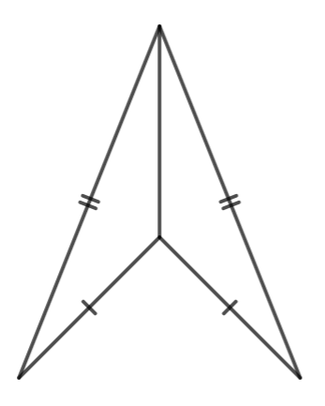 | 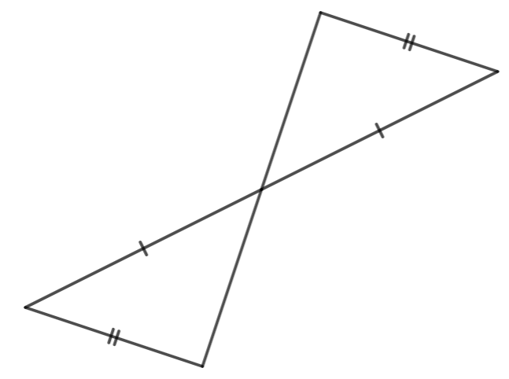 | 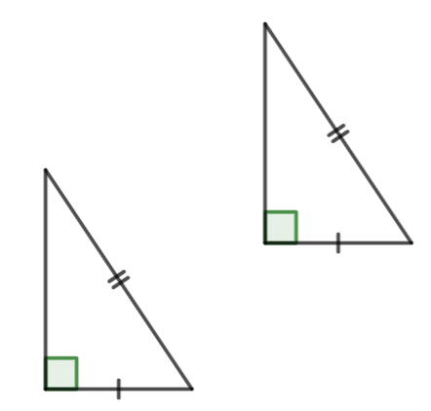

- Instruction includes identifying what else is needed to prove two given triangles congruent.
- For example, given triangles $ABC$ and $CDA$, which congruence statement about segments or angles is needed to prove the triangles congruent?
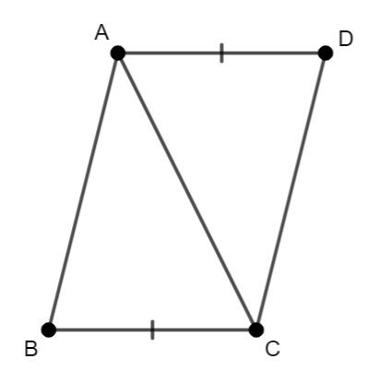
- Students should have practice solving proportions.
- For example, find the value of $x$ if $\frac{x+2}{3}=\frac{3}{4}$.

Instructional Tasks
Instructional Task 1 (MTR.4.1, MTR.5.1)
Pentagon $ABCDE$, as shown below, is a regular pentagon.
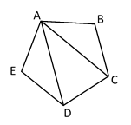
Part A. Can you identify two possible congruent triangles in the figure?
Part B. Write a congruence statement for the two triangles that are assumed congruent.
Part C. What theorem or postulate can be used to prove the two triangles congruent?
Part D. Prove that the two triangles chosen in Part A are congruent.
Part E. Determine whether a triangle in the image or added to the image could be congruent to triangle $ACD$.
Part F. If so, repeat Part B, Part C, and Part D with the new pair of triangles.

Instructional Task 2 (MTR.4.1, MTR.5.1)
Part A. Draw a triangle with side lengths 6 inches, 7 inches and 10 inches. Compare your triangle with a partner.
Part B. Draw a triangle with side lengths 4 inches and 6 inches, and with a $70°$ angle in between those side lengths. Compare your triangle with a partner.
Part C. Draw a triangle with angle measures of $40°$ and $60°$, and a side length of 5 inches between those angle measures. Compare your triangle with a partner.
Part D. Based on the comparison of triangles created in Parts A, B and C, what can you conclude about criteria for determining triangle congruence?

Instructional Items
Instructional Item 1
Use rectangle $ABCD$ to fill in the blanks.
In a rectangle opposite sides are _______ which means $\overline{}≅\overline{}$. Triangles $ABC$ and $CDA$ can be proven congruent by Hypotenuse-Leg because _____ is the hypotenuse for both triangles.
*The strategies, tasks and items included in the B1G-M are examples and should not be considered comprehensive.

MA.912.GR.1.3

Benchmark
MA.912.GR.1.3 Prove relationships and theorems about triangles. Solve mathematical and real-world problems involving postulates, relationships and theorems of triangles.
Benchmark Clarifications:
Clarification 1: Postulates, relationships and theorems include measures of interior angles of a triangle sum to 180°; measures of a set of exterior angles of a triangle sum to 360°; triangle inequality theorem; base angles of isosceles triangles are congruent; the segment joining midpoints of two sides of a triangle is parallel to the third side and half the length; the medians of a triangle meet at a point.
Clarification 2: Instruction includes constructing two-column proofs, pictorial proofs, paragraph and narrative proofs, flow chart proofs or informal proofs.
Clarification 3: Instruction focuses on helping a student choose a method they can use reliably.

Connecting Benchmarks/Horizontal Alignment
- MA.912.GR.3.1, MA.912.GR.3.2, MA.912.GR.3.3
- MA.912.GR.5.3
- MA.912.T.1.1, MA.912.T.1.2
- MA.912.LT.4.3, MA.912.LT.4.10

Terms from the K-12 Glossary
- Angle
- Isosceles Triangle
- Triangle
Vertical Alignment
Previous Benchmarks  - MA.8.GR.1.1, MA.8.GR.1.2, MA.8.GR.1.3  - MA.912.AR.2.1 | Next Benchmarks  - MA.912.NSO.3  - MA.912.T.1.8
Purpose and Instructional Strategies
In grade 8, students applied the Pythagorean Theorem to solve mathematical and real-world problems involving right triangles. Students also used the Triangle Inequality Theorem and solve problems involving the relationships of interior and exterior angles of a triangle. In Geometry, students prove relationships and theorems about triangles and solve mathematical and real-world problems involving triangles, including right triangles. In another benchmark in this course, students deepen their understanding of the relationships of angle measures and side lengths in right triangles using trigonometry. In Geometry Honors and later courses, students will use trigonometry to study further relationships between angle measures and side lengths of non-right triangles.
- For expectations of this benchmark in its clarification, instruction includes the following proofs:
- The measures of the interior angles of a triangle sum to 180° (Triangle Angle Sum Theorem).
- Students should verify this theorem using manipulatives in different ways (e.g., folding paper). Students should also verify the theorem with geometry dynamic software. Instruction includes writing the formal proof of the theorem. This proof connects to angles formed by parallel lines cut by a transversal (MA.912.GR.1.1) and properties of equality.
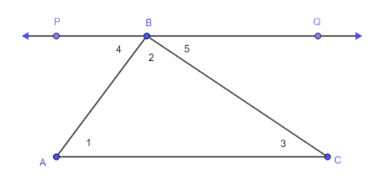

- Instruction should extend the student understanding of the relationships of interior and exterior angles of a triangle (Grade 8). Students should be able to identify the measures of an exterior angle of a triangle is the sum of the measures of the two remote interior angles.
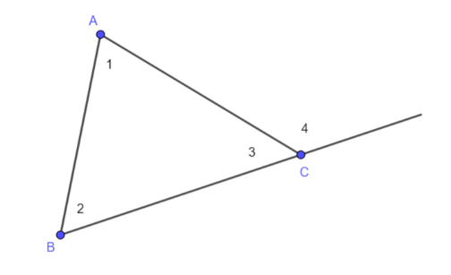
- Instruction includes the proof of the statement “triangles with two pairs of congruent angles also have a third pair of congruent angles” (Third Angle Theorem). This theorem justifies that two pairs of congruent angles is enough to prove two triangles are similar by the Angle-Angle criterion (MA.912.GR.1.2).
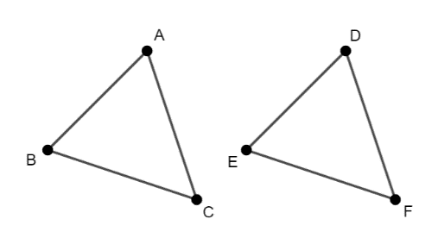

- The measures of a set of exterior angles of a triangle sum to 360° (Exterior Angle Sum Theorem).
- Instruction includes the connection of the proof of this theorem with the Triangle Angle Sum Theorem and properties of equality.
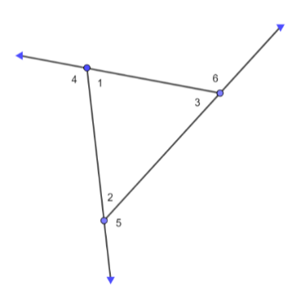
- The Triangle Inequality Theorem.
The proof of the Triangle Inequality Theorem requires an auxiliary segment joining one vertex of the triangle with the opposite side forming right angles.
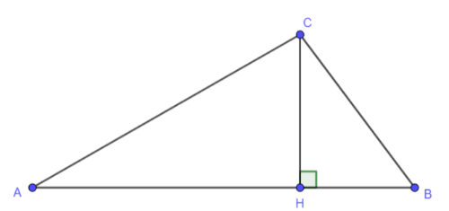

- Instruction includes determining whether a triangle is possible from a given set of three side lengths and if so, it spirals to use the Pythagorean Theorem to classify the triangle in acute, right, or obtuse (Grade 8).
      - For example, in a triangle with sides $a$, $b$ and $c$, with $c>a$ and $c>b$, if $a^{2}+b^{2}=c^{2}$, then the triangle is right. But if $a^{2}+b^{2}>c^{2}$, then the triangle is acute, and if $a^{2}+b^{2}<c^{2}$, then the triangle is obtuse.
- Instruction includes extending the understanding of the Triangle Inequality Theorem to determine the range of possible of lengths of the third side of a triangle given the lengths of the other two.

- Base angles of isosceles triangles are congruent (Isosceles Triangle Theorem).
Instruction includes considering the construction of an auxiliary line segment (median, angle bisector, or perpendicular bisector) to prove the Isosceles Triangle Theorem. Once the auxiliary line segment has been chosen, the proof involves the definition of the line segment selected, proving triangle congruent (MA.912.GR.1.2), and the definition of congruent triangles (MA.912.GR.1.6). (MTR.2.1)
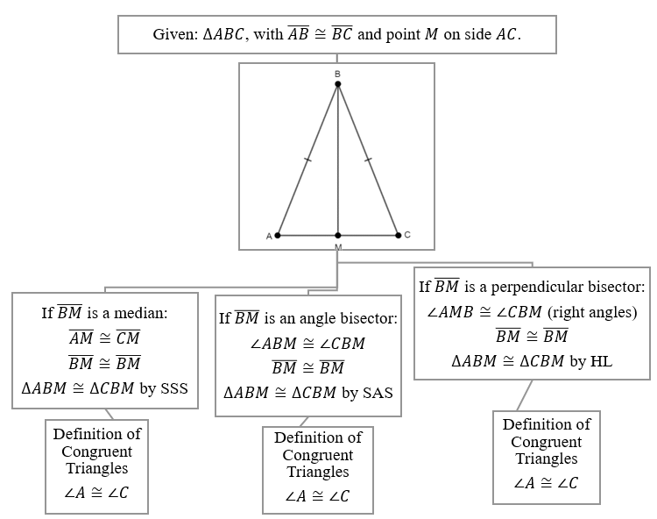

- The segment joining midpoints of two sides of a triangle is parallel to the third side and half the length (Triangle Midsegment Theorem).
The proof of this theorem requires an auxiliary construction, proving triangles congruent (MA.912.GR.1.2), angles formed by parallel lines cut by a transversal (MA.912.GR.1.1), and using properties of parallelograms (MA.912.GR.1.4).

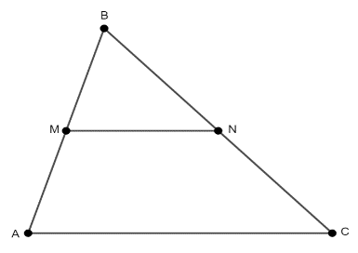
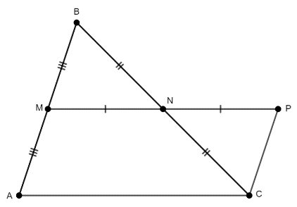

- Instruction includes the connection to coordinate geometry when proving the Triangle Midsegment Theorem (MA.912.GR.3.2) and to the Trapezoid Midsegment Theorem (MA.912.GR.1.5). (MTR.5.1)

- The medians of a triangle meet at a point (and the Centroid Theorem).
Instruction makes connections with similarity of triangles to prove the Centroid Theorem.
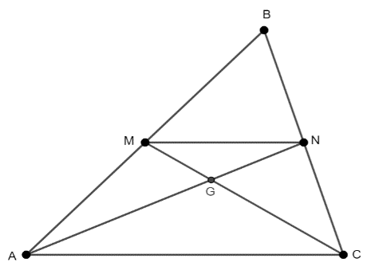
Instruction makes the connection to weighted average (MA.912.GR.1.1) and partitions (MA.912.GR.3.3). The centroid partitions each media from the vertex to the midpoint of the opposite side in the ratio $2:1$. The centroid is the weighted average of its endpoint when the weight of one is twice the other.
Instruction makes the connection to coordinate geometry (MA.912.GR.3.3). The coordinates of the centroid of a triangle on the coordinate plane is the weighted average of the coordinates of the vertices when they have the same weight. That is. $C=\left(\frac{1}{3}x_{1}+\frac{1}{3}x_{2}+\frac{1}{3}x_{3},\frac{1}{3}y_{1}+\frac{1}{3}y_{2}+\frac{1}{3}y_{3}\right)$, where $(x_{1}, y_{1})$, $(x_{2}+y_{2})$, and $(x_{3}, y_{3})$ are the coordinates of the vertices of the triangle.

- Instruction also includes definitions, relationships, or other theorems about triangles, like theorems about inequalities in one triangle (Exterior Angle Inequality Theorem and Scalene Triangle Theorem or Angle-Side Relationship Theorem) and inequalities in two triangles (Hinge Theorem).
  - Exterior Angle Inequality Theorem.
Instruction includes the understanding that any exterior angles of a triangle is greater than each of the remote interior angles. This notion is related to the relationship between an interior angle of a triangle and its corresponding exterior angles ($m∠4=m∠1+m∠2$). Since when two positive numbers are added, the sum is greater than each addend, $m∠4>m∠1$ and $m∠4>m∠2$.
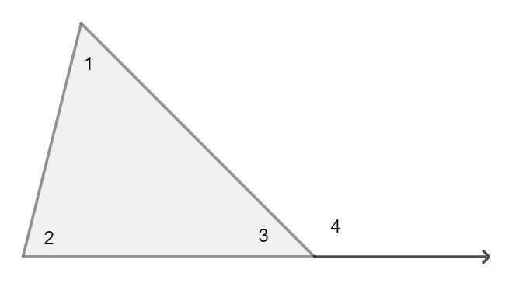
- Scalene Triangle Theorem or Angle-Side Relationship.
Instruction includes the understanding that the angle opposite the longest side in a triangle has the greatest measure, and the side opposite the greatest angle in a triangle is the longest. The proof of this theorem requires an auxiliary segment, the Isosceles Triangle Theorem, and the Exterior Angle Inequality Theorem.
Given $∆ABC$, with $AB>AC$. $P$ lies on $\overline{AB}$ such that $AP=PC$. $∆APC$ is isosceles with $∠1≅∠2$. By the Angle Addition Postulate, $m∠ACB=m∠4+m∠2$. Then, $m∠ACB>m∠2$. By substitution, $m∠ACB>m∠1$. Applying the Exterior Angle Theorem in $∆BPC$, $m∠1=m∠3+m∠4$ and $m∠1>m∠3$. By the transitive property, $m∠ACB>m∠3$ or $m∠ACB>m∠ABC$.
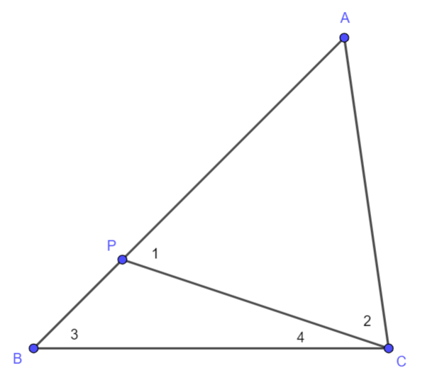
Instruction includes verifying whether the converse is true.

- The Hinge Theorem (if two sides of two triangles are congruent and the included angle is different, then the angle that is larger is opposite the longer side).
Given triangles $ABD$ and $ACD$ where $AB=AC$ and $\overline{AD}$ is a common side. Since $∆ABC$ is isosceles, $m∠ABC=m∠ACB$. By the Angle Addition Postulate, $m∠DBC =m∠ DCA +m∠ ACB$, and $m∠DCB>m∠ACB$. By substitution, $m∠DCB>m∠ABC$. Again, $m∠ABC =m∠ ABD +m∠ DBC$, $m∠ABC>m∠DBC$. By the Transitive Property of Inequality, $m∠DCB>m∠DBC$ and $DB>DC$.
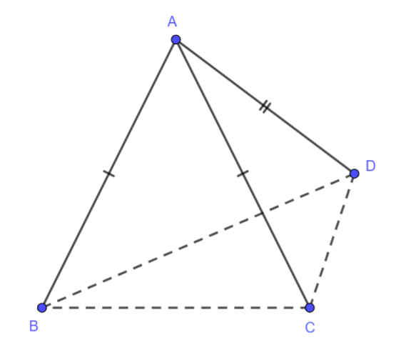

- Instruction includes proving that the medians of a triangle meet at a point (centroid).
  - For example, using weighted averages.
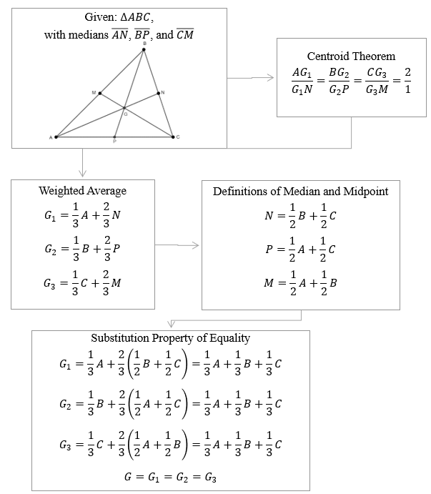

Common Misconceptions or Errors
- Students may misidentify an exterior angle as the one resulting from extending two sides of a triangle at the same vertex.

Strategies to Support Tiered Instruction
- Teacher models how to use the cutout of a triangle to prove the Triangle Angle Sum Theorem. Students tearing off the corners of the triangle and verify that the angle formed by adding the interior angles of a triangle is a straight angle.
- Students should explore the Triangle Angle Sum Theorem using folding paper. Fold the base onto itself such that the crease contains the opposite vertex of the triangle. Fold that region of the triangle such that the vertex coincides with the point where the base and the crease met. Fold the other two parts of the triangle until forming a rectangle. All the vertices of the triangle will meet at a point, the vertex of a straight angle resulting from adding the three interior angles of the triangle.
- Teacher models how to use patty paper to verify the Exterior Angle Sum Theorem. Trace a set of the exterior angles of a triangle on the patty paper, adjacent to each other, and verify they sum to $360°$.
- Teacher models the Triangle Inequality Theorem using manipulatives (e.g., straws of different length). Cut straws in different lengths. Try to form triangles using different combinations. Students should identify the need of using three straws with the sum of the lengths of each two is more than the other side.

Instructional Tasks
Instructional Task 1 (MTR.4.1)
Print and cut apart the given pieces of information, including statements and reasons, and provide to students. Ask students to work in groups and use the given information to construct the proof of the Exterior Angle Sum Theorem.

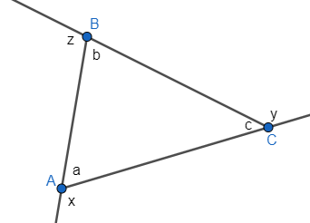

Given:
$∆ABC$ with exterior angles $x$, $y$ and $z$.

Prove:
$$m∠x +m∠z + m∠y=360.$$

$∆ABC$ with exterior angles $x$, $y$ and $z$ |  |  | Given
$∠a$ and $∠x$ form a linear pair  $∠b$ and $∠z$ form a linear pair  $∠c$ and $∠y$ form a linear pair |  |  | Definition of Linear Pair
$∠a$ and $∠x$ are supplementary  $∠b$ and $∠z$ are supplementary  $∠c$ and $∠y$ are supplementary |  |  | Angles forming a linear pair are supplementary (Linear Pair Postulate)
$$m∠a+ m∠x=180˚$$  $$m∠b+ m∠z=180˚$$  $$m∠c+ m∠y=180˚$$ |  |  | Definition of Supplementary Angles
$$m∠a=180˚-m∠x$$  $$m∠b=180˚- m∠z$$  $$m∠c=180˚- m∠y$$ |  |  | Subtraction Property of Equality
$$m∠a+ m∠b+m∠c=180˚$$ |  |  | The measures of the interior angles of a triangle sum to $180°$ (Triangle Angle Sum Theorem)
$$180˚-m∠x+180˚- m∠z+180˚- m∠y=180˚$$ |  |  | Substitution Property of Equality
$$540˚-m∠x- m∠z- m∠y=180˚$$ |  |  | Properties of Addition
$$-m∠x- m∠z- m∠y=-360˚$$ |  |  | Subtraction Property of Equality
$$m∠x+m∠z+m∠y=360˚$$ |  |  | Multiplication Property of Equality

Instructional Task 2 (MTR.2.1, MTR.4.1, MTR.5.1)
Provide students with various sizes and types of triangles cut from a paper; large enough for students to tear off the vertices of the triangles. Additionally, provide students tape, glue stick and a blank piece of paper.
Part A. Using one of the triangles provided, tear off the vertices.
Part B. Place the three vertices in such a way that they are adjacent and create a straight line. If necessary, use tape or glue to keep the vertices in place on the straight line.
Part C. What do you notice about the type of angle the three vertices create? If the angle measure are added, how many degrees does it sum to?
Part D. How does this relate to the Triangle Sum Theorem?

Instructional Items
Instructional Item 1
$\overline{GH}$ is a midsegment of triangle $DEF$ and $\overline{DE}$ is a midsegment of triangle $ABC$. If $GH=1.5$ cm, what is the length of segment $BC$?
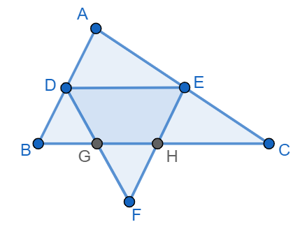
Instructional Item 2
Verify whether each one of the equations is true about the given triangle. The image shows one set of the exterior angles of the triangle
$m∠5=m∠1+m∠3$
$m∠1+m∠2=m∠3$
$m∠4+m∠5+m∠6=180°$
$m∠2+m∠5=180°$
$m∠4+m∠5=m∠6$
$m∠2+m∠3=180°-m∠1$
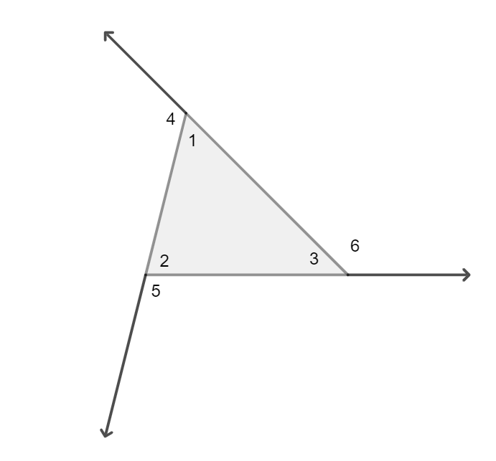
*The strategies, tasks and items included in the B1G-M are examples and should not be considered

MA.912.GR.1.4

Benchmark
MA.912.GR.1.4 Prove relationships and theorems about parallelograms. Solve mathematical and real-world problems involving postulates, relationships and theorems of parallelograms.
Benchmark Clarifications:
Clarification 1: Postulates, relationships and theorems include opposite sides are congruent, consecutive angles are supplementary, opposite angles are congruent, the diagonals of a parallelogram bisect each other, and rectangles are parallelograms with congruent diagonals.
Clarification 2: Instruction includes constructing two-column proofs, pictorial proofs, paragraph and narrative proofs, flow chart proofs or informal proofs.
Clarification 3: Instruction focuses on helping a student choose a method they can use reliably.

Connecting Benchmarks/Horizontal Alignment
- MA.912.GR.3.2, MA.912.GR.3.3
- MA.912.LT.4.3, MA.912.LT.4.10
Terms from the K-12 Glossary
- Angle
- Parallelogram
- Quadrilateral
- Rectangle
- Rhombus
- Square
- Supplementary Angles

Vertical Alignment
Previous Benchmarks  - MA.3.GR.1.2  - MA.5.GR.1.1  - MA.7.GR.1.1  - MA.912.AR.2.1 | Next Benchmarks  - MA.912.NSO.3

Purpose and Instructional Strategies
In grade 3, students identified and drew quadrilaterals, including parallelograms, rectangles, rhombi (or rhombuses), squares, and trapezoids. In grade 5, students classified quadrilaterals into different categories based on shared defining attributes. In grade 7, students solved problems involving the area of parallelograms. In Geometry, students prove theorems and relationships between sides, angles, and diagonals of parallelograms (including the special cases rectangles, rhombi, and squares), and solve mathematical and real-world problems involving these theorems and relationships. In later courses, students will use notions of parallelograms when adding and subtracting vectors.
- Students should develop the understanding that the definition of parallelogram states a parallelogram is a trapezoid with two pairs of parallel sides. A parallelogram is a trapezoid using the inclusive definition, a quadrilateral with at least one pair of parallel sides, included in the K-5 Mathematics Glossary. In parallelograms, opposite sides and angles are congruent, consecutive angles are supplementary, and diagonal bisect each other. Instruction includes proving these properties and using them to solve problems.
- Instruction includes classifying parallelograms based on defining attributes. Rectangles are parallelograms with four right angles. Rhombi are parallelograms with four equal side lengths. Squares are rectangles and rhombi.
- Instruction makes the connection to Logic and Discrete Math. Students should write definitions using a “if… then” statement, determine whether the converse of the conditional statement is true, and if so, write the “if and only if” statement (MA.912.LT.4.3).
- For example, the definition of rectangle can be written “if a quadrilateral is a rectangle, then the quadrilateral has four right angles.” The converse is “if a quadrilateral has four right angles, then the quadrilateral is a rectangle.” The converse is true, then “a quadrilateral is a parallelogram if and only if the quadrilateral has four right angles.”
- Instruction includes judging the validity of arguments about parallelograms, including “all” and “not” statements (MA.912.LT.4.3). If the argument is not valid, students should identify a counterexample (MA.912.LT.4.10).
- For example, “all rectangles are squares” is false, and the counterexample is a rectangle with different lengths for the base and for the height.

- For expectations of this benchmark in its clarification, instruction includes the following proofs:

- If a quadrilateral is a parallelogram, then the opposite sides are congruent (and its converse).
Instruction for this proof includes using an auxiliary segment (one of the diagonals of the parallelogram), to use relationships between angles formed when parallel lines are cut by a transversal (MA.912.GR.1.1), to prove triangle congruence (MA.912.GR.1.2), and to use the definition of congruent triangles to prove that opposite sides are congruent (MA.912.GR.1.6).
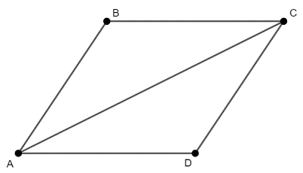
- If a quadrilateral is a parallelogram, then the consecutive angles are supplementary (and its converse).
Instruction for this proof includes using use relationships between angles formed by parallel lines cut by a transversal.

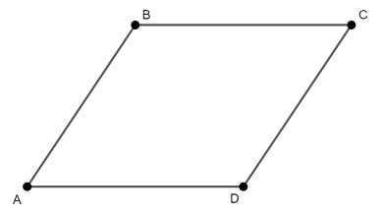

- If a quadrilateral is a parallelogram, then the opposite angles are congruent (and its converse).
Instruction for this proof includes using an auxiliary segment (one of the diagonals of the parallelogram), to use relationships between angles formed when parallel lines are cut by a transversal (MA.912.GR.1.1), to prove triangle congruence (MA.912.GR.1.2), and to use the definition of congruent triangles to prove that opposite angles are congruent (MA.912.GR.1.6).
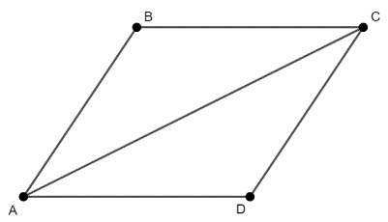

- If a quadrilateral is a parallelogram, then the diagonals bisect each other (and its converse).
Instruction for this proof includes using two auxiliary segments (the diagonals of the parallelogram), to use relationships between angles formed when parallel lines are cut by a transversal (MA.912.GR.1.1), to prove triangle congruence (MA.912.GR.1.2), and to use the definition of congruent triangles to prove the diagonals are bisected (MA.912.GR.1.6).
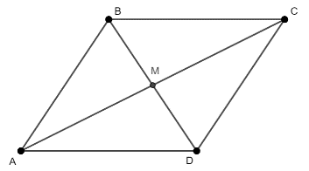

- If a parallelogram is a rectangle, then the diagonals are congruent (and its converse).
Instruction for this proof includes proving the congruence of two triangles formed by consecutives sides and the diagonals.
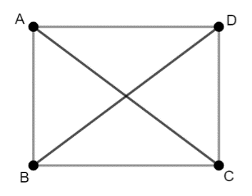

- Instruction includes proving that a quadrilateral with one pair of congruent and parallel sides is a trapezoid and a parallelogram.
- Instruction includes making the connection between the properties of parallelograms and the properties of rectangles, rhombi, and squares, resulting from being parallelograms. Precision and accuracy are important when discussing the definitions of the special parallelograms. (MTR.3.1, MTR.4.1)
  - For example, some possible discussion questions include:
    - What makes a parallelogram a rectangle?
    - What is the unique feature of a rhombus?
    - Is a square always a rectangle?
    - Is a square sometimes a rhombus?
    - Is a rectangle always a square? Is a rhombus always a square?
    - What are the properties of a parallelogram observed in a rhombus?

- Instruction includes proving that the diagonals of a parallelogram bisect each other and that the diagonals of a parallelogram are congruent if and only if the parallelogram is a rectangle. Clarify that just having congruent diagonals is not enough to identify a quadrilateral as a rectangle as this is also a property of isosceles trapezoids. The quadrilateral must be proved a parallelogram to use this property to classify it as a rectangle.
- Instruction makes the connection to triangle congruence (MA.912.GR.1.2) to verify properties of rhombi like the diagonals of a rhombus are perpendicular and bisect opposite sides. It also makes the connection to the Pythagorean Theorem to solve problems about rhombi, their side lengths, and the length of their diagonals. Students should develop the understanding that the property about the diagonals of a rhombus can be used when decomposing a rhombus into triangles to find its area (MA.912.GR.3.3 and MA.912.GR.4.4) given a rhombus and its diagonals, and leads to the formula to find the area of a rhombus $A=\frac{d_{1}d_{2}}{2}$, where $d_{1}$ and $d_{2}$ are the diagonals of the rhombus. This formula can be also used to find the area of a kite.
- Instruction includes the use of hands-on manipulatives and geometric software for students to explore relationships, postulates, and theorems about trapezoids.
Problem types include those including algebraic expressions.
Common Misconceptions or Errors
- Students may misidentify squares, parallelograms, rectangles, and rhombi as being exclusive to each other.
- Students may think that parallelograms are not trapezoids. The K-12 Mathematics Glossary defines trapezoids as quadrilaterals with at least one pair of parallel sides. Therefore, all parallelograms are trapezoids.

Strategies to Support Tiered Instruction
- Instruction includes using anchor charts and graphic organizers to stablish the relationships between parallelograms and special parallelograms.
- Teacher models how to use the hierarchy of quadrilaterals.
- For example, if a parallelogram is a rhombus, it is a parallelogram, a trapezoid, and a quadrilateral. That is identifying how each one of those categories is a subset of the next.
- Instruction includes using cutouts shaped as parallelograms and verify the properties by folding and manipulating the cutouts. Other manipulatives can be used to compare sides, angles, and diagonals of parallelograms like translucent paper (e.g., patty paper).

Instructional Tasks
Instructional Task 1 (MTR.3.1)
Given parallelogram $ABCD$, prove all the relationships between angles, opposite and consecutive.
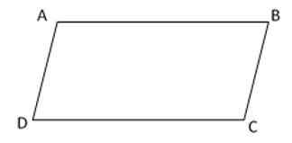

Instructional Task 2 (MTR.4.1)
Given quadrilateral $JKLM$ with $\overline{JK}≅\overline{LM}$ and $\overline{KL}≅\overline{MJ}$.
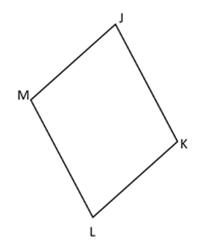
Part A. Draw the diagonal connecting points $M$ and $K$. Identify two triangles and prove the two triangles are congruent.
Part B. Using the congruent triangles from Part A, what is true about segments $MJ$ and $LK$?
Part C. Prove that quadrilateral $JKLM$ is a parallelogram.

Instructional Items
Instructional Item 1
Given parallelogram $WXYZ$, where $WX=2x+15$, $XY=x+27$ and $YZ=4x-21$, determine the length of $ZW$.
*The strategies, tasks and items included in the B1G-M are examples and should not be considered comprehensive.

MA.912.GR.1.5

Benchmark
MA.912.GR.1.5 Prove relationships and theorems about trapezoids. Solve mathematical and real-world problems involving postulates, relationships and theorems of trapezoids.
Benchmark Clarifications:
Clarification 1: Postulates, relationships and theorems include the Trapezoid Midsegment Theorem and for isosceles trapezoids: base angles are congruent, opposite angles are supplementary and diagonals are congruent.
Clarification 2: Instruction includes constructing two-column proofs, pictorial proofs, paragraph and narrative proofs, flow chart proofs or informal proofs.
Clarification 3: Instruction focuses on helping a student choose a method they can use reliably.

Connecting Benchmarks/Horizontal Alignment
- MA.912.GR.3.2, MA.912.GR.3.3
- MA.912.LT.4.3, MA.912.LT.4.10
Terms from the K-12 Glossary
- Angle
- Parallelogram
- Quadrilateral
- Rectangle
- Rhombus
- Square
- Supplementary Angles
- Trapezoid
Vertical Alignment
Previous Benchmarks  - MA.3.GR.1.2  - MA.5.GR.1.1  - MA.7.GR.1.1  - MA.912.AR.2.1 | Next Benchmarks  - MA.912.C.4.2

Purpose and Instructional Strategies
In grade 1, students identified trapezoids. In grade 3, students drew trapezoids based on its defining attributes. In grade 5, students explained why a quadrilateral would or would not belong to the category of the trapezoids. In grade 7, students applied formulas to find the areas of trapezoids. In Geometry, students prove relationships and theorems about trapezoids, and solve problems using the properties of their sides, angles, and diagonals. In later courses, students will apply notions of trapezoids to determine the area under a curve.
- Students should develop the understanding that trapezoids are quadrilaterals with at least one pair of parallel sides (as defined in the K-12 Mathematics Glossary). Therefore, parallelograms are trapezoids. That includes rectangles, rhombi, and squares in the category of trapezoids. This definition is known as the inclusive definition of trapezoids.
- Instruction includes the understanding of special trapezoids. An isosceles trapezoid has congruent non-parallel sides. A right trapezoid has one right angle. It also includes judging the validity of the statement “all rectangles are right trapezoids”.
- Instruction incudes the vocabulary related to trapezoids. The parallel sides are called the bases. The non-parallel sides are called legs. When a trapezoid is isosceles, the legs are congruent. It also includes judging the validity of the statement “all isosceles trapezoids are parallelograms”.
- Instruction includes the definition of the midsegment of a trapezoid. The length of the midsegment of a trapezoid is the weighted average of the lengths of the bases when they have the same weight. It also includes the understanding that, in the formula for the area of a trapezoid $A=\frac{1}{2}h(b_{1}+b_{2})$, $\frac{1}{2}(b_{1}+b_{2})$ is the length of the midsegment. That is, the area of a trapezoid is the result of multiplying the height of the trapezoid and the length of the midsegment.

- For expectations of this benchmark in its clarification, instruction includes the following proofs:
- Trapezoid Midsegment Theorem.
The Trapezoid Midsegment Theorem states that the line segment joining the midpoints of the legs of a trapezoid, called midsegment, is parallel to the bases and equal to half their sum (or the average of the length of the bases).
Instruction makes the connection to relationships between angles formed by parallel lines cut by a transversal (MA.912.GR.1.1), triangle congruence (MA.912.GR.1.2 and MA.912.GR.1.6) and the Triangle Midsegment Theorem (MA.912.GR.1.3).
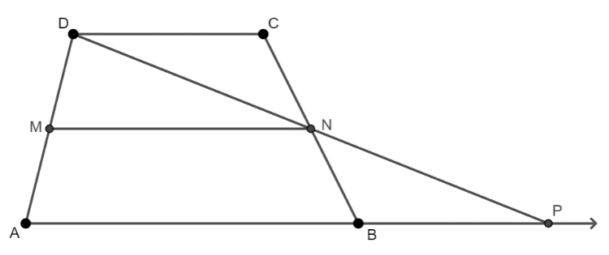
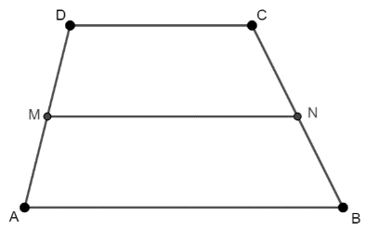

Students should verify whether the converse of this theorem is true. If so, students should write the biconditional statement “a segment is the midsegment of a trapezoid if and only if the segment is parallel to the bases and half their sum.”

- In isosceles trapezoids, the base angles are congruent.
To prove this statement, an auxiliary construction is required: the distances from the endpoints of the shorter base to the longer base (also known as the height of the isosceles trapezoid). Students should develop the understanding that the distance between parallel lines remains constant.
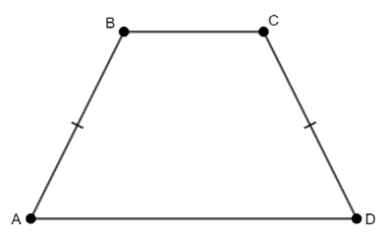
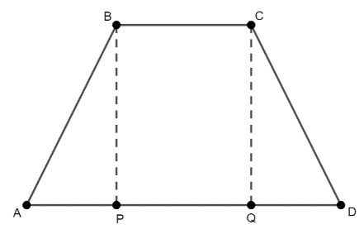
Instruction includes to apply the angle addition postulate or properties of equality to prove $∠ABC≅∠DCB$.
Students should determine whether the converse of the statement “if a trapezoid is isosceles, then the base angles are congruent” is true. If so, write the biconditional statement “a trapezoid is isosceles if and only if the base angles are congruent.”

- In isosceles trapezoids, the opposite angles are supplementary.
Students should make the connection between this statement and angles formed by parallel lines cut by a transversal.
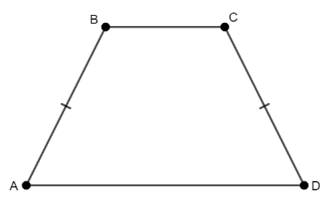
Students should determine whether the converse of the statement “if a trapezoid is isosceles, then the opposite angles are supplementary” is true. If so, write the biconditional statement “a trapezoid is isosceles if and only if the opposite angles are supplementary.”

- In isosceles trapezoids, the diagonals are congruent.

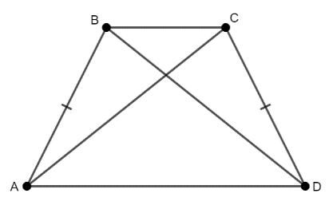
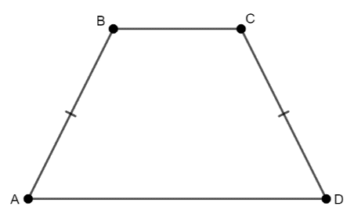

Students should determine whether the converse of the statement “if a trapezoid is isosceles, then the diagonals are congruent” is true. If so, write the biconditional statement “a trapezoid is isosceles if and only if the diagonals are congruent.”
- Instruction includes the use of hands-on manipulatives and geometric software for students to explore relationships, postulates, and theorems about trapezoids.
- Problem types include those including algebraic expressions.

Common Misconceptions or Errors
- Students may assume that all trapezoids are isosceles trapezoids.
- Students may misidentify parallelograms as quadrilaterals that are not trapezoids.

Strategies to Support Tiered Instruction
- Instruction includes examples of different types of trapezoids such as scalene trapezoids, right trapezoids, and trapezoids where the parallel sides are not horizontal or vertical.
- Instruction includes the reiteration of the definition of a trapezoid (quadrilateral with at least one pair of parallel sides).
- Instruction includes using manipulatives to verify properties and theorems of trapezoids.
- Teacher models how to use patty paper to verify congruent angles and congruent diagonals in isosceles trapezoids.

Instructional Tasks
Instructional Task 1 (MTR.3.1)
Trapezoid $JKLM$ is graphed on a coordinate plane.
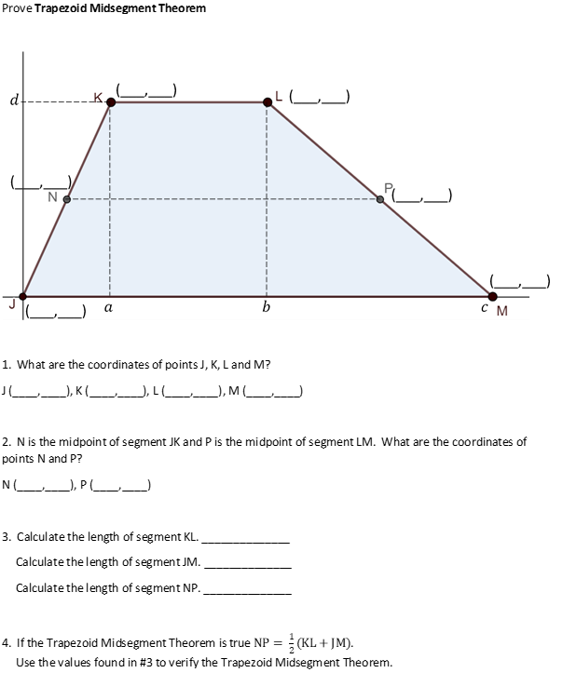
Part A. What are the coordinates of points $J$, $K$, $L$ and $M$ in terms of $a$, $b$, $c$, and $d?$
Part B. $N$ is the midpoint of segment $JK$ and $P$ is the midpoint of segment $LM$. What are the coordinates of points $N$ and $P$ in terms of $a$, $b$, $c$, and $d$?
Part C. What are the lengths of segments $KL$, $JK$ and $NP$ in terms of $a$, $b$, $c$, and $d$?
Part D. Use your answers from Parts A through C to prove the Trapezoid Midsegment Theorem.

Instructional Task 2 (MTR.5.1)
Isosceles trapezoid $ABCD$ is shown.
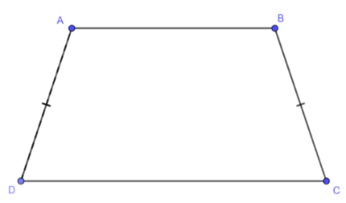
Part A. Prove that $∠A$ is supplementary to $∠D$ and that $∠B$ is supplementary to $∠C$.
Part B. Prove that $∠A≅∠B$.
Part C. Prove that $∠A$ is supplementary to $∠C$ and that $∠B$ is supplementary to $∠D$.
Part D. What do you know about isosceles trapezoid $ABCD$ based on the proofs from Parts A to C?

Instructional Task 3 (MTR.3.1)
Quadrilateral $ABCD$ is shown with a base that is parallel to its opposite side and has a pair of non-parallel sides. Assume that $\overline{AD}∥\overline{BF}$.
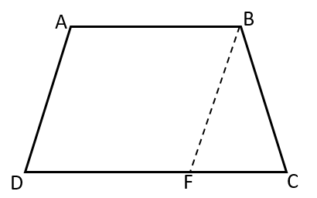
Part A. Prove that if non-parallel sides are congruent, then triangle $BFC$ is an isosceles triangle.
Part B. Prove that if the base angles, $∠C$ and $∠D$, are congruent, then triangle $BFC$ is an isosceles triangle.
Part C. Prove that the base angles are congruent when the non-parallel opposite sides are congruent.
Part D. Classify the quadrilateral.

Instructional Item 1
Tulips should be planted three inches apart to give a full look. The Starlings have a trapezoidal plot for a flower garden, as shown in the figure. They are going to put tulips along the parallel sides of the garden. The midsegment to the garden is 10 feet long. Tulips are sold in bags of 25 bulbs.
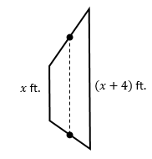
Part A. What are the lengths of the parallel sides of the garden?
Part B. How many tulips are needed to line the parallel sides?
Part C. What is the minimum number of bags the Starlings need to purchase to have enough bulbs to line the parallel sides of the garden?

*The strategies, tasks and items included in the B1G-M are examples and should not be considered comprehensive.

MA.912.GR.1.6

Benchmark
MA.912.GR.1.6 Solve mathematical and real-world problems involving congruence or similarity in two-dimensional figures.
Benchmark Clarifications:
Clarification 1: Instruction includes demonstrating that two-dimensional figures are congruent or similar based on given information.

Connecting Benchmarks/Horizontal Alignment
- MA.912.GR.2
- MA.912.GR.3.3
- MA.912.GR.4.3

Terms from the K-12 Glossary
- Congruent
- Similarity

Vertical Alignment
Previous Benchmarks  - MA.8.GR.2.4  - MA.912.AR.2.1 | Next Benchmarks  MA.912.T.2
Purpose and Instructional Strategies
In grade 8, students solved real-world and mathematical problems involving similar triangles, defining similarity in terms of dilations. In Geometry, students extend previous understanding of congruence and similarity to solve mathematical and real-world problems involving congruent or similar polygons. In later courses, students will use similar triangles to develop trigonometry related to the unit circle.
- Instruction includes discussing the definitions of congruent polygons and similar polygons based on corresponding parts. Students should understand that if a problem involves polygons (not including triangles), there are no congruence or similarity criteria, so proving them congruent or similar is based on the definitions in terms of corresponding parts. (MTR.4.1)
  - When two polygons are congruent, corresponding sides and corresponding angles are congruent.
  - When two polygons are similar, corresponding angles are congruent and corresponding sides are in proportion.
- Problem types includes using congruence and similarity criteria to determine whether two triangles are congruent or similar. Once it is stablished that two triangles are congruent or similar, the definition of congruence and similarity in terms of corresponding parts can be used to find missing angle measures and side lengths.
- Instruction includes solving mathematical problems involving congruent triangles, like the Perpendicular Bisector Theorem, the Isosceles Triangle Theorem, the Triangle Midsegment Theorem, and the Trapezoid Midsegment Theorem. Other mathematical problems include proving properties of parallelograms and isosceles trapezoids.
- Instruction includes using triangle similarity to solve problems in real-world contexts. Triangle similarity is present in contexts like objects casting shadows at the same time of the day, looking at the top of an object using a mirror placed on the ground, the image of a viewed object on the retina, among others.
- Instruction includes proving given statements about congruent triangles.
- For example,
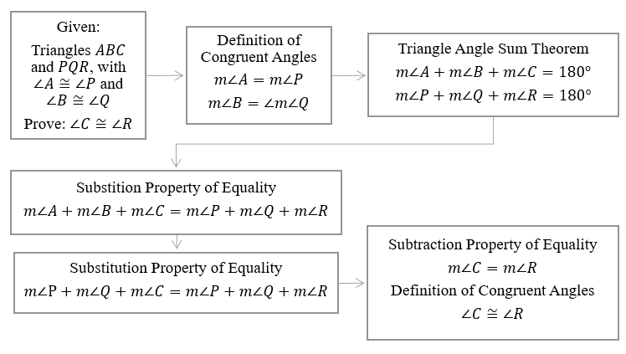
- Instruction includes the understanding of the geometric mean in right triangles and the height to the hypotenuse, and its connection to similarity criteria.
  - Geometric Mean Altitude Theorem
In a right triangle, the altitude from the right angle to the hypotenuse separates the hypotenuse into two segments. The length of the altitude, in triangle $ABC$, is the geometric mean between the lengths of the two line segments the altitude creates on the hypotenuse. Therefore, by applying the fact that $∆ABC\sim ∆HBA\sim ∆HAC$, students can conclude that $\frac{HC}{HA}=\frac{HA}{HB}$, which is equivalent to $HC⋅HB={\left(HA\right)}^{2}$, which is equivalent to $\sqrt{HC⋅HB}=HA$.
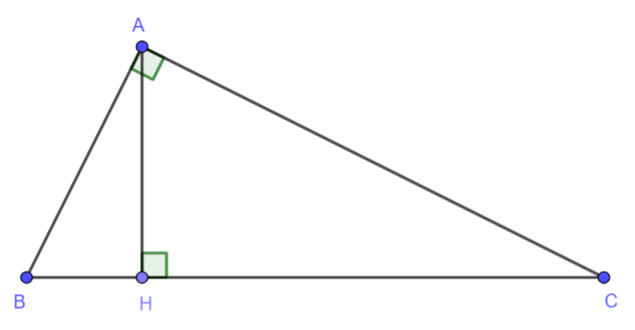

  - Geometric Mean Leg Theorem
In a right triangle, the altitude from the right angle to the hypotenuse separates the hypotenuse into two segments. The length of one of the legs, in triangle $ABC$, is the geometric mean between the length of the hypotenuse and the line segment of the hypotenuse adjacent to that leg. Therefore, by applying the fact that $∆ABC\sim ∆HBA\sim ∆HAC$ students can conclude that $\frac{HB}{BA}=\frac{BA}{BC}$, which is equivalent to $HB⋅BC={\left(BA\right)}^{2}$, which is equivalent to $\sqrt{HB⋅BC}=BA$.
- Instruction includes the connection between triangle similarity and the Triangle Proportionality Theorem, or Side-Splitter Theorem. Students can explore and conclude that if a line is parallel to one side of a triangle intersecting the other two sides of the triangle, then the line divides these two sides proportionally. The Triangle Midsegment Theorem is a special case of the Side-Splitter Theorem.
  - For example, given triangle $ABC$ and $\overline{PQ}∥\overline{AB}$, students can begin the proof that $\frac{PA}{CP}=\frac{QB}{CQ}$ by first proving $∆ABC\sim ∆PQC$ using the Angle-Angle (AA) criterion. Since corresponding sides of similar triangles are in proportion, students can determine the relationship $\frac{CA}{CP}=\frac{CB}{CQ}$. Students should be able to realize that $CA=CP+PA$ and $CB=CQ+QB$ using the segment addition postulate. Therefore, $\frac{CA}{CP}=\frac{CB}{CQ}$ can be written as $\frac{CP+PA}{CP}=\frac{CQ+QB}{CQ}$ . Students can use their algebraic reasoning to rewrite this relationship equivalently as $\frac{CP}{CP}+\frac{PA}{CP}=\frac{CQ}{CQ}+\frac{QB}{CQ}$, which is equivalent to $1+\frac{PA}{CP}=1+\frac{QB}{CQ}$, which is equivalent to $\frac{PA}{CP}=\frac{QB}{CQ}$.
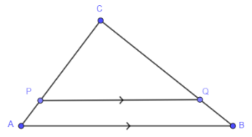

- For extension of this benchmark, instruction includes how the Side-Splitter Theorem can be used when two nonparallel lines are cut by parallel lines. Even when it is not shown in the image, the two nonparallel lines intersect forming triangles with the line segments determined by the nonparallel lines.
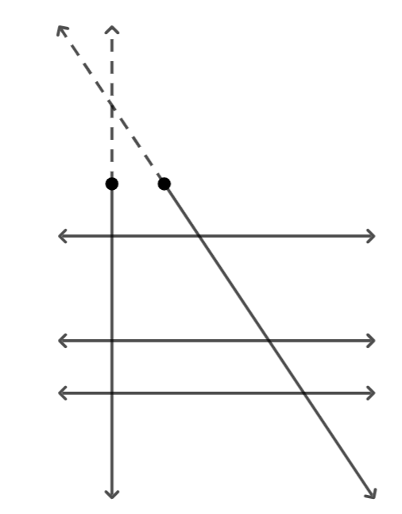
- For enrichment of this benchmark, instruction includes proving the Pythagorean Theorem, making the connection to triangle similarity (MA.912.GR.1.6).
- Given triangle $ABC$ with $m∠C=90˚$ and $h$, the height to the hypotenuse. $∆AHC\sim ∆CHB\sim ∆ACB$ can be proved using the Angle-Angle criterion. By the definition of similar triangles, $\frac{a}{c}=\frac{m}{a}$ (in $∆AHC\sim ∆ACB$) and $\frac{b}{c}=\frac{n}{b}$ (in $∆CHB\sim ∆ACB$). After applying the Multiplication Property of Equality, $a^{2}=cm$ and $b^{2}=cn$, after applying the Addition Property of Equality, $a^{2}+b^{2}=cm+cn$. By the Segment Addition Postulate, c = m + n, and by the Substitution Property of Equality $a^{2}+b^{2}=c^{2}$.
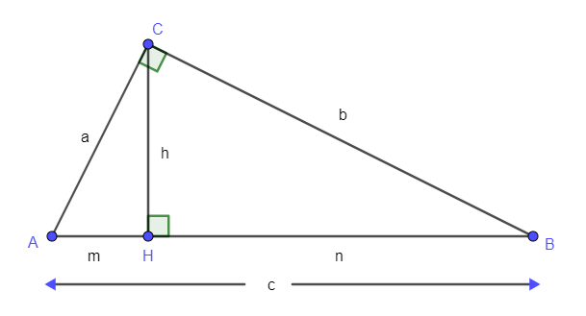

- Given a right triangle with side lengths $a$, $b$, and $c$, it is dilated three times with scale factors $a$, $b$, and $c$. Using the resulting similar right triangles, a rectangle can be formed where one pair of parallel sides measure $a^{2}+b^{2}$ and $c^{2}$. The opposite sides of a rectangle are congruent, so $a^{2}+b^{2}=c^{2}$.
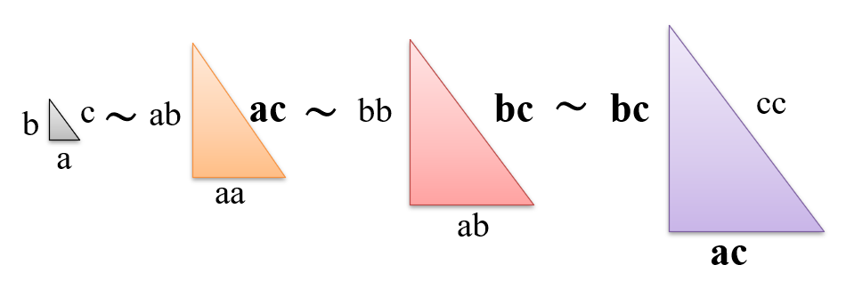
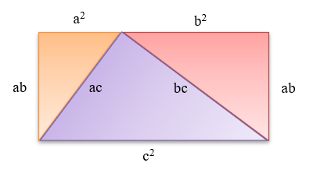

Common Misconceptions or Errors
- Students may set up a proportion incorrectly. If the proportion is $\frac{a}{b}=\frac{c}{d}$, a common mistake is to write $\frac{a}{b}=\frac{d}{c}$.
- Students may set up a proportion incorrectly when having two similar triangles with a common angle.
- For example, in the image it is true that $\frac{c}{g}=\frac{b}{h}$, but it is not that $\frac{c}{f}=\frac{g}{a}$.
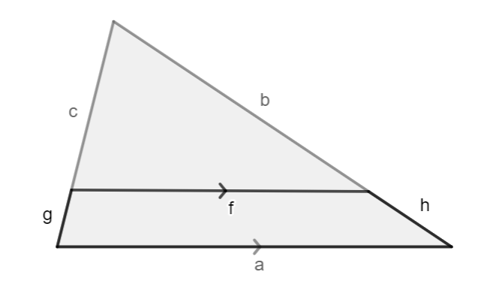

- Students may assume two polygons, with 4 sides or more, are congruent or similar when their sides are congruent or in proportion. This is not enough to prove congruence or similarity in polygons with 4 sides or more. It is also necessary to prove corresponding angles are congruent.
- For example, the following quadrilaterals have proportional sides, but they are not similar.
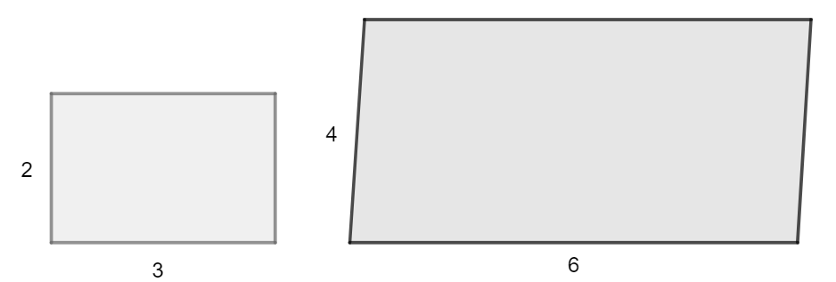

Strategies to Support Tiered Instruction
- Teacher models how to separate two similar triangles with a common angle to set up the proportions. When the triangles are separated, students should be able to identify the sides of the larger triangle using the Segment Addition Postulate.
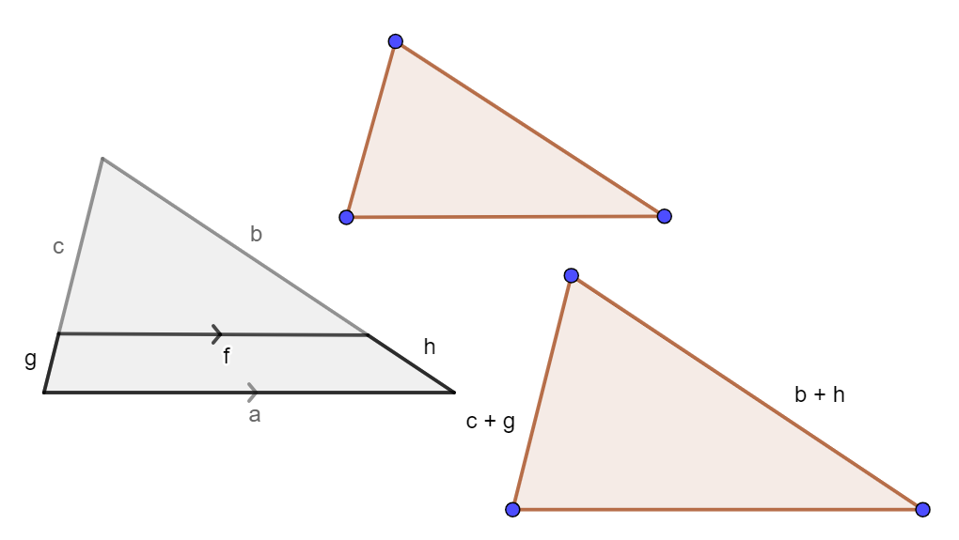

Instructional Tasks
Instructional Task 1 (MTR.7.1)
An artist rendering for the Hapbee Honey Company logo is on a 24” x 36” canvas. The company wants to use the logo on a postcard and is determining the size of the logo based on the different mailing costs. According to the United States Postal Service, mailing costs are determined using the following information.
 | Postcard Size | Price
 | First-Class Mail® Postcards  Maximum size: 6 inches long by 4.25 inches high by 0.016 inch thick | $0.40
 | First-Class Mail® Stamped Large Postcards  Maximum size: 11.5 inches long by 6.125 inches high by 0.25 inch thick | $0.58

Part A. What is the maximum length of the postcard if it is similar to the original rendering and falls within the First-Class Mail® Postcards dimensions?
Part B. What is the maximum width of the postcard if it is similar to the original rendering and falls within the First-Class Mail® Stamped Large Postcards dimensions?

Instructional Task 2 (MTR.3.1)
Polygons $ABCDE$ and $A’B’C’D’E’$ are similar and shown.
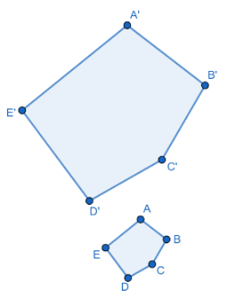
Part A. If $m∠A'=103°$, what is the measure of angle $A$?
Part B. If $m∠D=97°$, what other angle measures 97°?
Part C. Find the value of $x$ if $DC=2x+1.5$, $D'C'=5.1$ and $\frac{BC}{B'C'}=\frac{1}{3}$.

Instructional Task 3 (MTR.5.1)
Figure $ABCDEFG$ is similar to Figure $LKJIHFM$ since there is a dilation with a scale factor of $\frac{1}{2}$ that maps $ABCDEFG$ onto $LKJIHFM$. Assume that the measure of angle $B$ within Figure $ABCDEFG$ is 90°.
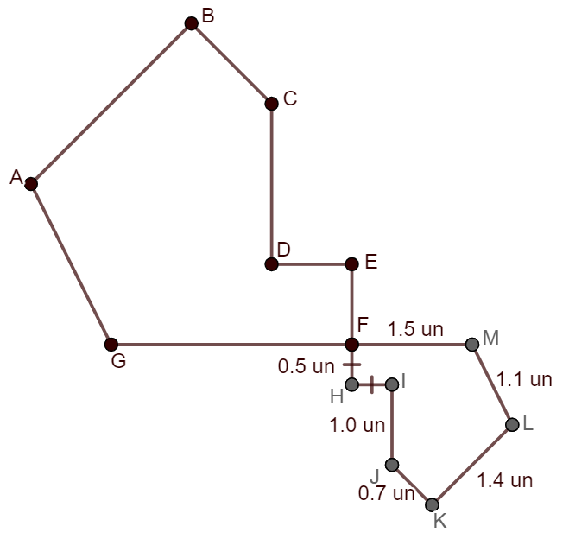
Part A. If point $F$ is located at the origin on a coordinate plane, line segments $EF$ and $CD$ are vertical, and line segments $GF$ and $DE$ are horizontal, determine possible coordinates of each of the points, except points $A$ and $B$, on Figure $ABCDEFG$.
Part B. What is the perimeter of Figure $ABCDEFG$?
Part C. What is the length of segment $DE$?
Part D. What is the perimeter of triangle $AGC$?

Instructional Items
Instructional Item 1
Triangles $ABC$ and $DEF$ are shown where $∠A≅∠D$, $∠C≅∠F$ and $\overline{AC}≅\overline{DF}$,
Part A. Determine whether the triangles are congruent.
Part B. If the triangles are congruent, find $EF$
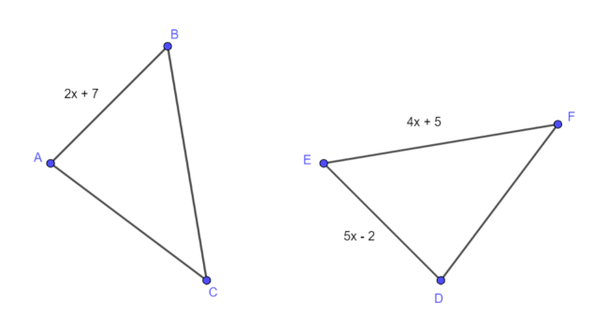

Instructional Item 2
If $∆ADE$ and $∆ABC$ are similar, what is the length of $\overline{AC}$?
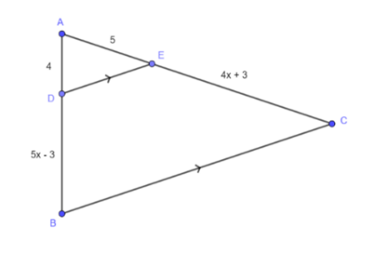

*The strategies, tasks and items included in the B1G-M are examples and should not be considered comprehensive.

MA.912.GR.2 Apply properties of transformations to describe congruence or similarity.

MA.912.GR.2.1

Benchmark
MA.912.GR.2.1 Given a preimage and image, describe the transformation and represent the transformation algebraically using coordinates.
Example: Given a triangle whose vertices have the coordinates $(-3, 4)$, $(2, 1.7)$ and $(-0.4, -3)$. If this triangle is reflected across the $y$-axis the transformation can be described using coordinates as $(x, y)→(-x, y)$ resulting in the image whose vertices have the coordinates $(3, 4)$, $(-2, 1.7)$ and $(0.4, -3)$.

Benchmark Clarifications:
Clarification 1: Instruction includes the connection of transformations to functions that take points in the plane as inputs and give other points in the plane as outputs.
Clarification 2: Transformations include translations, dilations, rotations and reflections described using words or using coordinates.
Clarification 3: Within the Geometry course, rotations are limited to 90°, 180° and 270° counterclockwise or clockwise about the center of rotation, and the centers of rotations and dilations are limited to the origin or a point on the figure.
Connecting Benchmarks/Horizontal Alignment
- MA.912.GR.3.2, MA.912.GR.3.3
- MA.912.GR.4.3
Terms from the K-12 Glossary
- Coordinate Plane
- Dilation
- Origin
- Reflection
- Rigid Transformation
- Rotation
- Scale Factor
- Translation

Vertical Alignment
Previous Benchmarks  - MA.8.GR.2.1  - MA.8.GR.2.2  - MA.8.GR.2.3  - MA.912.F.2.1 | Next Benchmarks  - MA.912.NSO.4  - MA.912.F.2.2, MA.912.F.2.3, MA.912.F.2.5  - MA.912.T.4

Purpose and Instructional Strategies
In Grade 8, students identified a single transformation given the preimage and the image, limited to reflections, translations, or rotations. Students also identified the scale factor given the preimage and the image of a dilation. In Algebra 1, students identified the effect on the graph of a function of replacing $f(x)$ with $f(x+k)$ and $f\left(x\right)+k$, corresponding to horizontal and vertical translations. In Geometry, students describe a transformation algebraically, using coordinates. In later courses, students will state the type of transformations and will find the values of real numbers that define the transformation.
- For the expectations of this benchmark, students should describe a transformation in words or algebraically using coordinates.
Common transformations are provided below.
  - Rotations
90° counterclockwise about the origin or $(x,y)→(-y,x)$
90° clockwise about the origin or $(x,y)→(y,-x)$
180° counterclockwise about the origin or $(x,y)→(-x,-y)$
180° clockwise about the origin or $(x,y)→(-x,-y)$
270° counterclockwise about the origin or $(x,y)→(y,-x)$
270° clockwise about the origin or $(x,y)→(-y,x)$
  - Reflections
Over the $x$-axis or $(x,y)→(x,-y$
Over the $y$-axi or $(x,y)→(-x,y)$
Over the line $y=x$ or $(x,y)→(y,x)$
Over the line $y=-x$ or $(x,y)→(-y,-x)$
  - Dilations
Dilation centered at the origin with scale factor $k$ or $(x,y)→(kx,ky)$
  - Translations
Horizontal translation by $h$ units or $(x,y)→(x+h,y)$
Vertical translation by $k$ units or $(x,y)→(x,y+k)$
Horizontal translation by $h$ units and vertical translation by $k$ units or $(x,y)→(x+h,y+k)$
- Students should develop the understanding of the mapping notation. In a function, the input is a number, $x$, and the output is another, $f(x)$. In a geometric transformation, the input is a point, $(x, y)$, and the output is another. This can be represented as $\left(x, y\right)→(x_{1}, y_{1})$. The values of $x_{1}$ and $y_{1}$ result from arithmetic operations applied to $x$ and $y$.
- For example, under the transformation $\left(x, y\right)→(-3y, x+y+2)$, the point $(-1, 2)$ has $(-6, 3)$ as its image.
- Instruction includes describing a transformation given the image of the preimage and the image and given the coordinates of the vertices of the preimage and the image.
  - For example, if the vertices of $∆ABC$ are $(4, -2)$, $(4, 5)$ and $(3, 3)$, respectively, and the vertices of $∆A'B'C'$ are $(8, -4)$, $(8, 10)$ and $(6, 6)$, respectively, the description of the transformation is a dilation centered at the origin with a scale factor of $3$ or $\left(x, y\right)→(2x, 2y)$.
- Instruction includes the use of hands-on manipulatives (e.g., patty paper) and geometric software for students to explore transformations.

- Instruction includes using a variety of ways to describe a transformation using coordinates. (MTR.2.1)
  - For example, $\left(x,y\right)→(x+2,y-4)$ could be represented with $T_{x, y}=(x+2, y-4)$ or $T_{〈2, -4〉}$, where $〈2, -4〉$ is a vector.
  - For example, $\left(x, y\right)→(x, -y)$ could be represented with $r_{x-axis}\left(x,y\right)=(x, -y)$.
  - For example, $\left(x, y\right)→(-y, x)$ could be represented with $R_{O,90˚}(x, y)=(-y, x)$, where $O$ is the origin.
- Instruction includes describing reflections over vertical and horizontal lines different than the axes.
- For example, the transformation that maps the given preimage to the given image can be described in words as a reflection over $x=2$. To describe the transformation algebraically, it is necessary to translate the reflection until the axis of the reflection coincides with the $y-$axis, then apply a reflection over the y-axis and translate the reflection back to its original place. Let $(x, y)$ be the coordinates of any point of the preimage. $\left(x, y\right)→\left(x-2, y\right)→\left(-x+2, y\right)→\left(-x+2+2, y\right)$. Then, this transformation can be described algebraically as $\left(x, y\right)→(-x+4, y)$.
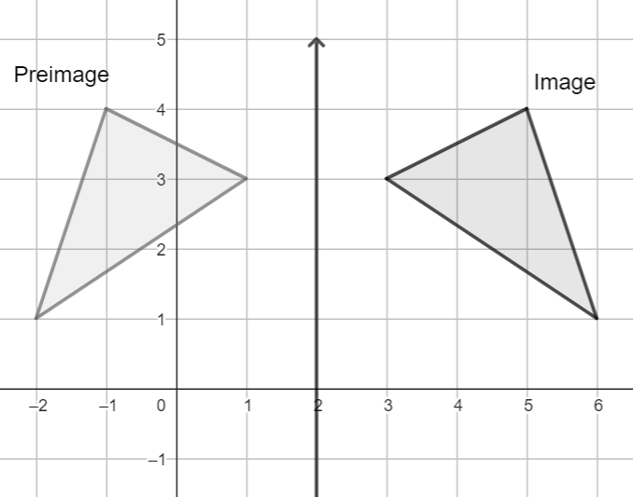

- For expectations of this benchmark in the clarifications, rotations and dilations can be centered at a point on the figure.
- For example, the transformation that maps the given preimage to the given image can be described in words as a $90°$ rotation counterclockwise around the point $\left(2, 2\right)$. To describe the transformation algebraically, it is necessary to translate the rotation until the center of the rotation coincides with the origin, then apply a $90°$ rotation clockwise around the origin and translate the rotation back to its original place. Let $(x, y)$ be the coordinates of any point of the preimage. $\left(x, y\right)→\left(x-2, y-2\right)→\left(2-y, x-2\right)→(2-y+2, x-2+2)$. Then, this transformation can be described algebraically as $\left(x, y\right)→(4-y, x)$.
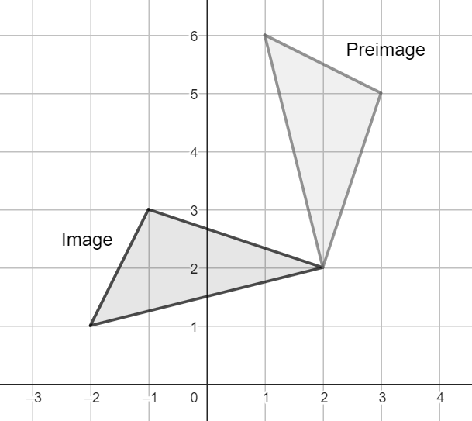
- Instruction includes making the connection between the distances from the center of the dilation to the vertices of the preimage and the image with the scale factor. When the dilation is centered at the origin, the distance from the origin to $A'$ is twice the distance from the origin to $A$, since the scale factor of the dilation is $2$. When the dilation is centered at $A$, the distance from $A$ to $B'$ is twice the distance from $A$ to $B$, since the scale factor of the dilation is $2$.
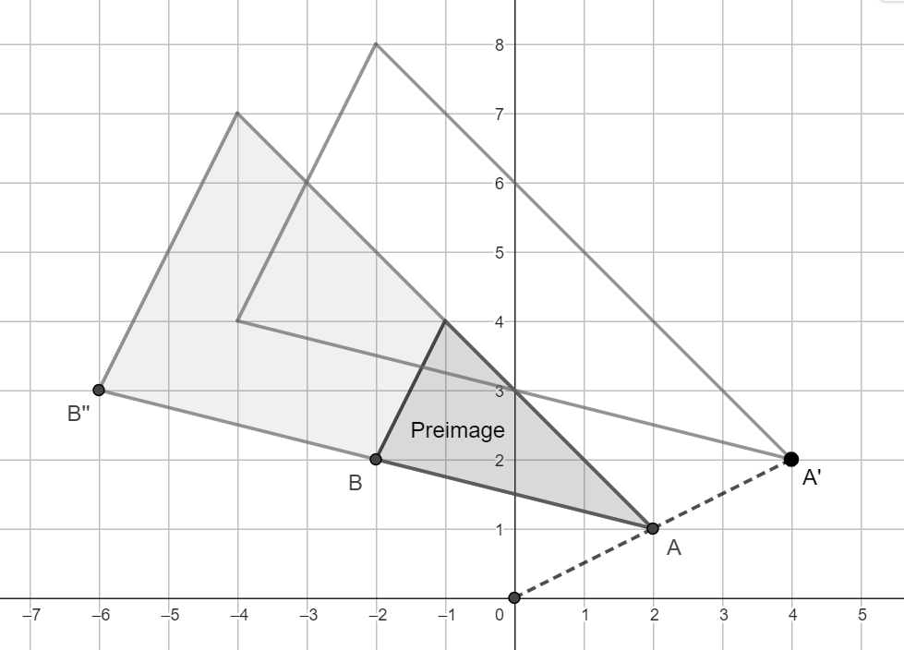

Common Misconceptions or Errors
- Students may assume that in a rotation about a point, a figure turns around like a gondola on a Ferris Wheel, instead of changing its orientation along the rotation.
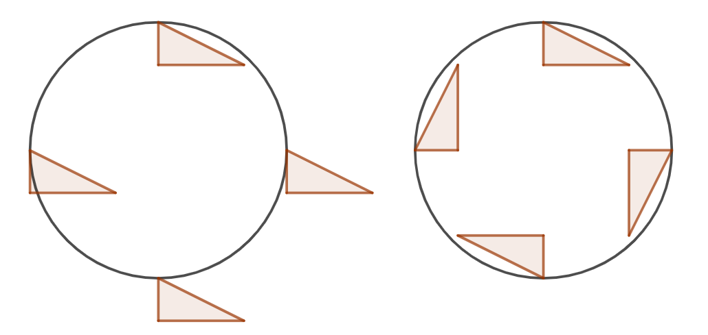
- Students may misidentify the direction of a rotation given the words clockwise and counterclockwise.

Strategies to Support Tiered Instruction
- Teacher models with patty paper rotations and reflections. Rotations can be modeled tracing the preimage, overlapping the polygon on the patty paper to the one on the coordinate plane, and then using a pencil or a pen to put pressure on the origin, rotating the patty paper. Reflections can be modeled tracing the preimage and the axis of reflection, flipping the patty paper with the axis of symmetry overlapping the one on the coordinate plane.
- Students should develop the understanding that the preimage and the image are at the same distance to the axis of symmetry. It helps to verify one vertex at a time that the one in the preimage and its corresponding vertex on the image are at the same distance to the axis of symmetry.
- Instruction makes the connection to the slope criterion for perpendicular lines. If a line is drawn passing through a vertex of the preimage and the center of the rotation, its slope can be used to draw a line perpendicular to the first and passing through the center of the rotation. The images resulting from rotating the vertex in multiples of $90°$ lie on one of the lines.
- Teacher models how to use coordinate notation starting with symbols.
- For example, if $\left(∆, ∎\right)→(-3∎, 2+∆)$, then $\left(2, -1\right)→(3, 4)$.
- Instruction includes the exploration of the effect of changing the sign and the order of the coordinates of a given point.
- For example, given $(-2, 3)$, the point $\left(2, -3\right)$ is the reflection over the $y-$axis and the point $(-3, -2)$ is the $90°$ rotation about the origin counterclockwise.
- Instruction includes using dynamic geometry software to allow students hands-on experiences and flexibility in exploration.

Instructional Tasks
Instructional Task 1 (MTR.3.1)
Use the image below to answer the following questions.
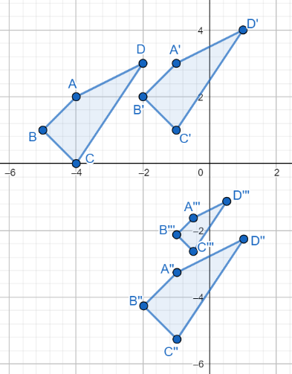

Part A. Describe the transformation that maps $ABCD$ onto $A’B’C’D’$.
Part B. Represent the transformation described in Part A algebraically.
Part C. Represent the transformation needed to map $A’’B’’C’’D’’$ onto $ABCD$ algebraically.
Part D. Describe the transformation that maps $A’’B’’C’’D’’$ onto $A’’’B’’’C’’’D’’’$.
Part E. How is the transformation described in Part D related to the transformation needed to map $A’’’B’’’C’’’D’’’$onto $A’’B’’C’’D’’$?

Instructional Task 2 (MTR.5.1)
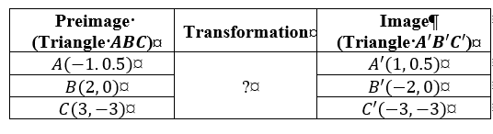
Part A. Ask students to plot $A$, $B$ and $C$ and $A'$, $B'$ and $C'$on the coordinate plane. What do you notice?
Part B. How can you describe this transformation using words? Explore the patterns among the coordinates of the vertices of the preimage and the image.
Part C. How can you describe the transformation algebraically (using coordinate notation)?

Instructional Items
Instructional Item 1
A triangle whose vertices are located at $\left(\frac{2}{7},-1\right)$, $\left(-4,-\frac{14}{5}\right)$ and $(3,1)$ is shifted to the right 2 units.
Part A. What are the coordinates of the triangle after the translation?
Part B. Describe the transformation that would map the preimage to the image algebraically.

Instructional Item 2
Describe the transformations mapping polygon $A$ onto polygon $B$ and polygon $C$ onto polygon $B$.

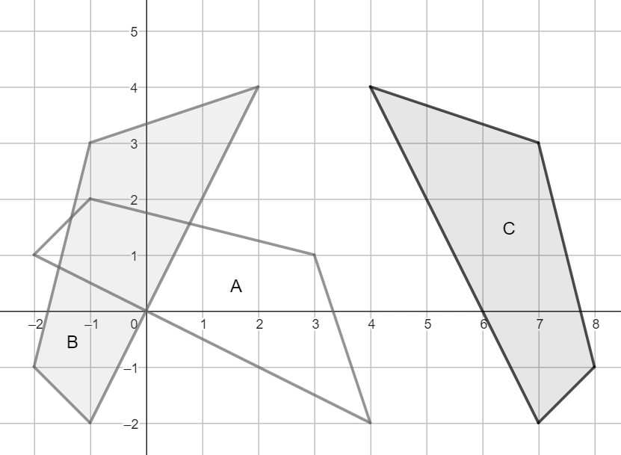

Instructional Task 3

A single rotation mapped quadrilateral $ABCD$ onto quadrilateral $A’B’C’D’$.
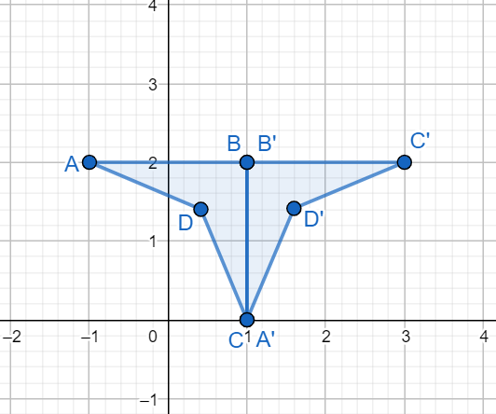

Part A. What is the center of the rotation?
Part B. If the rotation is counterclockwise, what is the measure of the angle of rotation?
Part C. Can you identify another transformation that maps quadrilateral $ABCD$ onto quadrilateral $A’B’C’D’$? If so, describe the transformation.
*The strategies, tasks and items included in the B1G-M are examples and should not be considered comprehensive.

MA.912.GR.2.2

Benchmark
MA.912.GR.2.2 Identify transformations that do or do not preserve distance.
Benchmark Clarifications:
Clarification 1: Transformations include translations, dilations, rotations and reflections described using words or using coordinates.
Clarification 2: Instruction includes recognizing that these transformations preserve angle measure.

Connecting Benchmarks/Horizontal Alignment
- MA.912.GR.1.2, MA.912.GR.1.6
- MA.912.GR.3.2, MA.912.GR.3.3
Terms from the K-12 Glossary
- Coordinate Plane
- Dilation
- Origin
- Reflection
- Rigid Transformation
- Rotation
- Scale Factor
- Translation

Vertical Alignment
Previous Benchmarks  - MA.8.GR.2 | Next Benchmarks  - MA.912.F.2.2, MA.912.F.2.3, MA.912.F.2.5
Purpose and Instructional Strategies
In grade 8, students identified a single transformation given the preimage and the image, and instruction focused on the preservation of congruence when the transformation is a reflection, a translation, or a rotation. Students also identified the scale factor of a dilation given the preimage and the image, and instruction focused on the lack of preservation of congruence unless the scale factor is $1$. In Geometry, students determine which transformations preserve distance (rigid transformations, or rigid motions) and which do not (non-rigid transformations, or non-rigid motions). Later in this course, students will define congruence and similarity in terms of the transformations they can identify mapping one figure onto another.
- Instruction includes the comparison of a variety of geometric figures before and after a single transformation (including reflections, translations, rotations, and dilations) to solidify that each of these transformations preserves angle measure. (MTR.4.1)

- Students should develop the understanding that when a transformation is described as rigid, distances and angle measures are preserved. These transformations are called rigid motions. When a transformation is described as non-rigid, distances and angle measures are not necessarily preserved. Dilations are non-rigid motions that preserve angle measures.
- Students should develop the understanding that when a transformation preserves distances, it also preserves angle measures, but a transformation can preserve angle measures and not distances. In the first case, the preimage and the image are congruent; in the second, the preimage and the image are similar. This understanding should come from the exploration of a collection of reflections, translations, rotations, and dilations, and the use of tools to compare distances and angles measures (e.g., ruler and protractor). It should not come from just recalling that reflections, translations, and rotations are rigid, and dilations are not.
- Students should develop the understanding that a transformation based on stretching and shrinking one dimension will not preserve angle measures. When a transformation is a dilation, angle measures are preserved. In this case, the scale factor is stretching or shrinking two dimensions.
  - For example, the transformation $\left(x,y\right)→(2.5x,2.5y)$ preserves angle measure, but the transformation $\left(x,y\right)→(2.5x,3.5y)$ does not.
- Instruction includes describing transformations using words and using coordinates.
- Instruction includes the use of folding paper (e.g., patty paper) to verify whether distances and angle measures are preserved. It also includes dynamic geometry software to students to explore the effect of a variety of transformations on the side lengths and the angle measures of the transformed polygon.

Common Misconceptions or Errors
- Students may incorrectly assume that dilations change angle measures.
- Students may assume that a dilation can occur in just one dimension, or that a dilation can stretch or compress a polygon vertically or horizontally. This misunderstanding could be related to the transformations of functions learned in Algebra 1.
Strategies to Support Tiered Instruction
- Teacher models how to verify if distances and/or angle measures were preserved after a transformation using translucent paper. If the image is transferred to the translucent paper, and using motions like shifting, turning over, and flipping, the drawing coincides with the preimage, it is proved the distances and the angle measures were preserved.
- Teacher models how to use tools such as protractors and rulers to measure angles and side lengths in the pre-image and the image and determined if angle measures and distances were preserved. A compass can be used too to verify whether the sides of two polygons have the same measure.
- Teacher models how a protractor or translucent paper can be used to compare angles and determine whether they have the same measure.
- Instruction includes opportunities for students to do their own exploration using the methods modeled by the teacher.

Instructional Tasks
Instructional Task 1 (MTR.4.1)
Penelope made the following statement in Geometry class, “Figure A is a rotation of Figure B about the origin.” Chalita disagreed because distance and angle measures are not preserved between the two figures.
- Figure A has its vertices at $(1,-1)$, $(3,-1)$ and $(1,-2)$.
- Figure B has its vertices at $(1, 1)$, $(1, 3)$ and $(2, 1)$.
Part A. What does “distance and angle measures are not preserved” mean?
Part B. Determine whether angle measures were preserved from Figure A to Figure B.
Part C. Determine whether distances were preserved from Figure A to Figure B.
Part D. Based on your answers from Part B and Part C, determine which student is correct.

Instructional Task 2 (MTR.3.1)
Sort the following transformations into two categories: transformations that preserve distance and angle measures and transformations that do not preserve distance, but preserve angle measures.
A $90°$ counterclockwise rotation about the origin. | A translation that moves a figure to the right and up. | A reflection over the line $x=0$.
A dilation centered at the origin with a scale factor of $\frac{1}{2}$. | A clockwise rotation about the point $(2, -1)$. | A translation that moves a figure to the left and up.
A translation that moves a figure from quadrant I to quadrant III. | A dilation centered at $(1, 1)$ with a scale factor of $3$. | A reflection over the $x$-axis.

Instructional Items
Instructional Item 1
Circle the transformations that can be used when it is important to preserve angle measure.

Horizontal Translations | Reflections | Clockwise Rotations
Dilations | Vertical Translations | Counterclockwise Rotations

Instructional Item 2
Circle the transformations that can be used when it is important to preserve distance.
Horizontal Translations | Reflections | Clockwise Rotations
Dilations | Vertical Translations | Counterclockwise Rotations
Instructional Item 3
Describe a transformation that preserves angle measures but does not preserve distance.
*The strategies, tasks and items included in the B1G-M are examples and should not be considered comprehensive.

MA.912.GR.2.3

Benchmark
MA.912.GR.2.3 Identify a sequence of transformations that will map a given figure onto itself or onto another congruent or similar figure.
Benchmark Clarifications:
Clarification 1: Transformations include translations, dilations, rotations and reflections described using words or using coordinates.
Clarification 2: Within the Geometry course, figures are limited to triangles and quadrilaterals and rotations are limited to 90°, 180°and 270°counterclockwise or clockwise about the center of rotation.
Clarification 3: Instruction includes the understanding that when a figure is mapped onto itself using a reflection, it occurs over a line of symmetry.
Connecting Benchmarks/Horizontal Alignment
- MA.912.GR.1.2
- MA.912.GR.1.6
Terms from the K-12 Glossary
- Coordinate Plane
- Dilation
- Origin
- Reflection
- Rigid Transformation
- Rotation
- Scale Factor
- Translation
Vertical Alignment
Previous Benchmarks  - MA.3.GR.1.3  - MA.8.GR.2 | Next Benchmarks  - MA.912.AR.6.6  - MA.912.T.3.3

Purpose and Instructional Strategies
In Grade 2, students identified lines of symmetry and in Grade 3, drew the lines of symmetry of two-dimensional figures. In Algebra 1, students interpreted key features in the graphs of absolute value functions and quadratic functions, including symmetry. In Geometry, students use their knowledge on translations, dilations, rotations, and reflections to identify a sequence or composition of transformations that maps a triangle or a quadrilateral onto another congruent or similar figure or onto itself. Students make connections between the lines of symmetry of two-dimensional figures and the reflection of those figures over their lines of symmetry. In later courses, the notion of symmetry is used to identify key features in the graphs of polynomials and trigonometric functions.

- Students should have developed skills on describing a single transformation (MA.912.GR.2.1) to progress to describe a sequence of transformations, using words or using coordinates.
- Instruction includes describing the transformations in a composition including vertical and horizontal shifts for translations; the center, the direction (clockwise or counterclockwise) and the angle for rotations; the equation of the line of reflection for reflections; and the center and the scale factor for dilations. (MTR.3.1)
- Instruction includes providing multiple opportunities for students to explore how to map triangles and quadrilaterals using sequences of two or three transformations onto congruent or similar triangles and quadrilaterals using manipulatives (e.g., transparencies or patty paper) and dynamic geometry software.
- Instruction includes exploring sequences of transformations given the preimage and the image mapping a figure onto another considering one vertex at a time.
- For example, given two triangles, start with a translation to map $A$ onto $A'$, then a rotation to map $B$ onto $B'$, and then a reflection to map $C$ onto $C'$.

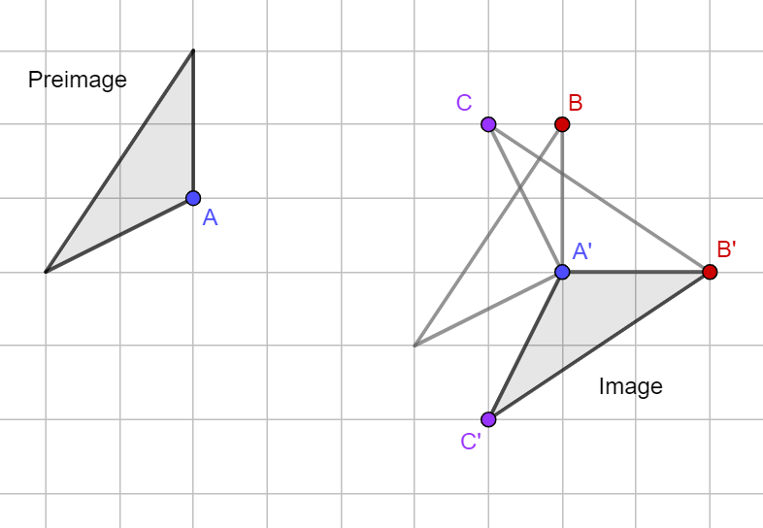

- Students should develop the understanding that there is more than one sequence of transformations that can map a figure onto another or onto itself. Students should also verify that a composition of transformations is not commutative. (MTR.2.1)
- For example, a reflection over the $y-$axis maps triangle $A$ onto triangle $B$ and a translation 2 units to the left and 3 units down maps triangle $B$ onto triangle $C$. Using the same transformations, a translations 2 units to the left and 3 units down maps triangle $A$ onto triangle $D$, and a reflection over the $y-$axis maps triangle $D$ onto triangle $E$.
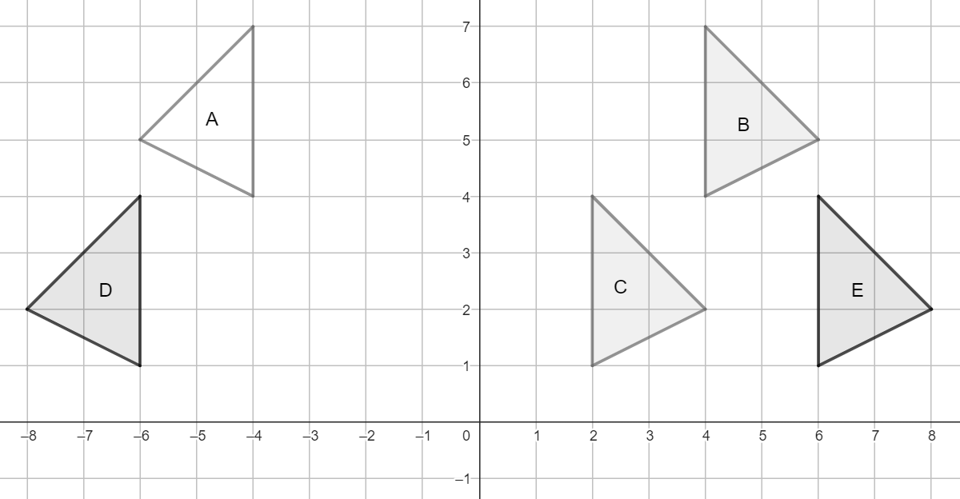
- Instruction includes identifying a sequence of transformations when the given preimage and image partially overlap each other.
- Instruction includes exploring a sequence of two transformations including a reflection over the $x$-axis and a reflection over the $y$-axis (or any sequence of two reflections over axes perpendicular to each other). Students should develop the understanding that two consecutive reflections over perpendicular axes produces the same image that a $180°$ rotation about the point of intersection of the lines. (MTR.5.1)
- For example, given triangle $A$, its image after two consecutive reflections over lines $m$ and $n$ is triangle $B$. The image of triangle A after a $180°$ rotation about $(-1, 2)$ is also triangle $B$.
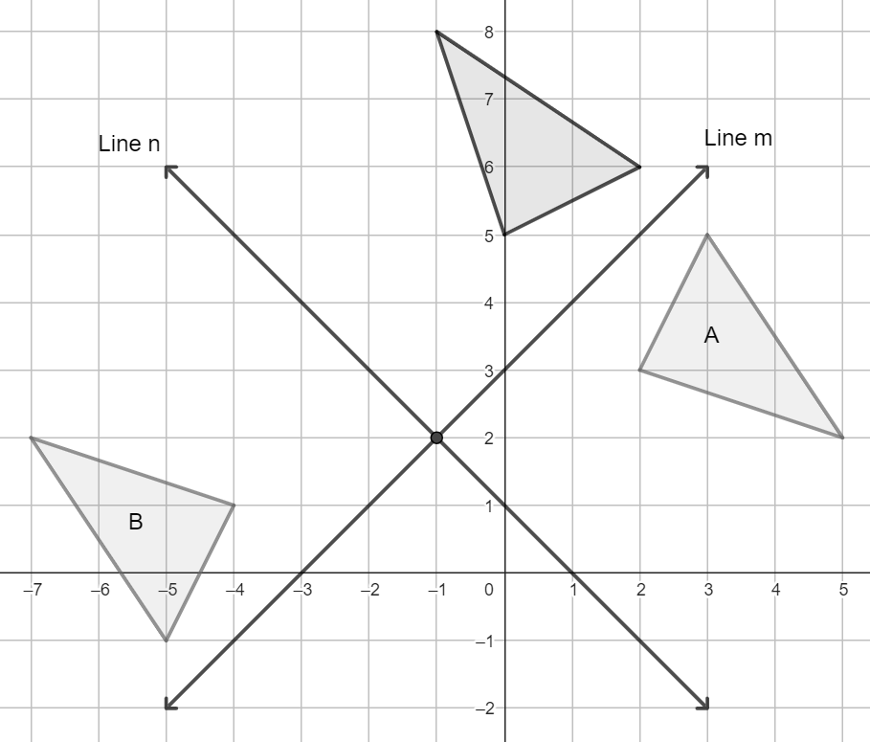
- Students should develop the understanding of which transformations could be used to map a figure onto itself. After exploring the effect of each transformation, students should identify reflections and rotations as those transformations. Using two translations, $360°$ rotations (including rotations about a vertex of the preimage), and dilations with a scale factor of $1$ are considered trivial cases.
- Instruction includes the consideration that when a reflection maps a figure onto itself, the line of reflection is also a line of symmetry of the preimage. Among the two-dimensional figures with at least one line of symmetry, students should explore isosceles and equilateral triangles, and rectangles, rhombi, squares, isosceles trapezoids, and kites.
- Instruction includes the consideration that when a rotation maps a figure onto itself, the center of the rotation is the point of concurrency of the angle bisectors of the interior angles, and the angle of the rotation that maps the figure onto itself the first time is equivalent to $360°$ divided by the number of sides (multiples of these angles will also map the figure onto itself). Students should explore equilateral triangles and squares. Students should also explore rectangles and rhombi to verify they can be mapped onto themselves with a $180°$ rotation about the point of concurrency of the angle bisectors of the interior angles.
- For enrichment of this benchmark, students should explore the reflections and rotations that map regular polygons onto themselves (e.g., regular pentagons, regular hexagons). (MTR.5.1)

Common Misconceptions or Errors
- Students may believe there is only one sequence of transformations that maps a figure onto another.
- Students may assume that compositions of transformations are commutative, that is, that order does not matter when mapping a figure onto another using a sequence of transformations.

Strategies to Support Tiered Instruction
- Instruction includes opportunities for students to practice how to describe single transformations given the preimage and the image using words and using coordinates, before attempting to identify a sequence of transformations.
- Instruction includes selecting the sequence of transformation that maps a figure onto another from a given list, progressing to select each transformation in the sequence from a given list.

- Teacher models that it may be helpful to identify the dilation first, when a sequence maps a preimage onto a similar image, and then continue with the needed rigid motions.
- For example, to identify the sequence of transformations that maps triangle $A$ onto triangle $B$, the teacher can model how to transform triangle $A$ with a dilation centered at the origin with a scale factor 2, and then continue with a $90°$ rotation counterclockwise about the origin to map triangle $A$ onto triangle $B$. Students should verify the results of rotating triangle $A$ first, and the continue with the dilation, with the consideration that a composition of transformations in not necessarily commutative.
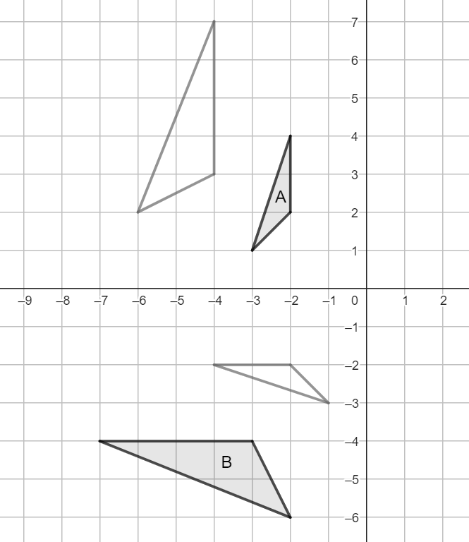

- Instruction includes exploring multiple sequences of transformation that can map a given preimage onto a given preimage and considering the conveniences of using each sequence. Students should explore these compositions using manipulatives (e.g., patty paper) or dynamic geometry software.

Instructional Tasks
Instructional Task 1 (MTR.2.1)

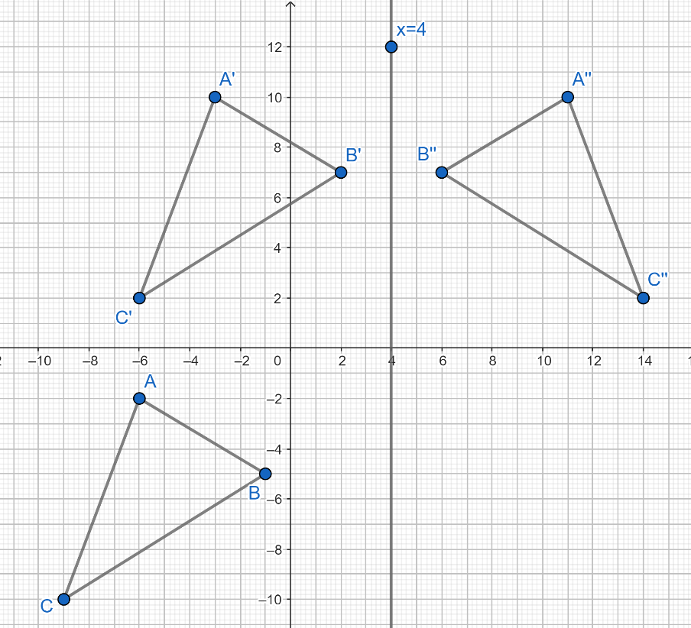

Part A. Describe the transformation that maps $∆ABC$ onto $∆A'B'C'$.
Part B. Describe the transformation that maps $∆A'B'C'$ onto $∆A''B''C''$.
Part C. From the list provided below, choose and order a sequence of two or three transformations that could be used to map $∆ABC$ onto $∆A''B''C''$.

A vertical translation $12$ units up and a horizontal translation $3$ units to the right | A $270°$ rotation counterclockwise about point $D$
A $90°$ rotation counterclockwise about the origin | A reflect over $x =4$
A reflect over $y=x+4$ | A vertical translation$3$ units down and a horizontal translation $12$ units to the left

Instructional Task 2
A single rotation could map quadrilateral $ABCD$ onto quadrilateral $A’B’C’D’$.

Part A. Describe, using words and using coordinates, at least two sequences of two or three transformations that could map quadrilateral $ABCD$ onto quadrilateral $A’B’C’D’$. (A sequence of two transformation where the second annuls the first is not allowed, e.g., a translation 3 units up, followed by a translation 3 units down).

Instructional Task 3
Describe the transformations that could map each of the following polygons onto itself. Add the line of reflection, the center of the rotation, and the angle of the rotation, when needed.

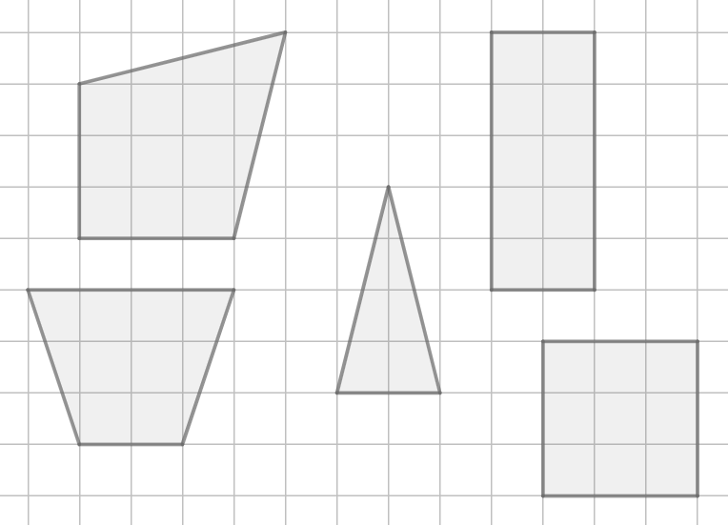

Instructional Items
Instructional Item 1
A sequence of transformations mapped the triangle with vertices at $C\left(-6,-2\right)$, $A\left(-1,-5\right)$, and $P(-9,-10)$ onto the triangle with vertices at $C''(11, 10)$, $A''(6, 7)$, and $P''(14, 2)$.
List the transformations that mapped triangle $CAP$onto $C''A''P''$.

Instructional Item 2
A sequence of transformations mapped quadrilateral $WINS$onto triangle quadrilateral $W'''I'''N'''S'''$.

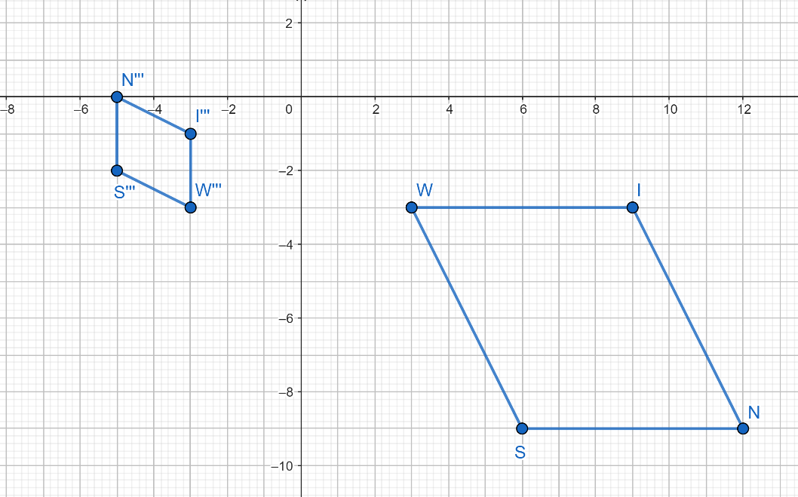

Describe a sequence of transformations that maps triangle $WINS$onto $W^{'''}I^{'''}N^{''}'S^{'''}$ algebraically using coordinates.
*The strategies, tasks and items included in the B1G-M are examples and should not be considered comprehensive.

MA.912.GR.2.4
Benchmark
MA.912.GR.2.4 Determine symmetries of reflection, symmetries of rotation and symmetries of translation of a geometric figure.
Benchmark Clarifications:
Clarification 1: Instruction includes determining the order of each symmetry.
Clarification 2: Instruction includes the connection between tessellations of the plane and symmetries of translations.
Connecting Benchmarks/Horizontal Alignment
- MA.912.GR.1.1, MA.912.GR.1.3, MA.912.GR.1.5

Terms from the K-12 Glossary
- Coordinate Plane
- Line of Symmetry
- Reflection
- Rotation
- Translation

Vertical Alignment
Previous Benchmarks  - MA.3.GR.1.3 | Next Benchmarks  - MA.912.AR.6.6  - MA.912.T.3
Purpose and Instructional Strategies
In Grades 2 and 3, students identified lines of symmetry. In Geometry, students explore other types of symmetries related to mapping a polygon onto itself using reflections and rotations (MA.912.GR.2.3). In later courses, students will learn that line symmetry and point symmetry are closely related to even and odd functions.
- Instruction includes multiple opportunities for students to explore line symmetry and point symmetry using manipulatives (e.g., reflective devices or patty paper) and dynamic geometry software.
- Instruction includes using a variety of two-dimensional figures to explore symmetries of reflection, rotation, and translation. It also includes determining the order of each symmetry.
- Students should develop the understanding that the order of a symmetry of translation is infinite because no matter how many times one applies it, no point gets mapped onto itself.
- Instruction includes activities for students to explore tessellations.
- For enrichment of this benchmark, students should explore remarkable tessellations with two polygons (e.g., the Penrose Tiling) and with one polygon (e.g., “the hat”). (MTR.5.1)

Common Misconceptions or Errors
  - Students may assume that the order of a translational symmetry is not infinite when observing a finite pattern (e.g., a sheet of wallpaper, the tiling of a wall).

Strategies to Support Tiered Instruction
- Instruction includes cutouts of triangles and quadrilaterals that students can manipulate to fold and turn around to identify line symmetry and point symmetry. These cutouts can be used to determine the order of each symmetry.
- Teacher facilitates activities where students can tessellate rectangles using cutouts of triangles and quadrilaterals.
- Teacher models how to use a protractor to determine the order of rotational symmetry of a given two-dimensional figure.

Instructional Tasks
Instructional Task 1 (MTR.5.1)
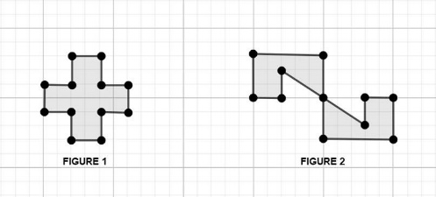

Part A. Draw the lines of symmetry of each figure.
Part B. What is the order of each symmetry of FIGURE 1? How is the order of each symmetry determined?

Part C. Identify the symmetries of FIGURE 2 and determine the order of each symmetry.

Instructional Task 2



Part A. What types of symmetry are displayed on the given image?
Part B. Identify the lines of reflectional symmetry on the given image.
Part C. What is the order of each symmetry of the given image?

Instructional Task 3
To tesselate the plane, you can only use the two figures in the image below. Add, at least, 6 more figures to the grid. Describe the symmetries of each figure and the order of each symmetry. What is the order of the translational symmetry is instead of a rectangle you must tesselate a plane?

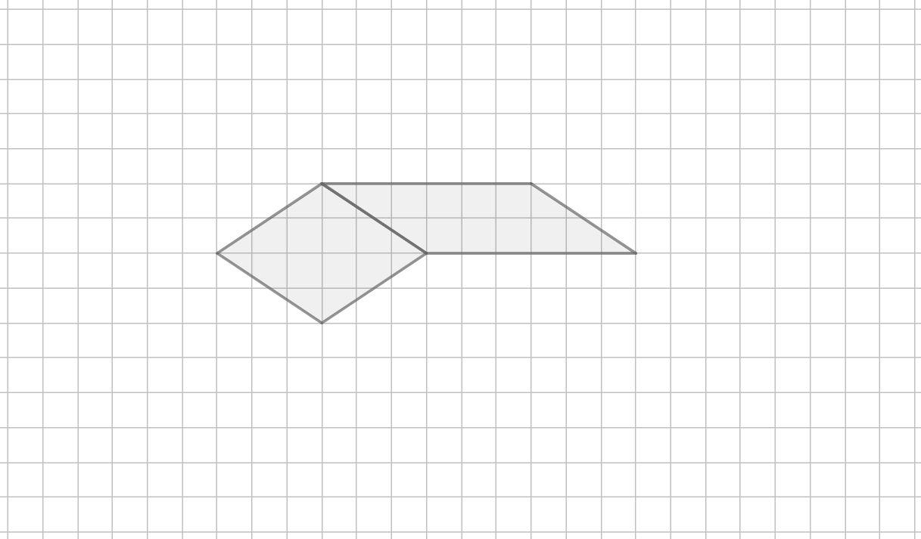

Instructional Items
Instructional Item 1
Describe the symmetry of translation in the image below if the pattern continues infinitely in both directions.
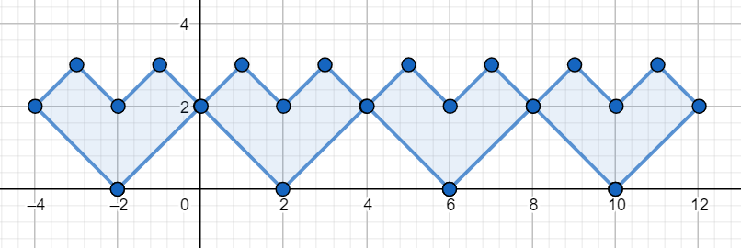

Instructional Item 2
Identify the symmetries and determine the order of each symmetry of the figure in the image below.
Consider that the image is the result of attaching both octagons.

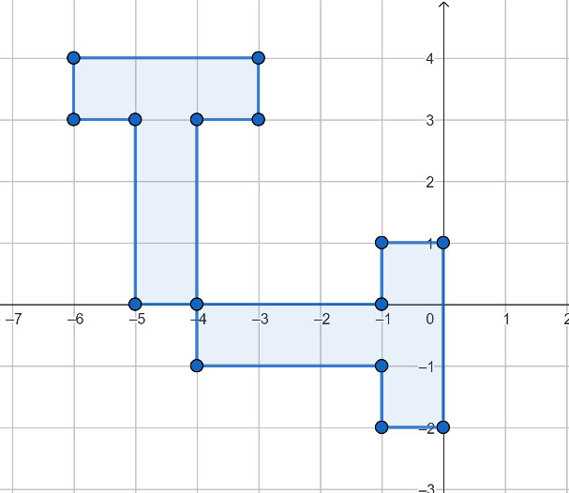

*The strategies, tasks and items included in the B1G-M are examples and should not be considered comprehensive.

MA.912.GR.2.5
Benchmark
MA.912.GR.2.5 Given a geometric figure and a sequence of transformations, draw the transformed figure on a coordinate plane.
Benchmark Clarifications:
Clarification 1: Transformations include translations, dilations, rotations and reflections described using words or using coordinates.
Clarification 2: Instruction includes two or more transformations.
Connecting Benchmarks/Horizontal Alignment
- MA.912.GR.3.2, MA.912.GR.3.3
- MA.912.GR.4.3
Terms from the K-12 Glossary
- Coordinate Plane
- Dilation
- Origin
- Reflection
- Rigid Transformation
- Rotation
- Scale Factor
- Translation

Vertical Alignment
Previous Benchmarks  - MA.8.GR.2.1, MA.8.GR.2.2, MA.8.GR.2.3  - MA.912.F.2.1 | Next Benchmarks  - MA.7.AR.2.2 MA.912.NSO.4  - MA.912.F.2.2, MA.912.F.2.3, MA.912.F.2.5  - MA.912.T.4
Purpose and Instructional Strategies
In grade 8, students learned about the effect of a single transformation (translation, rotation, reflection, and dilations) on two-dimensional figures on the coordinate plane. In Geometry, students learn the effect of applying two or more transformations on two-dimensional figures on the coordinate plane. Students draw the image of the composition given the preimage. In later courses, students will learn the effect of more than one transformation applied to functions.
- For the expectations of this benchmark, students produce an image on the coordinate plane as the result of a composition of transformations including translations, dilations, rotations, and reflections. Students should be able to list the coordinates of the vertices of the image and draw the image on the coordinate plane
- Instruction includes sequences of transformations described using words and using coordinates.
- Instruction includes the understanding that a sequence of transformations described algebraically can be rewritten as a single transformation.
  - For example, the sequence of transformations including a translation 1 unit to the left, followed a $90°$ rotation clockwise about the origin, and then a translation 1 unit to the right can de represented algebraically as $\left(x,y\right)→\left(x-1,y\right)$, followed by $\left(x, y\right)→\left(y, -x\right)$, and then $\left(x, y\right)→\left(x+1, y\right)$. The result is the same as rotating the preimage $90°$ clockwise about the point $\left(1,0\right)$, that is, $\left(x, y\right)→\left(x-1, y\right)→\left(y,-\left(x-1\right)\right)→\left(y+1, -\left(x-1\right)\right)$. So, this sequence of transformations is equivalent to $\left(x, y\right)→(y+1, 1-x)$.
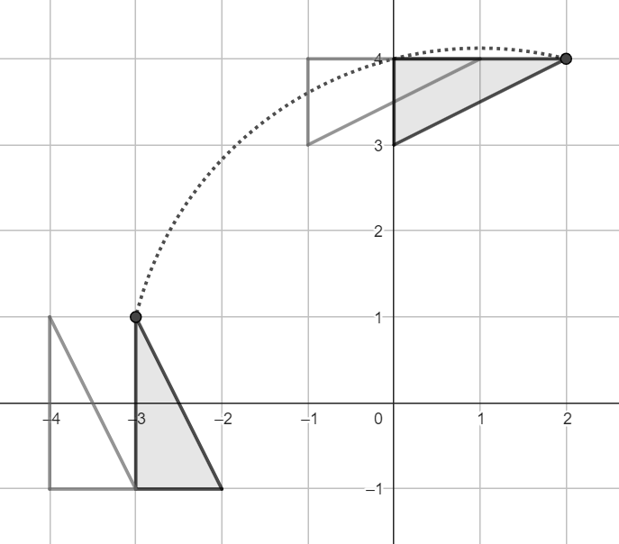

- Instruction includes exploring the resulting images given one preimage and a set of transformations, applied to the preimage in different orders. Students should develop the understanding that compositions of transformations are not commutative. There could be exceptions.
  - For example, if the transformation is the result of a vertical and a horizontal translation, the sequence is commutative; if the transformation is the result of a $180°$ rotation and a reflection over the $x$-axis, the sequence is commutative; but if the transformation is the result of a $90°$ rotation and a reflection over the $x$-axis, the sequence is not commutative.

Common Misconceptions or Errors
- Students may assume the order of the transformations in a sequence does not matter.

Strategies to Support Tiered Instruction
- Instruction includes opportunities for students to practice drawing the image of a single transformation.
- Teacher models single transformations that can be more challenging to the students (e.g., rotations).
- Instruction includes the use of dynamic geometry software to study sequences of transformations. In this exploration, students can compare the resulting images if the order of the transformations in the sequence is changed.
- Instruction includes selecting the image of a sequence of transformations form a given list. Students should develop the skill of visualizing the resulting image, at least as a sketch.

Instructional Tasks
Instructional Task 1 (MTR.3.1, MTR.5.1)
Part A. On the coordinate plane, draw the resulting image after transforming quadrilateral $ABCD$ using the following sequence.
- Reflect quadrilateral $ABCD$ over the line $y=x$
- $(x,y)→(x+3, y-2)$

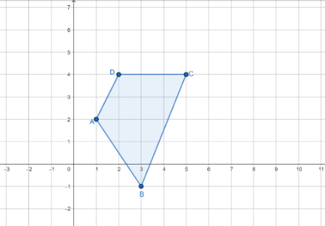

Part B. Would the resulting figure be the same if the order of the transformations were changes? If so, draw the image of the new sequence.

Instructional Task 2
Part A. On the coordinate plane, draw the resulting image after transforming triangle $MNO$ using the following sequence.
- Dilate triangle $MON$ using a scale factor of $k=\frac{1}{2}$
- Rotate 90˚ counterclockwise about the origin

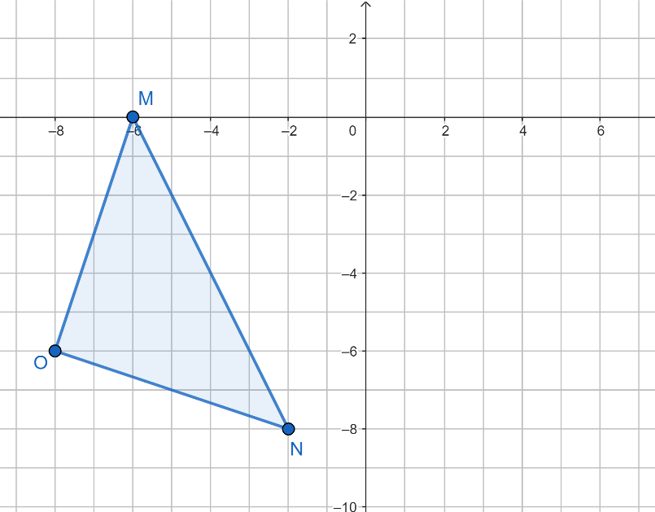

Part B. Describe a different sequence of transformations that would produce the same image than the given sequence (part A).

Instructional Items
Instructional Item 1
Perform the following sequence of transformations on the polygon $ABCDEF$ on the given coordinate plane.
- Rotate 180˚ counterclockwise about the origin
- Translate horizontally 2 units to the left and vertically 3 units down

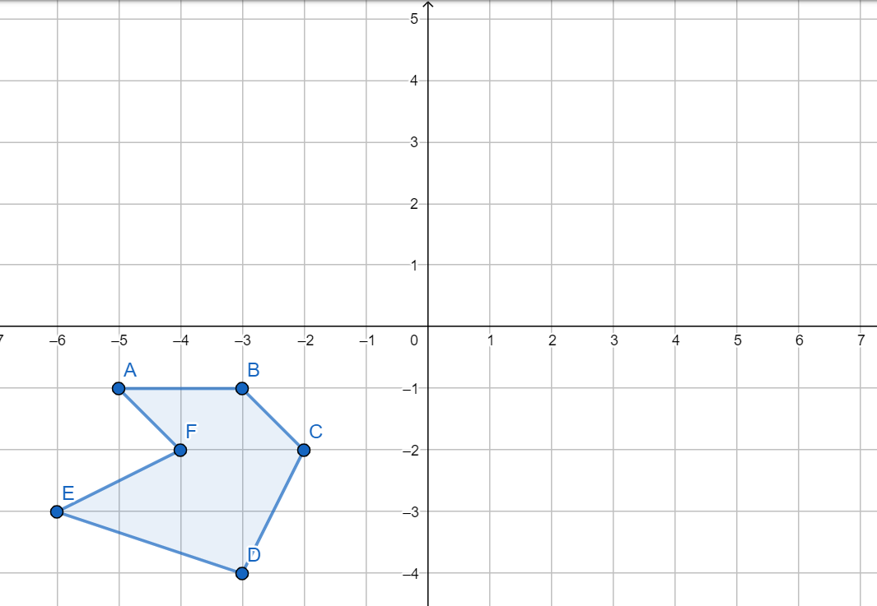

Instructional Item 2
Part A. Draw the resulting image after quadrilateral $ABCD$ is transformed using $(x,y)→(-x, y-3)$. Describe the effect of the given transformation on the quadrilateral.
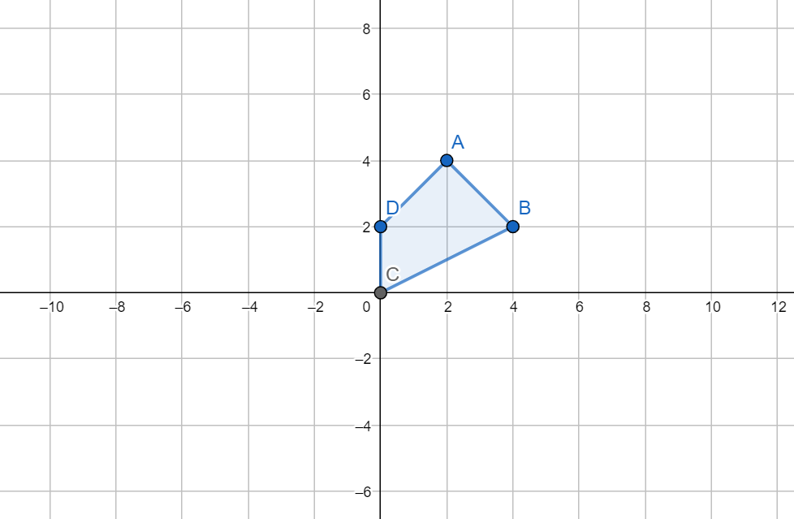

Part B. Identify a sequence of transformation that would produce the same image that the transformation in Part A.
*The strategies, tasks and items included in the B1G-M are examples and should not be considered comprehensive.

MA.912.GR.2.6

Benchmark
MA.912.GR.2.6 Apply rigid transformations to map one figure onto another to justify that the two figures are congruent.
Benchmark Clarifications:
Clarification 1: Instruction includes showing that the corresponding sides and the corresponding angles are congruent.
Connecting Benchmarks/Horizontal Alignment
- MA.912.GR.1.2
- MA.912.GR.1.6
Terms from the K-12 Glossary
- Coordinate Plane
- Origin
- Reflection
- Rigid Transformation
- Rotation
- Translation

Vertical Alignment
Previous Benchmarks  - MA.8.GR.2.1, MA.8.GR.2.2, MA.8.GR.2.3 | Next Benchmarks
Purpose and Instructional Strategies
In grade 8, students learned that when a figure is transformed with a single rigid transformation (reflection, translation, rotation), congruence is preserved, and the preimage is mapped onto a copy of itself. In Geometry, students determine whether two figures are congruent and if so, justify the congruence using sequences of rigid motions. This leads to the definition of congruence in terms of rigid transformations. (MTR.5.1)
- For the expectations of this course, when describing a sequence of transformations students should specify the vertical and horizontal shifts of the translations, the center and angle of the rotations, the direction of the rotations (clockwise or counterclockwise), and the equations of the lines of reflection.
- Instruction includes describing the rigid transformations using words and using coordinates.
- Instruction includes the understanding that after a sequence of rigid transformations, the preimage and the image are two congruent figures. When the preimage is a polygon, the preimage and the image have corresponding sides and corresponding angles congruent. Identifying the corresponding parts leads to the congruence statement.
  - For example, a sequence of rigid transformations shows that triangles $PHN$ and $AWF$are congruent and $P$ corresponds to $F$, $H$ corresponds to $A$, and $N$ corresponds to $W$. Then, $∆PHN≅∆FAW$. This is called the congruence statement.
- For expectations of this benchmark, students should determine the distances between two consecutive vertices of the preimage, or side lengths, and between two consecutive vertices of the image to verify that distance was preserved, and the figures are congruent. Students should make the connection to proving triangles congruent using Side-Side-Side
- Instruction includes disproving that a given preimage and its image are not congruent. Students should be able to show how rigid motions are failing to verify congruence when trying to map one figure onto the other. (MTR.4.1)
Common Misconceptions or Errors
- Students may have trouble identifying a sequence of transformations to verify congruence when a reflection or a rotation is in the composition.
- Students may misidentify the corresponding parts of the preimage and the image after a sequence of transformations, especially when a reflection or a rotation is in the composition.

Strategies to Support Tiered Instruction
- Instruction includes the use of manipulatives (e.g., translucent paper) to verify whether two figures are congruent.
- Instruction includes the use of dynamic geometry software to explore whether a sequence of transformations can map a given preimage onto its image.
- Students should practice choosing a sequence of transformations to verify congruence from a given list, and then progress to choose each of the transformations in the composition from a given list.
- Teacher models how when the congruence statement is written, the order of the letters determined the correspondence of the vertices.
  - For example, if $∆ABC≅∆PQR$, then $A$ corresponds to $P$, $B$ corresponds to $Q$, and $C$ corresponds to $R$.
Instructional Tasks
Instructional Task 1 (MTR.3.1, MTR.4.1)
Two triangles on the coordinate plane are shown below.
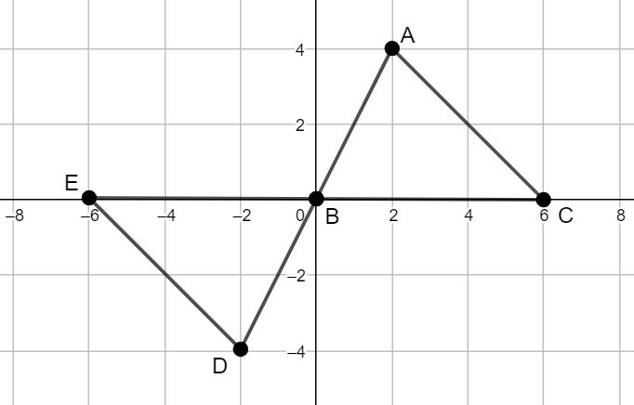

Part A. What transformation(s) could be applied to map triangle $EBD$ onto triangle $CBA$?
Part B. Once the sequence of transformations is completed, how can you determine if preimage and the image are congruent?
Part C. Identify the corresponding parts and write the congruence statement.

Instructional Task 2
The figure below depicts a sequence of transformations that maps quadrilateral $MATH$ onto quadrilateral $BEST$.

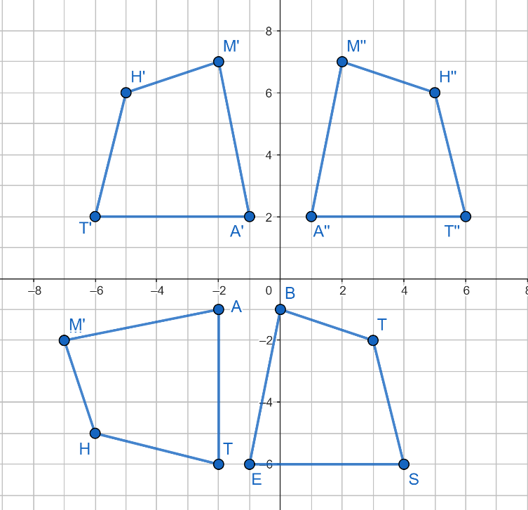

Part A. Describe a sequence of transformations that maps quadrilateral $MATH$ onto quadrilateral $BEST$.
Part B. If the order of the transformations in the sequence used is changed, would the new sequence still map quadrilateral $MATH$ onto quadrilateral $BEST$?
Part C. How can you prove that the quadrilaterals $MATH$ and $BEST$ are congruent?
Part D. Identify the pairs of congruent sides and the pairs of congruent angles of quadrilateral $MATH$ and quadrilateral $BEST$. Write the congruence statement.

Instructional Items
Instructional Item 1
List the transformation or sequence of transformations algebraically using coordinates that could be used to prove that $∆ CAN$ and $∆ YES$ shown below are congruent.

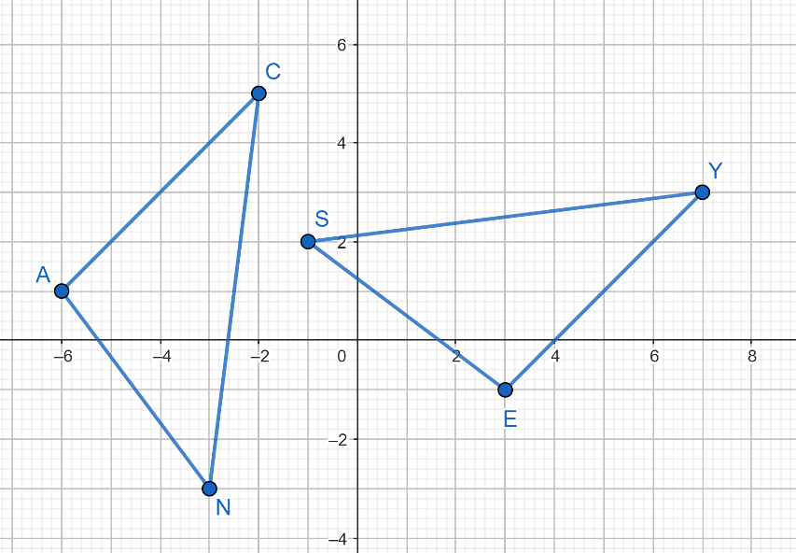

Instructional Item 2
Describe the transformation or sequence of transformations that could be used to prove that quadrilaterals $MNOP$ and $QRST$ are congruent. Write the congruence statement.

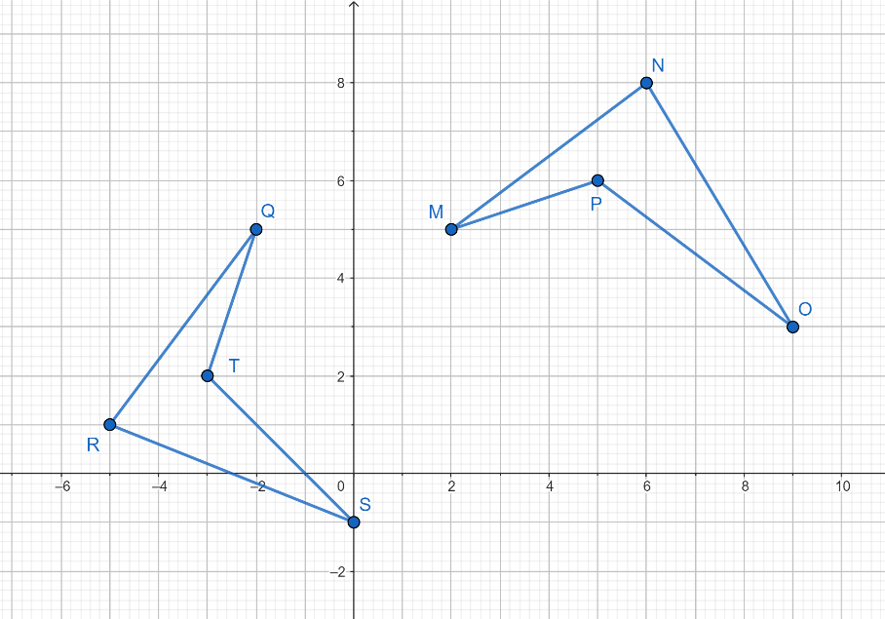

*The strategies, tasks and items included in the B1G-M are examples and should not be considered comprehensive.

MA.912.GR.2.8

Benchmark
MA.912.GR.2.8 Apply an appropriate transformation to map one figure onto another to justify that the two figures are similar.
Benchmark Clarifications:
Clarification 1: Instruction includes showing that the corresponding sides are proportional, and the corresponding angles are congruent.
Connecting Benchmarks/Horizontal Alignment
- MA.912.GR.1.2, MA.912.GR.1.6
Terms from the K-12 Glossary
- Coordinate Plane
- Dilation
- Origin
- Reflection
- Rigid Transformation
- Rotation
- Scale Factor
- Translation
Vertical Alignment
Previous Benchmarks  - MA.8.GR.2.1, MA.8.GR.2.2, MA.8.GR.2.3 | Next Benchmarks

Purpose and Instructional Strategies
In grade 8, students identified the scale factor of a dilation, given the preimage and the image, and learned that dilations do not necessarily preserve congruence. Unless the scale factor is equal to $1$, the preimage in a dilation is mapped onto a scaled copy of itself. In Geometry, students determine whether two figures are similar and justify the similarity using a dilation with scale factor different than $1$ or a composition of transformations that includes at least a dilation with a scale factor different than $A$. This leads to the definition of similarity in terms of similarity transformations. (MTR.5.1)
- For expectations of this course, when identifying the dilation, students specify the center and scale factor of the dilation.
- Instruction includes describing the transformations using words and using coordinates.
- Instruction includes identifying corresponding parts between the preimage and the image, the congruence of the corresponding angles and the proportionality of the corresponding sides. This leads to the similarity statement.
- Instruction includes cases where the preimage and the image are not similar. Students should be able to show how similarity transformations fail mapping one figure onto a scaled copy of itself. (MTR.4.1)
- Students should develop the understanding that when proving two figures are similar choosing the preimage affects the scale factor of the dilations.
  - For example, when proving that $∆ABC$ and $∆PQR$ are similar, the scale factor of the dilation that maps $∆ABC$ onto $∆PQR$ is $k$, while the scale factor of the dilation that maps $∆PQR$ onto $∆ABC$ is $\frac{1}{k}$.

Common Misconceptions or Errors
- Students may misidentify the scale factor of a dilation based on the figure selected to be the preimage and image, leading to a factor that is the reciprocal of the correct scale factor.

Strategies to Support Tiered Instruction
- Teacher models how when the similarity statement is written, the order of the letters determined the correspondence of the vertices.
- For example, if $∆ABC\sim ∆PQR$, then $A$ corresponds to $P$, $B$ corresponds to $Q$, and $C$ corresponds to $R$.
- Instruction includes the use of dynamic geometry software to explore sequences of similarity transformations and their success mapping one figure onto the other to justify similarity.
- Students should practice choosing a sequence of transformations to verify similarity from a given list, and then progress to choose each of the transformations in the composition from a given list.

Instructional Tasks
Instructional Task 1 (MTR.3.1)
A dilation with scale factor $3$ was used to map polygon $ABCD$ onto polygon $A’B’C’D’$.
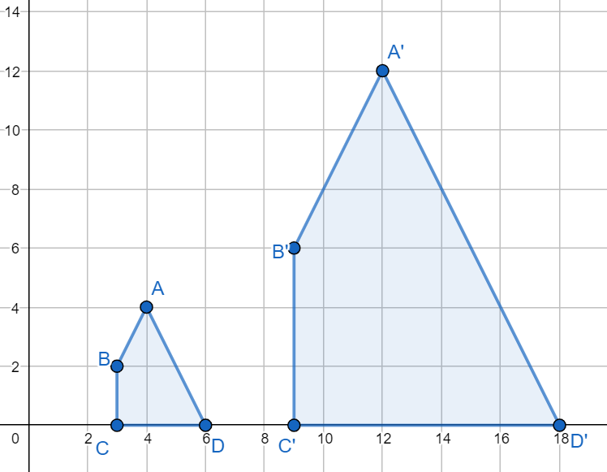

Part A. Fill in the blanks: If two figures are similar, the corresponding sides are _______ and corresponding angles are________.
Part B. Identify a sequence of rigid and non-rigid transformations that maps polygon $ABCD$ onto polygon $A’B’C’D’$. Compare with a partner.
Part C. Decompose polygons $ABCD$ and $A’B’C’D’$ into triangles. Verify the triangles are similar using the Side-Side-Side. Explain how proving the triangles are similar also proves the polygons are similar.

Instructional Task 2
In triangles $ABD$ and $JKL$, $m∠A=m∠J$, $m∠C=m∠L$, and $\overline{AC}=2\overline{JL}$.
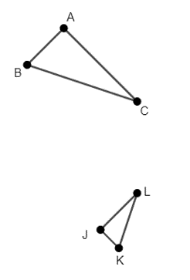
Part A. Describe a sequence of transformations that maps $∆ABC$ onto $∆JKL$.
Part B. Identify the pairs of corresponding sides and the pairs of corresponding angles.
Part C. Based on the composition from Part A, whether $∆ABC$ is congruent or similar but not congruent to $∆JKL$. If the triangles are similar, write the similarity statement.
Part D. Determine whether the pairs of sides and angles from Part C are congruent, proportional, or neither.

Instructional Items
Instructional Item 1
In rectangles $MNOP$and $ABCD$, $\overline{AB}=4\overline{MN},$ $\overline{AC}=4\overline{MO}$, $m∠D=m∠P$, and $m∠B=m∠N$. Describe the sequence of transformations that verifies whether the rectangles are similar. If so, write the similarity statement. Are all rectangles similar?
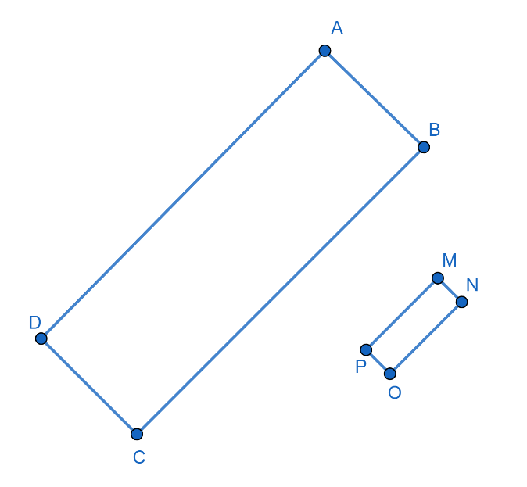
Instructional Item 2
Use the figure below to complete the similarity sentence.

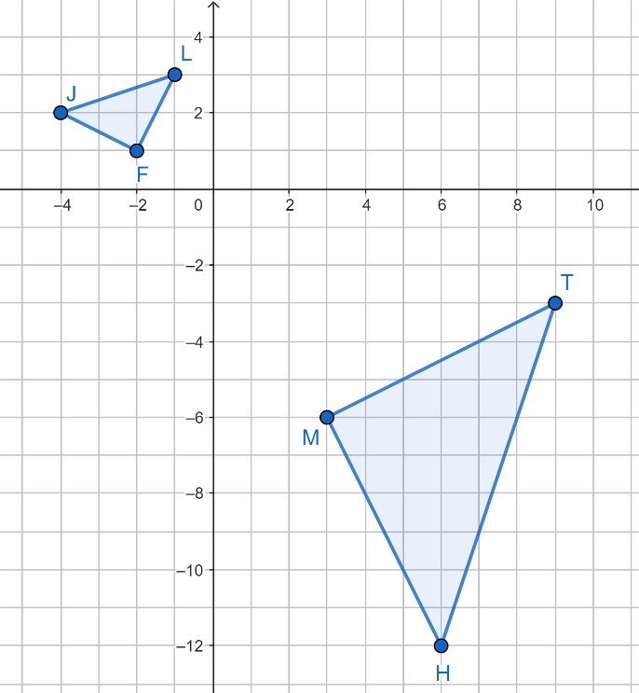

If $∆FJL \sim ∆TMH$, describe a sequence of transformations that justifies the similarity statement. If the similarity statement cannot be justified, write a true similarity statement.
Complete the sentence:
Since the triangles are similar, $∠L≅\boxed{}$ , $∠J≅\boxed{}$, and $∠F≅\boxed{}$ and$\frac{FJ}{}=\frac{LF}{}=\frac{JL}{}$.
*The strategies, tasks and items included in the B1G-M are examples and should not be considered comprehensive.

MA.912.GR.3.1

Benchmark
MA.912.GR.3.1 Determine the weighted average of two or more points on a line.
Benchmark Clarifications:
Clarification 1: Instruction includes using a number line and determining how changing the weights moves the weighted average of points on the number line.
Connecting Benchmarks/Horizontal Alignment
- MA.912.GR.1.1
- MA.912.GR.5.2

Terms from the K-12 Glossary
- Number Line

Vertical Alignment
Previous Benchmarks  - MA.7.AR.3 | Next Benchmarks  - MA.912.NSO.3  - MA.912.FL.1.3  - MA.912.DP.6.7  - MA.912.LT.2.7  - MA.912.LT.3.3
Purpose and Instructional Strategies
In grade 6, students found and interpreted the arithmetic mean or average of a numerical data set, where all numbers are assigned equal weight. In Geometry, students learn about weighted averages that assigns weights to each number that represent the relative importance of each number. Students use weighted averages of two points when partitioning a line segment on the coordinate plane given a ratio, and weighted averages of three points when determining the coordinates of the centroid given a triangle on a coordinate plane. In later courses, weighted averages are used in financial literacy (e.g., portfolios, decision making), probability (e.g., expected value in probability distribution), and in many other contexts (e.g., to calculate grades, in game theory, to multiply a vector by a scalar).
- Instruction focuses on determining the weighted average of two or more points, with emphasis on two and three points.
- Students should develop the understanding that the coordinate of the midpoint of a line segment on the number line is the weighted average of the endpoints of the line segment when the same weights are on each endpoint. Instruction includes finding the coordinate of one endpoint of the line segment on the number line, given the coordinate of the other endpoint and the coordinate of the midpoint.

- Students should develop the conceptual understanding of weighted averages using real-world contexts (e.g., yard stick, teeter totter). A beam is balanced along a horizontal plane when the object with the larger weight is located closer to the fulcrum (or pivot).
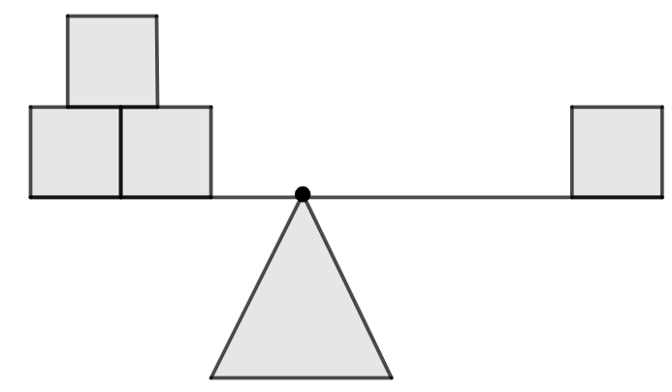
- For expectations of this benchmark, the weights assigned to two or more points on the number line must sum to $1$. Weights can be represented in fractions and in percentages. When weights are given in other forms, like $3$ and $5$ on points $P$ and $Q$, students should be able to convert weights to fractions (or percentages). Then, there is a weight of $\frac{3}{8}$ on $P$ and a weight on $\frac{5}{8}$ to $Q$.
- Instruction builds the concept of weighted averages starting with two points.
  - For example, the weighted average of the numbers $-1$ and $5$ with weight $\frac{1}{4}$ on the first number and $\frac{3}{4}$ on the second number is equal to $\frac{1}{4}\left(-1\right)+\frac{3}{4}\left(5\right)=\frac{1\left(-1\right)+3\left(5\right)}{4}=\frac{14}{4}=3.5$. Students can calculate this weighted average also with percentages, $25\%\left(-1\right)+75\%\left(5\right)=-\frac{1}{4}+3\frac{3}{4}=3\frac{1}{2}=3.5$.
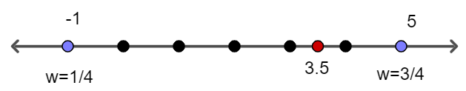
- Instruction makes the connection between the weighted average of two points and the partition of a line segments given a ratio.
  - For example, the weighted average of the numbers $-1$ and $5$ is equivalent to the location of the point on the number line that partitions the distance between $-1$ and $5$ in the ratio $3:1$. Also, the weighted average of the numbers $-1$ and $5$ is the point on the number line that is $\frac{3}{4}$ the way from the point $-1$ to the point $5$ and can be calculated adding $\frac{3}{4}$ of the distance between $-1$ and $5$ to $-1$ or $-1+\frac{3}{4}\left(5-\left(-1\right)\right)$.
- Students should develop the understanding that when a point on the number line has a weight of $\frac{a}{n}$ and another has a weight of $\frac{b}{n}$, then the weighted average partitions the distance between the points on the number line in the ratio $b:a$.
- Instruction includes finding the weighted average of more than two points. Students should extend their understanding of the weighted average of two points to three or more.
For example, given $A$, $B$, and $C$ on the number line, the weighted average when the three have the same weight is $\frac{1}{3}A+\frac{1}{3}B+\frac{1}{3}C$. This notion is used when determining the coordinates of the centroid of a triangle using coordinate geometry (MA.912.GR.3.3).
Common Misconceptions or Errors
- Students may associate the larger weight to the longer distance to the fulcrum (or pivot).
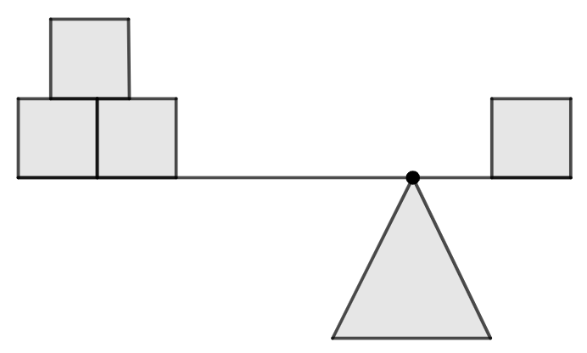
- Students may convert incorrectly the weighted average of two points with weight $\frac{a}{n}$ on the first and $\frac{b}{n}$ on the second to the point that partitions a line segment in the ratio $a:b$.

Strategies to Support Tiered Instruction
- Teacher models the weight given to a point on the number line with weight as a measure of gravitational pull.
- For example, in a teeter totter, the person with larger weight must move closer to the center of balance (or fulcrum) of the teeter totter to balance the beam.
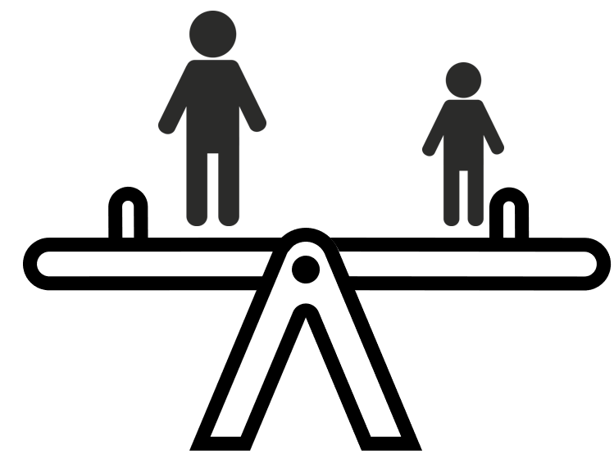
- For example, in a yard stick with four quarters on number 1 on and one quarter on number 6, the balance point (or fulcrum) should be about number $2$, closer to 6, the number holding more weight, to balance the yard stick.
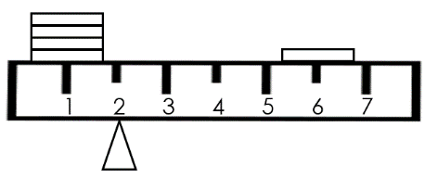
- Instruction includes considering two points on the number line with no weights assigned and their arithmetic mean or average.
- For example, $A$ located at $4$ and $C$ located at $12$ have an average of $\frac{4+12}{2}=8$. This average is the result of $A$ and $B$ having the same weight. Let assign a weight of $1$ to each point, then the total weight is $2$ and a weight of $\frac{1}{2}$ corresponds to each point now. The weighted average is $\frac{1}{2}\left(4\right)+\frac{1}{2}\left(12\right)=2+6=8$. Students should develop the understanding that each point contributes with half its value to determine the weighted average.

- Instruction includes considering two points on the number line with assigned weights.
- For example, $A$ is located at $4$ with a weight of $2$, and point $C$ is located at $12$ with a weight of $3$. Students should determine the weight that corresponds to each point such that the weights sum to $1$. With a total of $2+3=5$, the weight of $A$ is $\frac{2}{5}$ and the weight of $B$ is $\frac{3}{5}$. To find the weighted average, students should understand that $A$ contributes with $\frac{2}{5}$ of its value and $B$ with $\frac{3}{5}$ of its value. That is, $\frac{2}{5}\left(4\right)+\frac{3}{5}\left(12\right)=\frac{44}{5}=8.8$. The weight average is closer to $B$ since this point has a larger weight.
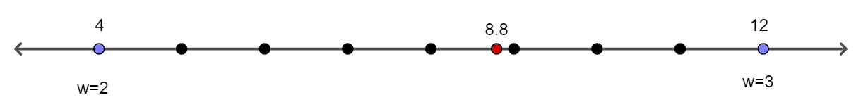
Instructional Tasks
Instructional Task 1 (MTR.2.1, MTR.4.1, MTR.5.1)
Three numbers are provided below. Use these numbers to answer each question below.
0, 1, 2
Part A. What is the arithmetic mean or average ($m_{1}$) of the three numbers?
Part B. Choose two of the numbers and determine their mean ($m_{2}$).
Part C. Determine the weighted average of $m_{2}$ and $2$ using the weights $\frac{2}{3}$ on $m_{2}$ and $\frac{1}{3}$ on $2$. What do you notice?
Part D. Repeat Parts B with a different choice of the two numbers and part C the point not included in Part B.
Part E. Repeat Parts A, B and C with any three real numbers, $x$, $y$ and $z$. What do you notice? Compare your answers with a partner.

Instructional Task 2 (MTR.4.1, MTR.6.1)
Given the number line with $A=-1$ and $B=5$.
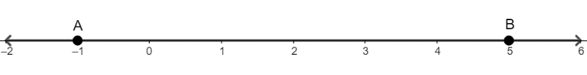
Part A. Calculate the weighted average of $A$ and $B$ in each of the following cases:.
- When the weight of $A$ is $12$ and the weight of $B$ is $36$
- When the weight of $B$ is three times the weight of $A$
- When the weight of $A$ is three times the weight of $B$
- When the weight of $A$ is $15$ and the weight of $B$ is $5$
Part B. What did you notice in the answers of Part A?
Part C. If the weighted average of $A$ and $B$ is $2.5$, and the weight of $A$ is $3$, what is the weight of $B$?

Instructional Items
Instructional Item 1
What point on the number line is $\frac{7}{9}$ the way from the point $-3.6$ to the point$10$?

Instructional Item 2
If a point is $\frac{2}{5}$ the way from point $P$ to point $Q$ and this point is the weighted average of $P$ and $Q$, what are the weights on $P$ and $Q$?

Instructional Item 3
On a number line, coordinate $-3$ has a weight of $\frac{1}{5}$ and coordinate 17 has a weight of $\frac{4}{5}$. What is the weighted average of the two coordinates?

*The strategies, tasks and items included in the B1G-M are examples and should not be considered comprehensive.

MA.912.GR.3.2

Benchmark
MA.912.GR.3.2 Given a mathematical context, use coordinate geometry to classify or justify definitions, properties and theorems involving circles, triangles or quadrilaterals.
Example: Given Triangle $ABC$ has vertices located at $(-2, 2)$, $(3, 3)$ and $(1, -3)$, respectively, classify the type of triangle $ABC$ is based on its angle measures and side lengths.
Example: If a square has a diagonal with vertices $(-1, 1)$ and $(-4, -3)$, find the coordinate values of the vertices of the other diagonal and show that the two diagonals are perpendicular.
Benchmark Clarifications:
Clarification 1: Instruction includes using the distance or midpoint formulas and knowledge of slope to classify or justify definitions, properties and theorems.
Connecting Benchmarks/Horizontal Alignment
- MA.912.GR.1.3, MA.912.GR.1.4, MA.912.GR.1.5
- MA.912.GR.7.2
Terms from the K-12 Glossary
- Circle
- Quadrilateral
- Slope
- Triangle

Vertical Alignment
Previous Benchmarks  - MA.8.AR.3  - MA.8.GR.1.2  - MA.912.AR.2.2  - MA.912.AR.2.3 | Next Benchmarks  - MA.912.GR.7  - MA.912.T.4
Purpose and Instructional Strategies
In grade 8, students determined and interpreted the slope of linear relationships and applied the Pythagorean Theorem to find the distance between two points on the coordinate plane. In Algebra 1, students wrote linear equations for a line that is parallel or perpendicular to a given line and goes through a given point. In Geometry, students expand their knowledge of distance and slopes in coordinate geometry to classify geometric figures. In later courses, coordinate geometry will be used to study conic sections.
- For expectations of this benchmark, students do not memorize the formulas for distance, midpoint, and slope. They can be found in the Geometry EOC Mathematics Reference Sheet.
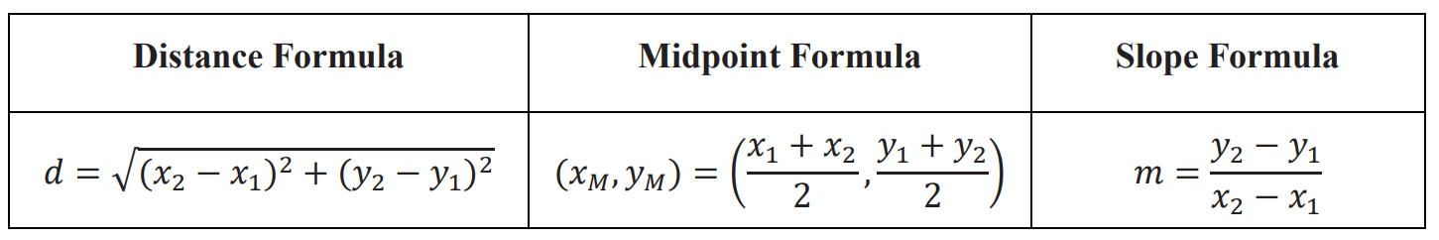
- Instruction makes the connection between the formula for the distance between two points on the coordinate plane and the Pythagorean Theorem (grade 8).
- For example, the distance between $A(1, 1)$ and $B(5, 3)$ and the length of $\overline{CD}$, with $C(1, 1)$ and $D(5, 3)$.
Distance Formula | Pythagorean Theorem
$$AB=\sqrt{{\left(x_{2}-x_{1}\right)}^{2}+{\left(y_{2}-y_{1}\right)}^{2}}$$  $$x_{2}-x_{1}=5-1=4$$  $$y_{2}-y_{1}=3-1=2$$  $$AB=\sqrt{{\left(4\right)}^{2}+{\left(2\right)}^{2}}$$  $$AB=\sqrt{20}$$ | $$c^{2}=a^{2}+b^{2}$$  $$a=4$$  $$b=2$$  $$c=\sqrt{{\left(4\right)}^{2}+{\left(2\right)}^{2}}$$  $$CD=\sqrt{20}$$
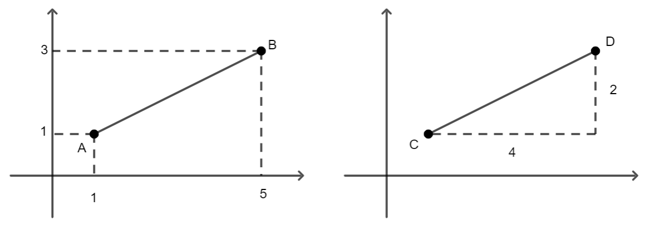

When $x_{2}-x_{1}<0$(e.g., $1-5=-4)$ and $y_{2}-y_{1}<0$, students should be able to connect these results with the notion of the difference between $a$ and $b$, $|a-b|$. In the distance formula, absolute values are not needed since $(a-b)$ is squared and ${\left(a-b\right)}^{2}={\left(b-a\right)}^{2}$.

- Students should use their preferred method when finding the distance between two points and the length of a line segment on the coordinate plane.
- Instruction includes expressing the distance between two points and the length of a line segment with exact values (e.g., $\sqrt{40}$) and with approximated values (e.g., $6.32$). When using the radical form, students are not expected to simplify but to identify equivalent radicals (e.g., $\sqrt{40}=2\sqrt{10}$).
- Students should use their preferred method when finding the midpoint of a segment, the Midpoint Formula or the weighted average of two points when they have the same weight (MA.912.GR.3.1).
- For example, the midpoint of $\overline{PQ}$, with $P(-3, 2)$ and $Q(1, -1)$ results from using the formula as follows: $\left(\frac{-3+1}{2}.\frac{2+\left(-1\right)}{2}\right)=\left(-1,\frac{1}{2}\right)$. The weighted average of $-3$ and $1$, and of $2$ and $-1$, when their weights are $\frac{1}{2}$ each, is $\frac{1}{2}\left(-3\right)+\frac{1}{2}\left(1\right)=-1$ and $\frac{1}{2}\left(2\right)+\frac{1}{2}\left(-1\right)=\frac{1}{2}$. Then, the weighted average of $P$ and $Q$ on the coordinate plane is $\left(-1,\frac{1}{2}\right)$.
- Instruction includes determining the slope of the lines containing the sides of a triangle and a quadrilateral (or the slopes of the sides) and applying the slope criteria for parallel and perpendicular lines (Algebra 1). To determine the slope, students can use the Slope Formula, “rise over run”, the change on the $y-$coordinates divided by the change on the $x-$coordinates comparing two points, or any other valid method. Students should use their preferred method.
- Instruction includes expressing the slope of a segment with exact values (e.g., $\frac{2}{3}$). When using the fractional form, students are not expected to simplify but to identify equivalent fractions (e.g., $\frac{12}{15}=\frac{4}{5}$).
- For expectations of this benchmark, definitions, properties, and theorems about circles, triangles, and quadrilaterals are limited to the ones included in the benchmarks of this course.
- Instruction includes determining when the lengths of the sides or the diagonals of triangles and quadrilaterals are necessary to classify triangles and quadrilaterals.
- For example, to justify that a triangle is isosceles using the lengths of the sides and that a parallelogram is a rectangle using the length of the diagonals.
- Instruction includes determining when the midpoint of a line segment is necessary to classify a quadrilateral.
- For example, to justify that a quadrilateral is a parallelogram using the property “diagonals bisect each other.”
- Instruction includes determining when the slopes of the sides of a triangle or the slopes of the sides or the diagonals of a triangle and a quadrilateral are necessary to classify triangles and quadrilaterals.
- For example, to justify that a triangle is right using the slope criterion for perpendicular lines, that a quadrilateral is a trapezoid using the slope criterion for parallel lines, or that a parallelogram is a rhombus using the slope criterion for perpendicular lines.

- Instruction includes determining when the slopes and the lengths of the sides are necessary to classify triangles and quadrilaterals.
  - For example, to justify that a quadrilateral is a parallelogram using one pair of sides or that a triangle is isosceles and rectangle (the special right triangle $45°-45°-90°$).
- Students should develop the understanding that in some cases there is more than one way to justify a definition.
  - For example, justify that a triangle is right can be done showing the slopes of two sides are opposite reciprocals (their product is $-1$) or showing the lengths of the three sides satisfy the Pythagorean Theorem.
- Students should have practice finding a missing vertex of triangles and quadrilaterals using definitions, properties, or theorems.
- For example, find the coordinates of the missing vertex such that the point forms a rhombus with (2, -3), (5, 1), and $\left(-1,1\right)$. Students should be able to identify more than one correct answer when possible.
- Instruction includes justifying properties, and theorems involving circles, triangles, and quadrilaterals.
- For example, justify a given segment is the midsegment of a triangle or a trapezoid, the centroid is located $\frac{2}{3}$ the way from the vertex to the midpoint of the opposite, or the segment tangent to a circle is perpendicular to the radius at the point of tangency.
- Instruction makes the connection between coordinate geometry and the proof of the Triangle Midsegment Theorem (MA.912.GR.1.3).
  - Given $∆ABC$ on the coordinate plane with $A$ at the origin, $B$ at $\left(b,0\right)$ and $C$ at $\left(x,y\right)$. Students should determine: $P$, the midpoint of $\overline{AC}$, and $Q$, the midpoint of $\overline{CB}$, $P\left(\frac{1}{2}x,\frac{1}{2}y\right)$ and $Q\left(\frac{1}{2}\left(x+b\right),\frac{1}{2}y\right)$; the slope of $\overline{PQ}=\frac{\frac{1}{2}y-\frac{1}{2}y}{\frac{1}{2}\left(x+b\right)-\frac{1}{2}x}=0$ and the slope of $\overline{AB}=\frac{0-0}{b-0}=0$, then $\overline{PQ}∥\overline{AB}$, both horizontal segments; and the lengths of $\overline{AB}$ and $\overline{PQ}$, $AB=b-0=b$, $PQ=\frac{1}{2}\left(x+b\right)-\frac{1}{2}x=\frac{1}{2}b$, then $AB=2\left(PQ\right).$ This proves that the midsegment $\overline{PQ}$ of $∆ABC$ is parallel to $\overline{AB}$ and half its length.
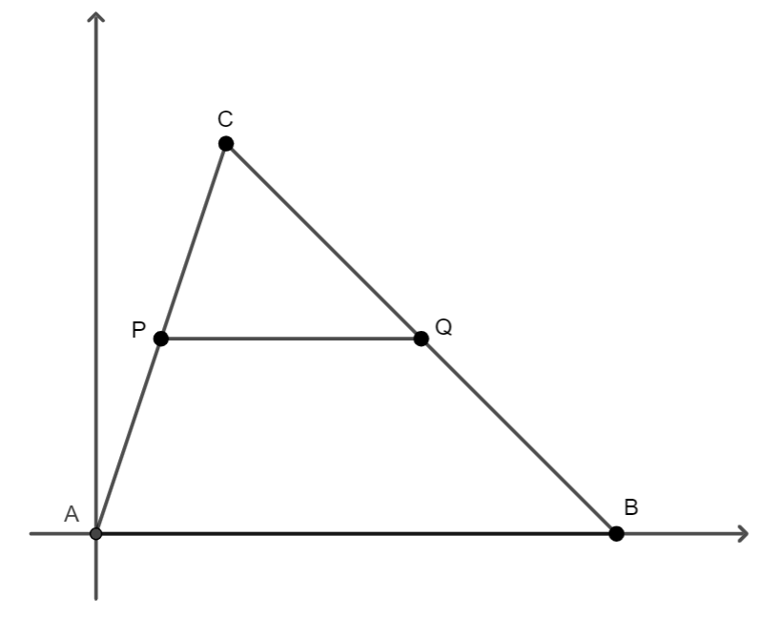p

- Instruction makes the connection between coordinate geometry and the proof of the Trapezoid Midsegment Theorem (MA.912.GR.1.5).
- Given trapezoid $ABCD$ with $A(0, 0)$, $B\left(x, y\right)$, $C\left(x+d, y\right)$, and $D(b,0)$

The midpoint of $\overline{AB}$ is at $P$ $\left(\frac{1}{2}x,\frac{1}{2}y\right)$ and the midpoint of $\overline{CD}$ is at $Q$ $\left(\frac{1}{2}(x+d+b),\frac{1}{2}y\right)$. The slope of $\overline{AD}$ is $\frac{0-0}{b-0}=0$ and the slope of $\overline{PQ}$ is $\frac{\frac{1}{2}y-\frac{1}{2}y}{\frac{1}{2}\left(x+d+b\right)-\frac{1}{2}x}=0$, then $\overline{AD}∥\overline{PQ}$, both horizontal segments. $AD=b-0=b$, $BC=\left(x+d\right)-x=d$, and $PQ=\frac{1}{2}\left(x+d+b\right)-\frac{1}{2}x=\frac{1}{2}(b+d)$, then $PQ=\frac{1}{2}(AD+BC)$. This proves that the midsegment $\overline{PQ}$ of trapezoid $ABCD$ is parallel to the bases and half their sum (semi-sum, average, or weighted average when the bases have the same weight).
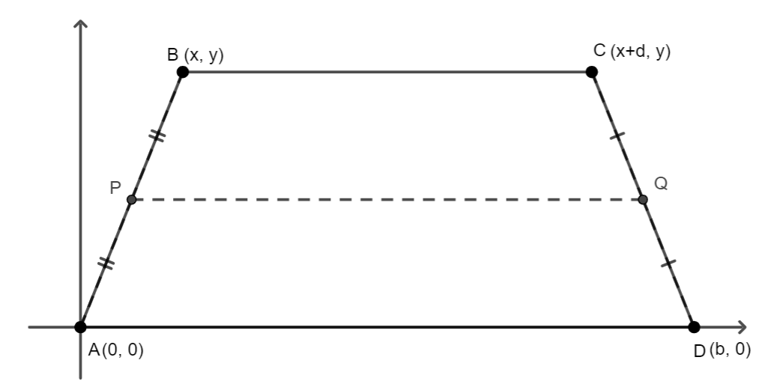

Common Misconceptions or Errors
- Students may use a description for triangles and quadrilaterals that is not precise enough.
- For example, a square is a quadrilateral with four equal sides, or a trapezoid is a quadrilateral with exactly one pair of parallel sides.
- Students may interpret a slope of a side as its length.
- Students may not recognize whether the lengths or the slopes are needed to justify definitions of triangles and quadrilaterals.

Strategies to Support Tiered Instruction
- Students should have practice with the definitions of the types of triangles and the types of quadrilaterals. They may use a graphic organizer or matching cards.
- Students should have practice with the definitions and properties of circles, triangles, and quadrilaterals.
- For example, the definition of a parallelogram is a quadrilateral with two pairs of parallel sides. Its properties include equal-length opposite sides, equal-measure opposite angles, supplementary consecutive angles and diagonals that bisect each other.
- Students should have practice finding distances, midpoints, and slopes, using the Geometry EOC Mathematics Reference Sheet, expressing the answers with exact values and with approximations.
- Students should have practice using the Pythagorean Theorem to find the length of the hypotenuse of a right triangle given the lengths of the legs. Students should extend their understanding of the Pythagorean Theorem to the distance formula between two points on the coordinate plane.
- Instruction includes the slope criteria for parallel and perpendicular lines.
- For example, given two pairs of points, students plot the points on the coordinate plane, determine the slope of the line segment joining the two points in each pair, and determine whether the line segments are parallel, perpendicular, or neither.

Instructional Tasks
Instructional Task 1 (MTR.1.1, MTR.2.1, MTR.4.1)
Part A. What are the coordinates of $P$ if $∆PQR$ is right with $Q\left(-1, 2\right)$ and $R\left(3, 0\right)?$
Part B. Show that $PQ^{2}+QR^{2}=PR^{2}$.
Part C. Find the slopes of $\overline{PQ}$ and $\overline{QR}$. What do you notice?
Part D. Compare your right triangle with the triangle of a partner.

Instructional Task 2 (MTR.3.1)
Three of the vertices of quadrilateral $PQRS$ are at $(-2, 1)$, $(3, -1)$ and $(-2, -3)$.
Part A. What are possible coordinates for the fourth vertex if $PQRS$ is a parallelogram?
Part B. Verify the properties of parallelograms: opposite sides are congruent, consecutive angles are supplementary, and diagonals bisect each other.
Part C. Justify that $PQRS$ is a trapezoid.

Instructional Task 3 (MTR.3.1, MTR.4.1)
The coordinates of the vertices of three two-dimensional figures are given.
Figure A with vertices at $(2,3)$, $(3,-4)$, and $\left(3,4\right)$
Figure B with vertices at $(3,3)$, $(2,-1)$, $(-2,0)$, and $(-1,4)$
Figure C with vertices at $(-2,3)$, $(-3,1)$, $(0,-4)$, and $(3,2)$
Part A. Plot the points and draw the three figures on the coordinate plane.
Part B. Write a conjecture about the best name of each two-dimensional figure (e.g., if a figure is a rectangle and a square, the best name is square).
Part C. Compare each pair of figures (A and B, B and C, A and C). Identify one feature that is similar and one that is different in each pair.
Part D. For each given figure, what would you need to determine (e.g., slopes, lengths) to show that your conjecture about the best name is true?
Part C. For figures B and C, verify one property of each figure.
Instructional Items
Instructional Item 1
Points $A(0,2)$ and $(2,0)$ are endpoints of $\overline{AB}$, a side of the quadrilateral $ABCD$. List possible coordinates for points $C$ and $D$ if quadrilateral $ABCD$ is a rhombus, not a square.

Instructional Item 2
Given quadrilateral $ABCD$ with vertices at $(-3,-4)$, $(1,5)$, $(5,3)$, and $(5,-8)$, classify the type of quadrilateral and justify your answer using coordinate geometry.

Instructional Item 3:
Given quadrilateral $ABCD$ with vertices at $A(-3,-4)$, $B(1,5)$, $C(5,3)$, and $D(x,y)$, what are the possible coordinates for vertex $D$ to make $ABCD$ a parallelogram? What are the coordinates of the point where the diagonals of $ABCD$ meet?
*The strategies, tasks and items included in the B1G-M are examples and should not be considered comprehensive.

MA.912.GR.3.3

Benchmark
MA.912.GR.3.3 Use coordinate geometry to solve mathematical and real-world geometric problems involving lines, circles, triangles and quadrilaterals.
Example: The line $x+2y=10$ is tangent to a circle whose center is located at $(2,-1)$. Find the tangent point and a second tangent point of a line with the same slope as the given line.
Example: Given $M(-4, 7)$ and $N(12,-1)$, find the coordinates of point $P$ on $\overline{MN}$ so that $P$ partitions $\overline{MN}$ in the ratio $2:3$.
Benchmark Clarifications:
Clarification 1: Problems involving lines include the coordinates of a point on a line segment including the midpoint.
Clarification 2: Problems involving circles include determining points on a given circle and finding tangent lines.
Clarification 3: Problems involving triangles include median and centroid.
Clarification 4: Problems involving quadrilaterals include using parallel and perpendicular slope criteria.
Connecting Benchmarks/Horizontal Alignment
- MA.912.GR.1.3, MA.912.GR.1.4, MA.912.GR.1.5
- MA.912.GR.7.2
Terms from the K-12 Glossary
- Circle
- Diameter
- Quadrilateral
- Radius
- Slope
- Triangle
Vertical Alignment
Previous Benchmarks  - MA.8.AR.3  - MA.8.GR.1.2  - MA.912.AR.2.2, MA.912.AR.2.3  - MA.912.AR.9.1 | Next Benchmarks  - MA.912.GR.7  - MA.912.T.4

Purpose and Instructional Strategies
In grade 8, students determined and interpreted the slope of linear relationships and applied the Pythagorean Theorem to find the distance between two points on the coordinate plane. In Algebra 1, students wrote linear equations for a line that is parallel or perpendicular to a given line and goes through a given point. In Geometry, students expand their knowledge of distance and slopes in coordinate geometry solve problems involving lines, circles, triangles, and quadrilaterals. In later courses, students will us coordinate geometry to solve problems involving conic sections and polar coordinates, including converting from polar to rectangular coordinates and vice versa.
- For expectations of this benchmark, students do not memorize the formulas for distance, midpoint, and slope. They can be found in the Geometry EOC Mathematics Reference Sheet.
- For expectations of this benchmark in its clarifications, students solve problems involving the partition of a line segment, points on a circle and line segments and lines tangent to a circle, medians and centroid, and quadrilaterals.
- Partitioning a line segment.
Students should be able to find the coordinates of the midpoint of a line segment on a coordinate plane and to find the coordinates of a point that partitions a line segment on the coordinate plane given the ratio of the partition. Instruction includes using the Midpoint Formula and the weighted average of two points with the same weight (MA.912.GR.3.1) to find the coordinates of the midpoint of a line segment on the coordinate plane. Students should use their preferred method. Instruction also includes finding the coordinates of the point partitioning a line segment given the ratio $a:b$ and determining the weighted average of the endpoints of the line segment with weight $\frac{b}{a+b}$ on the first endpoint and $\frac{a}{a+b}$ on the second endpoint. Students should use their preferred method.
Method 1
Given $\overline{AB}$, with $A(-3, 6)$ and $B(4, -8)$ and $P$ partitioning $\overline{AB}$ in the ratio $2:3$. $P$ is $\frac{2}{5}$ the way from $A$ to $B$. The horizontal distance from $A$ to $B$ is $7$ and the vertical distance from $A$ to $B$ is $-14$. $\frac{2}{5}$ of $7$ is $\frac{14}{5}=2.8$ and $\frac{2}{5}$ of $-14$ is $\frac{-28}{5}=-5.6$. From $A(-3, 6)$ to $B(4, -8)$, $P$ is $\left(-3+2.8, 6-5.6\right)=\left(-0.2, 0.4\right)=\left(-\frac{1}{5},\frac{2}{5}\right)$.
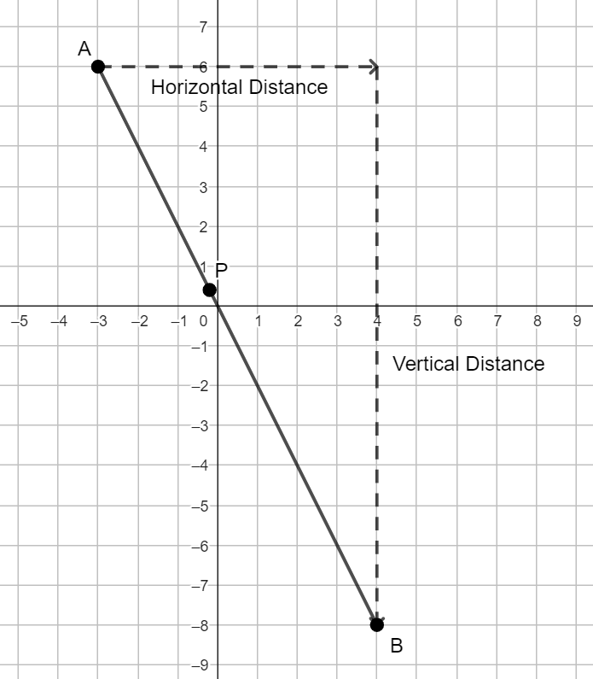
Method 2
Given $\overline{AB}$, with $A(-3, 6)$ and $B(4, -8)$ and $P$ partitioning $\overline{AB}$ in the ratio $2:3$. $P$ is the weighted average of $A$ and $B$ when the weight on $A$ is $3$ and the weight on $B$ is $2$. Then, the weight assigned to $A$ is $\frac{3}{5}$ and the weight assigned to $B$ is $\frac{2}{5}$. $P=\frac{3}{5}\left(-3, 6\right)+\frac{2}{5}\left(4, -8\right)=\left(\frac{3}{5}\left(-3\right)+\frac{2}{5}\left(4\right),\frac{3}{5}\left(6\right)+\frac{2}{5}(-8)\right)=\left(-\frac{9}{5}+\frac{8}{5},\frac{18}{5}-\frac{16}{5}\right)=\left(-\frac{1}{5},\frac{2}{5}\right)$.
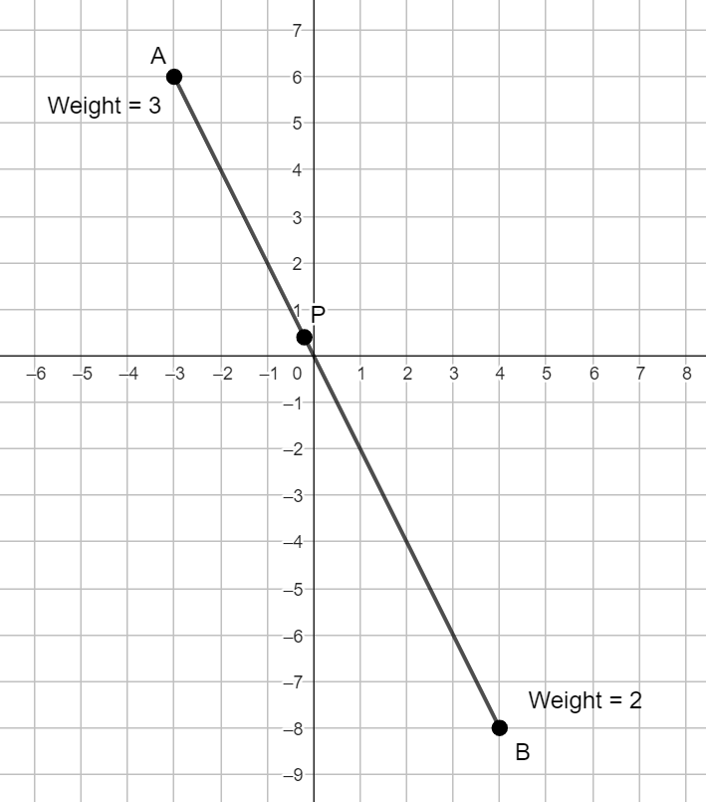
Students should be able to determine the coordinates of the point partitioning a line segment given the ratio part-to-part or part-to-whole (e.g., Find the coordinates of $P$ on $\overline{AB}$ such that $AP$ is to $AB$ as $2:5$).
Instruction includes determining the coordinates of one of the endpoints of a line segment on the coordinate plane, given the coordinates of the other endpoint and the coordinates of the midpoint. Similarly, students should be able to determine the coordinates of one of the endpoints of al line segment on the coordinate plane, given the coordinates of the other endpoint, the coordinates of the point partitioning the segment and the ratio of the partition.
- Points on a circle and line segments and lines tangent to a circle.
Instruction includes the definition of a line segment, ray, or line tangent to a circle and its properties or theorems. The properties or theorems include two line segments tangent to a circle, with a common endpoint outside the circle, are congruent, and a line segment, ray, or line tangent to a circle is perpendicular to the radius of the circle at the point of tangency.
For example, given $⨀O$ with center at $(4, 4)$ verify that $AP=AQ$ and that $\overline{AP}⊥\overline{QP}$ (the coordinates of $P$ and $Q$ are approximations). $AP≈\sqrt{{{\left(10-5.5\right)}^{2}+\left(4-6.6\right)}^{2}}=\sqrt{{4.5}^{2}+{2.6}^{2}}$ and $AQ≈\sqrt{{\left(10-5.5\right)}^{2}+{\left(4-1.4\right)}^{2}}=\sqrt{{4.5}^{2}+{2.6}^{2}}$, then $AP=AQ$. The slope of $\overline{AP}$ is $\frac{6.6-4}{5.5-10}=-\frac{2.6}{4.5}=-\frac{26}{45}$ approximately, and the slope of $\overline{QP}$ is $\frac{4-6.6}{4-5.5}=\frac{2.6}{1.5}=\frac{26}{15}$ approximately. The product of the slopes is, approximately, $-1$.
The exact coordinates of $P$ are $\left(\frac{14860}{2701},\frac{17824}{2701}\right)$.
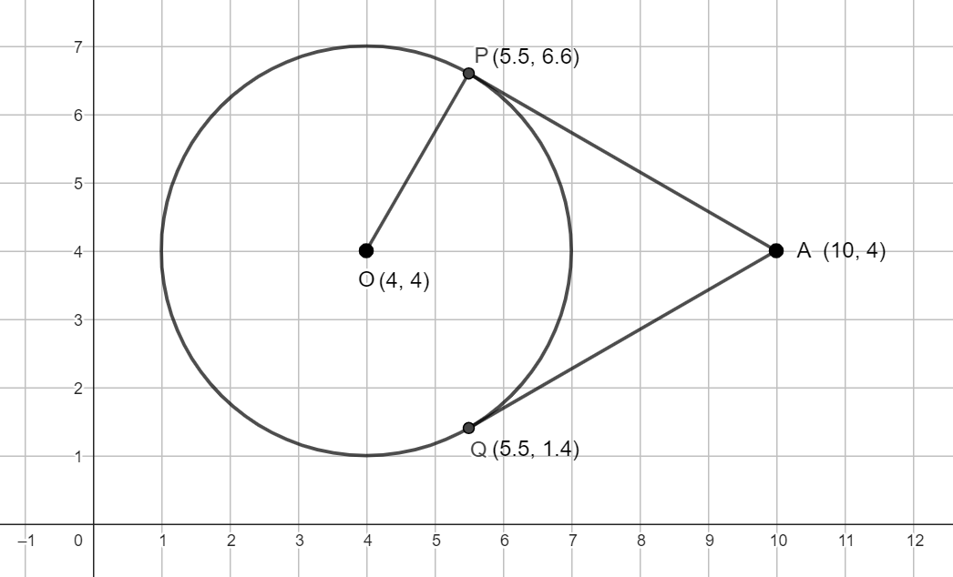
Instruction also includes writing the equation of the line tangent to the circle and the equation of the line containing the radius and solving the system to determine the coordinates of the point of tangency.
For example, the equation of the tangent line to $⨀O$ passing through $A$ is $y-4=-\frac{26}{45}(x-10)$ and the equation of the line containing the radius is $y-4=\frac{26}{15}(x-4)$. Solving the system of equations determine the coordinates of the point of tangency. The solution of the system of equations is $\left(\frac{11}{2},\frac{33}{5}\right)=(5.5, 6.6)$.
- Medians and Centroid.
Instruction makes connections between the Concurrency of Medians Theorem (MA.912.GR.1.3) and coordinate geometry. Instruction includes the definition of a median of a triangle and the centroid, their point of concurrency.
Method 1
Given $∆ABC$ and the medians $\overline{AE}$, $\overline{BD}$ and $\overline{CF}$. The equations of the lines containing the medians are $y=\frac{3}{5}x$, $y=-\frac{3}{4}\left(x-6\right)$, and $y-6=6(x-4)$. The solution of the system of equations formed by $y=\frac{3}{5}x$ and $y=-\frac{3}{4}(x-6)$, and point of intersection of the medians $\overline{AE}$ and $\overline{CB}$, is $\left(\frac{10}{3}, 2\right)$. This point satisfies the equation $y-6=6(x-4)$. Then, the medians are concurrent and $\left(\frac{10}{3}, 2\right)$ is the point of concurrency of the medians, $P$.
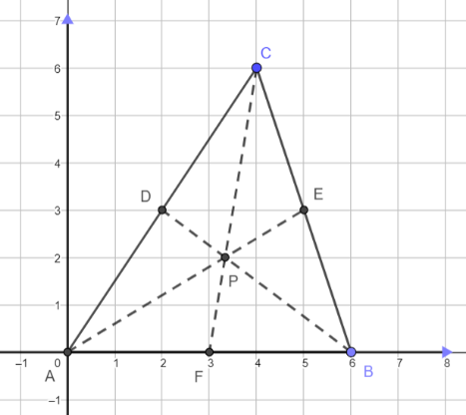
Method 2
Given $∆ABC$ and the medians $\overline{AE}$, $\overline{BD}$ and $\overline{CF}$. The midpoints of the sides of the triangle are at $(5, 3)$, $(2, 3)$ and $(3, 0)$. By the Centroid Theorem, the centroid partitions each median in the ratio $2:1$ from the corresponding vertex to the midpoint of the opposite side, or the centroid is the weighted average of the corresponding vertex and the midpoint of the opposite side when the weight of the midpoint is twice the weight of the vertex. The centroid of $\overline{AE}$ is at $\frac{1}{3}\left(0, 0\right)+\frac{2}{3}\left(5, 3\right)=\left(\frac{10}{3}, 2\right)$. The centroid of $\overline{BD}$ is at $\frac{1}{3}\left(6, 0\right)+\frac{2}{3}\left(2, 3\right)=\left(\frac{10}{3}, 2\right)$. The centroid of $\overline{CF}$ is at $\frac{1}{3}\left(4, 6\right)+\frac{2}{3}\left(3, 0\right)=\left(\frac{10}{3}, 2\right)$. Since the centroid of the three medians is the same point, $P\left(\frac{10}{3}, 2\right)$, then the medians are concurrent and $P$ is their centroid.
- Quadrilaterals.
Instruction includes the definitions, properties, and theorems about quadrilaterals in the benchmarks of this course.
- For expectations of this benchmark, students should develop the understanding that determining the coordinates of the midpoint of a line segment can be used, as needed, to partition a given line segment in the ratio $a:b$, when $a+b$ is a power of $2$ (e.g., $3:4$, $1:8$).
- For example, the midpoint of $\overline{AB}$ is at $M$, and the midpoint of $\overline{AM}$ is at $N$. Then, $N$ partitions $\overline{AB}$ in the ratio $1:3$ ($1+3=4=2^{2}$).
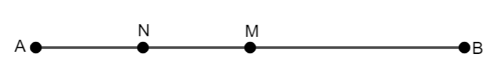

- Instruction includes the Centroid Formula. $Centroid=\left(\frac{x_{1}+x_{2}+x_{3}}{3},\frac{y_{1}+y_{2}+y_{3}}{3}\right)$, where $(x_{1},y_{1})$, $(x_{2},y_{2})$ and $(x_{3},y_{3})$ are the coordinates of the triangle. That is, the coordinates of the centroid of a triangle are the weighted average of the coordinates of its vertices, when all the vertices have the same weight.
Given $∆ABC$ with vertices $A(x_{1},y_{1})$, $B(x_{2}, y_{2})$ and $C(x_{3},y_{3})$. The midpoints of the sides of the triangles are $M\left(\frac{x_{2}+x_{3}}{2},\frac{y_{2}+y_{3}}{2}\right)$, $N\left(\frac{x_{1}+x_{3}}{2},\frac{y_{1}+y_{3}}{2}\right)$ and $L\left(\frac{x_{1}+x_{2}}{2},\frac{y_{1}+y_{2}}{2}\right)$ for $\overline{BC}$, $\overline{AC}$ and $\overline{AB}$, respectively. $\overline{AM}$, $\overline{BN}$, and $\overline{CL}$ are the medians of the triangle. Applying the Centroid Theorem, the centroid of $\overline{AM}$ is at $\left(\frac{1}{3}x_{1}+\frac{2}{3}\left(\frac{x_{2}+x_{3}}{2}\right),\frac{1}{3}y_{1}+\frac{2}{3}\left(\frac{y_{2}+y_{3}}{2}\right)\right)=\left(\frac{1}{3}x_{1}+\frac{1}{3}x_{2}+\frac{1}{3}x_{3}, \frac{1}{3}y_{1}+\frac{1}{3}y_{2}+\frac{1}{3}y_{3}\right)=\left(\frac{x_{1}+x_{2}+x_{3}}{3},\frac{y_{1}+y_{2}+y_{3}}{3}\right)$. Similarly, the centroid of $\overline{BN}$ is at $\left(\frac{x_{1}+x_{2}+x_{3}}{3},\frac{y_{1}+y_{2}+y_{3}}{3}\right)$ and the centroid of $\overline{CL}$ is at $\left(\frac{x_{1}+x_{2}+x_{3}}{3},\frac{y_{1}+y_{2}+y_{3}}{3}\right)$. This reasoning also proves the medians meet at a point, and that point is the centroid.
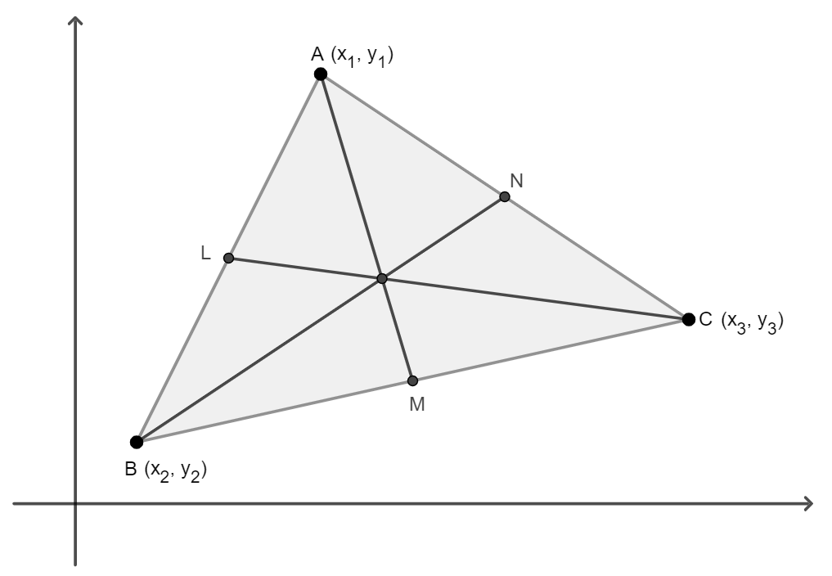

Common Misconceptions or Errors
- Students may convert the given ratio $a:b$ in the weights $\frac{a}{a+b}$ on the first endpoint of the line segment and $\frac{b}{a+b}$ on the second.
- Students may use the slope criterion for perpendicular lines incorrectly (e.g., the slopes are reciprocals, but not opposite).
- Students may calculate the centroid as the average between the corresponding vertex and the midpoint.

Strategies to Support Tiered Instruction
- Teacher models the partition of a line segment on the number line given the ratio $2:1$ and the weighted average of two numbers on the number line when the weight on the first is half the weight on the second. Students should have practice partitioning line segments on the number line given the ratio of the partition or the weights of the numbers.
- Teacher models the partition of a line segment on the coordinate plane given the ratio $2:1$ and the weight average of the coordinates of two points on the coordinate plane when the weight on the first point is half the weight on the second. Students should have practice partitioning line segments on the coordinate plane given the ratio of the partition or the weights of the points.
- Students should have practice determining slopes given two points on the coordinate plane and writing the equation passing through the given points in point-slope form.
- Students should have practice determining the slope of a line that is perpendicular to a given line and writing the equation of the line in point-slope form.

Instructional Tasks
Instructional Task 1 (MTR.3.1)
Given $\overline{AB}$, with $A(-4, 4$) and $B(6, -5)$.
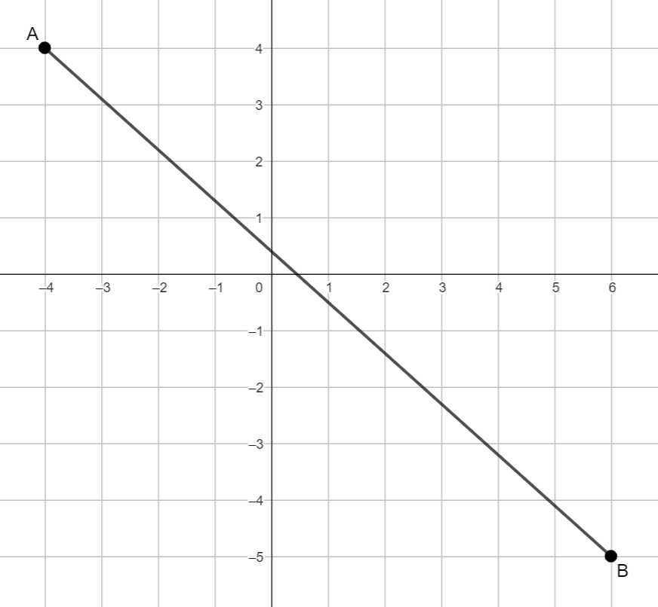
Part A. If $P$ is partitioning $\overline{AB}$ at $\left(1, -\frac{1}{2}\right)$, what is the ratio of the partition?
Part B. If $M$ is the midpoint of $\overline{AB}$, $N$ is the midpoint of $\overline{MB}$, and $L$ is the midpoint of $\overline{NB}$, what is the ratio of the partition of $\overline{AB}$ by $L$?
Part C. What are the coordinates of the point that partitions $\overline{AB}$ in the ratio $2:3$?
Part D. What is the weight average of $A$ and $B$ if the weight on $A$ is $60\%$ of the total weight and the weight on $B$ is $40\%$ of the total weight?

Instructional Task 2 (MTR.3.1)
Trapezoid $JKLM$ is graphed on a coordinate plane.
Part A. What are the coordinates of points $J$, $K$, $L$ and $M$?
Part B. $N$ is the midpoint of $\overline{JK}$ and $P$ is the midpoint of $\overline{LM}$. What are the coordinates of points $N$ and $P$?
Part C. Find $KL$, $JK$ and $NP$. What do you notice?
Part D. Find the slopes of $\overline{JM}$ and $\overline{KL}$. What do you notice?
Part D. Can you use your answers from Part C and Part D to prove the Trapezoid Midsegment Theorem?

Instructional Task 3 (MTR.5.1)
Circle $A$ is centered at $(2, 2)$ and contains the point $P(4,4)$.
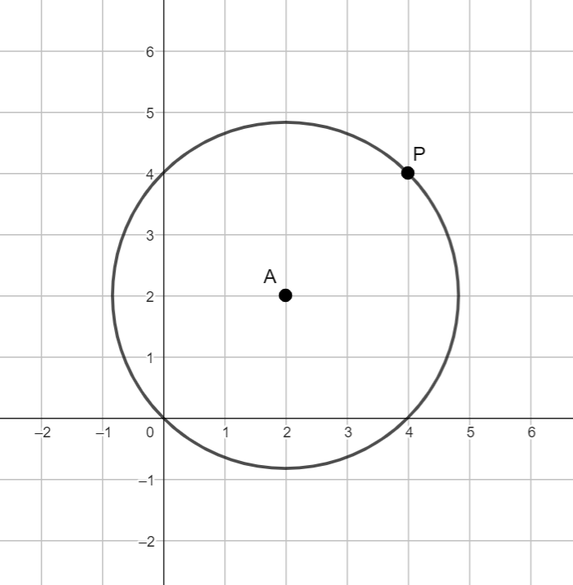
Part A. Write the equation of the line containing the radius through to $P$.
Part B. Write the equation of a line tangent to $⨀A$ at $P$.
Part C. Can we use the equations from Part A and Part B to verify the property of tangent lines that state that a line tangent to a circle is perpendicular to the radius at the point of tangency?
Part C. Write the equation of a line tangent to $⨀A$ and vertical.
Part D. Write the equation of a line tangent to $⨀A$ and horizontal.
Part E (Optional). Write the equation of $⨀A$ (MA.912.GR.7).

Instructional Task 4 (MTR.3.1)
$∆ABC$ has two of its three the vertices at $(-4,-1)$ and $(3,-3)$.
Part A. If $∆ABC$ has its centroid at $\left(-1,\frac{1}{3}\right)$. What are the coordinates of the third vertex of the triangle?
Part B. Determine whether $∆ABC$ is right based on its angle measures and its side lengths (MA.912.GR.3.1).
Part C. If $∆ABC$ is not right, can you classify what type of triangle $ABC$ is? (MA.912.GR.3.1)
Instructional Task 5 (MTR.2.1, MTR.4.1, MTR.5.1)
Given $∆ABC$ and its medians.
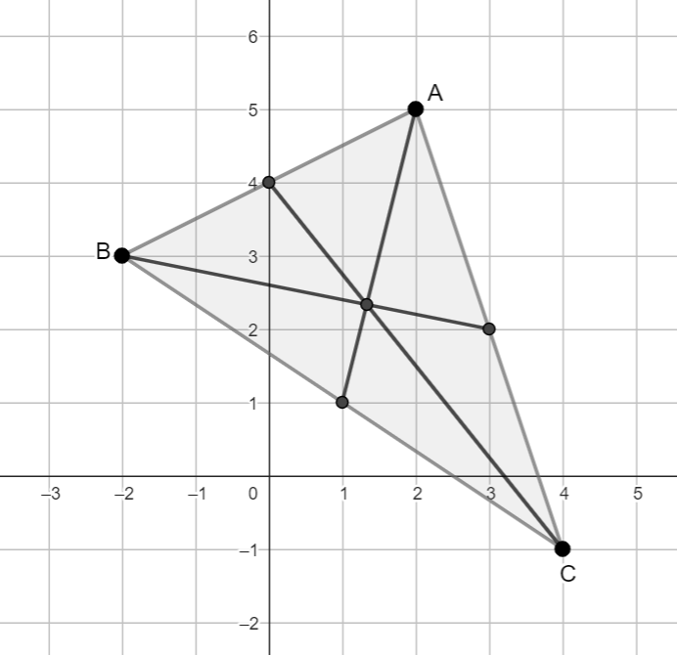
Part A. Find the midpoints of the three sides of $∆ABC$. Label them $D$, $E$ and $F$.
Part B. Write the equations of the lines containing two of the medians of the triangle.
Part C. Find the solution of the system of equations formed in Part B.
Part D. Write the equation of the line containing the third median of the triangle.
Part E. Check that the solution found from Part C satisfies the equation from Part D. If so, what can you conclude about the three medians of the triangle?

Instructional Task 6 (MTR.2.1, MTR.4.1, MTR.5.1)
Given triangle $ABC$ and its medians shown in the figure, prove that they meet in a point, $P$.
Part A. Find the midpoints of the three sides of triangle $ABC$. Label them $D$, $E$ and $F$.
Part B. Write the equations of the lines containing two of the medians of the triangle.
Part C. Find the solution of the system of equations created from the equations in Part B. Compare your solution with a partner.
Part D. Write the equation of the line containing the third median of the triangle.
Part E. Check that the solution from Part C satisfies the equation from Part D. If so, what can you conclude about the three medians of the triangle?

Instructional Items
Instructional Item 1
Given $J(-4,2)$ and $K(2,1)$, find the coordinates of point $M$ on $\overline{JK}$ that partitions the line segment in the ratio $1:2$.

Instructional Item 2
Circle $K$ has its center at $(2,-3)$, with a tangent line with equation $x=0$. Write the equation of a line tangent to the circle and perpendicular to $x=0$.

Instructional Item 3
Given $∆KIM$with vertices at $K(2,-3)$, $I(-8,-3)$, and M$(-12,-8)$, what are the coordinates for the centroid of the triangle?
*The strategies, tasks and items included in the B1G-M are examples and should not be considered comprehensive.

MA.912.GR.3.4

Benchmark
MA.912.GR.3.4 Use coordinate geometry to solve mathematical and real-world problems involving perimeter or area of polygons.
Example: A new community garden has four corners. Starting at the first corner and working counterclockwise, the second corner is 200 feet east, the third corner is 150 feet north of the second corner and the fourth corner is 100 feet west of the third corner. Represent the garden in the coordinate plane, and determine how much fence is needed for the perimeter of the garden and determine the total area of the garden.
Connecting Benchmarks/Horizontal Alignment
- MA.912.GR.4.4
Terms from the K-12 Glossary
- Area
- Perimeter
- Polygon
Vertical Alignment
Previous Benchmarks  - MA.2.GR.2  - MA.3.GR.2  - MA.4.GR.2  - MA.5.GR.2  - MA.6.GR.2  - MA.7.GR.1.1, MA.7.GR.1.2  - MA.8.GR.1.2  - MA.912.AR.2.1 | Next Benchmarks  - MA.912.C.5.5

Purpose and Instructional Strategies
In grade 6, students solved problems including the perimeter and the area of a rectangle on the coordinate plane. In grades 6 and 7, students found the area of triangles, trapezoids, parallelograms, rhombi, and polygons, decomposing into triangles and quadrilaterals. In Geometry, students find perimeters and areas of polygons on the coordinate plane. In later courses, students will find areas using calculus.
- For the expectations of this benchmark students use the Geometry EOC Mathematics Reference Sheet for the formulas to find the area of a parallelogram and the area of a trapezoid ($b=$ base and $h=$ height).
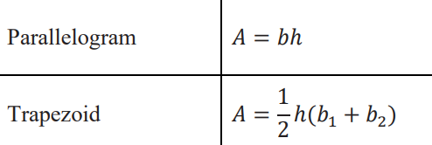
- The Geometry EOC Mathematics Reference Sheet also includes the formula to find the area of a regular polygon, where $P=$ perimeter and $a=$ apothem.
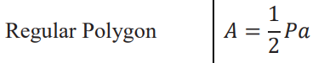
- Students a should be able to recall the formula to find the area of a triangle ($A=\frac{1}{2}bh=\frac{bh}{2}$) (Grade 6).
- Students should be able to consider any side of a triangle as its base (not necessarily horizontal), and its height as the segment that starts at the vertex opposite to the base and forms right angles with the base. Students should be able to determine the height of a triangle when the triangle is acute, right, and obtuse.
- For example, the height of the following triangles is $3$.
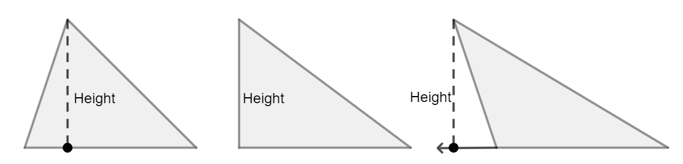
- Students should be able to identify the base and the height of a parallelogram, including rectangles, rhombi, and squares.
- Instruction includes determining the perimeter and the area of a polygon with exact values (e.g., $\sqrt{40}$) and with approximated values (e.g., $6.32$). Students are not expected to simplify radicals but to identify similar numerical expressions (e.g., $\sqrt{40}=2\sqrt{10}$).
- Instruction includes writing a numerical and an algebraic expression that represents the perimeter and the area of a polygon (e.g., $P=3+\sqrt{2}+\sqrt{5}$, $A=\frac{pq}{2}+3pq$), including the areas of composite figures and the areas of shaded regions.
- Students should develop the understanding that rounding partial answers when finding perimeters and areas may affect the final answer (e.g., $P=\sqrt{8}+\sqrt{3}=2.8+1.7=4.5$ versus $P=\sqrt{8}+\sqrt{3}=4.6$).

- Instruction includes using the corresponding units for perimeter and for area (e.g., inches and square inches). Students should be able to convert units when needed. Some customary and metric conversions can be found in the B.E.S.T. Geometry EOC Mathematics Reference Sheet.
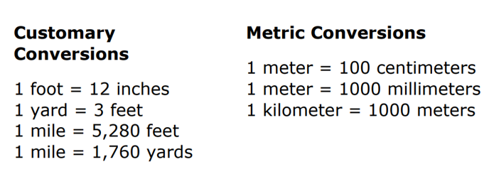
- Instruction includes the definition of apothem of a regular polygon as the line segment joining the center of the polygon with the midpoint of one of its sides. The center of a polygon is where the angle bisectors of the interior angles of the polygon meet. Students are not expected to determine the center of the polygon.
- Instruction includes finding the area of a regular polygon, given the coordinates of the center. Students should determine the side length of the regular polygon, its perimeter and the apothem using the Distance Formula or the Pythagorean Theorem. Students use their preferred method.
- Mathematical and real-world problem types include, but are not limited to:
- The perimeter of regular and irregular polygons
- The area of triangles and quadrilaterals using formulas
- The area of composite figures using different methods
- Shaded areas formed by triangles and quadrilaterals
- Missing dimensions given the perimeter and the area of the polygon
- Cost of projects based on perimeter and area
- Decision making based on perimeter and area
- Problem types include polygons that are convex (where all interior angle measures are less than 180 degrees), concave (where at least one interior angle measure is more than 180 degrees), regular (where all interior angle measures and side lengths are equivalent) and irregular.
- Instruction includes the use of the distance formula and the Pythagorean Theorem to find the lengths of the sides of a given polygon to determine its perimeter and its area. Students use their preferred method.

- Instruction includes various methods to determine the area of polygons or composite figures on the coordinate plane.
  - Method 1: Addition
The given polygon is decomposed into triangles and rectangles (or other quadrilaterals). The area of the polygon or composite figure is the sum of all the partial areas. When decomposing a polygon into triangles and quadrilaterals, the arrangement of these figures cannot produce gaps or overlapping. The image shows one of the possible ways to decompose the given pentagon. In this case, the sum of the areas of the three triangles and the two trapezoids equals the area of the polygon. $A=3+10+2+4.5+3=22.5$.
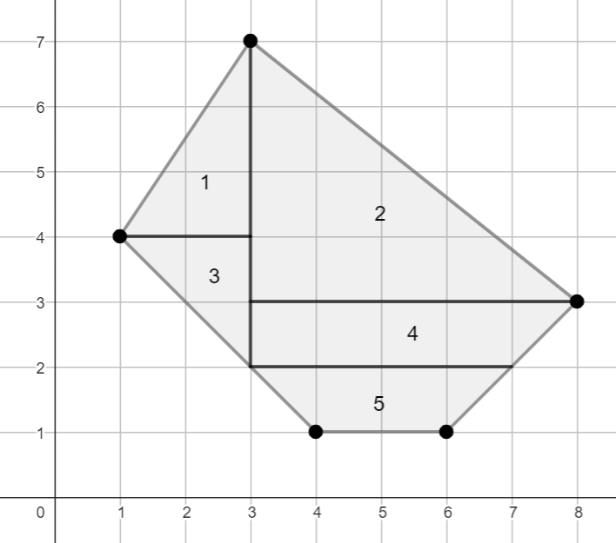
  - Method 2: Subtraction
The given polygon is enclosed in a rectangle, that includes as many vertices of the polygon as possible. The area of the polygon results from subtracting the area(s) of the shape(s) in the rectangle but not in the polygon from the area of the rectangle. The image shows one of the possible ways to enclose the given pentagon. In this case, the given polygon is inscribed in a rectangle, with base $7$ units, height $6$ units and area $42$ square units, and the area of the polygon equals the area of the rectangle, $42$, minus the areas of the four triangles. $A=42-\left(3+10+4.5+2\right)=42-19.5=22.5$

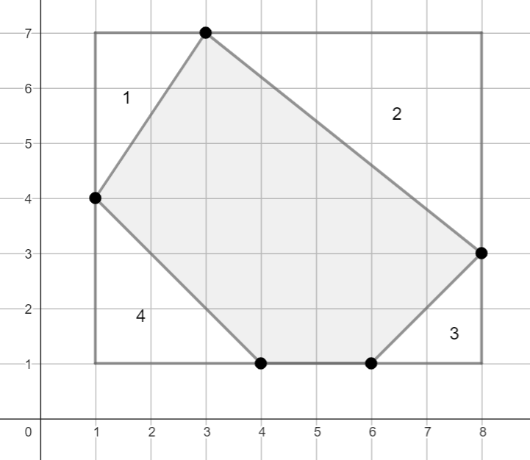

- For enrichment of this benchmark, instruction includes non-traditional methods to find areas.
  - Hero’s Formula (just for triangles): $A=\sqrt{s(s-a)(s-b)(s-c)}$, where $s$ is the semi-perimeter of the triangle and $a$, $b$, and $c$, the lengths of its sides.
The convenience of this formula depends on the convenience of determining the perimeter of the triangle. Given a triangle with side lengths $6$, $7$, and $11$, its perimeter is 24 and its semi-perimeter is $12$. Its area is $\sqrt{(12)(6)(5)(1)}=\sqrt{360}$.
  - Shoelace Method: using the coordinates of the vertices of the given polygon.
The $x-$coordinates and the $y-$coordinates of all the vertices are written in columns, starting, and ending with the coordinates of $A$. The shoelace represents the partial products (e.g., $3∙3=9$ and $7∙8=56$) organized in columns, too. These products (in red) are added, and the area of the polygon is the absolute value of the difference between the two sums divided by $2$.
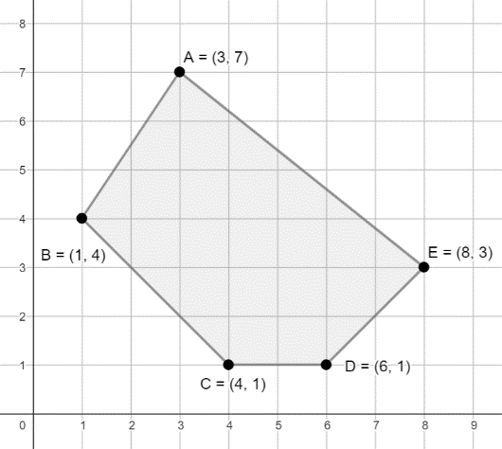
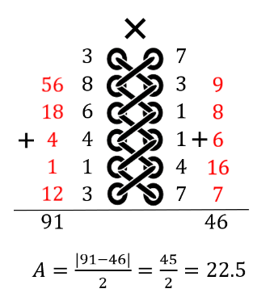

  - Pick’s Theorem: $A=I+\frac{B}{2}-1$, where $I$ is the number of points in the interior and $B$ is the number of points on the boundaries of the given polygon.
The given polygon has $18$ points in the interior and $9$ points on the boundaries. $A=19+\frac{9}{2}-1=22.5$.
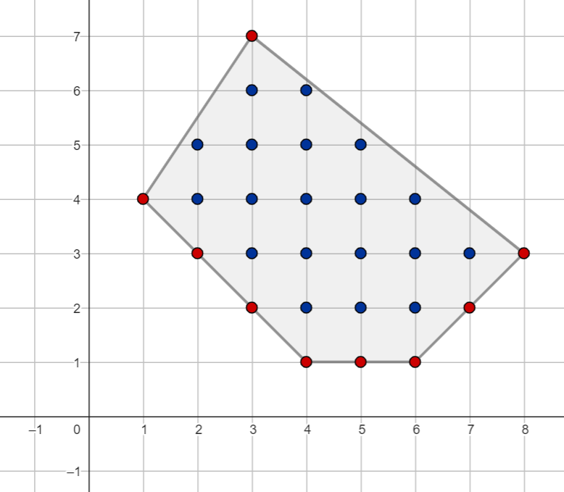

Common Misconceptions or Errors
- Students may label incorrectly the base and the height of triangles, and the base and the height of parallelograms.
- Students may confuse the concepts of perimeter and area.
- Students may assume that perimeter and area are in proportion (e.g., if the perimeter is doubled, then the area is doubled).
  - For example, $\frac{8}{4}≠\frac{10}{6}$.
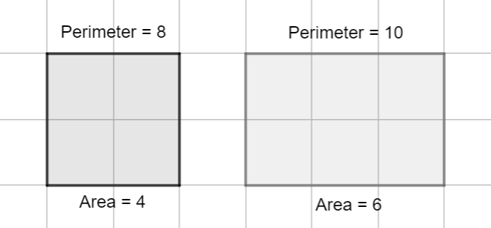
- Students may assume the larger the area, the larger the perimeter, and vice versa.
- For example, $2<6$, but $28>22$.
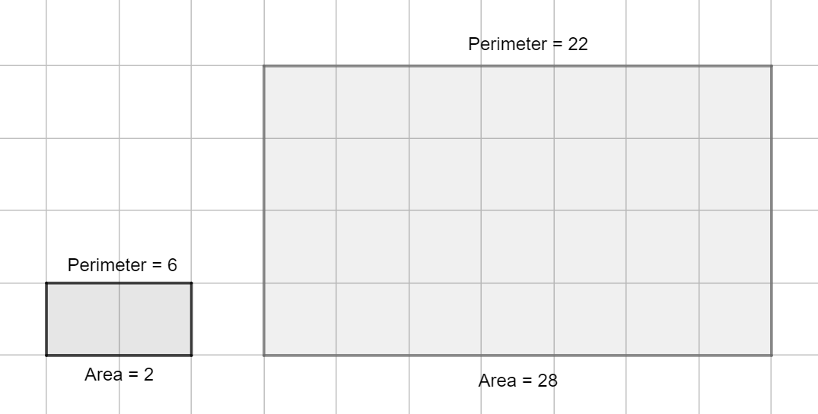
- Students may assign units of lengths to areas (e.g., $A=4$ inches).

Strategies to Support Tiered Instruction
- Students should have practice finding the distance between two points on the coordinate plane or the length of a give line segment on the coordinate plane. Students use their preferred method (Distance Formula or Pythagorean Theorem).
- Students should have practice finding areas of single polygons, including parallelograms and trapezoids on the coordinate plane using the Geometry EOC Mathematics Reference Sheet.
- Teacher models how to use the formula for a parallelogram to determine the area of triangle, a rectangle, a rhombus, and a square.
- Instruction includes creating a foldable or graphic organizer with the formulas to find triangles and quadrilaterals.
- Students should use hands-on activities and manipulative to decompose polygons or composite figures into triangles and quadrilaterals.

Instructional Tasks
Instructional Task 1 (MTR.3.1, MTR.6.1)
Given parallelogram $EFGH$ with vertices $E(-1, 5)$, $F(2, 8)$, $G(4, 4)$ and $H(1, 1)$.
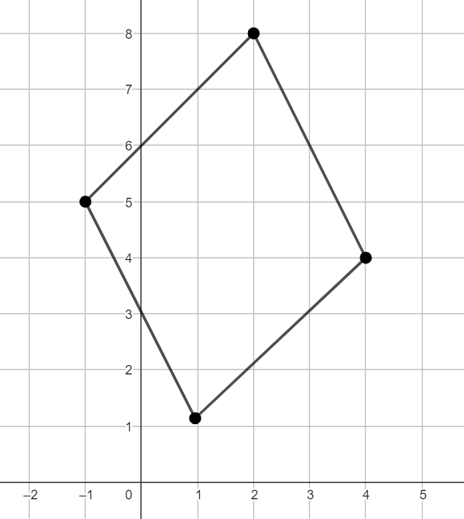
Part A. Find the exact perimeter and the exact area of the parallelogram.
Part B. Write the perimeter and the area of the parallelogram rounded to the nearest tenth.
Part C. Show that the area of the parallelogram determined in Part A is the same if the area is found decomposing the quadrilateral into triangles and rectangles (by addition) and enclosing the parallelogram in a rectangle (by subtraction).

Instructional Task 2 (MTR.2.1, MTR.4.1)
Joe’s commute to work can be represented in the coordinate plane as follows:
- His house is at $H(0,0)$.
- His favorite coffee shop is at $C(7, 6$) where he stops every morning.
- His office is at $W(4, 13)$.
Joe goes back home from his office every day without stopping.
Part A. Assume that Joe lives in a city where the roads are parallel to the coordinate axes and each intersection occurs at integer coordinates. Represent his daily route on the coordinate plane.
Each square on the coordinate plane is $1$ unit by $1$ unit, and $1$ unit on the coordinate plane is $175$ yards in real-world.
Part B. What is the total distance, in yards, that Joe commutes every day, if he uses the roads of his city?
Part C. If Joe could take the most direct route (cutting across city blocks) for his commute, what would be the total distance, in yards, that he commutes every day?

Instructional Task 3
Zack is building a dog pen and fencing a rectangular grassy area for his new Dalmatian puppy, Lucky.
- Lucky will grow to be a large dog, so Zack needs to build a dog pen with an area of $30$ squared feet minimum.
- The veterinarian has recommended that Lucky has a fenced grassy area no smaller than 2600 squared feet.
- The dimensions of Zack’s backyard are 32 feet by 110 feet.

Part A. To build the rectangular dog pen for Lucky, Zack plans to purchase plywood sheets that are $4$ feet by $8$ feet each. The maximum height of the pen will be 4 feet and he will not build a roof. If the plywood sheets cannot be cut, what is the minimum number of plywood sheets that he must purchase to ensure that Lucky’s pen meets the minimum space requirements and fits in his backyard?

Part B. Does Zack have a big enough backyard to accommodate Lucky and meet the minimum fenced grassy area recommended by the veterinarian?

Part C. If fencing panels are sold in $6$ feet by $8$ feet wood panels, and cannot be cut, and Zack plans to fence a rectangle with a maximum width of 30 feet and a maximum length of 90 feet, will this fenced grassy area meet the veterinarian’s size recommendations? If so, how many fence panels will Zack need to purchase?

Part E. What is the perimeter of the dog pen? What is the perimeter of Zack’s unfenced backyard? What is the perimeter of the fenced grassy area for Lucky?

Instructional Task 4
The Move With Us Team is planning to run around a rectangle about the area covered by Polk County and Osceola County.
- In the map, each unit square is approximately $25$ miles by $25$ miles.
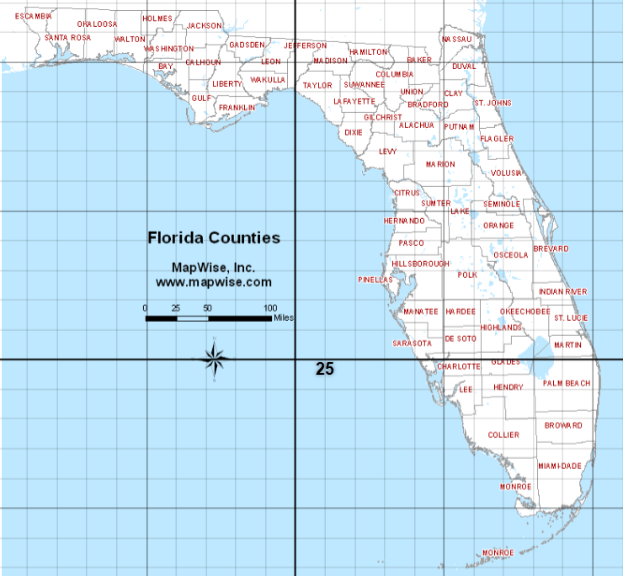
Part A. Plot a rectangle on the map that best encloses the area covered by Polk County and Osceola County, using the grid. What are the coordinates of the four vertices of the rectangle?
Part B. What would be the total distance of the run, in miles?
Part C. Assume that the group runs a total of 10 miles every day, how many days would it take them to complete the distance around the two counties?

Instructional Task 4
Given the kite on the coordinate plane.
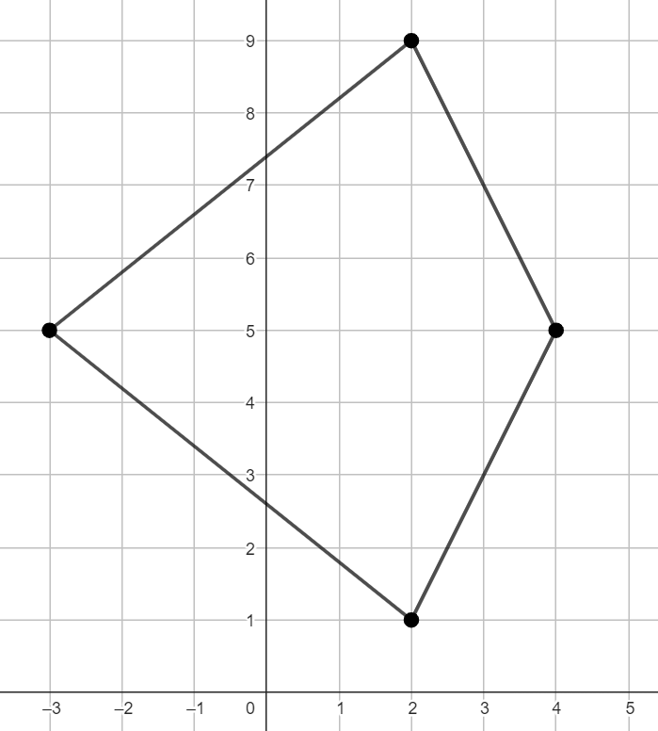
Part A. Find the area of the kite using your preferred method.
Part B. Draw the diagonals of the kite and find the area of right triangles formed by the diagonals.
Part C. Show the area obtained in Part A is equivalent to the sum of the area of the right triangles found in Part B.
Part D. Determine the length of the diagonals of the kite, $d_{1}$ and $d_{2}$.
Part E. Use the following formula to find the area of the kite: $A=\frac{d_{1}d_{2}}{2}$. What do you notice?
Part F. How could you explain the formula in Part E works for this kite? Could you use this formula for any kite? Could you use this formula for any rhombus? Show examples.
Instructional Items
Instructional Item 1
The quadrilateral on the coordinate plane is a dart or concave kite. Find its diameter and its area.
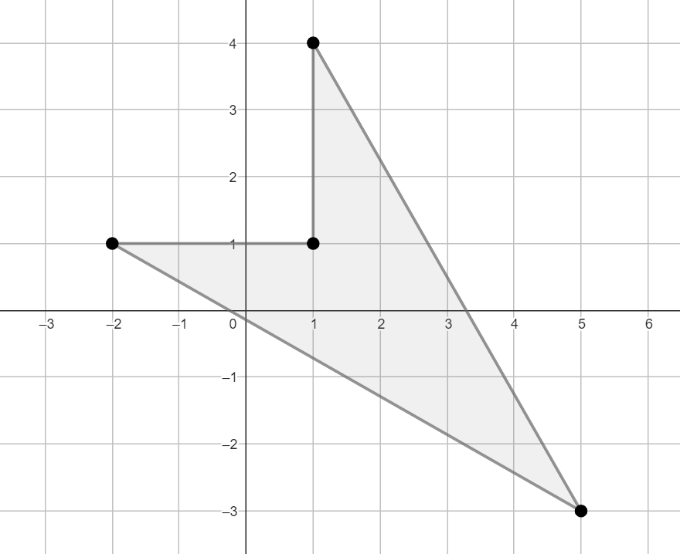

Instructional Item 2
Find the perimeter and the area of the shaded region.
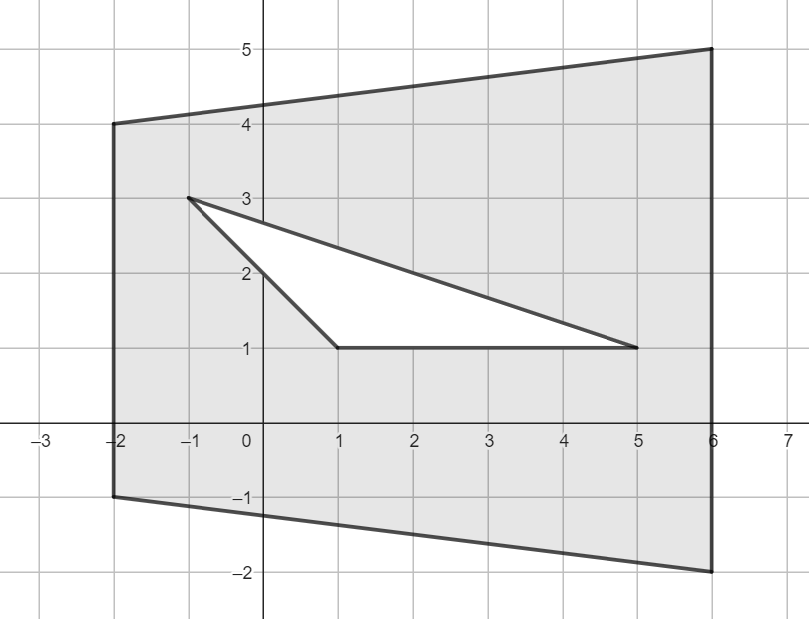

Instructional Item 3
Find the approximate area of the regular octagon, with $A(1.5, -2)$ and $B(6.5, -2)$. The coordinates of $A$ and $B$ are approximations.

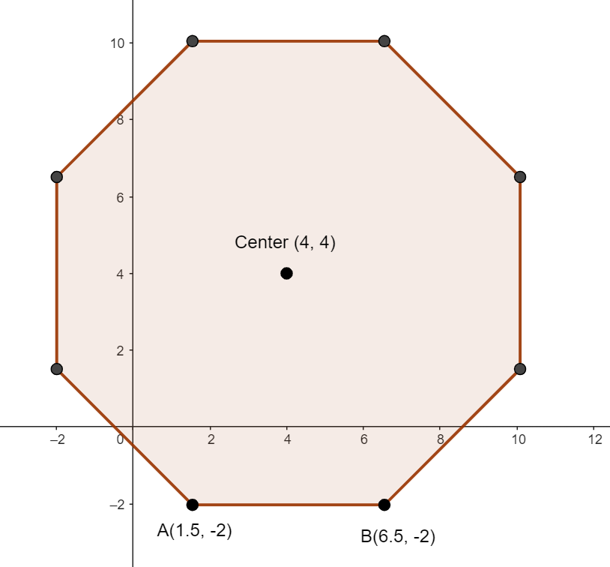
*The strategies, tasks and items included in the B1G-M are examples and should not be considered comprehensive.

MA.912.GR.4 Use geometric measurement and dimensions to solve problems.

MA.912.GR.4.1

Benchmark
MA.912.GR.4.1 Identify the shapes of two-dimensional cross-sections of three-dimensional figures.
Benchmark Clarifications:
Clarification 1: Instruction includes the use of manipulatives and models to visualize cross-sections.
Clarification 2: Instruction focuses on cross-sections of right cylinders, right prisms, right pyramids and right cones that are parallel or perpendicular to the base.

Connecting Benchmarks/Horizontal Alignment
- MA.912.GR.1.5
Terms from the K-12 Glossary
- Circle
- Cone
- Cylinder
- Prism
- Pyramid
- Rectangle
- Square
- Triangle
Vertical Alignment
Previous Benchmarks  - MA.5.GR.1  - MA.6.GR.2.4  - MA.7.GR.2.1 | Next Benchmarks  - MA.912.GR.7  - MA.912.C.5.7
Purpose and Instructional Strategies
In grade 6, students solved problems involving the volume and the surface area of right rectangular prisms, using visual models and the figure’s net. In grade 7, students extended their understanding of right rectangular prisms to right circular cylinders and found their volume and their surface area. In Geometry, students extend their knowledge of three-dimensional figures to right prisms (other than rectangular), right cones, right pyramids, and sphere. When exploring three-dimensional figures, students determine their two-dimensional cross-sections, parallel and perpendicular to the bases. In benchmark MA.912.GR.4.5, students apply the understanding of cross-sections and the Cavalieri’s Principal to give informal arguments about the formulas for the volumes of right and non-right cylinders, prisms, pyramids, and cones. In later courses, students will define conic sections as the cross-sections of a double cone and use cross-sections to find the volume of three-dimensional irregular figures using integrals.
- From the clarifications of this benchmark, students are not expected to identify two-dimensional cross-sections of non-right, or oblique, three-dimensional figures.
- Students should develop the understanding that two-dimensional cross-sections may include circles, triangles, rectangles, squares, trapezoids, and other polygons. When the two-dimensional cross-section is parallel to the base, then it has the shape of the base.
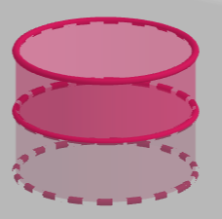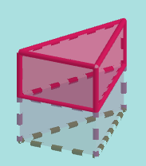
- Instruction includes the cross-section perpendicular to the base of a cone, just when it passes through the apex. This cross-section is an isosceles triangle. Students are not expected to memorize that the cross-section of a cone, perpendicular to the base and not passing through the vertex, describes a hyperbola. However, students should develop the understanding that a cross-section of a cone, perpendicular to the base and not passing through the apex, determines is a figure with a straight side and a curve, not a polygon.
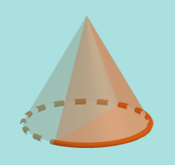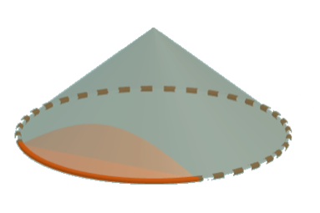
- Instruction focuses on equilateral triangle pyramids and square and rectangular pyramids, and the two-dimensional cross-sections perpendicular to the base. Students should develop the understanding that when the line segment where the cross-section and the base intersect is parallel to one of the sides of the base, then the cross-sections are triangles and trapezoids.
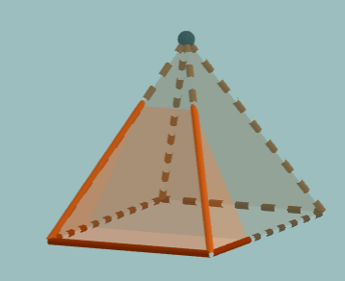
- Instruction includes utilizing objects, such as soda cans, cereal boxes, or party hats, as models to explore their two-dimensional cross-sections. Additionally, students can explore other cross-sections using manipulatives such as clay and string to cut through the three-dimensional figure. (MTR.7.1)
- For enrichment of this benchmark, students should explore two-dimensional cross-sections of three-dimensional figures not included in the clarification, or two-dimensional cross-sections that are nor parallel nor perpendicular to the bases. Students should consider the two0dimensional cross-sections of spheres that are parallel and perpendicular to the great circle.

- For enrichment of this benchmark, students should identify two-dimensional cross-sections of composite figures, resulting from arrangements of right cylinders, right prisms, right pyramids, and right cones, and perpendicular to the bases.
- For enrichment of this benchmark, students should compare the two-dimensional cross-sections, parallel to the bases, of two prisms, two cylinders, two pyramids, and two cones, one right and one oblique.
- For extension of this benchmark, instruction includes exploring the cross-sections resulting from planes parallel, perpendicular, and diagonal to the base of a composite three-dimensional figure formed by a double cone. These cross-sections are known as the conic sections.

Common Misconceptions or Errors
- Students may identify two-dimensional cross-sections using the names of a different shape (e.g., rectangle instead of trapezoid).
- Students may fail to identify the two-dimensional cross-section due to difficulties visualizing three-dimensional figures.
- Students may have difficulty with some two-dimensional cross-sections when perpendicular to the base of three-dimensional figures and misidentify them.
- For example, given an equilateral triangle pyramid, students may identify the two-dimensional cross-section shown in the image as an equilateral triangle.
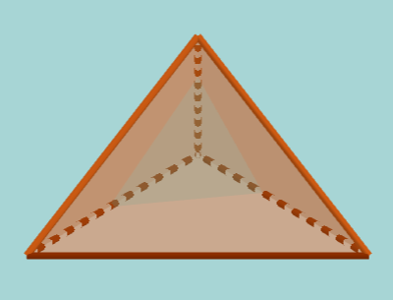

Strategies to Support Tiered Instruction
- Students should have practice determining the best name for the base of prisms and pyramids.
- Students should have practice identifying two-dimensional cross-sections using common objects that can be cut (e.g., cone paper cups or ice cream cones, roll cardstock tubes, cereal boxes).
- Instruction includes the use of manipulatives. Students should have opportunities to explore three-dimensional figures, holding and rotating them to identify different two-dimensional cross-sections. If using clear geometric solids, rubber bands can help students determine a two-dimensional cross-section. Students should have practice drawing the two-dimensional cross-sections of the three-dimensional figures when using manipulatives.
- Instruction includes the use of animations available on the Internet.

Instructional Tasks
Instructional Task 1 (MTR.3.1, MTR.4.1)
Draw and name…
- right three-dimensional figures that could have a triangular cross-section.
- right three-dimensional figures that could have a circular cross-section.
- right three-dimensional figures that could have a rectangular cross-section.
- right three-dimensional figures that could have a trapezoidal cross-section.
Compare your answers with a partner.
Instructional Task 2 (MTR.3.1)
Part A. Fill in the blank.
Right cylinders and right prisms have ________ cross-sections perpendicular to the base.
Part B. Draw cross-sections perpendicular to the base for each figure below.
Part C. Draw cross-sections parallel to the base for each figure below
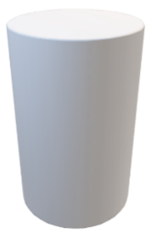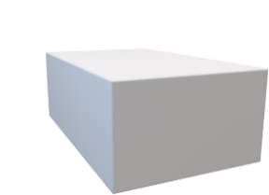

Instructional Items
Instructional Item 1
Which of the following polygons are cross-sections that are parallel or perpendicular to the base of a regular pentagonal pyramid? Select all that apply.
- Triangle
- Parallelogram
- Trapezoid
- Pentagon
- Hexagon
- Octagon

Instructional Item 2
Name a possible two-dimensional cross-section to each of the following three-dimensional figures, parallel or perpendicular to the bases:
- Right Square Prism
- Right Cylinder
- Right Cone
- Right Square Pyramid

Instructional Item 3
Identify the image that corresponds to a two-dimensional cross-section perpendicular to the base of the following three-dimensional figure.
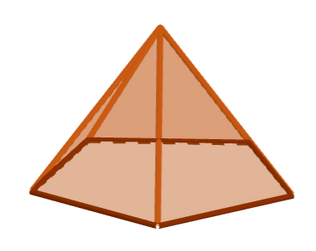
A | B | C | D
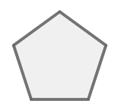 | 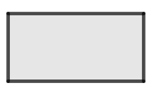 | 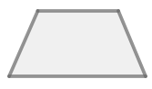 | 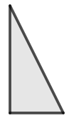

*The strategies, tasks and items included in the B1G-M are examples and should not be considered comprehensive.

MA.912.GR.4.2

Benchmark
MA.912.GR.4.2 Identify three-dimensional objects generated by rotations of two-dimensional figures.
Benchmark Clarifications:
Clarification 1: The axis of rotation must be within the same plane but outside of the given two-dimensional figure.
Connecting Benchmarks/Horizontal Alignment
- MA.912.GR.2.4, MA.912.GR.2.5
Terms from the K-12 Glossary
- Circle
- Cone
- Cylinder
- Prism
- Pyramid
- Rectangle
- Square
- Triangle

Vertical Alignment
Previous Benchmarks  - MA.5.GR.1.2 | Next Benchmarks  - MA.912.C.5.7

Purpose and Instructional Strategies
In grade 6, students solved problems involving the volume of right rectangular prisms, using visual models and the figure’s net. In grade 7, students extended their understanding of right rectangular prisms to right circular cylinders and found their volume. In Geometry, students identify the three-dimensional figure that results from the rotation of a two-dimensional figure about an axis. In later courses, students will use rotations of two-dimensional figures to determine a solid of revolution and its volume using integrals. (MTR.5.1)
- For expectations of this benchmark, the axis of rotation may be horizontal, vertical, or diagonal.
- Students should have practice rotating isosceles triangles and rectangles about their axis of symmetry and naming the resulting three-dimensional figure.
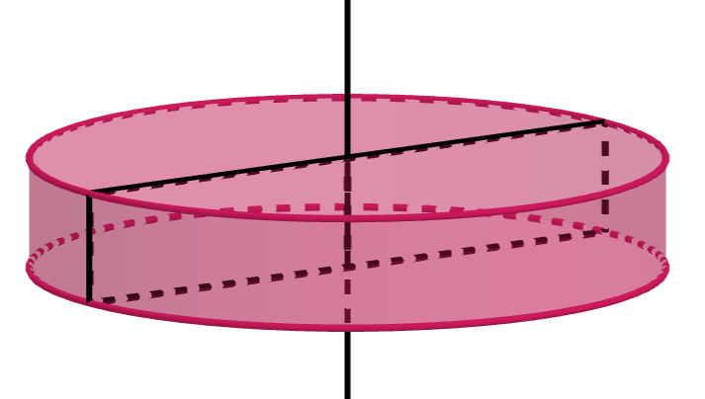
- Instruction includes axes of rotations containing one of the sides of the two-dimensional figure, including regular and irregular polygons, and other figures.
- For example, when a rectangle is rotated about one of its sides, it generates a cylinder.
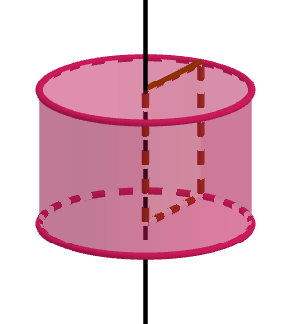
  - For example, when a right triangle is rotated about its hypotenuse, it generates a double cone.
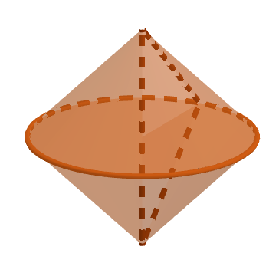
  - For example, when a right trapezoid is rotated about the nonparallel side forming the right angles, it generates a frustum.
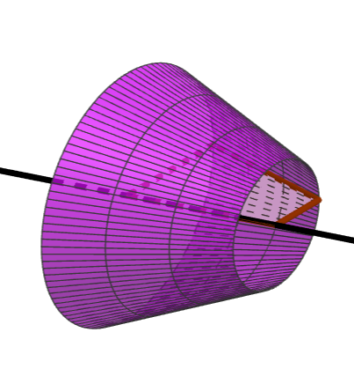
- Instruction extends the understanding of the rotations described prior to rotations when the axis of the rotation is outside the two-dimensional figure.
  - For example, a rectangle rotated about a line that is parallel to one of its sides generates a hollow cylinder.
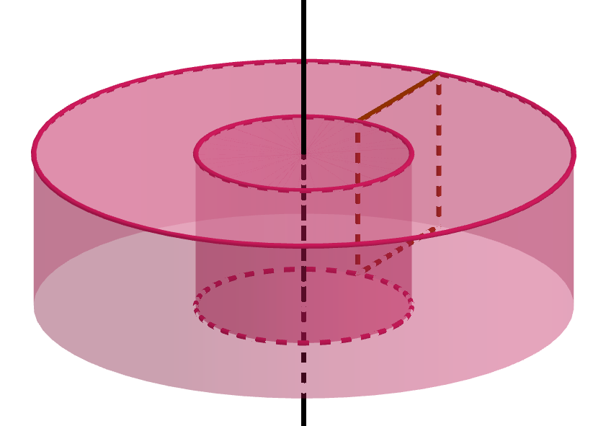
  - For example, a circle rotated about an axis of rotation outside of the circle generates a torus.
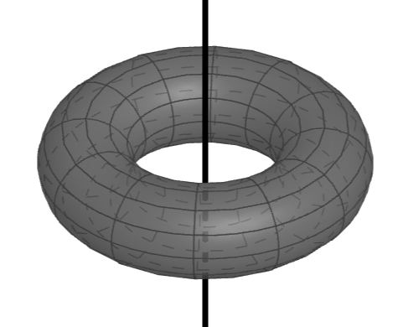
- Instruction includes identifying the name and the image of the three-dimensional figure generated by rotating a two-dimensional figure.
- Instruction includes two-dimensional figures and axes of rotation on the coordinate plane. The axes of rotation are limited to lines parallel to the $x-$ axis and the $y-$axis. Students should be able to identify attributes of the three-dimensional figure (e.g., the radius of a cylinder). Instruction makes connection with finding the volume of three-dimensional figures (MA.912.GR.4.5).
- Students should make connections between coordinate geometry and two-dimensional figures on the coordinate plane rotated to generate three-dimensional figures. Instruction includes connections with transformations (MA.912.GR.2), notions of distance, midpoint, and slope, and definitions and properties of two-dimensional figures (MA.912.GR.3) and the equation of a circle (MA.912.GR.7).
- Students should develop the understanding that prisms and pyramids cannot be obtained rotation a two-dimensional figure about an axis.
- For enrichment of this benchmark, students should explore solids of revolution generated by the rotation of two-dimensional curved figures.
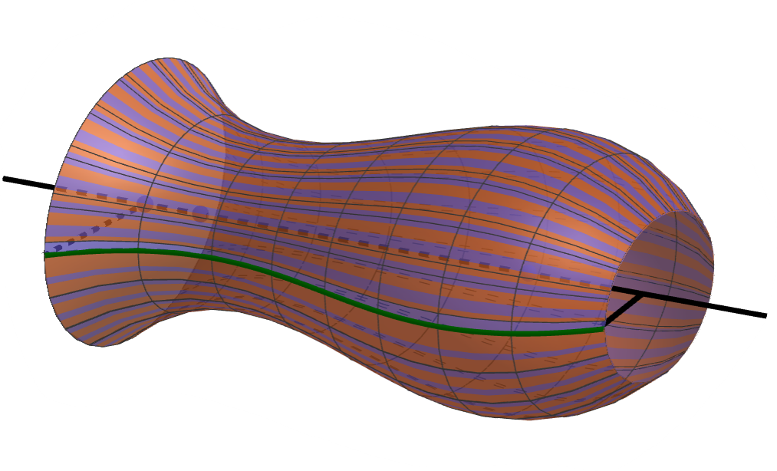
- Instruction includes the use of models, manipulatives, and animations.
  - For example, with straw and geometric figures cut outs, students can explore the three-dimensional figures generated by the rotation of two-dimensional figures with hands-on activities.
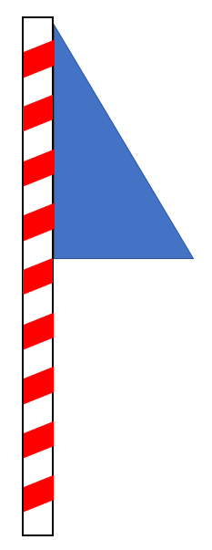

Common Misconceptions or Errors
- Students may have difficulties visualizing the three-dimensional figures generated by rotations of two-dimensional figures and use the name of the two-dimensional figures to identify the best name of the resulting three-dimensional figures.
- Students may identify incorrectly the name of the three-dimensional figures or not use the best name (e.g., triangular prism instead of cone, prism instead of circular prism or cylinder).

Strategies to Support Tiered Instruction
- Instruction includes identifying the line of symmetry of two-dimensional figures.
- Students should have practice naming two-dimensional and three-dimensional figures. It is recommended a graphic organizer or a foldable.
- Instruction includes exploring the rotations about a line of symmetry or a side of the two-dimensional figure for the axis of the rotations, using circles, triangles, and quadrilaterals.
- Students should have practice constructing manipulatives (e.g., pencil, cardstock, and tape) and experiencing their rotations.
- Teacher models rotations with horizontal, vertical, and diagonal axis of rotations.

Instructional Tasks
Instructional Task 1 (MTR.4.1, MTR.5.1)
Right trapezoid $CDEF$ is shown on the coordinate plane below.
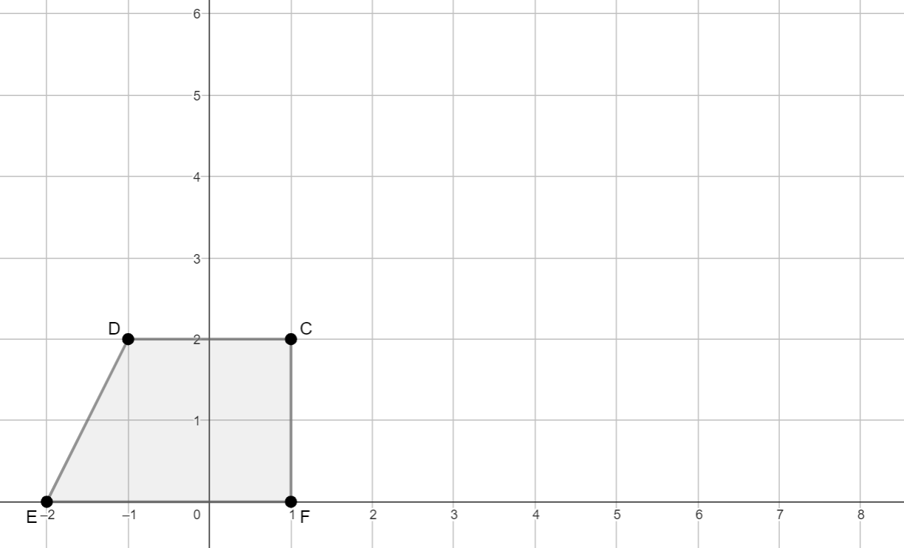
Part A. If right trapezoid $CDEF$ is rotated about line $x=1$, draw and describe the attributes of the figure generated by the rotation (dimensions of the base, height).

Part B. If $∆EFB$ is constructed by extending $\overline{FC}$, such that $F$, $C$, and $B$ are collinear with $C$ between $F$ and $B$, what kind of triangle is $∆EFB$? What are the coordinates of point $B$?
Part C. If $∆EFB$ is rotated about line $x=1$, what figure will it generate? Describe its attributes (dimensions of the base, height).
Part D. Determine the volume of the three-dimensional figure generated when rotating the right triangle.
Part E. Determine the volume of the three-dimensional figure generated when rotating the right trapezoid.
Part F. If right trapezoid $CDEF$ is rotated about line $x=3$, what figure will it generate? Draw and describe the attributes of the figure generated by the rotation (dimensions of the base, height).
Part G. Determine the volume of the three-dimensional figure generated in Part F.

Instructional Task 2 (MTR.3.1)
A circle with equation ${\left(x-7\right)}^{2}+{\left(y-5\right)}^{2}=9$ is drawn on a coordinate plane.
Part A. Identify the coordinates of the center of the circle and its radius, $r$.
Part B. Draw and describe the three-dimensional figure generated by rotating the circle about the $y-$axis (compare with common objects).
Part C. Determine the volume of the three-dimensional figure.
The formula for the volume of this three-dimensional figure is:
$V=(πr^{2})(2πd)$, where $r$ is the radius of the circle and $d$ is the distance from the axis of the rotation to the center of the circle.

Instructional Items
Instructional Item 1
Which real-world object could be used describe the figure generated by rotating a rectangle about a line that is parallel to one of its sides but not touching the rectangle?
- A doughnut
- A can of tune
- An ice cream cone
- A shoebox
- An egg

Instructional Item 2
Identify the three-dimensional figure generated by rotating the given two-dimensional figure around the given axis and describe its attributes (dimensions of the base, height).

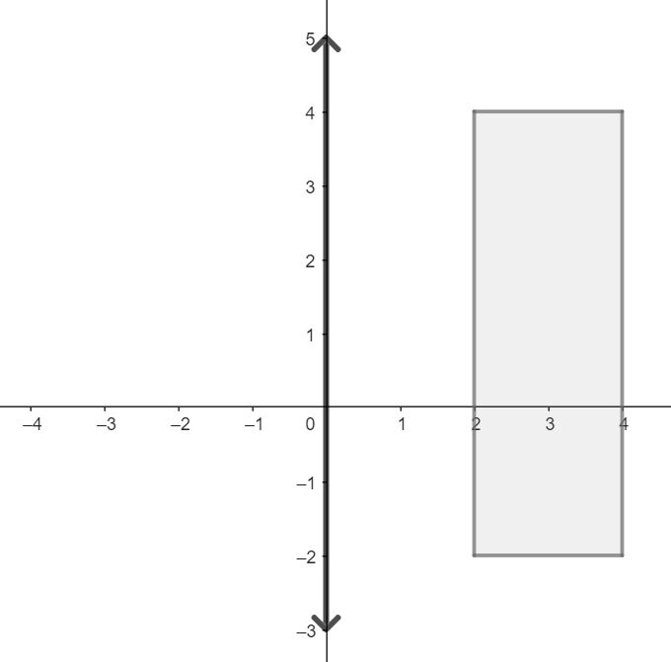 | 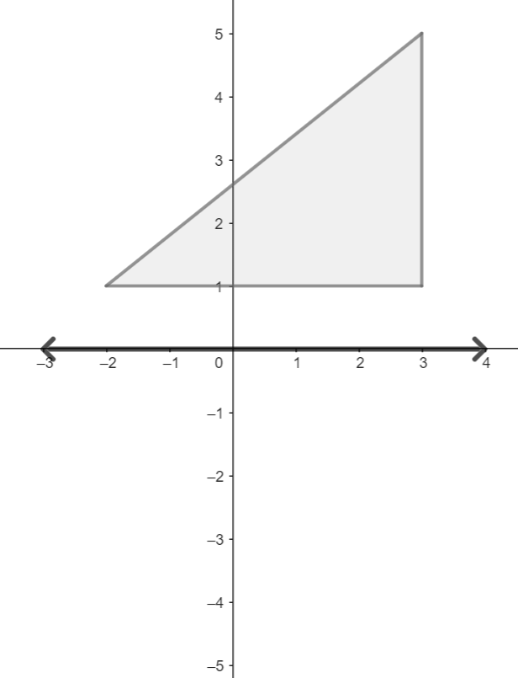 | 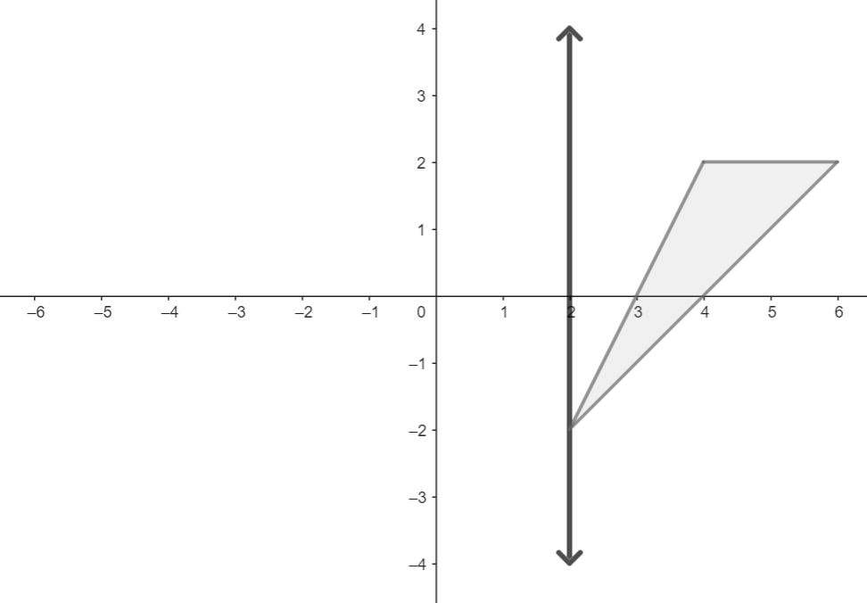

*The strategies, tasks and items included in the B1G-M are examples and should not be considered comprehensive.

MA.912.GR.4.3

Benchmark
MA.912.GR.4.3 Extend previous understanding of scale drawings and scale factors to determine how dilations affect the area of two-dimensional figures and the surface area or volume of three-dimensional figures.
Example: Mike is having a graduation party and wants to make sure he has enough pizza. Which option would provide more pizza for his guests: one 12-inch pizza or three 6-inch pizzas?
Connecting Benchmarks/Horizontal Alignment
- MA.912.GR.1.6
- MA.912.GR.2.4, MA.912.GR.2.8

Terms from the K-12 Glossary
- Area
- Scale Factor
- Scale Model
Vertical Alignment
Previous Benchmarks  - MA.7.GR.1.5  - MA.8.GR.2.2, MA.8.GR.2.4  - MA.912.AR.2.1 | Next Benchmarks
Purpose and Instructional Strategies
In grade 7, students solved problems about areas of two-dimensional figures, including the understanding that when a figure is dilated with a scale factor $k$, the ratio of the area of the resulting figure to the area of original figure is $k^{2}$. In Geometry, students extended their previous knowledge on relationships between areas to relationships between surface areas and volumes of three-dimensional figures when one is dilated to produce the other. This relationship can be applied to determine unknown dimensions or areas, surface areas, and volumes in cases when the relationship between two three-dimensional figures can be determined as a dilation (MA.912.GR.4.5-4.6). This notion is important in science courses. (MTR.2.1)
- Instruction includes reviewing that the area of the image of a dilation with scale factor $k$ is $k^{2}$ times the area of the pre-image for any two-dimensional figure (grade 7). Students should explore the relationship between these areas using examples with numerical values and progress towards algebraic expressions.
- For example, given figure $A$ and its image figure $B$ after a dilation with a scale factor $k=2$. The area of figure $A$ is $\frac{3}{2}$ and the area of figure $B$ is $6$, that is $4=2^{2}$ times the area of figure $A$. Algebraically, the area of figure $A$ is $\frac{1}{2}bh$ and the area of figure $B$ is $\frac{1}{2}(kb)(kh)$. That is, $k^{2}\left(\frac{1}{2}bh\right)$.
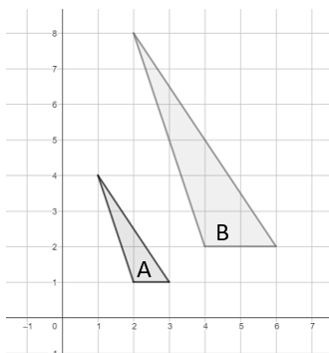

- Instruction includes the definition of the dilation of a three-dimensional figure extending the definition of the dilation of a two-dimensional figure (MA.912.GR.2).
- For example, the pyramid with base $∆ABC$ maps the pyramid with base $∆A'B'C'$ with a dilation of scale factor $3$. The height of the image is $3$ times the height of the preimage, and the dimensions of the base of the image are $3$ times the dimensions of the base of the preimage.
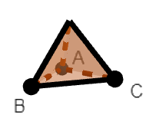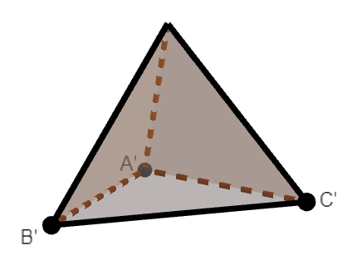
- Instruction makes connections between the relationships between areas of the preimage and image of a dilation to the relationships between surface areas and volumes. Students should have practice through problems including numerical values and work towards algebraic expressions. It is recommended to use tables to record surface areas and volumes of the preimages and the images in the dilation.
- For example, a rectangular prism with dimensions $a$, $b$, and $c$, is dilated with scale factor $k$. The image of the dilation is a rectangular prism with dimensions $ka$, $kb$, and $kc$.
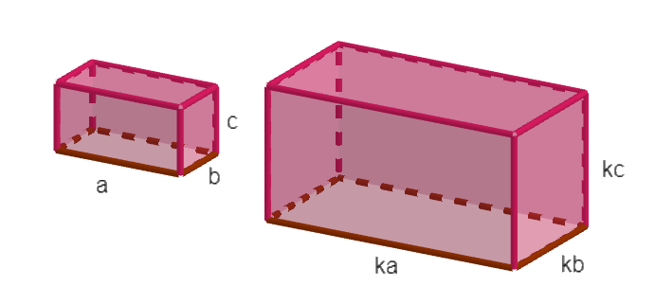
Preimage | Image
$$SA=2ab+2bc+2ac$$ | $$SA=2\left(ka\right)\left(kb\right)+2\left(kb\right)\left(kc\right)+2\left(ka\right)\left(kc\right)=$$  $$k^{2}\left(2ab\right)+k^{2}\left(2bc\right)+k^{2}\left(2ac\right)=$$  $k^{2}\left(2ab+2bc+2ac\right)=k^{2}(SA$ of the preimage$)$
$$V=abc$$ | $$V=\left(ka\right)\left(kb\right)\left(kc\right)=k^{3}\left(abc\right)=$$  $k^{3}(V$ of the preimage$)$

- For example, a cylinder with radius $r$ and height $h$ is dilated with scale factor $k$. The image of the dilation is a cylinder with radius $kr$ and height $kh$.
Preimage | Image
$$SA=2B+Ph=$$  $$2\left(πr^{2}\right)+\left(2πr\right)\left(h\right)=$$  $$2πr^{2}+2πrh$$ | $SA=2\left[π{\left(kr\right)}^{2}\right]+\left[(2πkr)(kh)\right]$=  $$k^{2}\left(2πr^{2}\right)+k^{2}\left(2πr\right)\left(h\right)=k^{2}\left(2πr^{2}+2πrh\right)=$$  $k^{2}(SA$ of the preimage$)$
$$V=Bh=\left(πr^{2}\right)(h)$$ | $$V=\left[π{\left(kr\right)}^{2}\right]\left(kh\right)=k^{2}\left(πr^{2}\right)\left(kh\right)=$$  $k^{3}(V$ of the preimage$)$
- Instruction includes the student understanding that the surface area of the image of a dilation with scale factor $k$ is $k^{2}$ times the surface area of the pre-image, and the volume of the image of a dilation with scale factor $k$ is $k^{3}$ times the volume of the pre-image for any three-dimensional figure.
- Students should develop the understanding that the scale factors $k$, $k^{2}$, and $k^{3}$ are related to the number of dimensions of the dilation. When a figure is dilated with a scale factor $k$, $k$ is the scale factor that determines the length of a line segment of the image, a measure in one dimension; $k^{2}$ is the scale factor that determines the area and surface area of the image, measures in two dimensions; $k^{3}$ is the scale factor that determines the volume of the image, a measure in three dimensions.
- Instruction includes the dilation of circles. When a circle is dilated with a scale factor $k$, the radius of the image is $k$ times the radius of the preimage, the area of the image is $k^{2}$ times the area of the preimage, and the volume of a cone or a cylinder resulting from a dilation is $k^{3}$ times the volume of the preimage.
- Problem types include finding the area of a two-dimensional figure and the surface area and the volume of a three-dimensional figure given the area, the surface area, and the volume of the preimage and the scale factor; and given the area, the surface area, and the volume of the preimage and the image after a dilation, determine the scale factor.
- Instruction includes extending the notion of the dilation of a three-dimensional figure to the transformation of the height and the dimensions of the base using different scale factors and the effect of the transformation in the surface of the image.
- For example, a cylinder with a base of radius $r$ and a height of $h$ is transformed into a cylinder with a base of radius $jr$ and a height of $kh$. The surface area of a preimage is the result of adding the areas of the bases, 2$πr^{2}$, and the lateral area, $2πrh$. The surface area of the image is the result of adding the area of the bases, $2π{(jr)}^{2}=j^{2}(2πr^{2})$, and the area of the lateral area, $2π\left(jr\right)\left(kh\right)=kk(2πrh)$.
- Instruction includes extending the notion of the dilation of a three-dimensional figure to the transformation of the height and the dimensions of the base using different scale factors and the effect of the transformation in the volume of the image.
For example, a rectangular pyramid with a base of dimensions $w$ and $l$ and a height of $h$ is transformed into a rectangular pyramid with a base of dimensions $ka$ and $lb$ and a height of $mh$. The volume of the preimage is $\frac{1}{3}Bh=\frac{1}{3}wlh$. The volume of the image is $\frac{1}{3}Bh=\frac{1}{3}\left(ka∙lb\right)\left(mh\right)=\frac{1}{3}(klm)(abh)$.
Common Misconceptions or Errors
- Students may identify two-dimensional cross-sections using the names of a different shape (e.g., rectangle instead of trapezoid).
- Students may fail to identify the two-dimensional cross-section due to difficulties visualizing three-dimensional figures.
- Students may have difficulty with some two-dimensional cross-sections when perpendicular to the base of three-dimensional figures and misidentify them.
- For example, given an equilateral triangle pyramid, students may identify the two-dimensional cross-section shown in the image as an equilateral triangle.

Strategies to Support Tiered Instruction
- Students may determine the area, the surface area, or the volume of the image of a dilation as the result of multiplying the area, the surface area, or the volume of the preimage by the scale factor $k$.
- Students may determine incorrectly the area the circle resulting from a dilation with scale factor $k$ as $k$ times the area of the preimage, or the volume of the cylinder or the cone resulting from a dilation with scale factor $k$ as $k^{2}$ times the volume of the preimage.

Instructional Tasks
Instructional Task 1 (MTR.4.1, MTR.5.1)
Answer the following questions.
Part A. Given a square pyramid with length and width of $4$ inches and height of $2$ inches, determine the surface area, in square inches, and the volume, in cubic inches, of the square pyramid.
Part B. Fill the table.
Scale factor of the dilation of the square pyramid, $k$ | Surface Area of the Image | Volume of the Image
$$k=2$$
$$k=3$$
$$k=\frac{1}{2}$$

Part C. Compare each of the new surface areas to the original surface area. Compare each of the new volumes to the original volume.
Part D. Predict the surface area and volume of the square pyramid resulting from a dilation with a scale factor of 5. Explain your method.

Instructional Task 2
A square is shown, with side length of $1$ unit.
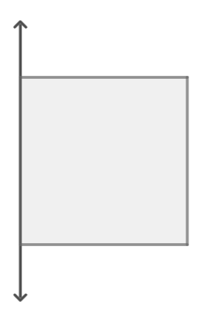
Part A. Determine the area of the square.
Part B. Determine the volume of the figure generated by the rotation of the square about the given axis of rotation.
Part C. Determine the surface area of the figure generated by the rotation of the square about the given axis of rotation.
Part D. Dilate the square with scale factor $k=4$ and repeat Parts A to C.
Part E. Write a conjecture about the relationship between the side length of the given square, the side length of the dilated square, their areas, and the volume and the surface area of the squares generated by the rotations.

Instructional Items
Instructional Item 1
The perfume Eau de Matematica is packaged in a triangular prism bottle. The dimensions of the travel size are $\frac{1}{3}$ the dimensions of the standard bottle. How does the volume of the standard bottle compare to the volume of the travel size?

Instructional Item 2
A company wants to make two water bottles with capacities of $24$ fluid ounces and $40$ fluid ounces. What is the ratio of their surface areas? (The surface area includes the bottom, the top, and the lateral areas of the bottles)
*The strategies, tasks and items included in the B1G-M are examples and should not be considered comprehensive.

MA.912.GR.4.4

Benchmark
MA.912.GR.4.4 Solve mathematical and real-world problems involving the area of two-dimensional figures.
Example: A town has 23 city blocks, each of which has dimensions of 1 quarter mile by 1 quarter mile, and there are 4,500 people in the town. What is the population density of the town?

Benchmark Clarifications:
Clarification 1: Instruction includes concepts of population density based on area.
Connecting Benchmarks/Horizontal Alignment
- MA.912.GR.1.6
- MA.912.GR.3.4
- MA.912.T.1.2
Terms from the K-12 Glossary
- Area
Vertical Alignment
Previous Benchmarks  - MA.5.GR.2  - MA.6.GR.2  - MA.7.GR.1.1, MA.7.GR.1.2  - MA.8.GR.1.2  - MA.912.AR.2.1 | Next Benchmarks  - MA.912.C.5

Purpose and Instructional Strategies
In grade 6, students derived and applied the formula for the area of a right triangle and solved problems involving the area of quadrilaterals and composite figures decomposing into triangle and rectangles. In grade 7, students solved problems including the conversion of units of lengths and areas, applied formulas to find the areas of trapezoids, parallelograms and rhombi, polygons and composite figures decomposing into triangles and quadrilaterals, and explored and applied the formula to find the area of a circle. In Geometry, students solve mathematical and real-world problems involving areas of two-dimensional figures, including population density. In Calculus, students will connect the concept of area under a curve to integrals and use integrals in mathematical and real-world contexts.
- The purpose of this benchmark is not to find areas of circles, triangles, quadrilaterals, and polygons, but to extend finding areas of single two-dimensional figures to solving problems involving areas, including composite figures, and overlapping figures.
- For example, the areas of the following figures:
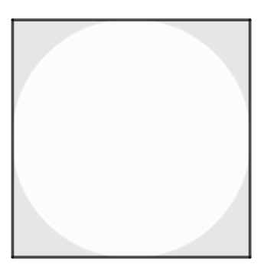 | 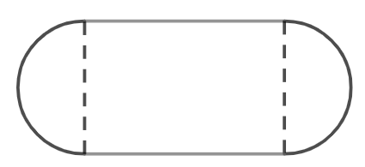 | 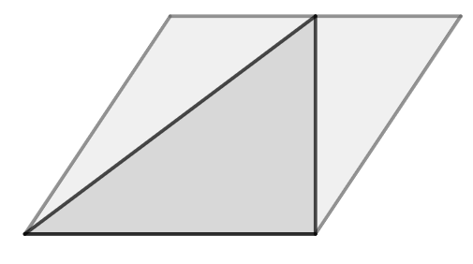
- Students should have practice converting units of length within each system, customary and metric, and across the systems, using the Geometry EOC Mathematics Reference Sheet.
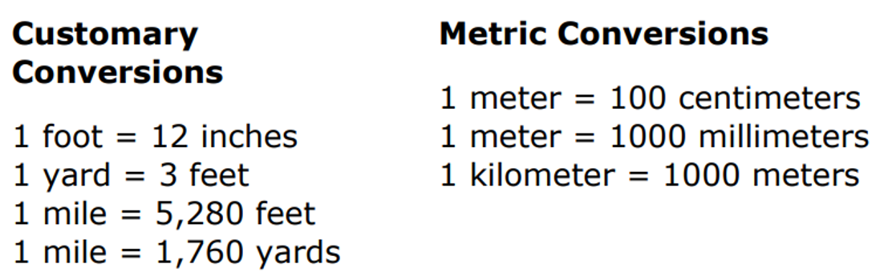
- Students should have practice converting units of area within each system and across systems.
- For example, if the area of a two-dimensional figure is $12$ square feet, then its area is equivalent to $12 ft^{2}=12 \left(1 ft\right)∙\left(1 ft\right)=12 \left(12 in\right)∙\left(12 in\right)=1,728 in^{2}$.
- Teacher models equivalent abbreviations for units of length and area.
- For example, square miles can be written as sq mi and $mi^{2}$ and square centimeters can be written as $cm^{2}$. Even when sq cm is used, it is not customary to use “sq” in the metric system.
- Students should be able to determine the area of a two-dimensional figure in square units when the dimensions of the figure were given in units.
- Instruction includes expressing areas with exact values and with approximations. For the area of a circle, students should have practice expressing areas in terms of $π$.
- For example, the area of a circle with radius $7$ is $49π$.

- Instruction includes expressing areas with numerical and algebraic expressions, including areas of composite figures and shaded regions.
- For example, the area of the given composite figure is $\frac{1}{2}\left(2+3\right)\left(3\right)+\frac{1}{2}(1)(3)$.
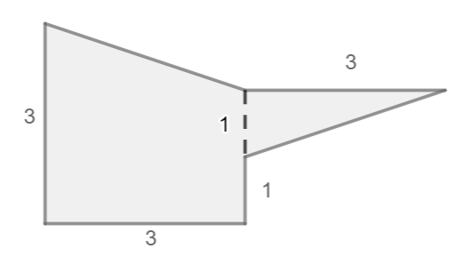
- Instruction includes comparing the total area of a composite figure when partial areas are rounded, to the total area when partial areas are written in exact values and the total area is rounded.
- Students are not expected to memorize the formulas to determine the area of a parallelogram, a trapezoid, a circle, and a regular polygon. They can be found in the Geometry EOC Mathematics Reference Sheet.
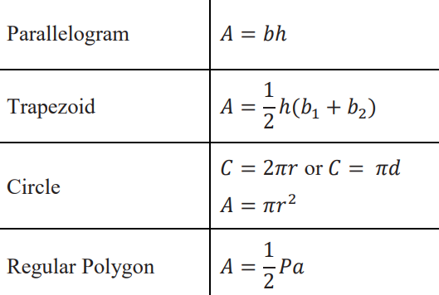
- Instruction includes determining the area of regular polygons using the formula $A=\frac{1}{2}Pa$, where $P$ is the perimeter of the polygon and $a$ is the apothem. The perimeter of a regular polygon is $ns$, where $n$ is the number of sides and $s$ is the side length of the polygon. The apothem is the distance from the center of a regular polygon to the midpoint of any of its sides. The center of a regular polygon is the point of concurrency of the angle bisectors of the interior angles of the polygon. It can be determined with two angle bisectors.
- For example, a regular pentagon, with side length of $3$ and apothem equal to $2.06$, has a perimeter of $15$ and an area of $\frac{1}{2}\left(15\right)\left(2.06\right)=15.45$.
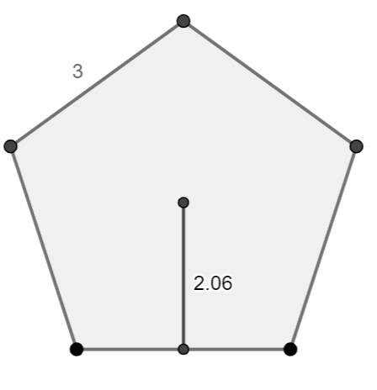

- Instruction makes the connection between the apothem of a regular polygon and trigonometric ratios (MA.912.T.1). The radius of a regular polygon is the distance between the center of the polygon and any of its vertices. The measures of the interior angles of a polygon sum to $\left(n-2\right)180°$, where $n$ is the number of sides (grade 8). The measure of each of the interior angles of a regular polygon is $\frac{\left(n-2\right)180°}{n}$.
- For example, a regular pentagon, with side length $3$ and radius $2.55$, has an apothem of $\sqrt{{2.55}^{2}-{1.5}^{2}}$ using the Pythagorean Theorem (grade 8). The apothem is also equal to $1.5\tan{54°}$ and $2.55\sin{54°}$.
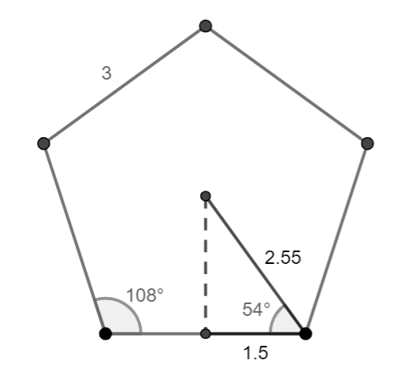
- Instruction includes solving problems involving population density. Population density is the number of people per unit land area. It is calculated by the quotient of number of people or population and the land area. Students should have practice finding the area of a two-dimensional figure and given the population determined the population density or vice versa.
- Mathematical problem types include, among others:
- Determining the area of composite figures, including circular sectors.
- Determining the area of shaded regions, including circles and circular sectors.
- Finding missing dimensions required to determine an area.
- Finding missing dimensions given the area.
- Real-world problem types include, among others:
- Finding the percentage of an area under certain conditions.
- Determining the cost of a project involving areas.
- Comparing areas of different two-dimensional figures or equal figures with different dimensions.
- Determining an area given certain constraints, including perimeter.

- For enrichment of this benchmark, students should explore the formulas to find the area of equilateral triangles and rhombi.
- The formula for the area of an equilateral triangle can be deduced using the Pythagorean Theorem (grade 8) and relationships in special right triangles (MA.912.T.1).
Given an equilateral triangle with side length $s$ and its height (from the vertex and perpendicular to the opposite side). The height of an equilateral triangle coincides with the angle bisector and the median starting at the same vertex and the perpendicular bisector of the opposite side.
$${\left(\frac{s}{2}\right)}^{2}+h^{2}=s^{2}⟹h=\frac{\sqrt{3}}{2}s$$
$$A=\frac{1}{2}bh=\frac{1}{2}s\left(\frac{\sqrt{3}}{2}s\right)=\frac{\sqrt{3}}{4}s^{2}$$
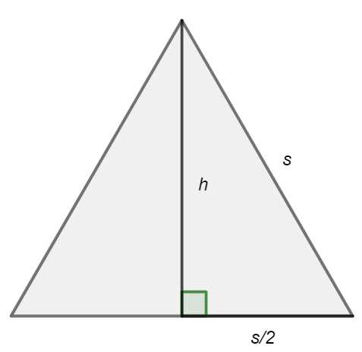
- The formula for the area of a rhombus can be deduced decomposing the rhombus into four congruent right triangles.
Given a rhombus with diagonals $d_{1}$ and $d_{2}$, the legs of the four congruent right triangles are $\frac{1}{2}d_{1}$ and $\frac{1}{2}d_{2}$ and the area of each one is $\frac{1}{2}\left(\frac{1}{2}d_{1}\right)\left(\frac{1}{2}d_{2}\right)$.
$A_{rhombus}=4\left(A_{triangle}\right)=4\left[\frac{1}{2}\left(\frac{1}{2}d_{1}\right)\left(\frac{1}{2}d_{2}\right)\right]=\frac{d_{1}d_{2}}{2}$ OR $\frac{1}{2}d_{1}d_{2}$
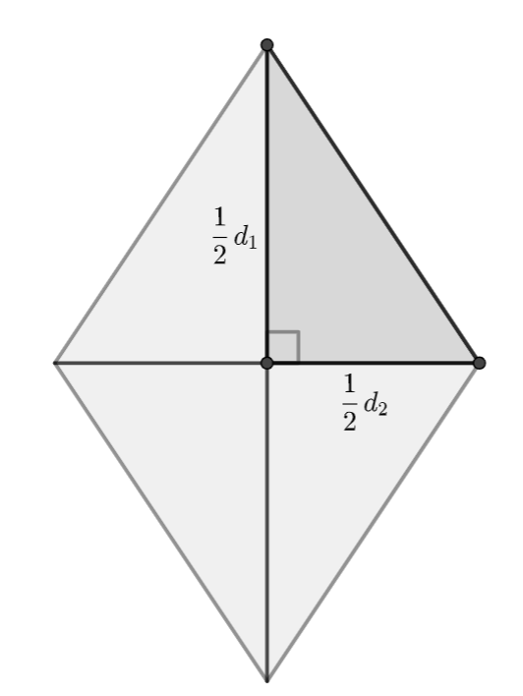

- For enrichment of this benchmark, students should explore non-traditional methods to find areas.
- For example, Hero’s formula to determine the area of a triangle using its perimeter.
- For enrichment of this benchmark, students should explore how to prove the Pythagorean Theorem using the areas of two-dimensional figures, as shown by James Garfield (20th president of the United States of America).
- Given a trapezoid formed by two right triangles with side lengths $a$, $b$, and $c$, and one right triangle whose legs have a length of $c$. The area of the three right triangles is equal to the area of the right trapezoid.
$$\frac{1}{2}ab+\frac{1}{2}ab+\frac{1}{2}c^{2}=\frac{1}{2}(a+b)(a+b)$$
$$2ab+c^{2}=a^{2}+2ab+b^{2}$$
$$c^{2}=a^{2}+b^{2}$$
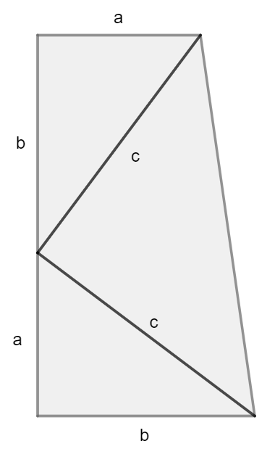

Common Misconceptions or Errors
- Students may have difficulties converting units of area.
- For example, given $12 ft^{2}$, students may convert incorrectly to $144 in^{2}$.
- For example, given $100 cm$, students may reason incorrectly that if there are $100$ centimeters in a meter, there are $100$ square centimeters in a square meter.
- Students may use the formula to find the area of a parallelogram.
- For example, given the following parallelogram, students may calculate the area incorrectly as $bh=7∙5$, instead of using the Pythagorean Theorem and the area as $bh=7∙4$.
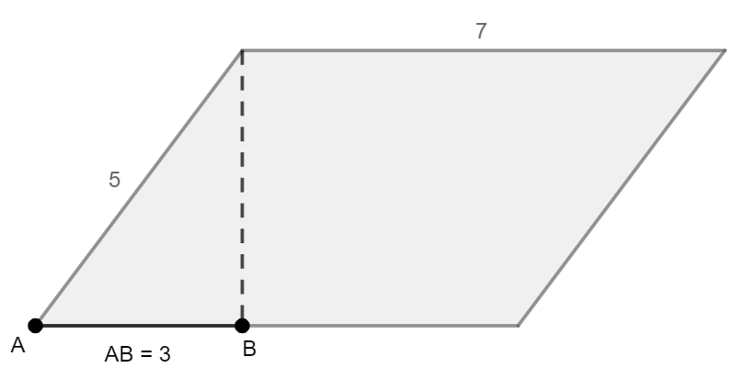

Strategies to Support Tiered Instruction
- Students should have practice converting units of length within the same system, using the Geometry EOC Mathematics Reference Sheet.
- Students should have practice solving the population density formula for population and for area of land.
- Instruction includes the understanding that the formula to find the area of a triangle can be deduced from the formula to find the area of a parallelogram.
- Given a parallelogram with base $b$ and height $h$, a triangle with the same base and the same height has half the area. When the parallelogram is a rectangle, the triangle with the same base and the same height has half the area of the rectangle. Then, the area of a triangle is $\frac{bh}{2}$ OR $\frac{1}{2}bh$, and when the triangle is right, the area can be written as $\frac{l_{1}l_{2}}{2}$ OR $\frac{1}{2}l_{1}l_{2}$ (half the product of the lengths of the legs).

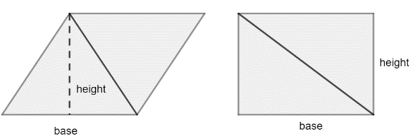
- Students should develop the understanding that the formula to find the area of a parallelogram can be used to find the area of special parallelograms, rectangles, rhombi, and squares. When a parallelogram is a square with side length $s$, then its area is $bh=s^{2}$.
- Instruction includes the understanding that the formula to find the area of a parallelogram can be deduced from the formula to find the area of a trapezoid. Students should classify parallelograms as trapezoids with two pairs of parallel sides. If a trapezoid is a parallelogram, then $b_{1}=b_{2}=b$, therefore $A=\frac{1}{2}h\left(b_{1}+b_{2}\right)=\frac{1}{2}h\left(b+b\right)=\frac{1}{2}h\left(2b\right)=bh$.
Instructional Tasks
Instructional Task 1 (MTR.7.1)
In 2019, the population of Leon County was 293,582 and the population of Sarasota County was 433,742. The area of Sarasota County is 752 square miles, while the area of Leon County is 702 square miles.
Part A. Which county has a higher population density? Name that county A.
Part B. What would the dimensions of a rectangular track of land be to have the same population density than county A, with the same population?
Part C. What would the dimensions of a triangular track of land be to have half the population density of county A, with the same population?
Part D. What would the radius of a circular track of land be to have twice the population density of count A, with the same population?
Part E. How would you describe the relationship between population density and area when the dimensions of the track of land change?

Instructional Task 2 (MTR.3.1)
The area of a regular decagon is 24.3 square meters. Determine the side length, in meters, of the regular decagon.
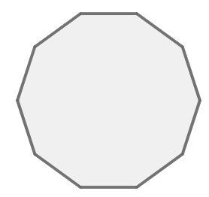
Instructional Items
Instructional Item 1
In 2019, Siesta Key, FL, had a population of $5,573$, while Destin, FL, had a population of $13,702$. Siesta Key is $3.475$ square miles and Destin is $8.46$ square miles. Which location has a smaller population density?

Instructional Item 2
The track and field throwing events happen within the area enclosed by the track. Find the area, in square meters, dedicated to the throwing events, if the shape of the track is formed by one rectangle, with dimensions $84.39$ meters by $72$ meters, and two semicircles. Round to the nearest tenth.
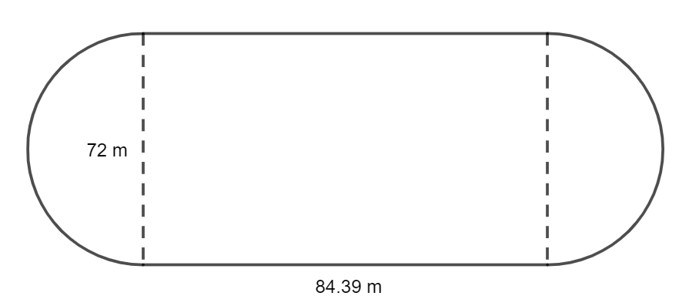

Instructional Item 3
Square LORI circumscribes circle M. The area of the shaded region between the square and the circle is going to be tiled. The cost of the tile is $3 per square foot. How much will it cost to tile the shaded region? Round to the nearest hundredth.
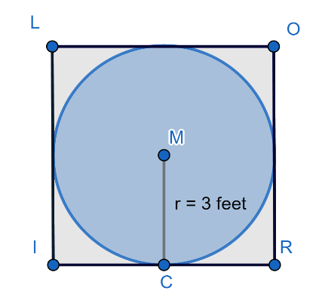

*The strategies, tasks and items included in the B1G-M are examples and should not be considered comprehensive.

MA.912.GR.4.5

Benchmark
MA.912.GR.4.5 Solve mathematical and real-world problems involving the volume of three-dimensional figures limited to cylinders, pyramids, prisms, cones and spheres.
Example: A cylindrical swimming pool is filled with water and has a diameter of 10 feet and height of 4 feet. If water weighs 62.4 pounds per cubic foot, what is the total weight of the water in a full tank to the nearest pound?

Benchmark Clarifications:
Clarification 1: Instruction includes concepts of density based on volume.
Clarification 2: Instruction includes using Cavalieri’s Principle to give informal arguments about the formulas for the volumes of right and non-right cylinders, pyramids, prisms and cones.

Connecting Benchmarks/Horizontal Alignment
- MA.912.T.1.2
Terms from the K-12 Glossary
- Cone
- Cylinder
- Prism
- Pyramid
- Sphere

Vertical Alignment
Previous Benchmarks  - MA.6.GR.2.3  - MA.7.GR.2.3  - MA.912.AR.2.1 | Next Benchmarks  - MA.912.C.5.7
Purpose and Instructional Strategies
In grade 6, students solved problems involving the volume of right rectangular prisms, including finding a missing dimension. In grade 7, students solved problems involving the conversion of units of volume across the customary system and the metric system and solved problems involving the volume of right circular cylinders. In Geometry, students explore the formulas to find the volume of pyramids, cones, and spheres, and prisms with bases other than rectangles and circles, and use these formulas to solve problems. In later courses, students learn how to find volume using integrals.
- Instruction includes reviewing the defining attributes of right cylinders, pyramids, prisms, cones, and spheres (grade 5), and discussing the definitions of right and oblique, regular, and irregular polygons.
- Students should have practice converting units of length, and volume and capacity within each system, customary and metric, and across the systems, using the Geometry EOC Mathematics Reference Sheet.
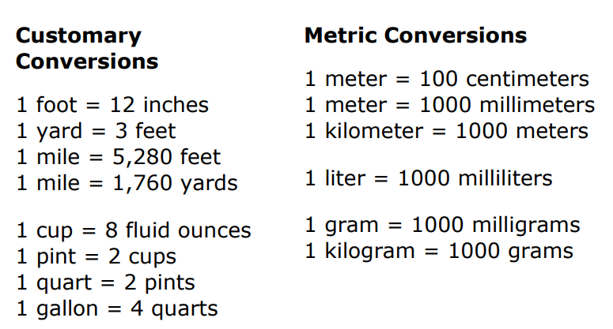
- Students should have practice converting units of volume within each system and across systems.
- For example, if the volume of a three-dimensional figure is $5$ cubic meters, then its volume is equivalent to $5 m^{3}=5 \left(1 m\right)∙\left(1 m\right)∙\left(1 m\right)=5 \left(100cm\right)∙\left(100 cm\right)∙\left(100 cm\right)=5,000,000 cm^{3}$.
- Teacher models equivalent abbreviations for units of length and volume.
- For example, cubic miles can be written as cu mi and mi³ and cubic centimeters can be written as cm³. It is common to abbreviate cm³ as cc and ccm. Even when cu cm is used, it is not customary to use “cu” in the metric system.
- Students should be able to determine the volume of a three-dimensional figure in cubic units when the dimensions of the figure were given in units.
- Instruction includes expressing volumes with exact values and with approximations. For the volume of cones, cylinders, and spheres, students should have practice expressing volumes in terms of $π$.
- For example, the volume of a sphere with radius $5$ is $\frac{500}{3}π$.

- Instruction includes expressing volumes numerical and algebraic expressions, including volumes of composite figures.
- For example, the volume of the given composite figure is $\left(π\right)\left(7^{2}\right)\left(4\right)+\frac{1}{3}(π)(7^{2})(5).$
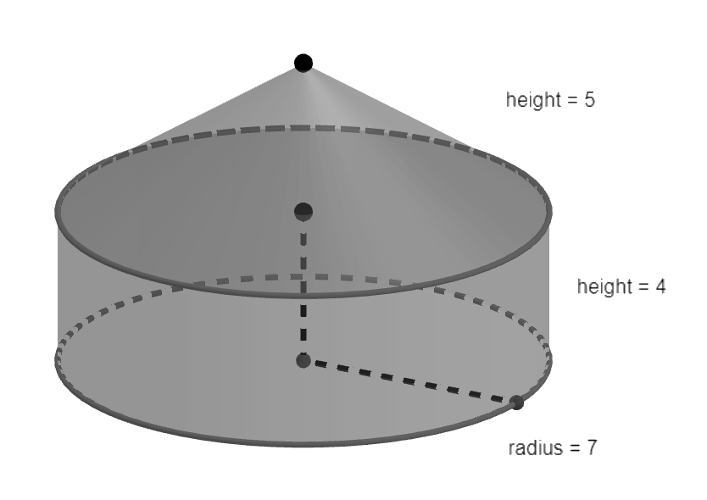
- Instruction includes comparing the total volume of a composite figure when partial volumes are rounded, to the total volume when partial volumes are written in exact values and the total volume is rounded.
- Students are not expected to memorize the formulas to determine the volume of prisms, cylinders, cones, regular pyramids, and spheres. They can be found in the Geometry EOC Mathematics Reference Sheet.
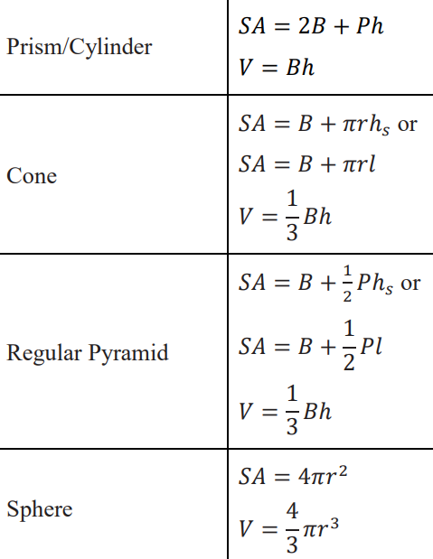
- Students should develop the understanding of the relationship between volume and capacity. While volume is the total amount of space taken up by a three-dimensional figure, capacity refers to the amount of something that a hollow three-dimensional figure can hold, usually liquids. In this course, volume and capacity are calculated with the same formulas, disregarding the thickness of the container walls.
- Instruction includes calculating density based on volume given the dimensions of three-dimensional figures. (MRT.7.1)
- For example, the material density of water is $1$ gram per $1$ cubic centimeter, $1$ g/cm³. This is the mass of water in a unit of volume.
- For example, the population density of tilapia in tanks is $120$ to $248$ fish per cubic meter.
- For example, the density of salt in a bucket of sea water is $35$ grams per liter.
- Instruction makes the connection to two-dimensional cross-sections of three-dimensional figures to explore the Cavalieri’s Principle. This principle states that if in two three-dimensional figures of equal height, the cross-sections made by planes parallel to the bases and at the same distance from their respective bases, then the volumes of the two figures are equal. (MTR.5.1)
- For example, the triangular prisms shown below, one right and one oblique, have the same base and height, and the cross-sections parallel to the bases and at the same distance to the bases are equal, then they have the same volume.
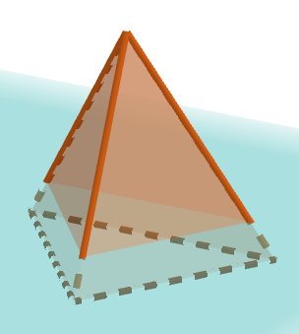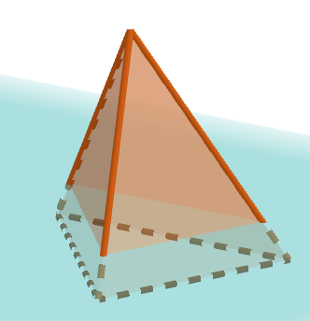
- Students should develop the understanding that the formulas to determine the volume of right prisms, cylinders, pyramids, and cones can be used to determine the volume of oblique prisms, cylinders, pyramids, and cones. (MTR.4.1)
- Problem types include a variety of real-world contexts where finding volume, capacity, or density based on volume is relevant, involving constraints and comparisons.
- For example, find the volume of a liquid occupying a given percentage of a three-dimensional figure.
- For example, determine the cost of a project given the price of the material.
- For example, select an air conditioning unit based on given information about units and BTUs (British Thermal Units).
- Students should have practice finding missing dimensions given the volume of a three-dimensional figure or composite figure.
- For example, given the volume of a hemisphere is $144π$ cubic inches, determine the radius.
- For enrichment of this benchmark, students should explore the statement “The volume of a cylinder of radius $r$ and height $2r$ is equal to the sum of the volumes of a sphere of radius $r$ and a cone with radius $r$ and height $2r$.” The relationship between the volume of a sphere and the volume of a cylinder was deduced by Archimedes and published in his treatise On the Sphere and Cylinder (225 BCE).
- Let $V$ be the volume of a cylinder whose height is equal to the diameter of its base, then $V=πr^{2}\left(2r\right)=2πr^{3}$. The volume of the cone with the same base and height is $\frac{1}{3}V$. That is, $\frac{1}{3}\left(2πr^{3}\right)=\frac{2}{3}πr^{3}$. The volume of a sphere whose diameter is equal to the diameter of the base of the cylinder is $\frac{2}{3}(2πr^{2})$. That is, the volume of a sphere in terms of its radius is $\frac{4}{3}πr^{3}$.

Common Misconceptions or Errors
- Students may convert units of volume incorrectly,
- For example, stating that $6$ cubic feet are equivalent to $72$ cubic inches, instead of
$10,638$ cubic inches.
- For example, stating that $25.4$ cubic millimeters are equivalent to $1$ cubic inch, since $25.4$ millimeters are approximately equivalent to $1$ inch.
- Students mat misidentify a triangular prism as a rectangular pyramid.
- For example, in the image shown below.
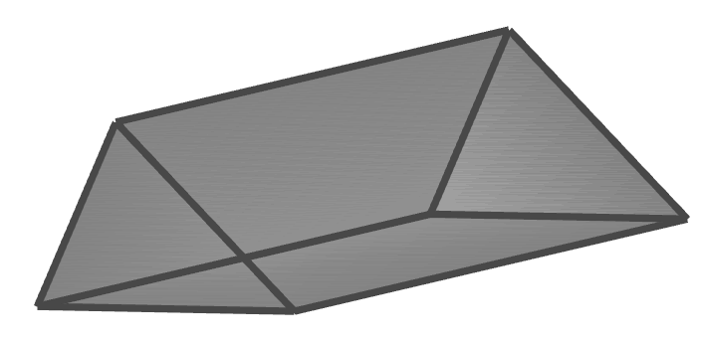
- Students may make mistakes when finding the volume of a composite three-dimensional figure and the order of operations, and when solving for a dimension of a figure given its volume.

Strategies to Support Tiered Instruction
- Students should have practice converting units of length and volume within the same system, using the Geometry EOC Mathematics Reference Sheet.
- Students should have practice solving the density formula based on volume for population and volume, and for mass and volume.
- For example, given $d=\frac{m}{v}$, then $v=\frac{m}{d}$ and $m=dv$, where $d$ is the material density, $m$ is the mass, and $v$ is the volume.
- Students should have practice finding the volume of single three-dimensional figures, before attempting to find the volume of composite figures.
- Students should have practice solving for one dimension of a three-dimensional figure given the formula.
- For example, solve for $r$ given $V=\frac{4}{3}πr^{3}$.
- Students should develop the understanding of the formulas for prisms, including cylinders, and for pyramids, including cones, $V=Bh$ and $V=\frac{1}{3}Bh$, respectively, applying the Cavalieri’s Principle. Instruction includes comparing the volume of a right cylinder formed by same size coins to the volume of a stack formed by the same coins but arranged in other ways, comparing the cross-sections of both three-dimensional figures at the same height to deduce the relationships between their volumes.
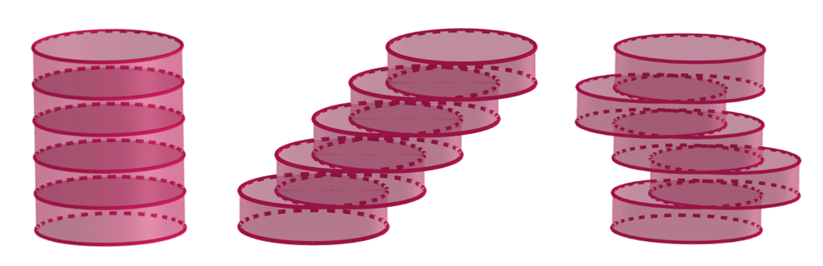

Instructional Tasks
Instructional Task 1 (MTR.7.1)
When filling silos, like SILO 1 and SILO 2, the cone at the top is not filled. However, when filling SILO 3, the cone at the bottom is filled. The silos are formed by one cylinder and one cone, or one cylinder and two congruent cones.
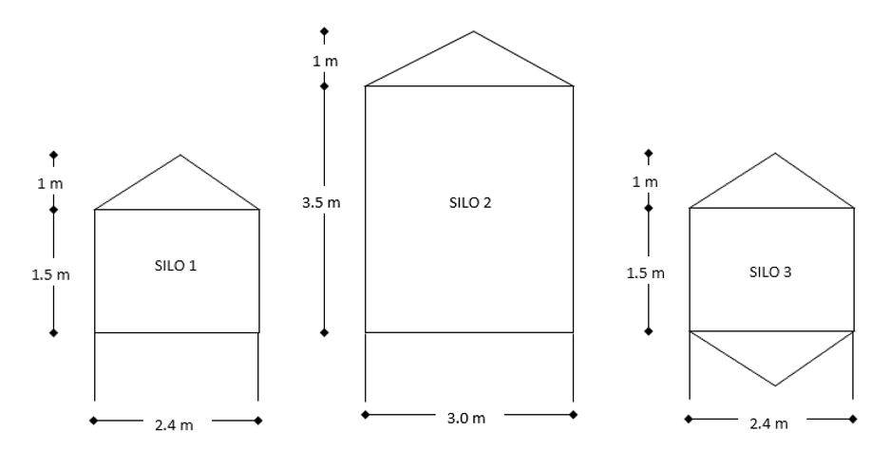
Part A. How much more grain SILO 3 holds than SILO 1?
Part B. The diameter of SILO 1 is 80% the diameter of SILO 2. Is the capacity of SILO 1 80% the capacity of SILO 2?
Part C. If a cone congruent to the cone at the top of SILO 2 is added at the bottom, how much does the capacity of this silo increase?

Instructional Task 2 (MTR.4.1)
The radius of a sphere is $4$ units so its volume is $\frac{256}{3}π$ cubic units.
Part A. Determine the exact volume of the sphere (exact means in terms of pi).
Part B. What is the value of an exact answer?
Part C. Determine the volume of the sphere, rounding the answer to the nearest tenth, in each case:
- If $π$ is substituted by $3.14$.
- If $π$ is substituted by $3.1416$.
- If $π$ is substituted by $\frac{22}{7}$.
Part D. What is the value of an approximated answer?

Instructional Task 3 (MTR 7.1)
Joshua is going to build cinder block raised garden beds on three sides of his backyard deck. He is going to plant a flower in each hole of each cinder block. The dimensions of the cinder blocks are $8$ inches by $16$ inches by $8$ inches. Each hole needs to be filled with potting soil before the flowers can be planted. Potting soil is sold in $1$ cubic foot bags. The image shows two views of the cinder blocks Joshua is going to use.
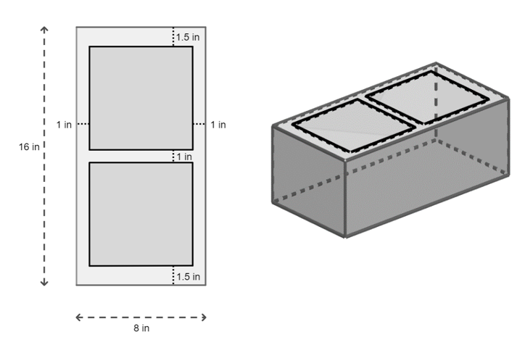
Part A. What is the capacity of each cinder block hole?
Part B. If the length of each side of the Joshua’s square patio is $8$ feet, how many cinder blocks Joshua needs for his project? (The garden bed consists of one row of cinder blocks on each side of the deck as shown in the image).
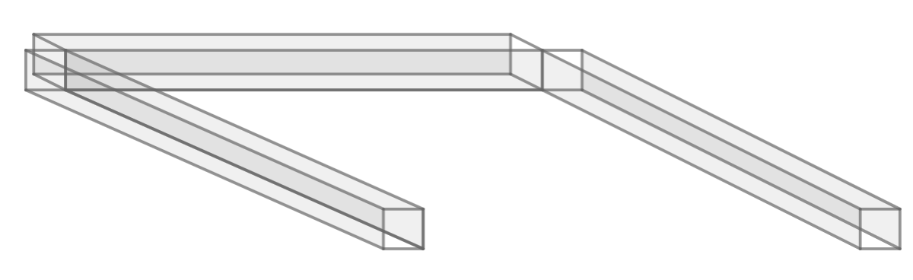
Part C. How many bags of potting soil does Joshua need to purchase to fill all the holes of the garden beds?

Instructional Items
Instructional Item 1
A solid wood post, with square prism measures of $4$ ft by $4$ ft by $8$ ft, is drilled out. The diameter of the drill bit is $3.5$ inches. Find the volume of the wood post after the hole has been drilled into the wood.
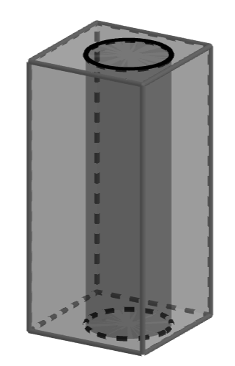

Instructional Item 2
The volume of a right triangular pyramid, with height of $12$ in, is $96$ cu in. The base of the pyramid is a right triangle and the length of one of its legs is $6$ in. Find the length of the other leg of the right triangle.
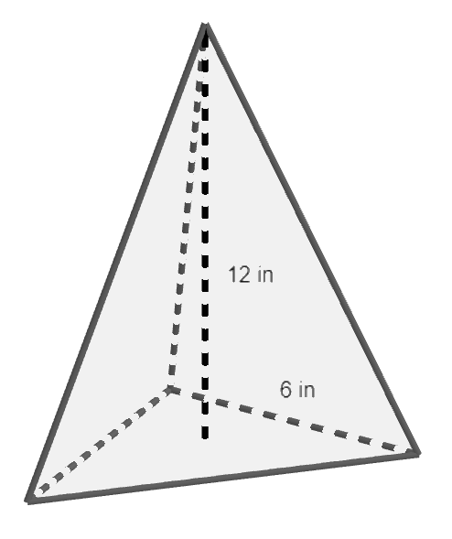
*The strategies, tasks and items included in the B1G-M are examples and should not be considered comprehensive.

MA.912.GR.4.6

Benchmark
MA.912.GR.4.6 Solve mathematical and real-world problems involving the surface area of three-dimensional figures limited to cylinders, pyramids, prisms, cones and spheres.

Connecting Benchmarks/Horizontal Alignment
- MA.912.T.1.2
Terms from the K-12 Glossary
- Circle
- Cone
- Cylinder
- Prism
- Pyramid
- Rectangle
- Sphere
- Square
- Triangle
Vertical Alignment
Previous Benchmarks  - MA.6.GR.2.4  - MA.7.GR.2.1, MA.7.GR.2.2  - MA.912.AR.2.1 | Next Benchmarks
Purpose and Instructional Strategies
In grade 6, students found the surface area of right rectangular prisms and right rectangular pyramids using the figure’s nest. In grade 7, students solved problems involving the surface area of a right circular cylinder using the figure’s nest. In Geometry, students extend their understanding of surface areas to solve problems involving right prims, cylinders, pyramids, cones, and spheres, applying volume formulas.
- Instruction includes the considerations about units of length and units of areas and conversions within an across the systems, using the Geometry EOC Mathematics Reference Sheet in MA.912.GR.4.4.
- Instruction includes the considerations about exact and approximated values to express area, including answers in terms of $π$ in MA.912.GR.4.4.
- Instruction includes the considerations about numerical and algebraic expressions to express the areas in MA.912.GR.4.4.

- Students are not expected to memorize the formulas to determine the surface area of prisms, cylinders, cones, regular pyramids, and spheres. They can be found in the Geometry EOC Mathematics Reference Sheet.
- Instruction includes reviewing the defining attributes of right cylinders, pyramids, prisms, cones, and spheres (grade 5), and discussing the definitions of right and oblique, regular, and irregular polygons. Students should develop the understanding that the bases of a prism are congruent and parallel. Instruction also includes the description of three-dimensional figures in terms of faces, edges, and vertices, and their nets.
- For example, the following net represents the surface area of a right rectangular prism with dimensions $a$, $b$, and $c$. A right rectangular prism has six faces, twelve edges, and eight vertices.
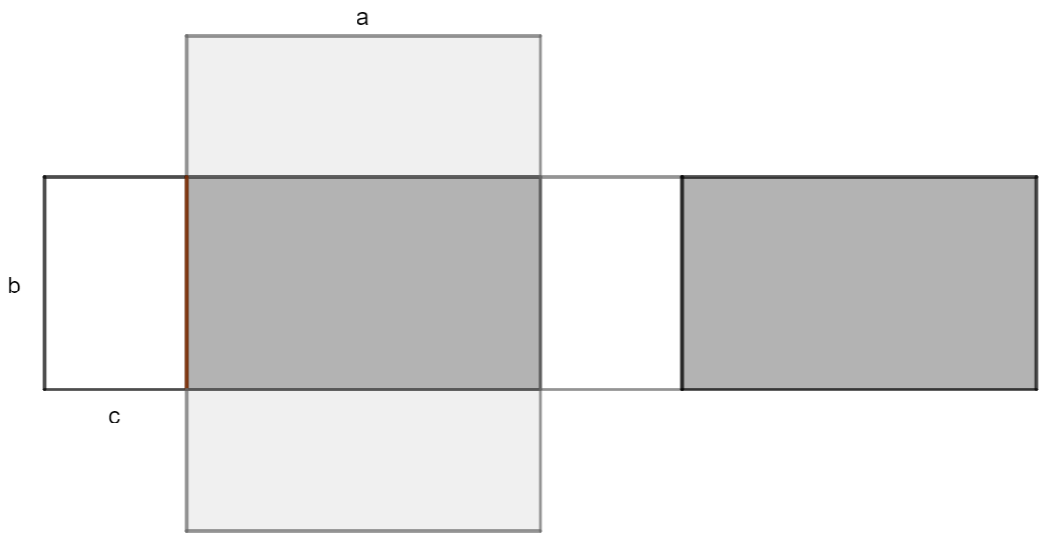
- For example, the following net represents the surface area of a right cone with radius $r$ and slant heigh $l$.
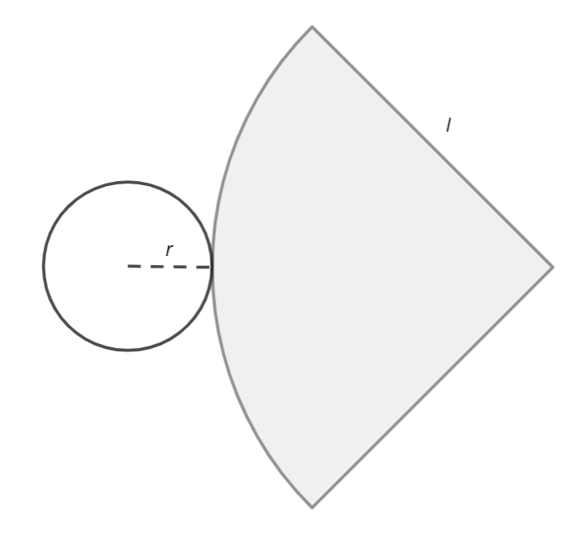

- Instruction makes the connection to areas of two-dimensional figures (MA.912.GR.4.4). The surface area of right prisms, cylinders, pyramids, and cones and prisms is the result of combining areas of triangles, quadrilaterals, regular polygons, circles, and circular sectors.
- For example, the surface area of the following right rectangular prism is the result of combining the areas of six rectangles. That is, $SA=ab+ab+bc+bc+ac+ac.$ Considering the rectangle with dimensions $a$ and $b$ the base of the prism and $c$ its height, and by rearranging the formula, $SA=2\left(ab\right)+2\left(bc\right)+2\left(ac\right)=2\left(ab\right)+\left(2b+2a\right)c=2B+Ph$, where $B$ is the area of the base and $P$ its perimeter.
- For example, the surface area of the following right cone is the result of combining the area of the circle with radius $r$, and the area of the circular sector with radius $l$ and central angle $m°$. The area of the circle is $πr^{2}$ and its circumference is $2πr$. The length of the arc determined by the circular sector is $2πr$. Then $\frac{2πr}{2πl}=\frac{m}{360}$, comparing central angles and the length of the intercepted arcs. Using the formula to find the area of a sector, $\frac{m}{360}(πr^{2})$, the area of the given circular sector is $\frac{r}{l}\left(πl^{2}\right)=πrl$ (MA.912.GR.6.4). Then, $SA=πr^{2}+πrl=B+πrl$.
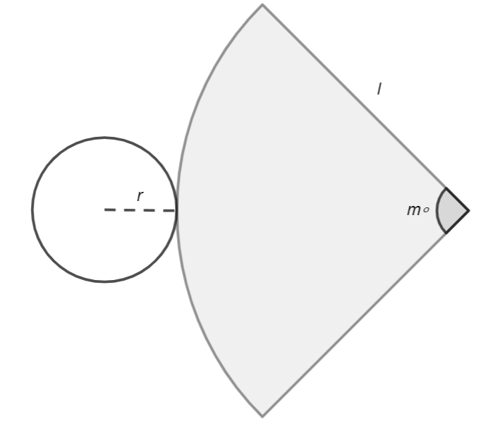

- Students should develop the understanding of the terms lateral area and surface area. (MTR.2.1) In general, the lateral area is the result of combining the areas of the faces of a three-dimensional figure not including the areas of the bases (one base when finding the lateral area of a cone or pyramid). Sometimes, the term surface area is used with some considerations.
- For example, the surface area of an open-top cylinder (e.g., a can with no lid.), is the result of combining the lateral area and the area of one of the bases.
- Problem types include a variety of real-world contexts where finding lateral areas or surface areas is relevant, involving constraints and comparisons.
- For example, find a percentage of a surface area.
- For example, determine the cost of a project given the price of the material.
- For example, determine the surface area of composite three-dimensional figures or resulting from removing certain portion, as shown in the images below.
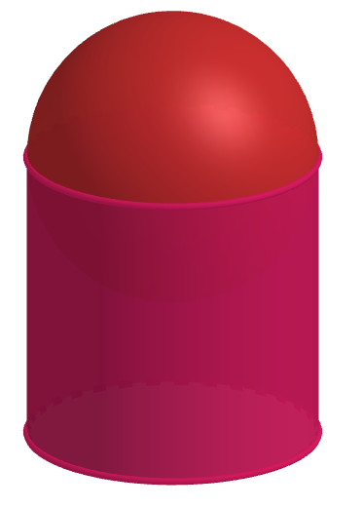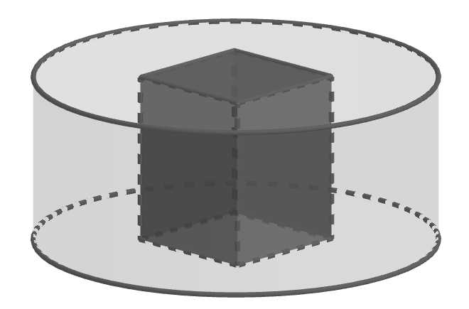
- Students should have practice finding missing dimensions given the surface are of a three-dimensional figure or composite figure.
- For example, given the surface area of a hemisphere is $27π$ square inches, determine the radius.
- For enrichment of this benchmark, students should explore the statement “The surface area of a sphere with radius $r$ is $\frac{2}{3}$ the surface area of a cylinder of radius $r$ and height $2r$.” The relationship between the surface area of a sphere and the surface area of a cylinder was deduced by Archimedes and published in his treatise On the Sphere and Cylinder (225 BCE).

Common Misconceptions or Errors
- Students may make mistakes when finding the volume of a composite three-dimensional figure and the order of operations, and when solving for a dimension of a figure given its volume.

Strategies to Support Tiered Instruction
- Students should have practice determining the surface area of a single three-dimensional figure, using the Geometry EOC Mathematics Reference Sheet.
- Students should have practice converting units of length and units of area within the same system, and across the systems.

Instructional Tasks
Instructional Task 1 (MTR.7.1)
There are three Pyramids of Giza. The largest, the Great Pyramid, has a base approximating a square with side length averaging $230$ meters and a lateral surface area of $85,836$ square meters.
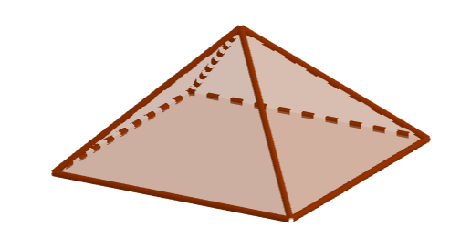
Part A. What is the height of the Great Pyramid?
Part B. What is the slant height?
Part C. It is estimated that the pyramids erode at a rate of $1$ meter every $10,000$ years, affecting the side length of the base and its height. What would the estimated surface area of the Great Pyramid be by 12,023?

Instructional Task 2 (MTR.4.1)
For each of the questions in this task, let the Earth be a sphere.
Eratosthenes deduced that the polar radius of the Earth is $6,267$ km.
Part A. What is the exact surface area of the Earth using Eratosthenes’ polar radius?
Part B. Nowadays, it is known the polar radius of the Earth is $6,357$ km. What is the exact difference between the surface area of the Earth using the Eratosthenes’ polar radius and the polar radius used in the present?
Part C. The Earth is almost a sphere, but the equatorial radius, $6,378$ km, is larger than the polar radius, $6,357$ km. What is the exact difference between the surface area of the Earth calculated with the polar radius and calculated with the equatorial radius?
Part D. $71\%$ of the surface area of the Earth is covered by water. Using the current equatorial radius, what is the exact area covered by water?
Part E. If the area of South America is $17,840,000$ km², what percentage of the surface area of the Earth not covered by water is occupied by South America?

Instructional Items
Instructional Item 1
Kristin and Rachel are hosting an art show where they will showcase local artists’ sculptures. They are painting pedestals upon which the sculptures will be placed. Pictures of the pedestals they will be using are shown below. One gallon of paint can cover 400 square feet.
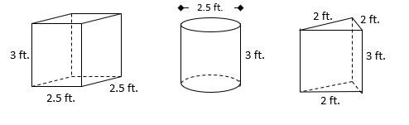
Part A. How many gallons of paint will they need to purchase to cover at least 4 of each type of pedestal? Assume that the base of each will not be painted.
Part B. If there is any paint left over, determine how many of which shape pedestals could be painted.

Instructional Item 2
Kim is wrapping a present for her friend Melissa’s birthday and wants to make sure she has enough wrapping paper. The box is in the shape of a right rectangular prism. What is the minimum amount of wrapping paper, in square feet, Kim needs to wrap the box if the dimensions of the box are 6 inches by 8 inches by 2 inches?
*The strategies, tasks and items included in the B1G-M are examples and should not be considered comprehensive.

MA.912.GR.5 Make formal geometric constructions with a variety of tools and methods.

MA.912.GR.5.1

Benchmark
MA.912.GR.5.1 Construct a copy of a segment or an angle.

Benchmark Clarifications:
Clarification 1: Instruction includes using compass and straightedge, string, reflective devices, paper folding or dynamic geometry software.
Connecting Benchmarks/Horizontal Alignment
- MA.912.GR.1.1, MA.912.GR.1.2
- MA.912.GR.2.2, MA.912.GR.2.3, MA.912.GR.2.5
Terms from the K-12 Glossary
- Angle
Vertical Alignment
Previous Benchmarks  - MA.2.GR.1.1  - MA.3.GR.1.1  - MA.4.GR.1.2 | Next Benchmarks
Purpose and Instructional Strategies
In Grade 1, students measured lengths of objects using rulers. In Grade 3, students described and drew lines. In Grade 4, students drew angles using a protractor. In Geometry, students are introduced to constructions with compass and straightedge. Copying a segment and copying an angle are procedures embedded in other basic geometric constructions, and the concepts of constructing and identifying copies of segments and angles are closely related to understanding and verifying congruence.
- Instruction makes connections with Logic and Discrete Theory (MA.912.LT.4.3 and MA.912.LT.4.10). Students should have practice using “if…then,” “if and only if,” “all” and “not” statements while making constructions with compass and straightedge, and with other tools. Constructions can be used to evaluate a conditional statement and its converse, its inverse, and its contrapositive. Also, students should develop the understanding that constructions can be used to judge the validity of an argument and to identify and create counterexamples.
- Students should develop the understanding that geometric constructions are based on definitions, theorems, and relationships about geometric figures, and that constructions can be used as visual proofs when verifying given statements.
- Students should experience that there are limitations on the precision of a construction that are inherent to the use of pencils and compasses. However, the properties, relationships, and theorems used to justify the construction are enough to consider the construction accurate.

- Problem types include identifying the result of a given construction, the next step of a construction, a missing step in a construction, and the order of the steps in a construction. Students should identify the properties, relationships, and theorems, supporting the steps and in the resulting construction.
- Instruction includes discussing the role of the compass in a geometric construction, beyond drawing circles. Students should develop the understanding that when a compass is used to draw a circle, or an arc, all the points on the circle, or the arc, are equidistant to the center, where the pointed end of the compass was placed.
  - For example, place the pointed end of the compass at $P$ and draw an arc. Choose two points on the arc, $A$ and $B$. The distance from $A$ and $B$ to $P$ is the same, $AP=BP$ and $\overline{AP}≅\overline{BP}$. $AP$ and $BP$ are radii of the circle centered at $P$ containing the arc drawn.
- Instruction includes discussing the role of the straightedge in a geometric construction, in contrast to the role of a ruler. A straightedge has no marks on it and is used to draw lines passing through two points or extend given segments, not to measure.
- Instruction includes the understanding that in the geometric constructions of copying a segment and copying an angle, rulers and protractors are not used, and segments and angles are not measured using these tools. The resulting segment and the resulting angle are congruent based on the construction with no need of verification.
- While going over the steps of geometric constructions, students should develop the vocabulary to describe the steps precisely. (MTR.4.1)
- For example, place the pointed end of the compass at $A$, set the compass to the radius $AB$, set the compass to a convenient width, without changing the compass settings, draw an arc intersecting another.
- For expectations of this benchmark in its clarification, instruction includes the following tools: compass and straightedge, string, reflective devices, paper folding, or dynamic geometry software.
- Students should develop the understanding that a string or any other tool that preserves the distance between two points can be used to replace the compass in a formal construction. Tools such as the bullseye compass, the woodworking compass scriber, the beam compass, and others can be used instead of a compass.
- Students should have practice with reflective devices. Copying segments with this tool makes the connection to reflections (MA.912.GR.2) and contributes to the exploration of lines of reflection. A reflective device can also be used to copy angles and two-dimensional figures and explore congruence.
- Students should connect constructions with compass and straightedge to constructions completed by folding paper (e.g., patty paper or parchment paper). Using translucent paper, students can trace the copy of a segment and the copy of an angle and explore the copy of a segment and the copy of an angle produced by other devices.
- Students should have practice with dynamic geometry software. These interactive tools allow students to copy segments and angles, determine their measures, and verify congruence.

- Instruction includes the connection between the construction of the copy of a segment and the construction of two-dimensional figures.
- For example, given $\overline{AB}$, a compass and a straightedge can be used to construct an equilateral triangle $ABC$. Placing the compass at $A$, and later at $B$, with radius $AB$, students draw circles, or arcs, and identify point $C$, the point of intersection of the circles, or arcs, as the only point that makes $\overline{AC}≅\overline{BC}≅\overline{AB}$.
- Instruction includes the connection between the construction of the copy of an angle and the relationships between angles formed by two parallel lines cut by a transversal (MA.912.GR.1.1).
- For example, given two parallel lines cut by a transversal, students can use the construction of the copy of an angle to verify the relationship between corresponding, alternate interior, and alternate exterior angles.
- For example, given line $l$ and point $P$ outside the line, students copy the angle formed by $l$ and a line passing through the exterior point and intersecting $l$, with vertex at $P$. The copied angle is corresponding (or alternate interior) with the original angle and the lines are parallel.
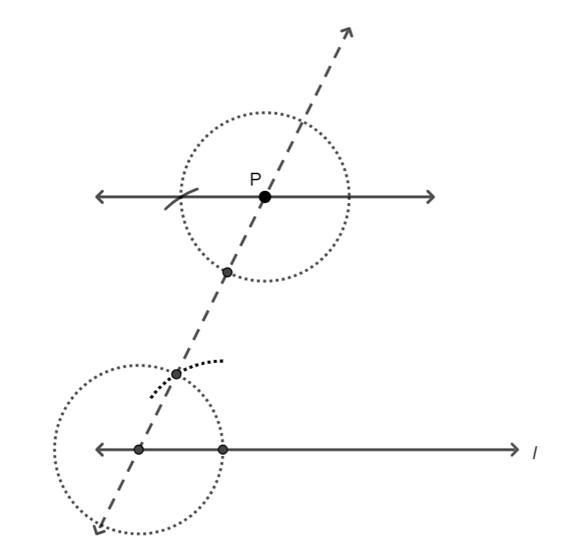
- Instruction includes the connection between the construction of the copy of an angle and triangle congruence (MA.912.GR.1.2 and MA.912.GR.1.6).
- The constructed copy of $∠APB$ is $∠A'P'B'$. $PA$ and $BP$ are radii of the same circle, then $\overline{PA}≅\overline{PB}$ and $∆APB$ is isosceles. $PA'$ and $PB'$ are radii of the same circle, congruent to the circle with center $P$. Then, $∆A'PB'$ is also isosceles. The distance from $B'$ to $A'$ is a copy of the distance from $A$ to $B$, so $\overline{AB}≅\overline{A'B'}$. Therefore, $∆APB≅∆A^{'}P^{'}B'$ and by the definition of congruent triangles $∠APB≅∠A'P'B'$.
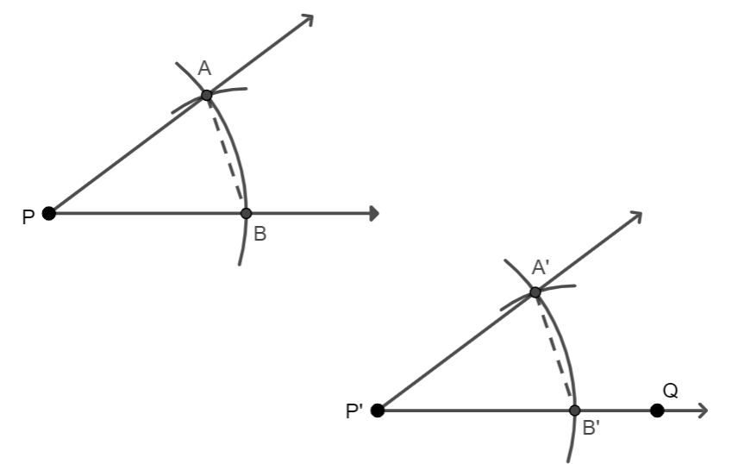

- Instruction includes the connection between the construction of the copy of a segment and the copy of an angle the construction of the copy of a given two-dimensional figure.
- For example, the construction of the copy of a given quadrilateral.
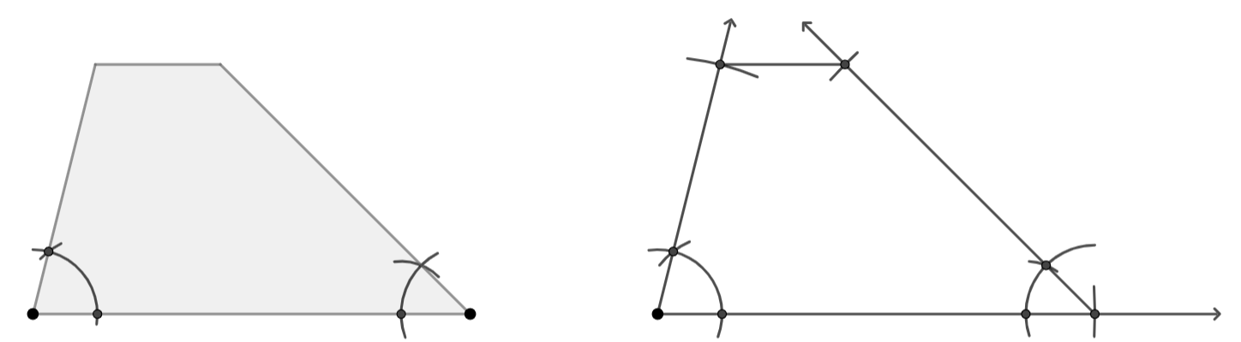
- For enrichment of this benchmark, students can apply the construction to copy a segment to partition a segment in the golden ratio (MA.912.GR.3.1, 3.3).
- Given a segment $AB$, its midpoint $M$, and a ray perpendicular to the segment and starting at one of its endpoints, $A$. $\overline{AC}$ is a copy of $\overline{AM}$, $\overline{CD}$ is a copy of $\overline{CA}$, and $\overline{BP}$ is a copy of $\overline{BD}$. $\frac{AB}{PB}=\frac{PB}{QP}=\frac{1+\sqrt{5}}{2}$.
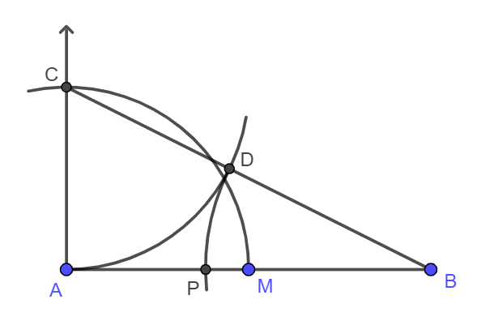

Common Misconceptions or Errors
- Students may struggle with the notions the size of the angle, or its measure, and the length of its sides.
- For example, given the following angles students may perceive one with a larger measure than the other. However, the angles have the same measure.
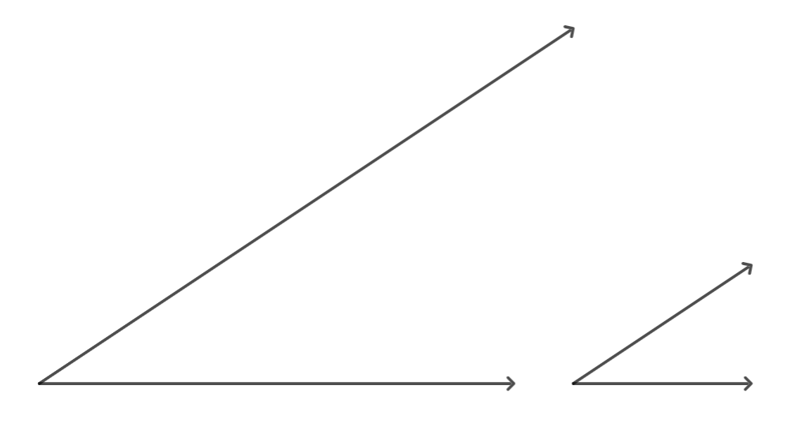
- Students may not see the value of using compasses and straightedges instead of protractors and rulers. Instruction should emphasize definitions and properties of geometric figures.

Strategies to Support Tiered Instruction
- Students should have opportunities to explore the role of the compass. First drawing circles and arcs and marking their centers where the compass leaves a mark. Later, verifying all the points on a circle, or arc, are equidistant to the center of the circle.
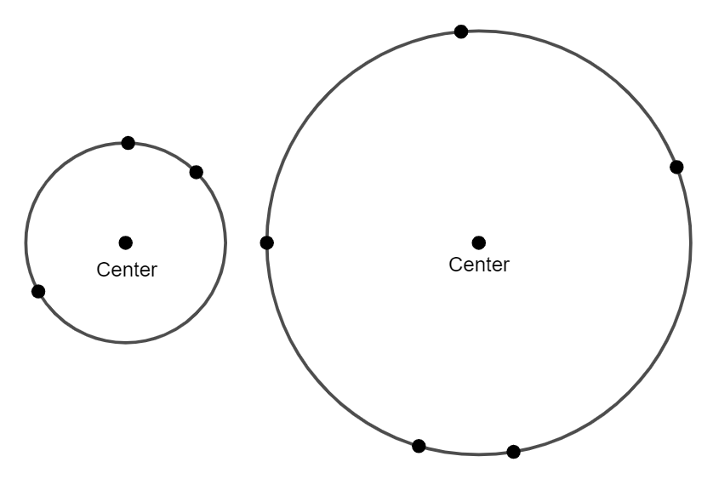
- Students should develop the understanding that the measure of an angle is the same regardless of how much their sides are extended. The angle may look “wider” but that does not mean the measure of the angle is larger.
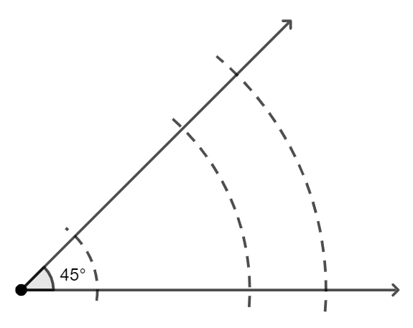
- Instruction includes discussing that when constructing the copy of a line segment or the copy of an angle, since graduated rulers and protractors are not used, the resulting construction is not measures in any specific units (e.g., inches, centimeter, degrees). Just when the length of the segment and the measure of the angle is given, then the length of the copied segment and the measure of the copied angle is known, and the same as the originals.

Instructional Tasks
Instructional Task 1 (MTR.2.1, MTR.3.1)
Construct quadrilateral $JKLM$ such that it is congruent to quadrilateral $ABCD$.
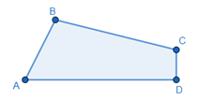

Instructional Task 2 (MTR.2.1, MTR.5.1)
Given $∠EFG$, construct $∠EHG$, a copy of the given angle, such that $EFGH$ is a parallelogram $EFGH$. (MA.912.GR.1.4)
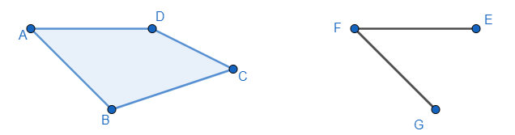

Instructional Items
Instructional Item 1
Construct the necessary segments and angles so quadrilateral $FGHE$ is congruent to quadrilateral $ABCD$, given $∠DAB≅∠EFG$, $\overline{DA}≅\overline{EF}$ and $\overline{AB}≅\overline{FG}$.

*The strategies, tasks and items included in the B1G-M are examples and should not be considered comprehensive.

MA.912.GR.5.2

Benchmark
MA.912.GR.5.2 Construct the bisector of a segment or an angle, including the perpendicular bisector of a line segment.
Benchmark Clarifications:
Clarification 1: Instruction includes using compass and straightedge, string, reflective devices, paper folding or dynamic geometry software.
Connecting Benchmarks/Horizontal Alignment
- MA.912.GR.1.1, MA.912.GR.1.2
- MA.912.GR.2.2, MA.912.GR.2.3, MA.912.GR.2.5
Terms from the K-12 Glossary
- Angle
Vertical Alignment
Previous Benchmarks  - MA.2.GR.1.1  - MA.3.GR.1.1  - MA.4.GR.1.2 | Next Benchmarks

Purpose and Instructional Strategies
In Grade 3, students described and drew perpendicular lines. In Grade 4, students measured angles using a protractor and demonstrated that angle measure is additive. In Geometry, students construct segment bisectors, including the perpendicular bisector, and angle bisectors, using compass and straightedge. These constructions do not rely on measurements from rulers or protractors. Instead, the constructions are based on definitions, properties, and theorems within this course. The construction that bisects a given line segment can be followed by the construction of a segment bisector and the construction of the perpendicular bisector of the given line segment. The construction of the perpendicular bisector of a line segment is used later in this course in the construction of a circumscribed circle of a triangle (MA.912.GR.5.3). The construction of the angle bisector of a given angle is used later in this course in the construction of an inscribed circle of a triangle (MA.912.GR.5.3).
- Instruction makes connections with Logic and Discrete Theory (MA.912.LT.4.3 and MA.912.LT.4.10). Students should have practice using “if…then,” “if and only if,” “all” and “not” statements while making constructions with compass and straightedge, and with other tools. Constructions can be used to evaluate a conditional statement and its converse, its inverse, and its contrapositive. Also, students should develop the understanding that constructions can be used to judge the validity of an argument and to identify and create counterexamples.
- Students should develop the understanding that geometric constructions are based on definitions, theorems, and relationships about geometric figures, and that constructions can be used as visual proofs when verifying given statements.
- Students should experience that there are limitations on the precision of a construction that are inherent to the use of pencils and compasses. However, the properties, relationships, and theorems used to justify the construction are enough to consider the construction accurate.
- Problem types include identifying the result of a given construction, the next step of a construction, a missing step in a construction, and the order of the steps in a construction. Students should identify the properties, relationships, and theorems, supporting the steps and in the resulting construction.
- Students should be able to use the terms midpoint, right angle, and perpendicular with fluency. These terms are used often within this course and, particularly, in this benchmark. Also, students should develop the understanding that to bisect means to divide into two equal parts, and that can be applied to line segments, angles, and figures, and in real-world contexts (e.g., a highway bisects a city). When a line segment, ray, or line bisects an angle, it is called the angle bisector. When a line segment, ray, or line bisects a line segment, it is called the segment bisector, and just when forming right angles with the given line segment, it is called perpendicular bisector.

- Instruction includes the connection to Logic and Discrete Theory (MA.912.LT.4.3 and MA.912.LT.4.10). Students should develop the understanding of the definitions of midpoint, segment bisector, perpendicular bisector, and angle bisector using “if…then,” “if and only if,” “all” and “not” statements.
- For example, given the statement “all segment bisectors are perpendicular bisectors”, students should determine whether the statement is true. If not, give a counterexample.
- For example, given the statement “an angle bisector divides an angle into two equal parts”, students should determine if the converse is true. If so, write the biconditional (“a line segment, ray, or line is an angle bisector if and only if it divides the angle into two equal parts”).
- Students should develop the understanding that the construction of the perpendicular bisector of a given line segment relates to determining the midpoint of the line segment and the construction of segment bisectors. Once the perpendicular bisector of a line segment is constructed, the midpoint is identified as the point where the perpendicular bisector intersects the line segment and segment bisectors can be draw with a straightedge, forming any angle with the line segment. A line segment has exactly one midpoint, infinitely many segment bisectors, and exactly one perpendicular bisector, the only segment bisector that forms right angles with the line segment. Also, students should develop the understanding that the midpoint of a segment lies on its perpendicular bisector, and as any point on the perpendicular bisector, is equidistant to the segment’s endpoints (MA.912.GR.1.1).

- For expectations of this benchmark, instruction includes the constructions of segment bisectors, including the perpendicular bisector of a line segment, with compass and straightedge.
- Perpendicular Bisector.
Instruction includes the connection between the construction of the perpendicular bisector of a line segment and the properties of parallelograms (rhombuses, in particular) (MA.912.GR.1.4). Students should make the connection with the Triangle Inequality Theorem (MA.912.GR.1.3) to understand that the compass setting used for this construction must be more than half the length of the given segment.
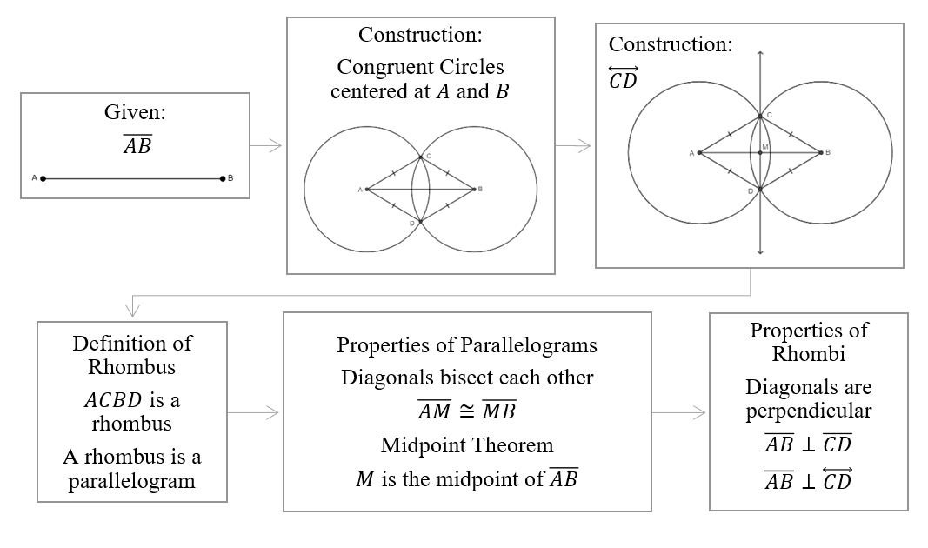
An alternate method to justify the construction of the perpendicular bisector of a line segment makes the connection to the Perpendicular Bisector Theorem (MA.912.GR.1.1). Since $C$ is equidistant to $A$ and $B$, and the same is true for $D$, both points lie on the perpendicular bisector. There is just one line passing through those two points, then line passing through $C$ and $D$ is the perpendicular bisector of the given line segment. That line exists and it is unique as stated in one of Euclid’s postulates.

- Angle Bisector.
Instruction includes the connection to triangle congruence (MA.912.GR.1.2) and the definition of congruent triangles (MA.912.GR.1.6).
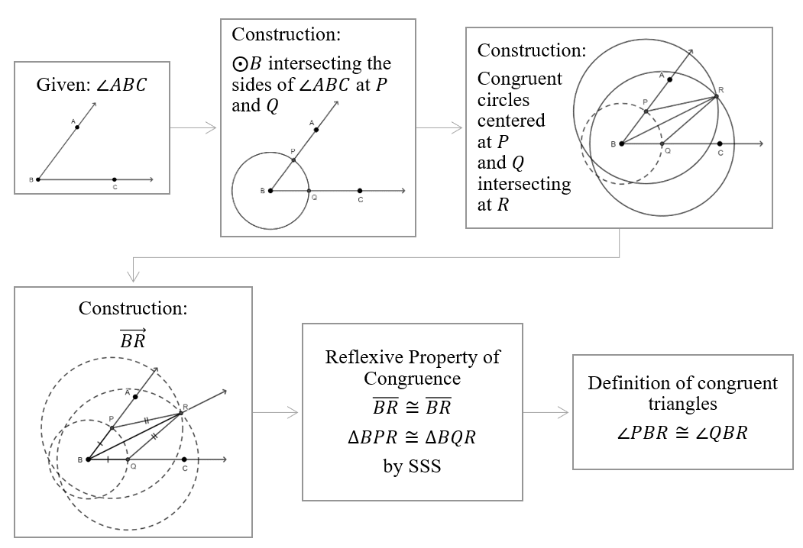

- Students should verify the Perpendicular Bisector Theorem using compass and straightedge. To confirm points on the perpendicular bisector are equidistant from the given segment’s endpoints, students select points on $\overset{⃡}{GH}$, the perpendicular bisector of $\overline{AB}$, such as $G$, $F$, $E$, and $H$, and use the compass to draw circles (or arcs). In each case, the distance from the chosen point and the line segment’s endpoints is the radius of the circle, then the distances are equal.
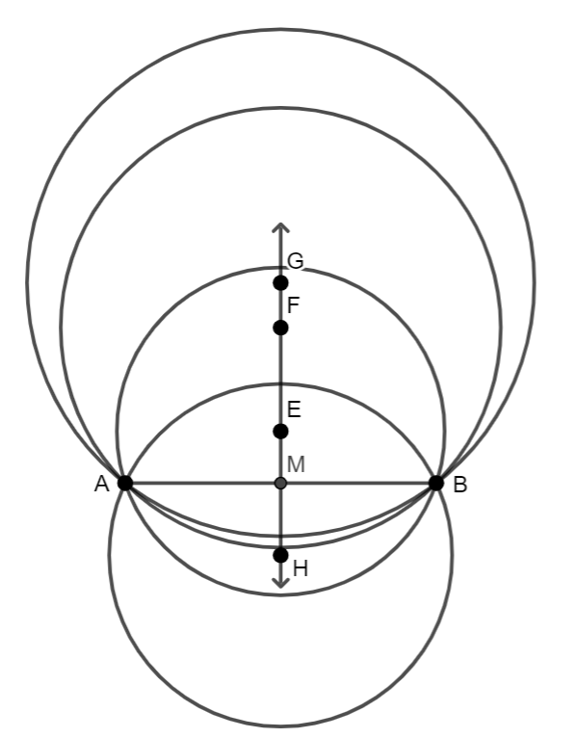

- Instruction includes verifying the converse of the Perpendicular Bisector Theorem. Students should determine whether the converse “if a point is equidistant from a segment’s endpoints, then the point is on the perpendicular bisector of the line segment” is true. If such points can be identified, the perpendicular bisector is the set (or locus) of all those points that are equidistant from the segment’s endpoints.
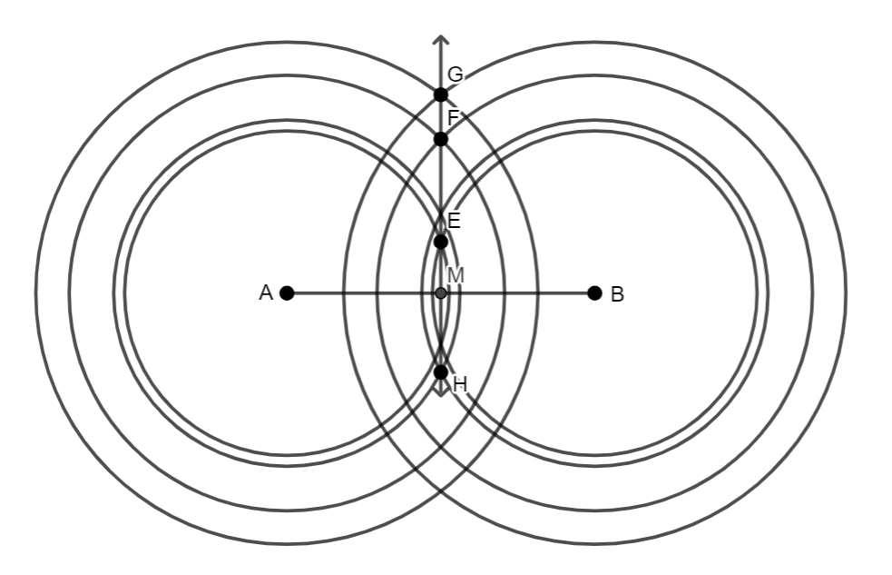
- Instruction includes the connection between the construction of the angle bisector of a given angle when the compass setting remains the same throughout the construction and the definition of rhombus and the properties of rhombi (MA.912.GR.1.4).
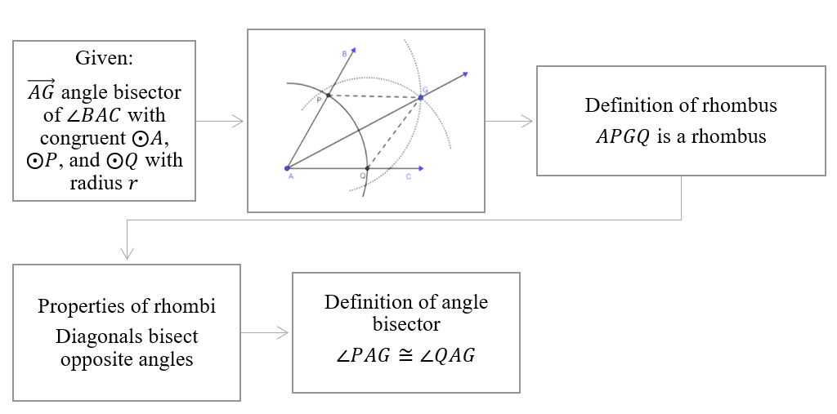

- Instruction makes connection to the notion of the distance from a point to a line. Any point on the angle bisector of a given angle is equidistant to the sides of the angle. This statement can be proved with triangle congruence (MA.912.GR.1.2) and the definition of congruent triangles (MA.912.GR.1.6). Students should write the “if... then” statement and verify whether the converse is true. If so, write the “if and only if” statement “a line, ray, or line segment is an angle bisector if and only if each point on the line, ray, or line segment is equidistant from the sides of the angle.”
- For example, given $\vec{VB}$ is the angle bisector of $∠AVC$, $\overline{BA}≅\overline{BC}$. $BA$ and $BC$ are the distances from $B$, that is they are the shortest segments joining $B$ with a point on each side of the angle. $\overline{BA}$ and $\overline{BC}$ are perpendicular to the sides of the angle.
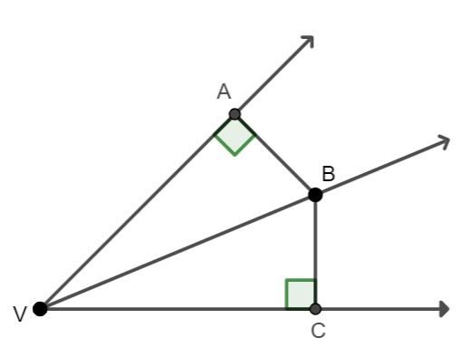

- For expectations of this benchmark in its clarification, instruction includes the following tools: compass and straightedge, string, reflective devices, paper folding or dynamic geometry software.
- Students should develop the understanding that a string or any other tool that preserves the distance between two points can be used to replace the compass in a formal construction. Tools such as the bullseye compass, the woodworking compass scriber, the beam compass, and others can be used instead of a compass.
- Students should have practice with reflective devices constructing the segment bisector and the perpendicular bisector of a given line segment and the angle bisector of a given angle.
- Students should connect constructions with compass and straightedge to constructions with paper folding (e.g., patty paper or parchment paper). Using folds and creases, students can bisect a given line segment and a given angle. Once a line segment is bisected, students can use folds and creases to determine segment bisectors and the perpendicular bisector of the given line segment.
- Students should have practice with dynamic geometry software. These interactive programs allow students to bisect segments and angles and verify the properties of the resulting constructions. Dynamic geometry software can be used to verify whether a point is the midpoint of a segment, the angles a line is forming with a line segment are right, the distances from one point to a segment’s endpoint are equal, the measures of two angles are equal, and the distances from a point to the sides of an angle are equal.

- Students should develop the understanding that using the construction of the perpendicular bisector of a line segment can determined a point partitioning the given line segment in the ratio $1:1$. And consecutive constructions of perpendicular bisectors can determine points partition the given line segment in the ratio $a:b$, where $b$ is a power of $2$.
- For example, given $\overline{PQ}$ determine $S$, the point that partitions the line segment in the ratio 3:4 (or the weighted average of the line segment’s endpoint when the weight on $Q$ is three times the weight on $P$).
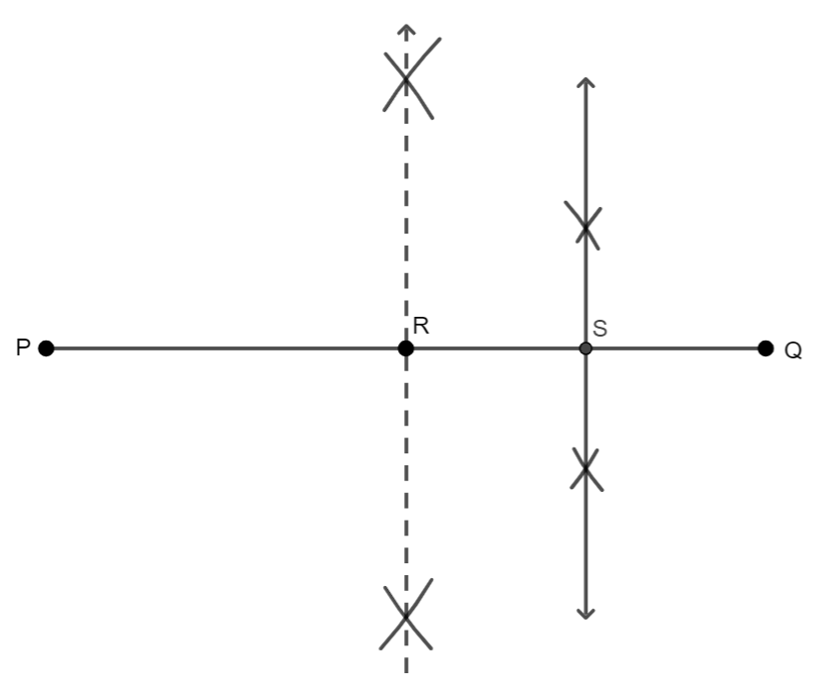
- Instruction includes considering the construction of the angle bisector of a straight angle. Students should determine if the angle bisector of a straight angle is perpendicular to the sides of the angle. Students should explore the cases where the angle bisector of a straight angle is also the construction of a perpendicular bisector.
- For enrichment of this benchmark, students should connect the construction of the perpendicular bisector of a line segment to the construction of a perpendicular to a line passing through an exterior point on the line. This construction is required to determine the radius of the inscribed circle of a triangle once the point of concurrency of the angle bisectors is determined.
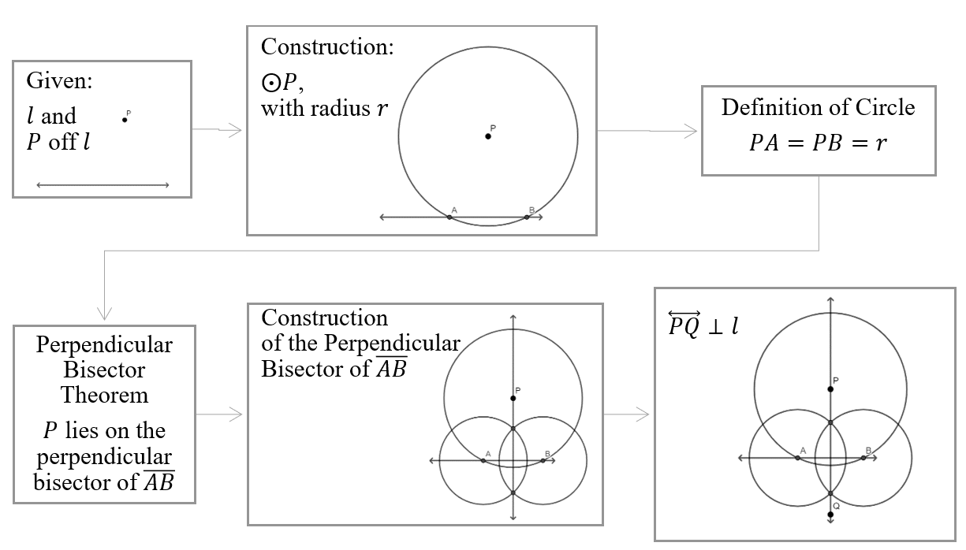
- Instruction includes the discussion of the radius, $r$, used in the construction of a line perpendicular to a given line and through a point outside the line. $r$ must be more than the distance from $P$ to the given line. Students should develop the understanding of this requirement making a connection to the Triangle Inequality Theorem (MA.912.GR.1.3). Students should consider whether they need to determine the points of intersection of two pairs of circles (or arcs) or just determine the intersection of one pair of circles (or arcs) and use the given point outside the line.
- For enrichment of this benchmark, students should connect the construction of a perpendicular bisector to the construction of a perpendicular to a given passing through a point on the line.
- For enrichment of this benchmark, instruction includes the construction of special right triangles (MA.912.T.1).
- $45°-45°-90°$ triangle.
Given $\vec{AP}$, construct $∆ABC$ such that $AB=AC$ and $∠C$ is right. Construct the extension of $\vec{AQ}$, opposite to $\vec{AP}$ and a line perpendicular to $\overset{⃡}{QP}$ and passing through $A$. Choose a point on the perpendicular line and label it $R$. Set the compass and draw a circle (or arc), centered at $A$, such that it intersects $\vec{AP}$ and $\overset{⃡}{AR}$ and label the points of intersection $B$ and $C$. The resulting triangle is an isosceles right triangle.
- $30°-60°-90°$ triangle.
Given a line segment $AB$. Construct an equilateral triangle, using the construction of the copies of the line segment $AB$ (MA.912.GR.5.1). Use $C$ to label the third vertex of the equilateral triangle. Then, construct the perpendicular bisector of the line segment $AB$. The perpendicular bisector contains $C$ by the Perpendicular Bisector Theorem. Use $M$ to label the midpoint of the line segment $AB$. Triangles $AMC$ and $BMC$ are special right triangles $30°-60°-90°$. This construction makes the connection to Trigonometry (MA.912.T.1.2).

Common Misconceptions or Errors
- Students may misidentify the midsegment as the only point equidistant to the line segment’s endpoints, not all the points on its perpendicular bisector. Also, students may apply the Perpendicular Bisector Theorem to any point but the midpoint, missing that the theorem includes all the points on the perpendicular bisector.
- Students may struggle with using compasses and straightedges instead of protractors and rules to bisect segments and angles. Instruction should emphasize on the definitions and properties that justify each construction.

Strategies to Support Tiered Instruction
- Students should have practice identifying the defining features of segment bisectors, perpendicular bisectors, and angle bisectors, resulting from the constructions.
- For example, $M$ is the midpoint of $\overline{PQ}$, $\overline{PM}≅\overline{MQ}$, $PM=MQ$, $m∠PMD=90°$, and $\overline{PQ}⊥\overset{⃡}{DM}$.
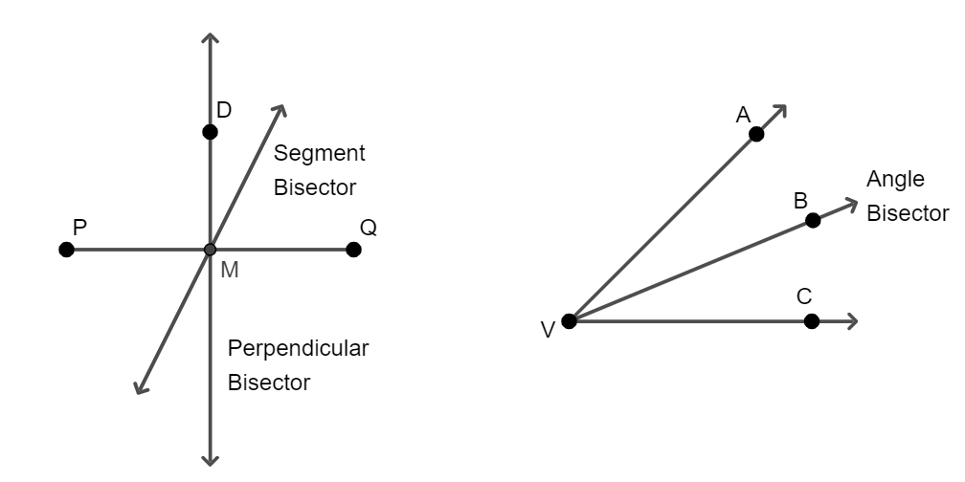
- For example, $∠AVB≅∠BVC$, $m∠AVB=m∠VBC$, $m∠AVC=2 m∠AVB=2 m∠BVC$.
- Students should have practice applying the segment addition postulate and the angle addition postulate given segment bisectors, perpendicular bisectors, and angle bisectors, and solve problems with numerical values.
- For example, $PM+MQ=QP$, $PM=\frac{1}{2}(PQ)$, $m∠AVB+m∠BVC=m∠AVC$ and $m∠ACB=\frac{1}{2}(m∠AVC)$.
For example, if $PQ=32$, what is $PM$?, if $m∠BVC=41°$, what is $m∠AVC$?

Instructional Tasks
Instructional Task 1 (MTR.7.1)
A map of some universities is shown below.
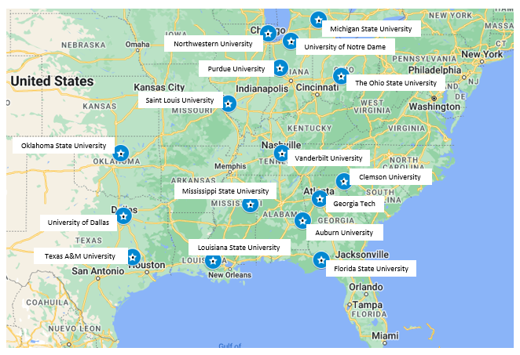
Part A. Prove that Vanderbilt University is approximately equidistant to Mississippi State University and Clemson University.
Part B. Find one or more universities that are approximately equidistant from Florida State University and Oklahoma State University.
Part C. How would you identify universities equidistant to the University of Dallas and Auburn University?

Instructional Task 2 (MTR.7.1)
Driving on Road 314, east to west, you must make the decision of making a left and drive towards Circle Ave or making a right and drive towards Sphere Ave in a coming exit. If the roads connecting Road 314 with Circle Ave and with Sphere Ave at your next exit are perpendicular to the avenues, what construction could you use to make this decision if your purpose is to drive the shortest distance to make it to one of the avenues?
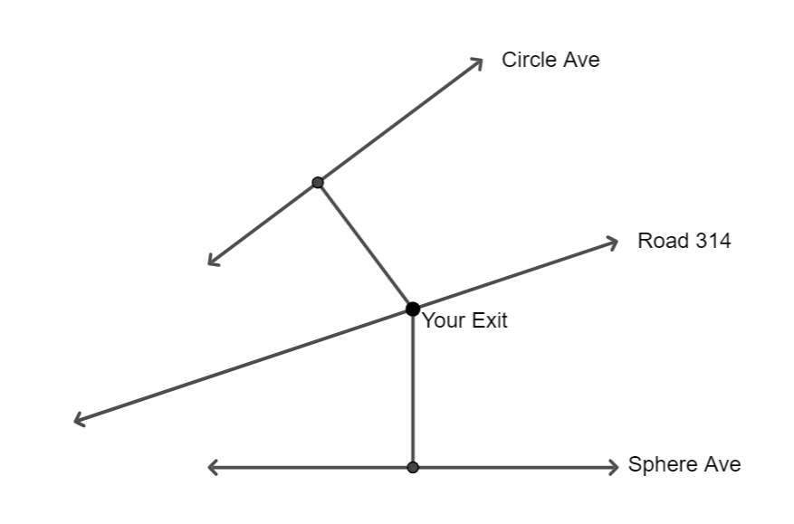

Instructional Task 3 (MTR.5.1)
Part A. Given $\overline{AB}$, construct its perpendicular bisector.

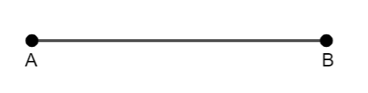

Label the midpoint of $\overline{AB}$ $M$ and the perpendicular bisector $l$. Choose any point on $l$ and label it $P$. Construct the perpendicular bisector of $\overline{MP}$. Label this perpendicular bisector $m$. What is the relationship between $\overline{AB}$, $l$, and $m$.

Part B. Given $l$ and $P$ external to $l$, construct the line perpendicular to $l$ and passing through $P$.

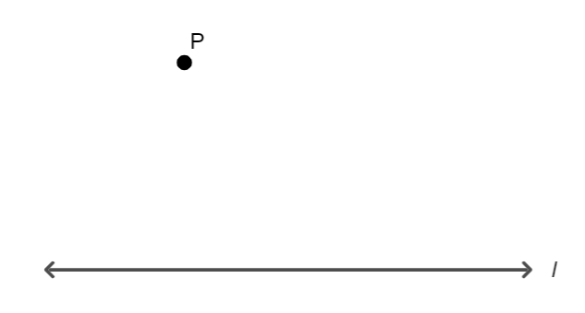

Label the constructed line $m$. Construct a line perpendicular to $m$ and passing through $P$. Label the constructed line $n$. What is the relationship between $l$, $m$, and $n$?

Instructional Items
Instructional Item 1
An image is provided below.
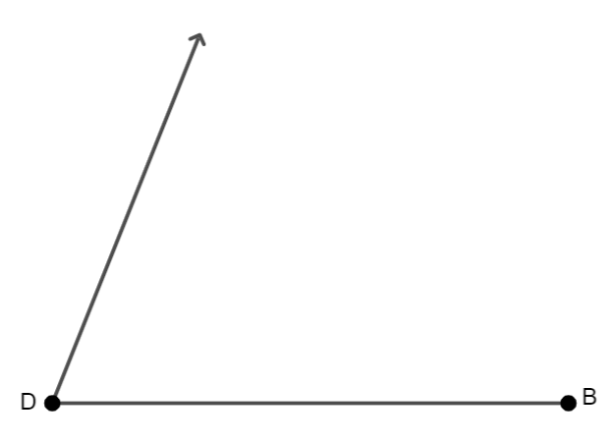
Part A. Construct a line bisecting $∠D$.
Part B. Construct any line passing through the midpoint of $\overline{DB}$, $M$.
Part C. Label the intersection of the lines constructed in Part A and Part B, $P$.
Part D. What kind of triangle is $DPM$? Compare your answer with your partners.

Instructional Item 2
Given $\overline{MN}$, use constructions to determine $P$ such that $MP=\frac{1}{3}(PN)$.

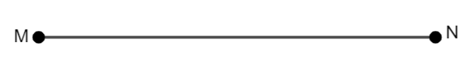

*The strategies, tasks and items included in the B1G-M are examples and should not be considered comprehensive.

MA.912.GR.5.3

Benchmark
MA.912.GR.5.3 Construct the inscribed and circumscribed circles of a triangle.
Benchmark Clarifications:
Clarification 1: Instruction includes using compass and straightedge, string, reflective devices, paper folding or dynamic geometry software.
Connecting Benchmarks/Horizontal Alignment
- MA.912.GR.6.3
Terms from the K-12 Glossary
- Inscribed Circle
- Circumscribed Circle
- Triangle

Vertical Alignment
Previous Benchmarks  - MA.7.GR.1.4 | Next Benchmarks
Purpose and Instructional Strategies
In grade 1, students identified circles and triangles. In Geometry, students construct circles inscribed and circumscribed to a triangle, known as the incircle and the circumcircle.
- Instruction makes connections with Logic and Discrete Theory (MA.912.LT.4.3 and MA.912.LT.4.10). Students should have practice using “if…then,” “if and only if,” “all” and “not” statements while making constructions with compass and straightedge, and with other tools. Constructions can be used to evaluate a conditional statement and its converse, its inverse, and its contrapositive. Also, students should develop the understanding that constructions can be used to judge the validity of an argument and to identify and create counterexamples.
- Students should develop the understanding that geometric constructions are based on definitions, theorems, and relationships about geometric figures, and that constructions can be used as visual proofs when verifying given statements.
- Students should experience that there are limitations on the precision of a construction that are inherent to the use of pencils and compasses. However, the properties, relationships, and theorems used to justify the construction are enough to consider the construction accurate.
- Problem types include identifying the result of a given construction, the next step of a construction, a missing step in a construction, and the order of the steps in a construction. Students should identify the properties, relationships, and theorems, supporting the steps and in the resulting construction.
- For expectations of this benchmark, students should construct incircles and circumcircles, depending on the constructions of angle bisectors and perpendicular bisectors (MA.912.GR.5.2). (MTR.2.1)
- Students should develop the understanding that an inscribed circle of a triangle is the largest circle contained within a triangle, tangent to the three sides of the triangle; and a circumscribed circle of a triangle is the circle that passes through the three vertices of the triangle.
- Students should develop the understanding that when a triangle is inscribed in a circle, the circle circumscribes the triangle. Similarly, when a triangle is circumscribing a circle, then the circle is inscribed in the triangle.
- Instruction includes the understanding that points of concurrency are the points where three or more lines intersect. The point where two lines intersect is called the point of intersection.
- Instruction includes the understanding that the distance between a point and a line segment, ray, or line, is the segment starting at the point and perpendicular to the line segment (or its extension), the ray (or its extension), or the line. The distance between a point and a line segment, ray, or line segments is the shortest distance between them.
- Students should have practice constructing a perpendicular line though a point outside a given line, as an extension of the understanding of the construction of the perpendicular bisector of a line segment. This construction is used to determine the radius of the incircle.
- For expectations of this benchmark, instruction includes the following constructions:
- Inscribed Circle of a Triangle (or Incircle)
Instruction includes the understanding that the center of a circle inscribed in a triangle is the point of concurrency of the angle bisectors of the interior angles of the triangle. This point of concurrency is called incenter. Students should also develop the understanding that to determine the radius of the inscribed circle, or inradius, is necessary to construct the segment perpendicular to one of the sides of the triangle and starting at the incenter. This construction can also be described as the construction of the distance from the incenter to one of the sides of the triangle.
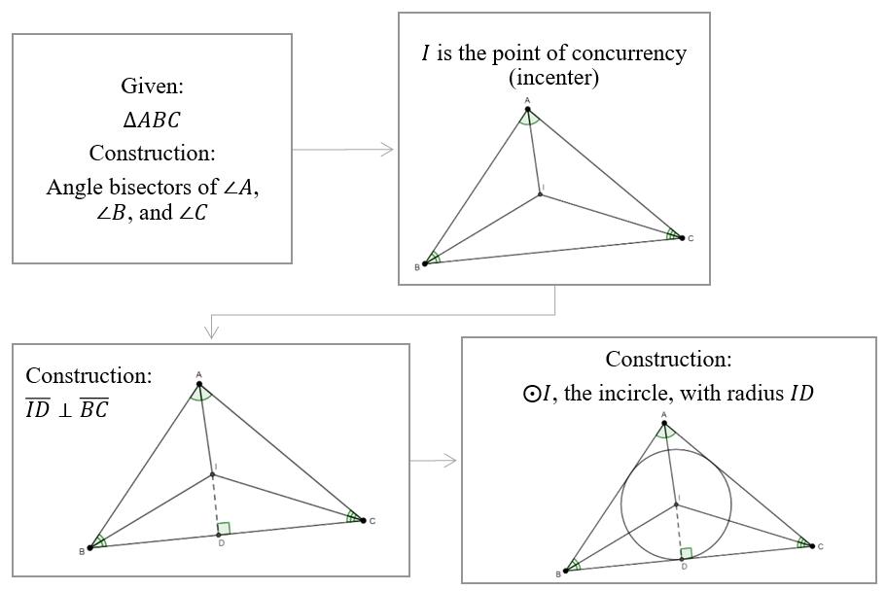

- Circumscribed Circle of a Triangle (or Circumcircle)
Instruction includes the understanding that the center of a circle circumscribed of a triangle is the point of concurrency of the perpendicular bisectors of the sides of the triangle. This point of concurrency is called circumcenter. The radius of the circumcircle, the circumradius, is the distance from the circumcenter to any of the vertices of the triangle.
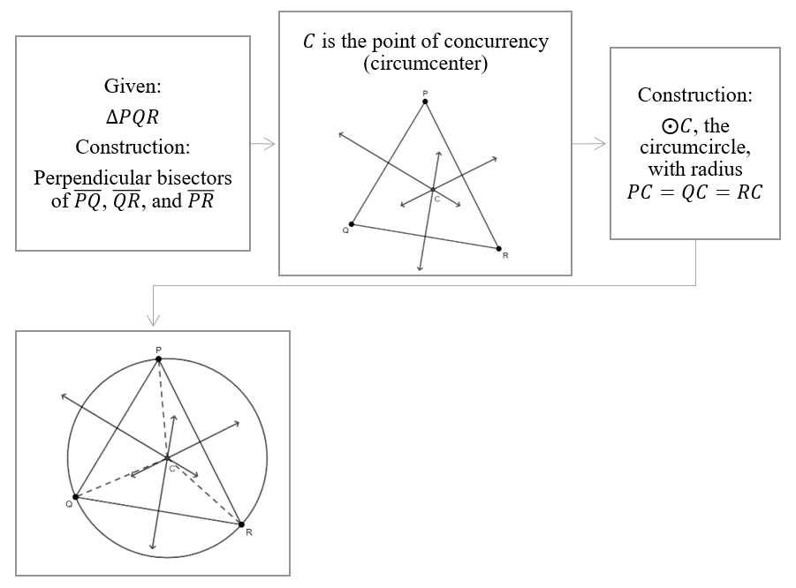
- Students should develop the understanding that two angle bisectors and two perpendicular bisectors are enough to determine the centers of the inscribed circle and the circumscribed circle of a triangle.

- Instruction makes the connection to triangle congruence (MA.912.GR.1.2) and the definition of congruent triangles (MA.912.GR.1.6). Students should deduce the incenter is equidistant to the sides of the triangle and the circumcenter is equidistant to the vertices of the triangle.
- Given the inscribed circle of a triangle.
Using the Reflexive Property of Congruence, the definition of angle bisector, the definition of distance from a point to a line, the definition of perpendicular, the definition of right angles, and the definition of congruent angles, $\overline{AI}≅\overline{AI}$, $∠QAI≅∠PAI$, and $∠AQI≅∠API$. Then, $∆AQI≅∆API$ by AAS, and by the definition of congruent triangles, $\overline{IQ}≅\overline{IP}$. $IQ$ and $IP$ are radii of the inscribed circle of the triangle and $I$ is the incenter.

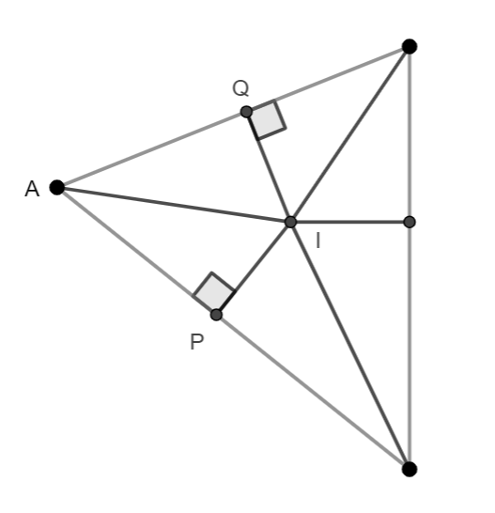
- Given the circumscribed circle of a triangle.
Using the Reflexive Property of Congruent, the definition of perpendicular bisector, the definition of right angles, and the definition of congruent angles, $\overline{CM}≅\overline{CM}$, $\overline{AM}≅\overline{BM}$, and $∠AMC≅∠BMC$. Then, $∆AMC≅∆BMC$ by SAS, and by the definition of congruent triangles, $\overline{AC}≅\overline{BC}$. $AC$ and $BC$ are radii of the circumscribed circle of the triangle and $C$ is the circumcenter.

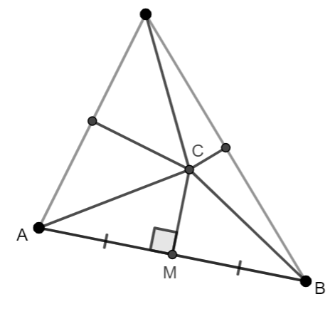

- Instruction includes the exploration of inscribed and circumscribed circles of a triangle when the triangle is acute, right, and obtuse. Students should develop the understanding that when a triangle is right, the circumcenter is the midpoint of the hypotenuse, making the connection with measures of arcs and related angles (MA.912.GR.6.1).

 | Acute | Right | Obtuse
Inscribed Circles | 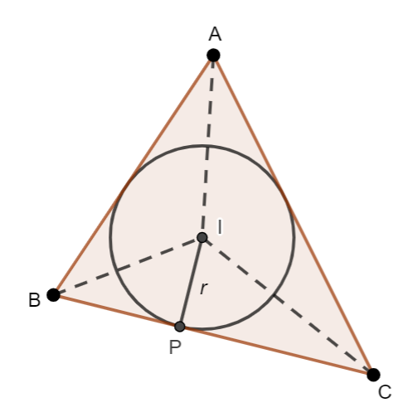 | 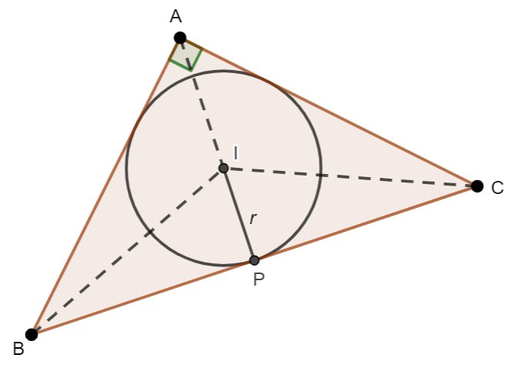 | 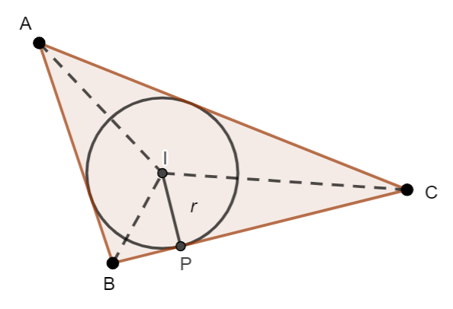
Circumscribed Circles | 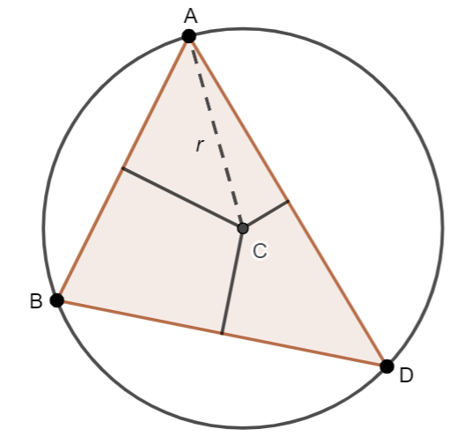 | 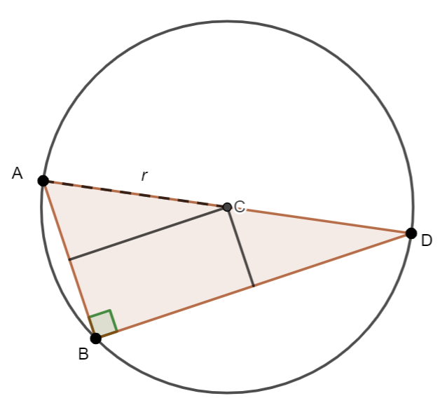 | 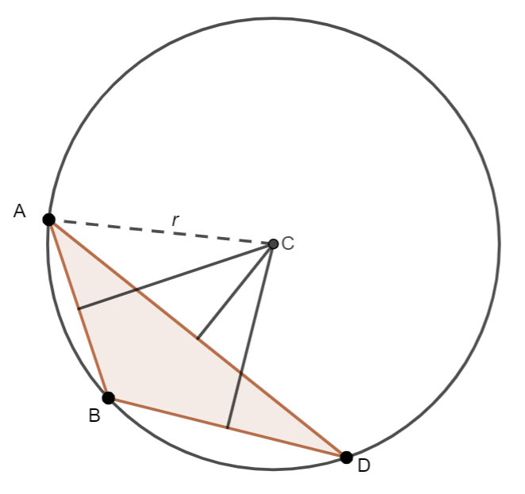

- For enrichment of this benchmark, students should solve the mathematical problem of drawing a circle given three points of the circle. Instruction makes the connection to the circumscribed circle of a triangle. Given three points, students should identify these points as the vertices of a triangle and use the construction of the perpendicular bisectors of at least two sides of the triangle to identify the circumcenter, the circumradius, and the circumcircle.

- For enrichment of this benchmark, students should explore the incenter and circumcenter of isosceles triangles and of equilateral triangles.
- When a triangle is isosceles, the angle bisector of the vertex angle coincides with the perpendicular bisector of the base. Students should use constructions to verify this statement. Students should consider the medians of the triangle and make a conjecture about the location of the centroid. The line passing through the circumcenter and the centroid of a non-equilateral triangle is called the Euler Line.
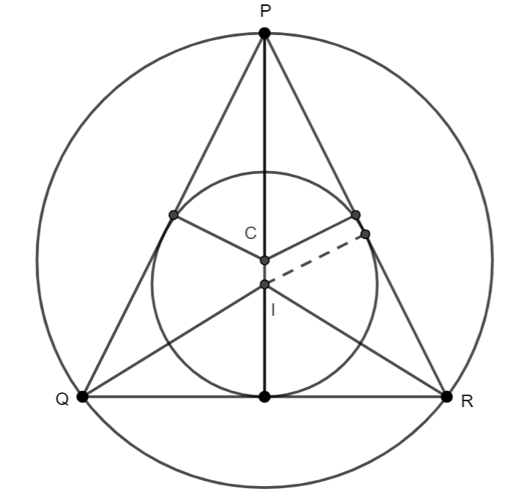
- When a triangle is equilateral, each angle bisector coincides with the perpendicular bisector of the opposite side, and incircle and circumcircle are concentric circles. Students should use constructions to verify this statement. Students should consider the medians of the triangle and make a conjecture about the location of the centroid.
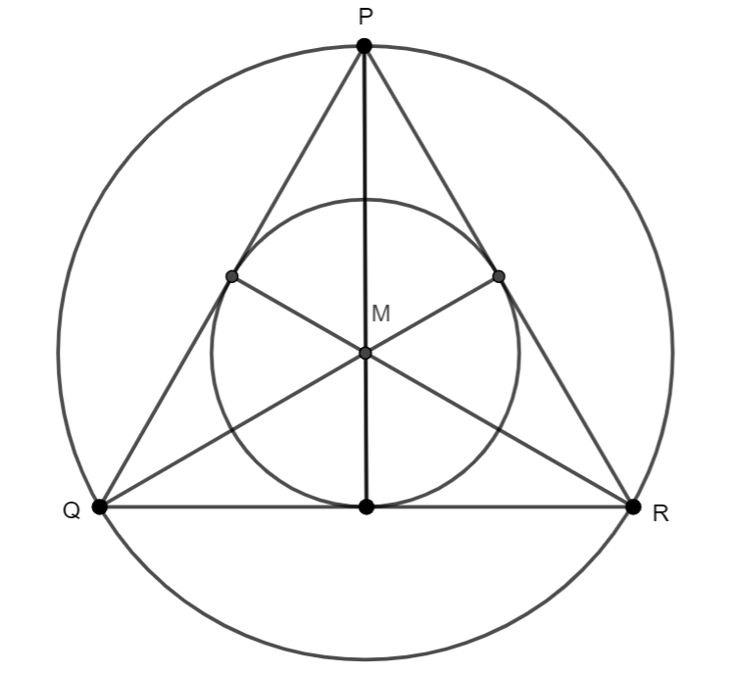

Common Misconceptions or Errors
- Students may use the distance from the incenter to a vertex of the triangle incorrectly as the radius of the incircle.
- Students may struggle with the construction of the circumscribed circle of a right triangle and of an obtuse triangle.

Strategies to Support Tiered Instruction
- Students should have practice determining the surface area of a single three-dimensional figure, using the Geometry EOC Mathematics Reference Sheet.
- Students should have practice converting units of length and units of area within the same system, and across the systems.

Instructional Tasks
Instructional Task 1 (MTR.2.1, MTR.4.1)
Given $∆PQR$, construct the angle bisectors of its interior angles using:
    - folding paper
    - compass and straightedge
    - dynamic geometry software
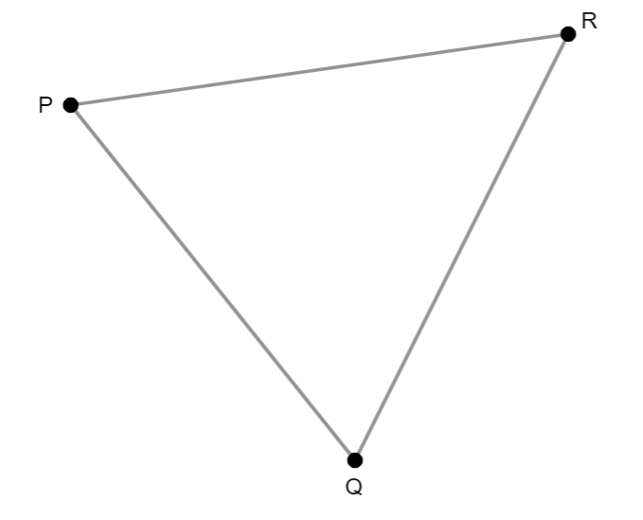
Part A. Construct the angle bisectors of the interior angles of an obtuse triangle and a right triangle, using one of the methods (folding paper, compass and straightedge, dynamic geometry software). Describe your findings.
Part B. Label the point of concurrency of the angle bisectors in each construction $I$. This point is the incenter, the center of the inscribed circle of each triangle. How can you determine the radius of that circle, the incircle?
Part C. Construct the inscribed circle of each of the triangles.

Instructional Task 2 (MTR.2.1, MTR.4.1)
Given $∆PQR$, construct the perpendicular bisectors of its sides using:
    - folding paper
    - compass and straightedge
    - dynamic geometry software
Part A. Construct the perpendicular bisectors of the sides of an obtuse triangle and a right triangle, using one of the methods (folding paper, compass and straightedge, dynamic geometry software). Describe your findings.
Part B. Label the point of concurrency of the perpendicular bisectors in each construction $C$. This point is the circumcenter, the center of the circumscribed circle of each triangle. How can you determine the radius of that circle, the circumcircle?
Part C. Construct the circumscribed circle of each of the triangles.

Instructional Items
Instructional Item 1
Construct the circle that is circumscribed about $∆XYZ$.
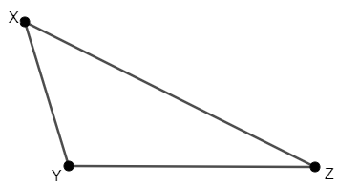

Construct the circle that is inscribed in $∆XYZ$.

*The strategies, tasks and items included in the B1G-M are examples and should not be considered comprehensive.

MA.912.GR.6.1

Benchmark
MA.912.GR.6.1 Solve mathematical and real-world problems involving the length of a secant, tangent, segment or chord in a given circle.
Benchmark Clarifications:
Clarification 1: Problems include relationships between two chords; two secants; a secant and a tangent; and the length of the tangent from a point to a circle.
Connecting Benchmarks/Horizontal Alignment
- MA.912.GR.3.2, MA.912.GR.3.3 MA.912.GR.5.3
MA.912.GR.7.2, MA.912.GR.7.3
Terms from the K-12 Glossary
- Circle
Vertical Alignment
Previous Benchmarks  - MA.7.GR.1.3, MA.7.GR.1.4  - MA.8.GR.1.1  - MA.912.AR.1.2  - MA.912.AR.2.1  - MA.912.AR.3.1 | Next Benchmarks
Purpose and Instructional Strategies
In grade 7, students explored the relationship between the diameter and the circumference of a circle and explored and applied the formula to determine the circumference and the area of a circle. In Algebra 1, students rearranged equations to isolate a quantity of interest and solved linear and quadratic equations in one variable. In Geometry, students solve problems involving the lengths of two secants, the lengths of two tangents, the length of a secant and a tangent, and the lengths of two chords.
- Instruction includes precise definitions for tangent and secant as qualitative adjectives that describe line segments, rays, and lines. It also includes the precise definition of chords, and the definition of a diameter as a chord passing though the center, the longest chord. Students should develop the understanding that chords are contained by secant line segments, rays, or lines; and the understanding that secants and tangents intersect outside the circle, and chords intersect inside the circle. (MTR.4.1)
- Instruction makes the connections to Logic and Discrete Theory (MA.912.LT.4.3 and MA.912.LT.4.10).
- For example, “if a chord passes though the center, then the chord is a diameter,” “not all chords are diameters are chords,” “all diameters are chords”, and “a chord is a diameter if and only if it passes through the center of the circle.”
- For example, given the argument “a line secant to a circle intersects the circle at two distinct points; if $\overline{AB}$ is a secant, then $\overline{AB}$ is a chord of the circle.” The argument is not valid, and a counterexample is $\overline{AB}$ with endpoints $A$ and $B$ outside the circle (instead of on the circle).
- Students should determine whether the converse of a given “if… then” statement is true. If so, write the biconditional statement.
- For example, given “if a line is secant to a circle, then the line contains a chord of the circle.” The converse is “if a line contains a chord of a circle, then the line is secant to the circle.” The converse is true. Then, “a line is secant to a circle if and only if the line contains a chord of the circle.”
- For expectations of this benchmark, instruction includes the following theorems.
- Intersecting Chords Theorem or the Chord-Chord Theorem
Instruction makes the connections to similar triangles and angles inscribed in a circle and their related arcs (MA.912.GR.6.2). Given a circle with chords $\overline{AD}$ and $\overline{CB}$. $∠APB≅∠CPD$ since they are vertical angles. $∠ABC≅∠ADC$ since they intercept the same arc, $\hat{AC}$, on the circle. By Angle-Angle for triangle similarity, $∆APB\sim ∆CPD$. By the definition of similar triangles, $\frac{AP}{CP}=\frac{BP}{DP}$, and using the properties of equality, $AP⋅DP=CP⋅BP$.
A
B
C
D
P
- Intersecting Secants Theorem, or the Secant-Secant Theorem
Instruction makes the connections to similar triangles angles inscribed in a circle and their related arcs (MA.912.GR.6.2). Given a circle with $\overline{AP}$ and $\overline{CP}$ secant to the circle. $∠PAD≅∠PCB$ since they intercept the same arc, $\hat{BD}$, on the circle. $∠P≅∠P$ by the Reflexive Property of Congruence. By Angle-Angle for triangle similarity, $∆PAD\sim ∆PCB$. By the definition of similar triangles, $\frac{PA}{PC}=\frac{PD}{PB}$, and using the properties of equality, $PB∙PA=PD∙PC$.
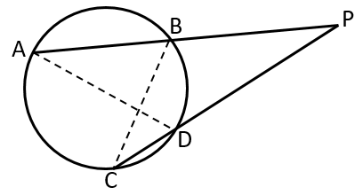

- Tangent-Secant Theorem and the Tangent-Tangent Theorem
Students should develop the understanding that the Tangent-Secant Theorem and the Tangent-Tangent Theorem are cases of the Secant-Secant Theorem.
Given a circle with $\overline{AP}$ secant to the circle and $\overline{CP}$ tangent to the circle. By the Secant-Secant Theorem $PB∙PA=PC∙PC$ or $PC^{2}=PB∙PA$.

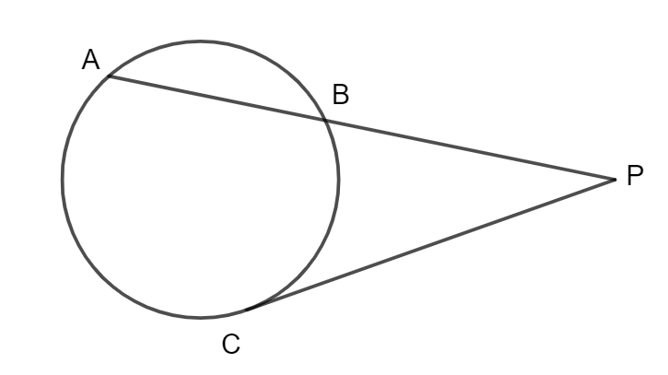
Given a circle with $\overline{AP}$ and $\overline{BP}$ tangents to the circle. By the Secant-Secant Theorem $PA∙PA=PB∙PB$ or $(P{A)}^{2}=(P{B)}^{2}$ and $PA=PB$ ($PA>0$, $PB>0$).
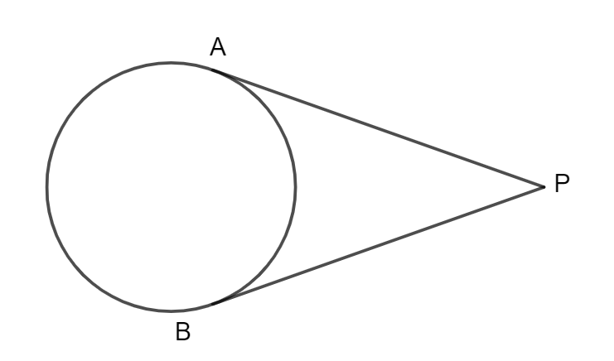
- Instruction makes the connection between the cases two secants, a secant and a tangent, and two tangents. Students should develop the understanding that in all the cases $PA∙PQ=PB∙PR$ is true.

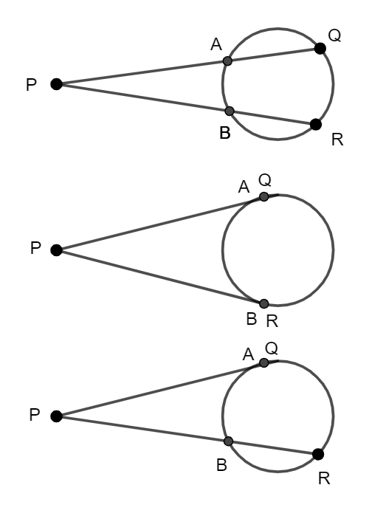

- Instruction includes the properties of chords.
- If two chords are equidistant from the center, then they are congruent (the converse is also true). Given circle $O$, with $\overline{OP}≅\overline{OQ}$. $∆OPB≅∆OQD$ are congruent by Hypotenuse-Leg. Similarly, $∆OPA≅∆OQC$. By the definition of congruent triangles, $\overline{PB}≅\overline{QD}$ and $\overline{PA}≅\overline{QC}$. Then, using the definition on congruent segments and the segment addition postulate, $\overline{AB}≅\overline{CD}$.
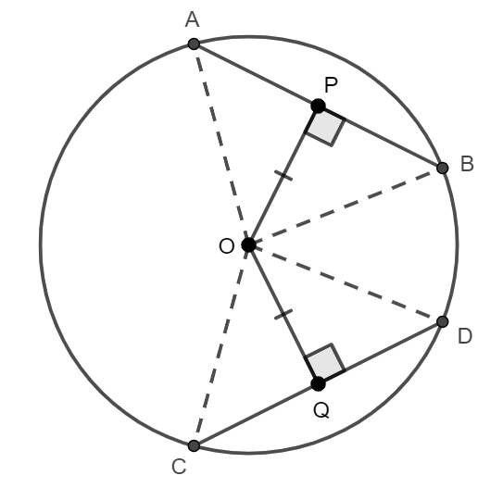
- If the lengths of two chords are equal, then they intercept arcs are congruent. Given circle $O$, with $\overline{AB}≅\overline{CD}$ ($\overline{AB}$ and $\overline{CD}$ are chords of the circle). $OA$, $OB$, $OC$, and $OD$ are radii of the circle and then, congruent. Therefore, $∆AOB≅∆COD$ and by the definition on congruent triangles $∠AOB≅∠COD$. Since two congruent central angles intercept congruent arcs, then $\hat{AB}≅\hat{CD}$ (MA.912.GR.6.2).
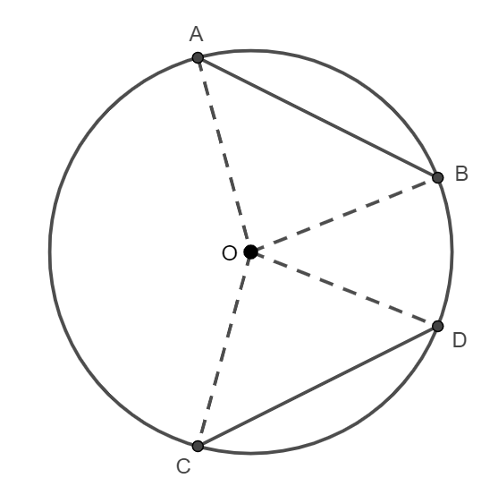

- If a chord passing through the center of a circle is perpendicular to another chord, then it bisects the chord. Given circle $O$, with $\overline{DC}$ a chord passing through the center and perpendicular to $\overline{AB}$. $OA$ and $OB$ are radii of the circle and then, congruent. By the Reflexive Property of Congruent $\overline{OP}≅\overline{OP}$, and Hypotenuse-Leg $∆OPA≅∆OPB$. By the definition of congruent triangles, $\overline{AP}≅\overline{BP}$.
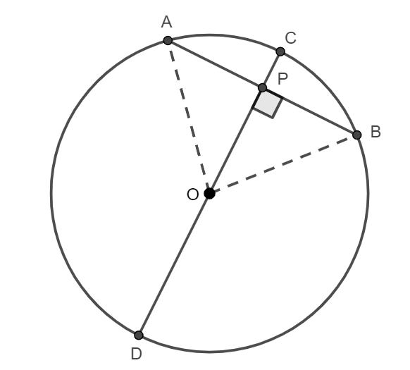
- Instruction makes the connections between a segment tangent to a circle, the radius at the point of tangency (MA.912.GR.6.2) and the Pythagorean Theorem (grade 8).
Given a circle with center at $P$, and $Q$, $S$, $T$, and $V$ points on the circle. $m∠TPQ=\frac{1}{2}\hat{TVQ}=\frac{1}{2}\left(180°\right)=90°$ (MA.912.GR.6.2). By the definition of perpendicular lines, $\overline{TQ}⊥\overline{QR}$. That is, a segment tangent to the circle is perpendicular to the radius at the point of tangency. Then, ${\left(PQ\right)}^{2}+{\left(QR\right)}^{2}={\left(PR\right)}^{2}$. It is also true that $RV∙RS={\left(RQ\right)}^{2}$.
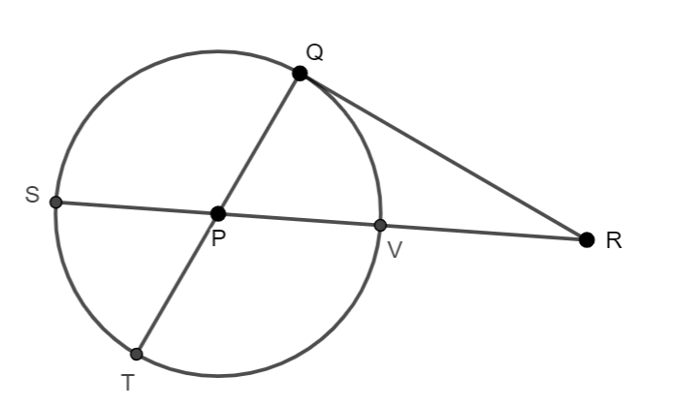
- Problem types include determining missing lengths in mathematical and real-world contexts involving chords, secants, and tangents, using numerical and algebraic expressions.

Common Misconceptions or Errors
- Students may apply the Chord-Chord Theorem incorrectly.
- For example, instead of $\left(2.51\right)\left(4.38\right)=2.71x$, students may write the equation $2.51x=(2.71)(4.28)$ or $x+2.71=2.51+4.38$.
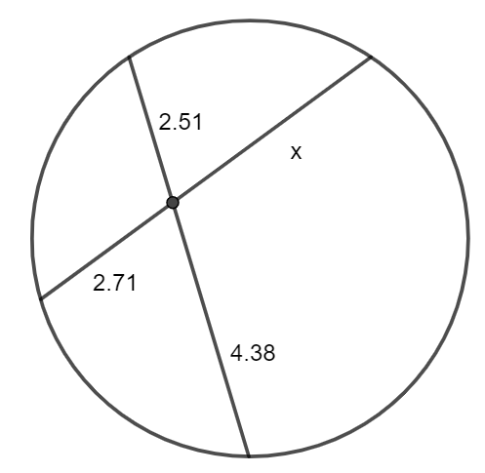
- Students may apply the Secant-Secant Theorem incorrectly.
- For example, given $AP=10.06$ and $BP=x$, instead of $\left(5.56\right)\left(10.06\right)=5.6x$, students may write the equation $\left(5.56\right)\left(5.6\right)=10.06x$ or $5.56+10.06=5.6+x$.
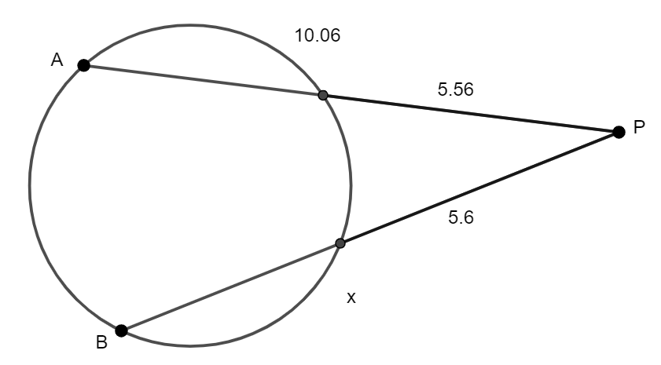

Strategies to Support Tiered Instruction
- Instruction includes answering questions about chords, diameters, secants, and tangents.
- For example, what is the difference between chord and diameter?, is a diameter always a chord?, what is the difference between tangent and secant?, what is the difference between a secant and a chord?
- Students should have practice identifying chords, secants, and tangents.
- For example, given the image, $\overline{CD}$ is tangent to the circle, $\overline{CE}$ is secant to the circle, and $\overline{FE}$ is a chord of the circle.
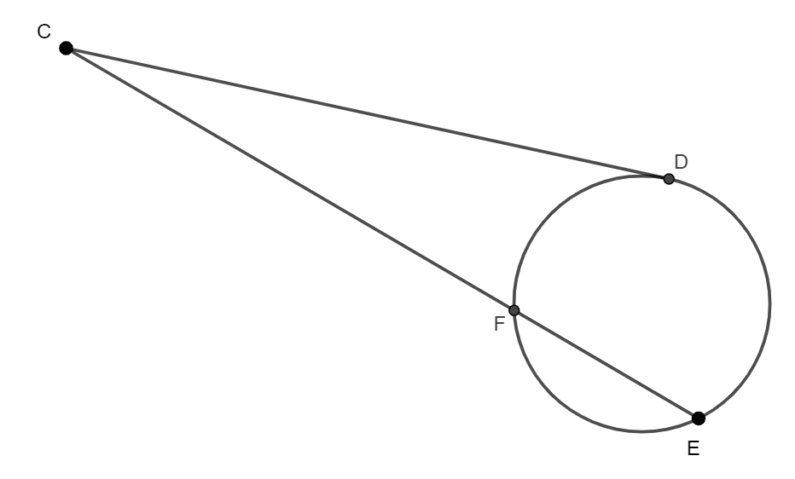

- Teacher models how to use the theorems in this benchmark using highlighters or colored pencils to identify the segments corresponding to the equation of each theorem.
- For example, to use the Secant-Tangent Theorem. Then, $CD^{2}=CE∙FE$.
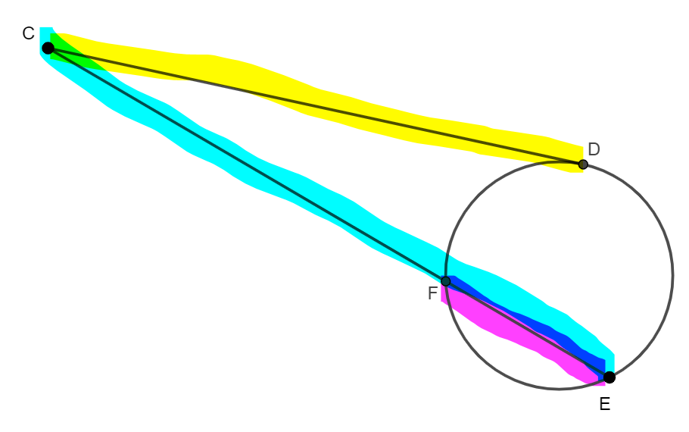
- Students should have practice solving for a variable given the equation of any of the theorems in this benchmark.
- For example, given $a∙b=c∙d$, solve for $c$; given $a^{2}=b∙c$ solve for $a$ and solve or $b$.

Instructional Tasks
Instructional Task 1 (MTR.4.1, MTR.5.1)
Circle $C$ is shown below with various line segments. $\overline{PS}$ and $\overline{PT}$ are tangent to Circle $C$.
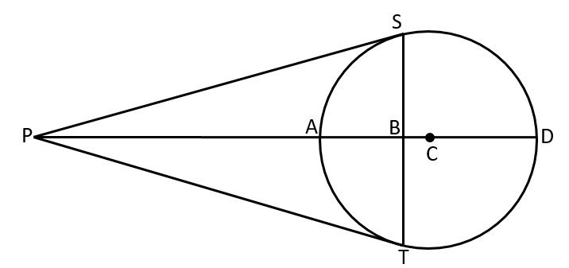
Part A. Write an equation that involves the length of a tangent and the length of a secant.
Part B. Write an equation that involves the lengths of two tangents.
Part C. Write a statement that involves a chord and a diameter.
Part D. Write an equation that involves the length of a tangent, the length of a line segment from a point outside the circle and the length of a radius.
Part E. Compare your statements from Parts A, B, C and D with a partner.

Instructional Task 2 (MTR.3.1)
In Circle $A$, $AE=DE$, $FE=6$ inches and $GE=10$ inches. What is the length of the radius of Circle $A$?
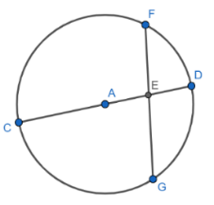
Instructional Items
Instructional Item 1
In Circle $A$, $\overline{BE} \text{and} \overline{DC}$ intersect at point $F$. $FE=1.3$ units, $CF=1.9$ units, $FB=x+1.3$ units and $DF=x$ units. Find the value of $x$.
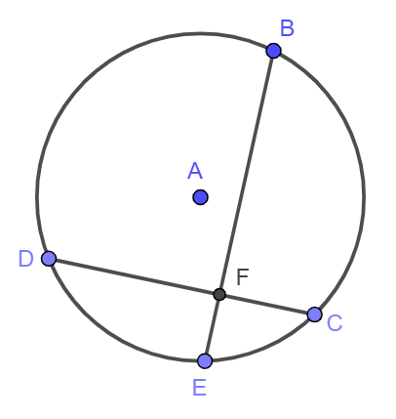

Instructional Item 2
Given circle O with $\overline{ML}$ secant to the circle and $\overline{AL}$ tangent to the circle. If $ML=19$ and $ME=8$, find the length of $\overline{AL}$. Round to the nearest hundredth if necessary.

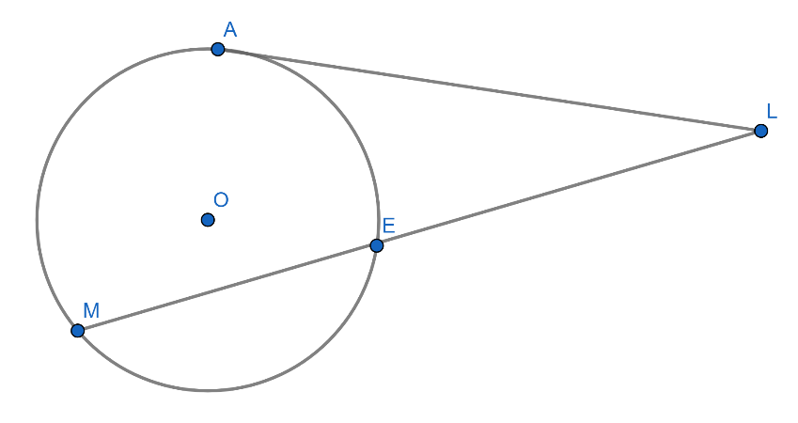

*The strategies, tasks and items included in the B1G-M are examples and should not be considered comprehensive.

MA.912.GR.6.2

Benchmark
MA.912.GR.6.2 Solve mathematical and real-world problems involving the measures of arcs and related angles.
Benchmark Clarifications:
Clarification 1: Within the Geometry course, problems are limited to relationships between inscribed angles; central angles; and angles formed by the following intersections: a tangent and a secant through the center, two tangents, and a chord and its perpendicular bisector.
Connecting Benchmarks/Horizontal Alignment
- MA.912.GR.3.2, MA.912.GR.3.3
- MA.912.GR.5.3
- MA.912.GR.7.2, MA.912.GR.7.3
Terms from the K-12 Glossary
- Central Angle
- Circle
- Inscribed Angle

Vertical Alignment
Previous Benchmarks  - MA.7.GR.1.3, MA.7.GR.1.4  - MA.7.DP.1.4  - MA.7.DP.2.3  - MA.912.AR.1.2  - MA.912.AR.2.1 | Next Benchmarks  - MA.912.T.2.1, MA.912.T.2.2
Purpose and Instructional Strategies
In grade 8, students solved problems involving complementary, supplementary, adjacent, and vertical angles, and the relationships between interior and exterior angles of a triangle. In Algebra 1, students rearranged equations to isolate a quantity of interest and solved linear equations in one variable. In Geometry, students solve problems involving the measures of central angles, inscribed angles, semi-inscribed, and circumscribed angles, and the arcs they intercept. Students also solved problems involving a chord and its perpendicular bisector. In later courses, students will apply relationships between central angles and their related arcs to determine the value of trigonometric functions for real numbers in the unit circle.

- Instruction includes the corresponding notation for arcs.
- For example, the notation for the minor arc with endpoints $B$ and $C$ is $\hat{BC}$ and its measure is less than $180°$; the notation for the major arc with endpoints $C$ and $E$ is $\hat{CBE}$ and its measure is more than $180°$. The arc whose endpoints are the endpoints of a diameter is a semi-circle and its measure is $180°$. In the given circle centered at $A$, $\hat{DF}$ is a semi-circle, and $m\hat{DF}=180°$.
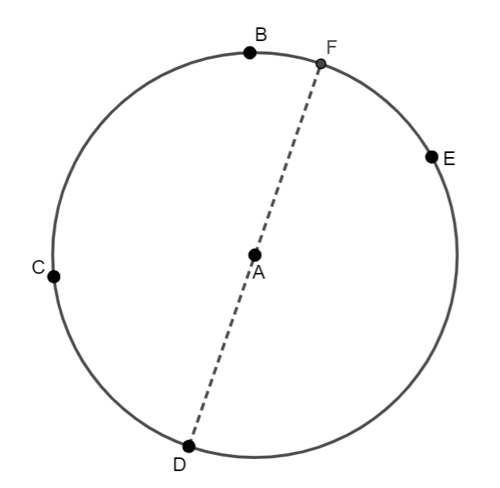
- Students should develop the understanding of the expressions “an arc intercepted by an angle” and “an angle subtended by an arc.”
- For example, in the given circle centered at $A$, $\hat{CB}$ is the arc intercepted by $∠CAB$, and $∠CAB$ is the angle subtended by $\hat{CB}$. Similarly, $\hat{BE}$ is the arc intercepted by $∠BDE$, and $∠BDE$ is the angle subtended by $\hat{BE}$.
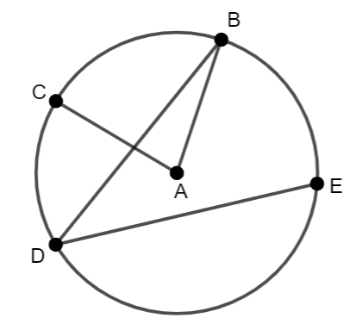
- Instruction includes precise definitions for central, inscribed, semi-inscribed, and circumscribed angles in terms of their vertices and their sides.
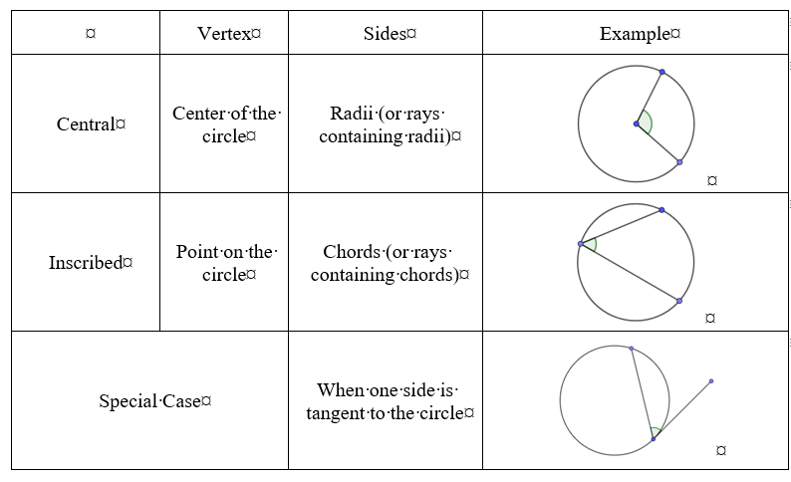
- Instruction makes the connections to Logic and Discrete Theory (MA.912.LT.4.3 and MA.912.LT.4.10).
  - For example, “if two inscribed angles intercept the same arc, then the inscribed angles are congruent,” “all pairs of angles formed by a central angle and a circumscribed angle intercepting the same arc are supplementary”, and “a central angle is straight if and only if it is formed by the opposite radii.”
  - For example, given the argument “two diameters form four distinct central angles and each one of these central angles intercept a distinct arc; if $\overline{PQ}$ and $\overline{RS}$ are diameters of circle $O$ (as shown in the image below), then $\hat{PR}≅\hat{RQ}$.”
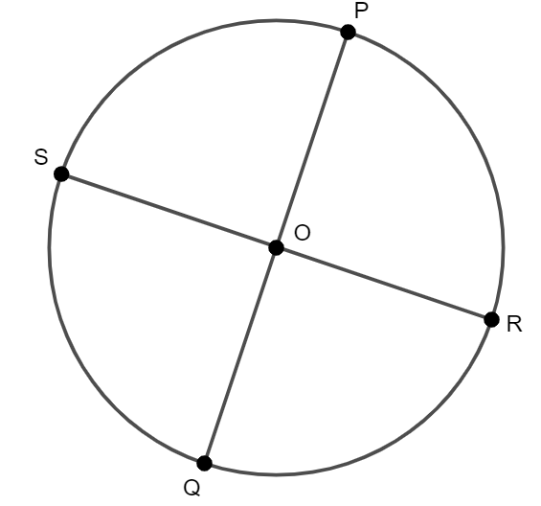
The argument is not valid, and a counterexample is $\overline{PQ}$ and $\overline{RS}$ forming one pair of acute angles and one pair of obtuse angles.
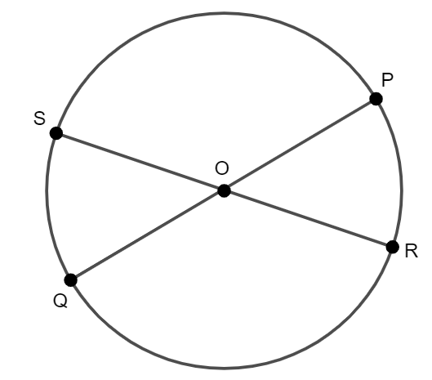
- Students should determine whether the converse of a given “if… then” statement is true. If so, write the biconditional statement.
  - For example, given a circle with chords $\overline{PQ}$ and $\overline{MN}$ and the statement “if $m∠PON=\frac{1}{2}\left(m\hat{PN}+m\hat{MQ}\right)$, then $O$ the point in the interior of the circle where the chords meet.” The converse is “if $O$ is the point on the interior of a circle where the chords meet, then $m∠PQN=\frac{1}{2}(m\hat{PN}+m\hat{MQ})$.” The converse is true. Then, “$m∠PQN=\frac{1}{2}(m\hat{PN}+m\hat{MQ})$ if and only if $O$ is the point on the interior of the circle where the chords meet.”
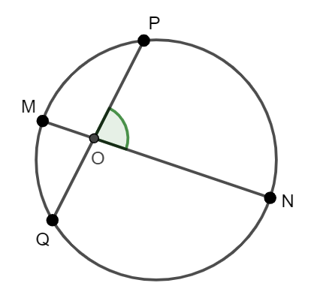
- For expectations of this benchmark, instruction includes the relationships between central angles, inscribed angles, and their related arcs.
  - In a circle, a central angle and its intercepted arc have the same measure. Then, a straight central angle measures the same than its intercepted arc, a semi-circle ($180°$) and a right central angle measures the same than its intercepted arc, a quarter of a circle ($90°$).
  - In a circle, the measure of an inscribed angle is half the measure of its intercept arc, or half the measure of the central angle intercepting the same arc. Then, an inscribed angle intercepting the same arc than a straight central angle or intercepting a $180°$ arc is right.
  - Two inscribed angles intercepting the same arc are congruent.
- Instruction makes the connections between central angles, inscribed angles, and the definition of isosceles triangle and the Isosceles Triangle Theorem.
- Given a circle, and a central angle, and an inscribed angle intercepting the same arc, there are three cases to consider.
Case 1 | Case 2 | Case 3
The inscribed angle is formed by a chord and a diameter with a common endpoint | The inscribed angle is formed by two chords one different sides of the center of the circle with a common endpoint | The inscribed angle is formed by two chords on the same side of the center of the circle with a common endpoint
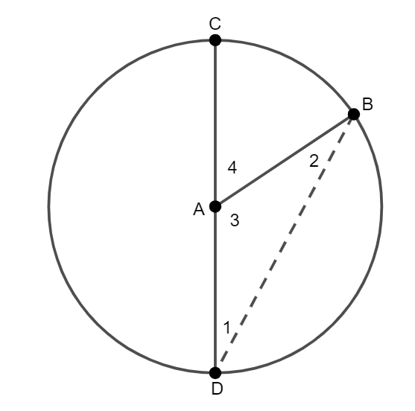 | 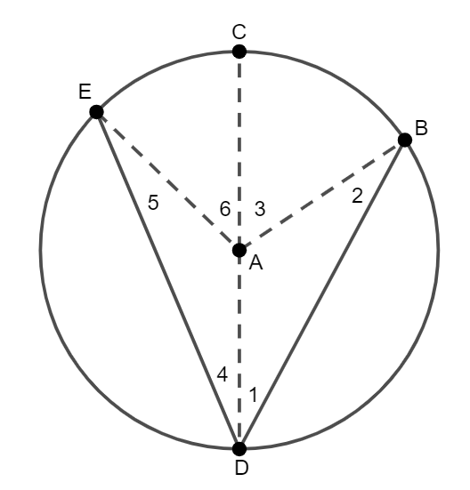 | 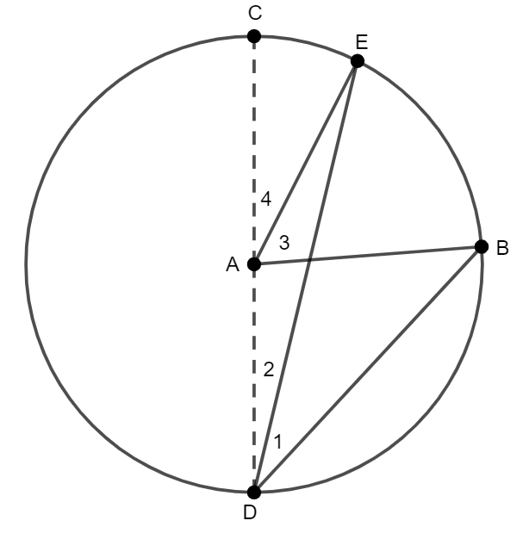
Since $\overline{AB}$ and $\overline{AD}$ are radii of the circle, $∆ADB$ is isosceles and $∠1≅∠2$. $∠4$ is exterior to $∆ADB$, so $m∠4=m∠1+m∠2$.  Therefore, $m∠4=2(m∠1)$ | Since $\overline{AB}$, $\overline{AD}$, and $\overline{AB}$ are radii of the circle, $∆ADB$ and $∆ADE$ are isosceles and $∠1≅∠2$ and $∠4≅∠5$. $∠3$ is exterior to $∆ADB$ and $∠6$ is exterior to $∆ADE$ so $m∠3=m∠1+m∠2$ and $m∠6=m∠4+m∠5$.  Therefore, $m∠3=2(m∠1)$, $m∠6=2(m∠4)$, and $m∠EDB=2(m∠EAB)$ | From case 1, $m∠4=2\left(m∠2\right)$ and $m∠CAB=2\left(m∠CDB\right)$. By substitution, $m∠4+m∠3=2\left(m∠2+m∠1\right)$. Using properties of equality, $2\left(m∠2\right)+m∠3=2\left(m∠2\right)+2(m∠1)$ and $m∠3=2(m∠1)$.

- Students should develop the understanding that inscribed angles intercepting the same are, or inscribed angles subtended by the same arc, are congruent.
- Instruction makes connections between inscribed angles and angles formed by a tangent and a chord with (its vertex at the point of tangency).
- Given a circle with center at $C$ and $\overline{AQ}$ tangent to the circle.
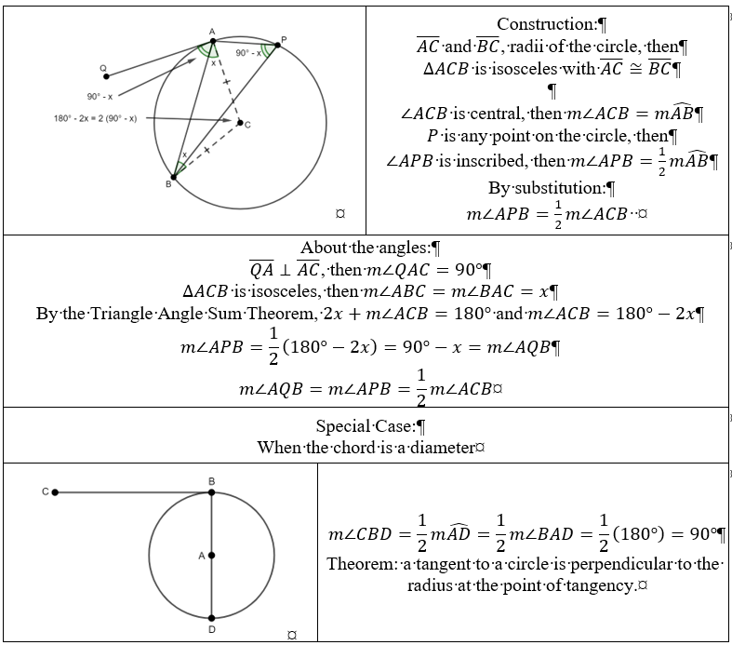
- For expectations of this benchmark, instruction includes the relationship between angles formed inside and outside the circle, and their related arcs. (MTR.5.1)
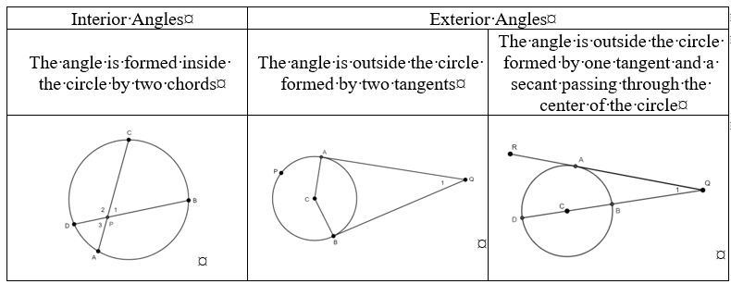

- Instruction should make connections between angles with the vertex in the interior of the circle, angles with the vertex on the circle, and angles with the vertex outside the circle.
Inside the circle | On the circle | Outside the circle
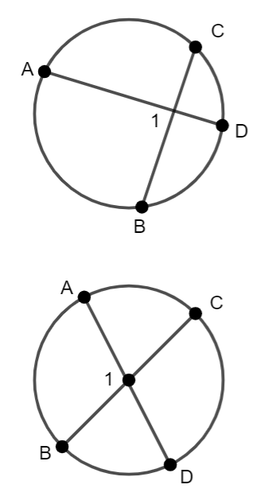 | 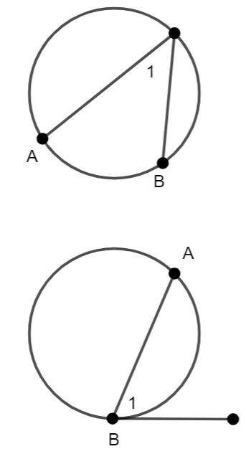 | 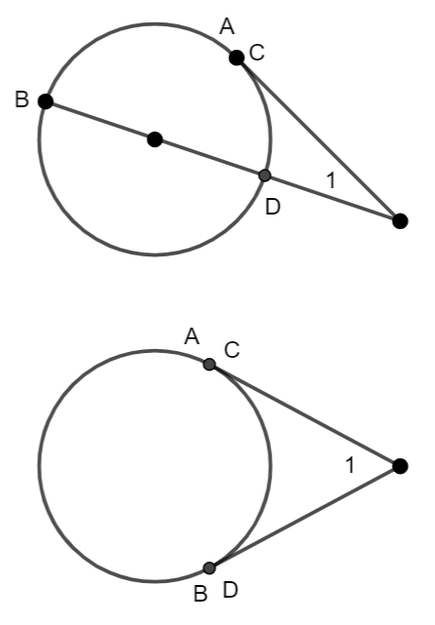
$$m∠1=\frac{1}{2}(m\hat{AB}+m\hat{CD})$$ | $$m∠1=\frac{1}{2}m\hat{AB}$$ | $$m∠1=\frac{1}{2}(m\hat{AB}-m\hat{CD})$$
In the images, segments that appear to be tangent to the circle are tangent to the circle.
- For expectations of this benchmark in the clarifications, instruction includes angles formed a chord and its perpendicular bisector.
Given a circle with $\overline{CB}$ a chord of the circle and its perpendicular bisector $\overset{⃡}{DH}$. Let $A$ be a point on $\overset{⃡}{DH}$. Construct $∆ABC$. $\overline{GA}≅\overline{GA}$ by the reflexive property and $∆CGA≅∆BGA$ by SAS. By the definition of congruent triangles, $\overline{AC}≅\overline{AB}$, then $\overline{AC}$ and $\overline{AB}$ are radii and $A$ is the center of the circle. The theorem states that if $\overset{⃡}{DH}$ is the perpendicular bisector to $\overline{CB}$, then it contains the center of the circle
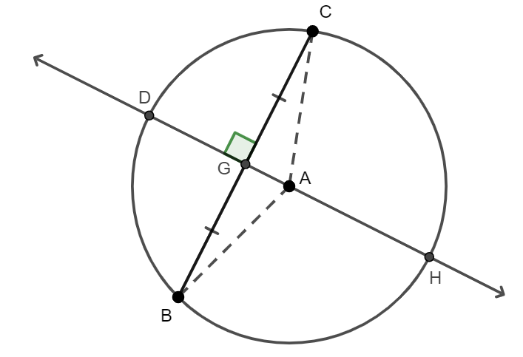
Two statements can also be proved: If $\overset{⃡}{DH}$ bisects the chord and passes through $A$, then it is perpendicular to the chord and if $\overset{⃡}{DH}$ is perpendicular to the chord and passes through $A$, then it bisects the chord.

- Students should develop the understanding that the relationship between inscribed angles and their related arcs can be used to prove the Triangle Angle Sum Theorem.
Given a circle with center at $A$, and $B$, $C$, and $D$ points on the circle. $∠B$, $∠C$, and $D$ are inscribed, then $m∠B=\frac{1}{2}m\hat{CD}$, $m∠C=\frac{1}{2}m\hat{BD}$, and $m∠D=\frac{1}{2}m\hat{BC}$. $m\hat{BC}+m\hat{CD}+m\hat{BD}=360°$, then $\frac{1}{2}m\hat{BC}+\frac{1}{2}m\hat{CD}+\frac{1}{2}m\hat{BD}=180°$. By substitution, $m∠B+m∠C+m∠D=180°$.
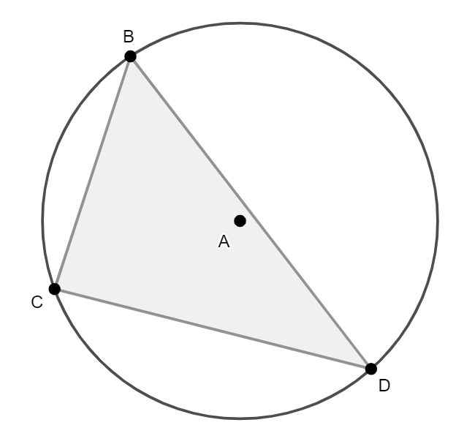

- Students should develop the understanding that the relationship between inscribed angles and their related arcs can be used to prove that the opposite angles of a cyclic quadrilateral are supplementary.
Given $ABCD$ a quadrilateral inscribed in a circle. $m∠ABC=\frac{1}{2}m\hat{CDA}$ and $m∠CDA=m\hat{ABC}$. Since $m\hat{ABC}+m\hat{CDA}=360°$, then $\frac{1}{2}m\hat{ABC}+\frac{1}{2}m\hat{CDA}=\frac{1}{2}\left(360°\right)=180°$. By substitution, $m∠ABC+m∠CDA=180°$.
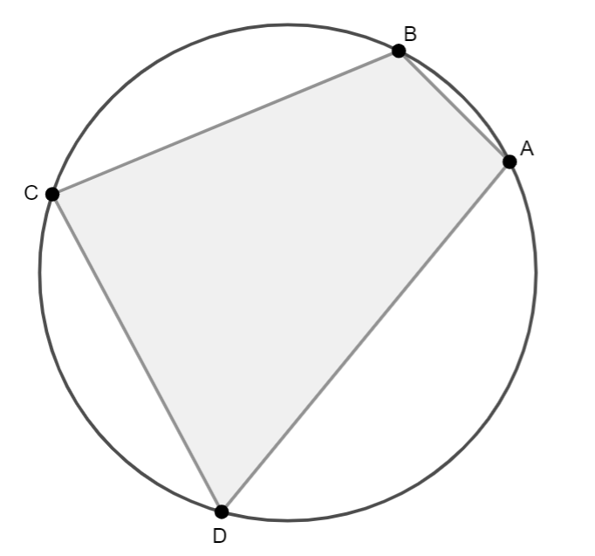
- Students should develop the understanding that an inscribed angle intercepting a $180°$ arc measures $90°$ (known as the Thales’s Theorem).
Given a circle with center at $A$. $C$ and $B$ are endpoints of a diameter of the circle. $∠CAB$ is straight and $m∠CAB=m\hat{CB}=180°$.$∠CDB$ and $∠CEB$ are inscribed angles intercepting$\hat{CB}$, then $m∠CDB=\frac{1}{2}\left(180°\right)=90°$ and $m∠CEB=\frac{1}{2}\left(180°\right)=90°$. That is, $∆CBD$ and $∆CBE$ are right. The theorem states that if $P$, $Q$, and $R$ are distinct points on a circle and $\overline{PR}$ is a diameter, then $∠PQR$ is right and $∆PQR$ is right.
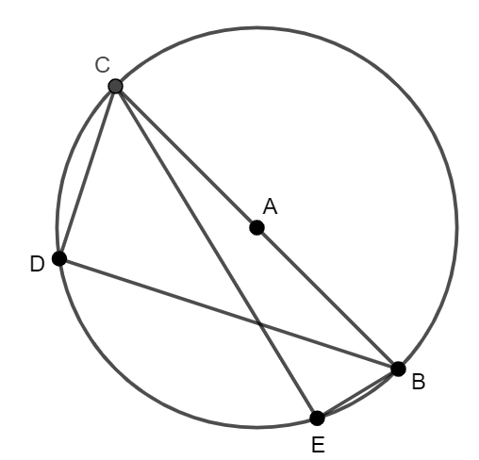
- Instruction makes the connection between the Thales’s Theorem and coordinate geometry.
- For example, given the circle centered at $(4, -2)$ and $J$, $K$, and $L$ points on the circle. Since the slopes of $\overline{AJ}$ and $\overline{JB}$ are opposite reciprocals, then $∠BJA$ is right and $∆BJA$ is right. Similarly, $∠BKA$ and $∠BLA$ are right.
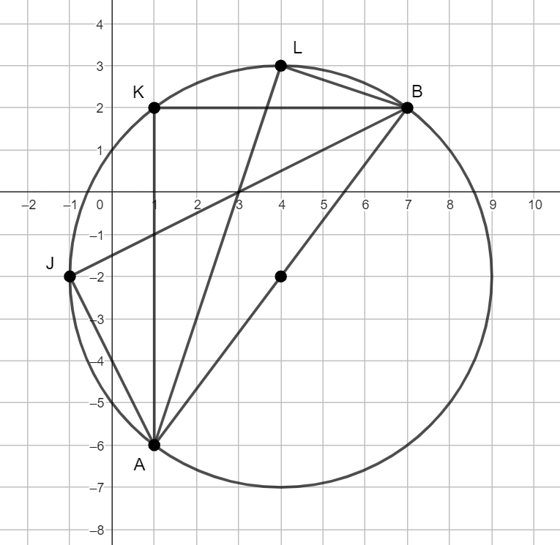

- Instruction makes the connection between the measure of an angle formed by two intersecting arcs and weighted averages. The measure of an angle whose vertex is in the interior of a circle is the weighted average of the measures of the two arcs the angle intercepts when the measures of the arcs has the same weight.
- Problem types include determining missing angle measures in both mathematical and real-world contexts using numerical and algebraic expressions.
- Instruction makes the connection between central angles, their measures, their related arcs, and the lengths of the related arcs (MA.912.GR.6.4).

Common Misconceptions or Errors
- Students may struggle identifying angles by their names in terms of their center and their sides (central, inscribed, interior, exterior, circumscribed).
- Students may misidentify the relationship between the angle and its related arc (same measure, half the measure, the semi-sum of their measures, their semi-difference of their measures).
- Students may struggle with the notions of arc measure and arc lengths. While the first is represented in degrees (or radians in later courses), the second is represented with units of length. The first is a fraction of the measure of the circle in degrees (or radians, in later courses), the second is a fraction of the circumference.

Strategies to Support Tiered Instruction
- Instruction includes the discussion of the answers to the following questions: “What is the difference between a central angle and an inscribed angle?”, “How are a diameter and a central angle related?”, “What is the difference between the measure of an inscribed angle and the measure of its intercepted arc?”, among others.
- Teacher models how to identify an angle based on its center and its sides. It is recommended students use graphic folders and foldables.
- Students should develop the understanding that central angles are measured in degrees as they relate to the measure of the circle in degrees.
- For example, in the given circle $m∠APB+m∠BPC+m∠CPD+m∠DPA=m\hat{AB}+m\hat{BC}+m\hat{CD}+m\hat{DA}=360°$.
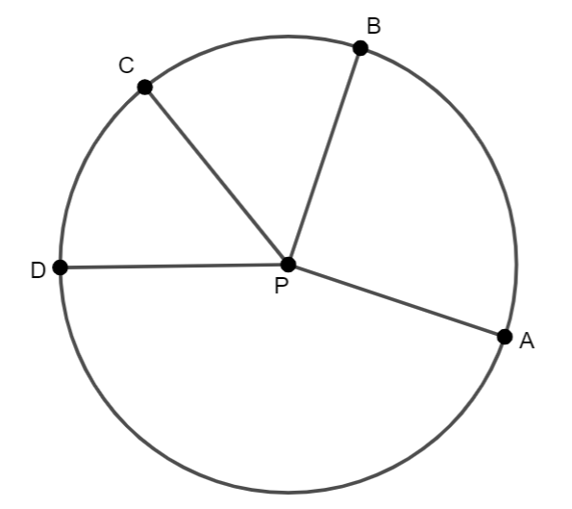

Instructional Tasks
Instructional Task 1 (MTR.3.1)
Given a circle with center at $A$, secants $\overline{ED}$ and $\overline{EC}$, and radii $\overline{AD}$ and $\overline{AC}$. Find the value of $x$.
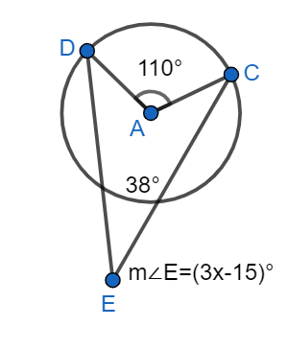

Instructional Task 2 (MTR.2.1, MTR.4.1, MTR.5.1)
A circle is given below with two intersecting secants, $\overline{PA}$ and $\overline{PC}$.
Part A. What is $m∠BCP+m∠CPB+m∠PBC$?
Part B. What is $m∠PBC+m∠ABC$?
Part C. What can you conclude about the relationship between the sum in Part A and the sum in Part B?
Part D. What can you conclude about the measure of $∠CPB$? State your conclusion algebraically ($m∠CPB= ?$).
Part E. How can you use your conclusion (Part D) to verify that the measure of an exterior angle formed by two secants is the semi-difference of the intercepted arcs? In this case, $m∠APC=\frac{m\hat{AC}-m\hat{BD}}{2}$. This is known as the Secant-Secant Theorem

Instructional Task 3 (MTR.4.1)
Given the statement: “An angle is inscribed in a circle if and only if its intercepted arc is half the measure of the central angle subtended by the same arc.”
Part A. Write the two conditional statements related to the given statement. Determine whether each of them is true.
Part B. Interpret the following statements. Determine whether they are true. If not, identify a counterexample.
    - All central angles intercept an arc.
    - If an arc subtends a central angle and an inscribed angle, then they are congruent.
    - Not all inscribed angles intercept an arc intercepted by a central angle.
    - All inscribed angles are formed by chords.
    - Not all central angles have their vertex at the center of the circle.

Instructional Items
Instructional Item 1
The International Space Station (ISS) passes over the earth $248$ miles above the earth’s surface. The angle formed between the two tangents formed from the ISS and the earth measures $140.4˚$. What is the measure of the arc of the earth that could have a view of the ISS passing overhead?
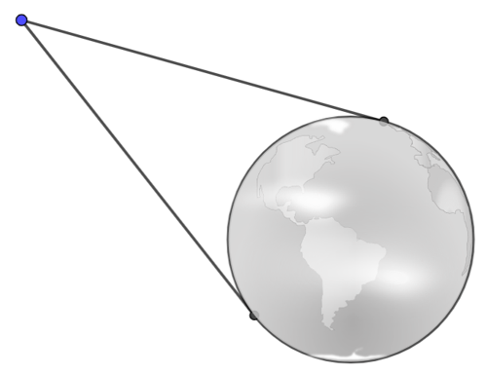

Instructional Item 2
Given circle $O$, and $B$, $W$, and $R$ points on the circle. The measure of $∠ROW$ is 30$°$. Find the measure of $\hat{RBW}$ and the measure of $∠RBW$.

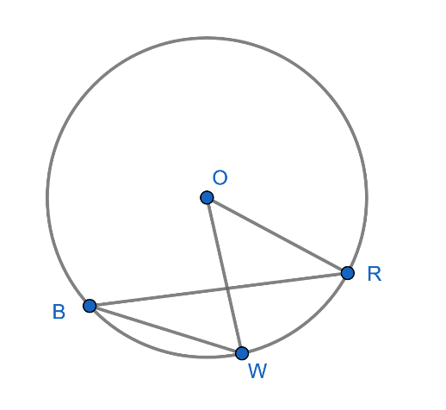

*The strategies, tasks and items included in the B1G-M are examples and should not be considered comprehensive.

MA.912.GR.6.3

Benchmark
MA.912.GR.6.3 Solve mathematical problems involving triangles and quadrilaterals inscribed in a circle.
Benchmark Clarifications:
Clarification 1: Instruction includes cases in which a triangle inscribed in a circle has a side that is the diameter.
Connecting Benchmarks/Horizontal Alignment
- MA.912.GR.3.2, MA.912.GR.3.3
- MA.912.GR.5.3
- MA.912.GR.7.2, MA.912.GR.7.3
Terms from the K-12 Glossary
- Circle
- Circumscribed Circle
- Diameter
- Inscribed Polygon in a Circle
- Quadrilateral
- Triangle

Vertical Alignment
Previous Benchmarks  - MA.8.GR.1.6  - MA.912.AR.1.2  - MA.912.AR.2.1 | Next Benchmarks
Purpose and Instructional Strategies
In grade 8, students solved problems involving supplementary angles and the relationship between the interior and the exterior angles of a triangle. Students also developed and use formulas for the sums of the interior angles of regular polygons. In Geometry, students solve problems applying the properties of the interior angles of triangles and quadrilaterals inscribed in a circle.
- Instruction includes the connection between triangles and quadrilaterals inscribed in a circle and inscribed angles and their intercepted arcs (MA.912.GR.6.2).
- Instruction makes connections to MA.912.LT.4.3 and MA.912.LT.4.10. Students should develop the mathematical language about triangles and quadrilaterals inscribed in circles. To start, students should define a term with a conditional statement (e.g., “if a quadrilateral is inscribed in a circle, then all its vertices are points on the circle”). Students should determine whether the converse of an “if… then” given statement is true, and if so, write the biconditional statement (e.g., “a quadrilateral is inscribed in a circle if and only if all its vertices are points on the circle”). Instruction includes determining whether a given statement is true, including “not” and “all” statements. Students should judge the validity of an argument and, if false, identify a counterexample (e.g., “all quadrilaterals can be inscribed in a circle”).
- Students should develop the understanding of the relationship between circles and inscribed polygons. That is, if a polygon is inscribed in a circle, then the polygon is circumscribing the circle. Students should be able to answer questions like “What is the difference between a polygon inscribed in a circle and a polygon circumscribed about a circle?” and “What is the difference between a circle inscribed in a polygon and a polygon inscribed in a circle?”
- Instruction includes the connection with the construction of equilateral triangles and squares inscribed in a circle (MA.912.GR.5.3). The vertices of equilateral triangles and squares inscribed in a circle determine congruent arcs.
- Instruction includes exploring various triangles inscribed in a circle.
- For example, if one side of a triangle inscribed in a circle is the diameter of the circle, then the triangle is right. This triangle is sometimes described as a triangle inscribed in a semicircle, but it is important to specify that the hypotenuse of the triangle must be the diameter of the circle.
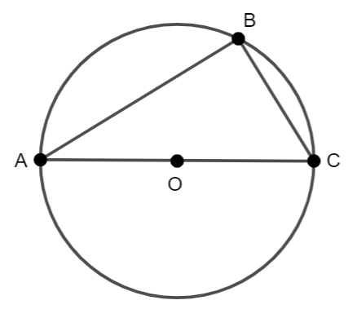
The interior angles of the triangle are inscribed angles. Since $A$, $B$ and $C$ are distinct points on a circle where $\overline{AC}$ is a diameter, $m∠ABC=\frac{1}{2}\left(180°\right)=90°$, a right angle. Therefore, the triangle $ABC$ is always a right triangle. This is known as one of the Thales’s Theorem.

- Students should explore the Thales’s Theorem and develop the understanding that there are an infinite number of right triangles that can be inscribed in one circle when the hypotenuse is the diameter of the circle.
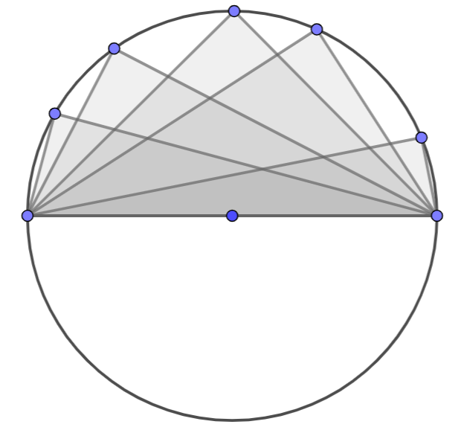
- Instruction makes the connection to the construction of the circumscribed circle to a triangle (MA.912.GR.5.3). Since $AB=AC=AD$, radii of the circle, then the circle with center at A contains the vertices of the triangle. That is, the circle with center at $A$ circumscribes a triangle that is right and the center of the circle is the midpoint of the hypotenuse.
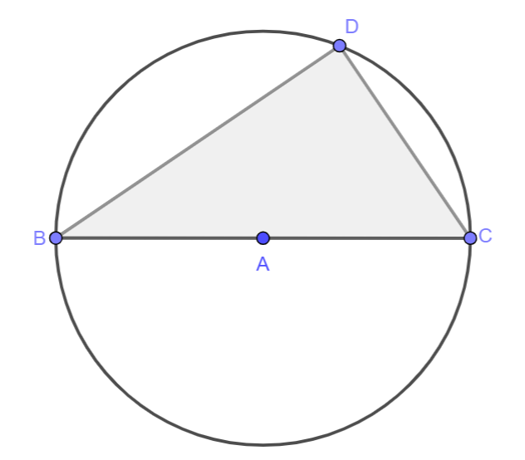
- A quadrilateral inscribed in a circle is called a cyclic quadrilateral. The opposite angles of such quadrilateral are supplementary, and each exterior angle is equal to the interior opposite angle. Students should be able to prove these statements using the relationship between inscribed angles and their intercepted arcs (MA.912.GR.6.2).
Given $ABCD$ inscribed in a circle. $m∠ABC=\frac{1}{2}m\hat{ADC}$ and $m∠CDA=\frac{1}{2}m\hat{CBA}$. Then, $m∠ABC+m∠CDA=\frac{1}{2}\left(m\hat{ADC}+m\hat{CBA}\right)=\frac{1}{2}\left(360°\right)=180°$. Also, $m∠EDC+m∠CDA=180°$. If and $m∠EDC+m∠CDA=180°$and $m∠ABC+m∠CDA=180°$, then $m∠EDC=m∠ABC$.
$$°°°°$$
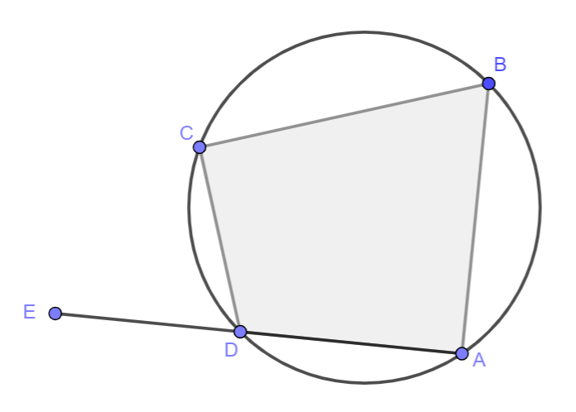

- For enrichment of this benchmark, instruction includes the Ptolemy’s Theorem for cyclic quadrilaterals. This theorem states that the product of the diagonals is equal to the sum of the product of its two pairs of opposite sides. Students should realize that when this theorem is applied to a rectangle inscribed in a circle, it can be used to prove the Pythagorean Theorem.
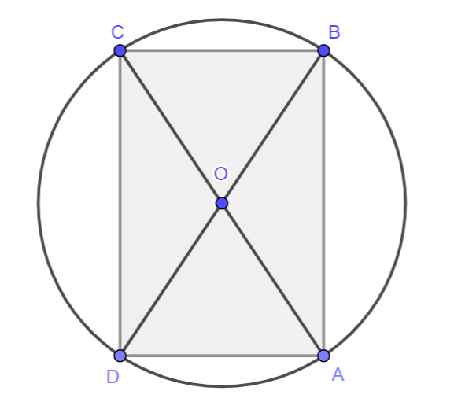
  - Given rectangle $ABCD$ inscribed in the circle with center $O$. Students can apply Ptolemy’s Theorem, so that $AC⋅BD=AB⋅CD+AD⋅BC$. Since the opposite sides of a rectangle are congruent and the diagonals of a rectangle are congruent, then $AB=CD$, $AD=BC$ and $AC=BD$. Using the Substitution Property of Equality, then $AC⋅AC=AB⋅AB+BC⋅BC$. That is, $AC^{2}=AB^{2}+BC^{2}$.

Common Misconceptions or Errors
- Students may consider that using a straightedge to draw a line passing through a point exterior to a circle and touching the circle once is enough for the construction of a tangent line.

Strategies to Support Tiered Instruction
- Instruction includes verifying if a triangle is right when the triangle is inscribed in a circle. Students can use patty paper to copy angles and compare with a right triangle or the corner of a sheet of paper.
- Instruction includes students using a triangle inscribed in a circle to see that there are many places a fourth vertex can be placed to form a quadrilateral that cannot be inscribed in the circle.
- Teacher models how to use patty paper to copy an angle of a cyclic quadrilateral and place the angle in the patty paper adjacent to the opposite angle in the quadrilateral. Students should be able to understand this makes the opposite angle of a cyclic quadrilateral supplementary.

Instructional Tasks
Instructional Task 1 (MTR.3.1)
Quadrilateral $CDEF$ is inscribed in the circle, with center at $A$, and the measure of angle $D$ is $75˚$.
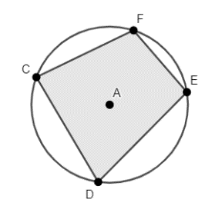
Part A. What is the measure of angle $CAE$? What is the measure of angle $CFE$?
Part B. What is the measure of the major arc $CDE$?
Part C. What can you determine about the measures of angle $DCF$ and angle $FED$?

Instructional Task 2 (MTR.4.1)
Given a quadrilateral is inscribed in a circle and one of the diagonals is a diameter of the circle. Classify the possible types of quadrilaterals it could be.

Instructional Items
Instructional Item 1
In circle $A$, segment $DE$ is a diameter.
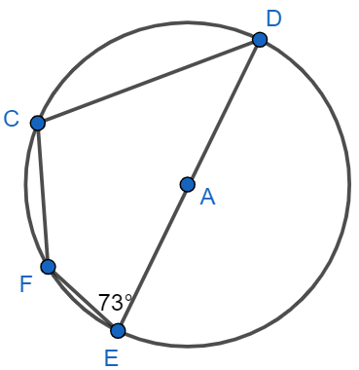
Part A. Determine the measure of angle $DCF$.
Part B. If the measure of arc $CF$ is $50°$, determine the measures of angles$CDE$ and $CFE$.

Instructional Item 2
Triangle $DAE$ is inscribed in the given circle, with center at $K$.
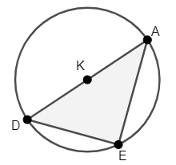
Part A. Determine the value of $x$ if the measure of angle $E$ is $(2x+30)°$.
Part B. Determine the measure of angle $D$ if the measure of angle $A$ is $(2x-20)°$.

*The strategies, tasks and items included in the B1G-M are examples and should not be considered comprehensive.

MA.912.GR.6.4

Benchmark
MA.912.GR.6.4 Solve mathematical and real-world problems involving the arc length and area of a sector in a given circle.
Benchmark Clarifications:
Clarification 1: Instruction focuses on the conceptual understanding that for a given angle measure the length of the intercepted arc is proportional to the radius, and for a given radius the length of the intercepted arc is proportional is the angle measure.
Connecting Benchmarks/Horizontal Alignment
- MA.912.GR.5.3
- MA.912.GR.7.2, MA.912.GR.7.3
Terms from the K-12 Glossary
- Circle
- Radius
Vertical Alignment
Previous Benchmarks  - MA.7.GR.1.3, MA.7.GR.1.4  - MA.912.AR.1.2  - MA.912.AR.2.1 | Next Benchmarks  - MA.912.T.2.1, MA.912.T.2.2
Purpose and Instructional Strategies
In grade 7, students explored the relationship between circumferences and diameters and solved mathematical problems applying the formula for the circumference of a circle. Students also solved problems applying the formula for the area of a circle. In Algebra 1, students rearranged formulas to highlight a quantity of interest and solved linear equations in one variable. In Geometry, students use their knowledge of circumference and area of the circle to relate arc measures and their related central angles to the length of an arc and the area of a sector. In later courses, students will determine the value of trigonometric functions for real numbers by identifying angle measures in the unit circle.
- Instruction includes the student understanding that arcs can be measured in degrees (arc measure) and in units of length (arc length). Given two noncongruent circles, arcs can have the same measure in degrees, but not the same length.
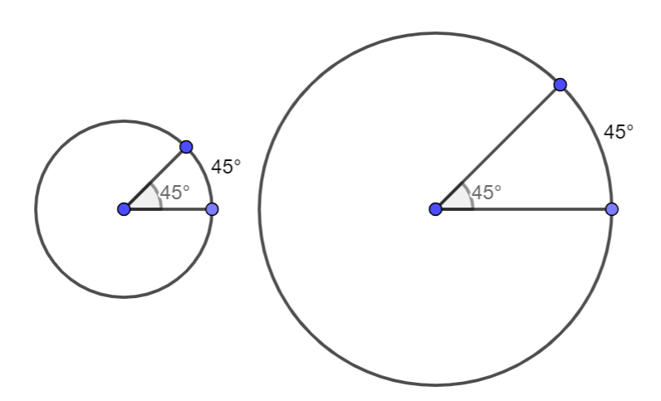
- For expectations of this benchmark, students only measure angles in degrees, not in radians. Students will use radians in later courses.
- Instruction makes connections to Logic and Discrete Math (MA.912.LT.4.3 and MA.912.LT.4.10). Students should be able to write a definition as a biconditional statement (e.g., “two circles are concentric if and only if they have the same center”). Students should also be able to interpret “not” and “all” statements (e.g., “not all congruent circles are concentric”). Given a conditional statement, students should determine whether the converse is true. When given a statement, students should be able to judge its validity and give a counterexample when the statement is not true (e.g., “when two circles are concentric with different radii, the arcs intercepted by the same central angle are congruent”).
- Instruction includes the use of the corresponding notation for the length of an arc. Given arc $MN$, the notation for the arc is $\hat{MN}$, for its measure $m\hat{MN}$, and for its length $s$. $s$ is commonly used in Geometry to refer to the length of an arc. When needed, other lowercase letters can be used.
- Instruction includes the understanding of the relationship between radii and arc length given concentric circles and a central angle.
- For example, given three concentric circles with center at O and the central angle $COR$, $m∠COR=n°$. The measure in degree of arcs $AP$, $BQ$, and $CR$ are equal since they were intercepted by the same central angle. However, the lengths of the arcs are not equal. Let $OA=a$, $OB=b=ka$ and $OC=c=ja$. Let the length of arc $AP$ be $s$, the length of arc $BQ$ be $r$, and the length of arc $CR$ be $t$. Then, $s=\frac{n}{360}\left(2πa\right)$, $r=\frac{n}{360}(2πb)$, and $t=\frac{n}{360}(2πc)$. By substitution, $r=\frac{n}{360}(2πka)$ and $t=\frac{n}{360}(2πja)$. Solving for $a$, $a=\frac{180s}{nπ}$, $a=\frac{180r}{nkπ}$, and $a=\frac{180t}{njπ}$. Then, $\frac{180s}{nπ}=\frac{180r}{nkπ}=\frac{180t}{njπ}$. Simplifying, $\frac{s}{1}=\frac{r}{k}=\frac{t}{j}$. That is, the length of the arc is proportional to the radius of the circle, when the circles are concentric, and the arcs intercepted by the same central angle. $r=ks$ and $t=js$.

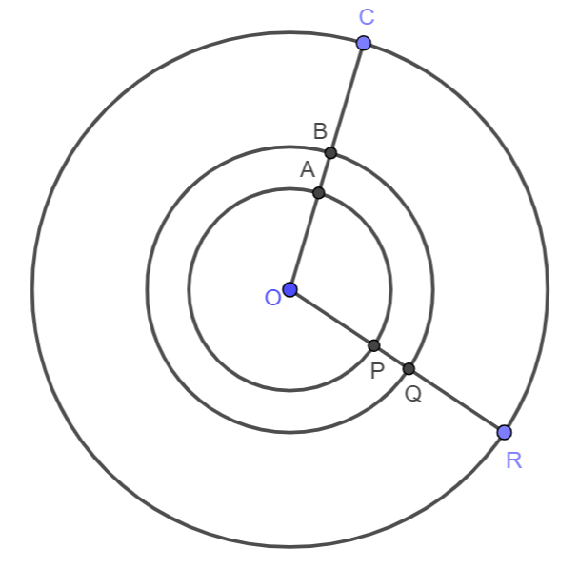

- For the expectations of this benchmark, students should be able to solve problems involving arc length and sector area. Students should develop the understanding that an arc length and a sector area are fractions of the circumference and the area of the circle. Given a circle with center at $0$ and radius $r$, and the central angle with measure $θ$, in degrees. $A$ and $B$ are points on the circle. The circumference of the circle is $2πr$ and its area $πr^{2}$. The length of arc $AB$ is $\frac{θ}{360}$ of the circumference, $\frac{θ}{360}\left(2πr\right)$ and the area of the sector determined by radii $\overline{OA}$ and $\overline{OB}$ is $\frac{θ}{360}$ of the area of the circle, $\frac{θ}{360}\left(πr^{2}\right).$
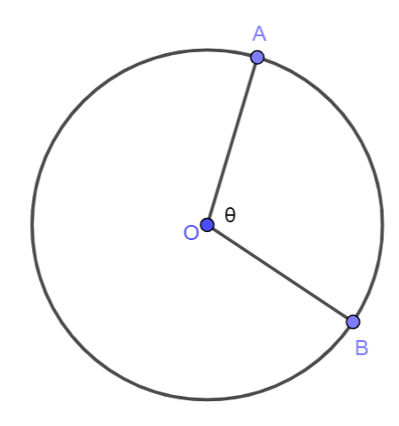
- For example, if the measure of the central angle and its intercepted arc is $57°$, the length of the intercepted arc is $\frac{57}{360}$ of the circumference and the area of the sector is $\frac{57}{360}$ of the area of the circle.
- Instruction includes the conversion of units of length when needed in a problem involving arc length and sector area. It also includes expressing arc lengths and sector areas in terms of pi.

Common Misconceptions or Errors
- Students may misidentify arc measure and arc length. Also, students may misuse degrees and units of length of referring to arc measure and arc length.

Strategies to Support Tiered Instruction
- Instruction includes the understanding that arc measures are in terms of degrees since they are fractions of the measure of a circle in degrees, $360°$, and that arc lengths are fractions of the circumference (sometimes written in terms of pi).
- Teacher models concentric circles and the relationships between radii and arc lengths. Drawing a central angle and extending its sides to the length of the radius of the largest circle, students should notice that the measure of the central angle remains the same, while the lengths of the arcs do not. The larger the radius, the longer is the intercepted arc.

Instructional Tasks
Instructional Task 1 (MTR.7.1)
De’Veon must create an animal using geometric shapes for his Geometry class. He has decided to use construction paper scraps from his mom’s crafting box to create a bird, like the one shown below. The head is a made from a sector with radius 1.5 centimeters and central angle measuring 130˚. The body is a semicircle with radius 1.9 centimeters.
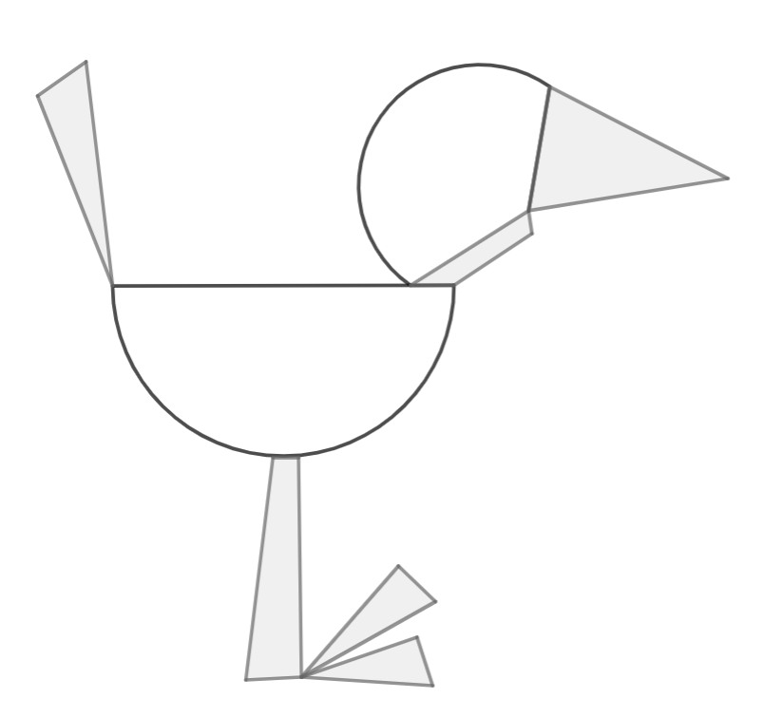
Part A. What fraction of the whole circle is the head?
Part B. How much glitter string will he need to outline the part of the bird’s head that is not touching the beak or neck?
Part C. What is the total area of construction paper used to create the head and the body of the bird?

Instructional Task 2
Given two concentric circle with center at $C$, m$∠MCR=50°$ and $CR=9$. The radius of small circle is $\frac{1}{3}$ of the radius of the big circle.

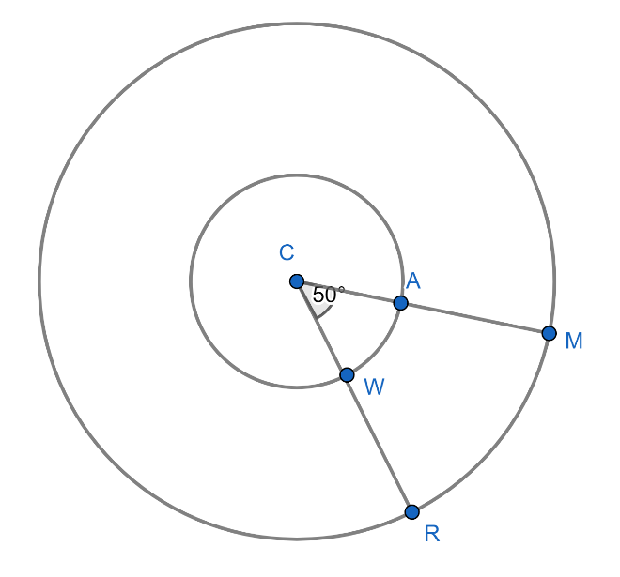
Part A. Find the measures and the lengths of $\hat{AW}$ and $\hat{MR}.$
Part B. Find the area of the sector determined by the radii $\overline{CM}$ and $\overline{CR}$.
Part C. Find the area of the sector determined by the radii $\overline{CA}$ and $\overline{CW}$.
Part D. How would you describe the relationship between the radii of the concentric circles and the measures and lengths of the arcs and areas of the sectors?

Instructional Items
Instructional Item 1
The North Rose Window in the Rouen Cathedral in France has a diameter of 23 feet ($\overline{GF}$ is a diameter). The stained-glass design is equally spaced about the center of the circle. What is the area of the sector determined by arc $GJ$?
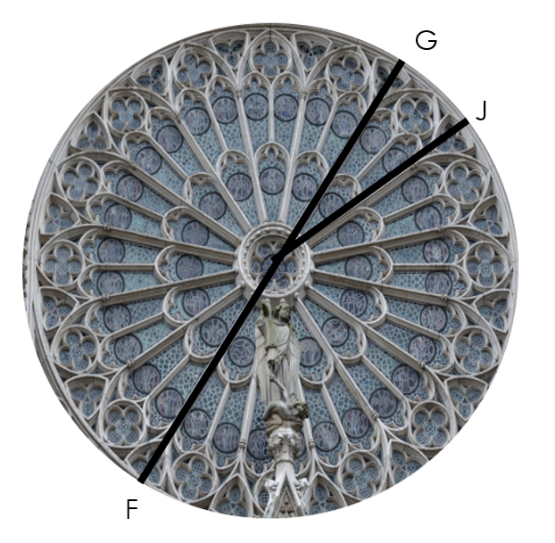

*The strategies, tasks and items included in the B1G-M are examples and should not be considered comprehensive.

MA.912.GR.7.2

Benchmark
MA.912.GR.7.2 Given a mathematical or real-world context, derive and create the equation of a circle using key features.
Benchmark Clarifications:
Clarification 1: Instruction includes using the Pythagorean Theorem and completing the square.
Clarification 2: Within the Geometry course, key features are limited to the radius, diameter and the center.
Connecting Benchmarks/Horizontal Alignment
- MA.912.GR.3.3
- MA.912.GR.5.3
- MA.912.GR.6

Terms from the K-12 Glossary
- Circle
- Diameter
- Radius

Vertical Alignment
Previous Benchmarks  - MA.8.GR.1.1, MA.8.GR.1.2  - MA.912.AR.1.2  - MA.912.AR.3.7  - MA.912.F.2 | Next Benchmarks
Purpose and Instructional Strategies

In grade 8, students solved problems involving unknown side lengths in right triangles and the distance between two points on the coordinate plane applying the Pythagorean Theorem. In Algebra 1, students solved quadratic equations by completing the square and identified the effect on the graph of a function after replacing $f(x)$ by $f(x+k)$. In Geometry, students derive the equation of a circle extending their understanding of the Pythagorean Theorem, the definition of a circle, and transformations of graphs on the coordinate plane. Students also create the equation of a circle using the center, the radius, the diameter, and points on the circle. In later courses, students will derive and create the equations of parabolas, hyperbolas, and ellipses using their key features.
- Instruction includes deriving the equation of a circle centered at the origin. The definition of a circle states all points on the circle are equidistant to the center of the circle. That is, for any point $(x, y)$ on a circle centered at the origin with radius $r$, the distance from $(x, y)$ to $(0, 0)$ is the same and equal to $r$. Using the distance formula or the Pythagorean Theorem, $r=\sqrt{x^{2}+y^{2}}$ or $x^{2}+y^{2}=r^{2}$, the equation of a circle centered at the origin.
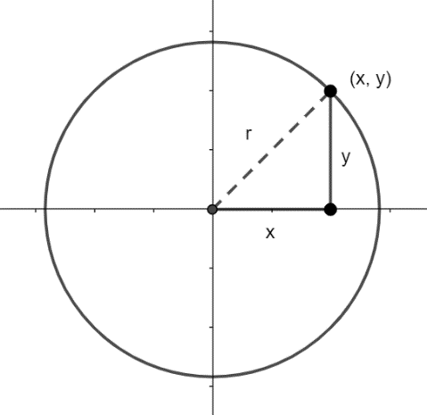
  - For example, given a circle centered at the origin with radius $5$, its equation is $x^{2}+y^{2}=5^{2}$ or $x^{2}+y^{2}=25$. Any point on the circle satisfies the equation. If $3^{2}+2^{2}≠25$, then $(3, 2)$ does not lie on the circle; if $3^{2}+4^{2}=25$, then $(3, 4)$ lies on the circle.
- Instruction includes deriving the equation of a circle centered at a point $(h,k)$. The definition of a circle states all points on the circle are equidistant to the center of the circle. That is, for any point $(x, y)$ on a circle centered at ($h, k)$ with radius $r$, the distance from $(x, y)$ to $(h, k)$ is the same and equal to $r$. Using the distance formula or the Pythagorean Theorem, $r=\sqrt{{(x-h)}^{2}+{(y-k)}^{2}}$ or ${(x-h)}^{2}+{(y-k)}^{2}=r^{2}$, the equation of a circle centered at the origin.
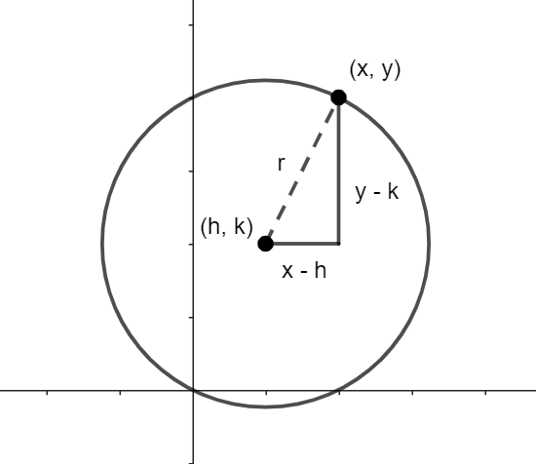
  - For example, given a circle centered at $(1, 3)$ with radius $6$, its equation is ${(x-1)}^{2}+{(y-3)}^{2}=6^{2}$ or ${(x-1)}^{2}+{(y-3)}^{2}=36$. Any point on the circle satisfies the equation. If ${(4-1)}^{2}+{(5-3)}^{2}≠36$, then $(4, 5)$ does not lie on the circle; if ${\left(7-1\right)}^{2}+{(3-3)}^{2}=36$, then $(7, 3)$ lies on the circle.
- Students should develop the understanding that if the center of the circle $(h,k)$ is the origin, then the equation of the circle is ${(x-0)}^{2}+{(y-0)}^{2}=r^{2}$ or $x^{2}+y^{2}=r^{2}$. That is, the equation of a circle centered at the origin is a special case of the equation of a circle centered at $(h, k)$.
- Instruction makes the connections to transformations of the graphs of functions (Algebra 1). Students should be able to identify the equation of a circle as a relationship between two quantities, $x$ and $y$. However, this relationship is not a function. Given $x^{2}+y^{2}=r^{2}$, the graph of ${\left(x-h\right)}^{2}+{\left(y-k\right)}^{2}=r^{2}$ results from a horizontal translation $h$ units to the right and a vertical translation $k$ units up of the graph of $x^{2}+y^{2}=r^{2}$.
  - For example, the graph of ${\left(x+2\right)}^{2}+{\left(y-1\right)}^{2}=9$ is a horizontal translation $2$ units to the left and $1$ unit up of the graph of $x^{2}+y^{2}=9$.
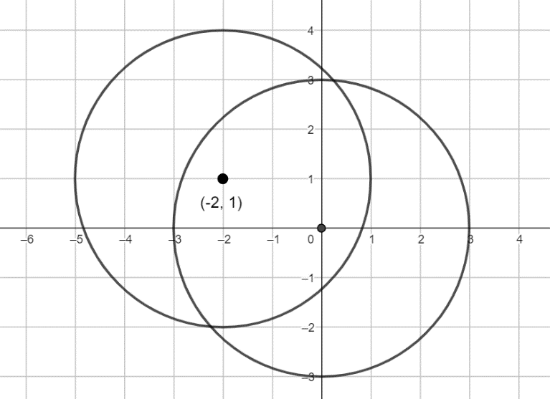
- For expectation of this benchmark, instruction includes the equation of the circle in general form, $Ax^{2}+By^{2}+Cx+Dy+E=0$ (with $A=B$). Students should have practice converting from general form to standard or center-radius form, and vice versa.
- For example, given $x^{2}+y^{2}+6x-4y-17=0$, by completing squares and the properties of equality $\left(x^{2}+6x+9\right)+\left(y^{2}-4y+4\right)=17-9-4$ and ${\left(x+3\right)}^{2}+{\left(y-2\right)}^{2}=4$.

- For example, given ${\left(x-1\right)}^{2}+{\left(y+5\right)}^{2}=1$, by expanding the binomials and using the properties of equality $x^{2}-2x+1+y^{2}+10y+25=1$ and $x^{2}+y^{2}-2x+10y+25=0$.
- Problem types include writing the equation of a circle given the graph, identifying the center and the radius of a circle given the equation of a circle in any form, writing the equation of a circle given the endpoints of the diameter, or given the center and a point on the circle, among others.
- For enrichment of this benchmark, instruction makes the connections to the circumscribed circle of a triangle. (MTR.5.1)
- For example, given $∆ABC$, the perpendicular bisectors of its sides intersect at $(4, 2)$, the midpoint of $\overline{BC}$ since $∆ABC$ is right. The distance from $(4, 2)$ to any of the vertices of the triangle is $\sqrt{10}$. Then, the equation of the circumscribed circle of the triangle is ${\left(x-4\right)}^{2}+{\left(y-2\right)}^{2}={\left(\sqrt{10}\right)}^{2}$.
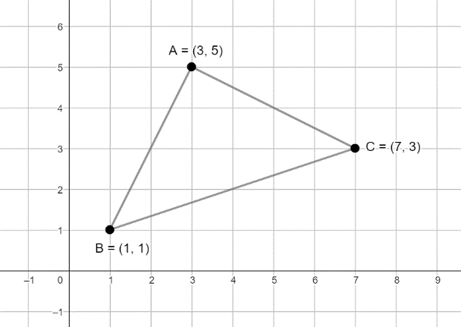
- For enrichment of this benchmark, students should identify the circle as one of the four conic sections. The eccentricity of a conic section is a non-negative real number characteristic for each conic section. The eccentricity of a conic section measures how much a conic section deviates from the circle. The eccentricity of a circle is $0$.

Common Misconceptions or Errors
- Students may misidentify the signs of $(h,k)$ when determining the center of the circle.
  - For example, given the equation ${\left(x-1\right)}^{2}+{\left(y+2\right)}^{2}=1$, the center is $(1,-2)$ and not $(-1, 2)$.
- Students may misinterpret the equation of a circle when determining the radius.
  - For example, given the equation ${\left(x+3\right)}^{2}+{\left(y+4\right)}^{2}=9$, the radius is $3$ and not $9$.

Strategies to Support Tiered Instruction
- Students should have practice completing the square. Instruction includes exploring patterns.
  - For example, given $x^{2}+8x=1$, students should recall that ${\left(x+4\right)}^{2}=x^{2}+8x+16$, then $x^{2}+8x+16=1+16$ and ${\left(x+4\right)}^{2}=17$.
- Teacher models how to complete the square using different methods.
  - For example, with hands-on manipulatives. Given $x^{2}+8x=1$, tiles can be used to represent $x^{2}+8x$ and identify that to complete the square of side length $x+4$ there are needed sixteen 1-by-1 tiles.
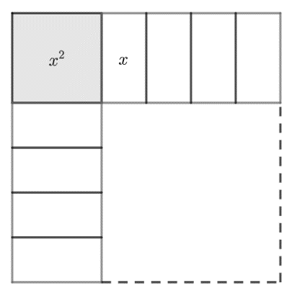
  - For example, with a geometric representation. Given $x^{2}+8x=1$, $x^{2}+8x$ can be represented with one square of area $x^{2}$ and four rectangles of area $2x$ each and identify that to complete the square of side length $x+4$ there are needed four 2-by-2 tiles.
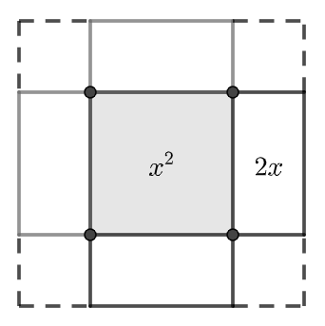

- Instruction includes completing the square with manipulatives to determine the center and the radius of a circle.
  - For example, given $x^{2}+y^{2}-8x+4y-5=0$.
$$x^{2}-8x+y^{2}+4y=5$$
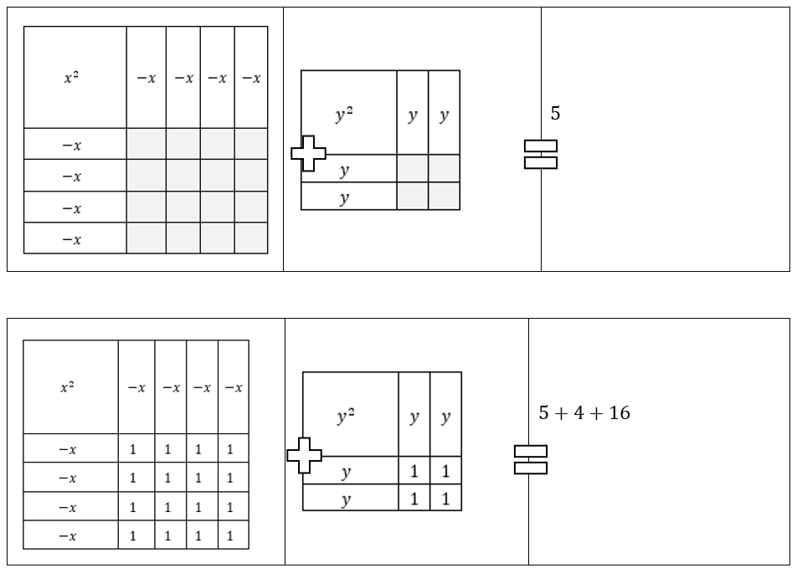
$${\left(x-4\right)}^{2}+{\left(x+2\right)}^{2}=25$$
- Instruction includes completing the square given $x^{2}+Cx+y^{2}+Dy=-E$. Students should be able to extend their understanding of completing the square given a quadratic equation to complete two squares given the equation of a circle, obtaining ${\left(x+\frac{C}{2}\right)}^{2}+{\left(y+\frac{D}{2}\right)}^{2}=-E+{\left(\frac{C}{2}\right)}^{2}+{\left(\frac{D}{2}\right)}^{2}$. In this equation, students should identify the center $\left(-\frac{C}{2}, -\frac{D}{2}\right)$ and the radius of the circle $\sqrt{-E+{\left(\frac{C}{2}\right)}^{2}+{\left(\frac{D}{2}\right)}^{2}}$.
- Students should have practice translating a two-dimensional figure using the coordinate rule $\left(x, y\right)→(x+a, y+b)$ and predicting the horizontal translation and the vertical translation in terms of the values of $a$ and $b$. Teacher models the connection between vertical and horizontal translations of two-dimensional figures and the translation of the center of a circle from the origin by the vector $〈h, k〉$.
- Instruction includes the case when one coordinate (or both) of the center of a circle is a negative number.
- For example, given the circle centered at $(4, -2)$, then the equation of the circle is ${\left(x-4\right)}^{2}+{\left(y-\left(-2\right)\right)}^{2}=r^{2}$ or ${\left(x-4\right)}^{2}+{\left(y+2\right)}^{2}=r^{2}$.
- Instruction includes the case when the center of the circle lies on one axis of the coordinate plane.
- For example, given the circle centered at $(5, 0)$, then the equation of the circle is ${\left(x-5\right)}^{2}+{\left(y-0\right)}^{2}=r^{2}$ or ${\left(x-5\right)}^{2}+y^{2}=r^{2}$.

Instructional Tasks
Instructional Task 1 (MTR.4.1)
A circle on the coordinate plane is given. $\overline{CB}$ and $\overline{ED}$ are diameters of circle $A$. Point $C$ is located at $(3, 5)$, point $D$ is located at $(6, 6)$, point $B$ is located at $(7, 3)$ and point $E$ is located at $(4, 2)$.
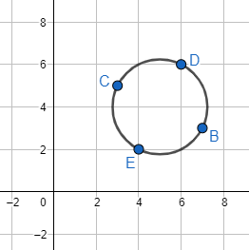
Part A. Determine the center of the circle. Explain your method.
Part B. Find the length of the radius of circle $A$. Explain your method.
Part C. Write the equation of the given circle.
Part D. Verify $B$, $C$, $D$ and $E$ lie on the circle and satisfy the equation.

Instructional Task 2 (MTR.2.1, MTR.5.1)
Point $(x,y)$ is on a circle with center $(h,k)$.
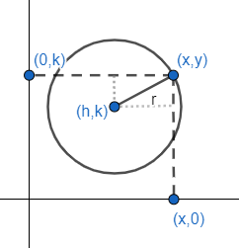
Part A. Complete the sentences.

The horizontal distance between point $(x,y)$ and center $(h,k)$ is ______.

The vertical distance between the point $(x,y)$and center $(h,k)$is ______.

The equation for the radius of the circle in terms of $(x,y)$ and $(h,k)$ is ______.

This is the equation of a circle where $(h,k)$ is the ______ of the circle and $r$ is the ______ of the circle.

Instructional Task 3 (MTR.7.1)
A school’s campus is designed in the shape of a circle. The architect would like to place the cafeteria equidistant from the Freshman building and from the Senior building. On a coordinate plane, the Freshman building is located at the point $(431, 219)$ and the Senior building is located at the point $(0,0)$, where the coordinates are given in feet. Assume that the endpoints of the diameter of circle are the Freshman building and the Senior building and that the cafeteria is on the line segment connecting the two buildings.
Part A. Determine the location of the cafeteria.
Part B. How far is it from the cafeteria to the Freshman building?
Part C. Write an equation that represents the boundary of the circular campus.
Part D. If the campus were to have a circular fence along its boundary, what is the total length of the fence, in feet?

Instructional Items
Instructional Item 1
Given the equation $x^{2}+2x+y^{2}-4y+E=0$, determine possible values of $E$ such that the equation is an equation of a circle.

Instructional Item 2
What is the equation of a circle centered at $(-1, 2)$, with a diameter of $2$ units?

Instructional Item 3
What is the equation of the circle centered at $(-2, -5)$ and passing through $(5, 0)$?

*The strategies, tasks and items included in the B1G-M are examples and should not be considered comprehensive.

MA.912.GR.7.3
Benchmark
MA.912.GR.7.3 Graph and solve mathematical and real-world problems that are modeled with an equation of a circle. Determine and interpret key features in terms of the context.
Benchmark Clarifications:
Clarification 1: Key features are limited to domain, range, eccentricity, center and radius.
Clarification 2: Instruction includes representing the domain and range with inequality notation, interval notation or set-builder notation.
Clarification 3: Within the Geometry course, notations for domain and range are limited to inequality and set-builder.
Connecting Benchmarks/Horizontal Alignment
- MA.912.GR.3.3
- MA.912.GR.5.3
- MA.912.GR.6

Terms from the K-12 Glossary
- Circle
- Domain
- Radius
- Range of a Relation or Function
Vertical Alignment
Previous Benchmarks  - MA.8.GR.1.1, MA.8.GR.1.2  - MA.912.AR.3.8  - MA.912.F.2 | Next Benchmarks  MA.912.GR.7
Purpose and Instructional Strategies
In grade 8, students graphed linear relationships and two variable linear equations. In Algebra 1, students solved and graphed problems modeled with linear functions and quadratic functions and graphed absolute value functions and exponential functions. Students also compared key features of linear and non-linear functions, including domain and range. In Geometry, students graph and solve problems modeled with the equation of a circle and interpret domain, range, center, and radius in terms of the context. In later courses, students will graph and solve problems modeled with the equation of a parabolas, a hyperbola, and an ellipse, and interpret their key features, including eccentricity.
- For expectations of this benchmark, students graph a circle given the equation in standard form and in general form. When the equation of a circle is given in general form, to identify the center and the radius of the circle, students should be able to perform the technique of completing the square.
- For example, given $x^{2}+y^{2}+6x-2x-15=0$, the equation in standard form is ${\left(x+3\right)}^{2}+{\left(y-1\right)}^{2}=25$, and the center of the circle is $(-3, 1)$ and the radius $5$.
- Students should develop the understanding that knowing the center and the radius of a circle, to graph the circle on the coordinate plane, they can plot the center and use the radius $r$ to identify points $r$ units above, below, to the left, and to the right of the center to sketch the circle.
- For example, given the equation of a circle ${\left(x+1\right)}^{2}+{\left(y-2\right)}^{2}=4$, plot the point $(-1, 2)$, the center of the circle, and then points $2$ units above, below, to the left, and to the right of $(-1, 2)$. That is, plot the points $\left(-1, 4\right)$, $(-1, 0)$, $(-3, 2)$, and $(1, 2)$, and sketch the circle (or draw the circle using a compass)
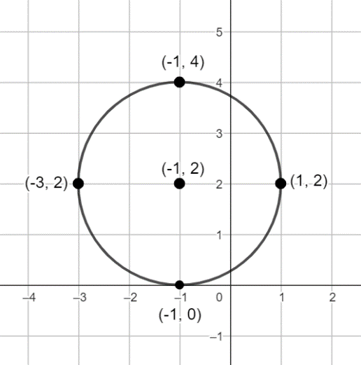
- Instruction includes using technology to graph the equation of a circle and describe its key features, center, radius, diameter, domain, and range.
- Instruction includes identifying and interpreting the domain and the range of the equation of a circle. Students should develop the understanding that these are the domain and the range of a relation, not a function. The domain and the range of a circle with equation ${\left(x-h\right)}^{2}+{\left(y-k\right)}^{2}=r^{2}$ are $h-r≤x≤h+r$ and $k-r≤y≤k+r$.
- For example, given the equation of a circle ${\left(x+1\right)}^{2}+{\left(y-2\right)}^{2}=4$, the domain is $-3≤x≤1$ or $\left\{x|-3≤x≤1\right\}$ and the range is $0≤y≤4$ or $\left\{y|0≤y≤4\right\}$.
- Students should interpret the domain and the range of the equation of a circle in terms of the context. That is, the points on a circle with equation ${\left(x-h\right)}^{2}+{\left(y-k\right)}^{2}=r^{2}$ have an $x-$coordinate between $h-r$ and $h+r$ and a $y-$coordinate between $k-r$ and $k+r$.
- For example, given the equation of a circle ${\left(x+1\right)}^{2}+{\left(y-2\right)}^{2}=4$, the point $(-3, 5)$ cannot lie on the circle and it is known that this point is outside the circle. Similarly, $(-2, 1)$ does not lie on the circle, ${\left(-2+1\right)}^{2}+{\left(1-2\right)}^{2}≠4$ and it is inside the circle.
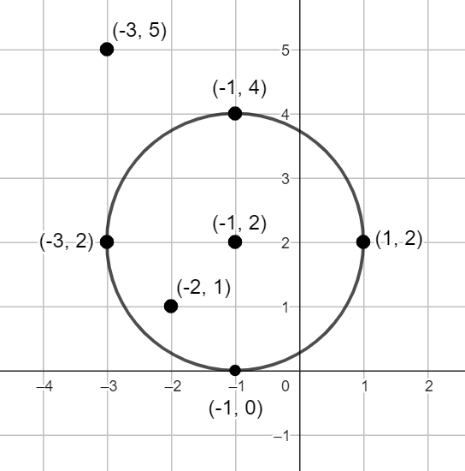
- Problem types include graphing circles given the equation in any form or a description of some of its key features, determining key features of circles given the graph, and interpreting key features of circles in real-world contexts, among others.
- Students are not expected to determine the eccentric of a circle. For enrichment of this benchmark, students should identify the circle as one of the four conic sections. The eccentricity of a conic section is a non-negative real number characteristic for each conic section. The eccentricity of a conic section measures how much a conic section deviates from the circle. The eccentricity of a circle is $0$.

- Instruction includes the understanding that ${\left(x-h\right)}^{2}+{\left(y-k\right)}^{2}=r^{2}$ is the equation of a relationship between the quantities $x$ and $y$, but not a function. This relationship is written implicitly. To write it in the explicit form, it is necessary to solve for $y$. Then, $y=k±\sqrt{r^{2}-{\left(x-h\right)}^{2}}$.
- For example, given ${\left(x-1\right)}^{2}+{\left(y+3\right)}^{2}=9$, $y=-3±\sqrt{9-{\left(x-1\right)}^{2}}$. For restrictions of the square root, $9-{\left(x-1\right)}^{2}≥0$. Then, the domain of this relationship is $-2≤x≤4$. By evaluating $y=-3±\sqrt{9-{\left(x-1\right)}^{2}}$:
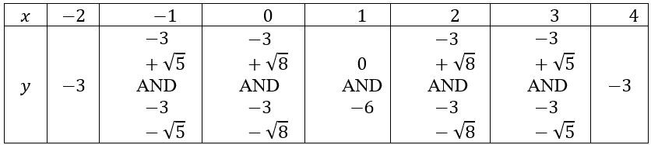
Plotting these points:
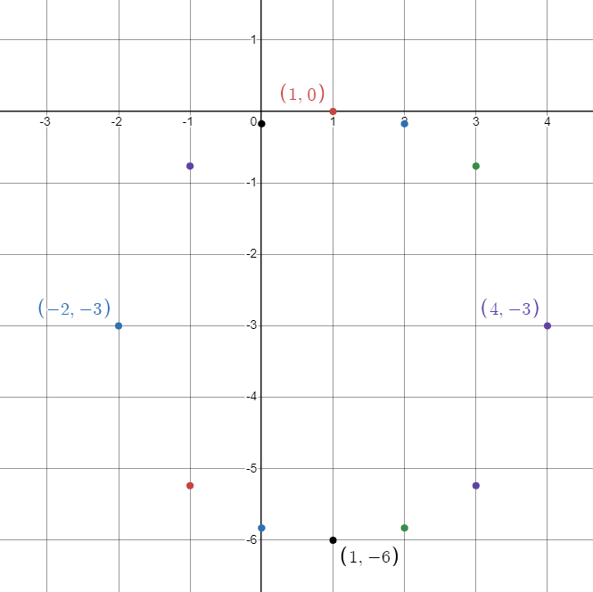
Connecting the points:
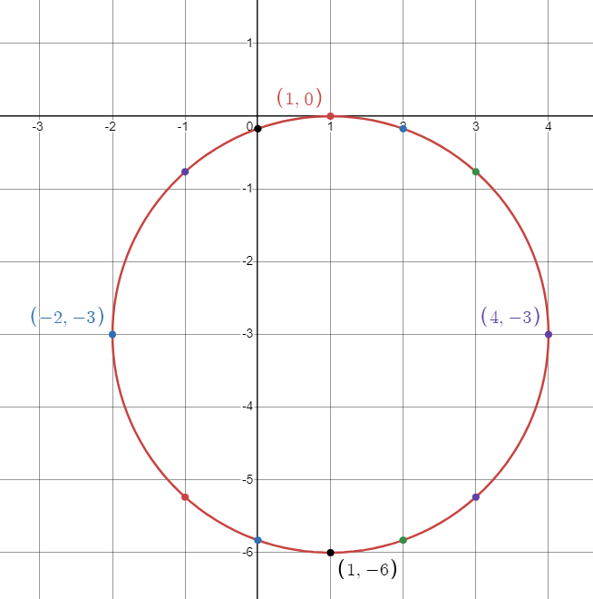
The range of the relationship is $-6≤y≤0$.
Common Misconceptions or Errors
- Students may plot the center of any circle at the origin, failing to identify the center at $(h, k)$.
- Students may plot the center of a given circle at $\left(-h,-k\right)$.
- For example, given the equation ${\left(x-1\right)}^{2}+{\left(y+2\right)}^{2}=1$, the center is $(1,-2)$ and not $(-1, 2)$.
- Students may use $r^{2}$ incorrectly as the radius of the circle.
- For example, given the equation ${\left(x+3\right)}^{2}+{\left(y-2\right)}^{2}=9$, the radius is $3$ and not $9$.

Strategies to Support Tiered Instruction
- Teacher models how to graph a circle given the two equations in standard form, one of the circles centered at the origin, the other centered at $(h, k)$, both with the same radius. Students should develop the understanding of the effect of the values of $h$ and $k$ on the graph of a circle.
- For example, $x^{2}+y^{2}=9$ and ${\left(x+1\right)}^{2}+{\left(y-2\right)}^{2}=9$.
- Teacher models how to graph a circle given the two equations in standard form, both centered at ($h, k)$ but with different radii. Students should develop the understanding of the effect of the value of $r$ on the graph of a circle.
- For example, ${\left(x+2\right)}^{2}+{\left(y+1\right)}^{2}=9$ and ${\left(x+2\right)}^{2}+{\left(y+1\right)}^{2}=25$.
- Students should have practice graphing circles given the equation in standard form and centered at the origin.
- Instruction makes the connections between transformations of functions and the graphs of circles. Students should have practice replacing $f(x)$ by $f(x+k)$ and interpreting the effects on the graph. Given an equation of a circle centered at the origin in standard form, $x^{2}+y^{2}=r^{2}$, students should describe the effect of replacing the given equation by ${\left(x-h\right)}^{2}+{\left(y-k\right)}^{2}=r^{2}$.
- For example, given $x^{2}+y^{2}=4$, describe the effect of replacing the equation by $x^{2}+{\left(y-2\right)}^{2}=4$, and ${\left(x-3\right)}^{2}+y^{2}=4$, and ${\left(x-3\right)}^{2}+{\left(y-2\right)}^{2}=4$.

Instructional Tasks
Instructional Task 1 (MTR.4.1, MTR.7.1)
Nikita is trying to determine which sprinkler to buy for her backyard. One rotating sprinkler has a throwing radius of 32 feet, which costs $13.99, and the other rotating sprinkler has a throwing radius of 42 feet, which costs $16.99. Note that the sprinkler throwing radius refers to the radius of the spray when the sprinkler is being used.
Part A. Write an equation that describes the region each sprinkler will cover if centered at the position $(h,k)$.
Part B. Nikita’s backyard is approximately a rectangle with dimensions 80 feet by 110 feet. Nikita would like to place her sprinklers so that she waters the majority of her backyard, doubling coverage with two or more sprinklers when necessary. Develop a pattern of sprinklers that would cover the backyard.
Part C. Compare your sprinkler pattern and cost with a partner. Can you and your partner determine a better, and cheaper, solution?

Instructional Items
Instructional Item 1
A florist serving the Orlando area located at (9,8), and marked with an X on the coordinate plane shown where each unit is 10 miles. The florist has a 50-mile delivery radius.

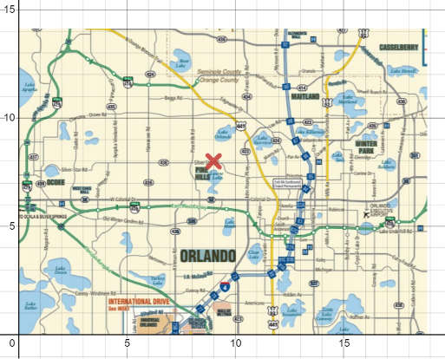
Part A. Write an equation that describes the delivery area.
Part B. Does any of the florist’s delivery area include part of Seminole County?

Instructional Item 2
The equation of a circle is given.
$$x^{2}+y^{2}-6x+8y+5=0$$
Part A. Determine the center and the radius of the circle.
Part B. What is the ordered pair that contains the maximum $y$-value of the circle?
Part C. Sketch the graph of the circle on the coordinate plane.
*The strategies, tasks and items included in the B1G-M are examples and should not be considered comprehensive.

Trigonometry

MA.912.T.1 Define and use trigonometric ratios, identities or functions to solve problems.

MA.912.T.1.1

Benchmark
MA.912.T.1.1 Define trigonometric ratios for acute angles in right triangles.
Benchmark Clarifications:
Clarification 1: Instruction includes using the Pythagorean Theorem and using similar triangles to demonstrate that trigonometric ratios stay the same for similar right triangles.
Clarification 2: Within the Geometry course, instruction includes using the coordinate plane to make connections to the unit circle.
Clarification 3: Within the Geometry course, trigonometric ratios are limited to sine, cosine and tangent.

Connecting Benchmarks/Horizontal Alignment
- MA.912.GR.1.1, MA.912.GR.1.2, MA.912.GR.1.6
- MA.912.GR.7.2, MA.912.GR.7.3

Terms from the K-12 Glossary
- Angle
- Hypotenuse
- Right Triangle

Vertical Alignment
Previous Benchmarks  - MA.8.GR.1.1  - MA.8.GR.2.4 | Next Benchmarks  - MA.912.T.1.5, MA.912.T.1.6, MA.912.T.1.7, MA.912.T.1.8  - MA.912.T.2  - MA.912.T.3

Purpose and Instructional Strategies
In grade 8, students determined the slope and made connections between slope and similar triangles and solved problems involving proportional relationships between similar triangles. In Geometry, students use similarity in right triangles to develop the definition of the trigonometric ratios of the acute angles, sine, cosine, and tangent. In later courses, students will extend trigonometric ratios to include cotangent, secant, and cosecant, and will use trigonometry to solve problems involving non-right triangles and the unit circle.
- Students are not expected to memorize formulas to determine the sine, the cosine, and the tangent of an acute angle in a right triangle. They can be found in the Geometry EOC Mathematics Reference Sheet.
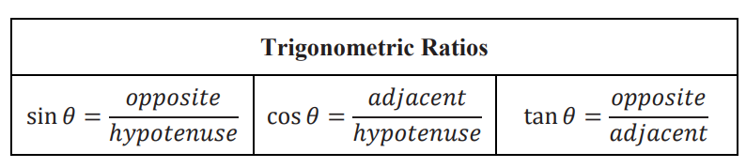
- Students should have practice defining the sine, the cosine, and the tangent of the acute angles of a right triangle given all the side lengths, numerically and algebraically, and using the corresponding notation.
- For example, given the right triangle $ABC$, with side lengths $a$, $b$, and $c$, the trigonometric ratios of $∠A$ are $\sin{A}=\frac{a}{c}$, $\cos{A}=\frac{b}{c}$, and $\tan{A}=\frac{a}{b}$.
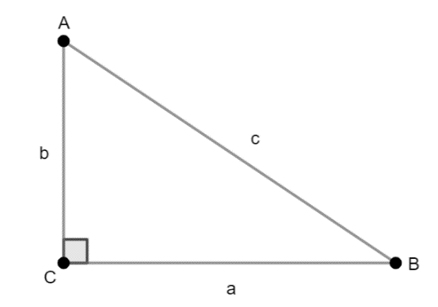
- Students should develop the understanding that trigonometric ratios correspond to angles and their measures. That is, the trigonometric ratio of an acute angle is the same when define using similar triangles.
- For example, given $∆PQR\sim ∆ABC$ with similarity ratio $\frac{1}{k}$ so $a=kp$ and $c=kr$. Then, $\sin{A}=\frac{a}{c}=\frac{kp}{kr}=\frac{p}{r}=\sin{P}$. $\sin{A}=\sin{P}$ since $m∠A=m∠P$ and $∠A≅∠P$. Similarly, $\cos{A}=\cos{P}$ and $\tan{A}=\tan{P}$.
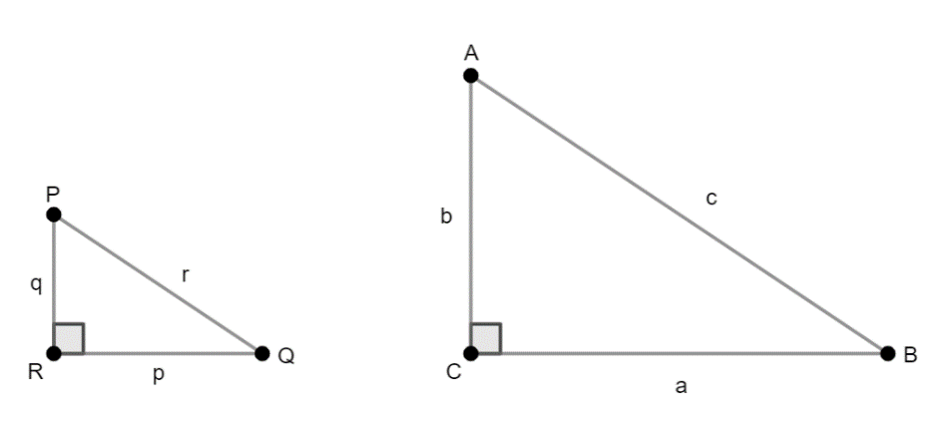

- Instruction includes defining trigonometric ratios of acute angles in right triangles when one side length of the triangle is missing. Students should determine the missing length by applying the Pythagorean Theorem (grade 8).
- For example, given the right triangle, the missing side length results from $\sqrt{{13}^{2}-5^{2}}=12$. Then, $\sin{V}=\frac{5}{13}$, $\cos{V}=\frac{12}{13}$, and $\tan{V}=\frac{5}{12}$.
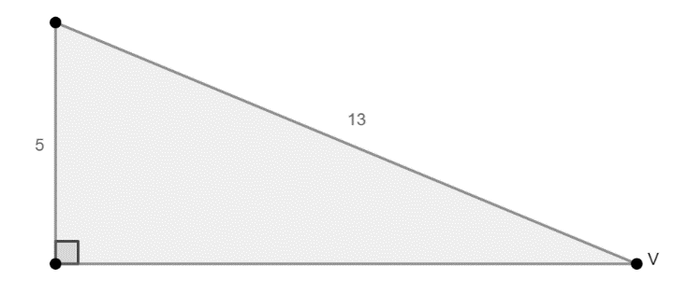

- Instruction includes defining trigonometric ratios given similar triangle with missing side lengths.
- For example, given similar right triangles with $∠A$ corresponding to $∠B$, define the tangent of $∠B$. The missing length of the leg opposite to $A$ results from $\sqrt{5^{2}-3^{2}}=4$. Then, $\tan{A}=\frac{4}{3}$, and $\tan{B}=\frac{4}{3}$.
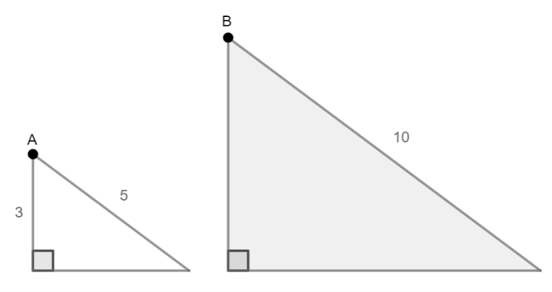
- Students should develop the understanding of the relationships between the sine, the cosine, and the tangent of the two acute angles of a right triangle.
  - For example, given the right triangle $ABC$, $\sin{A}=\frac{a}{b}=\cos{C}$, $\cos{A}=\frac{c}{b}=\sin{C}$ and $\tan{A}=\frac{a}{c}=\frac{1}{\frac{c}{a}}=\frac{1}{\tan{C}}$. These equations are true for any pair of complementary angles.
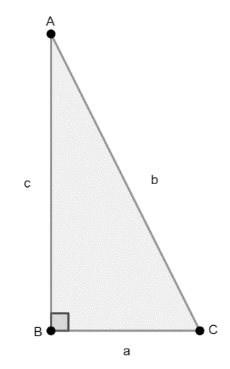
- Instruction includes the use of technology, including scientific calculators, to obtain the sine, the cosine, and the tangent of any acute angle. Students should explore what happens with other angles, but it is not expected within this course. Using technology, students can determine that the sine and the cosine of an acute angle $A$ in a right triangle are within a range of values, $0<\sin{A}<1$ and $0<\cos{A}<1$, while $\tan{A}>0$.
- For the expectations of this benchmark, the measure of an angle is given in degrees (not in radians).
- For the expectations of this benchmark, the trigonometric ratios secant, cosecant and cotangent are not included in the instruction.
- Students should have practice using Greek letters to represent angle measures (e.g., $θ=60°,α=100°,β=15°,γ=20°)$.
- Students should have practice identifying and completing Pythagorean triples (3$, 4, 5$; $5, 12, 13$; $7, 24, 25$; $8, 15, 17$ among others, and their multiples).
- For example, a triangle with side lengths $7$, $24$, and $25$ is right.
- For example, given a right triangle with two sides of length $30$ and $40$, has a hypotenuse of length $50$.
- Instruction includes trigonometric ratios in fractional form, decimal form, and radical form. Students are not expected to simplify fractions and simplify and rationalize radicals, but to identify equivalent expressions. When a trigonometric ratio is in decimal form, it could be an irrational number. It is recommended not to round trigonometric ratios when solving a multi-step problem as it may affect the accuracy of the final answer.
- Instruction makes connections with coordinate geometry (distance, midpoint, slope).
- For example, given the right triangle, the lengths of the legs are $5$ and $6$, and the length of the hypotenuse is $\sqrt{5^{2}+6^{2}}=\sqrt{25+36}=\sqrt{61}$. The trigonometric ratios of $∠C$ are $\sin{C}=\frac{6}{\sqrt{61}}$, $\cos{C}=\frac{5}{\sqrt{61}}$, and $\tan{C}=\frac{6}{5}$.
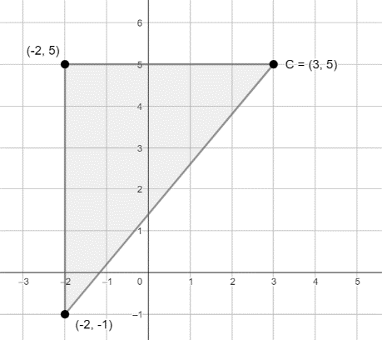

- Instruction makes the connections with the definition of the slope of a line (grade 8).
- For example, given the right triangle on the coordinate plane with vertices at $(1, 1)$, $(6, 1)$, and $\left(6, 4\right)$, $\tan{A}=\frac{3}{5}=\frac{4-1}{6-1}=m$, where $m$ is the slope of the line containing the hypotenuse of the triangle.
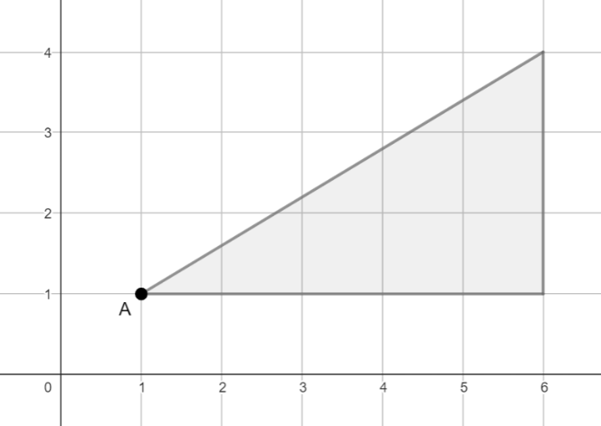
- Instruction includes special right triangles. Students are not expected to memorize the relationships between angles and sides of special triangles. The image shown below can be found in the Geometry EOC Mathematics Reference Sheet.
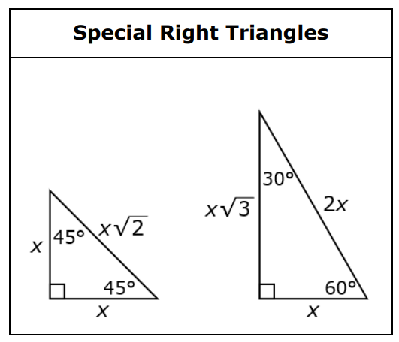
- Students should deduce the relationships between angles and sides in special right triangles by identifying patterns.
- The first special right triangle is the isosceles right triangle, also known as the $45°-45°-90°$ triangle, describing the angle measures. Given $∆ABC$, with $AB=BC$. Let $AB=BC=x$, then $AC=\sqrt{x^{2}+x^{2}}=x\sqrt{2}$. For example, if an isosceles right triangle has legs of length $5$, then the length of the hypotenuse is $5\sqrt{2}$; if an isosceles right triangle has hypotenuse of length $3$, then the length of each of the legs is $\frac{3}{\sqrt{2}}$.
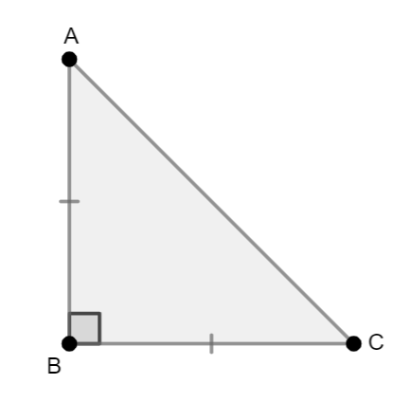
- The second special right triangle is known as the $30°-60°-90°$ triangle, describing the angle measures, and it results from bisecting an equilateral triangle. To divide an equilateral triangle into two congruent right triangles, a median, an angle bisector, or a perpendicular bisector may be used. Given $∆AMB$, with $MB=\frac{1}{2}AB$. Let $AB=2x$, $MB=x$, then $AM=\sqrt{{\left(2x\right)}^{2}-x^{2}}=x\sqrt{3}$. For example, if a $30°-60°-90°$ triangle has a hypotenuse of $10$, then the lengths of the legs are $5$ and $5\sqrt{3}$; if a $30°-60°-90°$ triangle has a leg of a length $4$, the longest leg, then the shortest leg is $\frac{4}{\sqrt{3}}$ and the length of the hypotenuse is $\frac{8}{\sqrt{3}}$.
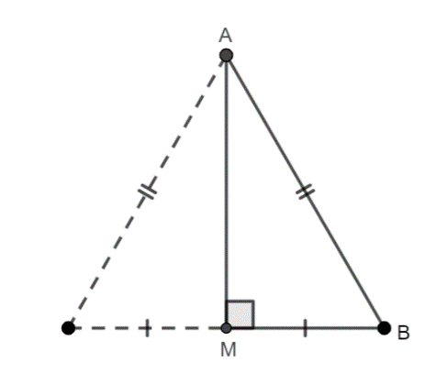
- Instruction includes the trigonometric ratios of the acute angles of the special right triangles.
- In the $45°-45°-90°$ triangle, $\sin{A}=\frac{x}{x\sqrt{2}}=\frac{1}{\sqrt{2}}=\sin{45°}$. Similarly, $\cos{45°}=\frac{1}{\sqrt{2}}$ and $\tan{45°}=\frac{x}{x}=1$. The sine and cosine of $45°$ can be rationalized to obtain $\frac{\sqrt{2}}{2}$, the exact value. A scientific calculator may produce the approximated value of $0.7071067812$, an irrational number.
- In the $30°-60°-90°$, $\sin{A}=\frac{x}{2x}=\frac{1}{2}=\sin{30°}$. Similarly, $\cos{A}=\frac{x\sqrt{3}}{2x}=\frac{\sqrt{3}}{2}=\cos{30°}$ and $\tan{A}=\frac{x}{x\sqrt{3}}=\frac{1}{\sqrt{3}}=\tan{30°}$ or $\frac{\sqrt{3}}{3}$ when rationalized. These are the exact values. A scientific calculator may produce approximated values of $0.8660254038$ and $0.5773502692$ for the cosine and tangent of a $30°$ angle, respectively. Since $∠A$ and $∠B$ are complementary, then $\cos{60°}=\frac{1}{2}$, $\sin{60°}=\frac{\sqrt{3}}{2}$, and $\tan{60°}=\sqrt{3}$.
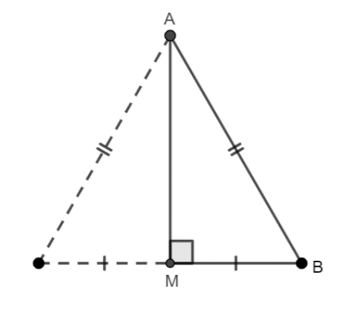
- For enrichment of this benchmark, students should explore right triangles on the coordinate plane such the length of the hypotenuse is $1$.
- For example, given a right triangle on the coordinate plane with vertices at $(0,0)$, $(x,0)$ and $(x,y)$, such that $\sqrt{x^{2}+y^{2}}=1$. $\sin{A}=\frac{y}{1}=y$, $\cos{A}=\frac{x}{1}=x$, and $\tan{A}=\frac{y}{x}$. These equations relate the trigonometric ratios of $∠A$ to the coordinates $x$ and $y$.
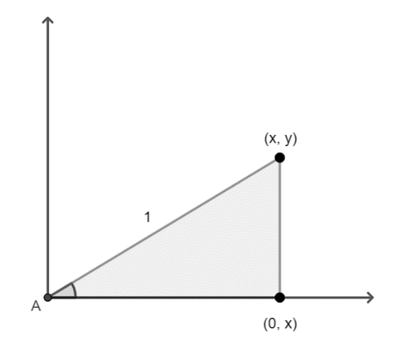

Common Misconceptions or Errors
- Students may misidentify the sides of triangles.
  - For example, students may label the hypotenuse as the adjacent leg or the opposite leg.

Strategies to Support Tiered Instruction

- Teacher models the definition of right triangle, and the definitions of leg and hypotenuse. The hypotenuse of a right triangle is the side opposite to the right angle and the longest side of the triangle.
- Students should have practice finding a missing side length in a right triangle using the Pythagorean Theorem.
- Students should develop the understanding that “opposite” and “adjacent” are adjectives applied to the legs, the sides forming the right angle. When defining the trigonometric ratio of an acute angle in a right triangle, the acute angle is the one formed by the adjacent leg and the hypotenuse.
- Students should develop the understanding that sine, cosine, and tangent are attributes of angles and their measures, and they don’t have any meaning on their own.
- For example, $\sin{ }=\frac{a}{b}$ has no meaning, $\sin{35°}$ instead refers to the value of the trigonometric ratio obtained for the angle measure $35°$, and $\sin{35°}=\frac{a}{b}$ is an equation that can be solved for $a$ and for $b$.
- Teacher models how the sine and the cosine of $90°$

Instructional Tasks
Instructional Task 1 (MTR.2.1)
Given the set of similar right triangles and the lengths of their legs.
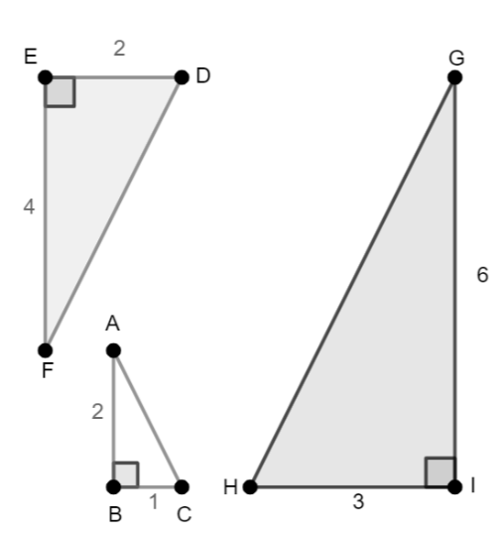
Part A. Identify the corresponding angles in the similar triangles.

$$∆ABC$$ | $$∆DEF$$ | $$∆GHI$$
$$∠A$$
$$∠B$$
$$∠C$$

Part B. Write the following ratios with respect of $∠A$ in $∆ABC$.

$$opposite leg:hypotenuse$$
$$adjacent leg:hypotenuse$$
$$opposite leg:adjacent leg$$

Write the following ratios with respect of $∠F$ in $∆DEF$.

$$opposite leg:hypotenuse$$
$$adjacent leg:hypotenuse$$
$$opposite leg:adjacent leg$$

Write the following ratios with respect of $∠G$ in $∆GHI$.

$$opposite leg:hypotenuse$$
$$adjacent leg:hypotenuse$$
$$opposite leg:adjacent leg$$

What do you notice?

Part C. How do your ratios created in Part B relate to sine, cosine, and tangent?

Instructional Task 2:
The image shows three similar right triangles that share $∠A$ .

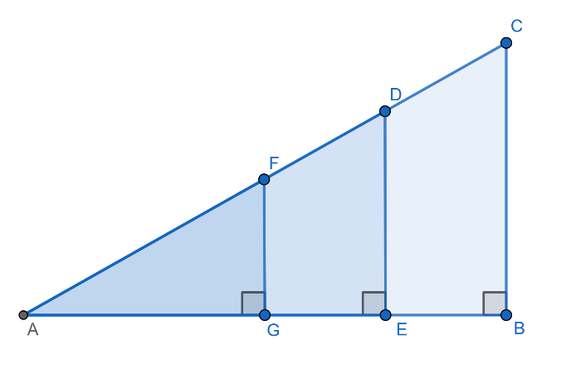
Part A. Why are the three triangles similar? Explain.
Part B. Complete the table with respect to $∠A$.

Triangle | Opposite Leg | Adjacent Leg | Hypotenuse
$$∆ABC$$
$$∆AED$$
$$∆AGF$$

Part C. Complete the table with respect to $∠A$, if $AB=8$, $BC=15$, and $AC=17$.

Triangle | $$\frac{opposite leg}{hypotenuse}$$ | $$\frac{adjacent leg}{hypotenuse}$$ | $$\frac{opposite leg}{adjacent leg}$$
$$∆ABC$$
$$∆AED$$
$$∆AGF$$

Instructional Items
Instructional Item 1
Belle is hanging streamers for her brother’s surprise birthday party. She secures two streamers of different lengths at the peak of the ceiling. The center of the floor is directly underneath the ceiling peak. The distance along the floor from the center of the room to where the first streamer is attached is 6 feet. The second streamer is attached to the floor further from the center of the floor than the first streamer.

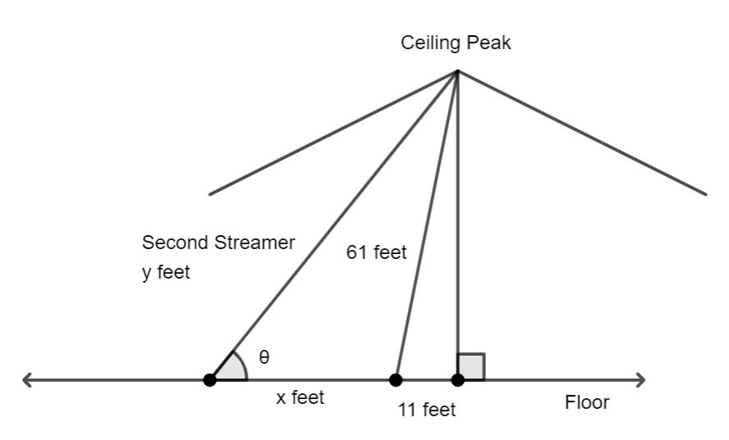
The distance between the streamers is $x$ feet and the length of the second streamer is $y$ feet. The angle formed between the second streamer and the floor is $θ$. Select all the true equations (based on the diagram).

- $sin θ=\frac{60}{y}$
- $\sin{θ}=\frac{61}{y}$
- $tan θ=\frac{60}{11}$
- $\cos{θ}=\frac{x}{y}$
- $\cos{θ}=\frac{x+11}{61}$
- $\tan{θ}=\frac{60}{x+11}$
- $\sin{θ}=\frac{60}{61}$
- $\tan{θ}=\frac{61}{x}$

Instructional Item 2
Given the diagram below showing two similar right triangles, complete the following statements.
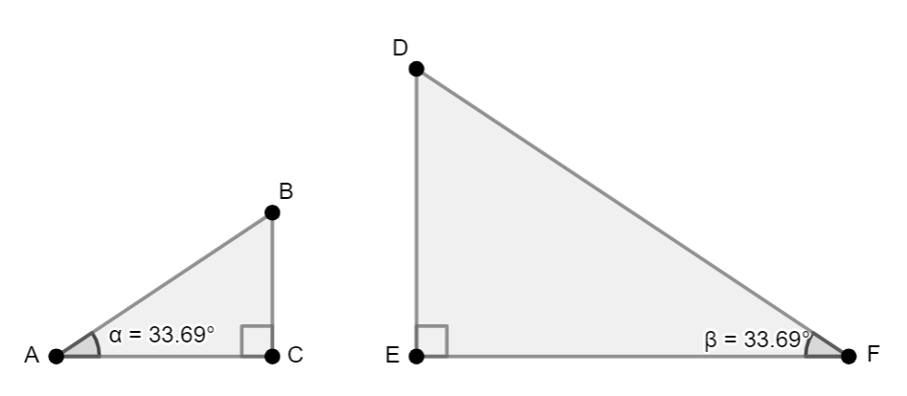

Statement A. $\frac{BC}{AB}=\frac{ }{ }$

Statement B. $\sin{33.69°=\frac{BC}{ }}$

Statement C. $\sin{33.69°=\frac{ }{DF}}$

What do you notice? Share with a partner.
*The strategies, tasks and items included in the B1G-M are examples and should not be considered comprehensive.

MA.912.T.1.2

Benchmark
MA.912.T.1.2 Solve mathematical and real-world problems involving right triangles using trigonometric ratios and the Pythagorean Theorem.
Benchmark Clarifications:
Clarification 1: Instruction includes procedural fluency with the relationships of side lengths in special right triangles having angle measures of $30°-60°-90°$ and $45°-45°-90°$.
Connecting Benchmarks/Horizontal Alignment
- MA.912.GR.1.2, MA.912.GR.1.6
MA.912.GR.6.3
Terms from the K-12 Glossary
- Angle
- Equilateral Triangle
- Hypotenuse
- Isosceles Triangle
- Right Triangle

Vertical Alignment
Previous Benchmarks  - MA.8.GR.1.1, MA.8.GR.1.2 | Next Benchmarks  - MA.912.T.1.5, MA.912.T.1.6, MA.912.T.1.7, MA.912.T.1.8  - MA.912.T.2  - MA.912.T.3
Purpose and Instructional Strategies
In grade 8, students solved problems involving unknown side lengths in right triangles applying the Pythagorean Theorem. In Geometry, students use the trigonometric ratios of acute angles in right triangles, sine, cosine, and tangent, to solve mathematical and real-world problems, involving unknown side lengths and unknown angle measures. In later courses, students will extend this knowledge to define the cotangent, the secant, and the cosecant, and to solve problems involving acute and obtuse triangles. Students will also extend the concept of trigonometric ratios to the unit circle and trigonometric functions and inverse trigonometric functions.
- Students are not expected to memorize the formulas of the trigonometric ratios (sine, cosine, and tangent). They can be found in the Geometry EOC Mathematics Reference Sheet.
- For the expectations of this benchmark, the measure of an angle is given in degrees (not in radians).
- For the expectations of this benchmark, the trigonometric ratios secant, cosecant and cotangent, and their corresponding inverse trigonometric ratios, are not included in the instruction.
- Students should have practice using Greek letters to represent angle measures (e.g., $θ=60°,α=100°,β=15°,γ=20°)$.
- Instruction includes the inverse trigonometric ratios of positive numbers, inverse sine, inverse cosine, and inverse tangent, corresponding to angle measures between $0°$ and $90°$.
- Instruction includes developing the notion that when given a trigonometric ratio, solving to find the measure of the angle cannot be done by the properties of equality. That is, given $\cos{V}=\frac{m}{n}$, the variable $V$ cannot be isolated using the addition, subtraction, multiplication, and division properties of equality. To determine the measure of angle $V$ it is necessary to determine the angle with a cosine equal $\frac{m}{n}$. The same way addition is the inverse operation to subtraction, and multiplication to division, the inverse operation to sine, cosine, and tangent, are inverse sine, inverse cosine, and inverse tangent. So, when solving for the measure of angle $V$, $V=\cos^{-1}\left(\frac{m}{n}\right).$
- Students should develop the understanding that the inverse trigonometric ratios are operations, doing the “opposite” of the trigonometric ratios, instead of memorizing an algorithm to use the calculator to find angle measures. In later courses, students will extend this notion to trigonometric functions and their inverse trigonometric functions.

- Students should have practice using the corresponding notation for inverse trigonometric ratios.
- For example, for the inverse sine of $x$ the notation is $\arcsin{x}$ or $\sin^{-1}{x}$, where $-1$ is not an exponent but a superscript. $\sin^{-1}\left(\frac{a}{b}\right)≠\frac{1}{\sin\left(\frac{a}{b}\right)}$.
- Instruction includes the use of technology, including scientific calculators, to obtain the inverse sine, the inverse cosine, and the inverse tangent of positive numbers. Students should be able to connect $0<\sin{A}<1$, $0<\cos{A}<1$, and $\tan{A}>0$, with the restrictions of the positive numbers.
- For example, the $\cos^{-1}{(3)}$ is undefined and the $\tan^{-1}{(0)}=0°$ (not an acute angle).
- Students should develop the understanding that trigonometric ratios can be used to determine side lengths and inverse trigonometric ratios to determine angle measures.
- For example, given the right triangle $ABC$, $\sin{A}=\frac{BC}{AC}$, then $AC=BC\sin{A}=3\sin{(36.87°)}≈1.8$.
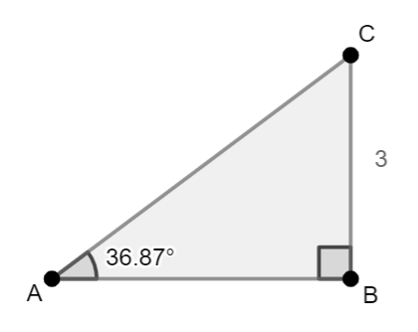
- For example, given the right triangle $ABC$, $\tan{A}=\frac{3}{4}$, then $m∠A=\tan^{-1}\left(\frac{3}{4}\right)≈36.87°$.
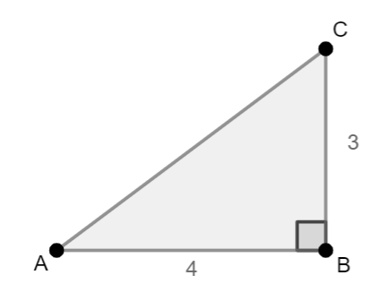
- Problem types include finding missing side length and missing angle measures using trigonometric ratios, inverse trigonometric ratios, the Pythagorean Theorem, and the Triangle Angle Sum Theorem, in mathematical and real-world contexts.

- Instruction includes solving problems involving angles of elevation and angles of depression in real-world contexts. Students should not assume that an angle of depreciation is never an interior angle of the triangle.
- For example, your friend drops an object from the top of a building while you are standing at the top of a building across the street of the same height. Your friend needs to determine the length of a wire he could use to fish the object. You see the object with an angle of depreciation. The following is the image that represents this context.
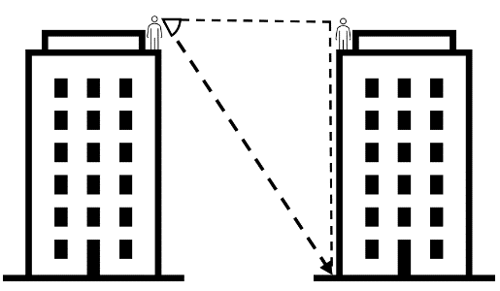
- Students should have practice solving problems with more than one right triangle, in mathematical and real-world contexts.
- For example, finding the missing side lengths given the images below.
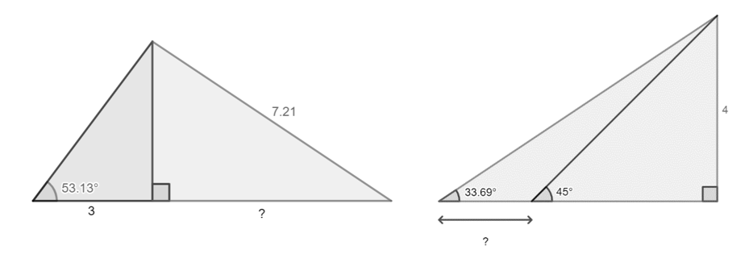
- Instruction includes make the connections between the definition of the slope of a line and the inverse tangent. Given $A\left(x_{1}, y_{1}\right)$ and $B\left(x_{2}, y_{2}\right)$ on the coordinate plane, the slope of the line passing through $A$ and $B$ is $m$, such that $m=\frac{y_{2}-y_{1}}{x_{2}-x_{1}}$. $\tan{θ}=\frac{opposite leg}{adjacent leg}=\frac{y_{2}-y_{1}}{x_{2}-x_{1}}=m$. Then, $θ=\arctan\left(\frac{opposite leg}{adjacent leg}\right)=\arctan\left(\frac{y_{2}-y_{1}}{x_{2}-x_{1}}\right)$.
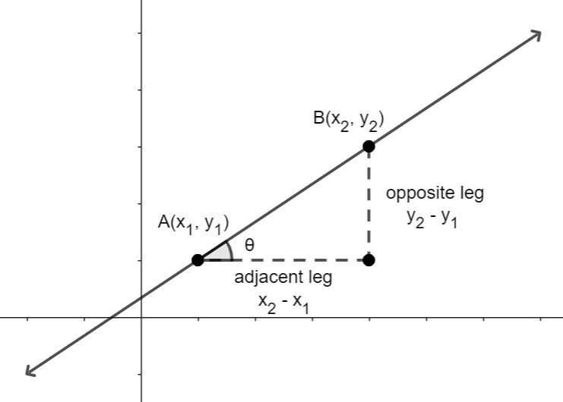

- For example, given a line on the coordinate plane with slope $\frac{2}{3}$, then $θ=\tan^{-1}\left(\frac{2}{3}\right)≈34°$. The measure of this angle describes the inclination or steepness of the line measured from the positive $x-$axis.
- Students should have practice solving mathematical and real-world problems involving special right triangles and Pythagorean triples.

Common Misconceptions or Errors
- Students may choose or define incorrectly the trigonometric ratio or the inverse trigonometric ratio when solving problems.
- Students may struggle rearranging an equation including a trigonometric ratio.
- For example, given $\sin{A}=\frac{a}{b}$, students may rearrange this expression as $A=\sin\left(\frac{a}{b}\right)$, instead of $A=\sin^{-1}\left(\frac{a}{b}\right)$.
- Students may attempt to write the trigonometric ratios with the respect of the right angle in a right triangle.

Strategies to Support Tiered Instruction
- Students should have practice solving equations of the form $a=\frac{b}{c}$ for $b$ and for $c$.
- Teacher models how to represent a real-world context using right triangles.
- For example, when the context is a child flying a kite or a person is at the top of a light house looking at a boat.
- Students should have practice identifying the given side lengths and angle measures and the variables in the image representing a real-world problem. Also, labeling the legs as opposite and adjacent, and the hypotenuse to define trigonometric ratios and inverse trigonometric ratios.
- Teacher models how to identify and define the trigonometric ratios and the inverse trigonometric ratios, including known side lengths and angle measures and the variables, to solve mathematical and real-world problems.
- Instruction includes problem types for students to explore and implement the following scaffolds when solving a problem:
- Set up equations including trigonometric ratios and inverse trigonometric ratios for acute angles in right triangles.
- Rearrange the equations to isolate a variable representing an unknown side length and an unknown angle measure, with numerical values and algebraic expressions.
- Use trigonometric ratios when a side length and an angle measure of a right triangle are given, and the purpose is to find a side length.
- Use trigonometric ratios when two side lengths of s right angle are given, and the purpose is to find an angle measure.

Instructional Tasks
Instructional Task 1 (MTR.3.1)
Given square $ABCD$.
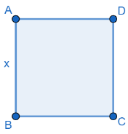
Part A. What is the measure of $\overline{BD}$ in terms of $x$?
Part B. If $BD=14$ units, what is $BC$?
Part C. If rectangle $ABPQ$ is constructed, such that $BP=2x$, what is the measure of $\overline{BQ}$ in terms of $x$?
Part D. If $x=5$, what is $BQ$?
Part E. What is the measure of $∠QBP$?

Instructional Task 2 (MTR.7.1)
Part A. A company is requesting tiles to be made for their new office floor. They want the tiles shaped like equilateral triangles. If the height of the tile is approximately $10.4$ inches, what is the side length of each tile?
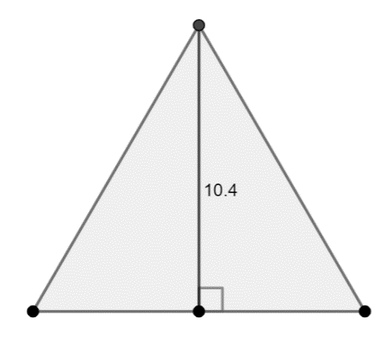
Part B. They are also ordering some tiles with the same base than the equilateral triangles in Part A, but twice the height. What would the angle measures be in each of these tiles?
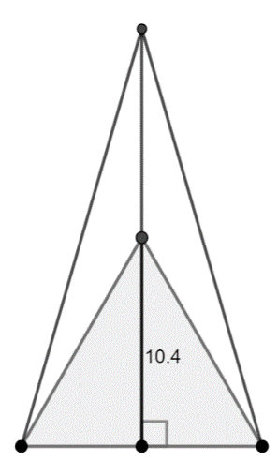
Part C. The same company decides they also want tiles shaped like isosceles right triangles with the lengths of the legs equal to the height of the equilateral triangles in Part A. What is the length of the longest side of these tiles?

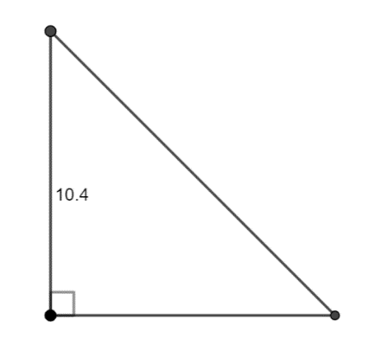

Instructional Task 3 (MTR.7.1)
From the ground, a person is looking up at a three-section monument. The angle of elevation to the top of the first section is 4$0°$, and the angle of elevation to the top of the second section is $65°$. The person is standing 62 feet away from the base of the monument.
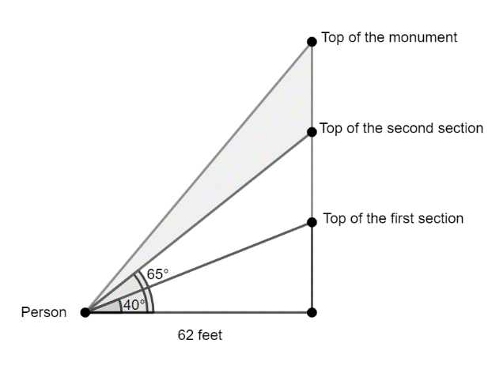
Part A. What is the distance from the top of the first section of the monument to the ground and from the top of the second section to the ground?
Part B. What is the distance between the top of the first section and the top of the second?
Part C. If the distance between the top of the monument and the top of the second section is the same than the distance found in Part B, what is the angle of elevation to the top of the monument?
Part D. If the person stands on a platform 2 feet high, what are the new angles of elevation to the top of each section and the top of the monument?
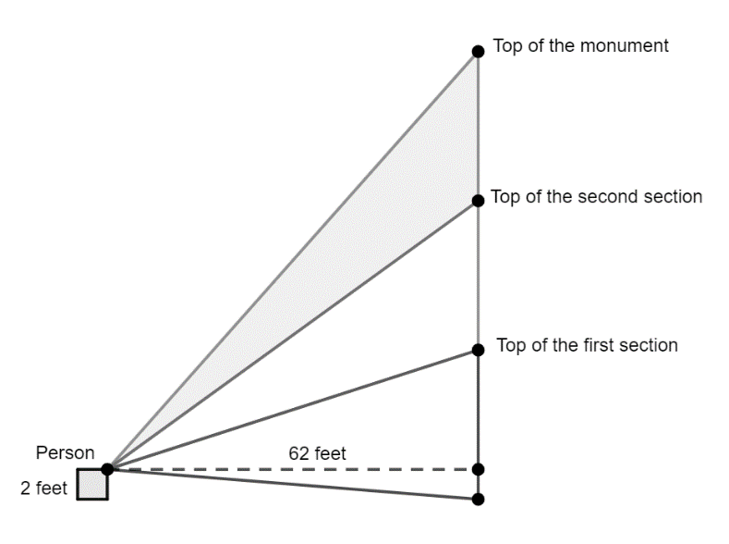

Instructional Items
Instructional Item 1
A traffic sign is in the shape of an equilateral triangle. The height of the triangle is 10 units. What is the length of the side of the triangle?

Instructional Item 2
The right triangle $ABC$ is shown, with right angle at $B$. $AB=1.5 cm$ and $BC=3.1 cm$.
A
B
C
Part A. Determine the measures of $∠A$ and $∠C$.
Part B. Determine the length of $\overline{AC}$.

Instructional Item 3
From the top of a tower, the angle of depression to a person on the ground is $32°$. If the tower has a height of $13$ meters, what is the distance from the top of the tower to the person and from the base of the tower to the person?

Instructional Item 4
Main Street and Jefferson Avenue intersect as shown in the image. What is the angle formed by these two roads?
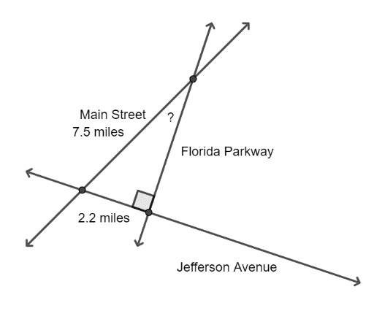

*The strategies, tasks and items included in the B1G-M are examples and should not be considered comprehensive.

Logic & Discrete Theory

MA.912.LT.4 Develop an understanding of the fundamentals of propositional logic, arguments and methods of proof.

MA.912.LT.4.3

Benchmark
MA.912.LT.4.3 Identify and accurately interpret “if…then,” “if and only if,” “all” and “not” statements. Find the converse, inverse and contrapositive of a statement.
Benchmark Clarifications:
Clarification 1: Instruction focuses on recognizing the relationships between an “if…then” statement and the converse, inverse and contrapositive of that statement.
Clarification 2: Within the Geometry course, instruction focuses on the connection to proofs within the course.
Connecting Benchmarks/Horizontal Alignment
- MA.912.GR.1
- MA.912.GR.2.6, MA.912.GR.2.8
- MA.912.GR.5
Terms from the K-12 Glossary

Vertical Alignment
Previous Benchmarks  - MA.8.GR.1 | Next Benchmarks  - MA.912.LT.4  - MA.912.LT.5

Purpose and Instructional Strategies
In grade 8, students applied the Pythagorean Theorem, the Triangle Inequality Theorem, and the Triangle Angle Sum Theorem to solve problems, and the converse of the Pythagorean Theorem to identify acute and obtuse triangles. In Geometry, students apply theorems about lines and angles, triangles, quadrilaterals, and circles, and for the expectations of the benchmarks, they prove some of them. Students are expected to use informal and formal arguments, and complete missing statements and reasons in two-column, flow, and paragraph proofs. In later courses, students refine their knowledge and skills regarding logic and set theory.
- For expectations of this benchmark, “if…then,” “if and only if,” “all” and “not” statements should be used throughout this course. Students should have practice interpreting statements related to definitions, properties, and theorems of lines and angles, triangles, quadrilaterals, and circles (restricted to the ones within this course).
- For expectations of this benchmark, students should have practice writing the converse, the inverse, and the contrapositive of definitions, properties, and theorems of lines and angles, triangles, quadrilaterals, and circles when given in “if… then” form (restricted to the ones within this course).
- Students should have practice of writing a conditional statement and determine whether the statement is true. If so, students should write its converse and determine whether is true. If so, students should write the “if and only if” statement (biconditional).
- Students should have practice writing the two conditional statements included in a biconditional.
- Students should develop the understanding that postulates cannot be proved.
- Instruction includes interpreting given descriptions of terms used within this course and determine whether the given description is an accurate and precise definition for the term. A good definition should be written as a true “if and only if” statement. Interpreting biconditionals helps students avoiding misconceptions related to definitions, properties, and theorems.
  - For example, the definition of a parallelogram states that it is a quadrilateral with two pairs of opposite sides parallel. This can be written as “a quadrilateral is a parallelogram if and only if its two pairs of opposite sides are parallel.” This means that “if a quadrilateral is a parallelogram, then it has two pairs of opposite sides that are parallel,” and that “if a quadrilateral has two pairs of opposite sides that are parallel, then it is a parallelogram.”
- Instruction includes discussing “not” and “all” statements.
  - For example, all translations are rigid motions, and all rigid motions are translations. Students should develop the understanding that an “all” statement can be interpreted verifying if it is always true.
  - For example, not all rhombuses are rectangles and not all rectangles and rhombuses. Students should develop the understanding that a “not” statement can be interpreted verifying if it sometime false.
- Instruction makes the connections between “if… then” statements and properties and theorems about lines and angles, triangles, quadrilaterals, and circles. Students should identify the hypothesis of a conditional statement, the phrase following “if” as the requisites to apply a property and theorem.
- For example, “if a triangle with side lengths $a$, $b$, and $c$ is right ($c$ the largest number), then $a^{2}+b^{2}=c^{2}$”. That means $a^{2}+b^{2}$ is equal to $c^{2}$ just when a triangle is right and it canoe be used in non-right triangles.
- For expectations of this benchmark, students are expected to write and interpret the following statements.
  - Conditional Statement (“if…then”)
For example, “if two angles are vertical, then the angles are congruent.” Students should interpret this statement and determine it is true.
  - Converse Statement
For example, “if two angles are congruent, then the angles are vertical.” Students should interpret this statement and determine it is not true. Students should develop the understanding that when the converse is true, then the inverse is true.
  - Inverse Statement
For example, “if two angles are not vertical, then the angles are not congruent.” Students should interpret this statement and determine it is not true.

  - Contrapositive Statement
For example, “if two angles are not congruent, then the angles are not vertical.” Students should interpret this statement and determine it is true. Students should develop the understanding that the contrapositive of a true conditional statement is true.
  - Biconditional Statement (“if and only if”)
For example, “two angles are congruent if and only if the two angles are vertical.” Students should interpret this statement and determine it is not true. When the converse of a conditional statement is not true, then the biconditional is not true.
- For enrichment of this benchmark, instruction includes the use of truth tables. Instruction includes the notation: $→$ for “if… then”.
- For example, given $p:$ two angles are vertical and $q:$ two angles are congruent.
$$p$$ | $$q$$ | $$p→q$$
T | T | T | Two angles are vertical, and they are congruent
T | F | F | Two angles are vertical, and they are not congruent
F | T | T | Two angles are not vertical, and they are congruent
F | F | T | Two angles are not vertical, and they are not congruent

Common Misconceptions or Errors
- Students may write the converse of a conditional statement as its inverse, and vice versa.
- Students may incorrectly determine a biconditional is true without verifying whether both conditionals in the statement are true.
- Students may interpret incorrectly a “not” statement as “never”.
- For example, “not all trapezoids are parallelograms” as “never a trapezoid is a parallelogram.”

Strategies to Support Tiered Instruction
- Teacher models conditional statements, with emphasis on the phrase after “if”, the hypothesis. Students should develop the understanding that the hypothesis determines the necessary conditions for the conclusion.
- Students should have practice writing true and false conditional statements in real-world contexts. Using these statements, students should write the converses, the inverses, and the contrapositives and determine whether they are true.
  - For example, “if it is Monday, then I am at school,” The hypothesis is “it is Monday”. The converse is “if I am at school, then today is Monday,” the inverse is “if it is not Monday, then I am not at school,” and the contrapositive is “if I am not at school, then it is not Monday.”
- Students should have practice writing biconditionals given definitions within this course.

Instructional Tasks
Instructional Task 1 (MTR.7.1)
Given:
“If two line segments tangent to a circle have a common endpoint outside the circle,
then the line segments are congruent.”
Part A. What is necessary for two line segments tangent to a circle to be congruent?
Part B. What is enough for any two line segments to be congruent?
Part C. What can be concluded about two line segments with a common endpoint outside a given circle?
Part D. What can be concluded about two line segments tangent to a circle?
Part E. Use the statements below to identify the converse, the inverse, and the contrapositive of the given statement, and determine whether they are true.
    - If two line segments tangent to a circle have a common endpoint outside the circle, then the line segments are not congruent.
    - If two line segments tangent to a circle have not a common endpoint outside the circle, then the line segments are not congruent.
    - If two line segments tangent to a circle have a not common endpoint outside the circle, then the line segments are congruent.
    - If two line segments tangent to a circle are congruent, then the two line segments have a common endpoint outside the circle.
    - If two line segments tangent to a circle are not congruent, then the two line segments have a common endpoint outside the circle.
    - If two line segments tangent to a circle are not congruent, then the two line segments have not a common endpoint outside the circle.
    - If two line segments tangent to a circle are congruent, then the two line segments have not a common endpoint outside the circle.

Instructional Task 2 (MTR.4.1)
Part A. Write a true “if…then” statement about quadrilaterals.
Part B. Write the converse of the conditional statement and determine whether the converse is true.
Part C. Write the “if and only if” statement formed by the conditional and its converse and determine whether the biconditional is true.
Part D. Write the contrapositive of the conditional statement and determine whether the contrapositive is true.
Part E. Write a false “if…then” statement about quadrilaterals.

Instructional Items
Instructional Item 1
Use the following statement to answer the questions.
“A triangle is an equilateral triangle
if and only if
the triangle has three congruent sides.”

Part A. Write the two “if…then” statements in the given biconditional statement.
Part B. Write the converse of the conditional statements created in Part A.

Instructional Item 2
For the conditional statement below, determine whether its converse, its inverse, and its contrapositive statements are true.
“If the polygon is an octagon, then the polygon has eight sides.”

 | Statement | True or False
Converse
Inverse
Contrapositive

Can the conditional statement be rewritten as a biconditional statement?
Why or why not?
*The strategies, tasks and items included in the B1G-M are examples and should not be considered comprehensive.

MA.912.LT.4.10

Benchmark
MA.912.LT.4.10 Judge the validity of arguments and give counterexamples to disprove statements.
Benchmark Clarifications:
Clarification 1: Within the Geometry course, instruction focuses on the connection to proofs within the course.

Connecting Benchmarks/Horizontal Alignment
- MA.912.GR.1
- MA.912.GR.2.6, MA.912.GR.2.8
- MA.912.GR.5

Terms from the K-12 Glossary

Vertical Alignment
Previous Benchmarks  - MA.7.GR.1  - MA.8.GR.1 | Next Benchmarks  - MA.912.LT.4  - MA.912.LT.5
Purpose and Instructional Strategies
In Geometry, students learn definitions, properties, relationships, and theorems about lines and angles, triangles, quadrilaterals, and circles. Students interpret “if…then,” “if and only if,” “all” and “not” statements and determine whether they are true. If not, they disprove the statement given a counterexample. In later courses, students will continue to judge the validity of mathematical arguments.
- Instruction includes definitions, properties, relationships, and theorems about lines and angles, triangles, quadrilaterals, and circles within this course.
- For expectations of this benchmark, students should judge the validity of given arguments throughout the course.
- Students should develop the understanding that a mathematical argument is a sequence of statements and reasons with the purpose to prove a given property, relationship, or theorem. With a mathematical argument, a given statement can be proved or disproved.
- Students should have practice identifying counterexamples when disproving an argument.
  - For example, given the argument “all rectangles have opposite sides parallel; therefore, given a quadrilateral is not a rectangle, then the quadrilateral does not have opposite sides parallel.” A counterexample to show the argument is not valid is a parallelogram with non-right angles.
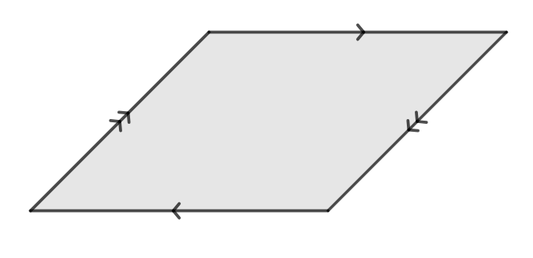

Common Misconceptions or Errors
- Students may have difficulty judging the validity of an argument when they have not developed precise definitions for the terms used in the argument.
- Students may state incorrectly a given statement is true because they do not identify a counterexample.

Strategies to Support Tiered Instruction
- Teacher models counterexamples for given statements.
  - For example, “all congruent angles are vertical.”
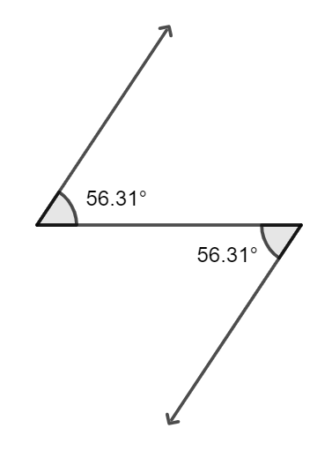
  - For example, “if a triangle has two sides of equal length, then the triangle is equilateral.”
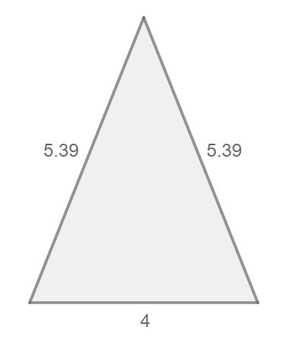
- Students should have practice identifying counterexamples of given statements and comparing them with partners.
  - For example, “given $\overline{PO}$ and $\overline{QO}$ tangents to a circle, then $PO≠QO$.”
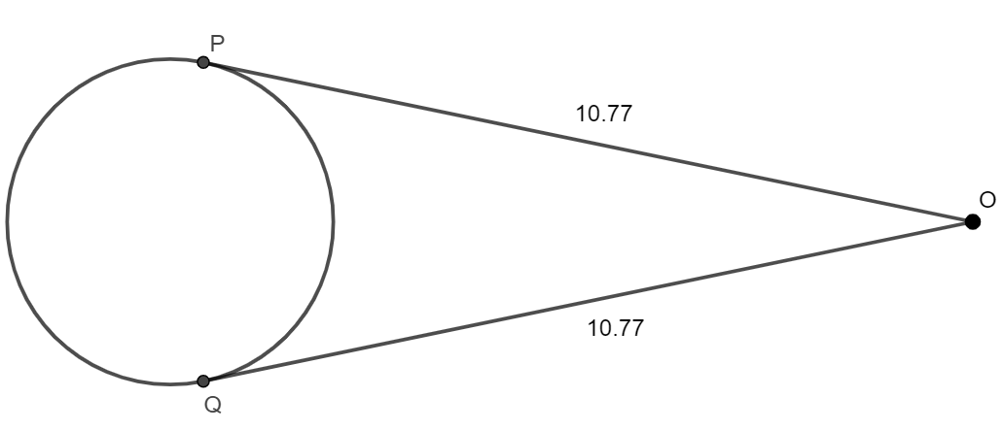

Instructional Tasks
Instructional Task 1 (MTR.3.1)
Part A. Which of the following statements is true? Select all that apply.
- If a quadrilateral is a square, then it is a rectangle.
- All trapezoids are parallelograms.
- Any quadrilateral can be inscribed in a circle.
Part B. If the statement is not true, provide a counterexample to disprove it..

Instructional Task 2
Given the argument:
In quadrilateral HIJK, $\overline{HI}$ and $\overline{KJ}$ are parallel.
Quadrilateral HIJK is a parallelogram.
Part A. Determine whether the argument is valid.
Part B. If not, provide a counterexample.
Part C. What argument can be used to quadrilateral HIJK is a parallelogram?

Instructional Items
Instructional Item 1
Puaglo said the following statements are true. Select all the statements that are false.
- All quadrilaterals have four right angles.
- A triangle is a polygon with three sides.
- All circles are similar.
- All equiangular quadrilaterals are congruent.
- A trapezoid must have at least one obtuse angle.

Instructional Item 2
Judge the validity of the following argument. If not valid, give a counterexample.
$∠A$ and $∠B$ form a linear pair.
If the measure of two angles is $90°$, then the angles form a linear pair.
Therefore, $m∠A=90°$ and $m∠B=90°$.
*The strategies, tasks and items included in the B1G-M are examples and should not be considered comprehensive

