The Benchmarks for Excellent Student Thinking (B.E.S.T.) Standards for Mathematics are the state’s mathematical standards that pave the way for Florida students to receive a world-class education and prepare them for a successful future.
These standards were written to:
Provide clarity on the grade-level expectations for educators, parents and students.

Allow students flexibility to solve problems using a method/strategy of their choice.

Allow for student discovery (i.e., exploration) of strategies rather than the teaching, naming and assessing of each strategy individually.

Education leaders from across the state came together to develop Florida’s B.E.S.T. Standards for Mathematics. These standards and benchmarks are goals that students are expected to achieve by the end of the school year. A standard is an overarching criterion for a grade level or grade band. A benchmark is a specific expectation or skill for the grade level or grade band that falls within a standard. The B.E.S.T. Standards are designed to ensure that ALL students reach their greatest potential.

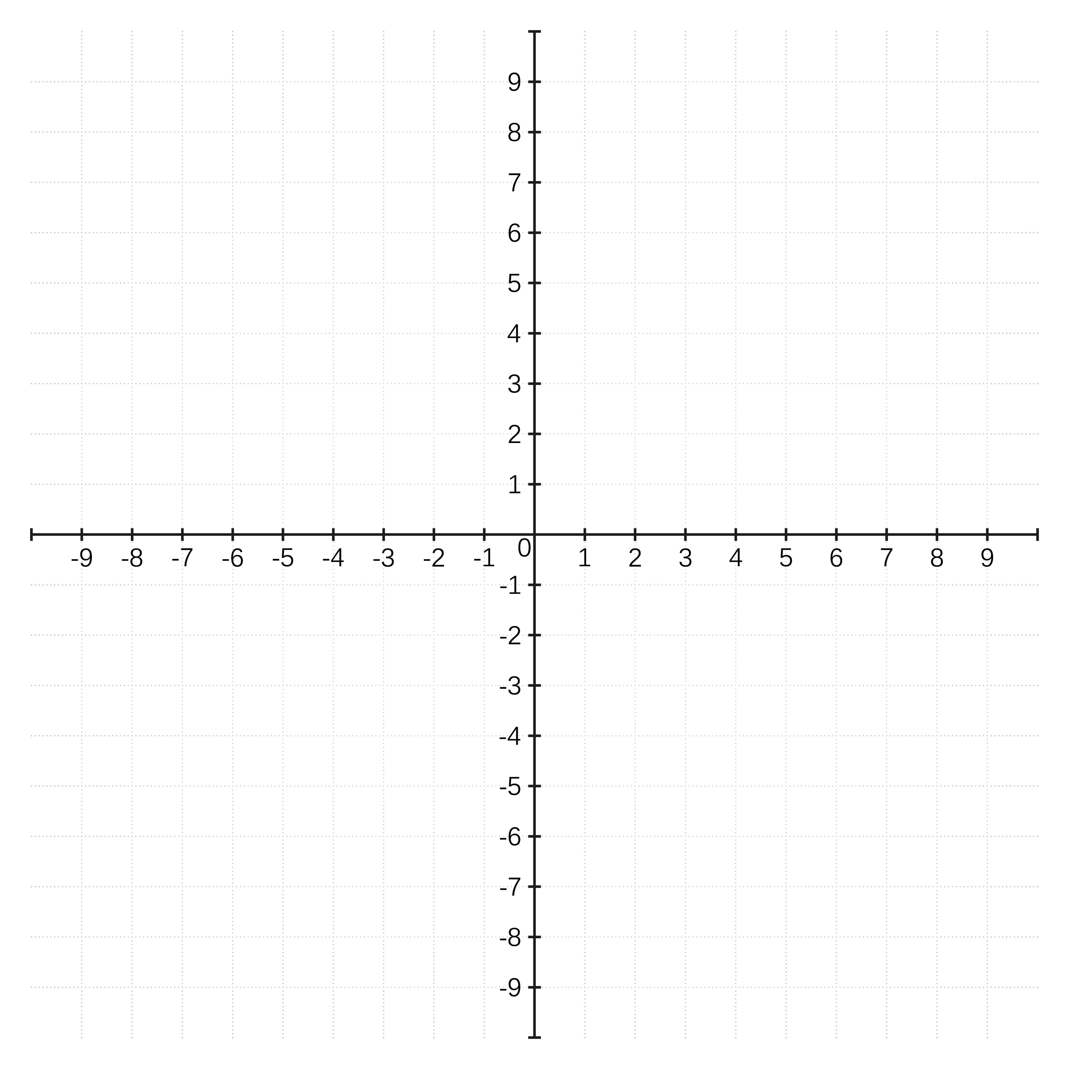
Preparing your student for success begins in Kindergarten and continues as your child progresses through each mathematics course. This guide will support parents, guardians and families with students in Algebra 1 by helping them:

- Learn about the B.E.S.T. Standards for Mathematics and why they matter for your student.
- Understand important educational (academic) words that you will see in your student’s grade-level standards and benchmarks.
- Talk with your student’s teacher about what they will be learning in the classroom.
- Locate activities and resources to support your student’s learning in practical ways at home.

Learn About the Algebra 1 Mathematics Standards
This table describes the areas of emphasis within Algebra 1 and provides examples of specific expectations within each area of emphasis. The purpose of the areas of emphasis is not to provide detailed guidance for specific units of learning and instruction, but rather provide insight on major mathematical topics that will be covered within the mathematics course.

Area of Emphasis | Examples
Performing operations with polynomials and radicals and extending the Laws of Exponents to include rational exponents. | - Add, subtract, multiply and divide polynomial expressions.  - Add, subtract, multiply and divide radical expressions.  - Convert between expressions with rational exponents and radical expressions.  - Apply the Laws of Exponents to exponents in the form $\frac{a}{b}$.
Extending understanding of functions to linear, quadratic and exponential functions and using them to model and analyze real-world relationships. | - Write, solve and graph linear, quadratic and exponential equations and functions in one and two variables.  - Connect linear, quadratic and exponential functions to real-world situations.
Solving quadratic equations in one variable and systems of linear equations and inequalities in two variables. | - Given a mathematical or real-world context, write and solve one-variable quadratic equations over the real number system and interpret the solution in terms of the context.  - Write and solve a system of two-variable equations and inequalities that describes quantities or relationships.  - Given a mathematical or real-world context, write and solve a system of two-variable linear equations algebraically or graphically.
Building functions, identifying their key features and representing them in various ways. | - Identify key features of functions such as domain; range; intercepts; intervals where the function is increasing, decreasing, positive or negative; end behavior; vertex; rate of change; and symmetry.  - Represent and recognize functions from written descriptions, equations, graphs and tables of values.  - Use inequality and set builder notations when representing domain and range.
Representing and interpreting categorical and numerical data with one and two variables. | - Classify data as categorical or numerical, and univariate or bivariate.  - Represent data in two-way relative frequency tables and interpret joint and marginal frequencies.

B.E.S.T. Instructional Guide for Mathematics
The B.E.S.T. Instructional Guide for Mathematics (B1G-M) is intended to assist educators with planning for student learning and instruction aligned to Florida’s Benchmarks for Excellent Student Thinking (B.E.S.T.) Standards. This guide is designed to aid high-quality instruction through the identification of components that support the learning and teaching of the B.E.S.T. Mathematics Standards and Benchmarks. The B1G-M can be utilized by parents, guardians and families to support learning at home through the Instructional Strategies section.

This document is posted on the B.E.S.T. Standards for Mathematics webpage (https://www.fldoe.org/academics/standards/subject-areas/math-science/mathematics/bestmath.stml) of the Florida Department of Education’s website and will continue to undergo edits as needed.

Educational Words to Know and Use in Algebra 1
Absolute Value | Domain | Inequality | Numerical Data | Rate of Change | Simulation
Base | Exponent | Intercept | Piecewise Function | Rational Number | Slope
Categorical Data | Exponential | Line of Fit | Polynomial | Real Numbers | Transformation
Coefficient | Exponential Function | Linear Equation | Quadratic Function | Rotation | Translation
Compound Inequality | Function | Linear Expression | Random Sampling | Scatter Plot | $x$-intercept
Coordinate Plane | Function Notation | Monomial | Range | Simple Interest | $y$-intercept
Definitions for these terms can be found in the glossary of the standards book accessed K-12 Mathematics Glossary.

Helpful Formulas for Algebra 1
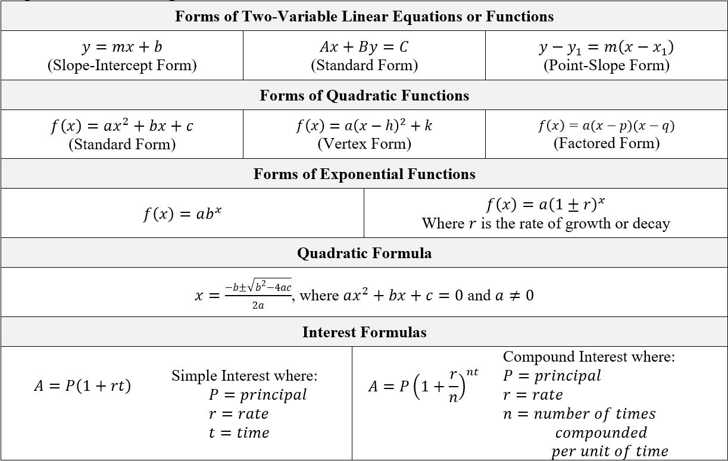

Support Learning at Home
You can encourage learning mathematics at home in ways that are fun for you and your student. Try these ideas after school, on weekends and during the summer:
- Have your child help you sort the laundry into different groups. For example, put all the pants in one pile, shirts in another pile and socks in a third pile. Talk about what the items in each pile have in common.
- Plan a trip to the movies with a specific budget. Before going, research the price for each adult and child ticket. Figure out the possible number of adults and children that could go. Ask your student to determine the maximum number of adults that could go when there are no children. Conversely, ask your student to determine the maximum number of children that could go if no adults attended.
- While viewing an online map, ask your student to identify streets that are parallel and perpendicular. Have your student explain the difference between parallel and perpendicular.
- When grocery shopping, give your student a specific budget. They must buy a gallon of milk. Have them choose a second item they would like to buy. They will use the remaining money to buy as many of the second item as possible. Have your student determine the maximum number they can buy of the second item.
- Visit a major site (e.g., museum, library, downtown, etc.) with your student. Have them observe the structures of the site. Then, have them identify places that look like the graphs of linear, quadratic or absolute value functions. Have them discuss what makes these structures linear, quadratic or absolute value.
- Have your child practice inputting the parent functions found in the table below in a graphing utility, handheld or online. Create a chart for each function to include the name, function notation and visual of the graph.

Linear $f(x)=x$ | Square root $f(x)=\sqrt{x}$ | Exponential (growth) $f(x)= 2^{x}$
Quadratic $f(x)=x^{2}$ | Cube root $f\left(x\right)= \sqrt[3]{x}$ | Exponential (decay) $f(x)= {\left(\frac{1}{2}\right)}^{x}$
Cubic $f(x)= x^{3}$ | Absolute value $f(x)=|x|$

- Be on the lookout for quadratic functions. When at a park/playground, discuss how shooting a basketball or hitting a golf ball creates a parabola.
- Discover perfect squares with your student. Provide your student with a multiplication chart up to 12. Have them highlight all of the products that are formed by the same two factors. What do you notice?
- Ask your student if they would rather receive $40 a week for a year or receive $1 the first week and doubling the amount every week for a year. How does this relate to linear and exponential functions?
- Have your student research real life examples of correlation and causation. Talk with your student about the societal effects of those examples.
- At a family gathering, provide a list of entrees and sides. Survey the family members on their choice of entrée and side and record the data in an appropriate data display. Determine if there seems to be a correlation between the entrée and side chosen.

Talk with Your Student’s Teacher
Remember, you are your student’s first teacher. Think about a parent-teacher conference as a “team meeting” in which you will discover the special contributions each of you bring to your student’s success. Here are some questions you could ask to prompt discussions:

Which skills or topics is my student working on? Which have they mastered? How can I support them at home?

In the area of mathematics, what are my student’s strengths? How are those strengths supported during instruction? Where is my student struggling and how can I help?

Can my student show you that they understand what they are learning about through manipulatives, drawing, talking and writing? If not, what challenges are they facing?

What topics in connection to science and social studies is my student learning about through math?

What behaviors should I see when my student is doing math? Can I see an example of the type of problems my student is given? How can I support them at home?

Mathematical Thinking and Reasoning Standards (MTRs)
Florida students are expected to engage with mathematics through the Mathematical Thinking and Reasoning Standards (MTRs). These standards are written in clear language so all stakeholders can understand them and teachers can assist students to use them as self-monitoring tools. The MTRs promote deeper learning and understanding of mathematics. By understanding the MTRs, parents, guardians and families can support the development of these skills at home.

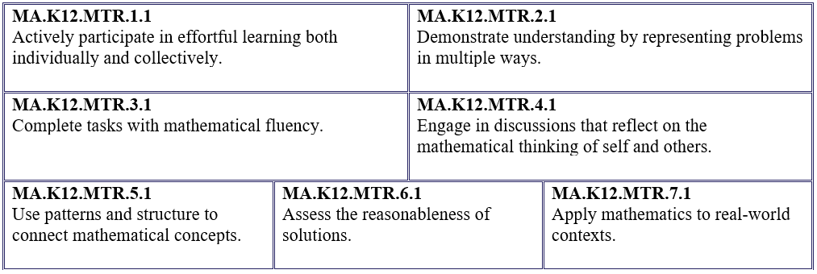
Your student will develop the above skills (MTRs) throughout their education and during their life. These skills will help maintain positive relationships through effective communication, collaboration, conflict resolution and problem solving.

Below are some ways you can help develop mathematical thinking and reasoning skills for your Algebra 1 student:
- Encourage your student to ask questions when they do not understand what is being asked of them.
- Ask your student to estimate before determining a solution to the task at hand.
- Identify a problem and create a plan to tackle it in smaller steps that are more manageable.
- Try activities like a scavenger hunt or a puzzle.

By helping to develop your student’s mathematical thinking and reasoning skills, you will prepare them to become a confident, independent and successful individual.

