These standards were written to:
Provide clarity on the grade- or course-level expectations for educators, parents and students.

Allow students flexibility to solve problems using a method/strategy of their choice.

Allow for student discovery (i.e., exploration) of strategies rather than the teaching, naming and assessing of each strategy individually.
The Benchmarks for Excellent Student Thinking (B.E.S.T.) Standards for Mathematics are the state’s mathematical standards that pave the way for Florida students to receive a world-class education and prepare them for a successful future.

Education leaders from across the state came together to develop Florida’s B.E.S.T. Standards for Mathematics. These standards and benchmarks are goals that students are expected to achieve by the end of the school year. A standard is an overarching criterion for a grade level or grade band. A benchmark is a specific expectation or skill for the grade level or grade band that falls within a standard. The B.E.S.T. Standards are designed to ensure that ALL students reach their greatest potential.
Preparing your student for success begins in Kindergarten and continues as your child progresses through each mathematics course. This guide will support parents, guardians and families with students in Mathematics for Data and Financial Literacy by helping them:

- Learn about the B.E.S.T. Standards for Mathematics and why they matter for your student.
- Understand important educational (academic) words that you will see in your student’s grade- or course-level standards and benchmarks.
- Talk with your student’s teacher about what they will be learning in the classroom.
- Locate activities and resources to support your student’s learning in practical ways at home.

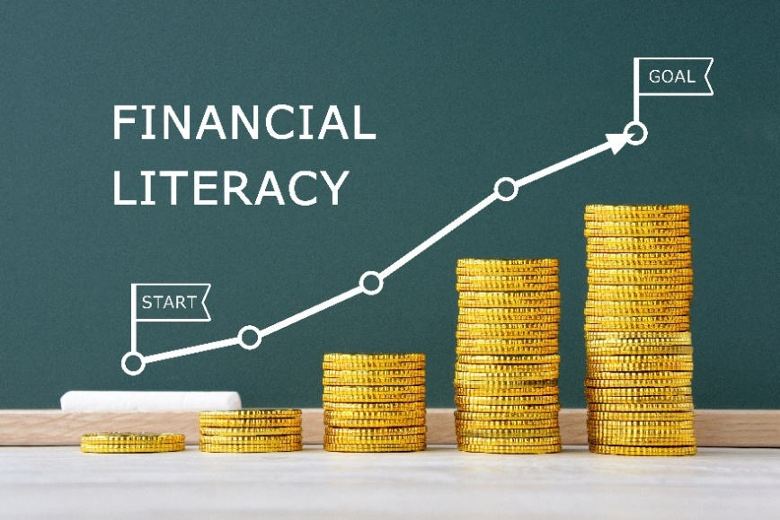

Learn About the Mathematics for Data and Financial Literacy Standards
The table describes the areas of emphasis within Mathematics for Data and Financial Literacy and provides examples of specific expectations within each area of emphasis. The purpose of the areas of emphasis is not to provide detailed guidance for specific units of learning and instruction but rather provide insight into major mathematical topics that will be covered within the mathematics course.

Area of Emphasis | Examples
Extending knowledge of ratios, proportions and functions to data and financial contexts. | - Add, subtract, multiply and divide polynomial expressions.  - Add, subtract, multiply and divide radical expressions.  - Write, solve and graph linear equations and functions.  - Write, solve and graph exponential equations and exponential functions in one and two variables.  - Solve real-world problems involving money and business.
Developing an understanding of basic economic and accounting principles. | - Use operations of fractions, percentages and decimals to solve real-world problems involving discounts, markups, simple interest, tax, tips, fees, percent increase, percent decrease and percent error.  - Interpret data distributions represented in various ways.  - Relate the slope and $y$-intercept of a line of fit to association in bivariate numerical data and interpret these features in real-world contexts.  - Develop budgets that fit within various incomes.
Determining advantages and disadvantages of credit accounts and short- and long-term loans. | - Solve and graph mathematical and real-world problems that are modeled with piecewise functions. Interpret key features and determine constraints in terms of financial situations.  - Given a mathematical or real-world context, write and solve a system of two-variable linear equations algebraically or graphically.  - Calculate the finance charges and the total amount due on a bill using various forms of credit.  - Establish a plan to pay off debt.
Developing understanding of planning for the future through investments, insurance and retirement plans. | - Use inequality and set builder notations when representing constraints of financial situations.  - Determine savings amounts based on how much and how often a certain amount of money is added to an account with various interest rates.  - Compare the advantages and disadvantages for adding on a one-time warranty to a purchase.  - Compare the advantages and disadvantages of various retirement savings plans.
Extending knowledge of data analysis to create and evaluate reports and to make predictions. | - Classify data as categorical or numerical, and univariate or bivariate.  - Plot and analyze residuals given a scatterplot that represents bivariate numerical data.  - Evaluate data-based arguments.

B.E.S.T. Instructional Guide for Mathematics
The B.E.S.T. Instructional Guide for Mathematics (B1G-M) is intended to assist educators with planning for student learning and instruction aligned to Florida’s Benchmarks for Excellent Student Thinking (B.E.S.T.) Standards. This guide is designed to aid high-quality instruction through the identification of components that support the learning and teaching of the B.E.S.T. Mathematics Standards and Benchmarks. The B1G-M can be utilized by parents, guardians and families to support learning at home through the Instructional Strategies section.

This document is posted on the B.E.S.T. Standards for Mathematics webpage of the Florida Department of Education’s website and will continue to undergo edits as needed.

Mathematical Words to Know and Use in Mathematics for Data and Financial Literacy
Arithmetic sequence | Coordinate | Expression | Line of fit | Population | Set-builder notation
Base | Coordinate plane | Frequency table | Linear function | Proportional relationships | Simple interest
Bivariate data | Data | Function | Measures of center | Random sampling | Slope
Categorical data | Domain | Function notation | Measures of variability | Range | $x$-intercept
Cluster | Equation | Geometric sequence | Percent error | Rate | $y$-intercept
Coefficient | Exponent | Joint frequency | Percent of change | Rate of change
Conditional relative frequency | Exponential function | Joint relative frequency | Piecewise function | Scatterplot
Definitions for these terms can be found in the glossary of the standards book accessed at 6-12 Mathematics Glossary.

Support Learning at Home
You can encourage learning mathematics at home in ways that are fun for you and your student. Try these ideas after school, on weekends and during the summer:
- Collect weekly grocery store ads or online prices (milk, eggs, cereal). Make a simple chart of prices over 4 weeks. Ask your student to predict trends over time based on the collected data.
- Parents and students can plug the same loan amount (say, $10,000) into free online calculators, changing:
  - Interest rate (e.g., 4% vs. 8%)
  - Term length (e.g., 3 years vs. 5 years)
- Help your student choose the best option for saving money. Research the different types of savings accounts and ways to save money. Discuss the best time for your student to withdraw the money from their account.
- Using an online stock simulator, have your student simulate the purchase of a stock portfolio with a set amount of money, and evaluate its worth over time considering gains, losses and selling, taking into account any associated fees.
- Choose two events related to finances to give to your student and ask them whether there is a correlation or causation. For example, gas prices vs. driving habits where your student watches to see if driving decreases when gas prices go up. Is it correlation (maybe it is just vacation season) or causation (higher cost discourages driving).
- Have your student sit with you to create a monthly budget.
- Have your student calculate debt-to-income ratios.

Talk with Your Student’s Teacher
Remember, you are your student’s first teacher. Think about a parent-teacher conference as a “team meeting” in which you will discover the special contributions each of you bring to your student’s success. Here are some questions you could ask to prompt discussions:

Which skills or topics is my student working on? Which have they mastered? How can I support them at home?

In the area of mathematics, what are my student’s strengths? How are those strengths supported during instruction? Where is my student struggling and how can I help?

Can my student show you that they understand what they are learning about through manipulatives, drawing, talking and writing? If not, what challenges are they facing?

What topics in connection to science and social studies is my student learning about through mathematics?

What behaviors should I see when my student is doing mathematics? Can I see an example of the type of problems my student is given? How can I support them at home?

Mathematical Thinking and Reasoning Standards (MTRs)
Florida students are expected to engage with mathematics through the Mathematical Thinking and Reasoning Standards (MTRs). These standards are written in clear language so all stakeholders can understand them and teachers can assist students to use them as self-monitoring tools. The MTRs promote deeper learning and understanding of mathematics. By understanding the MTRs, parents, guardians and families can support the development of these skills at home.

MA.K12.MTR.1.1  Actively participate in effortful learning both individually and collectively. |  | MA.K12.MTR.2.1  Demonstrate understanding by representing problems in multiple ways.
MA.K12.MTR.3.1  Complete tasks with mathematical fluency. |  | MA.K12.MTR.4.1  Engage in discussions that reflect on the mathematical thinking of self and others.
MA.K12.MTR.5.1  Use patterns and structure to connect mathematical concepts. | MA.K12.MTR.6.1  Assess the reasonableness of solutions. |  | MA.K12.MTR.7.1  Apply mathematics to real-world contexts.

Your student will develop the above skills (MTRs) throughout their education and during their life.

Below are some ways you can help develop mathematical thinking and reasoning skills for your mathematics student:
- Encourage your student to ask questions when they do not understand what is being asked of them.
- Ask your student to estimate before determining a solution to the task at hand.
- Identify a problem and create a plan to tackle it in smaller steps that are more manageable.
- Try activities like a scavenger hunt or a puzzle.

By helping to develop your student’s mathematical thinking and reasoning skills, you will prepare them to become a confident, independent and successful mathematician.

