The Benchmarks for Excellent Student Thinking (B.E.S.T.) Standards for Mathematics are the state’s mathematical standards that pave the way for Florida students to receive a world-class education and prepare them for a successful future.
These standards were written to:
Provide clarity on the grade- or course-level expectations for educators, parents and students.

Allow students flexibility to solve problems using a method/strategy of their choice.

Allow for student discovery (i.e., exploration) of strategies rather than the teaching, naming and assessing of each strategy individually.

Education leaders from across the state came together to develop Florida’s B.E.S.T. Standards for Mathematics. These standards and benchmarks are goals that students are expected to achieve by the end of the school year. A standard is an overarching criterion for a grade level or grade band. A benchmark is a specific expectation or skill for the grade level or grade band that falls within a standard. The B.E.S.T. Standards are designed to ensure that ALL students reach their greatest potential.

Preparing your student for success begins in Kindergarten and continues as your child progresses through each mathematics course. This guide will support parents, guardians and families with students in Mathematics for College Statistics by helping them:

- Learn about the B.E.S.T. Standards for Mathematics and why they matter for your student.
- Understand important educational (academic) words that you will see in your student’s grade- or course-level standards and benchmarks.
- Talk with your student’s teacher about what they will be learning in the classroom.
- Locate activities and resources to support your student’s learning in practical ways at home.

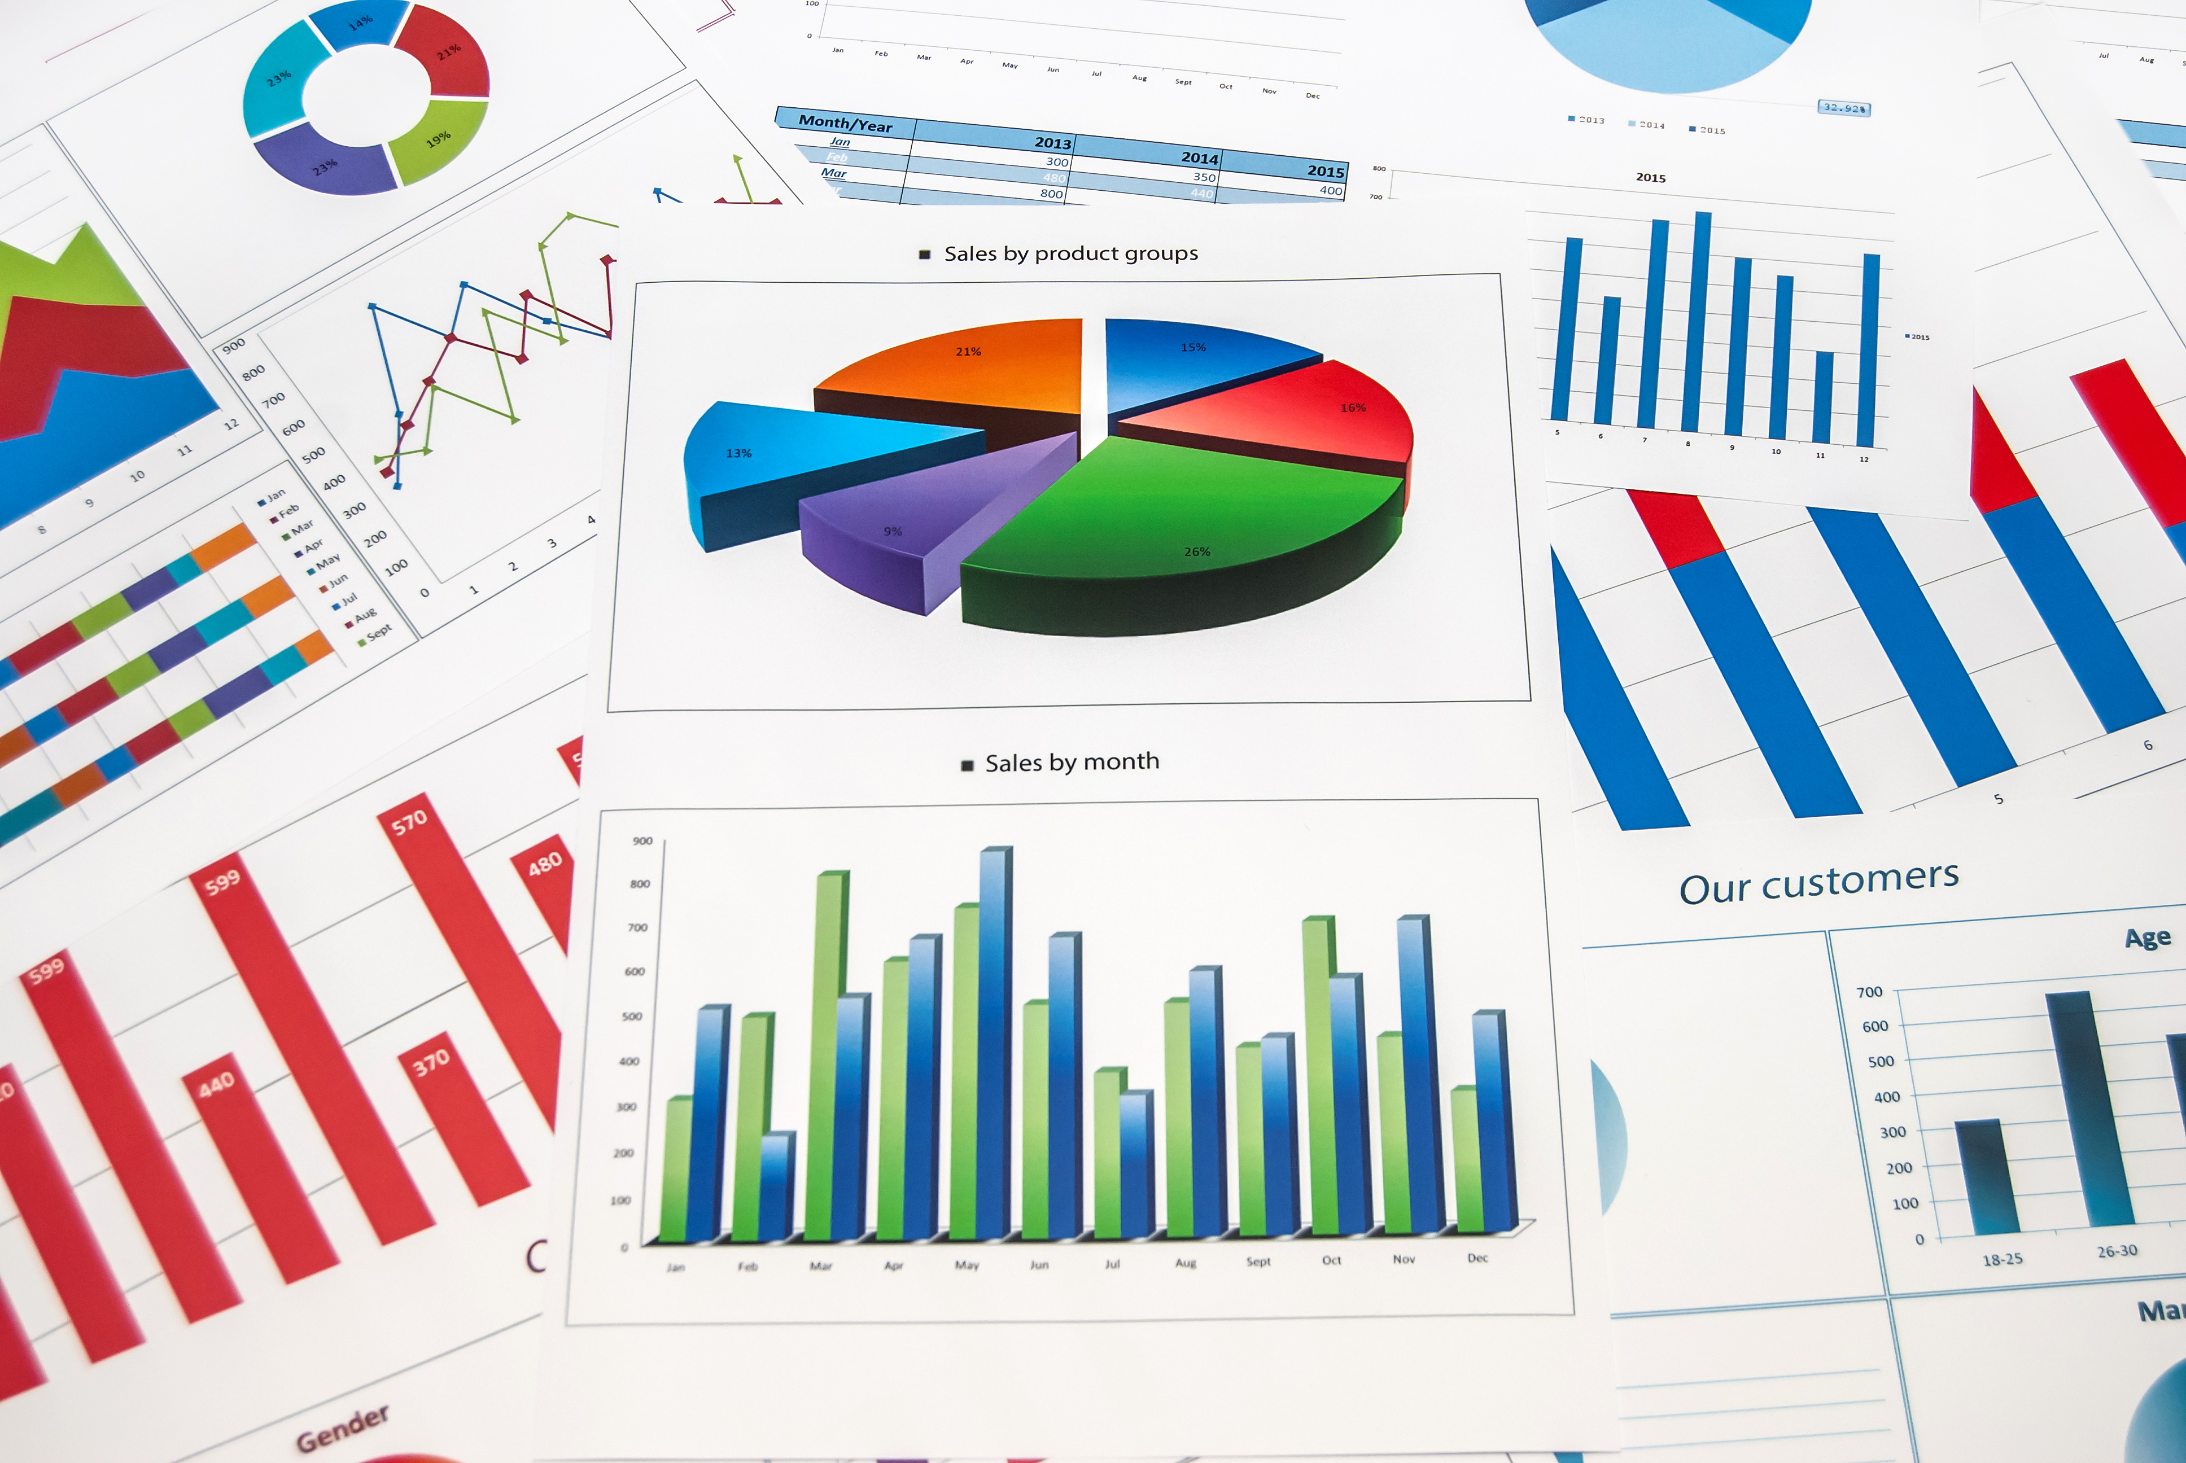

Learn About Mathematics for College Statistics
The table describes the areas of emphasis within Math for College Statistics and provides examples of specific expectations within each area of emphasis. The purpose of the areas of emphasis is not to provide detailed guidance for specific units of learning and instruction, but rather provide insight on major mathematical topics that will be covered within the mathematics course.

Area of Emphasis | Examples
Analyzing and applying linear and exponential functions within the context of statistics. | - Identify and interpret parts of an equation or expression in context.  - Solve and graph mathematical and real-world problems that are modeled with linear and exponential functions.  - Determine whether a linear, quadratic or exponential function best models a given real-world situation.  - Solve real-world problems involving money and business.
Extending understanding of probability using data and various representations, including two-way tables and Venn Diagrams. | - Select an appropriate method to represent data.  - Construct two-way frequency tables summarizing bivariate categorical data.  - Explore relationships and patterns and make arguments about relationships between sets using Venn Diagrams.
Representing and interpreting univariate and bivariate categorical and numerical data. | - Solve real-world problems involving weighted averages using spreadsheets and other technology.  - Calculate and compare the appropriate measures of center and measures of variability.  - Explain the difference between correlation and causation.  - Interpret data distributions represented in various ways.  - Compute the correlation coefficient of a linear model and interpret its strength and direction using technology.
Determining the appropriateness of different types of statistical studies. | - Distinguish between a population parameter and a sample statistic.  - Determine the appropriate design, survey, experiment or observational study, based on the purpose.  - Determine if a specific method for collecting data is consistent within a given process by analyzing the data distribution from a data-generating process.  - Compare and contrast surveys, experiments and observational studies.  - Interpret graphs and tables, evaluate data-based arguments, determine whether a valid sampling method was used and interpret provided statistics.

B.E.S.T. Instructional Guide for Mathematics
The B.E.S.T. Instructional Guide for Mathematics (B1G-M) is intended to assist educators with planning for student learning and instruction aligned to Florida’s Benchmarks for Excellent Student Thinking (B.E.S.T.) Standards. This guide is designed to aid high-quality instruction through the identification of components that support the learning and teaching of the B.E.S.T. Mathematics Standards and Benchmarks. The B1G-M can be utilized by parents, guardians and families to support learning at home through the Instructional Strategies section.

This document is posted on the B.E.S.T. Standards for Mathematics webpage (https://www.fldoe.org/academics/standards/subject-areas/math-science/mathematics/bestmath.stml) of the Florida Department of Education’s website and will continue to undergo edits as needed.

Educational Words to Know and Use in Mathematics for College Statistics
Association | Conditional relative frequency | Function Notation | Line plot | Percent of change | Scatter plot
Bar graph | Equation | Histogram | Linear Equation | Population | Set-Builder Notation
Bivariate data | Event | Intercept | Linear Expression | Quadratic Function | Simple Interest
Box plot | Experimental Probability | Interquartile range | Linear Function | Quartiles | Simulation
Categorical data | Exponent | Joint frequency | Measures of center | Random sampling | Standard deviation
Central angle | Exponential Function | Joint relative frequency | Measures of variability | Rate of Change | Statistical question
Circle graph | Expression | Line graph | Outlier | Repeated experiment | Stem-and-leaf plot
Cluster | Frequency table | Line of Fit | Percent error | Sample Space | Theoretical Probability
Definitions for these terms can be found in the glossary of the standards book accessed at 6-12 Mathematics Glossary.

Support Learning at Home
You can encourage learning mathematics at home in ways that are fun for you and your student. Try these ideas after school, on weekends and during the summer:
- Using a deck of playing cards, discuss with your student the probability of drawing a specific card from the deck given that a card has already been drawn without replacement. What would be different if there was replacement? For example, if a king of hearts is drawn from a deck of playing cards, what would be the probability of drawing another king if the king of hearts was placed back in the deck and if it is not placed back in the deck?
- Have your student conduct a survey and represent the data with an appropriate display based on whether it is univariate or bivariate and categorical or numerical.
- Choose two sets of data for your student to collect and ask them whether there just a correlation or also causation. For example, gas prices vs. driving habits where your student watches to see if driving decreases when gas prices go up. Is it correlation (maybe it is just vacation season) or causation (higher cost discourages driving)? Note: This data collection could take place over a period of a semester.
- Have your student look up a statistical claim from an advertisement or news article and analyze it for population, sample type and sample size and if it was representative of the population. Discuss this with your student and if it is not representative of the population, what could be changed to make it representative of the entire population?
- Have your student look up different careers, their education requirements and average salary. Determine whether there is correlation and, if so, whether there is causation.
- Randomly pick three sets of letters (letters can be in multiple sets) and label them Sets $A$, $B$ and $C$. Have your student determine the unions, intersections and/or complements of different combinations of the sets. For example, if Set $A$ = {c, e, m, o, s, z}, Set $B$ = {a, j, l, o, q, t}, Set $C$ = {a, c, m, o, u, x} and these letters are taken from the universal set of the alphabet. Find the following:
  - $A∩B$ = {o}
  - $B∪C$ = {a, c, j, l, m, o, q, t, u, x}
  - $C'$ = {b, d, e, f, g, h, i, j, k, l, n, p, q, r, s, t, v, w, y, z}
- Have your student survey family and friends asking “Do you have a pet with fur, without fur or both?” After recording the data, have them create a Venn diagram displaying the survey results.
- Look up a menu from your local pizza restaurant. Have you student determine how many combinations of two- or three-topping pizzas can be created with the different options for toppings.

Talk with Your Student’s Teacher
Remember, you are your student’s first teacher. Think about a parent-teacher conference as a “team meeting” in which you will discover the special contributions each of you bring to your student’s success. Here are some questions you could ask to prompt discussions:

Which skills or topics is my student working on? Which have they mastered? How can I support them at home?

In the area of mathematics, what are my student’s strengths? How are those strengths supported during instruction? Where is my student struggling and how can I help?

Can my student show you that they understand what they are learning about through manipulatives, drawing, talking and writing? If not, what challenges are they facing?

What topics in connection to science and social studies is my student learning about through mathematics?

What behaviors should I see when my student is doing mathematics? Can I see an example of the type of problems my student is given? How can I support them at home?

Mathematical Thinking and Reasoning Standards (MTRs)
Florida students are expected to engage with mathematics through the Mathematical Thinking and Reasoning Standards (MTRs). These standards are written in clear language so all stakeholders can understand them and teachers can assist students to use them as self-monitoring tools. The MTRs promote deeper learning and understanding of mathematics. By understanding the MTRs, parents, guardians and families can support the development of these skills at home.

MA.K12.MTR.1.1  Actively participate in effortful learning both individually and collectively. |  | MA.K12.MTR.2.1  Demonstrate understanding by representing problems in multiple ways.
MA.K12.MTR.3.1  Complete tasks with mathematical fluency. |  | MA.K12.MTR.4.1  Engage in discussions that reflect on the mathematical thinking of self and others.
MA.K12.MTR.5.1  Use patterns and structure to connect mathematical concepts. | MA.K12.MTR.6.1  Assess the reasonableness of solutions. |  | MA.K12.MTR.7.1  Apply mathematics to real-world contexts.

Your student will develop the above skills (MTRs) throughout their education and during their life. These skills will help maintain positive relationships through effective communication, collaboration, conflict resolution and problem solving.

Below are some ways you can help develop mathematical thinking and reasoning skills for your mathematics student:
- Encourage your student to ask questions when they do not understand what is being asked of them.
- Ask your student to estimate before determining a solution to the task at hand.
- Identify a problem and create a plan to tackle it in smaller steps that are more manageable.
- Try activities like a scavenger hunt or a puzzle.

By helping to develop your student’s mathematical thinking and reasoning skills, you will prepare them to become a confident, independent and successful individual.

