The Benchmarks for Excellent Student Thinking (B.E.S.T.) Standards for Mathematics are the state’s mathematical standards that pave the way for Florida students to receive a world-class education and prepare them for a successful future.
These standards were written to:
Provide clarity on the grade- or course-level expectations for educators, parents and students.

Allow students flexibility to solve problems using a method/strategy of their choice.

Allow for student discovery (i.e., exploration) of strategies rather than the teaching, naming and assessing of each strategy individually.

Education leaders from across the state came together to develop Florida’s B.E.S.T. Standards for Mathematics. These standards and benchmarks are goals that students are expected to achieve by the end of the school year. A standard is an overarching criterion for a grade level or grade band. A benchmark is a specific expectation or skill for the grade level or grade band that falls within a standard. The B.E.S.T. Standards are designed to ensure that ALL students reach their greatest potential.

Preparing your student for success begins in Kindergarten and continues as your child progresses through each mathematics course. This guide will support parents, guardians and families with students in Mathematics for College Liberal Arts by helping them:

- Learn about the B.E.S.T. Standards for Mathematics and why they matter for your student.
- Understand important educational (academic) words that you will see in your student’s grade- or course-level standards and benchmarks.
- Talk with your student’s teacher about what they will be learning in the classroom.
- Locate activities and resources to support your student’s learning in practical ways at home.

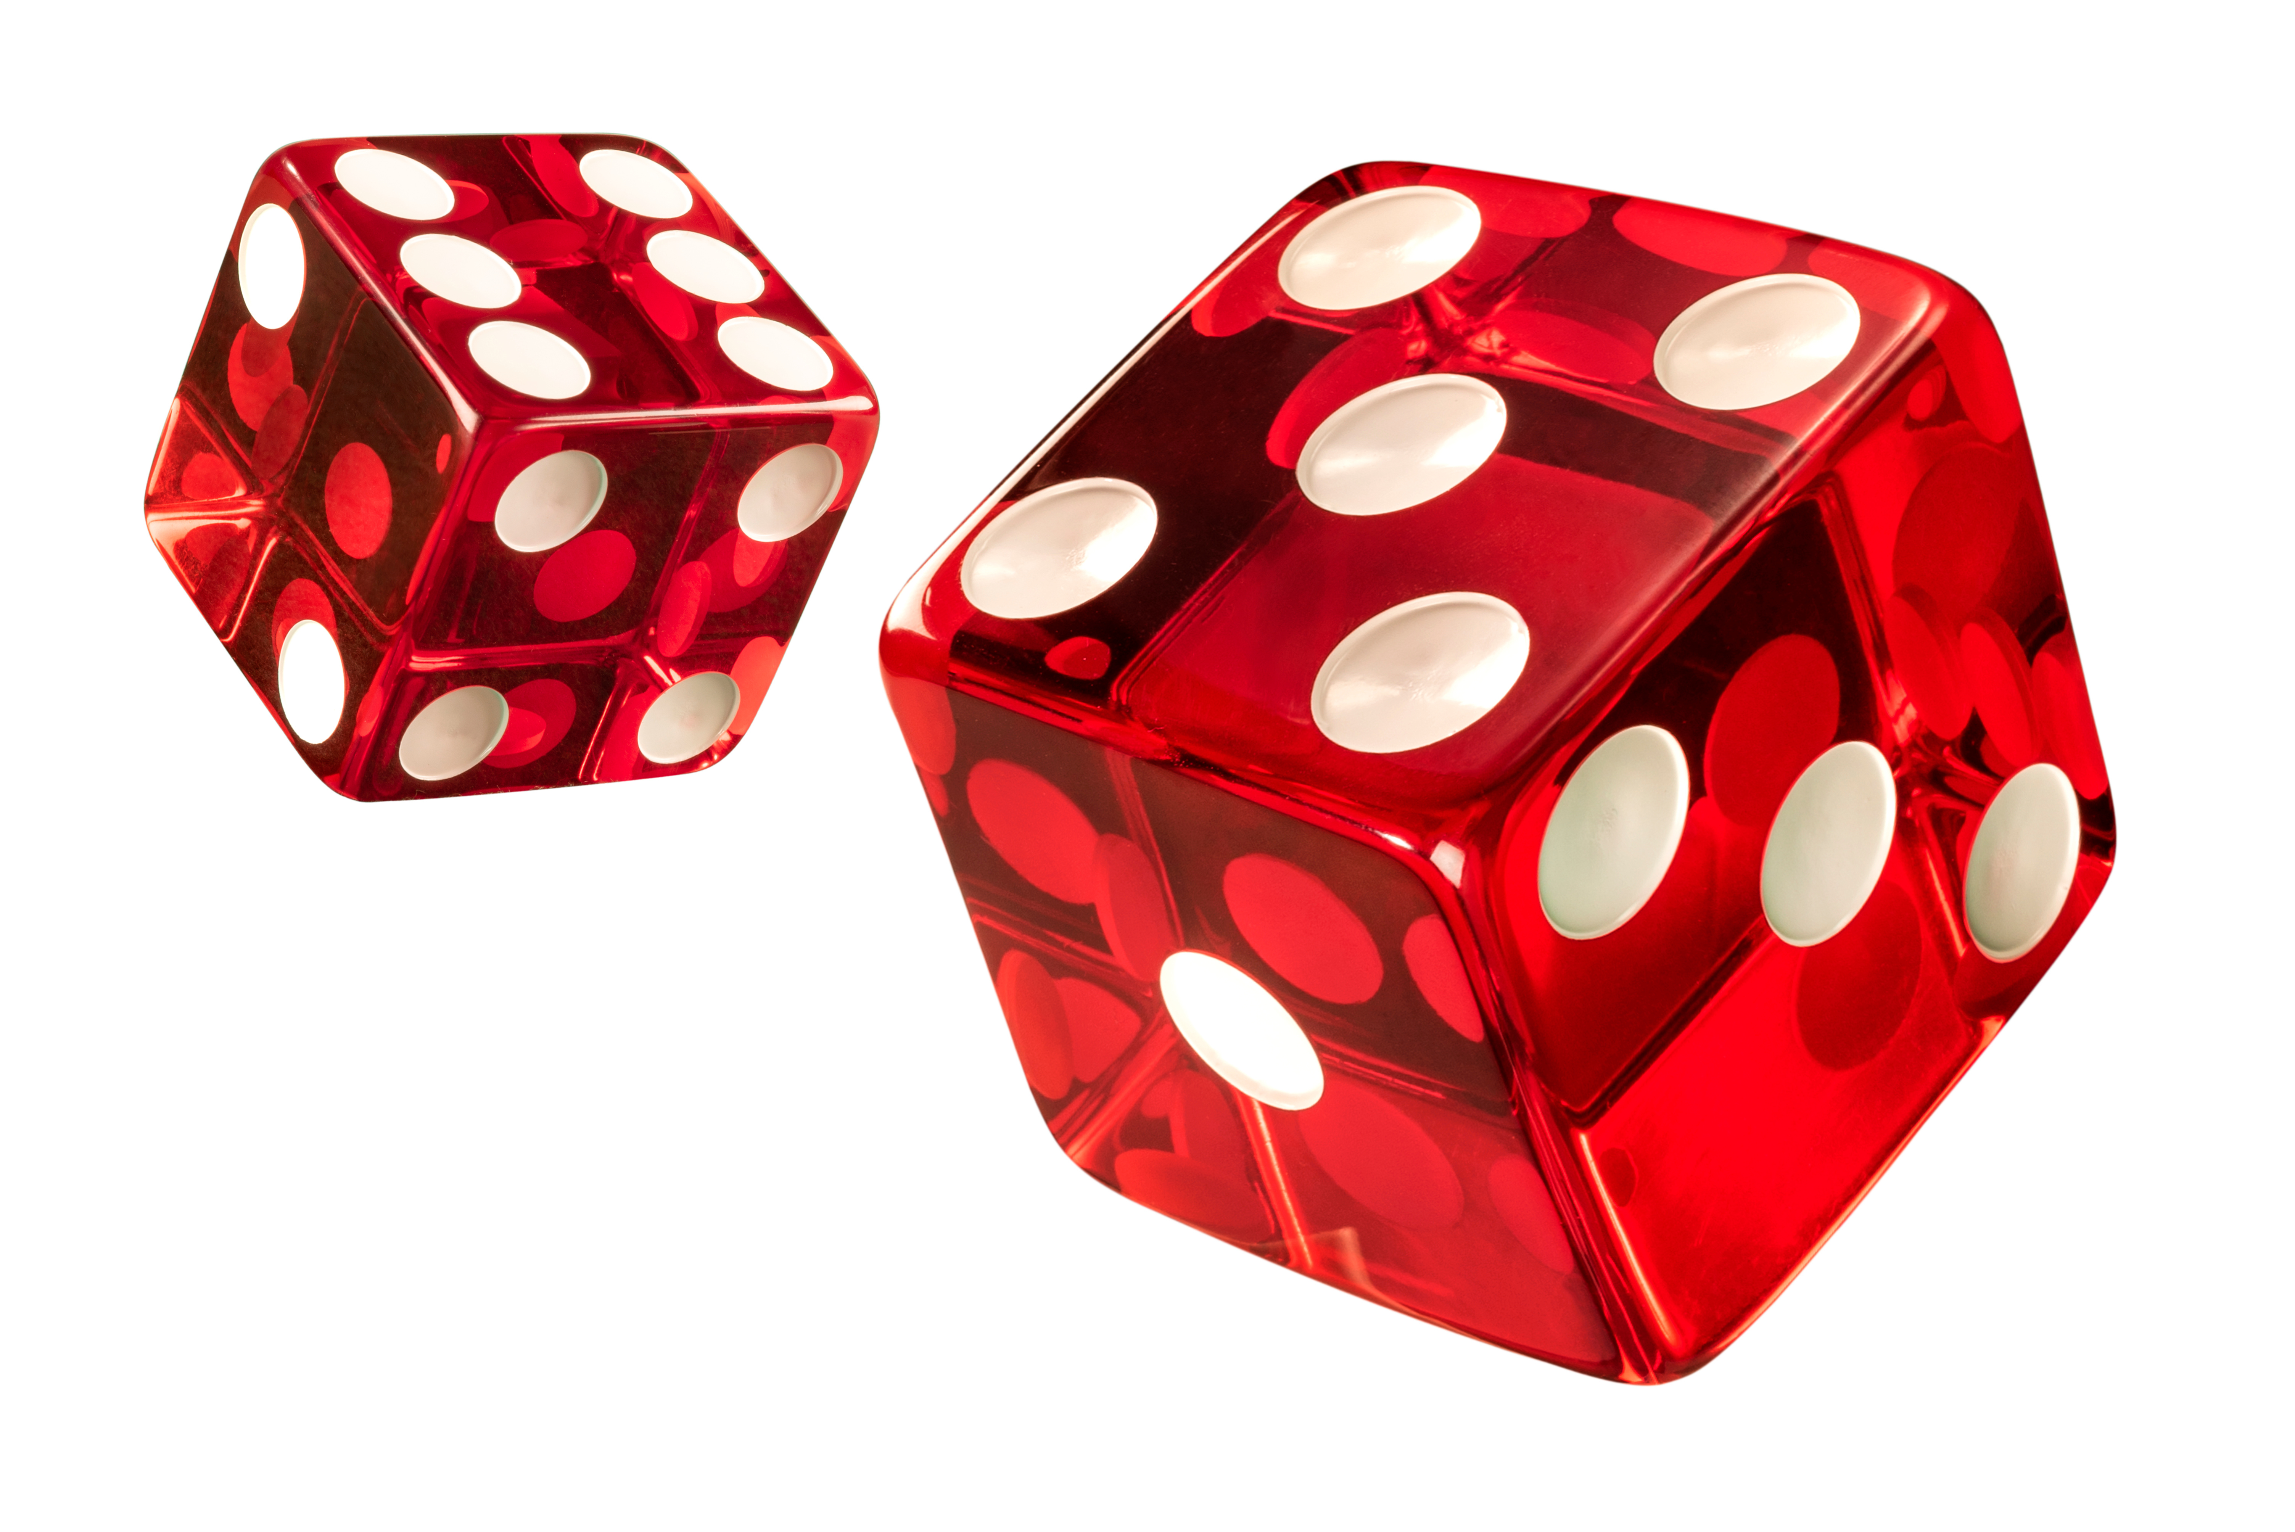

Learn About the Mathematics for College Liberal Arts Standards
The table describes the areas of emphasis within Mathematics for College Liberal Arts and provides examples of specific expectations within each area of emphasis. The purpose of the areas of emphasis is not to provide detailed guidance for specific units of learning and instruction, but rather provide insight on major mathematical topics that will be covered within the mathematics course.
Area of Emphasis | Examples
Analyzing and applying linear and exponential functions within a real-world context. | - Write, solve and graph linear and exponential functions in mathematical and real-world contexts.  - Determine and interpret key features of linear and exponential functions.  - Compare key features of linear and nonlinear functions.  - Compare simple, compound and continuously compounded interest over time.
Utilizing geometric concepts to solve real-world problems. | - Solve problems involving congruence or similarity in two-dimensional figures in mathematical and real-world contexts.  - Determine symmetries of reflection, rotation and translation of geometric figures.  - Solve problems involving volume and surface area of three-dimensional figures in mathematical and real-world contexts.  - Solve problems involving right triangles using trigonometric ratios and the Pythagorean Theorem in mathematical and real-world contexts.
Extending understanding of probability theory. | - Describe events as subsets of a sample space.  - Calculate the conditional probability of two events and interpret the result in terms of its context.  - Interpret the joint and marginal relative frequencies as empirical probabilities and the conditional relative frequencies as empirical conditional probabilities.  - Calculate the appropriate permutation or combination in context.
Representing and interpreting univariate and bivariate data. | - Select an appropriate method to represent data, depending on whether it is numerical or categorical and univariate or bivariate data.  - Interpret distributions in various ways.  - Calculate and compare the appropriate measures of center and measures of variability for two or more sets of numerical univariate data.  - Fit linear and exponential functions to bivariate numerical data that suggests linear and exponential associations.
Developing understanding of logic and set theory. | - Determine truth values of simple and compound statements using truth tables.  - Identify and accurately interpret if-then, if and only if, all and not statements.  - Perform set operations of taking the complement of a set and the union, intersection, difference and product of two sets.  - Determine whether two sets are equivalent and whether one set is a subset of another.

B.E.S.T. Instructional Guide for Mathematics
The B.E.S.T. Instructional Guide for Mathematics (B1G-M) is intended to assist educators with planning for student learning and instruction aligned to Florida’s Benchmarks for Excellent Student Thinking (B.E.S.T.) Standards. This guide is designed to aid high-quality instruction through the identification of components that support the learning and teaching of the B.E.S.T. Mathematics Standards and Benchmarks. The B1G-M can be utilized by parents, guardians and families to support learning at home through the Instructional Strategies section.

This document is posted on the B.E.S.T. Standards for Mathematics webpage of the Florida Department of Education’s website and will continue to undergo edits as needed.

Mathematical Words to Know and Use in Mathematics for College Liberal Arts
Bar graph | Cylinder | Hypotenuse | Numerical data | Rotation | Stem-and-leaf plot
Bivariate data | Domain | Interquartile range | Outlier | Sample space | Theoretical probability
Box plot | Equation | Isosceles triangle | Population | Scale factor | Translation
Categorical data | Event | Joint frequency | Prism | Scale model | Trapezoid
Circle | Experimental probability | Joint relative frequency | Pyramid | Scatterplot | Triangle
Circle graph | Exponential function | Line of fit | Quadratic function | Similarity | $x$-intercept
Conditional relative frequency | Frequency table | Line plot | Rate of change | Simple interest | $y$-intercept
Cone | Function notation | Measures of center | Reflection | Sphere
Congruent | Histogram | Measures of variability | Right triangle | Square
Definitions for these terms can be found in the glossary of the standards book accessed at 6-12 Mathematics Glossary.

Support Learning at Home
You can encourage learning mathematics at home in ways that are fun for you and your student. Try these ideas after school, on weekends and during the summer:
- Help your student choose the best option for saving money. Research the different types of savings accounts and ways to save money. Discuss the appropriate time for your student to withdraw the money from their account.
- Help your student practice finding the converse, inverse and contrapositive of statements and their validity by providing students with conditional statements in real time. For example, if you give the conditional statement “If your chores are done, then you can go to the football game,” your student would then give you the converse, “If you go to the football game, then your chores are done,” the inverse, “If your chores are not done, then you cannot go to the football game,” and the contrapositive, “If you cannot go to the football game, then your chores are not done.”
- Give your student a canned good and a ruler and ask them to find the volume of it.
- Have your child practice inputting the parent functions below in a graphing utility, handheld or online.
Linear $f(x) = x$ | Exponential (decay) $f(x) = {\left(\frac{1}{2}\right)}^{x}$ | Exponential (growth) $f(x) = 2^{x}$
- Have your student choose two events that they believe are related, for example, drinking lots of water and hot weather. Help them determine if there is a correlation and causation between the two events.
- Have your student check the weather forecast and tell them to determine the likelihood of it both raining and lightning based on the independent chances of each event.

Talk with Your Student’s Teacher
Remember, you are your student’s first teacher. Think about a parent-teacher conference as a “team meeting” in which you will discover the special contributions each of you bring to your student’s success. Here are some questions you could ask to prompt discussions:

Which skills or topics is my student working on? Which have they mastered? How can I support them at home?

In the area of mathematics, what are my student’s strengths? How are those strengths supported during instruction? Where is my student struggling and how can I help?

Can my student show you that they understand what they are learning about through manipulatives, drawing, talking and writing? If not, what challenges are they facing?

What topics in connection to science and social studies is my student learning about through mathematics?

What behaviors should I see when my student is doing mathematics? Can I see an example of the type of problems my student is given? How can I support them at home?

Mathematical Thinking and Reasoning Standards (MTRs)
Florida students are expected to engage with mathematics through the Mathematical Thinking and Reasoning Standards (MTRs). These standards are written in clear language so all stakeholders can understand them and teachers can assist students to use them as self-monitoring tools. The MTRs promote deeper learning and understanding of mathematics. By understanding the MTRs, parents, guardians and families can support the development of these skills at home.

MA.K12.MTR.1.1  Actively participate in effortful learning both individually and collectively. |  | MA.K12.MTR.2.1  Demonstrate understanding by representing problems in multiple ways.
MA.K12.MTR.3.1  Complete tasks with mathematical fluency. |  | MA.K12.MTR.4.1  Engage in discussions that reflect on the mathematical thinking of self and others.
MA.K12.MTR.5.1  Use patterns and structure to connect mathematical concepts. | MA.K12.MTR.6.1  Assess the reasonableness of solutions. |  | MA.K12.MTR.7.1  Apply mathematics to real-world contexts.

Your student will develop the above skills (MTRs) throughout their education and during their life. These skills will help maintain positive relationships through effective communication, collaboration, conflict resolution and problem solving.

Below are some ways you can help develop mathematical thinking and reasoning skills for your mathematics student:
- Encourage your student to ask questions when they do not understand what is being asked of them.
- Ask your student to estimate before determining a solution to the task at hand.
- Identify a problem and create a plan to tackle it in smaller steps that are more manageable.
- Try activities like a scavenger hunt or a puzzle.

By helping to develop your student’s mathematical thinking and reasoning skills, you will prepare them to become a confident, independent and successful individual.

