Grade 8 B.E.S.T. Instructional Guide for Mathematics

The B.E.S.T. Instructional Guide for Mathematics (B1G-M) is intended to assist educators with planning for student learning and instruction aligned to Florida’s Benchmarks for Excellent Student Thinking (B.E.S.T.) Standards. This guide is designed to aid high-quality instruction through the identification of components that support the learning and teaching of the B.E.S.T. Mathematics Standards and Benchmarks. The B1G-M includes an analysis of information related to the B.E.S.T. Standards for Mathematics within this specific mathematics course, the instructional emphasis and aligned resources. This document is posted on the B.E.S.T. Standards for Mathematics webpage of the Florida Department of Education’s website and will continue to undergo edits as needed.

Structural Framework and Intentional Design of the B.E.S.T. Standards for Mathematics

Florida’s B.E.S.T. Standards for Mathematics were built on the following.

- The coding scheme for the standards and benchmarks was changed to be consistent with other content areas. The new coding scheme is structured as follows:
Content.GradeLevel.Strand.Standard.Benchmark.
- Strands were streamlined to be more consistent throughout.
- The standards and benchmarks were written to be clear and concise to ensure that they are easily understood by all stakeholders.
- The benchmarks were written to allow teachers to meet students’ individual skills, knowledge and ability.
- The benchmarks were written to allow students the flexibility to solve problems using a method or strategy that is accurate, generalizable and efficient depending on the content (i.e., the numbers, expressions or equations).
- The benchmarks were written to allow for student discovery (i.e., exploring) of strategies rather than the teaching, naming and assessing of each strategy individually.
- The benchmarks were written to support multiple pathways for success in career and college for students.
- The benchmarks should not be taught in isolation but should be combined purposefully.
- The benchmarks may be addressed at multiple points throughout the year, with the intention of gaining mastery by the end of the year.
- Appropriate progression of content within and across strands was developed for each grade level and across grade levels.
- There is an intentional balance of conceptual understanding and procedural fluency with the application of accurate real-world context intertwined within mathematical concepts for relevance.
- The use of other content areas, like science and the arts, within real-world problems should be accurate, relevant, authentic and reflect grade-level appropriateness.

Components of the B.E.S.T. Instructional Guide for Mathematics

The following table is an example of the layout for each benchmark and includes the defining attributes for each component. It is important to note that instruction should not be limited to the possible connecting benchmarks, related terms, strategies or examples provided. To do so would strip the intention of an educator meeting students’ individual skills, knowledge and abilities.

Benchmark
focal point for instruction within lesson or task
This section includes the benchmark as identified in the B.E.S.T. Standards for Mathematics. The benchmark, also referred to as the Benchmark of Focus, is the focal point for student learning and instruction. The benchmark, and its related example(s) and clarification(s), can also be found in the course description. The 9-12 benchmarks may be included in multiple courses; select the example(s) or clarification(s) as appropriate for the identified course.

Connecting Benchmarks/Horizontal Alignment
in other standards within the grade level or course
This section includes a list of connecting benchmarks that relate horizontally to the Benchmark of Focus. Horizontal alignment is the intentional progression of content within a grade level or course linking skills within and across strands. Connecting benchmarks are benchmarks that either make a mathematical connection or include prerequisite skills. The information included in this section is not a comprehensive list, and educators are encouraged to find other connecting benchmarks. Additionally, this list will not include benchmarks from the same standard since benchmarks within the same standard already have an inherent connection.

Terms from the K-12 Glossary
This section includes terms from Appendix C: K-12 Glossary, found within the B.E.S.T. Standards for Mathematics document, which are relevant to the identified Benchmark of Focus. The terms included in this section should not be viewed as a comprehensive vocabulary list, but instead should be considered during instruction or act as a reference for educators.

Vertical Alignment
across grade levels or courses
This section includes a list of related benchmarks that connect vertically to the Benchmark of Focus. Vertical alignment is the intentional progression of content from one year to the next, spanning across multiple grade levels. Benchmarks listed in this section make mathematical connections from prior grade levels or courses in future grade levels or courses within and across strands. If the Benchmark of Focus is a new concept or skill, it may not have any previous benchmarks listed. Likewise, if the Benchmark of Focus is a mathematical skill or concept that is finalized in learning and does not have any direct connection to future grade levels or courses, it may not have any future benchmarks listed. The information included in this section is not a comprehensive list, and educators are encouraged to find other benchmarks within a vertical progression.

Purpose and Instructional Strategies
This section includes further narrative for instruction of the benchmark and vertical alignment. Additionally, this section may also include the following:
- explanations and details for the benchmark;
- vocabulary not provided within Appendix C;
- possible instructional strategies and teaching methods; and
- strategies to embed potentially related Mathematical Thinking and Reasoning Standards (MTRs).

Common Misconceptions or Errors
This section will include common student misconceptions or errors and may include strategies to address the identified misconception or error. Recognition of these misconceptions and errors enables educators to identify them in the classroom and make efforts to correct the misconception or error. This corrective effort in the classroom can also be a form of formative assessment within instruction.

Strategies to Support Tiered Instruction
The instructional strategies in this section address the common misconceptions and errors listed within the above section that can be a barrier to successfully learning the benchmark. All instruction and intervention at Tiers 2 and 3 are intended to support students to be successful with Tier 1 instruction. Strategies that support tiered instruction are intended to assist teachers in planning across any tier of support and should not be considered exclusive or inclusive of other instructional strategies that may support student learning with the B.E.S.T. Mathematics Standards. For more information about tiered instruction, please see the Effective Tiered Instruction for Mathematics: ALL Means ALL document.

Instructional Tasks
demonstrate the depth of the benchmark and the connection to the related benchmarks
This section will include example instructional tasks, which may be open-ended and are intended to demonstrate the depth of the benchmark. Some instructional tasks include integration of the Mathematical Thinking and Reasoning Standards (MTRs) and related benchmark(s). Enrichment tasks may be included to make connections to benchmarks in later grade levels or courses. Tasks may require extended time, additional materials and collaboration.

Instructional Items
demonstrate the focus of the benchmark
This section will include example instructional items which may be used as evidence to demonstrate the students’ understanding of the benchmark. Items may highlight one or more parts of the benchmark.
*The strategies, tasks and items included in the B1G-M are examples and should not be considered comprehensive.

Mathematical Thinking and Reasoning Standards
MTRs: Because Math Matters

Florida students are expected to engage with mathematics through the Mathematical Thinking and Reasoning Standards (MTRs) by utilizing their language as a self-monitoring tool in the classroom, promoting deeper learning and understanding of mathematics. The MTRs are standards which should be used as a lens when planning for student learning and instruction of the B.E.S.T. Standards for Mathematics.

Structural Framework and Intentional Design of the Mathematical Thinking and Reasoning Standards

The Mathematical Thinking and Reasoning Standards (MTRs) are built on the following.

- The MTRs have the same coding scheme as the standards and benchmarks; however, they are written at the standard level because there are no benchmarks.
- In order to fulfill Florida’s unique coding scheme, the 5th place (benchmark) will always be a “1” for the MTRs.
- The B.E.S.T. Standards for Mathematics should be taught through the lens of the MTRs.
- At least one of the MTRs should be authentically and appropriately embedded throughout every lesson based on the expectation of the benchmark(s).
- The bulleted language of the MTRs were written for students to use as self-monitoring tools during daily instruction.
- The clarifications of the MTRs were written for teachers to use as a guide to inform their instructional practices.
- The MTRs ensure that students stay engaged, persevere in tasks, share their thinking, balance conceptual understanding and procedures, assess their solutions, make connections to previous learning and extended knowledge, and apply mathematical concepts to real-world applications.
- The MTRs should not stand alone as a separate focus for instruction but should be combined purposefully.
- The MTRs will be addressed at multiple points throughout the year, with the intention of gaining mastery of mathematical skills by the end of the year and building upon these skills as they continue in their K-12 education.

MA.K12.MTR.1.1 Actively participate in effortful learning both individually and collectively.
Mathematicians who participate in effortful learning both individually and with others:
- Analyze the problem in a way that makes sense given the task.
- Ask questions that will help with solving the task.
- Build perseverance by modifying methods as needed while solving a challenging task.
- Stay engaged and maintain a positive mindset when working to solve tasks.
- Help and support each other when attempting a new method or approach.

Clarifications:
Teachers who encourage students to participate actively in effortful learning both individually and with others:
- Cultivate a community of growth mindset learners.
- Foster perseverance in students by choosing tasks that are challenging.
- Develop students’ ability to analyze and problem solve.
- Recognize students’ effort when solving challenging problems.

MA.K12.MTR.2.1 Demonstrate understanding by representing problems in multiple ways.
Mathematicians who demonstrate understanding by representing problems in multiple ways:
- Build understanding through modeling and using manipulatives.
- Represent solutions to problems in multiple ways using objects, drawings, tables, graphs and equations.
- Progress from modeling problems with objects and drawings to using algorithms and equations.
- Express connections between concepts and representations.
- Choose a representation based on the given context or purpose.

Clarifications:
Teachers who encourage students to demonstrate understanding by representing problems in multiple ways:
- Help students make connections between concepts and representations.
- Provide opportunities for students to use manipulatives when investigating concepts.
- Guide students from concrete to pictorial to abstract representations as understanding progresses.
- Show students that various representations can have different purposes and can be useful in different situations.

MA.K12.MTR. 3.1 Complete tasks with mathematical fluency.
Mathematicians who complete tasks with mathematical fluency:
- Select efficient and appropriate methods for solving problems within the given context.
- Maintain flexibility and accuracy while performing procedures and mental calculations.
- Complete tasks accurately and with confidence.
- Adapt procedures to apply them to a new context.
- Use feedback to improve efficiency when performing calculations.

Clarifications:
Teachers who encourage students to complete tasks with mathematical fluency:
- Provide students with the flexibility to solve problems by selecting a procedure that allows them to solve efficiently and accurately.
- Offer multiple opportunities for students to practice efficient and generalizable methods.
- Provide opportunities for students to reflect on the method they used and determine if a more efficient method could have been used.

MA.K12.MTR.4.1 Engage in discussions that reflect on the mathematical thinking of self and others.
Mathematicians who engage in discussions that reflect on the mathematical thinking of self and others:
- Communicate mathematical ideas, vocabulary and methods effectively.
- Analyze the mathematical thinking of others.
- Compare the efficiency of a method to those expressed by others.
- Recognize errors and suggest how to correctly solve the task.
- Justify results by explaining methods and processes.
- Construct possible arguments based on evidence.

Clarifications:
Teachers who encourage students to engage in discussions that reflect on the mathematical thinking of self and others:
- Establish a culture in which students ask questions of the teacher and their peers, and error is an opportunity for learning.
- Create opportunities for students to discuss their thinking with peers.
- Select, sequence and present student work to advance and deepen understanding of correct and increasingly efficient methods.
- Develop students’ ability to justify methods and compare their responses to the responses of their peers.

MA.K12.MTR.5.1 Use patterns and structure to help understand and connect mathematical concepts.
Mathematicians who use patterns and structure to help understand and connect mathematical concepts:
- Focus on relevant details within a problem.
- Create plans and procedures to logically order events, steps or ideas to solve problems.
- Decompose a complex problem into manageable parts.
- Relate previously learned concepts to new concepts.
- Look for similarities among problems.
- Connect solutions of problems to more complicated large-scale situations.

Clarifications:
Teachers who encourage students to use patterns and structure to help understand and connect mathematical concepts:
- Help students recognize the patterns in the world around them and connect these patterns to mathematical concepts.
- Support students to develop generalizations based on the similarities found among problems.
- Provide opportunities for students to create plans and procedures to solve problems.
- Develop students’ ability to construct relationships between their current understanding and more sophisticated ways of thinking.

MA.K12.MTR.6.1 Assess the reasonableness of solutions.
Mathematicians who assess the reasonableness of solutions:
- Estimate to discover possible solutions.
- Use benchmark quantities to determine if a solution makes sense.
- Check calculations when solving problems.
- Verify possible solutions by explaining the methods used.
- Evaluate results based on the given context.

Clarifications:
Teachers who encourage students to assess the reasonableness of solutions:
- Have students estimate or predict solutions prior to solving.
- Prompt students to continually ask, “Does this solution make sense? How do you know?”
- Reinforce that students check their work as they progress within and after a task.
- Strengthen students’ ability to verify solutions through justifications.

MA.K12.MTR.7.1 Apply mathematics to real-world contexts.
Mathematicians who apply mathematics to real-world contexts:
- Connect mathematical concepts to everyday experiences.
- Use models and methods to understand, represent and solve problems.
- Perform investigations to gather data or determine if a method is appropriate.
- Redesign models and methods to improve accuracy or efficiency.

Clarifications:
Teachers who encourage students to apply mathematics to real-world contexts:
- Provide opportunities for students to create models, both concrete and abstract, and perform investigations.
- Challenge students to question the accuracy of their models and methods.
- Support students as they validate conclusions by comparing them to the given situation.
- Indicate how various concepts can be applied to other disciplines.

Examples of Teacher and Student Moves for the MTRs

Below are examples that demonstrate the embedding of the MTRs within the mathematics classroom. The provided teacher and student moves are examples of how some MTRs could be incorporated into student learning and instruction. The information included in this table is not a comprehensive list, and educators are encouraged to incorporate other teacher and student moves that support the MTRs.

MTR | Student Moves | Teacher Moves
MA.K12.MTR.1.1  Actively participate in effortful learning both individually and collectively. | - Students engage in the task through individual analysis, student-to-teacher interaction and student-to-student interaction.  - Students ask task-appropriate questions to self, the teacher and to other students. (MTR.4.1)  - Students have a positive productive struggle exhibiting growth mindset, even when making a mistake.  - Students stay engaged in the task to a purposeful conclusion while modifying methods, when necessary, in solving a problem through self-analysis and perseverance. | - Teacher provides flexible options (i.e., differentiated, challenging tasks that allow students to actively pursue a solution both individually and in groups) so that all students have the opportunity to access and engage with instruction, as well as demonstrate their learning.  - Teacher creates a physical environment that supports a growth mindset and will ensure positive student engagement and collaboration.  - Teacher provides constructive, encouraging feedback to students that recognizes their efforts and the value of analysis and revision.  - Teacher provides appropriate time for student processing, productive struggle and reflection.  - Teacher uses data and questions to focus students on their thinking; help students determine their sources of struggle and to build understanding.  - Teacher encourages students to ask appropriate questions of other students and of the teacher including questions that examine accuracy. (MTR.4.1)
MA.K12.MTR.2.1  Demonstrate understanding by representing problems in multiple ways. | - Students represent problems concretely using objects, models and manipulatives.  - Students represent problems pictorially using drawings, models, tables and graphs.  - Students represent problems abstractly using numerical or algebraic expressions and equations.  - Students make connections and select among different representations and methods for the same problem, as appropriate to different situations or context. (MTR.3.1) | - Teacher provides students with objects, models, manipulatives, appropriate technology and real-world situations. (MTR.7.1)  - Teacher encourages students to use drawings, models, tables, expressions, equations and graphs to represent problems and solutions.  - Teacher questions students about making connections between different representations and methods and challenges students to choose one that is most appropriate to the context. (MTR.3.1)  - Teacher encourages students to explain their different representations and methods to each other. (MTR.4.1)  - Teacher provides opportunities for students to choose appropriate methods and to use mathematical technology.
MA.K12.MTR.3.1  Complete tasks with mathematical fluency. | - Students complete tasks with flexibility, efficiency and accuracy.  - Students use feedback from peers and teachers to reflect on and revise methods used.  - Students build confidence through practice in a variety of contexts and problems. (MTR.1.1) | - Teacher provides tasks and opportunities to explore and share different methods to solve problems. (MTR.1.1)  - Teacher provides opportunities for students to choose methods and reflect (i.e., through error analysis, revision, summarizing methods or writing) on the efficiency and accuracy of the method(s) chosen.  - Teacher asks questions and gives feedback to focus student thinking to build efficiency of accurate methods.  - Teacher offers multiple opportunities to practice generalizable methods.
MA.K12.MTR.4.1  Engage in discussions that reflect on the mathematical thinking of self and others. | - Students use content specific language to communicate and justify mathematical ideas and chosen methods.  - Students use discussions and reflections to recognize errors and revise their thinking.  - Students use discussions to analyze the mathematical thinking of others.  - Students identify errors within their own work and then determine possible reasons and potential corrections.  - When working in small groups, students recognize errors of their peers and offers suggestions. | - Teacher provides students with opportunities (through open-ended tasks, questions and class structure) to make sense of their thinking. (MTR.1.1)  - Teacher uses precise mathematical language, both written and abstract, and encourages students to revise their language through discussion.  - Teacher creates opportunities for students to discuss and reflect on their choice of methods, their errors and revisions and their justifications.  - Teachers select, sequence and present student work to elicit discussion about different methods and representations. (MTR.2.1, MTR.3.1)
MA.K12.MTR.5.1 Use patterns and structure to help understand and connect mathematical concepts. | - Students identify relevant details in a problem in order to create plans and decompose problems into manageable parts.  - Students find similarities and common structures, or patterns, between problems in order to solve related and more complex problems using prior knowledge. | - Teacher asks questions to help students construct relationships between familiar and unfamiliar problems and to transfer this relationship to solve other problems. (MTR.1.1)  - Teacher provides students opportunities to connect prior and current understanding to new concepts.  - Teacher provides opportunities for students to discuss and develop generalizations about a mathematical concept. (MTR.3.1, MTR.4.1)  - Teacher allows students to develop an appropriate sequence of steps in solving problems.  - Teacher provides opportunities for students to reflect during problem solving to make connections to problems in other contexts, noticing structure and making improvements to their process.
MA.K12.MTR.6.1 Assess the reasonableness of solutions. | - Students estimate a solution, including using benchmark quantities in place of the original numbers in a problem.  - Students monitor calculations, procedures and intermediate results during the process of solving problems.  - Students verify and check if solutions are viable, or reasonable, within the context or situation. (MTR.7.1)  - Students reflect on the accuracy of their estimations and their solutions. | - Teacher provides opportunities for students to estimate or predict solutions prior to solving.  - Teacher encourages students to compare results to estimations and revise if necessary for future situations. (MTR.5.1)  - Teacher prompts students to self-monitor by continually asking, “Does this solution or intermediate result make sense? How do you know?”  - Teacher encourages students to provide explanations and justifications for results to self and others. (MTR.4.1)
MA.K12.MTR.7.1 Apply mathematics to real-world contexts. | - Students connect mathematical concepts to everyday experiences.  - Students use mathematical models and methods to understand, represent and solve real-world problems.  - Students investigate, research and gather data to determine if a mathematical model is appropriate for a given situation from the world around them.  - Students re-design models and methods to improve accuracy or efficiency. | - Teacher provides real-world context to help students build understanding of abstract mathematical ideas.  - Teacher encourages students to assess the validity and accuracy of mathematical models and situations in real-world context, and to revise those models if necessary.  - Teacher provides opportunities for students to investigate, research and gather data to determine if a mathematical model is appropriate for a given situation from the world around them.  - Teacher provides opportunities for students to apply concepts to other content areas.

Grade 8 Areas of Emphasis

In Grade 8, instructional time will emphasize six areas:

- representing numbers in scientific notation and extending the set of numbers to the system of real numbers, which includes irrational numbers;
- generate equivalent numeric and algebraic expressions including using the Laws of Exponents;
- creating and reasoning about linear relationships including modeling an association in bivariate data with a linear equation;
- solving linear equations, inequalities and systems of linear equations;
- developing an understanding of the concept of a function and
- analyzing two-dimensional figures, particularly triangles, using distance, angle and applying the Pythagorean Theorem.

The purpose of the areas of emphasis is not to guide specific units of learning and instruction, but rather provide insight on major mathematical topics that will be covered within this mathematics course. In addition to its purpose, the areas of emphasis are built on the following:
- Supports the intentional horizontal progression within the strands and across the strands in this grade level or course.
- Student learning and instruction should not focus on the stated areas of emphasis as individual units.
- Areas of emphasis are addressed within standards and benchmarks throughout the course so that students are making connections throughout the school year.
- Some benchmarks can be organized within more than one area.
- Supports the communication of the major mathematical topics to all stakeholders.
- Benchmarks within the areas of emphasis should not be taught within the order in which they appear. To do so would strip the progression of mathematical ideas and miss the opportunity to enhance horizontal progressions within the grade level or course.

The table below shows how the benchmarks within this mathematics course are embedded within the areas of emphasis.

Number Sense and  Operations | Real Number System, Including Scientific Notation | Equivalent Expressions, Including Law of Exponents | Two-variable Linear Relationships, Including Bivariate Data | Solving Equations, Inequalities and Systems | Functions | Two-Dimensional Figures
MA.8.NSO.1.1 | X | X
MA.8.NSO.1.2 | X |  | X |  | X
MA.8.NSO.1.3 |  | X
MA.8.NSO.1.4 | X | X
MA.8.NSO.1.5 | X | X
MA.8.NSO.1.6 | X | X
MA.8.NSO.1.7 | X | X | X | X |  | X

Algebraic Reasoning | Real Number System, Including Scientific Notation | Equivalent Expressions, Including Law of Exponents | Two-variable Linear Relationships, Including Bivariate Data | Solving Equations, Inequalities and Systems | Functions | Two-Dimensional Figures
MA.8.AR.1.1 |  | X
MA.8.AR.1.2 |  | X
MA.8.AR.1.3 |  | X
MA.8.AR.2.1 |  |  |  | X |  | X
MA.8.AR.2.2 |  |  |  | X |  | X
MA.8.AR.2.3 | X |  |  | X |  | X
MA.8.AR.3.1 |  |  | X |  | X
MA.8.AR.3.2 |  |  | X |  | X
MA.8.AR.3.3 |  |  | X |  | X
MA.8.AR.3.4 |  |  | X |  | X
MA.8.AR.3.5 |  |  | X |  | X
MA.8.AR.4.1 |  |  | X | X | X
MA.8.AR.4.2 |  |  | X | X
MA.8.AR.4.3 |  |  | X | X

Functions | Real Number System, Including Scientific Notation | Equivalent Expressions, Including Law of Exponents | Two-variable Linear Relationships, Including Bivariate Data | Solving Equations, Inequalities and Systems | Functions | Two-Dimensional Figures
MA.8.F.1.1 |  |  |  |  | X
MA.8.F.1.2 |  |  | X |  | X
MA.8.F.1.3 |  |  | X |  | X

Geometric Reasoning | Real Number System, Including Scientific Notation | Equivalent Expressions, Including Law of Exponents | Two-variable Linear Relationships, Including Bivariate Data | Solving Equations, Inequalities and Systems | Functions | Two-Dimensional Figures
MA.8.GR.1.1 | X |  |  | X |  | X
MA.8.GR.1.2 | X |  |  | X |  | X
MA.8.GR.1.3 | X |  |  | X |  | X
MA.8.GR.1.4 |  |  |  | X |  | X
MA.8.GR.1.5 |  |  |  | X |  | X
MA.8.GR.1.6 |  |  |  | X |  | X
MA.8.GR.2.1 |  |  |  |  |  | X
MA.8.GR.2.2 |  |  |  |  |  | X
MA.8.GR.2.3 |  |  |  |  |  | X
MA.8.GR.2.4 |  |  |  |  |  | X

Data Analysis & Probability | Real Number System, Including Scientific Notation | Equivalent Expressions, Including Law of Exponents | Two-variable Linear Relationships, Including Bivariate Data | Solving Equations, Inequalities and Systems | Functions | Two-Dimensional Figures
MA.8.DP.1.1 |  |  | X |  | X
MA.8.DP.1.2 |  |  | X
MA.8.DP.1.3 |  |  | X
MA.8.DP.2.1 | X
MA.8.DP.2.2 | X
MA.8.DP.2.3 | X

Number Sense and Operations

MA.8.NSO.1 Solve problems involving rational numbers, including numbers in scientific notation, and extend the understanding of rational numbers to irrational numbers.

MA.8.NSO.1.1

Benchmark
MA.8.NSO.1.1 Extend previous understanding of rational numbers to define irrational numbers within the real number system. Locate an approximate value of a numerical expression involving irrational numbers on a number line.
Example: Within the expression $1+\sqrt{30}$, the irrational number $\sqrt{30}$ can be estimated to be
between $5$ and $6$ because $30$ is between $25$ and $36$. By considering ${\left(5.4\right)}^{2}$ and ${(5.5)}^{2}$,
a closer approximation for $\sqrt{30}$ is $5.5$. So, the expression $1+\sqrt{30}$ is equivalent to
about $6.5$.

Benchmark Clarifications:
Clarification 1: Instruction includes the use of number line and rational number approximations, and recognizing pi (π) as an irrational number.
Clarification 2: Within this benchmark, the expectation is to approximate numerical expressions involving one arithmetic operation and estimating square roots or pi (π).

Connecting Benchmarks/Horizontal Alignment
- MA.8.AR.2.3
- MA.8.GR.1.1, MA.8.GR.1.2

Terms from the K-12 Glossary
- Expression
- Irrational Numbers
- Number Line
- Pi
- Rational Numbers
- Real Numbers

Vertical Alignment
Previous Benchmarks  - MA.7.NSO.1.2 | Next Benchmarks  - MA.912.AR.3.1
Purpose and Instructional Strategies
In grade 7, students expressed rational numbers using terminating and repeating decimals. In grade 8, students define irrational numbers and determine their approximate location on a number line. In Algebra 1, students will expand their knowledge of the real number system to understand that complex numbers exist from their work with quadratics.
- Instruction includes using and creating a graphic organizer to show the relationship between the subsets of the real number system.
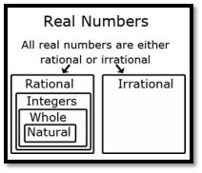
- Once students understand that (1) every rational number has a decimal representation that either terminates or repeats, and (2) every terminating or repeating decimal is a rational number, they can reason that on the number line, irrational numbers must have decimal representations that neither terminate nor repeat.
- Students sometimes overgeneralize that all square roots are rational numbers concluding that irrational numbers are unusual and rare. Instruction includes a variety of examples of irrational numbers. Irrational numbers are much more plentiful than rational numbers, in the sense that they are denser in the real number line.
- Instruction includes the understanding that the square root of a whole number is either another whole number or is irrational. When the result is another whole number, the original whole number is a perfect square. This fact is particularly relevant when the Pythagorean Theorem is applied to find a missing side length of a triangle whose other two side lengths are whole numbers.
- Instruction includes the understanding that the cube root of a whole number is either another whole number or is irrational. When the result is another whole number, the original whole number is a perfect cube.
- Instruction includes the understanding that adding or subtracting a rational number and an irrational number produces an irrational number. The same is true of multiplication or division unless the rational number is 0.
- Students should develop estimating skills when working with square roots without the use of a calculator. One strategy is to use benchmark square roots to determine an approximate value.
  - For example, to find an approximation of $\sqrt{28}$, first determine the perfect squares $28$ is between, which would be $25$ and $36$. The square roots of $25$ and $36$ are $5$ and $6$, respectively, so we know that $\sqrt{28}$ is between $5$ and $6$. Since $28$ is closer to $25$, an estimate of the square root would be closer to $5$.

Common Misconceptions or Errors
- Students may incorrectly believe that pi $(π)$ is a rational number since they have only been introduced to a decimal approximation and a fraction approximation. To address this misconception, instruction includes looking further at the decimal representation of pi $(π)$ so that students will notice that a pattern will not emerge. In fact, a pattern never emerges, therefore, pi is irrational.
- Students may incorrectly think that the number line only has the numbers that are labeled.
- Students may incorrectly think a numerical expression that includes addition or subtraction cannot be placed on a number line.
  - For example, $2+\sqrt{3}$ can be placed on a number line at approximately $3.73$.

Strategies to Support Tiered Instruction
- Teacher provides opportunities to look at the decimal representation of pi ($π$) and comparing decimal representations of rational numbers and irrational numbers.
- Teachers provide opportunities for practice with performing decimal expansion of rational and irrational numbers to check for a pattern.
- Teacher models how to estimate a numerical expression with addition or subtraction and locates a place on the number line.
  - For example, show a representation of pi ($π$) and compare it to a decimal representation of $\frac{22}{7}$. Students should identify that $\frac{1}{3}$ is a rational number and repeats $0.3333$, and that $\frac{22}{7}$ is pi ($π=3.1415$…) and does not repeat.
  - For example, a first approximation of $3+\sqrt{5}$, students could approximate $\sqrt{5}$ as 2.25 since 5 is between the perfect squares of 4 and 9, but closer to 4. Therefore $\sqrt{5}$ would be in between 2 and 3, but closer to 2. So, a reasonable guess for $\sqrt{5}$ can be 2.25 and therefore a reasonable estimate for $3+\sqrt{5}$ would be $3+2.25$ which equals 5.25. If more accuracy is required, students should understand that a calculator is needed.
- Instruction includes looking further at the decimal representation of pi $(π)$ so that students will notice that a pattern will not emerge. In fact, a pattern never emerges, therefore, pi is irrational.

Instructional Tasks
Instructional Task 1 (MTR.1.1)
Part A. Provide an example of a rational number and explain how you can determine that it is rational.
Part B. Choose which number(s) below are irrational and explain how you can determine that they are irrational.
- $\sqrt{3}-2$
- $6\sqrt{25}$
- $\sqrt[3]{36}$
- $2π$
- $-4+\sqrt[3]{-216}$

Instructional Task 2 (MTR.4.1)
Part A. Use the number lines below to estimate the value of $\sqrt{8}$. Explain why you put the points where you did.
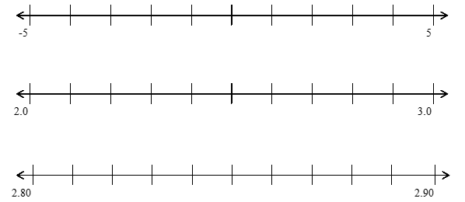

Part B. Plot $1+\sqrt{8}$ on a number line. Explain your process with a partner.

Instructional Items
Instructional Item 1
Plot the following numbers on a number line showing their approximate location to the nearest hundredth.
  - $π-2$
  - $-\left(\frac{1}{2}π\right)$
  - $2\sqrt{2}$
  - $2+\sqrt{17}$

Instructional Item 2
Is 0.12345 a rational or irrational number? Explain your answer.

*The strategies, tasks and items included in the B1G-M are examples and should not be considered comprehensive.

MA.8.NSO.1.2

Benchmark
MA.8.NSO.1.2 Plot, order and compare rational and irrational numbers, represented in various forms.
Benchmark Clarifications:
Clarification 1: Within this benchmark, it is not the expectation to work with the number $e$.
Clarification 2: Within this benchmark, the expectation is to plot, order and compare square roots and cube roots.
Clarification 3: Within this benchmark, the expectation is to use symbols (<, > or =).

Connecting Benchmarks/Horizontal Alignment
- MA.8.GR.1.1, MA.8.GR.1.2

Terms from the K-12 Glossary
- Irrational numbers
- Rational numbers

Vertical Alignment
Previous Benchmarks  - MA.7.NSO.1.2 | Next Benchmarks  - MA.912.NSO.1.4  - MA.912.GR.3.1
Purpose and Instructional Strategies
In grade 7, students expressed rational numbers with terminating and repeating decimals. In grade 8, students define irrational numbers, recognizing and expressing them in various forms, and students compare rational numbers to irrational numbers. In Algebra 1, students will perform operations with radicals. In Geometry, students will extend their understanding of radical approximations to weighted averages on a number line.
- Students should have the opportunity to draw number lines with appropriate scales to plot the numbers to provide an understanding of where the numbers are in relation to numbers that are greater than and less than the number to be plotted.
- Students locate and compare rational and irrational numbers on the number line. Additionally, students understand that the value of a square root or a cube root can be approximated between integers.
  - For example, to find an approximation of $\sqrt{28}$, two methods are described below, each using the nearest perfect squares to the radicand:
    - determine the perfect squares $28$ is between, which would be $25$ and $36$. The square roots of $25$ and $36$ are $5$ and $6$, respectively, so we know that $\sqrt{28}$ is between $5$ and $6$. Since $28$ is closer to $25$, an estimate of the square root would be closer to $5$.
    - since 28 is located $\frac{3}{11}$ of the distance from 25 to 36, the $\sqrt{28}$ is approximately located $\frac{3}{11}$ of the distance from $\sqrt{25}$ to $\sqrt{36}$. So, this reasoning gives the approximation $\sqrt{25}+\frac{3}{11}$, which is about 5.27. This method is particularly relevant when students determine weighted averages on a number line in Geometry.
- Students also recognize that every positive number has both a positive and a negative square root. The negative square root of n is written as $-\sqrt{n}$.
- Instruction includes the use of technology, including a calculator.

Common Misconceptions or Errors
- Students may not understand that square and cube roots can be plotted on a number line.

Strategies to Support Tiered Instruction
- Instruction includes providing students with examples of square and cube roots for them to place on a number line and facilitating a conversation on understanding the value of each square and cube root.
- Teacher provides opportunities to co-create number lines with appropriate scales and plot approximate values of cube roots and square roots.
  - For example, provide partially completed examples of non-perfect square roots and non-perfect cube roots by using perfect square roots and perfect cube roots as benchmark quantities.
- Teacher provides support in recognizing that every positive number has both a positive and negative square root.
  - For example, show examples of how multiplying two negative numbers gives a positive number, and how the square root of a number can be both positive and negative.
- Teacher assists students in writing an inequality to represent written statements.
  - For example:
- Monique has more books than Mary.
- Mark has 5 pencils and Barry has 8.
- Animal Kingdom has at least 100 different species of animals.

Instructional Tasks
Instructional Task 1 (MTR.6.1)
Below are irrational and rational numbers.
$1.\overline{3} π \frac{3}{2} \sqrt{3} 2.356 \sqrt{6} \sqrt{4}$
Part A. Order the numbers from least to greatest by plotting on a number line.
Part B. Identify which numbers are irrational.
Part C. Write an inequality that compares a rational number and an irrational number from the list.

Instructional Items
Instructional Item 1
Plot $-3.42857$… on the number line below and explain how you determined its location.
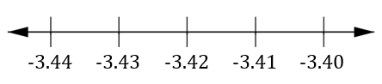

Instructional Item 2
Using the chart below, compare the irrational and rational numbers shown.

Number | Write $<$ or$>$ | Number
$$π^{2}$$ |  | 9
$$\sqrt{50}$$ |  | $$7$$
$$\frac{5}{3}$$ |  | $$\sqrt{8}$$
$$-2π$$ |  | $$-6$$

Instructional Item 3
Plot the following cube roots on a number line $\sqrt[3]{8}$, $\sqrt[3]{10}$ and $\sqrt[3]{27}$.

*The strategies, tasks and items included in the B1G-M are examples and should not be considered comprehensive.

MA.8.NSO.1.3

Benchmark
MA.8.NSO.1.3 Extend previous understanding of the Laws of Exponents to include integer exponents. Apply the Laws of Exponents to evaluate numerical expressions and generate equivalent numerical expressions, limited to integer exponents and rational number bases, with procedural fluency.
Example: The expression $\frac{2^{4}}{2^{7}}$ is equivalent to $2^{-3}$ which is equivalent to $\frac{1}{8}$.

Benchmark Clarifications:
Clarification 1: Refer to the K-12 Formulas (Appendix E) for the Laws of Exponents.

Connecting Benchmarks/Horizontal Alignment
- MA.8.AR.1.1, MA.8.AR.1.2

Terms from the K-12 Glossary
- Exponent
- Expressions
- Integer
- Rational Numbers

Vertical Alignment
Previous Benchmarks  - MA.7.NSO.1.1 | Next Benchmarks  - MA.912.NSO.1.1
Purpose and Instructional Strategies
In grade 7, students were introduced to the Laws of Exponents with numerical expressions. They focused on generating equivalent numerical expressions with whole-number exponents and rational number bases. In grade 8, the learning extends to integer exponents. In Algebra 1, students will extend the Laws of Exponents to include rational exponents.
- Instruction focuses on one law at a time to allow for conceptual understanding instead of just memorizing the rules. Students should be given the opportunity to derive the properties through experience and reasoning. During instruction, include examples that show the expansion of the bases using the exponents to show the equivalence. This strategy allows for moving beyond learning a rule or procedure.
- The expectation for this benchmark includes negative integer exponents but does not include fractional exponents.
- Students should develop and engage in understanding the rules of exponents from exploration. A strategy for developing meaning for integer exponents by making use of patterns is shown below:

Patterns in Exponents
$$5^{5}$$ | $$5∙5∙5∙5∙5$$
$$5^{4}$$ | $$5∙5∙5∙5$$
$$5^{3}$$ | $$5∙5∙5$$
$$5^{2}$$ | $$5∙5$$
$$5^{1}$$ | $$5$$
$$5^{0}$$ | $$1$$
$$5^{-1}$$ | $$\frac{1}{5}$$
$$5^{-2}$$ | $$\frac{1}{5∙5}$$
$$5^{-3}$$ | $$\frac{1}{5∙5∙5}$$
$$5^{-4}$$ | $$\frac{1}{5∙5∙5∙5}$$
$$5^{-5}$$ | $$\frac{1}{5∙5∙5∙5∙5}$$

- Students should develop fluency with and without the use of a calculator when evaluating numerical expressions involving the Laws of Exponents.
- Instruction includes cases where students must work backward as well as cases where the value of a variable must be determined (MTR.3.1). Students should use relational thinking as well as algebraic thinking.

Common Misconceptions or Errors
- When working with negative exponents, students may not understand the connection to fractions and values in the denominator. To address this misconception, use expanded notation to show how to simplify to help support the understanding of exponents and values in the denominator of a fraction.
  - For example, ${\left(\frac{5}{4}\right)}^{-3}$can be rewritten as ${\left({\left(\frac{5}{4}\right)}^{-1}\right)}^{3}$which can be rewritten as ${\left(\frac{1}{\frac{5}{4}}\right)}^{3}$which can be rewritten as ${\left(\frac{4}{5}\right)}^{3}$which can be rewritten as $\left(\frac{4}{5}\right)\left(\frac{4}{5}\right)\left(\frac{4}{5}\right)$ which is equivalent to $\frac{64}{125}$.

Strategies to Support Tiered Instruction
- Instruction includes teacher modeling the use expanded notation to show how to simplify. Have students practice the properties by generating equivalent expressions.
  - For example, $4^{2}×4^{-6}= \frac{1}{4^{4}}$ which equals $\frac{1}{256}$ or $4×4×\frac{1}{4} × \frac{1}{4} ×\frac{1}{4} ×\frac{1}{4} ×\frac{1}{4} ×\frac{1}{4}=\frac{1}{256}$. Help students to discover how $2^{-3}$ becomes a positive exponent in the denominator of a fraction, $\frac{1}{2^{3}}$.
- Instruction includes the use of a conceptual approach as opposed to memorizing the rules of the laws of integer exponents. Provide examples of the processes that lead to the rules for each law, such as the “Patterns in Exponents” table within Instructional Strategies.
- Instruction includes using expanded notation to show how to simplify to help support the understanding of exponents and values in the denominator of a fraction.
  - For example, ${\left(\frac{5}{4}\right)}^{-3}$ can be rewritten as ${\left({\left(\frac{5}{4}\right)}^{-1}\right)}^{3}$, which can be rewritten as ${\left(\frac{1}{\frac{5}{4}}\right)}^{3}$, which can be rewritten as ${\left(\frac{4}{5}\right)}^{3}$, which can be rewritten as $\left(\frac{4}{5}\right)\left(\frac{4}{5}\right)\left(\frac{4}{5}\right)$, which is equivalent to $\frac{64}{125}$.

Instructional Tasks
Instructional Task 1 (MTR.1.1)
Create an example that will show and explain the difference between $-b$ and $b^{-1}$.

Instructional Task 2 (MTR.5.1)
Create a pattern using the expanded form of the base, $4$, between $4^{-5}$and $4^{5}$. Explain why $4^{0}$ is equal to 1.

Instructional Items
Instructional Item 1
What is the value of ${\left(\frac{3^{6}}{3^{-4}}\right)}^{2}?$

Instructional Item 2
What is the value of the expression given below?
$${\left(-\frac{2}{3}\right)}^{-3}{\left(0.8\right)}^{2}$$

Instructional Item 3
Which of the following expressions are equivalent to $\frac{1}{2^{6}}$ ?
- $2^{-5}∙2^{-1}$
- $2^{-2}∙2^{-4}$
- $2^{1}∙2^{5}$
- $2^{1}∙2^{6}$
- $2^{2}∙2^{-8}$
- $2^{2}∙2^{3}$

*The strategies, tasks and items included in the B1G-M are examples and should not be considered comprehensive.

MA.8.NSO.1.4

Benchmark
MA.8.NSO.1.4 Express numbers in scientific notation to represent and approximate very large or very small quantities. Determine how many times larger or smaller one number is compared to a second number.

Example: Roderick is comparing two numbers shown in scientific notation on his calculator. The
first number was displayed as $2.3147E27$and the second number was displayed as
$3.5982E-5$. Roderick determines that the first number is about ${10}^{32}$ times bigger than the second number.

Connecting Benchmarks/Horizontal Alignment
- MA.8.NSO.1.5, MA.8.NSO.1.6

Terms from the K-12 Glossary
- Exponent
- Scientific Notation

Vertical Alignment
Previous Benchmarks  - MA.7.NSO.1.1  - MA.7.NSO.2.1 | Next Benchmarks  - MA.912.GR.4.5
Purpose and Instructional Strategies
In elementary school, students began to explore the place value system by understanding a number’s value is ten times larger than the number to its right and $\frac{1}{10}$ of the number to its left using whole numbers. In grade 7, students developed an understanding of the Laws of Exponents (Appendix E) with numerical expressions. They focused on generating equivalent numerical expressions with whole-number exponents and rational number bases. In grade 8, students use the knowledge of the Laws of Exponents to work with scientific notation. In Geometry, students will solve problems involving density in terms of area and volume which can be represented using scientific notation when the numbers are large. Additionally, students can apply their scientific notation knowledge in science courses.
- Instruction builds students’ number sense with scientific notation. Students should see how representing numbers in a given form allows for students to see the magnitude of the number in an efficient way.
- Instruction connects place value and expanded form with scientific notation. This will allow students to compare very large and very small numbers concisely.

thousands | hundreds | tens | ones |  | tenths | hundredths | thousandths
$${10}^{3}$$ | $${10}^{2}$$ | $${10}^{1}$$ | $${10}^{0}$$ | . | $${10}^{-1}$$ | $${10}^{-2}$$ | $${10}^{-3}$$
3 | 2 | 4 | 0 | . | 0 | 0 | 0
 |  |  | 0 | . | 3 | 2 | 4

Scientific notation for the numbers within the chart would be represented as $3.24×{10}^{3}$and $3.24×{10}^{-1}$respectively.
- Students should use place value knowledge to determine how many times larger a number is compared to another. Students should develop patterns to conclude that if the exponent increases by one, the value increases 10 times, as well as if the exponent decreases by one, the value decreases 10 times.
  - For example, if students are determining how many times bigger $7×{10}^{9}$ is than $3×{10}^{8}$. Students will need to recognize that 7 is approximately 2 times larger than 3, and ${10}^{9}$ is $10$ times greater than ${10}^{8}$. Therefore, to determine how many times greater, a student would reason that $7×{10}^{9}$ is approximately $2×10 (or 20)$ times greater than $3×{10}^{8}$.
- Instruction connects student's understanding of scientific notation to choosing appropriate units of measures.
- When using calculators to represent very large and very small numbers with an exponent indicated as “E”, instruction relates the number following “E” as the power of 10.

Common Misconceptions or Errors
- Students often confuse the meaning of the exponent and the value of the number in scientific notation.
- Some students misrepresent scientific notation by not expressing the number as a product of a power of 10 and a number that is at least 1 and less than 10.
- Students may incorrectly interpret the “E” on a calculator display as an error message.
- Students may interpret the comparison of two numbers in scientific notation incorrectly.
  - For example, if students were asked what is 3 times larger than $3×{10}^{3}$, they may respond with $9×{10}^{9}$ instead of the correct response of $9×{10}^{3}$.
  - For example, if a student determines the first number is ${10}^{4}$ times bigger than the second number, they may incorrectly believe the first number is 4 times as big as the second number instead of 10,000 times bigger.

Strategies to Support Tiered Instruction
- Instruction includes making connections of a number written in standard form to the same number written in scientific notation. Key connections include recognizing the similarities in the first two digits of both numbers and the connections between the place value of the number in standard form and the exponent of the power.
- Teacher provides opportunities for students to utilize calculators and provides instruction on the various calculator notations for scientific notation.
- Instruction includes rewriting whole numbers in scientific notation when finding products or quotients with scientific notation to demonstrate the correct use of operations and laws of exponents.
  - For example, if the student is asked what is five times larger than $2×{10}^{4}$, they should be multiplying $5×2$, and not multiply by the exponent.
- Teacher provides opportunities for students to check their work by rewriting numbers in standard form and applying any necessary operations before comparing their solution to the solution found with the use of a calculator.
- Instruction includes the use of manipulatives such as base 10 blocks to make connections to the purpose of utilizing scientific notation.
  - For example, the teacher could pose the question: “What would be the best way for us to represent 2430 using Base Ten Blocks. We could use 2430 individual Base Ten Unit blocks, or we could use 2- Base Ten Cubes, 4 Base Ten Flats, and 3 Base Ten Rods. Students can then see that it would be easier to represent 2430 using the Cubes, Flats, and Rods as opposed to the large amount of individual Unit blocks. When students see how it would be easier to use the larger blocks to represent the number, the teacher can explain how it is similar to using scientific notation to write out very large or very small numbers. Instead of writing $2873000000000000000$, they can write $2.873×{10}^{18}$.

Instructional Tasks
Instructional Task 1 (MTR.6.1)
The diameter of fishing lines varies. Fishing lines can have a diameter as small as $2×{10}^{-2}$ inch and as large as $6×{10}^{-2}$ inch.
Part A. Which value belongs to the thicker fishing line?
Part B. How many times larger is the thick line compared to the thin line?
Part C. If you want a fishing line whose thickness is in between the two values, what would be a possible thickness for the line you would like to use?

Instructional Items
Instructional Item 1
The distance in kilometers to Proxima Centauri, the closest star to Earth, is 39,900,000,000,000. Estimate the distance in kilometers to Proxima Centauri by writing it in the form of a single digit times an integer power of $10$.

Instructional Item 2
The Bohr radius of a hydrogen atom is $0.0000000000529$. Express the Bohr radius of a hydrogen atom in scientific notation.

Instructional Item 3
The average weight of a blue whale is $4×{10}^{5}$ pounds. The average weight of an elephant is $1×{10}^{4}$ pounds. Approximately how many times heavier is a blue whale than an elephant in pounds?

*The strategies, tasks and items included in the B1G-M are examples and should not be considered comprehensive.

MA.8.NSO.1.5

Benchmark
MA.8.NSO.1.5 Add, subtract, multiply and divide numbers expressed in scientific notation with procedural fluency.
Example: The sum of $2.31×{10}^{15}$ and $9.1×{10}^{13}$ is $2.401×{10}^{15}$.

Benchmark Clarifications:
Clarification 1: Within this benchmark, for addition and subtraction with numbers expressed in scientific notation, exponents are limited to within 2 of each other.

Connecting Benchmarks/Horizontal Alignment
- MA.8.NSO.1.4, MA.8.NSO.1.5, MA.8.NSO.1.6

Terms from the K-12 Glossary
- Scientific Notation

Vertical Alignment
Previous Benchmarks  - MA.7.NSO.1.1  - MA.7.NSO.2.1 | Next Benchmarks  - MA.912.GR.4.5
Purpose and Instructional Strategies
In grade 7, students developed an understanding of the Laws of Exponents (Appendix E) with numerical expressions. They focused on generating equivalent numerical expressions with whole-number exponents and rational number bases. In grade 8, students use the knowledge of Laws of Exponents to work with scientific notation. In Geometry, students will solve problems involving density in terms of area and volume which can be represented using scientific notation when the numbers are large. Additionally, students can apply their scientific notation knowledge in science courses.
- Instruction connects scientific notation work with the Laws of Exponents with integer exponents.
- Instruction includes having students color code or use a highlighter to help keep the numbers together.
  - For example, when multiplying $3.2×{10}^{28}$ and $6.7×{10}^{7}$, students can highlight the 3.2 and 6.7 in one color and the ${10}^{28}$ and ${10}^{7}$ in another color for organizational purposes.
- Students should develop fluency with and without using a calculator when performing operations with numbers expressed in scientific notation.
- It is helpful to include contextual problems to compare numbers written in scientific notation, including cross-curricular examples from science.

Common Misconceptions or Errors
- Some students may incorrectly apply addition and subtraction across a problem.
  - For example, students may miscalculate $(1.3×{10}^{3})+(3.4×{10}^{5})$as $4.7×{10}^{8}.$
- Some students may incorrectly apply multiplication across a problem.
  - For example, students may miscalculate $(2×{10}^{4})(3×{10}^{5})$ as $6×{10}^{20}$.
- Some students may incorrectly represent their final answer, not in scientific notation.
  - For example, students may write $(2×{10}^{4})(6×{10}^{5})$ as $12×{10}^{9}$ instead of $1.2×{10}^{10}$.

Strategies to Support Tiered Instruction
- Instruction includes making connections of a number written in standard form to the same number written in scientific notation. Key connections include recognizing the similarities in the first two digits of both numbers and the connections between the place value of the number in standard form and the exponent of the power.

Instructional Tasks
Instructional Task 1 (MTR.3.1, MTR.6.1)
A collection of meteorites includes three meteorites that weigh $1.1×{10}^{2}$ grams, $6.8×{10}^{2}$ grams, and $8.4×{10}^{-2}$ grams.
Part A. Why would a scientist represent the weights using scientific notation? Are all the meteorites approximately the same size?
Part B. What is the difference between the mass of the heaviest meteorite and the mass of the lightest meteorite? Write your answer in standard notation.

Instructional Items
Instructional Item 1
What is the sum of $7×{10}^{-8}$ and $6×{10}^{-8}$?

Instructional Item 2
Write the expression shown as a number in scientific number.
$$\frac{(8×{10}^{2})(7.5×{10}^{4})}{5×{10}^{2}}$$

*The strategies, tasks and items included in the B1G-M are examples and should not be considered comprehensive.

MA.8.NSO.1.6

Benchmark
MA.8.NSO.1.6 Solve real-world problems involving operations with numbers expressed in scientific notation.
Benchmark Clarifications:
Clarification 1: Instruction includes recognizing the importance of significant digits when physical measurements are involved.
Clarification 2: Within this benchmark, for addition and subtraction with numbers expressed in scientific notation, exponents are limited to within 2 of each other.
Connecting Benchmarks/Horizontal Alignment
- MA.8.NSO.1.4, MA.8.NSO.1.5

Terms from the K-12 Glossary
- Scientific Notation
- Significant Digits

Vertical Alignment
Previous Benchmarks  - MA.7.NSO.1.1  - MA.7.NSO.2.1 | Next Benchmarks  - MA.912.GR.4.5
Purpose and Instructional Strategies
In grade 7, students developed an understanding of Laws of Exponents with numerical expressions. They focused on generating equivalent numerical expressions with whole-number exponents and rational number bases. In grade 8, students use the knowledge of Laws of Exponents to work with scientific notation. In Geometry, students will solve problems involving density in terms of area and volume which can be represented using scientific notation when the numbers are large. Additionally, students can apply their scientific notation knowledge in science courses.
- Instruction includes opportunities to engage in virtual or physical situations to understand the importance of significant digits.
- Instruction includes student understanding of the following aspects:
- zeros at the beginning of a number are never significant,
- zeros at the end of a number are only significant if there is a decimal point and
- zeros in the middle of a number are always significant.
- Students should develop fluency with and without the use of a calculator when performing operations with numbers expressed in scientific notation.
- For mastery of this benchmark, students are expected to express the product or quotient with the appropriate number of significant digits. In general, the number of significant digits in the result will be the least number of digits in the operands.
  - For example, when multiplying two numbers together, one that has 4 significant digits and the other that has 2 significant digits, then only two significant digits should be retained for the product.

Common Misconceptions or Errors
- Students may incorrectly identify zeros as significant digits.
- Some students may incorrectly apply addition and subtraction across a problem.
  - For example, students may miscalculate $(1.3×{10}^{3})+(3.4×{10}^{5})$as $4.7×{10}^{8}.$
- Some students may incorrectly apply multiplication across a problem.
  - For example, students may miscalculate $(2×{10}^{4})(3×{10}^{5})$ as $6×{10}^{20}$.
- Some students may incorrectly represent their final answer not in scientific notation.
  - For example, students may write $(2.0×{10}^{4})(6.0×{10}^{5})$ as $12.0×{10}^{9}$instead of 1.2$×{10}^{10}$.

Strategies to Support Tiered Instruction
- Instruction includes making connections of a number written in standard form to the same number written in scientific notation by noticing patterns. Key connections include recognizing the similarities in the first two digits of both numbers and the connections between the place value of the number in standard form and the exponent of the power.
- Teacher provides opportunities for students to utilize appropriate calculators and provides instruction on the various calculator notations for scientific notation.
- Instruction includes rewriting whole numbers in scientific notation when finding products or quotients with scientific notation to demonstrate correct use of operations and laws of exponents.
  - For example, if the student is asked what is five times larger than $2×{10}^{4}$, they should be multiplying $5×2$, and not multiply by the exponent.
- Instruction includes making connections to the use of place values when adding and subtracting numbers written in standard form to place values with scientific notation. Teacher should demonstrate how rewriting numbers in scientific notation utilizing the same power of 10 represents numbers with the same place value.
- Instruction includes modeling the correct use of operations and laws of exponents when finding the products and quotients of numbers represented in scientific notation, paying close attention to the solution to ensure it is in scientific notation.
  - For example, when multiplying $\left(3×{10}^{2}\right)$ and $\left(4×{10}^{4}\right)$, students can rearrange the expression as $\left(3×4\right)\left({10}^{2}×{10}^{4}\right)$ to determine $12×{10}^{6}$ which is equivalent to $1.2×{10}^{7}$.
- Teacher provides opportunities for students to check their work by rewriting numbers in standard form and applying any necessary operations before comparing their solution to the solution found with the use of a calculator.
- Instruction includes the use of manipulatives such as Base Ten blocks to make connections to the purpose of utilizing scientific notation.
  - For example, the teacher could pose the question: “What would be the best way for us to represent 2430 using Base Ten Blocks? We could use 2430 individual Base Ten Unit blocks, or we could use 2 Base Ten Cubes, 4 Base Ten Flats and 3 Base Ten Rods. Students can then see that it would be easier to represent 2430 using the Cubes, Flats, and Rods as opposed to the large amount of individual Unit blocks. When students see how it would be easier to use the larger blocks to represent the number, Teachers can explain how it is similar to using scientific notation to write out very large or very small numbers. Instead of writing $2873000000000000000$, they can write $2.873×{10}^{18}$.
- Teacher provides opportunities for students to complete problems using scientific notation and standard form to check for the reasonableness of their solutions and build on connections between the two.
- Instruction includes the use of a three-read strategy. Students read the problem three different times, each with a different purpose (laminating these questions on a printed card for students to utilize as a resource in and out of the classroom would be helpful).
  - First, read the problem with the purpose of answering the question: What is the problem, context, or story about?
  - Second, read the problem with the purpose of answering the question: What are we trying to find out?
  - Third, read the problem with the purpose of answering the question: What information is important in the problem?

Instructional Tasks
Instructional Task 1 (MTR.6.1)
Measures of population density indicate how crowded a place is by giving the approximate number of people per square unit of area. In 2009, the population of Puerto Rico was approximately $3.98×{10}^{6}$ people.
Part A. How many significant digits are there in the population of Puerto Rico?
Part B. If the population density was about 1000 people per square mile, what is the approximate area of Puerto Rico in square miles?
Part C. Does the number of significant digits change when finding the population density? Why or why not?

Instructional Items
Instructional Item 1
The Amazon River releases $5.5×{10}^{7}$ gallons of water into the Atlantic Ocean every second. There are about $3.2×{10}^{9}$seconds in a year. How many gallons are released into the ocean in one year? Express your answer with the appropriate number of significant digits.

*The strategies, tasks and items included in the B1G-M are examples and should not be considered comprehensive.

MA.8.NSO.1.7

Benchmark
MA.8.NSO.1.7 Solve multi-step mathematical and real-world problems involving the order of operations with rational numbers including exponents and radicals.
Example: The expression ${\left(-\frac{1}{2}\right)}^{2}+\sqrt{\left(2^{3}+8\right)}$ is equivalent to $\frac{1}{4}+\sqrt{16}$ which is equivalent to
$\frac{1}{4}+4$ which is equivalent to $\frac{17}{4}$.

Benchmark Clarifications:
Clarification 1: Multi-step expressions are limited to 6 or fewer steps.
Clarification 2: Within this benchmark, the expectation is to simplify radicals by factoring square roots of perfect squares up to 225 and cube roots of perfect cubes from -125 to 125.

Connecting Benchmarks/Horizontal Alignment
- MA.8.NSO.1.4, MA.8.NSO.1.5

Terms from the K-12 Glossary
- Exponents
- Radical
- Rational Numbers

Vertical Alignment
Previous Benchmarks  - MA.8.AR.1.1, MA.8.AR.1.2  - MA.8.AR.2.1, MA.8.AR.2.3  - MA.8.GR.1.1, MA.8.GR.1.2, MA.8.GR.1.3 | Next Benchmarks  - MA.912.NSO.1.4
Purpose and Instructional Strategies
In grade 7, students solved mathematical problems using multi-step order of operations with rational numbers including whole-number exponents and absolute value. In grade 8, students continue to solve multi-step problems involving the order of operations with rational numbers but including integer exponents and radicals. In Algebra 1, students will solve problems with numerical radicals.
- Instruction includes providing a structure for students to track steps as they work through problems (MTR.5.1). Students should show the equivalence from one step to another to further their understanding.
- Avoid mnemonics, such as PEMDAS, that do not account for other grouping symbols and do not exercise proper number sense that allows for calculating accurately in a different order.
- Instruction includes the use of technology to help emphasize the proper use of grouping symbols for order of operations.
- Students should have experience using technology with radicals, decimals and fractions as they occur in the real world. This experience will help students working with irrational numbers in this grade level.

Common Misconceptions or Errors
- Students may confuse square roots with cube roots.
- Some students may incorrectly apply the order of operations. To address this misconception, be sure to review operations with rational numbers and order of operations.
- Students may incorrectly perform operations with the numbers in the problem based on what has recently been taught, rather than what is most appropriate for a solution. To address this misconception, have students estimate or predict solutions prior to solving and then compare those predictions to their actual solution to see if it is reasonable (MTR.6.1).
- Students may incorrectly oversimplify a problem by circling the numbers, underlining the question, boxing in keywords, and eliminating important contextual information that may seem unimportant. This process can cause students to not be able to comprehend the context or the situation (MTR.2.1, MTR.4.1, MTR.5.1, MTR.7.1). Teachers and students should engage in questions such as:
  - What do you know from the problem?
  - What is the problem asking you to find?
  - Are you putting groups together? Taking groups apart? Or both?
  - Are the groups you are working with the same sizes or different sizes?
  - Can you create a visual model to help you understand or see patterns in your problem?”

Strategies to Support Tiered Instruction
- Teacher provides opportunities for students to comprehend the context or situation by engaging in questions (laminating these questions on a printed card for students to utilize as a resource in and out of the classroom would be helpful).
  - What do you know from the problem?
  - What is the problem asking you to find?
  - Can you create a visual model to help you understand or see patterns in your problem?
- Instruction includes the use of colors to highlight each step of the process used to evaluate an expression.
  - For example, when evaluating ${\left(-\frac{1}{3}\right)}^{2}-\sqrt[3]{2^{2}+4}$ students can first highlight the grouping with any exponents, roots or parenthesis: ${\left(-\frac{1}{3}\right)}^{2}-\sqrt[3]{2^{2}+4}$. Then, students can determine any order of operations within each of those larger groupings. Students should see that within the cube root, they can perform $2^{2}+4$ and that they can perform ${\left(-\frac{1}{3}\right)}^{2}$. Students could have the expression $\frac{1}{9}-\sqrt[3]{8}$, and then perform $\sqrt[3]{8}$ to obtain $\frac{1}{9}-2$ which is equivalent to $-\frac{17}{9}$.
- Instruction includes the use of a three-read strategy. Students read the problem three different times, each with a different purpose (laminating these questions on a printed card for students to utilize as a resource in and out of the classroom would be helpful).
  - First, read the problem with the purpose of answering the question: What is the problem, context, or story about?
  - Second, read the problem with the purpose of answering the question: What are we trying to find out?
  - Third, read the problem with the purpose of answering the question: What information is important in the problem?
- Teacher has students estimate or predict solutions prior to solving and then compare those predictions to their actual solution to see if it is reasonable (MTR.6.1).

Instructional Tasks
Instructional Task 1 (MTR.7.1)
The Dotson’s family was designing their backyard to be a peaceful sanctuary with areas dedicated to working out, a swimming pool and a gazebo. Each space is a square design having the same size. The total backyard area is 600 square feet. The Dotsons want to fence the outside of their property but not what is up against the house. The diagram below shows the layout of the backyard.
Part A. How much fencing, in feet, would the Dotson’s need to purchase to fence in the property?

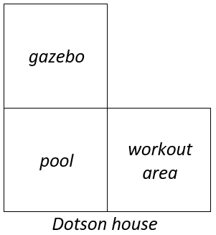

Part B. The Dotsons went to Fence2Fence and found the following options for purchase:
- $3\frac{1}{2}$ feet $×6$ feet Western Red Cedar Gothic Fence Panels for $60.05
- $3\frac{1}{2}$ feet $×8$ feet Western Red Cedar Essentials Fence Panels for $88.66
Which option is the better value? Why?

Instructional Items
Instructional Item 1
Calculate the value of the expression given.
$$\sqrt[3]{27}-1.4\left(\sqrt{3^{2}-5}\right)$$

*The strategies, tasks and items included in the B1G-M are examples and should not be considered comprehensive.

Algebraic Reasoning

MA.8.AR.1 Generate equivalent algebraic expressions.

MA.8.AR.1.1

Benchmark
MA.8.AR.1.1 Apply the Laws of Exponents to generate equivalent algebraic expressions, limited to integer exponents and monomial bases.
Example: The expression ${(3x^{3}y^{-2})}^{3}$ is equivalent to $27x^{9}y^{-6}$.

Benchmark Clarifications:
Clarification 1: Refer to the K-12 Formulas (Appendix E) for the Laws of Exponents.

Connecting Benchmarks/Horizontal Alignment
- MA.8.NSO.1.3, MA.8.NSO.1.7
- MA.8.AR.1.3

Terms from the K-12 Glossary
- Base
- Expression
- Integers
- Monomial

Vertical Alignment
Previous Benchmarks  - MA.7.NSO.1.1  - MA.7.NSO.2.1 | Next Benchmarks  - MA.912.NSO.1.2
Purpose and Instructional Strategies
In Grade 7, students applied the Laws of Exponents to evaluate and generate numerical expressions, limited to whole-number exponents and rational number bases. In Grade 8, students extend their knowledge of the Laws of Exponents to generate equivalent algebraic expressions with integer exponents and monomial bases. In Algebra 1, students will use their knowledge of the Laws of Exponents to generate equivalent algebraic expressions with rational and variable exponents.
- At the onset of learning about exponents, students learn that it is a way to write expanded multiplication in a more condensed form. It is foundational that students understand that the value of the exponent determines how many times the base is multiplied by itself.
- This benchmark can be paired with MA.8.NSO.1.3 which helps students work within numerical expressions using integer exponents and rational bases. Students should move from numerical expressions to algebraic expressions to best enhance their conceptual understanding of the Laws of Exponents.
- A strategy for developing meaning for integer exponents is to make use of patterns as shown below:
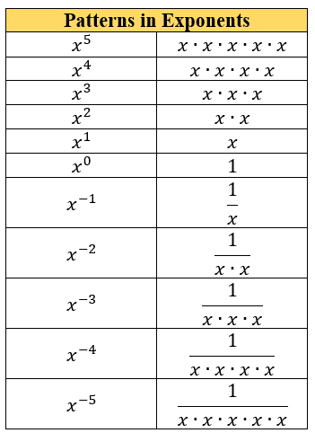

- For conceptual understanding, instruction should focus on one law at a time and students should derive the law of exponents through experience and reason. During instruction, include examples that show the expansion of the bases with the use of the exponents to show equivalence.
- For mastery of this benchmark, monomials can be defined in the following way: a base may be a product of a coefficient and one or more variables with integer exponents. This limitation should not prevent students from understanding that a negative exponent can be represented equivalently as a positive exponent with the reciprocal base (changing numerator to denominator or denominator to numerator).

Common Misconceptions or Errors
  - When working with negative exponents, students may not understand the connection to fractions and values in the denominator.
  - Students may incorrectly multiply the exponent with the base number.

Strategies to Support Tiered Instruction
- Teachers should write out the expanded form and then use it to model condensed multiplication as exponential form, providing opportunities to notice patterns as discussed in MA.8.NSO.1.3. Teachers can use the “Patterns in Exponents” chart shown in the Purpose and Instructional Strategies section with the right-side blank so that students can begin to complete and understand the patterns of integer exponents.
- Teachers should re-emphasize the structure of exponents, and how they indicate the number of times the base is multiplied by itself as denoted by the exponent.
- Teacher provides a review of the relationship between the base and the exponent by modeling an example of operations using a base and exponent.
  - For example, evaluate $6^{3}$.
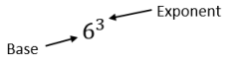
$6^{3}$ which is equivalent to $6⋅6⋅6$ which is equivalent to 216.

Instructional Tasks
Instructional Task 1 (MTR.2.1)
Two students were working on generating equivalent expressions for ${\left(15xy^{2}\right)}^{3},$and showed their solutions below.

Rachel's Answer | Justina's Answer
$$15∙15∙15∙x∙x∙x∙y∙y∙y∙y∙y∙y$$ | $$3,375x^{3}y^{6}$$

The teacher said Rachel and Justina both have the correct answer. Do you agree with the teacher? Explain your reasoning.

Instructional Task 2 (MTR.5.1)
Create a pattern using the expanded form of the base, $m$, between $m^{-5}$ and $m^{5}$. Explain why $m^{0}$ is equal to 1.

Instructional Items
Instructional Item 1
Write $x^{5}x^{8}$ with the variable $x$ used only one time.

Instructional Item 2
An expression is given.
$${\left(\frac{a^{3}}{4b^{-7}}\right)}^{5}$$
Write an equivalent expression with only two exponents and no negative exponents.

Instructional Item 3
Write $y^{-3}z^{-4}$ with only positive exponents.

*The strategies, tasks and items included in the B1G-M are examples and should not be considered comprehensive.

MA.8.AR.1.2

Benchmark
MA.8.AR.1.2 Apply properties of operations to multiply two linear expressions with rational coefficients.
Example: The product of $(1.1+x)$ and $(-2.3x)$ can be expressed as $-2.53x-2.3x^{2}$ or $-2.3x^{2}-2.53x$.

Benchmark Clarifications:
Clarification 1: Problems are limited to products where at least one of the factors is a monomial.
Clarification 2: Refer to Properties of Operations, Equality and Inequality (Appendix D).

Connecting Benchmarks/Horizontal Alignment
- MA.8.NSO.1.3, MA.8.NSO.1.7
- MA.8.AR.1.3

Terms from the K-12 Glossary
- Coefficient
- Linear Expression
- Rational

Vertical Alignment
Previous Benchmarks  - MA.7.NSO.1.1  - MA.7.AR.1.2 | Next Benchmarks  - MA.912.AR.1.3, MA.912.AR.1.4, MA.912.AR.1.7
Purpose and Instructional Strategies
In grade 7, students applied properties of operations to add and subtract linear expressions with rational coefficients. Additionally, students determined if two linear expressions were equivalent. In grade 8, students apply properties of operations to multiply two linear expressions with rational coefficients. In Algebra 1, students will add, subtract, multiply and divide polynomial expressions.
- Instruction includes working with multiplying two linear expressions and connecting the distributive property.
- Instruction includes modeling this benchmark concretely. One way to do this is to model with algebra tiles to generate equivalent expressions.
  - For example, $2(x+3)$ can be modeled using the algebra tiles to showcase the equivalent expression of $2x+6$.

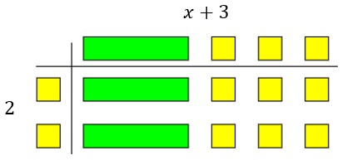

- Instruction moves from concrete models of examples with integer coefficients to rational coefficients.
- Instruction includes providing and discussing tasks that involve students analyzing errors which helps their ability to self-correct misconceptions within their own work.

Common Misconceptions or Errors
  - Students may incorrectly apply the distributive property by multiplying the monomial to only one of the terms in the parentheses. To address this misconception, emphasize that it is the distributive property (multiplication to all terms) to help support student understanding.
  - Students may incorrectly apply the rules of integers as they distribute. Students may incorrectly change the degree of the variable to simplify terms.
Strategies to Support Tiered Instruction
- Teacher models examples using the area model for multiplication, showing that the monomial should be multiplied by each term of the polynomial.
  - For example, the area model can be used to determine the product between $45$ and $5$ is $225$. Once students understand how distribution works, teachers re-introduce variables and solve problems the same way.

 | $$40$$ | $$5$$
$$5$$ | $$200$$ | $$25$$

  - For example, the area model can be used to determine the product between $x-3$ and $4$ is $4x-12$.

 | $$x$$ | $$-3$$
$$4$$ | $$4x$$ | $$-12$$

  - For example, the area model can be used to determine the product between $3x$ and $2x+4$ is $3y^{2}+6xy$.

 | $$2x$$ | $$+4$$
$$3x$$ | $${6x}^{2}$$ | $$+12x$$

- Algebra tiles could be used when solving problems using the distributive property. This will help students who incorrectly distribute the monomial to only one term of the polynomial.
- Teachers may color code each step of the problem so students can see the progression of distribution.
  - For example, the expression $3(x+7)$ is equivalent to $3x+21$.
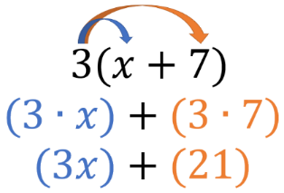
- Instruction includes emphasizing that it is the distributive property of multiplication over addition to help support student understanding.

Instructional Tasks
Instructional Task 1 (MTR.4.1, MTR.5.1)
Students were working on the math problem $-\frac{1}{2}x\left(4x+8\right).$ Kevin’s result is shown in the table below.
Part A. Is Kevin’s answer correct?
Part B. If no, explain his misconception and how he can correct his mistake. If yes, explain why he is correct and the steps he could have used.

Kevin's Answer
$$-2x^{2}+8$$

Instructional Task 2 (MTR.7.1 )
A rectangle is given below. Note: The figure is not drawn to scale.

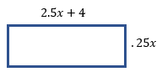

Part A. Find the area in terms of $x.$
Part B. If the value of $x$ is 4 cm, what is the area of the rectangle in square centimeters?

Instructional Items
Instructional Item 1
An expression is given below.
$$-\frac{7}{8}x \left(\frac{3}{4}x -\frac{5}{6}\right)$$
What is the product of the expression?

Instructional Item 2
Find the product of $0.25x(0.55x-0.3)$.

*The strategies, tasks and items included in the B1G-M are examples and should not be considered comprehensive.

MA.8.AR.1.3

Benchmark
MA.8.AR.1.3 Rewrite the sum of two algebraic expressions having a common monomial factor as a common factor multiplied by the sum of two algebraic expressions.
Example: The expression $99x-11x^{3}$ can be rewritten as $11x(9-x^{2})$ or as $-11x\left(-9+x^{2}\right)$.

Connecting Benchmarks/Horizontal Alignment
- MA.8.AR.1.1, MA.8.AR.1.2
- MA.8.AR.2.1, MA.8.AR.2.2

Terms from the K-12 Glossary
- Monomial
- Regular Polygon

Vertical Alignment
Previous Benchmarks  - MA.6.NSO.3.2  - MA.7.AR.1.2 | Next Benchmarks  - MA.912.AR.1.4, MA.912.AR.1.7
Purpose and Instructional Strategies
In grade 6, students learned to write the sum of two composite whole numbers that have a common factor, as a common factor multiplied by the sum of two whole numbers. In grade 7, students applied the properties of operations to add and subtract linear expressions with rational coefficients and determine if two linear expressions are equivalent. In grade 8, students rewrite the sum of two algebraic expressions having a common monomial factor as a common factor multiplied by the sum of two algebraic expressions. In Algebra 1, students will extend this learning to divide a polynomial by a monomial and to rewrite a polynomial expression as a product of polynomials by using a common factor.
- This benchmark is a foundational benchmark for work with the distributive property and factoring in more complex problems.
- Instruction begins with whole number coefficients to ensure students understand the process first. Then, move to rational number values (MTR.3.1).
- Instruction includes a review of common factors of two numbers (MA.6.NSO.3.2) so students can show understanding of the first step before applying it to the work of this benchmark.
- Instruction includes a review of the order of operations when working with multi-step problems (MTR.3.1).
- Instruction includes having expressions with more than one variable.
  - For example, $24xy^{2}+8xy$ can be rewritten as $8xy(3y+1)$.
- Emphasize properties of operations to determine equivalence when rewriting the expressions. Use manipulatives such as algebra tiles to represent the distributive property of multiplication over addition (MTR.2.1).
  - Manipulatives
$$3x^{2}+6x$$


  - Area Models
$$3x^{2}+6x$$
 | $$3x^{2}$$ | $$6x$$

Common Misconceptions or Errors
  - Students may incorrectly apply integer operations.
  - Students may incorrectly apply the Laws of Exponents.
  - Students may incorrectly change the degree of a variable to simplify terms.
  - Students may incorrectly factor out only one of the terms from the parentheses.
    - For example, in $18xy^{3}+3xy^{2}$, students may incorrectly factor the first term only resulting in $3xy^{2}\left(6y+3xy^{2}\right).$
  - Students may incorrectly combine terms.

Strategies to Support Tiered Instruction
- When factoring algebraic expressions, the teacher will provide instruction to review the process for finding the greatest common factor (GCF) of two numbers before attempting to factor algebraic expressions. Once students understand the process of finding factors, more specifically the GCF, the teacher will provide instruction on factoring variables with and without exponents.
- Teacher models how to expand the degrees of variables to better understand what they truly have in common.
  - For example, if the expression was $5x^{4}y+10x^{2}y^{3}$, it would be expanded as $5xxxxy+ 2∙5xxyyy$. Now that the expression is expanded, students can identify what variables each term has in common. This example shares one five, two $x$’s, and one $y$.
- Instruction includes breaking up expressions to compare similar portions will help students focus on each step of factoring the algebraic expressions.
  - For example, when factoring $36x^{2}y+42xy^{2}$, the expression could be broken up to factor as $36 \& 42, x^{2} \& x, y \& y^{2}$.

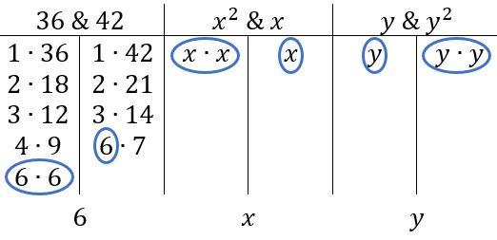

- Once students understand how to factor each portion of the expression individually, teachers model how to “remove” the common factor from each portion of the expression, and how to use what is left over.

Instructional Tasks
Instructional Task 1 (MTR.2.1)
Tammy is designing seating around a new fire pit for her outdoor patio. One of the fire pit designs is a regular octagon with a side length of $\frac{3}{4}x-\frac{1}{4}$. The other design is a regular hexagon with a side length of $12-x$.

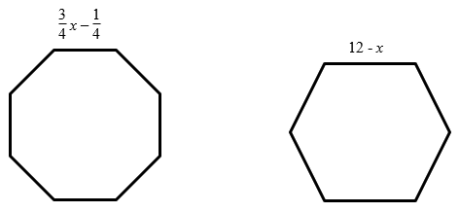

Part A. Find the perimeter of the regular octagon fire pit.
Part B. Find the perimeter of the regular hexagon fire pit.
Part C. Write an expression with the fewest number of terms to show the difference between the perimeters of the two fire pits.
Part D. Rewrite an equivalent expression from Part C as a common factor multiplied by the sum of two algebraic expressions.

Instructional Items
Instructional Item 1
Determine an equivalent expression written as a common factor multiplied by the sum of two algebraic expressions.
$$25x^{4}y +5xy^{3}$$

Instructional Item 2
For each expression shown, determine an equivalent expression written as a common factor multiplied by the sum of two algebraic expressions.
  - $125x^{2}+15x$
  - $-24-36y^{3}$
  - $\frac{3}{4}xy-\frac{1}{4}x^{2}y^{3}$

*The strategies, tasks and items included in the B1G-M are examples and should not be considered comprehensive.

MA.8.AR.2 Solve multi-step one-variable equations and inequalities.

MA.8.AR.2.1

Benchmark
MA.8.AR.2.1 Solve multi-step linear equations in one variable, with rational number coefficients. Include equations with variables on both sides.
Benchmark Clarifications:
Clarification 1: Problem types include examples of one-variable linear equations that generate one solution, infinitely many solutions or no solution..

Connecting Benchmarks/Horizontal Alignment
- MA.8.NSO.1.7
- MA.8.AR.1.3
- MA.8.AR.4.1
- MA.8.GR.1.4, MA.8.GR.1.5, MA.8.GR.1.6
Terms from the K-12 Glossary
- Coefficient
- Linear Equation
- Rational Number

Vertical Alignment
Previous Benchmarks  - MA.7.AR2.2 | Next Benchmarks  - MA.912.AR.2.1
Purpose and Instructional Strategies
In grade 7, students wrote and solved two-step equations in one variable within a mathematical or real-world context, where all terms are rational numbers. In grade 8, students solve multi-step linear equations in one variable, with rational number coefficients, including equations with variables on both sides. In Algebra 1, students will write and solve linear equations in one variable in a real-world context, with rational number coefficients.
- In this benchmark, students work with linear equations, which is foundational for the work with both linear equations and nonlinear equations throughout all future mathematics courses.
- Instruction includes the use of manipulatives, drawings, models, properties of operations and properties of equality.
  - Algebra Tiles

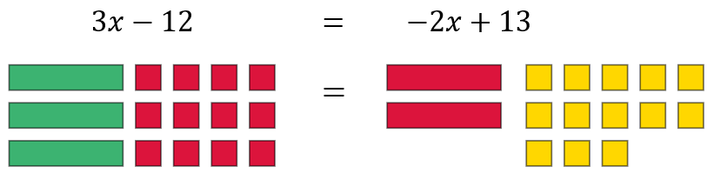

  - Balance
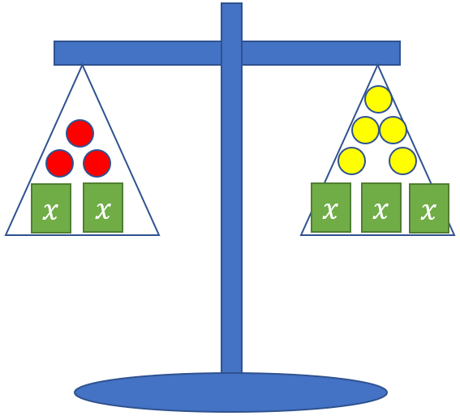

- Problem types involve multi-step problems that require the use of the distributive property, combining like terms, and variables on both sides of the equation.
- Since there are variables on both sides of the equation, instruction includes discovering that one-variable equations can result in three possible solution sets. The possible solutions are one solution, no solution or infinitely many solutions. This benchmark provides a foundation for MA.8.AR.4 when students are working with systems of equations and two-variable equations.

Common Misconceptions or Errors
  - Students may incorrectly apply the distributive property by multiplying the monomial to only one of the terms in the parentheses. To address this misconception, emphasize that it is the distributive property of multiplication over addition to help support student understanding.
  - Students may incorrectly apply the rules of integer arithmetic as they distribute when working with the operations of negative numbers and applying the distributive property of multiplication over addition.
  - Students may incorrectly think that you always need a constant as a solution when given a variable. To address this misconception, provide examples that show a constant equal to a variable as a solution, a constant equal to a constant or a false equality statement.

Strategies to Support Tiered Instruction
- Teacher provides opportunities to demonstrate the distributive property as repeated addition of the given expression.
  - For example, when using algebra tiles, the expression $3(x-4)$ can be represented as adding $(x-4)$ three times together.

Or
$$3\left(x- 4\right)=\left(x-4\right)+\left(x-4\right)+\left(x-4\right)=3x- 12$$

- Teacher co-creates a graphic organizer with examples of one, no solutions, and infinitely many solutions. Demonstrate using substitution to help students make sense of the solutions.
- Teacher co-creates an anchor chart for multiplying negative integers for students that incorrectly apply the rules of negative integers as they distribute.
- Teacher provides examples for students that need additional support for distributive property by using the area model for$2(x + 4)$.

$x$ $4$
$$2$$ | $$2x$$ | $$8$$

- Instruction includes emphasizing that it is the distributive property of multiplication over addition to help support student understanding.

Instructional Tasks
Instructional Task 1 (MTR.1.1, MTR.4.1)
Part A. How many solutions does the equation, $2y+7=7+2y$ have? Explain your reasoning to another student and justify your answer.
Part B. How many solutions does the equation, $2\left(y+3\right)+1=2(3.5+y)$ have? Explain your reasoning to another student and justify your answer.
Part C. What do you notice about the equations in Part A and Part B?

Instructional Task 2 (MTR.1.1, MTR.4.1)
For each equation, state whether there is no solution, one solution, or infinitely many solutions. Explain your reasoning.

Equation | Number of Solutions | Explanation
$$\frac{1}{3}x-6=\frac{1}{3}\left(x-3\right)-1$$
$$2x+7=-2x+7$$
$$0.8x+1.4=0.8x$$

Instructional Items
Instructional Item 1
Solve for $x:$
- $-3.5\left(10x-2\right)=-176.75$
- $15\left(2x-10\right)+4x=-3(15x+4)$

*The strategies, tasks and items included in the B1G-M are examples and should not be considered comprehensive.

MA.8.AR.2.2

Benchmark
MA.8.AR.2.2 Solve two-step linear inequalities in one variable and represent solutions algebraically and graphically.
Benchmark Clarifications:
Clarification 1: Instruction includes inequalities in the forms $px±q>r$ and $p\left(x±q\right)>r$, where $p$, $q$ and $r$ are specific rational numbers and where any inequality symbol can be represented.
Clarification 2: Problems include inequalities where the variable may be on either side of the inequality.

Connecting Benchmarks/Horizontal Alignment
- MA.8.AR.1.3
- MA.8.GR.1.3

Terms from the K-12 Glossary
- Coefficient
- Linear expression
- Rational Number

Vertical Alignment
Previous Benchmarks  - MA.7.AR.2.1 | Next Benchmarks  MA.912.AR.2.6
Purpose and Instructional Strategies
In grade 7, students wrote and solved one-step inequalities in one variable within a mathematical context and represented solutions algebraically or graphically. In grade 8, students solve two-step linear inequalities in one variable and represent solutions algebraically and graphically. In Algebra 1, students will extend this learning to write and solve one-variable linear inequalities, including compound inequalities representing solutions algebraically or graphically. Additionally, students will write and solve two-variable linear inequalities to represent relationships between quantities from a graph or a written description within a mathematical or real-world context.
- Instruction emphasizes the properties of inequality with connections to the properties of equality (MTR.5.1).
- Instruction includes showing why the inequality symbol reverses when multiplying or dividing both sides of an inequality by a negative number.
  - For example, if the inequality $6>-7$ is multiplied by $-3$, it results in $-18>21$ which is a false statement; therefore, the inequality symbol must be reversed to keep a true statement. Since 6 is to the right of -7 on the number line and multiplying by a negative number reverses directions, $6(-3)$ will be to the left of $-7(-3)$ on the number line.
- Instruction includes cases where the variable is on the right side of the inequality.
- Variables are not limited to $x$; instruction includes using a variety of lowercase letters for their variables; however, the letters $o$, $i$, and $l$ should be avoided as they too closely resemble zero and one.
- Instruction emphasizes the understanding of defining an algebraic inequality. Students should have practice with inequalities in the form of $px±q>r$, $px±q<r$, $px±q≥r$ and $px±q≤r$. Students should explore how "is greater than or equal to" and "is strictly greater than" are similar and different as well as "is less than or equal to" and "is strictly less than." Students should use academic language when describing an algebraic inequality.

Common Misconceptions or Errors
- Students may confuse when to use an open versus closed circle when graphing an inequality. Emphasize the inclusion $\left(≤and ≥\right)$ versus non-inclusion $(<and >)$ of that value as a viable solution and provide problems that motivate reasoning with different ranges of possible values for the variable.
- Some students are unable to see the difference between the multiplication or division property of equality and the multiplication or division property of inequality.
- Students may misunderstand the direction the inequality symbol is pointing is always the direction they shade on the number line. To address this misconception, emphasize reading the inequality sentence aloud and use numerical examples to test for viable solutions (MTR.6.1).

Strategies to Support Tiered Instruction
- Instruction includes the use of real-world inequality problems to help students determine when to use an open versus closed circle when graphing an inequality. Teacher facilitates discussion around whether various solutions make sense by having students graph all possible solutions on a number line and then deciding if the solutions make sense in the context of the problem.
- For example, Henry has up to $20 to spend at the football game and the dance after the game. He must buy a dance ticket for $13 and can spend the rest on hot dog and drink combinations at the football game for $2 per combo. After Henry buys his dance ticket, how many hot dog and drink combinations could Henry purchase? (The c represents the hotdog and drink combo.)
Students can write the inequality $2c+13≤20$ to represent the situation. Students should get the algebraic solution as $c≤3.5$, however, within the context of the problem the possible solutions are 0, 1, 2 or 3.
- Teacher models solving an equation and its corresponding inequality. Teacher facilitates discussion about their similarities and differences, paying close attention to cases when multiplying or dividing with negative values and using substitution to verify the solutions.
- Instruction includes using substitution to test possible solutions to determine the correct direction to shade on the number line.
- Teacher provides opportunities for students to use manipulatives for solving inequalities. When using manipulatives, ensure students use the appropriate inequality symbol, rather than an equal sign.
- Instruction includes emphasizing reading the inequality sentence aloud and use numerical examples to test for viable solutions.

Instructional Tasks
Instructional Task 1 (MTR.7.1)
As a social media employee, Rick is paid $100 a week plus $5 for every person that he adds to the website. This week, Rick wants his pay to be at least $200.
Part A. Write and solve an inequality for the number of sales Rick needs to make.
Part B. Graph the solution on a number line.
Part C. Describe what the solutions mean within the context of the problem.

Instructional Task 2 (MTR.4.1, MTR.7.1)
At his job, Jake earns $7.50 per hour. He also earns a $55 bonus every month. Jake needs to earn at least $235 every month.
Part A. Jake determines that the inequality $7.50h+55≥235$ can be used to calculate the number of hours he needs to work each month. Explain why the symbol $≥$ is used within the inequality.
Part B. Solve and graph the solution set for the number of hours Jake needs to work each month.

Instructional Items
Instructional Item 1
Represent the solutions to the inequality $550+8b>925$ graphically.

Instructional Item 2
Solve and graph the inequality $-225≤320-0.5x$.

*The strategies, tasks and items included in the B1G-M are examples and should not be considered comprehensive.

MA.8.AR.2.3

Benchmark
MA.8.AR.2.3 Given an equation in the form of $x^{2}=p$ and $x^{3}=q$, where $p$ is a whole number and $q$ is an integer, determine the real solutions.

Benchmark Clarifications:
Clarification 1: Instruction focuses on understanding that when solving $x^{2}=p$, there is both a positive and negative solution.
Clarification 2: Within this benchmark, the expectation is to calculate square roots of perfect squares up to 225 and cube roots of perfect cubes from -125 to 125.

Connecting Benchmarks/Horizontal Alignment
- MA.8.NSO.1.1, MA.8.NSO.1.7
- MA.8.GR.1.1, MA.8.GR.1.2

Terms from the K-12 Glossary
- Integer
- Real Numbers
- Whole Numbers

Vertical Alignment
Previous Benchmarks  - MA.7.AR.2.2 | Next Benchmarks  - MA.912.AR.3.1
Purpose and Instructional Strategies
In grade 7, students wrote and solved two-step equations in one variable. In grade 8, when given an equation in the form $x^{2}=p$ and $x^{3}=q$, where $p$ is a whole number and $q$ is an integer, students determine the real solutions. In Algebra 1, students will write and solve quadratic equations.
- This benchmark involves students understanding the concepts of how to square a number and find the square root as well as how to cube a number and find the cube root.
- Students should recognize that squaring a number and taking the square root of a number are inverse operations, therefore, cubing a number and taking the cube root are inverse operations as well. Students should use this understanding to solve equations containing square or cube numbers.
- In finding the square root, instruction involves discussion that there is both a positive and negative solution. Instruction can include relating the lengths of the sides of a square for square root and the length of the side of a cube to cube roots.
- Within this benchmark, it is not the expectation that students are required to isolate the $x^{2}$ term or the $x^{3}$ term when solving an equation.

Common Misconceptions or Errors
  - Students may incorrectly conclude that squaring a number means to multiply by 2. Likewise, cubing may be mistaken as multiplying by 3. Use length to show doubling and area of a square to show an exponent of 2. Use of two-dimensional and three-dimensional manipulatives (MTR.2.1) may also help to emphasize squares and cubes versus increasing length.
  - Students may think that since a negative number has no square root in the real number system, then a negative number has no cube root in the real number system.

Strategies to Support Tiered Instruction
- Instruction includes modeling the differences between doubling and squaring a value using a graphic organizer. Doubling a value would be represented by multiplying a given length by $2$whereas squaring a number would be represented by the area of a square with a given length.
  - For example, students can be given the table below to show how the left column doubles a length whereas the right column squares a length.
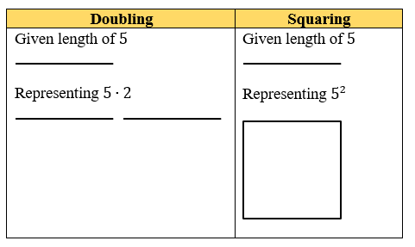
- Instruction includes modeling the differences between tripling or cubing a value using a graphic organizer. Tripling a value would be represented by multiplying a given length by 3$,$whereas cubing a number would be represented by the volume of a cube with a given length.
  - For example, students can be given the table below to show how the left column triples a length whereas the right column cubes a length.
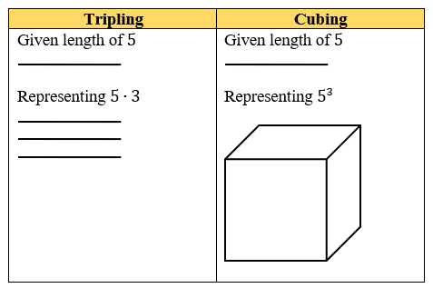
- Instruction may include providing students with the opportunity to develop their own note sheet or graphic organizer for the cubes of numbers from -5 to 5.

$$x$$ | $$x^{2}$$ | $$x^{3}$$
$$-5$$ | $$25$$ | $$-125$$
$$-4$$ | $$16$$ | $$-64$$
$$-3$$ | $$9$$ | $$-27$$
$$-2$$ | $$4$$ | $$-8$$
$$-1$$ | $$1$$ | $$-1$$
$$0$$ | $$0$$ | $$0$$
$$1$$ | $$1$$ | $$1$$
$$2$$ | $$4$$ | $$8$$
$$3$$ | $$9$$ | $$27$$
$$4$$ | $$16$$ | $$64$$
5 | $$25$$ | $$125$$

Instructional Tasks
Instructional Task 1(MTR.7.1)
A square tile in a kitchen has an area of 121 square inches.
Part A. What is the length of one side of the square tile in inches? Is this tile smaller or larger than a one-foot by one-foot tile?
Part B. The owner of the house, Kiana, wants to put larger tiles in their kitchen to change the look of the kitchen. The new tile is a square with an area of 196 square inches.
- What is the length of the side of the new tile?
- How does this larger tile compare to the current tile used in the kitchen?
Part C. A third tile has a side length of $2\sqrt{11}$. Kiana is trying to determine which square tile covers the most area. Put the tile’s side lengths of the tiles in order from greatest to least. Justify your thinking.

Instructional Task 2 (MTR.3.1)
The volume of a large cube is 125 cubic inches. The volume of a small cube is 27 cubic inches. What is the difference between the length of one side of the large cube and the length of one side of the small cube?

Instructional Items
Instructional Item 1
An equation is given.
$$x^{2}=49$$
What are the values of $x$?

Instructional Item 2
Solve for $b$ in the equation $-64=b^{3}$.

*The strategies, tasks and items included in the B1G-M are examples and should not be considered comprehensive.

MA.8.AR.3 Extend understanding of proportional relationships to two-variable linear equations.

MA.8.AR.3.1

Benchmark
MA.8.AR.3.1 Determine if a linear relationship is also a proportional relationship.
Benchmark Clarifications:
Clarification 1: Instruction focuses on the understanding that proportional relationships are linear relationships whose graph passes through the origin.
Clarification 2: Instruction includes the representation of relationships using tables, graphs, equations and written descriptions.

Connecting Benchmarks/Horizontal Alignment
- MA.8.F.1.2
- MA.8.GR.2.4
- MA.8.DP.1.3

Terms from the K-12 Glossary
- Constant of Proportionality
- Proportional Relationship

Vertical Alignment
Previous Benchmarks  - MA.7.AR.4.1, MA.7.AR.4.2, MA.7.AR.4.4 | Next Benchmarks  - MA.912.AR.2.2, MA.912.AR.2.4  - MA.912.F.1.3
Purpose and Instructional Strategies
In grade 7, students determined if two quantities are in a proportional relationship from a table and determined the constant of proportionality. In grade 8, students determine whether a given linear relationship is also a proportional relationship. In Algebra 1, students will use two-variable linear equations to represent mathematical or real-world contexts.
- Instruction includes using a variety of variables to represent the slope, which is the same as the constant of proportionality when the linear relationship is also a proportional relationship. Students used $p$ or $k$ in grade 7 to represent the constant of proportionality and now in grade 8 may use $m$ to represent slope. Students should understand that the slope or constant rate of change can be represented by any variable.
- Instruction includes students graphing relationships and writing equations to determine if two linearly related quantities are also proportional. Students need to be provided examples to show evidence that not all linear relationships are proportional.
- Students should connect unit rates, the constant of proportionality and slope to represent similar ideas in different contexts.

Common Misconceptions or Errors
- Students may incorrectly state a relationship is not proportional if the origin is not visible in the graph or given in the table.
- Students may incorrectly think all linear relationships are proportional. Some students find a constant rate of change and confuse this with a constant ratio. Help students understand that a constant ratio is only possible if the relationship passes through the origin.

Strategies to Support Tiered Instruction
- Instruction includes providing opportunities to explore relationships represented on graphs and in tables that do not include the origin. Students should determine the rate of change in these situations and use ratio reasoning to determine if the relationships pass through the origin or not.
- Instruction includes the use of geometric software to visually compare proportional and non-proportional graphs to model that all linear graphs are not proportional relationships.
- Teacher co-creates a graphic organizer to represent the similarities and differences of the terms: unit rate, constant of proportionality, and slope. Specifically include the different contexts applicable to each.

Instructional Tasks
Instructional Task 1 (MTR.4.1, MTR.6.1, MTR.7.1)
A student is making trail mix for each serving size in the table given.

Serving Size | 1 | 2 | 3 | 4
Cups of Nuts | 2 | 3 | 4 | 5
Cups of Fruit | 4 | 6 | 8 | 10

Part A. Is this relationship linear? If so, state the constant rate of change.
Part B. Determine if this relationship is also proportional.
Part C. What do you notice about the number of cups of nuts and fruit that would be in a serving size of zero? Discuss with a partner.

Instructional Task 2 (MTR.4.1)
Which graph represents a proportional relationship? Justify your answer.

Graph #1 | Graph #2
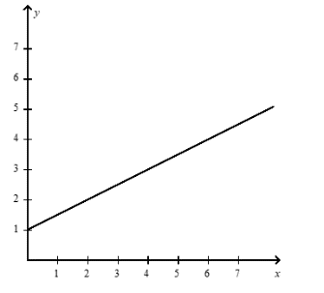 | 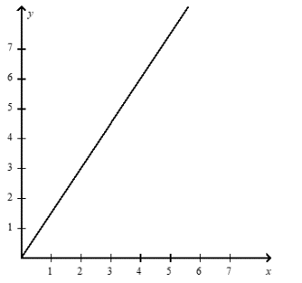

Instructional Items
Instructional Item 1
Alexia earns $14.75 an hour as a hostess at a local restaurant. She earns an additional $30 in tips each night from take-out orders. Determine if this linear relationship is proportional.

Instructional Item 2
The circumference of a circle is proportional to its diameter. This relationship can be expressed by the equation $C=πd.$ Determine if this linear relationship is proportional.

*The strategies, tasks and items included in the B1G-M are examples and should not be considered comprehensive.

MA.8.AR.3.2

Benchmark
MA.8.AR.3.2 Given a table, graph or written description of a linear relationship, determine the slope.
Benchmark Clarifications:
Clarification 1: Problem types include cases where two points are given to determine the slope.
Clarification 2: Instruction includes making connections of slope to the constant of proportionality and to similar triangles represented on the coordinate plane.

Connecting Benchmarks/Horizontal Alignment
- MA.8.AR.3.3, MA.8.AR.3.5
- MA.8.F.1.1
- MA.8.GR.2.4
- MA.8.DP.1.3

Terms from the K-12 Glossary
- Slope

Vertical Alignment
Previous Benchmarks  - MA.7.AR.3.2 | Next Benchmarks  - MA.912.AR.2.2
Purpose and Instructional Strategies
In grade 7, students determined the constant of proportionality in a proportional relationship. In grade 8, students are determining the slope of a linear relationship from a given table, graph, or written relationship. In Algebra 1, students will write a two-variable linear equation from a graph, written description, or a table to represent relationships between quantities in mathematical and real-world context.
- Students identified the unit rate or the constant of proportionality in prior grade levels. This benchmark is the first one that references the slope, which represents a constant rate of change. This is not the same as a constant of proportionality unless the relationship goes through the origin.
- Instruction includes interpreting the meaning and value of slope in real-world context.
- Understanding slope can be introduced through a graph and the change in value of the $y$ and the $x$.
- To introduce the concept to students, use at least two points on a graph in quadrant one.
- Instruction includes using a variety of vocabulary to make connections to real-world concepts and future courses. To describe the slope, one can say either “the vertical change divided by the horizontal change” or “rise over run.”
- Students should have experience utilizing a slope formula to determine the slope between two points on a line.
  - Slope of a line can be found by the expression $m=\frac{y_{2}-y_{1}}{x_{2}-x_{1}}$, where $\left(x_{1},y_{1}\right)$ and $\left(x_{2},y_{2}\right)$ are two different points on the line.

Common Misconceptions or Errors
  - Students may invert the $x$- and $y$-values when calculating slope. To address this misconception, students should represent the relationship visually.

Strategies to Support Tiered Instruction
- Teacher supports students who invert the $x$- and $y$-values when calculating slope by using real-world problems that students can relate to and helping students represent the relationship visually.
- Instruction includes providing students with graph paper with grid lengths larger than 1 centimeter and using appropriate scaling of the axes to allow for students to see the unit rate more easily.

Instructional Tasks
Instructional Task 1 (MTR.6.1)
Mr. Elliot needs to drain his above ground pool before the winter. The graph below represents the relationship between the number of gallons of water remaining in the pool and the number of hours that the pool has drained. Determine the slope and explain what it means in this situation.

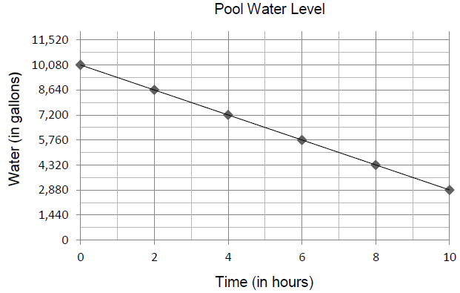

Instructional Task 2 (MTR.4.1, MTR.7.1)
Jack and Jill are selling gallons of water that are sold in different size pails. Jack charges $1.75 for every 2 gallons of water a pail holds. Additionally, he charges a $2 service fee. Jill's prices can be modeled with the graph shown.

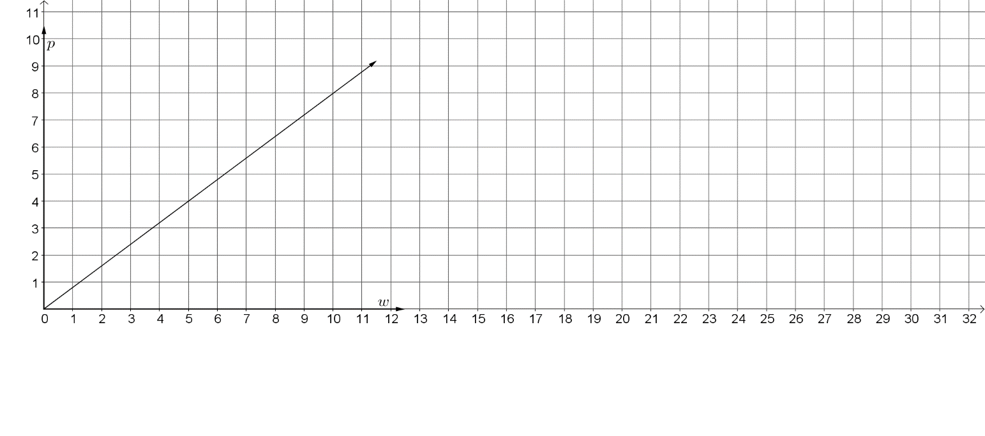
Price (in dollars)
Gallons of Water

Part A. Identify the slope of Jack's relationship. Explain what it means.
Part B. Identify the slope of Jill's graph and explain what it means.
Part C. Graph Jack’s prices on the same graph as Jill.
Part D. Whose has the better deal, Jack or Jill? Explain.

Instructional Items
Instructional Item 1
Cameron joins a local gym. There is an initial fee of $25 and then a fee of $5 per month. Determine the slope. After 12 months how much money has Cameron paid to the gym?

Instructional Item 2
A linear relationship is given in the table below. Determine the slope of the relationship.

$$x$$ | $$-1$$ | $$0$$ | $$1$$ | $$2$$ | $$3$$
$$y$$ | $$-18$$ | $$-9$$ | 0 | 9 | 18

*The strategies, tasks and items included in the B1G-M are examples and should not be considered comprehensive.

MA.8.AR.3.3

Benchmark
MA.8.AR.3.3 Given a table, graph or written description of a linear relationship, write an equation in slope-intercept form.

Connecting Benchmarks/Horizontal Alignment
- MA.8.AR.3.2, MA.8.AR.3.5
- MA.8.F.1.1
- MA.8.DP.1.3

Terms from the K-12 Glossary
- Intercept
- Slope

Vertical Alignment
Previous Benchmarks  - MA.7.AR.4.4 | Next Benchmarks  - MA.912.AR.2.2, MA.912.AR.2.3
Purpose and Instructional Strategies
In grade 7, students translated between different representations of proportional relationships. In grade 8, students write an equation in slope-intercept form from a written description, a table, or a graph. In Algebra 1, students write a linear two-variable equation to represent a relationship given by a variety of mathematical and real-world contexts.
- Point-slope form and standard form are not expectations at this grade level.
- Instruction connects proportional relationships to support the generation of the equation $y=mx+b$. Helping students see how the linear equation is both the same and different from the proportional relationship will support the appropriate use of proportional thinking using the rate of change.
- Using an online dynamic graphing tool to explore how the graph changes as either the slope or the $y$-intercept changes help students visualize the coefficients and constants in the equation (MTR.4.1).
- Students should recognize in a table that the $y$-intercept is the $y$-value when $x$ is equal to 0. The slope can be determined by finding the ratio between the change in two $y$-values and the change between the two corresponding $x$-values.
- Using graphs, students identify the $y$-intercept as the point where the line crosses the $y$-axis and the slope as the vertical change divided by the horizontal change. In a linear equation, the coefficient of $x$ is the slope and the constant is the $y$-intercept. Students need to be given the equations in formats other than $y=mx+b$, such as $y=ax+b$ or $y=b+mx$.
- Instruction includes using a variety of vocabulary to make connections to real-world concepts and future courses. To describe the slope, one can say either “the vertical change divided by the horizontal change” or “rise over run.”
- The instruction includes examples where the slope is positive or negative and the $y$-intercept is given as a positive or a negative in the equation.
- When providing a graph, be sure there are easily identifiable points for students to use in calculating the slope.
- Instruction allows students to make connections between the different representations of a linear relationship (MTR.2.1).

Common Misconceptions or Errors
- Students may incorrectly identify the values for the slope and $y$-intercept.
- Students may incorrectly calculate the slope with a common error of inverting the change in $y$ and the change in $x$.

Strategies to Support Tiered Instruction
- Teacher supports students who incorrectly identify the values for the slope and $y$-intercept by providing opportunities to notice patterns between a given value for $b$, a line graphed on the coordinate plane, and a given equation of the same line.
- Teacher supports students who incorrectly calculate the slope by inverting the change in $y$ and the change in $x$ using error analysis tasks, in which the expression $\frac{y_{2}-y_{1}}{x_{2}-x_{1}}$ is incorrectly written as $\frac{x_{2}-x_{1}}{y_{2}-y_{1}}$, and has students find and correct the error.
- Teacher supports students who invert the $x$ and $y$ values when calculating slope by using real-world problems that students can relate to and helping students represent the relationship visually.
- Teacher co-creates an anchor chart naming the slope and $y$-intercept of a given line and then discusses where to start when graphing the line.
- Instruction incudes graphing various linear equations from a table and then discussing the pattern students notice in regard to the $y$-intercept.
- Teacher provides students with graphs and equations of several linear equations then co-illustrates connections between the slopes and $y$-intercepts of each line to the corresponding parts of each equation using the same color highlights.
- Teacher co-creates a graphic organizer with students to include examples of positive and negative slope; the meaning of each variable in slope intercept form; and how to determine the slope and $y$-intercept in a table, graph and verbal description.

Instructional Tasks
Instructional Task 1 (MTR.7.1)
Victoria owns a store that sells board games. She made the following graph to relate the number of board games she sells to her overall profits.

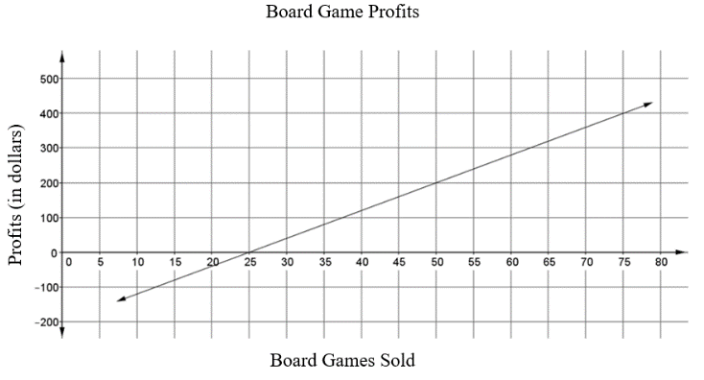

Part A. Write an equation in slope-intercept form to describe this relation. Explain how to determine the equation.
Part B. What is the meaning of the $y$-intercept in the given context? What is the meaning of the slope in the given context?

Instructional Items
Instructional Item 1
Write an equation that represents the graph shown.

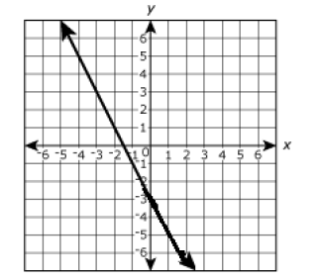

Instructional Item 2
The table shown represents a linear relationship. Using the table, write an equation in slope-intercept form.

$$x$$ | $$y$$
$$0$$ | $$-4$$
$$1$$ | $$-1$$
$$2$$ | $$2$$
3 | 5

*The strategies, tasks and items included in the B1G-M are examples and should not be considered comprehensive.

MA.8.AR.3.4

Benchmark
MA.8.AR.3.4 Given a mathematical or real-world context, graph a two-variable linear equation from a written description, a table or an equation in slope-intercept form.

Connecting Benchmarks/Horizontal Alignment
- MA.8.AR.4.2, MA.8.AR.4.3
- MA.8.DP.1.3

Terms from the K-12 Glossary
- Intercept
- Linear Equation
- Slope

Vertical Alignment
Previous Benchmarks  - MA.7.AR.4.3 | Next Benchmarks  - MA.912.AR.2.4
Purpose and Instructional Strategies
In grade 7, students graphed proportional relationships from a table, equation or a written description. In grade 8, students graph an equation from slope-intercept form from a written description, a table, a graph or an equation. In Algebra 1, students will graph a linear function when given a table, equation or written description.
- Point-slope form and standard forms are not expectations at this grade level.
- Review the concept of slope from MA.8.AR.3.2 for students who may need additional work to determine the slope and understand the meaning of slope.
- The instruction includes examples where the slope is positive or negative and the $y$-intercept is given as a positive or a negative in the equation.
- When introducing the benchmark, review graphing on the coordinate plane and determining appropriate scales for the graph.
- Instruction includes the understanding that a real-world context can be represented by a linear two-variable equation even though it only has meaning for discrete values. Discussing discrete values will prepare students to represent domain and range of real-world contexts in later courses.
  - For example, if a gym membership cost $10.00 plus $6.00 for each class, this can be represented as $y=10+6c$. When represented on the coordinate plane, the relationship is graphed using the points $(0,10)$, $(1,16)$, $(2,22)$, and so on.
- For mastery of this benchmark, students should be given flexibility to represent real-world contexts with discrete values as a line or as a set of points.

Common Misconceptions or Errors
- Students may incorrectly identify the slope and $y$-intercept.
- When graphing, students may incorrectly graph the line by inverting the directions of the slope values.
  - For example, if the slope is $\frac{2}{3}$, a student may think that 2 represents the change in the horizontal direction rather than the vertical direction.

Strategies to Support Tiered Instruction
- Teacher supports students who incorrectly identify the values for the slope and $y$-intercept by providing opportunities to notice patterns between a given value for $b$, a line graphed on the coordinate plane, and a given equation of the same line.
- Teacher supports students who invert the $x$- and $y$-values when calculating slope by using real-world problems that students can relate to and helping students represent the relationship visually.
- Instruction includes supporting students who incorrectly graph the line by inverting the directions of the slope values. Students may incorrectly calculate the slope with a common error of inverting the change in 𝑦 and the change in 𝑥. Teachers can support students using error analysis tasks, in which the expression $\frac{y_{2}-y_{1}}{x_{2}-x_{1}}$ is incorrectly written as $\frac{x_{2}-x_{1}}{y_{2}-y_{1}}$.
- Instruction includes having students find the error and make corrections.
- Teacher supports students who incorrectly graph the slope of a given line through error analysis tasks, in which a line is incorrectly graphed by inverting the change in$y$ and the change in $x$ and then have students find and correct the error.
- Teacher co-creates an anchor chart naming the slope and $y$-intercept of a given line and then discusses where to start when graphing the line.
- Teacher provides graphs and equations of several linear equations then co-illustrates connections between the slopes and $y$-intercepts of each line to the corresponding parts of each equation using the same color highlights.
- Teacher co-creates a graphic organizer with students to include examples of positive and negative slope; the meaning of each variable in slope-intercept form; and how to determine the slope and $y$-intercept in a table, graph and verbal description.
- Teacher provides instruction on creating an equation table to clear up the misconception of incorrectly graphing an equation on a coordinate plane.

$$x$$ | $$y = 2x + 5$$ | $$y$$ | Coordinate Points
0 | $$y = 2(0) + 5$$  $$y = 0 + 5$$  $$y = 5$$ | 5 | $$(0,5)$$
-2 | $$y = 2(-2) + 5$$  $$y = -4 + 5$$  $$y = 1$$ | 1 | $$(-2,1)$$
6 | $$y = 2(6) + 5$$  $$y = 12 + 5$$  $$y = 17$$ | 17 | $$(6,17)$$

- Teacher provides instruction on determining the slope and $y$-intercept when reading verbal description.

Instructional Tasks
Instructional Task 1 (MTR.6.1, MTR.7.1)
Brent wants to buy a 60" LED Smart TV. He opened a savings account and added money to the account every month. The table below shows the relationship between the number of months Brent has been saving and the total amount of money in his account.

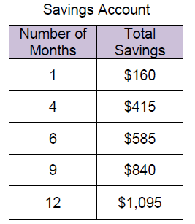

Part A. Graph the relationship on a coordinate plane.
Part B. If the new Smart TV costs $1500 and tax will be $110, approximately how many more months does he need to save money in order to make the purchase?

Instructional Task 2 (MTR.3.1, MTR.4.1)
Part A. Graph $y=.25x-3.5$ on the coordinate plane.
Part B. Discuss with a partner your method of graphing the equation of the line.

Instructional Items
Instructional Item 1
Graph $y=x-2$ on the coordinate plane.

Instructional Item 2
Supplies for the car wash cost $25. The booster club is charging $10 per car. Graph the relationship between the amount of money earned and the number of cars washed.

Instructional Item 3
The table shown represents a linear relationship. Use the table to graph the relationship.

$$x$$ | $$y$$
$$-1$$ | $$2$$
$$0$$ | $$0$$
$$1$$ | $$-2$$
$$2$$ | $$-4$$

*The strategies, tasks and items included in the B1G-M are examples and should not be considered comprehensive.

MA.8.AR.3.5

Benchmark
MA.8.AR.3.5 Given a real-world context, determine and interpret the slope and $y$-intercept of a two-variable linear equation from a written description, a table, a graph or an equation in slope-intercept form.
Example: Raul bought a palm tree to plant at his house. He records the growth over many months and creates the equation $h=0.21m+4.9$, where $h$ is the height of the palm tree in feet and $m$ is the number of months. Interpret the slope and $y$-intercept from his equation.

Benchmark Clarifications:
Clarification 1: Problems include conversions with temperature and equations of lines of fit in scatter plots.

Connecting Benchmarks/Horizontal Alignment
- MA.8.AR.3.2, MA.8.AR.3.3
- MA,8.AR.4.1, MA.8.AR.4.2, MA.8.AR.4.3
- MA.8.F.1.3
- MA.8.DP.1.3

Terms from the K-12 Glossary
- Intercept
- Linear Equation
- Slope

Vertical Alignment
Previous Benchmarks  - MA.7.AR.4.5 | Next Benchmarks  - MA.912.AR.2.5  - MA.912.F.1.5
Purpose and Instructional Strategies
In grade 7, students solved real-world problems involving proportional relationships. In grade 8, students interpret the slope and $y$-intercept of a two-variable linear equation within a real-world context when given a written description, a table, a graph or an equation. In Algebra 1, students will solve mathematical and real-world problems that are modeled by linear functions and will interpret key features of the graph in terms of the context.
- The purpose of this benchmark is to focus on interpreting the slope and $y$-intercept in a real-world context using information from a table, graph or written description.
- Students identify the rate of change (slope) and initial value ($y$-intercept) from tables, graphs, equations or verbal descriptions. Students recognize that if the value $x=0$ is in a table, the $y$-intercept is the corresponding $y$-value. Otherwise, the $y$-intercept can be found by substituting a point and the slope into the slope-intercept form of the equation and solving for the $y$-intercept. The slope can be determined by finding the ratio between the change in two $y$-values and the change between the two-corresponding $x$-values.
- Using graphs, students identify the $y$-intercept as the point where the line crosses the $y$-axis and the slope as the vertical change divided by the horizontal change. In a linear equation, the coefficient of $x$ is the slope and the constant is the $y$-intercept. Students should have practice with equations in formats other than $y=mx+b$, such as $y=ax+b$ or $y=b+mx$.
- Instruction includes using a variety of vocabulary to make connections to real-world concepts and future courses. To describe the slope, one can say either “the vertical change divided by the horizontal change” or “rise over run.”
- In contextual situations, the $y$-intercept is generally the starting value or the value in the situation when the independent variable is 0.
- The slope is the rate of change that occurs in the problem. Rates of change can often occur over years. In these situations, it is helpful for the years to be "converted" to the number of years since the start year.
  - For example, the years of 1960, 1970, and 1980 could be represented as 0 for 1960, 10 for 1970 and 20 for 1980.
- Students use the slope and $y$-intercept to write a linear function in the form $y=mx+b$.
- Students should remember to interpret the line of fit within the context of the data provided by the scatter plot (MA.8.DP.1.3). The line of fit is meant to understand the general trend of data, but it might not be able to explain everything about it.
- For mastery of this benchmark, it is not the expectation to compare slopes or $y$-intercepts of two linear equations in two variables.
- Instruction includes learning about linear relationships within other content areas. Students should recognize that the conversion between Fahrenheit and Celsius represents a linear relationship, but not a proportional one. Memorization of the formulas is not an expectation of the benchmark.
  - The formula for converting Fahrenheit to Celsius is: $C=\frac{5}{9}(F-32).$
  - The formula for converting Celsius to Fahrenheit is:$F=\frac{9}{5}C+32.$

Common Misconceptions or Errors
- Students may incorrectly identify the slope and $y$-intercept.
- Students may incorrectly interpret the slope and $y$-intercept.
- The misconceptions of this benchmark may develop for some students based on the real-world context of the problems presented. To address this misconception, scaffold questions to help students understand the context.

Strategies to Support Tiered Instruction
- Teacher supports students who incorrectly identify the values for the slope and $y$-intercept by providing opportunities for students to notice patterns between a given value for $b$, a line graphed on the coordinate plane, and a given equation of the same line.
- Teacher supports students who incorrectly calculate the slope by inverting the change in $y$ and the change in $x$ using error analysis tasks, in which the expression $\frac{y_{2}-y_{1}}{x_{2}-x_{1}}$is incorrectly written as $\frac{x_{2}-x_{1}}{y_{2}-y_{1}}$, and have students find and correct the error.
- Teacher co-creates an anchor chart naming the slope and $y$-intercept of a given line and then discusses where to start when graphing the line.
- Teacher provides graphs and equations of several linear equations then co-illustrates connections between the slopes and $y$-intercepts of each line to the corresponding parts of each equation using the same color highlights.
- Instruction includes utilizing a three-read strategy. Students read the problem three different times, each with a different purpose.
  - First, read the problem with the purpose of answering the question: What is the problem, context, or story about?
  - Second, read the problem with the purpose of answering the question: What are we trying to find out?
  - Third, read the problem with the purpose of answering the question: What information is important in the problem?

Instructional Tasks
Instructional Task 1 (MTR.7.1)
The graph below shows a scatter plot and its line of fit for data collected on the height and foot length of a sample of 10 male students.

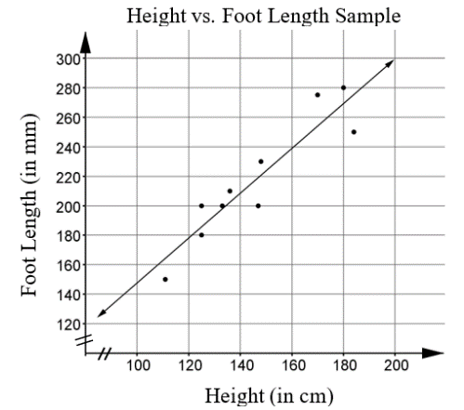
Part A. What does the graph indicate about the relationship between foot length and height?
Part B. The equation of the line of fit is $f=1.5 h–4.3$, where $f$ is foot length in millimeters and $h$ is height in centimeters. Explain the meaning of the slope and the $f$-intercept of this equation in the context of the data.

Instructional Items
Instructional Item 1
At Stay-a-While Coffee shop, they display their internet fees on a chart like the one shown below. Determine the slope for the relationship between the number of minutes, $x$, and the amount charged, $y$.

Time | Amount Charged
1 hour | $3.95
2 hours | $6.95
4 hours | $12.95

Instructional Item 2
Joshua adopted a puppy from a dog shelter. He records the puppy’s height over many months and creates the equation $h=\frac{m}{5}+3$, where $h$ is the height of the puppy, in feet, and $m$ is the number of months. Interpret the slope and $h$-intercept from his equation.

*The strategies, tasks and items included in the B1G-M are examples and should not be considered comprehensive.

MA.8.AR.4 Develop an understanding of two-variable systems of equations.

MA.8.AR.4.1

Benchmark
MA.8.AR.4.1 Given a system of two linear equations and a specified set of possible solutions, determine which ordered pairs satisfy the system of linear equations.
Benchmark Clarifications:
Clarification 1: Instruction focuses on the understanding that a solution to a system of equations satisfies both linear equations simultaneously.

Connecting Benchmarks/Horizontal Alignment
- MA.8.AR.2.1
- MA.8.AR.3.5
- MA.8.AR.4.2, MA.8.AR.4.3

Terms from the K-12 Glossary
- Linear Equation

Vertical Alignment
Previous Benchmarks  - MA.7.AR.4.2, MA.7.AR.4.3 | Next Benchmarks  - MA.912.AR.9.1
Purpose and Instructional Strategies
In grade 7, students determined constants of proportionality and graphed proportional relationships from a table, equation or a written description given in a mathematical or real-world context. In grade 8, students extend this learning to systems of two linear equations to determine possible solutions from a specified set of ordered pairs. In Algebra 1, students will write and solve a system of two-variable linear equations algebraically and graphically given a mathematical or real-world context.
- The focus of this benchmark is on the understanding that the solution of a system is a set of points that satisfy both equations of the system.
- Systems of linear equations can have one solution, infinitely many solutions or no solutions.
  - A system of linear equations whose graphs meet at one point (intersecting lines) has only one solution, the ordered pair representing the point of intersection.
  - A system of linear equations whose graphs are coincident (the same line) has infinitely many solutions, the set of ordered pairs representing all the points on the line.
  - A system of linear equations whose graphs do not meet (parallel lines) has no solutions and the slopes of these lines are the same. The technical name for these kinds of systems is "inconsistent".
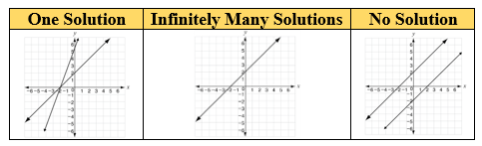
- A system of linear equations is two linear equations that should be solved at the same time.
- Instruction includes understanding that systems are on the same coordinate plane to determine solutions (MTR.4.1).

Common Misconceptions or Errors
  - Students may incorrectly substitute solutions into the equations. To address this misconception, remediate work with integers.
  - Students may not understand how a pair of values can be a single solution to a pair of equations. Emphasize the connection between the two variables in the equations and the two coordinates of the point on the coordinate plane.

Strategies to Support Tiered Instruction
- Instruction includes drawing connections between systems of equations represented graphically and with equations. Using a graphic organizer, reinforce the solution to a system of equations as the ordered pair that satisfies both equations simultaneously.
  - When there is one solution, the two lines intersect at one point and when using substitution, the coordinates of that one point will result in true statements for both equations.
  - When there is no solution, the two lines do not intersect and therefore there are no coordinates that will result in true statements for both equations.
  - When there are infinite solutions, the two lines coincide and intersect with an infinite number of points. When using substitution, all the points on the lines will result in true statements for both equations.
- Teacher provides opportunities to utilize manipulatives when substituting values into given equations to help visualize evaluating operations with integers.
    - $4+3$, both positive, sum is positive. When the signs are the same the counters would be the same color, so add them.
    - $-4+3$, different signs, more negative counters, the sum is negative.
    - $-4+(-3)$, both negative signs, the sum is negative.
    - $4+(-3)$, different signs, more positive counters, the sum is positive.
- Teacher provides scaffolding opportunities by first having students identify which value in each ordered pair represents the $x$-coordinate and which represents the $y$-coordinate. Once students correctly identify the coordinates, the teacher provides opportunities to use substitution to replace the variables in the provided equations with the correct value. Finally, students evaluate each equation to determine if the provided coordinates result in true statements or not.
- Instruction includes remediating work with integers for students that incorrectly substitute solutions into the equations.

Instructional Tasks
Instructional Task 1 (MTR.7.1, MTR 6.1)
The students in Mr. Cruz's Algebra class were determining the solution of a system of equations and determined what they believe are possible solutions. When Mr. Cruz checked their solutions, each of the students had a different set of points. Determine which student has the correct solution and explain why the other student's answers are not correct.

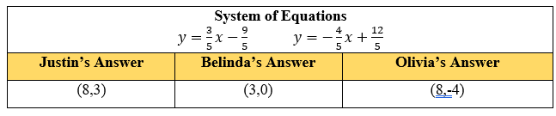

Instructional Items
Instructional Item 1
Determine which of the following points are a solution(s) of the given system of equations.
$$2x-8=y -x+1=y$$

- $\left(2, 2\right)$
- $\left(3, 2\right)$
- $\left(0, 2\right)$
- $\left(3, -2\right)$
- $(3, 3)$

*The strategies, tasks and items included in the B1G-M are examples and should not be considered comprehensive.

MA.8.AR.4.2

Benchmark
MA.8.AR.4.2 Given a system of two linear equations represented graphically on the same coordinate plane, determine whether there is one solution, no solution or infinitely many solutions.

Connecting Benchmarks/Horizontal Alignment
- MA.8.AR.2.1
- MA.8.AR.3.4, MA.8.AR.3.5
- MA.8.AR.4.1, MA.8.AR.4.3

Terms from the K-12 Glossary
- Linear Equation

Vertical Alignment
Previous Benchmarks  - MA.7.AR.4.3, MA.7.AR.4.4, MA.7.AR.4.5 | Next Benchmarks  - MA.912.AR.9.1, MA.912.AR.9.4
Purpose and Instructional Strategies
In grade 7, students determined constants of proportionality and graphed proportional relationships from a table, equation or a written description given in a mathematical or real-world context. In grade 8, students extend this learning to a system of two linear equations represented graphically on the same coordinate plane then students will determine whether there is one solution, no solution or infinitely many solutions. In high school, students will write and solve a system of two-variable linear equations algebraically and graphically given a mathematical or real-world context.
- The focus of this benchmark is on the understanding that the solution of a system is a set of points that satisfy both equations of the system.
- Systems of linear equations can have one solution, infinitely many solutions or no solutions.
  - A system of linear equations whose graphs meet at one point (intersecting lines) has only one solution, the ordered pair representing the point of intersection.
  - A system of linear equations whose graphs are coincident (the same line) has infinitely many solutions, the set of ordered pairs representing all the points on the line.
  - A system of linear equations whose graphs do not meet (parallel lines) has no solutions and the slopes of these lines are the same. The technical name for these kinds of systems is "inconsistent.”

One Solution | Infinitely Many Solutions | No Solution
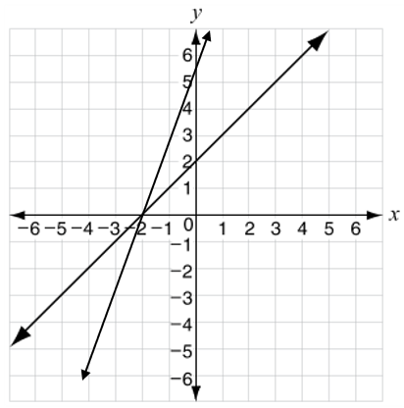 | 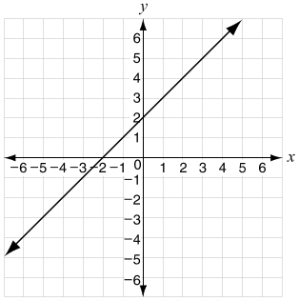 | 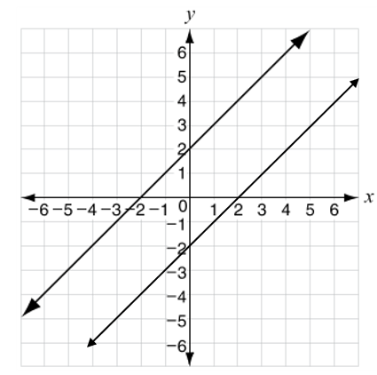

- A system of linear equations is two linear equations that should be solved at the same time.
- Instruction includes understanding that systems are on the same coordinate plane to determine solutions (MTR.4.1).

Common Misconceptions or Errors
  - Students may incorrectly interpret the solution when the lines are the same and have an infinite number of solutions. To address this misconception, provide multiple examples to show how the equations and graphs will be the same line on the coordinate plane.

Strategies to Support Tiered Instruction
- Instruction includes testing possible solutions for a given system of linear equations to demonstrate whether the equations have the same solution set, one common solution (only one ordered pair) or no common solution.
- Instruction includes drawing connections between systems of equations represented graphically and with equations. Using a graphic organizer, reinforce the solution to a system of equations as the ordered pair that stratifies both equations simultaneously.
- When there is one solution, the two lines intersect at one point and when using substitution, the coordinates of that one point will result in true statements for both equations.
- When there is no solution, the two lines do not intersect and therefore there are no coordinates that will result in true statements for both equations.
- When there are infinite solutions, the two lines coincide and intersect with an infinite number of points. When substituting ordered pairs, all will result in true statements for both equations.

Instructional Tasks
Instructional Task 1 (MTR.6.1)
Ashley looks at the following system of equations. She concludes that because there is no $y$-intercept value, the lines cannot intersect.
$y = -\frac{1}{2}x$ $y =\frac{1}{3}x$
Part A. Graph the system of equations on a coordinate plane.
Part B. Is Ashley's conclusion correct? Explain your answer and support your reasoning with mathematical examples.
Instructional Task 2 (MTR.3.1)
Part A. Identify the solution of the graphed system of equations. Explain why it is the solution.

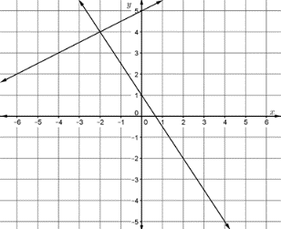

Part B. Identify the solution of the graphed system of equations. Explain how you know it is the solution. What conjecture can you make about parallel lines?

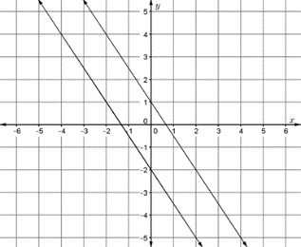

Instructional Items
Instructional Item 1
Determine the number of solutions of each graphed system of linear equations, A, B and C.

System A | System B | System C
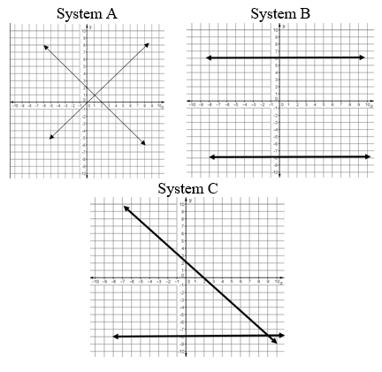
*The strategies, tasks and items included in the B1G-M are examples and should not be considered comprehensive.

MA.8.AR.4.3

Benchmark
MA.8.AR.4.3 Given a mathematical or real-world context, solve systems of two linear equations by graphing.
Benchmark Clarifications:
Clarification 1: Instruction includes approximating non-integer solutions.
Clarification 2: Within this benchmark, it is the expectation to represent systems of linear equations in slope-intercept form only.
Clarification 3: Instruction includes recognizing that parallel lines have the same slope.

Connecting Benchmarks/Horizontal Alignment
- MA.8.AR.3.4, MA.8.AR.3.5
- MA.8.AR.4.1, MA.8.AR.4.2

Terms from the K-12 Glossary
- Linear Equation

Vertical Alignment
Previous Benchmarks  - MA.7.AR.4.3, MA.7.AR.4.4, MA.7.AR.4.5 | Next Benchmarks  - MA.912.AR.9.1, MA.912.AR.9.6
Purpose and Instructional Strategies
In grade 7, students determined constants of proportionality and graphed proportional relationships from a table, equation or a written description given in a mathematical or real-world context. In grade 8, students extend this learning to a system of two linear equations and graphing the system on the same coordinate plane then students may determine whether there is one solution, no solution or infinitely many solutions. In Algebra 1, students will write and solve a system of two-variable linear equations algebraically and graphically given a mathematical or real-world context.
- Systems of linear equations can have one solution, infinitely many solutions or no solutions.
  - A system of linear equations whose graphs meet at one point (intersecting lines) has only one solution, the ordered pair representing the point of intersection.
  - A system of linear equations whose graphs are coincident (the same line) has infinitely many solutions, the set of ordered pairs representing all the points on the line.
  - A system of linear equations whose graphs do not meet (parallel lines) has no solutions and the slopes of these lines are the same. The technical name for these kinds of systems is "inconsistent.”

One Solution | Infinitely Many Solutions | No Solution

- A system of linear equations is two linear equations that should be solved at the same time. Instruction includes understanding that systems are on the same coordinate plane to determine solutions (MTR.4.1).
- The purpose of this benchmark is to focus on graphing to solve the system of equations. This allows for the visual representation of what the solution means in context (MTR.7.1).
- Instruction includes recognizing when the system does not have a solution: if there are two distinct lines, but the slopes of the two lines are the same, then the result is a pair of parallel lines. This could be modeled on a graph on paper or through an online resource to support students being able to visualize the lines.

Common Misconceptions or Errors
- Students make errors in plotting points and graphing lines on the coordinate plane, leading to incorrect solutions. To address this misconception, use graph paper, a printed coordinate plane or an online tool for graphing.
- Students incorrectly identify the solution to equations of the same line by stating only the graphed points are the solution set.
  - For example, in the system below with the infinitely many solutions, students may incorrectly not identify $(7, 9)$ as a solution because it is not a point graphed on the coordinate plane.

Strategies to Support Tiered Instruction
- Instruction includes the use of graph paper, a printed coordinate plane, or an online tool for graphing.
- Teacher provides opportunities for students to comprehend the context or situation by engaging in questions.
  - What do you know from the problem?
  - What is the problem asking you to find?
  - Can you create a visual model to help you understand or see patterns in your problem?
- Instruction includes drawing connections between systems of equations represented graphically and with equations. Using a graphic organizer, reinforce the solution to a system of equation as the ordered pair that satisfies both equations simultaneously.
- When there is one solution, the two lines intersect at one point and when using substitution, the coordinates of that one point will result in true statements for both equations.
- When there is no solution, the two lines do not intersect and therefore there are no coordinates that will result in true statements for both equations.
- When there are infinite solutions, the two lines coincide and intersect with an infinite number of points. When using substitution, all the points on the lines will result in true statements for both equations.
- Instruction includes the use of a three-read strategy. Students read the problem three different times, each with a different purpose.
- First, read the problem with the purpose of answering the question: What is the problem, context, or story about?
- Second, read the problem with the purpose of answering the question: What are we trying to find out?
- Third, read the problem with the purpose of answering the question: What information is important in the problem?

Instructional Tasks
Instructional Task 1 (MTR.6.1)
Part A. Graph the line $y=2x+2.5$ on a coordinate plane. Draw two other lines with the same slope but different $y$-intercepts.
Part B. Compare the lines graphed in part A. What do you notice about the other two lines when compared to the given line?

Instructional Items
Instructional Item 1
Solve the system of linear equations by graphing.

$y=x+5$ $y=3x-3$

Instructional Item 2
Solve the system of linear equations by graphing.

$$y=-\frac{3}{4}x+5 y=-4x - 2$$

Instructional Item 3
Solve the system of linear equations by graphing.

$y=2x+6$ $y=2x –4.2$

Instructional Item 4
Solve the system of linear equations by graphing.

$y=-1.5x+2$ $y=2-\frac{3}{2}x$

*The strategies, tasks and items included in the B1G-M are examples and should not be considered comprehensive

Functions

MA.8.F.1 Define, evaluate and compare functions..

MA.8.F.1.1

Benchmark
MA.8.F.1.1 Given a set of ordered pairs, a table, a graph or mapping diagram, determine whether the relationship is a function. Identify the domain and range of the relation.
Benchmark Clarifications:
Clarification 1: Instruction includes referring to the input as the independent variable and the output as the dependent variable.
Clarification 2: Within this benchmark, it is the expectation to represent domain and range as a list of numbers or as an inequality.

Connecting Benchmarks/Horizontal Alignment
- MA.8.AR.3.2, MA.8.AR.3.3
- MA.8.F.1.2, MA.8.F.1.3

Terms from the K-12 Glossary
- Domain
- Function
- Range

Vertical Alignment
Previous Benchmarks  - MA.7.AR.4.1, MA.7.AR.4.2, MA.7.AR.4.3 | Next Benchmarks  - MA.912.F.1.1, MA.912.F.1.2
Purpose and Instructional Strategies
In grade 7, students determined whether two quantities have a proportional relationship by examining a table, graph or written description and they determined the constant of proportionality. In grade 8, students work with linear equations with two variables and begin the introduction of functions. In Algebra 1, students will classify the function type and represent it using function notation.
- A mapping diagram consists of a list of $x$-values and their corresponding $y$-values shown with an arrow.
  - An example of a mapping diagram can include domain and range values or $x$- and $y$-values.
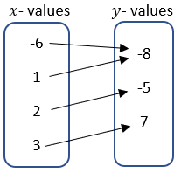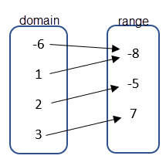
- The “vertical line test” should be treated with caution because (1) it allows you to apply a rule without thinking and (2) it may create misconceptions for later mathematics.
- Vocabulary is important in this benchmark as it connects to future learning related to domain and range.
- Students should explain how they verified if the given context was a function or non-function (MTR.4.1). Students should provide counterexamples to deepen their knowledge of the relationships in functions.
  - For example, students can be asked to create $x$- and $y$-values that create relations that are functions and non-functions.

Functions | Non-Functions
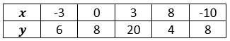  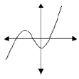  $$\left(4, 12\right), \left(5, 15\right), \left(6, 18\right), \left(7,21\right), (8,24)$$ | 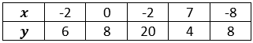  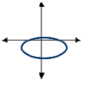  $$\left(4, 12\right), \left(4, 15\right), \left(5, 18\right), \left(5, 21\right), (6, 24)$$  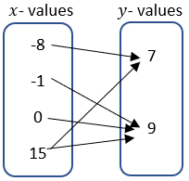

- Domain and range can be shown as a list, an inequality or as a verbal description depending on how the relation is given. The inequalities can be represented as inclusive or non-inclusive as determined by the context.
  - For example, if a graph represents a real-world context, with non-negative values, with the equation $y=6x+5$, the domain and range can be described as below.
    - List
A list cannot be used to represent this relation because it has infinitely many values.
    - Inequality
Domain: $x≥0$; Range: $y≥5$
    - Verbal Description
The domain is all real numbers that are greater than or equal to zero. The range is all real numbers that are greater than or equal to five.
  - For example, for the relation {$\left(4, 12\right), \left(5, 15\right), \left(6, 18\right), \left(7,21\right), (8,24)\}$, the domain and range can be described as below.
    - List
Domain: {4, 5, 6, 7, 8}; Range: {12, 15, 18, 21, 24}
    - Inequality
An inequality, such as $4≤x≤8$, cannot be used to represent this relation because it is based on a discrete set of values.
    - Verbal Description
The domain is all whole numbers from four to eight, inclusive. The range is the multiples of three from 12 to 24, inclusive.

Common Misconceptions or Errors
  - Students may invert the terms independent and dependent variable. To address this misconception, focus on the vocabulary and relationship to the input and output.

Strategies to Support Tiered Instruction
- Teacher reviews vocabulary and the difference between the terms. Once students understand that independent variables represent the input of the relation, they can make sense of real-world problems to accurately identify independent and dependent variables.
  - For example, in a scientific experiment one can determine that the input is the variable controlled by the scientist. So, the independent variable is the one controlled in the experiment and the dependent is the result of the experiment.
- Teacher creates a matching activity with real-world situations. Students match the dependent variable and independent variable for the situation. Teacher facilitates discussion among students on their reasoning behind their matches from the activity in order to clear up any lingering misconceptions.
- Instruction includes helping students see how no number within the domain is repeated when the relationship is a function.

Instructional Tasks
Instructional Task 1 (MTR.4.1)
A relation is shown below where $x$ represents the independent variable and $y$ represents the dependent variable.
$$\left(3, 4\right), \left(-2, 3\right), \left(7, 1\right), \left(-\frac{1}{2}, 4\right), \left(-2,\frac{1}{2}\right)$$
Part A. Create a mapping diagram, table and graph to represent this relation.
Part B. Determine the domain and range of the relation.
Part C. Determine if the relation represents a function or does not represent a function and justify your decision.
Part D. If the relation is not a function, which point could be removed to make it a function? If it is a function, add a point that would no longer make it a function.

Instructional Items
Instructional Item 1
A relation is shown in the table below where $x$ represents the independent variable and $y$ represents the dependent variable. Decide whether the table can represent a function or cannot represent a function.
$$x$$ | $$y$$
4 | 12
-1 | -3
0 | -4
-5 | -21
1 | -3
4 | 12
-2 | 0
Instructional Item 2
Identify the domain and range for the relation {$(3, 8), (2, 3), (1, 0), (0,-1), (-1, 0)\}$.

*The strategies, tasks and items included in the B1G-M are examples and should not be considered comprehensive.

MA.8.F.1.2

Benchmark
MA.8.F.1.2 Given a function defined by a graph or an equation, determine whether the function is a linear function. Given an input-output table, determine whether it could represent a linear function.
Benchmark Clarifications:
Clarification 1: Instruction includes recognizing that a table may not determine a function.

Connecting Benchmarks/Horizontal Alignment
- MA.8.AR.3.1
- MA.8.F.1.1, MA.8.F.1.3

Terms from the K-12 Glossary
- Function
- Linear Function

Vertical Alignment
Previous Benchmarks  - MA.7.AR.4.1 | Next Benchmarks  - MA. 912.F.1.1, MA.912.F.1.6
Purpose and Instructional Strategies
In grade 7, students determined whether a relationship was proportional, given a table, equation or written description. In grade 8, students determine whether the function defined by a graph or an equation is a linear function. In Algebra 1, students will classify the function type given an equation or graph and compare key features of linear and nonlinear functions.
- Instruction includes determining if the function has a constant rate of change between the $x$- and $y$-values.
  - For example, students can depict the rate of change between the values in a table like below.

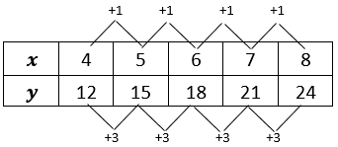

- Instruction includes a focus on the connection between the equation and the graph.
- Students should develop an understanding of a linear function by using examples and non-examples.
Examples | Non-Examples
  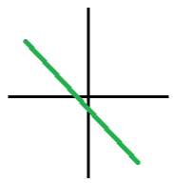  $$y=2x+5$$  $$y=9$$  $$y=\frac{1}{2}x$$  $$2y-3=8$$  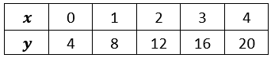 | 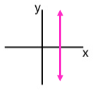  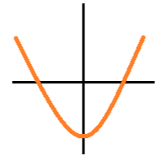  $$y=2x^{2}+5$$  $$x=9$$  $$y=\frac{1}{2}x^{3}$$  $$2x-3=8$$  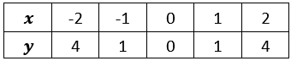

Common Misconceptions or Errors
  - Students may not understand the connection from a table to the visual of a graph of the same function. To address this misconception, provide opportunities for students to make connections and see the graph and table side by side.

Strategies to Support Tiered Instruction
- Teacher models how to get from a set of points displayed on a table to the points graphed on a coordinate plane, and how points from a coordinate plan can be written in a table. Then, the teacher provides opportunities to notice any patterns in the graph or table that will help identify if the function is linear.
- Teacher co-creates s a graph from a table with students, as well as a table from a graph to increase understanding of the relationship between the two. Once students become comfortable moving between graphs and tables, students can begin inspecting tables that represent functions. Teachers can review proportional and linear relationships and work with students to dissect tables to find if they contain a proportional relationship, meaning they are linear. Students should note that not all linear relationships are proportional, but all proportional relationships are linear.
- Teacher provides opportunities for students to make connections and see the graph and table of the same function side by side.

Instructional Tasks
Instructional Task 1 (MTR.6.1)
The area, $A$, of an isosceles right triangle is a function of the length of its legs, $s$, and is represented by the equation $A=0.5s^{2}$.
Part A. Create a table of values to represent this function.
Part B. Plot the points on a coordinate plane.
Part C. What is the domain and range of the function?
Part D. Is this function linear or nonlinear? Explain and justify your answer.
Instructional Task 2 (MTR.2.1)
Part A. Create a table that could represent a linear function.
Part B. Create a table that could represent a non-linear function.
Part C. Compare your table from Part B with a partner.

Instructional Items
Instructional Item 1
Taro and Jiro climbed a mountain and hiked back down. At the summit and at every station along the way back down, they recorded their altitude and the amount of time they had been traveling. Can the data in the table represent a linear function?

Time Traveled (in minutes) | Altitude (in meters)
0 | 3776
$$29\frac{1}{3}$$ | 3600
126 | 3020
$$179\frac{1}{3}$$ | 2700
231 | 2390

Instructional Item 2
Does the graph below represent a linear function? If so, justify your answer.

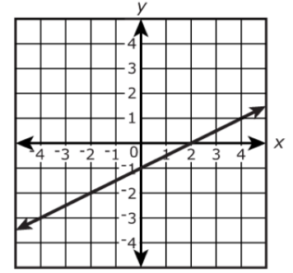

*The strategies, tasks and items included in the B1G-M are examples and should not be considered comprehensive.

MA.8.F.1.3

Benchmark
MA.8.F.1.3 Analyze a real-world written description or graphical representation of a functional relationship between two quantities and identify where the function is increasing, decreasing or constant.
Benchmark Clarifications:
Clarification 1: Problem types are limited to continuous functions.
Clarification 2: Analysis includes writing a description of a graphical representation or sketching a graph from a written description.

Connecting Benchmarks/Horizontal Alignment
- MA.8.AR.3.5
- MA.8.F.1.1, MA.8.F.1.2

Terms from the K-12 Glossary
- Function

Vertical Alignment
Previous Benchmarks  - MA.7.AR.4.2 | Next Benchmarks  - MA. 912.F.1.5, MA.912.F.1.
Purpose and Instructional Strategies
In grade 7, students determined one of the key features of a proportional relationship, its constant of proportionality, from its graph. In grade 8, students determine where a function is increasing or decreasing from its graph. In Algebra 1, students will compare key features of linear and nonlinear functions represented algebraically, graphically, in tables or written descriptions.
- Graphs can be described in many ways. Using knowledge of functions, equations, and graphs, students should be able to describe a graph in words and should be able to draw a graph if given a qualitative description.
- When working with graphs, instruction includes students reasoning through asking questions such as:
- Does the graph represent a function?
- Does the graph show increase, decrease, both, or neither?
- Are there intervals of the domain in which the graph shows that the function increases, decreases, or stays constant?
- Does the graph represent a linear function?
- What is the (approximate) slope of a given interval within the graph?
- Students should be given opportunities to analyze graphs individually and with others (MTR.4.1).
- When sketching a graph based on a written description, students may use curved or straight lines to represent portions of increase or decrease based on the description.
- Problems where students are creating a graph are not expected to differentiate between linear and nonlinear functions to represent the written description.
  - For example, if the description has a rapid increase, a student can sketch a curve that increases rapidly or a straight line with a steep slope.
  - For example, in grade 8 students are not expected to recognize curves that represent exponential growth or decay.

Common Misconceptions or Errors
- Students may invert domain and range.
- Students may incorrectly describe increasing, decreasing or constant intervals using elements outside of the domain.

Strategies to Support Tiered Instruction
- Teacher reviews vocabulary and the difference between the terms. Once students understand that domain represents the input variable (independent variable), they can make sense of real-world problems to accurately identify domain and range.
- Teacher poses questions to encourage discourse to gain information about graphs. Students have the opportunity to discuss what they see and know from the graph and have the ability to make inferences about its description.
- Instruction includes providing real-world situations and having the students identify domain and range for the situation, giving justification as to their reasoning. Students can create their own situation and identify the domain and range for their situation.
- Teacher provides examples of different characteristics of graphs. Once students can identify basic attributes of the graphs, they can begin to reason through more specific questions about each graph.
  - For example, describing if the graph is increasing or decreasing, if the graph is a linear function, if the graph is a function, what is the slope of the graph (if linear), etc.
- Instruction includes creating an anchor chart with students describing increasing, decreasing, or constant graph.

Instructional Tasks
Instructional Task 1 (MTR.6.1)
The graph describes the number of bacteria in a culture over time.

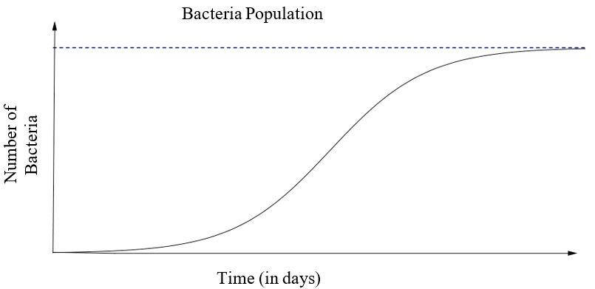

Describe in detail the relationship between the number of bacteria in the culture and time. Include where it is increasing, decreasing or remaining constant.

Instructional Items
Instructional Item 1
Sketch a graph of the representation described below.
Madison is studying the growth of bacteria in food and learned it has four phases. Label the axes and show a graph of the four stages, assuming an initial bacterium count of 50.
Phase 1: No growth in the number of cells for the first hour.
Phase 2: Rapid growth in the number of bacteria for the next two hours.
Phase 3: Growth stops for one hour as nutrients are used up and waste accumulates.
Phase 4: All bacteria gradually die off during the final four-hour phase.
*The strategies, tasks and items included in the B1G-M are examples and should not be considered comprehensive.

Geometric Reasoning

MA.8.GR.1 Develop an understanding of the Pythagorean Theorem and angle relationships involving triangles.

MA.8.GR.1.1

Benchmark
MA.8.GR.1.1 Apply the Pythagorean Theorem to solve mathematical and real-world problems involving unknown side lengths in right triangles.
Benchmark Clarifications:
Clarification 1: Instruction includes exploring right triangles with natural-number side lengths to illustrate the Pythagorean Theorem.
Clarification 2: Within this benchmark, the expectation is to memorize the Pythagorean Theorem.
Clarification 3: Radicands are limited to whole numbers up to 225.

Connecting Benchmarks/Horizontal Alignment
- MA.8.NSO.1.1, MA.8.NSO.1.2, MA.8.NSO.1.7
- MA.8.AR.2.3

Terms from the K-12 Glossary
- Pythagorean Theorem
- Converse of Pythagorean Theorem
- Hypotenuse

Vertical Alignment
Previous Benchmarks  - MA.6.GR.2.1 | Next Benchmarks  - MA.912.GR. 1.3  - MA.912.GR.7.2  - MA.912.T.1.2

Purpose and Instructional Strategies
In grade 6, students worked with right triangles, with a focus on how the area of a right triangle is determined by its side lengths. In grade 8, students use the Pythagorean Theorem to determine the side lengths of right triangles. In Geometry, students will use trigonometry to continue their work with right triangles and extend their understanding of the Pythagorean Theorem to create the equation of a circle.
- While it is not the expectation of this benchmark, instruction includes building an understanding of the Pythagorean Theorem ($a^{2}+b^{2}=c^{2}$) by proving it in various ways. Many of them connect the side lengths of right triangles to the areas of associated squares.
  - Instruction includes using exploration activities that allow students to see how to use areas of squares to find missing sides. Students can use grid paper to draw right triangles from given measures and represent and compute the areas of the squares on each side. Below is an example of what students can visualize to understand the conceptual understanding within the Pythagorean Theorem.
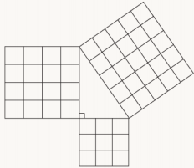

  - Data can be recorded in a chart such as the one below, allowing for students to conjecture about the relationship among the areas of squares and side lengths of right triangles.

Triangle | Measure of Leg 1 | Measure of Leg 2 | Area of Square on Leg 1 | Area of Square on Leg 2 | Area of Square on Hypotenuse
1
2

- When introducing the Pythagorean Theorem, some students may not be able to visualize the side lengths and the connection to the values of $a$, $b$ and $c$. Using colors to color code the sides and hypotenuse will allow students to see the connection and identify with the $a$, $b$, and $c$ used to represent the sides.
- While solving real-world problems, students should be encouraged to draw diagrams where they can see the right triangles being used. Students will need to understand the ideas within the Triangle Inequality Theorem to help differentiate between the legs and the hypotenuse of a right triangle.

Common Misconceptions or Errors
- Students may make errors in calculations when using the Pythagorean Theorem and finding square roots.
- Students may not be able to spatially visualize triangles within the real-world problems. To address this misconception, instruction includes models for these problems with triangles and drawings to help students orient the ideas within the tasks.
- Students may misidentify the side lengths and hypotenuse when connecting to the formula of $a^{2}+b^{2}=c^{2}$. To support students as they are developing the conceptual understanding of this benchmark, using the idea of ${leg}^{2}+{leg}^{2}={hypotenuse}^{2}$as a transition to using the formula.

Strategies to Support Tiered Instruction
- Instruction includes modeling the differences between doubling and squaring a radius. Doubling a radius would be represented by multiplying the given length, whereas squaring a number would be represented by the area of a square with the given radius.
  - For example, students can be given the table below to show how the left column doubles a length whereas the right column squares a length.
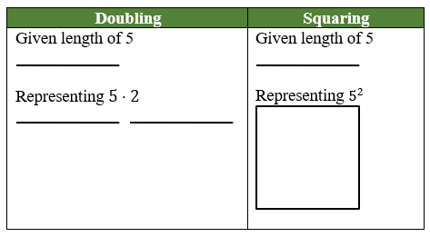

- Teacher co-creates and posts an anchor chart for calculating the Pythagorean Theorem with visuals focused on solving for the variable and finding the square root.
- Instruction includes providing students with the right triangle as a visual in the context of a real-world problem. Teacher provides instruction using the information from the real-world problem to label the visual representation before solving.
- Instruction includes co-creating a graphic organizer for the square root of perfect squares from 0 to 225 to provide students with the opportunity to determine benchmark numbers for non-perfect squares.
- Instruction includes color-coding and labeling a right triangle or a rectangular prism to provide a visual representation of variables, side lengths and hypotenuse.

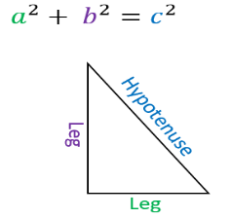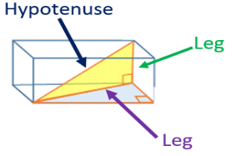

- Instruction includes co-creating a model with students and completing a graphic organizer to make the connection between the side lengths of right triangles to the area of the associated square.
- Instruction includes including time for reviewing solving for variables and finding square roots prior to instruction on this benchmark.
- Instruction includes models for problems with triangles and drawings to help students orient the ideas within the tasks.
- Instruction includes the use of the idea of $l{eg}^{2}+{leg}^{2}={hypotenuse}^{2}$ as a transition to using the formula to assist in developing a conceptual understanding of the benchmark for students that incorrectly identify the side lengths and hypotenuse when connecting the formula of $a^{2}+b^{2}=c^{2}$ (laminating formulas on a printed card for students to utilize as a resource in and out of the classroom would be helpful).

Instructional Tasks
Instructional Task 1 (MTR.2.1, MTR.4.1, MTR.7.1)
The bases on a baseball diamond are 90 feet apart on a standard baseball field.
Part A. Draw a model of the baseball diamond.
Part B. What is the distance, in feet, for the catcher to throw from home plate to second base?
Part C. What is the distance, in feet, from first base to third base?
Instructional Task 2 (MTR.1.1)
You are wrapping a gift for your teacher’s birthday. It is a very long and skinny pencil. You want to wrap it in a box so that your teacher cannot tell what shape it is. Your friend has a shoe box that measures 10 inches by 7 inches by 5 inches.

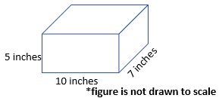

Part A. What questions would still need to be answered to approach this problem? Do you need all the measurements provided in the problem? Explain your answer.
Part B. If the pencil measures 13 inches long, will it fit in the shoe box with the lid closed? Explain your answer.
Part C. What are the possible dimensions of a box that can just barely fit a pencil measuring 9 inches long?

Instructional Items
Instructional Item 1
The bottom of a ladder must be placed 3 feet from a wall. The ladder is 12 feet long. How far above the ground does the ladder touch the wall? Round your answer to the nearest tenth.

Instructional Item 2
Using the figure below, find the value of the length of side $AB$ in meters.

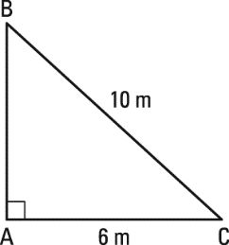

Enrichment Item 1
If a right triangle’s legs are both the same length, $x$, and the hypotenuse of the triangle is 20 feet, what is the value of $x$, in feet? Round your answer to the nearest tenth.

*The strategies, tasks and items included in the B1G-M are examples and should not be considered comprehensive.

MA.8.GR.1.2

Benchmark
MA.8.GR.1.2 Apply the Pythagorean Theorem to solve mathematical and real-world problems involving the distance between two points in a coordinate plane.
Example: The distance between $(-2, 7)$ and $(0, 6)$ can be found by creating a right triangle with the vertex of the right angle at the point $(-2, 6)$. This gives a height of the right triangle as 1 unit and a base of 2 units. Then using the Pythagorean Theorem the distance can be determined from the equation $1^{2}+2^{2}=c^{2}$, which is equivalent to $5=c^{2}$. So, the distance is $\sqrt{5}$ units.

Benchmark Clarifications:
Clarification 1: Instruction includes making connections between distance on the coordinate plane and right triangles.
Clarification 2: Within this benchmark, the expectation is to memorize the Pythagorean Theorem. It is not the expectation to use the distance formula.
Clarification 3: Radicands are limited to whole numbers up to 225.

Connecting Benchmarks/Horizontal Alignment
- MA.8.NSO.1.1, MA.8.NSO.1.2, MA.8.NSO.1.7
- MA.8.AR.2.3

Terms from the K-12 Glossary
- Coordinate
- Coordinate Plane

Vertical Alignment
Previous Benchmarks  - MA.6.GR.1.2, MA.6.GR.1.3 | Next Benchmarks  - MA.912.GR.3.2, MA.912.GR.3.3, MA.912.GR.3.4  - MA.912.GR.7.2  - MA.912.T.1.2

Purpose and Instructional Strategies
In grade 6, students used their understanding of the coordinate plane to plot rational-number ordered pairs in all four quadrants and on both axes, and they found the distances between ordered pairs with the same $x$-coordinate or the same $y$-coordinate represented on the coordinate plane. In grade 8, students find the distance between two points using the Pythagorean Theorem. In Geometry, students will use coordinate geometry to classify or justify definitions, properties and theorems involving circles, triangles or quadrilaterals. Additionally, students will extend this understanding to using coordinate geometry and trigonometry to solve mathematical and real-world problems involving lines, circles, triangles, quadrilaterals and finding the perimeter or area of polygons.
- Instruction includes creating a right triangle from two given points and then using the Pythagorean Theorem to find the distance between the two given points. This work can be started by using Geoboards to see the triangle that is formed within the coordinate plane. Students can show how to make a right triangle using vertical and horizontal lines. From there they can build the area models of the Pythagorean Theorem to support understanding.

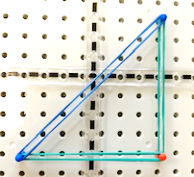

- Students should be given multiple opportunities to see the importance of using the coordinate plane to find the distance between two points.
- Instruction includes providing students with a structure to support the organization of their work since using the Pythagorean Theorem may require multiple steps. Provide students with resources, including the coordinate plane and graph paper, as a way to plan out their work.

Common Misconceptions or Errors
- Students may have the misconception that the Pythagorean Theorem will apply to any triangle.
- Students may invert the $x$- and $y$-value of the point.
- When finding distances that cross over an axis students may incorrectly use operations with integers.
  - For example, if given the points $(-2, 0)$ and $(3, 0)$, students may calculate the distance as 1 unit instead of 5 units.

Strategies to Support Tiered Instruction
- Instruction includes the use of geometric software to explore the Pythagorean Theorem on obtuse, acute and right triangles.
- Instruction includes students adding the absolute value of two x-coordinates or two y-coordinates when the given points cross over an axis.
  - For example, if the given points are $(-4, 8)$ and $(7, 8),$ students will add the absolute value of $-4$ and $7$.
$$\left|-4\right| + \left|7\right|= 11$$
- Teacher provides opportunities for students to comprehend the context or situation by engaging in questions.
  - What do you know from the problem?
  - What is the problem asking you to find?
  - Can you create a visual model to help you understand or see patterns in your problem?
- Instruction includes labeling the $x$- and $y$-value of a coordinate point before graphing to reinforce the process of graphing $x$- and $y$-values.
- Instruction includes laying trace paper on top of a coordinate plane, tracing the points, drawing a number line through the two points, and counting the space between the points to find the distance.
- Teacher co-creates an anchor chart while students create a similar own graphic organizer to include key features of a coordinate plane. Features include the $x$-axis, $y$-axis, origin, quadrants, numbered scales and an ordered pair.
- Instruction includes the use of a three-read strategy. Students read the problem three times, each with a different purpose (laminating these questions on a printed card for students to utilize as a resource in and out of the classroom would be helpful).
- First, read the problem with the purpose of answering the question: What is the problem, context, or story about?
- Second, read the problem with the purpose of answering the question: What are we trying to find out?
- Third, read the problem with the purpose of answering the question: What information is important in the problem?

Instructional Tasks
Instructional Task 1 (MTR.2.1, MTR.7.1)
Pineridge Middle School was given a grant from Home Helper Depot to create a triangular garden along a wall of the cafeteria for fresh vegetables. The length of the hypotenuse and the sides are being determined to see if it will fit in the space. On the model for the garden, the designer started by plotting the points $(2, 2)$ and $(6, 5)$ on a coordinate plane and connected the points with a line. She needs to complete the triangular model and determine all three side lengths.
Part A. Using a coordinate grid, complete the designer's drawing.
Part B. Calculate the side lengths of the triangular garden on the model.
Part C. What would be appropriate lengths for a triangular garden if the length of one side of the building is 20 feet? Use your model to help determine the side lengths.

Instructional Items
Instructional Item 1
On a coordinate plane, plot the points $(-3, 4)$and $(0,-3)$. Using the Pythagorean Theorem, determine the distance between the two points.

Instructional Item 2
Using the Pythagorean Theorem, determine the distance from point $(8,-6)$ to the origin.

*The strategies, tasks and items included in the B1G-M are examples and should not be considered comprehensive.

MA.8.GR.1.3

Benchmark
MA.8.GR.1.3 Use the Triangle Inequality Theorem to determine if a triangle can be formed from a given set of sides. Use the converse of the Pythagorean Theorem to determine if a right triangle can be formed from a given set of sides.

Connecting Benchmarks/Horizontal Alignment
- MA.8.NSO.1.7
- MA.8.AR.2.2
Terms from the K-12 Glossary
- Converse of the Pythagorean Theorem

Vertical Alignment
Previous Benchmarks  - MA.5.GR.1.1 | Next Benchmarks  - MA. 912.GR.1.3

Purpose and Instructional Strategies
In grade 5, students classified triangles based on their angle measures and their side lengths. In grade 8, students use the Triangle Inequality Theorem and Pythagorean Theorem to determine whether triangles, or right triangles, can be formed from a given set of sides. In Geometry, students will extend this understanding to prove relationships and theorems about triangles.
- Instruction includes modeling and drawing triangles with different side lengths to determine if they can make a triangle to help in conceptual understanding. Students can physically construct triangles with manipulatives such as straws, sticks, string or geometry apps prior to using rulers (MTR.2.1).
- Exploration should involve giving students three side measures to determine if a triangle can be made. Through discussion of their exploration results, students should conclude that triangles cannot be formed by any three arbitrary side measures.
  - For example, if students are given 4, 5 and 10, they should conclude that it does not form a triangle.
  - Through charting, students should realize that for a triangle to result, the sum of any two side lengths must be greater than the third side length. This can be charted in a table like the one below.

Length 1 (smallest) | Length 2  (middle) | Length 3 (largest) | Triangle? | $$L1+L2$$

- Once students understand the Triangle Inequality Theorem, they can apply their knowledge to the converse of the Pythagorean Theorem. In work with the previous benchmark, students verify using a model that the sum of the squares of the legs is equal to the square of the hypotenuse in a right triangle. Students should also understand that if the sum of the squares of the 2 smaller legs of a triangle is equal to the square of the third leg, then the triangle is a right triangle.

Common Misconceptions or Errors
- Students may incorrectly think that the Triangle Inequality Theorem only applies to right triangles due to the work with the Pythagorean Theorem. Discussion of the two theorems and examples will help with this misconception.
- Students may incorrectly believe endpoints of the sides of the triangle do not have to meet at a vertex.
  - For example, students will attempt to make a triangle such as the example below.


Strategies to Support Tiered Instruction
- Instruction includes co-creating a graphic organizer to highlight key differences and use of the Pythagorean Theorem and the Triangle Inequality Theorem.
- Instruction includes the use of manipulatives, such as angle legs and geometric software, to allow for students to explore the similarities and differences between the Pythagorean Theorem and the Triangle Inequality Theorem.
- Teacher provides instruction on the definition of a triangle and allows for students to explore various side lengths using geometric software or manipulatives to determine if the lengths form a triangle.

Instructional Tasks
Instructional Task 1 (MTR.6.1, MTR.7.1)
The following side lengths, in meters, were given to a carpenter to build a front porch with a triangular design. The carpenter needs to determine which set of lengths will make a triangle to be able to use it in his design.
Option 1: Side lengths: 4, 4, 8
Option 2: Side lengths: 6, 8, 10
Option 3: Side lengths: 6, 6, 13
Option 4: Side lengths: 5, 6, 10
Part A. Which of the options would create a triangle for his design?
Part B. The homeowner would like the porch to be in the shape of a right triangle. Will the carpenter be able to use any of the given options?
Part C. For any option that does not form a triangle, what side length could be changed to form a triangle? Explain your answer.

Instructional Items
Instructional Item 1
Can the side lengths of a triangle be 2, 4 and 8? Justify your answer.

Instructional Item 2
John drew a triangle with side lengths of 5, 12 and 13. His friend, Bryan, looked at it and asked John if it is a right triangle. John’s response was yes. Explain or show how John can prove to Bryan that the triangle is a right triangle.

*The strategies, tasks and items included in the B1G-M are examples and should not be considered comprehensive.

MA.8.GR.1.4

Benchmark
MA.8.GR.1.4 Solve mathematical problems involving the relationships between supplementary, complementary, vertical or adjacent angles.
Connecting Benchmarks/Horizontal Alignment
- MA.8.AR.2.1

Terms from the K-12 Glossary
- Angle $\left(∠\right)$
- Complementary $\left(∠\right)$
- Supplementary $\left(∠\right)$
- Vertical

Vertical Alignment
Previous Benchmarks  - MA.4.GR.1.1, MA.4.GR.1.2, MA.4.GR.1.3  - MA.5.GR.1.1 | Next Benchmarks  - MA.912.GR.1.1

Purpose and Instructional Strategies
In the elementary grades, students were introduced to acute, right, obtuse, straight reflex angles and solved real-world and mathematical problems involving angle measures. They also used angles to classify triangles and quadrilaterals. In grade 8, students solve problems involving supplementary, complementary, vertical and adjacent angles. In Geometry, students will extend the learning from this benchmark to prove relationships and theorems involving lines and angles.
- This benchmark is foundational to help develop the understanding of angles and connections related to parallel lines cut by a transversal.
- For students to learn relationships between angles, it is important to provide an opportunity to connect complementary and supplementary angles to work with triangles. Students should draw or be given a right triangle to explore rearranging the angles to show both the 90 and 180 degrees that can be created for a right angle and a straight line, respectively.
- To support the concept of adjacent angles, students should have examples and non-examples to write their own definition and revise it based on critiques from others (MTR.4.1). Students should trace each angle with different colors to ensure that there isn’t overlap but has a common side.

Criteria | Example | Non-Example
pair of angles | 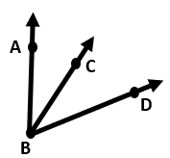 | 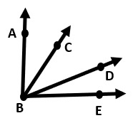
common vertex | 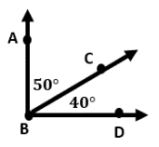 | 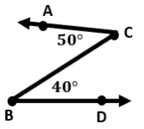
common side | 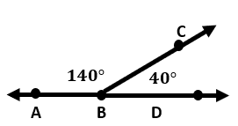 | 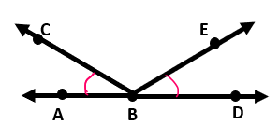
do not overlap | 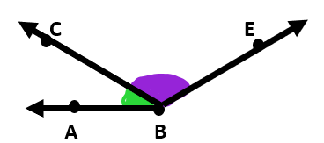 | 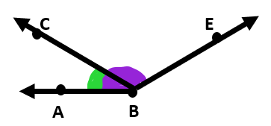

- When discussing vertical angles, use a model of two strips of paper with a small brad at the center where they cross. Then, moving the paper to create different-sized angles, measure each angle to show the vertical angle measures to lead to understanding that the vertical angles will have the same measure.
- Vertical angles can be explored using the same activity as adjacent angles with examples and non-examples. The criteria could include the following:
  - Formed from exactly 2 straight intersecting lines
  - Pair of angles
  - Non-adjacent
  - Common vertex
- Student reasoning can be supported by making statements such as “always true, sometimes true, never true.”
  - For example, a linear pair of angles (a type of adjacent angles) are always supplementary because they form a straight line.
- Once conceptual understanding and definitions are built, introduce algebraic concepts for students to write and solve equations using facts about the angle relationships. Students should be able to generate equations written in different forms.
  - For example, if students are provided the figure below, they can generate multiple equivalent equations to represent their thinking. For this figure, three possible equations are:
$$180=147+2x+3$$  $$180-147=2x+3$$  $$2x+150=180$$ | 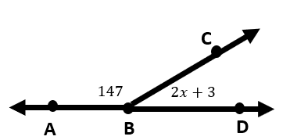

Common Misconceptions or Errors
- Students may invert the definition of complementary and supplementary.

Strategies to Support Tiered Instruction
- Instruction includes co-creating a graphic organizer with students to measure, label and record the angle measurement of two intersecting lines. The teacher facilitates discussion and documents the relationships between different angle pairs.
- Instruction includes erasing or covering part of a line for students to visually see the supplementary angles within two intersecting lines.
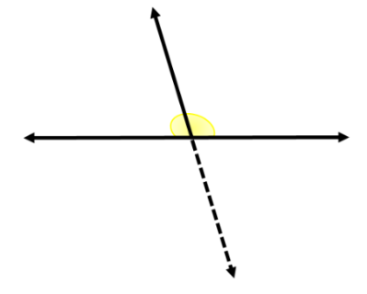

- Instruction includes co-creating a graphic organizer identifying the relationships between supplementary, complementary, vertical, and adjacent angles. Include a strategy for solving problems involving each type of angle pair, such as setting vertical angle measures equal.

Instructional Tasks
Instructional Task 1 (MTR.1.1, MTR.2.1)
Complete the table below that includes the following types of angles:

Angle Pairs | Draw an Example (include points to identify the angles) | Estimate the angle measures
Complementary
Supplementary
Adjacent
Vertical

Instructional Task 2 (MTR.4.1)
Determine if each of the following statements is always true, sometimes true or never true. For each statement that you chose as “sometimes true”, provide an example and non-example.
- The sum of the measures of two supplementary angles is $180°$.
- Vertical angles are also adjacent angles.
- Two adjacent angles are complementary.
- If two lines intersect, each pair of vertical angles are complementary.

Instructional Items
Instructional Item 1
The measure of angle 6 is 43˚ and the measure of angle 7 is 82˚. What is the measure of angle 1?

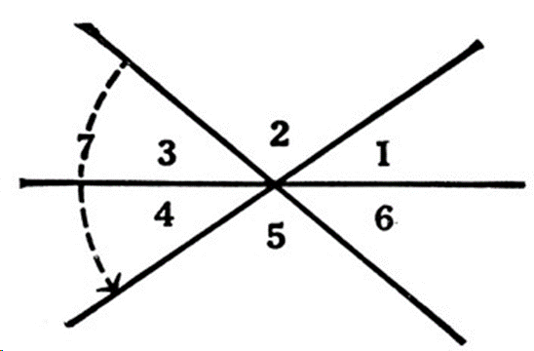

Instructional Item 2
The measure of angle 1 is 12 more than the measure of angle 2. What is the degree measure of angle 3?

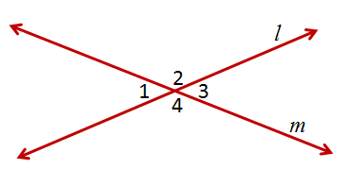

Instructional Item 3
If two angles are supplementary, and one angle is represented as x, how could you describe
the other angles using x?

*The strategies, tasks and items included in the B1G-M are examples and should not be considered comprehensive.

MA.8.GR.1.5

Benchmark
MA.8.GR.1.5 Solve problems involving the relationships of interior and exterior angles of a triangle.

Benchmark Clarifications:
Clarification 1: Problems include using the Triangle Sum Theorem and representing angle measures as algebraic expressions.

Connecting Benchmarks/Horizontal Alignment
- MA.8.AR.2.1

Terms from the K-12 Glossary
- Angle $\left(∠\right)$
- Supplementary Angles $\left(∠\right)$

Vertical Alignment
Previous Benchmarks  - MA.4.GR.1.2, MA.4.GR.1.3  - MA.5.GR.1.1 | Next Benchmarks  - MA.912.GR.1.3

Purpose and Instructional Strategies
In grades 4 and 5, students used angle measures as an attribute of two-dimensional figures and identified and classified angles as acute, right, obtuse, straight and reflex. In grade 8, students solve problems involving the interior and exterior angles of a triangle. In Geometry, the work in this benchmark will be extended to proving relationships and theorems about triangles.
- Students should explore the concept before being provided with the theorem. Once conceptual understanding is developed, students can use numerical equations to solve problems involving finding missing interior or exterior angles. From there, students should develop algebraic equations to solve for both missing angle measurements as well as variables.
- Instruction includes students exploring and using deductive reasoning to determine relationships that exist between angle sums and exterior angle sums of triangles. Students should construct various triangles and find the measures of both the interior and exterior angles. Applying knowledge of these relationships, students can use deductive reasoning to find the measure of any missing angles.
- Using an investigation, such as the one below, for the Triangle Sum Theorem will help students conceptually understand the total degree measures of a triangle related to a straight line.
  - Give each student a triangle. (A variety of triangle sizes will allow for discussion.)
  - Have students use a lined sheet of paper or draw a straight line using a ruler to represent the straight angle of $180°$.
  - Next, have the students tear off each angle of the triangle.
  - Then, putting the angle side towards the line, the students will be able to model the $180°$ of the triangle measures to a straight line. This is illustrated in the top part of the figure below.

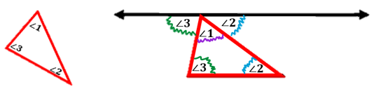

  - A similar investigation can be used to connect the measure of an exterior angle of a triangle and the two opposite interior angles in the triangle.
- Students can also use tracing paper to trace the concepts to make connections.

Common Misconceptions or Errors
- Students may incorrectly think that the exterior angle is the whole reflex angle of the interior angle.
- Students may not recognize that there are two exterior angles for each interior angle and that the exterior angles are congruent.

Strategies to Support Tiered Instruction
- Teacher provides a visual with one angle of the triangle on a straight line of 180°, similar to the illustration below. Teacher provides instruction on how to measure each of the angles with a protractor and color code congruent angles.
- Teacher provides tracing paper or patty paper to trace the related interior and exterior angles and have discussion about the angle relationships.

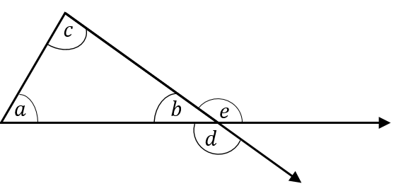
- Instruction includes providing a visual with one angle of the triangle on a straight line of 180° and measuring each angle in the figure. Teacher co-creates a graphic organizer with students to document the angle measurements, color-code congruent angles in the figure and in the graphic organizer, and identifies the relationships between interior and exterior angles of a triangle and the Triangle Sum Theorem.

Interior Angles | Exterior Angles | Relationship

Instructional Tasks
Instructional Task 1 (MTR.1.1, MTR.2.1)
$ΔABC$ and $ΔBCD$ share a common side of $BC$. Angle $BAC$ is $30°$ and angle $ABC$ is $60°$.
Part A. Create a diagram to represent this description.
Part B. What will be the measure of angle $BCD$? Provide an explanation to support how to find the measurement of angle $BCD$.
Part C. Are there questions that still need to be answered to approach Part B?

Instructional Items
Instructional Item 1
In triangle $LMN$, the measure of angle $L$ is $50°$ and the measure of angle $M$ $70°$. What is the measure of the exterior angle to angle $N$?

Instructional Item 2
One measure of an angle in a triangle is 96°. The other two angle measures are represented by $2x$ and $x +12$. Determine the other two degree measures for the missing angles.

*The strategies, tasks and items included in the B1G-M are examples and should not be considered comprehensive.

MA.8.GR.1.6

Benchmark
MA.8.GR.1.6 Develop and use formulas for the sums of the interior angles of regular polygons by decomposing them into triangles
Benchmark Clarifications:
Clarification 1: Problems include representing angle measures as algebraic expressions.

Connecting Benchmarks/Horizontal Alignment
- MA.8.AR.2.1

Terms from the K-12 Glossary
- Regular Polygon

Vertical Alignment
Previous Benchmarks  - MA.6.GR.2.2  - MA.7.GR.1.2 | Next Benchmarks  - MA.912.GR.1.3, MA.912.GR.1.4, MA.912.GR.1.5

Purpose and Instructional Strategies
In grades 6 and 7, students found areas of quadrilaterals and other polygons by decomposing them into triangles and trapezoids. In grade 8, students develop and use formulas for the sums of the interior angles of regular polygons by decomposing them into triangles. In Geometry, students will use this knowledge to prove relationships and theorems about triangles, parallelograms, trapezoids and other polygons.
- Once students understand the conceptual understanding associated with this benchmark, students should progress from numerical expressions to algebraic expressions.
- When beginning the exploration with polygons with four or more sides, students should be able to use one vertex to draw diagonals to non-adjacent vertices. Once students have drawn the diagonals, have them cut along the diagonals to showcase triangles.

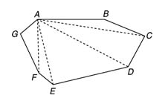

- Once the triangles are cut, then students can lay them out to see the number of triangles and relate the work to prior work with the sum of the angles of a triangle. Students can label their angles and show their equations that help provide information on the sum of the interior angles as shown below.

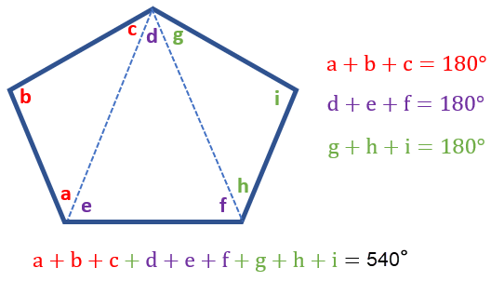

- Students should record this information in a chart like the one shown below to help them create a rule to use instead of counting the triangles each time.

Shape | Sides | # of Triangles | Sum of Interior Angles
triangle | 3 | 1 | $$180°$$
quadrilateral | 4 | 2 | $$360°$$
pentagon | 5 | 3 | $$540°$$
… | … | … | …
any polygon | $$n$$ | $$n-2$$ | $$(n-2)×180°$$

- Once students understand the sum of the interior angles, connections should be made to regular polygons. Students can add a column to indicate the regular polygon measurements of each angle.
- Encourage students to use proper vocabulary terms for polygons and regular polygons.

Common Misconceptions or Errors
- Students may incorrectly draw additional lines from the vertex to create additional triangles.

Strategies to Support Tiered Instruction
- Teacher encourages students to begin at an identified vertex and move around the polygon from that vertex when decomposing the polygons into triangles.

Instructional Tasks
Instructional Task 1 (MTR.5.1)
Use your knowledge about shapes to complete the following task.
Part A. Draw a pentagon, hexagon, heptagon and an octagon.
Part B. Determine the number of triangles that can be drawn from one vertex to each of the others in each figure.
Part C. Develop a conjecture to determine if there is a pattern or formula that can be determined to find the sums of the interior angles for any polygon.

Instructional Items
Instructional Item 1
Find the number of degrees for the sum of the interior angles of a regular 12-sided figure.

Instructional Item 2
Saylor computed that a polygon with 9 sides has 7 interior triangles, and the sum of
the interior angles of that polygon is 1,260$°$. Is Saylor correct? Explain your answer.

*The strategies, tasks and items included in the B1G-M are examples and should not be considered comprehensive.

MA.8.GR.2 Understand similarity and congruence using models and transformations

MA.8.GR.2.1

Benchmark
MA.8.GR.2.1 Given a preimage and image generated by a single transformation, identify the transformation that describes the relationship.
Benchmark Clarifications:
Clarification 1: Within this benchmark, transformations are limited to reflections, translations or rotations of images.
Clarification 2: Instruction focuses on the preservation of congruence so that a figure maps onto a copy of itself.

Connecting Benchmarks/Horizontal Alignment
- MA.8.GR.2.2, MA.8.GR.2.3

Terms from the K-12 Glossary
- Congruent
- Reflection
- Rigid Transformation
- Rotation
- Translation

Vertical Alignment
Previous Benchmarks  - MA.6.GR.1.1  - MA.7.GR.1.5 | Next Benchmarks  - MA.912. F.2.1, MA.912.F.2.2  - MA.912.GR.2.1, MA.912.GR.2.3, MA.912.GR.2.4

Purpose and Instructional Strategies
In grade 6, students identified the $x$- or $y$-axis as lines of reflection. In grade 7, students solved problems involving scale drawings of geometric figures. In grade 8, students are introduced to the geometric transformations of reflection, dilation (scaling) and translation. In Algebra 1, students will describe transformations applied to functions. In Geometry, students will describe transformations given a preimage and an image and represent the transformation algebraically using coordinates. They will use transformations to justify congruence and similarity.
- Informal language such as turns, flips, and slides can be used when exploring the concepts. As students transition, they should use formal mathematical language of rotations, reflections and translations. Students should have materials such as shapes cut from paper to model the transformations.
- Instruction includes the use of real-world examples that don’t have to be a geometric figure.
  - For example, wallpaper, art, architecture and mirrors have images generated by simple transformations.
- The work of transformations builds from students being able to visually see the images and developing a spatial understanding as the images move about the coordinate plane.
- Transformations can be noted using the prime notation ($'$) for the image and its vertices. The preimage and its vertices will not have prime notation.
  - For example, the picture below showcases a single transformation.

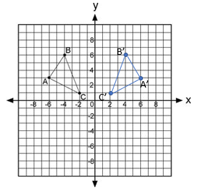
- Problem types include stating which direction, clockwise or counterclockwise, for rotations.
- The expectation of this benchmark is not to represent a transformation on the coordinate plane as this will be included in MA.8.GR.2.3 instruction. During instruction, there should be flexibility moving from this benchmark to MA.8.GR.2.3 with each transformation which allows students to build conceptually prior to algorithmically.
- For mastery of this benchmark, single transformations include one vertical translation or one horizontal translation. A vertical and horizontal translation would be considered two transformations.

Common Misconceptions or Errors
- Students may incorrectly visualize the movement of a figure. To support instruction, students may need manipulatives, such as tangrams and tessellations, to help with physically moving the figures to understand the transformations.

Strategies to Support Tiered Instruction
- Teacher supports instruction by using manipulatives, such as tangrams and tessellations, to help with physically moving the figures to understand the transformations.
- Teacher models using geometric software and creates a graphic organizer to understand each transformation with relatable vocabulary.
- Teacher uses example images and preimages to demonstrate the different types of transformation and how to identify images and preimages.
- Teacher encourages the use of manipulatives and models counting the units moved to verify the proper movement of the transformation.
Instruction includes the use of tracing paper to trace the pre-image and explore possible transformations by slides, rotating, and flipping the image to try to reproduce the image.

Instructional Tasks
Instructional Task 1 (MTR.6.1)
Is it possible to have $ΔPRQ$ make one translation, rotation, or reflection to become the image of $ΔABC$? Explain why or why it is not possible. Determine which transformation(s) may be used.

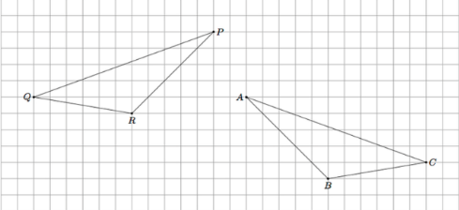

Instructional Items
Instructional Item 1
Determine the transformation from the preimage above line m to the image below line $m$.

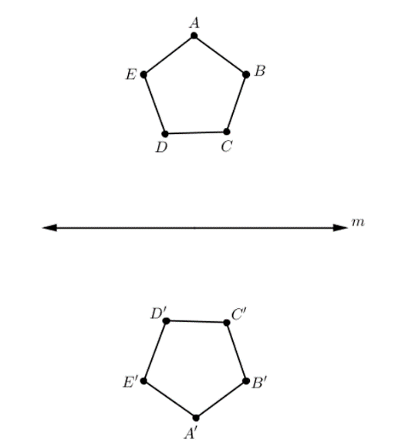

Instructional Item 2
Draw a right triangle labeled with vertices $MNO$ and then sketch the right triangle that has been rotated 90° counterclockwise.

*The strategies, tasks and items included in the B1G-M are examples and should not be considered comprehensive.

MA.8.GR.2.2

Benchmark
MA.8.GR.2.2 Given a pre-image and image generated by a single dilation, identify the scale factor that describes the relationship.
Benchmark Clarifications:
Clarification 1: Instruction includes the connection to scale drawings and proportions.
Clarification 2: Instruction focuses on the preservation of similarity and the lack of preservation of congruence when a figure maps onto a scaled copy of itself, unless the scaling factor is 1.

Connecting Benchmarks/Horizontal Alignment
- MA.8.GR.2.1, MA.8.GR.2.3

Terms from the K-12 Glossary
- Dilation
- Scale Factor

Vertical Alignment
Previous Benchmarks  - MA.7.GR.1.5 | Next Benchmarks  - MA.912.F.2.1, MA.912.F.2.2  - MA.912.GR.2.1, MA.912.GR.2.3, MA.912.GR.2.4

Purpose and Instructional Strategies
In grade 7, students solved mathematical and real-world problems involving scale factors. In grade 8, students determine the scale factor that describes the relationship after a single dilation. In Geometry, students will use dilations to study similarity.
- Instruction includes the use of real-world examples that do not have to be a geometric figure.
  - For example, projections, photocopies and maps have images generated by a single dilation.
- Students will need to understand scale factor to help in the idea of an image enlarging or reducing. A scale factor between 0 and 1 will be a reduction in the image. A scale factor that is greater than one will result in an enlargement of the image.
- Transformations can be noted using the prime notation ($'$) for the image and its vertices. The preimage and its vertices will not have prime notation.
  - For example, the picture below showcases a single dilation.

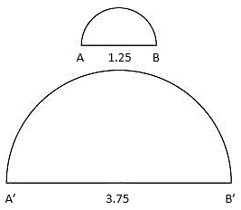

- The expectation of this benchmark is not to represent a dilation on the coordinate plane as this will be included in MA.8.GR.2.3 instruction.

Common Misconceptions or Errors
- Students may incorrectly visualize the images with scale factors. To address this misconception, include practice in visualizing the reduction and enlargement based on the scale factors.

Strategies to Support Tiered Instruction
- Instruction includes practice in visualizing the reduction and enlargement based on the scale factors for students that incorrectly visualize images with scale factors.
  - For example, two figures that have the same shape are said to be similar. When two figures are similar, the ratios of the lengths of their corresponding sides are equal and corresponding angles are congruent. Similar figures have the same shape, but not necessarily the same size.

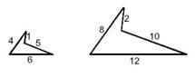

- Teachers can help students understand that two figures that have the same shape are said to be similar. When two figures are similar, the ratios of the lengths of their corresponding sides are equal. In example 1, the corresponding sides are 8:4, 2:1, 10:5, and 12:6. These ratios are equal to 2, meaning the shapes must be similar. The figures do not have to be the same size to be similar.
- Instruction includes practice in visualizing the reduction and enlargement based on the scale factors.

Instructional Tasks
Instructional Task 1 (MTR. 7.1)
The height of a document on your computer is 20 centimeters. When you change the setting to zoom in or out, you change it from 100% to 25%. The new image of your document is a dilation of your original document, the preimage. Determine the scale factor and the height of the new image.

Instructional Items
Instructional Item 1
Does the image show reduction or enlargement from the quadrilateral $JKLM$? What is the scale factor?

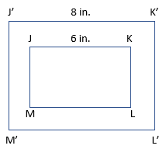

*The strategies, tasks and items included in the B1G-M are examples and should not be considered comprehensive.

MA.8.GR.2.3

Benchmark
MA.8.GR.2.3 Describe and apply the effect of a single transformation on two-dimensional figures using coordinates and the coordinate plane.

Benchmark Clarifications:
Clarification 1: Within this benchmark, transformations are limited to reflections, translations, rotations or dilations of images.
Clarification 2: Lines of reflection are limited to the $x$-axis, $y$-axis or lines parallel to the axes.
Clarification 3: Rotations must be about the origin and are limited to 90°, 180°, 270° or 360°.
Clarification 4: Dilations must be centered at the origin.

Connecting Benchmarks/Horizontal Alignment
- MA.8.GR.2.1, MA.8.GR.2.2

Terms from the K-12 Glossary
- Coordinates
- Coordinate Plane

Vertical Alignment
Previous Benchmarks  - MA.6.GR.1.1  - MA.7.GR.1.5 | Next Benchmarks  - MA.912.F.2.1, MA.912.F.2.2  - MA.912.GR.2.1, MA.912.GR.2.3, MA.912.GR.2.4

Purpose and Instructional Strategies
In grade 6, students plotted rational-number ordered pairs in all four quadrants as well as identified the $x$- or $y$-axis as a line of reflection when two ordered pairs have an opposite $x$- or $y$-coordinate. In grade 7, students solved mathematical and real-world problems involving scale factors. In grade 8, students apply a single transformation using coordinates and the coordinate plane. In Algebra 1, students will apply a single transformation to functions. In Geometry, students will describe transformations given a preimage and an image and represent the transformation algebraically using coordinates and use them to study congruence and similarity.
- Instruction includes using grid paper to illustrate translations of a line or triangle to demonstrate the relationship between them and a new image. Then, illustrate translations of more complex figures such as polygons.
- Transformations can be noted using the prime notation ($'$) for the image and its vertices. The preimage and its vertices will not have prime notation.
  - For example, the picture below showcases a single transformation.

- Problem types include telling which direction, clockwise or counterclockwise, for rotations.
- Instruction includes looking for patterns to create rules for transformations on the coordinate plane.
- For mastery of this benchmark, single transformations include one vertical translation or one horizontal translation. A vertical and horizontal translation would be considered two transformations.

Common Misconceptions or Errors
- Students may incorrectly visualize transformation on the coordinate plane. To address this misconception, provide students with manipulatives.
- Students may incorrectly apply rules for transformations. To address this misconception, students should generate examples and non-examples of given transformations.
- Students may invert clockwise and counterclockwise.

Strategies to Support Tiered Instruction
- Teacher supports understanding of transformations on the coordinate plane by providing examples using geometric software. Instruction includes the use of manipulatives, tracing paper and graph paper.
- Teacher reminds students when plotting points on a coordinate plane that they can first find the $x$-coordinate on the $x$-axis (horizontal axis) and then find the $y$-coordinate on the $y$-axis (vertical axis).
- Teacher reviews vocabulary discussing the meaning of the terms.
  - Translation is a vertical or horizontal slide of the figure. To determine the coordinates of the image of a translated figure you must add or subtract the horizontal distance to the $x$-coordinate of each vertex and add or subtract the vertical distance to the $y$-coordinate of each vertex. (Note that in later courses, students learn that translation can also occur diagonally.)
  - Preimage is the figure before any transformations are performed.
  - Image is the figure after a transformation is performed.
- Teacher co-creates a graphic organizer to generate examples and non-examples of reflections, translations, rotations, or dilations of images.
- Teacher provides instruction to support understanding of applying the translation to all vertices, not just one vertex.
- Teacher reviews directions of rotations. Clockwise is the direction the hands go on an analog clock . Counterclockwise is the opposite direction of the hands on an analog clock .
  - For example, which quadrant would the image be in if you rotated the figure?
  - 90 degrees clockwise
  - 90 degrees counterclockwise
  - 180 degrees clockwise
  - 180 degrees counterclockwise

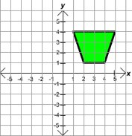

- Teacher reviews which is the $x$-axis and which is the $y$-axis for students that incorrectly reflect across the wrong axis. Teacher co-creates anchor chart explaining different parts of the coordinate plane and how to plot and label points.
  - For example, teachers could ask students which quadrant the image would be in if you reflected the figure across the $x$-axis or across the $y$-axis.
- Instruction includes providing students with manipulatives for students that incorrectly visualize transformations on the coordinate plane.

Instructional Tasks
Instructional Task 1 (MTR.1.1, MTR.2.1)
Use the information you have learned about transformations to complete the task below.
Part A. Using graph paper, plot the following points to create an image on the coordinate plane.
$A(-3,2)$, $B(0,1)$, $C(-3,-1)$ and $D(-1,-1)$
Part B. Using a different color for each transformation, complete each of the following transformations on the same coordinate plane.
  - A reflection over the $y$-axis
  - A rotation of 180° about the origin
Part C. Will any of the new images include the origin?

Instructional Items
Instructional Item 1
Find the coordinates of the vertices of the image of triangle $IJK$ after the translation 3 units to the left.
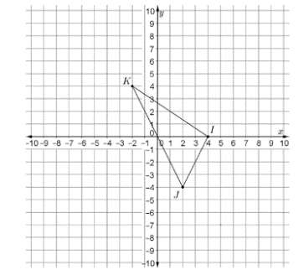

Instructional Item 2
Find the coordinates of the vertices of the image of triangle $CAT$ after a 270° counterclockwise rotation about the origin.

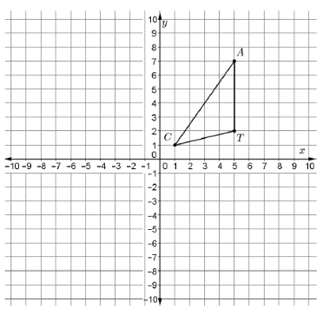

*The strategies, tasks and items included in the B1G-M are examples and should not be considered comprehensive.

MA.8.GR.2.4

Benchmark
MA.8.GR.2.4 Solve mathematical and real-world problems involving proportional relationships between similar triangles.
Example: During a Tampa Bay Lightning game one player, Johnson, passes the puck to his teammate, Stamkos, by bouncing the puck off the wall of the rink. The path of the puck creates two line segments that form hypotenuses for each of two similar right triangles, with the height of each triangle the distance from one of the players to the wall of the rink. If Johnson is 12 feet from the wall and Stamkos is 3 feet from the wall. How far did the puck travel from the wall of the rink to Stamkos if the distance traveled from Johnson to the wall was 16 feet?

Connecting Benchmarks/Horizontal Alignment
- MA.8.AR.3.1, MA.8.AR.3.2

Terms from the K-12 Glossary
- Proportional Relationships
- Similarity

Vertical Alignment
Previous Benchmarks  - MA.7.GR.1.5  - MA.7.AR.3.2 | Next Benchmarks  - MA.912.GR.1.2, MA.912.GR.1.3, MA.912.GR.1.6

Purpose and Instructional Strategies
In grade 7, students solved mathematical and real-world problems involving scale factors. In grade 8, students make connections of slope to the constant of proportionality through the use of similar triangles when represented in the coordinate plane (as stated in Clarification 2 in MA.8.AR.3.2). Additionally, students solve problems involving similar triangles. In high school, students will prove triangle congruence or similarity using Side-Side-Side, Side-Angle-Side, Angle-Side-Angle, Angle-Angle-Side, Angle-Angle and Hypotenuse-Leg.
- Instruction includes the definition of similarity applied to similar triangles, noting that the similar triangles will have the same shape but not necessarily the same size. This will extend to the angles being congruent and the sides being proportional.
- Students should be given real-world problem-solving opportunities in and out of the classroom to be able to visualize the work with similar triangles.
  - For example, students should draw a picture to represent an application problem. If students were given the problem: If a tree casts a 24-foot shadow at the same time that a yardstick casts a 2-foot shadow, find the height of the tree. Students can draw triangles to represent the situation.

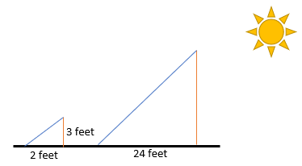

Common Misconceptions or Errors
- Students may incorrectly assume the sides and angles of similar triangles must be equivalent. To address this misconception, show a variety of examples of sizes of triangles that are similar.
- When checking to see if the triangles are proportional, students may incorrectly make connections to corresponding sides.
  - For example, when triangles have been turned to a different orientation, students may incorrectly match the sides to check for proportionality.

Strategies to Support Tiered Instruction
- Instruction includes co-creating foldables or graphic organizers with “Definition in Student’s Words, Examples, Non-Examples, and Real-World Application.” Present students with examples of triangles that are similar and of different sizes.
- Teacher provides objects that have the same shape and students label the corresponding sides.
- Teacher models use of geometric software to practice similarity and congruence.
- Instruction includes showing a variety of examples of sizes of triangles that are similar for students that incorrectly assume the sides and angles of a similar triangles must be equivalent.

Instructional Tasks
Instructional Task 1 (MTR.6.1, MTR.7.1)
Given the description of two similar triangles below, sketch each triangle described in the table.

Triangle 1 | Triangle 2
The height of the triangle is the height of a man who is 6 feet tall. The base of the triangle makes a 90-degree angle with the height and is 4 feet long. | The height of the triangle is unknown since it represents the height of a cell phone tower. The base of the triangle makes a 90-degree angle with the height and is 20 feet long.

Part A. What would be a reasonable height of a cell phone tower?
Part B. Find the height of the cell phone tower. Is this a realistic height for the cell phone tower?
Part C. Research the heights of cell phone towers in your area. How does this answer compare to cell phone towers in your area?
Part D. Using a typical height of cell phone towers in your area, what could you use in the real world to create similar triangles to be able to calculate the height of your local cell phone tower?

Instructional Items
Instructional Item 1
Given the two triangles, are they similar?

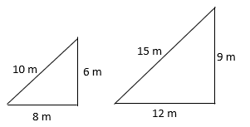

Instructional Item 2
What is the height, $h$, in meters?
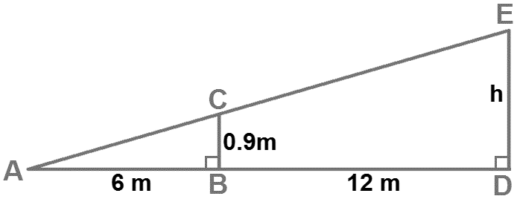

*The strategies, tasks and items included in the B1G-M are examples and should not be considered comprehensive.

Data Analysis and Probability

MA.8.DP.1 Represent and investigate numerical bivariate data.

MA.8.DP.1.1

Benchmark
MA.8.DP.1.1 Given a set of real-world bivariate numerical data, construct a scatter plot or a line graph as appropriate for the context.
Example: Jaylyn is collecting data about the relationship between grades in English and grades in mathematics. He represents the data using a scatter plot because he is interested if there is an association between the two variables without thinking of either one as an independent or dependent variable.
Example: Samantha is collecting data on her weekly quiz grade in her social studies class. She represents the data using a line graph with time as the independent variable.

Benchmark Clarifications:
Clarification 1: Instruction includes recognizing similarities and differences between scatter plots and line graphs, and on determining which is more appropriate as a representation of the data based on the context.
Clarification 2: Sets of data are limited to 20 points.

Connecting Benchmarks/Horizontal Alignment
- MA.8.DP.1.2, MA.8.DP.1.3

Terms from the K-12 Glossary
- Bivariate Data
- Scatter Plot

Vertical Alignment
Previous Benchmarks  - MA.6.DP.1  - MA.7.DP.1 | Next Benchmarks  - MA.912.DP.2.4, MA.912.DP.2.6  - MA.912.DP.3.1

Purpose and Instructional Strategies
In grades 6 and 7, students worked with both numerical and categorical univariate data. Additionally, students have had experience developing statistical questions since grade 6. In grade 8, students encounter bivariate data, and it is restricted to numerical data, which is often displayed with a scatter plot, but in some circumstances, may also be displayed with a line graph. In Algebra 1, students will continue working with scatter plots and line graphs for bivariate numerical data, but expand their knowledge to bivariate categorical data, displayed with frequency tables.
- Bivariate data refers to the two-variable data, with one variable graphed on the $x$-axis and the other variable on the $y$-axis. Instruction includes flexibility in the understanding of the dependent and independent variables. Students can represent situations in terms of $x$ or in terms of $y$.
- Instruction includes proper labeling of graphical representations, including axes, scales and a title.
- Line graphs are a way to map independent and dependent variables. Line graphs showcase data by connecting each data point together. The rate of change from a single data point to another data point can be measured. An overall trend can be described, but the trend is between individual or small groups of points. A line graph allows for the interpretation of the rate of change, or slope, between individual data points. The independent variable can be either numerical or categorical.
  - For example, independent variables can be shown as months of the year.

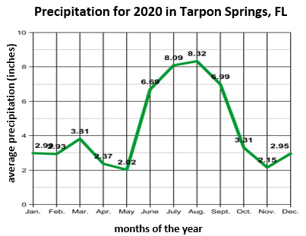

- Scatter plots are another way to show the relationship between two variables having individual points that will not be connected directly together. Often neither variable is thought of as the independent or dependent variable, so it is a matter of choice of which variable will be represented on the $x$-axis and which will be represented on the $y$-axis. Trends can be seen through the distribution of points. Scatter plots are used to collect a large number of data points to illustrate patterns in the data including linear or non-linear trends, clusters and outliers.
- Instruction includes the understanding that with bivariate data, a single $x$-value can be associated with more than one $y$-value. When this is the case, a scatter plot should be used as the graphical display rather than a line graph.
- Instruction includes providing opportunities for students to interact with scatter plots through the development of statistical questions.
- Students should label and determine appropriate scales when completing work with bivariate numerical data.

Common Misconceptions or Errors
- When discussing and interpreting the data, students may incorrectly identify an association when the scatter plot shows no association. To address this misconception, provide examples for students that would help them understand that some data will not have an association.
  - For example, the height of a person and their number of pets.
- Students may confuse the dependent and independent variables when creating line graphs.
- Students may incorrectly believe bivariate data can only be displayed as a scatter plot.

Strategies to Support Tiered Instruction
- Teacher provides instruction on different types of associations, then provides clear examples of associations of scatter plots for students who need additional assistance identifying associations.

Positive Association Negative Association No Association
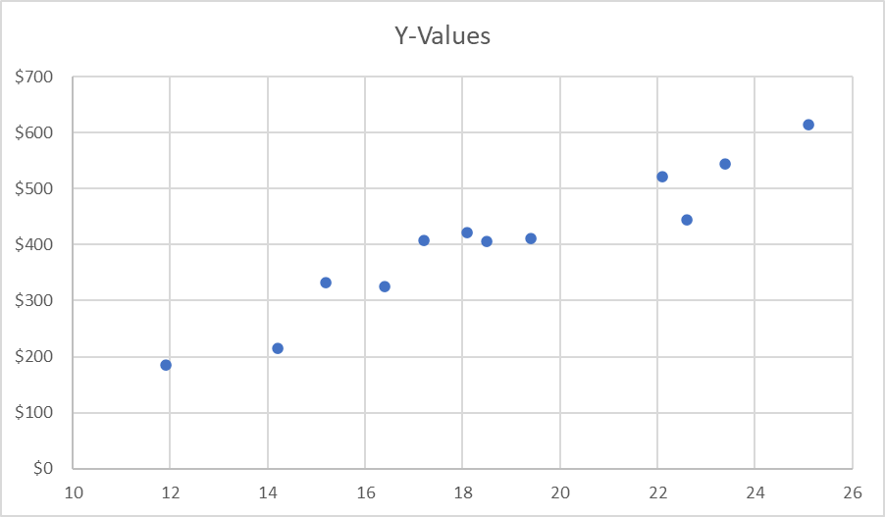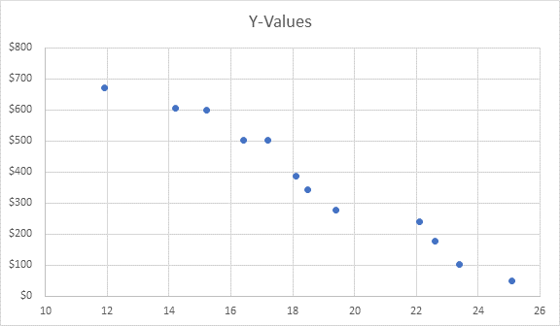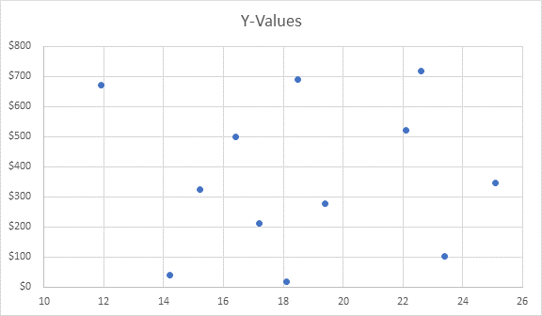

- Teacher provides instruction on independent and dependent variables and the difference between them. Instruction includes the use of real-world situations to accurately identify independent and dependent variables.
- Teacher co-creates anchor chart/graphic organizer showing different ways to display data.
- Teacher provides examples for students to help them understand that some data will not have an association.
- For example, the height of a person and their number of pets.

Instructional Tasks
Instructional Task 1 (MTR.2.1, MTR.4.1, MTR.6.1)
Scientists at the new company, BunG, tested their bungee cords, used for bungee jumping, with weights from 10 to 200 pounds. They identified a random sample of cords and measured the length that each cord stretched when different weights were applied. The table displays the average stretch length for the sample of cords for each weight.

Weight (in pounds) | 10 | 30 | 50 | 70 | 100 | 125 | 150 | 175 | 200
Length (in feet) | 11.5 | 16.4 | 20.7 | 25.1 | 29.6 | 35.2 | 38.8 | 42.3 | 44.7

Part A. Construct a scatter plot and a line graph for this set of data.
Part B. Which representation is most appropriate for displaying and describing the relationship between the weights applied to a bungee cord and the length the cord stretches? Explain your reasoning.

Instructional Items
Instructional Item 1
A pool cleaning service drained a full pool. The following table shows the number of hours it drained and the amount of water remaining in the pool at that time.

Time (hours) | 3 | 5 | 7 | 9 | 11
Water Remaining (gallons) | 13,200 | 12,050 | 10,900 | 9,800 | 8,750

Construct a line graph or scatter plot for the data above based on which is most appropriate for the context.

Instructional Item 2
Kennedy ran the Gasparilla marathon with a group of 25 of her friends. The table below
shows the number of her friends that stopped at each water break during the race.

Number of friends that stopped | 5 | 7 | 4 | 2 | 15 | 10 | 2 | 6 | 25
Water break Station | 1 | 2 | 3 | 4 | 5 | 6 | 7 | 8 | 9

*The strategies, tasks and items included in the B1G-M are examples and should not be considered comprehensive.

MA.8.DP.1.2

Benchmark
MA.8.DP.1.2 Given a scatter plot within a real-world context, describe patterns of association.
Benchmark Clarifications:
Clarification 1: Descriptions include outliers; positive or negative association; linear or nonlinear association; strong or weak association.

Connecting Benchmarks/Horizontal Alignment
- MA.8.DP.1.1, MA.8.DP.1.3

Terms from the K-12 Glossary
- Association
- Outlier
- Scatter Plot

Vertical Alignment
Previous Benchmarks  - MA.6.DP.1  - MA.7.DP.1 | Next Benchmarks  - MA.912.DP.2.4, MA.912.DP.2.6  MA.912.DP.3.1
Purpose and Instructional Strategies
In grades 6 and 7, students described and interpreted, quantitatively and qualitatively, both numerical and categorical univariate data. In grade 8, students encounter bivariate data and use scatter plots to determine whether there is any association between the variables. In Algebra 1, students will continue working with scatter plots to display association but expand their knowledge to consider association in bivariate categorical data, displayed with frequency tables.
- Instruction includes students communicating the relationships between two variables. Students should analyze scatter plots to determine the type and degree of association.
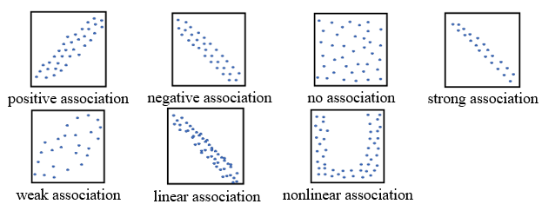

- Outliers in scatter plots are different than outliers in box plots. There is no special rule for determining if a data point is an outlier in a scatter plot. Instead, students need to consider why the outlier does not fit the pattern. Students should examine if outliers are valid or represent a recording or measurement error. Students should identify outliers and clusters and give possible reasons for their existence (MTR.4.1, MTR.7.1).
- Instruction includes opportunities to discuss the effects of changing the data slightly and how the changes impact the scatter plots (MTR.4.1).

Common Misconceptions or Errors
- Students may invert positive and negative correlations.
- Students may incorrectly assume that associations can only have one descriptor.
  - For example, students may only say that the correlation is a positive association instead of describing it as a strong, positive linear association.
- Students may misinterpret an outlier and why it may occur in a set of data.

Strategies to Support Tiered Instruction
- Teacher provides clear examples of associations of scatter plots (representing positive, negative, no, strong, weak, linear and non-linear associations). Teacher facilitates discussion about whether each association is positive or negative.

Positive Association | Negative Association | No Association

- Teacher provides examples of different outliers and discusses with students why this occurred. Creating this dialogue will help students begin to understand how outliers can be used differently depending on the type of data collected, and what the data is intended for.
- Instruction includes co-creating a graphic organizer to include examples of different patterns to association. Categories include trends in association (positive, negative, no), strength of association (strong, weak) and pattern of association (linear or nonlinear).
Instructional Tasks
Instructional Task 1 (MTR.4.1, MTR.7.1)
The graphs below show the test scores of the students in Dexter's class. The first graph shows the relationship between test scores and the amount of time the students spent studying, and the second graph shows the relationship between test scores and shoe size.

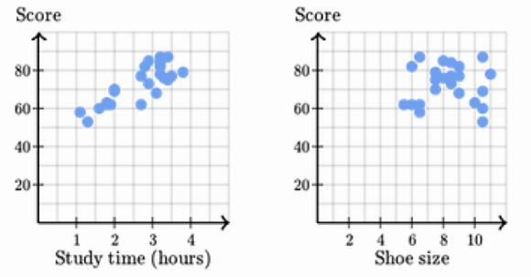

Part A. Describe and explain the pattern of association for each of the graphs.
Part B. If you were to add an outlier to the first graph, describe the data point and what it would mean in context.

Instructional Task 2 (MTR.4.1, MTR.7.1)
Population density measures are approximations of the number of people per square unit of area. The following scatter plot represents data from each of the 50 states comparing population (in millions) to land area (in 10,000 square miles) in 2012.

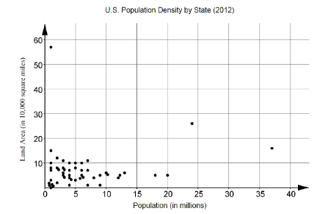

Part A. Describe the type and degree of association between population and land area.
Part B. Discuss with a partner possible interpretations of your answer to Part A. Do you think this would hold true for other countries?

Instructional Items
Instructional Item 1
The scatter plot below compares middle school students' scores on the Epworth Sleepiness Scale (ESS) to their scores on a recent math test. The Epworth Sleepiness Scale measures excessive daytime sleepiness with zero being least sleepy. Describe the type and degree of association between scores on the Epworth Sleepiness Scale and scores on the math test.
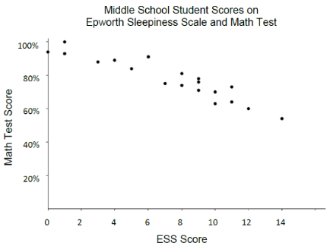

*The strategies, tasks and items included in the B1G-M are examples and should not be considered comprehensive.

MA.8.DP.1.3

Benchmark
MA.8.DP.1.3 Given a scatter plot with a linear association, informally fit a straight line.
Benchmark Clarifications:
Clarification 1: Instruction focuses on the connection to linear functions.
Clarification 2: Instruction includes using a variety of tools, including a ruler, to draw a line with approximately the same number of points above and below the line.

Connecting Benchmarks/Horizontal Alignment
- MA.8.AR.3.1, MA.8.AR.3.2, MA.AR.3.3, MA.8.AR.3.4, MA.8.AR.3.5
- MA.8.DP.1.1, MA.8.DP.1.2

Terms from the K-12 Glossary
- Association
- Line of Fit
- Scatter Plot

Vertical Alignment
Previous Benchmarks  - MA.6.DP.1  - MA.7.DP.1 | Next Benchmarks  - MA.912.DP.2.4, MA.912.DP.2.6  - MA.912.DP.3.1
Purpose and Instructional Strategies
In grades 6 and 7, students created graphical representations for both numerical and categorical univariate data. In grade 8, students encounter bivariate data displayed with scatter plots, and they use their knowledge of graphing lines to determine approximate lines of fit. In Algebra 1, students will continue working with scatter plots and lines of fit to display association. Also, they expand their knowledge to consider association in bivariate categorical data, displayed with frequency tables.
- Instruction includes the understanding that a straight line can be used to display a linear association in a scatter plot. This line allows predictions of other potential data points. Instruction includes students discussing what it means to be above and below the line of fit (MTR.4.1).
- Instruction includes providing opportunities to look at multiple lines of fit and determining which would be the best model for the scatter plot. The use of manipulatives is a way for students to make adjustments on their informal fit of a line. Students should compare and contrast their models and explain why their models best represent the fit of the data (MTR.4.1).
- Instruction includes the use of linear models to represent the line of fit. Students should describe the $y$-intercept and slope in terms of the context within the scatter plot.

Common Misconceptions or Errors
- Students may incorrectly believe the line of fit should go through all the data points. To address this misconception, provide examples to students to show some lines that do go through data points and examples that may go through very few or no data points.
- Students may incorrectly think the line of fit should go through the first and last data point on the scatter plot. To address this misconception, provide examples to students to show some lines that do not go through the first and last data points.

Strategies to Support Tiered Instruction
- Using digital tools to model graphing a line of fit will provide clarity for misunderstanding that a line of fit needs to either start with the first and end with the last point or go through all points.
- Teacher provides examples of lines of fit that go through data points and examples that may go through very few or no data points.
- Teacher provides examples to show lines of fit that do not go through the first and last data points.

Instructional Tasks
Instructional Task 1 (MTR.6.1, MTR.7.1)
Each graph shows the same set of data and a line that has been fitted to the data.

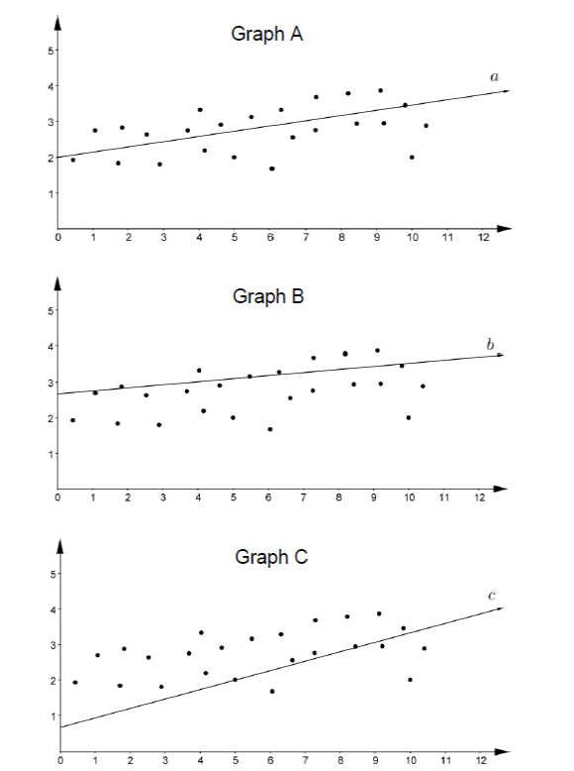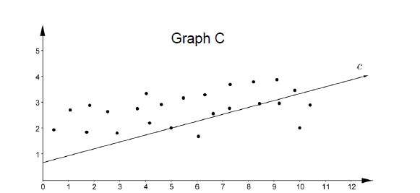

Part A. Determine which line, $a$, $b$ or $c$, most appropriately fits the data and explain why.
Part B. What statistical question could be asked to represent the set of data?

Instructional Items
Instructional Item 1
The scatter plot below shows the relationship between the ages and weights of 50 female infants. Draw a line on the scatter plot that fits the data.

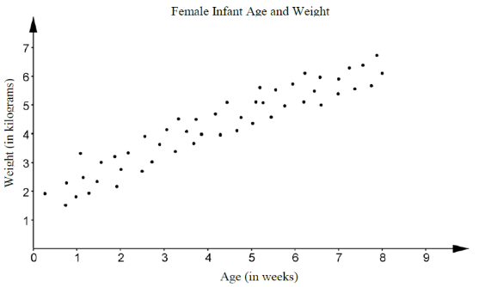

Instructional Item 2
A scatter plot is shown in the coordinate plane. Draw a line on the scatter plot that fits the data.

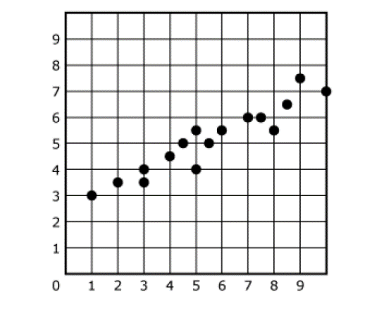

*The strategies, tasks and items included in the B1G-M are examples and should not be considered comprehensive.

MA.8.DP.2 Represent and find probabilities of repeated experiments.

MA.8.DP.2.1

Benchmark
MA.8.DP.2.1 Determine the sample space for a repeated experiment.
Benchmark Clarifications:
Clarification 1: Instruction includes recording sample spaces for repeated experiments using organized lists, tables or tree diagrams.
Clarification 2: Experiments to be repeated are limited to tossing a fair coin, rolling a fair die, picking a card randomly from a deck with replacement, picking marbles randomly from a bag with replacement and spinning a fair spinner.
Clarification 3: Repetition of experiments is limited to two times except for tossing a coin.

Connecting Benchmarks/Horizontal Alignment
- MA.8.DP.2.2

Terms from the K-12 Glossary
- Event
- Sample Space

Vertical Alignment
Previous Benchmarks  - MA.7.DP.2.1 | Next Benchmarks  - MA.912.DP.4.1

Purpose and Instructional Strategies
In grade 7, students determined the sample space for a single experiment. In grade 8, students find the sample space for a repeated experiment. In high school, students will describe events as subsets of a sample space and consider unions, intersections and complements of events.
- For mastery of this benchmark, an experiment is an action that can have more than one outcome. Experiments tend to have randomness, or uncertainty, in their outcomes.
  - For example, an experiment can be the action of tossing a coin more than once. Possible outcomes would be whether the coin lands on heads or lands on tails each time.
- For mastery of this benchmark, repeated experiments are restricted to those listed in Clarification 2.
  - Tossing a coin
Coins are not limited to those with heads or tails.
  - Rolling a die
Dice are not limited to 6-sided dice.
  - Picking a card from a deck
Card decks are not limited to a standard 52-card deck.
  - Picking a marble from a bag
Picking a marble from a bag is not limited to colors. Picking a tile, slip of paper, or other objects from a bag are acceptable for this benchmark.
  - Spinning a spinner
Spinning a spinner is not limited to colors.
- Instruction includes the understanding that when an experiment is repeated, the full sample space is kept for each repetition. For the experiments of drawing a card from a deck or a marble from a bag, this idea is referred to as “with replacement.”
  - For example, if you are selecting a card from a deck that card must be returned to the deck before selecting another card.
- Due to some repeated experiments having a large sample space, instruction may focus on repeating experiments that have at most 6 outcomes for each individual repetition.
  - For example, rolling a 6-sided die twice would have 6 outcomes for each individual repetition giving 36 outcomes for the repeated experiment.
  - For example, drawing a card with replacement twice from a deck containing 2 red cards, 1 green card and 1 blue card would have 4 outcomes for each individual repetition giving 16 outcomes for the repeated experiment.
  - For example, tossing a coin three times would have 2 outcomes for each individual repetition giving 8 outcomes for the repeated experiment.
- For repeating experiments that have more than 6 outcomes for each individual repetition, students should understand that a written description is likely the best way to describe the sample space because complete lists, tables and tree diagrams become challenging.
- Students should experience experiments before discussing the theoretical concept of probability. Within this benchmark, students are creating a sample space for an experiment that is repeated more than once.
  - For example, students could roll a die or spin a spinner twice, or randomly select a card from a deck or a marble from a bag twice, with replacement, or students could toss a coin multiple times.
- Students should informally explore the idea of likelihood, fairness, and chance while building the meaning of a probability value. In this benchmark, all experiments are fair, meaning that all the individual outcomes are equally likely.
  - For example, if the experiment is to draw a marble from a bag twice with replacement, then each marble is equally likely to be chosen on each draw.
- Have students practice making models to represent sample spaces to gain understanding on how probabilities are determined. Use familiar tools, including virtual manipulatives such as a coin, fair die, deck of cards and fair spinner (MTR.2.1).
- For repeated experiments, a sample space will typically be represented by a list of outcomes, a written description, a table or a tree diagram. Providing opportunities for students to match situations and sample spaces will assist with building their ability to visualize the sample space for any given experiment.
  - For example, the repeated experiment of tossing a coin three times has the sample space that can be written as:
    - List
{HHH, HHT, HTH, HTT, THH, THT, TTH, TTT}
    - Written Description
The collection of ordered triples in which each element is either H or T.
    - Table
This representation is not appropriate when an experiment is repeated more than twice.
    - Tree Diagram
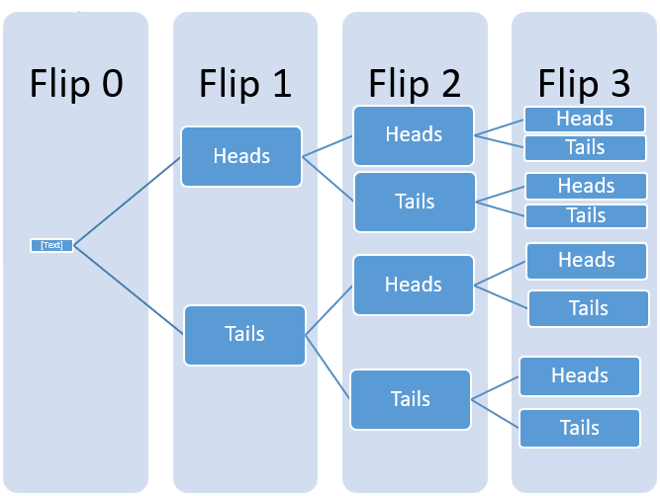
  - For example, the repeated experiment of drawing a marble twice from a bag containing 2 red marbles (each notated as $r_{1}$ and $r_{2}$ to distinguish them) and 1 blue marble (notated as b) has the sample space that can be written as:
    - List
{$r_{1}r_{2}$, $r_{1}$b, $r_{2}r_{1}$, $r_{2}$b, b$r_{1}$, b$r_{2}$, bb, $r_{1}r_{1}$, $r_{2}r_{2}$}.
    - Written Description
The collection of ordered pairs in which each element is either r₁, r₂ or b (as shown in the list).
    - Table

 | Red 1 | Red 2 | Blue
Red 1 | R1, R1 | R1, R2 | R1, B
Red 2 | R2, R1 | R2, R2 | R2, B
Blue | B, R1 | B, R2 | B, B

    - Tree Diagram (two options shown)
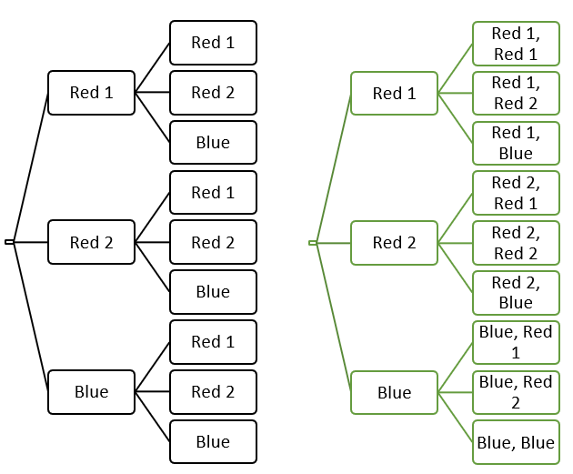

Common Misconceptions or Errors
- Students may incorrectly organize the data using tables or tree diagrams. To address this misconception, start with a small sample space first to ensure students understand the process.

Strategies to Support Tiered Instruction
- Teacher provides examples of small sample spaces and discusses with students how the options are logical, and where they come from. Once students begin to understand small sample spaces, the teacher continues to increase size of sample spaces and have the same conversations.
- Teacher provides examples of situations and has students decide on the sample space necessary.
- Teacher co-creates models with students to represent sample spaces using a coin, die, spinner or a standard deck of cards.
- Instruction includes the use of real-world objects (coin, die, deck of cards, spinner, marbles in a bag, etc.) to demonstrate the possible outcomes for a single experiment and then the possible outcomes if the experiment is repeated.
  - For example, there are three marbles in a bag that are green, yellow and blue. The sample space for the single experiment of drawing a marble in the bag can be written as $\{g, y, b\}$. If this experiment is repeated twice, the sample space could be written as $\{gg, gy, gb, yg, yy, yb, bg, by, bb\}$.
- Instruction includes starting with a small sample space first to ensure students understand the process.

Instructional Tasks
Instructional Task 1 ((MTR.7.1)
Brianna flips a round, flat game piece with yellow on one side and white on the other side. Make a tree diagram to show the sample space for flipping the game piece four times.

Instructional Task 2 (MTR.4.1)
List or describe all the possible outcomes for each experiment.

Experiment | Sample Space
rolling a fair 6-sided die two times
flipping a coin three times
pulling two cards from standard deck with replacement
a spin from the spinner below two times
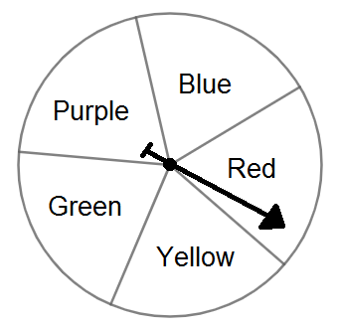

Compare your list with a partner and identify any differences. Allow each partner time to discuss their reasoning until an agreement is reached on the correct sample space.

Instructional Items
Instructional Item 1
Joanna is spinning a spinner twice with 4 equal sections numbered 1 to 4. What are all the possible outcomes in the sample space?

*The strategies, tasks and items included in the B1G-M are examples and should not be considered comprehensive.

MA.8.DP.2.2

Benchmark
MA.8.DP.2.2 Find the theoretical probability of an event related to a repeated experiment.
Benchmark Clarifications:
Clarification 1: Instruction includes representing probability as a fraction, percentage or decimal.
Clarification 2: Experiments to be repeated are limited to tossing a fair coin, rolling a fair die, picking a card randomly from a deck with replacement, picking marbles randomly from a bag with replacement and spinning a fair spinner.
Clarification 3: Repetition of experiments is limited to two times except for tossing a coin.

Connecting Benchmarks/Horizontal Alignment
- MA.8.DP.2.1, MA.8.DP.2.3

Terms from the K-12 Glossary
- Event
- Theoretical Probability
- Repeated Experiment
- Experimental Probability

Vertical Alignment
Previous Benchmarks  - MA.7.DP.2.1, MA.7.DP.2.2, MA.7.DP.2.3 | Next Benchmarks  - MA.912.DP.4.3, MA912.DP.4.9
Purpose and Instructional Strategies
In grade 7, students found the theoretical probability of an event related to a simple experiment. In grade 8, students will find the theoretical probability of an event related to a repeated experiment. In high school, students will determine theoretical probabilities, in more general experiments, and will use a variety of methods, including the addition and multiplication rules.
- Instruction builds on finding sample spaces from MA.8.DP.2.1. Have students discuss their understanding of the words “theoretical” and “probability” to build toward a formal definition of theoretical probability.
- Encourage students to use a variety of representations for the sample space, such as a table, tree diagram or list, to assist in determining the total possible outcomes when calculating the probability. Providing opportunities for students to match situations and sample spaces will assist with building their ability to visualize the sample space for any given experiment.
- When finding theoretical probability, have students work from their sample space. Doing so will lead to the understanding that since experiments for this benchmark are fair, the probability of an event is equivalent to $\frac{number of outcomes in the event}{number of outcomes in the sample space}$.
  - For example, if tossing a fair coin three times, the sample space is {HHH, HHT, HTH, HTT, THH, THT, TTH, TTT}. If one wants to find $P(at least 1 tails)$, students can circle all the outcomes in the sample space that have at least one T. Since there are 7 such outcomes, one can determine the probability as $\frac{7}{8}$, or 87.5%.
- Instruction focuses on the experiments listed in Clarification 2.
  - For example, when rolling a 6-sided die twice, $P(rolling a sum of 7)=\frac{6}{36}$. This can be determined by looking at the table of outcomes and circling the 6 outcomes that give a sum of 7.
  - For example, when picking a card twice with replacement from a deck that contains each of the five vowels of the alphabet (A, E, I, O and U), $P(not picking an A)=0.64$. This can be determined by reasoning that there are 9 ways to draw an A, so there are 16 ways to not draw an A.
  - For example, when spinning a spinner twice that contains 3 sections where two of the sections are red and the other section is blue, $P(spinning the same color twice)=\frac{5}{9}$. This can be determined by looking at the list {$r_{1}r_{2}$, $r_{1}$b, $r_{2}r_{1}$, $r_{2}$b, b$r_{1}$, b$r_{2}$, bb, $r_{1}r_{1}$, $r_{2}r_{2}$} and circling each of the four outcomes that has the same color twice.
- Instruction includes discussing student understanding of the words “theoretical” and “probability” to develop a formal definition of theoretical probability.
- Instruction includes $P(event)$notation.
- Students should develop the understanding that the order in which the outcome (from the simple experiment) occurs matters so that probabilities of the outcomes (from the repeated experiment) are the same.
  - For example, if the simple experiment is to draw a marble out of bag (that contains 1 blue, 1 green and 1 yellow marble), the outcomes for that simple experiment are {B, G, Y}. If this experiment is repeated two times, there are now nine outcomes: {BB, BG, BY, GG, GB, GY, YY, YB, YG}. If one wanted the $P(draw at least 1 yellow marble)$, students should be able to see that the drawing a yellow and then a green is as equally likely as drawing a green and then a yellow. Therefore, those are two distinct outcomes.

Common Misconceptions or Errors
- Students may incorrectly assume that all events are equally likely. To help address this misconception, reinforce that the likelihood of each event depends on the number of possible outcomes in the event.
- Students may incorrectly convert forms of probability between fractions and percentages. To address this misconception, scaffold with more familiar values initially to facilitate the interpretation of the data.

Strategies to Support Tiered Instruction
- Teacher encourages the use of precise language when working with simple experiments and repeated experiments. Students should always note when discussing “outcomes” they specify whether it is an outcome from a simple experiment, such as “heads,” or from a repeated experiment, such as “heads, heads.”
- Teacher facilitates discussion to explain that the outcome for a repeated experiment (a simple experiment that occurs more than once) consists of a sequence of outcomes that occur in the repeated simple experiment. Students should understand that the order in which the outcomes of the simple experiment occur matters when combining to form an outcome of the repeated experiment.
  - For example, if the simple experiment is to toss a coin once, the outcomes for that simple experiment are {H, T}. If this experiment is repeated three times, there are now eight outcomes, each of which is a sequence of Hs and Ts: {HHH, HHT, HTH, HTT, THH, THT, TTH, TTT}. Note that order matters, for instance, HHT is a different outcome than HTH or THH.
- Once students have correctly written the sample space, they can calculate the probability by counting.
  - For example, for the experiment of tossing a coin three times, the sample space can be represented as {HHH, HHT, HTH, HTT, THH, THT, TTH, TTT}. If students want to determine the probability of obtaining exactly one tails in this experiment, they can look through the outcomes of the sample space and highlight all that have exactly one T: {HHH, HHT, HTH, HTT, THH, THT, TTH, TTT}. Then, it can be observed that there are three out of eight highlighted. Therefore, the probability is $\frac{3}{8}$.
- Instruction includes the use of estimation to find the approximate decimal value of a fraction or mixed number before rewriting in decimal form to help with correct placement of the decimal point.
- Teacher co-creates a graphic organizer modeling conversions between fractions and percentages to understand and visually comprehend the relationship of the equivalent forms.
- Teacher provides opportunities for students to use a 100 frame to review place value for and the connections to decimal, fractional, and percentage forms.

Instructional Tasks
Instructional Task 1 (MTR.7.1)
A quiz contains 2 multiple-choice questions with five possible answers each, only one of which is correct. A student plans to guess the answers.
Part A. What is the sample space?
Part B. What is the probability the student guesses wrong answers for both questions?
Part C. What is the probability the student guesses the correct answers for both questions?
Part D. What is the probability the student guesses at least one correct answer?

Instructional Task 2 (MTR.3.1)
A fair 6-sided die is tossed twice.
Part A. What is the sample space?
Part B. Find the probability that the sum of the two results is even.

Instructional Items
Instructional Item 1
There are 3 red, 1 blue and 2 green marbles in a bag. A marble is randomly drawn from the bag twice, with replacement. What is the theoretical probability of choosing one red marble and one green marble?

Instructional Item 2
A fair coin is tossed four times. What is $P(tossing at least three heads)$?

*The strategies, tasks and items included in the B1G-M are examples and should not be considered comprehensive.

MA.8.DP.2.3

Benchmark
MA.8.DP.2.3 Solve real-world problems involving probabilities related to single or repeated experiments, including making predictions based on theoretical probability.
Example: If Gabriella rolls a fair die 300 times, she can predict that she will roll a 3 approximately 50 times since the theoretical probability is $\frac{1}{6}$.
Example: Sandra performs an experiment where she flips a coin three times. She finds the theoretical probability of landing on exactly one head as $\frac{3}{8}$. If she performs this experiment 50 times (for a total of 150 flips), predict the number of repetitions of the experiment that will result in exactly one of the three flips landing on heads.

Benchmark Clarifications:
Clarification 1: Instruction includes making connections to proportional relationships and representing probability as a fraction, percentage or decimal.
Clarification 2: Experiments to be repeated are limited to tossing a fair coin, rolling a fair die, picking a card randomly from a deck with replacement, picking marbles randomly from a bag with replacement and spinning a fair spinner.
Clarification 3: Repetition of experiments is limited to two times except for tossing a coin.

Connecting Benchmarks/Horizontal Alignment
- MA.8.DP.2.2

Terms from the K-12 Glossary
- Theoretical Probability

Vertical Alignment
Previous Benchmarks  - MA.7.DP.1.3, MA.7.DP.1.4  - MA.7.DP.2.1, MA.7.DP.2.3 | Next Benchmarks  - MA.912.DP.4.3, MA.912.DP.4.9
Purpose and Instructional Strategies
In grade 7, students used a simulation of a simple experiment to find experimental probabilities and compare them to theoretical probabilities. In grade 8, students solve real-world problems involving probabilities related to single or repeated experiments, including making predictions based on theoretical probability. In high school, students will expand their knowledge to include more general experiments.
- Students should understand that results from an experiment do not always match the theoretical results, but if they perform a large number of trials, they should be close.
- When determining experimental probabilities, students should understand that this may be done by performing a simple experiment more than once and also by performing a repeated experiment more than once.
  - For example, to determine the experimental probability of tossing four heads in a row, the repeated experiment of tossing a coin four times will need to be performed many times (see also Benchmark Example 2).
- Instruction includes $P(event)$notation.
- Instruction includes opportunities for students to run various numbers of trials to discover that the increased repetition of the experiment will bring the experimental probability closer to the theoretical. Use virtual simulations to quickly show higher and higher volumes of repetition that would be difficult to create with physical manipulatives (MTR.5.1).
- When comparing theoretical to experimental probability, it is important to not just compare the number of times the event occurs, but the probabilities themselves.

Common Misconceptions or Errors
- Students may incorrectly assume the theoretical and experimental probabilities of the same experiment will always be the same. To address this misconception, provide multiple opportunities for students to experience simulations of different situations, with physical or virtual manipulatives, to find and compare the experimental and theoretical probabilities.
- Students may incorrectly expect to see every possible outcome occur during a simulation. While all may occur in a simulation, it is not certain to happen. Students may inadvertently let their own experience with an experiment affect their response.
  - For example, during an experiment if a student never draws an ace from a standard deck of cards, this does not indicate it could never happen.
- Students may incorrectly believe the theoretical probability of an event is the proportion of times that event will actually occur.

Strategies to Support Tiered Instruction
- Teacher reviews the root words theoretical (theory) and experimental (experiment) and discusses the difference between a theoretical probability and experimental probability. Teacher provides a graphic organizer to keep as a reference for root words.
  - For example, experimental probabilities are from simulations whereas theoretical probabilities are from calculations.
- Teacher provides opportunities to discuss the difference between simulating simple experiments and simulating repeated experiments.
  - For example, students could discuss tossing a coin 150 times as a simulation of the simple (single) experiment “tossing a coin” and tossing a coin 150 times as a simulation of the repeated experiment “tossing a coin three times.” In the first case, the simulation has 150 trials whereas the second simulation has 50 trials.
- Teacher sets up a simulation with several trials to work through and discuss what ‘we think’ should happen (Theoretical Probability) and what actually happens when the experiment is completed (Experimental Probability). Then, the teacher models how to find experimental probability, showing how the more trials that are done, the closer the results should get closer to the theoretical probability. Teacher provides instruction focused on color-coding when setting up a proportional relationship to ensure corresponding parts are placed in corresponding positions within the proportion.
  - For example, if Jason chooses a card from a standard deck of cards 104 times and replaces the card each time, what is a reasonable prediction on how many times he will choose a heart?
$$\frac{number of outcomes in the event}{number of outcomes in the sample space}=\frac{predicted number of outcomes}{number of trials}$$

$$\frac{13 hearts}{52 cards}=\frac{x hearts predicted}{104 trials}$$
- Instruction includes providing multiple opportunities to experience simulations of different situations, with physical or virtual manipulatives, to find and compare the experimental and theoretical probabilities.

Instructional Tasks
Instructional Task 1 (MTR.5.1)
The bar graph shows the results of spinning the spinner 200 times.

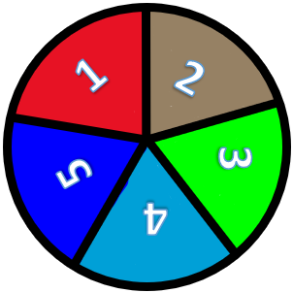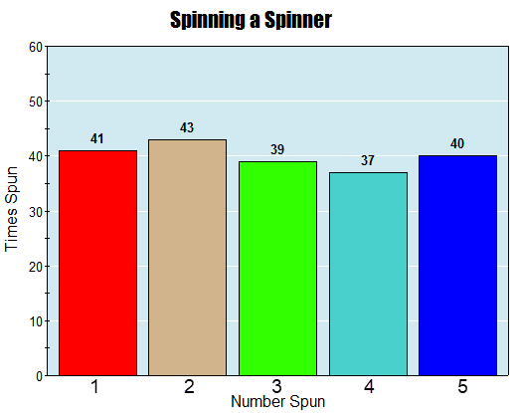

Part A. If the repeated experiment is to spin the spinner twice, predict how many times the event of landing on the same number twice will occur in 100 simulations of the repeated experiment.
Part B. Using technology, perform a simulation of the experiment described in Part A.
Part C. Compare the number of times you actually landed on the same number twice during the simulation to your prediction from Part A.

Instructional Items
Instructional Item 1
If Jackson rolls a fair 6-sided die 200 times, what is a reasonable prediction on how many times he will roll a 4?

Instructional Item 2
A spinner is divided into three equal parts 1-3. The repeated experiment of spinning the spinner twice is simulated 300 times. A table of outcomes is shown.

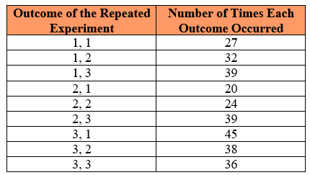

Based on the table, what is the experimental probability that the sum of the two outcomes is at least 4?

*The strategies, tasks and items included in the B1G-M are examples and should not be considered comprehensive.

Appendix A. Summary of Changes

The purpose of this table is to provide a summary of changes from the latest version of the B1G-M. For questions or feedback on the B1G-M, please direct them to BESTMath@fldoe.org.
Benchmark | B1G-M Component | Change Made
MA.8.NSO.1.1 | Vertical Alignment | REMOVED benchmark MA.6.NSO.1.2 and hyperlink with text
MA.8.NSO.1.2 | Connecting Benchmarks/Horizontal Alignment | REMOVED MA.8.AR.2.3
MA.8.NSO.1.2 | Vertical Alignment | REMOVED benchmark MA.6.NSO.1.1 and hyperlink with text
MA.8.NSO.1.2 | Strategies to Support Tiered Instruction | REMOVED "co-constructs" and REPLACDE with "co-create"
MA.8.NSO.1.3 | Vertical Alignment | REMOVED hyperlink with text
MA.8.NSO.1.4 | Connecting Benchmarks/Horizontal Alignment | ADDED benchmarks MA.8.NSO.1.5 and MA.8.NSO.1.6; REMOVED MA.8.GR.1.2
MA.8.NSO.1.4 | Vertical Alignment | REMOVED hyperlink and text; EDITED MA.912.GR.4 to include .5 at the end
MA.8.NSO.1.5 | Connecting Benchmarks/Horizontal Alignment | ADDED MA.8.NSO.1.4 and MA.8.NSO.1.6; REMOVED GR.1.2
MA.8.NSO.1.5 | Vertical Alignment | REMOVED hyperlink and text
MA.8.NSO.1.6 | Connecting Benchmarks/Horizontal Alignment | ADDED benchmarks MA.8.NSO.1.4 and MA.8.NSO.1.5; REMOVED MA.8.GR.1.2
MA.8.NSO.1.6 | Vertical Alignment | REMOVED hyperlink and text
MA.8.NSO.1.7 | Connecting Benchmarks/Horizontal Alignment | REMOVED benchmark MA.8.AR.1.3
MA.8.NSO.1.7 | Vertical Alignment | REMOVED hyperlink and text
MA.8.AR.1.1 | Vertical Alignment | ADDED MA.8.AR.1.3
MA.8.AR.1.1 | Purpose and Instructional Strategies | EDITED the first bullet point for clarity; general edits for grammar; 1st bullet after the table edited for concise language
MA.8.AR.1.1 | Instructional Tasks | EDITED values in task 1
MA.8.AR.1.1 | Common Misconceptions or Errors | REMOVED last bullet point; added "may"
MA.8.AR.1.1 | Strategies to Support Tiered Instruction | EDITED 1st and 2nd bullet point; CLARIFIED 1st open bullet
MA.8.AR.1.1 | Instructional Tasks | EDITED the variable in the 2nd task
MA.8.AR.1.2 | Connecting Benchmarks/Horizontal Alignment | ADDED MA.8.AR.1.3
MA.8.AR.1.2 | Vertical Alignment | REMOVED MA.7.NSO.2.2 and MA.7.AR.1.1
MA.8.AR.1.2 | Purpose and Instructional Strategies | EDITED for grammar
MA.8.AR.1.2 | Common Misconceptions or Errors | EDITED first bullet point for clarification, 2nd bullet point to be less limiting
MA.8.AR.1.2 | Strategies to Support Tiered Instruction | EDITED the 3rd example (open bullet) to meet the limitations of the benchmark; removed limiting wording on the 2nd closed bullet point
MA.8.AR.1.3 | Connecting Benchmarks/Horizontal Alignment | REMOVED benchmark MA.8.NSO.1.7; ADDED benchmarks MA.8.AR.1.1 and MA.8.AR.1.2
MA.8.AR.1.3 | Terms from the K-12 Glossary | ADDED "regular polygon"
MA.8.AR.1.3 | Vertical Alignment | REMOVED benchmark MA.7.AR.1.1
MA.8.AR.1.3 | Common Misconceptions or Errors | EDITED first solid and open bullet points for clarification; ADDED another bullet point
MA.8.AR.1.3 | Strategies to Support Tiered Instruction | EDITED the first open point to show the fully expanded form of the example and removed the final sentence which was confusing
MA.8.AR.1.3 | Instructional Items | ADDED a new Instructional Item 1 and updated the one that was already there as the 2nd Instructional Item.
MA.8.AR.2.1 | Connecting Benchmarks/Horizontal Alignment | REMOVED benchmarks MA.8.AR.3 and MA.8.AR.4; ADDED MA.8.AT.4.1 and MA.8.GR.1.6
MA.8.AR.2.1 | Vertical Alignment | EDITED benchmark MA.7.AR.2.1 to be MA.7.AR.2.2
MA.8.AR.2.1 | Common Misconceptions or Errors | EDITED 3rd bullet point for clarification
MA.8.AR.2.1 | Strategies to Support Tiered Instruction | EDITED 1st bullet point and 1st open point; ADDED spacing before example of repeated addition; EDITED 2nd bullet point to define the variable and clarity; edited 5th bullet point for grammar and removed example of added addition
MA.8.AR.2.2 | Vertical Alignment | EDITED benchmark MA.7.AR.2.1 to be MA.7.AR.2.2; REMOVED benchmarks MA.912.AR.2.7 and MA.912.AR.2.8
MA.8.AR.2.2 | Purpose and Instructional Strategies | EDITED for grammar
MA.8.AR.2.2 | Strategies to Support Tiered Instruction | EDITED first open bullet point to define the variable
MA.8.AR.2.3 | Connecting Benchmarks/Horizontal Alignment | ADDED benchmark MA.8.NSO.1.1; REMOVED benchmark MA.8.NSO.1.2
MA.8.AR.2.3 | Terms from the K-12 Glossary | ADDED "whole numbers"
MA.8.AR.2.3 | Strategies to Support Tiered Instruction | LABELED example table under both open points
MA.8.AR.3.1 | Connecting Benchmarks/Horizontal Alignment | REMOVED MA.8.AR.2.1 and ADDED MA.8.GR.2.4
MA.8.AR.3.1 | Vertical Alignment | ADDED benchmarks MA.7.AR.4.2 and MA.7.AR.4.4 as well as MA.912.AR.2.4 and MA.912.F.1.3
MA.8.AR.3.1 | Purpose and Instructional Strategies | EDITED for grammar
MA.8.AR.3.1 | Instructional Tasks | EDITED task 2 by removing Part A and making it a one-part question
MA.8.AR.3.2 | Connecting Benchmarks/Horizontal Alignment | REMOVED MA.8.AR.2.1 and ADDED benchmarks MA.8.AR.3.3, MA.8.AR.3.5 and MA.8.GR.2.4
MA.8.AR.3.2 | Purpose and Instructional Strategies | EDITED for grammar AND to ensure the slope formula matches the reference sheet
MA.8.AR.3.2 | Instructional Item | ADDED a new Instructional Item 1 and updated the one that was already there as the 2nd Instructional Item.
MA.8.AR.3.3 | Connecting Benchmarks/Horizontal Alignment | REMOVED MA.8.AR.2.1 and ADDED benchmarks MA.8.AR.3.2 and MA.8.AR.3.5
MA.8.AR.3.3 | Strategies to Support Tiered Instruction | EDITED to ensure the slope formula matches the reference sheet
MA.8.AR.3.4 | Connecting Benchmarks/Horizontal Alignment | REMOVED MA.8.AR.2.1
MA.8.AR.3.4 | Strategies to Support Tiered Instruction | EDITED to ensure the slope formula matches the reference sheet
MA.8.AR.3.5 | Connecting Benchmarks/Horizontal Alignment | DELETED MA.8.AR.2.1 and ADDED benchmarks MA.AR.3.2 and MA.8.AR.3.3
MA.8.AR.3.5 | Strategies to Support Tiered Instruction | EDITED to ensure the slope formula matches the reference sheet
MA.8.AR.4.1 | Connecting Benchmarks/Horizontal Alignment | ADDED benchmarks MA.8.AR.4.2 and MA.8.AR.4.3
MA.8.AR.4.2 | Connecting Benchmarks/Horizontal Alignment | ADDED benchmarks MA.8.AR.4.1 and MA.8.AR.4.3
MA.8.AR.4.2 | Strategies to Support Tiered Instruction | EDITED final sentence
MA.8.AR.4.3 | Connecting Benchmarks/Horizontal Alignment | REMOVED MA.8.R.2.1 and ADDED benchmarks MA.8.AR.4.1 and MA.8.AR.4.2
MA.8.AR.4.3 | Instructional Items | EDITED the slope and arrangement on item 4
MA.8.F.1.1 | Connecting Benchmarks/Horizontal Alignment | ADDED MA.8.F.1.2 and MA.8.F.1.3
MA.8.F.1.1 | Strategies to Support Tiered Instruction | EDITED for grammar
MA.8.F.1.2 | Connecting Benchmarks/Horizontal Alignment | ADDED benchmarks MA.8.F.1.1 and MA.8.F.1.3
MA.8.F.1.2 | Strategies to Support Tiered Instruction | CHANGED "co-constructs" to "co-creates"
MA.8.F.1.3 | Connecting Benchmarks/Horizontal Alignment | ADDED benchmarks MA.8.F.1.1 and MA.8.F.1.2
MA.8.GR.1.1 | Connecting Benchmarks/Horizontal Alignment | ADDED benchmark MA.8.NSO.1.1
MA.8.GR.1.1 | Vertical Alignment | REMOVED MA.912.T.1.1
MA.8.GR.1.1 | Strategies to Support Tiered Instruction | LABELED example table under the open point; EDITED for grammar and consistency throughout document
MA.8.GR.1.1 | Instructional Items | CHANGED measurement and defined when to round on item 1; CHANGED item 3 into an enrichment task because it exceeds the benchmark constraint
MA.8.GR.1.2 | Connecting Benchmarks/Horizontal Alignment | ADDED MA.8.NSO.1.1
MA.8.GR.1.2 | Vertical Alignment | REMOVED benchmark MA.912.T.1.1
MA.8.GR.1.2 | Strategies to Support Tiered Instruction | EDITED for grammar and consistency throughout the document
MA.8.GR.1.3 | Strategies to Support Tiered Instruction | EDITED for grammar and consistency throughout the document; ADDED manipulative information
MA.8.GR.1.3 | Instructional Tasks | ADDED 4th option
MA.8.GR.1.3 | Instructional Items | RENUMBERED
MA.8.GR.1.4 | Vertical Alignment | ADDED benchmarks MA.4.GR.1.2 and MA.4.GR.1.3
MA.8.GR.1.4 | Purpose and Instructional Strategies | EDITED the 6th bullet point for clarification
MA.8.GR.1.4 | Strategies to Support Tiered Instruction | EDITED the 1st bullet point for clarification and consistency throughout the document
MA.8.GR.1.4 | Instructional Items | ADDED a new Instructional Item 1 and updated the one that was already there as the 2nd Instructional Item.
MA.8.GR.1.5 | Purpose and Instructional Strategies | REPLACED "patty paper" with "tracing paper"
MA.8.GR.1.5 | Strategies to Support Tiered Instruction | CHANGED "co-constructs" to "co-creates"
MA.8.GR.1.5 | Instructional Items | ADDED Instructional Item 2.
MA.8.GR.2.1 | Connecting Benchmarks/Horizontal Alignment | ADDED benchmarks MA.8.GR.2.2 and MA.8.GR.2.3
MA.8.GR.2.1 | Vertical Alignment | ADDED benchmarks MA.912.F.2.2 and MA.912.GR.2.3 and MA.912.GR.2.4
MA.8.GR.2.1 | Purpose and Instructional Strategies | EDITED introductory paragraph for consistency and grammar
MA.8.GR.2.2 | Connecting Benchmarks/Horizontal Alignment | ADDED benchmarks MA.8.GR.2.1 and MA.8.GR.2.3
MA.8.GR.2.2 | Vertical Alignment | ADDED benchmarks MA.912.F.2.1, MA.912.F.2.2, MA.912.GR.2.1, MA.912.2.3, and MA.912.GR.2.4; REMOVED benchmarks MA.912.F.2 and MA.912.GR.2
MA.8.GR.2.3 | Connecting Benchmarks/Horizontal Alignment | ADDED benchmarks MA.8.GR.2.1 and MA.8.GR.2.2
MA.8.GR.2.3 | Vertical Alignment | ADDED benchmarks MA.912.F.2.1, MA.912.F.2.2, MA.912.GR.2.1, MA.912.2.3, and MA.912.GR.2.4; REMOVED benchmarks MA.912.F.2 and MA.912.GR.2
MA.8.GR.2.3 | Purpose and Instructional Strategies | Edited first bullet point for clarification
MA.8.GR.2.3 | Common Misconceptions or Errors | ADDED another bullet point
MA.8.GR.2.3 | Strategies to Support Tiered Instruction | ADDED "tracing paper" to the first bullet point
MA.8.GR.2.4 | Connecting Benchmarks/Horizontal Alignment | DELETED MA.8.GR.1.4, MA.8.GR.1.5 and MA.8.GR.1.6
MA.8.GR.2.4 | Vertical Alignment | ADDED benchmark MA.7.AR.3.2
MA.8.DP.1.1 | Connecting Benchmarks/Horizontal Alignment | DELETED MA.8.AR.3 and ADDED MA.8,.DP.1.2 and MA.8.DP.1.3
MA.8.DP.1.1 | Instructional Tasks | EDITED values in task 1
MA.8.DP.1.1 | Instructional Items | Updated Item 2
MA.8.DP.1.2 | Connecting Benchmarks/Horizontal Alignment | DELETED MA.8.AR.3 and ADDED MA.8,.DP.1.1 and MA.8.DP.1.3
MA.8.DP.1.2 | Purpose and Instructional Strategies | EDITED grammar
MA.8.DP.1.2 | Strategies to Support Tiered Instruction | EDITED first bullet point for clarity and inclusion of all associations
MA.8.DP.1.3 | Connecting Benchmarks/Horizontal Alignment | ADDED MA.8.AR.3.1, 3.2, 3.3, 3.4, & 3.5; ADDED MA.8.DP.1.1 and MA.8.DP.1.2
MA.8.DP.1.3 | Purpose and Instructional Strategies | EDITED grammar
MA.8.DP.2.1 | Connecting Benchmarks/Horizontal Alignment | ADDED benchmark MA.8.DP.2.2
MA.8.DP.2.1 | Purpose and Instructional Strategies | MOVED a bullet point up on the list
MA.8.DP.2.2 | Connecting Benchmarks/Horizontal Alignment | ADDED benchmark MA.8.DP.2.1 and MA.8.DP.2.2
MA.8.DP.2.2 | Terms from the K-12 Glossary | ADDED "Repeated Experiment" and "Experimental Probability"
MA.8.DP.2.2 | Vertical Alignment | ADDED MA.7.DP.2.1 and MA.7.DP.2.2 REMOVED benchmarks MA.912.DP.4.2, MA.912.DP.4.7 and MA.912.DP.4.8
MA.8.DP.2.2 | Purpose and Instructional Strategies | EDITED for grammar
MA.8.DP.2.2 | Common Misconceptions or Errors | EDITED for grammar
MA.8.DP.2.3 | Connecting Benchmarks/Horizontal Alignment | REMOVED benchmarks MA.8.NSO.1.2 and MA.8.NSO.1.7; ADDED benchmark MA.8.DP.2.2
MA.8.DP.2.3 | Vertical Alignment | ADDED benchmarks MA.7.DP.1.3, MA.7.DP.1.4, MA.7.DP.2.3 and MA.912.DP.4.9

