Grade 7 B.E.S.T. Instructional Guide for Mathematics

The B.E.S.T. Instructional Guide for Mathematics (B1G-M) is intended to assist educators with planning for student learning and instruction aligned to Florida’s Benchmarks for Excellent Student Thinking (B.E.S.T.) Standards. This guide is designed to aid high-quality instruction through the identification of components that support the learning and teaching of the B.E.S.T. Mathematics Standards and Benchmarks. The B1G-M includes an analysis of information related to the B.E.S.T. Standards for Mathematics within this specific mathematics course, the instructional emphasis and aligned resources. This document is posted on the B.E.S.T. Standards for Mathematics webpage of the Florida Department of Education’s website and will continue to undergo edits as needed.

Structural Framework and Intentional Design of the B.E.S.T. Standards for Mathematics

Florida’s B.E.S.T. Standards for Mathematics were built on the following.

- The coding scheme for the standards and benchmarks was changed to be consistent with other content areas. The new coding scheme is structured as follows:
Content.GradeLevel.Strand.Standard.Benchmark.
- Strands were streamlined to be more consistent throughout.
- The standards and benchmarks were written to be clear and concise to ensure that they are easily understood by all stakeholders.
- The benchmarks were written to allow teachers to meet students’ individual skills, knowledge and ability.
- The benchmarks were written to allow students the flexibility to solve problems using a method or strategy that is accurate, generalizable and efficient depending on the content (i.e., the numbers, expressions or equations).
- The benchmarks were written to allow for student discovery (i.e., exploring) of strategies rather than the teaching, naming and assessing of each strategy individually.
- The benchmarks were written to support multiple pathways for success in career and college for students.
- The benchmarks should not be taught in isolation but should be combined purposefully.
- The benchmarks may be addressed at multiple points throughout the year, with the intention of gaining mastery by the end of the year.
- Appropriate progression of content within and across strands was developed for each grade level and across grade levels.
- There is an intentional balance of conceptual understanding and procedural fluency with the application of accurate real-world context intertwined within mathematical concepts for relevance.
- The use of other content areas, like science and the arts, within real-world problems should be accurate, relevant, authentic and reflect grade-level appropriateness.

Components of the B.E.S.T. Instructional Guide for Mathematics

The following table is an example of the layout for each benchmark and includes the defining attributes for each component. It is important to note that instruction should not be limited to the possible connecting benchmarks, related terms, strategies or examples provided. To do so would strip the intention of an educator meeting students’ individual skills, knowledge and abilities.

Benchmark
focal point for instruction within lesson or task
This section includes the benchmark as identified in the B.E.S.T. Standards for Mathematics. The benchmark, also referred to as the Benchmark of Focus, is the focal point for student learning and instruction. The benchmark, and its related example(s) and clarification(s), can also be found in the course description. The 9-12 benchmarks may be included in multiple courses; select the example(s) or clarification(s) as appropriate for the identified course.

Connecting Benchmarks/Horizontal Alignment
in other standards within the grade level or course
This section includes a list of connecting benchmarks that relate horizontally to the Benchmark of Focus. Horizontal alignment is the intentional progression of content within a grade level or course linking skills within and across strands. Connecting benchmarks are benchmarks that either make a mathematical connection or include prerequisite skills. The information included in this section is not a comprehensive list, and educators are encouraged to find other connecting benchmarks. Additionally, this list will not include benchmarks from the same standard since benchmarks within the same standard already have an inherent connection.

Terms from the K-12 Glossary
This section includes terms from Appendix C: K-12 Glossary, found within the B.E.S.T. Standards for Mathematics document, which are relevant to the identified Benchmark of Focus. The terms included in this section should not be viewed as a comprehensive vocabulary list, but instead should be considered during instruction or act as a reference for educators.

Vertical Alignment
across grade levels or courses
This section includes a list of related benchmarks that connect vertically to the Benchmark of Focus. Vertical alignment is the intentional progression of content from one year to the next, spanning across multiple grade levels. Benchmarks listed in this section make mathematical connections from prior grade levels or courses in future grade levels or courses within and across strands. If the Benchmark of Focus is a new concept or skill, it may not have any previous benchmarks listed. Likewise, if the Benchmark of Focus is a mathematical skill or concept that is finalized in learning and does not have any direct connection to future grade levels or courses, it may not have any future benchmarks listed. The information included in this section is not a comprehensive list, and educators are encouraged to find other benchmarks within a vertical progression.

Purpose and Instructional Strategies
This section includes further narrative for instruction of the benchmark and vertical alignment. Additionally, this section may also include the following:
- explanations and details for the benchmark;
- vocabulary not provided within Appendix C;
- possible instructional strategies and teaching methods; and
- strategies to embed potentially related Mathematical Thinking and Reasoning Standards (MTRs).

Common Misconceptions or Errors
This section will include common student misconceptions or errors and may include strategies to address the identified misconception or error. Recognition of these misconceptions and errors enables educators to identify them in the classroom and make efforts to correct the misconception or error. This corrective effort in the classroom can also be a form of formative assessment within instruction.

Strategies to Support Tiered Instruction
The instructional strategies in this section address the common misconceptions and errors listed within the above section that can be a barrier to successfully learning the benchmark. All instruction and intervention at Tiers 2 and 3 are intended to support students to be successful with Tier 1 instruction. Strategies that support tiered instruction are intended to assist teachers in planning across any tier of support and should not be considered exclusive or inclusive of other instructional strategies that may support student learning with the B.E.S.T. Mathematics Standards. For more information about tiered instruction, please see the Effective Tiered Instruction for Mathematics: ALL Means ALL document.

Instructional Tasks
demonstrate the depth of the benchmark and the connection to the related benchmarks
This section will include example instructional tasks, which may be open-ended and are intended to demonstrate the depth of the benchmark. Some instructional tasks include integration of the Mathematical Thinking and Reasoning Standards (MTRs) and related benchmark(s). Enrichment tasks may be included to make connections to benchmarks in later grade levels or courses. Tasks may require extended time, additional materials and collaboration.

Instructional Items
demonstrate the focus of the benchmark
This section will include example instructional items which may be used as evidence to demonstrate the students’ understanding of the benchmark. Items may highlight one or more parts of the benchmark.
*The strategies, tasks and items included in the B1G-M are examples and should not be considered comprehensive.

Mathematical Thinking and Reasoning Standards
MTRs: Because Math Matters

Florida students are expected to engage with mathematics through the Mathematical Thinking and Reasoning Standards (MTRs) by utilizing their language as a self-monitoring tool in the classroom, promoting deeper learning and understanding of mathematics. The MTRs are standards which should be used as a lens when planning for student learning and instruction of the B.E.S.T. Standards for Mathematics.

Structural Framework and Intentional Design of the Mathematical Thinking and Reasoning Standards

The Mathematical Thinking and Reasoning Standards (MTRs) are built on the following.

- The MTRs have the same coding scheme as the standards and benchmarks; however, they are written at the standard level because there are no benchmarks.
- In order to fulfill Florida’s unique coding scheme, the 5th place (benchmark) will always be a “1” for the MTRs.
- The B.E.S.T. Standards for Mathematics should be taught through the lens of the MTRs.
- At least one of the MTRs should be authentically and appropriately embedded throughout every lesson based on the expectation of the benchmark(s).
- The bulleted language of the MTRs were written for students to use as self-monitoring tools during daily instruction.
- The clarifications of the MTRs were written for teachers to use as a guide to inform their instructional practices.
- The MTRs ensure that students stay engaged, persevere in tasks, share their thinking, balance conceptual understanding and procedures, assess their solutions, make connections to previous learning and extended knowledge, and apply mathematical concepts to real-world applications.
- The MTRs should not stand alone as a separate focus for instruction but should be combined purposefully.
- The MTRs will be addressed at multiple points throughout the year, with the intention of gaining mastery of mathematical skills by the end of the year and building upon these skills as they continue in their K-12 education.

MA.K12.MTR.1.1 Actively participate in effortful learning both individually and collectively.
Mathematicians who participate in effortful learning both individually and with others:
- Analyze the problem in a way that makes sense given the task.
- Ask questions that will help with solving the task.
- Build perseverance by modifying methods as needed while solving a challenging task.
- Stay engaged and maintain a positive mindset when working to solve tasks.
- Help and support each other when attempting a new method or approach.

Clarifications:
Teachers who encourage students to participate actively in effortful learning both individually and with others:
- Cultivate a community of growth mindset learners.
- Foster perseverance in students by choosing tasks that are challenging.
- Develop students’ ability to analyze and problem solve.
- Recognize students’ effort when solving challenging problems.

MA.K12.MTR.2.1 Demonstrate understanding by representing problems in multiple ways.
Mathematicians who demonstrate understanding by representing problems in multiple ways:
- Build understanding through modeling and using manipulatives.
- Represent solutions to problems in multiple ways using objects, drawings, tables, graphs and equations.
- Progress from modeling problems with objects and drawings to using algorithms and equations.
- Express connections between concepts and representations.
- Choose a representation based on the given context or purpose.

Clarifications:
Teachers who encourage students to demonstrate understanding by representing problems in multiple ways:
- Help students make connections between concepts and representations.
- Provide opportunities for students to use manipulatives when investigating concepts.
- Guide students from concrete to pictorial to abstract representations as understanding progresses.
- Show students that various representations can have different purposes and can be useful in different situations.

MA.K12.MTR. 3.1 Complete tasks with mathematical fluency.
Mathematicians who complete tasks with mathematical fluency:
- Select efficient and appropriate methods for solving problems within the given context.
- Maintain flexibility and accuracy while performing procedures and mental calculations.
- Complete tasks accurately and with confidence.
- Adapt procedures to apply them to a new context.
- Use feedback to improve efficiency when performing calculations.

Clarifications:
Teachers who encourage students to complete tasks with mathematical fluency:
- Provide students with the flexibility to solve problems by selecting a procedure that allows them to solve efficiently and accurately.
- Offer multiple opportunities for students to practice efficient and generalizable methods.
- Provide opportunities for students to reflect on the method they used and determine if a more efficient method could have been used.

MA.K12.MTR.4.1 Engage in discussions that reflect on the mathematical thinking of self and others.
Mathematicians who engage in discussions that reflect on the mathematical thinking of self and others:
- Communicate mathematical ideas, vocabulary and methods effectively.
- Analyze the mathematical thinking of others.
- Compare the efficiency of a method to those expressed by others.
- Recognize errors and suggest how to correctly solve the task.
- Justify results by explaining methods and processes.
- Construct possible arguments based on evidence.

Clarifications:
Teachers who encourage students to engage in discussions that reflect on the mathematical thinking of self and others:
- Establish a culture in which students ask questions of the teacher and their peers, and error is an opportunity for learning.
- Create opportunities for students to discuss their thinking with peers.
- Select, sequence and present student work to advance and deepen understanding of correct and increasingly efficient methods.
- Develop students’ ability to justify methods and compare their responses to the responses of their peers.

MA.K12.MTR.5.1 Use patterns and structure to help understand and connect mathematical concepts.
Mathematicians who use patterns and structure to help understand and connect mathematical concepts:
- Focus on relevant details within a problem.
- Create plans and procedures to logically order events, steps or ideas to solve problems.
- Decompose a complex problem into manageable parts.
- Relate previously learned concepts to new concepts.
- Look for similarities among problems.
- Connect solutions of problems to more complicated large-scale situations.

Clarifications:
Teachers who encourage students to use patterns and structure to help understand and connect mathematical concepts:
- Help students recognize the patterns in the world around them and connect these patterns to mathematical concepts.
- Support students to develop generalizations based on the similarities found among problems.
- Provide opportunities for students to create plans and procedures to solve problems.
- Develop students’ ability to construct relationships between their current understanding and more sophisticated ways of thinking.

MA.K12.MTR.6.1 Assess the reasonableness of solutions.
Mathematicians who assess the reasonableness of solutions:
- Estimate to discover possible solutions.
- Use benchmark quantities to determine if a solution makes sense.
- Check calculations when solving problems.
- Verify possible solutions by explaining the methods used.
- Evaluate results based on the given context.

Clarifications:
Teachers who encourage students to assess the reasonableness of solutions:
- Have students estimate or predict solutions prior to solving.
- Prompt students to continually ask, “Does this solution make sense? How do you know?”
- Reinforce that students check their work as they progress within and after a task.
- Strengthen students’ ability to verify solutions through justifications.

MA.K12.MTR.7.1 Apply mathematics to real-world contexts.
Mathematicians who apply mathematics to real-world contexts:
- Connect mathematical concepts to everyday experiences.
- Use models and methods to understand, represent and solve problems.
- Perform investigations to gather data or determine if a method is appropriate.
- Redesign models and methods to improve accuracy or efficiency.

Clarifications:
Teachers who encourage students to apply mathematics to real-world contexts:
- Provide opportunities for students to create models, both concrete and abstract, and perform investigations.
- Challenge students to question the accuracy of their models and methods.
- Support students as they validate conclusions by comparing them to the given situation.
- Indicate how various concepts can be applied to other disciplines.

Examples of Teacher and Student Moves for the MTRs

Below are examples that demonstrate the embedding of the MTRs within the mathematics classroom. The provided teacher and student moves are examples of how some MTRs could be incorporated into student learning and instruction. The information included in this table is not a comprehensive list, and educators are encouraged to incorporate other teacher and student moves that support the MTRs.

MTR | Student Moves | Teacher Moves
MA.K12.MTR.1.1  Actively participate in effortful learning both individually and collectively. | - Students engage in the task through individual analysis, student-to-teacher interaction and student-to-student interaction.  - Students ask task-appropriate questions to self, the teacher and to other students. (MTR.4.1)  - Students have a positive productive struggle exhibiting growth mindset, even when making a mistake.  - Students stay engaged in the task to a purposeful conclusion while modifying methods, when necessary, in solving a problem through self-analysis and perseverance. | - Teacher provides flexible options (i.e., differentiated, challenging tasks that allow students to actively pursue a solution both individually and in groups) so that all students have the opportunity to access and engage with instruction, as well as demonstrate their learning.  - Teacher creates a physical environment that supports a growth mindset and will ensure positive student engagement and collaboration.  - Teacher provides constructive, encouraging feedback to students that recognizes their efforts and the value of analysis and revision.  - Teacher provides appropriate time for student processing, productive struggle and reflection.  - Teacher uses data and questions to focus students on their thinking; help students determine their sources of struggle and to build understanding.  - Teacher encourages students to ask appropriate questions of other students and of the teacher including questions that examine accuracy. (MTR.4.1)
MA.K12.MTR.2.1  Demonstrate understanding by representing problems in multiple ways. | - Students represent problems concretely using objects, models and manipulatives.  - Students represent problems pictorially using drawings, models, tables and graphs.  - Students represent problems abstractly using numerical or algebraic expressions and equations.  - Students make connections and select among different representations and methods for the same problem, as appropriate to different situations or context. (MTR.3.1) | - Teacher provides students with objects, models, manipulatives, appropriate technology and real-world situations. (MTR.7.1)  - Teacher encourages students to use drawings, models, tables, expressions, equations and graphs to represent problems and solutions.  - Teacher questions students about making connections between different representations and methods and challenges students to choose one that is most appropriate to the context. (MTR.3.1)  - Teacher encourages students to explain their different representations and methods to each other. (MTR.4.1)  - Teacher provides opportunities for students to choose appropriate methods and to use mathematical technology.
MA.K12.MTR.3.1  Complete tasks with mathematical fluency. | - Students complete tasks with flexibility, efficiency and accuracy.  - Students use feedback from peers and teachers to reflect on and revise methods used.  - Students build confidence through practice in a variety of contexts and problems. (MTR.1.1) | - Teacher provides tasks and opportunities to explore and share different methods to solve problems. (MTR.1.1)  - Teacher provides opportunities for students to choose methods and reflect (i.e., through error analysis, revision, summarizing methods or writing) on the efficiency and accuracy of the method(s) chosen.  - Teacher asks questions and gives feedback to focus student thinking to build efficiency of accurate methods.  - Teacher offers multiple opportunities to practice generalizable methods.
MA.K12.MTR.4.1  Engage in discussions that reflect on the mathematical thinking of self and others. | - Students use content specific language to communicate and justify mathematical ideas and chosen methods.  - Students use discussions and reflections to recognize errors and revise their thinking.  - Students use discussions to analyze the mathematical thinking of others.  - Students identify errors within their own work and then determine possible reasons and potential corrections.  - When working in small groups, students recognize errors of their peers and offers suggestions. | - Teacher provides students with opportunities (through open-ended tasks, questions and class structure) to make sense of their thinking. (MTR.1.1)  - Teacher uses precise mathematical language, both written and abstract, and encourages students to revise their language through discussion.  - Teacher creates opportunities for students to discuss and reflect on their choice of methods, their errors and revisions and their justifications.  - Teachers select, sequence and present student work to elicit discussion about different methods and representations. (MTR.2.1, MTR.3.1)
MA.K12.MTR.5.1 Use patterns and structure to help understand and connect mathematical concepts. | - Students identify relevant details in a problem in order to create plans and decompose problems into manageable parts.  - Students find similarities and common structures, or patterns, between problems in order to solve related and more complex problems using prior knowledge. | - Teacher asks questions to help students construct relationships between familiar and unfamiliar problems and to transfer this relationship to solve other problems. (MTR.1.1)  - Teacher provides students opportunities to connect prior and current understanding to new concepts.  - Teacher provides opportunities for students to discuss and develop generalizations about a mathematical concept. (MTR.3.1, MTR.4.1)  - Teacher allows students to develop an appropriate sequence of steps in solving problems.  - Teacher provides opportunities for students to reflect during problem solving to make connections to problems in other contexts, noticing structure and making improvements to their process.
MA.K12.MTR.6.1 Assess the reasonableness of solutions. | - Students estimate a solution, including using benchmark quantities in place of the original numbers in a problem.  - Students monitor calculations, procedures and intermediate results during the process of solving problems.  - Students verify and check if solutions are viable, or reasonable, within the context or situation. (MTR.7.1)  - Students reflect on the accuracy of their estimations and their solutions. | - Teacher provides opportunities for students to estimate or predict solutions prior to solving.  - Teacher encourages students to compare results to estimations and revise if necessary for future situations. (MTR.5.1)  - Teacher prompts students to self-monitor by continually asking, “Does this solution or intermediate result make sense? How do you know?”  - Teacher encourages students to provide explanations and justifications for results to self and others. (MTR.4.1)
MA.K12.MTR.7.1 Apply mathematics to real-world contexts. | - Students connect mathematical concepts to everyday experiences.  - Students use mathematical models and methods to understand, represent and solve real-world problems.  - Students investigate, research and gather data to determine if a mathematical model is appropriate for a given situation from the world around them.  - Students re-design models and methods to improve accuracy or efficiency. | - Teacher provides real-world context to help students build understanding of abstract mathematical ideas.  - Teacher encourages students to assess the validity and accuracy of mathematical models and situations in real-world context, and to revise those models if necessary.  - Teacher provides opportunities for students to investigate, research and gather data to determine if a mathematical model is appropriate for a given situation from the world around them.  - Teacher provides opportunities for students to apply concepts to other content areas.

Grade 7 Areas of Emphasis

In Grade 7, instructional time will emphasize five areas:

- recognizing that fractions, decimals and percentages are different representations of rational numbers and performing all four operations with rational numbers with procedural fluency;
- creating equivalent expressions and solving equations and inequalities;
- developing understanding of and applying proportional relationships in two variables;
- extending analysis of two- and three-dimensional figures to include circles and cylinders; and
- representing and comparing categorical and numerical data and developing understanding of probability.

The purpose of the areas of emphasis is not to guide specific units of learning and instruction, but rather provide insight on major mathematical topics that will be covered within this mathematics course. In addition to its purpose, the areas of emphasis are built on the following:
- Supports the intentional horizontal progression within the strands and across the strands in this grade level or course.
- Student learning and instruction should not focus on the stated areas of emphasis as individual units.
- Areas of emphasis are addressed within standards and benchmarks throughout the course so that students are making connections throughout the school year.
- Some benchmarks can be organized within more than one area.
- Supports the communication of the major mathematical topics to all stakeholders.
- Benchmarks within the areas of emphasis should not be taught within the order in which they appear. To do so would strip the progression of mathematical ideas and miss the opportunity to enhance horizontal progressions within the grade level or course.

The table below shows how the benchmarks within this mathematics course are embedded within the areas of emphasis.

Number Sense and  Operations | Operations with and Representing Rational Numbers | Equivalent Expressions and Solving Equations and Inequalities | Two-variable Proportional Relationships | Area and Volume of Geometric Figures | Categorical and Numerical Data and Probability
MA.7.NSO.1.1 | X | X
MA.7.NSO.1.2 | X | X | X | X | X
MA.7.NSO.2.1 | X | X | X | X | X
MA.7.NSO.2.2 | X | X | X | X | X
MA.7.NSO.2.3 | X | X | X | X | X

Algebraic Reasoning | Operations with and Representing Rational Numbers | Equivalent Expressions and Solving Equations and Inequalities | Two-variable Proportional Relationships | Area and Volume of Geometric Figures | Categorical and Numerical Data and Probability
MA.7.AR.1.1 | X | X
MA.7.AR.1.2 | X | X
MA.7.AR.2.1 | X | X
MA.7.AR.2.2 | X | X | X | X | X
MA.7.AR.3.1 | X | X |  | X | X
MA.7.AR.3.2 | X | X |  | X | X
MA.7.AR.3.3 | X | X |  | X
MA.7.AR.4.1 | X |  | X | X
MA.7.AR.4.2 | X |  | X
MA.7.AR.4.3 | X |  | X | X
MA.7.AR.4.4 | X |  | X
MA.7.AR.4.5 | X |  | X | X

Geometric Reasoning | Operations with and Representing Rational Numbers | Equivalent Expressions and Solving Equations and Inequalities | Two-variable Proportional Relationships | Area and Volume of Geometric Figures | Categorical and Numerical Data and Probability
MA.7.GR.1.1 | X |  |  | X
MA.7.GR.1.2 | X |  |  | X
MA.7.GR.1.3 | X | X | X | X
MA.7.GR.1.4 | X | X |  | X
MA.7.GR.1.5 | X | X | X | X
MA.7.GR.2.1 | X |  |  | X
MA.7.GR.2.2 | X | X |  | X
MA.7.GR.2.3 | X | X |  | X

Data Analysis & Probability | Operations with and Representing Rational Numbers | Equivalent Expressions and Solving Equations and Inequalities | Two-variable Proportional Relationships | Area and Volume of Geometric Figures | Categorical and Numerical Data and Probability
MA.7.DP.1.1 | X |  |  |  | X
MA.7.DP.1.2 | X |  |  |  | X
MA.7.DP.1.3 | X | X |  |  | X
MA.7.DP.1.4 | X | X |  |  | X
MA.7.DP.1.5 | X |  |  |  | X
MA.7.DP.2.1 | X |  |  |  | X
MA.7.DP.2.2 | X |  |  |  | X
MA.7.DP.2.3 | X |  |  |  | X
MA.7.DP.2.4 | X | X |  |  | X

Number Sense and Operations

MA.7.NSO.1 Rewrite numbers in equivalent forms.

MA.7.NSO.1.1

Benchmark
MA.7.NSO.1.1 Know and apply the Laws of Exponents to evaluate numerical expressions and generate equivalent numerical expressions, limited to whole-number exponents and rational number bases.
Benchmark Clarifications:
Clarification 1: Instruction focuses on building the Laws of Exponents from specific examples. Refer to the K-12 Formulas (Appendix E) for the Laws of Exponents.
Clarification 2: Problems in the form $\frac{a^{n}}{a^{m}}=a^{p}$ must result in a whole-number value for $p$.

Connecting Benchmarks/Horizontal Alignment
- MA.7.NSO.2.1
- MA.7.GR.1.4
- MA.7.GR.2.2, MA.7.GR.2.3

Terms from the K-12 Glossary
- Base (of an exponent)
- Exponent (exponential form)
- Rational Number
- Whole Number

Vertical Alignment
Previous Benchmarks  - MA.6.NSO.3.3, MA.6.NSO.3.4 |  | Next Benchmarks  - MA.8.NSO.1.3  - MA.8.AR.1.1  - MA.8.NSO.1.7
Purpose and Instructional Strategies
In grade 6, students evaluated positive rational numbers and integers with natural number exponents. In grade 7, students build on this to evaluate numerical expressions and generate equivalent numerical expressions with positive and negative rational numbers having whole-number exponents. In grade 8, students will reach procedural fluency with evaluating numerical expressions with positive and negative bases and integer exponents.
- Instruction includes allowing students to develop the Laws of Exponents based on patterns emerging from a series of examples related to each Law of Exponents (MTR.5.1).
- Develop understanding of the zero exponent by using multiplication to increase values and division to decrease values (MTR.5.1).
- For example, to show decreasing values, $5^{3}÷5=5^{2}$ and then $5^{2}÷5=5^{1}$ (or 5) and then $5^{1}÷5=5^{0}$ (or $5 ÷ 5 = 1$).
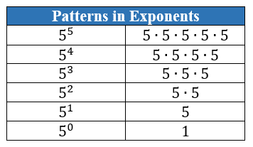

- Full expansion of exponents, limited to whole number exponents and rational number bases, should be modeled to help develop these patterns.
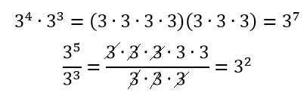
- Students should develop fluency with and without the use of a calculator when evaluating numerical expressions involving the Laws of Exponents.
- Instruction includes cases where students must work backwards as well as cases where the value of a variable must be determined (MTR.3.1). Students should use relational thinking as well as algebraic thinking.
  - For example, in $\frac{7^{n}}{7^{2}}=343$, what is the value of $n$? Students should ask themselves, “If I know that $343$ is $7^{3}$, what value would $n$ need to be so that $n-2=3$?”
  - For example, in ${\left(5^{2}\right)}^{n}=5^{10}$, what is the value of $n$? Students should ask themselves, “What power would $5^{2}$ be raised to equal $5^{10}$?”

Common Misconceptions or Errors
- Students may incorrectly conclude that squaring a number means to multiply by 2. Likewise, cubing may be mistaken as multiplying by 3. Use length to show doubling and area of a square to show an exponent of 2. Use of two-dimensional and three-dimensional manipulatives (MTR.2.1) may also help to emphasize squares and cubes versus increasing length.
- When finding the product or quotient of powers, students may incorrectly multiply or divide the bases, rather than only manipulating the exponents. Use full expansion of the exponential expression (MTR.2.1) to develop the laws.
- Students may incorrectly invert the product of powers and power of a power laws, wanting to multiply in the first and add in the latter.

Strategies to Support Tiered Instruction
- Instruction includes modeling the differences between doubling and squaring a value. Doubling a value would be represented by multiplying a given length by $2$ whereas squaring a number would be represented by the area of a square with a given length.
  - For example, students can be given the table below to show how the left column doubles the length whereas the right column squares a length.
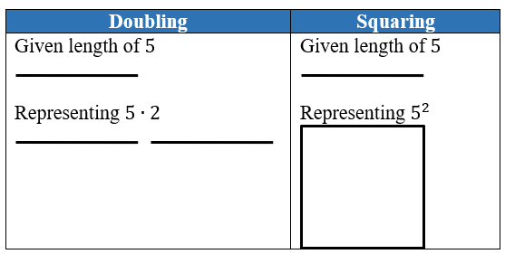
- Instruction includes modeling the differences between tripling or cubing a value. Tripling a value would be represented by multiplying a given length by 3, whereas cubing a number would be represented by the volume of a cube with a given length.
  - For example, students can be given the table below to show how the left column triples a length whereas the right column cubes a length.
  - 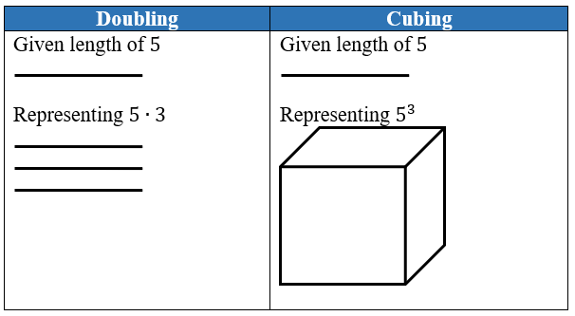
- The teacher provides opportunities for students who incorrectly apply the Laws of Exponents when generating equivalent numerical expressions to use full expansion of exponential expression as an additional step to visually represent the emerging patterns.
  - For example, the expression $4^{3}⋅4^{2}$ can be expanded to $(4⋅4⋅4)⋅(4⋅4)$ which is equivalent to 4$⋅4⋅4⋅4⋅4$ or $4^{5}$. This helps illustrate the product of powers Law.
- Teacher creates and posts an anchor chart with visual representations of the base of an exponent, exponent and any factor(s), then encourages students to utilize the anchor chart to assist in correct academic vocabulary when evaluating exponential expressions.
  - For example, the teacher can highlight different parts of the expression $4^{3}⋅4^{2}$ in different colors to visualize the base, exponents and factors: $4^{3}$ · $4^{2}$.
- Instruction includes co-creating a graphic organizer for each of the Laws of Exponents to include the name of the law, an original exponential expression, an equivalent expansion of the expression, the equivalent simplified expression, and a generalized rule for each of the laws.
  - For example, a graphic organizer with some of the Laws is shown.
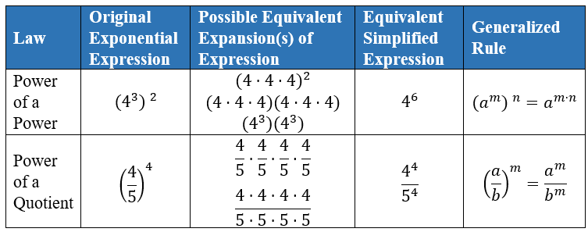

Instructional Tasks
Instructional Task 1 (MTR.5.1)
Complete the table by using numeric examples to develop a rule for each of the situations given. Then confirm or adjust your hypothesis as one of the Laws of Exponents.

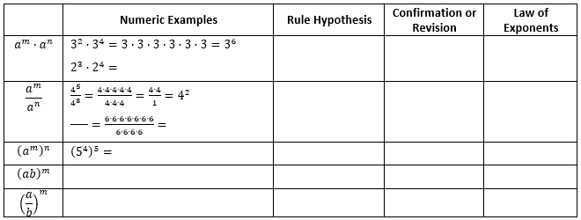

Instructional Items
Instructional Item 1
Generate an equivalent expression.
$${\left(\frac{1}{2}\right)}^{2}∙{\left(\frac{1}{2}\right)}^{3}$$
Instructional Item 2
Evaluate the following expression.
$${\left({\left(\frac{1}{4}\right)}^{2}\right)}^{3}∙{\left(\frac{1}{4}\right)}^{3}$$
Instructional Item 3
Evaluate the following expression.
$$\frac{{\left(8^{4}\right)}^{3}∙5^{2}∙5^{3}}{8^{7}∙{\left(8∙5\right)}^{4}}$$
*The strategies, tasks and items included in the B1G-M are examples and should not be considered comprehensive.

MA.7.NSO.1.2

Benchmark
MA.7.NSO.1.2 Rewrite rational numbers in different but equivalent forms including fractions, mixed numbers, repeating decimals and percentages to solve mathematical and real-world problems.
Example: Justin is solving a problem where he computes 17/3 and his calculator gives him the answer 5.6666666667. Justin makes the statement that 17/3=5.6666666667; is he correct?

Connecting Benchmarks/Horizontal Alignment
- MA.7.AR.1.2
- MA.7.AR.3.1, MA.7.AR.3.3
- MA.7.DP.1.4
- MA.7.DP.2.2, MA.7.DP.2.4

Terms from the K-12 Glossary
Rational Number

Vertical Alignment
Previous Benchmarks  - MA.6.NSO.1.1, MA.6.NSO.1.2  - MA.6.NSO.3.5 | Next Benchmarks  - MA.8.NSO.1.1, MA.8.NSO.1.2
Purpose and Instructional Strategies
In grade 6, students rewrote positive rational numbers in different but equivalent forms as long as the decimal form is terminating. This expectation expands to all rational numbers in grade 7, including those with repeating decimals, as well as using this skill to solve mathematical and real-world problems. In grade 8, students will learn about irrational numbers as well as working to plot, order and compare rational and irrational numbers.
- When solving problems with numbers written in various forms, students must be able to convert between these forms to perform operations or make comparisons (MTR.2.1).
- Students should begin to develop charts, like the one below, that allow them to find patterns within the different forms of rational numbers. Students should have common fractions, decimals and percentages at their disposal in order to move to ones that are more difficult to determine.

Fraction | Mixed Number | Decimal | Percentage

- Students should have practice with and without the use of technology to rewrite rational numbers in different but equivalent forms.
- Students should work with simple problems to highlight how truncating repeated decimals may result in incorrect solutions.
  - For example, using the fractional value of $\frac{1}{3}$ may provide a more precise answer than using the truncated decimal of 0.33.
$\frac{1}{3}\left(3000\right)=1000$ versus $0.33\left(3000\right)=990 .$
- Repeating decimals can be written using a repeating bar, a truncated decimal form, a fraction or may be rounded depending on the problem and the directions to the problem.
- Students should use reasonableness to determine if it is appropriate to use a specific equivalent form over another one when problem solving (MTR.6.1).

Common Misconceptions or Errors
- Students may not differentiate between terminating decimals, repeating decimals and rounded decimals, and they may not use them appropriately within the given contexts.
- Students may incorrectly truncate repeating decimals when problem solving.
- Students may incorrectly divide when the quotient is not a whole number.
  - For example, students may use the remainder of a problem as a decimal representation.

Strategies to Support Tiered Instruction
- Instruction includes the use of estimation to find the approximate decimal value of a fraction or mixed number before rewriting in decimal form to help with correct placement of the decimal point.
- Teacher provides opportunities for students to explore and discuss the differences between repeating and truncated decimals and the impact of truncating repeating decimals when solving problems.
  - For example, provide students with the equation $y=\frac{1}{3}x$ and have them create a table of values comparing using $\frac{1}{3}$, 0.3, 0.333 and 0.33333 as the constant of proportionality. Students can discuss the differences in $y$-values and importance of using exact values in some cases and approximate values in others.

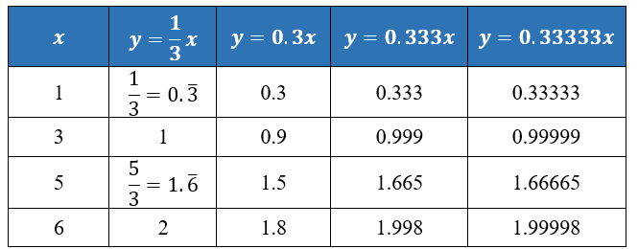
- Instruction includes co-creating a graphic organizer to highlight the differences between terminating decimals, repeating decimals, and rounded decimals.

Instructional Tasks
Instructional Task 1 (MTR.2.1)
Convert each of the following to an equivalent form in order to compare their values.
$$\frac{1}{5} -0.4 65\% -2\frac{1}{3} 5.75 \frac{9}{7} 123\% 2.\overline{3}$$

Part A. Graph the numbers on a number line to determine increasing order.

Part B. Robin plotted her number line using all decimals, whereas Courtney plotted them using the original forms. Describe why both would be acceptable answers.

Instructional Task 2 (MTR.2.1, MTR.4.1, MTR.5.1)
Complete the table to identify equivalent forms of each number. Explain how you approached your solutions. Prompting questions: What patterns did you use? How did you start? Which values in the table are you most comfortable in starting with?

Fraction | Mixed Number (if applicable) | Decimal | Percentage
 | $$-4\frac{1}{3}$$
 |  | $$0.125$$
$$\frac{29}{7}$$
$$-\frac{8}{25}$$ |  |  | $$-32\%$$
 | $$2\frac{7}{9}$$ | $$2.\overline{7}$$

Instructional Items
Instructional Item 1
All of the students in first period were given a glue stick to help build their interactive notebook. Benny said he has already used $\frac{2}{3}$ of his glue while Juniper has used 70% of hers. Which student has the most glue remaining for their notebooks?

Instructional Item 2
Ishana manages a corner store and wishes to give a discount to her customers for the holiday. If she subtracts 0.15 of the cost of any item in the store, what percent should her sale sign promote?

Instructional Item 3
Write three equivalent forms for $5\frac{7}{8}$.

*The strategies, tasks and items included in the B1G-M are examples and should not be considered comprehensive.

MA.7.NSO.2 Add, subtract, multiply and divide rational numbers.

MA.7.NSO.2.1

Benchmark
MA.7.NSO.2.1 Solve mathematical problems using multi-step order of operations with rational numbers including grouping symbols, whole-number exponents and absolute value.
Benchmark Clarifications:
Clarification 1: Multi-step expressions are limited to 6 or fewer steps.

Connecting Benchmarks/Horizontal Alignment
- MA.7.NSO.1.1
- MA.7.AR.1.1, MA.7.AR.1.2
- MA.7.AR.2.2
- MA.7.AR.3.1, MA.7.AR.3.2, MA.7.AR.3.3
- MA.7.AR.4.1. MA.7.AR.4.2, MA.7.AR.4.3, MA.7.AR.4.4, MA.7.AR.4.5
- MA.7.GR.1.1, MA.7.GR.1.2, MA.7.GR.1.3, MA.7.GR.1.4
- MA.7.GR.2.1, MA.7.GR.2.2, MA.7.GR.2.3

Terms from the K-12 Glossary
- Absolute Value
- Exponent
- Order of Operations
- Rational Number

Vertical Alignment
Previous Benchmarks  - MA.6.NSO.1.4  - MA.6.AR.1.3 | Next Benchmarks  - MA.8.NSO.1.5, MA.8.NSO.1.7  - MA.8.AR.1.1
Purpose and Instructional Strategies
In grade 6, students evaluated algebraic expressions using substitution and order of operations with integers, including the use of absolute value and natural number exponents. In grade 7, students move to multi-step order of operations with rational numbers including grouping symbols, whole-number exponents and absolute value. In grade 8, students will solve problems involving order of operations involving radicals.
- Number sense and properties of operations should be emphasized during instruction as this benchmark is the completion of operations with rational numbers.
- Remind students that subtraction is addition of an opposite and division is multiplication by a reciprocal when working with order of operations (MTR.3.1).
- Avoid mnemonics, such as PEMDAS, that do not account for other grouping symbols and do not exercise proper number sense that allows for calculating accurately in a different order.
- Instruction includes the use of technology to help emphasize the proper use of grouping symbols for order of operations.
- Students should have experience using technology with decimals and fractions as they occur in the real world. This experience will help to prepare students working with irrational numbers in grade 8.

Common Misconceptions or Errors
- Students may confuse when parentheses are used for grouping or multiplication.
- Some students may incorrectly apply the order of operations. In order to support students in moving beyond this misconception, be sure to review operations with rational numbers and order of operations.

Strategies to Support Tiered Instruction
- Instruction includes the use of colors to highlight each step of the process used to evaluate an expression.
- Teacher co-creates a graphic organizer for different grouping symbols and provides examples when the grouping symbols indicate operator symbols.
  - For example, students can be given the expressions below and discuss similarities and differences.

$$\left(\frac{4}{6}+9\right)+87$$ | $$\left(\frac{4}{6}+9\right)87$$ | $$\left(\frac{4}{6}+9\right)-87$$
$$\left(\frac{4}{6}+9\right)\left(+87\right)$$ | $$\left(\frac{4}{6}+9\right)\left(87\right)$$ | $$\left(\frac{4}{6}+9\right)(-87)$$
- Instruction includes reviewing operations with rational numbers and order of operations.

Instructional Tasks
Instructional Task 1 (MTR.4.1, MTR.5.1)
Part A. Using the integers –6 to 6 at most once, fill in the boxes to create an expression with the lowest value.
$$\frac{\boxed{}}{\boxed{}}\left(\boxed{}-\frac{\boxed{}}{\boxed{}}\left|\boxed{}-\boxed{}\right|\right)$$

Part B. Compare your value with those in your group. Who has the lowest value? Explain why this value was less than the others.

Instructional Task 2 (MTR.3.1, MTR.4.1)
Part A. Evaluate the expression ${\left(\frac{\left|\frac{3}{4}\left(24\right)-21\right|}{2}\right)}^{4}$.
Part B. Compare your strategy with a partner.

Instructional Items
Instructional Item 1
What is the value of the expression $\frac{{\left(12-\left|8-5\right|\right)}^{3}}{36}$?

Instructional Item 2
What is the value of the expression $\frac{1}{2}\left(3^{2}-4\right)+\left|7-\frac{1}{6}\right|$?

Instructional Item 3
Evaluate the expression $18-3\left(4.12+7.6÷2\right)$.

*The strategies, tasks and items included in the B1G-M are examples and should not be considered

MA.7.NSO.2.2

Benchmark
MA.7.NSO.2.2 Add, subtract, multiply and divide rational numbers with procedural fluency.

Connecting Benchmarks/Horizontal Alignment
- MA.7.AR.1.1
- MA.7.AR.2.1, MA.7.AR.2.2
- MA.7.AR.3.1, MA.7.AR.3.2, MA.7.AR.3.3
- MA.7.AR.4.1, MA.7.AR.4.2, MA.7.AR.4.3, MA.7.AR.4.4, MA.7.AR.4.5
- MA.7.GR.1.1, MA.7.GR.1.2, MA.7.GR.1.3, MA.7.GR.1.4, MA.7.GR.1.5
- MA.7.GR.2.1, MA.7.GR.2.2, MA.7.GR.2.3
- MA.7.DP.1.1, MA.7.DP.1.2, MA.7.DP.1.3
- MA.7.DP.2.1

Terms from the K-12 Glossary
- Rational Number

Vertical Alignment
Previous Benchmarks  - MA.6.NSO.2.1, MA.6.NSO.2.2  - MA.6.NSO.4.1, MA.6.NSO.4.2 | Next Benchmarks  - MA.8.NSO.1.5, MA.8.NSO.1.7
Purpose and Instructional Strategies

In grade 6, students performed operations with integers, multiplied and divided positive multi-digit numbers with decimals to the thousandths and computed products and quotients of positive fractions by positive fractions, including mixed numbers with procedural fluency. In grade 7, students perform all four operations with positive and negative rational numbers with procedural fluency. In grade 8, they will expand to operations with rational numbers including exponents and radicals and will perform operations with rational numbers expressed in scientific notation.
- This benchmark is the completion of arithmetic operations with rational numbers (MTR.3.1).
- Instruction includes the possibility that the division of two fractions can be written as a complex fraction. This connection will be important when students work with algebraic expressions in later grades.
- Students should develop fluency with and without the use of a calculator when performing operations with rational numbers.
Common Misconceptions or Errors
- Students may think the product of a fraction and another fraction is greater than either factor. Use manipulatives or models referenced in previous grade levels to support conceptual understanding (MTR.2.1).
- Students may incorrectly believe that dividing by $\frac{1}{2}$ is the same as dividing by 2.
- Students may incorrectly solve complex fractions by multiplying the two fractions.

Strategies to Support Tiered Instruction
- Instruction includes the use of fraction tiles to represent operations with positive fractions while simultaneously recording the equivalent numerical expressions.
- Instruction includes the use of base ten blocks to represent operations with positive decimals while simultaneously recording the equivalent numerical expressions.
- Instruction includes the use of two-color counters to represent operations with integers while simultaneously recording the equivalent numerical expressions.
- Teacher co-creates a graphic organizer with students to review operations with positive fractions and operations with integers to assist when applying operations with rational numbers.

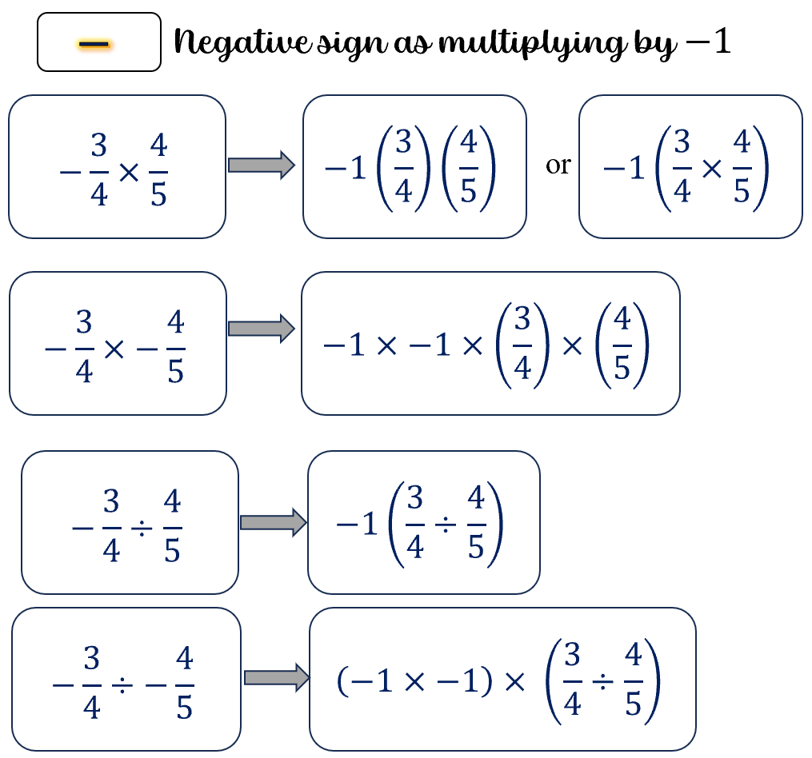

- Instruction includes using manipulatives or models referenced in previous grade levels to support conceptual understanding.

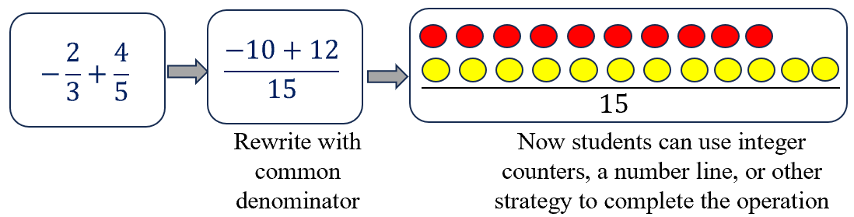

Instructional Tasks
Instructional Task 1 (MTR.7.1)
Daliah purchases eggs by the dozen for her two children. Each day, Zane eats $\frac{1}{4}$ carton and Amare eats $\frac{1}{6}$ carton. A carton of 12 eggs costs $1.65.
Part A. How much does Daliah spend on eggs for her two children in 30 days?
Part B. During one of her shopping trips, Daliah finds that her grocery store has started to sell cartons of 18 eggs for $2.25. If she begins to purchase these cartons, how much does Daliah spend on eggs for her two children in 30 days? After how many days will Daliah spend more than $50? Explain your reasoning.

Instructional Task 2 (MTR.3.1)
Given $a=-2\frac{3}{5}$ and $b=\frac{2}{3}$, calculate the following:
- $a+b$
- $a-b$
- $a∙b$
- $\frac{a}{b}$

Instructional Items
Instructional Item 1
Determine the product of $\frac{15}{6}$ and $-1.2$.

Instructional Item 2
What is the value of the expression $7.24-5.01-78.4$?

Instructional Item 3
What is the value of the expression $\frac{\frac{24}{5}}{\frac{1}{9}}$?

*The strategies, tasks and items included in the B1G-M are examples and should not be considered

MA.7.NSO.2.3

Benchmark
MA.7.NSO.2.3 Solve real-world problems involving any of the four operations with rational numbers.
Benchmark Clarifications:
Clarification 1: Instruction includes using one or more operations to solve problems.

Connecting Benchmarks/Horizontal Alignment
- MA.7.AR.2.1, MA.7.AR.2.2
- MA.7.AR.3.1, MA.7.AR.3.2, MA.7.AR.3.3
- MA.7.AR.4.1, MA.7.AR.4.2, MA.7.AR.4.3, MA.7.AR.4.4, MA.7.AR.4.5
- MA.7.GR.1.1, MA.7.GR.1.2, MA.7.GR.1.3
- MA.7.GR.2.1, MA.7.GR.2.2, MA.7.GR.2.3
- MA.7.DP.1.1, MA.7.DP.1.2, MA.7.DP.1.3

Terms from the K-12 Glossary
- Rational Number

Vertical Alignment
Previous Benchmarks  - MA.6.NSO.2.3 | Next Benchmarks  - MA.8.NSO.1.6, MA.8.NSO.1.7
Purpose and Instructional Strategies

In grade 6, students solve real-world problems involving any of the four operations with positive multi-digit decimals or positive fractions, including mixed numbers. In grade 7, students move to all rational numbers and in grade 8 extend to rational numbers, including exponents and radicals.
- This benchmark applies the procedural fluency skills of the previous benchmark to real-world problems (MTR.3.1).
- Students should develop fluency with and without the use of a calculator when performing operations with rational numbers.
- Instruction includes the use of technology to help emphasize the proper use of grouping symbols for order of operations.
- Students should have experience using technology with decimals and fractions as they occur in the real world. This experience will help to prepare students working with irrational numbers in grade 8.
- Open-ended tasks with real-world contexts (MTR.7.1) will allow students to practice multiple pathways for solutions as well as to make comparisons with their peers (MTR.4.1) to refine their problem-solving methods.
- Instruction includes support in vocabulary development as related to the context of real-world problems.

Common Misconceptions or Errors
- Students may incorrectly perform operations with the numbers in the problem based on what has recently been taught, rather than what is most appropriate for a solution. To overcome this misconception, have students estimate or predict solutions prior to solving them and then compare those predictions to their actual solution to see if it is reasonable (MTR.6.1).
- Students may incorrectly oversimplify a problem by circling the numbers, underlining the question, boxing in key words, and eliminating contextual information that is needed for the solution. This process can cause students to not be able to comprehend the context or the situation (MTR.2.1, MTR.4.1, MTR.5.1, MTR.7.1).

Strategies to Support Tiered Instruction
- Instruction includes the use of visual representations and manipulatives to represent the given situation and use the chosen representation to help find the solution.
- The teacher provides opportunities for students to comprehend the context or situation by engaging in questions like the ones below.
  - What do you know from the problem?
  - What is the problem asking you to find?
  - Can you create a visual model to help you understand or see patterns in your problem?
- Teacher co-creates a graphic organizer with students to review operations with positive fractions and operations with integers to assist when applying operations with rational numbers.
- Instruction includes the use of a three-read strategy. Students read the problem three different times, each with a different purpose. Laminating these questions on a printed card for students to utilize as a resource in and out of the classroom would be helpful.
  - First, read the problem with the purpose of answering the question: What is the problem, context, or story about?
  - Second, read the problem with the purpose of answering the question: What are we trying to find out?
  - Third, read the problem with the purpose of answering the question: What information is important in the problem?
- Instruction includes having students estimate or predict solutions prior to solving them and then compare those predictions to their actual solution to see if it is reasonable.

Instructional Tasks
Instructional Task 1 (MTR.7.1)
All of the 7th grade homeroom classes collected recycling, with the top three classes splitting
the grand prize of $800 toward building their own gardens. Mr. Brogle’s class turned in 237
pounds of recycling, Mrs. Abiola’s class turned in 192 pounds and Mr. Wheeler’s class turned
in 179 pounds. How should these top three divide the money so that each class gets the same
fraction of the prize money as the fraction of recycling they collected?

Instructional Task 2 (MTR.7.1)
Kari and Natalia went to the Fun Warehouse with $20 each to spend. There is a $3 entry fee each and the menu of activities is shown below. What are some possible combinations of activities Kari and Natalia can enjoy before they each run out of money?
Go-Karts $9.75
Laser Tag $7.50
Inflatables $5.00
Mini-Bowling $2.25
Video Games $0.75

Instructional Task 3 (MTR.4.1, MTR.7.1)
Anjeanette is making cupcakes for her sister’s birthday. Among other ingredients, her recipe calls for 2 cups of flour, $\frac{1}{2}$ cup of butter and $\frac{3}{4}$ cup sugar in one batch. In the kitchen, she has 8 cups of flour, 2 cups of butter and 2 cups of sugar.
Part A. How many batches of cupcakes can Anjeanette make?
Part B. What should Anjeanette ask for if she wants to borrow from her neighbor to make one more batch?

Instructional Items
Instructional Item 1
Kari and Natalia went to the Fun Warehouse with $20 each to spend. They paid the $3 entry fee each and then decided they would both play laser tag and mini-bowling. If they finished the day with playing 4 video games each, how much money will be left?
Go-Karts $9.75
Laser Tag $7.50
Inflatables $5.00
Mini-Bowling $2.25
Video Games $0.75

*The strategies, tasks and items included in the B1G-M are examples and should not be considered

Algebraic Reasoning

MA.7.AR.1 Rewrite algebraic expressions in equivalent forms.

MA.7.AR.1.1

Benchmark
MA.7.AR.1.1 Apply properties of operations to add and subtract linear expressions with rational coefficients.
Example: $\left(7x-4\right)-\left(2-\frac{1}{2}x\right)$ is equivalent to $\frac{15}{2}x-6$.

Benchmark Clarifications:
Clarification 1: Instruction includes linear expressions in the form $ax±b$ or $b±ax$, where $a$ and $b$ are rational numbers.
Clarification 2: Refer to Properties of Operations, Equality and Inequality (Appendix D).

Connecting Benchmarks/Horizontal Alignment
- MA.7.NSO.2.1, MA.7.NSO.2.2

Terms from the K-12 Glossary
- Coefficient
- Linear Expression
- Rational Number

Vertical Alignment
Previous Benchmarks  - MA.6.AR.1.4 | Next Benchmarks  - MA.8.AR.1.2, MA.8.AR.1.3
Purpose and Instructional Strategies
In grade 6, students generated equivalent algebraic expressions with integer coefficients. In grade 7, students perform operations (adding and subtracting) on linear expressions with rational coefficients and multiple variables. In grade 8, students will multiply two linear expressions with rational coefficients as well as continuing to write equivalent expressions.
- Students extend their understanding of operations with rational numbers to linear expressions. This will be critical to solving equations and inequalities having more than one step. This is also an opportunity to build fluency within MA.7.NSO.2 (MTR.3.1).
- Use manipulatives such as algebra tiles to emphasize the difference between linear and constant terms for integers. Once clear and confident, the transition from manipulatives to the abstract to include rational numbers (MTR.2.1).
  - Algebra Tiles
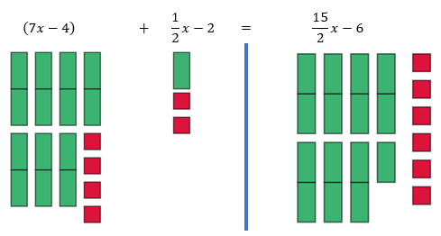
- Variables are not limited to $x$. Instruction includes using various lowercase letters for their variables; however, $o$, $i$ and $l$ should be avoided as they too closely resemble zero and one.
- Instruction includes students working within the same type of rational numbers when appropriate.
  - For example, if students are given fractions, the solution should be demonstrated in fractions and not be converted to decimals.

Common Misconceptions or Errors
- Students may incorrectly add and subtract terms that are unlike. To address this misconception, begin with a sorting activity to organize terms into groups before performing operations with those terms (MTR.2.1). Have students verbalize the criteria for being considered like terms to ensure they are focused on the correct similarities.
- Students may incorrectly distribute the negative sign when subtracting a linear expression with more than one term.
  - For example, $3-(2x+7)$ may be incorrectly rewritten as $3-2x+7$. To address this misconception, use algebra tiles or other manipulatives to physically show the removal or subtraction of an expression.

Strategies to Support Tiered Instruction
- Teacher provides instruction to students that may incorrectly add and subtract unlike terms by giving students examples of like and unlike expressions and having students decide if they are equivalent. Give students the opportunity to explain why the expressions are equivalent or not equivalent.
- Teacher provides instruction on using the properties of operations to group like terms together.
- Instruction includes the use of different color highlighters or shapes to identify algebraic terms and constants and then combining like terms identified with the same color.
  - For example, the expression $3x+5+\frac{2}{3}x-6$ can be color-coded as $3x+5+\frac{2}{3}x-6$ to determine that $3x+\frac{2}{3}x+5-6=3\frac{2}{3}x-1$.
- Teacher includes a leading coefficient of $1$ in front of grouping symbols to help students recognize the implications of a negative sign in front of grouping symbols.
  - For example, $\frac{1}{3}-\left(2x+\frac{7}{3}\right)$ could be written as $\frac{1}{3}+\left(-1\right)\left(2x+\frac{7}{3}\right)$ or as $\frac{1}{3}+\left(-1\right)⋅\left(2x+\frac{7}{3}\right)$ to help remind students to distribute the negative one before performing the next operation.
- Teacher provides students with a visual picture to decide if expressions are equivalent.
  - For example, if $s$ represents the number of blue squares and $t$ represents the number of red triangles shown, students can write an expression to represent the display. Students could write the expression as $s+s+s+t+t$, and then rewrite with combining like terms as $3s+2t$.

- Instruction includes building a foundation for the properties of operations by modeling the associative, commutative, and distributive properties with algebra tiles for numeric and algebraic expressions and allowing the students to manipulate the algebra tiles as well.
- Instruction includes providing students with two different linear expressions already represented with algebra tiles and then allowing the students to add and subtract the algebra tiles to determine their sum or difference.
- Teacher co-creates a graphic organizer with students to review operations with positive fractions and operations with integers to assist when applying operations with rational numbers.
- Teacher provides a sorting activity to organize terms into groups before performing operations with those terms. Have students verbalize the criteria for being considered like terms to ensure they are focused on the correct similarities.
- Instruction includes using algebra tiles or other manipulatives to physically show the removal or subtraction of an expression.

Instructional Tasks
Instructional Task 1 (MTR.4.1)
Part A. Write three expressions that are equivalent to $\frac{3}{4}x-1$.
Part B. Compare the expressions from Part A with a partner.
  - How many are the same?
  - How many are different?
  - How many are correct?
  - If there are incorrect expressions, what were the errors? Explain your reasoning.

Instructional Items
Instructional Item 1
Write the following expression using the fewest possible terms.
$$\left(5x-1\right)-(0.06x-4+0.4x)$$

Instructional Item 2
Write the following expression using the fewest possible terms.
$$\left(4+\frac{2}{3}x\right)+\left(\frac{1}{6}x-3\right)$$
Instructional Item 3
Write the following expression using the fewest possible terms.
$$\left(2x-\frac{4}{5}-3z\right)-(-8x+2z)$$

*The strategies, tasks and items included in the B1G-M are examples and should not be considered comprehensive.

MA.7.AR.1.2

Benchmark
MA.7.AR.1.2 Determine whether two linear expressions are equivalent.
Example: Are the expressions $\frac{4}{3}(6-x)-3x$ and $8-\frac{5}{3}x$ equivalent?

Benchmark Clarifications:
Clarification 1: Instruction includes using properties of operations accurately and efficiently.
Clarification 2: Instruction includes linear expressions in any form with rational coefficients.
Clarification 3: Refer to Properties of Operations, Equality and Inequality (Appendix D).

Connecting Benchmarks/Horizontal Alignment
- MA.7.NSO.1.2
- MA.7.NSO.2.1

Terms from the K-12 Glossary
Linear Expression

Vertical Alignment
Previous Benchmarks  - MA.6.AR.1.4 | Next Benchmarks  - MA.8.AR.1.1, MA.8.AR.1.3
Purpose and Instructional Strategies
In grade 6, students generated equivalent algebraic expressions with integer coefficients. In grade 7, students add and subtract linear expressions with rational coefficients as well as determine whether two linear expressions are equivalent. In grade 8, students will generate equivalent expressions including the use of integer exponents as well as rewrite the sum of two algebraic expressions having a common monomial factor as a common factor multiplied by the sum of two algebraic expressions.
- Emphasize properties of operations to determine equivalence. Use manipulatives such as algebra tiles to emphasize the difference between linear and constant terms.
  - Algebra tiles can also be used to model operations concretely (MTR.2.1).

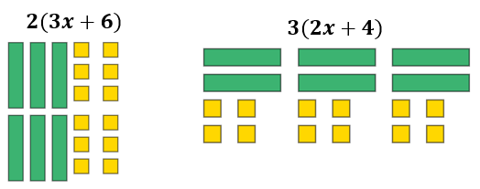

  - Area Model can be used to represent the distributive property of multiplication over addition before moving to the abstract (MTR.2.1).
$4\left(2x+3\right)=2(4x+6)$
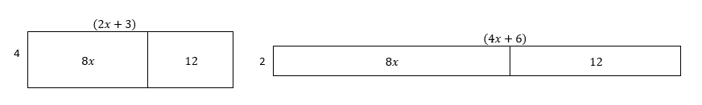
From these representations, students can showcase equivalency between the two different linear expressions.
- Instruction includes students working within the same type of rational numbers when appropriate.
  - For example, if students are given fractions, the solution should be demonstrated in fractions and not be converted to decimals.
- Multiple equivalent expressions should be given, not just the most simplified. Transforming one or both expressions may be needed to show equivalence (MTR.3.1).
  - For example, $\frac{1}{2}x is equivalent to\frac{1}{5}x+\frac{3}{10}x$ as well as $\frac{1}{10}x+\frac{1}{10}x+\frac{1}{10}x+\frac{1}{5}x$.

Common Misconceptions or Errors
- Students may incorrectly add and subtract terms that are unlike. To address this misconception, begin with a sorting activity to organize terms into groups before performing operations with those terms (MTR.2.1). Have students verbalize the criteria for being considered like terms to ensure they are focused on the correct similarities.
- Students may incorrectly distribute the negative sign when subtracting a linear expression with more than one term.
  - For example, $\frac{1}{3}-(2x+\frac{7}{3})$ may be incorrectly rewritten as $\frac{1}{3}-2x+\frac{7}{3}$ and concludes that it is equivalent to $\frac{8}{3}-2x$.

Strategies to Support Tiered Instruction
- Teacher provides instruction to students that may incorrectly add and subtract unlike terms by giving students examples of like and unlike expressions and having students decide if they are equivalent. Give students the opportunity to explain why the expressions are equivalent or not equivalent.
- Teacher includes a leading coefficient of $1$ in front of grouping symbols to help students recognize the implications of a negative sign in front of grouping symbols.
  - For example, $\frac{1}{3}-\left(2x+\frac{7}{3}\right)$ could be written as $\frac{1}{3}+\left(-1\right)\left(2x+\frac{7}{3}\right)$ or as $\frac{1}{3}+\left(-1\right)⋅\left(2x+\frac{7}{3}\right)$ to help remind students to distribute the negative one before performing the next operation.
- Teacher provides instruction on using the properties of operations to group like terms together.
- Instruction includes the use of different color highlighters or shapes to identify algebraic terms and constants and then combining like terms identified with the same color.
  - For example, the expression $3x+5+\frac{2}{3}x-6$ can be color-coded as $3x+5+\frac{2}{3}x-6$ to determine that $3x+\frac{2}{3}x+5-6=3\frac{2}{3}x-1$.
- Teacher provides students with examples of linear expressions to explain whether two or more of the expressions are equivalent or not. Teacher co-creates examples of equivalent and non-equivalent linear expressions with students.
- Teacher co-creates a graphic organizer with students to review operations with rational numbers.
- Instruction includes providing students with two different linear expressions already represented with algebra tiles and then allowing the students to manipulate the algebra tiles to determine if they are equivalent. Students should be allowed to justify their reasoning for why the expressions are equivalent, or not.
- Teacher provides a sorting activity to organize terms into groups before performing operations with those terms. Have students verbalize the criteria for being considered like terms to ensure they are focused on the correct similarities.

Instructional Tasks
Instructional Task 1 (MTR.4.1)
Part A. Write three expressions that are equivalent to $\frac{4}{3}\left(6-x\right)+3\left(\frac{2}{3}x+1\right)$.
Part B. Compare those expressions with a partner. Think about the following questions to guide your conversation:
- How many are the same?
- How many are different?
- How many are correct?
- If there are incorrect expressions, what were the errors?

Instructional Items
Instructional Item 1
Match the following equivalent expressions.

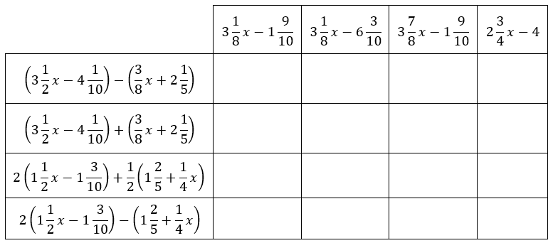

*The strategies, tasks and items included in the B1G-M are examples and should not be considered comprehensive.

MA.7.AR.2 Write and solve equations and inequalities in one variable.

MA.7.AR.2.1

Benchmark
MA.7.AR.2.1 Write and solve one-step inequalities in one variable within a mathematical context and represent solutions algebraically or graphically.
Benchmark Clarifications:
Clarification 1: Instruction focuses on the properties of inequality. Refer to Properties of Operations, Equality and Inequality (Appendix D).
Clarification 2: Instruction includes inequalities in the forms $px>q$; $\frac{x}{p}>q$; $x±p>q$ and $p±x>q$, where $p$ and $q$ are specific rational numbers and any inequality symbol can be represented.
Clarification 3: Problems include inequalities where the variable may be on either side of the inequality symbol.

Connecting Benchmarks/Horizontal Alignment
- MA.7.NSO.2.1, MA.7.NSO.2.2, MA.7.NSO.2.3

Terms from the K-12 Glossary
- N/A

Vertical Alignment
Previous Benchmarks  - MA.6.AR.1.2  - MA.6.AR.2.1 | Next Benchmarks  - MA.8.AR.2.2  - MA.8.GR.1.3
Purpose and Instructional Strategies
In grade 6, students are building on their ability to write and verify solutions in inequalities. In grade 7, students write and solve one-step inequalities in one variable (MTR.5.1). In grade 8, students will solve two-step linear inequalities in one variable.
- Instruction includes real-world scenarios to assist students with making sense of solving inequalities by checking the reasonableness of their answer.
- Instruction emphasizes properties of inequality with connections to the properties of equality (MTR.5.1).
- Instruction includes showing why the inequality symbol reverses when multiplying or dividing both sides of an inequality by a negative number.
  - For example, if the inequality $6>-7$ is multiplied by $-3$, it results in $-18>21$ which is a false statement. The inequality symbol must be reversed in order to keep a true statement. Since 6 is to the right of -7 on the number line and multiplying by a negative number reverses directions, $6(-3)$ will be to the left of $-7(-3)$ on the number line.
- Instruction includes cases where the variable is on the left side or the right side of the inequality.
- Variables are not limited to $x.$ Instruction includes using a variety of lowercase letters for their variables; however, $o$, $i$ and $l$ should be avoided as they too closely resemble zero and one.
- Instruction emphasizes the understanding of defining an algebraic inequality. Students should have practice with inequalities in the form of $x>a$, $x<a$, $x≥a$ and $x≤a$. Students should explore how “is greater than or equal to” and “is strictly greater than” are similar and different as well as “is less than or equal to” and “is strictly less than.” Students should use academic language when describing an algebraic inequality.

Common Misconceptions or Errors
- Students may confuse when to use an open versus closed circle when graphing an inequality. Emphasize the inclusion $(≤$and $≥)$ versus non-inclusion $(<$and $>)$ of that value as a viable solution and provide problems that motivate reasoning with different ranges of possible values for the variable.
- Some students are unable to see the difference between the division property of equality and the division property of inequality.
- Students may mistakenly think that the direction the inequality symbol is pointing is always the direction they shade on the number line. To address this misconception, emphasize reading the inequality sentence aloud and use numerical examples to test for viable solutions (MTR.6.1).

Strategies to Support Tiered Instruction
- Teacher provides instruction on when to use an open versus closed circle when graphing an inequality. Teacher encourages students to substitute their solution into their graphs and discuss whether their graph makes sense with the solution.
- Teacher provides a graphic organizer with examples and non-examples of the Division Property of Equality and the Division Property of Inequality.
- Teacher provides students with pre-drawn number lines for students to number as needed to graph solutions.
- Teacher provides students with instruction for similarities and differences of solving equations versus solving inequalities.
- Teacher emphasizes reading the inequality sentence aloud and use numerical examples to test for solutions.
- Instruction includes emphasizing the inclusion ($≤$ and $≥$) versus non-inclusion ($<$ and $>$) of that value as a solution and provide problems that motivate reasoning with different ranges of possible values for the variable.
  - For example, if the given inequality is $x+3>5$, students can test various numbers to determine if they are solutions. When students test $x=2$, students should realize that they get the inequality $5>5$ which is not a true statement, therefore $2$ is not a solution.

Instructional Tasks
Instructional Task 1 (MTR.3.1, MTR.4.1)
Determine if there is an error in each of the following. If there is an error, write the corrected solution. If there is not an error, indicate “No Error” next to the answer.

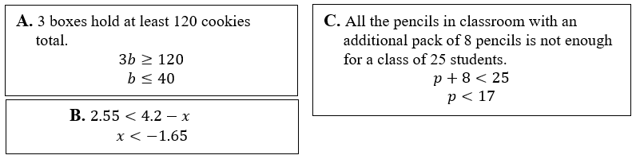

Instructional Task 2 (MTR.5.1, MTR.6.1)
Using integers between $-5$ and $5$ no more than once, finish writing the inequality below, whose solutions are $x≥\frac{1}{2}$.
$$\underline{}x≤\underline{}$$

Instructional Items
Instructional Item 1
Solve the inequality and graph its solutions on a number line.
$$12<\frac{a}{4}$$
Instructional Item 2
What are the solutions to the inequality $4.2+z ≤-5.3$?

Instructional Item 3
Represent the solutions to the inequality $-0.125c>0.375$ on a number line.

*The strategies, tasks and items included in the B1G-M are examples and should not be considered comprehensive.

MA.7.AR.2.2

Benchmark
MA.7.AR.2.2 Write and solve two-step equations in one variable within a mathematical or real-world context, where all terms are rational numbers.
Benchmark Clarifications:
Clarification 1: Instruction focuses on the application of the properties of equality. Refer to Properties of Operations, Equality and Inequality (Appendix D).
Clarification 2: Instruction includes equations in the forms $px±q=r$ and $p(x±q)=r$, where $p$, $q$ and $r$ are specific rational numbers.
Clarification 3: Problems include linear equations where the variable may be on either side of the equal sign.

Connecting Benchmarks/Horizontal Alignment
- MA.7.NSO.2.1, MA.7.NSO.2.2, MA.7.NSO.2.3
- MA.7.AR.3.1, MA.7.AR.3.2, MA.7.AR.3.3
- MA.7.AR.4.5
- MA.7.GR.2.2, MA.7.GR.2.3

Terms from the K-12 Glossary
- Equation
- Rational Number

Vertical Alignment
Previous Benchmarks  - MA.6.AR.2.2, MA.6.AR.2.3 | Next Benchmarks  - MA.8.AR.2.1, MA.8.AR.2.3
Purpose and Instructional Strategies
In grade 6, students are building on their ability to write and solve one-step equations with an emphasis on operations with linear expressions. In grade 7, students write and solve two-step equations. In grade 8, students solve multi-step linear equations (MTR.5.1).
- Instruction includes real-world contexts as well as linear equations where the variable may be on either side of the equal sign (MTR.7.1).
- Instruction includes students verbalizing or writing the Properties of Operations and Properties of Equality (see Appendix D) used at each step to their solution.
- Use models or manipulatives, such as algebra tiles, bar diagrams or balances, to conceptualize equations (MTR.2.1).
  - Algebra Tiles
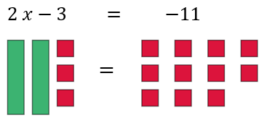

  - Bar Diagrams
$$2x-10=-26$$
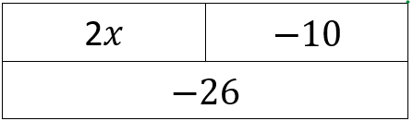

- Balances
$$3x+4=-11$$
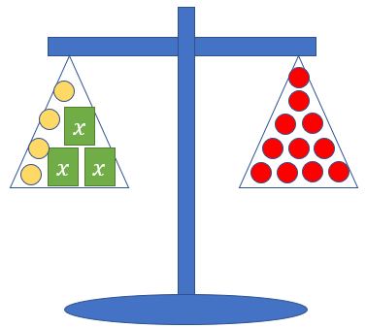

- Avoid a particular order when solving and allow students to proceed in multiple ways that are mathematically accurate.
- For example, in the equation $4\left(x+7\right)=12$, students may choose to divide both sides of the equation by 4 or use the Distributive Property with the 4. Compare the various strategies and ask students to determine which will be most efficient given different problem stems (MTR.3.1).

Common Misconceptions or Errors
- Some students may incorrectly use the addition and subtraction properties of equality on the same side of the equal sign while solving an equation. To address this misconception, use manipulatives such as balances, algebra tiles or bar diagrams to show the balance between the two sides of an equation (MTR.2.1).
- Students may incorrectly identify the constants and the coefficients within a real-world context of the problem.

Strategies to Support Tiered Instruction
- Teacher provides opportunities for students to practice solving equations using the addition and subtraction properties of equality using an interactive computer equation balance, manipulatives and other visual representations.
- Teacher provides support for students in identifying the coefficients and constants within a real-world context of the problem. Present students with examples of real-world problems that can be solved with equations.
  - For example, Cameron’s fish tank can hold 12 gallons of water and he adds 2.5 gallons of water a minute. If there are already 3.4 gallons of water in the tank, how many minutes can Cameron fill his tank without overflowing?
- Teacher provides opportunities for students to comprehend the context or situation by engaging in questions (laminating these questions on a printed card for students to utilize as a resource in and out of the classroom would be helpful).
  - What do you know from the problem?
  - What is the problem asking you to find?
  - Can you create a visual model to help you understand or see patterns in your problem?
- Teacher provides opportunities for students to use algebra tiles to co-solve provided equations with the teacher without the need of writing the equation first.
- Teacher provides opportunities for students to co-write an algebraic equation with the teacher without requiring students to solve the equation.
- Instruction includes the use of a three-read strategy. Students read the problem three different times, each with a different purpose (laminating these questions on a printed card for students to utilize as a resource in and out of the classroom would be helpful).
  - First, read the problem with the purpose of answering the question: What is the problem, context, or story about?
  - Second, read the problem with the purpose of answering the question: What are we trying to find out?
  - Third, read the problem with the purpose of answering the question: What information is important in the problem?
- Teacher models the use of manipulatives such as balances, algebra tiles or bar diagrams to show the balance between the two sides of an equation.

Instructional Tasks
Instructional Task 1 (MTR.1.1, MTR.7.1)
A plumber has been called in to replace a broken kitchen sink. The material needed costs $341.25, and the total expected cost of the job is $424.09. How many hours will the plumber need to work in order to get the job completed?
Part A. What questions would need to be answered to approach this problem? Is there enough information given to solve the problem? Why or why not?
Part B. The average rate for a plumber in Florida is $20.71 per hour. Write and solve an equation to determine how many hours the plumber will be working.

Instructional Task 2 (MTR.5.1)
The length of the rectangle is twice its width. The perimeter of the rectangle totals 45 feet. What is the width of the rectangle?

Instructional Items
Instructional Item 1
What is the exact value of $x$ in the equation $\frac{7}{9}=\frac{2}{3}x-7$?

Instructional Item 2
What is the value of $z$ in the equation $5.6\left(z-2\right)=11$?

*The strategies, tasks and items included in the B1G-M are examples and should not be considered comprehensive.

MA.7.AR.3 Use percentages and proportional reasoning to solve problems.

MA.7.AR.3.1

Benchmark
MA.7.AR.3.1 Apply previous understanding of percentages and ratios to solve multi-step real-world percent problems.
Example: 23% of the junior population are taking an art class this year. What is the ratio of juniors taking an art class to juniors not taking an art class?
Example: The ratio of boys to girls in a class is $3:2$. What percentage of the students are boys in
the class?

Benchmark Clarifications:
Clarification 1: Instruction includes discounts, markups, simple interest, tax, tips, fees, percent increase, percent decrease and percent error.

Connecting Benchmarks/Horizontal Alignment
- MA.7.NSO.1.2
- MA.7.NSO.2.1, MA.7.NSO.2.2, MA.7.NSO.2.3
- MA.7.AR.2.2
- MA.7.AR.4.4, MA.7.AR.4.5
- MA.7.DP.1.3, MA.7.DP.1.4, MA.7.DP.1.5
- MA.7.DP.2.2, MA.7.DP.2.3, MA.7.DP.2.4
Terms from the K-12 Glossary
- Percent of Change
- Percent Error
- Rate
- Simple Interest

Vertical Alignment
Previous Benchmarks  - MA.6.AR.3.2, MA.6.AR.3.4 | Next Benchmarks  - MA.8.AR.2.1
Purpose and Instructional Strategies
In grade 6, students solved mathematical and real-world problems involving percentages, ratios, rates and unit rates. In grade 7, students solve multi-step real-world percent problems. In grade 8, students solve multi-step linear equations given any context.
- Instruction includes discounts, markups, simple interest, tax, tips, fees, percent increase, percent decrease and percent error (MTR.7.1).
  - Markdown/discount is a percentage taken off of an initial price. Instruction includes showing the connection between subtracting the calculated discount or taking the difference between 100% and the discount and multiplying that by the initial price.
    - For example, if there was a 15% discount on an item that costs $15.99, students could take 85% of $15.99 or take 15% of $15.99 and subtract that value from the initial price of $15.99.
  - Markup showcases adding a charge to the initial price. Markups are often shown in retail situations.
  - Simple interest refers to money you can earn by initially investing some money (the principal). The percentage of the principal (interest) is added to the principal making your initial investment grow. The formula, $I=Prt$, represents $I$=interest, $P$=principal, $r$=rate, and $t$=time. When using simple interest, provide the formula as students should not be expected to memorize this.
  - Tax, tips and fees are an additional charge added to the initial price. Students can add the calculated tax, tip or fee to the original price or add 1 to the tax, tip or fee to reach the final cost.
    - For example, if there was a 6% sales tax on clothing and a t-shirt costs $7.99. Students can add 100% to the 6% and multiply that value to $7.99 or students can find 6% of the $7.99 and add that to the initial value of the t-shirt.
  - Percent Increase/Percent Decrease asks students to look for a percentage instead of a dollar amount. Students should discover that they can use the formula below to help become more flexible in their thinking.

$$\frac{new price-initial price}{original price}×100$$

- Percent Error is a way to express the size of the error (or deviation) between two measurements.

$$\% error=\frac{\left|estimation-actual\right|}{actual}×100$$

- Use bar models to model percent increase and decrease problems.
  - For example, if you are finding percentages that are in multiples of 10%, your bar model may look like the model below.

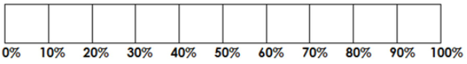

To showcase the percent increase, you would add additional boxes into the bar model. If you are showcasing a percent decrease, then you would cross out boxes for the decrease (MTR.2.1).
- Use bar models, double number lines, tables or other visual representations to model relationships between percentages and the part and whole amounts (MTR.2.1).
  - Double Number Line

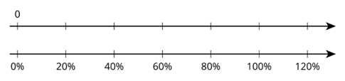

  - Table

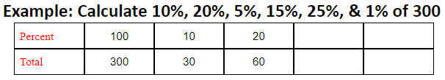

Instruction includes the use of patterns when using a table. In the example above, students can use the idea of 100% being 300 and using this knowledge to find other percentages. 10 is $\frac{1}{10}$ of 100, so students can divide by 10. To find 20%, students can multiply their solution from 10% by 2. The pattern can continue to relate common connections between percentages (MTR.5.1).
- Reinforce how percentages relate to fractions and decimals. Help students write equivalent ratios to represent problems using reasoning about the relationships between the quantities.
  - Instruction includes using proportional relationships and multiplicative reasoning to solve problems.

Common Misconceptions or Errors
- Students may incorrectly place the decimal point when calculating with percentages. If students have discovered the shortcut of moving the decimal point twice, instruction includes understanding of how a percent relates to fractions and decimals. Refer to MA.7.NSO.1.2 to emphasize equivalent forms.
- Students may forget to change the percent amount into decimal form (divide the percent by 100) when setting up an equation (MTR.3.1).
- Students may incorrectly believe all percentages must be between 1 and 100%. To address this misconception, provide examples of percentages below 1% and over 100%.
- Students may incorrectly believe a percent containing a decimal is already in decimal form.
  - For example, emphasize that 43.5% is 43.5 out of 100 and dividing by 100 will provide the decimal form.
- In multiple discount problems, students may incorrectly combine the discounts instead of working them sequentially (MTR.5.1).
  - For example, 25% off, then 10% off could incorrectly lead to 35% off rather than finding 25% off before calculating the additional 10% off.
- Students may incorrectly invert the part and the whole in the percent problem. To address this misconception, students should use bar models to help visualize and make sense of the problem (MTR.2.1).

Strategies to Support Tiered Instruction
- Instruction includes the use of estimation to find the approximate solution before calculating the actual result to help with correct placement of the decimal point and reasonableness of the solution.
- Teacher provides opportunities for students to use a 100 frame to review place value for and the connections to decimal, fractional, and percentage forms.
- Teacher provides support for students in dividing by 100 to change percent into decimal form. Teacher supports by providing calculators, manipulatives and base ten blocks to multiply decimals.
- Instruction includes having students take different percentages of the same amount, such as 40% of 80, 4% of 80, 0.4% of 80, 0.04% of 80 and 400% of 80. Students can be given the flexibility to provide the answer as decimal or fraction and compare.
- Teacher provides support for students when solving multi-discount problems and combining the discounts. Instruction might begin with a single-step discount problem in a real-world context.
  - For example, the teacher can include local sale flyers with products that students are interested in buying. Have students explain how to apply the multi-discounts with a comparison of the difference in costs when combining the discounts incorrectly.
- Teacher provides opportunities for students to reason and think about multiple discount problems by providing prompts.
  - For example, “if a pair of jeans is 50% off with an additional 50% off, does that mean the jeans are 100% off, or free?” or “what if the jeans are 75% off with an additional 50% off, does that mean the jeans are 125% off and the store now owes you money to take them?”
- Teacher provides opportunities for students to comprehend the context or situation by engaging in questions (laminating these questions on a printed card for students to utilize as a resource in and out of the classroom would be helpful).
  - What do you know from the problem?
  - What is the problem asking you to find?
  - Can you create a visual model to help you understand or see patterns in your problem?
- Teacher provides support when solving multi-discount problems, by providing students with a table to keep track of the information in the problem.
- Instruction includes the use of a three-read strategy. Students read the problem three different times, each with a different purpose (laminating these questions on a printed card for students to utilize as a resource in and out of the classroom would be helpful).
  - First, read the problem with the purpose of answering the question: What is the problem, context, or story about?
  - Second, read the problem with the purpose of answering the question: What are we trying to find out?
  - Third, read the problem with the purpose of answering the question: What information is important in the problem?
- Teacher encourages the use of bar models to help visualize and make sense of the problem.
- Instruction includes understanding of how a percent relates to fractions and decimals if students have discovered the shortcut of moving the decimal point twice. Refer to MA.7.NSO.1.2 to emphasize equivalent forms.

Instructional Tasks
Instructional Task 1 (MTR.4.1, MTR.7.1)
SurfPro Shop and The Surfer Store both sold surfboards for $350. In February, SurfPro Shop wanted to increase their profits, so they increased the prices of their boards by 15%. When this increase failed to bring in more money, they decreased their price again by 10% in November. To beat their competitor who had increased prices, The Surfer Store decided to decrease their price of surfboards by 10% in March. However, when they started to lose money on the final pricing scheme, they increased the price of surfboards in November by 15%.
Part A. If no other changes were made after November, which store now has the better price for surfboards?
Part B. What is the difference between their prices?

Instructional Items
Instructional Item 1
A college’s intramural soccer team has 30 players, 60% of which are women. After 22 new players joined the team, the percentage of women was reduced to 50%. How many of the new players are women?

Instructional Item 2
Miguel takes out a loan that adds interest each year on the initial amount. What is the interest Miguel will pay on the loan if he borrowed $5,000 at an annual interest rate of 4.5% for 15 years? (Use the formula $I=Prt$, where $I$ is the interest, $P$ is the principal or initial investment, $r$ is the interest rate per year, and $t$ is the number of years.)

Instructional Item 3
Massimo lost his mathematics textbook. The school charges a lost book fee of 70% of the original cost of the book. If Massimo received a notice that he owed the school $73.50 for the lost textbook, what was the original cost?

*The strategies, tasks and items included in the B1G-M are examples and should not be considered comprehensive.

MA.7.AR.3.2

Benchmark
MA.7.AR.3.2 Apply previous understanding of ratios to solve real-world problems involving proportions.
Example: Scott is mowing lawns to earn money to buy a new gaming system and knows he needs to mow 35 lawns to earn enough money. If he can mow 4 lawns in 3 hours and 45 minutes, how long will it take him to mow 35 lawns? Assume that he can mow each lawn in the same amount of time.
Example: Ashley normally runs 10-kilometer races which is about 6.2 miles. She wants to start training for a half-marathon which is 13.1 miles. How many kilometers will she run in the half-marathon? How does that compare to her normal 10K race distance?

Connecting Benchmarks/Horizontal Alignment
- MA.7.NSO.2.1, MA.7.NSO.2.2, MA.7.NSO.2.3
- MA.7.AR.2.2
- MA.7.AR.4.1, MA.7.AR.4.2, MA.7.AR.4.4, MA.7.AR.4.5
- MA.7.GR.1.3
- MA.7.DP.1.3, MA.7.DP.1.4

Terms from the K-12 Glossary
- Constant of Proportionality
- Proportional Relationships

Vertical Alignment
Previous Benchmarks  - MA.6.AR.3.5 | Next Benchmarks  - MA.8.AR.3.1  - MA.8.GR.2.4
Purpose and Instructional Strategies
In grade 6, students solved mathematical and real-world problems involving ratios, rates and unit rates, including comparisons, mixtures, ratios of lengths and conversions within the same measurement system. In grade 7, students apply that ratio reasoning to solve real-world problems involving proportions. In grade 8, students will determine if a linear relationship is also a proportional relationship and will solve problems involving proportional relationships between similar triangles.
- Instruction includes making connections to comparing ratios from grade 6 as a comparison using the equal sign.
  - For example, if a student can complete 7 math problems in 30 minutes and one wants to determine how many math problems they can complete in 90 minutes, they can compare the two ratios $\frac{7}{30}$ and $\frac{p}{90}$ as the equation $\frac{7}{30}=\frac{p}{90}$ to determine the number of math problems.
- Instruction does not emphasize rules, like cross multiplying, when solving proportions.
- Instruction allows time for students to analyze real-world situations. Ratio and rate reasoning can be applied to many types of real-life problems, including rate and unit rate, scaling, unit pricing, and statistical analysis (MTR.7.1).

Common Misconceptions or Errors
- Students may not understand the difference between an additive relationship and a multiplicative relationship. To help address this misconception, instruction includes the understanding that proportions are multiplicative relationships.
- Students may incorrectly set up proportions with one of the ratios having incorrect numbers in the numerator and denominator.
- Students may not recognize simplified forms of ratios in order to find equivalent ratios.

Strategies to Support Tiered Instruction
- Teacher provides instruction focused on the understanding of multiplicative relationships between two quantities in a proportional relationship.

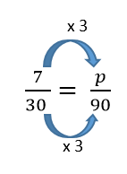

- Teacher provides instruction on color-coding and labeling the different units when setting up a proportional relationship to ensure corresponding units are placed in the corresponding positions within the proportion.
- For example, a student can complete 7 math problems in 30 minutes. How many math problems can they complete in 90 minutes?

$$\frac{7 problems}{30 minutes}=\frac{x problems}{90 minutes}$$

- Teacher co-creates visual models with students to visualize the multiplicative relationship between quantities.
  - For example, to solve the proportion, the corresponding numbers are tripled to find a missing value of 21.

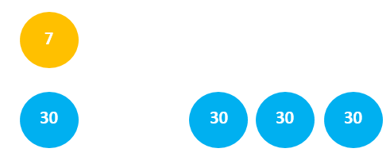

- Instruction includes the understanding that proportions are multiplicative relationships.

Instructional Tasks
Instructional Task 1 (MTR.3.1)
A recipe that makes 16 cookies calls for $\frac{1}{4}$ cup of sugar and $\frac{2}{3}$ cup of flour. Janelle wants to proportionally increase these amounts to get a new recipe using one cup of sugar.

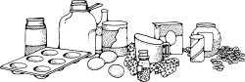

Part A. Using the new recipe, how much flour will she need? Explain or show your work.
Part B. How many cookies can she make with the new recipe? Explain or show your work.

Instructional Task 2 (MTR.6.1, MTR.7.1)
In buying ground beef for hamburgers, there are several packages from which to choose, as shown in the table below.

Pounds of Ground Beef | 1.5 | 2 | 3 | 3.75
Cost | $5.58 | $7.44 | $11.16 | $13.95

If Johannes needs 5 pounds of beef for his barbeque, what will he pay?

Instructional Items
Instructional Item 1
Anthony is writing the place cards for his best friend’s wedding reception. If he can write 12 place cards in 5 minutes, how long will it take him to complete the entire group of 180 place cards?

*The strategies, tasks and items included in the B1G-M are examples and should not be considered comprehensive.

MA.7.AR.3.3

Benchmark
MA.7.AR.3.3 Solve mathematical and real-world problems involving the conversion of units across different measurement systems.
Benchmark Clarifications:
Clarification 1: Problem types are limited to length, area, weight, mass, volume and money.

Connecting Benchmarks/Horizontal Alignment
- MA.7.NSO.1.2
- MA.7.NSO.2.1, MA.7.NSO.2.2, MA.7.NSO.2.3
- MA.7.AR.2.2
- MA.7.AR.4.3, MA.7.AR.4.4, MA.7.AR.4.5

Terms from the K-12 Glossary
- Area
- Capacity
- Customary Units
- Metric Units

Vertical Alignment
Previous Benchmarks  - MA.6.AR.3.5 | Next Benchmarks  - MA.8.GR.1.2
Purpose and Instructional Strategies
In grade 6, students performed conversions within the same measurement system. In grade 7, students solve mathematical and real-world problems involving the conversion of units across different measurement systems. In grade 8, students will apply these conversions when solving problems involving the distance between two points in a coordinate plane.
- Focus on using conversion ratios to create equivalent values.
  - For example, if 1 foot $=$ 12 inches, you can use the ratio of $\frac{1}{12}$ to solve problems.
Students may also use conversion ratios in their science courses. Emphasize that multiplying by equivalent values of 1 does not change the value but gives an equivalent value in another unit of measurement.
- Instruction includes using manipulatives to estimate conversion ratios across measurement systems such as yardsticks, meter sticks, measuring cups and graduated cylinders (MTR.2.1).
- Students may need review on which units are used to measure length, volume and mass.
- Instruction includes using a reference sheet with conversion ratios.

Common Misconceptions or Errors
- Students may incorrectly place the values in a conversion ratio. To address this misconception, have students estimate values prior to calculations using the conversion ratio (MTR.6.1).

Strategies to Support Tiered Instruction
- Teacher provides opportunities for students to comprehend the context or situation by engaging in questions (laminating these questions on a printed card for students to utilize as a resource in and out of the classroom would be helpful).
- What do you know from the problem?
- What is the problem asking you to find?
- Can you create a visual model to help you understand the problem?
- Teacher provides unit conversion sheet for students to determine the unit of measurement between different systems.
- Instruction focuses on using a unit conversion table to explicitly describe the process of converting between different units of measurement.
- Teacher provides instruction on color-coding and labeling the different units when setting up a proportional relationship to ensure corresponding units are placed in the corresponding positions within the proportion.
- Teacher encourages students to use their prior knowledge of proportions to convert unit of measurement across different measurement systems.

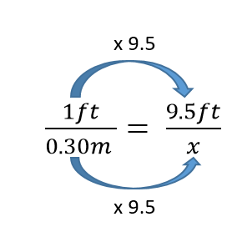

- Teacher provides students a visual of different units of measurements to compare and estimate the proper conversion ratio.
- Instruction includes the use of a three-read strategy. Students read the problem three different times, each with a different purpose (laminating these questions on a printed card for students to utilize as a resource in and out of the classroom would be helpful).
  - First, read the problem with the purpose of answering the question: What is the problem, context, or story about?
  - Second, read the problem with the purpose of answering the question: What are we trying to find out?
  - Third, read the problem with the purpose of answering the question: What information is important in the problem?
- Teacher has students estimate values prior to calculations using the conversion ratio (MTR.6.1).

Instructional Tasks
Instructional Task 1 (MTR.1.1, MTR.4.1)
Joe was planning a business trip to Canada, so he went to the bank to exchange $200 U.S. dollars for Canadian (CDN) dollars. On the way home from the bank, Joe’s boss called to say that the destination of the trip had changed to Mexico City. Joe went back to the bank to exchange his Canadian dollars for Mexican pesos. What is the value of Mexican pesos that Joe has now?
Part A. What questions still need to be answered to approach this problem?
Part B. The rates for CDN to the U.S. dollar and the rate of pesos to the CDN are shown below.
- Rate of $1.02 CDN per $1 U.S.
- Rate of 20.8 pesos per $1 CDN
What is the value of Mexican pesos that Joe has now?

Instructional Items
Instructional Item 1
Jia is buying strings of lights to hang on her patio deck. She needs 80 feet of lights to go around the entire patio, but the lights she wants to buy are only sold in packs of 5 meters. If one meter is approximately 3.28 feet, how many packs of lights will Jia need for her patio?

Instructional Item 2
How many milliliters are in 12 fluid ounces?

Instructional Item 3
Convert 50 pounds to kilograms.

Instructional Item 4
When driving from London to Poland, the speed limit signs change from miles per hour (mph) to kilometers per hour (kph), but your rental car speedometer only reads in mph. If the speed limit on the highway is 100 kph, at what speed will you exceed the speed limit?

*The strategies, tasks and items included in the B1G-M are examples and should not be considered comprehensive.

MA.7.AR.4 Analyze and represent two-variable proportional relationships.

MA.7.AR.4.1

Benchmark
MA.7.AR.4.1 Determine whether two quantities have a proportional relationship by examining a table, graph or written description.
Benchmark Clarifications:
Clarification 1: Instruction focuses on the connection to ratios and on the constant of proportionality, which is the ratio between two quantities in a proportional relationship.

Connecting Benchmarks/Horizontal Alignment
- MA.7.NSO.2.1, MA.7.NSO.2.2, MA.7.NSO.2.3
- MA.7.AR.3.2
- MA.7.GR.1.3, MA.7.GR.1.4, MA.7.GR.1.5

Terms from the K-12 Glossary
- Constant of Proportionality
- Proportional Relationships

Vertical Alignment
Previous Benchmarks  - MA.6.AR.3.3, MA.6.AR.3.4, MA.6.AR.3.5 | Next Benchmarks  - MA.8.AR.3.1  - MA.8.GR.2.4
Purpose and Instructional Strategies
In grade 6, students solved problems involving ratios, rates and unit rates, including comparisons, mixtures, ratios of lengths and conversions within the same measurement system. In grade 7, students work with proportional relationships between two variables. In grade 8, students will work with linear relationships.
- Instruction includes different ways of representing proportional relationships, such as tables and graphs. Multiplying or dividing one quantity in a ratio by a particular factor requires doing the same with the other quantity in the ratio to maintain the proportional relationship. Graphing equivalent ratios create a straight line passing through the origin.
  - Tables
$$x$$ | 5 | 40 | 65
$$y$$ | 1 | 8 | 13

  - Graphs
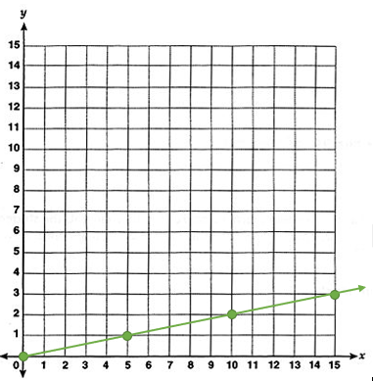

- Instruction should allow time for students to analyze real-world situations to determine if quantities are in proportional relationships (MTR.7.1).
- Instruction includes the connection between ratios and the constant of proportionality (MA.7.AR.4.2) as a method to determine whether a relationship is proportional or not. Determining the constant of proportionality may be helpful when given a table.
- Instruction builds on students’ knowledge of unit rates and equivalent fractions to determine this constant (MTR.5.1).
- Compare various representations of the same relationship for students to make comparisons and identify patterns. This should include both proportional and non-proportional relationships for compare and contrast discussions (MTR.4.1).

Common Misconceptions or Errors
- Using cross-products as a strategy to test for equivalent ratios may lead to errors and misconceptions in solving more complex equations in the future. To address this misconception, instruction focuses on testing equivalent ratios using tables or graphs to ensure students understand that two quantities are proportional to each other when each quantity in a ratio, multiplied by a constant, gives the corresponding quantity in the second ratio (MTR.3.1).
  - For example, provide students with the relationship between feet and yards. Students can discuss how the relationship 6 feet = 2 yards connects to the relationship 1.5 feet = 0.5 yard.
- Students may incorrectly believe the relationship is not proportional if the origin is not visible in the graph or given in the table. Help students extend the graph or table, using the pattern between points, until it reaches the origin.
- Students may incorrectly believe all graphs that are straight lines represent proportional relationships. To address this misconception, instruction focuses on the understanding that proportional relationships have a constant ratio between the two coordinates of each point and pass through the origin.
- Students reverse the position of the variables when writing equations. Students may find it useful to use letters for the variables that are specifically related to the quantities.
- Students may neglect to test all values when given a table.

Strategies to Support Tiered Instruction
- Teacher provides students with examples and non-examples of proportional relationships in a table, a graph and a verbal description. Teacher provides instructions for students to understand the patterns in proportional and non-proportional relationships.
- Instruction includes determining the value of $y$ when the $x$-value is zero to determine if the table is proportional.
- Instruction includes determining the ratio for each value of $x$ and $y$ in a table to ensure all values have the same ratio.
- Teacher reminds students to use their knowledge of unit rates or equivalent fractions to find the pattern and extend the graph to determine if the graph is proportional.
- Teacher co-creates a graphic organizer with examples and non-examples of proportional relationships in a table, graph and verbal description for students to compare and identify patterns in proportional and non-proportional relationships.
- Instruction includes the use of geometric software to represent proportional and non-proportional graphs to visually compare the models and clear the misconception that all linear graphs represent a proportional relationship.
- Instruction focuses on the understanding that proportional relationships have a constant ratio between the two coordinates of each point and pass through the origin.
- Instruction includes using the pattern between points to extend the graph or table until it reaches the origin.
- Teacher models how to use letters for the variables that are specifically related to the quantities.
  - For example, use $t$ for tacos, or $m$ for mice.

Instructional Tasks
Instructional Task 1 (MTR.4.1, MTR.7.1)
Johnny and Eleanor went to their local gas station to collect information about the cost of fuel for compact cars. They observed both regular and premium gas purchases that day and recorded their data in the table below.

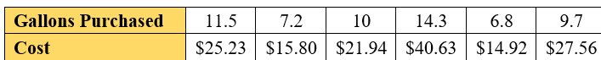

Part A. Is there a proportional relationship between the number of gallons of gas sold and the cost? Explain your answer.
Part B. If the relationship is not proportional, which data value or values should be changed to make the relationship proportional? What could explain this difference?

Instructional Items
Instructional Item 1
Angela is training for a marathon and completes her long mileage runs for training on the weekend. Over the last 3 weekends she ran 15 miles in 2 hours; 18 miles in 2 hours, 33 minutes; and 22 miles in 3 hours, 7 minutes. Determine if her weekend training runs showcase a proportional relationship.
*The strategies, tasks and items included in the B1G-M are examples and should not be considered comprehensive.

MA.7.AR.4.2

Benchmark
MA.7.AR.4.2 Determine the constant of proportionality within a mathematical or real-world context given a table, graph or written description of a proportional relationship.
Example: A graph has a line that goes through the origin and the point $(5, 2)$. This represents a proportional relationship and the constant of proportionality is $\frac{2}{5}$.
Example: Gina works as a babysitter and earns $9 per hour. She can only work 6 hours this week. Gina wants to know how much money she will make. Gina can use the equation $e=9h$, where $e$ is the amount of money earned, $h$ is the number of hours worked and $9$ is the constant of proportionality.

Connecting Benchmarks/Horizontal Alignment
- MA.7.NSO.2.1, MA.7.NSO.2.2, MA.7.NSO.2.3
- MA.7.AR.3.2, MA.7.AR.3.3
- MA.7.GR.1.3, MA.7.GR.1.5

Terms from the K-12 Glossary
- Constant of Proportionality
- Origin
- Proportional Relationships

Vertical Alignment
Previous Benchmarks  - MA.6.AR.3.2 | Next Benchmarks  - MA.8.AR.3.2
Purpose and Instructional Strategies
In grade 6, students determined rates and unit rates in ratios. In grade 7, students take a broader view of a rate or unit rate as they understand it to be the constant of proportionality in a proportional relationship. In grade 8, students will expand their understanding of the constant of proportionality in proportional relationships to slope in linear relationships.
- Instruction includes different ways of representing proportional relationships, such as tables and graphs. Multiplying or dividing one quantity in a ratio by a particular factor requires doing the same with the other quantity in the ratio to maintain the proportional relationship. Graphing equivalent ratios create a straight line passing through the origin.
  - Tables
$$x$$ | 5 | 40 | 65
$$y$$ | 1 | 8 | 13

  - Graphs

- Starting instruction with real-world context rather than mathematical procedure allows students to reason through the meaning of the constant of proportionality (MTR.7.1). Connect prior knowledge of unit rates when developing the constant of proportionality.
- Instruction includes a connection to pi $(π)$ as the constant of proportionality in the circumference formula within MA.7.GR.1.3.
- Problem types include positive and negative constants of proportionality.

Common Misconceptions or Errors
- Some students reverse the order of the ratio between the two quantities in a proportional relationship.
- Students may neglect the scale(s) of the axes on a graph. To address this misconception, have students interpret the constant of proportionality in context and evaluate the reasonableness of the answer. This may prompt students to revisit the graphical representation for better details.
- Students may incorrectly believe any line represents a proportional relationship. To address this misconception, revisit the development of the equation $y=px$ and be sure students see all proportional relationships have the origin as a common point.

Strategies to Support Tiered Instruction
- Instruction focuses on students’ comprehension of the context or situation by engaging in questions (laminating these questions on a printed card for students to utilize as a resource in and out of the classroom would be helpful).
  - What do you know from the problem?
  - What is the problem asking you to find?
  - What are the two quantities in this problem?
  - How are the quantities related to each other?
- When determining the constant of proportionally in a graph, the teacher can instruct students to interpret the coordinate point as it relates to the titles of each axis. Teacher and students can use this information to co-creates a table to clear up the misconception of misinterpreting the context of the constant proportionality.
- Instruction includes the use of a three-read strategy. Students read the problem three different times, each with a different purpose (laminating these questions on a printed card for students to utilize as a resource in and out of the classroom would be helpful).
  - First, read the problem with the purpose of answering the question: What is the problem, context, or story about?
  - Second, read the problem with the purpose of answering the question: What are we trying to find out?
  - Third, read the problem with the purpose of answering the question: What information is important in the problem?
- Teacher has students interpret the constant of proportionality in context and evaluate the reasonableness of the answer. This may prompt students to revisit the graphical representation for better details.
- Teacher revisits the development of the equation $y=px$ and be sure students see all proportional relationships have the origin as a common point.

Instructional Tasks
Instructional Task 1 (MTR.5.1, MTR.7.1)
Part A. The daily fee for docking a boat at a marina in Port Canaveral is proportional to the length of the boat. The table displays the fee for four different boat lengths. Find the constant of proportionality and explain what it means in the context of this problem.

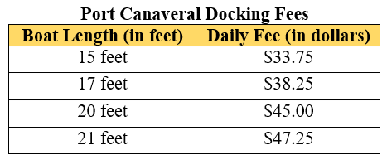

Part B. The daily fee for docking a boat at a marina in Fort Lauderdale is also proportional to the length of the boat. The graph displays the relationship between the fee and the boat length. Find the constant of proportionality and explain what it means in the context of this problem.
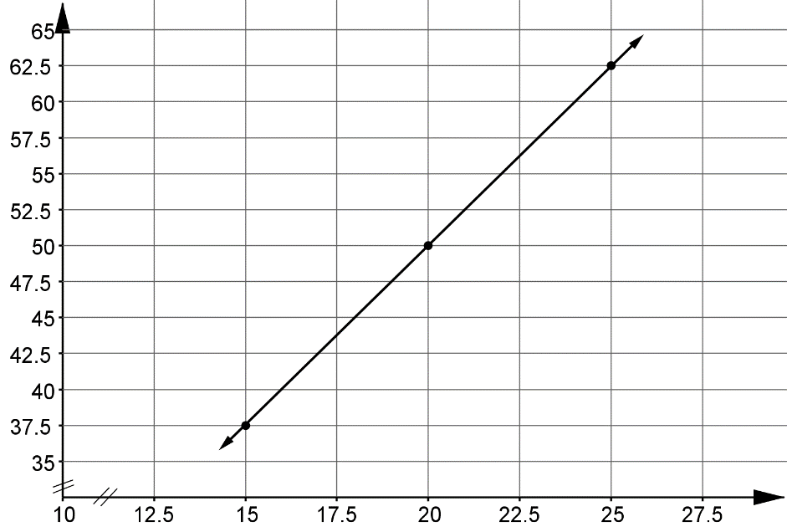
Daily Fee (in dollars)

Boat Length (in feet)

Fort Lauderdale Docking Fees

Part C. At which marina is it less expensive to dock a boat? Explain how you determined your answer.

Instructional Items
Instructional Item 1
After a workout at the gym, three friends made protein shakes to help in their recovery. Each protein shake contains 2 scoops of protein powder and 12 ounces of water. What is the constant of proportionality for this relationship?

Instructional Item 2
Determine the constant of proportionality for the following proportional relationships.

1. | 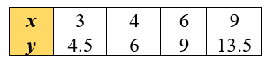 | 2. | 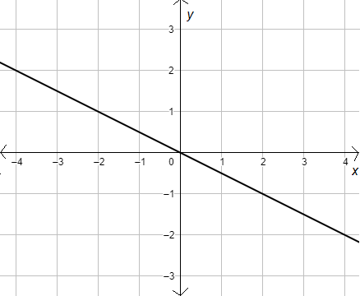

*The strategies, tasks and items included in the B1G-M are examples and should not be considered comprehensive.

MA.7.AR.4.3

Benchmark
MA.7.AR.4.3 Given a mathematical or real-world context, graph proportional relationships from a table, equation or a written description.
Benchmark Clarifications:
Clarification 1: Instruction includes equations of proportional relationships in the form of $y=px$, where $p$ is the constant of proportionality.

Connecting Benchmarks/Horizontal Alignment
- MA.7.NSO.2.1, MA.7.NSO.2.2, MA.7.NSO.2.3
- MA.7.AR.3.3

Terms from the K-12 Glossary
- Constant of Proportionality
- Proportional Relationships Unit Rate

Vertical Alignment
Previous Benchmarks  - MA.6.AR.3.4, MA.6.AR.3.5  - MA.6.GR.1.1 | Next Benchmarks  - MA.8.AR.3.4
Purpose and Instructional Strategies
In grade 6, students solved problems involving ratios, rates and unit rates, and began plotting points on the coordinate plane. In grade 7, students begin working with proportional relationships, including graphing proportional relationships given a table, equation or written description. In grade 8, students will determine if a linear relationship is proportional and graph two-variable linear equations from a written description, table or equation.
- Instruction includes different ways of representing proportional relationships, such as tables, equations, and graphs. Multiplying or dividing one quantity in a ratio by a particular factor requires doing the same with the other quantity in the ratio to maintain the proportional relationship. Graphing equivalent ratios create a straight line passing through the origin. The equations generated with the ratios will be unique in that they will follow the form of $y=px$.
  - Tables

$$x$$ | 5 | 40 | 65
$$y$$ | 1 | 8 | 13

  - Equations
$$y=\frac{1}{5}x$$

- Given one representation, have students provide the other three in order to determine their mastery of these equivalencies (as noted in MA.7.AR.4.4).
  - For example, if given a written description, have students provide a table, an equation and a graph of the given proportional relationship.
- Students should understand that although the most common variable used to represent the constant of proportionality is $p$, any other variable can be used.
  - For example, students can write the equation $p=1.6$ or $k=1.6$ to state that the constant of proportionality is $1.6$ given the equation $y=1.6x$.
- When an equation or written description is given, and have students create a corresponding table of values to assist with graphing. Be sure to emphasize the use of the origin as one of the points for the table (MTR.2.1).

Common Misconceptions or Errors
- Students may confuse the dependent and independent variables when graphing. To address this conception, instruction includes the understanding that the independent variable depends on the given context. Additionally, independent variables are not always the $x$-axis and the dependent variables are not always the $y$-axis.
- In grade 7, it is not the expectation that students define independent and dependent variables. Students may have experience with these terms from other content areas.
- Students may confuse the $x$- and $y$-axis.
- Students may not recognize the appropriate axis scale to graph the given scenario efficiently.
  - For example, if a situation involves fractional numbers, using a scale of 1 may not be appropriate. Instead, students should consider using a scale with a fractional value.

Strategies to Support Tiered Instruction
- Instruction focuses on students’ comprehension of the context or situation by engaging in questions (laminating these questions on a printed card for students to utilize as a resource in and out of the classroom would be helpful).
  - What do you know from the problem?
  - What is the problem asking you to find?
  - What are the two quantities in this problem?
  - How are the quantities related to each other?
  - Which quantity do you want to consider as the independent variable?
  - Which quantity do you want to consider as the dependent variable?
- Instruction includes co-creating a graphic organizer with key features of coordinate plane such as $x$-axis, $y$-axis, origin, quadrants, scales, origin and coordinates.
- Instruction includes the understanding that the independent variable depends on the given context. Additionally, independent variables are not always the $x$-axis and the dependent variables are not always the $y$-axis.
  - For example, if one has a proportional relationship between feet and meters, students can graph feet either on the $x$-axis or the $y$-axis. The dependent variable depends on the context. For instance, if one is given feet and converting to meters, then feet would be independent, and meters would be dependent.
- Teacher provides instruction on creating a table of values to assist graphing an equation on a coordinate plane.

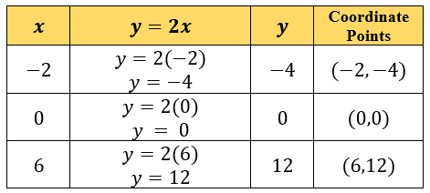

- Instruction includes modeling how to properly use a scale when situations involve fractional numbers. Instead of using a scale of 1, use a scale with a fractional value.

Instructional Tasks
Instructional Task 1 (MTR.5.1)
Coffee costs $18.96 for 3 pounds at the store, CoffeeUs.
Part A. What is the cost per pound of coffee?
Part B. At CoffeeUs, the price for a pound of coffee is the same no matter how many pounds you buy. Let $x$ be the number of pounds of coffee and $y$ be the total cost of $x$ pounds. Draw a graph of the proportional relationship between the number of pounds of coffee and the total cost.
Part C. Where can you see the cost per pound of coffee in the graph? What is it?

Instructional Items
Instructional Item 1
The cost of Hass avocados is a proportional relationship to the number of avocados being purchased. The equation $c=2.10a$ represents this relationship where $c$ is the total cost and $a$ is the number of Hass avocados being purchased. Create a graph representing this relationship.

Instructional Item 2
Graph the proportional relationship given in the table below.
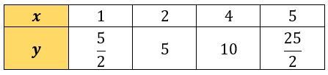

*The strategies, tasks and items included in the B1G-M are examples and should not be considered comprehensive.

MA.7.AR.4.4

Benchmark
MA.7.AR.4.4 Given any representation of a proportional relationship, translate the representation to a written description, table or equation.
Example: The written description, there are 60 minutes in 1 hour, can be represented as the equation $m=60h$.
Example: Gina works as a babysitter and earns $9 per hour. She would like to earn $100 to buy a new tennis racket. Gina wants to know how many hours she needs to work. She can use the equation $h=\frac{1}{9}e$, where $e$ is the amount of money earned, $h$ is the number of hours worked and $\frac{1}{9}$ is the constant of proportionality.
Benchmark Clarifications:
Clarification 1: Given representations are limited to a written description, graph, table or equation.
Clarification 2: Instruction includes equations of proportional relationships in the form of $y=px$, where $p$ is the constant of proportionality.

Connecting Benchmarks/Horizontal Alignment
- MA.7.NSO.2.1, MA.7.NSO.2.2, MA.7.NSO.2.3
- MA.7.AR.3.1, MA.7.AR.3.2, MA.7.AR.3.3
- MA.7.GR.2.2

Terms from the K-12 Glossary
- Constant of Proportionality
- Proportional Relationships
- Rate
- Unit Rates

Vertical Alignment
Previous Benchmarks  - MA.6.AR.1.1  - MA.6.AR.3.2, MA.6.AR.3.5 | Next Benchmarks  - MA.8.AR.3.2, MA.8.AR.3.3, MA.8.AR.3.4
Purpose and Instructional Strategies
In grade 6, students translated written descriptions into algebraic expressions and translated algebraic expressions into written descriptions. In grade 7, students translate any representation of a proportional relationship to a written description, table or equation. In grade 8, students will extend this work to include linear relationships.
- Instruction includes different ways of representing proportional relationships, such as tables, equations and graphs. Multiplying or dividing one quantity in a ratio by a particular factor requires doing the same with the other quantity in the ratio to maintain the proportional relationship. Graphing equivalent ratios create a straight line passing through the origin. The equations generated with the ratios will be unique in that they will follow the form of $y=px$.
  - Tables

$$x$$ | 5 | 40 | 65
$$y$$ | 1 | 8 | 13

  - Equations
$$y=\frac{1}{5}x$$

  - Graphs

- When providing a graph, be sure there are easily identifiable points for students to use in calculating the constant of proportionality.
- As students are building meaning, instruction makes connections between the different representations.
- Even though proportional relationships exist in Quadrant I, instruction includes opportunities for students to realize that the line does continue into Quadrant III but are not appropriate for the real-world situation.
- Students should be able to explain examples from the points on a graph or the numbers within the table by putting it back into the real-world context when appropriate.
- Instruction includes flexibility in understanding of the dependent and independent variables. Students can represent situations in terms of $x$ or in terms of $y$.
  - For instance, within example 1 students can represent the situation as $m=60h$ or $h=\frac{1}{60}m$.
- Students should construct verbal descriptions.
  - For example, a student might describe the situation as “the number of packs of gum times the cost for each pack is the total cost in dollars.” They can use the verbal model to construct the equation.
- Students can check the equation by substituting values and comparing their results to the table. The checking process helps students revise and recheck their model as necessary (MTR.6.1).
- Provide tables of values for various proportional relationships. Ask students to look at the tables and generalize how they can find the $y$-value in the tables given any $x$-value (MTR.1.1). Have students look for patterns and assist with developing the equation $y=px$ where $p$ is the constant of proportionality (MTR.5.1).
- Ensure the formal development of the equation $y=px$ where $p$ is the constant of proportionality. Instruction supports flexibility in the variable used for the constant of proportionality. Provide practice for students to develop this equation using different variables based on given scenarios, as in Example 2.

Common Misconceptions or Errors
- Students may neglect the scales on the axes when calculating and interpreting the constant of proportionality.
- Students may not be able to approximate the constant of proportionality from the graphs. To address this misconception, begin with graphs having easily identifiable points before moving toward problems that need approximations.
- Students may not see the connection between the constant of proportionality and the steepness of the graph. To address this misconception, provide a variety of graphs with various steepness and ask students to organize them based on increasing order of the constants of proportionality.

Strategies to Support Tiered Instruction
- Instruction includes utilizing the $x$- and $y$-axis when determining the constant of proportionality. Teacher provides instruction on locating the values for the variables $y$ and $x$ from the axis labels, rather than counting the minor gridlines to the chosen point on the graph.
- Instruction includes utilizing graphs containing easily identifiable points on minor gridlines before moving toward graphs containing points that lie between gridlines which requires estimation to determine an appropriate constant of proportionality.
- Instruction includes the co-creation of a graphic organizer containing examples of proportional relationships with increasing levels of steepness. For each example, include a real-world scenario, a table, a graph and the constant of proportionality.
- Instruction includes using letters for variables that relate to the given scenario, such as $w$ for water.
- For students that are not able to approximate the constant of proportionality from the graphs, begin with graphs having easily identifiable points before moving toward problems that need approximations. For students that cannot see the connection between the constant of proportionality and the steepness of the graph, provide a variety of graphs with various steepness and ask students to organize them based on increasing order of the constants of proportionality.

Instructional Tasks
Instructional Task 1 (MTR.5.1)
Kell works at an after-school program at an elementary school. The table below shows how much money he earned every day last week.

 | Monday | Wednesday | Friday
time worked | 1.5 hours | 2.5 hours | 4 hours
money earned | $12.60 | $21.00 | $33.60

Mariko has a job mowing lawns that pays $7 per hour.
Part A. Who would make more money for working 10 hours? Explain or show work.
Part B. Draw a graph that represents $y$, the amount of money Kell would make for working $x$ hours, assuming he made the same hourly rate he was making last week.
Part C. Using the same coordinate axes, draw a graph that represents $y$, the amount of money Mariko would make for working $x$ hours.
Part D. How can you see who makes more per hour just by looking at the graphs? Explain.
Part E. Write one equation to represent how much money Kell earns in $x$ hours and one equation to represent how much money Mariko earns in $h$ hours.

Instructional Task 2 (MTR.3.1)
Kelsi works as a lifeguard at the local pool. After an 8-hour day at work, she earns $100.
Part A. Write an equation that describes the relationship between the number of hours worked and the amount of money that she earns.
Part B. Kelsi would like to earn $450 to buy a new gaming system. Use your equation to determine how many hours she needs to work to buy a new gaming system.

Instructional Items
Instructional Item 1
Saylor needs to walk her dog Holloway every day after work. After 5 days Saylor walked her dog a total of 200 minutes. Write an equation that describes the relationship between the amount of minutes Saylor walked her dog each day.

*The strategies, tasks and items included in the B1G-M are examples and should not be considered comprehensive

MA.7.AR.4.5

Benchmark
MA.7.AR.4.5 Solve real-world problems involving proportional relationships.
Example: Gordy is taking a trip from Tallahassee, FL to Portland, Maine which is about 1,407
miles. On average his SUV gets 23.1 miles per gallon on the highway and his gas tanks
holds 17.5 gallons. If Gordy starts with a full tank of gas, how many times will he be
required to fill the gas tank?

Connecting Benchmarks/Horizontal Alignment
- MA.7.NSO.2.1, MA.7.NSO.2.2, MA.7.NSO.2.3
- MA.7.AR.2.2
- MA.7.AR.3.1, MA.7.AR.3.2, MA.7.AR.3.3
- MA.7.GR.1.5
- MA.7.GR.2.2, MA.7.GR.2.3
- MA.7.DP.1.3, MA.7.DP.1.4
- MA.912.AR.2.3

Terms from the K-12 Glossary
- Proportional Relationships
- Rate
- Unit Rates

Vertical Alignment
Previous Benchmarks  - MA.6.AR.3.5 | Next Benchmarks  - MA.8.AR.3.4, MA.8.AR.3.5
Purpose and Instructional Strategies
In grade 6, students solved mathematical and real-world problems involving ratios, rates and unit rates, including comparisons, mixtures, ratios of lengths and conversions within the same measurement system. In grade 7, students solve real-world problems involving proportional relationships. In grade 8, students will solve real-world problems involving linear relationships.
- This benchmark is a culmination of the work students have been doing throughout MA.7.AR.4.
- Instruction for this benchmark includes opportunities to compare two different proportional relationships to each other.
- Allow various methods for solving, encouraging discussion and analysis of efficient and effective solutions (MTR.4.1).
- In grade 7, it is not the expectation that students define independent and dependent variables. Students may have experience with these terms from other content areas.

Common Misconceptions or Errors
- Students may invert values when setting up proportions.

Strategies to Support Tiered Instruction
- Teacher provides opportunities for students to comprehend the context or situation by engaging in questions.
  - What do you know from the problem?
  - What is the problem asking you to find?
  - What are the two quantities in this problem?
  - How are the quantities related to each other?
- Instruction includes the use of a three-read strategy. Students read the problem three different times, each with a different purpose.
  - First, read the problem with the purpose of answering the question: What is the problem, context, or story about?
  - Second, read the problem with the purpose of answering the question: What are we trying to find out?
  - Third, read the problem with the purpose of answering the question: What information is important in the problem?
- Instruction includes the understanding that the independent variable depends on the given context. Additionally, independent variables are not always the $x$-axis and the dependent variable are not always the $y$-axis.
- For example, if one has a proportional relationship between feet and meters, they can graph feet either on the $x$-axis or the $y$-axis. Which one is dependent depends on the context. For instance, if one is given feet and converting to meters, then feet would be independent, and meters would be dependent.

Instructional Tasks
Instructional Task 1 (MTR.4.1)
Patsy is making shortbread cookies using the ingredients below.
10 tablespoons of butter  $1\frac{1}{2}$ cups powdered sugar  $\frac{1}{2}$ teaspoon vanilla extract | $1\frac{1}{2}$ cups flour  $\frac{1}{2}$ teaspoon salt
Part A. This recipe makes 16 cookies, but Patsy needs 5 dozen. How much of each ingredient will she need to make the 5 dozen cookies she needs?
Part B. Once Harrison tasted Patsy’s shortbread cookies, he ordered 7 dozen for a birthday party. If Patsy originally started with 4 cups of flour, 2 cups of powdered sugar and 16 tablespoons of butter, how much more (if any) will she need of each ingredient to complete Harrison’s order?
Part C. After the party, Jeb shared his recipe which calls for 2 cups of flour and $1\frac{3}{4}$ cup of powdered sugar. Since adding powdered sugar to cookies should make them sweeter, Jeb claims his larger ratio of powdered sugar to flour will produce sweeter cookies. Is this statement correct?

Instructional Items
Instructional Item 1
A couple is taking a horse and carriage ride through Central Park in New York City. After 8 minutes, they had traveled $\frac{1}{2}$ mile.
Part A. Create a graph to represent the proportional relationship between miles traveled and the number of minutes they are on the carriage.
Part B. Use this graph to determine how long it will take to complete the 2.5-mile ride around the park.

*The strategies, tasks and items included in the B1G-M are examples and should not be considered comprehensive.\

Geometric Reasoning

MA.7.GR.1 Solve problems involving two-dimensional figures, including circles.

MA.7.GR.1.1

Benchmark
MA.7.GR.1.1 Apply formulas to find the areas of trapezoids, parallelograms and rhombi.
Benchmark Clarifications:
Clarification 1: Instruction focuses on the connection from the areas of trapezoids, parallelograms and rhombi to the areas of rectangles or triangles.
Clarification 2: Within this benchmark, the expectation is not to memorize area formulas for trapezoids, parallelograms and rhombi.

Connecting Benchmarks/Horizontal Alignment
- MA.7.NSO.2.1, MA.7.NSO.2.2, MA.7.NSO.2.3

Terms from the K-12 Glossary
- Area
- Parallelogram
- Rectangle
- Rhombus
- Triangle
- Trapezoid

Vertical Alignment
Previous Benchmarks  - MA.6.GR.2.1, MA.6.GR.2.2 | Next Benchmarks  - MA.912.GR.3.3  - MA.912.GR.4.4

Purpose and Instructional Strategies
In grade 6, students solved problems involving the area of quadrilaterals and composite figures by decomposing them into triangles or rectangles. In grade 7, students apply formulas to find the areas of trapezoids, parallelograms and rhombi. In high school, students will extend this knowledge to solve mathematical and real-world problems involving the perimeter or area of any polygon using coordinate geometry and other tools.
- Instruction includes using students’ prior knowledge of finding the area of a rectangle to build the area formulas for trapezoids, parallelograms and rhombi. The use of grid paper can support students in counting the squares to verify the areas are accurate.
- Investigations and explore activities for students can include:
  - Draw or provide a cutout of a rhombus. Slice the rhombus vertically at a right angle. Slide the sliced-off portion to form a square so students can see the base and height of the square are the same as that of the rhombus (MTR.5.1).
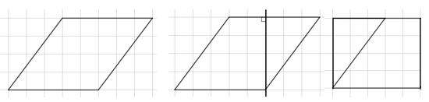

  - Draw or provide a cutout of a parallelogram. Slice the parallelogram vertically at a right angle. Slide the sliced off portion to form a rectangle so students can see the base and height of the rectangle are the same as that of the parallelogram (MTR.5.1).



  - Draw or provide a cutout of a trapezoid. Duplicate the trapezoid using tracing paper and rotate it to form a larger parallelogram formed with both figures. The base of the parallelogram then becomes the sum of the two bases of the original trapezoid while the height is the perpendicular height of the original trapezoid. The area is one half of the area of this parallelogram since it contains two identical trapezoids (MTR.5.1).

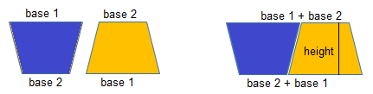

- Instruction includes the comparison of formulas between rectangles, trapezoids, parallelograms and rhombi.

Common Misconceptions or Errors
- Students may incorrectly identify a side length as a height rather than using the perpendicular distance between the bases. To address this misconception, use cutouts or measuring tools to show that these distances are not the same; consider using physical objects that are not square or rectangular to make sense of finding the correct height.
- Students may not properly locate the height or base(s) when using figures in various orientations. To address this misconception, provide multiple orientations of objects and figures. Note that parallelograms are like rectangles, in that any side can be considered a base, so there are two possible heights.

Strategies to Support Tiered Instruction
- Teacher models measuring the length and height of a given shape to demonstrate the difference between the dimensions.
- Instruction includes the use of manipulatives or geometric software to demonstrate the similarity of trapezoids, parallelograms and rhombi to square, rectangles, and triangles.
- Teacher co-creates a graphic organizer with images and formulas for trapezoids, parallelograms and rhombi and uses different colors to connect the dimensions of the figures to the variables within the formulas.
- Teacher uses cutouts or measuring tools to show that the length of the side of a figure is not necessarily the same as its height. Consider using physical objects that are not square or rectangular to make sense of finding the correct height.

Instructional Tasks
Instructional Task 1 (MTR.5.1)
Trace a parallelogram or a rhombus on a sheet of graph paper. Highlight (or color) each of the sides a different color. Slice your two-dimensional figure vertically from a vertex at a right angle to an opposite side, to create a right triangle. Move the sliced-off portion to form a rectangle.
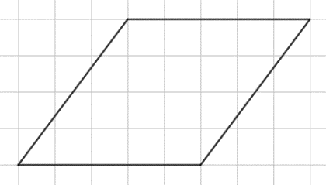

Part A. What are the length and width of the created rectangle?
Part B. Determine the formula for finding the area of your two-dimensional figure.
Part C. Compare your two-dimensional figure and formula with a partner. What do you notice?

Instructional Task 2 (MTR.5.1)
Duplicate the trapezoid given below using tracing paper and color the corresponding bases the same color. Cut out both trapezoids. Rotate one trapezoid 180º and line it up next to the other.
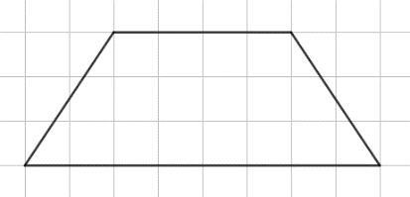

Part A. What figure has formed?
Part B. What is the formula for the figure’s area? Use this information to determine the formula for finding the area of a trapezoid.

Instructional Items
Instructional Item 1
A new park is being built in the shape of a trapezoid, as shown in the diagram below. The builders will cover the ground with a solid rubber surface to ensure the children playing have a safe and soft place to land when they jump or fall. How many square yards of rubber will be needed for this park?
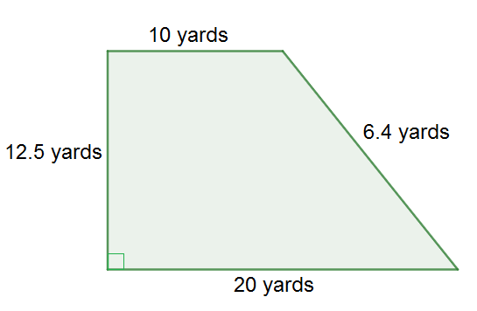

Instructional Item 2
Find the area of the figure below.
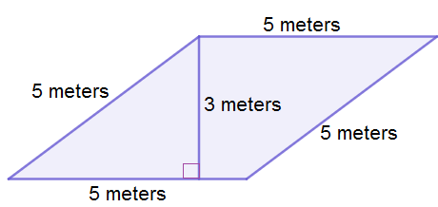

*The strategies, tasks and items included in the B1G-M are examples and should not be considered comprehensive.

MA.7.GR.1.2

Benchmark
MA.7.GR.1.2 Solve mathematical or real-world problems involving the area of polygons or composite figures by decomposing them into triangles or quadrilaterals.
Benchmark Clarifications:
Clarification 1: Within this benchmark, the expectation is not to find areas of figures on the coordinate plane or to find missing dimensions.

Connecting Benchmarks/Horizontal Alignment
- MA.7.NSO.2.1, MA.7.NSO.2.2, MA.7.NSO.2.3
- MA.7.GR.2.2

Terms from the K-12 Glossary
- Area
- Composite Figure
- Polygon
- Quadrilateral
- Triangle

Vertical Alignment
Previous Benchmarks  - MA.6.GR.2.2 | Next Benchmarks  - MA.912.GR.3.4  - MA.912.GR.4.3, MA.912.GR.4.4

Purpose and Instructional Strategies
In grade 6, students solved problems involving the area of quadrilaterals and composite figures by decomposing them into triangles or rectangles. In grade 7, students solve problems involving the area of polygons or composite figures by decomposing them into triangles or quadrilaterals. In high school, students will extend this knowledge to solve mathematical and real-world problems involving the perimeter or area of any polygon using coordinate geometry and other tools.
- Instruction includes problems where multiple decompositions are possible so students understand the various pathways to a solution (MTR.5.1). Scaffolded instruction may include figures on grid paper to allow students to more easily count the total area. Select and order student solutions to be shared with the whole group (MTR.4.1), depicting various solution pathways.
- Instruction includes figures where an efficient method is to subtract a basic figure from a larger figure.
- Students should use grid paper to draw a polygon that is composed of triangles and quadrilaterals that can be exchanged with a partner or within a group to find the corresponding areas.

Common Misconceptions or Errors
- Students may neglect to add the areas of the decomposed figures to find the total area of the composite figure. Students may also incorrectly add one (or more) of the decomposed figures more than once. To address misconceptions, have students mark or color the figures as they add them to the total to keep track of their work (MTR.3.1).
- Students may not decompose the figure into the most basic figures. To address this misconception, ask students if they can find the area of each of the pieces they have, or if they can break any of them down further to find a more familiar figure (MTR.5.1).

Strategies to Support Tiered Instruction
- Instruction includes writing the area of each decomposed figure inside the original figure and placing a check next to each of the decomposed areas as they are added to determine the total area of the composite figure.
- Teacher provides geometric software for students to interact with composite figures to develop understanding of how to decompose two dimensional figures.
- Teacher provides paper cutouts of different composite figures for students to fold or cut into triangles or quadrilaterals to visually understand how to decompose the area.
- Instruction includes color-coding parallel bases or heights to assist in determining missing measurements of composite figures.
  - For example, given the figure below (assuming the two right triangles have the same side lengths as each other), students can highlight the parallel bases of the rectangle.
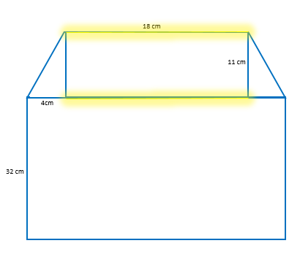

- Teacher has students mark or color the figures as they add them to the total to keep track of their work (MTR.3.1).
- Teacher asks students if they can find the area of each of the pieces they have, or if they can break any of them down further to find a more familiar figure (MTR.5.1).

Instructional Tasks
Instructional Task 1 (MTR.6.1)
After a recent storm, Evan has been offered two jobs to replace patio screens. The layouts for the screens needed at both locations are given below. The shaded part represents a stone layout that does not need to be screened.
Job #1
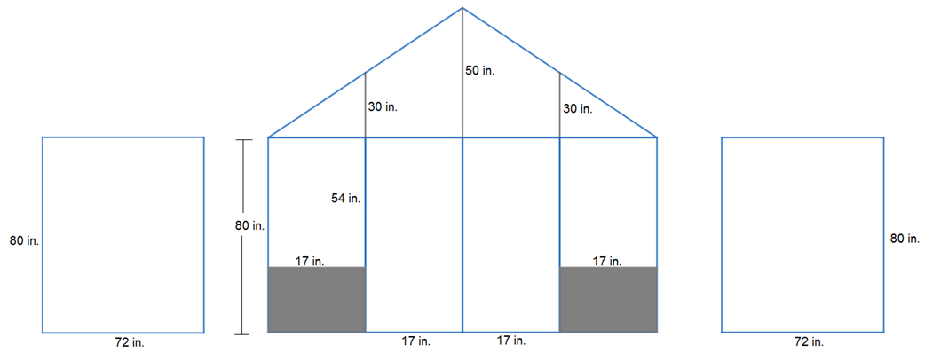

Job #2
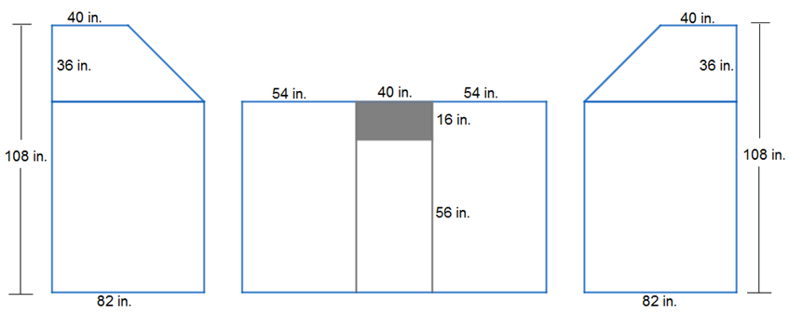

If Evan gets paid by the square inch and would like the highest-paying job, which job should he take? Justify your reasoning.

Instructional Task 1 (MTR.3.1)
Tyler and Samantha are building the set for a school play. The design shown below was cut out of wood and now needs to be covered in fabric.
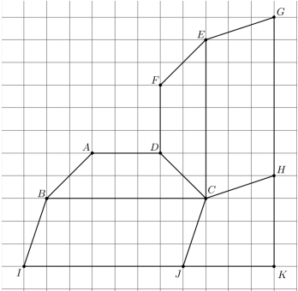

Part A. If each square in the grid has a length of one foot, estimate the total area of wood
that needs to be covered. Justify your answer.
Part B. What is the exact total area of the wood, in feet, that needs to be covered? Share
your strategy with a partner.

Instructional Items
Instructional Item 1
Find the area of the figure below. Note that the figure may not be drawn to scale.

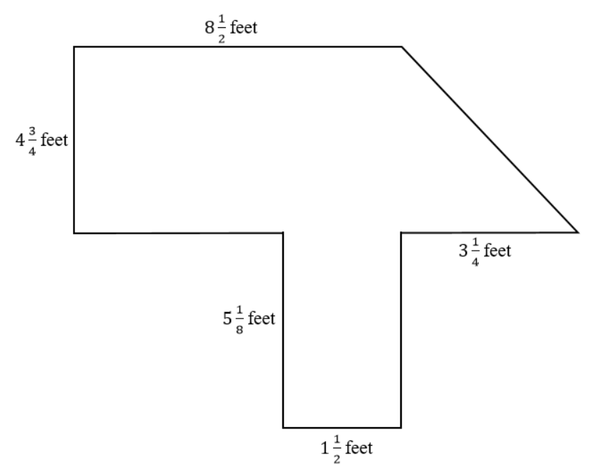

Instructional Item 2
Bena is building a kite based on the design shown below. Determine how much ripstop
nylon she will need to purchase for the sail material.

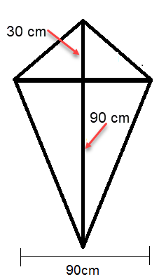

*The strategies, tasks and items included in the B1G-M are examples and should not be considered comprehensive.

MA.7.GR.1.3

Benchmark
MA.7.GR.1.3 Explore the proportional relationship between circumferences and diameters of circles. Apply a formula for the circumference of a circle to solve mathematical and real-world problems.
Benchmark Clarifications:
Clarification 1: Instruction includes the exploration and analysis of circular objects to examine the proportional relationship between circumference and diameter and arrive at an approximation of pi ($π$) as the constant of proportionality.
Clarification 2: Solutions may be represented in terms of pi ($π$) or approximately.

Connecting Benchmarks/Horizontal Alignment
- MA.7.NSO.2.1, MA.7.NSO.2.2, MA.7.NSO.2.3
- MA.7.AR.3.2
- MA.7.AR.4.1, MA.7.AR.4.2
- MA.7.GR.2.1, MA.7.GR.2.2

Terms from the K-12 Glossary
- Circumference
- Constant of Proportionality
- Diameter
- Pi ($π$)
- Proportional Relationship

Vertical Alignment
Previous Benchmarks  - MA.6.GR.1.3 | Next Benchmarks  - MA.8.GR.1.2  - MA.912.GR.7.2, MA.912.GR.7.3

Purpose and Instructional Strategies
In grade 6, students solved problems involving the perimeter and area of two-dimensional figures. In grade 7, students explore the proportional relationship between circumferences and diameters of circles and develop and learn a formula to solve circumference problems. In grade 8, students will learn and use the Pythagorean Theorem to find the distance between points in the coordinate plane, and this builds the foundation for the equation of a circle in high school geometry.
- Instruction includes opportunities for students to see circular or cylindrical household objects of different sizes. Students will measure the diameter and the circumference of the circle in each object to the nearest tenth of a centimeter to arrive at an approximation of pi ($π$) as the constant of proportionality. Students can record the values in a table and plot the points on a coordinate plane to discover the pattern that arises (MTR.5.1). Students should complete multiple trials to best support their conclusions using both radius and diameter.
Trial #1
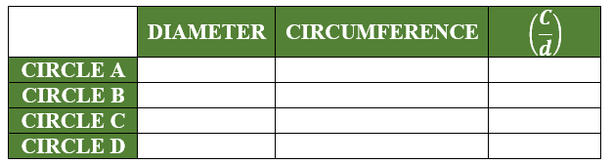

Trial #2
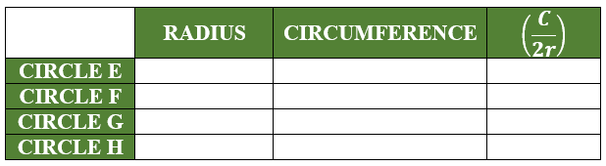

- Instruction emphasizes the relationship between radius and diameter so students will easily move between the equivalent forms of the circumference formula (MTR.3.1).
- Instruction includes student understanding that the circumference of a circle is the same as the perimeter of any other two-dimensional figure.
- Students are expected to know the approximations of pi $\left(\frac{355}{113},\frac{22}{7} or 3.14\right)$.

Common Misconceptions or Errors
- Students may invert the terms radius and diameter. To address this misconception, review parts of a circle including radii, diameters and chords.

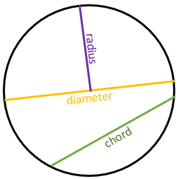

- Students may incorrectly believe pi is a variable, rather than a constant for every circle.
- Students may confuse circumference and area. To address this misconception, help students connect the circumference as the perimeter of a circle.

Strategies to Support Tiered Instruction
- Teacher provides opportunities for students to measure the radius and diameter of various circles and to explore and discuss the similarities and differences between radius and diameter.
- To clarify misconceptions between the relationship of diameter and circumference, instruction includes solving for the constant of proportionality between a given diameter and circumference of a circle and discussing the patterns that arise. Teacher provides opportunities for students to solve for the circumference of a given circle in terms of pi before replacing the value of pi with an approximation to determine the estimated circumference.
- Teacher co-creates a graphic organizer with students containing color-coded examples of circumference, area, diameter and radius.

Instructional Tasks
Instructional Task 1 (MTR.4.1, MTR.7.1)
Amy and Eunice are participating in a bike-a-thon this weekend. Amy has 29-inch road bike wheels and Eunice has 26-inch mountain bike wheels, where the bike wheel measurements are based on their diameter.
Part A. If they choose a bike-a-thon distance of 5 miles, whose bike wheels will need to do the fewest revolutions to reach the finish line?
Part B. How many more revolutions will the other bike need to make to reach the finish line? Explain your reasoning.

Instructional Items
Instructional Item 1
Determine the circumference of the following circles.

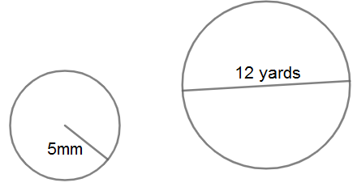

Instructional Item 2
When baking an apple pie, a strip of aluminum foil needs to be placed around the edge of the crust until the last 20 minutes of baking so that it will not burn. If using a $9\frac{1}{2}$ -inch diameter pie pan, how long should the strip of foil be?

*The strategies, tasks and items included in the B1G-M are examples and should not be considered comprehensive.

MA.7.GR.1.4

Benchmark
MA.7.GR.1.4 Explore and apply a formula to find the area of a circle to solve mathematical and real-world problems.
Example: If a 12-inch pizza is cut into 6 equal slices and Mikel ate 2 slices, how many square
inches of pizza did he eat?

Benchmark Clarifications:
Clarification 1: Instruction focuses on the connection between formulas for the area of a rectangle and the area of a circle.
Clarification 2: Problem types include finding areas of fractional parts of a circle.
Clarification 3: Solutions may be represented in terms of pi ($π$) or approximately.
Connecting Benchmarks/Horizontal Alignment
- MA.7.NSO.1.1
- MA.7.AR.4.1
- MA.7.GR.2.1, MA.7.GR.2.2, MA.7.GR.2.3

Terms from the K-12 Glossary
- Area
- Circle
- Pi ($π$)
- Rectangle

Vertical Alignment
Previous Benchmarks  - This is the first introduction to circles outside of recognizing the shape in early elementary. | Next Benchmarks  - MA.912.GR.4.4, MA.912.GR.4.6  - MA.912.GR.6.4

Purpose and Instructional Strategies
In grade 6, students found the areas of rectangles and triangles, and solved problems involving the area of quadrilaterals and composite figures by decomposing them into triangles or rectangles. In grade 7, students find the area of circles and other geometric figures. In both grade 7 and high school, students build on their knowledge of area to find the surface areas and volumes of various three-dimensional figures.
- Students are not expected to memorize the formula for the area of a circle (MTR.5.1).
- Students are expected to know approximations of pi $\left(\frac{355}{113},\frac{22}{7} or 3.14\right)$.
- Instruction includes students exploring circles. Provide students with a circle and have them highlight the circumference. Students will then fold the circle in half, half again, and half once more to allow them to cut it into 8 wedges of equal size. Then arrange the wedges so they alternately point up and down, forming a rectangle, with the highlighted circumference being the bases. Ensure students realize that the length of the rectangle is approximately equal to half the circumference, or $πr$, of the circle and the height of the rectangle is equal to the radius, $r$, of the circle (MTR.4.1).
  - For more accuracy, provide a circle with lines drawn for students to cut the circle into 16 equal-sized wedges.

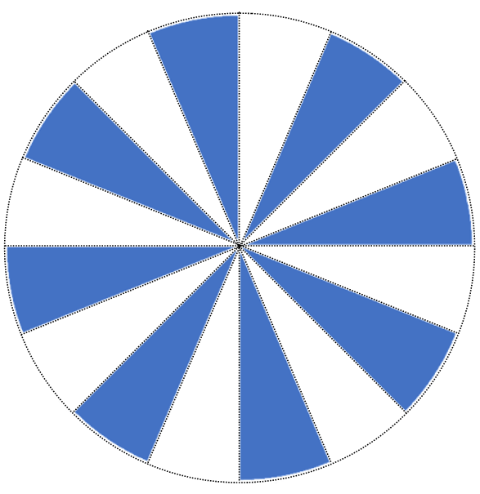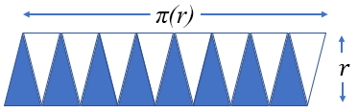

- Have students describe the area of a circle and explain if the area of a circle changes if it is cut up and rearranged.
- Ask questions to elicit student thinking (MTR.4.1) such as:
    - What formula was used to find the area of a circle?
    - How is the formula for the area of a circle related to the formula for the area of a parallelogram?
- Instruction includes using circles on grid paper for students to estimate area before making precise calculations.
- The expectation of this benchmark is not to find the radius or diameter of a circle when given the area.

Common Misconceptions or Errors
- Students may invert the terms radius and diameter. To address this misconception, review parts of a circle including radii, diameters and chords.

- Students may incorrectly believe pi is a variable, rather than a constant that does not change from one circle to the next. Review the development of pi in MA.7.GR.1.3.
- Students may confuse circumference and area. To address this misconception, help students connect area of a circle to area of a rectangle.
- Students may incorrectly double the radius (finding diameter), rather than squaring it, when finding an area. To address this misconception, review exponent rules from MA.6.NSO.3.3 and MA.7.NSO.1.1.

Strategies to Support Tiered Instruction
- Teacher provides opportunities for students to measure the radius and diameter of various circles and to explore and discuss the similarities and differences between radius and diameter.
- Instruction includes modeling the area of a given circle in terms of pi before replacing the value of pi with an approximation to determine the estimated area.
- Teacher co-creates a graphic organizer with students containing color-coded examples of circumference, area, diameter and radius.
- Teacher co-creates a table to find the constant of proportionality between the diameter and circumference of a circle, allowing students to discover the pattern that represents pi ($π$).
- Instruction includes modeling the differences between doubling and squaring a radius. Doubling a radius would be represented by multiplying the given length by $2$, whereas squaring a number would be represented by the area of a square with the given radius.
  - For example, students can be given the table below to show how the left column doubles a length whereas the right column squares a length.
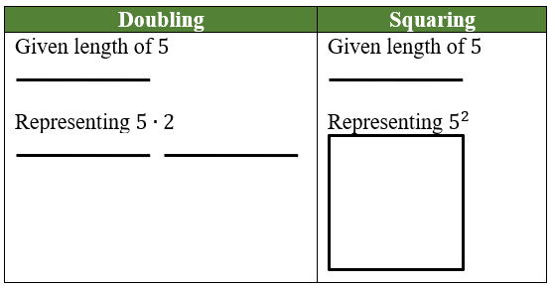

- Instruction includes rewriting the area formula for a circle in expanded form before evaluating.
  - For example, the formula for the area of a circle, $A=πr^{2}$, can be rewritten as $A=(π)(r)(r)$.
- Teacher helps students connect area of a circle to area of a rectangle.

Instructional Tasks
Instructional Task 1 (MTR.1.1)
The figure below is composed of eight circles, with seven small circles inside one large circle containing them all. Neighboring circles only share one point, and two regions between the smaller circles have been shaded. Each small circle has a radius of 5 centimeters.

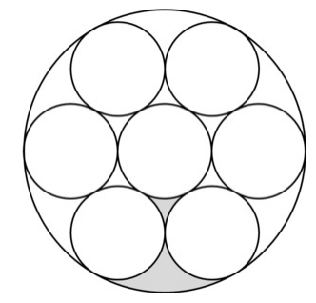

Part A. What is the area of the large circle?
Part B. What is the area of the shaded part of the figure?

Instructional Items
Instructional Item 1
What is the area of a circle whose radius is 4 centimeters? Round to the nearest hundredth.

Instructional Item 2
Find the exact area, in centimeters (cm), of each circle below.
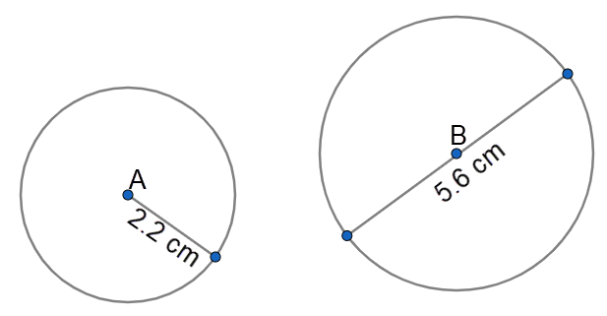

Instructional Item 3
Jamilah wants to add to her kitchen countertop, which is currently in the shape of a rectangle. If she adds the solid, semicircular piece shown in the picture below, determine how many square feet, to the nearest tenth of a foot, of marble Jamilah will need for the addition.
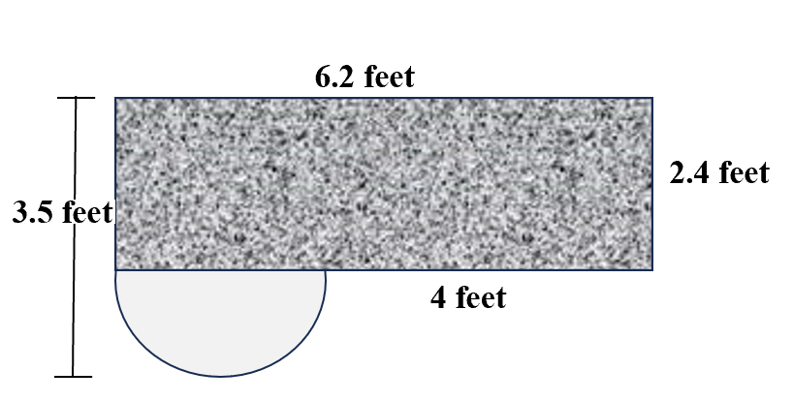

*The strategies, tasks and items included in the B1G-M are examples and should not be considered comprehensive.

MA.7.GR.1.5

Benchmark
MA.7.GR.1.5 Solve mathematical and real-world problems involving dimensions and areas of geometric figures, including scale drawings and scale factors.
Benchmark Clarifications:
Clarification 1: Instruction focuses on seeing the scale factor as a constant of proportionality between corresponding lengths in the scale drawing and the original object.
Clarification 2: Instruction includes the understanding that if the scaling factor is $k$, then the constant of proportionality between corresponding areas is $k^{2}$.
Clarification 3: Problem types include finding the scale factor given a set of dimensions as well as finding dimensions when given a scale factor.

Connecting Benchmarks/Horizontal Alignment
- MA.7.AR.4.2, MA.7.AR.4.5

Terms from the K-12 Glossary
- Area
- Constant of Proportionality
- Scale Factor

Vertical Alignment
Previous Benchmarks  - MA.6.AR.3.5  - MA.6.GR.2.2 | Next Benchmarks  - MA.8.GR.2.2  - MA.912.GR.4.3, MA.912.GR.4.4

Purpose and Instructional Strategies
In grade 6, students solved problems relating to the perimeter or area of a rectangle as well as the area of composite figures by decomposing them into triangles or rectangles. In grade 7, students solve mathematical and real-world problems involving dimensions and areas of geometric figures, including scale drawings and scale factors. In grade 8, students will continue to work with scale factors and apply to dilations before moving to high school and determining how dilations affect the area of two-dimensional figures and the surface area or volume of three-dimensional figures.
- Scale drawings of geometric figures connect proportionality to geometry, which leads to future work in similarity and congruence. Initially, students explore scale drawings as an enlargement or reduction of one object to obtain a similar object by using a scale factor. Calculations begin with whole number measurements, progressing to rational numbers as students deepen their understanding.
- Instruction focuses on seeing the scale factor as a constant of proportionality between corresponding lengths in the scale drawing and the original object. Use manipulatives such as Geoboards/pegboards, dot paper, centimeter grid paper, etc. to enlarge and reduce shapes by simple scale factors (MTR.2.1). Discuss whether multiplication or division may be used, reminding students that division can be represented by multiplication using its multiplicative inverse, and reinforcing that multiplication by a factor whose absolute value is between 0 and 1 will be a reduction in size.
  - Geoboards
green square has a scale factor of 3 from the original red square

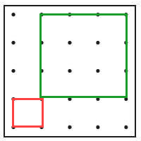

  - Dot or Grid Paper
green rectangle has a scale factor of 2 from the original red rectangle

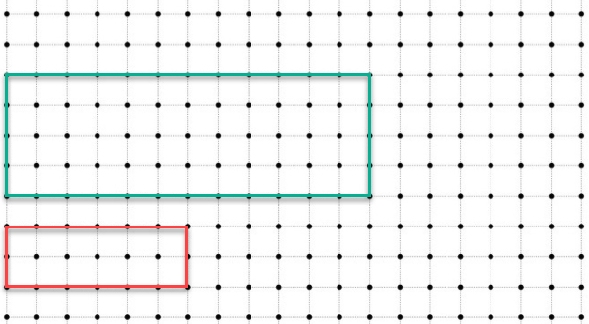

- Instruction includes having students construct scale drawings of the classroom, school, their homes and/or backyards or other familiar places where they can take measurements (MTR.7.1).
- Instruction includes the understanding that if the scaling factor is $k$, then the constant of proportionality between corresponding areas is $k^{2}$. Once students have become comfortable with scaling dimensions, extend their knowledge to solving problems with area. Provide several figures where students will determine new dimensions based on a given scale factor. Then have students calculate the original and new perimeters, as well as the original and new areas. Finally, students should analyze/compare the scale factors used in scaling the perimeters versus the scale factors used for area (MTR.1.1, MTR.4.1).
- Instruction supports flexibility in the variable used for the constant of proportionality.

Common Misconceptions or Errors
- Students may not understand how to read a map. To address this misconception, practice map reading skills, using familiar areas when possible.
- Students may incorrectly scale area in the same way they scale side length. To address this misconception, have students calculate areas of similar figures prior to determining the scale factor between the figures, then make comparisons. Interactive software can also be used to demonstrate.
- Students may incorrectly set up their proportions.
- Students may believe the scale factor is always greater than 1.
  - For example, students may respond the scale factor is 2 when it is $\frac{1}{2}$.

Strategies to Support Tiered Instruction
- Teacher provides instruction utilizing different types of maps to familiarize students with how to read a map and the key features of a map. Teacher can choose maps that are familiar to students within their region.
- Instruction includes the use of geometric software to allow students to explore the area of an original figure relative to its scale and draw conclusions on the impact of the scale factor.
- Teacher co-creates a graphic organizer with students containing examples of applying a scale factor to a length or to an area.
- Teacher provides instruction focused on color-coding and labeling the different units when setting up a proportional relationship to ensure corresponding units are placed in corresponding positions within the proportion.
- Teacher has students calculate areas of figures where the side lengths of one figure is a constant multiple of the corresponding side lengths of the other figure prior to determining the scale factor between the figures. Students can then make comparisons between the areas of the figures. Interactive software can also be used to demonstrate.

Instructional Tasks
Instructional Task 1 (MTR.7.1)
Many supersonic jet aircraft in the past have used triangular wings called delta wings. Below is a scale drawing of the top of a delta wing.
Scale: 2 centimeters (cm) in the drawing equals 192 cm on the actual wing.
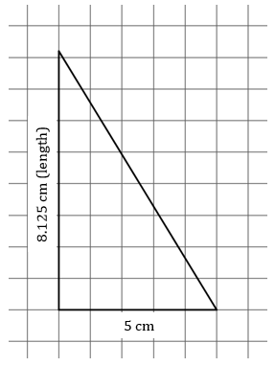

Part A. What is the length of the actual wing? Explain how you found your answer.
Part B. What is the area of the actual wing? Explain how you found your answer.

Instructional Task 2 (MTR.7.1)
Mariko has an 80:1 scale drawing of the floor plan of her house. On the floor plan, the dimensions of her rectangular living room are $1\frac{7}{8}$ inches by $2\frac{1}{2}$ inches. What is the area of her real living room in square feet?

Instructional Items
Instructional Item 1
The triangle below will be recreated using the scale factor that produced Figure 2 from Figure 1. What scale factor should be used?

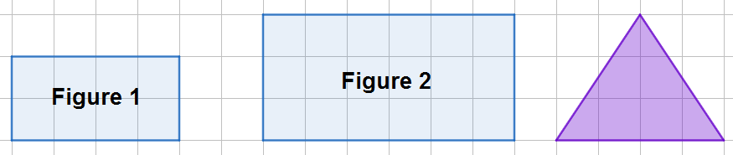

Instructional Item 2
Andrew needs to paint the side of his building white to prepare for a new mural that will be painted there. He measured the actual wall to be 26.25 feet long but he cannot easily measure the height. On his blueprints of the building, the wall measures 3.5 inches long and 4 inches tall. What is the actual area Andrew will need to paint?

*The strategies, tasks and items included in the B1G-M are examples and should not be considered comprehensive.

MA.7.GR.2 Solve problems involving three-dimensional figures, including right circular cylinders.

MA.7.GR.2.1

Benchmark
MA.7.GR.2.1 Given a mathematical or real-world context, find the surface area of a right circular cylinder using the figure’s net.
Benchmark Clarifications:
Clarification 1: Instruction focuses on representing a right circular cylinder with its net and on the connection between surface area of a figure and its net.
Clarification 2: Within this benchmark, the expectation is to find the surface area when given a net or when given a three-dimensional figure.
Clarification 3: Within this benchmark, the expectation is not to memorize the surface area formula for a right circular cylinder.
Clarification 4: Solutions may be represented in terms of pi ($π$) or approximately.

Connecting Benchmarks/Horizontal Alignment
- MA.7.NSO.2.1, MA.7.NSO.2.2, MA.7.NSO.2.3
- MA.7.GR.1.3
- MA.7.GR.2.3

Terms from the K-12 Glossary
- Cylinder (Circular)
- Net
- Pi (π)
- Surface Area

Vertical Alignment
Previous Benchmarks  - This is the first introduction to cylinders outside of recognizing the shape in early elementary. | Next Benchmarks  - MA.912.GR.4.6

Purpose and Instructional Strategies
In grade 6, students found the area of quadrilaterals and composite figures by decomposing them into triangles or rectangles, which developed into finding the surface area of right rectangular prisms and right rectangular pyramids using a figure’s net. In grade 7, students find the area of a circle as well as the surface area of a right circular cylinder using the figure’s net. In high school, students will solve mathematical and real-world problems involving the surface area of cylinders, pyramids, prisms, cones and spheres.
- Instruction includes problems that make connections to the understanding of a formula for the surface area of a right circular cylinder and its net (soup can and finding the area of the paper around the can). Show how different parts of the formula correspond to different parts of the net (MTR.7.1).
- Instruction allows students the opportunity to develop the formula for the surface area of a right circular cylinder.
  - For example, provide students cans of various sizes, paper, scissors, and tape (MTR.2.1). Ask students to cover the can completely without overlapping the paper and only using as little tape as possible. Ask students to explain their method if they feel it was successful in covering the can completely without overlapping any paper, until someone presents the idea of cutting two circles, taping them to the base and then one rectangle to cover the curved surface (MTR.4.1, MTR.5.1).
- Instruction allows students to use various nets for cylinders which they can cut out and form the three-dimensional figure or use virtual simulations which show the “unrolling” of the cylinder into its net (MTR.2.1).

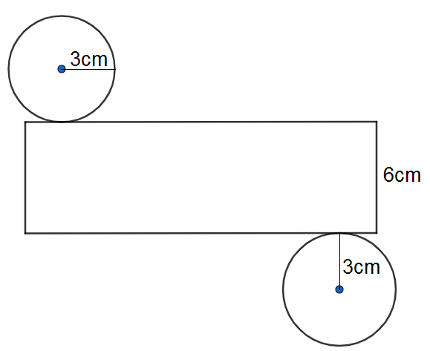

- Instruction focuses on recognizing the height of a cylinder as the perpendicular distance between the parallel (circular) bases.

Common Misconceptions or Errors
- Students often confuse the vocabulary base, length, height and “$B$” (base area), when moving between two- and three-dimensional figures. To address this misconception, continue to use the parts of the net to calculate the surface area, rather than focusing on the formula.
- Students may incorrectly invert the height and base of a cylinder when the cylinder is presented horizontally. To address this misconception, remind students that while a cylinder may lay on its side, the bases are the parallel circles.
- Students may incorrectly apply the formulas for area, surface area and volume. To address this misconception, use these concepts in context, or a manner in which they understand the meaning behind the terms to foster their conceptual development (MTR.7.1).

Strategies to Support Tiered Instruction
- Instruction includes the use of geometric software to allow students to explore the difference between base, length, height and “$B$” (base area).
- Instruction includes co-creating a graphic organizer to define the dimensions of rectangles, circles and right circular cylinders.
- Teacher provides students with an example of a three-dimensional figure in its original position then provides multiple orientations to discuss how the location of the figure’s base changes, but the dimensions of the figure do not change.
  - For example, two right circular cylinders are shown below with the same dimensions but in different orientations. A base is highlighted in each.


- Teacher instructs students to draw a visual of a three-dimensional figure and its dimensions in the context of a real-world problem.
- Instruction includes finding the exact area of a given circle in terms of pi before replacing the value of pi with an approximation to determine the estimated area.
- Instruction includes color-coding and labeling the dimensions of rectangles, circles and right circular cylinder.
- Teacher provides instruction using manipulatives or geometric software for students to understand the difference between the formulas for area, surface area and volume.
- Teacher encourages students to continue to use the parts of the net to calculate the surface area, rather than focusing on a formula.
- Provide multiple orientations of cylinders, focusing on the height as the perpendicular distance between the parallel bases, continuing to break them down to their net.

Instructional Tasks
Instructional Task 1 (MTR.7.1)
An ocean resort decided to build a large room in the shape of a cylinder to host events. The room is 34 feet in diameter with a height of 9 feet. They are going to paint the floor, wall and ceiling blue to make attendees feel like they are floating in the sky. Determine the surface area that needs to be painted.

Instructional Task 2 (MTR.7.1)
Reviews from several events in a blue room at a resort have come in and attendees are reporting feeling trapped in the enclosed room. The room is 34 feet in diameter with a height of 9 feet. The resort has decided to replace the solid wall with windows for a 360º view of the ocean and surrounding area.
Part A. How many square feet of windows will need to be ordered to do so?
Part B. If the resort decided to make a glass ceiling instead of replacing the curved wall,
how much glass would be needed?

Instructional Items
Instructional Item 1
Determine the surface area of the cylinder below. Round to the nearest tenth. Note: Figure is not drawn to scale.

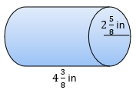

Instructional Item 2
Determine the surface area of the cylinder below. Write your answer as the exact surface area.

Instructional Item 3
Lyndon is making a nylon case for his new snare drum which measures 14 inches in diameter and is 6 inches deep. If the case fits snugly around the drum, how much nylon will Lyndon need?

*The strategies, tasks and items included in the B1G-M are examples and should not be considered comprehensive.

MA.7.GR.2.2

Benchmark
MA.7.GR.2.2 Solve real-world problems involving surface area of right circular cylinders.
Benchmark Clarifications:
Clarification 1: Within this benchmark, the expectation is not to memorize the surface area formula for a right circular cylinder or to find radius as a missing dimension.
Clarification 2: Solutions may be represented in terms of pi ($π$) or approximately.

Connecting Benchmarks/Horizontal Alignment
- MA.7.NSO.1.1
- MA.7.NSO.2.1, MA.7.NSO.2.2, MA.7.NSO.2.3
- MA.7.AR.2.2
- MA.7.AR.4.4
- MA.7.GR.1.2, MA.7.GR.1.3, MA.7.GR.1.4
- MA.7.GR.2.3

Terms from the K-12 Glossary
- Cylinder (Circular)
- Pi (π)
- Surface Area

Vertical Alignment
Previous Benchmarks  - This is the first introduction to cylinders outside of recognizing the shape in early elementary. | Next Benchmarks  - MA.912.GR.4.6

Purpose and Instructional Strategies
In grade 6, students found the area of quadrilaterals and composite figures by decomposing them into triangles or rectangles, which developed into finding the surface area of right rectangular prisms and right rectangular pyramids using a figure’s net. In grade 7, students find the surface area of a right circular cylinder using the figure’s net and build that into solving real-world problems involving surface area of right circular cylinders. In high school, students will solve mathematical and real-world problems involving the surface area of cylinders, pyramids, prisms, cones and spheres.
- Instruction includes finding the height or the circumference when given the surface area of a right circular cylinder, but students will not be expected to find the radius as a missing dimension (MTR.3.1).

Common Misconceptions or Errors
- Students often confuse the vocabulary base, length, height and “B” (base area), when moving between two- and three-dimensional figures. To address this misconception, continue to use the parts of the net to calculate the surface area, rather than focusing on the formula.
- Students may incorrectly invert the height and base of a cylinder when the cylinder is presented horizontally. To address this misconception, remind students that while a cylinder may lay on its side, the bases are the parallel circles.
- Students may incorrectly apply the formulas for area, surface area and volume. To address this misconception, use these concepts in context, or a manner in which they understand the meaning behind the terms to foster their conceptual development (MTR.7.1).

Strategies to Support Tiered Instruction
- Instruction includes the use of geometric software to allow students to explore the difference between base, length, height and “$B$” (base area).
- Teacher creates and posts an anchor chart with visual representations of a right circular cylinder to assist in correct academic vocabulary when solving real-world problems.
- Teacher provides students with an example of a three-dimensional figure in its original position then provides multiple orientations to discuss how the location of the figure’s base changes, but the dimensions of the figure do not change.
  - For example, two right circular cylinders are shown below with the same dimensions but in different orientations. The base is highlighted in each.

- Teacher co-creates a visual of a three-dimensional figure and its dimensions in the context of a real-world problem.
- Instruction includes opportunities for students to solve for the surface area of a given right circular cylinder in terms of pi before replacing the value of pi with an approximation to determine the estimated surface area.
- Instruction includes co-creating a graphic organizer of a right circular cylinder and color-coding and labeling the dimensions.
- Teacher provides instruction focused on manipulatives or geometric software for students to develop understanding of the difference between the formulas for area, surface area and volume.
- Teacher provides opportunities for students to comprehend the context or situation by engaging in questions (laminating these questions on a printed card for students to utilize as a resource in and out of the classroom would be helpful).
  - What do you know from the problem?
  - What is the problem asking you to find?
  - Can you create a visual model to help you understand or see patterns in your problem?
- Teacher encourages students to continue to use the parts of the net to calculate the surface area, rather than focusing on the formula.
- Provide multiple orientations of cylinders, focusing on the height as the perpendicular distance between the parallel bases, continuing to break them down to their nets.

Instructional Tasks
Instructional Task 1 (MTR.4.1)
The Fine Arts Club will be making and selling a soda can snuggie for a fundraiser. They researched the dimensions of a standard soda can to be 4.83 inches high with a diameter of 2.13 inches across the top and 2.6 inches at the widest part of the can. A soda snuggie that will keep the soda cold will require an insulated layer, a liner and a decorative outer fabric.
Part A. Provide a design the Fine Arts Club could use to make their soda snuggie. How much of each material will be needed for each soda snuggie?



Part B. Compare your design with a partner (or group). What are the similarities? What changes (if any) would you make to your design based on the ideas of others?

Instructional Items
Instructional Item 1
A cosmetics company is selling a new line of lipstick and needs to determine how much plastic is needed to wrap each cylindrical tube. If the lipstick tube is 12.1 millimeters (mm) in diameter with a length of 72 mm, how many mm² of plastic is needed for one tube? How much will be needed for a box of 24?

Instructional Item 2
Melanie is buying a candle for a gift. She has 80.07 in² of wrapping paper and all of the candles she is looking at have a radius of 1.5 in. What height candle can Melanie buy if she uses all of the wrapping paper she has?

*The strategies, tasks and items included in the B1G-M are examples and should not be considered comprehensive.

MA.7.GR.2.3

Benchmark
MA.7.GR.2.3 Solve mathematical and real-world problems involving volume of right circular cylinders.
Benchmark Clarifications:
Clarification 1: Within this benchmark, the expectation is not to memorize the volume formula for a right circular cylinder or to find radius as a missing dimension.
Clarification 2: Solutions may be represented in terms of pi ($π$) or approximately.

Connecting Benchmarks/Horizontal Alignment
- MA.7.NSO.1.1
- MA.7.NSO.2.1, MA.7.NSO.2.2, MA.7.NSO.2.3
- MA.7.AR.2.2
- MA.7.AR.4.5
- MA.7.GR.1.4
- MA.7.GR.2.1, MA.7.GR.2.2

Terms from the K-12 Glossary
- Cylinder (Circular)
- Pi (π)
- Volume

Vertical Alignment
Previous Benchmarks  - MA.6.GR.2.3 | Next Benchmarks  - MA.912.GR.4.5

Purpose and Instructional Strategies
In grade 6, students found the volume of rectangular prisms and right rectangular pyramids using the area of the base. In grade 7, students find the volume of a right circular cylinder and build that into solving real-world problems involving their volume using the area of their circular base. In high school, students will solve mathematical and real-world problems involving the volume of cylinders, pyramids, prisms, cones and spheres.
- Instruction builds on students’ knowledge of finding the volume of a rectangular prism, which also includes the area of the base multiplied by the height.
- Instruction encourages students to make conjectures about how to calculate the volume of a right circular cylinder. Students are provided the radius and height of several cylinders to verify or revise their conjecture (MTR.6.1).
- Instruction includes physical or virtual representations for the volume of a right circular cylinder (MTR.2.1).
  - For example, stack quarters one at a time to show repeated addition (the height) on the area of the base (the first quarter used).
- Instruction focuses on real-world situations to reinforce conceptual understanding of volume versus surface area (MTR.7.1).
Common Misconceptions or Errors
- Students often confuse the vocabulary base, length, height and “B” (base area), when moving between two- and three-dimensional figures. To address this misconception, continue to use the parts of the net to calculate the surface area, rather than focusing on the formula.
- Students may incorrectly believe that whatever is lying flat is the base of the figure. To address this misconception, remind students that while a cylinder may lay on its side, the bases are the parallel circles with the height being the perpendicular distance between them. Provide multiple orientations of objects and continue to break them down to their nets.
- Students may incorrectly invert the height and base of a cylinder when the cylinder is presented horizontally. To address this misconception, remind students that while a cylinder may lay on its side, the bases are the parallel circles.
- Students may incorrectly apply the formulas for area, surface area and volume. To address this misconception, use these concepts in context, or a manner in which they understand the meaning behind the terms to foster their conceptual development (MTR.7.1).

Strategies to Support Tiered Instruction
- Instruction includes the use of geometric software to allow students to explore the difference between base, length, height and “$B$” (base area).
- Teacher creates and posts an anchor chart with visual representations of a right circular cylinder to assist in correct academic vocabulary when solving real-world problems.
- Teacher provides students with an example of a three-dimensional figure in its original position then provides multiple orientations to discuss how the location of the figure’s base changes, but the dimensions of the figure do not change.
- For example, two right circular cylinders are shown below with the same dimensions but in different orientations. The base is highlighted in each.

- Teacher co-creates a visual of a three-dimensional figure and its dimensions in the context of a real-world problem, and color-coding and labeling the dimensions.
- Instruction includes opportunities for students to solve for the volume of a given right circular cylinder in terms of pi before replacing the value of pi with an approximation to determine the estimated volume.
- Teacher provides instruction focused on manipulatives or geometric software for students to develop understanding of the difference between the formulas for area, surface area and volume.
- Teacher provides opportunities for students to comprehend the context or situation by engaging in questions (laminating these questions on a printed card for students to utilize as a resource in and out of the classroom would be helpful).
  - What do you know from the problem?
  - What is the problem asking you to find?
  - Can you create a visual model to help you understand or see patterns in your problem?
- Teacher encourages students to continue to use the parts of the net to calculate the surface area, rather than focusing on the formula.
- Provide multiple orientations of cylinders, focusing on the height as the perpendicular distance between the parallel bases, continuing to break them down to their nets.

Instructional Tasks
Instructional Task 1 (MTR.1.1)
Coffee2Go wants to build a record-breaking giant coffee cup for a promotional celebration at a convention for coffee drinkers. In 2020, the Guinness Book of World Records reported that the World’s Largest Cup of Coffee contained 2,010 gallons of fresh-brewed coffee brewed.
Part A. What questions would need to be answered to approach this problem? Do you have all the information you need to solve the problem? Why or why not?
Part B. The Guinness Book of World Records, in 2020, documented the Largest Coffee Cup with a height of 8 feet and a diameter of 8 feet. How many cubic feet of coffee can be held in the World’s Largest Coffee Cup?
Part C. There are approximately 1.25 gallons of coffee in a cubic foot. If Coffee2Go has a goal of creating a coffee cup that holds 2,410 gallons of coffee, what could be the height and diameter of the coffee cup if they are the same size?

Instructional Task 2 (MTR.7.1)
Karim is setting up an inflatable pool in the yard for the little kids to play. The pool measures $3\frac{1}{2}$ feet across and 16 inches deep.
What is the volume of water needed to fill the pool 2 inches from the top? Justify your solution.

Instructional Items
Instructional Item 1
What is the height of a cylinder, with a radius of 3.4 meters (m), whose volume is 198 m³? Round to the nearest hundredth.

Instructional Item 2
Determine the exact volume of each of the following cylinders.

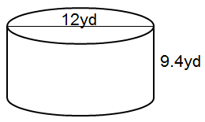
Instructional Item 3
A candle mold has 24π in³ of space in which wax can be poured to make a candle. If the radius of the mold is 2 inches (in), what is its height?

*The strategies, tasks and items included in the B1G-M are examples and should not be considered comprehensive.

Data Analysis & Probability

MA.7.DP.1 Represent and interpret numerical and categorical data.

MA.7.DP.1.1

Benchmark
MA.7.DP.1.1 Determine an appropriate measure of center or measure of variation to summarize numerical data, represented numerically or graphically, taking into consideration the context and any outliers.
Benchmark Clarifications:
Clarification 1: Instruction includes recognizing whether a measure of center or measure of variation is appropriate and can be justified based on the given context or the statistical purpose.
Clarification 2: Graphical representations are limited to histograms, line plots, box plots and stem-and-leaf plots.
Clarification 3: The measure of center is limited to mean and median. The measure of variation is limited to range and interquartile range.

Connecting Benchmarks/Horizontal Alignment
- MA.7.NSO.2.2, MA.7.NSO.2.3

Terms from the K-12 Glossary
- Box Plot
- Data
- Histogram
- Interquartile Range (IQR)
- Line Plot
- Mean
- Measures of Center
- Measures of Variability
- Median
- Outlier
- Quartiles
- Range (of data set)
- Stem-and-Leaf Plot

Vertical Alignment
Previous Benchmarks  - MA.6.DP.1.2, MA.6.DP.1.6 | Next Benchmarks  - MA.8.DP.1.1  - MA.912.DP.1.1

Purpose and Instructional Strategies
In grade 6, students found and interpreted mean, median, mode and range, as well as determined and described how changes in data values impacted measures of center and variation. In grade 7, students determine an appropriate measure of center or measure of variation to summarize numerical data, taking into consideration the context and any outliers. Instruction builds on student knowledge from MA.6.DP.1.6. In grade 8, students will be introduced to numerical bivariate data and will depict it with line graphs and lines of fit. In high school, students will select an appropriate method to represent both univariate and bivariate numerical data and interpret the different components in the display.
- The difference between range and interquartile range is just as important as, and very similar to, the difference between mean and median. In both cases, the difference has to do with whether or not one thinks outliers should be ignored (MTR.1.1, MTR.6.1).
  - Outliers should be mostly ignored if a researcher is more interested in only the “typical” members of a population, as might be the case in politics or advertising. In these cases, the median is often the best choice as a measure of center, and the IQR is often the best choice as a measure of variation. These measures are little affected by outliers.
  - Outliers should not be ignored if a researcher is concerned about the risks associated with “extreme” cases or concerned with the effects that outliers have on the average, as is the case in the insurance industry or in medical trials. In these cases, the mean is often a better choice than the median as a measure of center, and the range is better than the IQR as a measure of variation.
  - All four of these measures are widely used in data analysis.
- Instruction focuses on identifying outliers qualitatively rather than quantitatively. To determine quantitatively if a data point is an outlier, a teacher may use the following definition. A data value is considered to be an outlier if it lies 1.5 times the IQR below Q1, $\left(Q1-\left(1.5∙IQR\right)\right),$ or above Q3, $\left(Q3+\left(1.5∙IQR\right)\right)$.
- For example, the table below showcases a five-number summary of a data set.
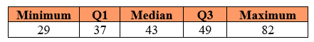
Within the data set, the IQR is 12. To calculate if a value is an outlier, start with finding $1.5∙12$, which is 18. From there, a data value is considered an outlier if it is less than $37-18$, or 19. It is also considered an outlier if it is greater than $49+18$, or 67.
The maximum value in this data set is an outlier within the data set, though there could be additional values when you see the entire data set.
- Instruction includes cases where students are able to gather their own data for analysis (MTR.7.1).
- Instruction includes activities that require students to match graphs and explanations, or measures of center/variation and explanations prior to interpreting graphs based upon the appropriate measures of center or spread calculated (MTR.2.1, MTR.4.1).

Common Misconceptions or Errors
- Some students may incorrectly calculate the measures of center and variation.
- Students may incorrectly believe all graphical displays are symmetrical. To address this misconception, students should use graphs of various shapes, including those with outliers, which will show this to be false. Start with small data sets related to familiar contexts to discuss how the data should be represented and to show how extreme values can alter the measures.
- Students may incorrectly identify data points as outliers.
Strategies to Support Tiered Instruction
- Instruction includes opportunities for students to calculate the measures of center or the measures of variation for the initial and the changed data sets before comparing the impact of an outlier or an additional data point.
- Teacher provides examples of several visual displays or graphs to discuss the shapes of each one. Opportunities should be provided for students to see the various shapes with and without outliers so they can see that not all graphical displays are symmetrical.
- Teacher provides instruction on the definition of an outlier and interpretation on when to consider outliers (refer to the Instructional Strategies). Teacher provides examples of how outliers can be displayed within different types of data displays.
- Instruction includes co-creating a graphic organizer for measures of center and measures of variation and including the generalized impact of outliers on each.
  - For example:
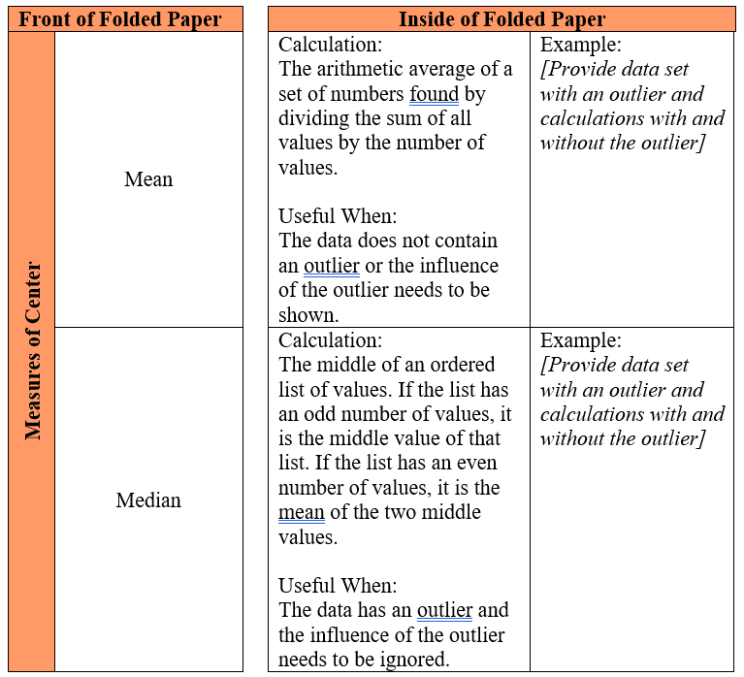

Instructional Tasks
Instructional Task 1 (MTR.7.1)
Teacher Background Information
Unlike many elections for public office where a person is elected strictly based on the results of a popular vote (i.e., the candidate who earns the most votes in the election wins), in the United States, the election for President of the United States is determined by a process called the Electoral College. According to the National Archives, the process was established in the United States Constitution “as a compromise between election of the President by a vote in Congress and election of the President by a popular vote of qualified citizens.” (Archives - electoral college accessed July 1, 2021).
Each state receives an allocation of electoral votes in the process, and this allocation is determined by the number of members in the state’s delegation to the U.S. Congress. This number is the sum of the number of U.S. Senators that represent the state (always 2, per the Constitution) and the number of Representatives that represent the state in the U.S. House of Representatives (a number that is directly related to the state’s population of qualified citizens as determined by the US Census). Therefore, the larger a state’s population of qualified citizens, the more electoral votes it has. Note: the District of Columbia (which is not a state) is granted 3 electoral votes in the process through the 23rd Amendment to the Constitution.

Task
The following table shows the allocation of electoral votes for each state and the District of Columbia for the 2012, 2016 and 2020 presidential elections. (Archives - electoral college accessed July 1, 2021).

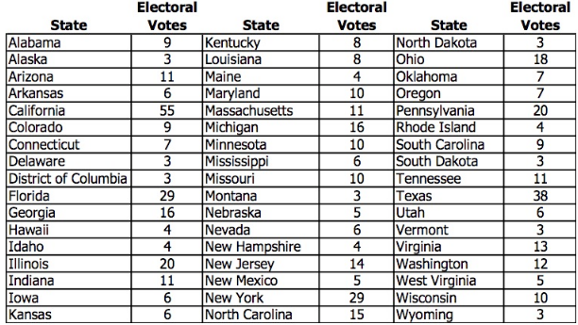

Part A. Which state has the most electoral votes? How many votes does it have?
Part B. Based on the given information, which state has the second highest population of qualified citizens?
Part C. Here is a line plot of the distribution.

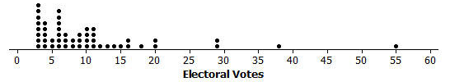

- What is the shape of this distribution: symmetric or skewed?
- Imagine that someone you are speaking with is unfamiliar with these shape terms. Describe clearly and in the context of this data set what the shape description you have chosen means in terms of the distribution.
Part D. Does the line plot lead you to think that any states are outliers in terms of their number of electoral votes? Explain your reasoning, and if you do believe that there are outlier values, identify the corresponding states.
Part E. What measure of center (mean or median) would you recommend for describing this data set? Why did you choose this measure?
Part F. Determine the value of the median for this data set (electoral votes).

Instructional Items
Instructional Item 1
The household incomes of 15 families in a local neighborhood were recorded to the nearest $1,000 in the table below.

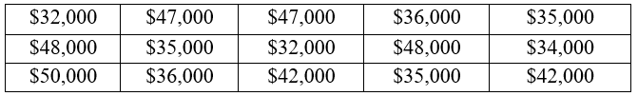

Determine the most appropriate measure of center to describe this data set. What is the value of that measure?

Instructional Item 2
The household incomes of 15 families in a local neighborhood were recorded to the nearest $1,000 in the table below.

At the end of the month, a new family is moving in whose household income is $475,000. Determine the most appropriate measure of center to describe this data set. What is the value of that measure? Justify your choice.

*The strategies, tasks and items included in the B1G-M are examples and should not be considered comprehensive.

MA.7.DP.1.2

Benchmark
MA.7.DP.1.2 Given two numerical or graphical representations of data, use the measure(s) of center and measure(s) of variability to make comparisons, interpret results and draw conclusions about the two populations.

Benchmark Clarifications:
Clarification 1: Graphical representations are limited to histograms, line plots, box plots and stem-and-leaf plots.
Clarification 2: The measure of center is limited to mean and median. The measure of variation is limited to range and interquartile range.

Connecting Benchmarks/Horizontal Alignment
- MA.7.DP.1.1
- MA.7.NSO.2.2, MA.7.NSO.2.3

Terms from the K-12 Glossary
- Box Plot
- Data
- Histogram
- Interquartile Range (IQR)
- Line Plot
- Mean
- Measures of Center
- Measures of Variability
- Median
- Range (of data set)
- Stem-and-Leaf Plot

Vertical Alignment
Previous Benchmarks  - MA.6.DP.1.2 | Next Benchmarks  - MA.8.DP.1.1
Purpose and Instructional Strategies
In grade 6, students calculated and interpreted mean, median, mode and range. In grade 7, students use those calculations to make comparisons, interpret results and draw conclusions about two populations. In grade 8, students will learn how to interpret the main features of line graphs and lines of fit.
- Instruction includes cases where students need to calculate measures of center and variation in order to interpret them.
- Instruction includes having students collect their own data for analysis. Students make connections to data they are interested in. (MTR.1.1, MTR.7.1).
- Students should not be expected to classify differences between data sets as “significant” or “not significant.”
- Data representations can be shown as a two-sided stem-and-leaf plot and multiple box plots on the same scale.
- Data representations should include titles, labels and a key as appropriate.

Common Misconceptions or Errors
- Some students may incorrectly believe a histogram with greater variability in the heights of the bars indicates greater variability of the data set.
- Students may not recognize when to use a stem-and-leaf plot or may not be able to read a two-sided stem-and-leaf plot.
- Students may not be able to explain their choice of the most appropriate measures of center and variability based on the given data.
- Students may think that the presence of one or more outliers leads to an automatic choice (median, IQR) for the measures of center and variation.

Strategies to Support Tiered Instruction
- Instruction includes explaining the difference between variability in the heights of the bars of histograms, and the actual variability of the data set.
- Teacher provides instruction on how to use different types of data displays to show two sets of data at the same time. Teachers co-create an anchor chart explaining the different parts of each display with explanations on when and how to use each of them.
  - For example, the teacher can provide students with a two-sided stem-and-leaf plot with the “stem” in the middle and “leaves” on either side, each displaying the two data sets.
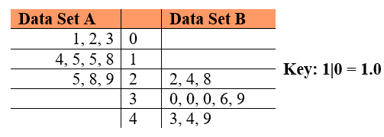

  - For example, the teacher can provide students with two line plots or two box plots on the same number line. Plots can be given in different colors to show the different data sets.
- Teacher provides instruction on which measure of center and variation should be used, making sure to include what to do when an outlier is present.
- Teacher facilitates discussion on the different measures of center and variability and how to know when to use each one. Use a graphic organizer to compare the different measures of center and variability to assist students in deciding when to use them.
- Instruction includes co-creating an anchor chart with different data displays containing visual representations and explanations of when and how to use them.

Instructional Tasks
Instructional Task 1 (MTR.1.1, MTR.7.1)
A group of students in the book club are debating whether high school juniors or seniors spend more time on homework. A random sampling of juniors and seniors at the local high school were surveyed about the average amount of time they spent per night on homework. The results are listed in the table below.

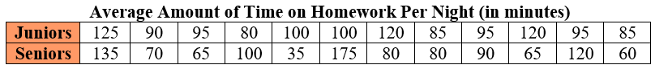

Part A. Calculate and compare the measures of center for the data sets.
Part B. Calculate and compare the variability in each distribution.
Part C. Does the data support juniors or seniors spending more time on homework? Explain your reasoning.

Instructional Items
Instructional Item 1
High schools around the state of Florida were asked what percentage of students in their graduating class would be attending a state college and what percentage would be attending a community college. The results are provided in the graph below.

Is a student more likely to go to a state or community college? Which choice has more variability?
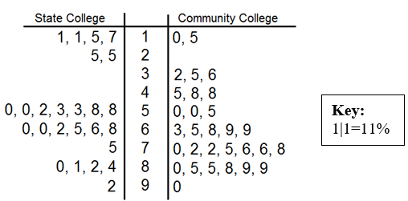

*The strategies, tasks and items included in the B1G-M are examples and should not be considered comprehensive.

MA.7.DP.1.3

Benchmark
MA.7.DP.1.3 Given categorical data from a random sample, use proportional relationships to make predictions about a population.
Example: O’Neill’s Pillow Store made 600 pillows yesterday and found that 6 were defective. If they plan to make 4,300 pillows this week, predict approximately how many pillows will be defective.
Example: A school district polled 400 people to determine if it was a good idea to not have school on Friday. 30% of people responded that it was not a good idea to have school on Friday. Predict the approximate percentage of people who think it would be a good idea to have school on Friday from a population of 6,228 people.

Connecting Benchmarks/Horizontal Alignment
- MA.7.NSO.2.2, MA.7.NSO.2.3
- MA.7.AR.3.1, MA.7.AR.3.2
- MA.7.AR.4.5

Terms from the K-12 Glossary
- Categorical Data
- Population (in Data Analysis)
- Proportional Relationships
- Random Sampling

Vertical Alignment
Previous Benchmarks  - MA.6.AR.3.4  - MA.6.DP.1.3, MA.6.DP.1.4 | Next Benchmarks  - MA.8.DP.1.1  - MA.912.DP.1.4
Purpose and Instructional Strategies
In grade 6, students described data using measures of center and variation. In grade 7, students use samples to compare measures of center and variation in data sets, as well as use samples to make a generalization about the population from which the sample was taken. In grade 8, students will use bivariate data to study proportional and linear relationships and make predictions with lines of fit. In high school, students will estimate a population total, mean or percentage using data from a sample survey and develop a margin of error through the use of simulation.
- Instruction includes helping students understand that since there is always variability in collecting samples. These generalizations, or predictions, can only be estimates of what we expect to see from the greater population.
- Use real-world scenarios to explain that random sampling is needed when we need to find information about a population that is too large or too difficult to measure completely (MTR.7.1).
  - As in the second example for this benchmark, the school district polled 400 people because it would be difficult, and perhaps costly, to poll all 6,228 people efficiently. Therefore, we can analyze a sample that is representative of the population to get an idea of what may be happening with the larger group.
- Students have done more precise work with proportional relationships in MA.7.AR.4, but in this benchmark, students will use the same proportional reasoning to make predictions or find estimates of what may be happening in a population that is too large or cumbersome for us to measure completely.
- Instruction includes having students make predictions about what the population measures will be, based on the sample (MTR.6.1).
- Instruction uses manipulatives or simulations to have students collect their own set of data (MTR.2.1).
- As in the first example for this benchmark about defective pillows, students can pull a random sample from a bag of chips that have been strategically marked D for defective or have no marking for no defects. They can use their proportion of defective chips to predict how many might be in the entire bag. Comparisons can be made across the different groups in the room to see how close the estimates were to the actual values (MTR.4.1).

Common Misconceptions or Errors
- Students may mistake part to total as part to part, which would give an incorrect ratio when setting up their proportion. To address this misconception, use percentages or counts out of 100 to help illustrate this more clearly.
- Students may not understand what random sampling is or why it is important. To address this misconception, allow students to collect random samples and make comparisons across groups to show they are not exact, but representative, of the larger population.

Strategies to Support Tiered Instruction
- Teacher provides instruction focused on color-coding and labeling the different categories based on the sample and the population when setting up a proportional relationship to ensure corresponding parts are placed in the corresponding positions within the proportion.
- For example, based on a random sample of 150 people, 23 people stated that they preferred to go grocery shopping on Saturday morning. If one wants to make a prediction on how many people, out of a town of 4500 people, who prefer to go shopping on Saturday morning, the proportion below can be used.
$$\frac{23 Saturday shoppers}{150 shoppers}=\frac{x Saturday shoppers}{4500 shoppers}$$

Students can also make the connection to multiplicative relationships between shoppers and Saturday shoppers as shown below.
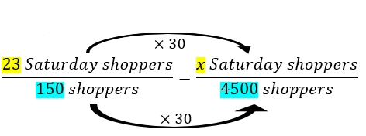

- Teacher uses percentages to help illustrate the difference between part to part and part to total more clearly. Use percentages or counts out of 100 to help illustrate this more clearly.
- Instruction includes providing students with an example of random sampling and biased sampling in a context that is relevant to students.
  - For example, Branden at Sunshine Middle School wants to predict if pizza should be served at the Fall Festival and Johnny suggests sampling 20 students in his 7th grade class. Amanda suggests it would be better to sample 20 random students from all grade levels at Sunshine Middle School. Since Branden wants to ensure that the sampling is not biased, he chooses Amanda’s plan since the prediction is for the whole school and not just for one class at the school.
- Instruction includes the use of problems with percentages or counts of 100.
  - For example, Mr. Smith surveyed students at his school last year to determine which candy bar they preferred. His results are shown in the pie chart below. Students can discuss how they can use this information to make a prediction about how many students prefer a certain candy bar this school year.

- Teacher allows students to collect random samples and make comparisons across groups to show they are not exact, but representative of the larger population.

Instructional Tasks
Instructional Task 1 (MTR.4.1, MTR.5.1)
A random sample of the 1,200 students at Moorsville Middle School was asked which type of movie they prefer. The results are compiled in the table below:
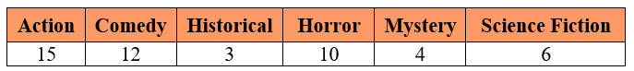

Part A. Use the data to estimate the total number of students at Moorsville Middle school who prefer horror movies.
Part B. Use the data to estimate the total number of students at Moorsville Middle school who prefer either mystery or science fiction movies.
Part C. Suppose another random sample of students was drawn. Would you expect the results to be the same? Explain why or why not.

Instructional Task 2 (MTR.4.1, MTR.7.1)
A constitutional amendment is on the ballot in Florida, and it needs at least 60% of the vote to pass. The editor of a local newspaper wants to publish a prediction of whether or not the amendment will pass. She hires ten pollsters to each ask 100 randomly selected voters if they will vote yes.

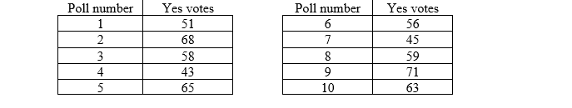

Should the newspaper’s prediction be that the amendment will pass or that it will not pass? Explain your reasoning.

Instructional Items
Instructional Item 1
A research group is trying to determine how many alligators are in a particular area. They tagged 30 alligators and released them. Later, they counted 12 alligators who were tagged out of the 150 they saw. What can the research group estimate is the total population of alligators in that area?

Instructional Item 2
The local grocery store is going to donate milk and cookies to an upcoming middle school event. They surveyed 150 students in the school to determine which type of milk they preferred and recorded the results below.

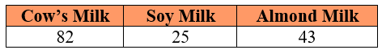

If there are 950 students in the school, how much soy milk should the store plan to donate?

*The strategies, tasks and items included in the B1G-M are examples and should not be considered comprehensive

MA.7.DP.1.4

Benchmark
MA.7.DP.1.4 Use proportional reasoning to construct, display and interpret data in circle graphs.
Benchmark Clarifications:
Clarification 1: Data is limited to no more than 6 categories.

Connecting Benchmarks/Horizontal Alignment
- MA.7.NSO.1.2
- MA.7.GR.1.4
- MA.7.AR.3.1

Terms from the K-12 Glossary
- Circle Graph
- Data
- Proportional Relationships

Vertical Alignment
Previous Benchmarks  - MA.6.AR.3.4 | Next Benchmarks  - MA.912.DP.1.1, MA.912.DP.1.2
Purpose and Instructional Strategies
In grade 6, students worked with solving problems using ratio relationships and their percentages. In grade 7, students apply their knowledge of ratios to solve problems involving proportions, including using proportional reasoning to construct, display and interpret categorical data in circle graphs. In high school, students will select an appropriate method to represent numerical or categorical data and univariate or bivariate.
- Circle graphs can be used to show how categories represent part of a whole, or compositions. Totals are represented as percentages that equal 100%, which illustrates the percentage breakdown of items and visually represents a comparison.
- Students should be able to identify strengths and limitations in showcasing data within a circle graph.

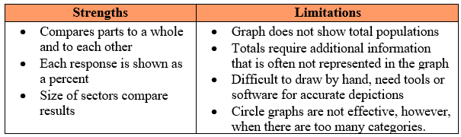

- Instruction begins with data sets out of 100 to allow for easier calculations of percentages.
- Instruction should include opportunities for students to brainstorm how they might split up their circle into the needed percentages (MTR.5.1).
  - For example, students can slice a circle into 4 equal parts to show students the 4 right angles at the center which total 360º. Then use proportional relationships to determine the central angle sizes needed based on the percentage size of each “slice” of the circle.
- Students should collect their own data with which to create a circle graph (MTR.7.1).
  - For example, have students count colored candy/snacks or survey other students in the room about their favorite color, favorite sport or favorite genre of music/movies.
- Use protractors or online software to assist in creating circle graphs accurately.

Common Misconceptions or Errors
- Students may incorrectly use the percent of a category for the central angle degrees instead of finding the degrees by using a proportion.
- Students may incorrectly round or make other errors in calculations that will lead to the circle graph sections not totaling 100%.
- Students may incorrectly use a protractor. To address this issue, provide students with a circle and allow them to measure sections and then find the percent.

Strategies to Support Tiered Instruction
- Teacher models several examples to work through with students, showing how to set up the proportion to find the central angle degrees, referencing patterns for students to discuss.
  - For example, if students need to determine the angle measure that corresponds to 21%, the proportion below can be used.
$$\frac{21}{100}=\frac{x}{360}$$
- Teacher models and works through several problems while discussing how to properly round when having to total to 100%, reinforcing to students to work through the problems carefully as to not make computation errors.
- Teacher models using computer-based software to create circle graphs to verify appropriate rounding.
- Teacher provides students with fill in the blank examples working from percent of a category using proportions to find the central angle degrees.
- Teacher provides several completed examples of problems where rounding was needed for students to reference while working through multiple problems together.
- Teacher models using fraction circle manipulatives to support converting fractions to percentages.

Instructional Tasks
Instructional Task 1 (MTR.4.1, MTR.7.1)
A group of friends has been given $800 to host a party. They must decide how much money will be spent on food, drinks, paper products, music and decorations.
Part A. As a group, develop two options for the friends to choose from regarding how to spend their money. Decide how much to spend in each area and create a circle graph for each option to represent your choices.
Part B. Mikel presented the circle graph below with his recommendations on how to spend the money. How much did he choose to spend on food and drinks? How much did he choose to spend on music?

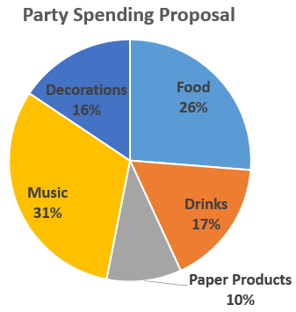

Instructional Items
Instructional Item 1
Circle Point High School surveyed its students to determine which mode of transportation they use to get to and from school. Create and label a circle graph based on the results given below.

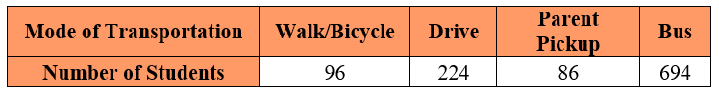

*The strategies, tasks and items included in the B1G-M are examples and should not be considered comprehensive.

MA.7.DP.1.5

Benchmark
MA.7.DP.1.5 Given a real-world numerical or categorical data set, choose and create an appropriate graphical representation.
Benchmark Clarifications:
Clarification 1: Graphical representations are limited to histograms, bar charts, circle graphs, line plots, box plots and stem-and-leaf plots.

Connecting Benchmarks/Horizontal Alignment
- MA.7.AR.3.1

Terms from the K-12 Glossary
- Bar Graph
- Box Plot
- Categorical Data
- Circle Graph
- Histogram
- Line Plot
- Stem-and-Leaf Plot

Vertical Alignment
Previous Benchmarks  - MA.7.AR.3.1 | Next Benchmarks  - MA.8.DP.1.1

Purpose and Instructional Strategies
In grade 6, students created box plots and histograms to represent numerical data. In grade 7, students must choose and create an appropriate graphical representation for a given numerical or categorical data set. In grade 8, students will construct a scatter plot or a line graph for a given set of bivariate numerical data.
- Students were introduced to bar charts (bar graphs) in grade 3, students may need to be reintroduced to this graphical representation.
- Graphical representations of categorical data sets are helpful for showing trends that can be analyzed and making comparisons of categories, among different items, or items over time periods. They visually show the mode of the data and, at a quick glance, show categories in a set of data that dominate others. Depending on the graphical representation chosen, either the frequency (number of items) or relative frequency (percentage) for each category can be illustrated.
- Histograms (for numerical data) and box plots (for categorical data) work well in grouping large sets of data to be easily compared but do not allow viewers access to each individual data point if needed for other calculations such as the mean.
- Circle graphs are not ideal when too many categories are included as it is difficult to distinguish the difference in sizes of the sectors. Bar charts (or bar graphs) make a similar comparison but the heights of the bars make the comparison more easily distinguishable.
- Stem-and-leaf plots and line plots are useful in displaying the shape of a numerical data set, easily identifying the mode and outliers, and they contain all of the values in the data set allowing for additional calculations such as the mean. They are not ideal when there is a large volume of data since it is time-consuming to create and becomes difficult to read or interpret.
- As an enrichment to this benchmark, students could explore segmented bar charts as they will be introduced to this in Algebra 1 (MA.912.DP.1.1).

Common Misconceptions or Errors
- Students may not distinguish between histograms (numerical data) and bar charts, also called bar graphs (categorical data).

Strategies to Support Tiered Instruction
- Instruction includes displaying histograms and bar charts side by side and allowing students to compare and contrast each one to help them understand the difference between the two, and what information we can learn from each one.
- Teacher provides a graphic organizer for each type of data display for students to reference in the future.
- Teacher co-creates examples of both bar graphs and histograms with students, explaining step-by-step how to create them and how/why they are different.

Instructional Tasks
Instructional Task 1 (MTR.2.1)
The following data shows the grams of protein in 21 protein bars.
$$\left\{12, 14, 11, 8, 10, 8, 14, 8, 8, 12, 10, 12, 15, 11, 15, 20, 10, 15, 12, 21, 20\right\}$$
Part A. Create two different graphical representations of the data using a histogram, bar chart, circle graph, line plot, box plot or stem-and-leaf plot.
Part B. Compare and contrast the two displays and determine which is more appropriate. Explain your reasoning.

Instructional Items
Instructional Item 1
Select an appropriate type of display for each of the following situations.
  - the salaries of all 40 employees at a small company
  - the salaries of all 250 people at a mid-sized company
  - the distribution of colors in a bag of colored candies
  - the number of siblings students in the 7th grade class have

*The strategies, tasks and items included in the B1G-M are examples and should not be considered comprehensive.

MA.7.DP.2 Develop an understanding of probability. Find and compare experimental and theoretical probabilities.

MA.7.DP.2.1

Benchmark
MA.7.DP.2.1 Determine the sample space for a simple experiment.
Benchmark Clarifications:
Clarification 1: Simple experiments include tossing a fair coin, rolling a fair die, picking a card randomly from a deck, picking marbles randomly from a bag and spinning a fair spinner.

Connecting Benchmarks/Horizontal Alignment
- MA.7.NSO.2.2
- MA.7.DP.2.3, MA.7.DP.2.4

Terms from the K-12 Glossary
- Event
- Sample Space

Vertical Alignment
Previous Benchmarks  - This is the first introduction to sample space. | Next Benchmarks  - MA.8.DP.2.1, MA.8.DP.2.2, MA.8.DP.2.3
Purpose and Instructional Strategies
In grade 7, students determine the sample space for a simple experiment. In grade 8, they will find the sample space for a repeated experiment.
- For mastery of this benchmark, an experiment is an action that can have more than one outcome. Experiments tend to have randomness, or uncertainty, in their outcomes.
  - For example, an experiment can be the action of tossing a coin. Possible outcomes would be whether the coin lands on heads or lands on tails.
- For mastery of this benchmark, simple experiments are restricted to those listed in Clarification 1.
  - Tossing a coin
Coins are not limited to those with heads or tails.
  - Rolling a die
Dice are not limited to 6-sided dice.
  - Picking a card from a deck
Card decks are not limited to a standard 52-card deck.
  - Picking a marble from a bag
Picking a marble from a bag is not limited to colors. Picking a tile, slip of paper or other objects from a bag are acceptable for this benchmark.
  - Spinning a spinner
Spinning a spinner is not limited to colors.
- Students should experience experiments before discussing the theoretical concept of probability.
- Students should informally explore the idea of likelihood, fairness and chance while building the meaning of a probability value. In this benchmark, all experiments are fair, meaning that all of the individual outcomes are equally likely.
  - For example, if the experiment is to draw a marble from a bag, then each marble is equally likely to be chosen.
- Have students practice making models to represent sample spaces to gain understanding on how probabilities are determined. Use familiar tools, including virtual manipulatives such as a coin, fair die, deck of cards and fair spinner (MTR.2.1).
- For simple experiments, a sample space will typically be represented by a list of outcomes, such as Heads, Tails or by a written description, such as “The sides of a 20-sided die.” Providing opportunities for students to match situations and sample spaces will assist with building their ability to visualize the sample space for any given experiment.
  - For example, the experiment of drawing a marble from a bag containing 2 red marbles and 1 blue marble has the sample space that can be written as {red, red, blue} or as {r, r, b}.

Common Misconceptions or Errors
- Students may incorrectly list more outcomes than the experiment merits. To address this misconception, ensure students can explain the experiment in their own words to then verify what is listed in their sample space.

Strategies to Support Tiered Instruction
- Teacher provides examples of situations and has students decide on the sample space necessary.
- Teacher co-creates a graphic organizer with different examples of sample spaces with the use of virtual manipulatives.
- Teacher co-creates a graphic organizer of a T-chart to list the experiment and the sample space necessary for the examples provided.
- Teacher co-creates models with students to represent sample spaces using a coin, fair die, fair spinner or deck of cards.
- Teacher ensures students can explain the experiment in their own words to then verify what is listed in their sample space.

Instructional Tasks
Instructional Task 1 (MTR.4.1)
List all of the possible outcomes for each experiment.

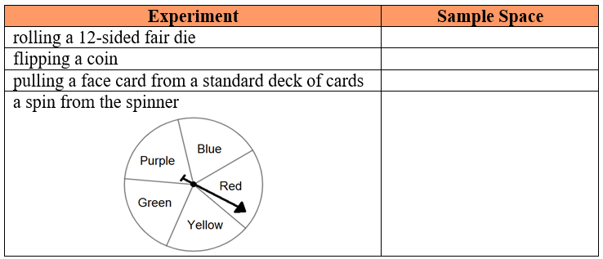

Compare your list with a partner and identify any differences. Allow each partner time to discuss their reasoning until an agreement is reached on the correct sample space.

Instructional Items
Instructional Item 1
Letter cards for the word “probability” are placed into a bag. List the sample space for choosing a card from this bag.

Instructional Item 2
There are 10 blue, 5 green and 7 white marbles in a jar. List the sample space for the simple
experiment of choosing a marble from the jar.

*The strategies, tasks and items included in the B1G-M are examples and should not be considered comprehensive.

MA.7.DP.2.2

Benchmark
MA.7.DP.2.2 Given the probability of a chance event, interpret the likelihood of it occurring. Compare the probabilities of chance events.
Benchmark Clarifications:
Clarification 1: Instruction includes representing probability as a fraction, percentage or decimal between 0 and 1 with probabilities close to 1 corresponding to highly likely events and probabilities close to 0 corresponding to highly unlikely events.
Clarification 2: Instruction includes $P(event)$notation.
Clarification 3: Instruction includes representing probability as a fraction, percentage or decimal.

Connecting Benchmarks/Horizontal Alignment
- MA.7.NSO.1.2
- MA.7.AR.3.1

Terms from the K-12 Glossary
- Event
- Theoretical Probability

Vertical Alignment
Previous Benchmarks  - MA.6.NSO.3.5 | Next Benchmarks  - MA.8.DP.2.2, MA.8.DP.2.3
Purpose and Instructional Strategies
In grade 7, students interpret the probability of a chance event and the likelihood of it occurring. In grade 8, students will solve problems involving probabilities related to single or repeated experiments, including making predictions based on theoretical probability.
- An event is a set of outcomes.
  - For example, if the experiment is to roll a six-sided die, possible events could be:
    - “Rolling a 3 or a 4;”
    - “Rolling an even number;” or
    - “Not rolling a 2.”
- Instruction includes the understanding that some events can have a probability of 1 or 0. Students should understand that if an event has a probability of zero, the event is impossible or will not occur. If an event has a probability of one, the event is certain or must occur.
  - For example, in the experiment of rolling a 6-sided die, the event of rolling a 1, 2, 3, 4, 5 or 6 would have a probability of 1.
  - For example, when rolling a 6-sided fair die, the event of rolling a 7 would have a probability of 0.
- Instruction includes having students use probabilities of 1, 0.5 and 0 as benchmark probabilities to interpret the likelihood of other events.
  - For example, if a student wants to interpret the likelihood represented by the probability of 80%, they can compare 80% to the benchmark probabilities of 50% and 100%.
- If an event has a probability of 0.5, it can be interpreted that it has the same likelihood as its opposite.
  - For example, in the experiment of picking a card from a standard 52-card deck, the event of picking a red card has a probability of 0.5, which can be interpreted as having the same likelihood as the opposite event, which is picking a black card.

Common Misconceptions or Errors
- Students may incorrectly assume that an event is only possible in an experiment and interchange the meaning of an event and an experiment.
- Students may confuse the mathematical meaning of a word like “event” with the everyday meaning.
- Students may incorrectly convert forms of probability between fractions and percentages. To address this misconception, scaffold with more familiar values initially to facilitate the interpretation.
- Students may incorrectly interpret a value with a negative sign as a possible probability.
  - For example, $-\frac{1}{2}$ cannot represent a probability since negative values are less than 0.

Strategies to Support Tiered Instruction
- Teacher creates and posts an anchor chart with visual representations of probability terms to assist students in correct academic vocabulary when solving real-world problems.
- Teacher provides opportunities for students to use a 100 frame to review place value for and the connections to decimal, fractional and percentage forms of probabilities.
- Instruction includes the use of a 100 frame to review place value for tenths, hundredths, and if needed, thousandths and the connections for decimal and fractional forms of probabilities.
- When students incorrectly convert from one form to another (i.e., fraction to percentage), the teacher scaffolds with more familiar values initially to facilitate the interpretation.

Instructional Tasks
Instructional Task 1 (MTR.1.1)
Determine which of the following could represent the probability of an event. For those that can, provide a possible event that would fit the probability given.

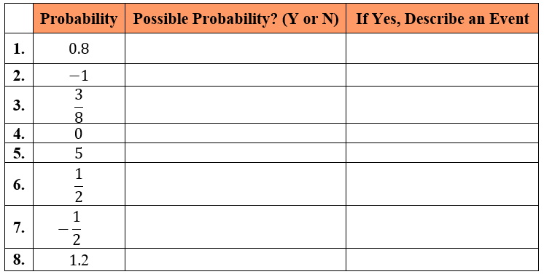
Instructional Items
Instructional Item 1
In each scenario, a probability is given. Describe each event as likely, unlikely or neither.
- The probability of a hurricane being within 100 miles of a location in two days is 40%.
- The probability of a thunderstorm being located within 5 miles of your house sometime tomorrow is $\frac{9}{10}$.
- The probability of a given baseball player getting at least three hits in the game today is 0.08.

*The strategies, tasks and items included in the B1G-M are examples and should not be considered comprehensive.

MA.7.DP.2.3

Benchmark
MA.7.DP.2.3 Find the theoretical probability of an event related to a simple experiment.
Benchmark Clarifications:
Clarification 1: Instruction includes representing probability as a fraction, percentage or decimal.
Clarification 2: Simple experiments include tossing a fair coin, rolling a fair die, picking a card randomly from a deck, picking marbles randomly from a bag and spinning a fair spinner.

Connecting Benchmarks/Horizontal Alignment
- MA.7.AR.3.1
- MA.7.DP.2.1

Terms from the K-12 Glossary
- Event
- Theoretical Probability

Vertical Alignment
Previous Benchmarks  - MA.6.NSO.3.5 | Next Benchmarks  - MA.8.DP.2.3
Purpose and Instructional Strategies
In grade 7, students are introduced to probability and will find the theoretical probability of an event related to a simple experiment. In grade 8, students will find the theoretical probability of an event related to a repeated experiment.
- Instruction builds on finding sample spaces from MA.7.DP.2.1. Have students discuss their understanding of the words “theoretical” and “probability” to build toward a formal definition of theoretical probability.
- When finding theoretical probability, have students work from their sample space. Doing so will lead to the understanding that since experiments for this benchmark are fair, the probability of an event is equivalent to $\frac{number of outcomes in the event}{number of outcomes in the sample space}$.
  - For example, if rolling a fair 6-sided die, the sample space is {1, 2, 3, 4, 5, 6,}. If one wants to find $P(rolling an odd number)$, students can circle all of the odd numbers from the sample space to determine the probability as $\frac{3}{6}$, or 0.5.
- While the benchmark does focus on fair experiments, instruction could include spinners with unequal sections making the connection to angle measures and to circle graphs.
- Instruction focuses on the simple experiments listed in Clarification 2.
  - For example, when tossing a coin with one yellow side and one red side, $P(landing on blue)=0$.
  - For example, when rolling a 10-sided die, $P(not rolling a multiple of 3)=0.7$.
  - For example, when picking a card from a deck that contains each of the letters of the alphabet, $P(picking a consonant)=\frac{21}{26}$.
  - For example, when picking a tile from a bag that contains a set of chess pieces, $P(picking a pawn)=50\%$.
  - For example, when spinning a spinner that contains 5 sections where two of the sections are green and the remaining sections are red, white and blue, $P(landing on a color from the American flag)=\frac{3}{5}$.

Common Misconceptions or Errors
- Students may incorrectly assume that an event is only possible in an experiment and interchange the meaning of an event and an experiment.
- Students may confuse the mathematical meaning of a word like “event” with the everyday meaning.
- Students may incorrectly convert forms of probability between fractions and percentages. To address this misconception, scaffold with more familiar values initially to facilitate the interpretation.
- Students may incorrectly interpret a value with a negative sign as a possible probability.
  - For example, $-\frac{1}{2}$ cannot represent a probability since negative values are less than 0.

Strategies to Support Tiered Instruction
- Teacher provides instruction in converting between fractions and percentages, by using more familiar values.
  - For example, $\frac{1}{2}=50\%, \frac{1}{4}=25\%, \frac{1}{3}≈33.3\%$, etc.
- Teacher co-creates a T-chart (like the one below) to list the experiment and the sample space necessary for the examples provided.

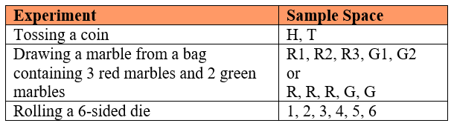
Instructional Tasks
Instructional Task 1 (MTR.4.1, MTR.7.1)
Look at the shirt you are wearing today and determine how many buttons it has. Then complete the following table using tally marks for all the members of your class.

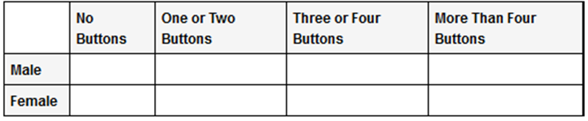

Suppose each student writes his or her name on an index card, and one card is selected randomly.
Part A. What is the probability that the student whose card is selected is wearing a shirt with no buttons?
Part B. What is the probability that the student whose card is selected is female and is wearing a shirt with two or fewer buttons?

Instructional Task 2 (MTR.4.1, MTR.5.1)
There is only one question on the next quiz, and it will be true or false.
Part A. If a student randomly answers the question, what is the probability of earning a score of 100%?
Part B. What is the probability of earning a 50%?

Instructional Items
Instructional Item 1
What is the probability of choosing a 9 from a standard deck of 52 cards?

Instructional Item 2
There are 7 red, 5 blue and 12 green marbles in a bag.
Part A. What is the probability of choosing a red marble?
Part B. What is the probability of not choosing a green marble?
Part C. What is the probability of choosing a yellow marble?
Part D. What is the probability of choosing a red or blue marble?

*The strategies, tasks and items included in the B1G-M are examples and should not be considered comprehensive.

MA.7.DP.2.4

Benchmark
MA.7.DP.2.4 Use a simulation of a simple experiment to find experimental probabilities and compare them to theoretical probabilities.
Example: Investigate whether a coin is fair by tossing it 1,000 times and comparing the percentage of heads to the theoretical probability 0.5.

Benchmark Clarifications:
Clarification 1: Instruction includes representing probability as a fraction, percentage or decimal.
Clarification 2: Instruction includes recognizing that experimental probabilities may differ from theoretical probabilities due to random variation. As the number of repetitions increases experimental probabilities will typically better approximate the theoretical probabilities.
Clarification 3: Experiments include tossing a fair coin, rolling a fair die, picking a card randomly from a deck, picking marbles randomly from a bag and spinning a fair spinner.

Connecting Benchmarks/Horizontal Alignment
- MA.7.NSO.1.2
- MA.7.DP.2.1, MA.7.DP.2.3

Terms from the K-12 Glossary
- Event
- Experimental Probability
- Simulation
- Theoretical Probability

Vertical Alignment
Previous Benchmarks  - MA.6.NSO.1.1  - MA.6.NSO.3.5 | Next Benchmarks  - MA.8.DP.2.1, MA.8.DP.2.2, MA.8.DP.2.3
Purpose and Instructional Strategies
In grade 6, students plot, order and compare rational numbers in addition to rewriting positive rational numbers in different but equivalents forms. In grade 7, students use a simulation of a simple experiment to find experimental probabilities and compare them to theoretical probabilities. In grade 8, students will solve real-world problems involving probabilities related to single or repeated experiments and will include making predictions based on theoretical probability.
- Instruction includes opportunities for students to run various numbers of trials to discover that the increased repetition of the experiment will bring the experimental probability closer to the theoretical. Use virtual simulations to quickly show higher and higher volumes of repetition that would be difficult to create with physical manipulatives (MTR.5.1).
- Remind students that chance and each repetition in the simulation has the same probability distribution for the possible events unless an option/possible outcome is removed.
  - For example, if you flip a coin and it lands on heads, the next flip does not rely on the first outcome and still can be either heads or tails.
- Instruction focuses on the simple experiments listed in Clarification 3.
- For example, students can roll a 6-sided die 30 times to determine the experimental probability of “not rolling a 2.” Students can then compare their experimental probability to the theoretical probability of “not rolling a 2,” which is $\frac{5}{6}$.

Common Misconceptions or Errors
- Students may incorrectly assume the theoretical and experimental probabilities of the same experiment will always be the same. To address this misconception, provide multiple opportunities for students to experience simulations of different situations, with physical or virtual manipulatives, in order to find and compare the experimental and theoretical probabilities.
- Students may incorrectly expect to see every possible outcome occur during a simulation. While all may occur in a simulation, it is not certain to happen. Students may inadvertently let their own experience with an experiment affect their response.
  - For example, during an experiment if a student never draws an ace from a standard deck of cards, they could incorrectly assume it could never happen.

Strategies to Support Tiered Instruction
- Teacher reviews the root words theoretical (theory) and experimental (experiment) and discusses the difference between theoretical probability and experimental probability. Teacher provides a graphic organizer to keep as a reference for root words.
  - For example, experimental probabilities are from simulations whereas theoretical probabilities are from calculations.
- Teacher provides opportunities to see a variety of outcomes.
  - For example, open a deck of cards and draw 5 random cards. After looking at the 5 cards, discuss all the possible cards that could have been drawn but were not. This will help students see that not all possible outcomes will occur when an experiment is done.
- Teacher provides multiple examples for students to discuss if a probability in the example is theoretical or experimental. After each answer, students discuss how they know it is theoretical or experimental.
  - For example, if one tosses a fair coin, the theoretical probability of landing on heads is 0.5. If one tosses a fair coin 14 times and it lands on hands 9 times, the experimental probability of landing on heads is $\frac{9}{14}$ based on the simulation.
- Teacher provides multiple opportunities for students to experience simulations of different situations, with physical or virtual manipulatives, in order to find and compare the experimental and theoretical probabilities.

Instructional Tasks
Instructional Task 1 (MTR.4.1)
Each set of partners has been given a bag containing 5 red, 5 green, 5 yellow and 10 brown candies.
Part A. Determine the theoretical probability for selecting one red candy at random from the bag. Do the same for blue, yellow and brown.

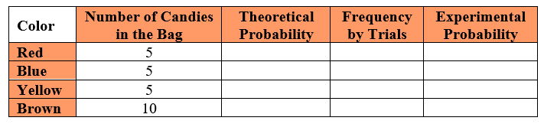

Part B. Experimental Trials: Select one candy from the bag, record its color in the table below and return it to the bag. Repeat this process for a total of 20 trials.

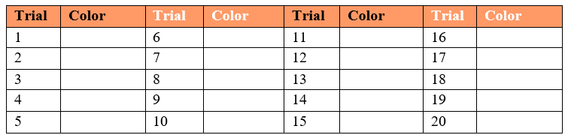

Part C. In the original table, record the total frequency of each color based on your 20 trials. Then calculate the experimental probability for each. How do the theoretical and experimental probabilities compare?
Part D. Collect the data from 2 other sets of partners and combine your total frequencies. Complete the table below based on those 60 trials. How do the theoretical and experimental probabilities compare? How does that compare to your original calculations using 20 trials?

Part E. Collect all of the class data to calculate new total frequencies and complete the table below.

Part F.
  - How do the theoretical and experimental probabilities compare?
  - How does that compare to the calculations using 20 trials and 60 trials?
  - What conclusions can you make about theoretical and experimental probabilities based on this information?

Instructional Items
Instructional Item 1
A bag contains green marbles and purple marbles. If a marble is randomly selected from the
bag, the probability that it is green is 0.6 and the probability that it is purple is 0.4. Dylan
draws a marble from the bag, notes its color, and returns it to the bag. He does this 50 times.
Approximately, how many times would you expect Dylan to draw a green marble?

*The strategies, tasks and items included in the B1G-M are examples and should not be considered comprehensive.

Appendix A. Summary of Changes

The purpose of this table is to provide a summary of changes from the latest version of the B1G-M. For questions or feedback on the B1G-M, please direct them to BESTMath@fldoe.org.
Benchmark | B1G-M Component | Change Made
MA.7.NSO.1.1 | Vertical Alignment | REMOVED hyperlink and text; ADDED MA.8.NSO.1.7
MA.7.NSO.1.1 | Strategies to Support Tiered Instruction | ADDED headings (centered) to tables under bullet 1 open bullet and under bullet 2 open bullet to read: "Doubling " in the left column header and "Squaring" in the right column header for BOTH tables.
MA.7.NSO.1.2 | Connecting Benchmarks/Horizontal Alignment | REMOVED benchmarks MA.7.NSO.2, MA.7.AR.3, MA.7.GR.1, MA.7.GR.2, MA.7.DP.2.5; ADDED benchmarks MA.7.AR.3.1, MA.7.AR.3.3, MA.7.DP.2.2, MA.7.DP.2.4
MA.7.NSO.1.2 | Vertical Alignment | REMOVED hyperlink and text
MA.7.NSO.1.2 | Purpose and Instructional Strategies | 4th bullet DELETE "-" after "to" and DELETED "showcase" and REPLACED with "highlight. At the 4th bullet and open bullet, INDENTED example and highlight INSTEAD of using it as a 2nd open bullet.
MA.7.NSO.1.2 | Purpose and Instructional Strategies | Added a NEW bullet after bullet 4: "Repeating decimals can be written using a repeating bar, a truncated decimal form, fraction or maybe rounded depending on the problem and the directions to the problem."
MA.7.NSO.2.1 | Connecting Benchmarks/Horizontal Alignment | DELETE MA.7.AR.1, MA.7.GR.1, MA.7.GR.2 and ADDED MA.7.AR.1.1, MA.7.AR.1.2, MA.7.AR.2.2, MA.7.AR.3.1, MA.AR.3.2, MA.7.AR.3.3, MA.7.AR.4.1, MA.7.AR.4.2, MA.7.AR.4.3, MA.7.AR.4.4, MA.7.AR.4.5, MA.7.GR.1.1, MA.7.GR.1.2, MA.7.GR.1.3, MA.7.GR.1.4, MA.7.GR.2.1, MA.7.GR.2.2, MA.7.GR2.3
MA.7.NSO.2.1 | Vertical Alignment | ADDED benchmark MA.8.AR.1.1
MA.7.NSO.2.1 | Purpose and Instructional Strategies | Introductory paragraph ADDED "the" after "including".
MA.7.NSO.2.1 | Purpose and Instructional Strategies | 5th bullet DELETED "With the completion of operations with rational numbers in grade 7" and capitalize "Students…"
MA.7.NSO.2.2 | Connecting Benchmarks/Horizontal Alignment | DELETED MA.7.AR.3, MA.7.GR.1, MA.7.GR.2 and ADDED MA.7.AR.2.1, MA.7.AR.3.1, MA.7.AR.3.2, MA.7.AR.3.3, MA.7.AR.4.1, MA.7.AR.4.2, MA.7.AR.4.3, MA.7.AR.4.4, MA.7.GR.1.1, MA.7.GR.1.2, MA.7.GR.1.3, MA.7.GR.1.4, MA.7.GR.1.5, MA.7.GR.2.1, MA.7.GR.2.2, MA.7.GR.2.3, MA.7.DP.2.1
MA.7.NSO.2.2 | Vertical Alignment | REMOVED hyperlink and text
MA.7.NSO.2.2 | Strategies to Support Tiered Instruction | 3rd bullet DELETED "positive and negative whole numbers" and REPLACED with "integers. Center visual under bullet 4. Added a visual under bullet 5.
MA.7.NSO.2.3 | Purpose and Instructional Strategies | EDITED first paragraph: DELETED "in grade 6" at the end of the first sentence in the introductory paragraph and INSERTED it at the beginning of that sentence and change "Students" to lowercase "students". CHANGE sentence 2 to read: "In grade 7, students move to all rational numbers, and in grade 8, extends to rational numbers, including exponents and radicals."
MA.7.NSO.2.3 | Purpose and Instructional Strategies | Bullet 4, DELETED "With completion of operations with rational numbers in grade 7". Removed the comma and capitalize "Students".
MA.7.NSO.2.3 | Purpose and Instructional Strategies | REMOVED "when necessary" from the last bullet point
MA.7.NSO.2.3 | Common Misconceptions or Errors | In 2nd bullet: CHANGED "context" to "contextual"
MA.7.NSO.2.3 | Strategies to Support Tiered Instruction | ADDED visual to 3rd bullet point
MA.7.AR.1.1 | Connecting Benchmarks/Horizontal Alignment | ADDED benchmark MA.7.NSO.2.1; REMOVED benchmark MA.7.NSO.2.3
MA.7.AR.1.1 | Purpose and Instructional Strategies | In the introductory paragraph at the end of sentence 1: ADDED "and multiple variables"; in bullet 3, ADDED comma after "however,"
MA.7.AR.2.1 | Connecting Benchmarks/Horizontal Alignment | ADDED benchmarks MA.7.NSO.2.2 and MA.7.NSO.2.3
MA.7.AR.2.1 | Purpose and Instructional Strategies | In the introductory paragraph MOVED "In grade 6" and "In grade 7" to the beginning of the sentence instead of the end; in bullet 5, ADDED a comma after "however,"
MA.7.AR.2.1 | Instructional Items | RENUMBERED the last item to be item "3" not "1"
MA.7.AR.2.2 | Connecting Benchmarks/Horizontal Alignment | REMOVED benchmark MA.7.NSO.2 and MA.7.NSO.3; ADDED benchmarks MA.7.NSO.2.1, MA.7.NSO.2.2, MA.7.NSO.2.3, MA.7.AR,.3.1, MA.7.AR.3.2, MA.7.AR.3.3
MA.7.AR.2.2 | Purpose and Instructional Strategies | In the introductory paragraph MOVED "In grade 6" and "In grade 7" and "In grade 8" to the beginning of the sentence instead of the end; DELETED "being critical as" and "then" in sentence 2 of the introductory paragraph. In sentence 3 ADDED "students solve" in front of "multi-step".
MA.7.AR.3.1 | Connecting Benchmarks/Horizontal Alignment | REMOVED benchmark MA.7.NSO.2 and ADDED benchmarks MA.7.NSO.2.1, MA.7.NSO.2.2, MA.7.NSO.2.3, MA.7.AR.2.2
MA.7.AR.3.1 | Purpose and Instructional Strategies | In the introductory paragraph MOVE "In grade 7" to the beginning of the sentence instead of the end and DELETED "then" and "and". Begin a NEW sentence "In grade 8, students". DELETED "of " and REPLACE with "given" in this last sentence. DELETED "in grade 8" at the end of the sentence.
MA.7.AR.3.2 | Connecting Benchmarks/Horizontal Alignment | REMOVED benchmark E MA.7.NSO.2 and ADDED benchmarks MA.7.NAO.2.1, MA.7.NSO.2.2, MA.7.NSO.2.3, MA.7.AR.2.2, MA.7.AR.4.1, MA.7.AR.4.2
MA.7.AR.3.2 | Strategies to Support Tiered Instruction | REPLACED "co-constructs" with "co-creates"
MA.7.AR.3.3 | Connecting Benchmarks/Horizontal Alignment | REMOVED benchmarks MA.7.NSO.2, MA.7.GR.1 and MA.7.GR.2 and ADDED benchmarks MA.7.NSO.2.1, MA.7.NSO.2.2, MA.7.NSO.2.3, MA.7.AR.2.2, MA.7.AR.4.3
MA.7.AR.4.1 | Connecting Benchmarks/Horizontal Alignment | REMOVED benchmark MA.7.NSO.2 and ADDED benchmarks MA.7.NSO.2.1, MA.7.NSO.2.2, MA.7.NSO.2.3
MA.7.AR.4.1 | Purpose and Instructional Strategies | Introductory paragraph, 2nd sentence, DELETED the -s in "grades 7" and place a period after variables. Begin the next sentence with a capital letter and REPLACED "they" with "students".
MA.7.AR.4.1 | Purpose and Instructional Strategies | In the 2nd bullet CHANGE "allow" to "should allow"
MA.7.AR.4.1 | Strategies to Support Tiered Instruction | CHANGED "co-constructs" to "co-creates"
MA.7.AR.4.2 | Connecting Benchmarks/Horizontal Alignment | REMOVED benchmark MA.7.NSO.2 and ADDED benchmarks MA.7.NSO.2.1, MA.7.NSO.2.2, MA.7.NSO.2.3
MA.7.AR.4.2 | Strategies to Support Tiered Instruction | CHANGED "co-constructs" to "co-creates"
MA.7.AR.4.3 | Connecting Benchmarks/Horizontal Alignment | REMOVED benchmark MA.7.NSO.2 and ADDED benchmarks MA.7.NSO.2.1, MA.7.NSO.2.2, MA.7.NSO.2.3
MA.7.AR.4.3 | Common Misconceptions or Errors | REMOVED open bullet point about determining dependent and independent values; INSERTED new 2nd bullet to follow the 1st bullet: "In grade 7, it is not the expectation that students define independent and dependent variables. Students may have experience with these terms from other content areas."
MA.7.AR.4.4 | Connecting Benchmarks/Horizontal Alignment | EXPANDED benchmark MA.7.NSO.2 to include 2.1, 2.2, 2.3; EXPANDED benchmark MA.7.AR.3 to include 3.1, 3.2, 3.3; ADDED benchmark MA.7.GR.2.2
MA.7.AR.4.4 | Instructional Tasks | ADDED task 2: "Instructional Task 2: Kelsi works as a lifeguard at the local pool. After an 8-hour day at work, she earns $100. Part A. Write an equation that describes the relationship between the number of hours worked and the amount of money that she earns. Part B. Kelsi would like to earn $450 to buy a new gaming system. Use your equation to determine how many hours she needs to work to buy a new gaming system."
MA.7.AR.4.4 | Instructional Items | REMOVED item 1 to Instructional Task 2 and ADDED a new Instructional item 1: "Saylor needs to walk her dog Holloway every day after work. After 5 days Saylor has walked her dog a total of 200 minutes. Write an equation that describes the relationship between the amount of minutes Saylor walked her dog each day."
MA.7.AR.4.5 | Connecting Benchmarks/Horizontal Alignment | EXPANDED benchmark MA.7.NSO.2 to include 2.1, 2.2, 2.3; ADDED benchmark MA.7.AR.2.2; EXPANDED benchmark MA.7.AR.3 to include 3.1, 3.2, 3.3; ADDED benchmark MA.7.GR.1.5, MA.7.GR.2.2 and MA.7.GR.2.3
MA.7.AR.4.5 | Purpose and Instructional Strategies | ADDED a new bullet 4: "In grade 7, it is not the expectation that students define independent and dependent variables. Students may have experience with these terms from other content areas."
MA.7.AR.4.5 | Common Misconceptions or Errors | DELETED both bullets and INSERT a new bullet to read: "Students may invert values when setting up proportions."
MA.7.AR.4.5 | Strategies to Support Tiered Instruction | Bullet 1, REMOVED last two open bullets about independent and dependent variables
MA.7.AR.4.5 | Instructional Item 1 | CHANGED "will it" to "it will"
MA.7.GR.1.1 | Connecting Benchmarks/Horizontal Alignment | Expanded benchmarks to include: MA.7.NSO.2.1, MA.7.NSO.2.2, MA.7.NSO.2.3
MA.7.GR.1.1 | Purpose and Instructional Strategies | REMOVED "patty paper or" from 3rd open bullet point
MA.7.GR.1.1 | Instructional Tasks | REMOVED "patty paper or" from task 2
MA.7.GR.1.2 | Connecting Benchmarks/Horizontal Alignment | Expanded benchmarks to include: MA.7.NSO.2.1, MA.7.NSO.2.2, MA.7.NSO.2.3, MA.7.GR.2.2
MA.7.GR.1.2 | Strategies to Support Tiered Instruction | 4th bullet CHANGED "determine" to "determining"
MA.7.GR.1.3 | Connecting Benchmarks/Horizontal Alignment | Expanded benchmarks to include: MA.7.NSO.2.1, MA.7.NSO.2.2, MA.7.NSO.2.3, MA.7.AR.3.2, MA.7.GR.2.1, MA.7.GR.2.2
MA.7.GR.1.3 | Strategies to Support Tiered Instruction | CHANGED "co-constructs" to "co-creates"
MA.7.GR.1.4 | Connecting Benchmarks/Horizontal Alignment | EXPANDED benchmark MA.7.GR.2 to include 2.1, 2.2, 2.3; ADDED benchmark MA.7.NSO.1.1; REMOVED benchmarks MA.7.NSO.2 and MA.7.DP.1.4
MA.7.GR.1.4 | Vertical Alignment | ADDED sentence: "This is the first introduction to circles outside of recognizing the shape in early elementary". REMOVED MA.6.GR.2.2
MA.7.GR.1.4 | Purpose and Instructional Strategies | Introductory paragraph DELETED "a" in front of "circles". 1st open bullet: CHANGED "dashed lined" to "lines drawn". Added an image under 1st open bullet.
MA.7.GR.1.4 | Strategies to Support Tiered Instruction | 3rd and 4th bullets CHANGED "co-constructs" to "co-creates"; ADDED "of" in front of "proportionality" in bullet 4.
MA.7.GR.1.4 | Strategies to Support Tiered Instruction | ADDED headings to tables under bullet 5 open bullet to read: "Doubling " in the left column header and "Squaring" in the right column header.
MA.7.GR.1.4 | Instructional Task 1 | Introductory paragraph DELETED "and" and REPLACED with "inside" in the 1st sentence; ADDED "with" in front of "seven small circles"
MA.7.GR.1.4 | Instructional Item 3 | REPLACED image under item 3 to an updated image.
MA.7.GR.1.5 | Connecting Benchmarks/Horizontal Alignment | REMOVED benchmarks MA.7.NSO.2, MA.7.AR.3.3, MA.7.AR.4.1
MA.7.GR.1.5 | Vertical Alignment/Next Benchmarks | REMOVED benchmarks MA.6.GR.1.3 and MA.912.GR.4.4
MA.7.GR.1.5 | Purpose and Instructional Strategies | Bullet 1 ADDED "Calculations" in front of "begin" in the 3rd sentence.
MA.7.GR.1.5 | Purpose and Instructional Strategies | Bullet 2, 3rd sentence, INSERTED "using its multiplicative inverse" after "by multiplication" and INSERTED "whose absolute value is" after "by a factor".
MA.7.GR.1.5 | Purpose and Instructional Strategies | Bullet 3, DELETED "Have" and REPLACED with "Instruction includes having"
MA.7.GR.1.5 | Purpose and Instructional Strategies | Bullet 4, 4th sentence, ADDED "Then" in front of "have" and DELETED "then" after "students". 5th sentence DELETED "Then" and REPLACED with "Finally, students should".
MA.7.GR.1.5 | Strategies to Support Tiered Instruction | 2nd bullet DELETED "verses" and REPLACE with "relative to"
MA.7.GR.1.5 | Instructional Task 2 | DELETED the "dash" in-between "scale" and "drawing"
MA.7.GR.1.5 | Instructional Item 1 | 1st sentence: DELETED "needs to" and REPLACED with "will". 2nd sentence: DELETED "is this" and ADDED "should be used?" at the end.
MA.7.GR.1.5 | Instructional Item 2 | 1st sentence CHANGED "repaint" to "paint". DELETED the last sentence and REPLACED with a question at the end: "What is the actual area Andrew will need to paint?"
MA.7.GR.2.1 | Connecting Benchmarks/Horizontal Alignment | EXPANDED benchmark MA.7.NSO.2 to include 2.1, 2.2, 2.3; ADDED benchmark MA.7.GR.2.3; REMOVED benchmarks MA.7.GR.1.2 and MA.7.GR.1.4
MA.7.GR.2.1 | Vertical Alignment/Previous Benchmarks | ADDED sentence: "This is the first introduction to cylinders outside of recognizing the shape in early elementary." REMOVED MA.6.GR.2.2 and MA.6.GR.2.4
MA.7.GR.2.1 | Purpose and Instructional Strategies | 3rd bullet DELETED "for" after "allows"; ADDED a bullet point at the end: "Instruction focuses on recognizing the height of a cylinder as the perpendicular distance between the parallel (circular) bases."
MA.7.GR.2.1 | Common Misconceptions or Errors | 2nd bullet, 1st sentence, DELETED "believe" and REPLACED with "invert the height and base of a cylinder when the cylinder is presented horizontally." Also in this same bullet 2, DELETED "that the part of the cylinder is lying flat is the base of the figure." 2nd bullet, 2nd sentence, DELETED "with the height being the perpendicular distance between them. Provide multiple orientations of objects and continue to break them down to their nets" and ADDED "parallel" in front of "circles".
MA.7.GR.2.1 | Common Misconceptions or Errors | 3rd bullet, 1st sentence, DELETED "often forget" and "or confuse" and REPLACED with "may incorrectly apply". 3rd bullet, 2nd sentence, DELETED "will be important in fostering" and REPLACED with "to foster".
MA.7.GR.2.1 | Strategies to Support Tiered Instruction | Bullet 3 @ open bullet and last sentence, DELETED "The" and REPLACED with "A" in front of "base is highlighted…"
MA.7.GR.2.1 | Strategies to Support Tiered Instruction | Bullet 5 DELETED "Teacher directs students to" and REPLACED with "Instruction includes" and CHANGED "find" to "finding"
MA.7.GR.2.1 | Strategies to Support Tiered Instruction | Bullet 7 DELETED "focused on" and REPLACED with "using"
MA.7.GR.2.1 | Strategies to Support Tiered Instruction | Bullet 8 DELETED "the" and REPLACE with "a" in front of formula.
MA.7.GR.2.1 | Strategies to Support Tiered Instruction | DELETED the last bullet and REPLACED with "Provide multiple orientations of cylinders, focusing on the height as the perpendicular distance between the parallel bases, continuing to break them down to their nets."
MA.7.GR.2.1 | Instructional Task 1 | Task 1, last sentence, ADDED "that needs" after "surface area" and DELETED "so they may order the needed supplies."
MA.7.GR.2.1 | Instructional Task 2 | Task 2, 1st sentence, DELETED "the" and REPLACED with "a" in front of blue room, INSERTED "at the resort after "blue room", DELETED "rather than floating". NEXT, ADDED this sentence: "The room is 34 feet in diameter with a height of 9 feet." Next sentence, DELETED "So" and capitalize "The".
MA.7.GR.2.2 | Connecting Benchmarks/Horizontal Alignment | EXPANDED benchmark MA.7.NSO.2 to include 2.1, 2.2, 2.3; ADDED benchmarks MA.7.NSO.1.1, MA.7.AR.2.2, MA.7.AR.4.4, MA.7.GR.2.3
MA.7.GR.2.2 | Vertical Alignment/Previous Benchmarks | ADDED sentence: "This is the first introduction to cylinders outside of recognizing the shape in early elementary." REMOVED MA.6.GR.2.2 and MA.6.GR.2.4
MA.7.GR.2.2 | Purpose and Instructional Strategies | REMOVED "(working backwards)"
MA.7.GR.2.2 | Common Misconceptions or Errors | REMOVED the last bullet point; ADDED two bullet points: Bullet 2, "Students may incorrectly invert the height and base of a cylinder when the cylinder is presented horizontally. To address this misconception, remind students that while a cylinder may lay on its side, the bases are the parallel circles." Bullet 3, "Students may incorrectly apply the formulas for area, surface area and volume. to address this misconception, use these concepts in context, or a manner in which they understand the meaning behind the terms to foster conceptual development (MTR.7.1)."
MA.7.GR.2.2 | Strategies to Support Tiered Instruction | Bullet 4, REPLACED "co-creates" with "models".
MA.7.GR.2.2 | Strategies to Support Tiered Instruction | Bullet 6 INSERTED "co-creating a graphic organizer of a right circular cylinder and…" after "Instruction includes" and DELETED "of a right circular cylinder" at the end of the sentence.
MA.7.GR.2.2 | Strategies to Support Tiered Instruction | Last bullet, DELETED both sentences and REPLACED with "Provide multiple orientations of cylinders, focusing on the height as the perpendicular distance between the parallel bases, continuing to break them down to their nets."
MA.7.GR.2.3 | Connecting Benchmarks/Horizontal Alignment | EXPANDED benchmark MA.7.NSO.2 to include 2.1, 2.2, 2.3; ADDED benchmark MA.7.NSO.1.1, MA.7.AR.2.2, MA.7.AR.4.5, MA.7.GR.2.1, MA.7.GR.2.2
MA.7.GR.2.3 | Purpose and Instructional Strategies | Introductory paragraph DELETED "Students progress...and spheres in high school." and REPLACED with "In grade 6, students found the volume of rectangular prisms and right rectangular pyramids using the area of the base. In grade 7m students find the volume of a right circular cylinder and build that into solving real-world problems involving their volume using the area of their circular base. In high school, students will solve mathematical and real-world problems involving the volume of cylinders, pyramids, prisms, cones and spheres." INDENTED a new bullet with "Instruction builds on students' knowledge..."
MA.7.GR.2.3 | Purpose and Instructional Strategies | 2nd bullet DELETED "Ask" and REPLACE with "Instruction encourages". DELETED "Provide" and REPLACED with "Students are provided"…DELETED "for students" after "cylinders".
MA.7.GR.2.3 | Common Misconceptions or Errors | 2nd bullet, 2nd sentence, INSERTED "parallel" in front of circles
MA.7.GR.2.3 | Common Misconceptions or Errors | ADDED two bullet points: Bullet 3, "Students may incorrectly invert the height and base of a cylinder when the cylinder is presented horizontally. To address this misconception, remind students that while a cylinder may lay on its side, the bases are the parallel circles." Bullet 4, "Students may incorrectly apply the formulas for area, surface area and volume. To address this misconception, use these concepts in context, or a manner in which they understand the meaning behind the terms to foster their conceptual development (MTR. 7.1)."
MA.7.GR.2.3 | Strategies to Support Tiered Instruction | Bullet 4 DELETED "instructs students to draw" and REPLACED with "co-creates". At the end of the sentence REMOVED the period and REPLACE with a comma and ADDED "and color-coding and labeling dimensions."
MA.7.GR.2.3 | Strategies to Support Tiered Instruction | REMOVED bullet 6 "Instruction includes co-constructing…"
MA.7.GR.2.3 | Strategies to Support Tiered Instruction | DELETED last bullet and REPLACED with "Provide multiple orientations of cylinders, focusing on the height as the perpendicular distance between the parallel bases, continuing to break them down to their nets."
MA.7.GR.2.3 | Instructional Task 1 | Task 1, ADDED a dash in between to read as follows: "record-breaking"
MA.7.GR.2.3 | Instructional Task 2 | Task 2, last sentence, CHANGED to read as follows: "What is the volume of water needed to fill the pool 2 inches from the top? Justify your solution."
MA.7.DP.1.1 | Purpose and Instructional Strategies | DELETE 2nd bullet, along with the table and open bullet beginning as "Instruction focuses on identifying…"
MA.7.DP.1.2 | Connecting Benchmarks/Horizontal Alignment | ADDED benchmark MA.7.DP.1.1
MA.7.DP.1.2 | Purpose and Instructional Strategies | Introductory paragraph, 1st sentence PLACED a period after "and range." DELETED "while" and "they". BEGAN new sentence: "In grade 7, students use those calculations…"
MA.7.DP.1.2 | Purpose and Instructional Strategies | Bullet 2, 2nd sentence, DELETED "interest in making comparisons assists with students making sense of the data to interpret comparisons" and REPLACED with "make connections to data they are interested in. (MTR.1.1, MTR.7.1)"
MA.7.DP.1.2 | Strategies to Support Tiered Instruction | 2nd bullet, 1st sentence, ADDED "-s" after "type". 2nd sentence CHANGED "co-constructs" to "co-creates".
MA.7.DP.1.3 | Connecting Benchmarks/Horizontal Alignment | ADDED MA.7.AR.3.1
MA.7.DP.1.3 | Purpose and Instructional Strategies | 2nd bullet, 1st open bullet, near the beginning of 1st sentence ADDED "example for this" after "As in the second" and DELETED "example" after "benchmark".
MA.7.DP.1.3 | Purpose and Instructional Strategies | 3rd bullet DELETED "here we will" and CHANGED to "in this benchmark, students will…"
MA.7.DP.1.3 | Purpose and Instructional Strategies | 6th bullet DELETED "example for" in 1st sentence and CHANGED first part of 1st sentence to read: "As in the first example for this benchmark about…"
MA.7.DP.1.3 | Strategies to Support Tiered Instruction | 3rd bullet @ open bullet, 2nd sentence CHANGED "sampling" to "to sample"
MA.7.DP.1.3 | Strategies to Support Tiered Instruction | 4th bullet @ open bullet, 1st sentence ADDED "to determine" after "last year"
MA.7.DP.1.4 | Connecting Benchmarks/Horizontal Alignment | REMOVED benchmarks MA.7.AR.3.2 and MA.7.AR.4.5, ADDED benchmarks MA.7.GR.1.4, MA.7.AR.3.1
MA.7.DP.1.4 | Purpose and Instructional Strategies | Introductory paragraph, 1st sentence, ADDED "and their percentages." to the end of that sentence. The last sentence DELETED "data, depending on whether it is" and DELETED "on whether it is" after "and".
MA.7.DP.1.4 | Purpose and Instructional Strategies | 1st bullet, 2nd sentence, CHANGED "totaling" to "that equal"
MA.7.DP.1.4 | Purpose and Instructional Strategies | MOVED the end of 1st bullet point into "Limitations" and DELETED the word "however" and the punctuation around "however"
MA.7.DP.1.4 | Purpose and Instructional Strategies | 4th bullet, 1st sentence DELETED "Students should" and REPLACED with "Instruction should include opportunities for students to…" 4th bullet, open bullet, 2nd sentence DELETED "emphasize" and CHANGED "using" to "use"
MA.7.DP.1.4 | Common Misconceptions or Errors | ADDED bullet 3: "Students may incorrectly use a protractor. To address this issue, provide students with a circle and allow them to measure sections and then find the percent."
MA.7.DP.1.4 | Strategies to Support Tiered Instruction | Bullet 2 DELETED "aloud"
MA.7.DP.1.4 | Strategies to Support Tiered Instruction | Bullet 3 DELETED "how to properly round proper" and REPLACED with "appropriate rounding"
MA.7.DP.1.4 | Strategies to Support Tiered Instruction | DELETED bullet 6, which reads "For students incorrectly…"
MA.7.DP.1.5 | Connecting Benchmarks/Horizontal Alignment | REMOVED benchmark MA.7.NSO.1.2
MA.7.DP.1.5 | Purpose and Instructional Strategies | 4th bullet, 2nd sentence DELETED "graph" and REPLACED with "charts"; in parentheses DELETED "charts" and REPLACED with "graphs". NEW bullet 5 should start at "Stem-and-leaf plots…"
MA.7.DP.1.5 | Purpose and Instructional Strategies | ADDED last bullet: "As an enrichment to this benchmark, students could explore segmented bar charts as they will be introduced to this in Algebra I. (MA.912.DP.1.1)"
MA.7.DP.1.5 | Instructional Task 1 | Part A ADDED "a" in front of "histogram" and DELETED "-s" at the end of "histograms, bar charts, circle graphs, line plots, box plots, stem-and-leaf plots".
MA.7.DP.2.1 | Connecting Benchmarks/Horizontal Alignment | ADDED MA.7.DP.2.3, MA.7.DP.2.4
MA.7.DP.2.1 | Purpose and Instructional Strategies | In the introductory paragraph DELETED the comma and ADDED period and DELETED "and". Start a new sentence with "In grade 8…"
MA.7.DP.2.1 | Purpose and Instructional Strategies | Bullet 6, open bullet, CHANGED "bad" to "bag"
MA.7.DP.2.2 | Connecting Benchmarks/Horizontal Alignment | ADDED MA.7.AR.3.1
MA.7.DP.2.2 | Purpose and Instructional Strategies | 4th bullet CHANGED "is" to "it"
MA.7.DP.2.2 | Common Misconceptions or Errors | 1st bullet DELETED "invert" and REPLACED with "incorrectly assume that an event is only possible in an experiment and interchange"
MA.7.DP.2.3 | Connecting Benchmarks/Horizontal Alignment | REMOVED benchmark MA.7.NSO.1.2; ADDED benchmark MA.7.AR.3.1, MA.7.DP.2.1
MA.7.DP.2.3 | Vertical Alignment/Next Benchmarks | REMOVED MA.8.DP.2.1 and MA.8.DP.2.2
MA.7.DP.2.3 | Purpose and Instructional Strategies | Introductory paragraph, 1st sentence, after students ADDED "are introduced to probability and will" and CHANGED comma after "experiment" to a period. DELETED "and" after "experiment. Begin next sentence as: "In grade 8, students will…"
MA.7.DP.2.3 | Purpose and Instructional Strategies | 4th bullet, 1st open bullet underneath it, DELETED "one side colored yellow and the other side colored red" and REPLACED with "one yellow side and one red side, "; 4th open bullet under bullet 4, CHANGED "tiles" to "tile".
MA.7.DP.2.3 | Instructional Task 1 | Task 1, 2nd sentence, ADDED "using tally marks" after "table"
MA.7.DP.2.4 | Connecting Benchmarks/Horizontal Alignment | ADDED benchmarks MA.7.DP.2.1 and MA.7.DP.2.3, DELETED MA.7.AR.3.1
MA.7.DP.2.4 | Vertical Alignment/Previous Benchmarks | ADDED benchmark MA.6.NSO.1.1
MA.7.DP.2.4 | Purpose and Instructional Strategies | ADDED introductory paragraph, new 1st sentence: "In grade 6, students plot, order and compare rational numbers in addition to rewriting positive rational numbers in different but equivalent forms." Last sentence DELETED comma and "including" and REPLACED with "and will include"
MA.7.DP.2.4 | Purpose and Instructional Strategies | 2nd bullet DELETED "has no memory". ADDED comma after "possible events" and ADDED "unless an option/possible outcome is removed".
MA.7.DP.2.4 | Common Misconceptions or Errors | 2nd bullet, open bullet DELETED "this does not indicate" and REPLACED with "they could incorrectly assume"

