Grade 4 B.E.S.T. Instructional Guide for Mathematics

The B.E.S.T. Instructional Guide for Mathematics (B1G-M) is intended to assist educators with planning for student learning and instruction aligned to Florida’s Benchmarks for Excellent Student Thinking (B.E.S.T.) Standards. This guide is designed to aid high-quality instruction through the identification of components that support the learning and teaching of the B.E.S.T. Mathematics Standards and Benchmarks. The B1G-M includes an analysis of information related to the B.E.S.T. Standards for Mathematics within this specific mathematics course, the instructional emphasis and aligned resources. This document is posted on the B.E.S.T. Standards for Mathematics webpage of the Florida Department of Education’s website and will continue to undergo edits as needed.

Structural Framework and Intentional Design of the B.E.S.T. Standards for Mathematics

Florida’s B.E.S.T. Standards for Mathematics were built on the following.

- The coding scheme for the standards and benchmarks was changed to be consistent with other content areas. The new coding scheme is structured as follows:
Content.GradeLevel.Strand.Standard.Benchmark.
- Strands were streamlined to be more consistent throughout.
- The standards and benchmarks were written to be clear and concise to ensure that they are easily understood by all stakeholders.
- The benchmarks were written to allow teachers to meet students’ individual skills, knowledge and ability.
- The benchmarks were written to allow students the flexibility to solve problems using a method or strategy that is accurate, generalizable and efficient depending on the content (i.e., the numbers, expressions or equations).
- The benchmarks were written to allow for student discovery (i.e., exploring) of strategies rather than the teaching, naming and assessing of each strategy individually.
- The benchmarks were written to support multiple pathways for success in career and college for students.
- The benchmarks should not be taught in isolation but should be combined purposefully.
- The benchmarks may be addressed at multiple points throughout the year, with the intention of gaining mastery by the end of the year.
- Appropriate progression of content within and across strands was developed for each grade level and across grade levels.
- There is an intentional balance of conceptual understanding and procedural fluency with the application of accurate real-world context intertwined within mathematical concepts for relevance.
- The use of other content areas, like science and the arts, within real-world problems should be accurate, relevant, authentic and reflect grade-level appropriateness.

Components of the B.E.S.T. Instructional Guide for Mathematics

The following table is an example of the layout for each benchmark and includes the defining attributes for each component. It is important to note that instruction should not be limited to the possible connecting benchmarks, related terms, strategies or examples provided. To do so would strip the intention of an educator meeting students’ individual skills, knowledge and abilities.

Benchmark
focal point for instruction within lesson or task
This section includes the benchmark as identified in the B.E.S.T. Standards for Mathematics. The benchmark, also referred to as the Benchmark of Focus, is the focal point for student learning and instruction. The benchmark, and its related example(s) and clarification(s), can also be found in the course description. The 9-12 benchmarks may be included in multiple courses; select the example(s) or clarification(s) as appropriate for the identified course.

Connecting Benchmarks/Horizontal Alignment
in other standards within the grade level or course
This section includes a list of connecting benchmarks that relate horizontally to the Benchmark of Focus. Horizontal alignment is the intentional progression of content within a grade level or course linking skills within and across strands. Connecting benchmarks are benchmarks that either make a mathematical connection or include prerequisite skills. The information included in this section is not a comprehensive list, and educators are encouraged to find other connecting benchmarks. Additionally, this list will not include benchmarks from the same standard since benchmarks within the same standard already have an inherent connection.

Terms from the K-12 Glossary
This section includes terms from Appendix C: K-12 Glossary, found within the B.E.S.T. Standards for Mathematics document, which are relevant to the identified Benchmark of Focus. The terms included in this section should not be viewed as a comprehensive vocabulary list, but instead should be considered during instruction or act as a reference for educators.

Vertical Alignment
across grade levels or courses
This section includes a list of related benchmarks that connect vertically to the Benchmark of Focus. Vertical alignment is the intentional progression of content from one year to the next, spanning across multiple grade levels. Benchmarks listed in this section make mathematical connections from prior grade levels or courses in future grade levels or courses within and across strands. If the Benchmark of Focus is a new concept or skill, it may not have any previous benchmarks listed. Likewise, if the Benchmark of Focus is a mathematical skill or concept that is finalized in learning and does not have any direct connection to future grade levels or courses, it may not have any future benchmarks listed. The information included in this section is not a comprehensive list, and educators are encouraged to find other benchmarks within a vertical progression.

Purpose and Instructional Strategies
This section includes further narrative for instruction of the benchmark and vertical alignment. Additionally, this section may also include the following:
- explanations and details for the benchmark;
- vocabulary not provided within Appendix C;
- possible instructional strategies and teaching methods; and
- strategies to embed potentially related Mathematical Thinking and Reasoning Standards (MTRs).

Common Misconceptions or Errors
This section will include common student misconceptions or errors and may include strategies to address the identified misconception or error. Recognition of these misconceptions and errors enables educators to identify them in the classroom and make efforts to correct the misconception or error. This corrective effort in the classroom can also be a form of formative assessment within instruction.

Strategies to Support Tiered Instruction
The instructional strategies in this section address the common misconceptions and errors listed within the above section that can be a barrier to successfully learning the benchmark. All instruction and intervention at Tiers 2 and 3 are intended to support students to be successful with Tier 1 instruction. Strategies that support tiered instruction are intended to assist teachers in planning across any tier of support and should not be considered exclusive or inclusive of other instructional strategies that may support student learning with the B.E.S.T. Mathematics Standards. For more information about tiered instruction, please see the Effective Tiered Instruction for Mathematics: ALL Means ALL document.

Instructional Tasks
demonstrate the depth of the benchmark and the connection to the related benchmarks
This section will include example instructional tasks, which may be open-ended and are intended to demonstrate the depth of the benchmark. Some instructional tasks include integration of the Mathematical Thinking and Reasoning Standards (MTRs) and related benchmark(s). Enrichment tasks may be included to make connections to benchmarks in later grade levels or courses. Tasks may require extended time, additional materials and collaboration.

Instructional Items
demonstrate the focus of the benchmark
This section will include example instructional items which may be used as evidence to demonstrate the students’ understanding of the benchmark. Items may highlight one or more parts of the benchmark.
*The strategies, tasks and items included in the B1G-M are examples and should not be considered comprehensive.

Mathematical Thinking and Reasoning Standards
MTRs: Because Math Matters

Florida students are expected to engage with mathematics through the Mathematical Thinking and Reasoning Standards (MTRs) by utilizing their language as a self-monitoring tool in the classroom, promoting deeper learning and understanding of mathematics. The MTRs are standards which should be used as a lens when planning for student learning and instruction of the B.E.S.T. Standards for Mathematics.

Structural Framework and Intentional Design of the Mathematical Thinking and Reasoning Standards

The Mathematical Thinking and Reasoning Standards (MTRs) are built on the following.

- The MTRs have the same coding scheme as the standards and benchmarks; however, they are written at the standard level because there are no benchmarks.
- In order to fulfill Florida’s unique coding scheme, the 5th place (benchmark) will always be a “1” for the MTRs.
- The B.E.S.T. Standards for Mathematics should be taught through the lens of the MTRs.
- At least one of the MTRs should be authentically and appropriately embedded throughout every lesson based on the expectation of the benchmark(s).
- The bulleted language of the MTRs were written for students to use as self-monitoring tools during daily instruction.
- The clarifications of the MTRs were written for teachers to use as a guide to inform their instructional practices.
- The MTRs ensure that students stay engaged, persevere in tasks, share their thinking, balance conceptual understanding and procedures, assess their solutions, make connections to previous learning and extended knowledge, and apply mathematical concepts to real-world applications.
- The MTRs should not stand alone as a separate focus for instruction but should be combined purposefully.
- The MTRs will be addressed at multiple points throughout the year, with the intention of gaining mastery of mathematical skills by the end of the year and building upon these skills as they continue in their K-12 education.

MA.K12.MTR.1.1 Actively participate in effortful learning both individually and collectively.
Mathematicians who participate in effortful learning both individually and with others:
- Analyze the problem in a way that makes sense given the task.
- Ask questions that will help with solving the task.
- Build perseverance by modifying methods as needed while solving a challenging task.
- Stay engaged and maintain a positive mindset when working to solve tasks.
- Help and support each other when attempting a new method or approach.

Clarifications:
Teachers who encourage students to participate actively in effortful learning both individually and with others:
- Cultivate a community of growth mindset learners.
- Foster perseverance in students by choosing tasks that are challenging.
- Develop students’ ability to analyze and problem solve.
- Recognize students’ effort when solving challenging problems.

MA.K12.MTR.2.1 Demonstrate understanding by representing problems in multiple ways.
Mathematicians who demonstrate understanding by representing problems in multiple ways:
- Build understanding through modeling and using manipulatives.
- Represent solutions to problems in multiple ways using objects, drawings, tables, graphs and equations.
- Progress from modeling problems with objects and drawings to using algorithms and equations.
- Express connections between concepts and representations.
- Choose a representation based on the given context or purpose.

Clarifications:
Teachers who encourage students to demonstrate understanding by representing problems in multiple ways:
- Help students make connections between concepts and representations.
- Provide opportunities for students to use manipulatives when investigating concepts.
- Guide students from concrete to pictorial to abstract representations as understanding progresses.
- Show students that various representations can have different purposes and can be useful in different situations.

MA.K12.MTR. 3.1 Complete tasks with mathematical fluency.
Mathematicians who complete tasks with mathematical fluency:
- Select efficient and appropriate methods for solving problems within the given context.
- Maintain flexibility and accuracy while performing procedures and mental calculations.
- Complete tasks accurately and with confidence.
- Adapt procedures to apply them to a new context.
- Use feedback to improve efficiency when performing calculations.

Clarifications:
Teachers who encourage students to complete tasks with mathematical fluency:
- Provide students with the flexibility to solve problems by selecting a procedure that allows them to solve efficiently and accurately.
- Offer multiple opportunities for students to practice efficient and generalizable methods.
- Provide opportunities for students to reflect on the method they used and determine if a more efficient method could have been used.

MA.K12.MTR.4.1 Engage in discussions that reflect on the mathematical thinking of self and others.
Mathematicians who engage in discussions that reflect on the mathematical thinking of self and others:
- Communicate mathematical ideas, vocabulary and methods effectively.
- Analyze the mathematical thinking of others.
- Compare the efficiency of a method to those expressed by others.
- Recognize errors and suggest how to correctly solve the task.
- Justify results by explaining methods and processes.
- Construct possible arguments based on evidence.

Clarifications:
Teachers who encourage students to engage in discussions that reflect on the mathematical thinking of self and others:
- Establish a culture in which students ask questions of the teacher and their peers, and error is an opportunity for learning.
- Create opportunities for students to discuss their thinking with peers.
- Select, sequence and present student work to advance and deepen understanding of correct and increasingly efficient methods.
- Develop students’ ability to justify methods and compare their responses to the responses of their peers.

MA.K12.MTR.5.1 Use patterns and structure to help understand and connect mathematical concepts.
Mathematicians who use patterns and structure to help understand and connect mathematical concepts:
- Focus on relevant details within a problem.
- Create plans and procedures to logically order events, steps or ideas to solve problems.
- Decompose a complex problem into manageable parts.
- Relate previously learned concepts to new concepts.
- Look for similarities among problems.
- Connect solutions of problems to more complicated large-scale situations.

Clarifications:
Teachers who encourage students to use patterns and structure to help understand and connect mathematical concepts:
- Help students recognize the patterns in the world around them and connect these patterns to mathematical concepts.
- Support students to develop generalizations based on the similarities found among problems.
- Provide opportunities for students to create plans and procedures to solve problems.
- Develop students’ ability to construct relationships between their current understanding and more sophisticated ways of thinking.

MA.K12.MTR.6.1 Assess the reasonableness of solutions.
Mathematicians who assess the reasonableness of solutions:
- Estimate to discover possible solutions.
- Use benchmark quantities to determine if a solution makes sense.
- Check calculations when solving problems.
- Verify possible solutions by explaining the methods used.
- Evaluate results based on the given context.

Clarifications:
Teachers who encourage students to assess the reasonableness of solutions:
- Have students estimate or predict solutions prior to solving.
- Prompt students to continually ask, “Does this solution make sense? How do you know?”
- Reinforce that students check their work as they progress within and after a task.
- Strengthen students’ ability to verify solutions through justifications.

MA.K12.MTR.7.1 Apply mathematics to real-world contexts.
Mathematicians who apply mathematics to real-world contexts:
- Connect mathematical concepts to everyday experiences.
- Use models and methods to understand, represent and solve problems.
- Perform investigations to gather data or determine if a method is appropriate.
- Redesign models and methods to improve accuracy or efficiency.

Clarifications:
Teachers who encourage students to apply mathematics to real-world contexts:
- Provide opportunities for students to create models, both concrete and abstract, and perform investigations.
- Challenge students to question the accuracy of their models and methods.
- Support students as they validate conclusions by comparing them to the given situation.
- Indicate how various concepts can be applied to other disciplines.

Examples of Teacher and Student Moves for the MTRs

Below are examples that demonstrate the embedding of the MTRs within the mathematics classroom. The provided teacher and student moves are examples of how some MTRs could be incorporated into student learning and instruction. The information included in this table is not a comprehensive list, and educators are encouraged to incorporate other teacher and student moves that support the MTRs.

MTR | Student Moves | Teacher Moves
MA.K12.MTR.1.1  Actively participate in effortful learning both individually and collectively. | - Students engage in the task through individual analysis, student-to-teacher interaction and student-to-student interaction.  - Students ask task-appropriate questions to self, the teacher and to other students. (MTR.4.1)  - Students have a positive productive struggle exhibiting growth mindset, even when making a mistake.  - Students stay engaged in the task to a purposeful conclusion while modifying methods, when necessary, in solving a problem through self-analysis and perseverance. | - Teacher provides flexible options (i.e., differentiated, challenging tasks that allow students to actively pursue a solution both individually and in groups) so that all students have the opportunity to access and engage with instruction, as well as demonstrate their learning.  - Teacher creates a physical environment that supports a growth mindset and will ensure positive student engagement and collaboration.  - Teacher provides constructive, encouraging feedback to students that recognizes their efforts and the value of analysis and revision.  - Teacher provides appropriate time for student processing, productive struggle and reflection.  - Teacher uses data and questions to focus students on their thinking; help students determine their sources of struggle and to build understanding.  - Teacher encourages students to ask appropriate questions of other students and of the teacher including questions that examine accuracy. (MTR.4.1)
MA.K12.MTR.2.1  Demonstrate understanding by representing problems in multiple ways. | - Students represent problems concretely using objects, models and manipulatives.  - Students represent problems pictorially using drawings, models, tables and graphs.  - Students represent problems abstractly using numerical or algebraic expressions and equations.  - Students make connections and select among different representations and methods for the same problem, as appropriate to different situations or context. (MTR.3.1) | - Teacher provides students with objects, models, manipulatives, appropriate technology and real-world situations. (MTR.7.1)  - Teacher encourages students to use drawings, models, tables, expressions, equations and graphs to represent problems and solutions.  - Teacher questions students about making connections between different representations and methods and challenges students to choose one that is most appropriate to the context. (MTR.3.1)  - Teacher encourages students to explain their different representations and methods to each other. (MTR.4.1)  - Teacher provides opportunities for students to choose appropriate methods and to use mathematical technology.
MA.K12.MTR.3.1  Complete tasks with mathematical fluency. | - Students complete tasks with flexibility, efficiency and accuracy.  - Students use feedback from peers and teachers to reflect on and revise methods used.  - Students build confidence through practice in a variety of contexts and problems. (MTR.1.1) | - Teacher provides tasks and opportunities to explore and share different methods to solve problems. (MTR.1.1)  - Teacher provides opportunities for students to choose methods and reflect (i.e., through error analysis, revision, summarizing methods or writing) on the efficiency and accuracy of the method(s) chosen.  - Teacher asks questions and gives feedback to focus student thinking to build efficiency of accurate methods.  - Teacher offers multiple opportunities to practice generalizable methods.
MA.K12.MTR.4.1  Engage in discussions that reflect on the mathematical thinking of self and others. | - Students use content specific language to communicate and justify mathematical ideas and chosen methods.  - Students use discussions and reflections to recognize errors and revise their thinking.  - Students use discussions to analyze the mathematical thinking of others.  - Students identify errors within their own work and then determine possible reasons and potential corrections.  - When working in small groups, students recognize errors of their peers and offer suggestions. | - Teacher provides students with opportunities (through open-ended tasks, questions and class structure) to make sense of their thinking. (MTR.1.1)  - Teacher uses precise mathematical language, both written and abstract, and encourages students to revise their language through discussion.  - Teacher creates opportunities for students to discuss and reflect on their choice of methods, their errors and revisions and their justifications.  - Teachers select, sequence and present student work to elicit discussion about different methods and representations. (MTR.2.1, MTR.3.1)
MA.K12.MTR.5.1 Use patterns and structure to help understand and connect mathematical concepts. | - Students identify relevant details in a problem in order to create plans and decompose problems into manageable parts.  - Students find similarities and common structures, or patterns, between problems in order to solve related and more complex problems using prior knowledge. | - Teacher asks questions to help students construct relationships between familiar and unfamiliar problems and to transfer this relationship to solve other problems. (MTR.1.1)  - Teacher provides students opportunities to connect prior and current understanding to new concepts.  - Teacher provides opportunities for students to discuss and develop generalizations about a mathematical concept. (MTR.3.1, MTR.4.1)  - Teacher allows students to develop an appropriate sequence of steps in solving problems.  - Teacher provides opportunities for students to reflect during problem solving to make connections to problems in other contexts, noticing structure and making improvements to their process.
MA.K12.MTR.6.1 Assess the reasonableness of solutions. | - Students estimate a solution, including using benchmark quantities in place of the original numbers in a problem.  - Students monitor calculations, procedures and intermediate results during the process of solving problems.  - Students verify and check if solutions are viable, or reasonable, within the context or situation. (MTR.7.1)  - Students reflect on the accuracy of their estimations and their solutions. | - Teacher provides opportunities for students to estimate or predict solutions prior to solving.  - Teacher encourages students to compare results to estimations and revise if necessary for future situations. (MTR.5.1)  - Teacher prompts students to self-monitor by continually asking, “Does this solution or intermediate result make sense? How do you know?”  - Teacher encourages students to provide explanations and justifications for results to self and others. (MTR.4.1)
MA.K12.MTR.7.1 Apply mathematics to real-world contexts. | - Student Students connect mathematical concepts to everyday experiences.  - Students use mathematical models and methods to understand, represent and solve real-world problems.  - Students investigate, research and gather data to determine if a mathematical model is appropriate for a given situation from the world around them.  - Students re-design models and methods to improve accuracy or efficiency. | - Teacher provides real-world context to help students build understanding of abstract mathematical ideas.  - Teacher encourages students to assess the validity and accuracy of mathematical models and situations in real-world context, and to revise those models if necessary.  - Teacher provides opportunities for students to investigate, research and gather data to determine if a mathematical model is appropriate for a given situation from the world around them.  - Teacher provides opportunities for students to apply concepts to other content areas.

Grade 4 Areas of Emphasis

In Grade 4, instructional time will emphasize five areas:

(1) extending understanding of multi-digit multiplication and division;
(2) developing the relationship between fractions and decimals and beginning operations with both;
(3) classifying and measuring angles; and
(4) developing an understanding for interpreting data to include mode, median and range.

The purpose of the areas of emphasis is not to guide specific units of learning and instruction, but rather provide insight on major mathematical topics that will be covered within this mathematics course. In addition to its purpose, the areas of emphasis are built on the following.
- Supports the intentional horizontal progression within the strands and across the strands in this grade level or course.
- Student learning and instruction should not focus on the stated areas of emphasis as individual units.
- Areas of emphasis are addressed within standards and benchmarks throughout the course so that students are making connections throughout the school year.
- Some benchmarks can be organized within more than one area.
- Supports the communication of the major mathematical topics to all stakeholders.
- Benchmarks within the areas of emphasis should not be taught within the order in which they appear. To do so would strip the progression of mathematical ideas and miss the opportunity to enhance horizontal progressions within the grade level or course.

The table below shows how the benchmarks within this mathematics course are embedded within the areas of emphasis.

Number Sense and Operations | Understand Multiplication and Division | Develop Relationship between Fractions and Decimals | Classify and Measure Angles | Interpret Data  (Median, Mode, Range)
MA.4.NSO.1.1 | X
MA.4.NSO.1.2 | X
MA.4.NSO.1.3 | X
MA.4.NSO.1.4 | X
MA.4.NSO.1.5 |  | X
MA.4.NSO.2.1 | X
MA.4.NSO.2.2 | X
MA.4.NSO.2.3 | X
MA.4.NSO.2.4 | X
MA.4.NSO.2.5 | X
MA.4.NSO.2.6 | X | X
MA.4.NSO.2.7 |  | X

Fractions | Understand Multiplication and Division | Develop Relationship between Fractions and Decimals | Classify and Measure Angles | Interpret Data  (Median, Mode, Range)
MA.4.FR.1.1 |  | X
MA.4.FR.1.2 |  | X
MA.4.FR.1.3 |  | X
MA.4.FR.1.4 |  | X
MA.4.FR.2.1 |  | X
MA.4.FR.2.2 |  | X
MA.4.FR.2.3 |  | X
MA.4.FR.2.4 | X | X

Algebraic Reasoning | Understand Multiplication and Division | Develop Relationship between Fractions and Decimals | Classify and Measure Angles | Interpret Data  (Median, Mode, Range)
MA.4.AR.1.1 | X
MA.4.AR.1.2 |  | X
MA.4.AR.1.3 | X | X
MA.4.AR.2.1 | X
MA.4.AR.2.2 | X
MA.4.AR.3.1 | X
MA.4.AR.3.2 | X

Measurement | Understand Multiplication and Division | Develop Relationship between Fractions and Decimals | Classify and Measure Angles | Interpret Data  (Median, Mode, Range)
MA.4.M.1.1 |  |  |  | X
MA.4.M.1.2 | X
MA.4.M.2.1 | X | X
MA.4.M.2.2 |  | X

Geometric Reasoning | Understand Multiplication and Division | Develop Relationship between Fractions and Decimals | Classify and Measure Angles | Interpret Data  (Median, Mode, Range)
MA.4.GR.1.1 |  |  | X
MA.4.GR.1.2 |  |  | X
MA.4.GR.1.3 |  |  | X
MA.4.GR.2.1 | X
MA.4.GR.2.2 | X

Data Analysis & Probability | Understand Multiplication and Division | Develop Relationship between Fractions and Decimals | Classify and Measure Angles | Interpret Data  (Median, Mode, Range)
MA.4.DP.1.1 |  | X |  | X
MA.4.DP.1.2 |  | X |  | X
MA.4.DP.1.3 |  | X |  | X

Number Sense and Operations

MA.4.NSO.1 Understand the place value of multi-digit numbers with decimals to the thousandth place.

MA.4.NSO.1.1

Benchmark
MA.4.NSO.1.1 Express how the value of a digit in a multi-digit whole number changes if the digit moves one place to the left or right

Connecting Benchmarks/Horizontal Alignment
• MA.4.NSO.2.5

Terms from the K-12 Glossary
- Whole Number

Vertical Alignment
Previous Benchmarks  - MA.3.NSO.2.3 | Next Benchmarks  - MA.5.NSO.1.1
Purpose and Instructional Strategies
The purpose of this benchmark is to extend students’ understanding of place value to build a foundation for multiplying and dividing by 10. Students should work with the idea that the tens place is ten times as much as the ones place, and the ones place is 1/10 the size of the tens place. Work in this benchmark builds from student understanding of what happens when they multiply by a multiple of 10 (MA.3.NSO.2.3). Students use these patterns as they generalize place value relationships with decimals in grade 5 (MTR.5.1).
- To help students understand the meaning of 10 times and 1/10 of relationship, students can use place-value manipulatives or bundle simple classroom objects (e.g., paper clips, pretzel sticks). Students should name numbers and use verbal descriptions to explain the relationship between numbers (e.g., “60 is 10 times greater than 6, and 60 is 1/10 of 600”). In addition to physical manipulatives, place value charts help students understand the relationship between digits in different place values (MTR.2.1).
- Throughout instruction, students should practice this concept using place value charts, place-value blocks and/or digit cards to manipulate and investigate place value relationships.
- Instruction makes the connection to working with multiplying and dividing by 10.
  - For example, students who understand 3×10=30 can reason that 30×10=300 because 30 is ten times greater than 3, therefore its product will be ten times greater (MTR.5.1)
- This benchmark focuses on building the foundational patterns of multiplying by 10 and 1/10 and will extend to multiplying by values such as 100 and 1/100 that will cause the digits to shift more than one place to the left and right (MA.5.NSO.1.1)

Common Misconceptions or Errors
Students may not understand that when the digit moves to the left that it has increased a place value which is the same as multiplying by 10 and when the digit moves to the right that it has decreased a place value, which is the same as dividing by 10. It is important to include models and discourse throughout instruction to reason why this is happening.

Strategies to Support Tiered Instruction
Instruction includes opportunities to use a place value chart and manipulatives such as base-ten blocks to demonstrate how the value of a digit changes if the digit moves one place to the left or right. Have math discourse throughout instruction about why this is happening.
- For example, the 5 in 543 is 10 times greater than the 5 in 156. Students write 543 and 156 in a place value chart like the one shown below and compare the value of the 5’s (500 and 50) using the place value charts and equations. The teacher explains that the 5 in the hundreds place represents the value 500, which is 10 times greater than the value 50 represented by the 5 in the tens place. Use a place value chart to show this relationship while writing the equation $10×50 =500$ to reinforce this relationship. The teacher explains that the 5 in the tens place represents the value 50, which is 10 times less than the value 500 represented by the 5 in the hundreds place. Use a place value chart to show this relationship while writing the equation $500÷10 =50$to reinforce this relationship and repeat with other sets of numbers that have one digit in common such as 3,904 and 5,321.
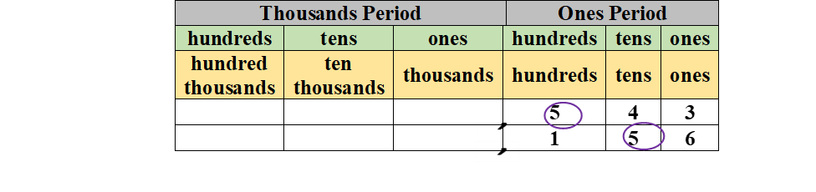
- For example, $10×1=10$ and $10×10=100$. The teacher begins with a ones cube and explains to students that “we are going to model $10×1=10$using our base-ten blocks.” Students count out 10 ones cubes and exchange them for a ten rod. The teacher explains that the tens rod represents the value 10, which is 10 times greater than the value 1 represented by the ones cube. Write the equation $10×1=10$ to reinforce this relationship and repeat this process to model $10×10=100$. Then, students exchange a hundreds flat for 10 ten rods to model $100 ÷10=10$.The teacher explains that the value represented by a tens rod is 10 times less than the value represented by the hundreds flat and use a place value chart to show this relationship while writing the equation $100÷10=10.$To reinforce this relationship repeat this process to model $10÷10=1$.

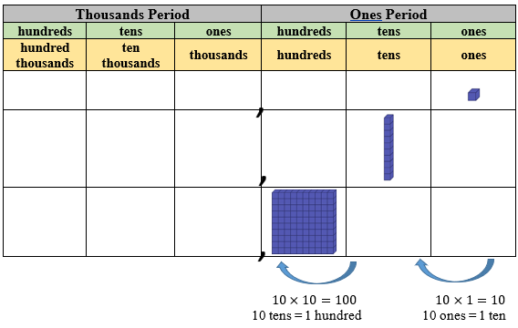

Instructional Tasks
Instructional Task 1 (MTR.7.1)
Paul and his family traveled 528 miles for their summer vacation. Wayne and his family traveled 387 miles for their summer vacation. How much greater is the digit eight in 387 than the digit eight in 528? Have students explain their answer and discuss what role, if any, the other digits play.

Instructional Task 2 (MTR.7.1)
Anna’s hamster weighs 867 grams. Erin’s hamster weighs 713 grams. How many times greater is the digit 7 in 713 than the digit 7 in 867? Have students explain their answers and discuss what role, if any, the other digits play?

Instructional Task 3
Use a number cube to roll a 3-digit number.
Part A. Multiply your 3-digit number by 10.
Part B. Take your answer from Part A and divide by 10.
Part C. How are your answers in each part related to the original 3-digit number? What patterns can you see?

Instructional Items
Instructional Item 1
The clues below describe the 4 digits of a mystery number that contains the digits 3,4,7,8.
- The value of the 8 is 10 times the value of the 8 in 3,518.
- The value of the 7 is 10 times the value of the 7 in 1,273.
- The value of the 4 is 10 times the value of the 4 in 7,482.
- The missing place value is the 3.

What is the number?
- 7,483
- 8,743
- 7,834
- 4,783

Instructional Item 2
The clues below describe the 4 digits of a mystery number that contains the following digits:
2, 5, 7, 9.
- The value of the 2 is $\frac{1}{10}$ the value of 2 in 7, 326.
- The value of the 5 is $\frac{1}{10}$ the value of 5 in 549.
- The value of the 7 is $\frac{1}{10}$ the value of 7 in 79,428.corrected
- The value of the 9 is $\frac{1}{10}$ the value of 9 in 9,823.

Instructional Item 3
In the table below, match each equation to the correct product or quotient.
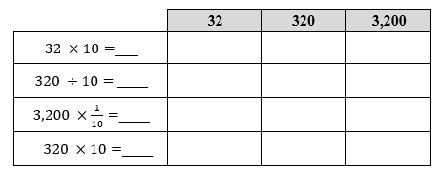

Instructional Item 4
Fill in the blanks.
Part A: When 963 is multiplied by $\frac{1}{10}$, the value of the 9 changes from 9 _______ to 9 ________ because the digits shift _______ places to the _______.

Part B: When 963 is multiplied by 10 the value of the 9 changes from 9 _______ to 9 ________ because the digits shift _______ places to the _______.

*The strategies, tasks and items included in the B1G-M are examples and should not be considered comprehensive.

MA.4.NSO.1.2

Benchmark
MA.4.NSO.1.2 Read and write multi-digit whole numbers from 0 to 1,000,000 using standard form, expanded form and word form.
Example: The number two hundred seventy-five thousand eight hundred two written in standard form is 275,802 and in expanded form is $200,000+70,000+5,000+800+2$ or $(2×100,000)+(7×10,000)+(5×1,000)+(8×100)+(2×1)$.

Connecting Benchmarks/Horizontal Alignment
MA.4.NSO.2.5

Terms from the K-12 Glossary
- Whole Number
- Expression

Vertical Alignment
Previous Benchmarks  • MA.3.NSO.1.1,  MA.3.NSO.1.2 | Next Benchmarks  MA.5.NSO.1.2
Purpose and Instructional Strategies
The purpose of this benchmark is for students to read numbers appropriately and to write numbers in all forms and have flexibility with the different forms. This benchmark builds on the work in Grade 3 of reading and writing numbers in multiple ways to 10,000 (MA.3.NSO.1.1). Writing numbers in expanded form can help students see the relationship between place-value positions (MTR.5.1). Additionally, translating from written form to symbolic form builds the understanding of place-value position which extends to decimal place values in Grade 5 (MA.5.NSO.1.2).
- During instruction, teachers should relate all three forms using place value charts and place-value manipulatives (e.g., blocks) (MTR.3.1, MTR.4.1, MTR.5.1).
- Students should have opportunities to explore flexibly grouping. For example, that 285 could be 28 tens + 5 ones or 1 hundred, 18 tens and 5 ones, etc.
- Decomposing numbers flexibly helps students reason through multiplication and division strategies. Multiple representations of the number (MTR.2.1) allow for opportunities to apply the commutative and associative properties. This will allow students to explain their thinking and show their work using place-value strategies and algorithms, in addition to verifying that their answer is reasonable.
- Instruction includes explanation of the word and when reading and writing in word form. Students should understand that the word and represents a decimal point in a number and separates the portions of the number that are greater than and less than 1.
  - For example, when reading 5,074, students should read as follows: five thousand seventy-four. Students may want to read the number five thousand and seventy-four, which is incorrect word form for whole numbers.

Common Misconceptions or Errors
Students may have misconceptions when translating word form to standard form. Numbers like one thousand often do not cause a problem; however, a number like three thousand four can cause problems for students. Many students will understand the 3,000 and the 4 but then instead of placing the 4 in the ones place, students will write the numbers as they hear them, 30,004, not understanding that this number represents more than 3,004

Students often include the word and when reading multi-digit whole numbers. And marks the transition between numbers greater than one and less than one.

Strategies to Support Tiered Instruction
Instruction includes opportunities to model and write numbers with a zero in various place values. A place value chart and models such as base-ten blocks or place value disks can be used to help students understand that when the digit in a multi-digit whole number is 0, it represents a 0 of that place value. Extend this understanding to include writing numbers in word and expanded form.
- For example, in the number 40,607 there are $0 thousands$ and $0 tens$.
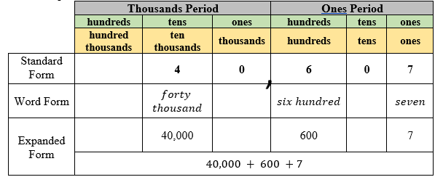
- For example, in the number 1,002, there are $0 hundreds$ and$0 tens$.
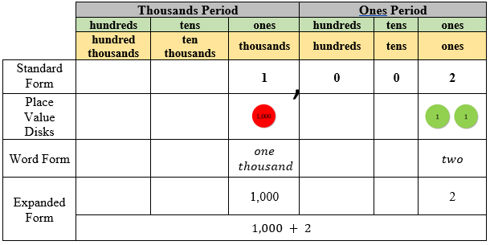

Instructional Tasks
Instructional Task 1 (MTR.3.1)
Write each number in standard form and in expanded form.
- $Eight hundred two thousand five hundred fifty$
- $Twenty thousand three$
- $One thousand four hundred fifty-six$
- $Seven hundred nineteen thousand two hundred forty-eight$
- $Three thousand eighty-one$

Instructional Task 2
Write each number in two other forms.
  - 5, 382
  - nine thousand one
  - $\left(6 X 10,000\right)+\left(4 X 1,000\right)+\left(3 X 100\right)+\left(8 X 10\right)+(9 X 1)$
  - five hundred sixty-five thousand, two hundred three

Instructional Task 3
Students will need 4-7 number cubes to complete this activity.
(Teacher can scaffold learning by starting with fewer number cubes and building up to 1,000,000- limit of the benchmark.)
Steps:
- Students roll number cubes.
- Students assemble the number cubes in an order of their choosing.
- Students write the number in standard form.
- Students write the number in expanded form.
- Students write the number in word form.
- Repeat all the steps as long as time allows.

Instructional Task 4
Write the following numbers as stated in the table.
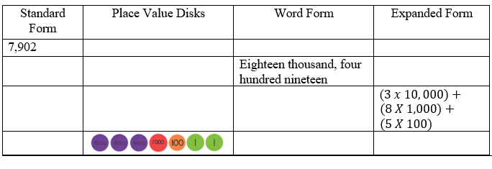

Instructional Items
Instructional Item 1
Select all the ways to rename the number 2,340.
- 234 tens
- $2,340 ones$
- $234 thousands$
- $2 hundreds+ 34 ones$
- $2 thousands+ 34 tens$
- $2 thousands+ 34 ones$
- $2 thousands+ 34 hundreds$

Instructional Item 2
Select all the ways to rename the number 3,182
- 3 thousands 182 ones
- 31 hundreds 8 tens 2 ones
- (3 x 1000) + (1 x 100) + (8 x 10) + (2 x 1)
- 3,182 tens
- 31 thousands 82 ones

Instructional Item 3
Part A. Write 345,987 in expanded form.
Part B. Write 345,987 in expanded form a different way.

Instructional Item 4
Write fifty-four thousand three hundred two in standard form.
________________________________

*The strategies, tasks and items included in the B1G-M are examples and should not be considered comprehensive.

MA.4.NSO.1.3

Benchmark
MA.4.NSO.1.3 Plot, order and compare multi-digit whole numbers up to 1,000,000.
Example: The numbers 75,421; 74,241 and 74,521 can be arranged in ascending order as 74,241; 74,521 and 75,421.
Benchmark Clarifications:
Clarification 1: When comparing numbers, instruction includes using an appropriately scaled number line and using place values of the hundred thousands, ten thousands, thousands, hundreds, tens and ones digits.
Clarification 2: Scaled number lines must be provided and can be a representation of any range of numbers.
Clarification 3: Within this benchmark, the expectation is to use symbols ( or =).

Connecting Benchmarks/Horizontal Alignment
- MA.4.NSO.2.5

Terms from the K-12 Glossary
- Whole Number

Vertical Alignment
Previous Benchmarks  - MA.3.NSO.1.3 | Next Benchmarks  - MA.5.NSO.1.4
Purpose and Instructional Strategies
The purpose of this benchmark extends the work in Grade 3 to plotting, ordering and comparing numbers using place value up to 1,000,000. In Grade 5, students will extend their thinking to plot, order and compare multi-digit numbers with decimals to the thousandths (MA.5.NSO.1.4).
- Place value strategies should be used to compare numbers.
  - For example, in comparing 65,570 and 65,192, a student might say both numbers have the same value of 10,000s and the same value of 1000s; however, the value in the 100s place is different so that is where the comparison of the two numbers would be determined.
- Students need opportunities to compare numbers in various situations to build procedural fluency and to compare numbers with the same number of digits, numbers that have the same number in the leading digit position, and numbers that have different numbers of digits and different leading digits (e.g., compare the four numbers) (MTR.5.1).
- It is important for instruction to define the meaning of the $≠$ symbol.. It is recommended that students use $=$ and $≠$ symbols first. Once students have determined that numbers are not equal, then they can determine “how” they are not equal, with the understanding now the number is either $<$ or $>$. If students cannot determine if amounts are $≠$or $=$then they will struggle with $<$ or $>$. This will build understanding of statements of inequality and help students determine differences between inequalities and equations.
- During instruction, students should apply understanding of flexible representations from MA.4.NSO.1.2 to help them reason while plotting, ordering and comparing.
- Instruction expects students to justify their arguments when plotting, comparing and ordering decimals (MTR.4.1).

Common Misconceptions or Errors
- Students often assume that the first digit of a multi-digit number indicates the size of a number. The assumption is made that 864 is greater than 2,001 because students are focusing on the leading digit instead of the place values of the number.
- Students may compare the place values from right to left because many algorithms add and subtract from right to left. Emphasize that the greatest place value is on the left, so they should compare from the largest to smallest place. Students may find it helpful to model the numbers using place-value blocks or a place-value chart to visualize comparisons.

Strategies to Support Tiered Instruction
- Instruction includes the use of a number line, models such as place value disks, place value charts and relational symbols to compare numbers that have a different number of digits.
  - For example, when comparing 789 and 1,202 the teacher labels the endpoints of the number line 0 and 2,000 and the midpoint of 1,000. The teacher asks students to place 789 and 1,202 on the number line and discusses the placement of the numbers and distance from zero, using the number line to show that 789 is closer to zero than 1,202 so $789 <1,202.$ Also, the teacher uses the number line to show that 1,202 is farther from zero so $1,202>789$. The teacher explains that 789 and 1,202 are different points on the number line so $789≠1,202,$ asking students to identify numbers that are greater than... and less than.... The teacher repeats with numbers that have a different number of digits (number line endpoints of 0 and 100,000 marked with multiples 10,000) and discusses the placement of the other numbers on the number line and if their values are greater than or less than other numbers.
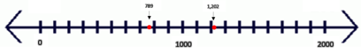
  - For example, when comparing 1,123 and 954, students represent 1,123 and 954 using place value disks and a place value chart. The teacher asks students to compare these numbers, beginning with the greatest place value, explaining that the number 1,123 has $1 thousands$ and the number 954 does not have any $thousands$ so$954<1,123$ and $1,123 >954.$ Additionally, the teacher explains that because 954 and 1,123 do not have the same values in the thousands place that $954≠1,123$.
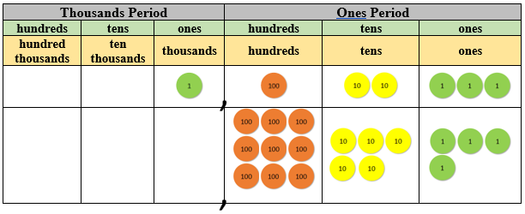

Instructional Tasks
Instructional Task 1 (MTR.5.1)
Students will create numbers that meet specific criteria through this performative task.
Provide students with cards numbered 0 through 9. Ask students to select 4 to 6 cards, then using all the cards make the greatest number possible with all cards, the least number possible, the closest number to 6,000, a number that is greater than 6,000, or a number that is less than 6,000, etc.then discussion. Mathematical discourse will reinforce student understanding.

Instructional Task 2
Provide students with 1 number cube. Students will roll the number cube 5 times creating the greatest 5-digit number possible. When the number cube is rolled the first time, the student must choose where to place the number rolled and continue rolling the number cube until all five spaces are filled. Whoever creates the greatest number wins.

Instructional Task 3
Part A. Plot the numbers in the table on the number line.
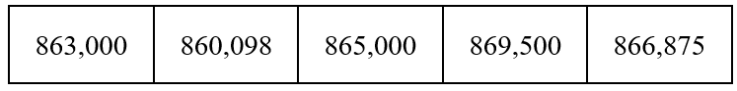
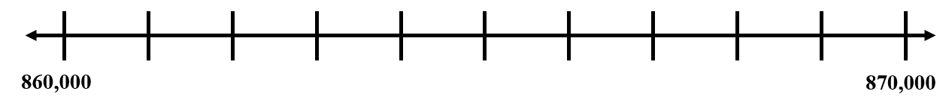
Part B. Choose two values from the list and compare them using <, >, or =.
Part C. Choose a number between 864,000 and 866,000 and plot it on the number line.
Part D: Use evidence from your number line to justify which number is the greatest.

Instructional Items
Instructional Item 1
Which number correctly completes this statement?
$$_________ < 44,038$$

- 40,000 + 600 + 30 + 7
- 40,000 + 5,000 + 30 = 7
- Forty-four thousand, nine hundred fifty
- Forty-four thousand, one hundred twelve

Instructional Item 2
Order 29,104; 28,652 and 29,099 in descending order.

Instructional Item 3
What is the value of the point on the number line?
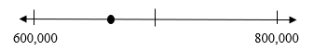

- 625,400
- 660,140
- 725,400
- 760,140

*The strategies, tasks and items included in the B1G-M are examples and should not be considered comprehensive.

MA.4.NSO.1.4

Benchmark
MA.4.NSO.1.4 Round whole numbers from 0 to 10,000 to the nearest 10, 100 or 1,000.
Example: The number 6,325 is rounded to 6,300 when rounded to the nearest 100.
Example: The number 2,550 is rounded to 3,000 when rounded to the nearest 1,000.

Connecting Benchmarks/Horizontal Alignment
- MA.4.NSO.2.5

Terms from the K-12 Glossary
- Whole Number

Vertical Alignment
Previous Benchmarks  - MA.3.NSO.1.4 | Next Benchmarks  - MA.5.NSO.1.5
Purpose and Instructional Strategies
The purpose of this benchmark is for students to use place value understanding to explain and reason about rounding. Students should have numerous experiences using a number line and a one hundred chart as tools to support their work with rounding. This benchmark continues instruction of rounding from Grade 3, where students rounded numbers from 0 to 1,000 to the nearest 10 or 100 (MA.3.NSO.1.4).
- In Grade 4, rounding is not a new concept and students need to build on the skills of rounding to the nearest 10 or 100 (MA.3.NSO.1.4) to include larger numbers and place value. What is new for Grade 4 is rounding to the nearest 1,000 and to digits other than the leading digit (e.g., round 23,960 to the nearest hundred). This requires more complex thinking than rounding to the nearest ten thousand because the digit in the hundreds place represents 900 and when rounded it becomes 1,000, not just zero. Students should also begin to develop some efficient rules for rounding fluently by building from the basic strategy of - “Is 37 closer to 30 or 40?” Number lines are effective tools for this type of thinking. Students need to generalize the rule for much larger numbers and rounding to values that are not the leading digit (MTR.3.1, MTR.5.1).
- Rounding numbers is a skill that helps students estimate reasonable solutions when using the four operations. Instruction of rounding skills should be taught within the context of estimating while using the four operations. Rounding numbers in an expression should be done before performing operations to estimate reasonable sums or differences. Rounding sums, differences, products and quotients should not be done after students have already performed operations.
- Instruction should not focus on tricks for rounding that do not focus on place value understanding or the use of number lines.
- Rounding skills continue important in later grades as students estimate while solving real-world problems. Students should explain and reason about their answers when they round and have numerous experiences using a number line and a place-value chart as tools to support their work with rounding (MTR.4.1, MTR.5.1).

Common Misconceptions or Errors
- Teaching only rote procedures for rounding may lead to misconceptions about the magnitudes of numbers. Students may need to have a strong foundation of place value concepts before students may find success with rounding. The reliance on mnemonics, songs or rhymes during instruction can often confuse students further because they may lack the conceptual understanding as they begin to round decimals in Grade 5.

Strategies to Support Tiered Instruction
- Instruction includes using number lines and place value understanding to round numbers to the nearest 10, 100 or 1,000. Instruction provides opportunities to reason about the magnitude of numbers using benchmarks and place value concepts.
  - For example, the teacher has students round 3,874 to the nearest thousand using a number line and place value understanding, explaining that the endpoints of the number line will be represented using thousands, because they are rounding to the nearest thousand. Next, the teacher explains that there are 3 thousands in the number 3,874 and one more thousand would be 4 thousands. The teacher then represents these endpoints on the number line as 3 thousands (3,000) and 4 thousands (4,000) with the mid-point labeled as 3 thousand and 5 hundreds (500). This midpoint is halfway between 3,000 and 4,000. Students are asked to plot 3,874 on the number line and discuss if it is closer to 3,000 or 4,000 while the teacher explains that 3,874 rounds to 4,000 because it is greater than the midpoint of 3,500 and closer to 4,000 on the number line.
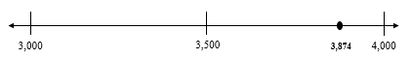

  - For example, students round 283 to the nearest ten using a number line and place value understanding while the teacher explains that the endpoints of the number line will be represented using tens, because they are rounding to the nearest ten. The teacher then explains that there are 28 tens in the number 283 and one more ten would be 29 tens, representing these endpoints on the number line as 28 tens (280) and 29 tens (290). The midpoint on the number line can be labeled as 28 tens and 5 ones (285). This midpoint is halfway between 280 and 290. Ask students to plot 283 on the number line and discuss if it is closer to 280 or 290. Explain that 283 rounds to 280 because it is 7 units away from 290 and only 3 units away from 280. It is also less than the midpoint of 285.
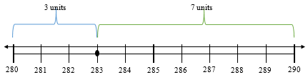

Instructional Tasks
Instructional Task 1 (MTR.3.1)
To the nearest ten, what is the least number that rounds to 4,000?
To the nearest hundred, what is the least number that rounds to 4,000?
Instructional Task 2
To the nearest ten, what is the greatest number that rounds to 7,000?
To the nearest hundred, what is the greatest number that rounds to 7,000?

Instructional Task 3
Round each number to the given place value.
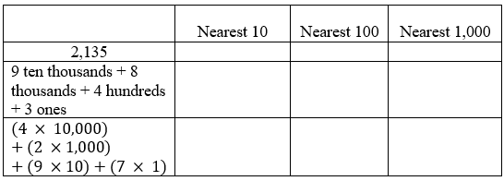
Instructional Task 4
Round each number to the given place value.
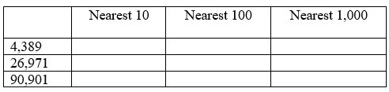

Instructional Items
Instructional Item 1
What is $5,686$ rounded to the nearest thousand??
- $5,000$
- $5,700$
- $6,000$
- $6,600$

Instructional Item 2
The school band sold 1,375 cookies at a bake sale.
What is 1,375 rounded to the nearest hundred?

Instructional Item 3
A local park rounded the attendance of people tubing down the river to 13,000.
They rounded to the nearest thousand.
Which of the following numbers can be the actual number of people who tubed down the river?
- 12,198
- 12,554
- 12,276
- 13,844

*The strategies, tasks and items included in the B1G-M are examples and should not be considered comprehensive.

MA.4.NSO.1.5

Benchmark
MA.4.NSO.1.5 Plot, order and compare decimals up to the hundredths.
Example: The numbers 3.2; 3.24 and 3.12 can be arranged in ascending order as 3.12; 3.2 and 3.24.
Benchmark Clarifications:
Clarification 1: When comparing numbers, instruction includes using an appropriately scaled number line and using place values of the ones, tenths and hundredths digits.
Clarification 2: Within the benchmark, the expectation is to explain the reasoning for the comparison and use symbols ($<$, $>$ or $=$).
Clarification 3: Scaled number lines must be provided and can be a representation of any range of numbers.

Connecting Benchmarks/Horizontal Alignment
- MA4.NSO.2.6, MA.4.NSO.2.7
- MA.4.FR.1.2,
- MA.4.DP.1.1, MA.4.DP.1.3

Terms from the K-12 Glossary
- Equal sign
- Number line

Vertical Alignment
Previous Benchmarks  - MA.3.NSO.1.3 | Next Benchmarks  MA. 5.NSO.1.4
Purpose and Instructional Strategies
The purpose of this benchmark is for students to plot, order and compare decimals using place value. Grade 4 contains the first work with decimals. During instruction make connections to decimal fractions (e.g., $\frac{1}{10},\frac{1}{100}$) (MA.4.FR.1.2).
- During instruction, students should apply understanding of flexible representations from MA.4.NSO.1.2 to help them reason while plotting, ordering and comparing.
- For instruction, teachers should show students how to represent these decimals on scaled number lines. Students should use place value understanding to make comparisons.
- Students learn that the names for decimals match their fraction equivalents (e.g., $2 tenths$ is equivalent to $0.2$ which is equivalent to $\frac{2}{10}$).
- Students build area models (e.g., a $10×10$ grid) and other models to compare decimals.
- Instruction expects students to justify their arguments when plotting, comparing and ordering decimals (MTR.4.1).

Common Misconceptions or Errors
- Students treat decimals as whole numbers when making comparison of two decimals. They think the longer the number, the greater the value. Students may be confused when comparing numbers that have the same number of digits (but different values).
  - For example, they think that 0.04 is greater than 0.4.
  - For example, when comparing 2.45 and 13.24, a student may not consider the magnitude of the numbers and only look at their digits. That student may claim that 2.45 is greater than 13.24 because the digit 2 is greater than the digit 1 (though they are actually comparing 2 and 10).
- Students may compare the place values from right to left because many algorithms add and subtract from right to left. Emphasize that the greatest place value is on the left, so they should compare from the greatest place value to the least. Students may find it helpful to model the numbers using base-10 blocks or a place-value chart to visualize decimal place comparisons.

Strategies to Support Tiered Instruction
- Instruction includes the use of place value understanding, decimal fractions and decimal grids to compare decimals.
  - For example, students compare 0.14 and 0.2 using decimal fractions. The teacher begins instruction by having students write each decimal as a fraction, $\frac{14}{100}$ and $\frac{2}{10}$. The teacher explains that $\frac{2}{10 }$ is equal to $\frac{20}{100 }$ because if we multiply the numerator and denominator of $\frac{2}{10}$ by 10, we generate the equivalent fraction $\frac{2}{10}=\frac{2 × 10}{10 ×10}=\frac{20}{100}$. Next, the teacher compares the fractions to determine that $\frac{14}{100}<\frac{20}{100}$ , so $0.14<0.2$.
  - For example, students use place value understanding and a place value chart to compare 0.14 and 0.2. The teacher explains that when comparing decimals, we start with the digit to the far left because we want to compare the greatest place values first. Both values have a 0 in the ones place, so we will move to the tenths place. One tenth is less than two tenths, so $0.14<0.2$.
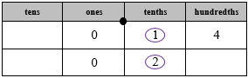
  - For example, students compare 0.3 and 0.03 using decimal fractions. The teacher begins instruction by having students write each decimal as a fraction, $\frac{3}{10}$ and $\frac{3}{100}$. The teacher then explains to students that $\frac{3}{10 }$ is equal to $\frac{30}{100 }$, because if we multiply the numerator and denominator of $\frac{3}{10}$ by 10, we generate the equivalent fraction $\frac{3}{10}=\frac{3 × 10}{10× 10}=\frac{30}{100}$. Next, the teacher compares the fractions to determine that $\frac{30}{100}>\frac{3}{100}$, so $0.3>0.03$.
  - For example, students compare 0.3 and 0.03 using decimal grids, representing each value and explain that 0.3 covers a greater are of the decimal grid than 0.03, so 0.3 is greater than 0.03.
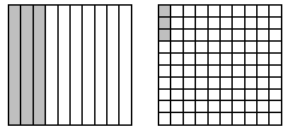

Instructional Tasks
Instructional Task 1 (MTR.3.1)
Use relational symbols to fill in the blanks to compare the numbers.
- $3 tenths + 5 hundredths _____ 3 tenths + 11 hundredths$
- $4 hundredths + 5 tenths _____ 1 tenth + 33 hundredths$
- $4 hundredths + 1 tenth _____ 1 tenth + 4 hundredths$
- $5 hundredths + 1 tenth _____ 15 hundredths + 0 tenths$
- $5 hundredths + 1 tenth _____ 0 tenths + 15 hundredths$

Instructional Task 2 (MTR 3.1)
0 .34, $\frac{38}{100}$, 25 hundredths, 0 hundredths
Part A. Plot the numbers above on a number line.
0 .34, $\frac{38}{100}$, 25 hundredths, 40 hundredths
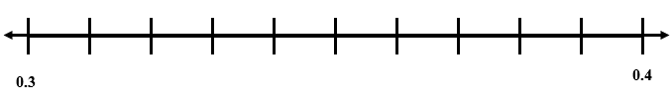
Part B. List the following numbers in order from least to greatest.

Instructional Task 3
Part A. Plot the numbers 12.23, 12.02, 12.12, 12.32, 12.30 on a number line. Make sure to label the points on the line.
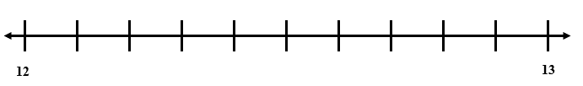
Part B. List the numbers in order from least to greatest.

Instructional Items
Instructional Item 1
Select all the values that would make the comparison $0.6>__$ a true statement.
- 0.06
- 0.70
- 0.8
- 0.5
- 0.42

Instructional Item 2
Order 0.3, 0.08 and 0.22 from least to greatest.

Instructional Item 3
Select the number the point on the line plot represents.

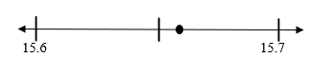

- 15.62
- 15.64
- 15.66
- 15.68

*The strategies, tasks and items included in the B1G-M are examples and should not be considered comprehensive.

MA.4.NSO.2 Build an understanding of operations with multi-digit numbers including decimals.

MA.4.NSO.2.1

Benchmark
MA.4.NSO.2.1 Recall multiplication facts with factors up to 12 and related division facts with automaticity.

Connecting Benchmarks/Horizontal Alignment
- MA. 4.FR.2.4
- MA.4.AR.2.1

Terms from the K-12 Glossary
- Associative property of multiplication
- Automaticity
- Commutative property of multiplication
- Distributive property
- Factor

Vertical Alignment
Previous Benchmarks  - MA.3.NSO.2.2, MA.3.NSO.2.4 | Next Benchmarks  - MA.5.NSO.2.1, MA.5.NSO.2.2
Purpose and Instructional Strategies
The purpose of this benchmark is for students to be able to state (recall) their multiplication and division facts in an effortless manner. This work builds on prior multiplication and related division fact strategy work from Grade 3 (MA.3.NSO.2.4). Students also understand that multiplication is commutative and that the Distributive Property can be used to break more complex facts into easier ones.
  - To help reach automaticity of multiplication facts, students should have opportunities to explore multiplication patterns with repetition. These concepts may be addressed during the exploration or procedural reliability stage (MA.3.NSO.2.4) of the benchmark progression.
    - Multiplication by zeroes and ones
    - Doubles (2s facts)
    - Double and Double Again (4s)
    - Doubling three times (8s)
    - Tens facts (relating to place value, $5×10$ is 5 tens or 50)
    - Five facts (half of tens or connect to the analog clock)
    - Skip counting (counting groups of __ and knowing how many groups have been counted)
    - Square numbers (the physical and visual representation of these facts makes a square; e.g., $3×3$)
    - Nines (10 groups less 1 group; e.g., $9×3$ is 10 groups of 3 minus 1 group of 3 so $30-3=27$)
    - Decomposing into known facts ($6×7$ is a double - $6×6$ - plus one more group of 6)
    - Elevens (10 groups and 1 group more; e.g., $11×5$ is 10 groups of 5 plus 1 group of 5 so $50+5=55$)
    - Decomposing using the Distributive property ($12×6=(10×6)+(2×6)=(60)+(12)=72$)
  - To help with reaching automaticity with division facts, students can use their understanding of the relationship between multiplication and division.
For example, to find the quotient of $54 ÷6$ students can begin by writing this expression as the missing factor equation ___$×6 =54$. Then, students can use a fact such as $5 ×6 =30$ or $10 ×6 =60$and adjusting to help them determine that $9 ×6=54$.
  - Throughout K-5 instruction, it is not recommended to use timed fact fluency assessments to learn and practice facts.

Common Misconceptions or Errors
- Many students have difficulty with multiplication and related division facts when teachers rely solely on memorization of facts. It is important that strategy work and conceptual understanding is the foundation of instruction for multiplication and division facts. It is important that conceptual understanding of multiplication and division, as well as repetition and practice connected to other mathematical concepts are included to facilitate the recall of facts.

Strategies to Support Tiered Instruction
- Instruction includes building strategies and conceptual understanding to recall facts to find unknown multiplication fact by using known facts.
  - For example, if students do not know the product for $9×12$ have them use a known fact such as $10×12$. The known fact of $10×12=120$ can be used to find the product of $9×12$ by subtracting one more group of 12 from the product of 120 to find the product of 108.
  - For example, if students do not know the product for $6×7$ have them use a known fact such as $5×7$. The known fact of $5×7=35$ can used to find the product of $6×7$by adding one more group of 7 to the product of 35 to find the product of 42.
- Instruction includes building strategies and conceptual understanding to recall facts to find unknown division facts by using multiplication facts.
  - For example, if students do not know the quotient for $121÷11$ have them think about how many groups of 11 equal 121. Have students write the problem as a missing factor problem $__×11=121$ to help use multiplication facts to find the quotient. Students can also use known multiplication facts to solve: 10 groups of 11 is 110 and one more group of 11 equals 121 so $121÷11$ equals 11.
  - For example, if students do not know the quotient for $45÷5$ have them think about how many groups of 5 equal 45. Have students write the problem as a missing factor problem $___×5=45$ to help use known multiplication facts to find the quotient.

Instructional Tasks
Instructional Task 1 (MTR.5.1)
Explain how the 2s facts, 4s facts and 8s facts for multiplication are related.

Instructional Task 2
List the first 12 multiples of each of the following 3, 6 and 9. Circle the multiples they have in common. Discuss why they share these multiples.

Instructional Task 3
Multiplication Challenge:
Students will use a blank 10x10 grid to create a multiplication chart without referring to a premade chart.
Suggested order to complete: 1’s, 10’s, 5’s, 9’s, 2’s, 3’s, 4’s, 6’s, 7’s, 8’s
Steps:
- Have students time themselves filling in the blank grid.
- If they are able to fill in all the blanks, challenge them to repeat in less time.
- Repeatedly challenge students to fill in a 10 x 10 multiplication chart as quickly and accurately as possible. To meet the expectations of the benchmark, the activity should be continued to a 12 x 12 grid.

Instructional Items
Instructional Item 1
Select all the true equations.
- $11 = 132 ÷ 11$
- $7 × 12 = 84$
- $56 = 7 × 7$
- $49 ÷ 7 = 7$
- $6 × 11 = 66$

Instructional Item 2
Match each equation to the correct product.

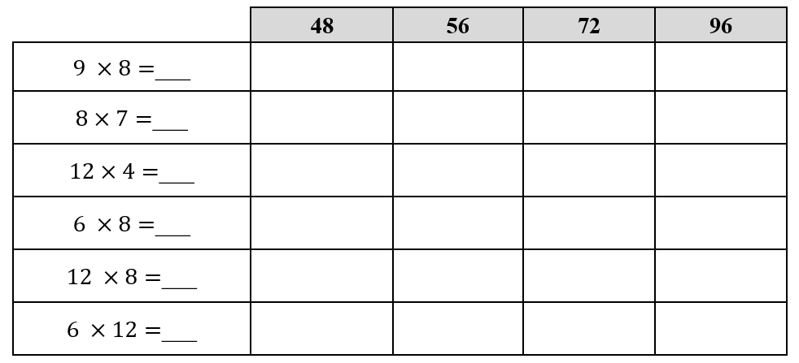.

Instructional Item 3
Match each equation to the correct quotient.
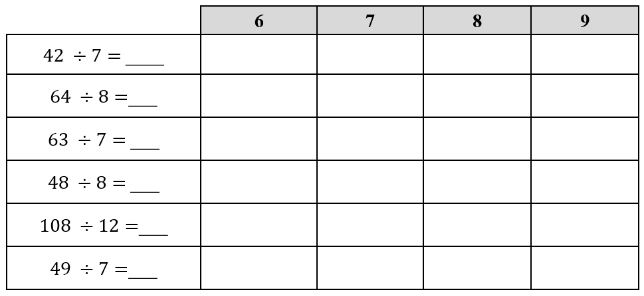

*The strategies, tasks and items included in the B1G-M are examples and should not be considered comprehensive.

MA.4.NSO.2.2

Benchmark
MA.4.NSO.2.2 Multiply two whole numbers, up to three digits by up to two digits, with procedural reliability..
Benchmark Clarifications:
Clarification 1: Instruction focuses on helping a student choose a method they can use reliably.
Clarification 2: Instruction includes the use of models or equations based on place value and the distributive property.

Connecting Benchmarks/Horizontal Alignment
- MA.4.AR.1.1
- MA.4.M.1.2
- MA.4.M.2.1
- MA.4.GR.2.1, MA.4.GR.2.2

Terms from the K-12 Glossary
- Area model
- Distributive property
- Expression
- Equation
- Factor

Vertical Alignment
Previous Benchmarks  - MA.3.NSO.2.2, MA.3.NSO.2.3, MA.3.NSO.2.4 | Next Benchmarks  - MA.5.NSO.2.1
Purpose and Instructional Strategies
The purpose of this benchmark is for students to choose a reliable method for multiplying 3-digit numbers by 2-digit numbers. It builds on the understanding developed in Grade 3 (MA.3.NSO.2.2/2.3/2.4), builds on automaticity (MA.4.NSO.2.1) and prepares for procedural fluency (MA.4.NSO.2.3 and MA.5.NSO.2.1).
- For instruction, students may use a variety of strategies when multiplying whole numbers and use words and diagrams to explain their thinking (MTR.2.1). Strategies can include using place-value blocks, area models, partitioning, compensation strategies and a standard algorithm.
- Using place value strategies enables students to develop procedural reliability with multiplication and transfer that understanding to division. Procedural reliability expects students to utilize skills from the exploration stage to develop an accurate, reliable method that aligns with their understanding and learning style.
- The area model shows students how they can use place value strategies and the distributive property to find products with multi-digit factors.
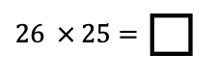 | 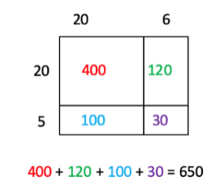
- Additionally, students can use their understanding of base-ten blocks along with place-value strategies to create an area model with pictorials.
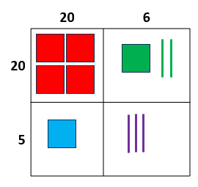
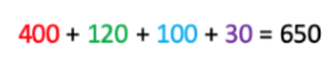

- The distributive property can also be used without the organizational structure of the area model.
  - For example, when solving the problem $43×72$, students can show their understanding by setting up the following expression: $(40×70)+(40×2)+(3×70)+(3×2)$. Instruction includes helping students understand what each partial product represents and how they are related to using the area model.

Common Misconceptions or Errors
- Students that are taught a standard algorithm without any conceptual understanding will often make mistakes. For students to understand a standard algorithm or any other method, they need to be able to explain the process of the method they chose and why it works. This explanation may include pictures, properties of multiplication, decomposition, etc.

Strategies to Support Tiered Instruction
- Instruction includes explaining mathematical reasoning while solving multiplication problems. Instruction also includes determining if a method was used correctly by reviewing the reasonableness of solutions.
  - For example, students determine $5×137$ using an area model and place value understanding.
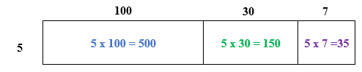 | 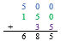
  - For example, students solve $5×137$ using partitioning and place value understanding.
$5×100=500$
$$685$$
$$650$$
$5×30=150$
$$5×7=35$$
  - For example, students determine $4×43$ using place-value blocks and place value understanding.
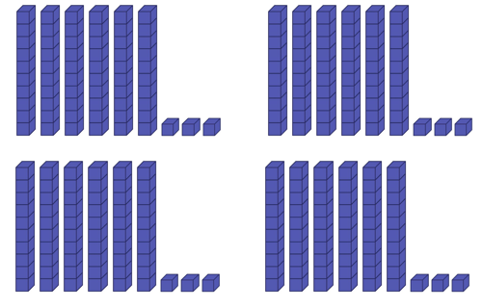
$$16 tens+12 ones$$
$160+12$

160
+ 12
172

  - For example, students determine $4×43$ using partitioning and place value understanding.
$4×40=160$
172
$4×3=12$

Instructional Tasks
Instructional Task 1
Paul orders tomatoes for The Produce Shop. Each box has 24 tomatoes in it. If Paul orders 32 boxes of tomatoes, how many tomatoes will The Produce Shop have to sell? Use a strategy of your choice to find the number of tomatoes The Produce Shop must sell. Explain your thinking and why your method works.

Instructional Task 2
Select four cards from the set of cards below.

Part A. Use your cards to create a three-digit number and a one-digit number. Find the product of your three-digit and one-digit numbers.
Part B. Use your cards to create a two-digit number and another two-digit number. Find the product of your two-digit numbers.
Part C. How are your two products similar? How are they different?

Instructional Task 3
Part A. How can you use the product of $75 ×8$to help you find the product of $750 ×8$?
Part B: Explain the relationship between the two products from Part A using the words “ten times greater and “ten times less.”

Instructional Items
Instructional Item 1
The product of $57$ and $92$ is $_______.$
- $627$
- $4,644$
- $5,234$
- 5,244

Instructional Item 2
Which expressions have a product of 2,128? Select all that apply.
- $56 ×38$
- $532 ×4$
- $44×52$
- $276×8$
- $28×76$

Instructional Item 3
What is the product of 465 x 32?

*The strategies, tasks and items included in the B1G-M are examples and should not be considered comprehensive.

MA.4.NSO.2.3

Benchmark
MA.4.NSO.2.3 Multiply two whole numbers, each up to two digits, including using a standard algorithm with procedural fluency.

Connecting Benchmarks/Horizontal Alignment
- MA.4.AR.1.1
- MA.4.M.1.2
- MA.4.M.2.1
- MA.4.GR.2.1
- MA.4.GR.2.2

Terms from the K-12 Glossary
- Expression
- Equation
- Factor

Vertical Alignment
Previous Benchmarks  MA. 3.NSO.2.2, MA.3.NSO.2.3, MA.3.NSO.2.4 | Next Benchmarks  - MA.5.NSO.2.1
Purpose and Instructional Strategies
The purpose of this benchmark is for students to become procedurally fluent in using a standard algorithm. Work with standard algorithms began in the procedural reliability stage when students explored a variety of methods and learned to use at least one of those methods accurately and reliably. To demonstrate procedural fluency, students may choose a standard algorithm that works best for them. A standard algorithm is a method that is efficient and accurate (MTR.3.1). A standard algorithm is also generalizable, meaning that it works no matter how many digits are involved.
- It is important to challenge students to explain the steps they follow when using a standard algorithm (i.e. regrouping, proper recording and placement of digits by place value). For example, when students use a standard algorithm, they should be able to justify why it works conceptually. Teachers can expect students to demonstrate how their algorithm works, for example, by comparing it to another method for multiplication (MTR.6.1).
- Along with using a standard algorithm, students should estimate reasonable solutions before solving. Estimation helps students anticipate possible answers and evaluate whether their solutions make sense after solving.
- This benchmark supports students as they solve multi-step real-world problems involving combinations of operations with whole numbers (MA.4.AR.1.1).

Common Misconceptions or Errors
- Students that are taught a standard algorithm without any conceptual understanding will often make mistakes. For students to understand a standard algorithm or any other method, they need to be able to explain the process of the method they chose and why it works. This explanation may include pictures, properties of multiplication, decomposition, etc. Students may make computational errors while using standard algorithms when they are unable to reason why their algorithms work.
- Some students may struggle with this benchmark if they do not have a strong command of basic addition and multiplication facts.

Strategies to Support Tiered Instruction
- Instruction includes explaining mathematical reasoning while using a multiplication algorithm. Instruction also includes determining if an algorithm was used correctly by reviewing the reasonableness of solutions.
  - For example, students use an algorithm to determine $41×23$ and explain their thinking using place value understanding. Explicit instruction includes: “Begin by multiplying $3 ones$ times $1 one$. This equals $3 ones$. We will write the $3 ones$ under the line, in the ones place. Next, we will multiply $3 ones$ times $4 tens$. This equals $12 tens$. We will write the $12 tens$ under the line in the hundreds and tens place because $12 tens$ is the same as $1 hundred$ and $2 tens$. This gives us our first partial product of 123. Now we will multiply the $1 one$ by the $2 tens$ from 23. This equals $2 tens$ or 20. We will record 20 below our first partial product of 123. Next, we, we will multiply $2 tens$ times $4 tens$, which equals $8 hundreds$. We will write the 8 in the hundreds place of our second partial product. Our second partial product is 820. Finally, we add our partial products to find the product of 943.”
 |  | 4 | 1
x |  | 2 | 3
 | 1 | 2 | 3 | $=3×41$  This is the same as $(2×41)×10$
+ | 8 | 2 | 0 | $$=20×41$$
 | 9 | 4 | 3

  - For example, students determine $41×23$ using an area model and place value understanding.
 | 8 | 0 | 0
 | 1 | 2 | 0
 |  | 2 | 0
$$+$$ |  |  | 3
 | 9 | 4 | 3
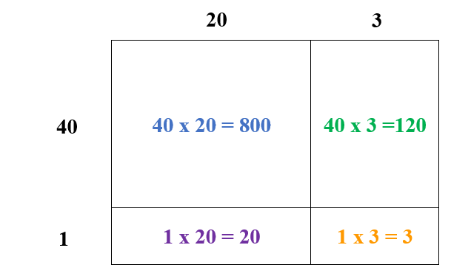

  - For example, students use an algorithm to determine $4×36$ and explain their thinking using place value understanding. Instruction includes stating, “Begin by multiplying $4 ones$ times $6 ones$. This equals $24 ones$ or $2 tens$ and $4 ones$. We will write the $4 ones$ from 24 under the line, in the ones place. We will write the $2 tens$ from 24 as a 2 above the 3, as a regrouped digit in the tens place. Next, we will multiply $4 ones$ times $3 tens$. This equals $12 tens$. We will add the $2 tens$ to the $12 tens$ for a total of $14 tens$. We will write the $14 tens$ under the line in the hundreds and tens place because $14 tens$ is the same as $1 hundred$ and $4 tens$. Our product is 144.”
This 2 represents the $2 tens$ from 24. | 2
 | 3 | 6
$$×$$ |  | 4
1 | 4 | 4

  - For example, students determine $4×36$ using an area model and place value understanding.
 | 1 | 2 | 0
+ |  | 2 | 4
 | 1 | 4 | 4
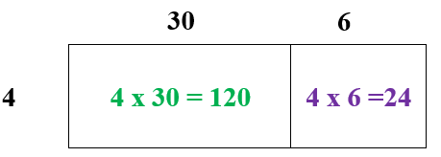
- Instruction includes the use of known facts to find unknown multiplication facts.
  - For example, if the student does not know the product for $4×6$ from the previous example, have students use a known fact such as $4×5$. The known fact of $4×5=20$can used to find the product of $4×6$by adding one more group of 4 to the product of 20 to find the product of 24.

Instructional Tasks
Instructional Task 1 (MTR.4.1, MTR.5.1)
Using the digits 1, 2, 3 and 4, arrange them to create two 2-digit numbers that when multiplied, will yield the greatest product.

Instructional Task 2
Part A. Solve $96×24$ using an area model or the distributive property.
Part B. Solve $96×24$ using a standard algorithm.
Part C. Explain the relationship between your partial products from Part A and your partial products from Part B.

Instructional Items
Instructional Item 1
Select the expressions that have a product of $480$.
- $10 × 48$
- $16 × 30$
- $24 × 24$
- $32 × 1540 × 80$

Instructional Item 2
A multiplication problem is shown.
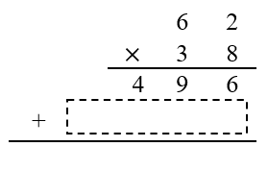
Part A. What is the missing value in the box in the problem shown?
Part B. What is product of $38 × 62$?

*The strategies, tasks and items included in the B1G-M are examples and should not be considered comprehensive.

MA.4.NSO.2.4

Benchmark
MA.4.NSO.2.4 Divide a whole number up to four digits by a one-digit whole number with procedural reliability. Represent remainders as fractional parts of the divisor.
Benchmark Clarifications:
Clarification 1: Instruction focuses on helping a student choose a method they can use reliably.
Clarification 2: Instruction includes the use of models based on place value, properties of operations or the relationship between multiplication and division.

Connecting Benchmarks/Horizontal Alignment
- MA.4.AR.1.1
- MA.4.M.1.2
- MA.4.M.2.1
- MA.4.GR.2.1, MA.4.2.2

Terms from the K-12 Glossary
- Dividend
- Divisor
- Expression
- Equation
- Quotient

Vertical Alignment
Previous Benchmarks  - MA.3.NSO.2.4 | Next Benchmarks  - MA.5.NSO.2.2

Purpose and Instructional Strategies
The purpose of this benchmark is for students to choose a reliable method for dividing 4-digit numbers by 1-digit numbers. This builds on the understanding developed during exploration (MA.3.NSO.2.2) and on automaticity (MA.4.NSO.2.1) and prepares for procedural fluency (MA.5.NSO.2.2).
- This benchmark connects to previous work with division within 144. Before achieving procedural reliability, it may be useful for students to engage in additional exploratory work dividing multi-digit numbers by single-digit numbers. Students should use multiple methods (MTR.2.1) such as area models or models of base-ten blocks to connect understanding to a method they will use with procedural reliability and ultimately leading to a standard algorithm.
  - Base-Ten Blocks
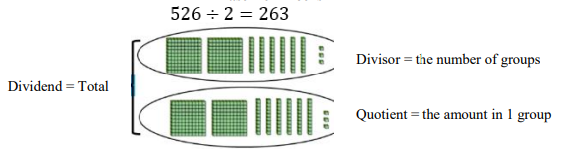
- Long Division Algorithm
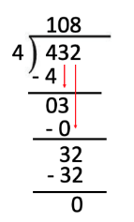
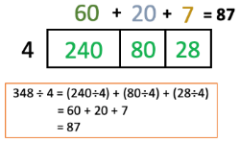
- Area Model

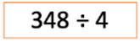

- Partial Quotient Division
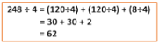
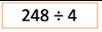
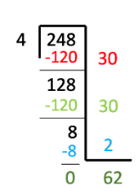
- When students are using their preferred method, they should be able to explain their thinking, connecting it to place value understanding and the relationship between division and repeated subtraction.
- A standard algorithm is a method that is efficient and accurate (MTR.3.1). A standard algorithm is also generalizable meaning that it works no matter how many digits are involved.
- Along with using a standard algorithm, students should estimate reasonable solutions before solving. Estimation helps students anticipate possible answers and evaluate whether their solutions make sense after solving.
- This benchmark supports students as they solve multi-step real-world problems involving combinations of operations with whole numbers (MA.4.AR.1.1). In a real-world problem, students should interpret remainders depending on its context.

Common Misconceptions or Errors
- Many students are taught an algorithm for division and then tend to look at the digits within the number as single digits instead of thinking about the place value of each digit or thinking about the number as a whole. When asked if their solution is reasonable, students do not understand what is reasonable because they are unable to estimate since they do not see the number in its entirety, but rather, as individual digits. Students must have a solid understanding about place value and the properties of operations to make sense of division.
- Along with using a standard algorithm, students should estimate reasonable solutions before solving. Estimation helps students anticipate possible answers and evaluate whether their solutions make sense after solving.
- Some students may not understand that the remainder represents a fraction with the divisor as the denominator. For example, $7÷3=2r1$ means that $7÷3 =2\frac{1}{3}$. Students should have experience with equal sharing division problems that involve remainders (MA.4.AR.1.1).

Strategies to Support Tiered Instruction
- Instruction includes connecting place value with the partial products model. Students should not view the digits as individual numbers but connect individual digits with the value of that number.
  - Example: 366 is $300 + 60 + 6$.
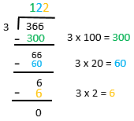
- Instruction includes problems involving division with a remainder. Students use models to understand what the remainder is. The remainder can be written as a whole number or a fraction.
  - For example, Karly, Juan, and Li share 4 cookies equally. How many whole cookies can each person eat? What fraction of the fourth cookie does each person get?
  - Karly, Juan, and Li each can eat one whole cookie but then must split the 4th cookie into thirds so that they can each eat 1$\frac{1}{3}$ cookies. The remainder 1 in this division problem represents the fraction $\frac{1}{3}$.
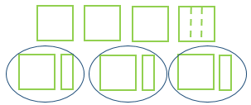
- Instruction connects place value to dividing whole numbers equally. Students build the number with base ten place-value blocks and then physically divide the number into equal groups.
- For example, when solving $366 ÷ 3$, students should build the number 366 and then physically move the blocks into 3 equal groups. This will help solidify the understanding from thinking of the digit as a “3” and now thinking about it as 300.
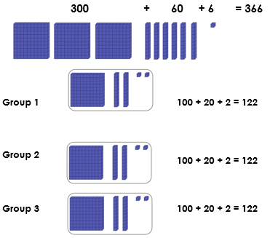
- Instruction includes the opportunity to use models to understand what the remainder is. The remainder can be written as a whole number or a fraction. Students physically cut or break apart paper to show what is happening in problems involving remainders.
  - For example, using the problem: Frank and Lisa share five brownies. How many whole brownies can they each eat? Students should model the problem with five pieces of paper, each representing one brownie. Students should start by labeling each brownie. Frank and Lisa each have two brownies with one brownie left over. Then, students physically cut the last brownie into two equal parts so that each person is able to eat 2 ½ brownies. Relate this to an equation $5÷2=2 ½.$
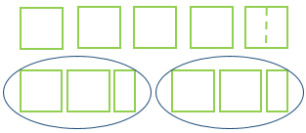

Instructional Tasks
Instructional Task 1 (MTR.5.1)
Using only the number tiles 2, 3, 4, 5, 6 or 7, fill in the blanks in the division situation to find a quotient as close to 100 as possible.
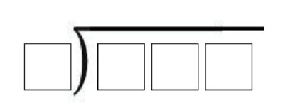

Instructional Task 2 (MTR.7.1)
Sam and Sally were given $117 after they helped deliver groceries for a month. To share the money equally, Sam divides 117 by 2 and gets 58 with a remainder of 1. Explain how they should use this result to determine their equal shares in dollars and cents.

Instructional Task 3
There are 167 fourth graders going on a field trip. Each van holds 8 students. How many vans are needed for the field trip? How do you interpret the remainder in this problem?

Instructional Task 4
Which of the quotients is the greatest?
a. $2,115 ÷ 3 =$
b. $1,908 ÷ 9 =$

c. $1,360 ÷ 2 =$
d. $1,117 ÷ 3 =$

Instructional Items
Instructional Item 1
What is 1,545 divided by 5?

Instructional Item 2
What is 311 divided by 7? (Express the remainder as a fraction)

Instructional Item 3Which of the following expressions has a remainder of 2?
- 65 ÷ 7
- 367 ÷ 2
- 482 ÷ 6
- 2,347 ÷ 5

*The strategies, tasks and items included in the B1G-M are examples and should not be considered comprehensive.

MA.4.NSO.2.5

Benchmark
MA.4.NSO.2.5 Explore the multiplication and division of multi-digit whole numbers using estimation, rounding and place value.
Example: The product of 215 and 460 can be estimated as being between 80,000 and 125,000 because it is bigger than $200×400$ but smaller than $250×500$.
Example: The quotient of 1,380 and 27 can be estimated as 50 because 27 is close to 30 and 1,380 is close to 1,500. 1,500 divided by 30 is the same as $150 tens$ divided by $3 tens$ which is $5 tens$, or 50.

Benchmark Clarifications:
Clarification 1: Instruction focuses on previous understanding of multiplication with multiples of 10 and 100, and seeing division as a missing factor problem.
Clarification 2: Estimating quotients builds the foundation for division using a standard algorithm.
Clarification 3: When estimating the division of whole numbers, dividends are limited to up to four digits and divisors are limited to up to two digits.

Connecting Benchmarks/Horizontal Alignment
- MA.4.NSO.1
- MA.4.AR.1.1
- MA.4.M.1.2
- MA.4.M.2.1
- MA.4.GR.2.1, MA.4.GR.2.2

Terms from the K-12 Glossary
- Expression
- Equation
- Factor

Vertical Alignment
Previous Benchmarks  - MA.3.NSO.1.4  - MA.3.NSO.2.2 | Next Benchmarks  - MA.5.NSO.2.4
Purpose and Instructional Strategies
The purpose of this benchmark is to give students authentic opportunities to estimate in multiplication and division. This work builds on students rounding to the nearest 10 or 100 without performing operations (MA.3.NSO.1.4).
- When students find exact solutions of multiplication and division problems, they should use mental math and computation strategies to determine if their solution is reasonable (MTR.6.1).
- Instruction of this benchmark focuses on number sense to help students develop procedural reliability. Students should have practice estimating multiplication and division equations using strategies based on place value and the properties of operations.
- Estimation is often about getting useful answers that need not be exact.
- Models that help students explore multiplication and division of multi-digit numbers include base ten representations (e.g., blocks) and place value mats.
- Students should be able to explain their reasoning.

Common Misconceptions or Errors
- Some students may not understand how an approximate answer can be useful.
- Students may obsess over whether they got the same estimate as someone else. This can be resolved when the teacher explains that both estimates are useful and acceptable.

Strategies to Support Tiered Instruction
- Instruction includes relating estimation strategies to real world situations.
  - For example, an art teacher has 10 classes with the following numbers of students, 21, 25, 18, 27, 23, 27, 30, 28, 30, 26. He wants to buy 12 pencils for each student.

Instructional Tasks
Instructional Task 1 (MTR.7.1)
Mrs. Diaz bought 50 packages of crayons to give to her art class. Each package contains 8 individual crayons. She wants to give an equal number of crayons to each of the 22 students in the class.
Part A. One student estimated that each student in Mrs. Diaz’ class would get 10 crayons. Do you think this is a good estimate? Why or why not?
Part B. Use estimation to determine about how many crayons each student will get. Write your answer below and explain your reasoning.

Instructional Task 2
A pet store owner has 3,330 goldfish. She sells 92 of them. She places the remaining goldfish in equal groups among her goldfish bowls. Each goldfish bowl holds 8.
Part A. Which is the closest estimate for the number of bowls the pet store owner needs for the remaining goldfish?
- 20
- 30
- 40
- 160

Part B. How many bowls does the pet store owner need for the remaining goldfish?
how many pennies are in $0.60.

Instructional Items
Instructional Item 1
Marianela bought 33 packages of pink erasers and 25 packages of glow-in-the-dark erasers for the school store. Packages of pink erasers cost $12 each and packages of glow-in-the-dark erasers cost $19 each. Marianela says she spent about $850, is her answer reasonable? Explain.
- Yes, because $(30 × \$10) + (25 × \$20) = \$800$.
- Yes, because $(30 × 25) + (\$10 × \$20) = \$950$.
- No, because $(30 × 30) + (\$10 × \$20) = \$1,100$.
- No, because $(30 + 30) × (\$10 × \$20) = \$1,200$.

Instructional Item 2
Which equations can be used to estimate the quotient $2,734 ÷56$? Select all that apply.
- $2,500 ÷50=50$
- $5,500 ÷50=110$
- $1,000 ÷50=20$
- $300÷60=50$
- $3,000÷60=50$

Instructional Item 3
Select the reasonable estimate for the product of $462 ×357.$
- 12,000
- 20,000
- 160,000
- 250,000

*The strategies, tasks and items included in the B1G-M are examples and should not be considered comprehensive.

MA.4.NSO.2.6

Benchmark
MA.4.NSO.2.6 Identify the number that is one-tenth more, one-tenth less, one-hundredth more and one-hundredth less than a given number.
Example: One-hundredth less than 1.10 is 1.09.
Example: One-tenth more than 2.31 is 2.41.

Connecting Benchmarks/Horizontal Alignment
- MA.4.NSO.1.5
- MA.4.FR1.1, MA.4.FR.1.2
- MA.4.M.1.2
- MA.4.M.2.2

Terms from the K-12 Glossary
- Equation
- Expression

Vertical Alignment
Previous Benchmarks  - MA.2.NSO.2.2 | Next Benchmarks  - MA.5.NSO.2.3, MA.5.NSO.2.4

Purpose and Instructional Strategies
The purpose of this benchmark is for students to develop an understanding of place value with tenths and hundredths in addition and subtraction.
- This benchmark extends upon students’ thinking about 1 more/less from whole numbers to decimals. Students should continue using place value understanding to reason how adding and subtracting 1 tenth and 1 hundredth changes a number’s value.
- Teachers should use familiar manipulatives to help connect students’ exploration of decimals to whole numbers. These materials include place-value blocks, tenths and hundredths charts (modeled after hundred charts students used in primary), and place value mats. During instruction, teachers model correct vocabulary consistently to describe decimals and expect the same from students (e.g., the number 1.09 is read as “one and 9 hundredths”).
- In this initial exploration of decimal addition and subtraction, the expectation is to develop understanding using manipulatives, visual models, discussions, estimation and drawings, with the focus being on adding and subtracting 1 tenth and 1 hundredth. This prepares students for the broader exploration of adding and subtracting decimals in MA.4.NSO.2.7.

Common Misconceptions or Errors
- When using place value blocks, it is important to first identify the value of each block. Students may have preconceptions about relating units to ones, rods to tens, and flats to hundreds, which can be confusing when their values shift from whole numbers to decimals. Teachers should share the relationship between the blocks (each larger block is ten times larger than the next smaller block) so that students understand they can be used flexibly.
- Students may struggle to understand that one-hundredth is smaller than one-tenth because of one hundred is greater than one ten. During instruction, emphasize that one-hundredth is less because it would require 100 hundredths to equal 1 whole and only 10 tenths to equal 1 whole.
- Students may not understand the reasoning behind the placement of the decimal point. Modeling and exploring the relationships between place-values will help students gain understanding.

Strategies to Support Tiered Instruction
- Instruction includes opportunities to model and represent decimals.
  - For example, if a 10 by 10 grid of 100 represents one whole, students shade in 0.4 on the grid using the appropriate language to connect “four-tenths” to the decimal 0.4. Then, students shade in what 0.12 represents. The teacher connects the language “twelve hundredths” to the decimal 0.12. Students compare the decimals using visuals. This will help solidify the understanding that tenths are larger than hundredths. Using visuals will also connect the learning of one tenth more/less and one hundredth more/less.
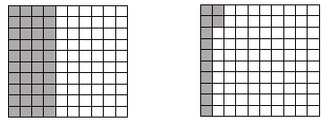
0.4 | 0.12
- Instruction includes building decimals with place value blocks.
- For example, the teacher asks students to build 0.3 (three-tenths) and 0.4 (four-tenths).
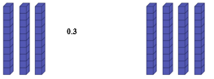
0.3 | 0.4
Students physically see that 0.3 is one-tenth less than 0.4.
- During instruction, the teacher shares the relationship between the blocks (each larger block is ten times larger the next smaller block) to demonstrate that they can be used flexibly.
- For example, emphasize that one-hundredth is smaller because it would require 100 hundredths to equal 1 whole and only 10 tenths to equal 1 whole.

Instructional Tasks
Instructional Task 1 (MTR.4.1)
Kathy says that 1 tenth more than 3.9 is 4. Mickey says that 1 tenth more than 3.9 is 3.91. Who is correct? Explain how you know.
Instructional Task 2
Part A. Plot 4.6 on the number line shown.
Part B. Find and plot one-tenth less and one-tenth more than 4.6.
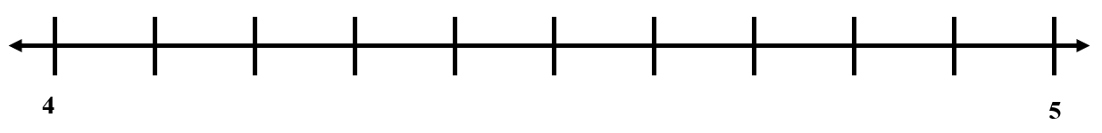

Part C. Choose two values plotted on the number line and compare them using >, <, or =.

Instructional Task 3

Part A. What is one-tenth more than 3.8?
Part B. What is one-tenth less than 7?
Part C. What is one-hundredth more than 15.29?
Part D. What is one-hundredth less than 7?

Instructional Items
Instructional Item 2
Which of the statements below are true? Select all that apply.
- 3.6 in one-tenth more than 3.5
- 11.32 is one-hundredth more than 11.22
- 9.54 is one-hundredth less than 9.55
- 7.18 is one-tenth less than 7.19
- 13 is one-tenth more than 12.9

Instructional Item 3
Which of the following numbers is one-tenth more than 5.9?
- 5.8
- 5.91
- 6
- 6.9

Instructional Item 4
Which of the following numbers is one-hundredths more than 3.59?
- 3.600
- 3.590
- 0.360
- 0.359

*The strategies, tasks and items included in the B1G-M are examples and should not be considered comprehensive.

MA.4.NSO.2.7

Benchmark
MA.4.NSO.2.7 Explore the addition and subtraction of multi-digit numbers with decimals to the hundredths.
Benchmark Clarifications:
Clarification 1: Instruction includes the connection to money and the use of manipulatives and models based on place value.

Connecting Benchmarks/Horizontal Alignment
- MA.4.NSO.1.5
- MA.4.FR.1.1, MA.4.FR.1.2
- MA.4.FR.2.3
- MA.4.M.2.2
- MA.4.DP.1.3

Terms from the K-12 Glossary
- Equation
- Expression

Vertical Alignment
Previous Benchmarks  - MA.2.NSO.2.2 | Next Benchmarks  - MA.5.NSO.2.3
Purpose and Instructional Strategies
The purpose of this benchmark is for students to explore addition and subtraction of decimals to the hundredths using manipulatives, visual models, discussions, estimation and drawing.
- Instruction should focus on strategies based on place value. Through the connection to money students can build on previous content knowledge about money by adding and subtracting decimals based on place value. Examples of manipulatives that support understanding when adding and subtracting decimals are base-ten blocks, place value chips, money (dollars and coins) and place value mats.
- Instruction includes explaining that lining up the decimal points to add or subtract decimals also lines up the corresponding place values. Due to the fixed denominator associated with each place value, such as $\frac{1}{10}$ or $\frac{1}{100},$the process of adding and subtracting the digits in a specific column is the same as adding or subtracting fractions with like denominators.

Common Misconceptions or Errors
- A common error that students make is to not add or subtract like place values, especially in an example such as $30.1+2.74$. Instruction should relate decimals to methods used for whole numbers. When adding whole numbers, ones were added to ones, tens to tens, hundreds to hundreds, and so forth. When adding decimal numbers, like place values are combined, too. Like place values are subtracted, just as with whole numbers.

Strategies to Support Tiered Instruction
- Instruction includes relating decimals to methods used for whole numbers. When adding whole numbers, ones were added to ones, tens to tens, hundreds to hundreds, and so forth. When adding decimal numbers, like place values are combined, too. Like place values are subtracted, just as with whole numbers. The teacher utilizes place value charts so that students can see where to line up values for the computation.
  - For example, $20.2-9.75$ is going to require some regrouping. By placing the problem in a place value chart, students line up the decimal and subtract like place values.
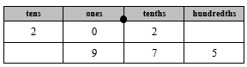
- Instruction includes relating decimal place values. Working with base ten blocks, students build decimals and their equivalents.
  - For example, building 0.2 “two-tenths” and 0.20 “twenty hundredths” with base ten blocks will help students to realize that the numbers have the same value.
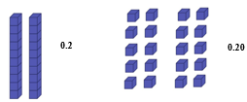
0.2 | 0.20

Instructional Tasks
Instructional Task 1
Part A. Write a subtraction equation with a difference of 0.9.
Part B. Write an addition equation with a sum of 0.9.
Part C. How are the decimals in your subtraction and addition equations similar? How are they different?

Instructional Task 2
Nyla had $12.65 in her piggy bank.
Her mom gave her $5.55 for helping with dishes.
Her dad gave her $13.76 for helping clean the yard.
Her neighbor gave her $25.50 for babysitting.
She wants to buy a new game for her gaming system.
The game costs $60.00.

Does she have enough money to buy the game?
If yes, will she get any money back? How much?
If no, how much more money does she need to earn?

Instructional Task 3
Adam joined the wrestling team.
Wrestlers are sorted by weight (in pounds) into classes: 106, 113, 120, 126, 132, 138, 144, 150, 157, 165, 175, 190, 215, and 285.
If Adam weighs 150.87 pounds but wants to wrestle two classes up, how much weight does he need to gain?
If Adam weighs 165.56 pounds but wants to wrestle three classes up, how much weight does he need to gain?
If Adam weighs 120.27 pounds and wants to wrestle five classes up, how much weight does he need to gain?
If Adam weighs 144.36 pounds and wants to wrestle three classes down, how much weight does he need to lose?
If Adam weighs 138.83 pounds and wants to wrestle four classes down, how much weight does he need to lose?
If Adam weighs 165.98 and wants to wrestle one class down, how much weight does he need to lose?

Instructional Items
Instructional Item 1
Tony’s lunchbox weighs 2.5 pounds. He took out an apple that weighs 0.65 pounds. How much does his lunchbox weigh now?

Instructional Item 2
Anna’s backpack weighs 10.7 pounds. She put her math book into her backpack. Now the backpack weighs 17.3 pounds. How much does the math book weigh?

Instructional Item 3
Suzi bought a ball for $4.63.
She paid with $20.00.
How much money will she receive back?

Instructional Item 4
What is the sum of 8.4 and 4.56?

*The strategies, tasks and items included in the B1G-M are examples and should not be considered comprehensive.

Fractions

MA.4.FR.1 Develop an understanding of the relationship between different fractions and the relationship between fractions and decimals.

MA.4.FR.1.1

Benchmark
MA.4.FR.1.1 Model and express a fraction, including mixed numbers and fractions greater than one, with the denominator 10 as an equivalent fraction with the denominator 100.
Benchmark Clarifications:
Clarification 1: Instruction emphasizes conceptual understanding through the use of manipulatives, visual models, number lines or equations.

Connecting Benchmarks/Horizontal Alignment
- MA.4.NSO.2.6, MA.4.NSO.2.7
- MA.4.FR.1.1, MA.4.FR.1.2
- MA.4.FR.2.3

Terms from the K-12 Glossary

Vertical Alignment
Previous Benchmarks  - MA.3.FR.2.2 | Next Benchmarks  - MA.5.FR.2.1
Purpose and Instructional Strategies
The purpose of this benchmark is to have students begin connecting fractions with decimals. This benchmark will connect fractions and decimals by writing equivalent fractions with denominators of 10 or 100 (decimal fractions). Decimal fractions are defined as fractions with denominators of a power of ten.
- For students to have a concrete foundation for future work with decimals (MA.4.NSO.1.5, MA.4.FR.1.2, MA.4.FR.1.3), teachers may provide experiences that allow students to use 10 by 10 grids, place value blocks, and other place value models (MTR.2.1) to explore the relationship between fractions with denominators of 10 and denominators of 100.
- Students may use their understanding of generating equivalent fractions (MA.4.FR.1.3) to model and express fractions and mixed numbers with denominators of 10 as an equivalent fraction with a denominator of 100.
  - For example, the 10 by 10 grids show that $1\frac{4}{10}$ and $1\frac{40}{100}$ have the same area which means that they are equivalent.
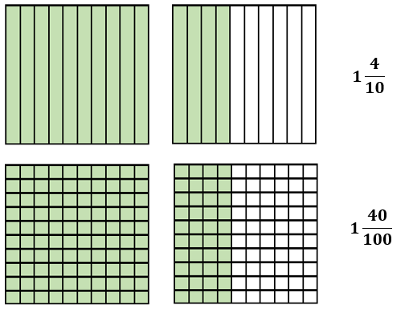
  - For example, when $\frac{8}{10}$ is multiplied by $\frac{10}{10}$ an equivalent fraction of $\frac{80}{100}$ is generated because multiplying by $\frac{10}{10 }$ is the same as multiplying by one and the value of the fraction does not change.
- This work lays the foundation for performing decimal addition and subtraction in MA.4.NSO.2.7.

Common Misconceptions or Errors
- Students often confuse decimals such as $\frac{6}{10}$and $\frac{6}{100}$. Students need to have conceptual understanding of the visual representations for tenths and hundredths. Students should use models and explain their reasoning to develop their understanding about the connections between fractions and decimals.

Strategies to Support Tiered Instruction
- Instruction includes concrete models and drawings to solidify the conceptual understanding of fraction place value.
  - For example, students create a model for $\frac{2}{10}$. The teacher then asks students to model a fraction that is equivalent with a denominator of 100 and explain what they notice about the models. Conversation involves connections to the value of the fractions.
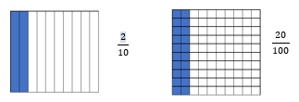
$$\frac{2}{10}$$ | $$\frac{20}{100}$$
- Instruction includes building fractions and their equivalents with base ten blocks.
  - For example, students build $\frac{2}{10}$“two-tenths” and $\frac{20}{100}$ “twenty hundredths” with base ten blocks while using vocabulary that will help students see the decimal connection as well. Students will realize that the numbers have the same value.
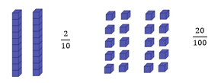
$$\frac{2}{10}$$ | $$\frac{20}{100}$$
- Instruction includes opportunities to use concrete models and drawings to solidify understanding of fraction equivalence.
  - For example, students use models to describe why fractions are equivalent or not equivalent when referring to the same size whole.
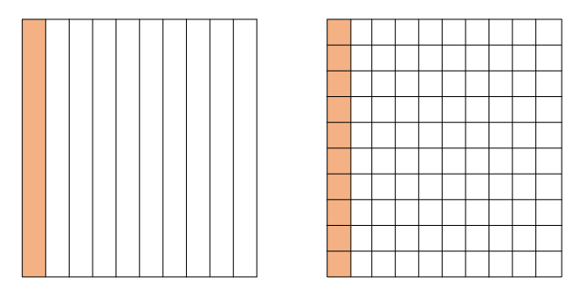
When looking at $\frac{1}{10}$ and $\frac{10}{100}$ , discussion includes that both fraction model are the same size. So, when comparing them, we are comparing the same size whole. Students see that 1 out of the 10 are shaded in the first model and 10 out of the 100 are shaded in the second model, making the $\frac{1}{10}$ equal to $\frac{10}{100}$. Students use this understanding to move into fractions with larger denominators.

Instructional Tasks
Instructional Task 1 (MTR.4.1)
Shade the models to complete the equivalent fractions.

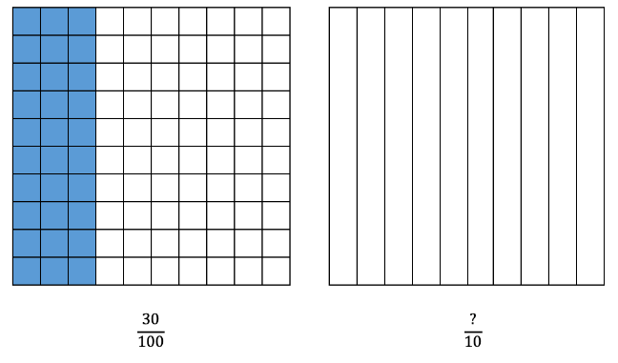
$$\frac{30}{100}$$ | $$\frac{?}{10}$$
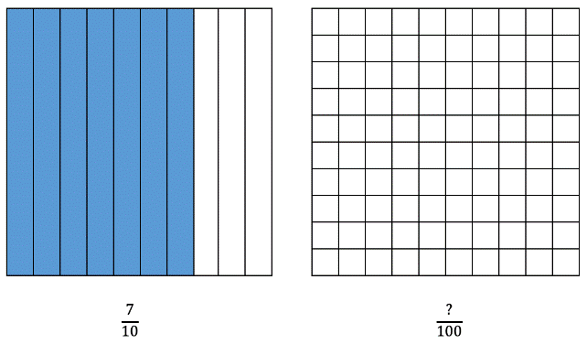
$$\frac{7}{10}$$ | $$\frac{?}{100}$$
Instructional Task 2
$\frac{3}{10}$ of students in Ms. Moore’s class like broccoli. Express and model this fraction with a denominator of 100.

Instructional Task 3
Part A. Represent $\frac{7}{10}$ in the model.
Part B. Model and explain how you can use the same grid from Part A to represent an equivalent fraction for $\frac{7}{10}$ with a denominator of 100.

Instructional Items
Instructional Item 1
An equation is shown. What number completes the equivalent fraction?
$$\frac{6}{10}=\frac{?}{100}$$

Instructional Item 2
Which fraction is equivalent to $\frac{12}{10}?$
- $\frac{2}{10}$
- $\frac{120}{10}$
- $\frac{12}{100}$
- $\frac{120}{100}$

Instructional Item 3
Select all that apply. $7 \frac{20}{100}=$
- $\frac{72}{10}$
- $\frac{72}{100}$
- $7 \frac{2}{10}$
- $7 \frac{2}{1}$
- . $\frac{720}{100}$
*The strategies, tasks and items included in the B1G-M are examples and should not be considered comprehensive.

MA.4.FR.1.2

Benchmark
MA.4.FR.1.2 Use decimal notation to represent fractions with denominators of 10 or 100, including mixed numbers and fractions greater than 1, and use fractional notation with denominators of 10 or 100 to represent decimals.
Benchmark Clarifications:
Clarification 1: Instruction emphasizes conceptual understanding through the use of manipulatives visual models, number lines or equations.
Clarification 2: Instruction includes the understanding that a decimal and fraction that are equivalent represent the same point on the number line and that fractions with denominators of 10 or powers of 10 may be called decimal fractions.

Connecting Benchmarks/Horizontal Alignment
- MA.4.NSO.1.5
- MA.4.NSO.2.6, MA.4.NSO.2.7
- MA.4.M.1.1, MA.4.M.1.2
- MA.4.M.2.2

Terms from the K-12 Glossary

Vertical Alignment
Previous Benchmarks  - MA.3.FR.2.2 | Next Benchmarks  - MA.6.NSO.3.5
Purpose and Instructional Strategies
The purpose of this benchmark is to connect fractions to decimals. Students extend their understanding of fraction equivalence (MA.3.FR.2.2) to include decimal fractions with denominators of 10 or 100. The connection will be continued in Grade 6 (MA.6.NSO.3.5) and completed in Grade 7 (MA.7.NSO.1.2).
- Instruction for this benchmark helps students understand that decimals are another way to write fractions. The place value system developed for whole numbers extends to fractional parts represented as decimals. The concept of one whole used in fractions is extended to models of decimals. It is important that students make connections between fractions and decimals in models.
- Instruction includes visual fraction models of tenths and hundredths, number lines and equations so that students can express a fraction with a denominator of 10 as an equivalent fraction with a denominator of 100.
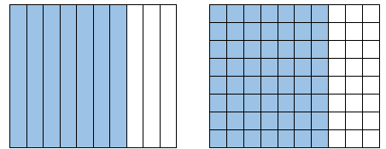
- Students reinforce understanding that the names for decimals match their fraction equivalents (e.g. seven tenths, 7 tenths, 0.7, $\frac{7}{10},$70 hundredths, 0.70 and $\frac{70}{100}$ are all equivalent).

$\frac{7}{10}=0.7$ $\frac{70}{100}=0.70$

- To help students understand decimals, instruction may use models as seen above and name the value using the fraction representation to then extend the place value chart including the decimal point, tenths, and hundredths.
For example, one whole divided into ten equal parts creates the tenths place and tenths divided into ten equal parts results in hundredths. This is an opportunity to make connections to MA.4.NSO.1.1.
- This benchmark is a connection point to the metric system and will be explored in MA.4.M.1.2.

Common Misconceptions or Errors
- Students often confuse decimals such as 6 tenths and 6 hundredths. Students should use models and explain their reasoning to develop their understanding about the connections between fractions and decimals.
- Some students may not understand that fractions and decimals are different representations of the same thing. Number lines and other visual models will help students gain a better understanding of this concept.
- Students need exposure to the whole number place value positions and their connection to decimal place value positions. Students may not understand that whole numbers and decimals are encompassed across the same place value continuum.
- Some students may not understand that zero can be used as a place holder in decimal place value positions,
  - For example, $seven tenths$ written in decimal notation is read $0.7$, and is equivalent to $seven hundredths$, or 0.70. The decimal is renamed but the value remains equal.

Strategies to Support Tiered Instruction
- Instruction includes building fractions and their decimals equivalents using base ten blocks.
  - For example, students build $\frac{2}{10}$“two-tenths” and $\frac{20}{100}$ “twenty hundredths” with base ten blocks while using vocabulary that will help students see the decimal connection as well. Students realize that the numbers have the same value.
$\frac{2}{10}$ or 0.2 | $\frac{20}{100}$ or 0.20

Instructional Tasks
Instructional Task 1 (MTR.6.1)
Read the following numbers and use the benchmark fractions to place them on the number line.
- 0.8
- 0.32
- 0.6
- 0.17

Instructional Task 2
Part A
Write each fraction using decimal notation.
$\frac{3}{10}=$ ____$\frac{3}{100}=$____ $\frac{30}{100}=$____ $3\frac{1}{10}=$____
Part B
Which numbers in Part A are equivalent? Explain your thinking using words or models.

Instructional Items
Instructional Item 1
A value is shown.
$$2\frac{5}{100}$$
What is the value in decimal form?
- 0.25
- 2.05
- 2.5
- 25.100

Instructional Item 2
A value is shown.
3.2
What is the value in fraction form?
- $\frac{32}{10}$
- $\frac{32}{100}$
- $3\frac{2}{10}$
- $3\frac{2}{100}$

Instructional Item 3
Match each decimal to its representation as a fraction or mixed number.
 | $$\frac{6}{10}$$ | $$\frac{6}{100}$$ | $$1\frac{6}{10}$$
0.06
0.6
1.6
*The strategies, tasks and items included in the B1G-M are examples and should not be considered comprehensive.

MA.4.FR.1.3

Benchmark
MA.4.FR.1.3 Identify and generate equivalent fractions, including fractions greater than one. Describe how the numerator and denominator are affected when the equivalent fraction is created.
Benchmark Clarifications:
Clarification 1: Instruction includes the use of manipulatives, visual models, number lines or equations.
Clarification 2: Instruction includes recognizing how the numerator and denominator are affected when equivalent fractions are generated.

Connecting Benchmarks/Horizontal Alignment
- MA.4.FR.2.1, MA.4.FR.2.3
- MA.4.M.1.1, MA.4.M.1.2
- MA.4.DP.1.1, MA.4.DP.1.2

Terms from the K-12 Glossary
- Integers
- Number Line
- Rational Number
- Whole Number

Vertical Alignment
Previous Benchmarks  - MA.3.FR.2.2 | Next Benchmarks  - MA.5.FR.2.1
Purpose and Instructional Strategies
The purpose of this benchmark is for students to begin generating equivalent fractions. This work builds on identifying equivalent fractions in Grade 3 (MA.3.FR.2.2) and builds the foundation for adding and subtracting fractions with unlike denominators in Grade 5 (MA.5.FR.2.1).
- For instruction, students should use multiple models to develop understanding of equivalent fractions (MTR.2.1). Students can use area models, set models, number lines and equations to determine and generate equivalent fractions.
  - Area Model
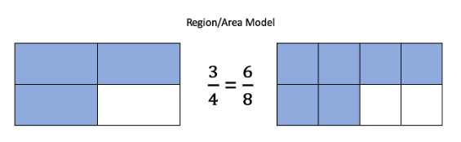
  - Number Lines
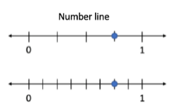
- Equations
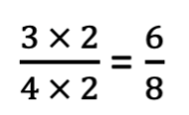
- Instruction should focus on reasoning about how the numerator and denominators are affected when equivalent fractions are generated.
- Reasoning about the size of a fraction using benchmark fractions helps solidify students’ understanding about the size of the fraction.
- Instruction includes fractions equal to and greater than one.
  - For example, $\frac{4}{3}=\frac{8}{6}$
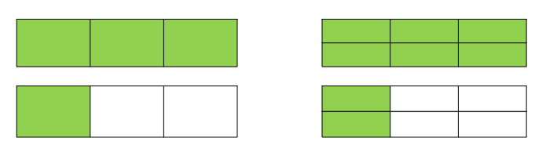

Common Misconceptions or Errors
- Students may think that when generating equivalent fractions, they need to multiply or divide only the numerator or only denominator, such as changing $\frac{3}{4}$ to $\frac{3}{8}$.

Strategies to Support Tiered Instruction
- Instruction includes opportunities to use concrete models and drawings to solidify understanding of fraction equivalence. Students use models to describe why fractions are equivalent or not equivalent when referring to the same size whole.
  - For example, when looking at $\frac{2}{5}$ and $\frac{4}{10}$ , conversation includes that both fraction models are the same size. So, when comparing them, we are comparing the same size whole. Students should be able to see that 2 out of the 5 are shaded in the first model and 4 out of the 10 are shaded in the second mode, making the $\frac{2}{5}$ equal to $\frac{4}{10}$.
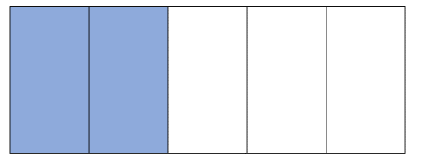 | 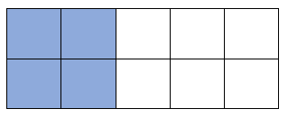
$$\frac{2}{5}$$ | $$\frac{4}{10}$$
- Instruction includes fraction tiles or fraction kits to physically place and see equivalent fractions of a model. Students line up fraction tiles and begin to make observations about equivalence. One-half is equivalent to 2 one-fourth pieces. Students then notice that those pieces are then equivalent to 4 one-eighth pieces. Once students have this understanding, then they can begin to rename fractions.
  - Example:
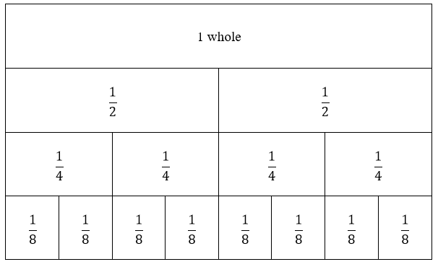

Instructional Tasks
Instructional Task 1 (MTR.4.1)
Divide the number line below into enough equal sections so that you can locate and label the point $\frac{2}{5}$$\frac{3}{4}$. Divide the same number line with a different color so that you can locate and label the point $\frac{4}{10}$. Discuss what you have learned.

Instructional Task 2


Use the model shown to generate two fractions equivalent to $\frac{1}{3}$. Describe how the numerator and denominator are affected as each equivalent fraction is created.

Instructional Items
Instructional Item 1
Olivia modeled a fraction by shading parts of the rectangle as shown.


Ethan draws a rectangle with the same size to model a fraction equivalent to Olivia’s. Which rectangle could Ethan have drawn?
a.
b.
c.
d.
Instructional Item 2
Select all the fractions equivalent to the point on the number line.

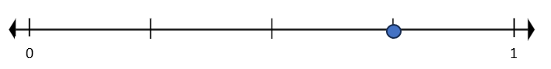
- $\frac{3}{5}$
- $\frac{3}{4}$
- $\frac{4}{6}$
- $\frac{9}{12}$
- $\frac{5}{6}$

Instructional Item 3
Part A. Generate an equivalent fraction for $\frac{10}{8}$ with a denominator of 16.
Part B. Generate an equivalent fraction for $\frac{10}{8}$ with a denominator of 4.

Instructional Item 4
Part A. Generate an equivalent fraction for $\frac{4}{6}$ with a numerator of 12.
Part B. Generate an equivalent fraction for $\frac{4}{6}$ with a numerator of 2.

Instructional Item 5
Aiden generated the equivalent fraction of $\frac{6}{8}$ for $\frac{3}{4}$. Which statement explains how the numerator and denominator were affected when Aiden generated the equivalent fraction?
- The numerator and denominator in $\frac{3}{4}$ were halved creating half as many identified and total parts.
- Two was added to the numerator and the denominator creating more identified and total parts.
- The numerator and denominator in $\frac{3}{4}$ were doubled creating twice as many identified and total parts.
- The numerator and denominator were not affected because the fractions are equivalent.

*The strategies, tasks and items included in the B1G-M are examples and should not be considered comprehensive.

MA.4.FR.1.4

Benchmark
MA.4.FR.1.4 Plot, order and compare fractions, including mixed numbers and fractions greater than one, with different numerators and different denominators.
Example: $1\frac{2}{3}>1\frac{1}{4}$ because $\frac{2}{3}$ is greater than $\frac{1}{2}$ and $\frac{1}{2}$ is greater than $\frac{1}{4}$.

Benchmark Clarifications:
Clarification 1: When comparing fractions, instruction includes using an appropriately scaled number line and using reasoning about their size.
Clarification 2: Instruction includes using benchmark quantities, such as 0, $\frac{1}{4}$, $\frac{1}{2}$, $\frac{3}{4}$ and 1, to compare fractions.
Clarification 3: Denominators are limited to 2, 3, 4, 5, 6, 8, 10, 12, 16 and 100.
Clarification 4: Within this benchmark, the expectation is to use symbols ($<$, $>$ or $=$).

Connecting Benchmarks/Horizontal Alignment
- MA.4.M.1.1
- MA.4.DP.1.1, MA.4.DP.1.2

Terms from the K-12 Glossary

Vertical Alignment
Previous Benchmarks  - MA.3.FR.2.1 | Next Benchmarks  - MA.5.NSO.1.4
Purpose and Instructional Strategies
The purpose of this benchmark is to understand the relative size of fractions. Students will plot fractions on an appropriately scaled number line, compare fractions using relational symbols, and order fractions from greatest to least or least to greatest. Work builds on conceptual understanding of the size of fractions from Grade 3 (MA.3.FR.2.1) where students learned to plot, order and compare fractions with common numerators or common denominators.
- Instruction may include helping students extend understanding by generating equivalent fractions with common numerators or common denominators to compare and order fractions.
  - For example, $\frac{3}{4}$ compared to $\frac{3}{5}$. Students should utilize understanding of common numerators; in order to compare two or more fractions with the same or like numerators, compare the denominators. The fraction that has the greater denominator is lesser because the more pieces of the whole, the smaller the piece.
  - For example, $\frac{1}{5}$ compared to $\frac{4}{5}$. Students should utilize their understanding of common denominators; in order to compare two or more fractions with the same or like denominators, compare the numerators. The fraction that has the greater numerator is greater because the more pieces of the whole, the greater the amount.
- Instruction may include number lines, which will make a connection to using inch rulers to measure to the nearest $\frac{1}{16}$ of one inch.
- Instruction may include using benchmark fractions and estimates to reason about the size of fractions when comparing them. Students can compare $\frac{3}{5}$ to $\frac{1}{2}$ by recognizing that 3 (in the numerator) is more than half of 5 (the denominator) so they can reason that $\frac{3}{5}>\frac{1}{2}$.
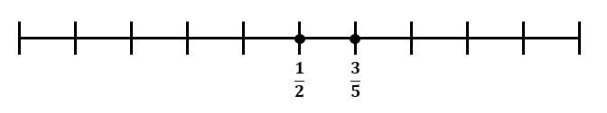
- Instruction includes fractions equal to and greater than one.

Common Misconceptions or Errors
- The student may mistake the fraction with the greater numerator and denominator as the greater fraction. The student may not pay attention to the relationship between numerator and denominator when estimating.
- The student incorrectly judges that a mixed number like $1\frac{3}{4}$is always greater than an improper fraction like $\frac{17}{4}$ because of the whole number in front.

Strategies to Support Tiered Instruction
- Instruction includes models that represent different numerators and denominators.
  - For example, students think about the fraction by reasoning about the size of the parts related to the numerator or denominator. Students compare $\frac{1}{4}$ to $\frac{1}{2}$ by recognizing that 1 (in the numerator) is less than half of 4 (the denominator) so they can reason that $\frac{1}{4}<\frac{1}{2}$ .
    - This can also be shown with a model so that students can see the difference in sizes of pieces when related to the whole.
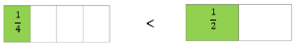 | $$<$$
- Instruction includes models and examples where fractions greater than one whole are represented in a mixed number and as an improper fraction.
  - For example, students might think that $\frac{7}{3}$ is greater than $1\frac{1}{4}$ because of the whole number being represented. Instruction includes models to represent fractions that build conceptual understanding of fractions greater than 1.
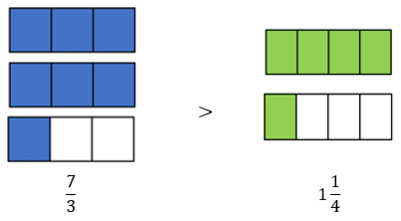
Instructional Tasks
Instructional Task 1 (MTR.6.1)
Use benchmark fractions and the number line below to compare the fractions $\frac{12}{5}$ and $2\frac{7}{8}$.
In the space below the number line, record the results of the comparison using the $<$, $>$ or $=$ symbol.

Instructional Task 2
Part A. Use the number line to plot $\frac{9}{10},\frac{3}{5} ,and\frac{4}{2}$

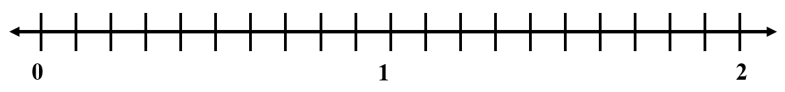
Part B. Order the fractions in order from greatest to least.
Part C. Choose two of the fractions to write a comparison using symbols (< , >, or =).

Instructional Items
Instructional Item 1
Four soccer players started a game with the exact same amount of water in their water bottles. The table shows how much water each soccer player has left at the end of the game. Who has the least amount of water remaining?
Player | Fraction of Water Left
Jackie | $$\frac{2}{6}$$
Laura | $$\frac{1}{3}$$
Terri | $$\frac{4}{9}$$
Amanda | $$\frac{2}{10}$$
- Jackie
- Laura
- Terri
- Amanda

Instructional Item 2
Write the fractions in order from least to greatest.
$$\frac{1}{4} \frac{7}{3} \frac{5}{8} \frac{10}{12}$$

Instructional Item 3
Use the number line to complete the questions below.
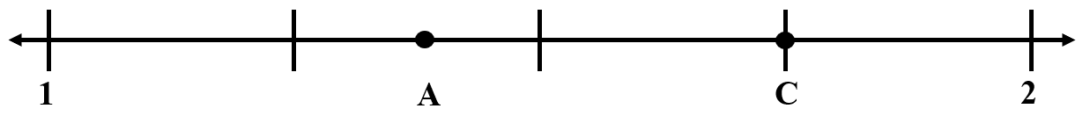
Part A: What value does Point C represent? Select all that apply.
- $\frac{3}{4}$
- $1\frac{1}{2}$
- $\frac{3}{2}$
- $\frac{7}{4}$
- $1\frac{3}{4}$
Part B: Which value does point A represent?
- 1$\frac{1}{4}$
- $1\frac{3}{8}$
- $1\frac{5}{8}$
- $1\frac{2}{3}$
Part C: Plot Point B between Points A and C. What is the value of B?

*The strategies, tasks and items included in the B1G-M are examples and should not be considered comprehensive.

MA.4.FR.2 Build a foundation of addition, subtraction and multiplication operations with fractions.

MA.4.FR.2.1

Benchmark
MA.4.FR.2.1 Decompose a fraction, including mixed numbers and fractions greater than one, into a sum of fractions with the same denominator in multiple ways. Demonstrate each decomposition with objects, drawings and equations.
Example: $\frac{9}{8}$ can be decomposed as $\frac{8}{8}+\frac{1}{8}$ or as $\frac{3}{8}+\frac{3}{8}+\frac{3}{8}$.

Benchmark Clarifications:
Clarification 1: Denominators are limited to 2, 3, 4, 5, 6, 8, 10, 12, 16 and 100.

Connecting Benchmarks/Horizontal Alignment
- MA.4.FR.1.3
- MA.4.AR.1.2

Terms from the K-12 Glossary
Expression

Vertical Alignment
Previous Benchmarks  - MA.3.FR.1.1  - MA.3.FR.1.2 | Next Benchmarks  - MA.5.FR.2.1
Purpose and Instructional Strategies
The purpose of this benchmark is to build students’ understanding from Grade 3 that each fraction is composed as the sum of its unit fractions. Decomposing fractions becomes the foundation for students to make sense of adding and subtracting fractions, much like decomposing whole numbers provided the foundation for adding and subtracting whole numbers in the primary grades.
- During instruction, students should show multiple ways to decompose a fraction into equivalent addition expressions with the support of models (e.g., objects, drawings and equations).
  - For example, $\frac{3}{4}=\frac{1}{4}+\frac{1}{4}+\frac{1}{4}$
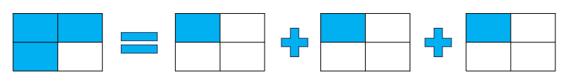
- Instruction includes opportunities for students to decompose fractions greater than one, focusing on finding decompositions that include fractions equal to one. For example: = $\frac{9}{4}=\frac{4}{4}+\frac{4}{4}+\frac{1}{4}$. This will support student understanding when adding and subtracting fractions with like denominators, including fractions greater than one (MA.4.FR.2.2).
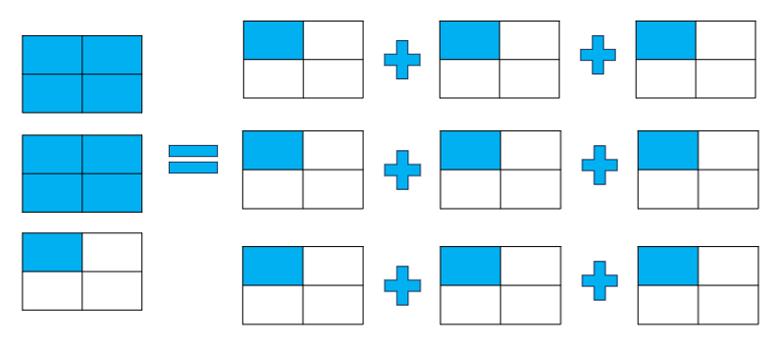

Common Misconceptions or Errors
- Students may have difficulty decomposing mixed numbers and fractions greater than one because of misunderstanding of flexible fraction representations (e.g., $\frac{4}{4}$ is equivalent to 1). It is helpful when students’ expressions are accompanied by a model that justifies them.

Strategies to Support Tiered Instruction
- Instruction includes fraction tiles or fraction kits to physically place and see equivalent expressions of the given fraction. Fractions of a model.
  - Example:
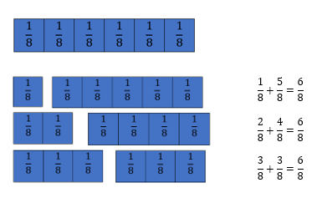
  - The teacher provides instruction that models how fractions can be decomposed in multiple ways.
$$\frac{4}{8}$$
  - For example, using fraction circles, students combine 4 one-quarter circles and then see that there are 4 pieces that make up the whole circle. Equations are accompanied by a model that justifies them.
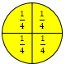 | $\frac{1}{4}+\frac{1}{4}+\frac{1}{4}+\frac{1}{4}=\frac{4}{4}$ | $$\frac{1}{4}+\frac{3}{4}=\frac{4}{4}$$

Instructional Tasks
Instructional Task 1 (MTR.2.1)
Part A. Use a visual fraction model to show one way to decompose$\frac{5}{8}$. Label each fraction part in the model and write an equation to show how you decomposed $\frac{5}{8}$.
Part B. Show how you could decompose $\frac{5}{8}$ in a different way using a visual fraction model. Again, make sure to label each fraction part in the model, and write an equation to show how you decomposed$\frac{5}{8}$.

Instructional Task 2
Find all the possible ways to decompose $\frac{7}{4}$. Use fraction tiles and write out each expression to support your thinking.
Instructional Task 3
Kayla is making a cake. The recipe says to put in 2$\frac{1}{2}$ cups of flour. She does not have a 1 cup measuring cup, but she does have a $\frac{1}{2}$ cup measuring cup.
Part A. How many $\frac{1}{2}$ cup scoops does she need to put into the bowl to equal 2$\frac{1}{2}$?
Part B. The recipe says to put in 4$\frac{3}{4}$ cups of flour. Can she use her $\frac{1}{2}$ cup measuring cup to put in the flour? Why or why not?
Part C. If she used a $\frac{1}{4}$ measuring cup, how many $\frac{1}{4} cup$scoops of flour would she need to add to the bowl?

Instructional Items
Instructional Item 1
Which sums show ways to express $\frac{8}{3}$ ? Select all that apply.
- $\frac{1}{3}+\frac{1}{3}+\frac{1}{3}$
- $\frac{1}{3}+\frac{1}{3}+\frac{1}{3}+\frac{1}{3}+\frac{1}{3}+\frac{1}{3}+\frac{1}{3}+\frac{1}{3}$
- $\frac{3}{3}+\frac{3}{3}+\frac{1}{3}$
- $\frac{3}{3}+\frac{3}{3}+\frac{1}{3}+\frac{1}{3}$
- $\frac{3}{3}+\frac{3}{3}+\frac{3}{3}$

Instructional Item 2
Select the expression that correctly represents $4 \frac{5}{12}$.
- $\frac{5}{12}+ \frac{5}{12}+ \frac{5}{12}+ \frac{5}{12}$
- $3 + \frac{1}{12}+ \frac{1}{12}+\frac{1}{12}+ \frac{1}{12}$
- $3+ \frac{12}{12} + \frac{2}{12} + \frac{4}{12}$
- $4 + \frac{1}{12}+ \frac{1}{12}+ \frac{2}{12}+ \frac{1}{12}$

*The strategies, tasks and items included in the B1G-M are examples and should not be considered comprehensive.

MA.4.FR.2.2

Benchmark
MA.4.FR.2.2 Add and subtract fractions with like denominators, including mixed numbers and fractions greater than one, with procedural reliability.
Example: The difference $\frac{9}{5}-\frac{4}{5}$ can be expressed as $9 fifths$ minus $4 fifths$ which is $5 fifths$, or $one$.

Benchmark Clarifications:
Clarification 1: Instruction includes the use of word form, manipulatives, drawings, the properties of operations or number lines.
Clarification 2: Within this benchmark, the expectation is not to simplify or use lowest terms.
Clarification 3: Denominators are limited to 2, 3, 4, 5, 6, 8, 10, 12, 16 and 100.

Connecting Benchmarks/Horizontal Alignment
- MA.4.AR.1.2

Terms from the K-12 Glossary
- Equation
- Expression

Vertical Alignment
Previous Benchmarks  - MA MA.3.FR.1.1  - MA.3.FR.1.2 | Next Benchmarks  - MA.5.FR.2.1
Purpose and Instructional Strategies
The purpose of this benchmark is for students to build upon their decomposition of fractions to develop an accurate, reliable method for adding and subtracting fractions with like denominators (including mixed numbers and fractions greater than one) that aligns with their understanding and learning style. Procedural reliability in addition and subtraction of fractions with unlike denominators is expected in Grade 5.
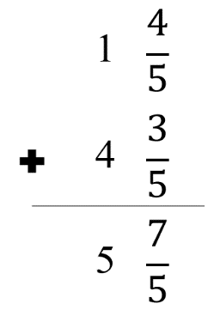
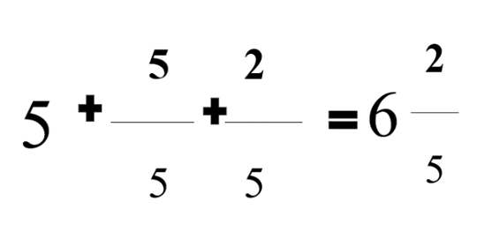
- Clarification 1 states that instruction should include word form (to build vocabulary), manipulatives and drawings (to model), and the properties of operations. Using properties of operations (e.g., commutative property of addition, associative property of addition) allows students to connect prior knowledge about whole number addition and subtraction to fractions. Properties of operations also allow for students to add and subtract fractions flexibly (e.g., students may add by rewriting the expression $1\frac{4}{5}+4\frac{3}{5}$ as $1+4+\frac{4}{5}+\frac{3}{5}$ using the associative property of addition).

- Students need to have experience regrouping a fraction equivalent to 1 as a whole number for addition and subtraction.
  - For example, $\frac{5}{6}+\frac{4}{6}=\frac{9}{6}=\frac{6}{6}+\frac{3}{6}=1\frac{3}{6}$.
This benchmark should be taught with MA.4.AR.1.2 for students to solve real-world problems while adding and subtracting fractions.

Common Misconceptions or Errors
- Some students may have difficulty understanding that when adding or subtracting fractions with like denominators, the denominator does not change. To help students understand why this happens, addition and subtraction should be accompanied with models to justify solutions.

Strategies to Support Tiered Instruction
- Instruction includes models and drawings demonstrating how when adding and subtracting with like denominators, we are adding and subtracting pieces of the whole. This learning connects to the understanding that fractions can be decomposed into smaller fractions from MA.4.FR.2.1.
For example, using a number line, the teacher models solving adding on the number line with guided questioning. Students explain how to use the number line as a model to solve the expression $\frac{3}{8} + \frac{4}{8}= ?$
$$\frac{3}{8} + \frac{4}{8}= \frac{7}{8}$$
- Instruction includes the use of fraction bars or fraction strips to model solving expressions with explicit instruction and guided questioning.
  - For example, students explain how to use fraction bars or fraction strips as a model to solve expressions.
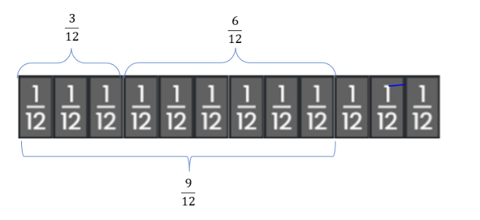$\frac{3}{12} + \frac{6}{12}= \frac{9}{12}$

Instructional Tasks
Instructional Task 1 (MTR.3.1, MTR.4.1)
Find the sum or difference and explain your method.
- $\frac{3}{4}+2\frac{3}{4}$
- $2\frac{3}{10}+1\frac{4}{10}$
- $2\frac{5}{8}-1\frac{3}{8}$
- $1\frac{2}{5}-\frac{3}{5}$

Instructional Task 2
Solve 1$\frac{4}{5}$ + 2$\frac{3}{5}$.
Using two colors, show how to solve this expression.

Create a different type of model to show how to solve the expression.

Instructional Task 3
Part A. Write a subtraction equation with fractions that have the same denominator that has a difference of $\frac{9}{10}$.
Part B. Write an addition equation with fractions that have the same denominator that has a sum of $\frac{9}{10}$.
Part C. How are the fractions in your subtraction and addition equations similar? How are they different?

Instructional Task 4
David and Paul decide to meet at the park on Saturday morning to play basketball. David’s house is 8 twelfths mile from the park and Paul’s house is 15 twelfths miles from the park.
Part A. How much farther does Paul have to walk than David?
Part B. How many miles will they walk total if they both go straight to the park and right back home?

Instructional Items
Instructional Item 1
The point on a number line shows the value of the sum of two fractions.
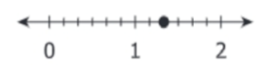

Which expression has that sum?
- $\frac{4}{3}+\frac{4}{3}$
- $\frac{6}{4}+\frac{2}{4}$
- $\frac{5}{6}+\frac{3}{6}$
- $\frac{2}{12}+\frac{6}{12}$

Instructional Item 2
Find the sum.
$$\frac{4}{12}+\frac{7}{12}$$
- $\frac{5}{12}$
- $\frac{11}{24}$
- $\frac{11}{12}$
- $\frac{13}{12}$

Instructional Item 3
Find the difference.
$$\frac{7}{3} - \frac{4}{3}=$$

Instructional Item 4
Select all the ways to express the difference.
- $\frac{3}{0}$
- $\frac{3}{3}$
- $\frac{11}{3}$
- one
- 3 thirds

*The strategies, tasks and items included in the B1G-M are examples and should not be considered comprehensive.

MA.4.FR.2.3

Benchmark
MA.4.FR.2.3 Explore the addition of a fraction with denominator of 10 to a fraction with denominator of 100 using equivalent fractions.
Example: $\frac{9}{100}+\frac{3}{10}$ is equivalent to $\frac{9}{100}+\frac{30}{100}$ which is equivalent to $\frac{39}{100}$.

Benchmark Clarifications:
Clarification 1: Instruction includes the use of visual models.
Clarification 2: Within this benchmark, the expectation is not to simplify or use lowest terms.

Connecting Benchmarks/Horizontal Alignment
- MA.4.NSO.2.7
- MA.4.FR.1

Terms from the K-12 Glossary

Vertical Alignment
Previous Benchmarks  - MA.3.FR.1.2 | Next Benchmarks  - MA.5.FR.2.1
Purpose and Instructional Strategies
The purpose of this benchmark is to connect fraction addition to decimal addition through decimal fractions (fractions where the denominator is a power of 10). This will be the first opportunity for students to create common denominators to add fractions. This benchmark continues the work of equivalent fractions (MA.3.FR.1.2) by having students rename fractions with denominators of 10 as equivalent fractions with denominators of 100 (MA.4.FR.1.1). Students who can generate equivalent fractions can adapt this new procedure to develop strategies for adding fractions with unlike denominators in Grade 5 (MA.5.FR.2.1).
- Instruction may include students shading decimal grids 10 by 10 grids) to support their understanding.
  - For example to add $\frac{34}{100} + \frac{4}{10}$ the decimal grids can be shaded to model fraction equivalency and addition.
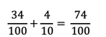
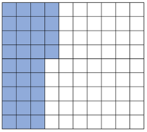$+$ 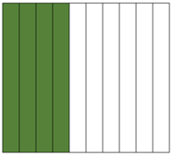$=$ 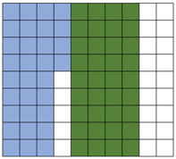
- Instruction may also include the use of equations to generate equivalent fractions.
  - For example, when adding $\frac{34}{100} + \frac{4}{10}$ the fraction $\frac{4}{10}$ can be multiplied by $\frac{10}{10}$ to generate an equivalent fraction with a denominator of 100. When $\frac{4}{10}$ is multiplied by $\frac{10}{10}$, it is renamed but its values does not change because multiplying by $\frac{10}{10 }$ is the same as multiplying by one.

- Subtraction of decimal fractions is not a requirement of Grade 4.

Common Misconceptions or Errors
- Students often will add the numerators and the denominators without finding the like denominator. Students will need visual models to understand what the like denominator means.

Strategies to Support Tiered Instruction
- Instruction includes opportunities to explore the addition of a fraction with a denominator of 10 to a fraction with a denominator of 100 using visual models to help understand equivalent fractions. Students use visual models to make sense of equivalent fractions when finding like denominators. The teacher provides clarification that students must find the like denominator before adding.
  - For example, the teacher displays the problem $\frac{4}{10}+\frac{23}{100}$ and asks students to share what they notice about this expression. Students identify that the denominators are different. The teacher guides students to shade decimal grids to represent the problem and solve while supporting students as they use the visual models to understand that $\frac{4}{10}$ is equivalent to $\frac{40}{100}$. This is repeated with similar addition problems that have denominators of 10 and 100.
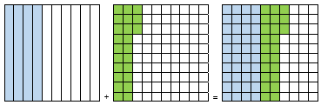
$\frac{4}{10}= \frac{40}{100}$ ; $\frac{40}{100}+\frac{23}{100}=\frac{63}{100}$
  - For example, the teacher displays the problem $\frac{24}{100}+\frac{3}{10}$, asking students to share what they notice about this expression. Students identify that the denominators are different. The teacher guides students to use place value blocks and shaded decimal grids to represent the problem and solve, having tens rods represent tenths, and ones cubes represent hundredths. Students are supported as they use the visual models to understand that $\frac{3}{10}$ is equivalent to $\frac{30}{100}$. This is repeated with similar addition problems that have denominators of 10 and 100.
$\frac{3}{10}= \frac{30}{100}$; $\frac{24}{100}+\frac{30}{100}=\frac{54}{100}$
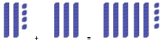
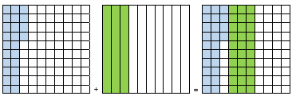

Instructional Tasks
Instructional Task 1 (MTR.5.1)
Determine the equivalent fraction.
$$\frac{5}{10} = \frac{ }{100}$$
Use your thinking from above to help you add the following fractions:
$$\frac{31}{100} + \frac{5}{10}=$$

Instructional Task 2
Part A. Write an equation to show how to find the sum of the fractions shown.
$$\frac{9}{10} , \frac{23}{100}$$
Part B. Find the sum of your equation from part A.

Instructional Task 3
Shade the first model to represent the equivalent fraction for $\frac{6}{10}$.
Shade the next model to represent the equivalent fraction for $\frac{2}{10}$
Shade the sum of the two equivalent fractions and represent it in the third model.

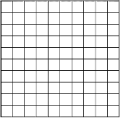

Instructional Items
Instructional Item 1
An expression is shown.
$$\frac{3}{10}+\frac{32}{100}$$
What is the value of the expression?

Instructional Item 2
An expression is shown.
$$\frac{4}{10}+\frac{8}{100}$$
Part A. Which expression is equivalent to the expression?
- $\frac{4}{10}+\frac{8}{10}$
- $\frac{4}{100}+\frac{8}{100}$
- $\frac{40}{100}+\frac{8}{100}$
- $\frac{40}{10}+\frac{8}{100}$

Part B. Find the sum of $\frac{4}{10}+\frac{8}{100}$.
*The strategies, tasks and items included in the B1G-M are examples and should not be considered comprehensive.

MA.4.FR.2.4

Benchmark
MA.4.FR.2.4 Extend previous understanding of multiplication to explore the multiplication of a fraction by a whole number or a whole number by a fraction.
Example: Shanice thinks about finding the product $\frac{1}{4}×8$ by imagining having 8 pizzas that she wants to split equally with three of her friends. She and each of her friends will get 2 pizzas since $\frac{1}{4}×8=2$.
Example: Lacey thinks about finding the product $8×\frac{1}{4}$ by imagining having 8 pizza boxes each with one-quarter slice of a pizza left. If she put them all together, she would have a total of 2 whole pizzas since $8×\frac{1}{4}=\frac{8}{4}$ which is equivalent to 2.

Benchmark Clarifications:
Clarification 1: Instruction includes the use of visual models or number lines and the connection to the commutative property of multiplication. Refer to Properties of Operation, Equality and Inequality (Appendix D).
Clarification 2: Within this benchmark, the expectation is not to simplify or use lowest terms.
Clarification 3: Fractions multiplied by a whole number are limited to less than 1. All denominators are limited to 2, 3, 4, 5, 6, 8, 10, 12, 16, 100.

Connecting Benchmarks/Horizontal Alignment
- MA.4.NSO.2.1
- MA.4.AR.1.3

Terms from the K-12 Glossary
- Equation
- Expression
- Factor

Vertical Alignment
Previous Benchmarks  - MA.3.NSO.2.2  - MA.3.FR.1.2 | Next Benchmarks  - MA.5.FR.2.2, MA.5.FR.2.3
Purpose and Instructional Strategies
The purpose of this benchmark is to connect previous understandings of whole-number multiplication concepts (MA.3.NSO.2.2) and apply them to the multiplication of fractions. This work builds a foundation for multiplying fractions with procedural reliability in Grade 5 (MA.5.FR.2.2).
- Contexts involving multiplying whole numbers and fractions lend themselves to modeling and examining patterns.
- This benchmark builds on students’ work of adding fractions with like denominators (MA.4.FR.2.2) and extending that work into the relationship between addition and multiplication.
- Students should use fraction models and drawings to show their understanding. Fraction models may include area models, number lines, set models, or equations.
- During instruction, teachers can relate “total group size” language that was used to introduce whole number multiplication- possibly changing from “total group size” to “total size” or “total amount” (see Appendix A). Using such language, the expression $5×\frac{3}{4}$ can be described as the total size or amount of 5 objects, each of which has size or amount of $\frac{3}{4}$.
  - For example, the weight of 5 slabs of chocolate that each weigh $\frac{3}{4}$ of a pound is $5×\frac{3}{4}$pounds. Students need to understand that when multiplying a whole number by a fraction, the most important idea is that the whole number describes the number of objects and the fraction describes the size of each object.
- Instruction includes representing a whole number times a fraction as repeated addition: $5×\frac{3}{4}=\frac{3}{4}+\frac{3}{4}+\frac{3}{4}+\frac{3}{4}+\frac{3}{4}$.
- When multiplying a whole number by a fraction teachers can use language like “portion of” to convey that the fraction represents the “portion of” the whole number.
  - For example, the $\frac{3}{4}$ portion of a 5 mile run is $\frac{3}{4 }×5$ miles.
- Exploring patterns of what happens to the numerator when a whole number is multiplied by a fraction will help students make sense of multiplying fractions by fractions in Grade 5.
For Enrichment:
- Instruction includes fractions equal to and greater than one.
- When multiplying whole numbers by mixed numbers, students can use the distributive property or write the mixed number as a fraction greater than one. During instruction, students should compare both strategies. Using the distributive property to multiply a whole number by a mixed number could look like this.
$$2×6\frac{1}{3}=\left(2×6\right)+\left(2×\frac{1}{3}\right)$$
$$=12+\frac{2}{3}$$
$$=12\frac{2}{3}$$

Common Misconceptions or Errors
- Students may multiply both the numerator and the denominator by the whole number. It is important to provide students with visual models, manipulatives or context to model the computation.
- Students may be confused by the fact that a fraction times a whole number often represents something quite different than a whole number times a fraction, even though the commutative property says the order does not affect the value.
- Without conceptual understanding of how fraction multiplication is modeled, students can be confused regarding why the denominator remains the same when multiplying a whole number by a fraction. During instruction, teachers should relate fraction multiplication to repeated addition to explain why only the numerator changes.

Strategies to Support Tiered Instruction
- Instruction includes connecting repeated addition and models to understand the meaning of the factors in a multiplication equation.
  - For example$, 8×\frac{1}{4}$ can be shown using repeated addition with 8 groups of $\frac{1}{4}$.
$\frac{1}{4}+ \frac{1}{4}+ \frac{1}{4}+ \frac{1}{4} + \frac{1}{4} +\frac{1}{4} + \frac{1}{4} + \frac{1}{4} = \frac{8}{4}$ or 2 wholes
  - For example, $\frac{1}{4}×8$can be shown as $\frac{1}{4}$of 8 using a number line.
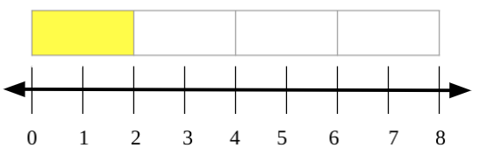
- Instruction includes real-world situations aligned with the content. The teacher provides a multiplication expression with real-world context and items to represent the situation to make connections.
  - For example, the teacher provides the student with the following situation: “The theater class has to make costumes that require $\frac{1}{4}$ foot of ribbon. They need to make 8 costumes. How many feet of ribbon will they need total?” The teacher provides ribbon already cut into $\frac{1}{4}$ foot pieces and has students model the problem. Students then write out the repeated addition problem to match $\frac{1}{4}+ \frac{1}{4} + \frac{1}{4} + \frac{1}{4} + \frac{1}{4} + \frac{1}{4} +\frac{1}{4} + \frac{1}{4}=\frac{8}{4}$ or 2 feet.
  - For example, the teacher provides the student with the following situation: “The theater class has 8 feet of ribbon. They need to make 4 costumes and they want to use up all of the ribbon. How many feet of ribbon does each costume use?” The teacher will provide the student with a piece of ribbon 8 feet long and have them mark it off into 4 equal sections and find the length of 1 section (2 feet).
- Teacher provides models that represent multiplication expressions to represent the Commutative Property of Multiplication and has students explain the difference in meaning.
  - For example, the teacher provides the student with the following models.
$3 × \frac{1}{4}$ $\frac{1}{4} × 3$
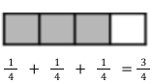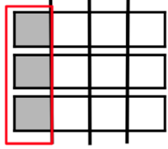
- The teacher provides models and asks students which expression it models.
  - For example, the teacher provides students with the following model and asks if it represents $\frac{1}{6}×4$ or $4 × \frac{1}{6}$.
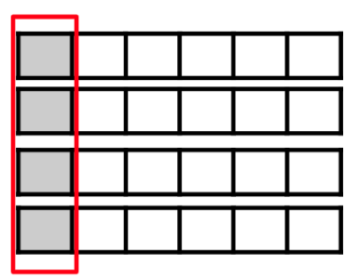

Instructional Tasks
Instructional Task 1 (MTR.2.1)
How many $\frac{2}{5}$ are in$\frac{12}{5}$? Use a visual model to explain your reasoning and show the relationship to the multiplication of a whole number by a fraction.

Instructional Task 2
Part A. Draw a model to show $4×\frac{3}{4}$

Part B. Then find the product. If possible, write the product as a mixed number.

Instructional Task 3
Select all the equations that are equal to the model.


- $\frac{2}{3}$ x 3
- $\frac{2}{3}$ + $\frac{2}{3}+ \frac{2}{3}$
- $\frac{1}{3}$ x 3
- $3+3+3$
- 3 x 2

Instructional Items
Instructional Item 1
An expression is shown.
$\frac{3}{4 }$ $×9$
What is the product?
- $\frac{3}{36 }$
- $\frac{27}{4 }$
- $\frac{27}{36 }$
- $\frac{39}{4 }$

Instructional Item 2
Choose all the ways to express the product of $\frac{3}{4}×5.$
- $5\frac{3}{4}$
- $\frac{15}{4}$
- $\frac{15}{20}$
- $3\frac{3}{4}$
- $\frac{3}{4}$

Instructional Item 3
The model shows $6 ×\frac{3}{8}.$
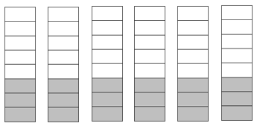
What is the product?
*The strategies, tasks and items included in the B1G-M are examples and should not be considered comprehensive.

Algebraic Reasoning

MA.4.AR.1 Represent and solve problems involving the four operations with whole numbers and fractions.

MA.4.AR.1.1

Benchmark
MA.4.AR.1.1 Solve real-world problems involving multiplication and division of whole numbers including problems in which remainders must be interpreted within the context.
Example: A group of 243 students is taking a field trip and traveling in vans. If each van can hold 8 students, then the group would need 31 vans for their field trip because 243 divided by 8 gives 30 with a remainder of 3.

Benchmark Clarifications:
Clarification 1: Problems involving multiplication include multiplicative comparisons. Refer to Situations Involving Operations with Numbers (Appendix A).
Clarification 2: Depending on the context, the solution of a division problem with a remainder may be the whole number part of the quotient, the whole number part of the quotient with the remainder, the whole number part of the quotient plus 1, or the remainder.
Clarification 3: Multiplication is limited to products of up to 3 digits by 2 digits. Division is limited to up to 4 digits divided by 1 digit.

Connecting Benchmarks/Horizontal Alignment
- MA.4.NSO.2
- MA.4.M.1.2
- MA.4.M.2.1
- MA.4.GR.1.3
- MA.4.GR.2

Terms from the K-12 Glossary
  - Equation
  - Expression
  - Factor

Vertical Alignment
Previous Benchmarks  MA.3.AR.1.2 | Next Benchmarks  - MA.5.AR.1.1
Purpose and Instructional Strategies
The purpose of this benchmark is to have students solve problems involving multiplication and division by using and discussing various approaches. This work builds on problem solving using the four operations from Grade 3 (MA.3.AR.1.2) and prepares for solving multi-step real-world problems involving any combination of the four operations with whole numbers in
Grade 5 (MA.5.AR.1.1).
- Students should use estimation, and this can include using compatible numbers (numbers that sum to 10 or 100) and rounding.
- Instruction should include allowing students many opportunities to solve multiplicative comparison situations.
- Students should have experience solving problems that require students to interpret the remainder to fit the situation. Students may have to round up to the next whole number, drop the remainder, use the remainder as a fraction or decimal, or use only the remainder as determined.
  - Add 1 to the quotient.
    - Thirty students are going on a field trip. They want to put 4 people in each car so that people can sit comfortably. How many cars will be needed?
    - Solution: Divide 30 by 4. The answer is 7 r2.
    - The answer shows that 7 cars will be needed, but 2 people are left over without a seat in a car. Therefore, 8 cars will be needed to transport all the students.
  - Use only the remainder.
    - Gerardo has 19 dollars in his pocket. He wants to give the same amount of money to 4 friends. The rest of the money, if any, will go to his sister to buy toys. How much money will go to his sister if Gerardo wants to give away everything he has?
    - Solution: Divide 19 by 4. The answer is 4 r3.
    - The remainder is 3, so 3 dollars will go to his sister.
  - Use the whole number part of the quotient.
    - Alicia has 48 dollars in her pocket. She wants to buy meals for 5 friends. If each meal costs 10 dollars, will Darlene be able to keep all her friends happy?
    - Solution: Divide 48 by 10. The answer is 4 r8.
    - Alicia can only buy 4 complete meals. Therefore, she cannot buy one for each of her 5 friends.
  - Write the remainder as a fraction.
- There are 3 friends who are equally sharing 124 feet of ribbon for an art project. How many feet of ribbon will each friend get?
- Solution: Divide 124 by 3. The answer is $41$ r3.
- The remainder is 1 foot of ribbon which can be divided and shared as an extra $\frac{1}{3}$ with each of the 3 friends. Each friend will receive $41\frac{1}{3}$ feet of ribbon.
- During instruction, teachers can allow students an opportunity to practice with word problems that require multiplication or division which can be solved by using drawings and equations, especially as students begin to make sense of the context within word problems (MTR.5.1).
- Work in this benchmark prepares students to effectively transition into algebraic concepts in the middle grades. It is important for students to have opportunities to connect mathematical statements and number sentences to equations.

Common Misconceptions or Errors
- Students apply a procedure that results in remainders that are expressed as r for all situations, even for those in which the result does not make sense.
  - For example, when a student is asked to solve the following problem, the student responds to the problem—there are 52 students in a class field trip. They plan to have 10 students in each van. How many vans will they need so that everyone can participate? And the student answers “5𝑟2 vans.” The student does not understand that the two remaining students need another van to go on the field trip.
- Students may not understand that the remainder represents a portion of something, rather than a whole number. Referring back to the previous example students may think r2 means two additional vans rather than a portion of an additional van.
- Students may have trouble seeing the remainder as a fraction.
  - For example, $7÷3=2r1$ means that $7÷3 =2\frac{1}{3}$. If 7 cupcakes are divided among 3 people, then each person will get 2 and $\frac{1}{3}$ cupcakes.
- It is essential to guide students in tackling real-world problems that may provide a quotient with a remainder, where interpretation may be necessary. Teachers can create environments where students relate remainders back to the contexts of the problems.

Strategies to Support Tiered Instruction
- Instruction includes opportunities to engage in guided practice completing real-world problems involving remainders. Students use models to understand how to interpret the remainder in situations in which they will need to “add 1 to the quotient,” “use only the remainder,” “use the whole number part of the quotient” or “treat the remainder as a fraction.”
  - For example, the teacher displays and reads the following problem aloud: “There are 55 pencils that need to be sorted into boxes. 10 pencils can go into each box. How many boxes are needed so all the pencils can be put into boxes?” The teacher uses models or drawings to represent the problem and guided questioning to encourage students to identify that they will need to add one to the quotient as their solution. If students state that they will need $5r5$ boxes, the teacher refers to the models to prompt students that a sixth box is needed for the remaining five pencils. If students state that they will need 5 more boxes since the remainder is 5, the teacher reminds students through guided questioning that the remainder of 5 represents 5 remaining pencils and only 1 more box is needed (i.e., “add 1 to the quotient”). This is repeated with similar real-world problems.
 | B1 B2 B3 B4 B5 B6
$$5r5$$ | 6 boxes are needed (B=box)
- Instruction includes opportunities to complete real-world problems involving remainders using pictorial representations to understand what the remainder is, including interpreting the remainder as a fraction.
  - For example, the teacher displays and reads the following problem aloud: “Karly, Juan and Li share 4 cookies equally. How many cookies can each person eat?” The teacher uses drawings to represent the problem and guided questioning to encourage students to identify that Karly, Juan and Li are able to eat 1 whole cookie but then must split the 4th cookie into thirds so that they can each eat 1$\frac{1}{3}$ cookies, therefore $4÷3=1\frac{1}{3}$. This is repeated with similar real-world problems.

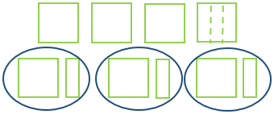
- Instruction includes opportunities to complete real-world problems involving remainders using manipulatives. Students use hands-on models to interpret the remainder in situations in which they will need to “add 1 to the quotient,” “use only the remainder,” “use the whole number part of the remainder” or “treat the remainder as a fraction.”
  - For example, the teacher displays and reads the following problem aloud: “There are 24 students in a class field trip. They plan to have 10 students in each van. How many vans will they need so that everyone can participate?” The teacher has students use counters or base-ten blocks to build a model of the problem and guided questioning to encourage students to identify that they will need to add 1 to the quotient as their solution. If students state that they will need $2r4$ vans, the teacher refers to the models to prompt students that a third van is needed for the remaining four students. If students state that they will need 4 more vans since the remainder is 4, the teacher reminds students through guided questioning that the remainder of 4 represents 4 remaining students and only 1 more van is needed (i.e., “add 1 to the quotient”). This is repeated with similar real-world problems.

 | V1 V2 V3
$$2r4$$ | 3 vans are needed so everyone can participate (v=van)

- Instruction includes using the 3-Read Protocol to break down the problem. First read the problem to understand the context, possibly without the numbers. Then, read to understand the mathematics. Finally, read to create a plan for solving the problem.

Instructional Tasks
Instructional Task 1 (MTR.5.1)
Write an example of a word problem involving division for each of the following situations that require a remainder to be interpreted: Add 1 to the quotient.
- Use only the remainder.
- Use the whole number part of the quotient.
- Write the remainder as a fraction.

Instructional Task 2 (MTR.7.1)
Ashley and Larry have to complete 27 benchmarks in 5 days. If they start on Monday and complete 6 benchmarks per day, how many will they need to complete on Friday?
- If completing 6 benchmarks takes an entire workday, how much of Friday will be needed to complete the remaining benchmarks?

Instructional Task 3
Mrs. Benito is putting manipulatives into plastic bags to create sets for her students. She has 212 flats and can fit 3 flats into each bag. How many bags will she need so that all the flats are in a bag?

Find the solution and explain how you interpreted the remainder.

How would your answer change if the question asked:
- How many bags have a complete set of 3 flats?
- How many flats are left over?

Instructional Items
Instructional Item 1
Sam has $50 to spend on video games. Video Games are on sale for $9. How many $9 games can Sam buy?
- 2 games
- 3 games
- 5 games
- 6 games

Instructional Item 2
This year, Mr. Buckley’s science club has three times the number of students as it did last year. This year, there are 78 students. How many students were in the science club last year?

Instructional Item 3
Sandhill Crane Elementary is using their cafeteria to host family night. Eight clubs will have booths set up to share activities with families. Each club will receive the same amount of space. If the cafeteria is 650 square feet, how much space will each club have to set up their booth?
- 81 square feet
- $81\frac{1}{4}$ square feet
- 82 square feet
- 5,200 square feet
*The strategies, tasks and items included in the B1G-M are examples and should not be considered comprehensive.

MA.4.AR.1.2

Benchmark
MA.4.AR.1.2 Solve real-world problems involving addition and subtraction of fractions with like denominators, including mixed numbers and fractions greater than one.
Example: Megan is making pies and uses the equation $1\frac{3}{4}+3\frac{1}{4}=x$ when baking. Describe a situation that can represent this equation.
Example: Clay is running a 10K race. So far, he has run $6\frac{1}{5}$ kilometers. How many kilometers does he have remaining?

Benchmark Clarifications:
Clarification 1: Problems include creating real-world situations based on an equation or representing a real-world problem with a visual model or equation.
Clarification 2: Fractions within problems must reference the same whole.
Clarification 3: Within this benchmark, the expectation is not to simplify or use lowest terms.
Clarification 4: Denominators limited to 2, 3, 4, 5, 6, 8, 10, 12, 16 and 100.

Connecting Benchmarks/Horizontal Alignment
- MA.4.FR.1.3
- MA.4.FR.2.2
- MA.4.M.2.1
- MA.4.DP.1.3

Terms from the K-12 Glossary
- Equation

Vertical Alignment
Previous Benchmarks  - MA.3.FR.1.2 | Next Benchmarks  - MA.5.AR.1.2
Purpose and Instructional Strategies
The purpose of this benchmark is to connect procedures for adding and subtracting fractions with like denominators (MA.4.FR.2.2) to real world situations (MTR.7.1). This builds on composing and decomposing fractions (MA.4.FR.2.1) to connect to addition and subtraction of fractions.
- Instruction includes providing students with the opportunity to recognize models or equations based on a real-world situation. During instruction, teachers can provide opportunities for students to practice solving problems using models or drawings to add and subtract with fractions. Begin with students modeling with whole numbers, have them explain how they used the model or drawing to arrive at the solution, then scaffold using the same methodology using fraction models. Instruction allows students to continue building understanding of fractions operations through modeling and the use of manipulatives. Models may include fraction bars, fraction circles and relationship rods.
- Instruction includes allowing students to create world situations based on models or equations.
- Instruction includes having students connect adding and subtracting procedures to real-world situations.

Common Misconceptions or Errors
- Students tend to have trouble with addition and subtraction because much instruction focuses only on procedures. Students need to know how to treat the numerator and denominator when following the procedures to add and subtract. It is important for students to use models, so they make sense of equations and real-world problems when they solve them.

Strategies to Support Tiered Instruction
- Instruction includes opportunities to engage in teacher-directed practice using visual representations to solve real-world problems involving addition and subtraction of fractions with like denominators. Students use models or equations based on real-world situations with an emphasis on how to treat the numerator and denominator when adding and subtracting.
  - For example, the teacher displays and reads the following problem: “Sara read $\frac{2}{8}$ of her book on Friday. On Saturday, she read $\frac{3}{8}$ of her book. How much of her book did she read on both days combined?” Using a number line, the teacher models solving this problem with explicit instruction and guided questioning. Students explain how to use the number line as a model to solve this question. Have students use an equation to represent the problem. This is repeated with similar real-world problems.

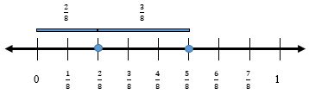

$$\frac{2}{8} + \frac{3}{8}= \frac{5}{8}$$
  - For example, the teacher displays and reads the following problem: “Jamal has a raised bed garden in his backyard. He planted tomatoes in $\frac{5}{12}$ of his garden and zucchini in $\frac{3}{12}$ of his garden. What fraction of his garden contains tomatoes and zucchini?” Using fraction bars or fraction strips, the teacher models solving this problem with explicit instruction and guided questioning. Students explain how to use fraction bars or fraction strips as a model to solve this question and create an equation to represent the problem. This is repeated with similar real-world problems.
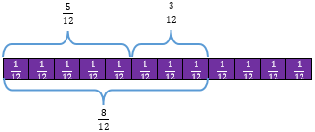$\frac{5}{12} + \frac{3}{12}= \frac{8}{12}$
- Instruction includes using the 3-Read Protocol to break down the problem. First read the problem to understand the context, possibly without the numbers. Then, read to understand the mathematics. Finally, read to create a plan for solving the problem.

Instructional Tasks
Instructional Task 1 (MTR.4.1)
Part A. Anna Marie has $\frac{3}{4}$ of a medium cheese pizza. Kent gives her $\frac{3}{4}$ of a medium pepperoni pizza. How much pizza does Anna Marie have now?
Part B. Anna Marie has $\frac{5}{8}$of a medium pizza. Kent gives her $\frac{4}{8}$of a large pizza. Explain why this problem cannot be solved by adding$\frac{5}{8}+\frac{4}{8}$ using a visual model.

Instructional Task 2
Gavin has a large granola bar for a snack before a soccer game. He ate $\frac{3}{8}$ of the granola bar. How much of the granola bar is left for him to eat after the game?
Use a model or write an equation to solve the problem.
Use your model or equation to explain what happens to the denominators when you subtract fractions with like denominators.

Instructional Task 3
Create a situation based on the following equation.
$$2\frac{3}{8}+1\frac{6}{8}=n$$
Find the sum.
Represent the sum in two different ways.

Instructional Items
Instructional Item 1
Jose was completing an exercise program. $\frac{8}{12}$ of the exercise program was sit-ups. The rest of the exercise program was pull-ups. What fraction of the exercise program was pull-ups?

Instructional Item 2
Abby is making a fruit punch with a mix of cherry and lime juices. She mixes $2\frac{7}{8}$ cups of cherry juice with 1$\frac{3}{8}$cups of lime juice. After mixing, what is the total amount of fruit punch, in cups, that she will have?

Instructional Item 3
Nathan cut a board that was $9\frac{5}{16}$ feet long. He made a mistake and was supposed to cut a board that was $10\frac{2}{16}$ inches long. How much longer is the board he should have cut?
- $\frac{11}{16}$
- $\frac{13}{16}$
- $1\frac{3}{16}$
- $1\frac{7}{16}$
*The strategies, tasks and items included in the B1G-M are examples and should not be considered comprehensive.

MA.4.AR.1.3

Benchmark
MA.4.AR.1.3 Solve real-world problems involving multiplication of a fraction by a whole number or a whole number by a fraction
Example: Ken is filling his garden containers with a cup that holds $\frac{2}{5}$ pounds of soil. If he uses 8 cups to fill his garden containers, how many pounds of soil did Ken use?

Benchmark Clarifications:
Clarification 1: Problems include creating real-world situations based on an equation or representing a real-world problem with a visual model or equation.
Clarification 2: Fractions within problems must reference the same whole.
Clarification 3: Within this benchmark, the expectation is not to simplify or use lowest terms.
Clarification 4: Fractions limited to fractions less than one with denominators of 2, 3, 4, 5, 6, 8, 10, 12, 16 and 100.

Connecting Benchmarks/Horizontal Alignment
- MA.4.FR.2.4
- MA.4.M.1.2
- MA.4.DP.1.3

Terms from the K-12 Glossary
  - Equation
  - Expression
  - Whole Number

Vertical Alignment
Previous Benchmarks  - MA.3.FR.1.2 | Next Benchmarks  - MA.5.AR.1.2, MA.5.AR.1.3
Purpose and Instructional Strategies
The purpose of this benchmark is to complement the instruction of MA.4.FR.2.4 with real-world context.
- Instruction should refer back to the two types of problems described in MA.4.FR.2.4 (whole number times a fraction and fraction times a whole number), and gives students opportunities to work with real-world examples of both types.
- Instruction should help students bring their understanding of working with units involving whole numbers (1 cup, 3 miles, etc.) to working with units involving fractions ($\frac{1}{2}$ cup, $\frac{3}{4}$ mile, etc.).
- During instruction it is acceptable to have students work with problems where fractional parts represent more than 1 whole (e.g., a cake recipe calls for $\frac{1}{3}$ cup of water and $\frac{1}{8}$ oz of vanilla extract, and the baker wants to double the recipe).
- Instruction may include having students create real-world situations that can be modeled by a given expression like $\frac{3}{5}×10$ (I have completed $\frac{3}{5}$ of my 10 mile run).
- During instruction, models and explanations should relate fraction multiplication to equal groups. This will activate prior knowledge and relate what students know to whole number multiplication.
  - For example, teachers can help students make connections to multiplication from Grade 3 by referring to an expression like $4×\frac{3}{5}$ as “four groups of 3 fifths,” that is, “four groups that each contain 3 items and each item is one fifth” (MTR.2.1, MTR.5.1).
  - Example: have table/bar to show that there are 4 groups of 3/5.
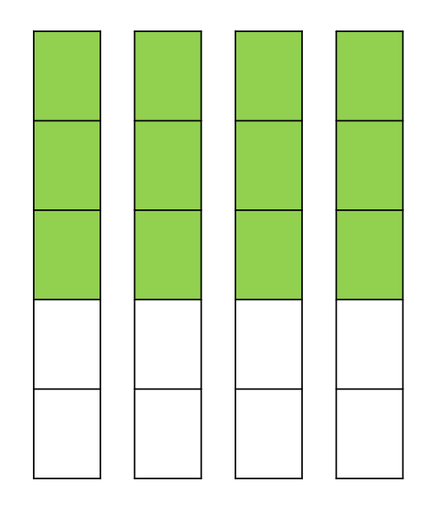
- Students are encouraged to express problem-solving solutions through various means, such as objects, illustrations, tables, graphs, and equations (MTR.2.1). When tackling fraction-related challenges, it is advisable to employ diverse models, including but not confined to area models (rectangles), linear models (fraction strips/bars and number lines), and set models (counters).
- Instruction includes exploring patterns of what happens to the numerator when a whole number is multiplied by a fraction will help students make sense of multiplying fractions by fractions in grade 5 (MTR.2.1). When multiplying whole numbers by mixed numbers, students can use the distributive property or write the mixed number as a fraction greater than one. During instruction, students should compare both strategies (MTR.6.1). Using the distributive property to multiply a whole number by a mixed number could look like this.
$$2×6\frac{1}{3}=\left(2×6\right)+\left(2×\frac{1}{3}\right)=12+\frac{2}{3}=12\frac{2}{3}$$
In the example, 2 groups of $6\frac{1}{3}$ was written as “the sum of 2 groups of 6 and 2 groups of 1 third.” The products of 12 and 2 thirds are added to show the product of $12\frac{2}{3}$.

Common Misconceptions or Errors
- Students may not understand that fractions are numbers (just as whole numbers are numbers) and this misconception may at first be reinforced by the fact that the phrase “group size” works well with whole numbers, but not so well with fractions; therefore, special attention should be given with many different real-world examples.
- Students may not understand what a fractional portion represents within context of a real-world situation.
- Students can have difficulty with word problems when determining which operation to use, and the stress of working with fractions makes this happen more often. Students need to apply what they already know about operations with fractions to create action plans to solve multi-step real-world problems involving fractions (MTR.7.1).

Strategies to Support Tiered Instruction
- Instruction includes opportunities to engage in teacher-directed practice using visual representations to solve real-world problems involving multiplication of a fraction by a whole number. Students are directed.
- how to use models or equations based on real-world situations. Through questioning, the teacher guides students to explain what each fractional portion represents in the problems used during instruction and practice.
  - For example, the teacher displays and reads aloud the following problem: “Angelica walks her dog $\frac{4}{5}$ of a mile every day. How far does she walk her dog after 7 days?” Using models, students solve the problem with explicit instruction and guided questioning. Students explain how to use models to solve this problem. The teacher reinforces the concept of multiplication as repeated addition by guiding students to represent this problem as $\frac{4}{5} + \frac{4}{5} + \frac{4}{5} + \frac{4}{5} + \frac{4}{5} + \frac{4}{5} + \frac{4}{5}$ and that$7×\frac{4}{5}$ is the same as seven groups of four fifths. The teacher guides students to create an equation to represent the problem, repeating with multiple real-world problems that involve multiplication of a whole number by a fraction or a fraction by a whole number.
- Instruction includes opportunities for students to use hands-on models and manipulatives to solve real-world problems involving multiplication of a whole number by a fraction. Students are guided in explaining how each model represents the real-world situation. Explicitly direct students on how to use models or equations based on real-world situations. Through questioning, students explain what each fractional portion represents in the problems used during instruction and practice.
  - For example, the teacher displays and reads aloud the following problem: “Ramon is baking cupcakes for his cousin’s birthday party. The recipe calls for 2 cups of sugar. He only needs to make $\frac{1}{3}$ as many cupcakes as the recipe call for. How many cups of sugar will Ramon need to use?” It may be useful to provide students with paper models that represent the cups of sugar. Students should cut the models into thirds to determine how much sugar will be needed for the recipe.
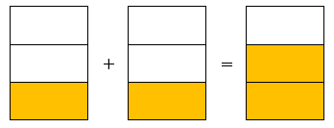

Instructional Tasks
Instructional Task 1 (MTR.2.1)
Lorelei is having a dessert party and wants to determine how much sugar she will need. For the party, she will make 4 batches of chocolate chip cookies and 8 vanilla smoothies. 1 batch of chocolate chip cookies requires $\frac{2}{3}$ cup of sugar and 1 vanilla smoothie requires $\frac{1}{3}$ cup of sugar. How much total sugar will she need for her dessert party? Draw a model to explain your thinking.

Instructional Task 2
Part A. An art project requires $\frac{2}{3}$ yard of ribbon to complete the project. Polly needs enough ribbon to complete 3 art projects. How many ribbons, in yards, will she need?
Use a model and write an equation to solve.
Part B. An art project requires 3 yards of ribbon to complete the project. Polly wants to create a smaller version of the art project and only needs $\frac{2}{3}$ of the amount of ribbon needed for the art project. How many ribbons, in yards, will she need?
Use a model and write an equation to solve.
Part C. How are the models and equations you used to solve situations from Part A and Part D the same and how are they different? How does this relate to what you already know about multiplication?
Instructional Task 3
There are 36 apples in a basket. $\frac{1}{4}$ of the apples are green. The rest are red.
Part A. How many of the apples are green?
Part B. What fraction of the total apples are red?
Part C. How many of the apples are red?

Instructional Items
Instructional Item 1
A butcher has 10 pounds of meat and sells $\frac{2}{3}$ of it in one day. How many pounds does the butcher sell?

Instructional Item 2
A painter uses gallon paint buckets when painting a house. He has 3 buckets of paint for his next job. After the job is complete, there is $\frac{1}{4}$ gallon left in each bucket. How much total paint does the painter have left?

Instructional Item 3
There are 24 students in Dr. Finley’s music class. $\frac{3}{8}$ of the students play the drums. How many students in Dr. Finley’s class play the drums?

Instructional Item 4
On his math test, Emmanuel answered $\frac{5}{6}$ of the items correctly. If there were 30 items on the test, how many did Emmanual answer correctly?
- 5
- 15
- 25
- 30
*The strategies, tasks and items included in the B1G-M are examples and should not be considered comprehensive.

MA.4.AR.2 Demonstrate an understanding of equality and operations with whole numbers.

MA.4.AR.2.1

Benchmark
MA.4.AR.2.1 Determine and explain whether an equation involving any of the four operations with whole numbers is true or false.
Example: The equation $32÷8=32-8-8-8-8$ can be determined to be false because the expression on the left side of the equal sign is not equivalent to the expression on the right side of the equal sign.

Benchmark Clarifications:
Clarification 1: Multiplication is limited to whole number factors within 12 and related division facts.

Connecting Benchmarks/Horizontal Alignment
- MA.4.NSO.2.1

Terms from the K-12 Glossary
  - Equal Sign
  - Equation
  - Expression

Vertical Alignment
Previous Benchmarks  - MA.2.AR.2.2  - MA.3.AR.2.2 | Next Benchmarks  - MA.5.AR.2.3
Purpose and Instructional Strategies
The purpose of this benchmark is to determine if students can connect their understanding of using the four operations fluently (MTR.3.1) to the concept of the meaning of the equal sign. This concept builds on the understanding of determining if addition and subtraction equations (MA.2.AR.2.2) and multiplication and division equations (MA.3.AR.2.2) are true and false.
- Students will determine if the expression on the left of the equal sign is equivalent to the expression to the right of the equal sign. If these expressions are equivalent, then the equation will be deemed true.
- Students may use comparative relational thinking or estimation, instead of solving, to determine if the equation is true or false (MTR.2.1, MTR.3.1, MTR.5.1).

Common Misconceptions or Errors
- Many students have difficulty understanding that the equal sign is a relational symbol. They believe that the equal sign makes the expression on the right side of the equation equal to the expression on the left side so that all equations would be true. Instead an equation with an equal sign can be true or false, depending on whether the expressions on each side of the equal sign are equal to each other or not.
- While justifying whether equations are true or false, students should explain what makes the equation true.

Strategies to Support Tiered Instruction
- Instruction includes opportunities to explore the meaning of the equal sign. The teacher provides clarification that the equal sign means “the same as” rather than “the answer is,” providing multiple examples for students to evaluate equations as true or false using the four operations with the answers on both the left and right side of the equation. The teacher begins by using single numbers on either side of the equal sign to build understanding and uses the same equations written in different ways to reinforce the concept.
  - For example, the teacher shows the following equations. Students are asked if they are true or false statements and to explain why. This is repeated with additional true and false equations using the four operations.
Example | True/False | Sample Student Rationale
$$5=5$$ | True | They are both the same number; five is the same as five.
$$9=3$$ | False | Nine and three have different values; they are not the same.
$$2+11=13$$ | True | When you add two and eleven, the total has a value of thirteen.
$$13=2+11$$ | True | The value of thirteen is the same as the value of two and eleven combined.
$$4÷2=42$$ | False | The quotient of four and two is two, not forty-two.
$$25-5=20$$ | True | When you take five away from twenty-five, the difference is twenty.
$$20=25-5$$ | True | The value of twenty is the same as the difference between twenty-five and five.
$$20=25+5$$ | False | The value of twenty-five plus five is thirty, not twenty.
$$4+1=2+3$$ | True | Four plus one has a value of five. Two plus three also has a value of five.
$$2×3=8-2$$ | True | Two times three has a value of six. Eight minus two also has a value of six.
- The teacher provides opportunities to explore the meaning of the equal sign using visual representations (e.g., counters, drawings, base-ten blocks) on a t-chart to represent the equations. The teacher provides clarification that the equal sign means “the same as” rather than “the answer is,” and provides multiple examples for students to evaluate equations as true or false using the four operations with the answers on both the left and right side of the equation. The teacher begins by using single numbers on either side of the equal sign to build understanding, using the same equations written in different ways to reinforce the concept.
  - For example, the teacher shows the following equations. Students use counters, drawings, or base-ten blocks on a t-chart to represent the equation. The teacher asks students if they are true or false statements and to explain why. This is repeated with additional true and false equations using the four operations.

Example | True/False | Visual Representation |  | Sample Student Rationale
$$5=5$$ | True |  |  | They are both the same number; the same amount is on both sides.
$$9=3$$ | False |  |  | Nine and three have different values; there is a different number on each side.
$$13=2+11$$ | True |  |  | The value of thirteen is the same as the value of two and eleven combined. Each side has the same amount.
$$4+2=42$$ | False |  |  | The sum of four and two is six, not forty-two. The value on each side is different.
$$4+1=2+3$$ | True |  |  | Four plus one has a value of five. Two plus three also has a value of five. Each side has the same number of counters.
$$2×3=8-2$$ | True |  |  | Two times three has a value of six. Eight minus two also has a value of six.

Instructional Tasks
Instructional Task 1
Using the numbers $3, 5, 6, 10$ create an equation that is true.
$$__ × __ = __ × __$$

Instructional Task 2
Part A. Explain why the equation $80-16=8×4$ is false.
Part B. Change the value of one number in the equation to make it true.

Instructional Items
Instructional Item 1
Determine whether the equation below is true or false.
86 + 58 = 144 ÷ 12

*The strategies, tasks and items included in the B1G-M are examples and should not be considered comprehensive.

MA.4.AR.2.2

Benchmark
MA.4.AR.2.2 Given a mathematical or real-world context, write an equation involving multiplication or division to determine the unknown whole number with the unknown in any position.
Example: The equation $96=8×t$ can be used to determine the cost of each movie ticket at the movie theatre if a total of $96 was spent on 8 equally priced tickets. Then each ticket costs $12.

Benchmark Clarifications:
Clarification 1: Instruction extends the development of algebraic thinking skills where the symbolic representation of the unknown uses a letter.
Clarification 2: Problems include the unknown on either side of the equal sign.
Clarification 3: Multiplication is limited to factors within 12 and related division facts.

Connecting Benchmarks/Horizontal Alignment
- MA.4.NSO.2.1

Terms from the K-12 Glossary
  - Equal Sign
  - Equation
  - Expression
  - Whole Number

Vertical Alignment
Previous Benchmarks  - MA.3.AR.2.3 | Next Benchmarks  - MA.5.AR.2.1  - MA.5.AR.2.4
Purpose and Instructional Strategies
The purpose of this benchmark is for students to continue connecting real world situations to multiplication and division by writing equations to represent these situations and using the relationship between multiplication and division to solve problems. This connects the work from Grade 3 of determining the value of the unknown number in multiplication and division equations that are given (MA.3.AR.2.3). This benchmark is extended in Grade 5, where factors are not limited to within 12 and equations may use parentheses, implying students may have to use order of operations to solve (MA.5.AR.2.4).
- Instruction of this benchmark should emphasize helping students to see the relationship between multiplication and division (MA.4.NSO.2.1) when solving for an unknown in any position in an equation.
- Success with this benchmark will facilitate automaticity with multiplication and division facts (MA.4.NSO.2.1).
- Within this benchmark, students may use multiplicative comparison (e.g., 50 is 5 times as many as 10).
- Using a bar or tape diagram can be helpful for students to model the real-world situations presented (see example below).
$$96 = 8 × t$$
$$t$$ | $$t$$ | $$t$$ | $$t$$ | $$t$$ | $$t$$ | $$t$$ | $$t$$
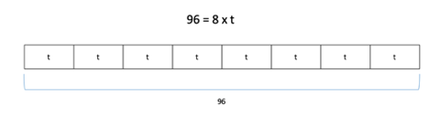
$$96$$
- In each context, students may provide many examples of equations that can be used to solve. During instruction, teachers can have students compare their equations and evaluate whether they can be used to solve (MTR.4.1).

Common Misconceptions or Errors
  - Even though many students know their multiplication and related division facts with automaticity, students without a firm conceptual understanding of multiplication and division may have difficulty problem solving with multiplication and division and writing equations to model situations. Provide opportunities for students to explain their models and justify solutions.
- When students have trouble comprehending contexts, they tend to just grab numbers from a given context and begin computing without justifying their arguments. Emphasis of instruction should be on the comprehension of problems through classroom discussion, sharing strategies, estimating reasonable solutions, and justifying equations and solutions (MTR.2.1).

Strategies to Support Tiered Instruction
- Instruction includes opportunities to connect real world situations to multiplication and division by writing equations to represent these situations and using the relationship between multiplication and division to solve problems. The teacher emphasizes the inverse relationship between multiplication and division, reinforcing conceptual understanding of multiplication and division by having students use drawings, models, and equations to solve real world problems.
  - For example, the teacher displays and reads the following problem aloud: “Enrique has 63 baseball cards, which is 9 times as many as Damion. How many baseball cards does Damion have?” The teacher guides students to use a drawing, such as a bar model, to solve and to write an equation. Through prompting and questioning, students explain their models and justify their solutions. This is repeated with multiple examples of real-world problems.
$$63=9×d$$
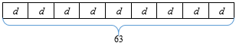
$$63÷9=7;63=9×7$$
$$d=7$$
- The teacher provides opportunities to connect real-world examples to multiplication and division using the relationship between multiplication and division to solve problems using hands-on models and manipulatives. The teacher emphasizes the inverse relationship between multiplication and division, reinforcing conceptual understanding of multiplication and division by having students use manipulatives and equations to solve real world problems. Through prompting and questioning, students explain their models and justify their solutions.
  - For example, the teacher displays and reads the following problem aloud: “Sabrina hiked 48 miles in the month of May. Andre hiked 8 miles in the same month. How many times more miles did Sabrina hike than Andre?” The teacher guides students to use manipulatives, such as counters or base-ten blocks, to model the problem by showing equal groups, reminding students that multiplication and division are inverse operations. Through prompting and questioning, students explain their models and justify their solutions and write an equation. This is repeated with multiple examples of real-world problems.

$$48=8×a$$
$$48÷8=6; 48=8×6$$
$$a=6$$
- Instruction includes using the 3-Read Protocol to break down the problem. First read the problem to understand the context, possibly without the numbers. Then, read to understand the mathematics. Finally, read to create a plan for solving the problem.

Instructional Tasks
Instructional Task 1 (MTR.7.1)
A typical Dalmatian weighs 54 pounds and a typical Yorkshire Terrier weighs 9 pounds. Write an equation to model this situation. Use your equation to determine how many more times does the typical Dalmatian weigh than the typical Yorkshire terrier?

Instructional Task 2
96 flowers are ordered for a party. Flowers are arranged so that one dozen will be placed at each table.
Part A. Write a division equation to indicate how many tables will have flowers. Use t to represent the number of tables.
Part B. Write a multiplication equation to indicate how many tables will have flowers. Use t to represent the number of tables.

Instructional Task 3
At 8:00 a.m., Marie’s shadow is three times shorter than her shadow at 1:00 p.m. Her shadow at 1:00 p.m. is 12 feet long.
Part A. Describe the error with using the equation below to the length of Marie’s shadow at 8:00 a.m.
$$3×12=l$$
Part B. Rewrite the equation from Part A so that it can determine the length of Marie’s shadow. Use l to represent the length of her shadow.
Part C. What is the length of Marie’s shadow at 8:00 a.m.?

Instructional Items
Instructional Item 1
Shernice has 84 comic books which is 12 times as many as Cindy.
Which equation below represents how many comic books, c, Cindy has?
- $84 = 12 + c$
- $84 = 12 × c$
- $c = 12 + 84$
- $c = 12 × 84$

Instructional Item 2
Wyatt bought 12 raffle tickets for a total cost of $84. Write an equation that can be used to find the cost of each raffle ticket.

*The strategies, tasks and items included in the B1G-M are examples and should not be considered comprehensive.

MA.4.AR.3 Recognize numerical patterns, including patterns that follow a given rule.

MA.4.AR.3.1

Benchmark
MA.4.AR.3.1 Determine factor pairs for a whole number from 0 to 144. Determine whether a whole number from 0 to 144 is prime, composite or neither.
Benchmark Clarifications:
Clarification 1: Instruction includes the connection to the relationship between multiplication and division and patterns with divisibility rules.
Clarification 2: The numbers 0 and 1 are neither prime nor composite.

Connecting Benchmarks/Horizontal Alignment
- MA.4.NSO.2.1

Terms from the K-12 Glossary
- Composite Number
- Factors
  - Prime Number

Vertical Alignment
Previous Benchmarks  - MA.3.AR.3.1, MA.3.AR.3.2 | Next Benchmarks  - MA.6.NSO.3.4
Purpose and Instructional Strategies
The purpose of this benchmark is for students to begin understanding of factors of whole numbers which sets the foundation for determining prime factorization in grade 6 (MA.6.NSO.3.4).
- This benchmark also refers to prime and composite numbers. Prime numbers have exactly two factors, the number one and the number itself (e.g., the number 13 has the factors of 1 and 13 only so it is a prime number). Composite numbers have more than two factors.
  - For example, 14 has the factors of 1, 2, 7 and 14. Since this number has more factors than 1 and 14, it is a composite number.
- Instruction should explore using number patterns and divisibility rules to determine the factors of a number.
  - All numbers are divisible by 1.
  - All even numbers are divisible by 2.
  - A number is divisible by 3 if the sum of the digits is divisible by 3.
  - A number is divisible by 4 if the 2-digit number in the tens and ones places is divisible by 4.
  - A number is divisible by 5 if the number in the ones place is a 0 or 5.
  - A number is divisible by 6 if it is an even number and the sum of the digits is divisible by 3.
  - A number is divisible by 9 if the sum of the digits is divisible by 9.
- Students should use models (arrays) to determine why a number would be prime or composite.

Common Misconceptions or Errors
- Students may think of the number 1 as a prime number. It is neither prime nor composite.
- Students may also think that all odd numbers are prime.
- Some students may think that larger numbers have more factors. Have students share all factor pairs and how they found the factors.
- Have students make connections with factors and number patterns.
  - For example, $6×3=18$. When 18 is doubled to 36, students can make connections that 36 has factors that include 3 and 6.

Strategies to Support Tiered Instruction
- Instruction includes opportunities to identify the factor pairs of whole numbers from 0-144 with teacher guidance. Students also determine if the number is prime, composite or neither. The teacher refers to the divisibility rules shown above in “Purpose and Instructional Strategies” to support students as they determine the factors of the given number. Students use manipulatives and models (e.g., counters and arrays) to identify factors of the given number.
  - For example, the teacher displays the following number: 48. Students draw arrays to determine the factors of 48 (1, 2, 3, 4, 6, 8, 12, 16, 24, 48). Students may use multiplication and skip counting to check factor pairs (e.g., 5 can be ruled out as a factor because $5×9=45$ and $5 ×10=50$). The teacher asks students if 48 is prime, composite, or neither (composite). This is repeated with additional whole numbers from 0-144.
48
1
24
2
16
3
12
4
8
6
  - For example, the teacher displays the following number: 32. Students are provided 32 counters and use them to create arrays to determine the factors of 32 (1, 2, 4, 8, 16, 32). Students may use multiplication and skip counting to check factor pairs (e.g., 5 can be ruled out as a factor because $5×6=30$ and $5 ×7=35$). Students may explore using counters to rule out additional numbers as factors (e.g., if you make 6 rows with a total of 32 counters, there will not be an even number in each row). The teacher asks students if 32 is prime, composite, or neither (composite). This is repeated with additional whole numbers from 0-144.
16
2
32
1
8
4

Instructional Tasks
Instructional Task 1 (MTR.3.1)
Find all the factors for the numbers between 20 and 30. Then sort the numbers as either Prime or Composite. Discuss what strategy you used to help you find all the factors of each number.

Instructional Task 2
Explain why the numbers 0 and 1 are neither prime nor composite.

Instructional Task 3
Frankie states that all even numbers greater than 2 are composite. Is she correct? Explain.

Instructional Task 4
Are all odd numbers prime? Explain.

Instructional Items
Instructional Item 1
Select all the true statements about the number $84$.
- $42$ is a factor of $84$.
- $84$ is a composite number.
- $84$ has exactly $4$ distinct factor pairs.
- $84$ is a prime number.
- One factor pair of 84 is 7 and 12.

Instructional Item 2
Which numbers are prime? Select all that apply.
- 0
- 1
- 2
- 3
- 4

Instructional Item 3
Izzy is thinking of a prime number is between 30 and 35. What is Izzy’s number?

*The strategies, tasks and items included in the B1G-M are examples and should not be considered comprehensive.

MA.4.AR.3.2

Benchmark
MA.4.AR.3.2 Generate, describe and extend a numerical pattern that follows a given rule.
Example: Generate a pattern of four numbers that follows the rule of adding 14 starting at 5.

Benchmark Clarifications:
Clarification 1: Instruction includes patterns within a mathematical or real-world context.

Connecting Benchmarks/Horizontal Alignment
- MA.4.NSO.2.2
- MA.4.FR.2.2
- MA.4.M.2.2

MA.5.AR.3.1Terms from the K-12 Glossary
- Expression

Vertical Alignment
Previous Benchmarks  - MA.3.AR.3.3 | Next Benchmarks  - MA.5.AR.3.1, MA.5.AR.3.2
Purpose and Instructional Strategies
The purpose of this benchmark is to build understanding of numerical patterns. Students should generate numerical patterns that follow a given rule with one step. This concept builds on identifying, creating and extending numerical patterns (MA.3.AR.3.3). In Grade 5, students will be asked to write rules as expressions with 1 or 2 operations.
- As students use numerical patterns, they will reinforce facts and develop fluency with operations (MTR.5.1).
- A pattern is a sequence that repeats the same rule over and over. Patterns and rules are related. A rule dictates what that pattern will look like.
- Students should understand that determining a rule for patterns helps them determine the value of future terms in the pattern (MTR.2.1, MTR.5.1).
- Students need multiple opportunities creating and extending number patterns.
- Students investigate different patterns to find rules, identify features in the patterns and justify the reason for those features.
- Students should look for relationships in the patterns they create and be able to describe and generalize.

Common Misconceptions or Errors
- Students often make mistakes due to lack of fluency with the four operations which hinders them from being able to extend the pattern according to the rule.
- Students may focus on a rule that works for a single term and its corresponding term. Remind students that the rule must work for all terms in the pattern.
  - For example, students may determine a rule based on the change in only the first two terms. During instruction, teachers should emphasize that a rule must work for the change in any two terms in a pattern.

Strategies to Support Tiered Instruction
- Instruction includes students drawing quick pictures of the numbers represented or using two-color counters or square tiles to model their patterns to aid students in seeing how the rule affects the terms and to make accurate calculations.
  - For example, shown is the pattern beginning with 4 and the rule is “add 7.”
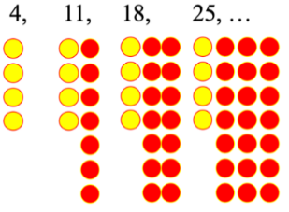

Instructional Tasks
Instructional Task 1 (MTR.5.1)
The first term of a pattern is an odd number. The rule is add 13. Is the 4th term of the pattern odd or even? Will this change if the first term in the pattern is a different odd number? Explain your reasoning.

Instructional Task 2 (MTR.5.1)
Part A. Find the areas of the squares shown in which the side lengths start at 1 and increase by 1 each time: ($1×1$) ($2×2$) ($3×3$) ($4×4$), etc.
Extend the pattern up to 10 terms.
Part B. Find the perimeters of the squares shown in which the side lengths start at 1 and increase by 1 each time: ($1×1$) ($2×2$) ($3×3$) ($4×4$), etc.
Extend the pattern up to 10 terms.

Instructional Task 3
Darnell is saving money and wants to save 12 more dollars each week than the week before. Darnell started with 10 dollars. How much money does he save in the 5th week?
What is the rule for the pattern?
Describe the pattern in two different ways.

Instructional Items
Instructional Item 1
The first term in a pattern is 6. The pattern follows the rule “add 4.”
Which of the numbers below is a term in the pattern?
- 1
- 8
- 14
- 16

Instructional Item 2
Part A. A pattern follows the rule “multiply by 2” and starts with the number 5. What is the 6th number in the pattern?
- 10
- 13
- 80
- 160

Part B. Select the statement that describes the pattern.
- All the numbers are multiples of 5.
- All the numbers are multiples of 2.
- The numbers alternate between odd and even.
- The numbers all have 5 in the ones place.
*The strategies, tasks and items included in the B1G-M are examples and should not be considered comprehensive.

Measurement

MA.4.M.1 Measure the length of objects and solve problems involving measurement.

MA.4.M.1.1

Benchmark
MA.4.M.1.1 Select and use appropriate tools to measure attributes of objects.

Benchmark Clarifications:
Clarification 1: Attributes include length, volume, weight, mass and temperature.
Clarification 2: Instruction includes digital measurements and scales that are not linear in appearance.
Clarification 3: When recording measurements, use fractions and decimals where appropriate.

Connecting Benchmarks/Horizontal Alignment
- MA.4.FR.1.2, MA.4.FR.1.4
- MA.4.GR.1.2
- MA.4.DP.1.1

Terms from the K-12 Glossary
- Equation

Vertical Alignment
Previous Benchmarks  - MA.3.M.1.1 | Next Benchmarks  MA.5.M.1.1
Purpose and Instructional Strategies
The purpose of this benchmark is to select and use tools to measure with precision. This concept builds on work to connect linear measurement to number lines (MA.3.M.1.1).
- Students will measure using the customary units of linear measurement to the nearest $\frac{1}{8}$ and $\frac{1}{16}$ of an inch.
- Students will measure volume, weight, mass and temperature using fractions or decimals where appropriate. As students work with this benchmark, they will begin to see relationships between units. For example, they will see that 10 millimeters is equivalent to one centimeter so one millimeter is $\frac{1}{10}$ of a centimeter.
- For instruction of linear measurement, instruction shows students equivalent fractions on a number line and how that connects to rulers and tape measures. Students should also gain experience measuring things larger than their piece of paper or their textbook so they can make decisions about what the best tool to measure is.
- Students should be given multiple opportunities to measure the same object with different measuring units. For example, have the students measure the length of a room with one-inch tiles, one-foot rulers and yardsticks. Students should notice that it takes fewer yard sticks to measure the room than rulers or tiles and explain their reasoning.
- For instruction of liquid volume, give students experiences with real-world measuring cups and graduated cylinders.
- For instruction of mass and weight, give students opportunities to use real-world balances and scales so they understand how they work and how to read measurements.
- For measuring temperature, provide examples of digital and analog thermometers.
- Examples of nonlinear scales include weight scales commonly used in grocery stores and many thermometers.
- Using protractors to measure angles provides the connection between MA.4.GR.2.1 and measurement with nonlinear scales.
- Students will begin to acquire an understanding of conversion rules (e.g. multiply to change a larger unit to a smaller unit and divide to change a smaller unit to a larger unit.) This foundational concept is applicable to the conversion of any unit of measure.

Common Misconceptions or Errors
- Students who struggle to identify benchmarks on number lines can also struggle to measure units of length, liquid volume, weight, mass and temperature. To assist students with this misconception, during instruction teachers can allow students to measure often and provide feedback. Students can also complete error and reasoning analysis activities to identify this common measurement misconception.

Strategies to Support Tiered Instruction
- Instruction includes opportunities to measure often and provide feedback. Use error and reasoning analysis activities to address common measurement difficulties.
- Instruction includes providing students with a variety of objects. Ask students which tool they would use to measure each object. Discussions would include asking which attribute of the object is to be measured.
  - For example, objects could include a banana (where length or weight could be measured), water in a container (where temperature, volume or weight could be measured).
Instructional Tasks
Instructional Task 1 (MTR.7.1)
Use a thermometer to measure the temperature to the nearest 0.1 degree Fahrenheit at 8:30 a.m., 11:00 a.m. and 1:30 p.m. every day for one week. Record each temperature in a table.

Instructional Task 2
Find a door in your classroom to measure the width.
Choose which of the following tools you think would be the most appropriate to use.
Inch tiles, one-foot ruler, or yardstick.

Record your choice in the space provided below.
Now use each tool to measure the width of the door. Record each measurement in the table below. Then decide which tool was most appropriate based on your measurement data. Explain your thinking.

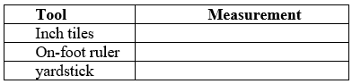

Instructional Items
Instructional Item 1
A pencil is shown. Using the ruler provided, what is the length of the pencil to the nearest $\frac{1}{8}$ inch?
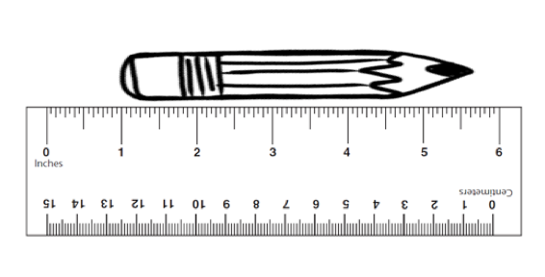

Instructional Item 2
Matt, Sara, Jamie, and Alex measured the length of their classroom with different units. Matt measured in feet, Sara measured in centimeters, Jamie measured in inches, and Alex measured in yards. Whose unit of measure would be the most appropriate to use when measuring the length of the classroom?
  - Alex
  - Jamie
  - Matt
  - Sara

Instructional Item 3
Elizabeth measuring the mass of a tennis ball. Which tool should she use to measure?
- Ruler
- Thermometer
- Pan balance
- Beaker
*The strategies, tasks and items included in the B1G-M are examples and should not be considered comprehensive.

MA.4.M.1.2

Benchmark
MA.4.M.1.2 Convert within a single system of measurement using the units: yards, feet, inches; kilometers, meters, centimeters, millimeters; pounds, ounces; kilograms, grams; gallons, quarts, pints, cups; liter, milliliter; and hours, minutes, seconds.
Example: If a ribbon is 11 yards 2 feet in length, how long is the ribbon in feet?
Example: A gallon contains 16 cups. How many cups are in $3\frac{1}{2}$ gallons?
Benchmark Clarifications:
Clarification 1: Instruction includes the understanding of how to convert from smaller to larger units or from larger to smaller units.
Clarification 2: Within the benchmark, the expectation is not to convert from grams to kilograms, meters to kilometers or milliliters to liters.
Clarification 3: Problems involving fractions are limited to denominators of 2, 3, 4, 5, 6, 8, 10, 12, 16 and 100.

Connecting Benchmarks/Horizontal Alignment
- MA.4.M.1.1

Terms from the K-12 Glossary

Vertical Alignment
Previous Benchmarks  - MA.3.M.1.1 | Next Benchmarks  MA.5.M.1.1
Purpose and Instructional Strategies
The purpose of this benchmark is for students to see the relationships between the units they use for measurement. Students should begin to generalize that the smaller the unit is, the more precise measurement they will get, but will also need more of the unit to measure (MTR.5.1). Work in this benchmark builds from Grade 3 foundations of using customary measurements (MA.3.M.1.1).
- For instruction, students need to use measuring devices in class to develop a sense of the attributes being measured to have a better understanding of the relationships between units.
- The number of units relates to the size of the unit. Students need to develop an understanding that there are 12 inches in 1 foot and 3 feet in 1 yard. Allow students to use rulers or a yardstick to discover these relationships among units of measurements. Using 12-inch rulers and yardsticks, students will see that three of the 12-inch rulers are the same length as a yardstick, so 3 feet is equivalent to one yard. A similar strategy can be used with rulers marked with centimeters and a meter stick to discover the relationships between centimeters and meters.
- To help students to visualize the size of units, they should be given multiple opportunities to measure the same object with different measuring tools.
  - For example, have the students measure the length of a room with one-inch tiles, with one-foot rulers, and with yardsticks. Students should notice that it takes fewer yard sticks to measure the room than rulers or tiles and explain their reasoning.
- During instruction, have students record measurement relationships in a two-column table or t-chart.
- Students are not expected to memorize conversions. Students should be provided conversion tools (e.g., charts) during instruction.

Common Misconceptions or Errors
- Students can assume that converting from smaller units to larger units (e.g., ounces to pounds), that multiplication is used, and when converting from larger units to smaller units (e.g., pounds to ounces), that division is used. To assist students with this misconception, expect them to estimate reasonable solutions. Students will begin to acquire an understanding of conversion rules (e.g. multiply to change a larger unit to a smaller unit and divide to change a smaller unit to a larger unit), an extension of the work started in the previous benchmark MA.4.M.1.1.

Strategies to Support Tiered Instruction
- Instruction includes demonstrating which operation to use when converting from smaller units to larger units (e.g., ounces to pounds) and when converting from larger units to smaller units (e.g., pounds to ounces). Instruction also includes estimating reasonable solutions. The teacher models a think aloud and record the relationships on a two-column chart.
  - For example, “If a ribbon is 11 yards 2 feet in length, how long is the ribbon in feet?”
    - “I know that for every 1 yard, there are 3 feet. So, I can multiply the number of yards by 3 to convert to feet. I also know that for every 3 feet, there is one yard. I can divide the number of feet by 3 to convert to yards. Therefore 2 yards convert to 6 feet and 6 feet converts to 2 yards. To find out how many feet there are in 11 yards, 2 feet, I have to multiply the number of yards by 3. $11 yards ×3=33 feet$. Next, I have to add the extra 2 feet. So, 11 yards, 2 feet converts to 35 feet.”
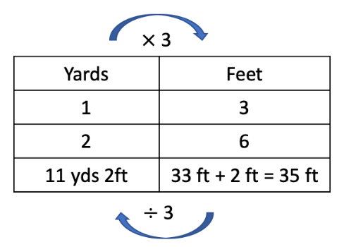
- Instruction includes using a bar model or tape diagram to show the relationship between the units. The teacher models a think aloud.
  - For example, “If a ribbon is 11 yards 2 feet in length, how long is the ribbon in feet?”
    - “I know that for every 1 yard, there are 3 feet. So, I can multiply the number of yards by 3 to convert to feet. I also know that for every 3 feet, there is one yard. I can divide the number of feet by 3 to convert to yards. Therefore 2 yards convert to 6 feet and 6 feet converts to 2 yards. To find out how many feet there are in 11 yards, 2 feet, I have to multiply the number of yards by 3. $11×3=33$. Next, I have to add the extra 2 feet. So, 11 yards, 2 feet converts to 35 feet.”
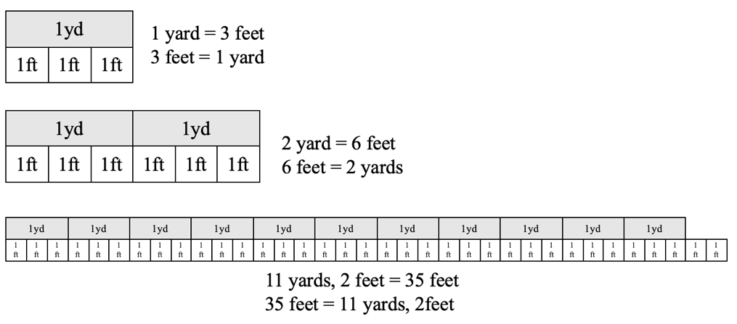

Instructional Tasks
Instructional Task 1 (MTR.3.1)
Calculate how many minutes there are in 1 week.

Instructional Task 2
A football field is 100 yards long. A college wants to display a large American flag on the field that is 245 feet long. Is the football field long enough to fit the length of the American flag? Use an equation or visual model to justify your answer.

Instructional Items
Instructional Item 1
There are 3 paperclip chains. Chain A is 50 inches long, Chain B is $4\frac{1}{4}$ feet long. Chain C is 1 yard long. Order the chains from the longest length to the shortest length.
- Chain A, Chain B, Chain C
- Chain B, Chain C, Chain A
- Chain C, Chain B, Chain A
- Chain B, Chain A, Chain C

Instructional Item 2
Darren grew a plant from seed. After 3 weeks, the plant grew 8 centimeters. How many millimeters did the plant grow?
- 0.8
- 8
- 80
- 800
*The strategies, tasks and items included in the B1G-M are examples and should not be considered comprehensive.

MA.4.M.2 Solve problems involving time and money.

MA.4.M.2.1

Benchmark
MA.4.M.2.1 Solve two-step real-world problems involving distances and intervals of time using any combination of the four operations.

Benchmark Clarifications:
Clarification 1: Problems involving fractions will include addition and subtraction with like denominators and multiplication of a fraction by a whole number or a whole number by a fraction.
Clarification 2: Problems involving fractions are limited to denominators of 2, 3, 4, 5, 6, 8, 10, 12, 16 and 100.
Clarification 3: Within the benchmark, the expectation is not to use decimals.

Connecting Benchmarks/Horizontal Alignment
- MA.4.M.1.2

Terms from the K-12 Glossary

Vertical Alignment
Previous Benchmarks  - MA.3.M.2.2 | Next Benchmarks
Purpose and Instructional Strategies
The purpose of this benchmark is to connect concepts of unit conversions to time and distance and solve problems with these conversions. In Grade 3, students solved one- and two-step elapsed time problems without converting units of time or crossing from a.m. to p.m. or p.m. to a.m. (MA.3.M.2.2).
- For distance problems, students may need to understand multiplicative comparison (e.g., 20 is twice as many as 10).
- For instruction, an open number line is a strategy students can use to solve elapsed time problems.
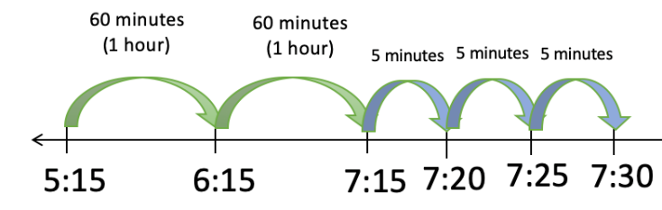
- Students need to spend time solving problems crossing between a.m. and p.m., and vice-versa.
- Students should also have a firm understanding of the terms quarter hour (15 minutes) and half hour (30 minutes).

Common Misconceptions or Errors
- Students can get confused when time crosses the hour because it does not follow the base-ten pattern where they are familiar. For example, students can misinterpret that the elapsed time between 9:55 a.m. and 10:05 a.m. and state that the elapsed time is 50 minutes because they have found the difference from 55 to 105. The use of number lines and clocks side-by-side help students build understanding about how elapsed time is calculated.

Strategies to Support Tiered Instruction
- Instruction includes the use of number lines and clocks side-by-side to help students build understanding about how elapsed time is calculated.
- Instruction includes using a number line and counting by ones to demonstrate what happens when time crosses the hour because it does not follow the familiar base ten pattern.
  - For example, use a number line to find the elapsed time between 9:55 a.m. and 10:05 a.m. and explain what happens when time crosses the hour at 10:00 a.m.
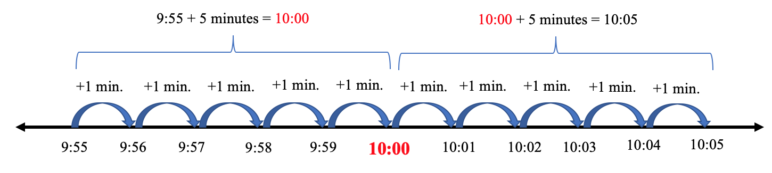
- Instruction includes demonstrating what happens when time crosses the hour because it does not follow the familiar base ten pattern.
- For example, instruction may include using a geared manipulative (Judy) clock to find the elapsed time between 9:55 a.m. and 10:05 a.m. Students move the minute of the hand one minute at a time from 9:55 to 10:00. After each minute, the teacher asks the students to record what time it is. The teacher has students pay special attention to what happens when the minute hand moves from 9:59 to the next minute.
- Instruction includes using the 3-Read Protocol to break down the problem. First read the problem to understand the context, possibly without the numbers. Then, read to understand the mathematics. Finally, read to create a plan for solving the problem.

Instructional Tasks
Instructional Task 1 (MTR.7.1)
Steve drove 2,465 miles away to college. On Parents’ Weekend, his parents drove the distance round trip from home, with an additional 385 miles traveled to visit his sister on their return trip. How many total miles did his parents drive on Parents’ Weekend?

Instructional Task 2
To prepare for track club, Miranda runs after school. Each day she trains, she completes three rounds of running for 4 minutes and 30 seconds. Between each round, she rests for 1 minute.

Part A. What is the total number of minutes Miranda runs each day she trains?
Part B. If she trained 4 days last week, what was the total number of minutes she trained for the week?

Instructional Items
Instructional Item 1
After lunch, Billy walked the dog for 17 minutes and then immediately after, did his chores for 58 minutes. If he finished his chores at 12:15 p.m., what time did he start walking the dog?
- 1:30 p.m.
- 1:13 p.m.
- 11:17 a.m.
- 11:00 a.m.

Instructional Item 2
John is working to complete his science fair project during winter break. On Monday, he begins working at 10:30 a.m. At 11:20, he takes a 45-minute break for lunch and then continues working for an additional 2 hours and 15 minutes. What time is it when John finishes working for the day?
- 12:45 p.m.
- 1:35 p.m.
- 2:20 p.m.
- 3:50 p.m.

Instructional Item 3
A television show is one-half hour long. During the show, there are four commercial breaks that are each 90 seconds long. There are no other interruptions to the show. How many minutes is the television show?
*The strategies, tasks and items included in the B1G-M are examples and should not be considered comprehensive.

MA.4.M.2.2

Benchmark
MA.4.M.2.2 Solve one- and two-step addition and subtraction real-world problems involving money using decimal notation.
Example: An item costs $1.84. If you give the cashier $2.00, how much change should you receive? What coins could be used to give the change?
Example: At the grocery store you spend $14.56. If you do not want any pennies in change, how much money could you give the cashier?

Connecting Benchmarks/Horizontal Alignment
- MA.4.NSO.2.7

Terms from the K-12 Glossary

Vertical Alignment
Previous Benchmarks  - MA.2.M.2.2 | Next Benchmarks  MA.5.M.2.1
Purpose and Instructional Strategies
The purpose of this benchmark is to connect money concepts to adding and subtracting decimals. This benchmark can be taught in tandem with the addition and subtraction of decimals to the hundredths (MA.4.NSO.2.7). Students solve problems within a real-world context using money (MTR.7.1). Money contexts are an important concept and build the foundation in later grades where students are expected to fluently use decimal operations to solve equations with variables (MA.6.NSO.2.3).
- For instruction, students should have opportunities using multiplication to count collections of coins (e.g., How much money is 50 nickels?).
- Instruction allows students to make computations flexibly using various strategies (MTR.2.1)
- When students solve problems, invite flexible strategies that students learned with whole number addition and subtraction. For example, when finding the change for $2.00 on an item that costs $1.84, students may count up $0.16 instead of subtracting $2.00 - $1.84.
- Students need to understand how different coins and bills relate to each other.

Common Misconceptions or Errors
- Students can add and subtract incorrectly when they do not add or subtract like place values.

Strategies to Support Tiered Instruction
- Instruction includes connecting place value to addition and subtraction of whole numbers, utilizing place value charts so that students can see where to line up values for the computation.
  - For example, $20.20 – $9.75 is going to require some regrouping. By placing the problem in a place value chart, students can line up the decimal and subtract like place values.
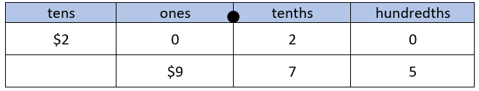
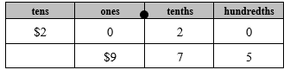
- Instruction includes relating decimal place values. Working with base ten blocks, students can build decimals and their equivalents.
  - For example, building 0.2 “two tenths” and 0.20 “twenty hundredths” with base ten blocks. Students will notice that the numbers have the same value.

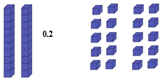
0.2 | 0.20
- Instruction includes using the 3-Read Protocol to break down the problem. First read the problem to understand the context, possibly without the numbers. Then, read to understand the mathematics. Finally, read to create a plan for solving the problem.
  - The teacher encourages and guides students to think backwards when completing word problems. Identify what the problem is asking and create action steps to solve the problem. For example, why do you subtract when a question asks you to find how much change will be given back after a purchase? Students should have an understanding that change back is the difference between the amount of money given and the cost of an item.
  - The teacher encourages students to utilize peer discourse to identify important information when solving word problems. Have students read word problems to a partner and explain to each other what steps are needed to solve the problem (MTR.4.1).

Instructional Tasks
Instructional Task 1
Jordan was saving his money to buy a remote control motorcycle. He saved $45.00 from his allowance and received two checks worth $10.00 each for his birthday. Jordan also has a half dollar coin collection with 30 coins in it. If the motorcycle costs $73.00, does Jordan have enough money to buy the motorcycle?

Instructional Task 2
Erika and Wade have collections of coins. Erika has 78 dimes. Wade has 113 nickels.
Part A. How much money does each person have? Express the amounts in decimal form.
Part B. What is the difference between the amounts of money each person has?

Instructional Task 3
Greta has a collection of quarters that she will roll and bring to the bank to deposit into her account. She fills seven rolls with 9 quarters left over. If each roll is worth $10, what is the total amount of money she brings to the bank? Express your answer in decimal form.
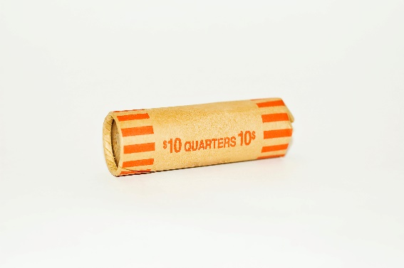

Instructional Items
Instructional Item 1
Maria went to the comic bookstore and bought a comic book for $5.34 and a comic book for $9.55. If she paid with a $20 bill, how much change would she get back?

Instructional Item 2
Anna got $100 for her birthday. She uses this money to buy a skateboard for $65.00 and a book that costs $7.50. How much money will she have left after making these purchases?
a. $27.50
b. $35.00
c. $72.50
d. $92.50

Instructional Item 3
Henry, Jakob, and Kelvin go to breakfast. Each of them buy a meal for $5.49. $1.07 is added to their bill for tax. What is the total amount on the bill?
*The strategies, tasks and items included in the B1G-M are examples and should not be considered comprehensive.

Geometric Reasoning

MA.4.GR.1 Draw, classify and measure angles.

MA.4.GR.1.1

Benchmark
MA.4.GR.1.1 Informally explore angles as an attribute of two-dimensional figures. Identify and classify angles as acute, right, obtuse, straight or reflex.
Benchmark Clarifications:
Clarification 1: Instruction includes classifying angles using benchmark angles of $90°$ and $180°$ in two-dimensional figures.
Clarification 2: When identifying angles, the expectation includes two-dimensional figures and real-world pictures.

Connecting Benchmarks/Horizontal Alignment
- MA.4.GR.1.2
- MA.4.GR.1.3

Terms from the K-12 Glossary
- Acute Angle
- Angle
- Obtuse Angle
- Reflex Angle
- Right Angle
- Straight Angle
- Vertex

Vertical Alignment
Previous Benchmarks  - MA.3.GR.1.1  - MA.3.GR.1.2 | Next Benchmarks  - MA.5.GR.1.1  - MA.5.GR.1.2
Purpose and Instructional Strategies
The purpose of this benchmark is to begin the understanding of angles and how they can be identified in lines and shapes. Understanding angles will be used to define shapes by their attributes. This builds on the work students completed in grade 3 to identify perpendicular lines in shapes in mathematical and real-world situations (MA.3.GR.1.1).
- During instruction, students should gain experience using benchmark angles of $90°$ and $180°$ (MTR.6.1). For right angles ($90°$) students can use the corner of a piece of paper. By lining the edge of the corner of the paper on one ray to the vertex of the angle, students can determine that angles that are smaller than the corner are acute and angles that are larger than the corner are obtuse. Similarly, students can use the side of a piece of paper to determine if the angles are greater than $180°$.
- In mathematical contexts, students find evidence of points, lines, line segments, rays, intersecting lines, perpendicular lines and parallel lines, and acute, obtuse, reflex, right and straight angles in models of two-dimensional figures (e.g., quadrilaterals, triangles). In real-world contexts, students identify evidence of these geometric attributes in real-life images (e.g., aerial views of city maps, architectural designs, photos of objects) (MTR.4.1, MTR.7.1). This will extend their understanding of identifying angles in two-dimensional figures.
- When instructing students on the different types of angles, ensure students understand there can be more than one type of angle in a two-dimensional figure. For example, a figure may have a reflex angle and an obtuse angle.
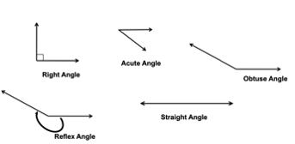

Common Misconceptions or Errors
- Students believe a wide angle with short sides may seem smaller than a narrow angle with long sides. Students can compare two angles by tracing one and placing it over the other. Students will then realize that the length of the sides does not determine whether one angle is larger or smaller than another angle. The measure of the angle does not change.
- Students may struggle to identify examples of points, lines, line segments, rays, intersecting lines, perpendicular lines and parallel lines and acute, obtuse, reflex, right and straight angles in real-world examples. Classroom instruction should include many examples for students to explore.

Strategies to Support Tiered Instruction
- Instruction includes providing a graphic organizer and several examples of each type of angle (acute, right, obtuse, straight and reflex). The graphic organizer will have angles labeled on them for the students to use to help them classify the figures provided.
  - For example, the teacher provides a graphic organizer similar to the one shown below. Along with the graphic organizer, the teacher provides examples of various angles to classify.
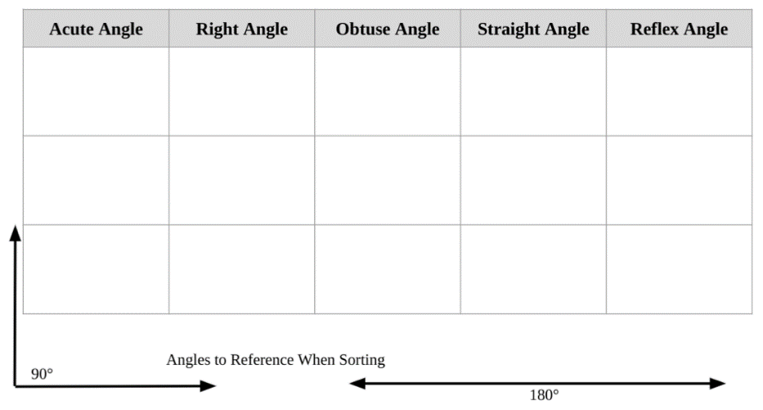
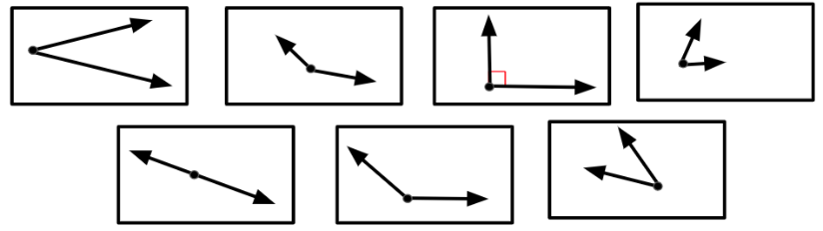
- Instruction includes providing a right angle and a straight angle printed on a clear transparency or sheet protector. Students lay the angles over angle examples provided by the teacher to help them classify the angles as less than 90 degrees (acute angle), greater than 90 degrees (obtuse angle), exactly 90 degrees (right angle), exactly 180 degrees (straight angle), or greater than 180 degrees (reflex angle). Students trace one angle and place it over the other to compare them.
- For example, the teacher may provide the student with a clear transparency with a right angle printed on it. The teacher provides sample angles and asks students to place transparency over the angles. The students sort the angles into greater than 90 degrees, less than 90 degrees, and equal to 90 degrees. The teacher will then provide a straight angle printed on a transparency and have students use that to classify the angles that were sorted as greater than 90 degrees into an additional grouping. Students will determine if the angles are equal to 180 degrees or greater than 180 degrees.
- Instruction includes real-world examples of points, lines, line segments, rays, intersecting lines, perpendicular lines, parallel lines, acute angles, obtuse angles, reflex angles, right angles and straight angles. The teacher provides images of real-world examples that include geometric figures. Students identify the geometric figure in the example. o For example, the teacher provides an image of railroad tracks to represent parallel lines, a speed sign to represent perpendicular lines, a balance beam to represent a line segment, and other common images.

Instructional Tasks
Instructional Task 1 (MTR.4.1)
Part A: Draw and label an example of 3 different objects that have a right angle.
Part B: Draw and label an example of 3 different objects that have an acute angle.
Part C: Draw and label an example of 3 different objects that have an obtuse angle.
Part D: Is it possible to find an object with a reflex angle? Why or why not?

Instructional Task 2


Use the picture of the building above to answer the following questions:
Part A: What different types of angles do you see in the building? Name each type of angle you locate and describe where it is located within the picture.
Part B: What different figures are present within this building? Name two figures and describe the different angles each figure has.

Instructional Task 3
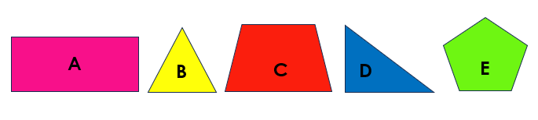
Use the figures above to answer the following questions.
Part A. Which shapes have acute angles?
Part B. Which shapes have obtuse angles?
Part C. Are there any shapes with both right and acute angles?

Instructional Task 4
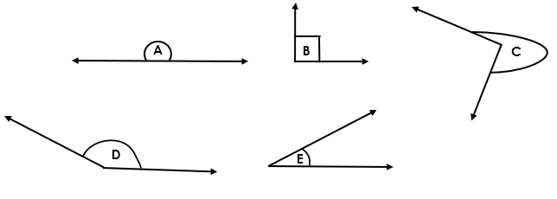
Part A. Write the letter of the angle in the correct column in the table below.

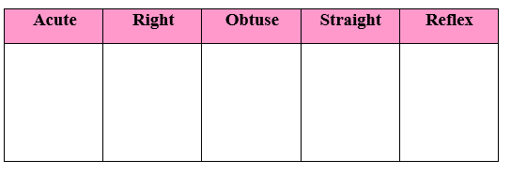

Instructional Items
Instructional Item 1
Which statement correctly describes the figure?
- 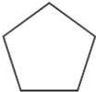 It has 5 acute angles.
- 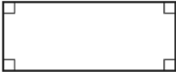 It has 4 obtuse angles.
- 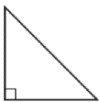 It has 1 right angle and 2 acute angles.
- 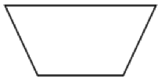 It has 2 right angles and 2 obtuse angles.

Instructional Item 2
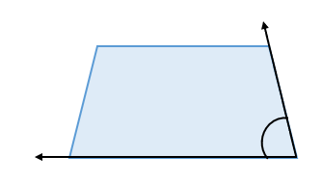
Is the angle shown in the trapezoid above greater than or less than a right angle? How do you know?

Instructional Item 3
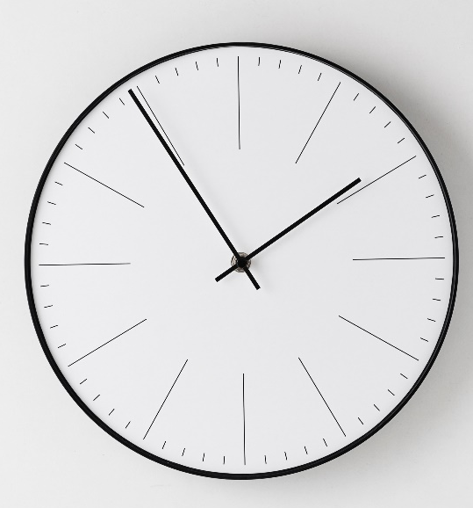
What kind of angles are created by the hands on the clock in the image above? Select all that apply.
  - Acute
  - Obtuse
  - Reflex
  - Right
  - Straight

Instructional Item 4
The angle at the top of the ladder created by the two sides can be best classified as what type of angle?
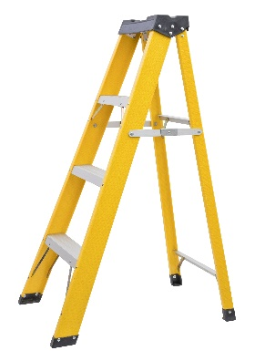
- acute
- obtuse
- right
- straight

*The strategies, tasks and items included in the B1G-M are examples and should not be considered comprehensive.

MA.4.GR.1.2

Benchmark
MA.4.GR.1.2 Estimate angle measures. Using a protractor, measure angles in whole-number degrees and draw angles of specified measure in whole-number degrees. Demonstrate that angle measure is additive.
Benchmark Clarifications:
Clarification 1: Instruction includes measuring given angles and drawing angles using protractors.
Clarification 2: Instruction includes estimating angle measures using benchmark angles ($30°$, $45°$, $60°$, $90°$ and $180°$).
Clarification 3: Instruction focuses on the understanding that angles can be decomposed into non-overlapping angles whose measures sum to the measure of the original angle.

Connecting Benchmarks/Horizontal Alignment
- MA.4.GR.1.1
- MA.4.GR.1.3

Terms from the K-12 Glossary
- Acute Angle
- Angle
- Obtuse Angle
- Reflex Angle
- Right Angle
- Straight Angle
- Vertex

Vertical Alignment
Previous Benchmarks  - MA.3.GR.1.1  - MA 3.GR.1.2 | Next Benchmarks  MA.5.GR.1.1
Purpose and Instructional Strategies
The purpose of this benchmark is to build understanding that angles can be measured. Students have experience identifying acute, obtuse, right, reflex and straight angles (MA.4.GR.1.1). Through instruction in this benchmark, students will attach precise measurements to their informal understanding of the angles they have explored.
- Students will also estimate angle measures based on their growing familiarity of the size of angles according to the benchmark angles $30°$, $45°$, $60°$, $90°$ and $180°$.
- Instruction should allow students to draw angles of all sizes, including situations where they must make angles that are larger than their protractor or their piece of paper. This will ensure that students have an understanding that the angle measure does not change even if the length of the rays do.
- Instruction should use explicit and direct instruction to show students how to use a protractor (standard or circle) to measure and draw angles. Using circle protractors helps students explore reflex angles.
- Instructional time should also be spent breaking apart angles into smaller angles so that students build understanding that angle measures are additive.

Common Misconceptions or Errors
- Students may have difficulty using a protractor to measure. Possible mistakes may include:
- using the centimeter ruler or inch ruler instead of the baseline when measuring the angles.
- measuring the length of each ray and finding the sum of the lengths.
- not correctly lining up the angle to be measured on the protractor.
- To assist students with these misconceptions, opportunities should be provided for students to use the protractor to measure angles while the teacher provides feedback. Students can also use angle estimation to determine accuracy of their angle measurement.

Strategies to Support Tiered Instruction
- Instruction includes using a right angle, 90 degrees measure, as a benchmark to estimate angle measures prior to measuring with a protractor. The teacher provides students with a right angle to overlap with the angles they are measuring as a way to compare their size.
  - For example, when given an angle, students will determine if the angle is 90 degrees, greater than 90 degrees, or less than 90 degrees. Students then measure the angle using a protractor and determine if their measurement makes sense based on their estimate.
- The teacher provides angles that have a baseline ray labeled so that students know which ray to line up with the baseline on the protractor and begin their measurement from. Students explain how they will use the protractor to measure the angle (which set of numbers they will use to measure and how they know where to stop measuring).
- For example, the teacher provides an angle similar to the one shown below. Students line up the baseline of the protractor with the ray on the angle that is labeled as the baseline. Students will start measuring with the set of numbers that begins with 0 at the end of the ray and follow the measurements around to the point where the other ray intersects with the protractor.
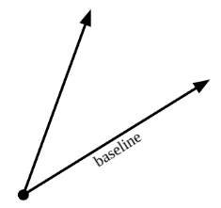

Instructional Tasks
Instructional Task 1
Use a protractor to find the measure of each indicated angle.
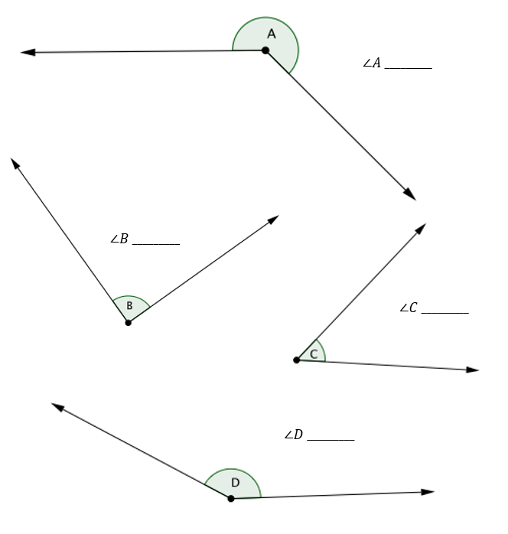
Instructional Task 2
Use the following angle to help you answer the questions.
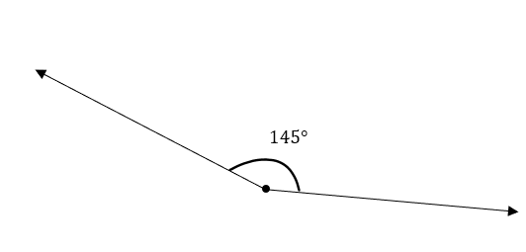
Part A. Decompose the angle shown above into two different angles. What are the measures of your two angles?
Part B. Now decompose the angle shown above a different way. What are the measures of your two new angles?
Part C. What benchmark angles helped you decide the measurements of your angles?
Part D. If I did not know the benchmark angles, what other resource(s) could I use to help me determine the measurement of the decomposed angles?

Instructional Task 3
Part A. Draw an angle that measures 85$°$.
Part B. Add another 45$°$ angle that connects to your 85$°$ angle (this angle should share the same vertex.) What is the measure of the two angles together?
Part C. What are the names of the three angles you have drawn?

Instructional Items
Instructional Item 1
Which angles when added together make a right angle?
- 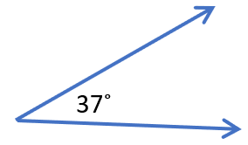
- 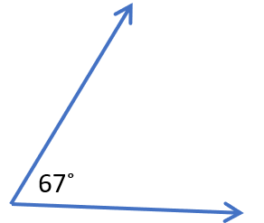
- 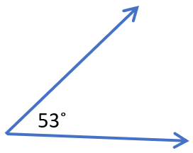

- 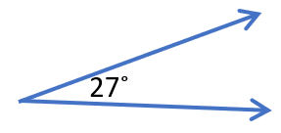

- 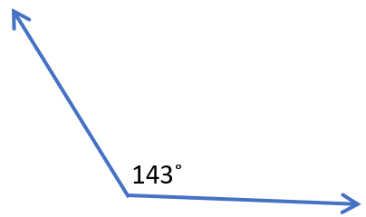

Instructional Item 2
What is the measure of the following angle?

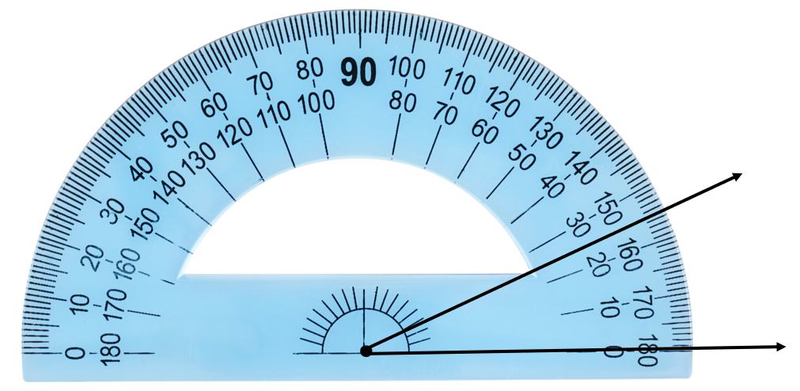
        - 155$°$
        - 180$°$
        - 145$°$
        - 25$°$

Instructional Item 3
Use your knowledge of benchmark angles to estimate the measurement of this angle.
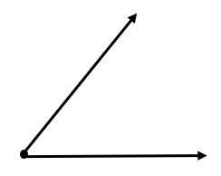
The measure of this angle is about:
- 100$°$
- 25$°$
- 50$°$
- 85$°$

Instructional Item 4
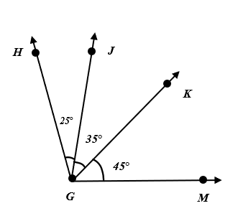

What is the measure of <HGM?
*The strategies, tasks and items included in the B1G-M are examples and should not be considered comprehensive.

MA.4.GR.1.3

Benchmark
MA.4.GR.1.3 Solve real-world and mathematical problems involving unknown whole-number angle measures. Write an equation to represent the unknown.
Example: A $60°$ angle is decomposed into two angles, one of which is $25°$. What is the measure of the other angle?

Benchmark Clarifications:
Clarification 1: Instruction includes the connection to angle measure as being additive.

Connecting Benchmarks/Horizontal Alignment
- MA.4.AR.1.1
- MA.4.AR.2.2
- MA.4.GR.1.2

Terms from the K-12 Glossary
- Angle
- Circle
- Equation
- Right Angle
- Straight Angle

Vertical Alignment
Previous Benchmarks  MA.3.GR.1.1 | Next Benchmarks  - MA.8.G.1.4
Purpose and Instructional Strategies
The purpose of this benchmark is to extend student thinking about angle measures beyond right angles that were taught in grade 3 (MA.3.GR.1.1) and introducing the idea that angle measures are additive (MA.4.GR.1.2). Students will use this idea to find a missing angle measure.
- For instruction, students should use protractors to draw angles that add up to make right angles, straight angles and circles.
- With the knowledge that angle measures are additive, students can solve interesting and challenging problems with all four operations to find the measurements of unknown angles on a diagram in real world and mathematical problems.
- Students can use a protractor to ensure that they develop understanding of benchmark angles (e.g., $30°$, $45°$, $60°$ and $90°$).

Common Misconceptions or Errors
- Students may make errors when writing equations used to solve angle measurement problems. During instruction, expect students to justify their equations and solutions.
- Students may not understand that straight lines, even if intersected, measure $180°$.

Strategies to Support Tiered Instruction
- The teacher provides a right angle, straight angle or circle and asks students to use the protractor to divide the angle into two angles and specify their measurements. The teacher has students write an equation to show that the sum of the two angles is equivalent to the angle they started with and explain their equation.
  - For example, when provided with a straight angle, students divide the angle into a 45-degree angle and a 135-degree angle as show below. Students label each angle and explain the equation $135°+45°=180°$, knowing that a straight angle measures 180-degrees.
  - 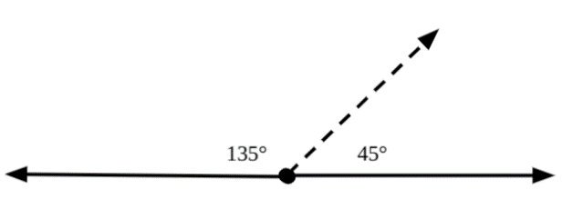
- Instruction includes matching equations with given angle images containing angle measures. Students explain the equations and how they know they match the image selected.
  - For example, when provided images similar to those shown below, students match the equation from a list of equations provided and explain how they know the equation matches.
$$60° + 30° = 90°$$ | $$150° + 30° = 180°$$
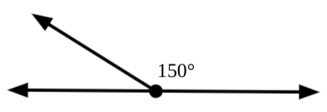
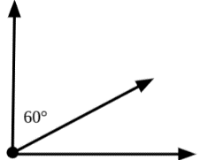

- The teacher provides images that contain missing angle measures. Students identify straight angles in the image and use their understanding that straight angles measure 180-degrees to help them find the missing angle measure.
  - For example, when provided with the image below, students highlight or trace over the straight angle and label as 180-degrees. Students then write an equation using this information and the angle measure provided to help them solve for the unknown angle.
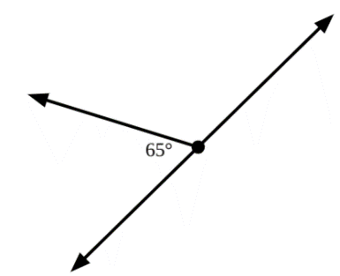

- Instruction includes identifying straight angles as measuring 180-degrees.
- For example, when provided images similar to the one shown below, students highlight straight angles and label them as 180-degrees. In this example, students identify both straight angles, highlighting them with different colors and explain that both have a measure of 180-degrees

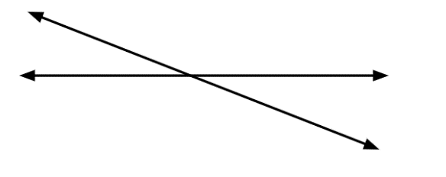
- Instruction includes using the 3-Reads Protocol to break down the problem. First read the problem to understand the context, possibly without the numbers. Then, read to understand the mathematics. Finally, read to create a plan for solving the problem

Instructional Tasks
Instructional Task 1
Two straight lines, $AC$ and $BD$, intersect at point $E$. Using the given angle $∠AEB$, find the measure of the other 3 angles.
This item may seem a bit challenging, but it fits within the benchmark, because it can be solved by repeatedly using additivity, and that fact that a straight line is $180°.$
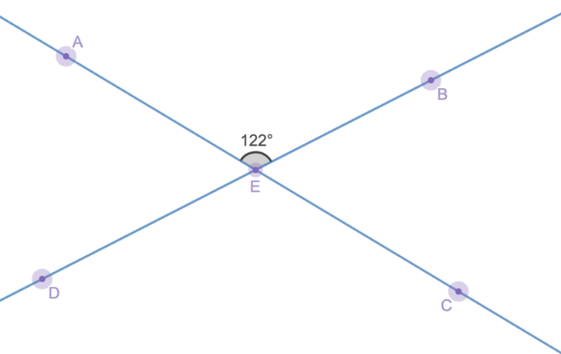

Instructional Task 2
Part A. Draw a street map that includes the following:
  - At least 3 acute angles
  - 2 obtuse angles
  - 4 right angles
  - 2 straight angles
Part B. Use a protractor to measure and label each angle

Instructional Task 3
Fans sit in three different sections of a baseball stadium to watch a game. These three areas form a 105$°$angle as shown in the diagram below.
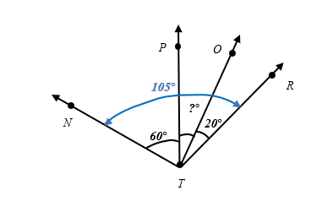
Part A. Write an equation to represent the missing <PTO.
Part B. What is the angle of the center section of the stadium?
Part C. If the baseball stadium wanted to add a fourth section of seating that extended 35$°$ more, what would be the total sum of the viewing area?

Instructional Items
Instructional Item 1
Carlos is adding angles together to create a $150°$ angle. Select all the angle measures that Carlos can use to create a$150°$angle.

- $50° +100°$
- $45° +95°$
- $50° +90°$
- $50° +20° +20°$
- $50° +50° +50°$

Instructional Item 2
Erin’s laptop can open up to a 180° angle. She prefers to have it opened to 108° while working. What angle measure could be added to 108° to show the laptop completely open?
- 72°
- 82°
- 198°
- 288°

Instructional Item 3
Select all the equations that are correct for the diagram below.
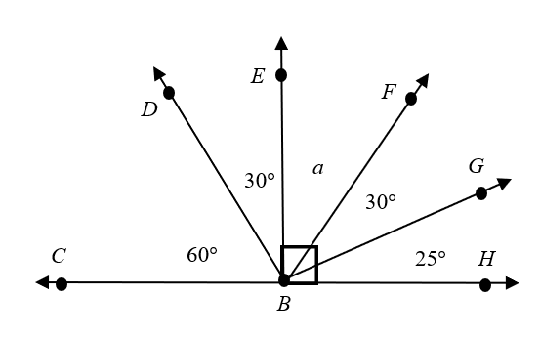
- 25$°$ + 30$°$ + a = 180$°$
- a + 25$°$ + 30$°$ = 90$°$
- 180$°$ - 90$°$ = 90$°$
- 25$°$ + a = 60$°$
- a + 30$°$ = 90$°$
- 90$°$ - 35$°$ = 45$°$

*The strategies, tasks and items included in the B1G-M are examples and should not be considered comprehensive.

MA.4.GR.2 Solve problems involving the perimeter and area of rectangles.

MA.4.GR.2.1

Benchmark
MA.4.GR.2.1 Solve perimeter and area mathematical and real-world problems, including problems with unknown sides, for rectangles with whole-number side lengths.
Benchmark Clarifications:
Clarification 1: Instruction extends the development of algebraic thinking where the symbolic representation of the unknown uses a letter.
Clarification 2: Problems involving multiplication are limited to products of up to 3 digits by 2 digits. Problems involving division are limited to up to 4 digits divided by 1 digit.
Clarification 3: Responses include the appropriate units in word form.
Connecting Benchmarks/Horizontal Alignment
- MA.4.NSO.2.2
- MA.4.NSO.2.3
- MA.4.NSO.2.4
- MA.4.NSO.2.5
- MA.4.GR.2.2
- MA.4.AR.1.1

Terms from the K-12 Glossary
- Equation
- Expression
- Perimeter

Vertical Alignment
Previous Benchmarks  - MA.3.GR.2.2  - MA.3.GR.2.3  - MA.3.GR.2.4 | Next Benchmarks  - MA.5.GR.2.1
Purpose and Instructional Strategies
The purpose of this benchmark is for students to connect perimeter and area problems to algebraic concepts to find the measures of unknown side lengths. This new idea builds from solving area and perimeter problems with whole number side lengths when using models and formulas in grade 3 (MA.3.GR.2.3) and will form the foundation for problems involving fractional and decimal side lengths in grade 5 (MA.5.GR.2.1).
- In the provided mathematical and real-world problems, instruction should include cases where students use a ruler to measure lengths before determining its perimeter and/or area (MTR.3.1).
- Mathematical problems include visual models of rectangles, while examples of real-world problems could include photos or classroom objects (e.g., measuring the area of one face on a tissue box). Students will not be expected to find unknown side lengths until Grade 4 (MTR.7.1).
- During instruction, students should use a letter (variable) to represent the missing side length and have experiences solving for unknowns in perimeter situations with a given area and vice-versa.
Instruction includes having students use the fact that opposite sides in rectangles and squares are equal when solving problems involving area and perimeter.

Common Misconceptions or Errors
- Students frequently confuse area and perimeter. Instruction should provide lots of opportunity for students to work with both measures on the same object and have them explain which measure is area and which is perimeter and why. Instruction should also focus on naming the units properly.

Strategies to Support Tiered Instruction
- Instruction provides many opportunities for students to work with both measures on the same object and explain which measure is area and which is perimeter and why. Instruction should also focus on naming the units properly.
- Instruction includes finding both the area and perimeter in real world examples and having students explain how they solved for both.
  - For example, when provided with examples like the following, students use the measurements provided to create an equation to find area and perimeter and explain the difference. “A rectangular garden is being built at the school. The dimensions for the garden are 8 feet by 4 feet. Write and solve an equation to find the area of the garden and an equation to find the perimeter of the garden.”
- The teacher provides students with images created using square tiles. Students count and label the side lengths based on the tiles, then write equations to show how they would find the area and how they would find the perimeter.
  - For example: When provided with an image like the one shown below, students label each side length based on the number of tiles and write an equation for perimeter and then count the units around the outside of the figure to confirm their solution. Students multiply the length and width to find area and then count the number of squares that make up the figure to confirm their solution.
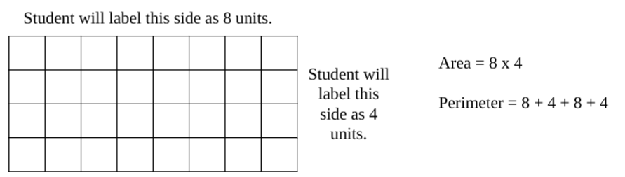
- Instruction includes using the 3-Read Protocol to break down the problem. First read the problem to understand the context, possibly without the numbers. Then, read to understand the mathematics. Finally, read to create a plan for solving the problem.

Instructional Tasks
Instructional Task 1
The perimeter of the patio below is 98 feet.
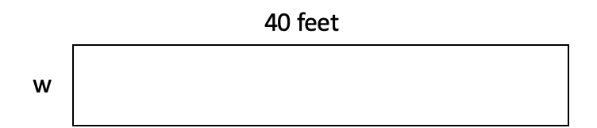
What is the area of the patio?

Instructional Task 2
Mrs. Evans’ class is planting a school garden in the shape of a rectangle. The garden has an area of 96 square feet and is 12 feet wide.
Part A
The class would like to plant a row of marigolds along each length of the garden. What is the length of the garden?
Part B
Mrs. Evans is looking into purchasing fencing materials to surround the perimeter of the garden. How many feet of fencing are needed?

Instructional Task 3
The area of a rectangle is 360 square centimeters. The length of the rectangle is 9 centimeters.
Part A. Write a division equation that can be used to find the width of the rectangle. Use w to represent the unknown width.
Part B. Write a multiplication equation that can be used to find the width of the rectangle. Use w to represent the unknown width.
Part C. What is the perimeter of the rectangle

Instructional Task 4
Mr. Robins wants to put four tables in his classroom that are each 5 feet long and 3 feet wide.
Part A. What is the total area of the four tables?
Part B. Mr. Robins has 75 square feet of space for the tables. He remembered he needs more space for students to sit in chairs. How much total space will he have left over for students to sit after the tables are placed?

Instructional Items
Instructional Item 1
A soccer field with its dimensions is shown.
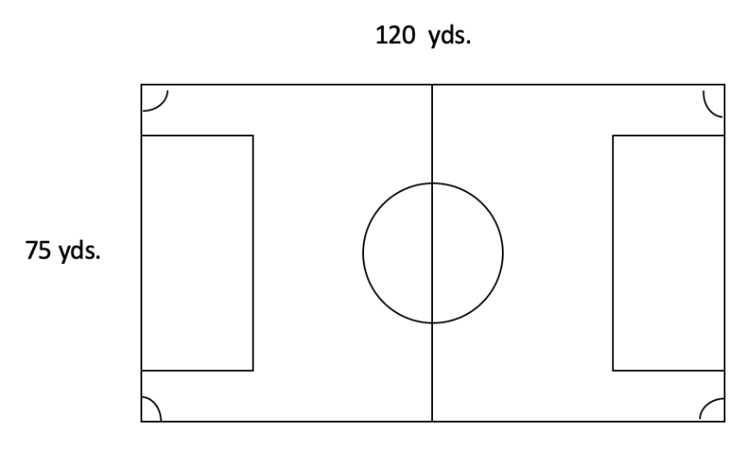
Which equation can be used to find the area of the soccer field?
- 75 yards + 120 yards = A yards
- 75 yards + 75 yards + 120 yards + 120 yards = A yards
- 75 yards × 120 yards = A square yards
- 75 yards × 120 yards × 75 yards ×120 yards = A square yards

Instructional Item 2
Stephen is having a pool built in his back yard. The pool measures 30 feet long by 17 feet wide. How many feet of tile are needed to cover the border of the pool?

Instructional Item 3
The length of a large window is 6 feet. If the area of the window is 252 square feet, what is the width of the window?

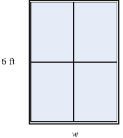
*The strategies, tasks and items included in the B1G-M are examples and should not be considered comprehensive.

MA.4.GR.2.2

Benchmark
MA.4.GR.2.2 Solve problems involving rectangles with the same perimeter and different areas or with the same area and different perimeters.
Example: Possible dimensions of a rectangle with an area of 24 square feet include 6 feet by 4 feet or 8 feet by 3 feet. This can be found by cutting a rectangle into unit squares and rearranging them

Benchmark Clarifications:
Clarification 1: Instruction focuses on the conceptual understanding of the relationship between perimeter and area.
Clarification 2: Within this benchmark, rectangles are limited to having whole-number side lengths.
Clarification 3: Problems involving multiplication are limited to products of up to 3 digits by 2 digits. Problems involving division are limited to up to 4 digits divided by 1 digit.
Clarification 4: Responses include the appropriate units in word form.

Connecting Benchmarks/Horizontal Alignment
- MA.4.NSO.2.2/2.3/2.4/2.5
- MA.4.GR.2.1
- MA.4.AR.1.1

Terms from the K-12 Glossary
- Equation
- Expression
- Perimeter

Vertical Alignment
Previous Benchmarks  - MA.3.GR.2.2/2.3/2.4 | Next Benchmarks  - MA.5.GR.2.1
Purpose and Instructional Strategies
The purpose of this benchmark is for students to understand the relationship between perimeter and area. Students will explore situations where two or more different figures can have the same area and different perimeters or same perimeter and different areas. This benchmark supports the perimeter and area work in MA.4.GR.2.1.
Instruction will help students begin to generalize that when working with rectangles with the same area, squares will have the smallest perimeter and the longer one side is, the greater the perimeter is going to be.

Common Misconceptions or Errors
- Students may believe that a rectangle with a large perimeter must also have a large area.

Strategies to Support Tiered Instruction
- Instruction includes comparing figures with the same perimeter but different areas and the same area but different perimeters.
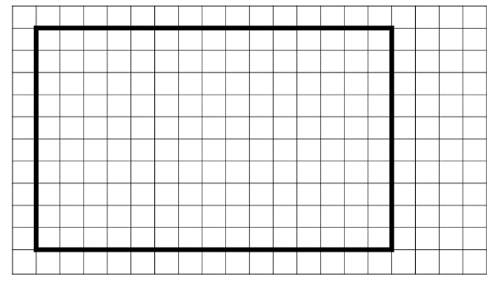
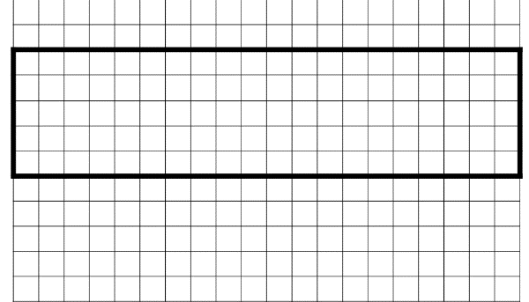
  - For example, students find the area and perimeter for figures created using grid paper making the connection that not all figures with a large perimeter have a large area.
Perimeter$=15 + 15 + 10 + 10 = 50$  Area$=15 × 10=150$square units | Perimeter$=20 + 20 + 5 + 5 = 50$  Area$=20 × 5=100$ square units

- Instruction includes providing several square tiles that can be arranged to make rectangular figures in many ways. Students build figures with the same area and calculate the perimeter.
  - For example, students use 36 tiles to make a figure that is 2 tiles by 18 tiles. They would calculate Area = $2 × 18 =36$ square units, and then calculate Perimeter = $2 + 2 + 18 + 18 = 40$units. Students would then rearrange the tiles to create a rectangle that is 6 tiles by 6 tiles. They would calculate the Area$=6×6=$26 square units, and Perimeter as $6 + 6 + 6 + 6 = 24$ units. Students compare the area and perimeter of both figures and make the connection that the area of a figure does not determine the perimeter.
- Instruction includes using the 3-Read Protocol to break down the problem. First read the problem to understand the context, possibly without the numbers. Then, read to understand the mathematics. Finally, read to create a plan for solving the problem.

Instructional Tasks
Instructional Task 1
Shawn has 600 feet of fencing. He is trying to figure out how to build his fence so that he has a rectangle with the greatest square footage inside the fence.
Part A. What are the dimensions of the fence he can build with the greatest area inside?
Part B. What is the area inside his fence?
Instructional Task 2
Two rectangles have area measurements of 48 square units. They have different perimeters.

Part A. What could the dimensions of the rectangles be?
Part B. What are the perimeters of the different rectangles?

Instructional Task 3
Rectangles A and B both have area measurements of 36 square units. The length of Rectangle A is 12 units.

Part A. What is the width of Rectangle A?
Part B. If the length of Rectangle B is one-half the length of Rectangle A, what is the width of Rectangle B?

Instructional Items
Instructional Item 1
Skylar built a rectangular table for her doll house. The area of the table is 105 square inches, and the side lengths are whole-number inches. What are some possible perimeters of the table? Select all that apply.

- 26 inches
- 44 inches
- 52 inches
- 76 inches
- 210 inches

Instructional Item 2
Molly bought a table that has a top with an area of 36 square inches. Select all of the possible measurements for the length and width of the table?
a. 6 inches × 6 inches
b. 6 inches × 12 inches
c. 7 inches × 11 inches
d. 9 inches × 4 inches
e. 12 inches × 3 inches

Instructional Item 3
Mrs. Torres has 20 yards of string lights to make a border around a rectangular bulletin board. What are the areas of bulletin boards she could make with her string lights? Select all that apply.
- 9 square yards
- 15 square yards
- 20 square yards
- 24 square yards
- 25 square yards

*The strategies, tasks and items included in the B1G-M are examples and should not be considered comprehensive.

Data Analysis & Probability

MA.4.DP.1 Collect, represent and interpret data and find the mode, median and range of a data set.

MA.4.DP.1.1

Benchmark
MA.4.DP.1.1 Collect and represent numerical data, including fractional values, using tables, stem-and-leaf plots or line plots.
Example: A softball team is measuring their hat size. Each player measures the distance around their head to the nearest half inch. The data is collected and represented on a line plot

Benchmark Clarifications:
Clarification 1: Denominators are limited to 2, 3, 4, 5, 6, 8, 10, 12, 16 and 100.

Connecting Benchmarks/Horizontal Alignment
- MA.4.NSO.1.5
- MA.4.FR.1.3, MA.4.FR.1.4
- MA.4.M.1.1

Terms from the K-12 Glossary
- Line Plot
- Stem-and-Leaf Plot

Vertical Alignment
Previous Benchmarks  - MA.3.DP.1.1 | Next Benchmarks  - MA.5.DP.1.1
Purpose and Instructional Strategies
The purpose of this benchmark is to collect authentic data and display the data using the appropriate format. This concept builds on collecting and displaying whole number data using line plots, bar graphs, and tables in grade 3 (MA.3.DP.1.1). Student data in gGrade 4 will be displayed using stem-and-leaf plots, in addition to other methods. In Grade 5, fractional and decimal data will be included (MA.5.DP.1.1).
- A stem-and-leaf plot displays numerical data and use place value to display data frequencies. In a stem-and-leaf-plot, a number is decomposed so that leaves represent the smallest part of a number (e.g., ones, fraction less than 1) and the stem consists of all its other place values (e.g., hundreds, tens, ones in fractions greater than 1). Stem-and-leaf plots help students build line plots. Stem-and-leaf plots can help students identify benchmarks for their number lines when creating a line plot.
- During instruction connections may be made between how data is represented on stem-and-leaf and line plots.
- A stem-and-leaf plot organizes data by size (e.g., least to greatest or greatest to least) and identifies the mode of a data set as the stem with the greatest number of leaves. It can be used to find the median and range of the data set.
Measurement data can be gathered (including measuring with precision to the nearest $\frac{1}{16}$ inch) and displayed on tables, line plots, and stem and leaf plots. The data is the same for each of the displays below.
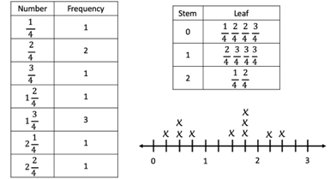
- Instruction of line plots should first focus on creating appropriate number lines that allow a data set to be displayed.

Common Misconceptions or Errors
- For line plots, students may misread a number line and have difficulty because they use whole-number names when counting fractional parts on a number line instead of the fraction name. Students also count the tick marks on the number line to determine the fraction, rather than looking at the “distance” or “space” between the marks.
- For stem-and-leaf plots, students may read they key incorrectly. Some students may try to represent numerical data in a stem-and-leaf plot without first arranging the leaves for each stem in order.

Strategies to Support Tiered Instruction
- Instruction includes opportunities to use concrete models and draw number lines to connect learning with fraction understanding. Students plot fourths on the number line, paying particular attention to what each tick mark and the “distance” between each tick mark represents.
  - Example:
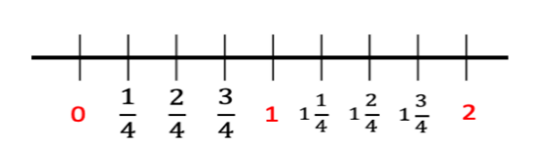
  - For example, utilizing fraction strips or tiles, students will be able to connect fractional parts to the measurement on a number line.
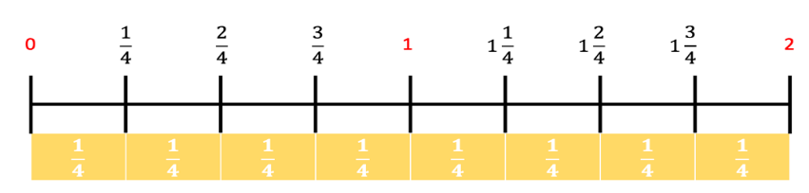

- Instruction includes representing numerical data in a stem and leaf plot and ordering the data from least to greatest. The stem will be the greatest place value of the largest number in the set. With a set of mixed numbers, the stems will be the whole numbers.
  - For example, create a steam and leaf plot using the data set shown.
Data set: 6, 8, 11, 20, 24
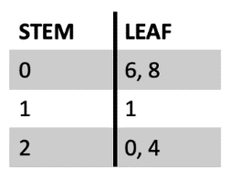
- Instruction includes representing numerical data in a stem-and-leaf plot and writing the data set on index cards or sticky notes.
  - Example:
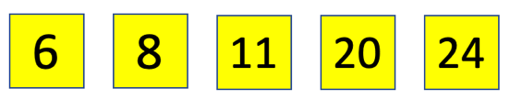
After organizing the data set in order from least to greatest, the students rip each number, separating the place values and place them on the graphic organizer. The greater place value will be the stem, the tens place for this example. The lesser place value will be the leaf, the ones place in this example. Since the stems will only be labeled once, the numbers with the same place value will be stacked on top of each other. Each of the leaves will be represented, even if repeated. Numbers with 0 in the tens place will be represented by a 0 for the stem.
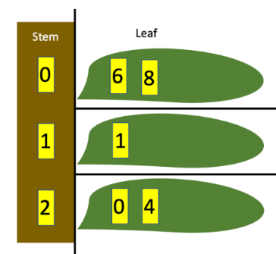

Instructional Tasks
Instructional Task 1
Measure the length of 10 used pencils in the class to the nearest $\frac{1}{8}$ inch. Create a stem-and-leaf plot and a line plot to represent the lengths of all ten pencils.

Instructional Task 2
The PE coach recorded how many sit ups each student could do in 60 seconds.
22, 42, 33, 27, 18, 36, 40, 37, 30, 29, 25, 31, 25, 22, 28, 41, 38, 36, 33, 24
Part A. Use the data below to create a stem-and-leaf plot.
Part B. How many stems are needed for stem-and-leaf plot? How many leaves are on your stem-and-leaf plot?

Instructional Items
Instructional Item 1
Laura was given the data in the chart below.

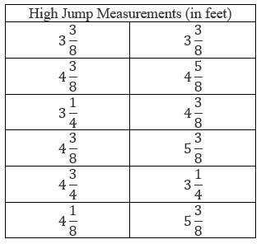
She was asked to create a line plot to represent her data. How many X’s will she place above $4\frac{3}{8}$?
- 3
- 4
- 8
- 12

Instructional Item 2
Shari is training for a race. She records the distance she runs during her first two weeks of training in the table below. Which line plot correctly represents this data?
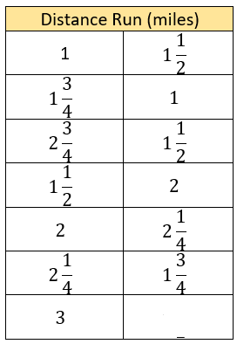

- 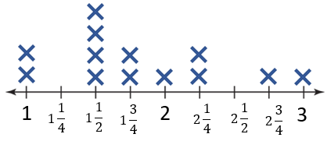
- 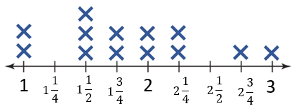
- 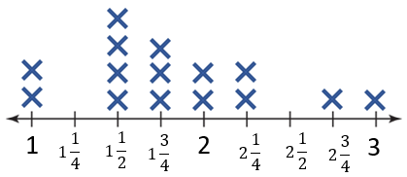
- 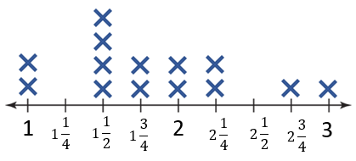

Instructional Item 3
Len recorded the number of pages he read in his book in a table and then used the data to create the stem-and-leaf plot shown.

0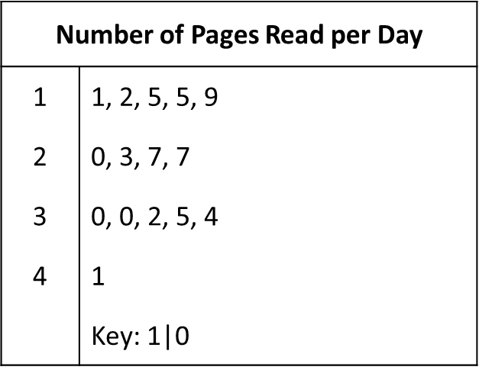
Which table correctly displays the data Len used to create the stem-and-leaf plot shown?
- 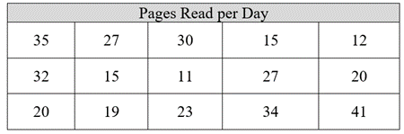
- 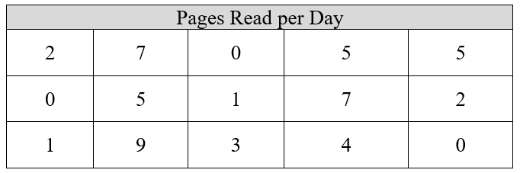
- 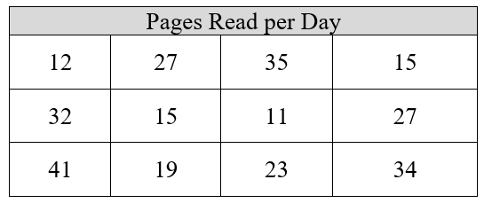
- 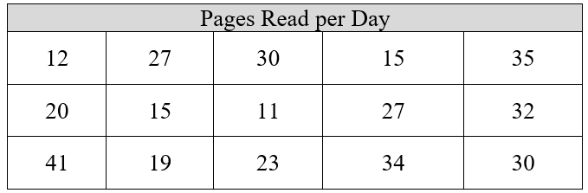

*The strategies, tasks and items included in the B1G-M are examples and should not be considered comprehensive.

MA.4.DP.1.2

Benchmark
MA.4.DP.1.2 Determine the mode, median or range to interpret numerical data including fractional values, represented with tables, stem-and-leaf plots or line plots.
Example: Given the data of the softball team’s hat size represented on a line plot, determine the most common size and the difference between the largest and the smallest sizes.

Benchmark Clarifications:
Clarification 1: Instruction includes interpreting data within a real-world context.
Clarification 2: Instruction includes recognizing that data sets can have one mode, no mode or more than one mode.
Clarification 3: Within this benchmark, data sets are limited to an odd number when calculating the median.
Clarification 4: Denominators are limited to 2, 3, 4, 5, 6, 8, 10, 12, 16 and 100.

Connecting Benchmarks/Horizontal Alignment
- MA.4.FR1.3
- MA.4.FR.1.4

Terms from the K-12 Glossary
- Line Plot
- Median
- Mode
- Range
- Stem-and-Leaf Plot

Vertical Alignment
Previous Benchmarks  - MA.3.DP.1.2 | Next Benchmarks  - MA.5.DP.1.2
Purpose and Instructional Strategies
The purpose of this benchmark is to introduce concepts of mode, median, and range as measures of center and spread in a set of data. This work builds on interpreting different kinds of graphs with numerical and categorical data in Grade 3 (MA.3.DP.1.2). The mean as a measure of center is introduced in Grade 5 (MA.5.DP.1.2).
- Instruction includes providing students multiple opportunities to organize their data (MA.4.FR.1.4). During instruction it is important for students to organize their data from least to greatest which will help them determine:
  - range by subtracting the least value from the greatest value in the set.
  - mode by finding the value that occurs most often.
  - median by finding the value in middle of the set.
  - For example, fifteen students were asked to rate how much they like fourth grade on a scale from one to ten. Here is the data collected: 1, 10, 9, 6, 5, 10, 9, 8, 3, 3, 8, 9, 7, 4, 5. The first step is to put the data in ascending order.
1, 3, 3, 4, 5, 5, 6, 7, 8, 8, 9, 9, 9, 10, 10. The median is 7 because there are seven values before 7 in the data set and seven values after 7 in the data, meaning that it is the middle of the set. The mode is 9 because it occurs most often, 3 times, in the data set. The range of 9 can be found by subtracting 1, the least value in the data set, from 10, the greatest value in the data set.

Common Misconceptions or Errors
- Students sometimes have difficulty understanding that there may be no mode or more than one mode of a data set. Examples should be given to explicitly teach this concept.
- Students may confuse the range with the number of data points.

Strategies to Support Tiered Instruction
- Instruction includes providing a data set that may have no mode or more than one mode.
  - For example, for the data set 2, 3, 5, 7, 9, 11, there is no mode.
  - For example, for the data set 2, 2, 3, 5, 5, 7, 9, 11, 11, the modes are 2, 5, and 11.
- Instruction includes providing the data set on index cards or sticky notes. Students then move the data set in order from least to greatest. For numbers that repeat, students stack the numbers on top of each other. This helps with understanding if there is no mode, or more than one mode.
  - Example:
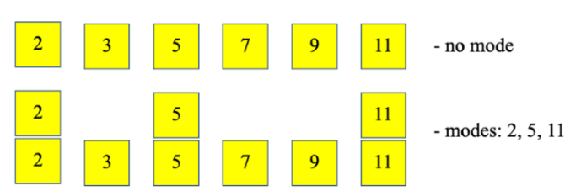
- Instruction includes opportunities to find the range on a line plot. Students subtract the least value on the line plot with an X from the greatest value with an X.
  - Example:
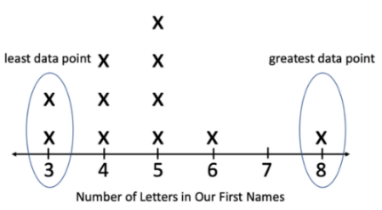
- Instruction includes showing how to cover up the data points in the middle of the line plot so that only the first and last data points are shown. This allows students to focus on the values that will be used to calculate the range.
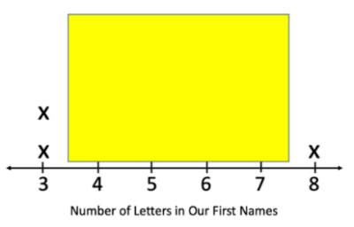
  - Example:
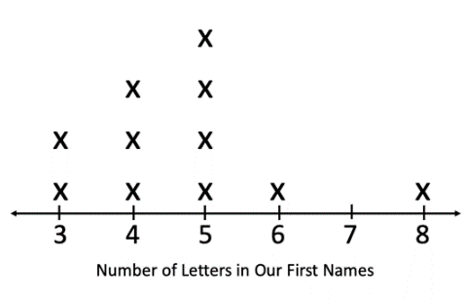

Instructional Tasks
Instructional Task 1 (MTR.7.1)
Measure the length of 11 used pencils in the class to the nearest $\frac{1}{8}$ inch.
Part A. Create a stem-and-leaf plot and a line plot to represent the length of all eleven pencils.
Part B. From your completed line plot, find the median, range and mode of your data set

Instructional Task 2
Amy’s mom keeps track of the amount of time she Amy works on her chores each week.
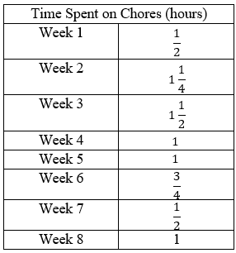

Part A. Create a line plot of Amy’s data.
Part B. What does the mode value represent in her data?

Instructional Task 3
Dana recorded the time spent on math homework per day in the line plot below.
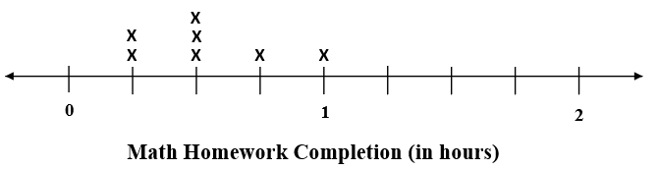
Part A. Find the median, mode and range for the data set.
Part B. How will the median, mode, and range for the data set change if Dana completes math homework for $1\frac{1}{4}$ hours each day for an additional four days?

Instructional Items
Instructional Item 1
The line plot below shows all of the results of the sum of two six-sided dice.
Number of Ways to Roll a 2, 3, 4 … with a Pair of Dice
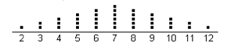
What is the mode of the data on the line plot?
- 12
- 10
- 7
- 6

Instructional Item 2
The line plot below shows the number of miles Shari ran each day for two weeks while training for a race.
What is the median of the data on the line plot?
- $1 \frac{1}{2}$
- $1 \frac{3}{4}$
- $1 \frac{7}{8}$
- $2$

Instructional Item 3
Find the range in the data on the stem-and-leaf plot below.
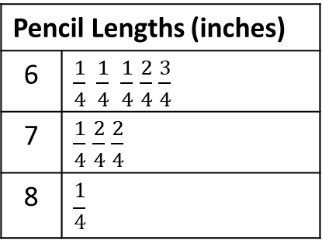

- $\frac{2}{4}$
- 1
- 2

*The strategies, tasks and items included in the B1G-M are examples and should not be considered comprehensive.

MA.4.DP.1.3

Benchmark
MA.4.DP.1.3 Solve real-world problems involving numerical data.
Example: Given the data of the softball team’s hat size represented on a line plot, determine the fraction of the team that has a head size smaller than 20 inches.

Benchmark Clarifications:
Clarification 1: Instruction includes using any of the four operations to solve problems.
Clarification 2: Data involving fractions with like denominators are limited to 2, 3, 4, 5, 6, 8, 10, 12, 16 and 100. Fractions can be greater than one.
Clarification 3: Data involving decimals are limited to hundredths.

Connecting Benchmarks/Horizontal Alignment
- MA.4.NSO.1.5
- MA.4.NSO.2.7
- MA.4.AR.1.2
- MA.4.AR.1.3

Terms from the K-12 Glossary
Numerical Data
Vertical Alignment
Previous Benchmarks  - MA.3.DP.1.2 | Next Benchmarks  - MA.5.DP.1.2
Purpose and Instructional Strategies
The purpose of this benchmark is to use data sets as real-world context for doing arithmetic with whole numbers, fractions and decimals beyond finding measures of center and spread.
- Instruction includes having students solve one- and two-step problems from a given data set or by comparing two data sets in the same units.
- Instruction includes problems that involve addition, subtraction, multiplication or division.
This benchmark should be taught with MA.4.DP.1.1 and MA.4.DP.1.2 (collecting and representing data). Students should have a strong command of creating and interpreting line plots and stem-and-leaf plots to be successful with the interpretation these data displays.

Common Misconceptions or Errors
- Students can make errors when writing equations used to solve problems with numerical data. During instruction, expect students to justify their equations and solutions.

Strategies to Support Tiered Instruction
- Instruction includes visualizing word problems. The Three-Reads Protocol is a strategy to help students conceptualize what the question is asking. Students draw pictures or models to represent what is happening in the word problem. These pictures and models are used to help students write equations for the problem they are solving.
- Instruction includes breaking down word problems into smaller parts. Students use a highlighter to emphasize the important information in the word problem. Also, students paraphrase the word problem so the teacher can determine if the student understands what the question is asking.
- Instruction includes using the 3-Read Protocol to break down the problem. First read the problem to understand the context, possibly without the numbers. Then, read to understand the mathematics. Finally, read to create a plan for solving the problem.

Instructional Tasks
Instructional Task 1
Collect 10 used pencils from people in your class. Measure the length of each pencil to the nearest $\frac{1}{8}$ inch and record the lengths on a line plot. What is difference in length of the longest pencil and the shortest pencil?

Instructional Task 2
A plant is grown from seed and its change in growth is recorded in a table each week.
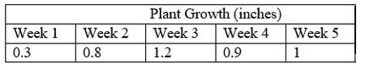

Part A. Create a stem-and-leaf plot for the plant growth data.
Part B. How tall is the plant after week 5?
Part C. If the plant begins producing flowers after reaching a height of 12 inches, how many more inches does it need to grow before it flowers?

Instructional Task 3
Part A. Explain how you could use a stem-and-leaf plot to find the median of a numerical data set.
Part B. Explain how you could use a stem-and-leaf plot to find the mode of a numerical data set.
Part C. Explain how you could use a stem-and-leaf plot to find the range of a numerical data set.
Part D. Use the stem-and-leaf plot below to find the median, mode, and range of the data set.
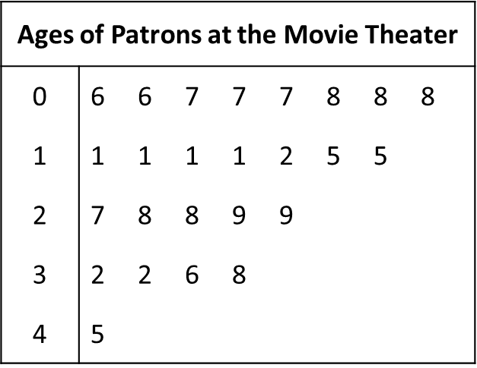

Instructional Items
Instructional Item 1
The last 5 putt lengths, in feet, for the 18th hole of a golf tournament are shown below.
Stem | 1 | 3 | 4
Leaf | $$\frac{1}{2} \frac{1}{2}$$ | $$\frac{0}{2}$$ | $$\frac{1}{2} \frac{1}{2}$$
What is the sum of the 5 putt lengths?
- 8 feet
- 9 feet
- 12 feet
- 15 feet

Instructional Item 2
Jasmine tracks the minutes she spends reading each night on a stem-and-leaf plot. She made a goal to read 100 minutes a week. How many more minutes does she have to read this week to reach her goal?
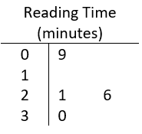

a. 14 minutes
b. 24 minutes
c. 41 minutes
d. 86 minutes
*The strategies, tasks and items included in the B1G-M are examples and should not be considered comprehensive.

Appendix A. Summary of Changes
The purpose of this table is to provide a summary of changes from for the latest version of the B1G-M. For questions or feedback on the B1G-M, please direct them to BESTMath@fldoe.org.

Benchmark | B1G-M Component | Change Made
MA.4.NSO.1.1 | Purpose and Instructional Strategies | Added “To help students understand the meaning of 10 $times$ and $\frac{1}{10}$ $of$ relationship, students can use base ten manipulatives or simply bundle classroom objects (e.g., paper clips, pretzel sticks). Students should name numbers and use verbal descriptions to explain the relationship between numbers (e.g., “60 is 10 times greater than 6, and 60 is $\frac{1}{10}$ of 600”). In addition to physical manipulatives, place value charts help students understand the relationship between digits in different place values (MTR.2.1).”
MA.4.NSO.1.1 | Purpose and Instructional Strategies | Instruction of this benchmark should connect with student work with multiplying and dividing by 10. For example, students who understand $3×10=30$ can reason that $30×10=300$ because 30 is ten $times$ greater than 3, therefore its product will be ten $times$ greater (MTR.5.1)  This benchmark focuses on building the foundational patterns of multiplying by 10 and $\frac{1}{10}$, and will extend to multiplying by values such as 100 and $\frac{1}{100}$ that will cause the digits to shift more than one place to the left and right (MA.5.NSO.1.1)
MA.4.NSO.1.1 | Common Misconceptions and Errors | Students may not understand that when the digit moves to the left that it has increased a place value which is the same as multiplying by 10 and when the digit moves to the right that is has decreased a place value, which is the same as dividing by 10. It is important to include models and discourse throughout instruction to reason why this is happening.
MA.4.NSO.1.1 | Strategies to Support Tiered Instruction Place Value Table | The example with number 543 and 156  Updated hundred thousands  Updated ten thousands
MA.4.NSO.1.1 | Strategies to Support Tiered Instruction | I could not get this table to insert below the $x 10$ so it is placed above that table.  Added a place value table with $\frac{1}{10}$ the value illustrated.
MA4.NSO.1.1 | Instructional Task | Added Instructional Task 2
MA4.NSO.1.1 | Instructional Task | Instructional Task 3  Use a number cube to roll a 3-digit number.  Part A. Multiply your 3-digit number by 10.Part B. Multiply your 3-digit number by 100.  Part C. Take your answer from Part B and divide by 10.  Part D. Take your answer from Part A and divide by 100.  Part E. How are your answers in each part related to the original 3-digit number? What patterns can you see?
MA.4.NSO.1.1 | Instructional Item | Added Instructional Item 2
MA.4.NSO.1.2 | Strategies for Tiered Support Place Value Tables | Updated the both example tables to:  Hundred thousands  Ten thousands  Thousands
MA.4.NSO.1.2 | Instructional Task | Added Instructional Task 2
MA.4.NSO.1.2 | Instructional Item | Added Instructional Item 2
MA.4.NSO.1.3 | Strategies for Tiered Support | Updated Place Value Chart  Ten Thousands  Hundred Thousands
MA.4.NSO.1.3 | Instructional Task | Added Instructional Task 3
MA.4.NSO1.3 | Instructional Item | Added instructional Item 2
MA.4.NSO.1.4 | Instructional Task | Added Instructional Task 2
MA.4.NSO.1.4 | Instructional Item | Added Instructional Item 2
MA.4.FR.1.1 | Strategies to Support Tiered Instruction | Removed example with fractions that did not have tenths or hundredths as the denominator.
MA.4.FR.1.1 | Instructional Items | Added Instructional Item 2
MA.4.FR.1.2 | Purpose and Instructional Strategies | Provided additional clarifications to support instruction.
MA.4.FR.1.2 | Instructional Items | Added Instructional Item 2 and Instructional Item 3
MA.4.FR.1.2 | Instructional Tasks | Added Instructional Task 2
MA.4.FR.1.3 | Instructional Tasks | Added Instructional Task 2
MA.4.FR.1.3 | Instructional Items | Added Instructional Item 2 and Instructional Item 3
MA.4.FR.1.4 | Instructional Tasks | Added Instructional Task 2
MA.4.FR.1.4 | Instructional Items | Added Instructional Item 2
MA.4.FR.2.1 | Purpose and Instructional Strategies | Provided additional information to support instruction.
MA.4.FR.2.1 | Instructional Tasks | Added Instructional Task 2
MA.4.FR.2.2 | Instructional Tasks | Added answer choice d to Instructional Task 1
MA.4.FR.2.2 | Instructional Items | Added Instructional Item 2 and Instructional Item 3
MA.4.FR.2.3 | Instructional Tasks | Added Instructional Task 2
MA.4.FR.2.3 | Instructional Items | Added Instructional Item 2
MA.4.FR.2.4 | Instructional Tasks | Added Instructional Task 2
MA.4.FR.2.4 | Instructional Items | Added Instructional Item 2
MA.4.AR.1.1 | Purpose and Instructional Strategies | Added an example of a division problem with a situation where the remainder would be written as a fraction.
MA.4.AR.1.1 | Instructional Tasks | Updated Instructional Task 1 and added Instructional Task 3
MA.4.AR.1.2 | Instructional Tasks | Update Instructional Task 1 and added Instructional Task 2 and Instructional Task 3.
MA.4.AR.1.3 | Instructional Tasks | Added Instructional Task 2
MA.4.AR.3.2 | Instructional Tasks | Updated Task 1 and added Instructional Task 3
MA.4.AR.3.2 | Instructional Items | Added Instructional Item 2
MA.4.M.1.1 | Instructional Task | Added Instructional Task 2
MA.4.M.1.1 | Instructional Items | Added Instructional Items 2 and 3
MA.4.M.1.2 | Instructional Item | Added Instructional Task 2
MA.4.M.1.2 | Instructional Task | Added Instructional Item 2
MA.4.M.2.1 | Instructional Item | Added Instructional Item 2
MA.4.M.2.1 | Instructional Task | Added Instructional Tasks 2 and 3
MA.4.M.2.2 | Instructional Item | Added Instructional Items 2 and 3
MA.4.M.2.2 | Instructional Task | Added Instructional Task 2
MA.4.GR.1.1 | Vertical Alignment | Added MA.3.GR.1.1 and MA.5.GR.1.2
MA.4.GR.1.1 | Terms from the K-12 Glossary | Added vertex
MA.4.GR.1.1 | Instructional Item | Added Instructional Items 2, 3 and 4
MA.4.GR.1.1 | Instructional Task | Added Instructional Tasks 2, 3 and 4
MA.4.GR.1.2 | Connecting Benchmarks/Horizontal Alignment | Added MA.4.GR.2.3
MA.4.GR.1.2 | Vertical Alignment | Added MA.3.GR.1.1
MA.4.GR.1.2 | Terms from the K-12 Glossary | Added reflex angle, straight angle and vertex
MA.4.GR.1.2 | Common Misconceptions and Errors | Updated
MA.4.GR.1.2 | Instructional Task | Added Instructional Task 2 and 3
MA.4.GR.1.2 | Instructional Item | Added Instructional Item 2, 3 and 4
MA.4.GR.1.3 | Connecting Benchmarks/Horizontal Alignment | Added 4.GR.1.2
MA.4.GR.1.3 | Terms from the K-12 Glossary | Added equation
MA.4.GR.1.3 | Instructional Item | Added Instructional Item 2 and 3
MA.4.GR.1.3 | Instructional Task | Added Instructional Task 2 and 3
MA.4.GR.2.1 | Instructional Item | Added Instructional Items 2 and 3
MA.4.GR.2.1 | Instructional Task | Added Instructional Task 2
MA.4.GR.2.2 | Instructional Item | Added Instructional Item 2
MA.4.GR.2.2 | Instructional Task | Added Instructional Tasks 2 and 3
MA.4.DP.1.1 | Instructional Item | Added Instructional Item 2
MA.4.DP.1.1 | Instructional Task | Added Instructional Task 2
MA.4.DP.1.2 | Instructional Item | Added Instructional Item 2
MA.4.DP.1.2 | Instructional Task | Added Instructional Tasks 2 and 3
MA.4.DP.1.3 | Instructional Item | Added Instructional Item 2
MA.4.DP.1.3 | Instructional Task | Added Instructional Task 2

