Grade 2 B.E.S.T. Instructional Guide for Mathematics

The B.E.S.T. Instructional Guide for Mathematics (B1G-M) is intended to assist educators with planning for student learning and instruction aligned to Florida’s Benchmarks for Excellent Student Thinking (B.E.S.T.) Standards. This guide is designed to aid high-quality instruction through the identification of components that support the learning and teaching of the B.E.S.T. Mathematics Standards and Benchmarks. The B1G-M includes an analysis of information related to the B.E.S.T. Standards for Mathematics within this specific mathematics course, the instructional emphasis and aligned resources. This document is posted on the B.E.S.T. Standards for Mathematics webpage of the Florida Department of Education’s website and will continue to undergo edits as needed.

Structural Framework and Intentional Design of the B.E.S.T. Standards for Mathematics

Florida’s B.E.S.T. Standards for Mathematics were built on the following.

- The coding scheme for the standards and benchmarks was changed to be consistent with other content areas. The new coding scheme is structured as follows:
Content.GradeLevel.Strand.Standard.Benchmark.
- Strands were streamlined to be more consistent throughout.
- The standards and benchmarks were written to be clear and concise to ensure that they are easily understood by all stakeholders.
- The benchmarks were written to allow teachers to meet students’ individual skills, knowledge and ability.
- The benchmarks were written to allow students the flexibility to solve problems using a method or strategy that is accurate, generalizable and efficient depending on the content (i.e., the numbers, expressions or equations).
- The benchmarks were written to allow for student discovery (i.e., exploring) of strategies rather than the teaching, naming and assessing of each strategy individually.
- The benchmarks were written to support multiple pathways for success in career and college for students.
- The benchmarks should not be taught in isolation but should be combined purposefully.
- The benchmarks may be addressed at multiple points throughout the year, with the intention of gaining mastery by the end of the year.
- Appropriate progression of content within and across strands was developed for each grade level and across grade levels.
- There is an intentional balance of conceptual understanding and procedural fluency with the application of accurate real-world context intertwined within mathematical concepts for relevance.
- The use of other content areas, like science and the arts, within real-world problems should be accurate, relevant, authentic and reflect grade-level appropriateness.

Components of the B.E.S.T. Instructional Guide for Mathematics

The following table is an example of the layout for each benchmark and includes the defining attributes for each component. It is important to note that instruction should not be limited to the possible connecting benchmarks, related terms, strategies or examples provided. To do so would strip the intention of an educator meeting students’ individual skills, knowledge and abilities.

Benchmark
focal point for instruction within lesson or task
This section includes the benchmark as identified in the B.E.S.T. Standards for Mathematics. The benchmark, also referred to as the Benchmark of Focus, is the focal point for student learning and instruction. The benchmark, and its related example(s) and clarification(s), can also be found in the course description. The 9-12 benchmarks may be included in multiple courses; select the example(s) or clarification(s) as appropriate for the identified course.

Connecting Benchmarks/Horizontal Alignment
in other standards within the grade level or course
This section includes a list of connecting benchmarks that relate horizontally to the Benchmark of Focus. Horizontal alignment is the intentional progression of content within a grade level or course linking skills within and across strands. Connecting benchmarks are benchmarks that either make a mathematical connection or include prerequisite skills. The information included in this section is not a comprehensive list, and educators are encouraged to find other connecting benchmarks. Additionally, this list will not include benchmarks from the same standard since benchmarks within the same standard already have an inherent connection.

Terms from the K-12 Glossary
This section includes terms from Appendix C: K-12 Glossary, found within the B.E.S.T. Standards for Mathematics document, which are relevant to the identified Benchmark of Focus. The terms included in this section should not be viewed as a comprehensive vocabulary list, but instead should be considered during instruction or act as a reference for educators.

Vertical Alignment
across grade levels or courses
This section includes a list of related benchmarks that connect vertically to the Benchmark of Focus. Vertical alignment is the intentional progression of content from one year to the next, spanning across multiple grade levels. Benchmarks listed in this section make mathematical connections from prior grade levels or courses in future grade levels or courses within and across strands. If the Benchmark of Focus is a new concept or skill, it may not have any previous benchmarks listed. Likewise, if the Benchmark of Focus is a mathematical skill or concept that is finalized in learning and does not have any direct connection to future grade levels or courses, it may not have any future benchmarks listed. The information included in this section is not a comprehensive list, and educators are encouraged to find other benchmarks within a vertical progression.

Purpose and Instructional Strategies
This section includes further narrative for instruction of the benchmark and vertical alignment. Additionally, this section may also include the following:
- explanations and details for the benchmark;
- vocabulary not provided within Appendix C;
- possible instructional strategies and teaching methods; and
- strategies to embed potentially related Mathematical Thinking and Reasoning Standards (MTRs).

Common Misconceptions or Errors
This section will include common student misconceptions or errors and may include strategies to address the identified misconception or error. Recognition of these misconceptions and errors enables educators to identify them in the classroom and make efforts to correct the misconception or error. This corrective effort in the classroom can also be a form of formative assessment within instruction.

Strategies to Support Tiered Instruction
The instructional strategies in this section address the common misconceptions and errors listed within the above section that can be a barrier to successfully learning the benchmark. All instruction and intervention at Tiers 2 and 3 are intended to support students to be successful with Tier 1 instruction. Strategies that support tiered instruction are intended to assist teachers in planning across any tier of support and should not be considered exclusive or inclusive of other instructional strategies that may support student learning with the B.E.S.T. Mathematics Standards. For more information about tiered instruction, please see the Effective Tiered Instruction for Mathematics: ALL Means ALL document.

Instructional Tasks
demonstrate the depth of the benchmark and the connection to the related benchmarks
This section will include example instructional tasks, which may be open-ended and are intended to demonstrate the depth of the benchmark. Some instructional tasks include integration of the Mathematical Thinking and Reasoning Standards (MTRs) and related benchmark(s). Enrichment tasks may be included to make connections to benchmarks in later grade levels or courses. Tasks may require extended time, additional materials and collaboration.

Instructional Items
demonstrate the focus of the benchmark
This section will include example instructional items which may be used as evidence to demonstrate the students’ understanding of the benchmark. Items may highlight one or more parts of the benchmark.
*The strategies, tasks and items included in the B1G-M are examples and should not be considered comprehensive.

Mathematical Thinking and Reasoning Standards
MTRs: Because Math Matters

Florida students are expected to engage with mathematics through the Mathematical Thinking and Reasoning Standards (MTRs) by utilizing their language as a self-monitoring tool in the classroom, promoting deeper learning and understanding of mathematics. The MTRs are standards which should be used as a lens when planning for student learning and instruction of the B.E.S.T. Standards for Mathematics.

Structural Framework and Intentional Design of the Mathematical Thinking and Reasoning Standards

The Mathematical Thinking and Reasoning Standards (MTRs) are built on the following.

- The MTRs have the same coding scheme as the standards and benchmarks; however, they are written at the standard level because there are no benchmarks.
- In order to fulfill Florida’s unique coding scheme, the 5th place (benchmark) will always be a “1” for the MTRs.
- The B.E.S.T. Standards for Mathematics should be taught through the lens of the MTRs.
- At least one of the MTRs should be authentically and appropriately embedded throughout every lesson based on the expectation of the benchmark(s).
- The bulleted language of the MTRs were written for students to use as self-monitoring tools during daily instruction.
- The clarifications of the MTRs were written for teachers to use as a guide to inform their instructional practices.
- The MTRs ensure that students stay engaged, persevere in tasks, share their thinking, balance conceptual understanding and procedures, assess their solutions, make connections to previous learning and extended knowledge, and apply mathematical concepts to real-world applications.
- The MTRs should not stand alone as a separate focus for instruction but should be combined purposefully.
- The MTRs will be addressed at multiple points throughout the year, with the intention of gaining mastery of mathematical skills by the end of the year and building upon these skills as they continue in their K-12 education.

MA.K12.MTR.1.1 Actively participate in effortful learning both individually and collectively.
Mathematicians who participate in effortful learning both individually and with others:
- Analyze the problem in a way that makes sense given the task.
- Ask questions that will help with solving the task.
- Build perseverance by modifying methods as needed while solving a challenging task.
- Stay engaged and maintain a positive mindset when working to solve tasks.
- Help and support each other when attempting a new method or approach.

Clarifications:
Teachers who encourage students to participate actively in effortful learning both individually and with others:
- Cultivate a community of growth mindset learners.
- Foster perseverance in students by choosing tasks that are challenging.
- Develop students’ ability to analyze and problem solve.
- Recognize students’ effort when solving challenging problems.

MA.K12.MTR.2.1 Demonstrate understanding by representing problems in multiple ways.
Mathematicians who demonstrate understanding by representing problems in multiple ways:
- Build understanding through modeling and using manipulatives.
- Represent solutions to problems in multiple ways using objects, drawings, tables, graphs and equations.
- Progress from modeling problems with objects and drawings to using algorithms and equations.
- Express connections between concepts and representations.
- Choose a representation based on the given context or purpose.

Clarifications:
Teachers who encourage students to demonstrate understanding by representing problems in multiple ways:
- Help students make connections between concepts and representations.
- Provide opportunities for students to use manipulatives when investigating concepts.
- Guide students from concrete to pictorial to abstract representations as understanding progresses.
- Show students that various representations can have different purposes and can be useful in different situations.

MA.K12.MTR. 3.1 Complete tasks with mathematical fluency.
Mathematicians who complete tasks with mathematical fluency:
- Select efficient and appropriate methods for solving problems within the given context.
- Maintain flexibility and accuracy while performing procedures and mental calculations.
- Complete tasks accurately and with confidence.
- Adapt procedures to apply them to a new context.
- Use feedback to improve efficiency when performing calculations.

Clarifications:
Teachers who encourage students to complete tasks with mathematical fluency:
- Provide students with the flexibility to solve problems by selecting a procedure that allows them to solve efficiently and accurately.
- Offer multiple opportunities for students to practice efficient and generalizable methods.
- Provide opportunities for students to reflect on the method they used and determine if a more efficient method could have been used.

MA.K12.MTR.4.1 Engage in discussions that reflect on the mathematical thinking of self and others.
Mathematicians who engage in discussions that reflect on the mathematical thinking of self and others:
- Communicate mathematical ideas, vocabulary and methods effectively.
- Analyze the mathematical thinking of others.
- Compare the efficiency of a method to those expressed by others.
- Recognize errors and suggest how to correctly solve the task.
- Justify results by explaining methods and processes.
- Construct possible arguments based on evidence.

Clarifications:
Teachers who encourage students to engage in discussions that reflect on the mathematical thinking of self and others:
- Establish a culture in which students ask questions of the teacher and their peers, and error is an opportunity for learning.
- Create opportunities for students to discuss their thinking with peers.
- Select, sequence and present student work to advance and deepen understanding of correct and increasingly efficient methods.
- Develop students’ ability to justify methods and compare their responses to the responses of their peers.

MA.K12.MTR.5.1 Use patterns and structure to help understand and connect mathematical concepts.
Mathematicians who use patterns and structure to help understand and connect mathematical concepts:
- Focus on relevant details within a problem.
- Create plans and procedures to logically order events, steps or ideas to solve problems.
- Decompose a complex problem into manageable parts.
- Relate previously learned concepts to new concepts.
- Look for similarities among problems.
- Connect solutions of problems to more complicated large-scale situations.

Clarifications:
Teachers who encourage students to use patterns and structure to help understand and connect mathematical concepts:
- Help students recognize the patterns in the world around them and connect these patterns to mathematical concepts.
- Support students to develop generalizations based on the similarities found among problems.
- Provide opportunities for students to create plans and procedures to solve problems.
- Develop students’ ability to construct relationships between their current understanding and more sophisticated ways of thinking.

MA.K12.MTR.6.1 Assess the reasonableness of solutions.
Mathematicians who assess the reasonableness of solutions:
- Estimate to discover possible solutions.
- Use benchmark quantities to determine if a solution makes sense.
- Check calculations when solving problems.
- Verify possible solutions by explaining the methods used.
- Evaluate results based on the given context.

Clarifications:
Teachers who encourage students to assess the reasonableness of solutions:
- Have students estimate or predict solutions prior to solving.
- Prompt students to continually ask, “Does this solution make sense? How do you know?”
- Reinforce that students check their work as they progress within and after a task.
- Strengthen students’ ability to verify solutions through justifications.

MA.K12.MTR.7.1 Apply mathematics to real-world contexts.
Mathematicians who apply mathematics to real-world contexts:
- Connect mathematical concepts to everyday experiences.
- Use models and methods to understand, represent and solve problems.
- Perform investigations to gather data or determine if a method is appropriate.
- Redesign models and methods to improve accuracy or efficiency.

Clarifications:
Teachers who encourage students to apply mathematics to real-world contexts:
- Provide opportunities for students to create models, both concrete and abstract, and perform investigations.
- Challenge students to question the accuracy of their models and methods.
- Support students as they validate conclusions by comparing them to the given situation.
- Indicate how various concepts can be applied to other disciplines.

Examples of Teacher and Student Moves for the MTRs

Below are examples that demonstrate the embedding of the MTRs within the mathematics classroom. The provided teacher and student moves are examples of how some MTRs could be incorporated into student learning and instruction. The information included in this table is not a comprehensive list, and educators are encouraged to incorporate other teacher and student moves that support the MTRs.

MTR | Student Moves | Teacher Moves
MA.K12.MTR.1.1  Actively participate in effortful learning both individually and collectively. | - Students engage in the task through individual analysis, student-to-teacher interaction and student-to-student interaction.  - Students ask task-appropriate questions to self, the teacher and to other students. (MTR.4.1)  - Students have a positive productive struggle exhibiting growth mindset, even when making a mistake.  - Students stay engaged in the task to a purposeful conclusion while modifying methods, when necessary, in solving a problem through self-analysis and perseverance. | - Teacher provides flexible options (i.e., differentiated, challenging tasks that allow students to actively pursue a solution both individually and in groups) so that all students have the opportunity to access and engage with instruction, as well as demonstrate their learning.  - Teacher creates a physical environment that supports a growth mindset and will ensure positive student engagement and collaboration.  - Teacher provides constructive, encouraging feedback to students that recognizes their efforts and the value of analysis and revision.  - Teacher provides appropriate time for student processing, productive struggle and reflection.  - Teacher uses data and questions to focus students on their thinking; help students determine their sources of struggle and to build understanding.  - Teacher encourages students to ask appropriate questions of other students and of the teacher including questions that examine accuracy. (MTR.4.1)
MA.K12.MTR.2.1  Demonstrate understanding by representing problems in multiple ways. | - Students represent problems concretely using objects, models and manipulatives.  - Students represent problems pictorially using drawings, models, tables and graphs.  - Students represent problems abstractly using numerical or algebraic expressions and equations.  - Students make connections and select among different representations and methods for the same problem, as appropriate to different situations or context. (MTR.3.1) | - Teacher provides students with objects, models, manipulatives, appropriate technology and real-world situations. (MTR.7.1)  - Teacher encourages students to use drawings, models, tables, expressions, equations and graphs to represent problems and solutions.  - Teacher questions students about making connections between different representations and methods and challenges students to choose one that is most appropriate to the context. (MTR.3.1)  - Teacher encourages students to explain their different representations and methods to each other. (MTR.4.1)  - Teacher provides opportunities for students to choose appropriate methods and to use mathematical technology.
MA.K12.MTR.3.1  Complete tasks with mathematical fluency. | - Students complete tasks with flexibility, efficiency and accuracy.  - Students use feedback from peers and teachers to reflect on and revise methods used.  - Students build confidence through practice in a variety of contexts and problems. | - Teacher provides tasks and opportunities to explore and share different methods to solve problems. (MTR.1.1)  - Teacher provides opportunities for students to choose methods and reflect (i.e., through error analysis, revision, summarizing methods or writing) on the efficiency and accuracy of the method(s) chosen.  - Teacher asks questions and gives feedback to focus student thinking to build efficiency of accurate methods.  - Teacher offers multiple opportunities to practice generalizable methods.
MA.K12.MTR.4.1  Engage in discussions that reflect on the mathematical thinking of self and others. | - Students use content specific language to communicate and justify mathematical ideas and chosen methods.  - Students use discussions and reflections to recognize errors and revise their thinking.  - Students use discussions to analyze the mathematical thinking of others.  - Students identify errors within their own work and then determine possible reasons and potential corrections.  - When working in small groups, students recognize errors of their peers and offers suggestions. | - Teacher provides students with opportunities (through open-ended tasks, questions and class structure) to make sense of their thinking. (MTR.1.1)  - Teacher uses precise mathematical language, both written and abstract, and encourages students to revise their language through discussion.  - Teacher creates opportunities for students to discuss and reflect on their choice of methods, their errors and revisions and their justifications.  - Teachers select, sequence and present student work to elicit discussion about different methods and representations. (MTR.2.1, MTR.3.1)
MA.K12.MTR.5.1 Use patterns and structure to help understand and connect mathematical concepts. | - Students identify relevant details in a problem in order to create plans and decompose problems into manageable parts.  - Students find similarities and common structures, or patterns, between problems in order to solve related and more complex problems using prior knowledge. | - Teacher asks questions to help students construct relationships between familiar and unfamiliar problems and to transfer this relationship to solve other problems. (MTR.1.1)  - Teacher provides students opportunities to connect prior and current understanding to new concepts.  - Teacher provides opportunities for students to discuss and develop generalizations about a mathematical concept. (MTR.3.1, MTR.4.1)  - Teacher allows students to develop an appropriate sequence of steps in solving problems.  - Teacher provides opportunities for students to reflect during problem solving to make connections to problems in other contexts, noticing structure and making improvements to their process.
MA.K12.MTR.6.1 Assess the reasonableness of solutions. | - Students estimate a solution, including using benchmark quantities in place of the original numbers in a problem.  - Students monitor calculations, procedures and intermediate results during the process of solving problems.  - Students verify and check if solutions are viable, or reasonable, within the context or situation. (MTR.7.1)  - Students reflect on the accuracy of their estimations and their solutions. | - Teacher provides opportunities for students to estimate or predict solutions prior to solving.  - Teacher encourages students to compare results to estimations and revise if necessary for future situations. (MTR.5.1)  - Teacher prompts students to self-monitor by continually asking, “Does this solution or intermediate result make sense? How do you know?”  - Teacher encourages students to provide explanations and justifications for results to self and others. (MTR.4.1)
MA.K12.MTR.7.1 Apply mathematics to real-world contexts. | - Students connect mathematical concepts to everyday experiences.  - Students use mathematical models and methods to understand, represent and solve real-world problems.  - Students investigate, research and gather data to determine if a mathematical model is appropriate for a given situation from the world around them.  - Students re-design models and methods to improve accuracy or efficiency. | - Teacher provides real-world context to help students build understanding of abstract mathematical ideas.  - Teacher encourages students to assess the validity and accuracy of mathematical models and situations in real-world context, and to revise those models if necessary.  - Teacher provides opportunities for students to investigate, research and gather data to determine if a mathematical model is appropriate for a given situation from the world around them.  - Teacher provides opportunities for students to apply concepts to other content areas.

Grade 2 Areas of Emphasis

In grade 2, instructional time will emphasize four areas:

- extending understanding of place value in three-digit numbers;
- building fluency and algebraic reasoning with addition and subtraction;
- extending understanding of measurement of objects, time and the perimeter of geometric figures; and
- developing spatial reasoning with number representations and two-dimensional figures.

The purpose of the areas of emphasis is not to guide specific units of learning and instruction, but rather provide insight on major mathematical topics that will be covered within this mathematics course. In addition to its purpose, the areas of emphasis are built on the following:
- Supports the intentional horizontal progression within the strands and across the strands in this grade level or course.
- Student learning and instruction should not focus on the stated areas of emphasis as individual units.
- Areas of emphasis are addressed within standards and benchmarks throughout the course so that students are making connections throughout the school year.
- Some benchmarks can be organized within more than one area.
- Supports the communication of the major mathematical topics to all stakeholders.
- Benchmarks within the areas of emphasis should not be taught within the order in which they appear. To do so would strip the progression of mathematical ideas and miss the opportunity to enhance horizontal progressions within the grade level or course.

The table below shows how the benchmarks within this mathematics course are embedded within the areas of emphasis.

Number Sense and Operations | Place value in three-digit numbers | Fluency and algebraic reasoning with addition and subtraction | Measurement of objects, geometric figures and time | Spatial reasoning with numbers and two-dimensional figures
MA.2.NSO.1.1 | X | X
MA.2.NSO.1.2 | X | X
MA.2.NSO.1.3 | X |  | X | X
MA.2.NSO.1.4 | X | X | X | X
MA.2.NSO.2.1 |  | X
MA.2.NSO.2.2 | X | X
MA.2.NSO.2.3 |  | X | X | X
MA.2.NSO.2.4 |  | X |  | X

Fractions | Place value in three-digit numbers | Fluency and algebraic reasoning with addition and subtraction | Measurement of objects, geometric figures and time | Spatial reasoning with numbers and two-dimensional figures
MA.2.FR.1.1 |  |  | X | X
MA.2.FR.1.2 |  |  | X | X

Algebraic Reasoning | Place value in three-digit numbers | Fluency and algebraic reasoning with addition and subtraction | Measurement of objects, geometric figures and time | Spatial reasoning with numbers and two-dimensional figures
MA.2.AR.1.1 |  | X | X
MA.2.AR.2.1 |  | X
MA.2.AR.2.2 |  | X
MA.2.AR.3.1 |  | X |  | X
MA.2.AR.3.2 |  | X |  | X

Measurement | Place value in three-digit numbers | Fluency and algebraic reasoning with addition and subtraction | Measurement of objects, geometric figures and time | Spatial reasoning with numbers and two-dimensional figures
MA.2.M.1.1 |  |  | X | X
MA.2.M.1.2 |  | X | X | X
MA.2.M.1.3 |  | X | X
MA.2.M.2.1 |  |  | X | X
MA.2.M.2.2 |  | X

Geometric Reasoning | Place value in three-digit numbers | Fluency and algebraic reasoning with addition and subtraction | Measurement of objects, geometric figures and time | Spatial reasoning with numbers and two-dimensional figures
MA.2.GR.1.1 |  |  |  | X
MA.2.GR.1.2 |  |  |  | X
MA.2.GR.1.3 |  |  |  | X
MA.2.GR.2.1 |  |  | X | X
MA.2.GR.2.2 |  | X | X

Data Analysis & Probability | Place value in three-digit numbers | Fluency and algebraic reasoning with addition and subtraction | Measurement of objects, geometric figures and time | Spatial reasoning with numbers and two-dimensional figures
MA.2.DP.1.1 |  |  |  | X
MA.2.DP.1.2 |  | X

Number Sense and Operations

MA.2.NSO.1 Understand the place value of three-digit numbers.

MA.2.NSO.1.1

Benchmark
MA.2.NSO.1.1 Read and write numbers from 0 to 1,000 using standard form, expanded form and word form.
Example: The number four hundred thirteen written in standard form is 413 and in expanded form is $400+10+3$.
Example: The number seven hundred nine written in standard form is 709 and in expanded form is $700+9.$

Connecting Benchmarks/Horizontal Alignment
- MA.2.NSO.2.2/2.4

Terms from the K-12 Glossary
- Expression

Vertical Alignment
Previous Benchmarks  - MA.1.NSO.1.2 | Next Benchmarks  - MA.3.NSO.1.1
Purpose and Instructional Strategies
The purpose of this benchmark is to extend the understanding of place value from grade 1 to include reading and writing numbers up to 1,000 in various forms. The value of a digit is impacted by its position in a number (MTR.5.1).
- Instruction includes the understanding that in expanded form each digit of a multi-digit number is assigned a value based on its place.
- Instruction includes experiences with numbers written in different forms. (MTR.2.1.)
Instruction includes the use of both proportional and non-proportional models (i.e., base ten models or place value disks) (MTR.5.1).
Common Misconceptions or Errors
- Students may identify digits instead of naming their value.
  - For example, students may say the value of the 4 in the number 142 is just 4, as in $4 ones$.
- Students may misinterpret the value of the ones, tens or hundreds digit as the number of ones, tens or hundreds.
  - For example, students may say that there are $40 tens$ in the number 142.
- Students may have difficulty expressing numbers with zero tens.
Students may incorrectly record the standard form based on word form.

Strategies to Support Tiered Instruction
- Instruction includes the use of base-ten blocks and a place value chart. The teacher asks students to build a number using base-ten blocks on a place value chart. Then, asks them to write the number (standard form). Teacher asks about how many base-ten blocks in each place value and rewrites the number while discussing the value of the hundreds, tens and ones.
- Instruction includes using base-ten blocks and a place value chart to represent a 3-digit number (e.g., 365 can be represented by 3 flats, 6 rods, 5 units).
  - For example, teacher asks students to label the place value using the expanded form under the rods on the chart. (300 under the flats, 60 under the rods, 5 under the units). The teacher has students write out the word form using the expanded form to assist in writing it out. Finally, teacher asks students what the number would be in all forms if we removed 60:
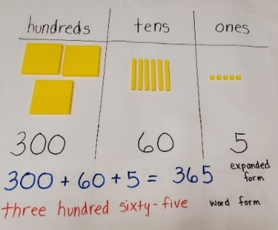

Instructional Tasks
Instructional Task 1 (MTR.2.1)
Provide a series of three-digit modeled numbers using a base ten model like the one shown below.
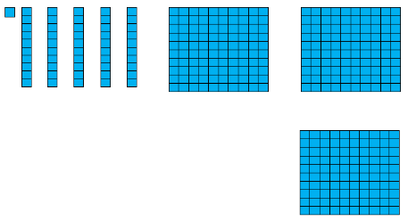

Ask students to record two other ways to represent the quantity. Discuss similarities and differences between the various representations.

Instructional Items
Instructional Item 1
Which of the following shows 613 in expanded form?
- $600+3$
- $600+13$
- $600+10+3$
- $500+90+33$

Instructional Item 2
Select all the ways to describe the number 809.
- Nine hundred eight
- Eight hundred nine
- Eighty-nine
- 908
- 800 + 9
- 800 + 90.

*The strategies, tasks and items included in the B1G-M are examples and should not be considered comprehensive.

MA. 2.NSO.1.2

Benchmark
MA.2.NSO.1.2 Compose and decompose three-digit numbers in multiple ways using hundreds, tens and ones. Demonstrate each composition or decomposition with objects, drawings and expressions or equations.
Example: The number 241 can be expressed as $2 hundreds + 4 tens + 1 one$ or as $24 tens + 1 one$ or as $241 ones$.

Connecting Benchmarks/Horizontal Alignment
- MA.2.NSO.2.2/2.4

Terms from the K-12 Glossary
- Equal sign
- Equation
- Expression

Vertical Alignment
Previous Benchmarks  - MA.1.NSO.1.3 | Next Benchmarks  - MA.3.NSO.1.2
Purpose and Instructional Strategies
The purpose of this benchmark is to extend the understanding of place value from grade 1 to include three-digit numbers and help students to identify ways numbers can be renamed flexibly using composition and decomposition (MTR.2.1).
- Instruction includes the use of base ten manipulatives and place value disks. (MTR.5.1)
- Instruction includes the understanding that 100 can be thought of as a bundle of ten tens – called a “hundred.”
- Instruction includes the idea that the equal sign means “same as” and is used to balance equations.

Common Misconceptions or Errors
- Students may think that because the grouping of the digits changes the value also changes.
  - For example, 879 is the same as $87 tens+9 ones$ or $8 hundreds+79 ones$.
- Students may think that numbers that contain a zero in a place means that the number cannot be decomposed using that place.
- For example, 205 has 0 tens but can also be decomposed into 20 tens and 5 ones.

Strategies to Support Tiered Instruction
- Instruction includes opportunities to use base ten blocks and a place value chart with a 3-digit number. Teacher provides opportunities to allow students to exchange or decompose blocks to other place values.
- For example, teacher asks students to represent the number 326 using base ten blocks or a drawing in their place value chart. Teacher asks students to exchange one ten into ones. Students are asked to explain what they now have and how it is similar and different from the original representation of the number. Repeat this process with exchanging hundreds and tens. Teacher has students share the different representations with the group and again compare the similarities and differences. Students are asked to name/identify the different ways to name the values (grouping the hundreds into tens and the tens into the ones, e.g., 32 tens and 6 ones or 3 hundreds and 26 ones, etc.) Utilize sentence stems for students to complete with each decomposition using: ___ hundreds + ___ tens + ___ ones.

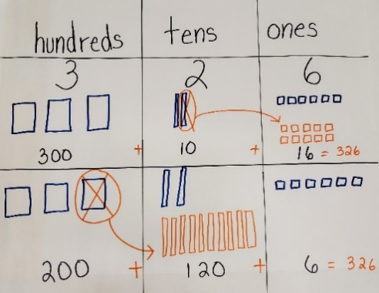

- Instruction includes opportunities to use base ten blocks to practice exchanging tens for ones and hundreds for tens. With each exchange, teacher has students represent using both the original representation and the new representation in a drawing on a place value chart. At every opportunity teacher asks students to name/identify the values they are using in the numbers.
- Example:

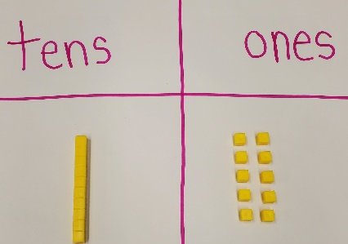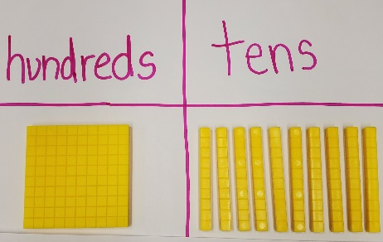
One ten can be exchanged for 10 ones. One hundred can be exchanged for 10 tens.

Instructional Tasks
Instructional Task 1 (MTR.2.1)
The number 317 can be expressed as $3 hundreds+1 ten+7 ones$ or as $31 tens+7 ones$. Explain using objects or drawings how both expressions equal 317.

Instructional Task 2 (MTR.3.1)
Use a place value model to show how the number 134 can be represented as $13 tens$ and $4 ones$.

Instructional Items
Instructional Item 1
Express the number 783 using only hundreds and ones.
Instructional Item 2
Express the number 783 in multiple ways using only tens and ones.

*The strategies, tasks and items included in the B1G-M are examples and should not be considered comprehensive.

MA.2.NSO.1.3

Benchmark
MA.2.NSO.1.3 Plot, order and compare whole numbers up to 1,000.

Example: The numbers 424, 178 and 475 can be arranged in ascending order as 178, 424 and 475.

Benchmark Clarifications:
Clarification 1: When comparing numbers, instruction includes using a number line and using place values of the hundreds, tens and ones digits.

Clarification 2: Within this benchmark, the expectation is to use terms (e.g., less than, greater than, between or equal to) and symbols ($<$, $>$ or=).

Connecting Benchmarks/Horizontal Alignment
- MA.2.NSO.2.2

Terms from the K-12 Glossary
- Natural Number
- Number line

Vertical Alignment
Previous Benchmarks  - MA.1.NSO.1.4 | Next Benchmarks  - MA.3.NSO.1.3
Purpose and Instructional Strategies
The purpose of this benchmark is to extend the place value work of plot, order and compare from grade 1 by increasing the number set to 1,000. In grade 1, students ordered numbers in ascending order only.
- Instruction includes the use of numbers presented in multiple ways and different forms.
- Instruction includes the understanding that the value of a digit is impacted by its position in a number.
- Instruction includes the use of place value charts, place value cards, place value disks, place value chips and base ten blocks (MTR.2.1).
- Instruction includes the use of number lines using benchmark numbers to support comparing.
- Instruction includes the understanding that numbers can be reordered in both ascending and descending order.

Common Misconceptions or Errors
- Students may incorrectly plot a three-digit number on a number line.
- Students may not understand that a representation of a smaller portion of a number line ($200-220$) may have the same physical size as a representation of a larger number line ($0-1,000$).
- Students may have difficulty comparing two numbers that have the same digits in a different order (i.e., 852 and 582).
- Students may not understand the digit in the greatest place helps determine the correct comparison unless it is equal. For example: 129 is less than 231 even though there is a 9 in the number 129. Building these numbers with base ten blocks or place value disks might be helpful.

Strategies to Support Tiered Instruction
- Instruction includes the use of a hundreds chart and base ten blocks. Teacher shares two numbers that have the same digits, but the numbers are in different places.
  - For example, using numbers like 852 and 582, the students build the two numbers on place value charts. Teacher has students write the number under each of the base ten blocks representation. With the visual representation of the numbers available, ask which number greater and which number has fewer of each of the base ten blocks. If students identify the incorrect number, teacher points out that there is a greater number of hundreds/flats in 852 than in 582.

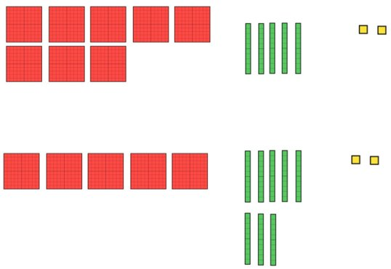
- Instruction includes the use of number lines with benchmark numbers to aid in placement of 3-digit numbers. May use multiple number lines with different end numbers to show the need to focus on the portion where the numbers lie.
- For example, teachers begin with having students label a number line with end benchmarks 0 and 1,000. Then, have students determine what number is located in the middle (500). Students can then further label all of the 100 multiples on the line from 0 to 1,000. Next, show students three numbers (i.e. 435, 442, and 427) Teacher can then show a second number line and discuss that the end numbers can now change to get closer to these three numbers and label the ends with 400 and 450. Work with students to label the multiples of 10s that exist on this line. Then, have students determine where these three numbers are located.

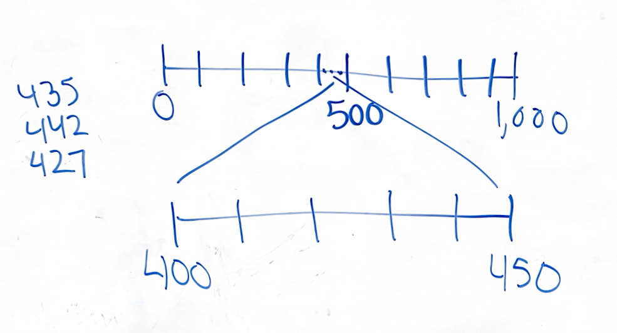

Instructional Tasks
Instructional Task 1 (MTR.2.1)
Provide students with five digit cards (i.e., 1, 8, 5, 4 and 0).
Part A. Create four different three-digit numbers that have a 4 in the hundreds place.
Part B. Arrange the numbers created in order from greatest to least. Explain why which number is the greatest.
Part C. Using two of the numbers created from Part A, write a statement using $>$ or $<$ to compare.

Instructional Task 2 (MTR.1.1, MTR.2.1 MTR.4.1, MTR.5.1)
Class Plotting on an Open Number Line
Materials: 4 Clothespins, 4 index cards, 4 feet of string or rope,
Teacher: Hang a piece of string in the classroom.
- Ask a student to think of a three-digit number that has 3 tens in it and a 1 in the hundreds place. Write that number on an index card. Ask another student to place the number anywhere on the piece of string (open number line) using a clothespin.
- Ask a student to think of a three-digit number that has 1 hundred in it. Write that number on an index card. Ask another student to place the number on the piece of string (open number line) using a clothespin. Ask the class if it should be placed to the right or the left of the first number. Ask “Is this number more or less than our first number?”
- Ask a student to think of a three-digit number that has 1 hundred in it that would come after the 3 tens number. Write that number on an index card. Ask another student to place the number on the piece of string using a clothespin. Ask the class if it is greater than, less than, or equal to the first number on the number line. Ask the class if adjustments are needed to make room for the new number on the open number line (string). Make adjustments as needed.
- Ask a student to think of a number that would come between the first and second number. Write that number on an index card. Ask the class “Should this number be placed closer to the first number or second number? How do you know?” Ask the class if adjustments are needed to the number line more accurate now that they have all the numbers placed. Make adjustments as needed.
- Ask students to independently come up with at least three different true statements from the numbers on the class number line using >, < or = symbols. After giving students time to come up with statements, call on students and write their findings. Ask students to evaluate if they are in fact true statements. Remind students to come up with both greater than and less than statements.
Sample Class Number Line:
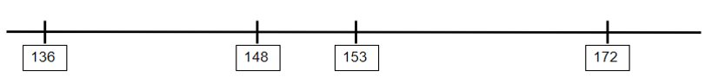

Instructional Task 3 (MTR.1.1, MTR.2.1 MTR.4.1, MTR.5.1)
Teacher provides 6 to 10 numbers on cards in either standard form, expanded form, word form or pictural form. Ask students to place them in ascending order. If any numbers are equal, they can be placed on top of each other to show that they are located at the same spot because they represent the same number. Ask students to come up with at least five different true statements from the numbers using the <,>, or = symbols.

Instructional Items
Instructional Item 1
Use the number line below to plot the numbers 234, 247, 205.
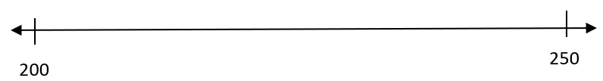

Instructional Item 2

Use $<$, $>$ or $=$ to make the comparison statement $567 \boxed{} 576$ true.

*The strategies, tasks and items included in the B1G-M are examples and should not be considered

MA.2.NSO.1.4

Benchmark
MA.2.NSO.1.4 Round whole numbers from 0 to 100 to the nearest 10.

Example: The number 65 is rounded to 70 when rounded to the nearest 10.

Benchmark Clarifications:
Clarification 1: Within the benchmark, the expectation is to understand that rounding is a process that produces a number with a similar value that is less precise but easier to use.

Connecting Benchmarks/Horizontal Alignment
- MA.2.NSO.2.4
- MA.2.AR.1.1
- MA.2.M.1.1

Terms from the K-12 Glossary
- Natural Number
- Number line

Vertical Alignment
Previous Benchmarks  - MA.1.NSO.1.4 | Next Benchmarks  - MA.3.NSO.1.4
Purpose and Instructional Strategies
The purpose of this benchmark is to introduce rounding as an estimation strategy, creating a number that is easier to compute mentally and check for reasonableness. In grade 1, students were only expected to plot, order and compare numbers to 100.
- Instruction includes the use of a number line to help students determine the nearest 10.
- Instruction includes the use of real-world context to help students make sense of how a rounded number may be less precise but easier to use.
- Instruction includes cases where students must provide numbers that would round to a given number.

Common Misconceptions or Errors
- Students may round down instead of up when there is a 5 in the ones place.
- Students may not be able to identify which two tens a number is between.
  - For example, a student may not be able to determine that 72 is between 70 and 80.
- Students may look at the digit in the tens place to determine how to round, rather than the ones place.

Strategies to Support Tiered Instruction
- Instruction includes using a hundreds chart and showing the relationship of 10 and the next decade. Students will use the number line/number path to clarify where a number is rounded to. Images below show how to take a 120 chart into a number path/number line.
- Top down 120 chart. Teacher can have students highlight column of tens and the column of 5s to help with rounding when cut into a number line.
- Line the consecutive numbers up from one decade to the next and tape.
- Cut the number path/number line.
- The number path/number line end result.
  - For example, after demonstrating how the hundreds chart is a stacked number line/number path, have students find the number 43 on the number line. Ask if it rounds to 40 or 50.
- 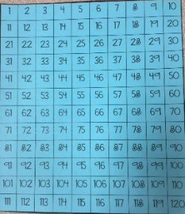 B. 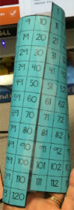

C.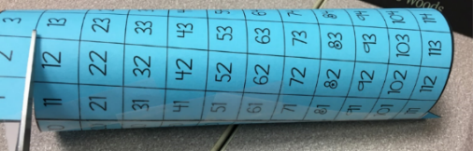

D. 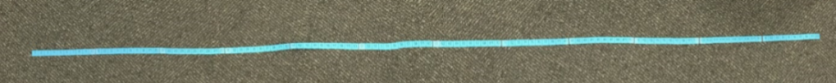

- Instruction includes using a number line and base ten blocks. Using the base ten blocks on the number line, students will represent a number and reference its location to the nearest 10.
- For example, using a number line and base ten blocks teacher asks students to represent the number 27. Students will then need to determine if 27 is closer to 20 or 30 by answering how far from 20 versus 30 that 27 is. (i.e. 27 is 7 away from 20 and 3 away from 30.
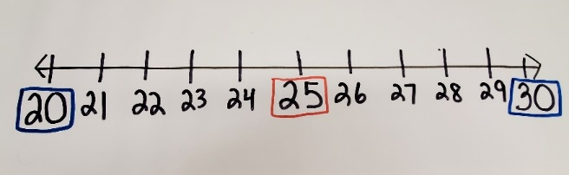

Instructional Tasks
Instructional Task 1 (MTR.6.1)
Provide students with three sets of number cards with the digits 0-9
Part A. Create various two-digit numbers from two of the sets of number cards provided. Plot each of the numbers on a number line.
Part B. Round each number created from Part A to the nearest 10. Explain why each number rounds to the identified ten.
Part C. Create a two-digit number from one of the sets of number cards provided. Use the other sets to create the closest rounding to nearest 10. Explain why each number rounds to the identified ten.

Instructional Task 2 (MTR.6.1)
- Provide students with three sets of digit cards 0-9. Given a target multiple of 10, have students create at least three numbers that would round to the target. One number must have a different tens digit than the other two. (i.e. given 40 as the target, students could make the numbers 37, 39 and 42)

Instructional Items
Instructional Item 1
Use the number line below to plot 3 numbers that would round to 30 when rounded to the nearest 10.

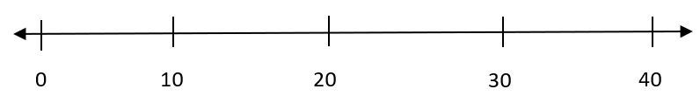

Instructional Item 2
Jamie has a collection of 52 stickers. Rounded to the nearest 10, about how many stickers does Jamie have?

Instructional Item 3
Select the numbers that would round to 50 when rounded to the nearest 10.
- 42
- 49
- 44
- 45
- 58
- 51

*The strategies, tasks and items included in the B1G-M are examples and should not be considered

MA.2.NSO.2 Add and subtract two- and three-digit whole numbers.

MA.2.NSO.2.1

Benchmark
MA.2.NSO.2.1 Recall addition facts with sums to 20 and related subtraction facts with automaticity.

Connecting Benchmarks/Horizontal Alignment
- MA.2.AR.1.1
- MA.2.AR.3.2
- MA.2.M.1.2
- MA.2.GR.2.2

Terms from the K-12 Glossary
- Automaticity
- Equation
- Expression

Vertical Alignment
Previous Benchmarks  - MA.1.NSO.2.1/2.2/2.4/2.5 | Next Benchmarks  - MA.3.NSO.2.1
Purpose and Instructional Strategies
The purpose of this benchmark is to build students’ automaticity with addition facts with sums to 20 and related subtraction facts. Students in grade 1 worked to recall sums within 10 and the related subtraction facts. In grade 3, students will compose and decompose four-digit numbers in multiple ways, as well as fluently adding and subtracting multi-digit whole numbers.
- Instruction should not focus on speed in the classroom.
- Instruction focuses on the fact that automaticity is usually the result of repetition and practice.
- Instruction of this benchmark should not be in isolation from other benchmarks that emphasize understanding.
- Instruction may initially include explicit strategies such as doubles, doubles plus one, making a ten and fact families.
- The correct way to assess automaticity is to observe students within the instructional setting as they complete problems that involve addition and subtraction. Even though such problems can typically be done without automaticity they will be done with less effort with automaticity.

Common Misconceptions or Errors
- Students may rely heavily on visual representation or manipulatives.

Strategies to Support Tiered Instruction
- Teacher provides the addition expression $8 + 6$ and has students provide the sum. Once they have given the correct sum of 14, teacher asks “Is there another fact with the same sum?” If students are able to provide another addition expression, teacher asks them to find another one and repeats with subtraction expression, $17 – 9$. Students should provide the difference of 8. Students may need to use a manipulative to assist in determining the difference. Once students have given the correct difference, teacher asks “Can you give me a related subtraction equation?”
  - Example.
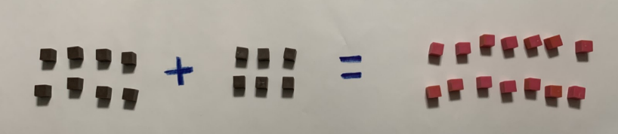
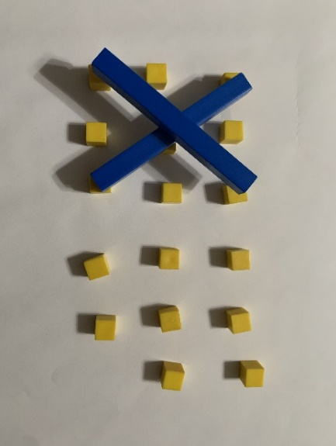
- Teacher co-creates a real-world scenario using a set of given numbers: 6, 7, and 13. Once students have helped to develop an appropriate real-world scenario, teacher discusses what might happen with the problem if the scenario is changed to the inverse operation. The teacher may find that students are not creating a true equation from the scenario they shared. Consider discussing how the numbers are related and how they are affected when the inverse operation is used.
- Teacher provides manipulatives like two color counters and asks students to create a representation of 12. Depending on how they represent the number six, the teacher has them separate the counters into two addends. They may have 12 red counters and 0 yellow showing. The equation is $12 + 0 = 12$. The teacher asks them how they could create a different representation, but with the same sum. Manipulation of the counters is continued until students can identify all sets of two addends that equal 12. Students represent their model with an equation.
- Teacher provides a real-world problem using numbers up to 20.
  - For example, Gavin has 14 toy cars. His brother takes 6 of his toy cars. How many toy cars does he have now? Students use a manipulative to helps solve the problem. The teacher acts out the scenario with the students, then students represent the problem in an equation.
- Once students create their models, teacher asks them to draw the models on paper, bridging students between concrete manipulatives and drawings. Students should always write the equation to represent any of their models to help move the student towards abstract thinking.

Instructional Tasks
Instructional Task 1 (MTR.3.1)
Using any number between 11-20 as the target number, provide students with digit cards 1-9.
Part A. Have students select a digit card to recall the missing addend needed to make the target number.
Part B. Work mentally to create an equation that is equal to the target number.

Instructional Task 2 (MTR.5.1)
Create two addition equations and two related subtraction equations using only the digits 1, 4, 7, and 3. (Digits can be combined and used more than once.

Instructional Items
Instructional Item 1
What subtraction equation can be used to determine of value of $5+13$?
- $19 – 5 = 14$
- $18 – 5 = 13$
- $12 – 8 = 4$
- $13 – 5 = 8$

Instructional Item 2
Which of the following addition expressions have a sum of 20?
- $8 + 12$
- $15 + 4$
- $11 + 9$
- $6 + 13$
- $3 + 7$
- $14 + 4$
- $10 + 10$

*The strategies, tasks and items included in the B1G-M are examples and should not be considered

MA.2.NSO.2.2

Benchmark
MA.2.NSO.2.2 Identify the number that is ten more, ten less, one hundred more and one hundred less than a given three-digit number.

Example: The number 236 is one hundred more than 136 because both numbers have the same digit in the ones and tens place, but differ in the hundreds place by one.

Connecting Benchmarks/Horizontal Alignment
- MA.2.NSO.1.1/1.3/1.4
- MA.2.M.2.2

Terms from the K-12 Glossary

Vertical Alignment
Previous Benchmarks  - MA.1.NSO.2.3 | Next Benchmarks  - MA.3.NSO.1.2/1.4
Purpose and Instructional Strategies
The purpose of this benchmark is to extend the work from grade 1 with two-digit numbers to find the number that is one more, 10 more, one less, or 10 less than a given two-digit number. In grade 3, students will apply and extend this knowledge to decompose four-digit numbers in multiple ways, and round numbers to the nearest 10 and 100.
- Instruction includes encouraging students to use additive reasoning to determine patterns for identifying a number that is 10 more, 10 less, 100 more or 100 less.
- Instruction supports helping students make a connection to the position of a digit within a multi-digit number.
- Instruction includes the use of a hundreds and thousands chart or a number line.
- Instruction is not intended to focus on addition and subtraction strategies.

Common Misconceptions or Errors
- Students may incorrectly assume ten more, ten less, one hundred more and one hundred less can only be applied to multiples of ten.
- Students may have difficulty determining 10 more or 10 less than a three-digit number, especially when combining tens to make a hundred or decomposing a hundred into tens.
- For example, students may not be able to determine that 10 more than 192 is 202. Utilizing a number line or chart may be helpful in visualizing this.

Strategies to Support Tiered Instruction
- Instruction includes the use of place value cards, base-ten blocks, and/or a place value chart. Students build a three-digit number using the place value cards and identifies numbers that are 10 more, 10 less, 100 more, and 100 less. Then, students relate the base ten manipulatives to the place value cards.
  - For example, using the place value cards for the number 428, build the number. Then, separate your number into expanded form showing 400, 20, and 8. Then, the teacher asks students which value would you change if we were making a number 10 more or 10 less? [20]. The teacher asks, “Which value would you change if we were making a number 100 more or 100 less?” [400]. Create the different numbers that are 10 more, 10 less, 100 more, or 100 less with 428.

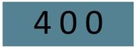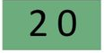

- Instruction includes the use of place value cards and base ten blocks, and/or a place value chart. Students build a three-digit number using the cards that has a value of 9 in the tens place. Then, students identify the values of 10 more, 10 less, 100 more, and 100 less. They may have difficulty knowing how to exchange the 10 tens to the next hundred.
- For example, using base ten blocks and place value cards have students build 293. Have students represent 10 more, 10 less, 100 more, and 100 less. Students will need to exchange the 10 tens for 1 hundred when creating 10 more. If students have difficulty, the teacher asks, “How many tens are in 100?” “How many tens in 200?”
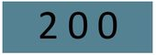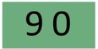
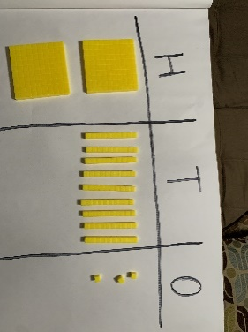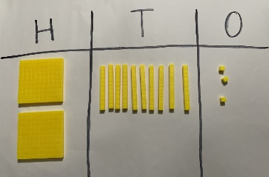

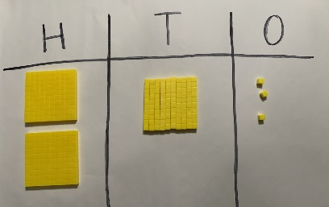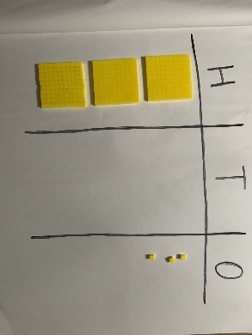

Instructional Tasks
Instructional Task 1 (MTR.2.1)
Melanie is thinking of a number. Her number is one hundred more than 456. One student found the solution by adding $100+456$. Use place value cards to show another way to find Melanie's number.

Instructional Task 2
- Identify the missing numbers in the chart.
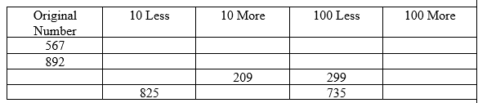

Instructional Items
Instructional Item 1
Determine whether the number in column A is 10 more, 10 less, 100 more or 100 less than the number in column B. Write your response in column C.
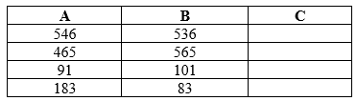

*The strategies, tasks and items included in the B1G-M are examples and should not be considered

MA.2.NSO.2.3

Benchmark
MA.2.NSO.2.3 Add two whole numbers with sums up to 100 with procedural reliability. Subtract a whole number from a whole number, each no larger than 100, with procedural reliability.

Example: The sum $41+23$ can be found by using a number line and “jumping up” by two tens and then by three ones to “land” at 64.
Example: The difference $87-25$ can be found by subtracting 20 from 80 to get 60 and then 5 from 7 to get 2. Then add 60 and 2 to obtain 62.

Benchmark Clarifications:
Clarification 1: Instruction focuses on helping a student choose a method they can use reliably.

Connecting Benchmarks/Horizontal Alignment
- MA.2.NSO.2.4/2.5

Terms from the K-12 Glossary
- Equation
- Expression

Vertical Alignment
Previous Benchmarks  - MA.1.NSO.2.4/2.5 | Next Benchmarks  - MA.3.NSO.2.1
Purpose and Instructional Strategies
The purpose of this benchmark is for students to develop and use reliable methods to add or subtract within 100. In grade 1, students worked in the exploration stage which heavily relied on the use of manipulatives and drawings. In grade 3, students will fluently add and subtract multi-digit whole numbers.
- Instruction includes the understanding that when adding it is sometimes necessary to combine ones and compose a new ten from those ones.
- Instruction includes the understanding that when subtracting it is sometimes necessary to decompose tens and regroup ones.
- Instruction includes using the relationship between addition and subtraction to find differences.
- Instruction includes strategies that support decomposing and composing numbers in multiple ways (MTR.2.1).
- It is not the expectation for students to use a standard algorithm, but students should be supported if they do choose to use a standards algorithm at this stage. Students will formally learn a standard algorithm in grade 3 for addition or subtraction of multi-digit whole numbers.

Common Misconceptions or Errors
- Students may regroup ones incorrectly or forget to regroup the ones.
- Students may always think it is necessary to subtract the lesser digit from the greater digit.
- Students who use a vertical method may record the total sum of the digits in a place value instead of regrouping.

Strategies to Support Tiered Instruction
- Instruction includes the opportunities where regrouping may need to take place with addition and subtraction. Teacher provides students with addition and subtraction problems that may or may not require regrouping. Teacher asks, “Which problems require regrouping and how do you know?”
  - For example, teacher may provide a few expressions like $36+27$, $23+14$, $87-2$ and $64-28$. Students sorts the problems as regrouping or no regrouping. Teacher asks how do you know that you need to regroup? Students solve a couple of the expressions and teacher checks for understanding.
- Using a number line to represent an addition problem may assist in understanding when an answer is not reasonable because the ones were not regrouped into tens and instead were wrongly recorded as two-digit number.
  - For example, teacher provides the problem $54+39$. Students use a place value chart and don’t regroup the ones into tens writing down the answer as 813. Teacher models using a number line to add $54+39$ and show the jumps on the number line and prove that the answer is 93 and not 813.
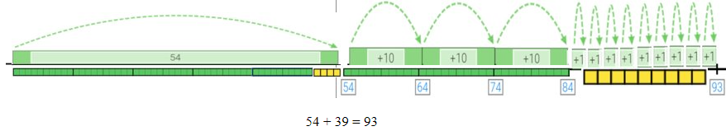

- Instruction includes the use of base ten blocks and place value chart. Teacher provides a subtraction problem where the digit in the ones places of the subtrahend is greater than the digit in the ones place of the minuend. Students begin with the base ten blocks for the minuend, then subtract the subtrahend from the minuend where they may need to regroup a ten into ten ones. Teacher asks students to write the subtraction equation that matches the base ten model.
- For example, teacher asks students to use the base ten blocks to model the subtraction problem $73-48$. Students use the place value chart to help organize the subtraction problem. They can exchange a ten rod for 10 ones. Students then “take away” 4 tens and 8 ones from the 6 tens and 13 ones. They may need to be reminded or revisit when regrouping/exchanging tens and ones is needed. Teacher asks students to write the equation to match.

Instructional Tasks
Instructional Task 1 (MTR.4.1)
Determine the difference between 62 and 39 in as many different ways as possible. Discussion of student responses should allow the opportunity to make connections between varying strategies and discuss the efficiency of a chosen strategy.

Instructional Items
Instructional Item 1
Tina was determining the sum of $3 tens$ and $8 ones+4 tens$ and $5 ones$. She records the sum as $7 tens$ and $13 ones$. Her friend Brene also determined the sum, but says the sum is 83. Who is correct? Explain.

Instructional Item 2
What is the sum of 52 and 3?

Instructional Item 3
What is the difference between 100 and 87?

*The strategies, tasks and items included in the B1G-M are examples and should not be considered

MA.2.NSO.2.4

Benchmark
MA.2.NSO.2.4 Explore the addition of two whole numbers with sums up to 1,000. Explore the subtraction of a whole number from a whole number, each no larger than 1,000.

Example: The difference $612-17$ can be found by rewriting it as $612-12-5$ which is equivalent to $600-5$ which is equivalent to $595$.
Example: The difference $1,000-17$ can be found by using a number line and making a “jump” of 10 from 1,000 to 990 and then 7 “jumps” of 1 to 983.

Benchmark Clarifications:
Clarification 1: Instruction includes the use of manipulatives, number lines, drawings, properties of operations or place value.
Clarification 2: Instruction focuses on composing and decomposing ones, tens and hundreds when needed.

Connecting Benchmarks/Horizontal Alignment
- MA.2.NSO.1.2/1.3

Terms from the K-12 Glossary
- Commutative property of addition
- Equation
- Expression
- Number line

Vertical Alignment
Previous Benchmarks  - MA.1.NSO.2.4/2.5  - MA.1.AR.1.2 | Next Benchmarks  - MA.3.NSO.2.1
Purpose and Instructional Strategies
The purpose of this benchmark is to extend the exploration of addition and subtraction of two whole numbers work from grade 1 to include a number set through 1,000. In grade 3, students will fluently add and subtract multi-digit whole numbers.
- Instruction includes the use of two- or three-digit numbers to add and subtract.
- Instruction includes the use of the commutative property of addition.
- It is not the expectation for students to use a standard algorithm. Instruction focuses on strategies supported by manipulatives, number lines, base ten blocks, place value and drawings.
- Instruction includes helping students understand that when adding it is sometimes necessary to combine ones or tens and compose a new ten or new hundred.
- Instruction includes helping students understand that when subtracting it may be necessary to decompose tens or hundreds and regroup ones or tens.

Common Misconceptions or Errors
- Students may try to apply properties of addition, such as the commutative property, to solve subtraction problems.
- Students may regroup but also include an additional, unnecessary ten or hundred.
- Students may incorrectly add or subtract because they have lost track of the value of digits.

Strategies to Support Tiered Instruction
- Instruction includes examples of the commutative property of addition, and how it does not apply to the related facts for subtraction.
  - For example, using two color counters have students represent the expression $13+5$. Teacher asks, “What is the sum?” Then asks, “What are the related facts?” If students can identify the addition, but not the subtraction problems correctly, the teacher has students start with the total number of counters, 18. “$18-5$ is what?” Students should respond with 13. Then the teacher asks, “What is another related fact?” If they try to do $5-18$, have them start with 5 and take away 18. They will not be able to show the related fact with the numbers 18, 13 and 5. They will end up with negative numbers.
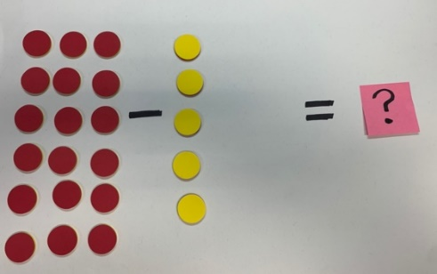
- Instruction includes the use of base ten blocks. Students may regroup ones and tens unnecessarily. Once students understand how to regroup you may find that they attempt to regroup when it is not needed. Using base ten blocks provide examples of expression with and without regrouping. When students are solving an addition problem and they have more than 10 ones or tens remind them that this is when they are to exchange for the next place. When subtracting remind the student that regrouping is only necessary when there is not enough base ten blocks to take away from the place value.
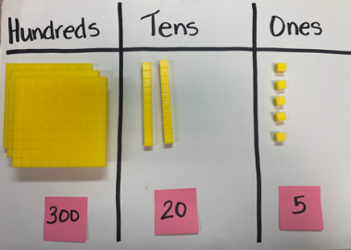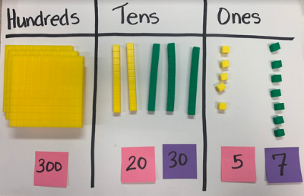
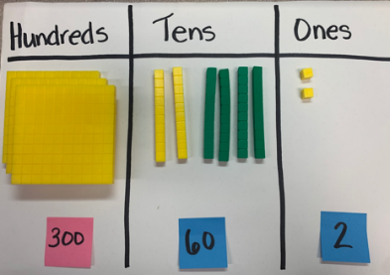

- Instruction includes the use of a place value chart to clarify understanding of the value of the digit to add or subtract. Using the chart will ensure the digit and its value are correct.
  - For example, using the place value chart and base-ten blocks, students place the number 325 into the chart using the base-ten blocks. Then, the teacher asks students to add or subtract 37 by either adding 37 or subtracting 37 base-ten blocks ensuring that students write and align the digits of the number in the correct place value

Instructional Tasks
Instructional Task 1 (MTR.2.1)
A student represented the number 237, using counters, as a place value model shown below. Use the model below to find the value of $237-185$.
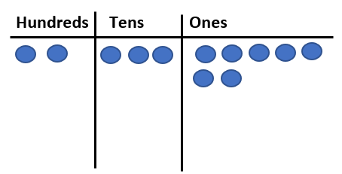

Instructional Task 2 (MTR.4.1)
Part A. Allow students to use various methods to find the sum of 581 and 72. Students may choose to count by 10s and 1s, use a number line, base ten blocks, a place value chart, or use the properties of operations.
Part B. Have a discussion about the different methods students decided to use:

Instructional Items
Instructional Item 1

Find the value of the expression $454+219$.

*The strategies, tasks and items included in the B1G-M are examples and should not be considered

Fractions

MA.1.FR.1 Develop an understanding of fractions by partitioning shapes into halves and fourths.

MA.2.FR.1.1

Benchmark
MA.2.FR.1.1 Partition circles and rectangles into two, three or four equal-sized parts. Name the parts using appropriate language, and describe the whole as two halves, three thirds or four fourths.

Benchmark Clarifications:
Clarification 1: Within this benchmark, the expectation is not to write the equal-sized parts as a fraction with a numerator and denominator.
Clarification 2: Problems include mathematical and real-world context.

Connecting Benchmarks/Horizontal Alignment
  - MA.2.M.2.1

Terms from the K-12 Glossary
  - Circle
- Rectangle

Vertical Alignment
Previous Benchmarks  - MA.1.FR.1.1 | Next Benchmarks  - MA.3.FR.1.1
Purpose and Instructional Strategies
The purpose of this benchmark is to extend the work from grade 1 of partitioning circles and rectangles into halves and fourths. In this grade level, students will also partition circles and rectangles into three equal-sized parts, name the parts as three thirds and describe the whole (MTR.5.1).
- Instruction includes the use of manipulatives such as geoboards, fraction circles, pattern blocks or color tiles, along with contextual sharing situations.
- Instruction includes the idea of part-whole relationships as supported by a model.
- Naming the parts is based on the number of equal parts that make the whole.
- Students are not expected to use formal fraction notation until grade 3.

Common Misconceptions or Errors
- Students may have difficulty partitioning into equal-sized parts.
- Students may not understand that the parts can be equal parts even if they do not look identical.

Strategies to Support Tiered Instruction
- Instruction includes geoboards to partition rectangles and circles into thirds.
- Instruction includes graph paper to divide shapes into equal parts when given part of a whole by counting the units inside the shape to prove each piece is of equal size.
  - For example, the shape is a total of 30 units and one equal part is given. Students partition the shape into 3 equal parts using the knowledge that one part is equal to 10 units.
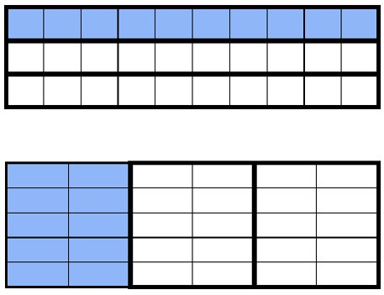
- Teacher provides opportunities to use fraction manipulatives to develop understanding of thirds in circles and rectangles.
- For example, teacher provides pictures of circles and rectangles (of the same size as the manipulatives) on a sheet of paper. Students then use the “thirds” manipulatives to trace the thirds into the circles and rectangles, so they develop an understanding of how to partition these shapes into thirds

Instructional Tasks
Instructional Task 1 (MTR.2.1)
Provide students with paper copies of circles and rectangles.
Part A. Cut or fold the figures to determine how one can create two, three or four equal-sized parts.
Part B. Use mathematical language to describe the parts created in Part A.

Instructional Items
Instructional Item 1
Which shape is partitioned into four fourths? Explain your thinking.
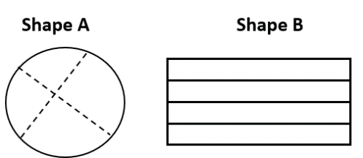

Instructional Item 2
Below is one-half of a whole. Draw two halves to make a whole. Encourage students to provide two different ways to make a whole.

*The strategies, tasks and items included in the B1G-M are examples and should not be considered comprehensive.

MA.2.FR.1.2

Benchmark
MA.2.FR.1.2 Partition rectangles into two, three or four equal-sized parts in two different ways showing that equal-sized parts of the same whole may have different shapes.
Example: A square cake can be cut into four equal-sized rectangular pieces or into four equal-sized triangular pieces.

Connecting Benchmarks/Horizontal Alignment
  - MA.2.M.2.1

Terms from the K-12 Glossary
- Rectangle

Vertical Alignment
Previous Benchmarks  - MA.1.FR.1.1 | Next Benchmarks  - MA.3.FR.1.1
Purpose and Instructional Strategies
The purpose of this benchmark is to build understanding that figures can be partitioned in multiple ways, the parts can look different, but they still represent an equal amount of the whole.
- Instruction includes the use of manipulatives including geoboards, fraction circles, pattern blocks or color tiles.
- Instruction includes the idea of part-whole relationship if supported by a model.
- Students are not expected to use formal fraction notation until grade 3.

Common Misconceptions or Errors
- Students may have difficulty partitioning into equal-sized parts.
- Students may not understand that the parts can be equal parts even if they do not look identical.

Strategies to Support Tiered Instruction
- Instruction includes geoboards to partition rectangles and circles into thirds.
- Instruction includes graph paper to divide shapes into equal parts when given part of a whole by counting the units inside the shape.
  - For example, the shape is a total of 30 units and one equal part is given. Students partition the shape into 3 equal parts using the knowledge that one part is equal to 10 units.

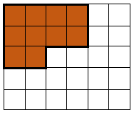

- Teacher provides opportunities to use fraction manipulatives to develop understanding of thirds in circles and rectangles.
  - For example, teacher provides pictures of circles and rectangles (of the same size as the manipulatives) on a sheet of paper. Students then use the “thirds” manipulatives to trace the thirds into the circles and rectangles, so they develop an understanding of how to partition these shapes into thirds.
- Teacher provides opportunities to use a pre-partitioned shape on graph paper to count units and determine if the different sized parts are equal.
  - For example, the shape is partitioned into two parts. Students may count to determine if they are equal parts.

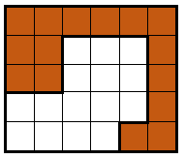

Instructional Tasks
Instructional Task 1 (MTR.2.1)
Provide students with multiple copies of a three-unit by four-unit array.
Part A. Shade the array to show how it can be partitioned into two, three and four equal-sized pieces in as many ways as possible.
Part B. Discuss with a partner or in a group why the parts look different but still represent the same equal-sized part of the whole.

Instructional Task 2 (MTR.4.1)
Given the images below, discuss why these are divided into three equal parts.


Instructional Items
Instructional Item 1
Four friends will share a large rectangular pizza. Show several ways they can cut the pizza to show four equal-sized pieces.

Instructional Item 2
Select all the rectangles that are partitioned into thirds.

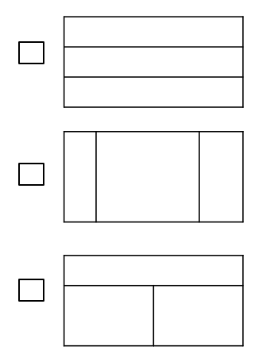
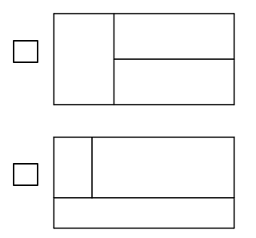

*The strategies, tasks and items included in the B1G-M are examples and should not be considered comprehensive.

Algebraic Reasoning

MA.2.AR.1 Solve addition problems with sums between 0 and 20 and subtraction problems using related facts.

MA.2.AR.1.1

Benchmark
MA. 2.AR.1.1 Solve one- and two-step addition and subtraction real-world problems.

Benchmark Clarifications:
Clarification 1: Instruction includes understanding the context of the problem, as well as the quantities within the problem.
Clarification 2: Problems include creating real-world situations based on an equation.
Clarification 3: Addition and subtraction are limited to sums up to 100 and related differences. Refer to Situations Involving Operations with Numbers (Appendix A.

Connecting Benchmarks/Horizontal Alignment
- MA.2.NSO.2.3
- MA.2.AR.2.2
- MA.2.M.1.2
- MA.2.M.2.2
- MA.2.DP.1.2

Terms from the K-12 Glossary
- Associative Property of Addition
- Commutative Property of Addition
- Equation
- Expression
- Number line

Vertical Alignment
Previous Benchmarks  - MA.1.AR.1.2 | Next Benchmarks  - MA.3.AR.1.2
Purpose and Instructional Strategies
The purpose of this benchmark is to provide opportunities for students to solve various real-world situation types involving addition and subtraction. In grade 1, students solved real-world addition and subtraction problems within 20 (MTR.7.1).
- Instruction includes experience with all situation types involving addition and subtraction.
- Mastery of all situation types, as shown in Appendix A, is expected at by the end of this grade level.
- Instruction leads students to focus on context and apply reasoning to determine the appropriate operation.
- Instruction includes the use of number lines, drawings, diagrams or models to represent problem context

Common Misconceptions or Errors
- Students may have difficulty interpreting the quantities in the context of the problem or misidentifying the operation needed to solve the problem.
- Students may interpret a start or change unknown problem as a result unknown problem.
- Students may look for key words which can lead to the incorrect operations and cause students to ignore the context and reasoning.

Strategies to Support Tiered Instruction
- Teacher provides a graphic organizer to record information about the problem that focuses on the quantities in context and the operation(s) needed to solve the problem.
  - For example, use the following problem to complete the organizer below.
- John collected 23 leaves on his walk on Monday. On Tuesday, he collected 35 leaves on his walk. At the end of his walk on Wednesday, he had collected a total of 97 leaves. How many leaves did he collect on Wednesday?
- What is this problem about? John collected leaves on Monday, Tuesday, and Wednesday.
- What do I know? John collected 23 leaves on Monday and 35 leaves on Tuesday. He has a total of 97 leaves.
- What is the problem asking? How many leaves did John collect Wednesday?
- Does this problem have one or two steps? This problem has 2 steps.
- What operation can I use to solve this problem? I can add and subtract.
    - How can I model this problem to solve it? Students may use an equation, a drawing, or manipulatives to model their work.

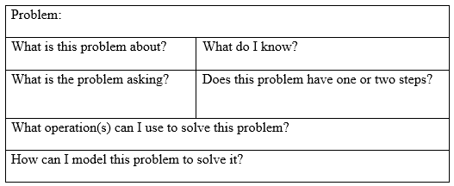

- Teacher provides the chart/organizer below and guides students through determining if the start, change and result are known for each word problem.
  - Example:
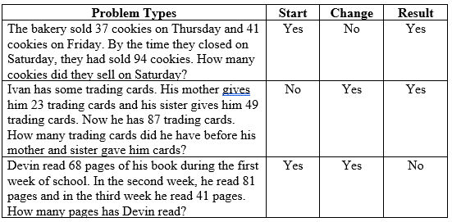
- Instruction provides opportunities to determine the context of numberless word problems with a focus on what is happening in the problem and how to solve it.
  - For example, the teacher provides the following word problem to students.
Cindy Lou needs ___ cupcakes for the bake sale. She has already made ___ cupcakes. How many cupcakes does she still need to make?
Teacher asks: What is this problem about? What is happening in this problem? What information do we know? How do you think you would solve this problem?

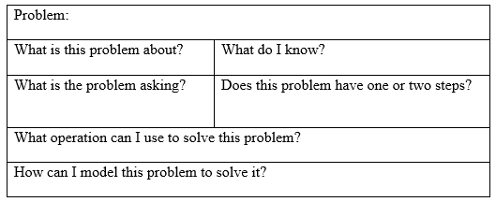
Instructional Tasks
Instructional Task 1 (MTR.4.1)
A bus leaves Park Elementary School with 27 students. Twelve students get off at stop A and eight more get off at stop B. How many students are on the bus at stop C? [Teacher note: Discussion of student responses should allow the opportunity to make connections between multiple strategies and discuss the efficiency of a chosen strategy.]

Instructional Task 2
Create a word problem that can be solved using the equation $76=11+65$.

Instructional Items
Instructional Item 1
Mr. Gene sharpened some pencils. Ms. Smith sharpened 32 pencils. There are 78 sharpened pencils. How many pencils did Mr. Gene sharpen?

Instructional Item 2

Josephine bought 86 tickets at the fair to go on rides. She used 28 tickets for rides. She then gave her sister 11 tickets so she could ride some rides too. How many tickets does Josephine have left?

*The strategies, tasks and items included in the B1G-M are examples and should not be considered comprehensive.

MA.2.AR.2 Demonstrate an understanding of equality and addition and subtraction.

MA.2.AR.2.1

Benchmark
MA.2.AR.2.1 Determine and explain whether equations involving addition and subtraction are true or false.
Example: The equation $27+13=26+14$ can be determined to be true because 26 is one less than 27 and 14 is one more than 13.

Benchmark Clarifications:
Clarification 1: Instruction focuses on understanding of the equal sign.
Clarification 2: Problem types are limited to an equation with three or four terms. The sum or difference can be on either side of the equal sign.
Clarification 3: Addition and subtraction are limited to sums up to 100 and related differences.

Connecting Benchmarks/Horizontal Alignment
- MA.2.NSO.2.3

Terms from the K-12 Glossary
- Equal sign
- Equation

Vertical Alignment
Previous Benchmarks  - MA.1.AR.2.2 | Next Benchmarks  MA.3.AR.2.2
Purpose and Instructional Strategies
The purpose of this benchmark is to further develop an understanding of the equal sign by examining equations. In grade 1, students determined and explained whether equations involving addition and subtraction within 20 were true or false.
- Instruction includes the use of manipulatives or drawings to show balanced equations.
- Instruction includes equations where the minuend, subtrahend or addends are on either side of the equal sign.
- Instruction includes equations in different forms such as $a+b=c$ or $c=a+b$.
- Instruction includes examples of equations that are false).

Common Misconceptions or Errors
- Students may not understand the equal sign means “the same as” and only relate it to “the answer is.”
- Students may think the equal sign requires them to do something.

Strategies to Support Tiered Instruction
- Teacher provides opportunities to use a number balance to support understanding of the equal sign.
  - For example, students build the expression $5+6$ on one side of the balance and are asked to build an expression of equal magnitude of the other side. Students may choose to use a 9 and a 2, an 8 and a 3, or a 7 and a 4. Since students cannot use an 11 and must use two separate numbers instead, they are dispelling the misconception that the equal sign means “the answer is.”

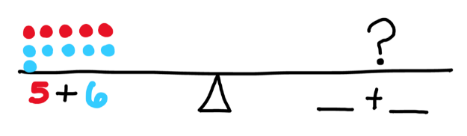

- Teacher provides examples of simple equations with no operations to determine if they are true or false using a number balance. Focus should be on the equality of an equation that only contains the equal sign. Students may draw a picture to show the quantities are equal.
  - For example, the equation $5=5$ can be modeled using the number balance below.
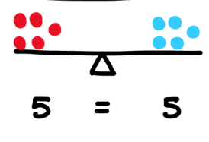
- Teacher provides manipulatives to model each side of the equation to determine if an equation is true or false.
  - For example, for the equation $8 + 6 = 10 + 5$ students would use two-color counters to build each side of the equation and then count to determine if they are equal.
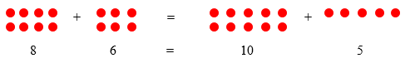

- Teacher provides opportunities to use a balance to explore simple equations that only contain an equal sign.
For example, students use cubes to represent the equation on the balance using the equations $5=5$, $8=8$, and $3=3$.
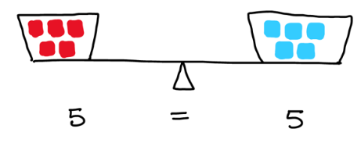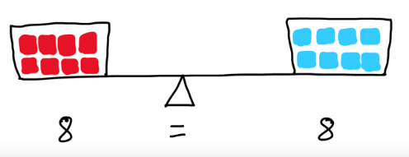

Instructional Tasks
Instructional Task 1 (MTR.6.1)
Provide students the table below. Ask students to determine and explain how they know that each equation is true or false.
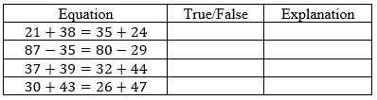

Instructional Items
Instructional Item 1
Which of the following explains why $15+18=25+8$ is a true equation?
- The equation $15+18=25+8$ is true because 15 is ten less than 25 and 18 is ten more than 8.
- The equation $15+18=25+8$ is true because both equations are adding 8 ones.
- The equation $15+18=25+8$ is true because both equations have a number that has a 5 in the ones place.
*The strategies, tasks and items included in the B1G-M are examples and should not be considered comprehensive.

MA.2.AR.2.2

Benchmark
MA.2.AR.2.2 Determine the unknown whole number in an addition or subtraction equation, relating three or four whole numbers, with the unknown in any position.
Example: Determine the unknown in the equation $45+\underline{}=23+46$.

Benchmark Clarifications:
Clarification 1: Instruction extends the development of algebraic thinking skills where the symbolic representation of the unknown uses any symbol other than a letter.
Clarification 2: Problems include having the unknown on either side of the equal sign.
Clarification 3: Addition and subtraction are limited to sums up to 100 and related differences. Refer to Situations Involving Operations with Numbers (Appendix A).

Connecting Benchmarks/Horizontal Alignment
- MA.2.AR.1.1

Terms from the K-12 Glossary
- Equation
- Equal Sign
- Expression

Vertical Alignment
Previous Benchmarks  MA.1.AR.2.3 | Next Benchmarks  - MA.3.AR.2.3
Purpose and Instructional Strategies
The purpose of this benchmark is to build relational thinking. In grade 1, students determined an unknown whole number in an addition or subtraction problem within 20.
- Instruction includes an unknown value in any position.
- Instruction includes compensation of values to balance equations.
- Instruction includes the use of number lines, drawings, or models to solve addition and subtraction problems.

Common Misconceptions or Errors
- Students may confuse the value on one side of the equation with an unknown number.
- Students may think equivalent values have to look identical.
- Students may incorrectly use compensation to add or subtract.

Strategies to Support Tiered Instruction
- Teacher provides opportunities to draw quantities in an equation and use drawings to determine the unknown. Teacher provides an organizer to help students represent the quantities.
  - For example, $5 + 7 = ___ + 9$.

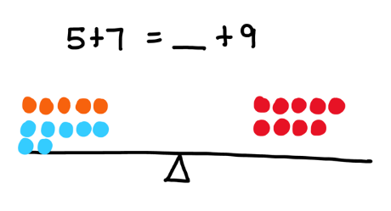
- Teacher provides opportunities to create a drawing to represent an equation by decomposing numbers on each side. The focus should be on the quantities being equal even though they look different.
  - For example, $20 + 7 = 10 + 17$.

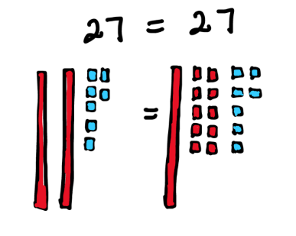

- Teacher provides opportunities to use a number balance to support understanding of finding an unknown quantity in a balanced equation.
  - For example, students build the equation $4 + 5 = ____ + 7$ on a number balance. Students then determine the value of the unknown quantity by balancing the number balance. This builds understanding that the two sides of the equation must be equal. If students try to use 9 as the unknown quantity, it will not balance.
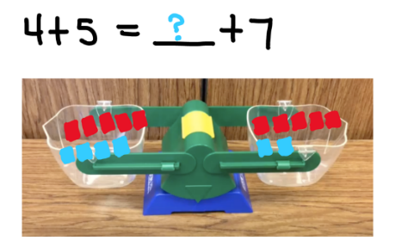
- Teacher provides number strings to teach compensation strategies based on number relationships. The teacher may reveal one line at a time and give students time to think about their responses. As students move through the string, the teacher asks questions to help draw attention to the target strategy of compensation. Students illustrate their thinking using manipulatives such as base 10 blocks or illustrations.
- Example:
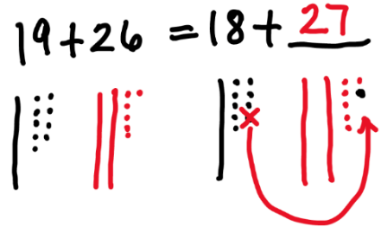
Instructional Tasks
Instructional Task 1 (MTR.5.1)
A student solved for the missing addend in $30+43=26+\underline{}$. The student says the missing addend is 47 because 26 is 4 less than 30, so we can add 4 more to 43 and that is 47. Using this strategy determine the missing addend in the equation below and justify your thinking.
$$16+37=\underline{}+38$$

Instructional Task 2 (MTR.4.1)
Provide students the opportunity to use other strategies to determine the unknown in the equation $16+37=\underline{}+38$. Allow students to discuss which method they prefer.

Instructional Items
Instructional Item 1
Solve for the number in the blank that makes the equation true. Explain using models or drawings.
$$54-\underline{}=32-15$$

*The strategies, tasks and items included in the B1G-M are examples and should not be considered comprehensive.

MA.2.AR.3 Develop an understanding of multiplication.

MA.2.AR.3.1

Benchmark
MA.2.AR.3.1 Represent an even number using two equal groups or two equal addends. Represent an odd number using two equal groups with one left over or two equal addends plus 1.

Example: The number 8 is even because it can be represented as two equal groups of 4 or as the expression $4+4$.
Example: The number 9 is odd because it can be represented as two equal groups with one left over or as the expression $4+4+1$.

Benchmark Clarifications:
Clarification 1: Instruction focuses on the connection of recognizing even and odd numbers using skip counting, arrays and patterns in the ones place.
Clarification 2: Addends are limited to whole numbers less than or equal to 12.

Connecting Benchmarks/Horizontal Alignment
- MA.2.NSO.1.2
- MA.2.NSO.2.1
- MA.2.FR.1.1

Terms from the K-12 Glossary

Vertical Alignment
Previous Benchmarks  - MA.1.NSO.2.1 | Next Benchmarks  - MA.3.AR.3.1
Purpose and Instructional Strategies
The purpose of this benchmark is to introduce the concept of even and odd numbers by building on students' understanding of equal groups and equal addends while continuing to build their automaticity with basic facts. This work lays the foundation for understanding multiples of 2 (MTR.5.1).
- Instruction includes the use of arrays to show equal groups in rows and columns.
- Instruction includes the use of manipulatives, drawings, models, or equations to show a number as even or odd.
- Instruction includes numbers no larger than 25.
- Instruction includes building the foundation for patterns in grade 3.

Common Misconceptions or Errors
- Students may think a number is odd if the doubles addition fact involves odd numbers.

Strategies to Support Tiered Instruction
- Instruction includes opportunities to draw models of double facts or use two-color counters to explore the sums produced. Focus should be on sums always being even.
  - For example, students draw a model for $4 + 4$, $5 + 5$, $6 + 6$, $7 + 7$, $8 + 8$ and $9 + 9$ by drawing a column of circles to represent each number. Students then pair the circle in each row to see there are no circles left without a match even when odd addends are used. Enough examples should be completed for students to see the pattern in the sums and realize the sums will always be even.
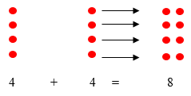
- Instruction includes opportunities to build models of numbers using two-color counters to determine if a number is even or odd.
  - For example, using 15 two-color counters, students pair the counters together to determine if each counter will have a partner or if one counter will be left without a partner. Students will determine if the number is even or odd by developing the understanding that an even number can be split into two equal groups.

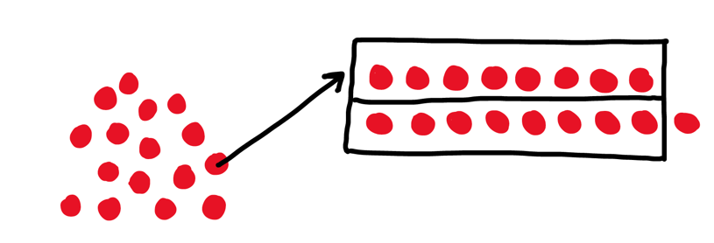

Instructional Tasks
Instructional Task 1 (MTR.5.1)
Present students with a variety of numbers between 0 and 25. Ask students to determine if the given number is even or odd by visually representing groups and creating an expression to determine if the total number of counters is even or odd. Student discussion should center around students being able to make generalizations about odd and even numbers.

Instructional Items
Instructional Item 1
The counters below represent the number 10. Use groups and an expression to justify if the number 10 is even or odd.

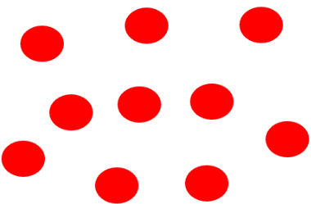

Instructional Item 2
Tim says 15 is odd because there is a 5 in the ones place. Use an array to show that he is correct.

*The strategies, tasks and items included in the B1G-M are examples and should not be considered comprehensive.

MA.2.AR.3.2

Benchmark
MA.2.AR.3.2 Use repeated addition to find the total number of objects in a collection of equal groups. Represent the total number of objects using rectangular arrays and equations.
Benchmark Clarifications:
Clarification 1: Instruction includes making a connection between arrays and repeated addition, which builds a foundation for multiplication.
Clarification 2: The total number of objects is limited to 25.

Connecting Benchmarks/Horizontal Alignment
- MA.2.NSO.2.1/2.3

Terms from the K-12 Glossary
- Equation
- Rectangular array

Vertical Alignment
Previous Benchmarks  - MA.K.NSO.1.1  - MA.1.NSO.2.1 | Next Benchmarks  - MA.3.NSO.2.2
Purpose and Instructional Strategies
The purpose of this benchmark is to connect the idea of repeated addition as a way to represent equal groups. At this grade level, students are also introduced to the array as a model for arranging groups into equal rows and equal columns.
- Instruction includes the language of rows and columns to reinforce the number of groups and the number of objects in each group. The number of groups can be represented by the number of rows with the number of objects in each group being represented by the size of the row (the number of columns), or the number of objects in each group can be represented by the number of columns and the number of objects in a group represented by the size of a column (the number of rows).
- Instruction includes the idea that a scattered collection can be arranged into equal groups in various ways without changing the total number (i.e., the Cardinality Principle).
- Instruction includes the use of number lines and counters).

Common Misconceptions or Errors
- Students may mistakenly add the number of rows and columns instead of the number of objects in each row.
- Students may count the array total as the perimeter instead of the area.
- Students may not recognize that when rows and columns are rearranged in arrays the total number of objects in the array remains the same.
Strategies to Support Tiered Instruction
- Teacher provides opportunities to create multiple arrays for a specific number using two-color counters and write a repeated addition equation to represent the sum of the array.
  - For example, students build arrays for the number 24, count the number of objects in each row and write a repeated addition equation to represent the array. While each array will be different, the sum will always be the same, building understanding that the equation changes based on the number of objects in each row Teacher provides opportunities for students to use algebra tiles to co-solve provided equations with the teacher without the need of writing the equation first.
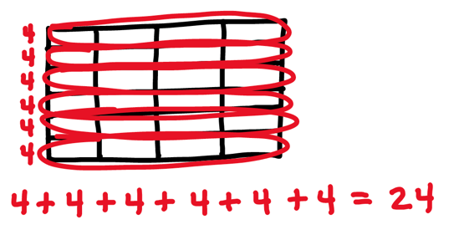

- Teacher provides arrays cards to match multiple variations of an array that match a specific number.
  - For example, students may see a variety of arrays for the number 24. Arrays are presented as arrays of 3 rows of 8, 8 rows of 3, 2 rows of 12, 12 rows of 2, 4 rows of 6, 6 rows of 4, and some non-examples of arrays for 24. By sorting the arrays into a group that represents 24, students develop an understanding that columns and rows can be rearranged and still represent the same sum.
- Teacher provides a template of an array for students to number the number of objects in each row and write a repeated addition equation to represent the array.
  - Example:

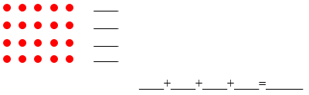
Instructional Tasks
Instructional Task 1 (MTR.2.1, MTR.7.1)
A teacher is putting chairs at a table for a class party. The teacher puts five chairs at each of the four tables.
Part A. Use counters to represent the total number of chairs and write a repeated addition equation to show the total number of chairs.
Part B. Represent the chairs by putting counters into an array in more than one way.

Instructional Items
Instructional Item 1
Part A. Draw three triangles in each of the groups below.
Part B. Create an array to represent the total amount of triangles.
Part C. Write a repeated addition equation to show the total number of triangles
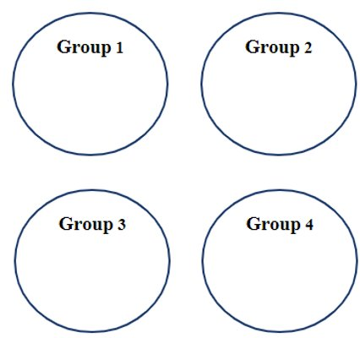

*The strategies, tasks and items included in the B1G-M are examples and should not be considered comprehensive.

Measurement

MA.2.M.1 Measure the length of objects and solve problems involving length.

MA.2.M.1.1

Benchmark
MA.2.M.1.1 Estimate and measure the length of an object to the nearest inch, foot, yard, centimeter or meter by selecting and using an appropriate tool.
Benchmark Clarifications:
Clarification 1: Instruction includes seeing rulers and tape measures as number lines.
Clarification 2: Instruction focuses on recognizing that when an object is measured in two different units, fewer of the larger units are required. When comparing measurements of the same object in different units, measurement conversions are not expected.
Clarification 3: When estimating the size of an object, a comparison with an object of known size can be used
Connecting Benchmarks/Horizontal Alignment
- MA.2.GR.2.1

Terms from the K-12 Glossary

Vertical Alignment
Previous Benchmarks  - MA.1.M.1.1 | Next Benchmarks  - MA.3.M.1.1
Purpose and Instructional Strategies
The purpose of this benchmark is to build instruction from grade 1 to include additional U.S. customary and metric units. Students will both estimate and measure objects in various units and are expected to select an appropriate measurement tool.
- Instruction includes helping students identify benchmark measurement references.
- Instruction includes helping students connect the concept of a number line to linear measurement tools such as rulers and tape measures.

Common Misconceptions or Errors
- Students may misalign the measurement tool with the object and measure an object from 1 instead of 0.
- Students may count all marks, not just the whole-unit marks, when reading a measurement tool.
- Students may not have a clear concept of the approximate length of an inch, a foot, a centimeter or a meter.

Strategies to Support Tiered Instruction
- Instruction includes modeling how to measure an object and guiding students to notice that the object’s measurement does not change if the object is placed further down the ruler.
- For example, modeling may include identifying the end points of an object and lining the endpoint with the zero mark of the ruler or tape measure. Note that often the “zero” mark is not labeled and may be the end of the ruler or the very first tick mark depending on the ruler. The teacher states the correct measurement and then as students watch, move the object down the ruler and ask, “Does the object’s measurement change if its end point lines up with a different number?”
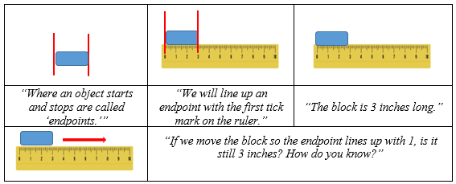
- Students can also be shown examples of a ruler or tape measure on which the zero mark is not labeled and is the end of the measurement tool.

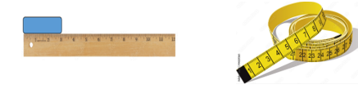
- Instruction includes opportunities to compare a regular ruler to a ruler that only has whole number tick marks. The teacher demonstrates how to measure using the modified ruler and then measures the same object with the regular ruler. Students compare the two rulers
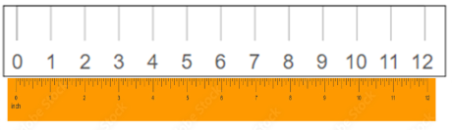
- Instruction includes directing students to make connections between their world and measurements of inch, foot, centimeter and meter. Students discuss these relationships, draw pictures and write labels that can be used as a reference to help them remember the different length units and their approximate sizes.
  - For example, students can use index cards to draw examples of each length unit relationship. Multiple cards can be made so that students can sort, do a memory match, or combine them to create a mini booklet.
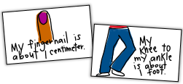

Instructional Tasks
Instructional Task 1 (MTR.4.1, MTR.6.1)
As a class, determine several classroom objects whose lengths can be measured (e.g., pencil, book, desk, glue stick, etc.).
Part A. Before measuring, select an appropriate tool and estimate the number of units.
Part B. Compare their estimates to the actual measurement. Include a comparison of the number of units based on the tool selected.

Instructional Items
Instructional Item 1
Nancy measured her index card using a ruler. She thinks the index card is about 9 centimeters long. Is Nancy’s work correct? Explain why or why not.

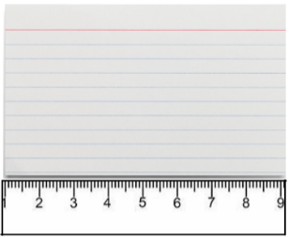

*The strategies, tasks and items included in the B1G-M are examples and should not be considered comprehensive.

MA.2.M.1.2

Benchmark
MA.2.M.1.2 Measure the lengths of two objects using the same unit and determine the difference between their measurements.
Benchmark Clarifications:
Clarification 1: Within this benchmark, the expectation is to measure objects to the nearest inch, foot, yard, centimeter or meter.

Connecting Benchmarks/Horizontal Alignment
- MA.2.NSO.2.3
- MA.2.AR.1.1

Terms from the K-12 Glossary

Vertical Alignment
Previous Benchmarks  - MA.1.M.1.2 | Next Benchmarks  - MA.3.M.1.2
Purpose and Instructional Strategies
The purpose of this benchmark is to directly compare the length of two objects measured using the same unit and determine the difference.
- Instruction includes selecting the appropriate tool to measure.
- Instruction includes helping a student choose a method they can use reliably to determine the difference.
- Instruction includes the use of number lines, drawings, diagrams or models to subtract.
- Instruction includes helping students record the appropriate measurement when the object falls between two whole number measurements.

Common Misconceptions or Errors
- Students may always choose to use a ruler to measure length, even when the object is longer than a ruler.
- Students may count all tick marks, not just the whole-unit marks, when reading a measurement tool and misread the nearest whole unit.
- Students may add instead of subtract to find the difference between the two lengths or try to subtract the longer length from the shorter length because they measured them in that order.

Strategies to Support Tiered Instruction
- Instruction includes helping students understand that when we measure longer objects, it is best to use a tape measure, yard stick or meter stick and use larger units, if possible.
  - For example, ask students to use their inch or centimeter rulers to measure the length of the whiteboard or another long object in the room. Then show them how to use a tape measure (or meter or yard stick) to measure. Note that it is easier to measure with these tools.
  - Next, have students note that they could find the number of inches or centimeters more accurately with the longer tool because they didn’t have to keep moving their tool.
  - Then, have students notice the different units of measure on the measurement tool (meters with the centimeters and feet and yards with the inches).
  - Model how to count by meters, feet and yards on the measurement tool and have students practice measuring objects in these units. Talk about the number of inches it takes to measure an object versus measuring the same object with feet.
- Instruction includes modeling a think aloud using a ruler as a number line to show how a measurement is about ____ units when the object falls between two whole number measurements.
  - For example, show a ruler with just the whole number tick marks. Measure an object that is closer to 3 inches and measure an object that is closer to 4 inches.

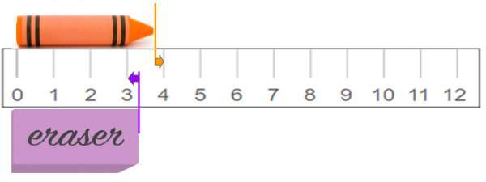
The _eraser_ is about _3_ inches long. The _crayon_ is about _4_ inches long.

Instructional Tasks
Instructional Task 1 (MTR.4.1)
Provide students with an object of a given measurement in various units.
Part A. Find objects in the classroom or that are shorter or longer than the given object and find the difference using the common unit.
Part B. Discuss which tool was more appropriate to use and what strategy was used to find the difference.

Instructional Items
Instructional Item 1
A pair of scissors measure 22 centimeters long, and a glue stick measures 14 centimeters long. Which statement below is true about the measurement of the objects?
- The glue stick is 9 centimeters longer than the scissors.
- The glue stick and scissors are 8 centimeters long.
- The scissors are 8 centimeters longer than the glue stick.

*The strategies, tasks and items included in the B1G-M are examples and should not be considered comprehensive.

MA.2.M.1.3

Benchmark
MA.2.M.1.3 Solve one- and two-step real-world measurement problems involving addition and subtraction of lengths given in the same units.
Example: Jeff and Larry are making a rope swing. Jeff has a rope that is 48 inches long. Larry’s rope is 9 inches shorter than Jeff’s. How much rope do they have together to make the rope swing.

Benchmark Clarifications:
Clarification 1: Addition and subtraction problems are limited to sums within 100 and related differences.

Connecting Benchmarks/Horizontal Alignment
- MA.2.NSO.2.3
- MA.2.AR.1.1

Terms from the K-12 Glossary

Vertical Alignment
Previous Benchmarks  - MA.1.AR.1.2  - MA.1.M.1.2 | Next Benchmarks  - MA.3.M.1.2
Purpose and Instructional Strategies
The purpose of this benchmark is to incorporate the concept of measurement when solving real-world problems.
- Instruction includes the use of inches, feet, yards, centimeters or meters as appropriate measurement units.
- Instruction includes the use of drawing, manipulatives and number lines to solve problems.

Common Misconceptions or Errors
- Students may regroup numbers incorrectly or unnecessarily when adding or subtracting.
- Students may incorrectly decide to add or when to subtract based on the context of the problem.

Strategies to Support Tiered Instruction
- Instruction includes modeling the problem with materials that represent the single length units being considered in the problem, such as 1-inch square tiles or 1-inch grid paper, and 1-centimeter unit cubes or 1-centimeter grid paper and requiring students to specify the unit of measure after they state a number.
- For example, students can act out what is happening in the word problem with the materials to make connections between measurement situations that involve adding or subtracting.
- Teacher encourages students to utilize strategies that make the most sense for the numbers in the problem, such as “think addition or adding up.”
- Students are guided to connect the idea of length units and numbers represented on a number line.
- Questions or statements that can help elicit student thinking about measurement problems:
- “What unit of measurement do you notice in the problem?”
- “How can we show how the length changed?”
- “What operation best represents what is happening to the units?”
Sample Problem
On Tuesday, the tomato plant was 24 inches tall. After 2 weeks, the tomato plant was 37 inches tall. How many inches did the tomato plant grow in 2 weeks?

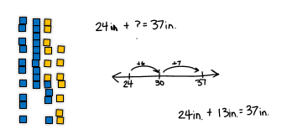
Sample Student Response
“I represented 24 inches with the blue tiles. Then I added yellow tiles until I got to 37 inches. I added 6 tiles to get to 30 and 7 more to get to 37. That means there are 13 spaces between 24 and 37, so the plant grew 13 inches.”
Instructional Tasks
Instructional Task 1 (MTR.7.1)
Kim and Erin measured the length of their left legs from the knee down. Kim’s leg length measured 48 centimeters. Erin’s leg length measured 15 centimeters more than Kim’s. What is the total length of both Erin’s and Kim’s left legs?

Instructional Items
Instructional Item 1
Ester had 83 inches of ribbon. She used 25 inches to wrap a gift for her brother and 37 inches to wrap a gift for her sister. How much ribbon does she have left over.

Instructional Item 2
In a 100-meter swim, Katie already swam 47 meters. How many more meters does she have to swim?

*The strategies, tasks and items included in the B1G-M are examples and should not be considered comprehensive.

MA.2.M.2.1

Benchmark
MA.2.M.2.1 Using analog and digital clocks, tell and write time to the nearest five minutes using a.m. and p.m. appropriately. Express portions of an hour using the fractional terms half an hour, half past, quarter of an hour, quarter after and quarter til.
Benchmark Clarifications:
Clarification 1: Instruction includes the connection to partitioning of circles and to the number line.
Clarification 2: Within this benchmark, the expectation is not to understand military time.

Connecting Benchmarks/Horizontal Alignment
- MA.2.FR.1.1
Terms from the K-12 Glossary

Vertical Alignment
Previous Benchmarks  - MA.1.FR.1.1  - MA.1.M.2.1 | Next Benchmarks  - MA.3.M. 2.1
Purpose and Instructional Strategies
The purpose of this benchmark is to build on the work of grade 1 by telling and writing time to a more precise measurement in increments of 5 minutes. Instruction at this grade level also makes a connection to fractional terms to express portions of an hour.
- Instruction includes the purpose of the minute and hour hand in analog clocks.
- Instruction includes the understanding that a.m. is used to reference the time from 12:00 midnight to one minute before 12:00 noon, and p.m. is used to reference the time from 12:00 noon to one minute before 12:00 midnight.
- Instruction includes the reinforcement of a clock and its connection to a number line.

Common Misconceptions or Errors
- Students may incorrectly identify the minute and the hour hand.
- Students may think that when the hour hand is pointing between two numbers, the hour corresponds to the larger number.
- Students may incorrectly skip count by 5s.
- Students may have difficulty identifying the time when the hour hand is approaching the next hour.

Strategies to Support Tiered Instruction
- Teacher provides a blank clock for students to draw and label the parts and use visual supports to help remember the names of each part.
  - For example, students label the inside of the minute and hour hand as shown to provide a mental picture. It may be helpful to show this illustration with the minute and hour hands in various positions.

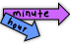

- Instruction includes the teacher removing the minute hand from a clock and guides students to notice if the hour hand is pointing before, on, or after a number encouraging students to use approximations such as, “It’s just past 2 o’clock” when pointing after the 2, or “It’s almost 4 o’clock” when pointing before the 4.
- Instruction includes relating counting minutes on a clock to skip counting sets of 5 by using manipulatives or representations, noting each group of five as a set. Teacher makes connections to the number line and how this relates to the way a clock is like a circular number line.
  - For example, groups of 5 can be made using twelve 1 by 5 grid paper arrays. Teacher arranges the arrays in a horizontal line, having students color every other array, skip counting the rows aloud, and recording the skip counts below each array. Number each set of 5 with a number above the end of each array.
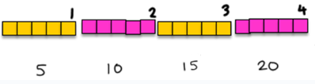

Students arrange these 12 sets of 5 into a circular pattern, labeling each set as the hours and then skip count by 5 as the minutes. Teacher guides students to notice how the units of time are represented on a real clock and on their skip count model; each square is 1 minute, each array is 5 minutes, and all 12 arrays together make 1 hour.
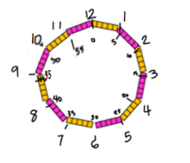

Instructional Tasks
Instructional Task 1 (MTR.5.1)
Provide students with individual clocks and various times. [Teacher note: Examples provided should include opportunities for students to rename given times using fractional terms as necessary.]
Part A. Using the clock provided, show and tell the given time to the nearest five minutes.
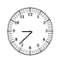
Part B: Using the clock provided, what are all the ways you can say the time shown?


Instructional Items
Instructional Item 1
Which of the following is another way to express the time shown on the clock?
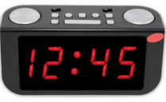

  - Twelve minutes past the hour
  - Half past twelve
  - Quarter past twelve
  - Quarter til one

*The strategies, tasks and items included in the B1G-M are examples and should not be considered comprehensive

MA.2.M.2.2

Benchmark
MA.2.M.2.2 Solve one- and two-step addition and subtraction real-world problems involving either dollar bills within $100 or coins within 100¢ using $ and ¢ symbols appropriately.
Benchmark Clarifications:
Clarification 1: Within this benchmark, the expectation is not to use decimal values.
Clarification 2: Addition and subtraction problems are limited to sums within 100 and related differences. Refer to Situations Involving Operations with Numbers (Appendix A).

Connecting Benchmarks/Horizontal Alignment
- MA.2.NSO.2.3
- MA.2.AR.1.1

Terms from the K-12 Glossary

Vertical Alignment
Previous Benchmarks  - MA.1.M.2.3 | Next Benchmarks  - MA.4.NSO.2.7
Purpose and Instructional Strategies
The purpose of this benchmark is to include the use of dollars and cents to add or subtract in real-world problems (MTR.7.1).
- It is not the expectation of this benchmark to include combining cents with dollars. Students will explore that concept in grade 4 with the introduction of decimals.
- Instruction includes the use of drawings, manipulatives, and number lines to solve addition or subtraction situations.
- Instruction leads students to focus on context and apply reasoning to determine the appropriate operation.
- Instruction includes the idea that making change is the same as finding a difference.
- Instruction uses the format 45¢ not $0.45.

Common Misconceptions or Errors
- Student may confuse coin or coin collection values that occur within the word problems.
- Students may incorrectly decide to add or when to subtract based on the context of the problem.
- Students may regroup numbers incorrectly or unnecessarily when adding or subtracting.

Strategies to Support Tiered Instruction
- Instruction includes providing a way to organize information about coin and dollar values that can later be used to reference for finding the values of coin and dollar collections that occur in real-world problems.
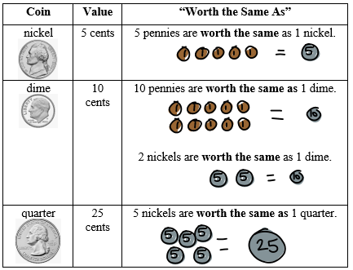
- Instruction includes modeling the problem with money or other manipulatives.
- For example, students can act out what is happening in the word problem with the money manipulatives to make connections between situations that involve adding or subtracting.
- For example, teacher has objects or images that are “for sale” in the classroom. Items must be in whole dollar amounts less than $100 or have coin values less than 100¢. Students take turns being the “store clerk” and the “customer”.
  - The customer chooses items to buy and calculates the total, paying with either a dollar or coin amount. The store clerk calculates the change in either dollars or coins.

- Teacher provides a graphic organizer like the one shown below to record information about the problem that focuses on the quantities in context and the operation(s) needed to solve the problem.

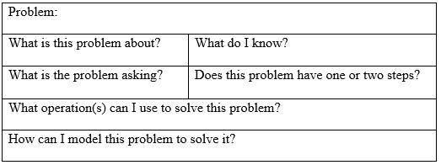
- Teacher encourages students to utilize strategies that make the most sense for the numbers in the problem, such as “think addition or adding up.”

Instructional Tasks
Instructional Task 1 (MTR.7.1)
Marco wants to buy three items from the school shop. The images below provide different items the school shop has in stock and its price.

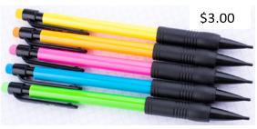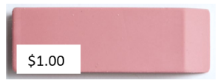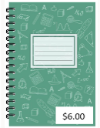

Part A. If Marco has $10 to spend, list all of the combinations of items he can purchase. Discuss your strategy to determine possible combinations.
Part B. Which combination put them under/over budget?

Instructional Items
Instructional Item 1
Whitney has 93¢ in her piggy bank. She empties her piggy bank for a trip to the store. She gives her brother three dimes and her sister one quarter. The rest of the money is hers to spend. How much money does Whitney have left to spend at the store?

Instructional Item 2
Maya and Tanya earned $47 dollars from their bake sale. Each of the girls wants to buy a sweatshirt that costs $15 dollars. Once the sweatshirts are purchased, do the girls have enough money to buy one bag of candy that costs $4? Explain why or why not.

*The strategies, tasks and items included in the B1G-M are examples and should not be considered comprehensive

Geometric Reasoning

MA.2.GR.1 Identify and analyze two-dimensional figures and identify lines of symmetry.

MA.2.GR.1.1

Benchmark
MA.2.GR.1.1 Identify and draw two-dimensional figures based on their defining attributes. Figures are limited to triangles, rectangles, squares, pentagons, hexagons and octagons.
Benchmark Clarifications:
Clarification 1: Within this benchmark, the expectation includes the use of rulers and straight edges.

Connecting Benchmarks/Horizontal Alignment
- MA.2.FR.1.1

Terms from the K-12 Glossary
- Hexagon
- Octagon
- Pentagon
- Polygon
- Regular polygon
- Rectangle
- Square
- Triangle

Vertical Alignment
Previous Benchmarks  - MA.1.GR.1.1  - MA.1.GR.1.2 | Next Benchmarks  - MA.3.GR.1.2
Purpose and Instructional Strategies
The purpose of this benchmark is to build on the work of grade 1 by including the task of drawing specific two-dimensional figures based on a defined attribute. At this grade level, five- and eight-sided figures have been included and a ruler would be used to create straight edges.
- Instruction includes experience with a variety of examples and non-examples that lack a defining attribute.
- Instruction includes defining attributes such as numbers of sides, sides of equal length or number of vertices, whether they are closed or not and whether the edges are curved or straight.

Common Misconceptions or Errors
- Students may misidentify a figure based on a non-defining attribute.
- Students may not recognize figures that have been rotated or that are irregular.
- Students may struggle with content related vocabulary (i.e. sides, faces, vertex/vertices, etc.)

Strategies to Support Tiered Instruction
- Teacher provides students with a collection of two-dimensional shapes, including triangles, rectangles, squares, pentagons, hexagons, and octagons as well as some non-examples, to do the following activities in order:
  - Begin “Collect and Display” by asking the students to sort the shapes into groups any way they like. Then be prepared to capture the language they use in describing the shapes (i.e. students may create a group that includes squares and rectangles because they all have “corners”). Collect the list of the informal language used here and display it on chart paper next to the shapes being used.
  - Ask the students which words were important to know as they did their sort. As students respond, annotate on the chart paper and shapes to help them make the connection. For example, a student might refer to “corners” as something that helped them create their group of four-sided polygons. Write the formal term next to the student language on the chart to help them make the connection to vocabulary. The teacher might write “vertex” next to the word “corner” in the above example.
  - Keep and display the chart for future activities and remind the students to borrow language from the chart as needed.
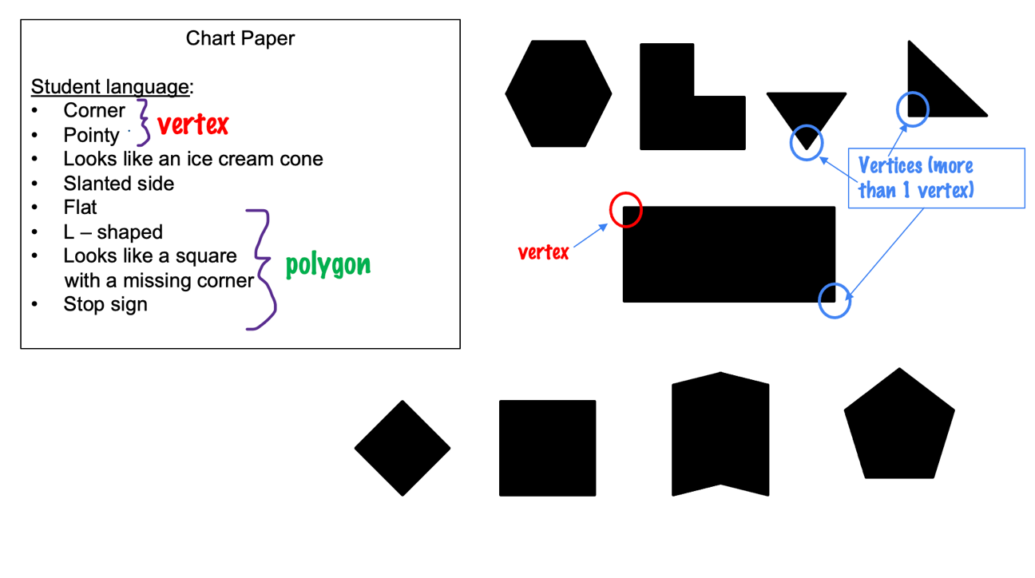
- Teacher provides a geoboard for students to use with the following series of activities to help students develop an understanding of specific defining attributes:
  - The teacher may say, “Make a closed shape with three straight sides and three vertices.” or “Make a closed shaped with 5 straight sides and 5 vertices.” Students use the geoboard to create the shape. Teacher can ask questions like, “How did you know to make this shape?” to draw attention to the defining attributes. It may be helpful to have students compare their shapes with other students so they can see that different answers are possible.
  - Example:
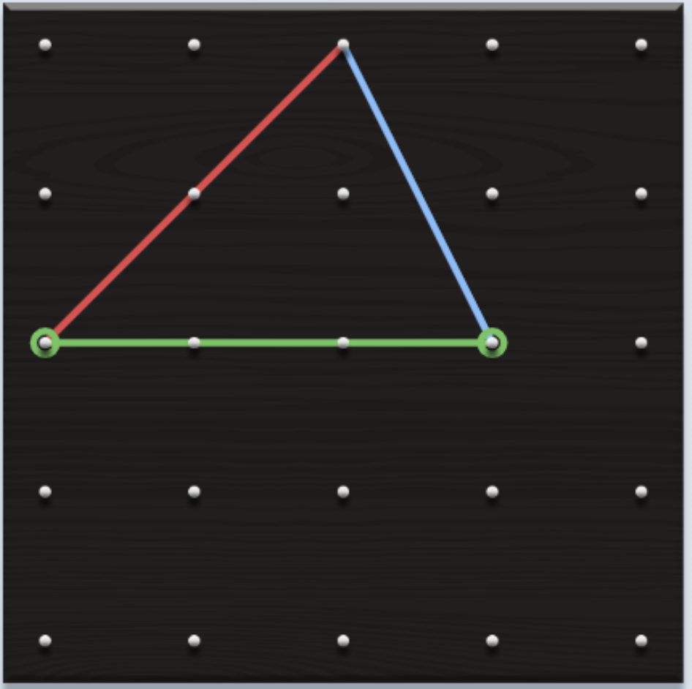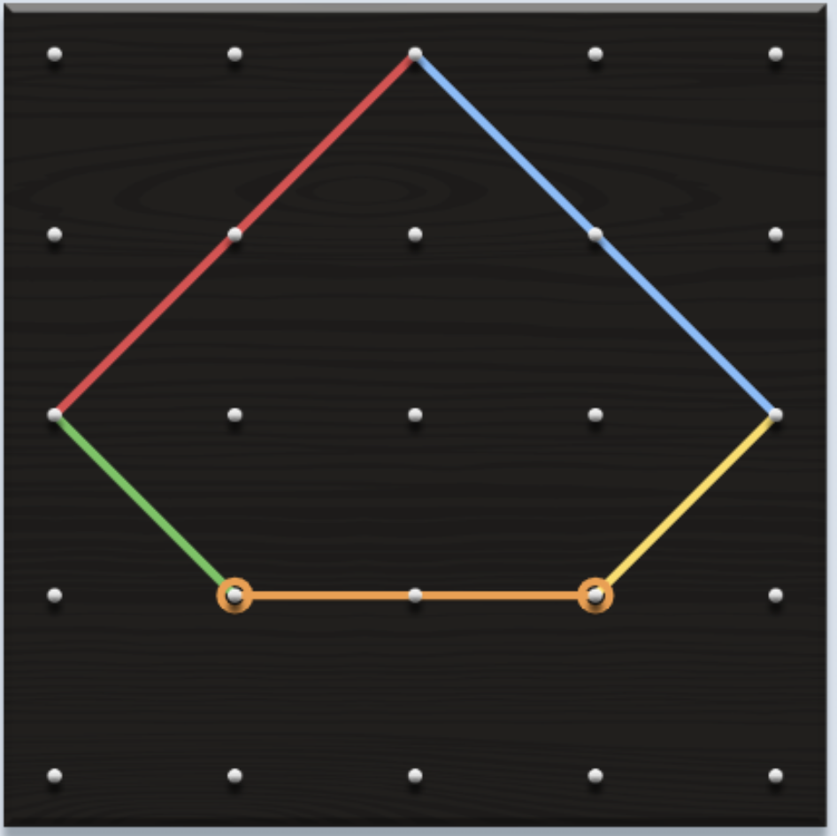
  - The teacher may call out a defining attribute that the students have been struggling with in class (i.e., “make a two-dimensional figure with three vertices”). After creating a correct figure, the teacher has students rotate the geoboard 90 degrees to see that it is still the same figure.
  - Example:
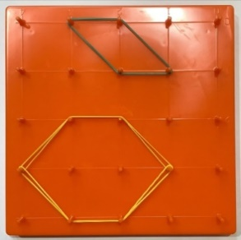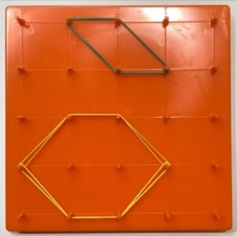
  - If students continue to struggle, the teacher may provide similar instruction from above but limits the amount and types of shapes students build on a geoboard (i.e., only build a square or triangle).

Instructional Tasks
Instructional Task 1 (MTR.4.1)
Provide pairs of students with figure cards, geoboards and rubber bands. Students will play a game of “describe and build” to support identifying figures.
Part A. Partner A uses the figure card to describe a two-dimensional figure. As Partner A describes the figure, Partner B uses the geoboard to construct the figure that is being described. Neither partner should be able to see each other's card or geoboard.
Part B. Once Partner B has constructed the figure based on the defining attributes, the partners finish by comparing the figure on the figure card to the figure that was created. Discussion should include language about specific defining attributes.
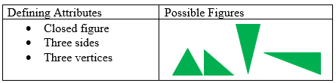
Disclaimer: Enrichment Tasks are not intended for assessment but as a way for students to explore ideas that extend past their benchmark.

Enrichment Task 1
Equally partition a regular hexagon in multiple ways.

Enrichment Task 2
Part A. Equally partition a regular octagon in multiple ways.
Part B. Partition a regular octagon into two, four or eight equal parts.

Instructional Items
Instructional Item 1
Which word best identifies the figure below?



- Triangle
- Pentagon
- Hexagon
- Square

*The strategies, tasks and items included in the B1G-M are examples and should not be considered comprehensive.

MA.2.GR.1.2

Benchmark
MA.2.GR.1.2 Categorize two-dimensional figures based on the number and length of sides, number of vertices, whether they are closed or not and whether the edges are curved or straight.
Benchmark Clarifications:
Clarification 1: Instruction focuses on using formal and informal language to describe defining attributes when categorizing
Connecting Benchmarks/Horizontal Alignment
- MA.2.M.1.1
- MA.2.DP.1.1

Terms from the K-12 Glossary
- Hexagon
- Octagon
- Pentagon
- Polygon
- Rectangle
- Regular polygon
- Square
- Triangle

Vertical Alignment
Previous Benchmarks  - MA.1.GR.1.1 | Next Benchmarks  - MA.3.GR.1.2
Purpose and Instructional Strategies
The purpose of this benchmark is for students to work specifically with two-dimensional figures to categorize them based on their attributes.
- Instruction includes a variety of examples and non-examples which lack defining attributes.
- Instruction includes the understanding that some figures may share the attributes of another figure, possibly creating subcategories. For example, squares form a subcategory of rectangles.
- Instruction is not limited to polygons.

Common Misconceptions or Errors
- Students may not realize figures can be categorized in more than one way.
- Students may have difficulty categorizing figures that are considered irregular.

Strategies to Support Tiered Instruction
- Teacher may refer to “Collect and Display” activity from 2.GR.1.1 and replicate for this benchmark activity.
- Teacher provides students with a collection of two-dimensional shapes, including triangles, rectangles, squares, pentagons, hexagons, and octagons as well as some non-examples, to do the following activities:
  - Teacher, using only regular plane figures, asks students to sort them by size, shape or color. If needed, the teacher can explicitly teach that shapes can be sorted in different ways. Call attention to the words used during each sort to help students make connections between their informal language and the formal content vocabulary (see “Collect and Display” math language routine above).
- Teacher provides a set of plane shapes, including irregular polygons, and asks students to sort them any way they can but that they must use all the figures provided.
  - Teacher asks, “How did you decide to sort them that way?” or “How did you know which shape belongs in this group?”, calling attention to the student language used and its connection to the formal content language.

Instructional Tasks
Instructional Task 1 (MTR.2.1)
Provide students with isometric dot paper. Read aloud and describe a two-dimensional figure by naming the attributes.
Part A. Draw the figures described. Once the figures are drawn, cut and place their figures under the appropriate provided categories in the table below. Some figures may fit in multiple categories, so encourage students to choose different categories to place their figures.
Part B. Discuss why you chose the different categories.
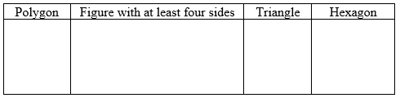

Instructional Items
Instructional Item 1
Tina builds the following figures and categorizes them both as hexagons. Is she correct? Explain why or why not.



*The strategies, tasks and items included in the B1G-M are examples and should not be considered comprehensive.

MA.2.GR.1.3

Benchmark
MA.2.GR.1.3 Identify line(s) of symmetry for a two-dimensional figure.
Example: Fold a rectangular piece of paper and determine whether the fold is a line of symmetry by matching the two halves exactly

Benchmark Clarifications:
Clarification 1: Instruction focuses on the connection between partitioning two-dimensional figures and symmetry.
Clarification 2: Problem types include being given an image and determining whether a given line is a line of symmetry or not.

Connecting Benchmarks/Horizontal Alignment
- MA.2.FR.1.1/1.2
- MA.2.M.2.1

Terms from the K-12 Glossary
- Hexagon
- Line of symmetry
- Pentagon
- Polygon
- Rectangle
- Square
- Triangle

Vertical Alignment
Previous Benchmarks  - MA.1.GR.1.3 | Next Benchmarks  - MA.3.GR.1.3
Purpose and Instructional Strategies
The purpose of this benchmark is to introduce the concept of line symmetry in two-dimensional figures.
- Instruction includes the idea that a line of symmetry decomposes a figure into mirror images.
- Instruction explores line symmetry through familiar figures such as triangles, rectangles, squares, pentagons, hexagons and octagons, but is not limited to polygons.

Common Misconceptions or Errors
- Students may assume a figure has the same number of lines of symmetry as sides or that a figure with more sides has more lines of symmetry.
- Students may assume all diagonals are lines of symmetry.
- Students may think two halves will always create a line of symmetry.
- Students may think all figures have a line of symmetry.

Strategies to Support Tiered Instruction
- Teachers provides instruction on why the lines shown on a rectangle and a parallelogram are not lines of symmetry and gives students shapes made from paper. Students fold the paper along these lines to demonstrate the non-example. Teacher provides additional practice drawing lines of symmetry on two-dimensional figures and asking students to test each line to see if each is a line of symmetry. Students may also record their work in writing on paper or in a journal.
  - Example:
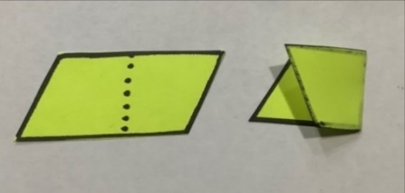

- Teacher provides mirrors and has students use the mirrors to determine if a line drawn is actually a line of symmetry.
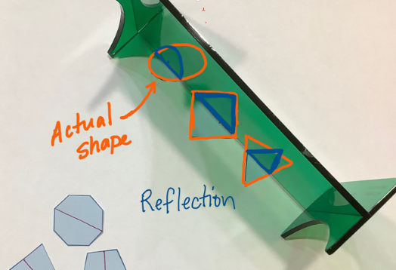

- Teacher provides sheets of paper. Students fold paper shapes into two matching parts to identify lines of symmetry using only shapes that have them. Students may trace the lines of symmetry onto the unfolded paper.
  - For example, teacher may ask, “Which shapes had lines of symmetry, and which did not? How do you know?”
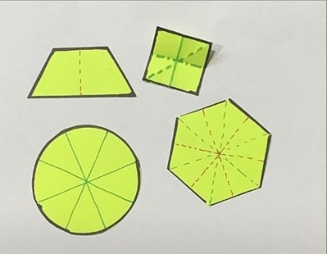
- Teacher provides geoboards to students with six rubber bands. Teachers dictate which shape should be made on the geoboard and models the first line of symmetry. Students work with the rubber bands to find the rest of lines of symmetry. Students draw the examples on a piece of paper.
- Teacher provides sheets of paper. Students fold paper shapes into two matching parts to identify lines of symmetry. Include shapes that do not have lines of symmetry. Students trace the lines of symmetry onto the unfolded paper.
  - For example, teacher asks, “Which shapes had lines of symmetry, and which did not? How do you know?”
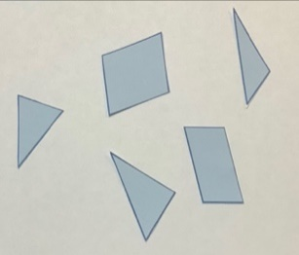
- Teacher provides geoboards to students along with six rubber bands. The teacher makes a shape that has no line of symmetry on the geoboard. Students work with rubber bands to determine the lines of symmetry. Teacher engages in discussion with students about why they cannot find a line of symmetry.
- Teacher provides additional practice through a symmetry sort by preparing cards that each show a two-dimensional figure with a line drawn on the figure. Some show a line of symmetry while others do not. Students sort figures into those that show a line of symmetry and those that do not.
  - For example, the teacher asks students to compare answers with a partner and reconcile any differences by tracing the figure and folding along its line.

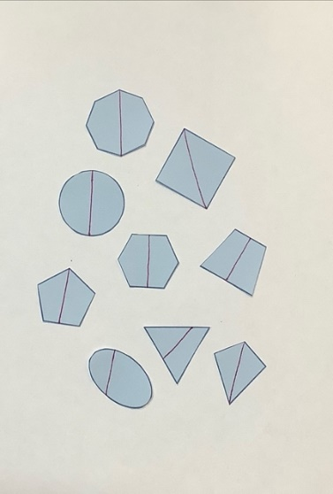
- Teacher provides instruction on the concept of line symmetry. Using one shape, students are shown examples and non-examples of lines of symmetry, emphasizing that they divide a figure into two parts that are mirror images of each other. Teacher also provides students with paper shapes that can be folded along a given line to determine if the line is a line of symmetry.

Instructional Tasks
Instructional Task 1 (MTR.5.1)
Provide students with cutouts of various two-dimensional figures.
Part A. Show how a fold will or will not create a line of symmetry.
Part B. Record your findings to identify patterns you notice about lines of symmetry in certain figures.

Instructional Items
Instructional Item 1
Look at the figures below. Choose yes or no to determine whether the line drawn is a line of symmetry?

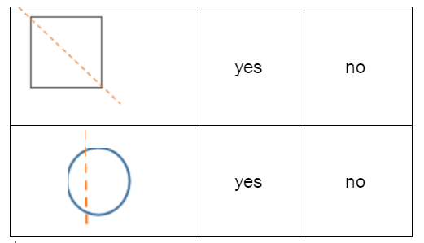

*The strategies, tasks and items included in the B1G-M are examples and should not be considered comprehensive.

MA.2.GR.2 Describe perimeter and find the perimeter of polygons.

MA.2.GR.2..1

Benchmark
MA.2.GR.2.1 Explore perimeter as an attribute of a figure by placing unit segments along the boundary without gaps or overlaps. Find perimeters of rectangles by counting unit segments.

Benchmark Clarifications:
Clarification 1: Instruction emphasizes the conceptual understanding that perimeter is an attribute that can be measured for a two-dimensional figure.
Clarification 2: Instruction includes real-world objects, such as picture frames or desktops.

Connecting Benchmarks/Horizontal Alignment
- MA.2.NSO.2.3
- MA.2.M.1.1

Terms from the K-12 Glossary
- Rectangle

Vertical Alignment
Previous Benchmarks  Perimeter is a new concept in grade 2. | Next Benchmarks  - MA.3.GR.2.3
Purpose and Instructional Strategies
The purpose of this benchmark is to introduce the concept of perimeter as a measurement attribute along the exterior of a two-dimensional figure that can be determined by counting unit segments (MTR.5.1).
- Instruction includes the understanding that the measurement is only valid when units are placed and counted without space or overlay.
- Instruction includes informal language of length and width.

Common Misconceptions or Errors
- Students may miscount or double count the number of unit segments.

Strategies to Support Tiered Instruction
- Instruction includes teacher modeling how to make tic marks on each unit as you count around the edge of a figure.
- Instruction includes the opportunity to use tiles to mark the edge of a figure before touching and counting the units to find the perimeter. Teacher makes a connection to the drawn figure with tic marks.
- Instruction includes showing how to line up a ruler. Students measure an unsharpened pencil with the ruler and then verify by lining up 1-inch tiles.
- Teacher measures an object using tiles but leaving gaps. Then, the teacher measures the same object again but this time ensuring there are no gaps and uses the tiles to illustrate how leaving gaps can change the measurement.

Instructional Tasks
Instructional Task 1 (MTR.2.1, MTR.4.1)
Provide students with centimeter cubes or snap cubes.
Part A. Using centimeter cubes or snap cubes, construct several rectangles (12 inches by 6 inches, 5 inches by 3 inches, and 14 inches by 8 inches).
Part B. Determine the perimeter of each rectangle constructed. What do you notice about the numbers of cubes and the perimeter.

Instructional Items
Instructional Item 1
A student lays down unit cubes to find the perimeter of a rectangle. If the student determines the length is 30-unit cubes long, explain what they may have done incorrectly.

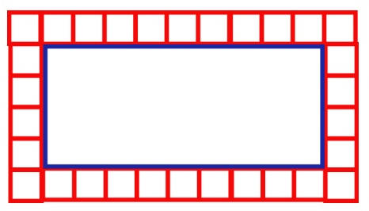

*The strategies, tasks and items included in the B1G-M are examples and should not be considered comprehensive.

MA.2.GR.2.2

Benchmark
MA.2.GR.2.2 Find the perimeter of a polygon with whole-number side lengths. Polygons are limited to triangles, rectangles, squares and pentagons.
Benchmark Clarifications:
Clarification 1: Instruction includes the connection to the associative and commutative properties of addition. Refer to Properties of Operations, Equality and Inequality (Appendix D).
Clarification 2: Within this benchmark, the expectation is not to use a formula to find perimeter.
Clarification 3: Instruction includes cases where the side lengths are given or measured to the nearest unit.
Clarification 4: Perimeter cannot exceed 100 units and responses include the appropriate units.

Connecting Benchmarks/Horizontal Alignment
- MA.2.NSO.2.3
- MA.2.M.1.1
- MA.2.GR.1.2

Terms from the K-12 Glossary
- Associative property of addition
- Commutative property of addition
- Pentagon
- Polygon
- Rectangle
- Square
- Triangle

Vertical Alignment
Previous Benchmarks  Perimeter is a new concept in grade 2. | Next Benchmarks  - MA.3.GR.2.3
Purpose and Instructional Strategies
The purpose of this benchmark is for students to use the attribute of side length to find the perimeter in the context of familiar two-dimensional figures.
- Instruction includes the use of properties of addition to help students think and solve flexibly.
- Instruction includes the use of a number of sides as a defining attribute of triangles, rectangles, squares and pentagons to help them solve problems.
- Instruction includes recognizing that when given a rectangle the opposite side lengths are the same
- Instruction includes using linear tools such as toothpicks, straws, popsicle sticks, etc. to explore perimeter as additive.
  - For example, students can be given dimensions of a figure and asked to build the figure’s boundary using toothpicks or straws. Students can then write an addition expression or equation to represent the perimeter.
- Instruction includes applying the commutative and associative properties to find the perimeter of a figure.

Common Misconceptions or Errors
- Students may add incorrectly when adding up the side lengths of a polygon.
- Students may not add up all the sides (i.e. they may add two sides of a rectangle instead of all four side lengths).
- Students may leave gaps when measuring objects with tiles.
Students may need support in making the connection to the commutative and associative properties when determining the perimeter of a figure.

Strategies to Support Tiered Instruction
- Teacher provides color tiles to transition to measuring with rulers. Teacher provides a line segment and asks the students to measure it using the tiles. The teacher may say, “I heard another student say the length was 5 tiles. We measured 7 tiles long. Why did you think we got a different answer? The teacher discusses why they are different measurements when the line didn’t change. The teacher may choose to have the students also measure the length of the line segment again using a ruler and discuss how it is the same and how it is different from using the tiles.
  - Teacher uses straws cut to a single unit. Given side lengths, students build a figure using the straws, attaching them to create a entire side length. Label the side lengths (i.e. one side is 3 units long). Students may then, unfold the figure by laying the side lengths end-to-end to figure out the total number of units. Rearrange the side lengths to show that the perimeter will remain the same regardless of the order in which units, are added.

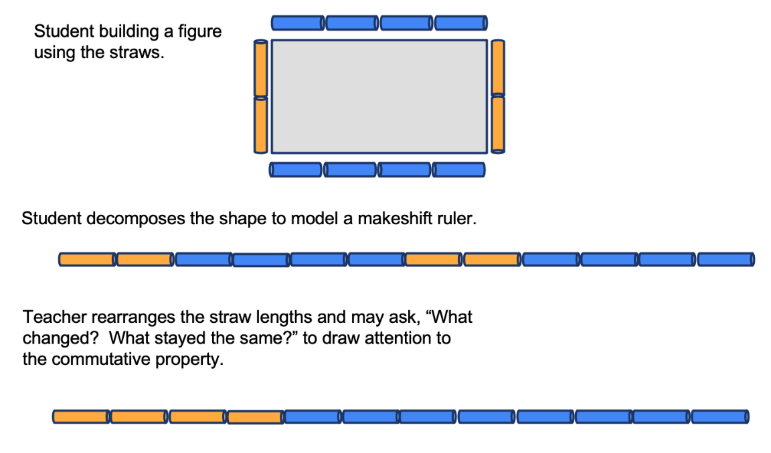
Instructional Task 1 (MTR.3.1)
Provide pre-cut straws of varying lengths.
Part A. Construct polygons according to their defining attributes.
Part B. Measure and determine the perimeter of each figure.

Instructional Tasks
Instructional Task 1 (MTR.4.1)
Provide pairs of students with figure cards, geoboards and rubber bands. Students will play a game of “describe and build” to support identifying figures.
Part A. Partner A uses the figure card to describe a two-dimensional figure. As Partner A describes the figure, Partner B uses the geoboard to construct the figure that is being described. Neither partner should be able to see each other's card or geoboard.
Part B. Once Partner B has constructed the figure based on the defining attributes, the partners finish by comparing the figure on the figure card to the figure that was created. Discussion should include language about specific defining attributes.

Instructional Items
Instructional Item 1
Bill wanted to plant a small garden with the measurements shown below. He wants to buy a fence to go around the perimeter of the garden. How much fence should Bill buy?

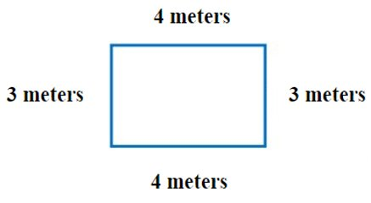
*The strategies, tasks and items included in the B1G-M are examples and should not be considered comprehensive.

Data Analysis and Probability

MA.2.DP.1 Collect, categorize, represent and interpret data using appropriate titles, labels and units.

MA.2.DP.1.1

Benchmark
MA.2.DP.1.1 Collect, categorize and represent data using tally marks, tables, pictographs or bar graphs. Use appropriate titles, labels and units.
Example: A class collects data on the number of students whose birthday is in each month of the year and represents it using tally marks.

Benchmark Clarifications:
Clarification 1: Data displays can be represented both horizontally and vertically. Scales on graphs are limited to ones, fives or tens.

Connecting Benchmarks/Horizontal Alignment
MA.2.GR.1.2
Terms from the K-12 Glossary
- Categorical data
- Bar graph

Vertical Alignment
Previous Benchmarks  - MA.1.DP.1.1 | Next Benchmarks  - MA.3.DP.1.1

Purpose and Instructional Strategies
The purpose of this benchmark is to gather, sort, represent and make comparisons about data using several methods. In grade 1, representation of data was limited to tally marks and pictographs. At this grade level, students will select the most appropriate representation, use appropriate titles, labels and units.
- Instruction includes context for data representations.
- Instruction includes understanding that different types of graphs are useful in representing different contexts.
- Instruction includes the understanding that data can show trends or frequency.

Common Misconceptions or Errors
- Students may formulate questions that involve only mathematical data.
- Students may ignore categories and only list data points.
  - For example, students may be collecting data on favorite color (8 red, 5 blue, 7 green) and may only list 8, 5 and 7.
- Students may put the data totals in the incorrect categories.
- Students may misrepresent the count for each data point.

Strategies to Support Tiered Instruction
- Instruction includes opportunities to create a bar graph to represent the data. The teacher guides students in the creation of the bar graph by posing the following questions:

- Example:
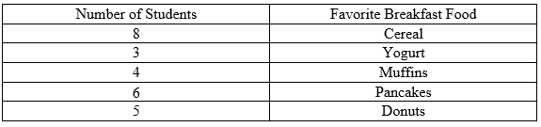
  - Question 1: What should the title of the graph be? (Ensure students write an appropriate title on the title line.)
  - Question 2: What do the numbers on the side represent? (Ensure students understand that the scale represents the number of students that chose each breakfast food.)
  - Question 3: Based on the numbers of students in the table, should we use ones, fives, or tens for the scale on our graph? What labels should I put along the bottom of the graph?
  - Question 4: What numbers should each bar stop at for each breakfast food identified? (Ensure students draw the bars correctly.)
  - Teacher verifies that students answer each question completely and accurately, guiding students in creating bars of an appropriate height, with appropriate labels for each individual breakfast food category.

Instructional Tasks
Instructional Task 1 (MTR.4.1)
Allow students an opportunity to gather data using a tally chart based on several pre-selected categories (i.e., favorite lunch food, favorite sport). Students can then visually represent their data using another method they choose, and discuss the similarities and differences based on the representation chosen. Students can be guided to determine the appropriate label, unit and scale based on the amount of data that needs to be represented.

Instructional Items
Instructional Item 1
A class is collecting data about the type of pets in their house. The data is shown below. Create a bar graph to represent the data.
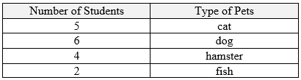

*The strategies, tasks and items included in the B1G-M are examples and should not be considered comprehensive.

MA.2.DP.1.2

Benchmark
MA.2.DP.1.2 Interpret data represented with tally marks, tables, pictographs or bar graphs including solving addition and subtraction problems.

Benchmark Clarifications:
Clarification 1: Addition and subtraction problems are limited to whole numbers with sums within 100 and related differences.
Clarification 2: Data displays can be represented both horizontally and vertically. Scales on graphs are limited to ones, fives or tens.

Connecting Benchmarks/Horizontal Alignment
- MA.2.NSO.2.3
- MA.2.AR.1.1

Terms from the K-12 Glossary
- Categorical data
- Bar graph

Vertical Alignment
Previous Benchmarks  - MA.1.DP.1.2 | Next Benchmarks  - MA.3.DP.1.2
Purpose and Instructional Strategies
The purpose of this benchmark is to extend the work of grade 1 to interpretation of various data representations and solving problems involving addition and subtraction.
- Instruction includes questions that focus on the context of the situation.
- Instruction includes the idea that a picture can represent a single piece of data or a fixed amount.
- Interpretation of data includes both factual and reasoning-based questions.

Common Misconceptions or Errors
- Students may miscount the number of pictures in a pictograph graph or misread the height of a bar in a bar graph.
- Students may think that one picture of an item in a pictograph represents only one item.

Strategies to Support Tiered Instruction
- Teacher provides a pictograph and reads accompanying questions with students, checking for understanding along the way. The teacher focuses on students accurately counting the items in each category, paying special attention to the scale while ensuring that students are utilizing addition and subtraction strategies to accurately respond to each question. Teacher reviews related vocabulary such as fewer, more, in total, and less. Additionally, the teacher aids in accurately counting the items in each category, especially on graphs or tables that require skip counting by 5s or 10s. Ensure students are utilizing addition and subtraction strategies to accurately respond to each question.

Example:
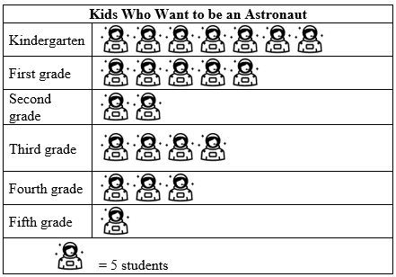

Part A. How many astronauts does one  represent? (Point to the scale if student is unsure.)
Part B. In what grades did fewer than 20 students want to be astronauts?
Part C. In what grades did at least 5 students want to be an astronaut?
Part D. How many students wanted to be an astronaut in First grade and Fourth grade? (Aid student in skip counting 5, 10, 15, 20, 25, 30, 35, 40.)
Part E. How many more students wanted to be an astronaut in kindergarten than in first grade? (Review “more” with students in this context and provide the sentence equation frame $_____ - _____ = _____$ to aid them if needed.)

- Teacher provides a bar graph and accompanying questions, reading each question, and checking for understanding along the way. The teacher focuses on accurately reading the height of each bar in the bar graph, paying special attention to the scale and ensuring students are utilizing addition and subtraction strategies to accurately respond to each question.
  - Example:
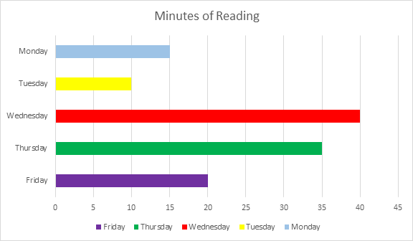
Part A. On which night did Timmy read for 35 minutes?
Part B. How many more minutes did Timmy read on Tuesday and Friday than on Monday?
Part C. On which nights did Timmy read more than 20 minutes?
Part D. On which night did Timmy read fewer than 35 minutes, but more than 15 minutes?
Part E. If Timmy read for 30 minutes on Saturday night, what would the bar look like

Instructional Tasks
Instructional Task 1 (MTR.7.1)
A grade 2 class is collecting books to donate. They graph the number of books collected in a pictograph below.
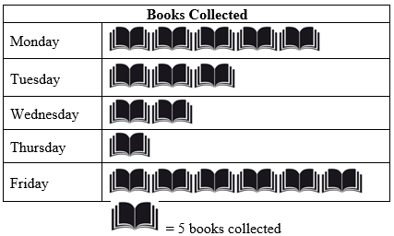

Part A. If the goal was to collect at least 20 books, by how many books did the class exceed their goal?
Part B. On which days did the class collect at least 6 books.

Enrichment Task 1
Adjust the graph from Instructional Task 1 where you can adjust the scale for each book to equal 10. The images could also be adjusted to show half of a book (to show the value of 5). Have students answer the same questions.

Instructional Items
Instructional Item 1
A group of students were surveyed about what sport they prefer to play. According to the data on the table below, how many more children prefer to play soccer and tennis compared to the number of children who prefer to play basketball?

Soccer | Basketball | Tennis | Running
6 | 11 | 8 | 5

*The strategies, tasks and items included in the B1G-M are examples and should not be considered comprehensive.
Appendix A. Summary of Changes

The purpose of this table is to provide a summary of changes from for the latest version of the B1G-M. For questions or feedback on the B1G-M, please direct them to BESTMath@fldoe.org.

Benchmark | B1G-M Component | Change Made
MA.2.NSO.1.1 | Inst. Items | Added item #2 – Select all
MA.2.NSO.1.2 | Horizontal Align | Removed 2.FR.2.1
MA.2.NSO.1.2 | Glossary | Added the term “equal sign”
MA.2.NSO.1.2 | Common Misc. | Added 2nd bullet
MA.2.NSO.1.2 | S2STI | Revamped first bullet and added strategy to end of paragraph
MA.2.NSO.1.3 | Glossary | Deleted Cardinality Principle  Added number line
MA.2.NSO.1.3 | Purpose | Added sentence about work done in grade 1
MA.2.NSO.1.3 | SSTI | Added 2nd bullet example and image
MA.2.NSO.1.3 | Tasks | Added 2nd and 3rd Tasks (adapted from grade 1)
MA.2.NSO.1.4 | Glossary | Deleted Cardinality Principle
MA.2.NSO.1.4 | Purpose | Added grade 1 connection
MA.2.NSO.1.4 | S2STI | Clarified directions for 1st bullet and added a strategy to direction A about coloring to aid in rounding.  Added more to 2nd bullet
MA.2.NSO.1.4 | Inst. Task | Added 2nd task
MA.2.NSO.1.4 | Inst. Item | Added 3rd item
MA.2.NSO.2.1 | Vertical Benchmarks | Added MA.1.NSO.2.2/2.4/2.5 to 1.NSO.2.1
MA.2.NSO.2.1 | Purpose | Added grade 3 connection
MA.2.NSO.2.1 | SSTI | Adapted 3rd bullet and Added 5th bullet /strategy
MA.2.NSO.2.2 | Horizontal Benchmarks | Added MA.2.M.2.2
MA.2.NSO.2.2 | Vertical Alignment | Added MA.3.NSO.1.2/Removed 4.NSO.1.1 and 4.NSO.2.6
MA.2.NSO.2.2 | Purpose | Rewrote what students did in grade 1  Added what students in grade 3 will do
MA.2.NSO.1.4 | Inst. Task | Added 2nd task
MA.2.NSO.1.4 | Inst. Item | Added 3rd item
MA.2.NSO.2.2 | Instructional Task 2 | Added new task and deleted the enrichment tasks
MA.2.NSO.2.3 | Horizontal | Added 2.M.1.2/2.M.1.3 and 2.M.2.2
MA.2.NSO.2.3 | Purpose | Added grade 3 connection
MA.2.NSO.2.3 | Instructional Items | Added:  Instructional Item 2  What is the sum of 52 and 3?  Instructional Item 3  What is the difference between 100 and 87?
MA.2.NSO.2.4 | Glossary | Added terms - Commutative property and number line
MA.2.NSO.2.4 | Vertical | Added 1.AR.1.2
MA.2.NSO.2.4 | Purpose | Added grade 3 connection
MA.2.NSO.2.4 | Instructional Task 2 | Part A Revised to reflect benchmark
MA.2.FR.1.1 | Horizontal | Deleted 2.NSO.1.2
MA.2.FR.1.1 | S2STI | Adapted 1st bullet and images for clarity &  Deleted last bullet
MA.2.FR.1.2 | Instructional Item | Added Item 2
MA.2.AR.1.1 | Glossary | Added the term Number line
MA.2.AR.1.1 | Instructional Task 2 | Added Task 2 using Instructional Item 2
MA.2.AR.1.1 | Instructional Items | Adjusted language on item 1 to create a change unknown word problem  Created a new item 2 to include a muti-step word problem
MA.2.AR.2.1 | Horizontal Align | Deleted 2.AR.1.1 and Added 2.NSO.2.3
MA.2.AR.2.2 | Items | Rewrote Item 1
MA.2.M.1.1 | S2STI | Added 2nd sub-bullet and image to 1st bullet  Added 2nd bullet with an image (adapted from 2.GR.2.2) and moved bullet 2 to bullet 3
MA.2.M.1.2 | Common Misc. | Changed to match grade level benchmark
MA.2.M.1.2 | S2STI | Complete rewrite to address misconceptions and added an image
MA.2.M.1.3 | S2STI | Removed 2nd benchmark that didn’t match benchmark expectations
MA.2.M.2.1 | Purpose | Reworded 2nd bullet for clarity
MA.2.M.2.1 | S2STI | Reworded last sub-bullet and adjusted images for handwriting glitches
MA.2.M.2.2 | Purpose | Changed to match benchmark
MA.2.M.2.2 | Common Misc. | Changed to match grade level benchmark
MA.2.M.2.2 | S2STI | Changed to match grade level benchmark  Adapted 1st bullet and removed sub-bullet  Added 2nd bullet and sub-bullets  Added 3rd bullet
MA.2.GR.1.1 | Glossary | Added term: Regular polygon
MA.2.GR.1.1 | Common Misc. | Added a bullet point
MA.2.GR.1.1 | S2STI | First bullet point – deleted original strategy, added a new one
MA.2.GR.1.1 | S2STI | First bullet point has a new picture
MA.2.GR.1.1 | S2STI | 2nd bullet point – reworked the strategy, developing it further
MA.2.GR.1.1 | Enrichment Task | Modified the tasks to be more open ended
MA.2.GR.1.1 | Glossary | Alphabetized terms and added term: regular polygon
MA.2.GR.1.2 | S2STI | Added a new first bullet and developed the following bullet points more fully
MA.2.GR.1.3 | S2STI | Removed a bullet
MA.2.GR.2.2 | Glossary | Added 2 terms: Commutative property of addition and Associative property of addition
MA.2.GR.2.2 | Common Misc | Deleted two, added two to replace
MA.2.GR.2.2 | SSTI | Deleted 4 of the 6 strategies and then rewrote the remaining 2 strategies to meet the benchmark and address the misconceptions (added 2 new ones)  Also added a picture to help describe the work.
MA.2.DP.1.1 | SSTI | Modified layout and question 3
MA.2.DP.1.1 | Task 1 | Adapted Task 1
MA.2.DP.1.2 | SSTI | Changed to skip counting 5s or 10s
MA.2.DP.1.2 | Task 1 | Added an Enrichment task to address half of a picture in pictograph

