Grade 1 B.E.S.T. Instructional Guide for Mathematics

The B.E.S.T. Instructional Guide for Mathematics (B1G-M) is intended to assist educators with planning for student learning and instruction aligned to Florida’s Benchmarks for Excellent Student Thinking (B.E.S.T.) Standards. This guide is designed to aid high-quality instruction through the identification of components that support the learning and teaching of the B.E.S.T. Mathematics Standards and Benchmarks. The B1G-M includes an analysis of information related to the B.E.S.T. Standards for Mathematics within this specific mathematics course, the instructional emphasis and aligned resources. This document is posted on the B.E.S.T. Standards for Mathematics webpage of the Florida Department of Education’s website and will continue to undergo edits as needed.

Structural Framework and Intentional Design of the B.E.S.T. Standards for Mathematics

Florida’s B.E.S.T. Standards for Mathematics were built on the following.

- The coding scheme for the standards and benchmarks was changed to be consistent with other content areas. The new coding scheme is structured as follows:
Content.GradeLevel.Strand.Standard.Benchmark.
- Strands were streamlined to be more consistent throughout.
- The standards and benchmarks were written to be clear and concise to ensure that they are easily understood by all stakeholders.
- The benchmarks were written to allow teachers to meet students’ individual skills, knowledge and ability.
- The benchmarks were written to allow students the flexibility to solve problems using a method or strategy that is accurate, generalizable and efficient depending on the content (i.e., the numbers, expressions or equations).
- The benchmarks were written to allow for student discovery (i.e., exploring) of strategies rather than the teaching, naming and assessing of each strategy individually.
- The benchmarks were written to support multiple pathways for success in career and college for students.
- The benchmarks should not be taught in isolation but should be combined purposefully.
- The benchmarks may be addressed at multiple points throughout the year, with the intention of gaining mastery by the end of the year.
- Appropriate progression of content within and across strands was developed for each grade level and across grade levels.
- There is an intentional balance of conceptual understanding and procedural fluency with the application of accurate real-world context intertwined within mathematical concepts for relevance.
- The use of other content areas, like science and the arts, within real-world problems should be accurate, relevant, authentic and reflect grade-level appropriateness.

Components of the B.E.S.T. Instructional Guide for Mathematics

The following table is an example of the layout for each benchmark and includes the defining attributes for each component. It is important to note that instruction should not be limited to the possible connecting benchmarks, related terms, strategies or examples provided. To do so would strip the intention of an educator meeting students’ individual skills, knowledge and abilities.

Benchmark
focal point for instruction within lesson or task
This section includes the benchmark as identified in the B.E.S.T. Standards for Mathematics. The benchmark, also referred to as the Benchmark of Focus, is the focal point for student learning and instruction. The benchmark, and its related example(s) and clarification(s), can also be found in the course description. The 9-12 benchmarks may be included in multiple courses; select the example(s) or clarification(s) as appropriate for the identified course.

Connecting Benchmarks/Horizontal Alignment
in other standards within the grade level or course
This section includes a list of connecting benchmarks that relate horizontally to the Benchmark of Focus. Horizontal alignment is the intentional progression of content within a grade level or course linking skills within and across strands. Connecting benchmarks are benchmarks that either make a mathematical connection or include prerequisite skills. The information included in this section is not a comprehensive list, and educators are encouraged to find other connecting benchmarks. Additionally, this list will not include benchmarks from the same standard since benchmarks within the same standard already have an inherent connection.

Terms from the K-12 Glossary
This section includes terms from Appendix C: K-12 Glossary, found within the B.E.S.T. Standards for Mathematics document, which are relevant to the identified Benchmark of Focus. The terms included in this section should not be viewed as a comprehensive vocabulary list, but instead should be considered during instruction or act as a reference for educators.

Vertical Alignment
across grade levels or courses
This section includes a list of related benchmarks that connect vertically to the Benchmark of Focus. Vertical alignment is the intentional progression of content from one year to the next, spanning across multiple grade levels. Benchmarks listed in this section make mathematical connections from prior grade levels or courses in future grade levels or courses within and across strands. If the Benchmark of Focus is a new concept or skill, it may not have any previous benchmarks listed. Likewise, if the Benchmark of Focus is a mathematical skill or concept that is finalized in learning and does not have any direct connection to future grade levels or courses, it may not have any future benchmarks listed. The information included in this section is not a comprehensive list, and educators are encouraged to find other benchmarks within a vertical progression.

Purpose and Instructional Strategies
This section includes further narrative for instruction of the benchmark and vertical alignment. Additionally, this section may also include the following:
- explanations and details for the benchmark;
- vocabulary not provided within Appendix C;
- possible instructional strategies and teaching methods; and
- strategies to embed potentially related Mathematical Thinking and Reasoning Standards (MTRs).

Common Misconceptions or Errors
This section will include common student misconceptions or errors and may include strategies to address the identified misconception or error. Recognition of these misconceptions and errors enables educators to identify them in the classroom and make efforts to correct the misconception or error. This corrective effort in the classroom can also be a form of formative assessment within instruction.

Strategies to Support Tiered Instruction
The instructional strategies in this section address the common misconceptions and errors listed within the above section that can be a barrier to successfully learning the benchmark. All instruction and intervention at Tiers 2 and 3 are intended to support students to be successful with Tier 1 instruction. Strategies that support tiered instruction are intended to assist teachers in planning across any tier of support and should not be considered exclusive or inclusive of other instructional strategies that may support student learning with the B.E.S.T. Mathematics Standards. For more information about tiered instruction, please see the Effective Tiered Instruction for Mathematics: ALL Means ALL document.

Instructional Tasks
demonstrate the depth of the benchmark and the connection to the related benchmarks
This section will include example instructional tasks, which may be open-ended and are intended to demonstrate the depth of the benchmark. Some instructional tasks include integration of the Mathematical Thinking and Reasoning Standards (MTRs) and related benchmark(s). Enrichment tasks may be included to make connections to benchmarks in later grade levels or courses. Tasks may require extended time, additional materials and collaboration.

Instructional Items
demonstrate the focus of the benchmark
This section will include example instructional items which may be used as evidence to demonstrate the students’ understanding of the benchmark. Items may highlight one or more parts of the benchmark.
*The strategies, tasks and items included in the B1G-M are examples and should not be considered comprehensive.

Mathematical Thinking and Reasoning Standards
MTRs: Because Math Matters

Florida students are expected to engage with mathematics through the Mathematical Thinking and Reasoning Standards (MTRs) by utilizing their language as a self-monitoring tool in the classroom, promoting deeper learning and understanding of mathematics. The MTRs are standards which should be used as a lens when planning for student learning and instruction of the B.E.S.T. Standards for Mathematics.

Structural Framework and Intentional Design of the Mathematical Thinking and Reasoning Standards

The Mathematical Thinking and Reasoning Standards (MTRs) are built on the following.

- The MTRs have the same coding scheme as the standards and benchmarks; however, they are written at the standard level because there are no benchmarks.
- In order to fulfill Florida’s unique coding scheme, the 5th place (benchmark) will always be a “1” for the MTRs.
- The B.E.S.T. Standards for Mathematics should be taught through the lens of the MTRs.
- At least one of the MTRs should be authentically and appropriately embedded throughout every lesson based on the expectation of the benchmark(s).
- The bulleted language of the MTRs were written for students to use as self-monitoring tools during daily instruction.
- The clarifications of the MTRs were written for teachers to use as a guide to inform their instructional practices.
- The MTRs ensure that students stay engaged, persevere in tasks, share their thinking, balance conceptual understanding and procedures, assess their solutions, make connections to previous learning and extended knowledge, and apply mathematical concepts to real-world applications.
- The MTRs should not stand alone as a separate focus for instruction but should be combined purposefully.
- The MTRs will be addressed at multiple points throughout the year, with the intention of gaining mastery of mathematical skills by the end of the year and building upon these skills as they continue in their K-12 education.

MA.K12.MTR.1.1 Actively participate in effortful learning both individually and collectively.
Mathematicians who participate in effortful learning both individually and with others:
- Analyze the problem in a way that makes sense given the task.
- Ask questions that will help with solving the task.
- Build perseverance by modifying methods as needed while solving a challenging task.
- Stay engaged and maintain a positive mindset when working to solve tasks.
- Help and support each other when attempting a new method or approach.

Clarifications:
Teachers who encourage students to participate actively in effortful learning both individually and with others:
- Cultivate a community of growth mindset learners.
- Foster perseverance in students by choosing tasks that are challenging.
- Develop students’ ability to analyze and problem solve.
- Recognize students’ effort when solving challenging problems.

MA.K12.MTR.2.1 Demonstrate understanding by representing problems in multiple ways.
Mathematicians who demonstrate understanding by representing problems in multiple ways:
- Build understanding through modeling and using manipulatives.
- Represent solutions to problems in multiple ways using objects, drawings, tables, graphs and equations.
- Progress from modeling problems with objects and drawings to using algorithms and equations.
- Express connections between concepts and representations.
- Choose a representation based on the given context or purpose.

Clarifications:
Teachers who encourage students to demonstrate understanding by representing problems in multiple ways:
- Help students make connections between concepts and representations.
- Provide opportunities for students to use manipulatives when investigating concepts.
- Guide students from concrete to pictorial to abstract representations as understanding progresses.
- Show students that various representations can have different purposes and can be useful in different situations.

MA.K12.MTR. 3.1 Complete tasks with mathematical fluency.
Mathematicians who complete tasks with mathematical fluency:
- Select efficient and appropriate methods for solving problems within the given context.
- Maintain flexibility and accuracy while performing procedures and mental calculations.
- Complete tasks accurately and with confidence.
- Adapt procedures to apply them to a new context.
- Use feedback to improve efficiency when performing calculations.

Clarifications:
Teachers who encourage students to complete tasks with mathematical fluency:
- Provide students with the flexibility to solve problems by selecting a procedure that allows them to solve efficiently and accurately.
- Offer multiple opportunities for students to practice efficient and generalizable methods.
- Provide opportunities for students to reflect on the method they used and determine if a more efficient method could have been used.

MA.K12.MTR.4.1 Engage in discussions that reflect on the mathematical thinking of self and others.
Mathematicians who engage in discussions that reflect on the mathematical thinking of self and others:
- Communicate mathematical ideas, vocabulary and methods effectively.
- Analyze the mathematical thinking of others.
- Compare the efficiency of a method to those expressed by others.
- Recognize errors and suggest how to correctly solve the task.
- Justify results by explaining methods and processes.
- Construct possible arguments based on evidence.

Clarifications:
Teachers who encourage students to engage in discussions that reflect on the mathematical thinking of self and others:
- Establish a culture in which students ask questions of the teacher and their peers, and error is an opportunity for learning.
- Create opportunities for students to discuss their thinking with peers.
- Select, sequence and present student work to advance and deepen understanding of correct and increasingly efficient methods.
- Develop students’ ability to justify methods and compare their responses to the responses of their peers.

MA.K12.MTR.5.1 Use patterns and structure to help understand and connect mathematical concepts.
Mathematicians who use patterns and structure to help understand and connect mathematical concepts:
- Focus on relevant details within a problem.
- Create plans and procedures to logically order events, steps or ideas to solve problems.
- Decompose a complex problem into manageable parts.
- Relate previously learned concepts to new concepts.
- Look for similarities among problems.
- Connect solutions of problems to more complicated large-scale situations.

Clarifications:
Teachers who encourage students to use patterns and structure to help understand and connect mathematical concepts:
- Help students recognize the patterns in the world around them and connect these patterns to mathematical concepts.
- Support students to develop generalizations based on the similarities found among problems.
- Provide opportunities for students to create plans and procedures to solve problems.
- Develop students’ ability to construct relationships between their current understanding and more sophisticated ways of thinking.

MA.K12.MTR.6.1 Assess the reasonableness of solutions.
Mathematicians who assess the reasonableness of solutions:
- Estimate to discover possible solutions.
- Use benchmark quantities to determine if a solution makes sense.
- Check calculations when solving problems.
- Verify possible solutions by explaining the methods used.
- Evaluate results based on the given context.

Clarifications:
Teachers who encourage students to assess the reasonableness of solutions:
- Have students estimate or predict solutions prior to solving.
- Prompt students to continually ask, “Does this solution make sense? How do you know?”
- Reinforce that students check their work as they progress within and after a task.
- Strengthen students’ ability to verify solutions through justifications.

MA.K12.MTR.7.1 Apply mathematics to real-world contexts.
Mathematicians who apply mathematics to real-world contexts:
- Connect mathematical concepts to everyday experiences.
- Use models and methods to understand, represent and solve problems.
- Perform investigations to gather data or determine if a method is appropriate.
- Redesign models and methods to improve accuracy or efficiency.

Clarifications:
Teachers who encourage students to apply mathematics to real-world contexts:
- Provide opportunities for students to create models, both concrete and abstract, and perform investigations.
- Challenge students to question the accuracy of their models and methods.
- Support students as they validate conclusions by comparing them to the given situation.
- Indicate how various concepts can be applied to other disciplines.

Examples of Teacher and Student Moves for the MTRs

Below are examples that demonstrate the embedding of the MTRs within the mathematics classroom. The provided teacher and student moves are examples of how some MTRs could be incorporated into student learning and instruction. The information included in this table is not a comprehensive list, and educators are encouraged to incorporate other teacher and student moves that support the MTRs.

MTR | Student Moves | Teacher Moves
MA.K12.MTR.1.1  Actively participate in effortful learning both individually and collectively. | - Students engage in the task through individual analysis, student-to-teacher interaction and student-to-student interaction.  - Students ask task-appropriate questions to self, the teacher and to other students. (MTR.4.1)  - Students have a positive productive struggle exhibiting growth mindset, even when making a mistake.  - Students stay engaged in the task to a purposeful conclusion while modifying methods, when necessary, in solving a problem through self-analysis and perseverance. | - Teacher provides flexible options (i.e., differentiated, challenging tasks that allow students to actively pursue a solution both individually and in groups) so that all students have the opportunity to access and engage with instruction, as well as demonstrate their learning.  - Teacher creates a physical environment that supports a growth mindset and will ensure positive student engagement and collaboration.  - Teacher provides constructive, encouraging feedback to students that recognizes their efforts and the value of analysis and revision.  - Teacher provides appropriate time for student processing, productive struggle and reflection.  - Teacher uses data and questions to focus students on their thinking; help students determine their sources of struggle and to build understanding.  - Teacher encourages students to ask appropriate questions of other students and of the teacher including questions that examine accuracy. (MTR.4.1)
MA.K12.MTR.2.1  Demonstrate understanding by representing problems in multiple ways. | - Students represent problems concretely using objects, models and manipulatives.  - Students represent problems pictorially using drawings, models, tables and graphs.  - Students represent problems abstractly using numerical or algebraic expressions and equations.  - Students make connections and select among different representations and methods for the same problem, as appropriate to different situations or context. (MTR.3.1) | - Teacher provides students with objects, models, manipulatives, appropriate technology and real-world situations. (MTR.7.1)  - Teacher encourages students to use drawings, models, tables, expressions, equations and graphs to represent problems and solutions.  - Teacher questions students about making connections between different representations and methods and challenges students to choose one that is most appropriate to the context. (MTR.3.1)  - Teacher encourages students to explain their different representations and methods to each other. (MTR.4.1)  - Teacher provides opportunities for students to choose appropriate methods and to use mathematical technology.
MA.K12.MTR.3.1  Complete tasks with mathematical fluency. | - Students complete tasks with flexibility, efficiency and accuracy.  - Students use feedback from peers and teachers to reflect on and revise methods used.  - Students build confidence through practice in a variety of contexts and problems. (MTR.1.1) | - Teacher provides tasks and opportunities to explore and share different methods to solve problems. (MTR.1.1)  - Teacher provides opportunities for students to choose methods and reflect (i.e., through error analysis, revision, summarizing methods or writing) on the efficiency and accuracy of the method(s) chosen.  - Teacher asks questions and gives feedback to focus student thinking to build efficiency of accurate methods.  - Teacher offers multiple opportunities to practice generalizable methods.
MA.K12.MTR.4.1  Engage in discussions that reflect on the mathematical thinking of self and others. | - Students use content specific language to communicate and justify mathematical ideas and chosen methods.  - Students use discussions and reflections to recognize errors and revise their thinking.  - Students use discussions to analyze the mathematical thinking of others.  - Students identify errors within their own work and then determine possible reasons and potential corrections.  - When working in small groups, students recognize errors of their peers and offers suggestions. | - Teacher provides students with opportunities (through open-ended tasks, questions and class structure) to make sense of their thinking. (MTR.1.1)  - Teacher uses precise mathematical language, both written and abstract, and encourages students to revise their language through discussion.  - Teacher creates opportunities for students to discuss and reflect on their choice of methods, their errors and revisions and their justifications.  - Teachers select, sequence and present student work to elicit discussion about different methods and representations. (MTR.2.1, MTR.3.1)
MA.K12.MTR.5.1 Use patterns and structure to help understand and connect mathematical concepts. | - Students identify relevant details in a problem in order to create plans and decompose problems into manageable parts.  - Students find similarities and common structures, or patterns, between problems in order to solve related and more complex problems using prior knowledge. | - Teacher asks questions to help students construct relationships between familiar and unfamiliar problems and to transfer this relationship to solve other problems. (MTR.1.1)  - Teacher provides students opportunities to connect prior and current understanding to new concepts.  - Teacher provides opportunities for students to discuss and develop generalizations about a mathematical concept. (MTR.3.1, MTR.4.1)  - Teacher allows students to develop an appropriate sequence of steps in solving problems.  - Teacher provides opportunities for students to reflect during problem solving to make connections to problems in other contexts, noticing structure and making improvements to their process.
MA.K12.MTR.6.1 Assess the reasonableness of solutions. | - Students estimate a solution, including using benchmark quantities in place of the original numbers in a problem.  - Students monitor calculations, procedures and intermediate results during the process of solving problems.  - Students verify and check if solutions are viable, or reasonable, within the context or situation. (MTR.7.1)  - Students reflect on the accuracy of their estimations and their solutions. | - Teacher provides opportunities for students to estimate or predict solutions prior to solving.  - Teacher encourages students to compare results to estimations and revise if necessary for future situations. (MTR.5.1)  - Teacher prompts students to self-monitor by continually asking, “Does this solution or intermediate result make sense? How do you know?”  - Teacher encourages students to provide explanations and justifications for results to self and others. (MTR.4.1)
MA.K12.MTR.7.1 Apply mathematics to real-world contexts. | - Students connect mathematical concepts to everyday experiences.  - Students use mathematical models and methods to understand, represent and solve real-world problems.  - Students investigate, research and gather data to determine if a mathematical model is appropriate for a given situation from the world around them.  - Students re-design models and methods to improve accuracy or efficiency. | - Teacher provides real-world context to help students build understanding of abstract mathematical ideas.  - Teacher encourages students to assess the validity and accuracy of mathematical models and situations in real-world context, and to revise those models if necessary.  - Teacher provides opportunities for students to investigate, research and gather data to determine if a mathematical model is appropriate for a given situation from the world around them.  - Teacher provides opportunities for students to apply concepts to other content areas.

Grade 1 Areas of Emphasis

In grade 1, instructional time will emphasize four areas:

(1) understanding the place value of tens and ones within two-digit whole numbers;
(2) extending understanding of addition and subtraction and the relationship between them;
(3) developing an understanding of measurement of physical objects, money and time and
(4) categorizing, composing and decomposing geometric figures.

The purpose of the areas of emphasis is not to guide specific units of learning and instruction, but rather provide insight on major mathematical topics that will be covered within this mathematics course. In addition to its purpose, the areas of emphasis are built on the following.

- Supports the intentional horizontal progression within the strands and across the strands in this grade level or course.
- Student learning and instruction should not focus on the stated areas of emphasis as individual units.
- Areas of emphasis are addressed within standards and benchmarks throughout the course so that students are making connections throughout the school year.
- Some benchmarks can be organized within more than one area.
- Supports the communication of the major mathematical topics to all stakeholders.
- Benchmarks within the areas of emphasis should not be taught within the order in which they appear. To do so would strip the progression of mathematical ideas and miss the opportunity to enhance horizontal progressions within the grade level or course.

The table below shows how the benchmarks within this mathematics course are embedded within the areas of emphasis.

Number Sense and Operations | Understanding place value within two-digit whole numbers | Addition and subtraction and the relationship between them | Measurement of physical objects, money and time | Categorizing, composing and decomposing geometric figures
MA.1.NSO.1.1 | X | X | X
MA.1.NSO.1.2 | X | X
MA.1.NSO.1.3 | X | X | X
MA.1.NSO.1.4 | X |  | X
MA.1.NSO.2.1 |  | X
MA.1.NSO.2.2 | X | X
MA.1.NSO.2.3 | X | X | X
MA.1.NSO.2.4 | X | X | X
MA.1.NSO.2.5 | X | X

Fractions | Understanding place value within two-digit whole numbers | Addition and subtraction and the relationship between them | Measurement of physical objects, money and time | Categorizing, composing and decomposing geometric figures
MA.1.FR.1.1 |  |  | X | X

Algebraic Reasoning | Understanding place value within two-digit whole numbers | Addition and subtraction and the relationship between them | Measurement of physical objects, money and time | Categorizing, composing and decomposing geometric figures
MA.1.AR.1.1 |  | X | X
MA.1.AR.1.2 |  | X
MA.1.AR.2.1 |  | X
MA.1.AR.2.2 |  | X
MA.1.AR.2.3 |  | X

Measurement | Understanding place value within two-digit whole numbers | Addition and subtraction and the relationship between them | Measurement of physical objects, money and time | Categorizing, composing and decomposing geometric figures
MA.1.M.1.1 |  |  | X
MA.1.M.1.2 |  |  | X
MA.1.M.2.1 |  |  | X | X
MA.1.M.2.2 |  |  | X
MA.1.M.2.3 |  | X | X

Geometric Reasoning | Understanding place value within two-digit whole numbers | Addition and subtraction and the relationship between them | Measurement of physical objects, money and time | Categorizing, composing and decomposing geometric figures
MA.1.GR.1.1 |  |  | X
MA.1.GR.1.2 |  |  | X
MA.1.GR.1.3 |  |  | X | X
MA.1.GR.1.4 |  |  | X

Data analysis and Probability | Understanding place value within two-digit whole numbers | Addition and subtraction and the relationship between them | Measurement of physical objects, money and time | Categorizing, composing and decomposing geometric figures
MA.1.DP.1.1 |  | X |  | X
MA.1.DP.1.2 |  | X |  | X

Number Sense and Operations

MA.1.NSO.1 Extend counting sequences and understand the place value of two-digit numbers.

MA.1.NSO.1.1

Benchmark
MA.1.NSO.1.1 Starting at a given number, count forward and backwards within 120 by ones. Skip count by 2s to 20 and by 5s to 100.
Benchmark Clarifications:
Clarification 1: Instruction focuses on the connection to addition as “counting on” and subtraction as “counting back.”
Clarification 2: Instruction also focuses on the recognition of patterns within skip counting which helps build a foundation for multiplication in later grades.
Clarification 3: Instruction includes recognizing counting sequences using visual charts, such as a 120 chart, to emphasize base 10 place value.

Connecting Benchmarks/Horizontal Alignment
- MA.1.NSO.2.1/2.2/2.3/2.4/2.5
- MA.1.M.2.3
- MA.1.DP.1.1/1.2

Terms from the K-12 Glossary
Whole Number

Vertical Alignment
Previous Benchmarks  - MA.K.NSO.2.1 | Next Benchmarks  - MA.2.AR.3.2  - MA.2.NSO.2.2
Purpose and Instructional Strategies
The purpose of this benchmark is for students to interact with patterns found in counting. In Kindergarten, students recited number names to 100, counted forwards within 100 and backwards within 20. In Kindergarten, students also built the understanding that successive numbers refer to quantities one larger and built the foundation for addition and subtraction (MTR.5.1).
- Instruction builds the foundation for strategies of addition and subtraction through counting forwards and backwards (MTR.5.1).
- Instruction includes skip counting within this benchmark which builds to repeated addition, the basis for multiplication (MTR 3.1).

Common Misconceptions or Errors
- Students may omit numbers when counting in a sequence.
Students may not understand how to use visual charts to answer questions.

Strategies to Support Tiered Instruction
- Instruction includes the use of a bottoms-up hundreds or 120 chart. Using the chart, the teacher asks students to find a number to start at, like 8. Once they point out or identify the number, students count forward by one until they reach a stopping number, like 25. Students should locate and identify each number on the chart as they count.
  - For example, the teacher asks the student what happens when they come to the number 10? 20? What do they notice? Repeat this activity starting at a given number, like 57 and have them count backward by one until they reach a target number, like 35.

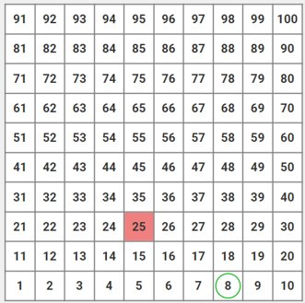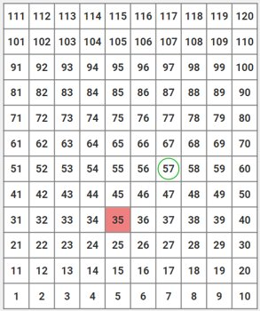

- Instruction includes the use of a bottoms-up hundreds chart. Students identify specified numbers on the chart and understand that values increase as they move to the right and up on the chart, as well as decreasing or counting backward would require tracking left and down. Students may need additional instruction once they reach the end of a row, they start back on the left as they count up or back on the right as they count down. Teacher may utilize color cues along the sides to help student tracking.

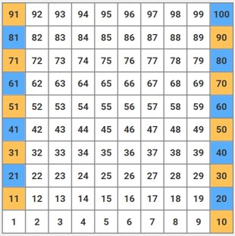

- Instruction includes the use of ten-frames to aid in skip counting by 2s. Students place a counter or draw a circle around numbers stated as they skip count by 2s. Teachers asks: “How do you know which numbers to mark?”, “Is there a pattern you notice?”

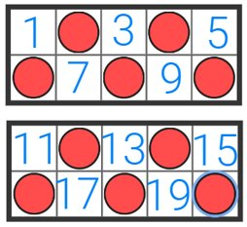

- Instruction includes the use of a bottoms up hundreds chart and nickels or counters to aid in skip counting by 5s. Using the chart, teacher asks students to cover the numbers said when counting aloud by 5s.
  - For example, teacher asks the student to start at a given multiple of five, like 20. The teacher asks the student to add five more and place a counter or nickel on the sum. Students should keep repeating this strategy to reinforce skip counting is repeated addition. “What pattern do you notice?”, “We use nickels because each one is worth five so we can skip count on them when counting by 5s.”

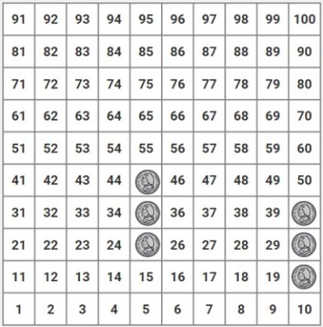

Instructional Tasks
Instructional Task 1 (MTR.1.1, MTR. 3.1, MTR.5.1, MTR.6.1)
Part A. In a small group, present students with the portion of the 120 chart below. Use the questions to facilitate discussion. Allow students time to independently think then share with the group. Encourage students to justify their thinking.
- What pattern do you notice?
- Should any other numbers be shaded on her chart?
- What other numbers do you think she could shade on a 120 chart?
- If Emma continues the pattern, would 75 be shaded or not shaded?

Part B. Provide students with a blank hundred-twenty chart and a highlighter and ask them to complete Emma’s pattern, as shown below, by highlighting the numbers Emma should include to 100.

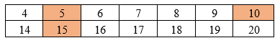

Instructional Task 2 (MTR.7.1)
Jeremiah and Michael are going to the store with these coins in their pocket. What is the total value of the coins?
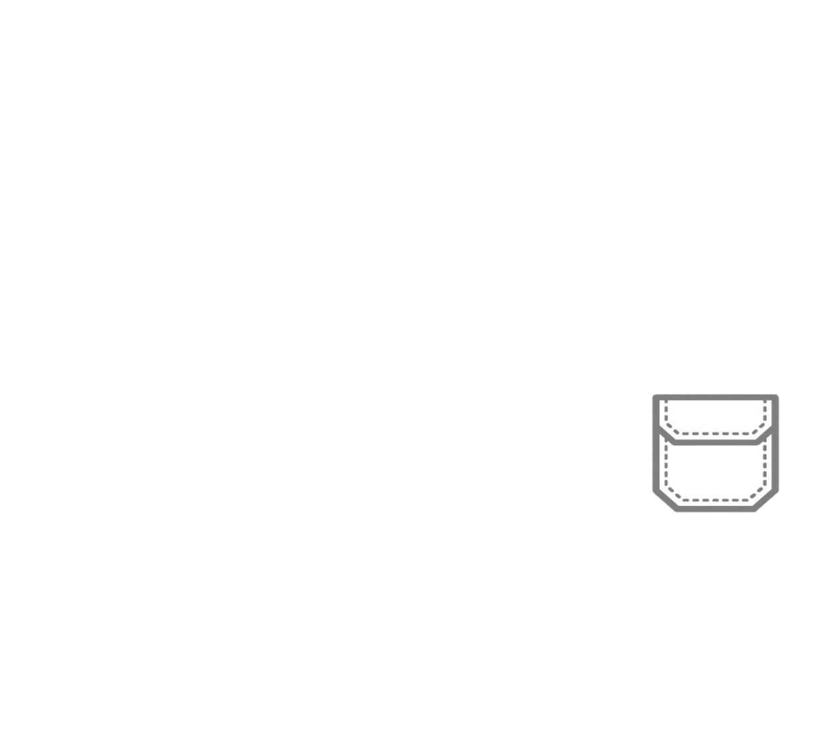

Instructional Items
Instructional Item 1
Count on from 95 until you reach 112.

Instructional Item 2
Count backward from 54 until you get to 32.

Instructional Item 3
What numbers come next when you count by 2s?
$$2, 4, 6, __, __,$$

Instructional Item 4
Ben is counting by 5s but he can’t remember which numbers go in the missing blanks. What are the numbers he needs to complete his task? 60,65,70,__,___,___,90,95,100.

*The strategies, tasks and items included in the B1G-M are examples and should not be considered comprehensive.

MA.1.NSO.1.2

Benchmark
MA.1.NSO.1.2 Read numbers from 0 to 100 written in standard form, expanded form and word form. Write numbers from 0 to 100 using standard form and expanded form.
Example: The number seventy-five written in standard form is 75 and in expanded form is $70+5$.

Connecting Benchmarks/Horizontal Alignment
- MA.1.NSO.2.4

Terms from the K-12 Glossary
- Expression

Vertical Alignment
Previous Benchmarks  - MA.K.NSO.2.1/2.2 | Next Benchmarks  - MA.2.NSO.1.1/1.2
Purpose and Instructional Strategies
The purpose of this benchmark is for students to understand that the value of a digit is impacted by its position in a number. A three in the tens place has a value of 30 while a 3 in the ones place has a value of 3. In Kindergarten, students learned to recognize and count numbers to 100 verbally. Students counted out objects within 20 when given that number verbally or by its written numeral(MTR.5.1). Students represented whole numbers 10 to 20 using a ten and a group of ones. (MTR.2.1)
- Instruction includes the understanding that in expanded form each digit of a multi-digit number is assigned a value based on its place.
- Instruction includes experiences with numbers written in different forms (MTR.2.1).
- Instruction includes the use of both proportional and non-proportional models like base ten models or place value disks (MTR.5.1).

Common Misconceptions or Errors
- Students may confuse the value of the digits with how they are stated as a number.
  - For example, the standard form of fifteen is 15 and not 51.
- Students may confuse the word form of 11 eleven and 12 twelve since they are composed of one ten but do not include the suffix of “teen” when stated in word form.
- Students may write sequences of numbers rather than expanded form like 83 as $8 + 3$ instead of $80 + 3$. Having students use base ten blocks to model the number could be helpful for students to understand that the value is directly correlated to tens and ones.

Strategies to Support Tiered Instruction
- Instruction includes opportunities to use a place value chart and base ten blocks to represent a two-digit number like 76. Students write the expanded form below the base ten blocks on the place value chart, reading the expanded form aloud. This will assist in the word form of the numbers. Students match the word form below the expanded form, referring to a math word wall where number names may be listed as needed.
  - For example, to confirm that students understand the value of the digits ask, “How is the number 67 the same or different than 76?”

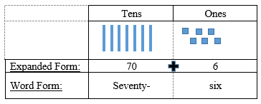

- Teacher provides the opportunity to use a place value chart and connecting cubes or break-apart base ten blocks.
  - For example, have students represent a two-digit number, like 36. Then, have the students represent this model with a drawing on the place value chart. Ask students to use the same blocks and create the representation of 63 (students should not be able to do so with only 3 tens and 6 ones). Discuss why they cannot create this number with blocks they have. Then, provide them with more blocks and have them create the representation of 63. Ask them to compare the two different numbers. What do they notice and wonder? Have students identify or match the expanded forms and word forms of the numbers used.

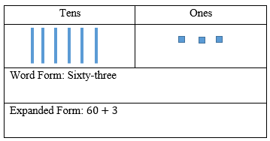
- Teacher provides the opportunity to use place value disks to represent numbers non-proportionally.
  - For example, have students write numbers using word form into expanded and standard form while representing them with place value disks. Show students the number card “thirty- seven” and ask them to place disks into a place value chart. “How many tens does this number have?”, “How many ones does this number have?”

Instructional Tasks
Instructional Task 1 (MTR.2.1, MTR.4.1)
Provide students with the graphic organizer shown below.
Part A. Using tens and ones base ten blocks, create a two-digit number and record in the first column. Write an addition expression in the second column that corresponds to the representation in the first. In the last column, write your number. Repeat until you have created four numbers and written four addition expressions.
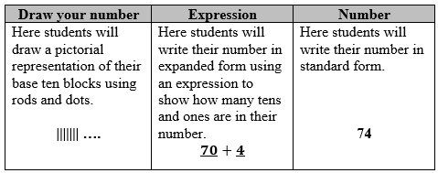
Part B. With a partner, review your work and explain how you know your expressions are correct.
Instructional Task 2 (MTR.2.1, MTR.4.1)
Provide students with the graphic organizer below. Students must complete the missing number forms and then reflect on how the numbers are different.

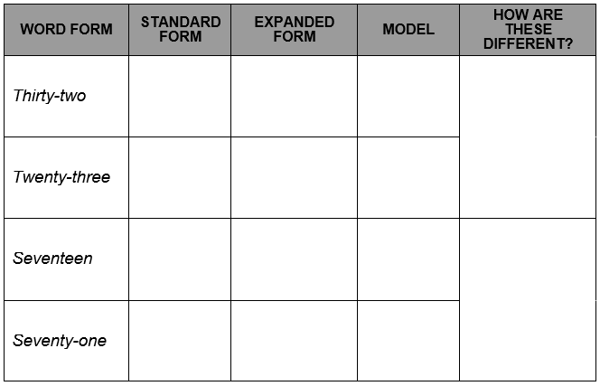

Instructional Items
Instructional Item 1
How are 16 and 61 alike and different?

Instructional Item 2
Kourtney wrote a number in expanded form:$90+4$
What is the standard form of her number?

Instructional Item 3
Using the word form of a number, complete the table below with the missing standard form or expanded form.

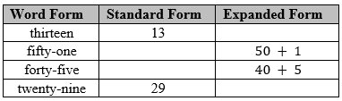

*The strategies, tasks and items included in the B1G-M are examples and should not be considered comprehensive.

MA.1.NSO.1.3

Benchmark
MA.1.NSO.1.3 Compose and decompose two-digit numbers in multiple ways using tens and ones. Demonstrate each composition or decomposition with objects, drawings and expressions or equations.
Example: The number 37 can be expressed as$3 tens + 7 ones$, $2 tens+17 ones$ or as $37 ones$.

Connecting Benchmarks/Horizontal Alignment
- MA.1.NSO.2.2/2.3/2.4/2.5
- MA.1.AR.2.2
- MA.1.M.2.3

Terms from the K-12 Glossary
- Equal Sign
- Equation
- Expression

Vertical Alignment
Previous Benchmarks  - MA.K.NSO.2.2  - MA.K.AR.1.2 | Next Benchmarks  - MA.2.NSO.1.2
Purpose and Instructional Strategies
The purpose of this benchmark is for students to identify ways that numbers can be written flexibly using decomposition. In Kindergarten, students decomposed numbers from 0 to 10 into two numbers and decomposed numbers from 10 to 20 into a ten and the corresponding ones (MTR.2.1).
- Instruction includes the use of base ten manipulatives and place value disks for students to develop a conceptual understanding that $3 tens+7 ones$ is the same as $2 tens+17 ones$ (MTR.5.1).
- Instruction includes the idea that the equal sign means “same as” and is used to balance equations.

Common Misconceptions or Errors
- Students may not recognize that larger sets of ones can also be seen as tens and ones.
  - For example, $15 ones$ is the same amount as $1 ten+5 ones$. The use of base ten manipulatives can help model for students that $15 ones$ units is the same as amount at 1 $ten + 5 ones$ though it is arranged differently (MTR.2.1).
- Students may not decompose a larger unit to an equal number of smaller units to add to existing ones.
  - For example, seeing 34 as only 3 tens + 4 ones and when asked to decompose a ten into ones, students may need reminding that 1 ten can be decomposed into 10 ones and then add them to the current number of ones to get 2 tens + 14 ones.

Strategies to Support Tiered Instruction
- Instruction provides opportunities to use base ten blocks and a place value chart.
  - Teacher provides a 2-digit number, like 56, and asks students to exchange one ten for ones. Next, the teacher asks students to decompose a ten into ones. Then, students are asked to explain what their new model shows and how it is similar and different from the original representation of the number. Students share the different representations with the group and again compare the similarities and differences. Finally, students name/identify the different ways to name the values (e.g. grouping the tens into the ones, 5 tens and 6 ones, 4 tens and 16 ones, or 3 tens and 26 ones, etc.) Have students record expressions on the place value chart each time: ___ tens + __ ones).
  - Example:
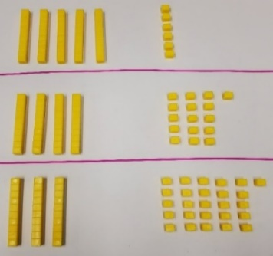

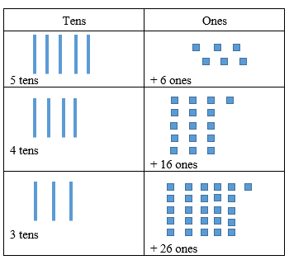
- Teacher models using connecting cubes or break-apart base ten blocks. Students practice exchanging tens for ones and ones for tens. Students connect ten ones to create a rod, therefore showing that the ten ones are equivalent to one ten. With each exchange, the students represent using both the original representation and the new representation in a drawing on a place value chart. At every opportunity, ask the students to name/identify the values they are using in the numbers.
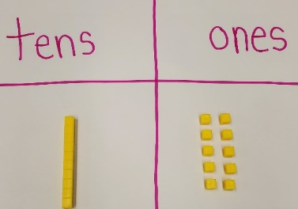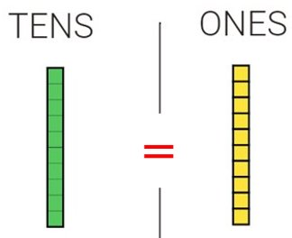

Instructional Tasks
Instructional Task 1 (MTR.2.1)
Part A. Look at each equation in the table below. Circle true or false for each expression.

Equation | True or False
$2 tens+4 ones=1 ten+14 ones$ | True False
$4 tens+0 ones=40 tens$ | True False
$6 tens+13 ones=83$ | True False
$8 tens+16 ones=96$ | True False

Part B. Choose one true statement from above and explain how you know it is true. Choose one false statement from above and explain how you know it is false.

Instructional Items
Instructional Item 1
Which of the following are ways to make 43?
- $40 tens+3 ones$
- $4 tens+3 ones$
- $30 ones+13 ones$
- $3 tens+13 ones$
- $3 tens+3 ones$

Instructional Item 2
Using base ten manipulatives or drawings show at least two different ways to make the number 62.
*The strategies, tasks and items included in the B1G-M are examples and should not be considered comprehensive.

MA.1.NSO.1.4

Benchmark
MA.1.NSO.1.4 Plot, order and compare whole numbers up to 100.
Example: The numbers 72, 35 and 58 can be arranged in ascending order as 35, 58 and 72.

Benchmark Clarifications:
Clarification 1: When comparing numbers, instruction includes using a number line and using place values of the tens and ones digits.
Clarification 2: Within this benchmark, the expectation is to use terms (e.g., less than, greater than, between or equal to) and symbols ($<$, $>$ or $=$).

Connecting Benchmarks/Horizontal Alignment
- MA.1.NSO.2.3
- MA.1.M.1.2

Terms from the K-12 Glossary
- Cardinality Principle
- Natural Number
Number line

Vertical Alignment
Previous Benchmarks  - MA.K.NSO.2.3  - MA.K.NSO.1.4 | Next Benchmarks  - MA.2.NSO.1.3
Purpose and Instructional Strategies
The purpose of this benchmark is for students to understand that the value of a digit is impacted by its position in a number. A three in the tens place has a value of 30 while a 3 in the ones place has a value of 3. In Kindergarten, students located, ordered and compared numbers from 0 to 20 using the same number line. Students fill in missing numbers on a number a line. Kindergarten students are not expected to use the relational symbols $=$, $>$ or $<$ when comparing numbers (MTR.5.1).
- Instruction includes students modeling the numbers with manipulatives to compare given numbers prior to placing them on the number line or after placing them on a number line. (MTR.2.1)
- Instruction includes students writing numbers in expanded form to compare given numbers.
- Instruction includes students plotting numbers on a number line to compare numbers.

Common Misconceptions or Errors
- Students may not recognize that a number’s value is directly related to its placement on a number line. In these cases, having students build a number using base ten manipulatives prior to plotting the number onto a number lines could be helpful.
- Students may not understand the digit in the greatest place helps determine the correct comparison unless it is equal. For example: 29 is less than 31 even though there is a 9 in the number 29. Building these numbers with base ten blocks or place value disks might be helpful.

Strategies to Support Tiered Instruction
- Teacher co-constructs a number line (string or painter’s tape), labeling the ends of the number line (0-100). Students are asked to place 50 on the number line. Teacher discusses the placement of the number and then repeats the process with the numbers 25 and 75. Teacher can also label multiples of 10s on the number line for further support. Teacher asks students to identify numbers that are greater than... and less than....
  - Example:
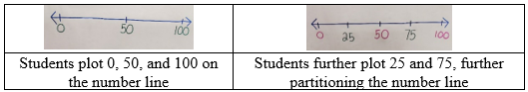

- Teacher provides opportunities to use a number line and place value chart with base-ten blocks. Have students begin by placing the place value rods end to end along the number line (creating a number path). If students have difficulty with understanding that each rod represents a group of ten, use tiles or units to represent each whole number on the number line (number path). Teacher asks students to plot and represent a number on the number line and on the place value chart. Then, the teacher asks students to identify a number that is greater, also plotting this number on the number line and representing the number on the place value chart. Repeat with a number that is less than.
  - Example:
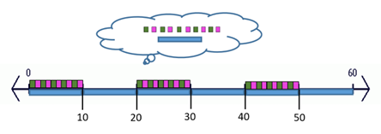
- Teacher provides opportunities to allow students to use a place value chart with base ten blocks or place value discs to build numbers and compare. Have students build each number using a place value chart. Then, model the thinking of looking at the tens place when starting to compare the numbers. If the digit is the same, then have students move on to comparing the ones place.
  - For example, give students two two-digit numbers to compare like 34 and 43. Have students represent both numbers in the place value chart. Teacher asks, “How many tens does each number have?”, “Which number has more tens?” Students should be able to state that 43 is greater than 34 since it has one more ten than 34. Repeat this with numbers that have the same digit in the tens place and how the ones place would be used to determine the correct comparison.
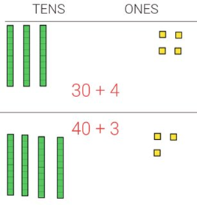
Instructional Tasks
Instructional Task 1 (MTR.1.1, MTR.2.1 MTR.4.1, MTR.5.1)
Class Plotting on an Open Number Line
Materials: 4 Clothespins, 4 index cards, 4 feet of string or rope
Teacher: Hang a piece of string in the classroom.
- Ask a student to think of a two-digit number that has 3 tens in it. Write that number on an index card. Ask another student to place the number anywhere on the piece of string (open number line) using a clothespin.
- Ask a student to think of a two-digit number that has 5 tens in it. Write that number on an index card. Ask another student to place the number on the piece of string (open number line) using a clothespin. Ask the class if it should be placed to the right or the left of the first number. Ask “Is this number more or less than our first number?”
- Ask a student to think of a two-digit number that has 9 ones in it that would come after the 5 tens number. Write that number on an index card. Ask another student to place the number on the piece of string using a clothespin. Ask the class if it is greater than, less than, or equal to the first number on the number line. Ask the class if adjustments are needed to make room for the new number on the open number line (string). Make adjustments as needed.
- Ask a student to think of a number that would come between the first and second number. Write that number on an index card. Ask the class “Should this number be placed closer to the first number or second number? How do you know?” Ask the class if adjustments are needed to the number line more accurate now that they have all the numbers placed. Make adjustments as needed.
- Ask students to independently come up with at least three different true statements from the numbers on the class number line using >, < or = symbols. After giving students time to come up with statements, call on students and write their findings. Ask students to evaluate if they are in fact true statements. Remind students to come up with both greater than and less than statements.
Sample Class Number Line:

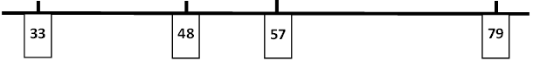

Instructional Task 2 (MTR.1.1, MTR.2.1 MTR.4.1, MTR.5.1)
Teacher provides 6 to 10 numbers on cards in either standard form, expanded form, word form or pictural form. Ask students to place them in ascending order. If any numbers are equal, they can be placed on top of each other to show that they are located at the same spot because they represent the same number. Ask students to come up with at least five different true statements from the numbers using the <,>, or = symbols.

Instructional Items
Instructional Item 1
Order the numbers 99, 79 and 89 from least to greatest. Plot the numbers on the number line.

Instructional Item 2
Using the numbers 37, 73 and 53, make three true statements.
$$______ > ______$$
$$______< ______$$
$$______ > ______$$
$$______ = ______$$

Instructional Item 3
Write a true statement using the numbers 52 and 25.

*The strategies, tasks and items included in the B1G-M are examples and should not be considered

MA.1.NSO.2. Develop an understanding of addition and subtraction operations with one- and two-digit numbers.

MA.1.NSO.2.1

Benchmark
MA.1.NSO.2.1 Recall addition facts with sums to 10 and related subtraction facts with automaticity.

Connecting Benchmarks/Horizontal Alignment
- MA.1.NSO.1.1
- MA.1.AR.1.1/1.2
- MA.1.AR.2.1/2.2/2.3

Terms from the K-12 Glossary
- Automaticity
- Expressions
Equations

Vertical Alignment
Previous Benchmarks  - MA.K.NSO.3.1/3.2 | Next Benchmarks  - MA.2.NSO.2.1
Purpose and Instructional Strategies
The purpose of this benchmark is for students to continue through exploration and reliability towards efficiency and eventually automaticity. In Kindergarten, students added two one-digit numbers with sums from $0-10$ and they subtracted by using related facts with procedural reliability. Instruction for Kindergarten focused first on exploring to build understanding, then students focused on selecting reliable methods. Students in grade 2 recall addition and subtraction facts with automaticity.
- Instruction focuses on the fact that automaticity is usually the result of repetition and practice.
- Instruction of this benchmark should not be in isolation from other benchmarks that emphasize understanding.
- Instruction should not focus on speed or competition in the classroom.
- The correct way to assess automaticity is to observe students within the instructional setting as they complete problems that involve addition and subtraction. Even though such problems can typically be done without automaticity they will be done with less effort with automaticity.

Common Misconceptions or Errors
- Students may encounter difficulty with knowing all the ways a number can be decomposed. In these cases, it is helpful to let students explore decomposing a given number such as 9 and having them find all the possible ways to get to nine when adding ($0 + 9$, $1 + 8$ and $2 + 7$).
- Students may inappropriately substitute automaticity for understanding when understanding of context is required.
  - For example, a student may see a problem containing the numbers 5 and 3 and automatically think the answer is 8 without first using their understanding to determine what operation is required for the context of the problem.

Strategies to Support Tiered Instruction
- Teacher provides instruction with the addition expression, $4+5$ and has students provide the sum. Once students have given the correct sum of 9, teacher asks “Is there another fact with the same sum?” If students are able to provide another addition expression, ask them to find another one. Repeat with subtraction expression, $8-5$. Students should provide the difference of 3. Students may need to use manipulatives to assist in determining the difference. Once students have given the correct difference, teacher asks “Can you give me a related subtraction equation?”

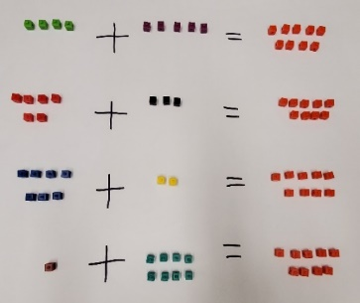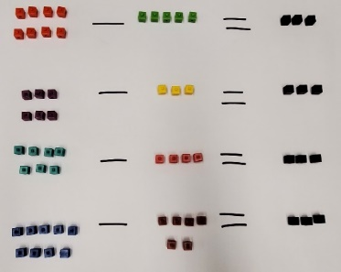

- Teacher provides a manipulative like two color counters, asking students to create a representation of 6. Depending on how they represent the number six, the teacher has students separate the counters into two addends.
  - For example, they may have 6 red counters and 0 blue showing. The equation is $6+0=6$. Ask them how they could create a different representation, but with the same sum. Continue this manipulation of the counters until student can identify all sets of two addends that equal 6.

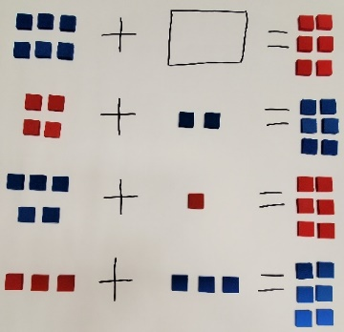

- Teacher provides a real-world problem using numbers up to 10.
- For example, Gavin has 8 toy cars. His brother takes 3 of his toy cars. How many toy cars does he have now? Students can use a manipulative to help solve the problem. Teacher can act out the scenario with students. Then, the student represents the problem in an equation.

Instructional Tasks
Instructional Task 1 (MTR.4.1)
Part A. Ryan has 8 apples. His dad asked him to put the apples into 2 baskets. What are all the ways Ryan could put the apples into the baskets?
Part B. With a partner, compare your ways and see if you found all the ways Ryan could have put the apples into the baskets.

Instructional Items
The following items give examples of simple problems that can be used to observe automaticity in the classroom.

Instructional Item 1
Choose the subtraction equation can be used to solve $5+3=?$.
- $9-5=4$
- $8-5=3$
- $8-2=6$
- $7-5=2$

Instructional Item 2
Create two addition equations and two related subtraction equations using only the digits 4, 7 and 3.

Instructional Item 3
Which of the following addition expressions have a sum of 10?
- $8+2$
- $5+4$
- $1+9$
- $6+3$
- $3+7$
- $4+4$

*The strategies, tasks and items included in the B1G-M are examples and should not be considered

MA.1.NSO.2.2

Benchmark
MA.1.NSO.2.2 Add two whole numbers with sums from 0 to 20, and subtract using related facts with procedural reliability.
Benchmark Clarifications:
Clarification 1: Instruction focuses on helping a student choose a method they can use reliably.
Clarification 2: Instruction includes situations involving adding to, putting together, comparing and taking from.

Connecting Benchmarks/Horizontal Alignment
- MA.1.NSO.1.1/1.2/1.3
- MA.1.AR.1.1/1.2
- MA.1.AR.2.1/2.2
- MA.1.M.2.3
- MA.1.DP.1.2

Terms from the K-12 Glossary
- Expressions
- Equations

Vertical Alignment
Previous Benchmarks  - MA.K.NSO.3.1/3.2 | Next Benchmarks  - MA.2.NSO.2.1/2.3/2.4
Purpose and Instructional Strategies
The purpose of this benchmark is for students to recognize the relationship between addition and subtraction and to use that relationship as a possible strategy (i.e., if $12+3$ is 15, then $15-3$ is $12$). In Kindergarten, students explored adding two numbers between 0 and 10 and related subtraction facts and added two one-digit numbers with sums from 0 to 10 and used related subtraction facts with procedural reliability. In grade 2, students recall addition and subtraction facts to 20 with automaticity and explore through 1,000.
- Instruction focuses on students choosing reliable methods to find the sum.
- Instruction encourages students to use strategies that move them towards building efficiency but need not include the use of an algorithm.
- Instruction includes the explicit use of strategies.
  - Strategies include skip counting, decomposing into tens and ones, and making a ten (there is an expectation of automaticity within 10 in grade 1).
- Instruction includes situations involving add to, take from, put together, and compare. Refer to Appendix A for more information. Classroom instruction includes discussions about how an equation like 8 + ____ = 15 could be an addition or a subtraction equation. Students could count on using a number line or they might find the difference.

Common Misconceptions or Errors
- Students may reverse the minuend and subtrahend in the ones, from the assumption the minuend must be larger than the subtrahend (i.e., for $12 - 5$, finding $15 - 2$). In these cases is it important for students to use concrete manipulatives such as base ten blocks as they must exchange a tens rod for ten ones so that they may physically take away from the ones place.

Strategies to Support Tiered Instruction
- Teacher provides a real-world problem using subtraction asking students to create a subtraction equation that is represented in the problem. Students are provided the opportunity to use a manipulative to solve the subtraction problem.
  - For example, Cora has 15 stickers on her sheet. She gives her friend 8 of the stickers. How many stickers are still on her sheet?

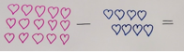

- Teacher provides a subtraction expression verbally asking students to write the expression. Teacher provides manipulatives to solve the subtraction problem. Acting out the “take from” action can provide the support for understanding. Students may need to regroup tens to ones to solve or to regroup when it is not needed.
  - For example, in the equation 13 – 5, students may use base-ten blocks to represent the problem. Students will need to regroup one rod for ten units. Then, remove 5 units to solve the subtraction problem. Students may need prompting as to what needs to be exchanged.
- Teacher provides an equation with a blank if various positions and asks students to solve it. Students use a part, part, whole model to help students recognize what is missing. Teacher asks if we have a total? Are we comparing the numbers? Teacher helps students select the best method to reliably solve each type of situation.

Instructional Tasks
Instructional Task 1 (MTR.4.1, MTR.5.1)
Joey was trying to find the difference $15-7$. He counted backward by ones from 15 saying “14, 13, 12, 11, 10, 9, 8.” What might be a more efficient strategy that Joey could use to take 7 away from 15? Will your strategy work for all subtraction expressions? Explain.

Instructional Task 2 (MTR.2.1, MTR.7.1)
Two students are working together on a project. Each student has nine crayons. If the students put their crayons together, how many will they have together? Write an addition or subtraction equation that you could use to help you solve the problem.

Instructional Items
Instructional Item 1
Josephine used the subtraction equation $17 - 9 = 8$ to help her solve an addition problem. What could have been Josephine’s addition problem?

Instructional Item 2
What is the sum of 8 and 11?

*The strategies, tasks and items included in the B1G-M are examples and should not be considered

MA.1.NSO.2.3

Benchmark
MA.1.NSO.2.3 Identify the number that is one more, one less, ten more and ten less than a given two-digit number.
Example: One less than 40 is 39.
Example: Ten more than 23 is 33.

Connecting Benchmarks/Horizontal Alignment
- MA.1.NSO.1.1/1.2/1.3/1.4
- MA.1.AR.1.2
- MA.1.M.1.1
- MA.1.M.2.3

Vertical Alignment
Previous Benchmarks  - MA.K.NSO.2.1 | Next Benchmarks  - MA.2.NSO.2.2
Purpose and Instructional Strategies
The purpose of this benchmark is to bring a focus on place value and patterns that are found in numbers. In Kindergarten students counted forward and backward by 1s and 10s). In grade 2, students will identify numbers ten more and ten less, and one hundred more and one hundred less than a three-digit number.
- Instruction focuses on making the connection to the place value of digits.
- The expectation of the benchmark is not to focus on addition and subtraction strategies.
- Instruction includes use of a number line to reinforce the idea of one more, one less, and the use of a hundred chart (top down and bottom up) to focus students understanding about place value patterns.

Common Misconceptions or Errors
- Some students may confuse the place value when asked what is ten more or ten less and give a response that is only one more or one less. Using a hundred chart may help students visually see what is ten more, ten less as well as one more, one less. Consider using a bottom-up hundreds chart so students are moving up when counting up.

Strategies to Support Tiered Instruction
- Teacher provides a hundred chart with the numbers identified with base ten blocks. Have students identify a specific number and ask them about the numbers that are 1 more, 1 less, 10 more, and 10 less.
  - For example, the teacher asks students to identify the number 47. Once they identify the number on the chart ask, “Which number is one more than 47? [48] How do you know? Which number is 10 more than 47? [57] How do you know? How are they like 47? How are they different from 47? What is the relationship between the numbers and their place value?” Students provide other examples using any two-digit number they choose. (A portion of the chart is shown below.)

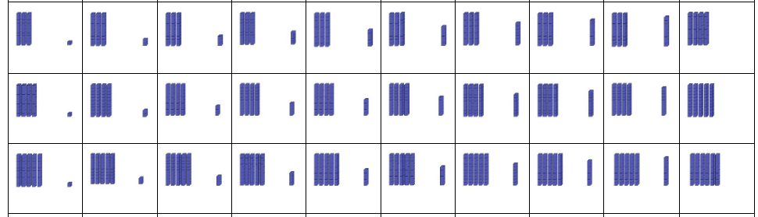

Instructional Tasks
Instructional Task 1 (MTR.4.1, MTR.6.1)
What numbers should go in the blanks of the given equations below to make them true? Choose one statement and explain how you know you are correct.
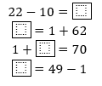
Instructional Task 2 (MTR.4.1, MTR.5.1)
Provide students with one of the charts below.
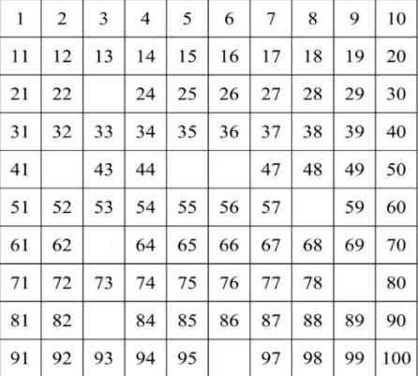

Part A. Have students complete the chart independently.
Part B. Facilitate a group discussion allowing students to explain the process or strategies they used to complete the chart. Below are possible questions and student responses.
- How did you know that 23 was the missing number?
  - Student responses may include: I know 23 is one more than 22. I know 23 is one less than 24. I know that 23 is 10 more than 13. I know that 23 is 10 less than 33.
- How many ways can you prove that 42 is the missing number between 41 and 43? What are those ways? Can you think of additional strategies to use?

Instructional Task 3 (MTR.7.1)
Nevaeh has 33 blueberries. Jonathon has 10 more blueberries than Nevaeh. How many blueberries does Jonathon have?

Instructional Items
Instructional Item 1
Complete the chart below to show one more, one less, ten more and ten less than 57.

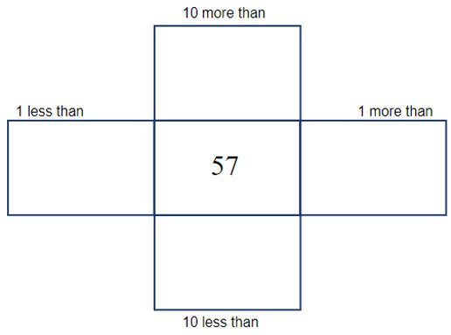

Instructional Item 2
What is one less than 98?

*The strategies, tasks and items included in the B1G-M are examples and should not be considered

MA.1.NSO.2.4

Benchmark
MA.1.NSO.2.4 Explore the addition of a two-digit number and a one-digit number with sums to 100.
Benchmark Clarifications:
Clarification 1: Instruction focuses on combining ones and tens and composing new tens from ones, when needed.
Clarification 2: Instruction includes the use of manipulatives, number lines, drawings or models.

Connecting Benchmarks/Horizontal Alignment
- MA.1.NSO.1.1/1.2/1.3
- MA.1.M.2.3

Terms from the K-12 Glossary
- Expressions
- Equal sign
Equations

Vertical Alignment
Previous Benchmarks  - MA.K.NSO.2.1/2.2  - MA.K.NSO.3.1/3.2 | Next Benchmarks  - MA.2.NSO.2.3/2.4
Purpose and Instructional Strategies
The purpose of this benchmark is for students to critically think about choosing a strategy that makes sense based on their given numbers. In Kindergarten, instruction focused on adding single digit whole numbers up to 10. Students recited number names to 100 and counted forward and backward within 20. In grade 2, students extend their exploration of addition and subtraction through 1,000.
- Instruction includes connecting inefficient strategies to more efficient strategies. Strategies may include, but are not limited to, counting on, skip-counting, decomposing and composing, combining ones and tens, and composing new tens from ones when needed (MTR.2.1, MTR.5.1).
- The expectation for instruction does not include the use of an algorithm, but students should not be prevented from using an algorithm if they can use it reliably. However, the intent of this benchmark is for all students to deepen their understanding of place value while exploring addition. There is no expectation of procedural reliability until grade 2 within the range of this benchmark (MTR.5.1).

Common Misconceptions or Errors
- Students may inaccurately compose new tens when they have more than 9 ones. In these cases it is important for students to use concrete manipulatives such as base ten blocks as they exchange tens ones for a single ten rod in order to visually see the ones units making a new ten.

Strategies to Support Tiered Instruction
- Instruction includes the use of base ten blocks, place value chart, and number lines. Teacher provides an addition expression with 2-digit and 1-digit addends and allows students to solve the addition problem with a manipulative and a representation.
  - For example, teacher provides students with a problem like $28+4$. Students may represent the addition problem using the base ten blocks on a place value chart. If they do not regroup, ask them if they can compose a group of ten ones.

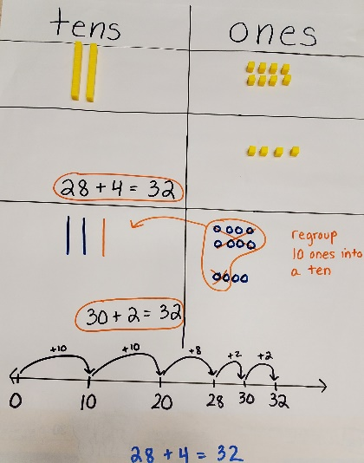

  - For example, teacher provides a problem like $64+7$. Students may represent the addition problem on a number line. Using this representation shows that the student is counting on. Ask them if they notice how the digits change from 69 to 70 as they counted on the number line.

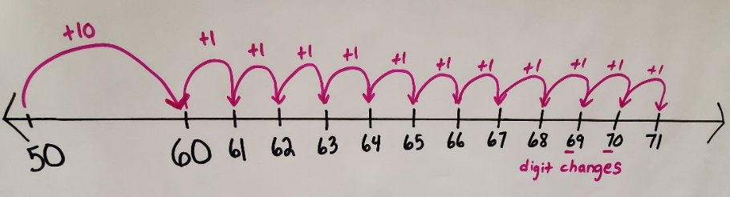

- Instruction includes the use of base ten blocks in a place value chart and a hundreds chart. Teacher provides a 2-digit number and has students build the number with the base ten blocks on the place value chart. Then, the teacher tells them that they are adding a 1-digit number to the number of blocks they already have. Teacher asks, “What number do you have now?” Exchange the 10 ones for 1 ten rod. Repeat with several problems with and without regrouping.
  - For example, teacher provides students with the problem $36+5$ and has students build 36 with base ten blocks and place on the place value chart. Then, students add 5 more ones to the chart. The teacher asks students, “What is your sum? Do you need to regroup?” Repeat with and without regrouping and ask if they need to regroup each time.
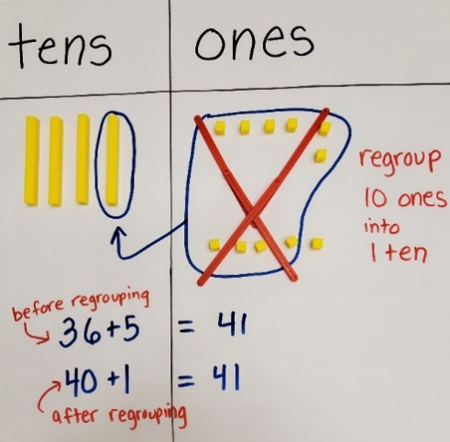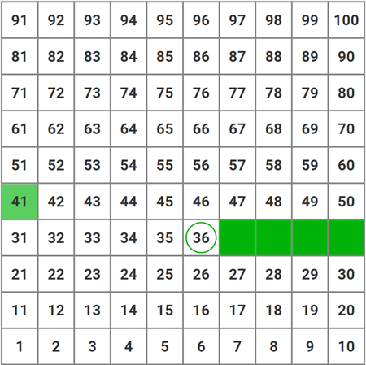

Instructional Tasks
Instructional Task 1 (MTR.4.1)
Pair students in groups of two and provide each group with the table below, two dice and base ten blocks (1 hundred mat, 12 tens rods per student, 20 ones per student).
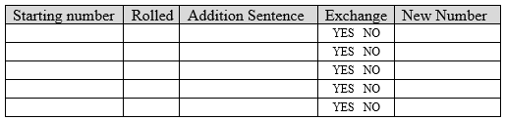
Part A. Students take turns rolling two dice to determine their starting number using one die to represent the tens place and one die to represent the ones place. Both students build their starting number with base ten blocks. The student who has the smallest starting number starts the game.
Part B. The first student rolls a single die to add that amount to their starting number. The student writes the addition sentence they would use to get their new number. The student must decide if they have enough ones to exchange for a tens rod. If the student has 10 or more ones then they ask their partner to exchange their 10 ones for a tens rod.
Part C. The student writes their new number down. Then they write that new number as their starting number on the next row but wait for their turn before completing the row.
Part D. The second student rolls a single die and completes one row before the first student goes again.

Instructional Items
Instructional Item 1
To find $68+7$, Jamal added 5 to 70 and got 75. Explain Jamal’s strategy. Is Jamal correct? Write another expression where his strategy can be used.

Instructional Item 2
When adding 56 and 6 using base 10 blocks, Jasmine realized she now has 5 tens and 12 ones. What might be Jasmine’s next step to find the sum of $56+6$?
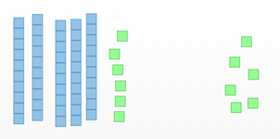

*The strategies, tasks and items included in the B1G-M are examples and should not be considered

MA.1.NSO.2.5

Benchmark
MA.1.NSO.2.5 Explore subtraction of a one-digit number from a two-digit number.
Example: Finding $37-6$ is the same as asking, “What number added to 6 makes 37?”
Benchmark Clarifications:
Clarification 1: Instruction focuses on utilizing the number line as a tool for subtraction through “counting on” or “counting back.” The process of counting on highlights subtraction as a missing addend problem.
Clarification 2: Instruction includes the use of manipulatives, drawings or equations to decompose tens and regroup ones, when needed.

Connecting Benchmarks/Horizontal Alignment
- MA.1.NSO.1.1/1.3

Vertical Alignment
Previous Benchmarks  - MA.K.NSO.2.1  - MA.K.NSO.3.1/3.2 | Next Benchmarks  - MA.2.NSO.2.3/2.4
Purpose and Instructional Strategies
The purpose of this benchmark is to deepen students’ understanding of place value while students explore subtraction. There is no expectation of procedural reliability until grade 2 within this given range. In Kindergarten, students explored subtracting within 20 and subtracting within 10 with procedural reliability. In Kindergarten students counted forward to 100 by 1s and 10s and backward by 1s within 20. In grade 2, students subtract within 100 with procedural liability and explore subtraction with numbers no larger than 1,000 .
- Instruction focuses on choosing a strategy that makes sense to the student based on the given numbers, while guiding students to appropriate and more efficient strategies (MTR.2.1, MTR.5.1).
  - Strategies include counting back, skip-counting, decomposing and composing, subtracting ones and tens, and decomposing tens for more ones when needed.
- The expectation for instruction of this benchmark does not include the use of an algorithm, but students should not be prevented from using an algorithm if they can use it reliably. However, the intent of this benchmark is for all students to deepen their understanding of place value while exploring subtraction. There is no expectation of procedural reliability until grade 2 within the range of this benchmark.

Common Misconceptions or Errors
- Students may reverse the minuend and subtrahend in the ones, from the assumption the minuend must be larger than the subtrahend (i.e., for $12 - 5$, finding $15 - 2$). It is important for students to use concrete manipulates such as base ten blocks as they must exchange a tens rod for ten ones so that they may physically take away from the ones place.
- Students may fail to subtract a ten from the difference when decomposing a ten to gain enough ones to subtract the ones. In these cases, it can be helpful for students to use base ten blocks to manipulate the exchange of a single tens rod for ten one units to subtract.

Strategies to Support Tiered Instruction
- Instruction includes providing context to the subtraction problem to ensure that students understands that the minuend is the amount that the student will take from. At this stage of the learning progress the minuend is greater than the subtrahend. Teacher should not refer the minuend as always being greater than the subtrahend as this will lead to a later misconception.
- Instruction includes the use of base ten blocks, place value chart, hundreds chart, and/or number line. Teacher provides a subtraction problem and students may solve using manipulatives like the ones listed. Teacher may need to assist in regrouping of tens and ones to subtract. Students may need to use the number line or hundreds chart to count back to solve.
  - For example, the teacher provides students with a problem like $33-6$. Students may use base ten blocks and take away the 6. Teacher may need to remind students that regrouping of a ten may be needed. Teacher asks students what they need to do to subtract 6.

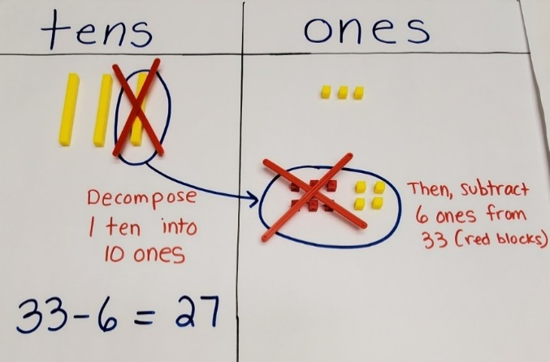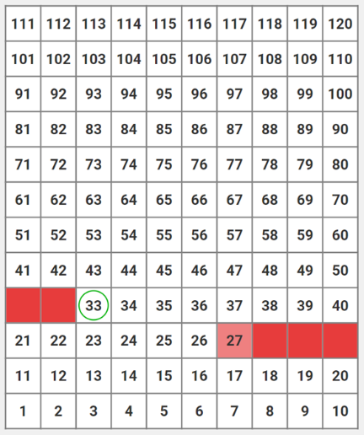

  - For example, teacher provides students with a problem like $33-6$. Student may use a number line and count back 6 to find the difference. Teacher asks the student about how the digits change when counting back and demonstrates how the numbers change when counting by using the hundreds chart as a tool.

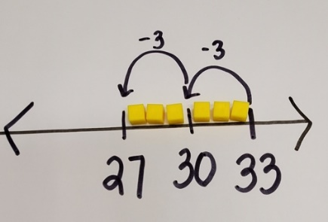

Instructional Tasks
Instructional Task 1 (MTR.4.1)
Edward has 88 cents in his jacket pocket. There was a small tear and a nickel slipped out.
Part A. How many cents does Edward have now? Use a number line to show your work. Write a subtraction equation to represent this problem.
Part B. Compare your number line and equation with a partner, did you both start at the same place on your number line? Did you both get the same answer?

Instructional Items
Instructional Item 1
To find the difference of $74-6$, Tanya first subtracted 4 to get 70. What could her next step be? What is the difference? Use Tanya’s strategy to find $35-6$.

Instructional Item 2
Using two different strategies find the difference of $64-9$. Show your work to support your thinking.

Instructional Item 3
To find $32-8$, a student used base ten blocks. After removing 2 ones, the student is not sure what else to do. What might the next step be?

*The strategies, tasks and items included in the B1G-M are examples and should not be considered

Fractions

MA.1.FR.1 Develop an understanding of fractions by partitioning shapes into halves and fourths.

MA.1.FR.1.1

Benchmark
MA.1.FR.1.1 Partition circles and rectangles into two and four equal-sized parts. Name the parts of the whole using appropriate language including halves or fourths.

Benchmark Clarifications:
Clarification 1: This benchmark does not require writing the equal sized parts as a fraction with a numerator and denominator.

Connecting Benchmarks/Horizontal Alignment
- MA.1.NSO.1.3
- MA.1.M.2.1

Terms from the K-12 Glossary
- Circle
- Rectangle

Vertical Alignment
Previous Benchmarks  - MA.K.GR.1.1/1.5 | Next Benchmarks  - MA.2.FR.1.1  - MA.2.FR.1.2  - MA.2.M.2.1
Purpose and Instructional Strategies
The purpose of this benchmark is to introduce the initial idea of equal parts in the form of halves and fourths. While students are not expected to use a numerator or denominator, it is the first exposure for students to see circles and rectangles partitioned into two or four equal-sized parts which sets the stage for fractional understanding. In Kindergarten, students recognized how combining two equal-sized triangles can form a rectangle. Also in Kindergarten, students learned that whole numbers up to 10 could be broken apart into two other whole numbers (MTR.5.1).
- Instruction includes the idea of part-whole relationships as supported by the model (MTR.5.1).
- Instruction includes naming the parts based on the number of equal parts that make the whole.
- Instruction includes partitioning rectangles in multiple ways, such as horizontal, vertical, and diagonal, to show halves or fourths. Depending on the type of rectangle that is being presented, it may not result in four equal parts (MTR.2.1).

Common Misconceptions or Errors
- Students may have difficulty partitioning circles or rectangles into equal-sized parts; additional guided practice may be helpful in these cases.
- When a rectangle is divided into fourths using its diagonals students may have trouble seeing that all four parts are the same size. This should not be a point of contention, but it should be an opportunity to explain to students that they will get a deeper understanding of this in later grades.

Strategies to Support Tiered Instruction
- Teacher models partitioning circles and rectangles into fourths using a geoboard to investigate equal-sized parts.
  - Example:

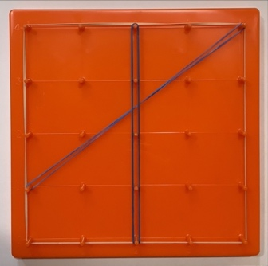 | 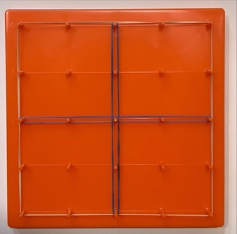
Not equal parts | Equal parts
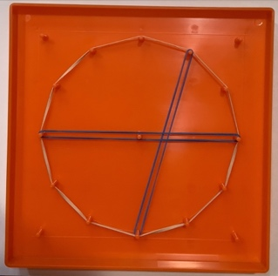 | 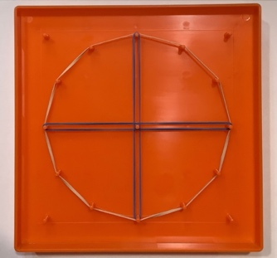
Not equal parts | Equal parts

- Teacher models folding rectangles and circles into halves and fourths to develop an understanding of equal sized parts.
- Instruction provides opportunities to investigate equal sized parts using paper squares divided into fourths on the diagonal.
  - For example, teacher provides paper squares and demonstrates how to divide it into fourths on the diagonal. Discussion should be centered on recognizing parts that are equal by folding the paper over onto itself to show the parts are equal.

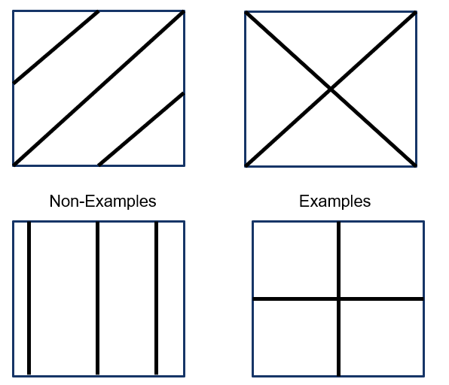

Instructional Tasks
Instructional Task 1 (MTR.2.1, MTR.4.1)
Part A. Partition the circles and rectangles in different ways to show two equal parts. Name the parts of the whole.

My shapes are partitioned into ________________________.
Compare with a partner to discuss if your circles and rectangles look alike and share how you know your shapes show two equal parts.
Part B. Partition the circles and rectangles in different ways to show four equal parts. Name the parts of the whole.

My shapes are partitioned into ________________________.
Compare with a partner to discuss if your circles and rectangles look alike and share how you know your shapes show four equal parts.

Instructional Task 2 (MTR.4.1)
Josephine says she partitioned the clocks below into halves. Do you agree with her? Why or Why not?
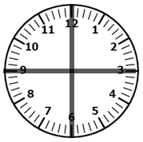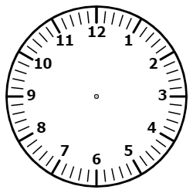
Clock A
Clock B
Clock C

Instructional Task 3 (MTR.4.1)
Repeat Instructional Task 2 with halves replaced by fourths.

Instructional Items
Instructional Item 1
Divide a piece of paper into two parts so that each part has an equal amount. How could you describe each part?

Instructional Item 2
Pretend each of the circles below is a cake.
- The first one is for two people. Can you show how you would partition the cake for 2? This cake is partitioned into _________.
- The second cake is for 4 people. Can you show how you would partition the cake for 4? This cake is partitioned into _________.

*The strategies, tasks and items included in the B1G-M are examples and should not be considered comprehensive.

Algebraic Reasoning

MA.1.AR.1 Solve addition problems with sums between 0 and 20 and subtraction problems using related facts.

MA.1.AR.1.1

Benchmark
MA.1.AR.1.1 Apply properties of addition to find a sum of three or more whole numbers.
Example: 8+7+2 is equivalent to 7+8+2 which is equivalent to 7+10 which equals 17.

Benchmark Clarifications:
Clarification 1: Within this benchmark, the expectation is to apply the associative and commutative properties of addition. It is not the expectation to name the properties or use parentheses. Refer to Properties of Operations, Equality and Inequality (Appendix D).
Clarification 2: Instruction includes emphasis on using the properties to make a ten when adding three or more numbers.
Clarification 3: Addition is limited to sums within 20.

Connecting Benchmarks/Horizontal Alignment
- MA.1.NSO.2.1/2.2
- MA.1.AR.2.2
- MA.1.M.2.3

Terms from the K-12 Glossary
- Associative Property of Addition
- Commutative Property of Addition
- Equation
- Expression

Vertical Alignment
Previous Benchmarks  - MA.K.AR.1.1  - MA.K.AR.1.2 | Next Benchmarks  - MA.2.AR.2.1
Purpose and Instructional Strategies
The purpose of this benchmark is for students to explore addition and think flexibly when it comes to adding three numbers together such as rearranging addends, looking for doubles, making a ten, etc. In Kindergarten, students find ways to make a ten when given a 1 to 9 digit. Students also find ways to represent a given number from 0 to 10 as the sum of two numbers (MTR.2.1, MTR.5.1).
  - Instruction includes use of manipulatives to model addition problems within 20 (MTR.5.1).

Common Misconceptions or Errors
- Students may not understand that when three numbers are rearranged the sum will still be the same. In this case, open a class discussion by showing the following expressions A. $3 + 9 + 4$ and B. $9 + 4 + 3$.
  - Ask students what they notice about the expressions. Once a student notices that both expressions have the same exact numbers but that the numbers are arranged in a different order ask, “Do you think they will have the same sum?” Have students share how they could solve the expressions using a strategy. Then have a discussion about the sums of both equations being 16. Then repeat having the students the same numbers together but in a different order. Have them discuss if they addends will always have the same total.

Strategies to Support Tiered Instruction
- Instruction provides opportunities to use a set of three number cards and make multiple equations with three addends. Students solve all equations and then discuss how they are similar and different.
- For example, students choose three numbers from a set of number cards and create the equations below. After students have finished solving the equations, they answer and discuss the following questions:
  - How are the equations different?
  - Students should discuss how the order of the addends is different in each equation. How are the equations the same? Students should conclude that the sum is always the same no matter the order in which the addends are added.
  - Would the same thing happen if we used three different number cards?
  - Would we be able to create equations in which the addends are in different orders?
  - Would the sum be the same no matter the order in which we add the addends?

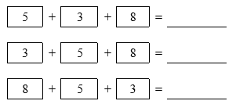

- Instruction provides opportunities to build equations with three addends in multiple orders to explore the concept of the commutative property.
- For example, the teacher provides the expression $3 + 2 + 4$. Students build each addend using snap cubes and determine the sum. Teacher records the student work on chart paper. Teacher gives the students another expression $2 + 4 + 3$. Students build each addend using snap cubes and determine the sum. Teacher adds the student work to the chart paper. Teacher gives the students a final expression $4 + 3 + 2$. Students build each addend and determine the sum. Teacher adds the students work to the chart paper. Teacher asks “How are these expressions similar? How are they different? What happens to the sum when you solved $3 + 4 +2$?”

Instructional Tasks
Instructional Task 1 (MTR.2.1)
Provide students with three different colors of manipulatives (six of each color), three dice and a recording sheet.
Part A. Student rolls three dice and set out that many one color manipulatives per die that they rolled. Student arranges the manipulatives to create an addition sentence then records it.
Part B. Student rearrange their manipulatives to create a new addition sentence and records it. Student thinks of another way they could get to their sum by creating a true equation.
Roll 1 | Roll 2 | Roll 3 | Addition Sentence/Sketch | New Addition Sentence/Sketch | True Equation
3 | 4 | 6 | $3+4+6=13$  □□□□□□□□□□□□□ | $6+4+3=13$ □□□□□□□□□□□□□ | $$10+3=13$$

Instructional Task 2 (MTR.5.1, MTR.6.1)
Melonie is working on solving an addition equation with three numbers. She says that she can make a ten with two of her numbers then add the third number. What could two of Melonie’s numbers be that would make a ten?

Instructional Items
Instructional Item 1
Using three digits, create an addition equation that would have a sum of 18.

Instructional Item 2
The total of three numbers is eleven. What could the three numbers be?

Instructional Item 3
How many different ways can you get a total of seventeen when you roll three six-sided dice? Record each way.

Instructional Item 4
Which of the following addition expressions will get the same sum as $2+6+2+4$?
- $2+8+7$
- $2+4+8$
- $4+8+2$
- $8+6$ + 0
- $10+3+1$

*The strategies, tasks and items included in the B1G-M are examples and should not be considered comprehensive.

MA.1.AR.1.2

Benchmark
MA.1.AR.1.2 Solve addition and subtraction real-world problems using objects, drawings or equations to represent the problem.
Benchmark Clarifications:
Clarification 1: Instruction includes understanding the context of the problem, as well as the quantities within the problem.
Clarification 2: Students are not expected to independently read word problems.
Clarification 3: Addition and subtraction are limited to sums within 20 and related subtraction facts. Refer to Situations Involving Operations with Numbers (Appendix A).

Connecting Benchmarks/Horizontal Alignment
- MA.1.NSO.2.1/2.2/2.3
- MA.1.AR.2.1/2.2/2.3
- MA.1.M.1.1
- MA.1.M.2.3
- MA.1.DP.1.2

Vertical Alignment
Previous Benchmarks  - MA.K.AR.1.3 | Next Benchmarks  - MA.2.AR.1.1
Purpose and Instructional Strategies
The purpose of this benchmark is for students to start to apply their understanding of mathematical concepts as they critically apply their knowledge in visualizing and deciphering word problems. In Kindergarten, students solved real-world addition and subtraction problems within 10, with a focus on drawings and equations to represent problems. Students are not expected to independently read word problems (MTR.7.1).
- Instruction allows students to focus on context and apply reasoning to determine the appropriate operation (MTR.7.1).
- Instruction includes helping students realize that there can be more than one representation for a given problem which could be helpful for students to choose which representation they prefer and to communicate with other students who might prefer a different representation (MTR.2.1, MTR.4.1, MTR.5.1).
- Instruction includes getting students to assess the reasonableness of their solutions within context (MTR.6.1).
- Instruction may begin with concrete models, pictures, numbers and words, and then move into writing equations (MTR.2.1).
- Instruction should include a variety of problem types (see Appendix A) and not a focus on any single problem type. It is important that students have opportunities to solve various problem types.

Common Misconceptions or Errors
- Students may have difficulty modeling or solving problems that involve a change unknown or start unknown problem type. To help with this misconception, include the use of Appendix A in instruction.
- Students may look for key words rather than context and reasoning, which can lead to the incorrect operation.

Strategies to Support Tiered Instruction
- Teacher provides a graphic organizer to identify important information for solving the problem.
  - For example, students develop an understanding of context and reasoning by answering questions about the context and gathering information from the problem to promote reasoning.

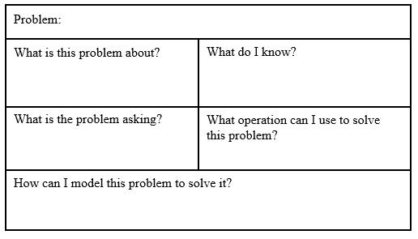

- Instruction provides opportunities to determine the context of numberless word problems with a focus on what is happening in the problem and how to solve it.
  - For example, the teacher provides the following word problem to students.
Victor has ____ video games. He went to the store with his brother. Victor’s brother bought him some more video games. When Victor got home, he counted his video games and now he has ____ video games.
Teacher asks: What is this problem about? What is happening in this problem? What information do we know? How do you think you would solve this problem?
- Instruction provides the opportunity to create word problems to match change unknown and start unknown problem types.
  - For example, the teacher provides the change unknown equation $12-____=8$ to the students. Students develop a situation that matches the equation to make into a word problem.
- Instruction provides the opportunity to determine the context of word problems with a focus on what is happening in the problem and how it can be solved.
  - For example, the teacher provides the following word problem: Patrick’s Pet Care washed 3 dogs in the morning and some more dogs in the afternoon. Patrick washed a total of 7 dogs. How many dogs did Patrick wash in the afternoon?
Teacher asks “What is this problem about? What is happening in this problem? What information do we know? How do you think you would solve this problem?”
- Teacher provides a variety of change unknown and start unknown problems for students to match to the correct equation. Problem types and examples can be found in Appendix A.
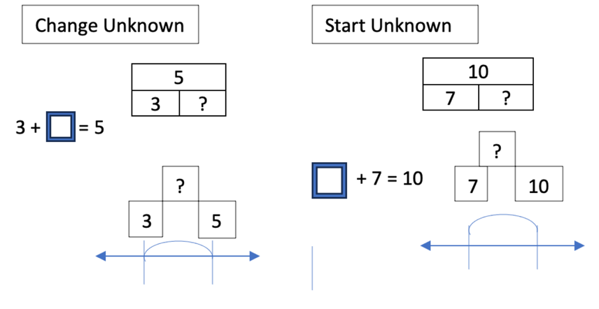

Instructional Tasks
Instructional Task 1 (MTR.4.1)
There are chickens, sheep and pigs in a barn. There are 17 animals total in the barn.
Part A. Draw how many chickens, sheep and pigs could be in the barn?
Part B. With a partner, compare your work. How are your barns alike? How are your barns different? Write an equation to match you drawing.

Instructional Task 2 (MTR.1.1, MTR.2.1, MTR.7.1)
Provide students with the equation$12=\underline{}+7$. Provide time for students to draw a model that represents the equation then verbally express a word problem to match.

Instructional Items
Instructional Item 1
Trevor had 16 toy cars. He went to the toy store with his father. His father bought him some more toy cars. When Trevor got home, he counted his cars and now he has 20 cars. How many toy cars did his father buy for him? Write an equation to show how you solved the problem.

Instructional Item 2
Elliana had 19 stuffed animals. She gave some away. Now Elliana has 11 stuffed animals. How many stuffed animals did Elliana give away? Draw a picture to show your work.

*The strategies, tasks and items included in the B1G-M are examples and should not be considered comprehensive.

MA.1.AR.2. Develop an understanding of the relationship between addition and subtraction.

MA.1.AR.2.1

Benchmark
MA.1.AR.2.1 Restate a subtraction problem as a missing addend problem using the relationship between addition and subtraction.
Example: The equation $12-7=?$ can be restated as $7+?=12$ to determine the difference is 5.

Benchmark Clarifications:
Clarification 1: Addition and subtraction are limited to sums within 20 and related subtraction facts.
Connecting Benchmarks/Horizontal Alignment
- MA.1.NSO.2.1/2.2
- MA.1.AR.1.2

Terms from the K-12 Glossary
- Equation
- Expression

Vertical Alignment
Previous Benchmarks  - MA.K.AR.2.1 | Next Benchmarks  MA.2.AR.2.2
Purpose and Instructional Strategies
The purpose of this benchmark is to get students thinking about the relationships between addition and subtraction. In Kindergarten, students explored equations and developed an understanding of the equal sign by explaining why addition and subtraction equations are true using objects and drawings.
- Instruction may present equations in different forms such as $a+b=c$ or$c=a+b$.
- Instruction may include students using a related addition fact or a part-part-whole mat to help them find the missing addend in a subtraction equation.

Common Misconceptions or Errors
- Students may not recognize how an addition problem can help them solve a subtraction problem. Guided practice with related facts may be helpful for students who do not recognize this.
- Students may solve the equation and look for the solution in the answer choices rather than relying on reasoning.

Strategies to Support Tiered Instruction
- Teacher provides opportunities to use number bonds to develop an understanding of fact families and inverse relationships.
  - For example, students create a number bond for the number 9 using counters on a number bond work mat. Students then write the fact families for the number 9. Discussion should be focused on how the fact families are related and how knowing the addition facts can help the students solve a subtraction problem.

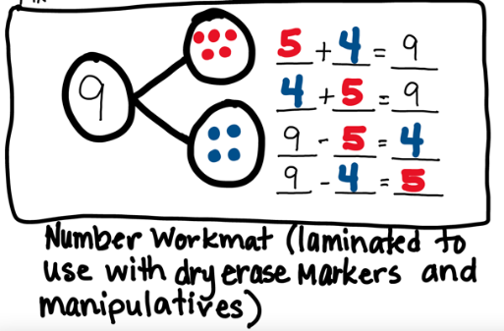

- Instruction provides opportunities to match a range of subtraction equations to their missing addend equation.
  - For example, the teacher provides a variety of equations which may include:
$11 - 4 = ____$, $4 + ___ = 11$, $___ + 4 = 11$, $___ + 11 = 4$, and $11 + ___ = 4$. Students determine which missing addend equations will help them solve $11 - 4 = ____$. The discussion should focus on reasoning about which equations will work and which will not.

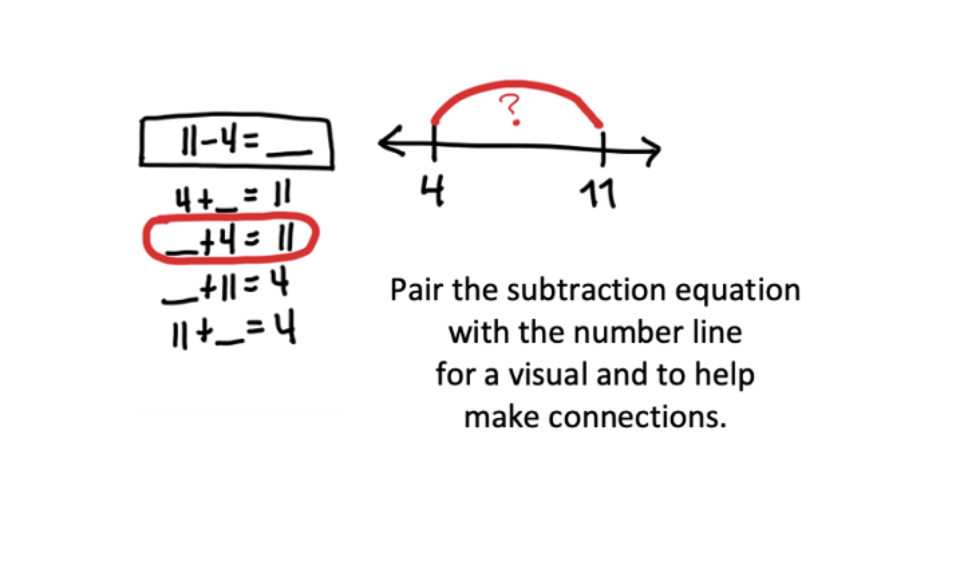

- Instruction provides opportunities to solve problems that highlight the relationship between addition and subtraction using a linear ten frame.
- For example, students use two different colors to shade the addend on the ten frame. Students write the addition fact that is represented on the ten frame $5 + 3 = 8$. They then subtract 3 from 8 by folding under the three “orange” blocks. Students are left with the 5 “blue” blocks, so $8-3 = 5$. They should practice with multiple addition facts. Discussion should be focused on the relationship between addition and subtraction.




Teacher provides opportunities to work in reverse of the benchmark to solve missing addend equations and then write the subtraction equation that matches the missing addend equation.
  - For example, students use two-color counters to build the knowns of the following equation on a given empty equation mat $5 + ____ = 9$.

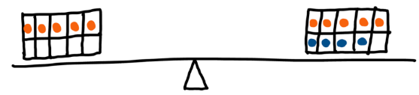

Teacher asks “How many do you need to put in the empty space to equal the other side of the equation of you already have 5?” Write a subtraction equation to help us solve this problem.
Instructional Tasks
Instructional Task 1 (MTR.7.1)
Katina has 14 grapes. She gives 8 of them to her brother Kevin. What addition equation could help Katina figure out how many grapes she has left for herself?

Instructional Items
Instructional Item 1
Which addition equation can help you determine $10-3$?
- $3+10=13$
- $5+3=8$
- $7+3=10$
- $11+3=14$

Instructional Item 2
Part A: Complete the part-part-whole mat to help you determine $11-5$.

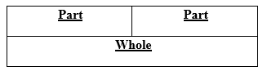

Part B: Write an addition equation that could help you solve.

*The strategies, tasks and items included in the B1G-M are examples and should not be considered comprehensive.

MA.1.AR.2.2

Benchmark
MA.1.AR.2.2 Determine and explain if equations involving addition or subtraction are true or false.
Example: Given the following equations, $8=8$, $9-1=7$, $5+2=2+5$ and $1=9-8$, $9-1=7$ can be determined to be false.
Benchmark Clarifications:
Clarification 1: Instruction focuses on understanding of the equal sign.
Clarification 2: Problem types are limited to an equation with no more than four terms. The sum or difference can be on either side of the equal sign.
Clarification 3: Addition and subtraction are limited to sums within 20 and related subtraction facts.

Connecting Benchmarks/Horizontal Alignment
- MA.1.NSO.1.3
- MA.1.NSO.2.1/2.2
- MA.1.AR.1.1/1.2
- MA.1.AR.2.2

Terms from the K-12 Glossary
- Equal Sign
- Equation
- Expression

Vertical Alignment
Previous Benchmarks  - MA.K.AR.2.1 | Next Benchmarks  - MA.2.AR.2.1
Purpose and Instructional Strategies
The purpose of this benchmark is for students to understand that the equal sign means “the same as.” In Kindergarten, students used objects or drawings to explain why addition or subtraction equations are true or false.
- Instruction should include a variety of problem types where the sum or difference can be on either side of the equal sign.
- Instruction may include the use of a balance with cubes to help students understand that the equal sign means the same as (MTR.2.1, MTR.6.1).
  - For example, $8=3+5$ is true because 8 is the result of adding 5 and 3.



- For example, $8=2+4$ is false because 8 is more than 6, which is the result of adding 2 and 4.



- For example, $8=3+7$ is false because 8 is less than 10, which is the result of adding 3 and 7.



Common Misconceptions or Errors
- Students may not understand that the equal sign means “the same as,” since they may think the equal sign signals that the answer comes at the end. It can be beneficial to use a scale where students can complete problems to discover if in fact they are equal.

Strategies to Support Tiered Instruction
- Teacher provides number cards to build balanced equations.
  - For example, using two sets of number cards 0 – 9, students build equations with two single digit addends on both sides.
$$4 + 3 = 6 + 1$$
Alternatively, the teacher provides two of the missing addends and allows students to make the equation true using their number cards.
$$4 + ___ = 6 + ___$$

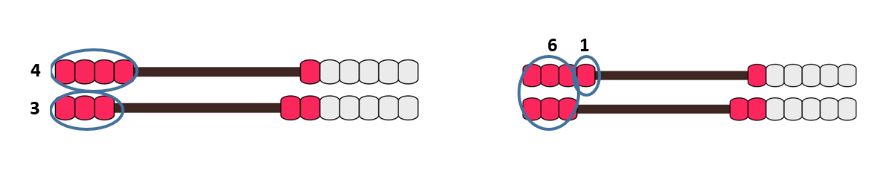
- Instruction provides opportunities to use a number balance to support understanding of the equal sign.
  - For example, students build the expression $5 + 6$ on one side of the balance and are asked to build an expression of equal magnitude of the other side. Students may choose to use a 9 and a 2, an 8 and a 3, or a 7 and a 4. Since students cannot use an 11 and must use two separate numbers instead, they are dispelling the misconception that the equal sign means “the answer is.”

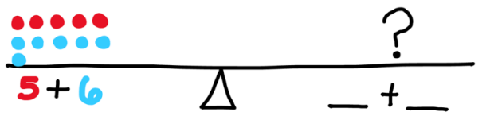

Instructional Tasks
Instructional Task 1 (MTR.3.1)
Lee had 14 building blocks. He then shared 6 of his blocks with his friend Remi. Create an equation to show how many building blocks Lee has now.

Instructional Task 2 (MTR.4.1)
The answer to a math equation is 15. Halsey says a true equation is $15=20-5$. Henry says a true equation is $11+4=15$. Who is correct? How do you know?

Instructional Items
Instructional Item 1
Tiffany says that $9=8+1$ is a true equation. Paulie says it is a false equation. Who do you agree with Tiffany or Paulie? Why?

Instructional Item 2
What does the equal sign in $11=10+1$ mean?

Instructional Item 3
Which of the following statements are true?
- $17=18-1$
- $16=16+1$
- $14-6=8$
- $12=12$
- $2+8=11$

Instructional Item 4
Create a true statement where 19 is the sum.

Instructional Item 5
Create a true statement where 17 is the difference.

*The strategies, tasks and items included in the B1G-M are examples and should not be considered comprehensive.

MA.1.AR.2.3

Benchmark
MA.1.AR.2.3 Determine the unknown whole number in an addition or subtraction equation, relating three whole numbers, with the unknown in any position.
Example: $9+?=12$
Example: $17=□+5$
Example: $?-4=8$

Benchmark Clarifications:
Clarification 1: Instruction begins the development of algebraic thinking skills where the symbolic representation of the unknown uses any symbol other than a letter.
Clarification 2: Problems include the unknown on either side of the equal sign.
Clarification 3: Addition and subtraction are limited to sums within 20 and related subtraction facts. Refer to Situations Involving Operations with Numbers (Appendix A).

Connecting Benchmarks/Horizontal Alignment
- MA.1.AR.1.2

Terms from the K-12 Glossary
- Equal Sign
- Equation
- Expression

Vertical Alignment
Previous Benchmarks  - MA.K.AR.2.1 | Next Benchmarks  - MA.2.AR.2.2
Purpose and Instructional Strategies
The purpose of this benchmark is for students to deepen their understanding of the equal sign and build relational thinking when looking at equations. In Kindergarten, students used objects or drawings to explain why addition or subtraction equations are true or false (MTR.5.1).
- Instruction includes helping students to begin to develop the algebraic skill of determining a number that makes an equation true.
- Within this benchmark, students are expected to understand the meaning of the equal sign and how equations are used to model mathematical situations and problems.
- Instruction includes an unknown value in any position (MTR.2.1).
- Instruction includes presenting equations in different forms such as $a+b=c$ or $c=a+b$ (MTR.2.1).
- Instruction may include the use of a balance scale representation or bar model to help students understand how to write equations (MTR.2.1, MTR.5.1).
- For example, a balance model and a “bar model” for $8=5+3$ are shown below.
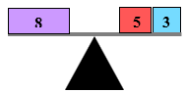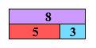

Common Misconceptions or Errors
  - Students may not understand that they can use addition to figure out a subtraction equation or use subtraction to figure out an addition equation. In these cases, ask students to find the related facts for a given problem.

Strategies to Support Tiered Instruction
- Teacher provides opportunities to use number bonds to develop an understanding of fact families and inverse relationships.
  - For example, students create a number bond for the number 9. Students then write the fact families for the number 9. Discussion should be focused on how the fact families are related and how knowing the addition facts can help the students solve a subtraction problem.

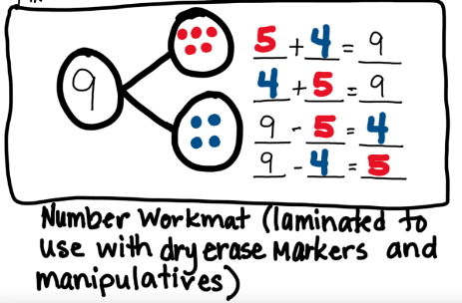

- Teacher models solving problems that highlight the relationship between addition and subtraction using connecting cubes. Then, students use two different colors to shade the addends on a ten frame.
  - Example:



Students write the addition fact that is represented by the connecting cubes $5 + 3 = 8$.
Students then subtract 3 from 8 by removing the three “orange” cubes.



Students are left with the 5 “blue” cubes, so $8 - 3 = 5$.
Students should practice with multiple addition facts. Discussion should be focused on the relationship between addition and subtraction.

Instructional Tasks
Instructional Task 1 (MTR.2.1)
Annette says the missing number for $18-\boxed{}=14$ is 8. Jessica says the missing number is 4. Use related facts to write an addition equation to show who is correct, Jessica or Annette. Use numbers, pictures and/or words to show your thinking.

Instructional Task 2 (MTR.2.1, MTR.4.1)
Emelio needs to find the missing number in the following number sentence: $\boxed{}-7=9$. Draw a picture to show Emelio how he could find the missing number. Then describe how you found the missing number.

Instructional Task 3 (MTR.3.1)
What missing number would balance the equation $10=7+\boxed{}$ ?

Instructional Items
Instructional Item 1
Which of the following equations are true with an unknown value equal to 8?
  - $19-\boxed{}=9$
  - $18-\boxed{}=10$
  - $\boxed{}=20-8$
  - $\boxed{}=2+6$
  - $4+5=\boxed{}$

Instructional Item 2
What is the missing addend in the equation $15=\boxed{}+6$?
- 15
- 10
- 9
- 5

Instructional Item 3
What addition equation could help to determine the unknown in the equation $13=\boxed{}-4$?
- $11+2=13$
- $10+4=14$
- $13+4=17$
- $4+8=12$
*The strategies, tasks and items included in the B1G-M are examples and should not be considered comprehensive.

Measurement

MA.1.M.1 Compare and measure the length of objects.

MA.1.M.1.1

Benchmark
MA.1.M.1.1 Estimate the length of an object to the nearest inch. Measure the length of an object to the nearest inch or centimeter.
Benchmark Clarifications:
Clarification 1: Instruction emphasizes measuring from the zero point of the ruler. The markings on the ruler indicate the unit of length by marking equal distances with no gaps or overlaps.
Clarification 2: When estimating length, the expectation is to give a reasonable number of inches for the length of a given object.

Connecting Benchmarks/Horizontal Alignment
- MA.1.NSO.1.1/1.2/1.4
- MA.1.NSO.2.2/2.4

Vertical Alignment
Previous Benchmarks  - MA.K.M.1.1/1.2/1.3 | Next Benchmarks  - MA.2.M.1.1
Purpose and Instructional Strategies
The purpose of this benchmark is for students to estimate length and formally and accurately measure the length of objects using a ruler. In Kindergarten, students used non-standard units such as paper clips to express the length of objects up to 20 units long (MTR.6.1).
- Instruction includes getting students to understand that estimating is about making a reasonable guess. It is not about getting a “right” answer but thinking logically about estimating lengths when thinking about centimeters or inches (MTR.6.1).
- Instruction includes noting that there is a larger number of centimeters for an object than when that object is measured in inches because an inch unit is longer than a centimeter unit (MTR.5.1).
- Estimation of measurement focuses on inches as students may be more familiar with U.S. customary units (MTR.2.1).

Common Misconceptions or Errors
- Some students may not line the zero marking on the ruler to one of the ends of the item being measured. Students need to explore why lining up at the zero point gives the most accurate measurement and have additional practice starting at 0 when measuring.
Students may measure with the incorrect side of the ruler (i.e., using the centimeter side when needing to measure in inches or using inches when needing to measure in centimeters).

Strategies to Support Tiered Instruction
- Instruction includes modeling how to measure an object and guiding students to notice that the object’s measurement does not change if the object is placed further down the ruler.
- Modeling includes identifying the endpoints of an object and lining the endpoint with the zero mark of the ruler. Note that often the “zero” mark is not labeled and may be the end of the ruler or on the very first tick mark depending on the ruler. State the correct measurement and then as the student watches, move the object down the ruler and ask, “Does the object’s measurement change if its endpoint lines up with a different number?”

- Instruction includes providing opportunities to make and use rulers so that students can construct their understanding of how lengths of each unit align to tick marks and numbers on a ruler.
- For example, students make and use their own ruler in 3 phases:
    - Using 1 inch paper square tiles glued to a strip of cardstock, students count the units that span an object to measure. They can see that the eraser has the same length regardless of where its endpoints are.

    - Labeling each square tile with a number in the center of the unit, students use numbers to count the units of measure.
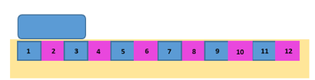
3. Students draw tick marks at the end of each unit with a number starting at zero as shown, then eliminate the square tiles. Students then compare this to a ruler to see how the numbers and tick marks correspond to the units of measure (inches). When we use a ruler, we measure the distance from the first to the second endpoint of the object.
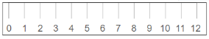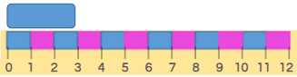

- Teacher provides instruction to discuss key differences between centimeters and inches. Write or draw about those differences to use as a reference during instruction.
- For example, a t-chart can be used to organize comparisons about inches and centimeters. Students can use sticky notes to draw pictures and write words or sentences about inches and centimeters.

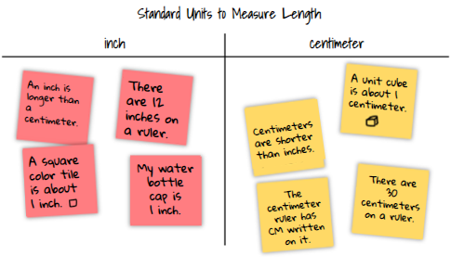
- Teacher can have students use the inch ruler that they created with only whole inch measurements. Then have students use a modified ruler like the one below with only inch and half-inch tick marks, instead of a ruler with tick marks to sixteenths.
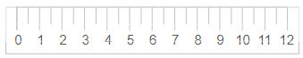
If students continue to confuse inches and centimeters when they are on different sides of the same ruler, they can use two different rulers, one with only inches and one with only centimeters.

Instructional Tasks
Instructional Task 1 (MTR.6.1)
Terri has a tiger plush toy that is 12 inches long. Her sister Kimberley has a smaller version of the same tiger plush toy. What would be a reasonable estimate for Kimberley’s tiger?

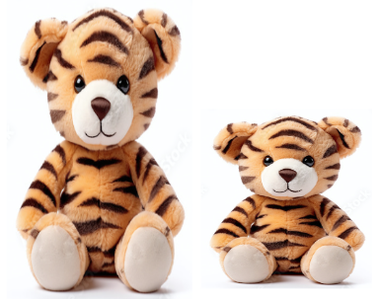
Instructional Task 2 (MTR.7.1)
Provide students with several objects to measure, such as a bouncy ball, paper clip, toy car or pencil. Use a table, like the one below to record answers for each part.

Object | Estimate (inches) | Actual Length (inches) | Difference Between Actual Length and Estimate (inches)

Part A. Estimate the length for each object in inches.
Part B. Use a ruler to measure the actual length of each object in inches.
Part C. Find the difference between the actual length and your estimate for each object in inches.
Part D. Measure the same objects in centimeters and record the length of each object in a table like the one below.

Object | Length (centimeters)

Enrichment Task 1 (MTR.7.1)
Extend Instructional Task 2 Part D by having students estimate centimeters before measuring.

Instructional Items
Instructional Item 1
If a reasonable estimate for the length of the broken eraser below is 1 inch, what would be a reasonable estimate in inches for the whole eraser shown?



Instructional Item 2
Kyle was measuring the length of his toy car. He stated his toy car was 4 inches long. Did Kyle measure the length of his toy car correctly? How do you know?
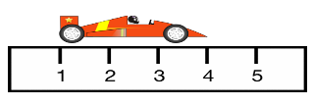
Inch

*The strategies, tasks and items included in the B1G-M are examples and should not be considered comprehensive.

MA.1.M.1.2

Benchmark
MA.1.M.1.2 Compare and order the length of up to three objects using direct and indirect comparison.
Benchmark Clarifications:
Clarification 1: When directly comparing objects, the objects can be placed side by side or they can be separately measured in the same units and the measurements can be compared.
Clarification 2: Two objects can be compared indirectly by directly comparing them to a third object.

Connecting Benchmarks/Horizontal Alignment
- MA.1.NSO.1.4

Vertical Alignment
Previous Benchmarks  - MA.K.M.1.2 | Next Benchmarks  - MA.2.M.1.2/MA.2.M.1.3
Purpose and Instructional Strategies
The purpose of this benchmark is to have students explore transitivity. Transitivity is a relation between three elements. For example, if object A is longer than object B and object B is longer than object C, then object A must be longer than C as well. In Kindergarten, students directly compared two objects with a common attribute. When directly comparing the length of the two objects, students used terms such as shorter, longer, taller and higher to describe the objects (MTR.1.1, MTR.5.1).

Common Misconceptions or Errors
- Some students may try to use a ruler to measure a length when reasoning alone would be sufficient to make an indirect comparison. In these cases, remind students that they can use reasoning rather than an actual measurement.
Students may mix units when measuring objects (where one item is measured in inches and another is measured in centimeters) when comparing their lengths.
Strategies to Support Tiered Instruction
- Instruction provides opportunities to reason using direct and indirect comparison. Real-world, inquiry-based tasks that involve situations in which a standard measurement tool is not provided are presented.
- For example, the teacher presents a task such as:
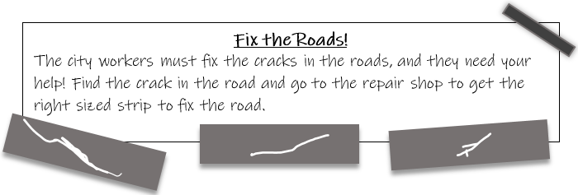
Students are provided with several pieces of construction paper “roads” with various sized tears to be the “cracks.” Across the room, place 3 different sized strips of paper to serve as the “repair shop.” Guide students to use indirect measurement such as comparing their hand to the size of the “crack” and then get a strip of paper that is equal to their comparison. If the strip is too long or too short, they will return to the “repair shop” to get the right size.
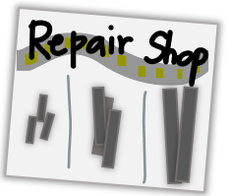
  - After the task is completed, students will use comparison language to describe the lengths of the strips of paper using sentence frames like
  - “Strip A is shorter than Strip B” and “Strip C is the longest.”
- Instruction provides opportunities for students to measure objects to compare and order their lengths. If students confuse inches and centimeters when they are on different sides of the same ruler, they can use two different rulers, one with only inches and one with only centimeters.

Instructional Tasks
Instructional Task 1 (MTR.4.1)
Adeline, Eli and Sarai are comparing their pieces of yarn. Adeline says her piece of yarn is the same length as Sarai’s piece of yarn. Eli says his piece of yarn is longer than Sarai’s piece of yarn. Draw what Adeline, Eli and Sarai’s yarn pieces could look like. Make sure to label each child’s yarn. Who had the longest piece of yarn?
With a partner, discuss how your drawings are similar and different. Do you or your partner need to make changes to your work?

Instructional Task 2 (MTR.6.1)
Around your classroom look for an object that could fit in the box below. Then complete the task by following the directions below. When measuring the length of the objects, choose inches or centimeters. Label your measurements with the same unit each time.

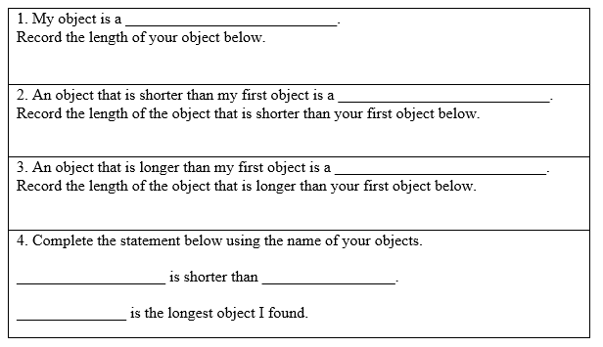

Instructional Items
Instructional Item 1
Jamal needs to write a true statement about his towers shown here. Which statement below is true?
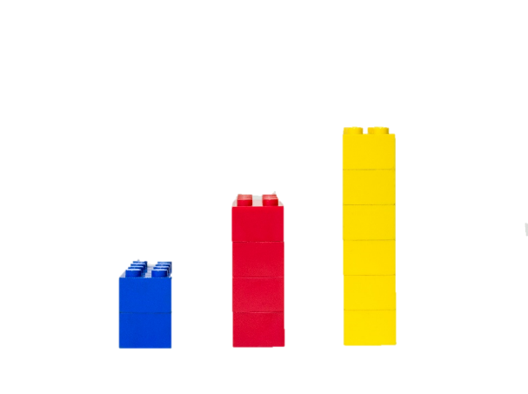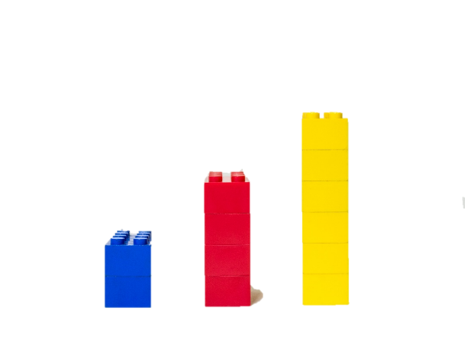

- The red tower is the tallest tower.
- The yellow tower is the shortest tower.
- The blue tower is taller than the red tower.
- The red tower is shorter than the yellow tower.

Instructional Item 2
Look at the rectangles below. Color the longest rectangle blue. Color the shortest rectangle red. Write two sentences to describe your rectangles.

Instructional Item 3
Look at the cube train below.

Part A. Use a blue crayon to draw something longer than the cube train.
Part B. Use a red crayon to draw something shorter than the cube train.
Part C. Use a yellow crayon to draw something that is equal in length to the cube train.
Part D. Write a true statement about the blue and red drawings.

*The strategies, tasks and items included in the B1G-M are examples and should not be considered comprehensive.

MA.1.M.2 Tell time and identify the value of coins and combinations of coins and dollar bills.

MA.1.M.2.1

Benchmark
MA.1.M.2.1 Using analog and digital clocks, tell and write time in hours and half-hours.
Benchmark Clarifications:
Clarification 1: Within this benchmark, the expectation is not to understand military time or to use a.m. or p.m.
Clarification 2: Instruction includes the connection to partitioning circles into halves and to semi-circles.

Connecting Benchmarks/Horizontal Alignment
- MA.1.FR.1.1

Vertical Alignment
Previous Benchmarks  - This is the first introduction to the concept of telling time. | Next Benchmarks  - MA.2.M.2.1
Purpose and Instructional Strategies
The purpose of this benchmark is for students to begin to formally tell and write time.
- Instruction includes getting students familiar with an analog clock as to what the hour hand and minute hand are and how to tell time with both digital and analog clocks (MTR.2.1, MTR.5.1). The focus in grade 1 is learning to read a clock.
- Instruction includes providing opportunities for students to manipulate analog clocks and to discuss and work with time in context (MTR.5.1, MTR.7.1).
- Instruction connects partitioning clocks in half as a representation of half an hour.
  - For example, half the clock represents half of an hour.
- Instruction can include a connection to skip counting by fives from 0 to 30 to know that 30 means the number of minutes.
- Within this benchmark, it is not the expectation for students to round all given times to the hour or half-hour, rather all given times should be shown in hours and half-hours.

Common Misconceptions or Errors
- Students may confuse the minute hand and the hour hand.
- Students may confuse which hour to read when the hour hand is between two numbers.
- Students may get distracted by the second hand on a real analog clock.

Strategies to Support Tiered Instruction
- Teacher provides a small clock with the minute hand removed. Instruction includes identifying where the arrow on the hour hand is pointing, how that hour is read and what is happening to the hour hand as time passes. Student-friendly language about the time includes approximations such as:
  - Example:

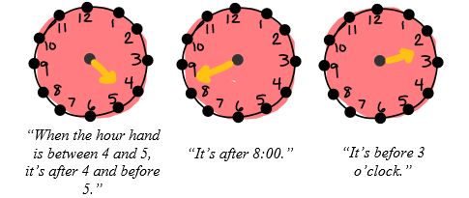

- Instruction includes making connections to the partitioning of a circle into two equal halves.
  - For example, a clock can be partitioned into two equal halves by drawing a line or by folding the clock in half, noting the semi-circle shape of half hours.
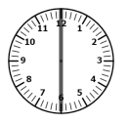

- Instruction includes showing that when the minute hand is pointing at the 12, we read it as “o’clock” and write __:00. When the minute hand is pointing at the 6, we read and write __:30.

Instructional Tasks
Instructional Task 1 (MTR.2.1)
Part A. Look at each analog clock below, write the digital time for the clock.
Part B. Sort analog and digital clock cards that show times to the hour or half-hour by placing them on the correct side of the chart below.
Part C. With a partner, compare your answers and explain how you know you put the time in the correct spot.

Time to the hour | Time to the half hour

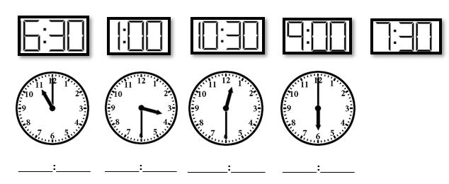
Instructional Task 2 (MTR.5.1)

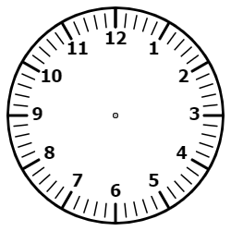

Part A. Use a blue crayon to color the clocks above that are partitioned into halves.
Part B. Use a yellow crayon color the clocks above that are partitioned into fourths.

Instructional Items
Instructional Item 1
Match the digital clock with the analog clock that has the same time.

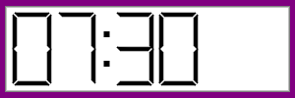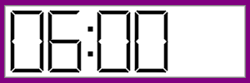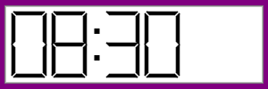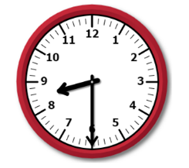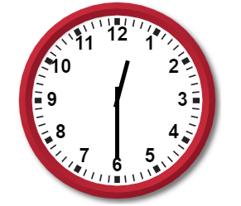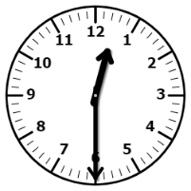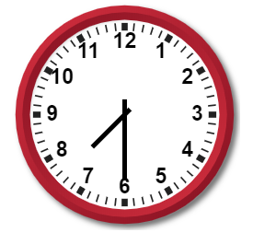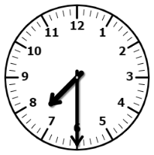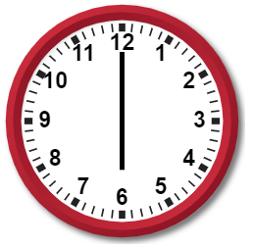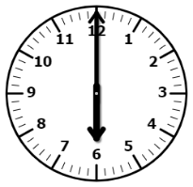

Instructional Item 2
Part A. Robbie went to lunch at eleven-thirty. Show the time that Robbie went to lunch on the analog and digital clock below.

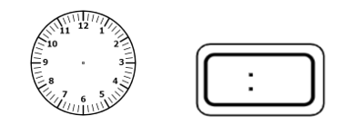

Part B. What do you notice about the minute hand on the clock when thirty minutes have passed since 11 o’clock?

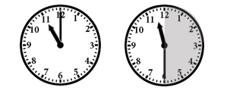

*The strategies, tasks and items included in the B1G-M are examples and should not be considered comprehensive.

MA.1.M.2.2

Benchmark
MA.1.M.2.2 Identify pennies, nickels, dimes and quarters, and express their values using the ¢ symbol. State how many of each coin equal a dollar.
Benchmark Clarifications:
Clarification 1: Instruction includes the recognition of both sides of a coin.
Clarification 2: Within this benchmark, the expectation is not to use decimal values.

Connecting Benchmarks/Horizontal Alignment
- MA.1.NSO.1.1

Vertical Alignment
Previous Benchmarks  - This is the first grade level where students will explore money concepts. | Next Benchmarks  - MA.2.M.2.2
Purpose and Instructional Strategies
The purpose of this benchmark is for students to formally recognize the respective value of coins (MTR.5.1, MTR.7.1).
- Instruction includes both the front and back sides of pennies, nickels, dimes and quarters.
- Instruction emphasizes that the relative size of the coin is not representative of its value in comparison to other coins (MTR.5.1).
- Instruction uses the format $25¢$, not $\$0.25$.

Common Misconceptions or Errors
- Students may believe the value of a coin is directly related to its size (e.g., a nickel is bigger than a dime and is worth more, or a penny is bigger than a dime, so it must also be worth more). Students need additional practice identifying a coin with its actual value.
- Students may have difficulty understanding the relationship between the number of coins that equal a dollar because they are familiar with each object having the value of 1 when counting.

Strategies to Support Tiered Instruction
- Teacher provides opportunities to use descriptive language to discuss observable details of each coin and record their observations in a chart. Students can use a magnifying lens to notice details closely. As students practice identifying coins with their values, they can use the chart as a reference.
  - For example, a chart (like the one below) can be used to organize the information students observe about the coins. Student misconceptions about coins can be observed by the teacher and guided toward understanding in the “What do you notice or wonder?” column.

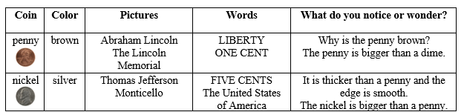

Information from the chart can be made into cards for students to sort using each coin name as a header.
  - Teacher asks questions to elicit ideas of what students notice about the coins and those that require students to make comparisons such as:
- “What do you notice about the outside edge of this coin? Why do you think some coins have ridges?”
- “Who is on the smallest coin?”
- “What are the words you see on the penny?”
- “Do all of the coins tell their value?”
- Teacher provides a hundreds chart to help students see the relationships between coin values and how many of each coin equal a dollar. Students can lay pennies on the hundreds chart to count by ones. They can lay nickels on the chart to skip count by 5s and dimes on the chart to skip count by 10s to 100. Students may also use the hundreds chart to see why there are 4 quarters in a dollar; they can count 25 between each quarter laid on the chart.
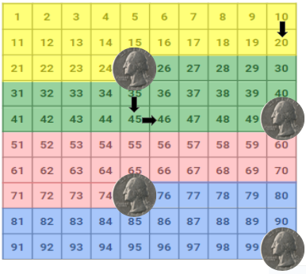

Instructional Tasks
Instructional Task 1 (MTR.7.1)
Part A. Using the table below, identify each coin’s name and the value.
Part B. With a partner, compare your value column and discuss if you both came up with the same values. What could you do to figure out who is right or check your work for accuracy?
Part C. Work with your partner to find how many of each coin equal a dollar. How do you know?

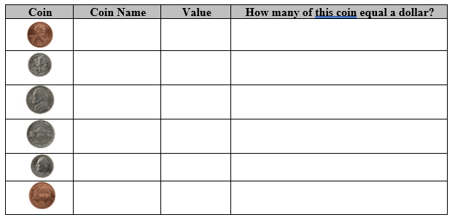

Instructional Items
Instructional Item 1

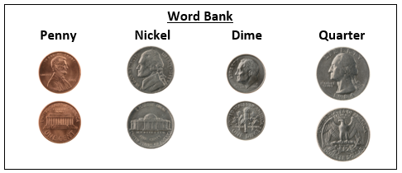

Complete the table using the word bank above.

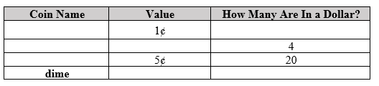

*The strategies, tasks and items included in the B1G-M are examples and should not be considered comprehensive.

MA.1.M.2.3

Benchmark
MA.1.M.2.3 Find the value of combinations of pennies, nickels and dimes up to one dollar, and the value of combinations of one, five and ten dollar bills up to $100. Use the ¢ and $ symbols appropriately.
Benchmark Clarifications:
Clarification 1: Instruction includes the identification of a one, five and ten dollar bill and the computation of the value of combinations of pennies, nickels and dimes or one, five and ten dollar bills.
Clarification 2: Instruction focuses on the connection to place value and skip counting.
Clarification 3: Within this benchmark, the expectation is not to use decimal values or to find the value of a combination of coins and dollars.

Connecting Benchmarks/Horizontal Alignment
- MA.1.NSO.1.1
- MA.1.NSO.2.3/2.4
- MA.1.AR.1.1

Vertical Alignment
Previous Benchmarks  - MA.K.NSO.2.1 | Next Benchmarks  - MA.2.M.2.2
Purpose and Instructional Strategies
The purpose of this benchmark is for students to relate skip counting by 5s and 10s with counting a sequence of coins or bills. Students will relate the coin or bill to its value. In Kindergarten, students skip counted by 10s (MTR.2.1, MTR.5.1, MTR.7.1).
- Instruction includes and reinforces strategies for addition.
- Instruction includes helping students to realize that it may be easier to first skip count by tens using dimes, and then by fives using nickels, with pennies being added last.
- Instruction includes making a connection to tally marks by putting pennies into groups of five.
- Instruction uses the format $25¢$, not $\$0.25$.

Common Misconceptions or Errors
- Students may believe the value of a coin is directly related to its size (e.g., a nickel is bigger than a dime and is worth more, or a penny is bigger than a dime, so it must also be worth more). Students may need additional practice identifying a coin with its actual value.
- Students may not count coins as a sequence of their value and make mistakes in counting. Have students identify coins with their value prior to counting. Then have students explore ways to count the coins that make sense for them (i.e., counting dimes then nickels and pennies).

Strategies to Support Tiered Instruction
- Since combinations of pennies, nickels, and dimes are up to one dollar, provide students with a hundreds chart to organize their coins and provide opportunities to see that it may be easier to first skip count by tens using dimes, and then skip count by fives using nickels, with pennies being counted last by ones.
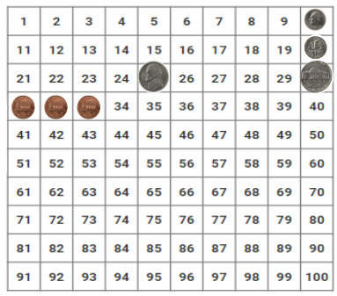

- Teacher provides opportunities to trade coins for equal values to find it easier to count the coin collection and to practice counting coin collections.
  - For example, students can take turns “trading up to a dollar (or 100 dollars)” using a tray of sorted coins pennies, nickels, and dimes (or one, five, and ten dollar bills), enough to allow for multiple rounds of trading, and dice or dot cards. Each student will take a turn rolling a die or flipping a dot card. On their turn, the student takes that many pennies (or dollars) from the bank, counts the total amount they have, and then determines if a “trade” can be made (i.e., trade 5 pennies for a nickel or 2 nickels for a dime.) Each student continues to take turns and make trades until one player has enough to exchange for the $1 (or $100 dollar) bill.

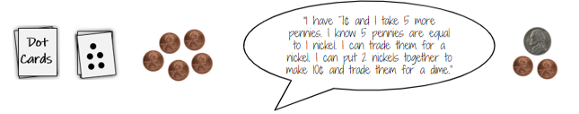
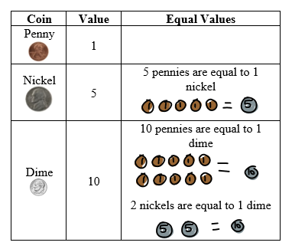
Instructional Tasks
Instructional Task 1 (MTR.7.1)
Part A. Matt counted coins that he found in his pocket. How much money does he have?
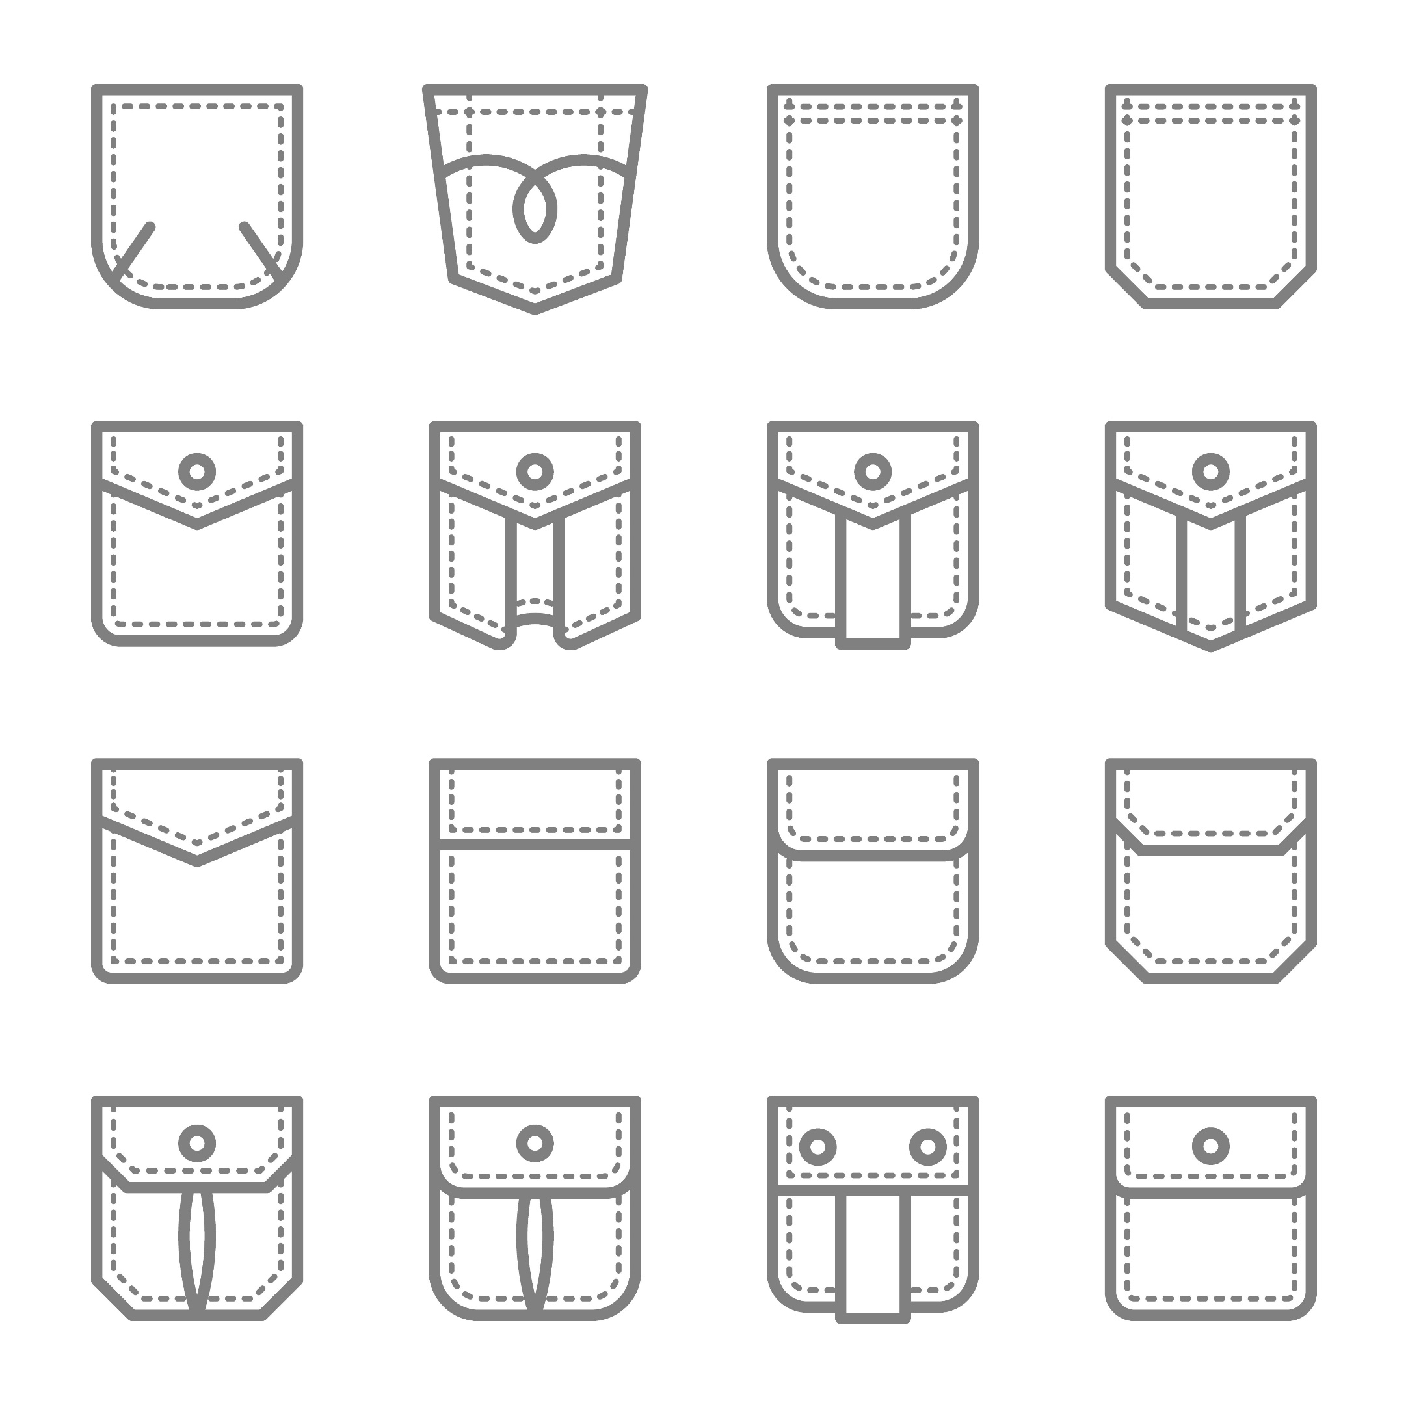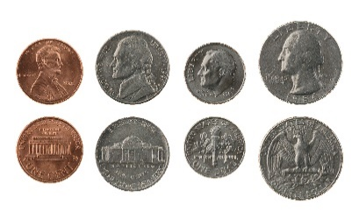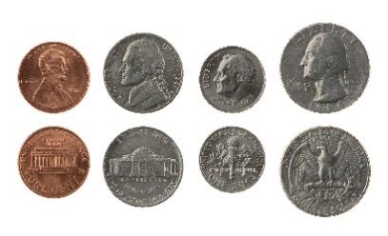
Part B. Matt’s friend gave him the five coins shown below. Count on from the coins Matt had in his pocket. How much money does Matt have now?
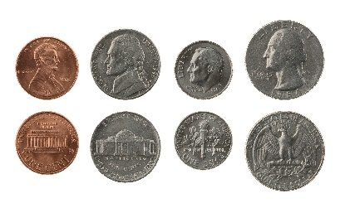

Instructional Items
Instructional Item 1
There are three dimes and seven pennies on the table. What is the total value of the coins?

Instructional Item 2
What is the value of the coins shown?


Instructional Item 3
What is the value of the dollar bills shown?


*The strategies, tasks and items included in the B1G-M are examples and should not be considered comprehensive.

Geometric Reasoning

MA.1.GR.1 Identify and analyze two- and three-dimensional figures based on their defining attributes.

MA.1.GR.1.1

Benchmark
MA.1.GR.1.1 Identify, compare and sort two- and three-dimensional figures based on their defining attributes. Figures are limited to circles, semi-circles, triangles, rectangles, squares, trapezoids, hexagons, spheres, cubes, rectangular prisms, cones and cylinders.
Benchmark Clarifications:
Clarification 1: Instruction focuses on the defining attributes of a figure: whether it is closed or not; number of vertices, sides, edges or faces; and if it contains straight, curved or equal length sides or edges.
Clarification 2: Instruction includes figures given in a variety of sizes, orientations and non-examples that lack one or more defining attributes.
Clarification 3: Within this benchmark, the expectation is not to sort a combination of two- and three-dimensional figures at the same time or to define the attributes of trapezoids.
Clarification 4: Instruction includes using formal and informal language to describe the defining attributes of figures when comparing and sorting.

Connecting Benchmarks/Horizontal Alignment
MA.1.DP.1.1

Terms from the K-12 Glossary
- Circle
- Cone
- Cube
- Cylinder
- Edge
- Hexagon
- Rectangle
- Rectangular Prism
- Square
- Sphere
- Trapezoid
- Triangle
- Vertex

Vertical Alignment
Previous Benchmarks  MA.K.GR.1.1 | Next Benchmarks  - MA.2.GR.1.1/1.2
Purpose and Instructional Strategies
The purpose of this benchmark is for students to recognize figures by their defining attributes as this will help them sort figures based on attributes rather than orientation, color or size. In Kindergarten, students identified circles, triangles, rectangles, squares, spheres, cubes, cones, and cylinders by a defining attribute (MTR.2.1, MTR.5.1).
- Instruction includes a variety of examples and non-examples that lack a defining attribute.
- While the K-12 Glossary uses the inclusive definition of a trapezoid, students will not formally identify or classify trapezoids until grade 3.

Common Misconceptions or Errors
- Students may only recognize a figure by its size or orientation. In these cases, students need practice in locating figures by a defining attribute like “find the two-dimensional figures with three vertices” rather than find the triangles. Students may struggle with formal language as they are introduced to content specific vocabulary. For example, when learning the definition for vertex as defined in the K-12 Glossary as “the point at which the rays or sides of an angle, the sides of a two-dimensional figure, or the edges of a three-dimensional figure meet”, and seeing examples of vertices, students may only assume vertices can occur on figures with straight sides. A circle has no vertices, so they may assume that a semi-circle also has no vertices. However, a semi-circle has 2 points where the sides of the figure would meet, as shown below.
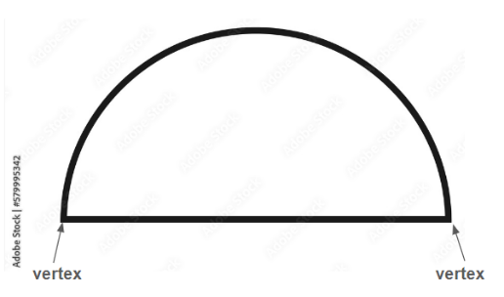

Strategies to Support Tiered Instruction
- Teacher may provide students with a collection of two-dimensional shapes to do the following activities in order:
  - Begin “Collect and Display” by asking the students to sort the shapes into groups any way they like. Then be prepared to capture the language they use in describing the shapes (i.e. students may create a group that includes squares and rectangles because they all have “corners”). Generate a list of the informal language used here and display it on chart paper next to the shapes being used.
  - Ask the students which words were important to know as they did their sort. As students respond, annotate on the chart paper and shapes to help them make the connection. For example, a student might refer to “corners” as something that helped them create their group of rectangles and squares. Write the formal term next to the student language on the chart to help them make the connection to vocabulary. The teacher might write “vertex” next to the word “corner” in the above example.
  - Keep and display the chart for future activities and remind the students to borrow language from the chart as needed.
- Instruction provides opportunities to build shapes on a geoboard as the teacher calls out defining attributes (i.e., “make a two-dimensional figure with three vertices” and remind them that they can use the chart from the activity above). After creating a correct figure, the teacher has students rotate the geoboard 45 degrees to see that it is still the same figure.
  - Example:

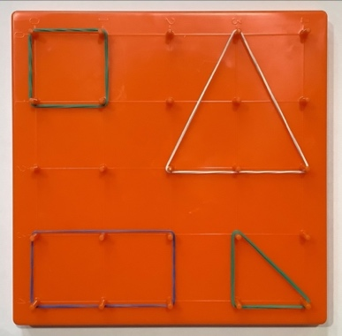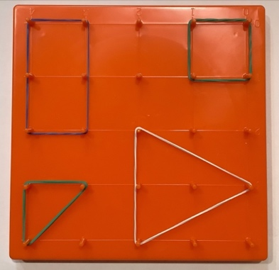

- Teachers may limit the amount and types of shapes built on the geoboard (i.e., only build a square or triangle) if students have difficulty with multiple shapes.
  - Example:

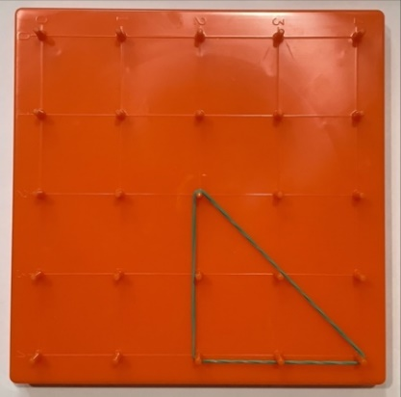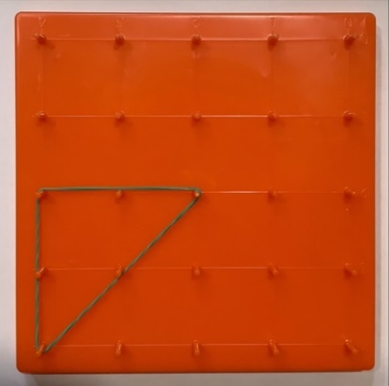

Instructional Tasks
Instructional Task 1 (MTR.4.1)
Provide students pictures of figures like the one provided below.
Part A. Sort the figures by ones that have three sides and ones that have four or more sides.
Part B. Discuss what they notice about the figures they sorted that have three sides. What is a two-dimensional figure called that has three sides? Ask students what they notice about the triangles. Are they all the same size? Do they all look the same? What makes them triangles?
Part C. Have students look at the figures they sorted in the “four or more sides” pile. What could these figures be sorting further by? Once students determine an attribute they can sort by, have students sort by that attribute.
Part D. How did you sort the figures? Ask students what they notice about the figures. Are they all the same size? Do they all look the same? Are they all the same figure?
Part E. Discuss which attributes put all the same figures together and which did not. Have students take their sorted shapes to create a pictograph by stacking their shapes on top of each other.
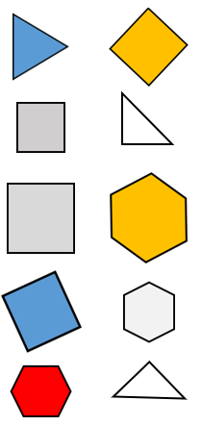

Instructional Items
Instructional Item 1
Which of the figures below is a triangle? How do you know?

Instructional Item 2
This is a cone. What makes this a cone?


Instructional Item 3
Jill says these two shapes are both cubes. Do you agree with her? Why or why not?

*The strategies, tasks and items included in the B1G-M are examples and should not be considered comprehensive.

MA.1.GR.1.2

Benchmark
MA.1.GR.1.2 Sketch two-dimensional figures when given defining attributes. Figures are limited to triangles, rectangles, squares and hexagons.

Connecting Benchmarks/Horizontal Alignment
There are no direct connections outside of this standard, however teachers are encouraged to find possible indirect connections.

Terms from the K-12 Glossary
- Triangle
- Rectangle
- Square
Hexagon

Vertical Alignment
Previous Benchmarks  - MA.K.GR.1.1/1.2/1.3 | Next Benchmarks  - MA.2.GR.1.1
Purpose and Instructional Strategies
The purpose of this benchmark is to allow students to use their understanding of the various attributes to sketch a two-dimensional figure. In Kindergarten, students identified, compared and found real world two-dimensional figures of circles, triangles and rectangles regardless of their size or orientation; however, they did not formally sketch the figures (MTR.5.1).
- Instruction includes guiding students to use defining attributes such as number of sides, number of vertices and side lengths to draw two-dimensional figures. Students are not expected to use a ruler or straight edge to draw a more precise figure until grade 2 (MTR.5.1).
- Instruction includes the use of graph paper, grid paper or dot paper to assist students with drawing figures.
- Instruction includes the use of both formal and informal language.

Common Misconceptions or Errors
- Students may get confused when asked to draw a two-dimensional figure that has four sides and four vertices. With only those attributes given, students could draw a square or a rectangle as either is acceptable given those attributes.
- Students may struggle with formal vocabulary terms.

Strategies to Support Tiered Instruction
- Teacher may refer to the benchmark MA.1.GR.1.1 Strategy to Support Tiered Instruction activity “Collect and Display”. If “Collect and Display” has been started, encourage students to refer to the chart as needed for language support during the following activities.
- Teacher provides opportunities to build shapes on a geoboard by calling out an attribute and asking students to create a shape on a geoboard that have said attribute. Students then draw the representation in the math journal or on geoboard paper. Encourage students to refer to the “Collect and Display” poster from previous activities to help them make connections to formal content vocabulary.
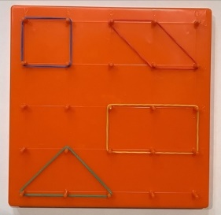
- Teacher provides pattern blocks and asks students to find the shape with specific attributes (such as 3 sides and 3 vertices). The students choose from the group of pattern blocks the shape that matches the attributes. The students can then trace the correct shape in the math journal.
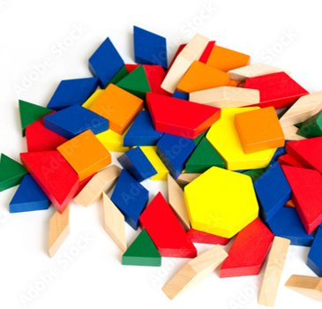
Instructional Tasks
Instructional Task 1 (MTR.7.1)
Place the pictures of triangles, rectangles, squares and hexagons from below around your classroom. To ensure students have additional items to choose from, students may choose to use objects in the classroom as well. Some photos contain multiple figures that students could use for their sketches.
Part A. Look around your classroom for items that have the same attribute as listed. Sketch the items and label what you found.
Part B. Compare with a partner and explain how you know your items have those attributes. Discuss what you notice about the sketches for items that have three vertices and the sketches that have three sides.

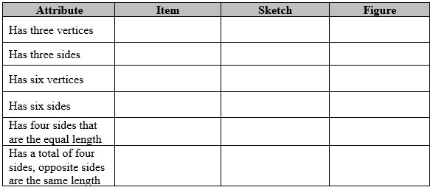
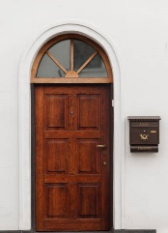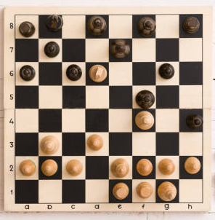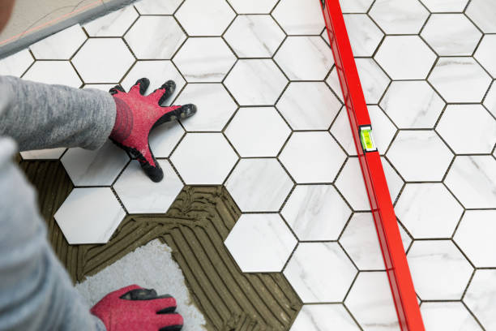

Instructional Items
Instructional Item 1
Draw a figure with six sides and six vertices. What figure did you draw?

Instructional Item 2
Draw a triangle. How do you know it is a triangle?

*The strategies, tasks and items included in the B1G-M are examples and should not be considered comprehensive.

MA.1.GR.1.3

Benchmark
MA.1.GR.1.3 Compose and decompose two- and three-dimensional figures. Figures are limited to semi-circles, triangles, rectangles, squares, trapezoids, hexagons, cubes, rectangular prisms, cones and cylinders.
Example: A hexagon can be decomposed into six triangles.
Example: A semi-circle and a triangle can be composed to create a two-dimensional representation of an ice cream cone.
Benchmark Clarifications:
Clarification 1: Instruction focuses on the understanding of spatial relationships relating to part-whole, and on the connection to breaking apart numbers and putting them back together.
Clarification 2: Composite figures are composed without gaps or overlaps.
Clarification 3: Within this benchmark, it is not the expectation to compose two- and three- dimensional figures at the same time.

Connecting Benchmarks/Horizontal Alignment
- MA.1.NSO.1.3
- MA.1.FR.1.1

Terms from the K-12 Glossary
- Cone
- Cube
- Cylinder
- Hexagon
- Rectangle
- Rectangular Prism
- Square
- Trapezoid
- Triangle

Vertical Alignment
Previous Benchmarks  - MA.K.GR.1.5 | Next Benchmarks  - MA.2.GR.1.3
Purpose and Instructional Strategies
The purpose of this benchmark is to promote students’ spatial reasoning. Students should begin to see figures as compositions of other figures. In Kindergarten, students combined triangles, rectangles, and squares to form composite figures.
- Instruction should include guiding students to ensure that when composing a new three- dimensional figure those figures should have one set of the faces touching without gaps or overlaps.
  - For example, the flat surface of a cone touching one face of a cube.
- Instruction includes making a connection to partitioning shapes.

Common Misconceptions or Errors
- Students may not initially recognize that a figure can be made using other figures. Class activities should promote exploring what figures could make a given figure.
  - For example, using pattern blocks a student could manipulate two triangles to make a square, four triangles to make a rectangle, or six triangles to make a hexagon.

Strategies to Support Tiered Instruction
- Teacher may provide opportunities to identify shapes around the school. This could happen, for example, while transitioning between the classroom to other areas of the school. When possible, trace shapes with sidewalk chalk (such as the rectangles that make up sections of the sidewalks or the bricks in the wall).
- Teachers may provide students with colorful tape to highlight shapes around the classroom (windows, doors, cupboards, desks, etc.) to make them visible.
- Instruction could include providing students with a collection of pattern blocks or paper shapes and asking them to create a new shape out of the individual shapes.
  - For example, students may manipulate two triangles to make a square, four triangles to make a rectangle and six triangles to make a hexagon.
 |  | 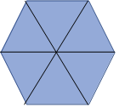
- Teacher provides a set of tangram pieces for the students create their own tangram animal. If a student has trouble getting started, provide students with an outline of an animal and ask the student to fill in the outline using the shapes given. If tangram pieces are not available to the teacher, the teacher may use a search engine to print a set of tangram pieces to copy.
  - For example, the teacher may say, “Here is a tangram animal. What animal can you create on your own?”

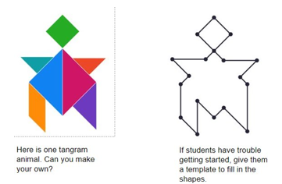
- Instruction may include providing students with a three-dimensional composite shape and asking them what smaller solid shapes could be used to make the composite shape.
  - For example, an orange sports cone and an empty container of rolled oats may be secured together and wrapped in paper to give the appearance of a singular shape. Set the shape on the table and ask students to figure out which of the solid shapes provided could be used to recreate the given composite shape. Students may use a cylinder and a cone to build the given three-dimensional shape.

Instructional Tasks
Instructional Task 1 (MTR.5.1)
Provide pattern blocks to students; be sure students get at least six triangles, two squares, two trapezoids and one hexagon. Read the directions to students and give students time to explore to find possible solutions. After students have come up with solutions, have discussion around whether all students found the same solution or if they had different solutions. Ask students if they could come up with a different response.

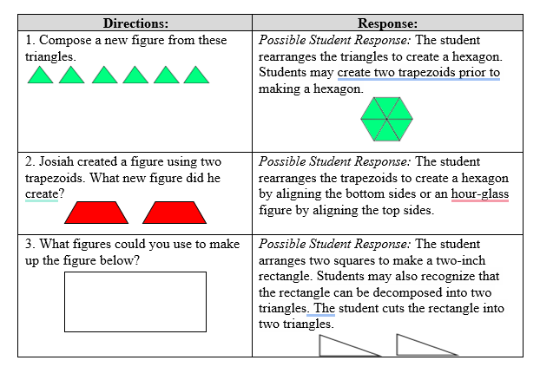

Instructional Items
Instructional Item 1
What three-dimensional figures make up the composite figure below?
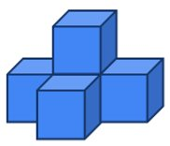

Instructional Item 2
What two-dimensional figures make up the figure below?

Instructional Item 3
How many of the squares would you need to tile the rectangle below with no gaps or overlaps?
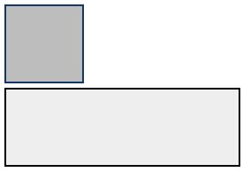

*The strategies, tasks and items included in the B1G-M are examples and should not be considered comprehensive.

MA.1.GR.1.4

Benchmark
MA.1.GR.1.4 Given a real-world object, identify parts that are modeled by two- and three-dimensional figures. Figures are limited to semi-circles, triangles, rectangles, squares and hexagons; spheres, cubes, rectangular prisms, cones and cylinders.

Connecting Benchmarks/Horizontal Alignment
- MA.1.FR.1.1
- MA.1.DP.1.1

Terms from the K-12 Glossary
- Cone
- Cube
- Cylinder
- Hexagon
- Rectangle
- Rectangular Prism
- Square
- Sphere
- Triangle

Vertical Alignment
Previous Benchmarks  - MA.K.GR.1.4 | Next Benchmarks  - MA.2.GR.1.1
Purpose and Instructional Strategies
The purpose of this benchmark is for students to recognize that real-world objects can be modeled by two- and three-dimensional figures. In Kindergarten, students looked for real-world objects that could be modeled by a given two- or three-dimensional figure. Instructional time for the Kindergarten benchmark was focused on circles, triangles, rectangles, squares, spheres, cubes, cones and cylinders (MTR.7.1).
- Instruction includes guiding students to recognize attributes of three-dimensional figures that are identifiable and found in real-world objects.
  - For example, a castle tower shares the attributes of a cone and cylinder.

Common Misconceptions or Errors
- Students may not initially recognize that real-world objects can be composed of multiple figures.

Strategies to Support Tiered Instruction
- Teacher provides geoboards to students and displays a shape for the students to copy. The teacher specifies the number of small shapes they should use to decompose the large shape. Specify whether the large shapes should be congruent or just the same type.
  - For example, a isosceles trapezoid is displayed for students. The teacher says, “Break apart this shape into three same sized triangles”.
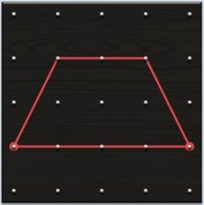

For example, a rectangle is displayed for students. The teachers says, “Break this shape apart into four triangles”
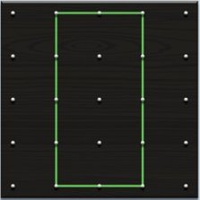

  - For example, an irregular shape is displayed for students. The teacher says “What is the fewest number of triangles that will fit this shape?”

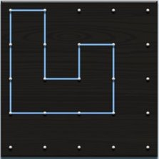

  - For example, an irregular shape is displayed for students. The teacher says, “Fill this shape with three rectangles all the same”
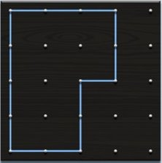

- Teacher provides geometric solid shapes. Students are asked to find objects around the classroom (or school or playground) that look like any one of their wooden solids.
  - For example, “What things did you find that were shaped like your wooden figures?,” “What things did you find that were made by people?,” or “What things did you find in nature?”

- Teacher provides geometric solid shapes and pattern blocks that reflect skill deficits (i.e., the student has trouble identifying cylinders in real-world context). Teacher instructs students to pick up the solid figure and say the name. Student repeats the name of the figure and identifies something in the environment that looks like the solid figure.

Instructional Tasks
Instructional Task 1 (MTR.7.1)
Place the pictures of real-world objects around your classroom. Photos contain real-world objects that model two and three-dimensional figures. Say to the students, “Look around our classroom at the pictures of real-world objects. In the first column, write the name of the object in the picture. Then list the figures that compose that object and explain your reasoning.

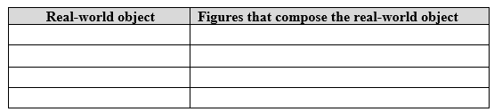






Instructional Items
Instructional Item 1
Combine two solid figures that would model a real-world object.

Instructional Item 2
What solid figures have been combined to make this tower?



*The strategies, tasks and items included in the B1G-M are examples and should not be considered comprehensive.

Data Analysis & Probability

MA.1.DP.1 Develop an understanding for collecting, representing and comparing data.

MA.1.DP.1.1

Benchmark
MA.1.DP.1.1 Collect data into categories and represent the results using tally marks or pictographs.
Example: A class collects data on the number of students whose birthday is in each month of the year and represents it using tally marks.
Benchmark Clarifications:
Clarification 1: Instruction includes connecting tally marks to counting by 5s.
Clarification 2: Data sets include geometric figures that are categorized using their defining attributes and data from the classroom or school.
Clarification 3: Pictographs are limited to single-unit scales.

Connecting Benchmarks/Horizontal Alignment
- MA.1.NSO.1.1
- MA.1.GR.1.1

Vertical Alignment
Previous Benchmarks  - MA.K.DP.1.1 | Next Benchmarks  - MA.2.DP.1.1

Purpose and Instructional Strategies
The purpose of this benchmark is to get students thinking about how they can organize information in a way that can be interpreted. In Kindergarten, students collected and sorted objects. Students recorded their results either verbally, with written numerals or drawings. The expectation is not for students to create a graph on their own (MTR.5.1).
- Instruction includes providing opportunities for students to understand that bundling tally marks into groups of five allows for more efficient counting of larger data sets (MTR.5.1).
- Instruction includes guiding students to skip count by 5s when using tally marks that have been bundled into fives (MTR.3.1).
- Instruction includes real-world context for data representations (MTR.7.1).
- Instruction includes providing opportunities for students to choose a representation (pictograph or tally marks) for their data set and have discussions of the efficiency of the representation.
Instruction includes the understanding that different types of graphs are useful in representing different contexts.

Common Misconceptions or Errors
- Students may not recognize that when using tally marks they make a slash through four tally marks to represent a bundle of five tally marks.
- Students may misrepresent the count for each data point.
Strategies to Support Tiered Instruction
- Teacher models how to make groups of five using straws and gives students straws and have students practice placing straws in groups of five, including how to arrange the fifth straw in a group. The teacher has the students practice counting the straws in groups of five and then records the number of straws they counted using both tally marks and numerals. If the student isn’t sure how to draw a bundle of five tally marks correctly, the teacher shows them how to draw the fifth tally mark diagonally across four tally marks. The teacher has the student count each tally mark to verify that there are five tallies. Next the teacher models how to make groups of six and has the student show them where they would place a sixth tally mark as it should be near the bundle of five but not a part of the bundle. Next, the teacher has the students practice placing a sixth straw in their bundle. Once the students have successfully modeled how to create six with straws, the teacher asks the students to draw larger numbers, such as seven or nine with tally marks and record the numeral.
- Teacher provides data that shows which type of cookie students like the most: chocolate chip, sugar, or peanut butter. The table below shows which cookie type each student picked. Organize that data using a pictograph.
  - For example, students can draw circles to represent each cookie.

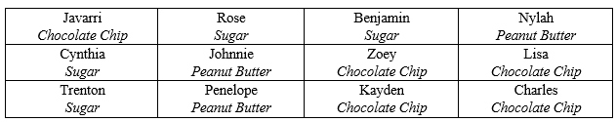
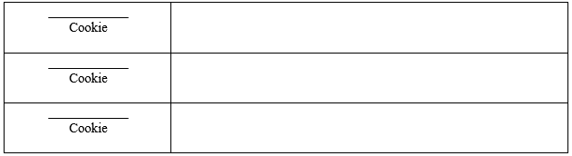

Instructional Tasks
Instructional Task 1 (MTR.3.1)
Josie was sorting figures for her teacher and made a tally chart for the figures she put in the bin. The bell rang before Josie had a chance to sort all the figures and finish her chart. Help Josie finish by adding tally marks for the figures she hasn’t sorted yet.

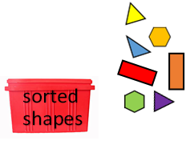

Instructional Items
Instructional Item 1
The students in Mrs. Frank’s class collected data on the color of shirts they would wear on the school field trip. Students could choose red, blue or green. Organize the data using a pictograph. Teacher Tip: Students may sketch circles to represent shirts.

Tameka- red | Cindy- blue | Mark- blue
Randy- blue | Lin- blue | Greg- red
Raphael- green | Lisa- green | Shawna- blue

_____________ shirts
_____________ shirts
_____________ shirts

Instructional Item 2
Julie wants to know the favorite flavor of milk for first grade students. Is it chocolate, vanilla or strawberry milk? Collect data from your classmates on their favorite flavor of milk. Then, represent the results using tally marks.

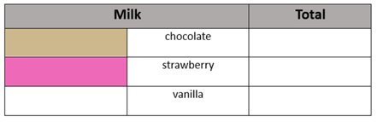

*The strategies, tasks and items included in the B1G-M are examples and should not be considered comprehensive.

MA.1.DP.1.2

Benchmark
MA.1.DP.1.2 Interpret data represented with tally marks or pictographs by calculating the total number of data points and comparing the totals of different categories.
Benchmark Clarifications:
Clarification 1: Instruction focuses on the connection to addition and subtraction when calculating the total and comparing, respectively.

Connecting Benchmarks/Horizontal Alignment
- MA.1.NSO.1.1
- MA.1.NSO.2.2

Vertical Alignment
Previous Benchmarks  - MA.K.DP.1.1 | Next Benchmarks  - MA.2.DP.1.2
Purpose and Instructional Strategies
- The purpose of this benchmark is for students to begin to understand different displays of data and the information that they can represent. In Kindergarten, students collected and sorted objects into categories and compare by counting the objects. Students reported their results either verbally, with a written numeral, or a drawing. Instruction includes providing opportunities for students to use addition and subtraction strategies when interpreting a data representation (MTR.5.1).
- Instruction includes questions that focus on the context of the situation (MTR.7.1).
- Instruction includes opportunities for students to choose a representation (pictograph or tally marks) for their data set and have discussions of the efficiency of the representation.

Common Misconceptions or Errors
- Students may misread or misinterpret data by not understanding the context of a question.
- Students may try to solve an addition or subtraction problem by making an unnecessary data display.
  - For example, the following question does not require making a data display; Jacob has 10 toy trucks and Courtney has 8 toy trucks. How many more trucks does Jacob have than Courtney?
- Students may make minor errors when answering questions from the data. In these cases, it is helpful to have students write an equation that could be used to solve the problem.
- When calculating the total number in the data set students may not recognize that they need to add all categories together.

Strategies to Support Tiered Instruction
- Teacher provides the following pictogram and accompanying questions. Teacher reads each question with students, checking for understanding along the way while focusing on accurately counting the items in each category. Additionally, the teacher provides opportunities for creating addition or subtraction equations to solve each question. Finally, the teacher ensures understanding of the relationship between the total number of items in a data set and addition.
  - Example:
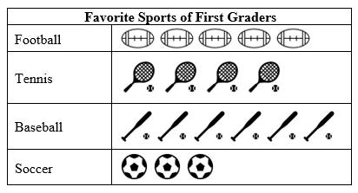

Part A. How many students chose football as their favorite sport? (For Part A, help students to count and record the number of footballs in the graph.)
Part B. How many students voted for tennis, soccer and football as their favorite sport? (For Part B, help students to count all the pictures in the pictogram, and create the addition equation $4 + 3 + 5=12$. Teacher provides students with equation frame $__+___+___=___$ if needed.)
Part C. How many more students prefer baseball over soccer? (For Part C, help students count the number of first graders that chose baseball and soccer, then create the subtraction equation $6-3=3$. Teacher will review key vocabulary with students, including what “more” means in the context of the question.)
Part D. How many fewer students prefer tennis than baseball? (For Part D, help students count the number of first graders that chose tennis and baseball, then create the subtraction equation $6-4=2$. Teacher will review key vocabulary with students, including what “fewer” means in the context of the question.)
- Teacher provides the following graph and has students answer the accompanying questions. The teacher reads each question with students, checking for understanding along the way focusing on accurately counting the tally marks in each category. Additionally, the teacher provides opportunities for creating addition or subtraction equations to solve each question. Finally, the teacher ensures understanding of the relationship between the total number of items in a data set and addition.
- Example:
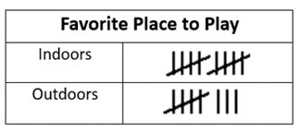

Part A. How many students chose outdoors as their favorite place to play? (For Part A, help students to count and record the number of tally marks in the graph, focusing on what the slanted tally mark means and groups of five.)
Part B. How many more students voted for outdoors than indoors? (For Part B, help students count the group of tally marks in both indoors and outdoors to create the subtraction equation $10-8=2$.)
Part C. How many students voted in all? (For Part C, help students count the total number of students that chose indoors and outdoors to create the addition equation $10+8=18$.)
- Teacher will provide opportunities for practicing counting each group of items (by picture or tally mark) and recording that number in digit form to reinforce making connections between counting the objects and recording the numerals.
- Teacher will pose addition and subtraction related questions to students about the data.
- For example, teacher will provide students with equation frames (such as $___+___=___$ for addition equations or $___-___=___$ for subtraction equations) to help them create equations to match the graphs.

Instructional Tasks
Instructional Task 1 (MTR.7.1)
Musafa surveyed her classmates to find out what kind of pet they owned. Use the list below for the classmates Musafa didn’t get a chance to put on her pictograph to complete her pictograph. Then answer the questions below.

Stephanie - dog | Ginger - cat | Joe - dog
Tyrone - dog | Susan - fish | Jeff - fish
Jessica - cat | Jeremiah - fish | Hayley - dog

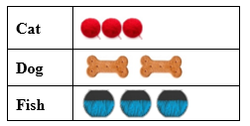

Part A. How many students have a dog?
Part B. How many fewer students have a fish than a cat?
Part C. How many pets do Musafa’s classmates have in all?

Enrichment Task 1(MTR.5.1)
Refer to Instructional Item 2 below, complete the same task with 53 tally marks for hot dogs and 65 tally marks for hamburgers.

Instructional Items
Instructional Item 1
Look at the pictograph below. Each picture represents one student’s choice.
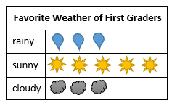
Part A. How many students chose a rainy day as their favorite weather?
Part B. How many more students chose a sunny day over a cloudy day?
Part C. How many students prefer days that are not sunny?
Part D. Which is the most popular weather among first graders?

Instructional Item 2
The lunchroom was serving hot dogs or hamburgers for lunch. The tally marks show the choices the students made. Each tally mark represents one student’s choice.
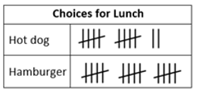
Part A. How many students want hot dogs for lunch?
Part B. How many students want hamburgers for lunch?
Part C. How many fewer students want hot dogs than hamburgers?
*The strategies, tasks and items included in the B1G-M are examples and should not be considered comprehensive.

Appendix A. Summary of Changes
The purpose of this table is to provide a summary of changes from for the latest version of the B1G-M. For questions or feedback on the B1G-M, please direct them to BESTMath@fldoe.org.

Benchmark | B1G-M Component | Change Made
MA.1.NSO.1.1 | Terms from the K-12 Glossary | Added Whole number to terms
MA.1.NSO.1.1 | S2STI | Added pictures of charts  Added ten frame strategy for skip counting  Added skip count by 5s on hundreds chart using nickels.
MA.1.NSO.1.1 | Instructional Task 1 | Moved questions from part B to part A
MA.1.NSO.1.1 | Item 1 | Changed numbers to count by to count past 100
MA.1.NSO.1.2 | Vertical Alignment | Removed K.1.2 and added K.2.2
MA.1.NSO.1.2 | Common Misc. | Added bullet point to address the numbers eleven and twelve
MA.1.NSO.1.2 | S2STI | Changed expectation from writing to matching word form. Moved verbiage from the second bullet point to the sub point example
MA.1.NSO.1.2 | Inst. Task 2 | Added new task
MA.1.NSO.1.3 | Horizontal Alignment | Added MA.1.M.2.3 (coins as a tool to decompose) but MA.1.2.3 will not have this benchmark listed because the expectations differ
MA.1.NSO.1.3 | Terms | Added equal sign
MA.1.NSO.1.3 | Common Misc. (CME) | Added 2nd bullet point (CME)
MA.1.NSO.1.3 | S2STI | Removed hundreds and tens image to match benchmark  Added sentence stems to pictures
MA.1.NSO.1.4 | Terms | *Added 3 terms
MA.1.NSO.1.4 | Common Misc. | Added 2nd bullet point
MA.1.NSO.1.4 | S2STI | Added 3rd bullet point strategy & picture
MA.1.NSO.1.4 | Instructional Task | Added step by step instruction for task
MA.1.NSO.1.4 | Instr. Task | Added 2nd task
MA.1.NSO.2.1 | Vertical Alignment - VA | Added MA.K.NSO.3.1
MA.1.NSO.2.1 | S2STI | Removed example from first strategy as it didn’t match the strategy.
MA.1.NSO.2.1 | S2STI | Changed final sentence: Then, the student represents the problem in an equation.
MA.1.NSO.2.2 | HA | Removed MA.1.M.1.1
MA.1.NSO.2.2 | VA | Added MA.2.NSO.2.4 and K.NSO.3.1
MA.1.NSO.2.2 | Purpose | Added Kinder benchmarks numbers mentioned
MA.1.NSO.2.2 | Purpose | Added: In grade 2, students recall addition and subtraction facts to 20 with automaticity (MA.2.NSO.2.1) and explore through 1,000 (MA.2.NSO.2.4)
MA.1.NSO.2.2 | Purpose | Instruction includes situations involving add to, take, from, put together, and compare. Refer to Appendix A for more information.
MA.1.NSO.2.2 | Common Misconceptions & Errors - CME | Added bullet - Students may confuse situations.
MA.1.NSO.2.2 | S2STI | Updated picture to not have
MA.1.NSO.2.3 | Horizontal Alignment | Added MA.1.M.2.3
MA.1.NSO.2.3 | Purpose | Added “In grade 2, students identify numbers ten more and less, and one hundred more and less than a three-digit number.”
MA.1.NSO.2.3 | Misconceptions | Added a sentence.  Consider using a bottom-up hundreds chart so you are moving up when counting up.
MA.1.NSO.2.3 | Task 2 | Added Bottoms up hundreds chart image and let teachers choose one of the charts
MA.1.NSO.2.3 | Inst. Item | Fixed text on picture to reflect ten more increasing (going up) – bottoms up hundreds chart
MA.1.NSO.2.4 | Glossary | Added term “equal sign”
MA.1.NSO.2.4 | Purpose | Connected to prior benchmarks and added connection to 2nd grade. Changed first purpose sentence to say: Instruction includes connecting inefficient strategies to more efficient strategies.
MA.1.NSO.2.4 | S2STI | Added images of hundreds charts
MA.1.NSO.2.5 | Horizontal Align | Deleted 1.M.2.2 and 1.M.2.3 – not subtracting coins
MA.1.NSO.2.5 | Purpose | Added Kinder benchmark numbers and connecting 2nd grade benchmark verbiage.
MA.1.NSO.2.5 | S2STI | Added hundreds chart
MA.1.NSO.2.5 | Instructional Items 2 and 3 | Item 2 Removed verbiage to use number line and asked for 2 strategies.  Item 3 Deleted last sentence.
MA.1.FR.1.1 | Vertical Alignment | Removed K.AR.1.2  Added 2.M.2.1
MA.1.FR.1.1 | Instructional Item 2 | Changed last question on both bullets to sentence frames
MA.1.AR.1.1 | Instructional Item 4 | Changed answer choice D to include adding zero
MA.1.AR.1.2 | S2STI | Added 1st bullet and graphic organizer
MA.1.AR.2.1 | Instructional Item 2 | Added Part B
MA.1.AR.2.3 | Instructional task 1 | Adapted - Use related facts to write an addition equation to show who is correct, Jessica or Annette. Use pictures or words to your thinking.
MA.1.M.1.1 | Purpose | Adapted last bullet to match benchmark
MA.1.M.1.1 | S2STI | Adapted the images and directions for 2nd bullet
MA.1.M.1.1 | S2STI | Added 3rd bullet and adapted images from 1.M.1.2
MA.1.M.1.1 | S2STI | Added 4th bullet and image to address 2nd misconception
MA.1.M.1.1 | Task 1 | Adapted and added image
MA.1.M.1.1 | Task 2 | Removed Task 2 and replaced with an adapted version of Instructional Item 2. Also added Enrichment Task 1 to extend Task 2
MA.1.M.1.1 | Items | Moved Item 1 to Task 2/ Changed Item 2 to 1 and Item 3 to 2
MA.1.M.1.2 | S2STI | Removed last bullet and moved to 1.M.1.1  Added sub-bullet to “Repair Shop” activity to address comparison language  Added new bullet to address 2nd misconception
MA.1.M.1.2 | Tasks 1 and 2 | Added question in Task 1 to address comparison language  Added sentences to Task 2 to address using consistent units of measure
MA.1.M.2.1 | Misconceptions | Removed misconceptions that were not grade level appropriate and added 2nd bullet, rewrote old 2nd bullet and moved to 3rd bullet
MA.1.M.2.1 | S2STI | Rewrote last bullet
MA.1.M.2.1 | Task | Removed duplicate clock from task
MA.1.M.2.2 | Misconceptions | Added 2nd bullet
MA.1.M.2.2 | S2STI | Added last bullet and image
MA.1.M.2.2 | Task 1 | Adapted task to match benchmark and 1.NSO.1.1, but not 1.M.2.3 (not finding value) Added front and back of coin, Part C, column
MA.1.M.2.3 | Horizontal Align | Removed 1.NSO.2.5
MA.1.M.2.3 | S2STI | Added 1st bullet and image  Rewrote 2nd bullet and adapted image to match situation
MA.1.GR.1.1 | Common Misc | Added a piece about informal/formal language
MA.1.GR.1.1 | S2STI | Changed first bullet and sub-bullets to address the formal/informal language connections
MA.1.GR.1.1 | Common Misc | Added a piece about informal/formal language
MA.1.GR.1.1 | SSTI | Replaced strategy (first bullet) with a new strategy to address the formal/informal language connections
MA.1.GR.1.2 | SSTI | Added a new bullet point referring teachers to the “Collect and Display” routine from GR.1.1 to use again as needed.  Rewrote second bullet point  3rd bullet point has a new image
MA.1.GR.1.2 | S2STI | Changed 2nd bullet
MA.1.GR.1.2 | SSTI | Added a new bullet point referring teachers to the “Collect and Display” routine from GR.1.1 to use again as needed.  Rewrote second bullet point  3rd bullet point has a new image
MA.1.GR.1.3 | Vertical | Removed MA.3.GR.2.4
MA.1.GR.1.3 | S2STI | Reworked all of the bullet points, some with minor language tweaks and the 3rd bullet point with a major overhaul; added bullet points 4, 5 and 6 with accompanying images
MA.1.GR.1.3 | SSTI | Reworked all of the bullet points, some with minor language tweaks and the 3rd bullet point with a major overhaul; added bullet points 4, 5 and 6 with accompanying images
MA.1.GR.1.3 | Instructional Items | All Instructional Items received an updated image
MA.1.GR.1.4 | Vertical | Removed grade 5 benchmark
MA.1.GR.1.4 | S2STI | Added 1st bullet point with sub-bullets and new pictures
MA.1.GR.1.4 | Task 1 | Revised wording and new images
MA.1.GR.1.4 | SSTI | New strategy (first bullet with sub-bullet points) and new pictures to go with them
MA.1.GR.1.4 | Instr. Task | Edited the wording and the table
MA.1.DP.1.1 | Purpose | Changed 3rd sentence: Student results are recorded either verbally, with written numerals, or drawings.
MA.1.DP.1.1 | Purpose | Added a bullet point – geometric figures
MA.1.DP.1.1 | CME | Added 2nd bullet – students may misrepresent the count for each data point.
MA.1.DP.1.1 | S2STI | Added 2nd and 3rd bullet (moved from 1.DP.1.2)
MA.1.DP.1.1 | Item 2 | Add graph for students to record tally marks.
MA.1.DP.1.2 | Purpose | Reordered the paragraph to connect work students did in kindergarten.
MA.1.DP.1.2 | SSTI | Deleted 3rd bullet and 4th bullet (moved to 1.DP.1.1)
MA.1.DP.1.2 | Tasks | Added Enrichment Task

