Algebra I Honors B.E.S.T. Instructional Guide for Mathematics

The B.E.S.T. Instructional Guide for Mathematics (B1G-M) is intended to assist educators with planning for student learning and instruction aligned to Florida’s Benchmarks for Excellent Student Thinking (B.E.S.T.) Standards. This guide is designed to aid high-quality instruction through the identification of components that support the learning and teaching of the B.E.S.T. Mathematics Standards and Benchmarks. The B1G-M includes an analysis of information related to the B.E.S.T. Standards for Mathematics within this specific mathematics course, the instructional emphasis and aligned resources. This document is posted on the B.E.S.T. Standards for Mathematics webpage of the Florida Department of Education’s website and will continue to undergo edits as needed.

Structural Framework and Intentional Design of the B.E.S.T. Standards for Mathematics

Florida’s B.E.S.T. Standards for Mathematics were built on the following.

- The coding scheme for the standards and benchmarks was changed to be consistent with other content areas. The new coding scheme is structured as follows:
Content.GradeLevel.Strand.Standard.Benchmark.
- Strands were streamlined to be more consistent throughout.
- The standards and benchmarks were written to be clear and concise to ensure that they are easily understood by all stakeholders.
- The benchmarks were written to allow teachers to meet students’ individual skills, knowledge and ability.
- The benchmarks were written to allow students the flexibility to solve problems using a method or strategy that is accurate, generalizable and efficient depending on the content (i.e., the numbers, expressions or equations).
- The benchmarks were written to allow for student discovery (i.e., exploring) of strategies rather than the teaching, naming and assessing of each strategy individually.
- The benchmarks were written to support multiple pathways for success in career and college for students.
- The benchmarks should not be taught in isolation but should be combined purposefully.
- The benchmarks may be addressed at multiple points throughout the year, with the intention of gaining mastery by the end of the year.
- Appropriate progression of content within and across strands was developed for each grade level and across grade levels.
- There is an intentional balance of conceptual understanding and procedural fluency with the application of accurate real-world context intertwined within mathematical concepts for relevance.
- The use of other content areas, like science and the arts, within real-world problems should be accurate, relevant, authentic and reflect grade-level appropriateness.

Components of the B.E.S.T. Instructional Guide for Mathematics

The following table is an example of the layout for each benchmark and includes the defining attributes for each component. It is important to note that instruction should not be limited to the possible connecting benchmarks, related terms, strategies or examples provided. To do so would strip the intention of an educator meeting students’ individual skills, knowledge and abilities.

Benchmark
focal point for instruction within lesson or task
This section includes the benchmark as identified in the B.E.S.T. Standards for Mathematics. The benchmark, also referred to as the Benchmark of Focus, is the focal point for student learning and instruction. The benchmark, and its related example(s) and clarification(s), can also be found in the course description. The 9-12 benchmarks may be included in multiple courses; select the example(s) or clarification(s) as appropriate for the identified course.

Connecting Benchmarks/Horizontal Alignment
in other standards within the grade level or course
This section includes a list of connecting benchmarks that relate horizontally to the Benchmark of Focus. Horizontal alignment is the intentional progression of content within a grade level or course linking skills within and across strands. Connecting benchmarks are benchmarks that either make a mathematical connection or include prerequisite skills. The information included in this section is not a comprehensive list, and educators are encouraged to find other connecting benchmarks. Additionally, this list will not include benchmarks from the same standard since benchmarks within the same standard already have an inherent connection.

Terms from the K-12 Glossary
This section includes terms from Appendix C: K-12 Glossary, found within the B.E.S.T. Standards for Mathematics document, which are relevant to the identified Benchmark of Focus. The terms included in this section should not be viewed as a comprehensive vocabulary list, but instead should be considered during instruction or act as a reference for educators.

Vertical Alignment
across grade levels or courses
This section includes a list of related benchmarks that connect vertically to the Benchmark of Focus. Vertical alignment is the intentional progression of content from one year to the next, spanning across multiple grade levels. Benchmarks listed in this section make mathematical connections from prior grade levels or courses in future grade levels or courses within and across strands. If the Benchmark of Focus is a new concept or skill, it may not have any previous benchmarks listed. Likewise, if the Benchmark of Focus is a mathematical skill or concept that is finalized in learning and does not have any direct connection to future grade levels or courses, it may not have any future benchmarks listed. The information included in this section is not a comprehensive list, and educators are encouraged to find other benchmarks within a vertical progression.

Purpose and Instructional Strategies
This section includes further narrative for instruction of the benchmark and vertical alignment. Additionally, this section may also include the following:
- explanations and details for the benchmark;
- vocabulary not provided within Appendix C;
- possible instructional strategies and teaching methods; and
- strategies to embed potentially related Mathematical Thinking and Reasoning Standards (MTRs).

Common Misconceptions or Errors
This section will include common student misconceptions or errors and may include strategies to address the identified misconception or error. Recognition of these misconceptions and errors enables educators to identify them in the classroom and make efforts to correct the misconception or error. This corrective effort in the classroom can also be a formative assessment within instruction.

Strategies to Support Tiered Instruction
The instructional strategies in this section address the common misconceptions and errors listed within the above section that can be a barrier to successfully learning the benchmark. All instruction and intervention at Tiers 2 and 3 are intended to support students to be successful with Tier 1 instruction. Strategies that support tiered instruction are intended to assist teachers in planning across any tier of support and should not be considered exclusive or inclusive of other instructional strategies that may support student learning with the B.E.S.T. Mathematics Standards. For more information about tiered instruction, please see the Effective Tiered Instruction for Mathematics: ALL Means ALL document.

Instructional Tasks
demonstrate the depth of the benchmark and the connection to the related benchmarks
This section will include example instructional tasks, which may be open-ended and are intended to demonstrate the depth of the benchmark. Some instructional tasks include integration of the Mathematical Thinking and Reasoning Standards (MTRs) and related benchmark(s). Enrichment tasks may be included to make connections to benchmarks in later grade levels or courses. Tasks may require extended time, additional materials and collaboration.

Instructional Items
demonstrate the focus of the benchmark
This section will include example instructional items which may be used as evidence to demonstrate the students’ understanding of the benchmark. Items may highlight one or more parts of the benchmark.

*The strategies, tasks and items included in the B1G-M are examples and should not be considered comprehensive.

Mathematical Thinking and Reasoning Standards
MTRs: Because Math Matters

Florida students are expected to engage with mathematics through the Mathematical Thinking and Reasoning Standards (MTRs) by utilizing their language as a self-monitoring tool in the classroom, promoting deeper learning and understanding of mathematics. The MTRs are standards which should be used as a lens when planning for student learning and instruction of the B.E.S.T. Standards for Mathematics.

Structural Framework and Intentional Design of the Mathematical Thinking and Reasoning Standards

The Mathematical Thinking and Reasoning Standards (MTRs) are built on the following.

- The MTRs have the same coding scheme as the standards and benchmarks; however, they are written at the standard level because there are no benchmarks.
- In order to fulfill Florida’s unique coding scheme, the 5th place (benchmark) will always be a “1” for the MTRs.
- The B.E.S.T. Standards for Mathematics should be taught through the lens of the MTRs.
- At least one of the MTRs should be authentically and appropriately embedded throughout every lesson based on the expectation of the benchmark(s).
- The bulleted language of the MTRs was written for students to use as self-monitoring tools during daily instruction.
- The clarifications of the MTRs were written for teachers to use as a guide to inform their instructional practices.
- The MTRs ensure that students stay engaged, persevere in tasks, share their thinking, balance conceptual understanding and procedures, assess their solutions, make connections to previous learning and extended knowledge, and apply mathematical concepts to real-world applications.
- The MTRs should not stand alone as a separate focus for instruction but should be combined purposefully.
- The MTRs will be addressed at multiple points throughout the year, with the intention of gaining mastery of mathematical skills by the end of the year and building upon these skills as they continue in their K-12 education.

MA.K12.MTR.1.1 Actively participate in effortful learning both individually and collectively.
Mathematicians who participate in effortful learning both individually and with others:
- Analyze the problem in a way that makes sense given the task.
- Ask questions that will help with solving the task.
- Build perseverance by modifying methods as needed while solving a challenging task.
- Stay engaged and maintain a positive mindset when working to solve tasks.
- Help and support each other when attempting a new method or approach.

Clarifications:
Teachers who encourage students to participate actively in effortful learning both individually and with others:
- Cultivate a community of growth mindset learners.
- Foster perseverance in students by choosing tasks that are challenging.
- Develop students’ ability to analyze and problem solve.
- Recognize students’ effort when solving challenging problems.

MA.K12.MTR.2.1 Demonstrate understanding by representing problems in multiple ways.
Mathematicians who demonstrate understanding by representing problems in multiple ways:
- Build understanding through modeling and using manipulatives.
- Represent solutions to problems in multiple ways using objects, drawings, tables, graphs and equations.
- Progress from modeling problems with objects and drawings to using algorithms and equations.
- Express connections between concepts and representations.
- Choose a representation based on the given context or purpose.

Clarifications:
Teachers who encourage students to demonstrate understanding by representing problems in multiple ways:
- Help students make connections between concepts and representations.
- Provide opportunities for students to use manipulatives when investigating concepts.
- Guide students from concrete to pictorial to abstract representations as understanding progresses.
- Show students that various representations can have different purposes and can be useful in different situations.

MA.K12.MTR. 3.1 Complete tasks with mathematical fluency.
Mathematicians who complete tasks with mathematical fluency:
- Select efficient and appropriate methods for solving problems within the given context.
- Maintain flexibility and accuracy while performing procedures and mental calculations.
- Complete tasks accurately and with confidence.
- Adapt procedures to apply them to a new context.
- Use feedback to improve efficiency when performing calculations.

Clarifications:
Teachers who encourage students to complete tasks with mathematical fluency:
- Provide students with the flexibility to solve problems by selecting a procedure that allows them to solve them efficiently and accurately.
- Offer multiple opportunities for students to practice efficient and generalizable methods.
- Provide opportunities for students to reflect on the method they used and determine if a more efficient method could have been used.

MA.K12.MTR.4.1 Engage in discussions that reflect on the mathematical thinking of self and others.
Mathematicians who engage in discussions that reflect on the mathematical thinking of self and others:
- Communicate mathematical ideas, vocabulary and methods effectively.
- Analyze the mathematical thinking of others.
- Compare the efficiency of a method to those expressed by others.
- Recognize errors and suggest how to correctly solve the task.
- Justify results by explaining methods and processes.
- Construct arguments based on evidence.

Clarifications:
Teachers who encourage students to engage in discussions that reflect on the mathematical thinking of self and others:
- Establish a culture in which students ask questions of the teacher and their peers, and error is an opportunity for learning.
- Create opportunities for students to discuss their thinking with peers.
- Select, sequence and present student work to advance and deepen understanding of correct and increasingly efficient methods.
- Develop students’ ability to justify methods and compare their responses to the responses of their peers.

MA.K12.MTR.5.1 Use patterns and structure to help understand and connect mathematical concepts.
Mathematicians who use patterns and structure to help understand and connect mathematical concepts:
- Focus on relevant details within a problem.
- Create plans and procedures to logically order events, steps or ideas to solve problems.
- Decompose a complex problem into manageable parts.
- Relate previously learned concepts to new concepts.
- Look for similarities among problems.
- Connect solutions of problems to more complicated large-scale situations.

Clarifications:
Teachers who encourage students to use patterns and structure to help understand and connect mathematical concepts:
- Help students recognize the patterns in the world around them and connect these patterns to mathematical concepts.
- Support students to develop generalizations based on the similarities found among problems.
- Provide opportunities for students to create plans and procedures to solve problems.
- Develop students’ ability to construct relationships between their current understanding and more sophisticated ways of thinking.

MA.K12.MTR.6.1 Assess the reasonableness of solutions.
Mathematicians who assess the reasonableness of solutions:
- Estimate to discover possible solutions.
- Use benchmark quantities to determine if a solution makes sense.
- Check calculations when solving problems.
- Verify possible solutions by explaining the methods used.
- Evaluate results based on the given context.

Clarifications:
Teachers who encourage students to assess the reasonableness of solutions:
- Have students estimate or predict solutions prior to solving.
- Prompt students to continually ask, “Does this solution make sense? How do you know?”
- Reinforce that students check their work as they progress within and after a task.
- Strengthen students’ ability to verify solutions through justifications.

MA.K12.MTR.7.1 Apply mathematics to real-world contexts.
Mathematicians who apply mathematics to real-world contexts:
- Connect mathematical concepts to everyday experiences.
- Use models and methods to understand, represent and solve problems.
- Perform investigations to gather data or determine if a method is appropriate.
- Redesign models and methods to improve accuracy or efficiency.

Clarifications:
Teachers who encourage students to apply mathematics to real-world contexts:
- Provide opportunities for students to create models, both concrete and abstract, and perform investigations.
- Challenge students to question the accuracy of their models and methods.
- Support students as they validate conclusions by comparing them to the given situation.
- Indicate how various concepts can be applied to other disciplines.

Examples of Teacher and Student Moves for the MTRs

Below are examples that show embedding the MTRs within the mathematics classroom. The provided teacher and student moves are examples of how some MTRs could be incorporated into student learning and instruction. The information included in this table is not a comprehensive list, and educators are encouraged to incorporate other teacher and student moves that support the MTRs.

MTR | Student Moves | Teacher Moves
MA.K12.MTR.1.1  Actively participate in effortful learning both individually and collectively. | - Students engage in the task through individual analysis, student-to-teacher interaction and student-to-student interaction.  - Students ask task-appropriate questions to self, the teacher and to other students. (MTR.4.1)  - Students have a positive productive struggle exhibiting growth mindset, even when making a mistake.  - Students stay engaged in the task to a purposeful conclusion while modifying methods, when necessary, in solving a problem through self-analysis and perseverance. | - Teacher provides flexible options (i.e., differentiated, challenging tasks that allow students to actively pursue a solution both individually and in groups) so that all students have the opportunity to access and engage with instruction, as well as demonstrate their learning.  - Teacher creates a physical environment that supports a growth mindset and will ensure positive student engagement and collaboration.  - Teacher provides constructive, encouraging feedback to students that recognizes their efforts and the value of analysis and revision.  - Teacher provides appropriate time for student processing, productive struggle and reflection.  - Teacher uses data and questions to focus students on their thinking; help students determine their sources of struggle and to build understanding.  - Teacher encourages students to ask appropriate questions of other students and of the teacher including questions that examine accuracy. (MTR.4.1)
MA.K12.MTR.2.1  Demonstrate understanding by representing problems in multiple ways. | - Students represent problems concretely using objects, models and manipulatives.  - Students represent problems pictorially using drawings, models, tables and graphs.  - Students represent problems abstractly using numerical or algebraic expressions and equations.  - Students make connections and select among different representations and methods for the same problem, as appropriate to different situations or context. (MTR.3.1) | - Teacher provides students with objects, models, manipulatives, appropriate technology and real-world situations. (MTR.7.1)  - Teacher encourages students to use drawings, models, tables, expressions, equations and graphs to represent problems and solutions.  - Teacher questions students about making connections between different representations and methods and challenges students to choose one that is most appropriate to the context. (MTR.3.1)  - Teacher encourages students to explain their different representations and methods to each other. (MTR.4.1)  - Teacher provides opportunities for students to choose appropriate methods and to use mathematical technology.
MA.K12.MTR.3.1  Complete tasks with mathematical fluency. | - Students complete tasks with flexibility, efficiency and accuracy.  - Students use feedback from peers and teachers to reflect on and revise methods used.  - Students build confidence through practice in a variety of contexts and problems. (MTR.1.1) | - Teacher provides tasks and opportunities to explore and share different methods to solve problems. (MTR.1.1)  - Teacher provides opportunities for students to choose methods and reflect (i.e., through error analysis, revision, summarizing methods or writing) on the efficiency and accuracy of the method(s) chosen.  - Teacher asks questions and gives feedback to focus student thinking to build efficiency of accurate methods.  - Teacher offers multiple opportunities to practice generalizable methods.
MA.K12.MTR.4.1  Engage in discussions that reflect on the mathematical thinking of self and others. | - Students use content specific language to communicate and justify mathematical ideas and chosen methods.  - Students use discussions and reflections to recognize errors and revise their thinking.  - Students use discussions to analyze the mathematical thinking of others.  - Students identify errors within their own work and then determine possible reasons and potential corrections.  - When working in small groups, students recognize errors of their peers and offers suggestions. | - Teacher provides students with opportunities (through open-ended tasks, questions and class structure) to make sense of their thinking. (MTR.1.1)  - Teacher uses precise mathematical language, both written and abstract, and encourages students to revise their language through discussion.  - Teacher creates opportunities for students to discuss and reflect on their choice of methods, their errors and revisions and their justifications.  - Teachers select, sequence and present student work to elicit discussion about different methods and representations. (MTR.2.1, MTR.3.1)
MA.K12.MTR.5.1 Use patterns and structure to help understand and connect mathematical concepts. | - Students identify relevant details in a problem to create plans and decompose problems into manageable parts.  - Students find similarities and common structures, or patterns, between problems to solve related and more complex problems using prior knowledge. | - Teacher asks questions to help students construct relationships between familiar and unfamiliar problems and to transfer this relationship to solve other problems. (MTR.1.1)  - Teacher provides students opportunities to connect prior and current understanding to new concepts.  - Teacher provides opportunities for students to discuss and develop generalizations about a mathematical concept. (MTR.3.1, MTR.4.1)  - Teacher allows students to develop an appropriate sequence of steps in solving problems.  - Teacher provides opportunities for students to reflect during problem solving to make connections to problems in other contexts, noticing structure and making improvements to their process.
MA.K12.MTR.6.1 Assess the reasonableness of solutions. | - Students estimate a solution, including using benchmark quantities in place of the original numbers in a problem.  - Students monitor calculations, procedures and intermediate results while solving problems.  - Students verify and check if solutions are viable, or reasonable, within the context or situation. (MTR.7.1)  - Students reflect on the accuracy of their estimations and their solutions. | - Teacher provides opportunities for students to estimate or predict solutions prior to solving.  - Teacher encourages students to compare results to estimations and revise if necessary for future situations. (MTR.5.1)  - Teacher prompts students to self-monitor by continually asking, “Does this solution or intermediate result make sense? How do you know?”  - Teacher encourages students to provide explanations and justifications for results to self and others. (MTR.4.1)
MA.K12.MTR.7.1 Apply mathematics to real-world contexts. | - Students connect mathematical concepts to everyday experiences.  - Students use mathematical models and methods to understand, represent and solve real-world problems.  - Students investigate, research and gather data to determine if a mathematical model is appropriate for a given situation from the world around them.  - Students re-design models and methods to improve accuracy or efficiency. | - Teacher provides real-world context to help students build understanding of abstract mathematical ideas.  - Teacher encourages students to assess the validity and accuracy of mathematical models and situations in real-world context, and to revise those models if necessary.  - Teacher provides opportunities for students to investigate, research and gather data to determine if a mathematical model is appropriate for a given situation from the world around them.  - Teacher provides opportunities for students to apply concepts to other content areas.

Algebra I Honors Areas of Emphasis

In Algebra I Honors, instructional time will emphasize five areas:

- performing operations with polynomials and radicals, and extending the Laws of Exponents to include rational exponents;
- extending understanding of functions to linear, quadratic and exponential functions and using them to model and analyze real-world relationships;
- solving quadratic equations in one variable and systems of linear equations and inequalities in two variables;
- building functions, identifying their key features and representing them in various ways; and
- representing and interpreting categorical and numerical data with one and two variables.

The purpose of the areas of emphasis is not to guide specific units of learning and instruction, but rather provide insight on major mathematical topics that will be covered within this mathematics course. In addition to its purpose, the areas of emphasis are built on the following:
- Supports the intentional horizontal progression within the strands and across the strands in this grade level or course.
- Student learning and instruction should not focus on the stated areas of emphasis as individual units.
- Areas of emphasis are addressed within standards and benchmarks throughout the course so that students are making connections throughout the school year.
- Some benchmarks can be organized within more than one area.
- Supports the communication of major mathematical topics to all stakeholders.
- Benchmarks within the emphasis areas should not be taught in the order they appear in. To do so would strip the progression of mathematical ideas and miss the opportunity to enhance horizontal progressions within the grade level or course.

The table below shows how the benchmarks within this mathematics course are embedded within the areas of emphasis.

Number Sense and Operations | Operations with Polynomials and Radicals and Laws of Exponents | Linear, Quadratic and Exponential Functions | Solving Equations and Systems of Linear Equations  and Inequalities | Building Functions, Identifying Key Features and Various Representations | Representing and Interpreting Categorical and Numerical Data
MA.912.NSO.1.1 | X | X | X | X
MA.912.NSO.1.2 | X |  |  | X
MA.912.NSO.1.4 | X |  | X

Algebraic Reasoning | Operations with Polynomials and Radicals and Laws of Exponents | Linear, Quadratic and Exponential Functions | Solving Equations and Systems of Linear Equations  and Inequalities | Building Functions, Identifying Key Features and Various Representations | Representing and Interpreting Categorical and Numerical Data
MA.912.AR.1.1 | X | X | X | X | X
MA.912.AR.1.2 |  |  | X
MA.912.AR.1.3 | X
MA.912.AR.1.4 | X
MA.912.AR.1.7 | X | X | X | X
MA.912.AR.2.1 |  |  | X
MA.912.AR.2.2 |  | X |  |  | X
MA.912.AR.2.3 |  | X
MA.912.AR.2.4 |  | X |  | X
MA.912.AR.2.5 |  | X |  | X | X
MA.912.AR.2.6 |  |  | X
MA.912.AR.2.7 |  |  | X
MA.912.AR.2.8 |  |  | X
MA.912.AR.3.1 | X |  | X
MA.912.AR.3.4 |  | X
MA.912.AR.3.5 |  | X
MA.912.AR.3.6 |  | X |  | X
MA.912.AR.3.7 |  | X |  | X
MA.912.AR.3.8 |  | X |  | X
MA.912.AR.4.1 |  | X |  | X
MA.912.AR.4.2 |  |  | X
MA.912.AR.4.3 |  | X |  | X
MA.912.AR.5.3 |  | X
MA.912.AR.5.4 |  | X |  | X
MA.912.AR.5.6 |  | X |  | X
MA.912.AR.9.1 |  |  | X
MA.912.AR.9.4 |  |  | X
MA.912.AR.9.6 |  |  | X

Functions | Operations with Polynomials and Radicals and Laws of Exponents | Linear, Quadratic and Exponential Functions | Solving Equations and Systems of Linear Equations  and Inequalities | Building Functions, Identifying Key Features and Various Representations | Representing and Interpreting Categorical and Numerical Data
MA.912.F.1.1 |  | X |  | X | X
MA.912.F.1.2 | X |  |  | X
MA.912.F.1.3 |  |  |  | X
MA.912.F.1.5 |  | X |  | X
MA.912.F.1.6 |  | X |  | X
MA.912.F.1.8 |  | X |  | X | X
MA.912.F.2.1 |  | X |  | X
MA.912.F.2.3 |  | X |  | X
MA.912.F.3.1 | X |  |  | X

Financial Literacy | Operations with Polynomials and Radicals and Laws of Exponents | Linear, Quadratic and Exponential Functions | Solving Equations and Systems of Linear Equations  and Inequalities | Building Functions, Identifying Key Features and Various Representations | Representing and Interpreting Categorical and Numerical Data
MA.912.FL.3.2 |  | X
MA.912.FL.3.4 |  | X |  | X

Data Analysis & Probability | Operations with Polynomials and Radicals and Laws of Exponents | Linear, Quadratic and Exponential Functions | Solving Equations and Systems of Linear Equations  and Inequalities | Building Functions, Identifying Key Features and Various Representations | Representing and Interpreting Categorical and Numerical Data
MA.912.DP.1.1 |  |  |  |  | X
MA.912.DP.1.2 |  |  |  |  | X
MA.912.DP.1.3 |  |  |  |  | X
MA.912.DP.1.4 |  |  |  |  | X
MA.912.DP.2.4 |  | X | X | X | X
MA.912.DP.2.5 |  | X |  |  | X
MA.912.DP.2.6 |  |  |  |  | X
MA.912.DP.3.1 |  |  |  |  | X
MA.912.DP.3.2 |  |  |  |  | X
MA.912.DP.3.3 |  |  |  |  | X

Number Sense and Operations

MA.912.NSO.1 Generate equivalent expressions and perform operations with expressions involving exponents, radicals or logarithms.

MA.912.NSO.1.1
Benchmark
MA.912.NSO.1.1 Extend previous understanding of the Laws of Exponents to include rational exponents. Apply the Laws of Exponents to evaluate numerical expressions and generate equivalent numerical expressions involving rational exponents.
Benchmark Clarifications:
Clarification 1: Instruction includes the use of technology when appropriate.
Clarification 2: Refer to the K-12 Formulas (Appendix E) for the Laws of Exponents.
Clarification 3: Instruction includes converting between expressions involving rational exponents and expressions involving radicals.
Clarification 4: Within the Mathematics for Data and Financial Literacy course, it is not the expectation to generate equivalent numerical expressions

Connecting Benchmarks/Horizontal Alignment
- MA.912.AR.8.3
- MA.912.FL.3.2

Terms from the K-12 Glossary
- Base
- Exponent
- Expression
- Rational Number

Vertical Alignment
Previous Benchmarks  - MA.8.NSO.1.3  - MA.7.NSO.1.1  - MA.8.NSO.1.3 | Next Benchmarks  - MA.912.NSO.1.6

Purpose and Instructional Strategies
In grade 8, students generated equivalent numerical expressions and evaluated expressions using the Laws of Exponents with integer exponents. In Algebra I, students work with rational-number exponents. In later courses, students extend the Laws of Exponents to properties of logarithms.
- Instruction includes using the terms Laws of Exponents and properties of exponents interchangeably.
- Instruction includes student discovery of the patterns and the connection to mathematical operations and the inverse relationship between powers and radicals (MTR.8.1).
- Problem types include having a fraction, integer or whole number as an exponent.
- Students should make the connection of the root being equivalent to a unit fraction exponent (MTR.4.1).
  - For example,$\sqrt[3]{8}=\sqrt[3]{2^{3}}$is equivalent to the equation
$\sqrt[3]{8} ={\left\{{\left(2\right\}}^{3}\right)}^{\frac{1}{3}}$which is equivalent to the equation$\sqrt[3]{8}={(2^{3})}^{\frac{1}{3}}$ which is equivalent to the equation$\sqrt[3]{8}$=$2^{1}$which is equivalent to the equation $\sqrt[3]{8}$ = 2.
- When evaluating, students should be encouraged to approach from different entry points and discuss how they are different but equivalent strategies (MTR.2.1).
For example, if evaluating ${\left(-27\right)}^{\frac{2}{3}}$students can:
    - Take the cube root of -27 first ${\left(\sqrt[3]{-27}\right)}^{2}$, or
    - Raise -27 to the second power first $\sqrt[3]{{\left(-27\right)}^{2}}$.

Common Misconceptions or Errors
- Students may not understand the difference between an expression and an equation.
- Students may try to perform operations on bases as well as exponents.
- Students may multiply the base by the exponent instead of understanding that the exponent is the number of times the base occurs as a factor.
- Students may not truly understand exponents that are zero or negative.
- Students may not understand operations with rational numbers.

Strategies to Support Tiered Instruction
- Teacher provides a review of the relationship between the base and the exponent by modeling an example of operations using a base and exponent.
  - For example, determine the numerical value of 6³.
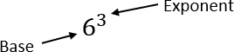
6³ which is equivalent to 6 ⋅ 6 ⋅ 6 which is equivalent to 216.
- Teacher provides exploration of the rules of exponents through patterns. A strategy for developing meaning for integer exponents by making use of patterns is shown below:

Patterns in Exponents
$$5^{5}$$ | $$5∙5∙5∙5∙5$$
$$5^{4}$$ | $$5∙5∙5∙5$$
$$5^{3}$$ | $$5∙5∙5$$
$$5^{2}$$ | $$5∙5$$
$$5^{1}$$ | $$5$$
$$5^{0}$$ | $$1$$
$$5^{-1}$$ | $$\frac{1}{5}$$
$$5^{-2}$$ | $$\frac{1}{5∙5}$$
$$5^{\text{-3}}$$ | $$\frac{1}{5∙5∙5}$$
$$5^{-4}$$ | $$\frac{1}{5∙5∙5∙5}$$
$$5^{-5}$$ | $$\frac{1}{5∙5∙5∙5∙5}$$

- Teacher provides exploration of the rules of rational exponents through patterns. A strategy for developing meaning for rational exponents by making use of patterns is shown below:
Patterns in Rational Exponents

$$5^{\frac{5}{2}}$$ | $$\sqrt{5}∙\sqrt{5}∙\sqrt{5}∙\sqrt{5}∙\sqrt{5}$$ | $$\sqrt{5∙5∙5∙5∙5}$$
$$5^{\frac{4}{2}}$$ | $$\sqrt{5}∙\sqrt{5}∙\sqrt{5}∙\sqrt{5}$$ | $$\sqrt{5∙5∙5∙5}$$
$$5^{\frac{3}{2}}$$ | $$\sqrt{5}∙\sqrt{5}∙\sqrt{5}$$ | $$\sqrt{5∙5∙5}$$
$$5^{\frac{2}{2}}$$ | $$\sqrt{5}∙\sqrt{5}$$ | $$\sqrt{5∙5}$$
$$5^{\frac{1}{2}}$$ | $$\sqrt{5}$$ | $$\sqrt{5}$$
$$5^{0}$$ | $\sqrt{1}$ or $1$ | $\sqrt{1}$ or $1$
$$5^{-\frac{1}{2}}$$ | $$\frac{1}{\sqrt{5}}$$ | $\sqrt{\frac{1}{5}}$ or $\frac{1}{\sqrt{5}}$
$$5^{-\frac{2}{2}}$$ | $$\frac{1}{\sqrt{5}∙\sqrt{5}}$$ | $\sqrt{\frac{1}{5∙5}}$ or $\frac{1}{\sqrt{5∙5}}$
$$5^{-\frac{3}{2}}$$ | $$\frac{1}{\sqrt{5}∙\sqrt{5}∙\sqrt{5}}$$ | $\sqrt{\frac{1}{5∙5∙5}}$ or $\frac{1}{\sqrt{5∙5∙5}}$
$$5^{-\frac{4}{2}}$$ | $$\frac{1}{\sqrt{5}∙\sqrt{5}∙\sqrt{5}∙\sqrt{5}}$$ | $\sqrt{\frac{1}{5∙5∙5∙5}}$ or $\frac{1}{\sqrt{5∙5∙5∙5}}$
$$5^{-\frac{5}{2}}$$ | $$\frac{1}{\sqrt{5}∙\sqrt{5}∙\sqrt{5}∙\sqrt{5}∙\sqrt{5}}$$ | $\sqrt{\frac{1}{5∙5∙5∙5∙5}}$ or $\frac{1}{\sqrt{5∙5∙5∙5∙5}}$

- Instruction includes the use of fraction tiles to represent operations with positive fractions while simultaneously recording the equivalent numerical expressions.

Instructional Tasks
Instructional Task 1 (MTR.4.1, MTR.5.1)
Part A. Think about when solving an equation with a radical. What is the inverse operation of a square root? Of a cube root?
Part B. Given the expression $\sqrt[3]{27}$, express 27 as a prime number with natural-number exponent.
Part C. How can we use the information from Part A and B to convert $\sqrt[3]{27}$ to exponential form?

Instructional Task 2 (MTR3.1, MTR.4.1)
Part A. Evaluate ${64}^{\frac{1}{3}}$ by first writing 64 as a power of 2 and using the properties of
exponents.
Part B. Evaluate 64 using a calculator.
Part C. Explain your process in both Part A and Part B. Define powers with fractional exponents in your own words.

Instructional Task 3 (MTR.3.1, MTR.5.1)
Part A. Given 𝑓(𝑥) = 32^{𝑥}, evaluate 𝑓(0), 𝑓(0.2), 𝑓(0.4), 𝑓(0.8) and 𝑓(1) without the use of a calculator.
Part B. Graph the function 𝑓 in the domain 0 ≤ 𝑥 ≤ 1.
Part C. Between which two values in Part A would 𝑓(0.5) be? Which one would it be closer to on the graph and why?

Instructional Items
Instructional Item 1
Evaluate the numerical expression ${\left(64\right)}^{\frac{4}{3}}$.

Instructional Item 2
Rewrite $8^{0.5}∙ 2^{\frac{2}{5}}$as a single power of 2.

Instructional Item 3
Choose all of the expressions that are equivalent to $7^{\frac{5}{12}}$.
- $\left({49}^{\frac{1}{3}}\right)\left(7^{-\frac{1}{4}}\right)$
- $\left(7^{\frac{2}{3}}\right)\left(7^{-\frac{1}{4}}\right)$
- $7\left(7^{-\frac{1}{4}}\right)$
- $\sqrt[5]{7^{12}}$
- $\sqrt[12]{7^{5}}$
Instructional Item 4
Evaluate the numerical expression ${\left(-\frac{729}{64}\right)}^{-\frac{2}{3}}$.
*The strategies, tasks and items included in the B1G-M are examples and should not be considered comprehensive.

MA.912.NSO.1.2
Benchmark
MA.912.NSO.1.2 Generate equivalent algebraic expressions using the properties of exponents.
Example: The expression 1.5^{3𝑡+2} is equivalent to the expression 2.25(1.5)^{3𝑡} which is equivalent to 2.25(3.375)^{𝑡}.

Connecting Benchmarks/Horizontal Alignment
- MA.912.AR.1.1, MA.912.AR.1.3,
- MA.912.AR.1.4, MA.912.AR.1.7
- MA.912.AR.5.3
- MA.912.FL.3.2

Terms from the K-12 Glossary
- Base
- Expression
- Exponent

Vertical Alignment
Previous Benchmarks  - MA.8.AR.1.1 | Next Benchmarks  - MA.912.NSO.1.7
Purpose and Instructional Strategies
In grade 8, students generated equivalent algebraic expressions using the Laws of Exponents with integer exponents. In Algebra I, students expand this work to include rational-number exponents. In later courses, students extend the Laws of Exponents to algebraic expressions with logarithms.
- Instruction includes using the terms Laws of Exponents and properties of exponents interchangeably.
- Instruction includes student discovery of the patterns and the connection to mathematical operations (MTR.8.1).
- Students should be able to fluently apply the Laws of Exponents in both directions.
  - For example, students should recognize that 𝑎⁶ is the quantity (𝑎³)²; this may helpful when students are factoring a difference of squares.
- When generating equivalent expressions, students should be encouraged to approach from different entry points and discuss how they are different but equivalent strategies (MTR.2.1).
- The expectation for this benchmark does not include the conversion of an algebraic expression from exponential form to radical form and from radical form to exponential form.

Common Misconceptions or Errors
- Students may not understand the difference between an expression and an equation.
- Students may not have fully mastered the Laws of Exponents and understand the mathematical connections between the bases and the exponents.
- Student may believe that with the introduction of variables, the properties of exponents differ from numerical expressions.

Strategies to Support Tiered Instruction
- Instruction includes the opportunity to distinguish between an expression and an equation. These should be captured in a math journal.
  - For example, when generating equivalent expressions, place an equal sign in between the expressions and label each expression and the equation.
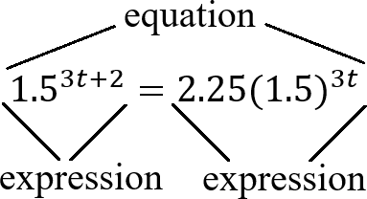
- Instruction provides opportunities to write each term in expanded form first and then use Laws of Exponents to combine like factors. It may also be helpful to chunk each step.
  - For example, to rewrite the expression (8𝑥³)² with one exponent, write out (8)(𝑥)(𝑥)(𝑥)(8)(𝑥)(𝑥)(𝑥) and then use the commutative property to write (8)(8)(𝑥)(𝑥)(𝑥)(𝑥)(𝑥)(𝑥) = 64𝑥⁶.
- Teacher provides instruction for problems that require multiple applications of the Laws of Exponents by chunking the steps so that students are applying one property at each time and explaining the property applied. Each time ask students to identify the property of exponents that they applied.
- Teacher provides students side-by-side problems, one with variable bases and the other choosing a value for the variable. As students work through the problems, ask them about the similarities in the problem-solving process.
  - For example, teacher can model generating equivalent expressions like the ones below.
$${\left(\frac{5{\left(3\right)}^{4}}{4{\left(3\right)}^{2}}\right)}^{0.5}=$$ | $${\left(\frac{5{\left(x\right)}^{4}}{4{\left(x\right)}^{2}}\right)}^{0.5}=$$
$$\frac{5^{0.5}3^{4∙0.5}}{4^{0.5}{\left(3\right)}^{2∙0.5}} =$$ | $$\frac{5^{0.5}x^{4∙0.5}}{4^{0.5}{\left(x\right)}^{2∙0.5}} =$$
$$\frac{5^{0.5}3^{2}}{2{\left(3\right)}^{1}} =$$ | $$\frac{5^{0.5}x^{2}}{2{\left(x\right)}^{1}} =$$
$$\frac{\left\{5^{0.5}{\left(3\right\}}^{2-1}\right)}{2} =$$ | $$\frac{\left\{5^{0.5}{\left(x\right\}}^{2-1}\right)}{2} =$$
$$\frac{\left\{5^{0.5}{\left(3\right\}}^{1}\right)}{2} =$$ | $$\frac{\left\{5^{0.5}{\left(x\right\}}^{1}\right)}{2} =$$
$$\frac{3\sqrt{5}}{2}$$ | $$\frac{x\sqrt{5}}{2}$$
- Teacher provides a review of the relationship between the base and the exponent by modeling an example of operations using a base and exponent.
  - For example, determine the numerical value of 6³.
6³ which is equivalent to 6 ⋅ 6 ⋅ 6 which is equivalent to 216.

Instructional Tasks
Instructional Task 2 (MTR.3.1, MTR.4.1)
Part A. Write the algebraic expression${\left(\frac{6x^{\frac{2}{7}}y z^{0}}{9x^{2}y^{5} z^{-8}}\right)}^{3} as$ an equivalent expression where each
variable only appears once.
Part B. Compare your method of simplifying with a partner.

Instructional Task 2 (MTR.3.1, MTR.4.1)
Part A. Describe the steps taken to simplify the following expression:$\frac{ 5a^{4}b^{3}}{{\left(2ab\right)}^{2}}$ using exponent rules.
Part B. Which rules were used in each step?

Instructional Task 3(MTR.3.1, MTR.4.1, MTR.6.1)
Part A. Consider the following expression: $\frac{{4x}^{0} y^{-2} z^{3}}{4x}$ and explain the first rule that would be used to simplify the expression.
Part B. Why did you choose that rule? Compare your answer with a partner.

Instructional Items
Instructional Item 1
Given the algebraic expression ${2.3}^{2t-1}$, create an equivalent expression.
Instructional Item 2
Use the properties of exponents to create an equivalent expression for the given expression shown below with no variables in the denominator.
(64𝑥²)- (32𝑥⁵)

Instructional Item 3
Create an expression equivalent to the expression ${\left(\frac{{12x}^{-5}}{{7z}^{-3}}\right)}^{-10}$.
*The strategies, tasks and items included in the B1G-M are examples and should not be considered comprehensive.

MA.912.NSO.1.4
Benchmark
MA.912.NSO.1.4 Apply previous understanding of operations with rational numbers to add, subtract, multiply and divide numerical radicals.

Algebra I Example: The expression $\frac{\sqrt{136}}{\sqrt{2}}$ is equivalent to $\sqrt{\frac{136}{2}}$ which is equivalent to $\sqrt{68}$ which is equivalent to $2\sqrt{17}$.

Benchmark Clarifications:
Clarification 1: Within the Algebra I course, expressions are limited to a single arithmetic operation involving two square roots or two cube roots.
Connecting Benchmarks/Horizontal Alignment
- MA.912.AR.1.1, MA.912.AR.1.2

Terms from the K-12 Glossary
- Base
- Rational Number

Vertical Alignment
Previous Benchmarks  - MA.8.NSO.1.5  - MA.912.AR.7.1, MA.912.AR.7.4 | Next Benchmarks  - MA.912.NSO.1.5

Purpose and Instructional Strategies
In grade 8, students evaluated numerical expressions with square and cube roots. In Algebra I, students perform operations with numerical square or cube roots. In later courses, students will perform operations with algebraic expressions involving radicals.
- It is important to reinforce and activate the prior knowledge of simple calculations with radicals within this benchmark.
- Within this benchmark, it is not the expectation to rationalize the denominator. However, students should have experience and understanding of how to rationalize the denominator. Students should understand when it may be helpful to rationalize, for example when estimating values.
- Instruction includes making the connection to properties of exponents with rational exponents.
- For example, when determining the value of the expression $4\sqrt{3}\left(\sqrt{3}\right),$a student could convert to exponential notation, which would result in 4$\left(3^{\frac{1}{2 }}\right)x 3^{\frac{1}{2 }}$. A student could then use properties of exponents to obtain 4 $\left(3^{\frac{1}{2 }+\frac{1}{2}}\right)$ which is equivalent to 12.
- For example, when determining the value of the expression $\frac{4\sqrt{3}}{\sqrt{3}}$ , a student could convert to exponential notation, which would result in $\frac{4\left(3^{\frac{1}{2}}\right)}{3^{\frac{1}{2}}}$. A student could then use properties of exponents to obtain 4 $\left(3^{\frac{1}{2 }-\frac{1}{2}}\right)$ which is equivalent to 4.

- Instruction allows students to write their answer in radical or exponential form.
- Instruction may include use of the words
  - Radicand – the value or expression written under the radical sign
  - Index – the value that indicates the root of the radicand to be taken
$$\sqrt[index]{radicand}$$

Common Misconceptions or Errors
- Students may not know how to do simple calculations with radicals; therefore, they may not take the square root of the perfect square factor; or they may suggest using a factor pair within a radical that does not contain a perfect square as a factor.
- Students may confuse radicands and coefficients and perform the operations on the wrong part of the expression.

Strategies to Support Tiered Instruction
- Teacher provides opportunities to write out all of the factors, as sets, of the radicand. Once the factors have been identified, the students can use the set of factors with the highest perfect square or cube, as applicable.
  - For example, given $\sqrt{200}$, the radicand is 200, the factor sets are {1 and 200}, {2 and 100}, {4 and 50}, etc., 100 is the highest perfect square; so, $\sqrt{200}$ = 10$\sqrt{20}$
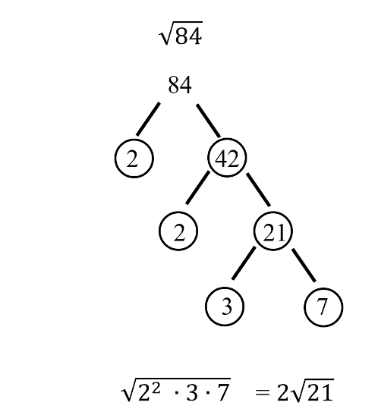
- Teacher models prime factorization as a strategy to find all factors of radicand.

- Teacher co-creates a list of common perfect squares and cubes that can be used as problems are performed.
  - For example, a list of common perfect squares and cubes is shown.
 | Perfect Squares | Perfect Cubes
1 | 1² = 1 | 1³ = 1
2 | 2² = 4 | 2³ = 8
3 | 3² = 9 | 3³ = 27
4 | 4² = 16 | 4³ = 64
5 | 5² = 25 | 5³ = 125
6 | 6² = 36 | 6³ = 216
7 | 7² = 49 | 7³ = 343
- Teacher models identifying all parts of the radical expression and rules specific to the operation prior to calculating answers. To add or subtract radicals the radicand must be the same prior to adding the coefficients.
  - For example, given 6$\sqrt{20}$ + 4$\sqrt{20 }$, 6 and 4 are coefficients and 20 is the radicand for both terms. Therefore, 6$\sqrt{20}$ + 4$\sqrt{20 }$ = 10 $\sqrt{20 }.$
  - For example, given 4$\sqrt{5}$ + 9$\sqrt{20 }$, 4 and 9 are coefficients and 5 and 20 are the radicands. Therefore, the terms cannot be combined as is. But notice that if $\sqrt{20 }$ is rewritten as 2$\sqrt{5},$then 5 is the radicand for both terms. So, 4$\sqrt{5}$ - 9$\sqrt{20 }$, which is equivalent to $4\sqrt{5}$ - $18\sqrt{5 }$which when subtracted results in -$14\sqrt{5}$.
- Teacher provides a visual aid (e.g., laminated cue card) to distinguish the parts of a radical expression.
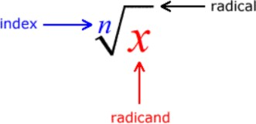
  - For example, in the expression $\sqrt[3]{20}$, 3 is the index (or root) and 20 is the radicand.

Instructional Tasks
Instructional Task 1 (MTR.3.1, MTR.7.1)
The velocity, 𝑣, measured in meters per second of an object can be measured in terms of its mass, 𝑚, measured in kilograms and Kinetic Energy, 𝐸_{𝑘}, measured in Joules. The equation below describes this relationship.
𝑣 =$\sqrt{\frac{2E_{k}}{m}}$
Part A. What is the exact velocity of an object if its mass measures 31 kilograms and its Kinetic Energy measures 310 Joules?
Part B. Rearrange the formula to highlight mass as the quantity of interest.
Part C. What is the mass of an object if the velocity measures 6.1 meters per second and its Kinetic Energy measures 31.4 Joules?

Instructional Items
Instructional Item 1
Determine the value of the expression $\sqrt[3]{24} + \sqrt[3]{81}$ Write your answer as an exact quantity using only a single radical.

Instructional Item 2
Determine the difference of the expression $\sqrt{24} - 2\sqrt{54}$. Write your answer as an exact quantity using only a single radical.

Instructional Item 3
Determine the value of the expression $4\sqrt{10} \left(-3\sqrt{15}\right)$. Write your answer as an exact quantity using only a single radical.

Instructional Item 4
Determine the value of the expression $\frac{3\sqrt{3}}{5\sqrt{75}}$.
*The strategies, tasks and items included in the B1G-M are examples and should not be considered

Algebraic Reasoning

MA.912.AR.1 Interpret and rewrite algebraic expressions and equations in equivalent forms.

MA.912.AR.1.1
Benchmark
MA.912.AR.1.1 Identify and interpret parts of an equation or expression that represent a quantity in terms of a mathematical or real-world context, including viewing one or more of its parts as a single entity.
Algebra I Example: Derrick is using the formula 𝑃 = 1000(1 + .1)^{𝑡} to make a prediction about the camel population in Australia. He identifies the growth factor as (1 + .1), or 1.1, and states that the camel population will grow at an annual rate of 10% per year.
Example: The expression 1.15𝑡 can be rewritten as $\left\{({{1.15}^{\frac{1}{12}})}^{12t}\right\}$which is approximately
equivalent to 1.012^{12t}. This latter expression reveals the approximate equivalent monthly interest rate of 1.2% if the annual rate is 15%.
Benchmark Clarifications:
Clarification 1: Parts of an expression include factors, terms, constants, coefficients and variables. Clarification 2: Within the Mathematics for Data and Financial Literacy course, problem types focus on money and business.

Connecting Benchmarks/Horizontal Alignment
- MA.912.NSO.1.2
- MA.912.AR.2.2, MA.912.AR.2.5, MA.912.AR.2.6
- MA.912.AR.3.1, MA.912.AR.3.6, MA.912.AR.3.7, MA.912.AR.3.8
- MA.912.AR.4.1
- MA.912.AR.5.3, MA.912.AR.5.6
- MA.912.FL.3.2

Terms from the K-12 Glossary
- Coefficient
- Expression
- Equation

Vertical Alignment
Previous Benchmarks  - MA.8.AR.2.1, MA.8.AR.2.2 | Next Benchmarks  - MA.912.AR.5.5, MA.912.AR.5.9  - MA.912.AR.8.2  - MA.912.T.3.2

Purpose and Instructional Strategies
In grade 8, students generated and identified equivalent linear expressions, and solved multi-step
problems involving linear expressions within real-world contexts. In Algebra I, students generate and interpret equivalent linear, absolute value, quadratic and exponential expressions and equations. In later courses, students will identify and interpret other functional (exponential, rational, logarithmic, trigonometric, etc.) expressions and equations.
- Instruction includes making the connection to linear, absolute value, quadratic and exponential functions.
  - Students should be able to identify factors, terms, constants, coefficients and variables in expressions and equations.
      - Go beyond these popular parts of an expression and equation: the growth/decay factor in exponential functions, rate of change in linear functions, interest, etc.
  - Look for opportunities to interpret these components in context – make these discussions part of daily instruction.

Common Misconceptions or Errors
- Students may not be able to identify parts of an expression and equation or interpret those parts within context. Ensure these are embedded throughout instruction and discussions.
        - For example, building in questions to identify these parts and discussing their connection to the context in which they represent in a routine way will help students to make these connections.

Strategies to Support Tiered Instruction
- Teacher facilitates discussions which include questions and clarifications to identify the connections of expressions and equations to the context of problems.
- Instruction provides opportunities to increase understanding of vocabulary terms.
  - For example, instruction may include a vocabulary review using a chart shown.
Term | 6𝑥
Coefficient | 6𝑥
Variable | 𝑥
Constant | 6
- Teacher provides students with an expression or equation and allows them to match the parts to key vocabulary.
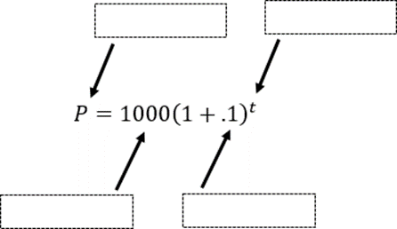
  - For example, teacher can provide the word bank to identify the different parts of the equation shown.

Instructional Tasks
Instructional Task 1 (MTR.5.1)
The algebraic expression (𝑛 – 1)² + (2𝑛 – 1) can be used to calculate the number of symbols in each diagram below. Explain what 𝑛 likely represents, how the parts of this expression relate to the diagrams, and why the expression results in the number of symbols in each diagram.



Instructional Task 2 (MTR.3.1, MTR.7.1)
Last weekend, Cindy purchased two tops, a pair of pants, and a skirt at her favorite store. The equation 𝑇 = 1.075𝑥 can be used to calculate her total cost where 𝑥 represents the pretax subtotal cost of her purchase.
Part A. In the equation 𝑇 = 1.075𝑥, what does the number 1 represent? Explain using the context of Cindy’s situation.
Part B. In the equation 𝑇 = 1.075𝑥, what does the number 0.075 represent? Explain using the context of Cindy’s situation.

Instructional Items
Instructional Item 1
Identify the factors in the expression 2(3𝑥 − 1) + 2(2𝑥 + 2).

Instructional Item 2
A bacteria’s growth can be modeled by the equation y=10${\left(1+0.3\right)}^{\left(t \right)}$ Identify the value that represents the starting amount of bacteria.

*The strategies, tasks and items included in the B1G-M are examples and should not be considered comprehensive.

MA.912.AR.1.2
Benchmark
MA.912.AR.1.2 Rearrange equations or formulas to isolate a quantity of interest.
Algebra I Example: The Ideal Gas Law 𝑃𝑉 = 𝑛𝑅𝑇 can be rearranged as $T = \frac{PV}{nR}$ to isolate
temperature as the quantity of interest.
Example: Given the Compound Interest formula 𝐴 = 𝑃(1 + $\frac{r}{n}$)^{𝑛𝑡}, solve for 𝑃.

Mathematics for Data and Financial Literacy Honors Example: Given the Compound Interest formula 𝐴 = 𝑃(1 +$\frac{r}{n}$)^{𝑛𝑡}, solve for 𝑡.
Benchmark Clarifications:
Clarification 1: Instruction includes using formulas for temperature, perimeter, area and volume; using equations for linear (standard, slope-intercept and point-slope forms) and quadratic (standard, factored and vertex forms) functions.
Clarification 2: Within the Mathematics for Data and Financial Literacy course, problem types focus on money and business.

Connecting Benchmarks/Horizontal Alignment
- MA.912.NSO.1.2
- MA.912.AR.2.2, MA.912.AR.2.5, MA.912.AR.2.6
- MA.912.AR.3.1, MA.912.AR.3.6, MA.912.AR.3.7, MA.912.AR.3.8
- MA.912.AR.4.1
- MA.912.AR.5.3, MA.912.AR.5.6
- MA.912.FL.3.2

Terms from the K-12 Glossary
- Equation

Vertical Alignment
Previous Benchmarks  - MA.8.AR.2, MA.8.AR.2.3  - MA.8.GR.1 | Next Benchmarks  - MA.912.AR.5.5, MA.912.AR.5.9  - MA.912.AR.8.2  - MA.912.T.3.2
Purpose and Instructional Strategies
In grade 8, students isolated variables in one-variable linear equations and one-variable quadratic equations in the form 𝑥² = 𝑝 and 𝑥³ = 𝑞. In Algebra I, students isolate a variable or quantity of interest in equations and formulas. Equations and variables will focus on linear, absolute value and quadratic in Algebra I. In later courses, students will highlight a variable or quantity of interest for other types of equations and formulas, including exponential, logarithmic and trigonometric.
- Instruction includes making connections to inverse arithmetic operations (refer to Appendix D) and solving one-variable equations.
$4x – 2y = 8$ Given
$-4x + 4x – 2y = 8 – 4x$ Subtraction Property of Equality
$-2y = 8 – 4x$ Simplify
$\frac{-2y}{-2}= \frac{8}{-2} -\frac{4x}{-2}$ Division Property of Equality
$y = –4 + 2x$ Simplify

- Instruction includes justifying each step while rearranging an equation or formula.
  - For example, when rearranging 𝐴 = 𝑃 (1 +$\frac{r}{n}$) for 𝑃, it may be helpful for
students to highlight the quantity of interest with a highlighter, so students remain
focused on that quantity for isolation purposes. It may also be helpful for students to identify factors, or other parts of the equations.
$$A=P{\left(1+\frac{r}{n}\right)}^{nt}$$

P and (1) are factors so the inverse operation is division.
$$P= \frac{A}{{\left(1+\frac{r}{n}\right)}^{nt}}$$

Common Misconceptions or Errors
- Students may not have mastered the inverse arithmetic operations.
- Students may be frustrated because they are not arriving at a numerical value as their solution. Remind students that they are rearranging variables that can be later evaluated to a numerical value.
- Having multiple variables and no values may confuse students and make it difficult for them to see the connections between rearranging a formula and solving a one-variable equation.

Strategies to Support Tiered Instruction
- Instruction includes doing a side-by-side comparison of solving a multistep equation
with rearranging equations and formulas. The teacher should allow students time to understand that the steps in solving both equations are the same.
    - For example, solve both equations and note the similarities in solving both types of equations.

Solving One-Variable Equations | Rearranging Equations/Formulas
Determine the height, ℎ, in the formula 𝑆𝐴 = 2𝐵 + 𝑃ℎ if the surface area (𝑆𝐴) is 537 units squared, the area of the base (𝐵) is 112 units squared and the perimeter of the base (𝑃) is 25 units.  $$537 = 2\left(112\right) + 25h$$  $$537-22= 224 + 25h-224$$  $313 = 25h$  $\frac{313}{25} = \frac{25h}{25}$  $12.52 =h$ | Isolate height, ℎ, in the formula 𝑆𝐴 = 2𝐵 + 𝑃ℎ.  𝑆𝐴 = 2𝐵 + 𝑃ℎ  𝑆𝐴 − 2𝐵 = 2𝐵 + 𝑃ℎ − 2𝐵  𝑆𝐴 − 2𝐵 = 𝑃ℎ  $\frac{SA - 2B}{P}$ = $\frac{Ph}{P}$  $\frac{SA - 2B}{P}$ = $h$
- Teacher provides a chart for students to use as a study guide or to copy in their interactive notebook.
    - For example, inverse operations chart below.
Inverse Operations Chart
Addition  + | ↔ | Subtraction  −
Multiplication  × | ↔ | Division  ÷
Square  𝑥2 | ↔ | Square Root  $$\sqrt{x}$$

Instructional Tasks
Instructional Task 1 (MTR.4.1, MTR.5.1)
Part A. Given the equation 𝑎𝑥² + 𝑏𝑥 + 𝑐 = 0, solve for 𝑥.
Part B. Share your strategy with a partner. What do you notice about the new equation(s)?

Instructional Task 2 (MTR.4.1, MTR.5.1)
Part A. Given the equation 𝐴𝑥 + 𝐵𝑦 = 𝐶, solve for B.
Part B. Given the equation 7𝑥 − 6𝑦 = 24, determine the 𝑥- and 𝑦-intercepts.
Part C. What do you notice between Part A and Part B?

Instructional Items
Instructional Item 1
Solve for 𝑥 in the equation 3𝑥 + 𝑦 = 5𝑥 − 𝑥𝑦.

Instructional Item 2
The formula 𝑑 = 𝑣𝑜+𝑣𝑡 𝑡 relating to the translational of motion, where 𝑑 represents distance,
2
𝑣_{𝑜} represents initial velocity, 𝑣_{𝑡} represents final velocity, and 𝑡 represents time. Rearrange
the formula to isolate final velocity.

Instructional Item 3
The area A of a sector of a circle with radius r and angle-measure S (in degrees) is given by
$A=\frac{πr^{2}}{360}$ solve for the radius r.
*The strategies, tasks and items included in the B1G-M are examples and should not be considered comprehensive.

MA.912.AR.1.3
Benchmark
MA.912.AR.1.3 Add, subtract and multiply polynomial expressions with rational number coefficients.
Benchmark Clarifications:
Clarification 1: Instruction includes an understanding that when any of these operations are performed with polynomials the result is also a polynomial.
Clarification 2: Within the Algebra I course, polynomial expressions are limited to 3 or fewer terms.

Connecting Benchmarks/Horizontal Alignment
- MA.912.NSO.1.1, MA.912.NSO.1.2
- MA.912.F.3.1

Terms from the K-12 Glossary
- Polynomial
- Monomial

Vertical Alignment
Previous Benchmarks  - MA.7.AR.1.1  - MA.8.AR.1.2  - MA.8.AR.1.3 | Next Benchmarks  - MA.912.AR.1.5, MA.912.AR.1.6, MA.912.AR.1.7  - MA.912.AR.6.3
Purpose and Instructional Strategies
In middles grades, students added, subtracted and multiplied linear expressions. In Algebra I, students perform operations on polynomials limited to 3 or fewer terms. In later courses, students will perform operations on all polynomials.
- Instruction includes making the connection to dividing a polynomial by a monomial and the understanding that division does not have closure (the result may or may not be another polynomial).
- Reinforce like terms during instruction (using different colors can be a strategy to help identify them as unique from one another).
- Instruction includes the use of manipulatives, like algebra tiles, and various strategies, like the area model, properties of exponents and the distributive property.
  - Area model
The expression (2𝑥² + 1.5𝑥 + 6) (3𝑥 + 4.2) is equivalent to 6𝑥³ + 12.9𝑥² + 24.3𝑥 + 25.2 and can be modeled below.
 | 2𝑥² | 1.5𝑥 | 6
3𝑥 | 6𝑥³ | 4.5𝑥² | 18𝑥
4.2 | 8.4𝑥² | 6.3𝑥 | 25.2

- Instruction should not rely upon the use of tricks or acronyms, like FOIL.
- Although within the Algebra I course, polynomial expressions are limited to 3 or fewer terms, this restriction only refers to the expressions given to the student, not the expression after the operation applied.

Common Misconceptions or Errors
  - Students may not understand the meaning of closure or the operations it applies to with polynomials.
  - Students may not understand like terms or the properties of exponents.
  - Students may not distribute the factor of -1 when subtracting a polynomial.
  - Student might multiply incorrectly when squaring a binomial. For example, (𝑥 – ℎ)² incorrectly distributed as $x^{2}-h^{2}x^{2}-h^{2}$ instead of $x^{2}-2xh+h^{2}x^{2}-2xh+h^{2}$
Strategies to Support Tiered Instruction
- Teacher models subtracting polynomials with algebra tiles.
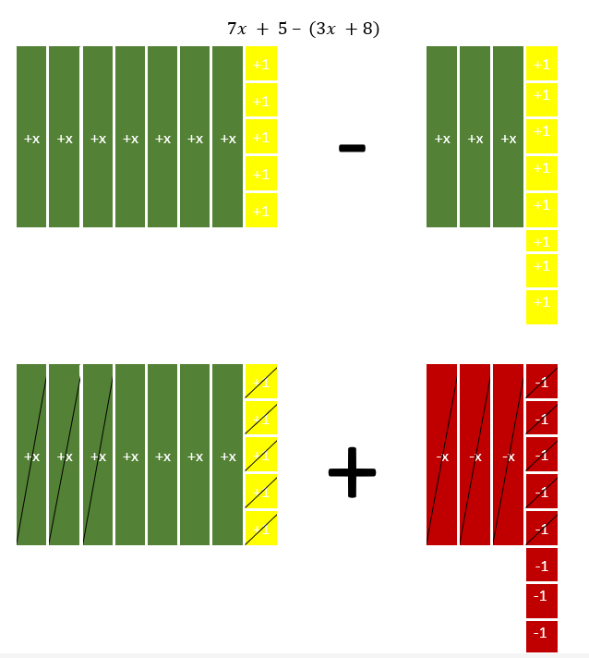
- Instruction includes converting a quadratic from vertex form to standard form. Instruct students to write out ${(x – h)}^{2}$ as (𝑥 – ℎ)(𝑥 – ℎ). Remind students that different methods can be used to multiply binomials.

- Instruction includes the use of shapes or colors to demonstrate like terms. Teacher must ensure that students understand that the sign in front of the terms are key when combining like terms.
- For example, different colors can be used when adding the polynomials shown below.
(𝑥² − 4𝑥 + 12) + (3𝑥² + 7𝑥 − 4)
(𝑥² − 4𝑥 + 12) + (3𝑥² + 7𝑥 − 4)
𝑥² + 3𝑥² − 4𝑥 + 7𝑥 + 12 − 4
4𝑥² + 3𝑥 + 8
- Teacher provides examples showing that polynomials are closed under the operations of addition, subtraction and multiplication, but not under division.
- For example, when subtracting or multiplying polynomials (as shown below), the result is always a polynomial.
$$7x + 5 - (3x + 8) = 4x - 3$$
$$(7x + 5)(3x + 8) = 21x^{2} + 71x + 40$$
- For example, when dividing polynomials (as shown below), the result may or may not be a polynomial.
$\frac{2x^{2}+5x}{x}$= 2𝑥 + 5 (which is a polynomial)
$\frac{2x^{2}+5x+1}{x}$= 2𝑥 + 5 +$\frac{1}{x}$ (which is not a polynomial)
Instructional Tasks
Instructional Task 1 (MTR.3.1, MTR.4.1)
Part A. Determine the sum of 3𝑥² − 2𝑥 + 5 and $\frac{1}{6}$𝑥² + 7𝑥 + $\frac{8}{7}$. Explain the method used in
determining the sum.
Part B. Discuss whether the addition of polynomials will always result in another polynomial. Why or why not?
Part C. Determine the difference of 3𝑥³ − 2𝑥² + 5 and 𝑥² − 0.25𝑥 + 1.24. Explain the method used in determining the difference.
Part D. Discuss whether the subtraction of polynomials will always result in another polynomial. Why or why not?
Part E. Determine the product of 2𝑥 + 5 and $\frac{2}{9}$𝑥 ² − $\frac{11}{2}$𝑥 + 1. Explain the method used in
determining the product.
Part F. Discuss whether the multiplication of polynomials will always result in another polynomial. Why or why not?
Part G. Determine the quotient of 9𝑥² − 3𝑥 + 12 and 3𝑥. Explain the method used in determining the quotient.
Part H. Discuss whether the division of polynomials will always result in another polynomial. Why or why not?

Instructional Items
Instructional Item 1
Determine the sum of the expression $(\frac{3}{4}x^{3} - \frac{2}{3}) + (- \frac{1}{2}x^{2} + x + \frac{5}{6})$.

Instructional Item 2
Determine the coefficient of the 𝑥² term when the expression $(x^{2} + \frac{3}{4}x - \frac{1}{2})$ is multiplied by $\left(x-\frac{2}{3}\right).$

Instructional Item 3
Determine the difference of the expression (−0.4𝑥 + 0.5𝑥² + 2) − (0.6 + 𝑥² + 0.5𝑥).

*The strategies, tasks and items included in the B1G-M are examples and should not be considered comprehensive.

MA.912.AR.1.4

Benchmark
MA.912.AR.1.4 Divide a polynomial expression by a monomial expression with rational number coefficients.
Benchmark Clarifications:
Clarification 1: Within the Algebra I course, polynomial expressions are limited to 3 or fewer terms.

Connecting Benchmarks/Horizontal Alignment
- MA.912.NSO.1.1
- MA.912.NSO.1.2
- MA.912.F.3.1
Terms from the K-12 Glossary
- Monomial
- Polynomial

Vertical Alignment
Previous Benchmarks  - MA.7.AR.1.1  - MA.8.AR.1.2  - MA.8.AR.1.3 | Next Benchmarks  - MA.912.AR.1.5, MA.912.AR.1.6, MA.912.AR.1.7  - MA.912.AR.6.3
Purpose and Instructional Strategies
In middles grades, students added, subtracted and multiplied linear expressions. In Algebra I, students perform operations on polynomials limited to 3 or fewer terms and divide polynomials by a monomial. In later courses, students will perform operations on all polynomials.
- Instruction includes the connection to addition, subtraction and multiplication of polynomials to develop the understanding of closure, and the connection to properties of exponents.
- Instruction includes proper vocabulary and terminology, keeping in mind that when dividing, the word “cancel” can become a misconception for students. A number or an expression divided by itself is equivalent to 1 and does not disappear (see Appendix D).
- Instruction includes the use of manipulatives, like algebra tiles, and various strategies, like the area model, properties of exponents and decomposing fractions.
  - Decomposing fractions
The expression $\frac{12mn^{6}- 40m^{2}n^{3} }{4m^{2}n^{3}}$ can be written as $\frac{12mn^{6} }{4m^{2}n^{3}} - \frac{40m^{2}n^{3} }{4m^{2}n^{3}}$. Students can then perform the division with each fraction to determine the difference.

Common Misconceptions or Errors
- Students may not understand the meaning of closure (although not directly discussed in this benchmark, polynomials are not closed under division).
- Students may not understand like terms.

Strategies to Support Tiered Instruction
- Teacher provides examples showing that polynomials are closed under the operations of addition, subtraction and multiplication, but not under division.
- For example, when subtracting or multiplying polynomials (as shown below), the result is always a polynomial.
7𝑥 + 5 − (3𝑥 + 8) = 4𝑥 − 3
(7𝑥 + 5)(3𝑥 + 8) = 21𝑥² + 71𝑥 + 40
- For example, when dividing polynomials (as shown below), the result may or may not be a polynomial.
$\frac{2x^{2}+5x}{x}$ = 2𝑥 + 5 (which is a polynomial)

$\frac{2x^{2}+5x+1}{x}$= 2𝑥 + 5 +1 (which is not a polynomial)
Instructional Tasks
Instructional Task 1 (MTR.3.1, MTR.4.1, MTR.5.1)

Part A. Determine the quotient of ($\frac{1}{3}$𝑎⁴ - 3𝑎³ + $\frac{1}{2}$𝑎²) and 3𝑎³.
Part B. Discuss with your partner the strategy used. How do your quotients compare to one
another?

Instructional Task 2 (MTR.3.1, MTR.4.1, MTR.5.1)
Part A. Determine the quotient of 𝑥 + 𝑥² and 𝑥⁻¹.
Part B. What do you notice about your answer and the Laws of Exponents?
Part C. What happens when you divide 𝑥 + 𝑥² by the expression $x^{\frac{1}{2}}$(which is not a
monomial)?

Instructional Items
Instructional Item 1
What is the quotient of the expression $\frac{15d^{2}-25d^{4}}{5d^{3}}$?

Instructional Item 2
What is the quotient of the expression $\frac{8m^{2}n-5mn^{2}-20mn}{\frac{1}{4}mn}$ ?

Instructional Item 3
What is the quotient of the expression (- $\frac{5}{12}$ 𝑥³𝑦 + $\frac{2}{3}$ 𝑥²𝑦² - $\frac{1}{2}$ 𝑥²𝑦) ÷ (−6𝑥²𝑦)?
*The strategies, tasks and items included in the B1G-M are examples and should not be considered comprehensive.

MA.912.AR.1.7

Benchmark
MA.912.AR.1.7 Rewrite a polynomial expression as a product of polynomials over the real number system.
Example: The expression 4𝑥³𝑦 − 3𝑥²𝑦⁴ is equivalent to the factored form 𝑥²𝑦(4𝑥 − 3𝑦³).
Example: The expression 16𝑥² − 9𝑦² is equivalent to the factored form (4𝑥 − 3𝑦)(4𝑥 + 3𝑦).

Benchmark Clarifications:
Clarification 1: Within the Algebra I course, polynomial expressions are limited to 4 or fewer terms with integer coefficients.

Connecting Benchmarks/Horizontal Alignment
- MA.912.NSO.1.1
- MA.912.NSO.1.2
- MA.912.AR.3.1, MA.912.AR.3.5, MA.912.AR.3.6, MA.912.AR.3.7, MA.912.AR.3.8

Terms from the K-12 Glossary
- Expression
- Polynomial
- Greatest Common Factor

Vertical Alignment
Previous Benchmarks  - MA.6.AR.1.4  - MA.7.AR.1.2  - MA.8.AR.1.3 | Next Benchmarks  - MA.912.AR.1.8
Purpose and Instructional Strategies
In grade 8, students rewrote binomial algebraic expressions as a common factor times a
binomial. In Algebra I, students rewrite polynomials, up to 4 terms, as a product of polynomials over the real numbers. In later grades, students will rewrite polynomials as a product of polynomials over real and complex number systems.
- Instruction includes special cases such as difference of squares and perfect square trinomials.
- Instruction builds upon student prior knowledge of factors, including greatest common factors.
- Instruction includes the student understanding that factoring is the inverse of multiplying polynomial expressions.
- Instruction includes the use of models, manipulatives and recognizing patterns when factoring.
  - Sum-Product Pattern
The expression 𝑥² + 7𝑥 + 10 can be written as (𝑥 + 5)(𝑥 + 2) since 5 + 2 = 7
and 5(2) = 10.
  - Factor by Grouping
The expression 𝑥³ + 7𝑥² + 2𝑥 + 14 can be grouped into two binomials and rewritten as (𝑥³ + 7𝑥²) + (2𝑥 + 14). Each binomial can be factored and rewritten as 𝑥²(𝑥 + 7) + 2(𝑥 + 7) resulting in the same factor and the factored form as (𝑥² + 2)(𝑥 + 7).
  - A-C Method
When factoring trinomials 𝑎𝑥² + 𝑏𝑥 + 𝑐, multiply 𝑎 and 𝑐, then determine factor pairs of the product. Using the factor pair that adds to 𝑏 and multiplies to 𝑐, rewrite the middle term and then factor by grouping.
    - For example, given 2𝑥² + 𝑥 − 6 and that 𝑎𝑐 = −12, one can determine that two numbers that add to 1 and multiply to$-12$ are $4$ and$-3$. This information can be used to rewrite the given quadratic as 2𝑥² + 4𝑥 − 3𝑥 − 6. Then, using factor by grouping the expression is equivalent to (2𝑥² + 4𝑥) − (3𝑥 + 6) which is equivalent to 2𝑥(𝑥 + 2) − 3(𝑥 + 2) which is equivalent to the factored form (2𝑥 − 3)(𝑥 + 2).
  - Area Model/Box Method
To factor 𝑎𝑥² + 𝑏𝑥 + 𝑐, the general box method is shown below.

 | 𝑎𝑥² | 𝑏₁𝑥
 | 𝑏_{2𝑥} | 𝑐

    - For example, to factor 2𝑥² − 9𝑥 − 5 the box method is shown below. The first term, $2x^{2}$, is placed in the top left box and the constant, -5, is placed in the bottom right box. Then reference the A-C Method or guess and check to determine how to separate the middle term, $-9x$ into the remaining boxes. The factors can then be identified using the Greatest Common Factor across each row and column.

 | 2𝑥 | 1
𝑥 | 2𝑥² | 1𝑥
−5 | −10𝑥 | −5

- Area Model/Box Method (Algebra tiles)
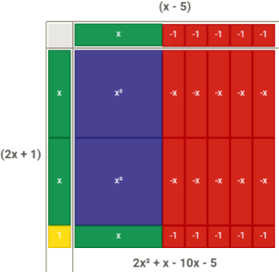
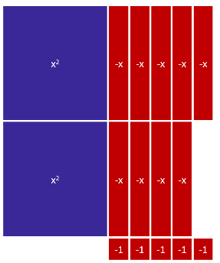
The factorization of 2𝑥² − 9𝑥 − 5 using algebra tiles is shown below. Begin with the representation of the given polynomial and arrange the tiles into a complete rectangle, adding zero pairs of tiles if needed. The factors are then determined by the dimensions of the rectangle.

Common Misconceptions or Errors
- Students may not identify the greatest common factor or factor completely.

Strategies to Support Tiered Instruction
- Instruction includes providing a flow chart to reference while completing examples.
- Instruction includes providing definition of greatest common factor and strategies for identifying the greatest common factor of numerical or algebraic terms.
- For example, the expression 8𝑥³ − 4𝑥² has common factors of 2 and 𝑥, but these are not greatest common factors. The greatest common factor of the coefficients is 4 and the greatest common factor of the variable terms is 𝑥². So, the greatest common factor of the two terms is 4𝑥². The expression 8𝑥³ − 4𝑥² can be rewritten as 4𝑥²(2𝑥 − 1).
Instructional Tasks
Instructional Task 1 (MTR.3.1, MTR.4.1, MTR.5.1)
Part A. Given the polynomial 𝑥⁴ − 16𝑦⁴𝑧⁸, rewrite it as a product of polynomials.
Part B. Discuss with your partner the strategy used. How do your polynomial factors compare to one another?

Instructional Task 2 (MTR.3.1, MTR.5.1)
Part A. What are the factors of the quadratic 16𝑥² − 48𝑥 + 36?
Part B. Determine the roots of the quadratic function 𝑓(𝑥) = 16𝑥² − 48𝑥 + 36. Part C. What do you notice about your answers from Part A and Part B?
Part D. Graph the function 𝑓(𝑥) = 16𝑥² − 48𝑥 + 36.

Instructional Items
Instructional Item 1
Given the polynomial 𝑥⁴ − 16𝑦⁴𝑧⁸, rewrite it as a product of polynomials.

Instructional Item 2
Given the polynomial 𝑥² − 10𝑥 + 24, rewrite it as a product of polynomials.

Instructional Item 3
Given the polynomial 𝑥³ − 3𝑥² − 9𝑥 + 27, rewrite it as a product of polynomials.

Instructional Item 4
What is one of the factors of the polynomial 21𝑟³𝑠² − 14𝑟²𝑠 + 14$rs^{3}$?
*The strategies, tasks and items included in the B1G-M are examples and should not be considered comprehensive.

MA.912.AR.2 Write, solve and graph linear equations, functions and inequalities in one and two variables.

MA.912.AR.2.1

Benchmark
MA.912.AR.2.1 Given a real-world context, write and solve one-variable multi-step linear equations.

Connecting Benchmarks/Horizontal Alignment
- MA.912.AR.4.1
- MA.912.AR.9.1
- MA.912.FL.3.2

Terms from the K-12 Glossary
- Linear Equation

Vertical Alignment
Previous Benchmarks  - MA.6.AR.2.2, MA.6.AR.2.3  - MA.7.AR.2.2  MA.8.AR.2.1 | Next Benchmarks  - MA.912.NSO.4.2  - MA.912.AR.9.8  - MA.912.AR.9.9
Purpose and Instructional Strategies
In grade 8, students solved one-variable multi-step linear equations. In Algebra I, students write
and solve one-variable multi-step linear equations within a real-world context. In future courses, students will work with linear systems in three-variables and linear programing. Additionally, linear equations and linear functions are fundamental parts of all future high school courses.
- Problem types includes the writing of an equation from a given context, the solving of a given equation and writing and solving an equation within context.
- Instruction includes the use of manipulatives, drawings, models and the properties of equality.
- Instruction includes the interpretation of the solution within context.
- Instruction emphasizes the understanding solving a linear equation in one variable mirrors the process of determining 𝑥-intercepts, or roots, of the graph of a linear function.
- In many contexts, students may generate solutions that may not make sense when placed in context. Be sure students assess the reasonableness of their solutions in terms of context to check for this (MTR.6.1).
  - For example, if students are solving a problem where 𝑥 represents the number of paintings sold at an art gallery. If the solution is 𝑥 = 6.3, then the number of paintings sold would be 6 since a portion of a painting cannot be sold.

Common Misconceptions or Errors
- Students may experience difficulty translating contexts into expressions. In these cases, give students sample quantities to help them reason.
- Students may not use properties of equality properly.

Strategies to Support Tiered Instruction
- Instruction includes opportunities to draw pictures or use bar models to represent real- world contexts.
  - For example, Kevin buys 66 markers plus 5 packs of markers. Fernando buys 48 markers plus 8 packs of markers. If Kevin and Fernando buy the same total number of markers, how many markers are in a pack?
66 Markers |  |  |  | P | P | P | P | P
48 Markers | P | P | P | P | P | P | P | P
- Instruction includes providing expressions and having students act out the context with props.
  - For example, Karen earns $100 a day plus $5 commission for each sale made at the store that day. In this example, give a student $100 in play money and then ask how much more they would get if they made 1 sale, 2 sales, and so on. Then ask how they could represent an unknown amount of sales.
- Instruction includes opportunities to use algebra tiles to model a multi-step equation and write the steps algebraically. For each step, ask students to identify the property of equality they would use.
- Instruction includes vocabulary development by co-creating a graphic organizer for each property of equality.
- Instruction includes the use of algebra tiles to model the distributive property or to add and subtract like terms as a problem is solved algebraically.
  - An example of modeling the distributive property using algebra tiles for −2(2𝑥 − 3) is shown below.
−2(2𝑥 − 3)
−2(2𝑥) + (−2)(−3)
−4𝑥 + 6
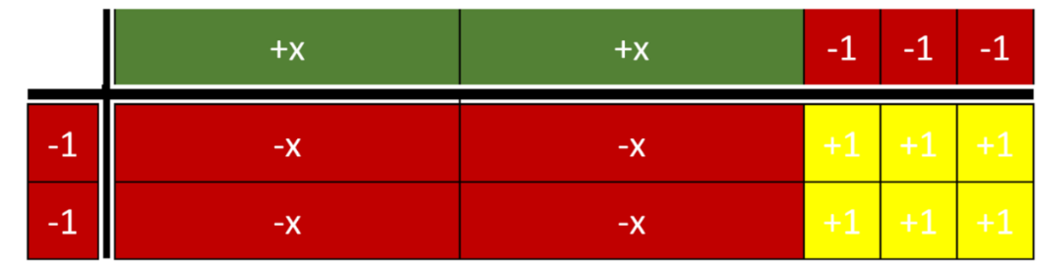

  - An example of modeling combining like terms using algebra tiles for −3𝑥 + 2 + 5𝑥 − 6 + 5 is shown below.
−3𝑥 + 2 + 5𝑥 − 6 + 5
−3𝑥 + 5𝑥 + 2 − 6 + 5
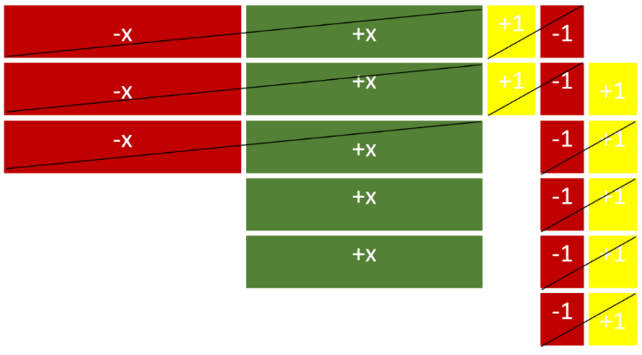
2𝑥 + 1

Instructional Tasks
Instructional Task 1 (MTR.4.1, MTR.6.1, MTR.7.1)
City A has a current population of 156,289 residents and has an annual growth of 146 residents. City B has a current population of 151,293 and has an annual growth of 363 residents.
Part A. Write an equation for when City A and City B will have the same population.
Part B. Compare your equation with a partner.
Part C. Solve your equation.
Part. D. Describe what the solutions mean within the context of the problem.

Instructional Task 2 (MTR.4.1, MTR.6.1, MTR.7.1)
Part A. Write a real-world context that could be represented with the equation
$$4(x+5)=6x+12$$
Part B. Define the variable in the context.
Part C. Solve the equation and discuss the solution with a partner.

Instructional Items
Instructional Item 1
A group of friends decides to go out of town to a championship football game. The group pays $185 per ticket plus a one-time convenience fee of $15. They also each pay $27 to ride a tour bus to the game. If the group spent $2,771 in total, how many friends are in the group?

Instructional Item 2
Two rectangular fields, both measured in yards, are modeled below. What value of 𝑥, in yards, would cause the fields to have equal areas?

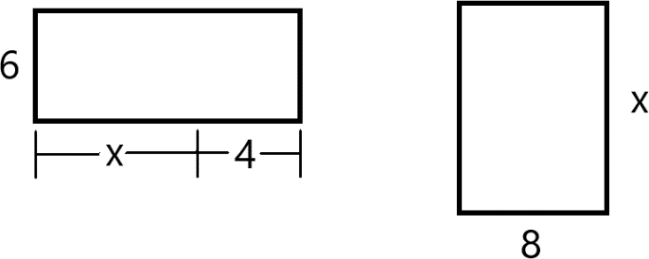
Instructional Item 3
A nutrition store starts a new membership program. Members of the program pay $52 to join and can purchase a canister of protein powder for $42.50. Non-members pay $49 for a canister of protein powder. After how many canisters is the total cost the same for members as it is for non-members?
*The strategies, tasks and items included in the B1G-M are examples and should not be considered comprehensive.

MA.912.AR.2.2

Benchmark
MA.912.AR.2.2 Write a linear two-variable equation to represent relationships between quantities from a graph, a written description or a table of values within a mathematical or real-world context.
Benchmark Clarifications:
Clarification 1: Instruction includes the use of standard form, slope-intercept form and point-slope form, and the conversion between these forms.

Connecting Benchmarks/Horizontal Alignment
- MA.912.AR.4.1
- MA.912.AR.9.1
- MA.912.F.1.4
- MA.912.FL.3.2, MA.912.FL.3.4
- MA.912.DP.2.4

Terms from the K-12 Glossary
- Linear Equation
- Slope
- 𝑦-intercept

Vertical Alignment
Previous Benchmarks  - MA.7.AR.4.4  - MA.8.AR.3.2  - MA.8.AR.3.3 | Next Benchmarks  - MA.912.NSO.4.2  - MA.912.AR.9.8  - MA.912.AR.9.9
Purpose and Instructional Strategies
In grade 8, students wrote linear two-variable equations in slope-intercept form from tables, graphs and written descriptions. In Algebra I, students write linear two-variable equations in all forms from real-world and mathematical contexts. In future courses, students will write systems and solve problems involving systems in three-variables and linear programming. Additionally, linear equations and linear functions are fundamental parts of all future high school courses.
- Instruction includes making connections to various forms of linear equations to show their equivalency. Students should understand and interpret when one form might be more useful than another depending on the context.
  - Standard Form
Can be described by the equation 𝐴𝑥 + 𝐵𝑦 = 𝐶, where 𝐴, 𝐵 and 𝐶 are any rational number. This form can be useful when identifying the 𝑥- and 𝑦- intercepts.
  - Slope-Intercept Form
Can be described by the equation 𝑦 = 𝑚𝑥 + 𝑏, where 𝑚 is the slope and 𝑏 is the
𝑦-intercept. This form can be useful when identifying the slope and 𝑦-intercept.
  - Point-Slope Form
Can be described by the equation 𝑦 − 𝑦₁ = 𝑚(𝑥 − 𝑥₁), where (𝑥₁, 𝑦₁) is a point on the line and 𝑚 is the slope of the line. This form can be useful when a point on the line is given and the 𝑦-intercept is not easily determinable.
- Look for opportunities to point out the connection between linear contexts and constant rates of change.
- Problem types should include cases for vertical and horizontal lines.

Common Misconceptions or Errors
- Students may have difficulty identifying both variables from a context. Much of their work previously has involved univariate contexts. Place emphasis on asking students what is changing in each context. Help guide their thoughts to recognize bivariate contexts as having two “things” that change in tandem.
- Students may attempt to estimate intercepts in order to continue using a linear form they prefer for some contexts. Use these opportunities to address the need for precision in mathematics.

Strategies to Support Tiered Instruction
- Instruction includes strategies from MA.912.AR.1.2 on rearranging equations to help students when they convert from one form of two-variable linear equation to another.
- Teacher models opportunities to address the need for precision in mathematics when determining intercepts.
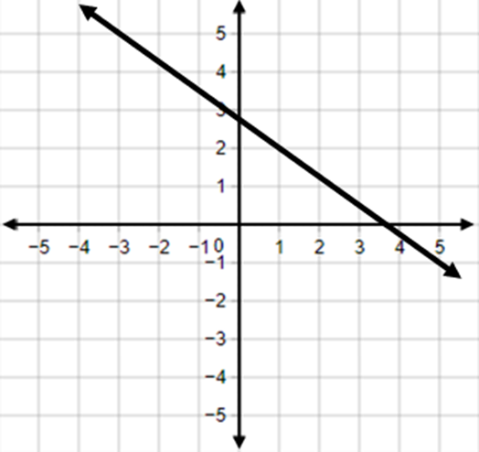
  - For example, a student could prefer to use slope-intercept form when writing two- variable linear equations. If the given information, as shown below, is two points that do not include the 𝑦-intercept, then the student may only estimate the 𝑦- intercept rather than determining it exactly. The student should realize that they could use point-slope form to write the equation without having to determine the 𝑦-intercept

- Instruction includes explicit questions such as “What is staying the same or constant?”, “What is changing or varying?” or “Is there anything else varying?”
  - For example, students are given the situation where a dog groomer charges $25 for a shampoo and hair cut plus $10 for each hour the dog stays at the groomer and are asked to write a linear two-variable equation that represents the total cost. The teacher can provide questions to help determine the constant value and two variables.
Constant | Variable #1 | Variable #2
Charge for Shampoo ($25) | Number of Hours ($10 each) | Total Cost
- Instruction includes discussions about what a particular coordinate point on a line means in the context of the problem. Teachers may ask, “What does the identified point represent in the context of the problem?” and “How does the 𝑦 change as 𝑥 increases/decreases?”
- Teacher models finding the slope by color coding the points.
  - For example, to find the slope of a line passing through points (1,2) and (4,0), you would use 𝑚 = $\frac{2-0}{1-4}$ or 𝑚 = $\frac{0-2}{4-1}$.
- For students who need extra support in adding or subtracting integers, instruction includes using two-colored counters or algebra tiles to model the operation.
  - For example, given the expression 8 − (−2), students can use two-colored counters to find the difference as shown.
Start with 8. | There are not two negatives to subtract so you must add two zero pairs. | Subtract the two negatives to show that  8 − (−2) = 10.
 | 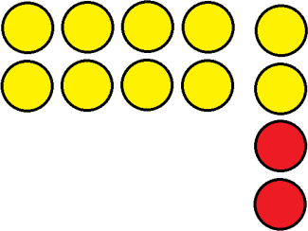 | 

- Instruction includes a graphic organizer to identify the key features. Based on the key features identified, ask students which form of an equation would be the best.
  - For example, given the graph below, students can use an organizer to fill in some of the information.

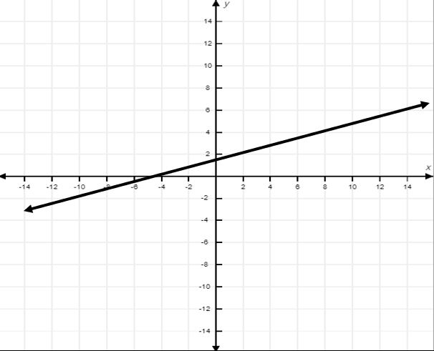

Once the information is filled in, students can write an equation of the line and determine the rest of the key features.

Slope | 𝒙-intercept | 𝒚-intercept | Point(s) on the graph that are not intercepts | Equation of Line

Instructional Tasks
Instructional Task 1 (MTR.2.1, MTR.3.1, MTR.5.1)
Jamie bought a car in 2005 for $28,500. By 2008, the car was worth $23,700.
Part A. What function type could model the given situation?
Part B. What is the rate of change in the vehicle’s worth per year?
Part C. Create a model that describes this situation.

Instructional Task 2 (MTR.3.1, MTR.4.1)
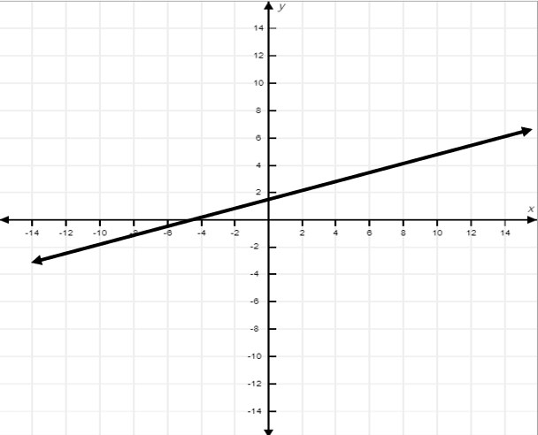
Use the graph below to answer the following questions.

Part A. In order to write the equation that represents this line, what information do you need?
Part B. Write a linear two-variable equation that represents the graph. Justify the linear form you chose (standard form, point-slope form, slope-intercept form).
Part C. Write a real-world situation that could represent this graph.

Instructional Items
Instructional Item 1
Sharon is ordering tickets for an upcoming basketball game for herself and her friends. The ticket website shows the following table of ticket options.
Number of tickets | Cost (including processing fee)
1 | $42.50
2 | $68.50
3 | $94.50
4 | $120.50
5 | $146.50
10 | $276.50
15 | $406.50
Write a linear two-variable equation to represent the total cost 𝐶 of 𝑡 tickets.

Instructional Item 2
Write a linear two-variable equation that represents the graph below.
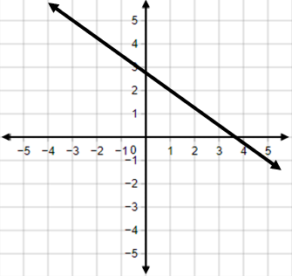

*The strategies, tasks and items included in the B1G-M are examples and should not be considered comprehensive.

MA.912.AR.2.3

Benchmark
MA.912.AR.2.3 Write a linear two-variable equation for a line that is parallel or perpendicular to a given line and goes through a given point.
Benchmark Clarifications:
Clarification 1: Instruction focuses on recognizing that perpendicular lines have slopes that when multiplied result in −1 and that parallel lines have slopes that are the same.
Clarification 2: Instruction includes representing a line with a pair of points on the coordinate plane or with an equation.
Clarification 3: Problems include cases where one variable has a coefficient of zero.

Connecting Benchmarks/Horizontal Alignment
MA.912.AR.9.1

Terms from the K-12 Glossary
- Linear Equation
- Rotation
- Slope
- Translation

Vertical Alignment
Previous Benchmarks  - MA.8.AR.3.2  - MA.8.AR.3.3  - MA.8.AR.4.2  - MA.8.GR.2.1 | Next Benchmarks  - MA.912.GR.1.1  - MA.912.GR.3.2, MA.912.GR.3.3

Purpose and Instructional Strategies
In grade 8, students determined whether a graphed system of linear equations resulted in one solution, no solution (parallel lines) or infinitely many solutions. In Algebra I, students write linear two-variable equations that are parallel or perpendicular to one another. In Geometry, students will use slope criteria of parallel and perpendicular lines to justify postulates, relationships or theorems.
- Instruction includes allowing students to explore the transformations of two lines using graphing software or other technology. If students don’t have their own computers, use your own and let students direct the exploration.
  - For example, using graphing software, ask students to use the sliders to discover two lines that are parallel. Once students achieve this, write the equations of these two lines on the board and ask them to find two different lines that are parallel. Write the equations for these lines on the board. Repeat this for multiple pairs of lines. As students explore, ask them to find patterns in the equations they develop (MTR.5.1). Guide their discussion to focus on the fact that parallel lines have equivalent slopes (MTR.4.1).
  - Repeat this exercise for perpendicular lines.
- When students establish connections and understanding of slopes of parallel and perpendicular lines, tie them back to their work with transformations in Grade 8, with instruction of the benchmark MA.8.GR.2.1. (MTR.5.1).
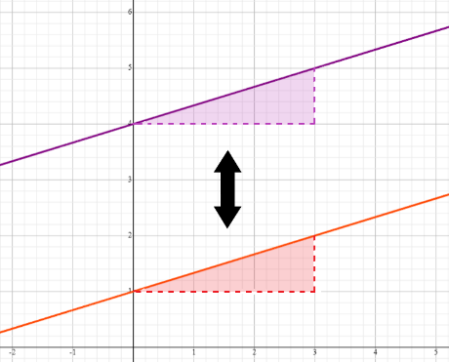
  - For example, parallel lines can be translated to coincide with each other without changing slope.

  - For example, perpendicular lines can be rotated 90° about the point of intersection to coincide with each other. Use slope to draw congruent triangles on each line and show the change in slope to an opposite reciprocal after rotation.
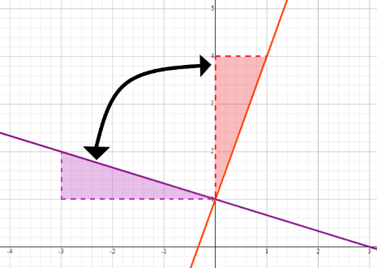
- Once students understand slope relationships, instruction should guide them to utilize slope and a point on the line to develop the point-slope equation for the line.
Students can also develop slope-intercept equations for the line. Students should have prior knowledge from their work in MA.912.AR.2.2 that 𝑥 and 𝑦 in a linear equation represent points on the corresponding line. Direct students to see that substituting the slope of a line (𝑚) and the coordinates of a point on that line (𝑥, 𝑦) into slope-intercept form (𝑦 = 𝑚𝑥 + 𝑏) allows them to solve to find the 𝑦- intercept.

Common Misconceptions or Errors
- Some students may forget to change the sign of the slope when working through perpendicular line problems. Others may change the sign correctly but forget to make the slope a reciprocal. In both cases, consider having the student sketch a rough graph or use graphing software to check their result.

Strategies to Support Tiered Instruction
- Instruction provides opportunities to identify parallel or perpendicular lines using a graphing tool, graphing software or sketching a rough graph.
- Instruction includes opportunities to graph a linear function on a coordinate grid. Teacher models using a piece of spaghetti or other straight item (such as a pencil) to show a line parallel or perpendicular to the one they graphed and estimate the slope of the straight item. Students can compare that estimate with the slope of the parallel or perpendicular line they determined algebraically.
  - For example, if the given line has a slope of − $\frac{1}{2}$ and the student determines
incorrectly that the perpendicular slope is −2, they can visually see the mistake
when using a straight object that is placed perpendicular to the graph of the given line.
- Teacher provides opportunities to practice identifying the slope of parallel and perpendicular lines using a graphic organizer. To follow up this activity, have students do a card match where they match a linear equation to the slope of a parallel line and the slope of a perpendicular line.
  - For example, the organizer below could be used to identify the slope of the parallel and perpendicular line of the given equation.

Linear  Equation | Slope of the  Given Line | Slope of a  Parallel Line | Slope of a  Perpendicular Line
$$y=\frac{2}{3}x+5$$ | $$\frac{2}{3}$$ | $$\frac{2}{3}$$ | $$-\frac{3}{2}$$

Instructional Tasks
Instructional Task 1(MTR.4.1)
Part A. A vertical line that passes through the point (−0.42, 7.8) is perpendicular to another line. What could be the equation of the second line?
Part B. Graph both lines on a coordinate plane. What do you notice about the lines? Part C. Compare your graph with a partner.

Instructional Task 2 (MTR.4.1)
Sarah is walking on the sidewalk in a city shown in the graph. Each grid square represents 1 square block. Shawna is walking on a street parallel to Sarah represented by equation $y=\frac{3}{2}x+2$. Shawna wants to meet up with Sarah at the point (4, 5). What would be the equation of the line that Shawna would take to walk perpendicular to Sarah’s path to meet her?

Instructional Items
Instructional Item 1
Write a linear function for a line that passes through the point (4, – 3) and is perpendicular to
$y = 0.25x + 9$.

Instructional Item 2
Write an equation for the line that passes through (3, 14) and is parallel to the line that passes through (10, 2) and (25, 15).

Instructional Item 3
Write a linear function for a line that is parallel to $f(x) = \frac{1}{3}x - 8$ and passes through the
point (−7, 0).

Instructional Item 4
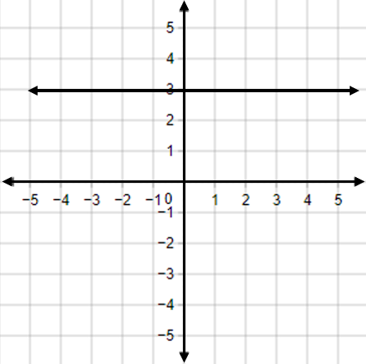

Part A: What is the slope of a line that is parallel to the given graph?
Part B: Write a linear equation that is perpendicular to the given graph.

*The strategies, tasks and items included in the B1G-M are examples and should not be considered comprehensive.

MA.912.AR.2.4
Benchmark
MA.912.AR.2.4 Given a table, equation or written description of a linear function, graph that function, and determine and interpret its key features.

Benchmark Clarifications:
Clarification 1: Key features are limited to domain, range, intercepts and rate of change.
Clarification 2: Instruction includes the use of standard form, slope-intercept form and point-slope form.
Clarification 3: Instruction includes cases where one variable has a coefficient of zero.
Clarification 4: Instruction includes representing the domain and range with inequality notation, interval notation or set-builder notation.
Clarification 5: Within the Algebra I course, notations for domain and range are limited to inequality and set-builder notations.

Connecting Benchmarks/Horizontal Alignment
- MA.912.F.1.3, MA.912.F.1.5, MA.912.F.1.6

Terms from the K-12 Glossary
- Coordinate Plane
- Domain
- Function Notation
- Range
- Rate of Change
- Slope
- 𝑥-intercept
- 𝑦-intercept

Vertical Alignment
Previous Benchmarks  - MA.8.AR.3.4 | Next Benchmarks  - MA.912.NSO.4.2  - MA.912.AR.9.8, MA.912.AR.9.9, MA.912.AR.9.10
Purpose and Instructional Strategies
In grade 8, students graphed two-variable linear equations given a written description, a table or an equation in slope-intercept form. In Algebra I, students graph linear functions from equations in other forms, as well as tables and written descriptions, and they determine and interpret the domain, range and other key features. In later courses, students will graph and solve problems involving linear programming, systems of equations in three variables and piecewise functions.
- Instruction includes representing domain and range using words, inequality notation and set-builder notation.
  - Words
If the domain is all real numbers, it can be written as “all real numbers” or “any value of 𝑥, such that 𝑥 is a real number.”

  - Inequality Notation
If the domain is all values of 𝑥 greater than 2, it can be represented as 𝑥 > 2.
  - Set-Builder Notation
If the domain is all values of x less than or equal to zero, it can be represented as
{𝑥|𝑥 ≤ 0} and is read as “all values of 𝑥 such that 𝑥 is less than or equal to zero.”
- Within this benchmark, linear two-variable equations include horizontal and vertical lines. Instruction includes writing horizontal and vertical lines in the form $y = 3$ and $x =-4$ and as$0x + 1y = 3$ and $1x + 0y = -4$, respectively. Students should understand that vertical lines are not linear functions but rather linear two-variable equations.
  - Discussions about this topic are a good opportunity to foreshadow the use of horizontal and vertical lines as common constraints in systems of equations or inequalities.
- Instruction includes the use of 𝑥-𝑦 notation and function notation.
- Instruction includes the use of appropriately scaled coordinate planes, including the use of breaks in the 𝑥- or 𝑦-axis when necessary.

Common Misconceptions or Errors
- Students may express initial confusion with the meaning of 𝑓(𝑥) for functions written in function notation.
- Students may confuse the x or y coordinates that correspond to domain and range.

Strategies to Support Tiered Instruction
- Teacher provides equations in both function notation and 𝑥-𝑦 notation written in slope- intercept form and models graphing both forms using a graphing tool or graphing software (MTR.2.1).
  - For example, $f(x) = \frac{2}{3} x + 6$ and $y =\frac{2}{3}x + 6$, to show that both 𝑓(𝑥) and 𝑦
represent the same outputs of the function.
- Teacher provides instruction using a coordinate plane geoboard to provide students support in graphing a linear function.
  - For example, given the 𝑦-intercept and slope of line, teacher first puts a peg at the 𝑦-intercept. Then, the teacher models using the slope to graph a second point by moving a second peg from the y-intercept “up and over” (or “down and over”) to another point. Students can check their second point by substituting it into the given equation of the line. If the equation makes a true statement, then the student has graphed the second point correctly. If the equation makes a false statement, then the student has not graphed the second point correctly.
- For students who need extra support in plotting points, teacher provides instruction using a coordinate plane geoboard to find the 𝑥-value on the 𝑥-axis and the 𝑦-value on the 𝑦- axis. Then, the teacher models moving to find the coordinate point, where the 𝑥- and 𝑦- value meet.
  - The graph below shows how a teacher could model plotting the points (−3, 5)
and (2, −4).
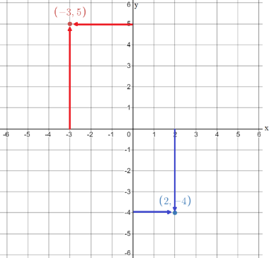

- Teacher provides an Anchor Chart to clarify vocabulary terms for x and y coordinates.

$$x$$ | $$y$$
domain | range
input | output
$$x$$ | $$f(x)$$

Instructional Tasks
Instructional Task 1 (MTR.3.1, MTR.7.1)
There are a total of 549 seniors graduating this year. The seniors walk across the stage at a rate of 42 seniors every 30 minutes. The ceremony also includes speaking and music that lasts a total of 25 minutes.
Part A. Write a function that models this situation.
Part B. What is the slope of the function you created? How does that translate to this situation?
Part C. Graph the function you created in Part A. What is the feasible domain and range for this situation?
Part D. For how many hours will the graduation ceremony take place?

Instructional Items
Instructional Item 1
A linear function has a y-intercept of -3 and a slope of 0.
Part A. Graph the function.
Part B. Identify the domain and range. Write them in inequality notation.
Part C. Identify the x-intercept.

*The strategies, tasks and items included in the B1G-M are examples and should not be considered comprehensive.

MA.912.AR.2.5
Benchmark
MA.912.AR.2.5 Solve and graph mathematical and real-world problems that are modeled with linear functions. Interpret key features and determine constraints in terms of the context.
Algebra I Example: Lizzy’s mother uses the function 𝐶(𝑝) = 450 + 7.75𝑝, where 𝐶(𝑝)
represents the total cost of a rental space and 𝑝 is the number of people
attending, to help budget Lizzy’s 16th birthday party. Lizzy’s mom wants to spend no more than $850 for the party. Graph the function in terms of the context.
Benchmark Clarifications:
Clarification 1: Key features are limited to domain, range, intercepts and rate of change.
Clarification 2: Instruction includes the use of standard form, slope-intercept form and point-slope form. Clarification 3: Instruction includes representing the domain, range and constraints with inequality notation, interval notation or set-builder notation.
Clarification 4: Within the Algebra I course, notations for domain and range are limited to inequality and set-builder.
Clarification 5: Within the Mathematics for Data and Financial Literacy course, problem types focus on money and business.
Connecting Benchmarks/Horizontal Alignment
- MA.912.AR.1.1
- MA.912.AR.9.6
- MA.912.F.1.5, MA.912.F.1.6, MA.912.F.1.8
- MA.912.DP.1.1, MA.912.DP.1.2
- MA.912.DP.2.4

Terms from the K-12 Glossary
- Coordinate Plane
- Domain
- Function Notation
- Range
- Rate of Change
- Slope
- 𝑥-intercept
- 𝑦-intercept

Vertical Alignment
Previous Benchmarks  - MA.8.AR.3.4  - MA.8.AR.3.5 | Next Benchmarks  - MA.912.NSO.4.2  - MA.912.AR.9.8, MA.912.AR.9.9, MA.912.AR.9.10

Purpose and Instructional Strategies
In grade 8, students determined and interpreted the slope and y-intercept of a two-variable linear equation in slope-intercept form from a real-world context. In Algebra I, students solve real- world problems that are modeled with linear functions when given equations in all forms, as well as tables and written descriptions, and they determine and interpret the domain, range and other key features. Additionally, students will interpret key features and identify any constraints. In later courses, students will graph and solve problems involving linear programming, systems of equations in three variables and piecewise functions.
- This benchmark is a culmination of MA.912.AR.2. Instruction here should feature a variety of real-world contexts.
- Instruction includes representing domain, range and constraints using words, inequality notation and set-builder notation.
  - Words
If the domain is all real numbers, it can be written as “all real numbers” or “any value of 𝑥, such that 𝑥 is a real number.”
  - Inequality Notation
If the domain is all values of 𝑥 greater than 2, it can be represented as 𝑥 > 2.
  - Set-Builder Notation
If the domain is all values of 𝑥 less than or equal to zero, it can be represented as
{𝑥|𝑥 ≤ 0} and is read as “all values of 𝑥 such that 𝑥 is less than or equal to zero.”
- Instruction includes the use of 𝑥-𝑦 notation and function notation.
- This benchmark presents the first opportunity for students to represent constraints in the domain and range of functions. Students should develop an understanding that linear graphs, without context, have no constraints on their domain and range. When specific contexts are modeled by linear functions, parts of the domain and range may not make sense and need to be removed, creating the need for constraints.
- For example when a variable represents an amount of time, negative values
would not be possible and therefore be a constraint.
- Instruction includes the understanding that a real-world context can be represented by a linear two-variable equation even though it only has meaning for discrete values.
  - For example, if a gym membership cost $10.00 plus $6.00 for each class, this can be represented as 𝑦 = 10 + 6𝑐. When represented on the coordinate plane, the relationship is graphed using the points (0,10), (1,16), (2,22), and so on.
- For mastery of this benchmark, students should be given flexibility to represent real- world contexts with discrete values as a line or as a set of points.
- Instruction directs students to graph or interpret a representation of a context that necessitates a constraint. Discuss the meaning of multiple points on the line and announce their meanings in the associated context (MTR.4.1). Allow students to discover that some points do not make sense in context and therefore should not be included in a formal solution (MTR.6.1). Ask students to determine which parts of the line create sensible solutions and guide them to make constraints to represent these sections.
- Instruction includes the use of technology to develop the understanding of constraints.
- Instruction includes the connection to scatter plots and lines of fit (MA.912.DP.2.4) and the connection to systems of equations or inequalities (MA.912.DP.9.6).

Common Misconceptions or Errors
- Students may express initial confusion with the meaning of 𝑓(𝑥) for functions written in function notation.
- Students may assign their constraints to the incorrect variable.
- Students may miss the need for compound inequalities in their constraints. Students may not include zero as part of the domain or range.
  - For example, if a constraint for the domain is between 0 and 10, a student may forget to include 0 in some contexts, since they may assume that one cannot have zero people, for instance.

Strategies to Support Tiered Instruction
- Teacher provides equations in both function notation and 𝑥-𝑦 notation written in slope- intercept form and models graphing both forms using a graphing tool or graphing software (MTR.2.1).
  - For example, 𝑓(𝑥) = $\frac{2}{3}$ 𝑥 + 6 and 𝑦 = $\frac{2}{3}$𝑥 + 6, to show that both 𝑓(𝑥) and 𝑦 represent the same outputs of the function.
- Instruction provides opportunities for identifying the domain and range on the 𝑥- and 𝑦- axis respectively using a highlighter.
  - For example, Tim bought 2 cubic feet of fertilizer and used a little every day on his lawn for 6 months, and the amount of fertilizer decreases at a constant rate as shown on the graph. The domain of the function in this context is 0 ≤ 𝑥 ≤ 6.
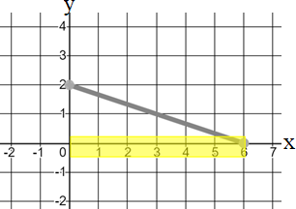
- Teacher provides context to visualize and determine if it would make sense for the function to extend to a given area.
  - For example, if Garrison bought a house in 2014 and the price increases at a constant rate, he could model this by graphing a linear function where 𝑥 represents the time since 2014. The domain could include negative values if he wanted to show the estimated price of the house before 2014.
  - For example, if the temperature in Alaska is at 14 degrees Fahrenheit at 6:00 am and drops at a constant rate, this can be modeled by graphing a linear function
where 𝑡 represents the time since 6:00 am. The range could include negative numbers to show the temperature below 0 degrees Fahrenheit.

Instructional Tasks
Instructional Task 1 (MTR.7.1)
The population of St. Johns County, Florida, from the year 2000 through 2010 is shown in the graph below. If the trend continues, what will be the population of St. Johns County in 2025?
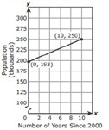

Instructional Task 2 (MTR 4.1, MTR.7.1)
Devon is attending a local festival downtown. He plans to park his car in a parking garage that operates from 7:00 a.m. to 10:00 p.m. and charges $5 for the first hour and $2 for each additional hour of parking.
Part A. Create a linear graph that represents the relationship between the price and number of hours parked.
Part B. What is an appropriate domain and range for the given situation?
Part C. Discuss with a partner whether there are constraints on the domain and range.

Instructional Task 3 (MTR.7.1)
Suppose you fill your truck’s tank with fuel and begin driving down the highway for a road trip. Assume that, as you drive, the number of minutes since you filled the tank and the number of gallons remaining in the tank are related by a linear function. After 40 minutes, you have 28.4 gallons left. An hour after filling up, you have 26.25 gallons left.
Part A. Graph this relationship.
Part B. Determine how many hours it will take for you to run out of fuel.

Instructional Items
Instructional Item 1
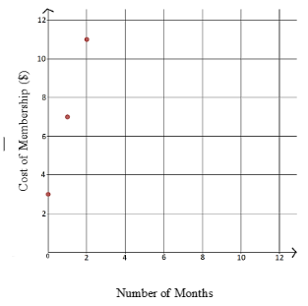
Mohammed wants to reach his fitness goals and decides to join a local gym to start his journey to a healthier lifestyle. The gym membership cost for students is shown in the graph below.
What is the range for the given situation?
a. $\{x|x ≥ 0\}$
b. $\{y|y ≥ 3\}$
c. $\{3, 7, 11\}$
d. All Real Numbers

Instructional Item 2
The band is selling cookie dough as a fundraiser for instruments at their annual concert. They start with 100 boxes, and they sell approximately 20 boxes per hour. The function
C(t) = 100−20t
represents the number of boxes of cookie dough remaining after hours.

Select all the statements that are true.

- The domain is all real numbers
- The y-intercept is 0.
- The range is all real numbers
- The range is 0≤y ≤ 100
- The y-intercept is 100
- The boxes of cookie dough increase 20 boxes per hour.

*The strategies, tasks and items included in the B1G-M are examples and should not be considered comprehensive.

MA.912.AR.2.6
Benchmark
MA.912.AR.2.6 Given a mathematical or real-world context, write and solve one-variable linear inequalities, including compound inequalities. Represent solutions algebraically or graphically.
Algebra I Example: The compound inequality 2𝑥 ≤ 5𝑥 + 1 < 4 is equivalent to −1 ≤ 3𝑥 and 5𝑥 < 3, which is equivalent to ⁻$\frac{1}{3}$ ≤ 𝑥 <$\frac{3}{5}$.

Connecting Benchmarks/Horizontal Alignment
- MA.912.AR.1.1
- MA.912.AR.4.1
- MA.912.AR.9.1, MA.912.AR.9.4, MA.912.AR.9.6

Terms from the K-12 Glossary
- Linear Expression

Vertical Alignment
Previous Benchmarks  - MA.8.AR.2.2 | Next Benchmarks  - MA.912.AR.3.3  - MA.912.AR.9.8

Purpose and Instructional Strategies
In grade 8, students solved two-step linear inequalities in one variable. In Algebra I, students solve one-variable linear inequalities, including compound inequalities. In later courses, students will solve problems involving linear programming and will solve one-variable quadratic inequalities.
- Instruction includes representing the solution using words, inequality notation, set-builder notation and a graph.
  - Words
For example, the solution to the compound inequality $2 < x + 1 < 5$ could be represented as all real numbers greater than one and less than four.
  - Inequality Notation
For example, if the solution is all values of 𝑥 greater than 2, it can be represented as 𝑥 > 2.
  - Set-Builder Notation
For example, if the domain is all values of 𝑥 less than or equal to zero, it can be represented as
  - {𝑥|𝑥 ≤ 0} and is read as “all values of 𝑥 such that 𝑥 is less than or equal to zero.” Graph
    - For example, 𝑥 ≥ 6 𝑜𝑟 𝑥 < 1
- Instruction emphasizes that solutions for compound inequalities with an or statement contain all the solutions for both inequalities and that solutions for compound inequalities with an and statement contain only the solutions that both inequalities have in common. Allow for student discovery of this by discussing whether each point on a number line is a solution for its compound inequality (MTR.4.1).
  - For example, plot various points on a number line and ask student whether certain points are a solution to the compound inequality 𝑥 < −6 or 𝑥 ≥ 8.
- Instruction includes student understanding that compound inequalities with or create a combining (or a union) of the solutions of the individual inequalities while compound inequalities with and create an overlap (or an intersection) of the solutions of the individual inequalities.
- For mastery of this benchmark, students do not need to have familiarity with the terms “unions” and “intersections” as this will be part of a later course.
- Instruction builds understanding that compound inequalities may have different looks graphically.
  - Graphs of Compound Inequalities with or
    - 𝑥 ≥ 6 𝑜𝑟 𝑥 < 1
    - 𝑥 < −5 𝑜𝑟 𝑥 ≥ −9 (Solution is all real numbers)

    - 𝑥 ≥ 3 𝑜𝑟 𝑥 > 0

  - Graphs of Compound Inequalities with and
    - 𝑥 ≥ 6 𝑎𝑛𝑑 𝑥 ≤ 1 (There are no solutions)

    - 𝑥 < −7 𝑎𝑛𝑑 𝑥 ≥ −9
    - 𝑥 ≥ 3 𝑎𝑛𝑑 𝑥 > 0

Common Misconceptions or Errors
- Given that students’ prior experience has dealt with equation work far more than inequality work, students will likely forget to consider the direction of the inequality symbol as they solve inequalities.
- When creating inequalities, look for students to experience confusion with the phrase “less than.”
- Students may interchange the meanings of “at most” and “at least”.

Strategies to Support Tiered Instruction
- Teacher models which direction to shade when graphing inequalities. Teacher additionally models and co-creates a number line while providing a think-aloud explaining that after solving for 𝑥, you must select values for 𝑥. If the value selected creates a true statement, have students place a dot on that value. If it creates a false statement, have students place an “x” on that value. At the beginning, students may need to choose a few values before being able to accurately shade. The same thing can be done for compound inequalities by replacing values for 𝑥 in both inequalities.
- Teacher provides instruction involving real-world contexts where students must determine the direction of the inequality symbol on a number line.
- Teacher supports student understanding on why the inequality symbol changes direction when multiplying or dividing by a negative.
  - For example, students are provided with a numerical inequality and a series of operations where they put in the inequality after each operation to determine when the inequality is flipped and when it is not.
5 > −3
Add −6 to both sides. | −1 > −9
Subtract 3 from both sides. | −4 > −12
Multiply both sides by 2. | −8 > −24
Divide both sides by −4. | 2 < 6
Subtract 4 from both sides. | −2 < 2
Multiply both sides by −3. | 6 > −6

- Teacher provides a highlighter to identify the phrases “is less than,” “is greater than,” “is less than or equal to,” and “is greater than or equal to” when writing inequalities.
- Teacher provides clarification on “less than” and “is less than”, since “less than” has been used for subtraction in prior grade levels.

- It is helpful to compare the placement of the word “is” in the two statements: “eight less than four times a number is …” which is the same as “$4n – 8 =$ …” and “eight is less than four times a number” which is represented as “$8 < 4n$”.
- Teacher provides an anchor chart with inequality symbols and possible associated key words including “at most” and “at least”.

< | ≤ | > | ≥
Less than | Less than or equal to | Greater than | Greater than or equal to
Fewer than | Maximum | More than | Minimum
Does not include | At most | Does not include | At least

- Instruction includes the use of algebra tiles to model the distributive property or to add and subtract like terms as a problem is solved algebraically.
  - An example modeling the distributive property using algebra tiles for −2(2𝑥 − 3) is shown below.

−2(2𝑥 − 3)
−2(2𝑥) + (−2)(−3)
−4𝑥 + 6
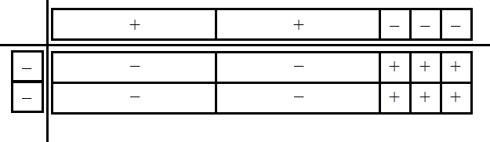

- An example modeling combining like terms using algebra tiles for −3𝑥 + 2 + 5𝑥 − 6 + 5 is shown below.

−3𝑥 + 2 + 5𝑥 − 6 + 5
−3𝑥 + 5𝑥 + 2 − 6 + 5
2𝑥 + 1

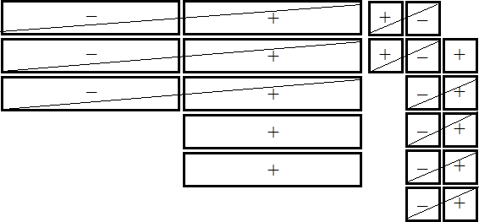
- Instruction includes providing expressions and have students act out the context with props.
  - For example, Karen earns a base salary of $3500 plus $200 commission for each sale made. She wants to earn at least $4500 this month, and the company will only pay at most $5300 each month. In this example, give a student play money and then ask how much money they make after 1 sale, 2 sales, and so on this month. Then ask them what the least number of sales they want to make and the most number of sales they would want to make, and to represent this using an inequality.
- Instruction includes vocabulary development by co-creating a graphic organizer for each property of inequality.

Instructional Tasks
Instructional Task 1 (MTR.4.1, MTR.7.1)
Each month, Phone Company A charges $105 for unlimited talk and text plus an additional
$11.50 for each gigabit of data used. Phone Company B charges $28.50 per gigabit of data used, and the price includes unlimited talk and text.
Part A. How many gigabits of data could a person use monthly to make the total cost from Phone Company B more expensive than Phone Company A?
Part B. Compare your solution with a partner.
Part C. What are all of the possible gigabits a person could use to make the total cost from Phone Company B more expensive than Phone Company A?

Instructional Task 2 (MTR.7.1)
Tamar is shopping for food for an upcoming graduation party for her senior class. She starts with $350 and hopes to retain between $100 and $125 after her purchases to hire a DJ. She spends a total of $163 on food and plans to buy 24-packs of soda that are priced at $8 each. What range of 24-packs of soda can Tamar afford to buy?

Instructional Items
Instructional Item 1
The expression 45ℎ + 225 represents the total cost in dollars of renting a large party tent from a local rental store for ℎ hours. Jamal’s parents are willing to spend between $500 and
$750 for the tent.
Part A. Write an inequality to represent the possible lengths of time the tent can be rented.
Part B. Using your inequality in Part A, what is one possible length of time the tent could be rented? Give your answer in number of hours.

Instructional Item 2
Graph the solution to the inequality $- \frac{4}{5} - 9.2w < 1.24w - 3.75.$

Instructional Item 3
You are planning a road trip, and you want to ensure that the fuel level in your car stays within an acceptable range, between 8 and 15 gallons. Let g represent the number of gallons of gas in your tank. You want to make sure that your fuel level is neither too low nor too high. Write an inequality to model the situation

*The strategies, tasks and items included in the B1G-M are examples and should not be considered comprehensive.

MA.912.AR.2.7
Benchmark
MA.912.AR.2.7 Write two-variable linear inequalities to represent relationships between quantities from a graph or a written description within a mathematical or real- world context.
Benchmark Clarifications:
Clarification 1: Instruction includes the use of standard form, slope-intercept form and point-slope form and any inequality symbol can be represented.
Clarification 2: Instruction includes cases where one variable has a coefficient of zero.

Connecting Benchmarks/Horizontal Alignment
- MA.912.AR.4.1
- MA.912.AR.9.1, MA.912.AR.9.4, MA.912.AR.9.6

Terms from the K-12 Glossary
- Coordinate Plane
- Linear Expression

Vertical Alignment
Previous Benchmarks  - MA.8.AR.2.2  - MA.8.AR.3.3 | Next Benchmarks  - MA.912.AR.3.9  - MA.912.AR.9.8
Purpose and Instructional Strategies
In grade 8, students wrote two-variable linear equations in slope-intercept form. In Algebra I, students write two-variable linear inequalities. In later courses, students will solve problems involving linear programming and will write two-variable quadratic inequalities.
- Instruction includes making connections to various forms of linear inequalities to show their equivalency. Students should understand and interpret when one form might be more useful than another depending on the context.
  - Standard Form
Can be described by the inequality 𝐴𝑥 + 𝐵𝑦 > 𝐶, where 𝐴, 𝐵 and 𝐶 are any rational number and any inequality symbol can be used. This form can be useful when identifying the 𝑥- and 𝑦-intercepts.
  - Slope-Intercept Form
Can be described by the inequality 𝑦 < 𝑚𝑥 + 𝑏, where 𝑚 is the slope and 𝑏 is the
𝑦-intercept and any inequality symbol can be used. This form can be useful when identifying the slope and 𝑦-intercept.
  - Point-Slope Form
Can be described by the inequality 𝑦 − 𝑦₁ ≤ 𝑚(𝑥 − 𝑥₁), where (𝑥₁, 𝑦₁) is a point on the boundary line and 𝑚 is the slope of the line and any inequality symbol can be used. This form can be useful when the 𝑦-intercept is not readily apparent.
- Look for opportunities to point out the connection between linear contexts and constant rates of change.
- Problem types should include cases for vertical and horizontal lines.
- Instruction includes the connection to one-variable linear inequalities and their solutions on a number line.
  - For example, provide the inequality 𝑥 ≥ 2 and a coordinate plane for students to determine points that satisfy the inequality. Students will determine that all points on the half-plane to the right of 𝑥 = 2 contain solutions.
Instruction includes the connection to graphs of the solution sets of one-variable inequalities on a number line; recognizing whether the boundary line should be dotted (exclusive – meaning not included in the solution set) or solid (inclusive – meaning included in the solution set).

Common Misconceptions or Errors
- Students often choose the incorrect inequality symbol when interpreting graphs or contexts. Help these students develop the habit of using a test point to check their work. Any point can be used, but many students find it easiest to use the origin (0, 0) as it often makes mental calculation much quicker.
- When creating inequalities, look for students to experience confusion with the phrase “less than.”

Strategies to Support Tiered Instruction
- Instruction includes opportunities to use a highlighter to identify the phrases “is less
than,” “is greater than,” “is less than or equal to,” and “is greater than or equal to” when writing inequalities.
- Instruction includes opportunities to identify a test point to substitute into an inequality to determine which symbol should be used when writing the inequality. It is usually easiest to use the origin (0,0) as it makes mental calculations easier. If the point selected creates a true statement, their inequality is true. If it creates a false statement, their inequality is false.
  - For example, given the graph below, one could use the test point (0,0) to determine whether the inequality $y ≤\frac{2}{3} x + 3$ or $y ≥\frac{2}{3}x + 3$ represents the graph. When substituting in (0,0) for $y ≥\frac{2}{3} x + 3$, it results in the inequality 0 ≥ 3 which is a false statement. When substituting in (0,0) for $y ≤\frac{2}{3}x + 3$, it results in the equality 0 ≤ 3 which is a true statement. Therefore, the inequality $y≤\frac{2}{3}x$ represents the given graph.

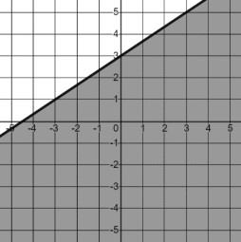

- Teacher provides clarification on “less than” and “is less than”, since “less than” has been used for subtraction in prior grade levels.
  - It is helpful to compare the placement of the word “is” in the two statements: “eight less than four times a number is …” which is the same as “$4n – 8 =$ …” and “eight is less than four times a number” which is represented as “$8 < 4n$”.

Instructional Tasks
Instructional Task 1 (MTR.7.1)
A carpenter makes two types of chairs: a lawn chair and a living room chair. It takes her 3 hours to make a lawn chair and 5 hours to make a living room chair.
Part A. If the carpenter works a maximum of 55 hours per week, write a two-variable linear inequality to describe the number of possible chairs of each type she can make in a week.
Part B. What is one possible combination of lawn chair and living room chair that the carpenter can make in one week?
Part C. What is one possible combination of lawn chair and living room chair that the carpenter could make in one month?

Instructional Task 2 (MTR.3.1, MTR.4.1)
The graph of the solution set to a linear inequality is shown below.
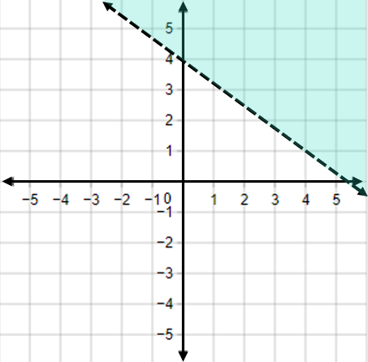
Part A. Create a linear inequality that corresponds to this graph.
Part B. Create a real-world situation that could be described by the graph and the inequality created in Part A.

Instructional Items
Instructional Item 1
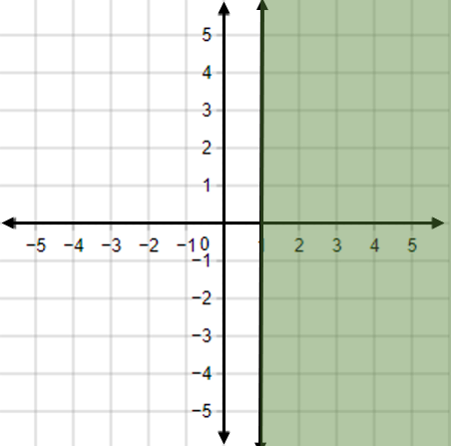
The graph of the solution set to a linear inequality is shown below. Create a linear inequality that corresponds to this graph.

Instructional Item 2
The Drama Club sold sodas and sandwiches in the cafeteria to raise money for costumes. The sodas were sold for $2 each and the sandwiches were sold for $5 each. In order to cover the cost of expenses, the Drama Club needed to raise more than $80. Which inequality represents this situation?
- $2x+5y<80$
- $2x+5y>80$
- $(2+5)x>80$
- $(2+5)x<80$

*The strategies, tasks and items included in the B1G-M are examples and should not be considered comprehensive.

MA.912.AR.2.8
Benchmark
MA.912.AR.2.8 Given a mathematical or real-world context, graph the solution set to a two- variable linear inequality.
Benchmark Clarifications:
Clarification 1: Instruction includes the use of standard form, slope-intercept form and point-slope form and any inequality symbol can be represented.
Clarification 2: Instruction includes cases where one variable has a coefficient of zero.

Connecting Benchmarks/Horizontal Alignment
- MA.912.AR.4.1, MA.912.AR.4.3
- MA.912.AR.9.1, MA.912.AR.9.4, MA.912.AR.9.6

Terms from the K-12 Glossary
- Coordinate Plane
- Linear Expression

Vertical Alignment
Previous Benchmarks  - MA.8.AR.2.2  - MA.8.AR.3.4 | Next Benchmarks  - MA.912.AR.3.1  - MA.912.AR.9.8
Purpose and Instructional Strategies
In grade 8, students graphed linear two-variable equations written in slope-intercept form. In Algebra I, students graph the solution set to a two-variable linear inequality. In later courses, students will solve problems involving linear programming and will graph the solutions sets of two-variable quadratic inequalities.
- Instruction includes the use of linear inequalities in standard form, slope-intercept form and point-slope form. Include examples in which one variable has a coefficient of zero such as 𝑥 < − $\frac{17}{5}$.
- Instruction includes the connection to graphing solution sets of one-variable inequalities on a number line; recognizing whether the boundary line should be dotted (exclusive) or solid (inclusive). Additionally, have students use a test point to confirm which side of the line should be shaded (MTR.6.1).
- Students should recognize that the inequality symbol only directs which side of the line is shaded (above or below) for inequalities when in slope-intercept form. Students shading inequalities in other forms will need to use a test point to determine the correct half-plane to shade.

Common Misconceptions or Errors
- Students often choose to shade the wrong half-plane when graphing two-variable linear inequalities.
- Students may think that the inequality symbol’s orientation always determines the side of the line to shade.
  - For example, students may say that inequalities with a less than symbol should be shaded below the line while inequalities with a greater than symbol should be shaded above the line. This typically happens after graphing multiple inequalities in slope-intercept form. To address this, provide counterexamples to this such as 3𝑥 − 2𝑦 < 15 𝑜𝑟 − 4𝑥 − 7 ≥ 𝑦. Use these counterexamples to emphasize the benefit of using a test point to confirm the direction of shading.

Strategies to Support Tiered Instruction
- Instruction includes opportunities to use a highlighter to identify the phrases “is less
than,” “is greater than,” “is less than or equal to,” and “is greater than or equal to” when writing inequalities.
- Teacher provides instruction modeling how to correctly identify the solution set of a linear inequality given in slope-intercept form. After graphing, students can circle the 𝑦- intercept. If the inequality is in form 𝑦 < 𝑚𝑥 + 𝑏 or 𝑦 ≤ 𝑚𝑥 + 𝑏, the solution set is the half-plane that contains the 𝑦-axis values below the 𝑦-intercept. If the inequality is in form 𝑦 > 𝑚𝑥 + 𝑏 or 𝑦 ≥ 𝑚𝑥 + 𝑏, the solution set is the half-plane that contains the 𝑦- axis values above the 𝑦-intercept.
- Teacher provides counterexamples to address the misconception that the inequality symbol’s orientation always determines the side of the line to shade.
  - For example, 3𝑥 − 2𝑦 < 15 𝑜𝑟 − 4𝑥 − 7 ≥ 𝑦 can be used to emphasize the benefit of using a test point to confirm the direction of shading.
- Instruction includes opportunities to graph the boundary line of a system of inequalities, based on an inaccurate translation from word problem. To assist in determining the boundary line for the system, students can create a graphic organizer like the one below.
< | ≤ | > | ≥
Less than | Less than or equal to | Greater than | Greater than or equal to
Fewer than | Maximum | More than | Minimum
Does not include | “No More Than” or “At most” | Does not include | “No less than” or “At least”
Dashed line | Solid Line | Dashed line | Solid Line

- Instruction includes making the connection between the algebraic and graphical representations of a two-variable linear inequality and its key features.
  - For example, teacher can provide a graphic organizer such as the one below.
Algebraic Representation  $$y≥3+ \frac{4}{9}x$$ | 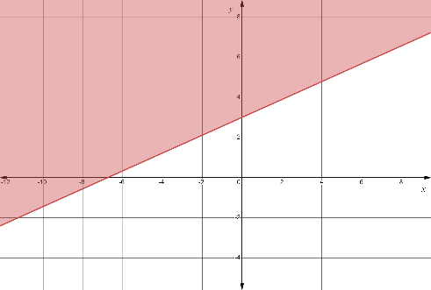  Graphical Representation
The y-intercept is located at the point (0,3). | 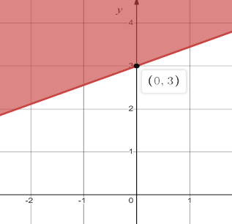
The y-intercept is located at the point (0,3).
The slope of the boundary line is$\frac{4}{9}$. | From any point on the boundary  line, the next point can be found by moving up/down 4 units and then moving right/left 9 units.
≥ | The boundary line is solid with the solution set shaded above the boundary line.
- Instruction includes opportunities to identify a test point to substitute into an inequality. It is usually easiest to use the origin (0,0) as it makes mental calculations easier. If the point selected creates a true statement, their inequality is true, and they should shade in the half- plane containing that point. If it creates a false statement, they should shade in the half- plane not containing that point. By using a test point, students avoid the mistake of thinking that the direction of the inequality determines the shading.
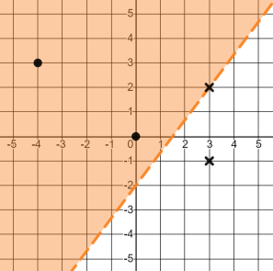
  - For example, the points (−4,3), (0,0), (3,2) and (3, −1) were used to determine where to shade for the inequality 4𝑥 − 3𝑦 < 6 shown below.

Instructional Tasks
Instructional Task 1 (MTR.7.1)
Penelope is planning to bake cakes and cookies to sell for an upcoming school fundraiser. Each cake requires 1 $\frac{3}{4}$ cups of flour and each batch of cookies requires 2$\frac{1}{4}$ cups of flour
Penelope bought 3 bags of flour. Each bag contains around 17 cups of flour.
Part A. Assuming she has all the other ingredients needed, create a graph to show all the possible combinations of cakes and batches of cookies Penelope could make.
Part B. Create constraints for this given situation.

Instructional Items
Instructional Item 1
Graph the solution set to the inequality 𝑦 + 3 > −2(𝑥 − 2).

Instructional Item 2
Fred has $9 in his pocket and wants to buy chips and candy for a movie he is going to watch. Chips cost $1.50 per bag and candy is $1 a box. Graph the solution set that represents the amount of chips and candy Fred can buy.

*The strategies, tasks and items included in the B1G-M are examples and should not be considered comprehensive.

MA.912.AR.3 Write, solve and graph quadratic equations, functions and inequalities in one and two variables.

MA.912.AR.3.1
Benchmark
MA.912.AR.3.1 Given a mathematical or real-world context, write and solve one-variable quadratic equations over the real number system.
Benchmark Clarifications:
Clarification 1: Within the Algebra I course, instruction includes the concept of non-real answers, without determining non-real solutions.
Clarification 2: Within this benchmark, the expectation is to solve by factoring techniques, taking square roots, the quadratic formula and completing the square.

Connecting Benchmarks/Horizontal Alignment
- MA.912.AR.1.2, MA.912.AR.1.3, MA.912.AR.1.7

Terms from the K-12 Glossary
- Coefficient
- Quadratic Equation
- Real Numbers
- 𝑥-intercept

Vertical Alignment
Previous Benchmarks  - MA.8.AR.2.3 | Next Benchmarks  - MA.912.AR.3.2
Purpose and Instructional Strategies
In grade 8, students solved quadratic equations in the form of $x^{2} = p$. In Algebra I, students
solve quadratic equations in one variable over the real number system. In later courses, students will solve quadratic equations in one variable over the real and complex number systems.
- Instruction includes the use of manipulatives, models, drawings and various methods, including Loh’s method.
- Instruction allows the flexibility to solve quadratics using factoring techniques, taking the square root, using the quadratic formula and completing the square. Students should understand that one method may be more efficient than another depending on the content and context of the problem (MTR.2.1).
- Instruction emphasizes the understanding that solving a quadratic equation in one variable is the same as the process of determining 𝑥-intercepts, or roots, of the graph of a quadratic function.
- While the derivation of the quadratic formula is not an expectation of this benchmark, students can develop the quadratic formula by using completing the square to isolate 𝑥 in the equation $ax^{2} + bx + c = 0$; making the connection to solving literal equations.
- Instruction includes evaluating the discriminant (𝑏²– 4𝑎𝑐) to determine whether there is one real solution (equals zero), two real solutions (equals a positive rational number) or two complex solutions (equals a negative rational number).
  - Discuss the connection of the number of solutions of a quadratic equation to the graph of a quadratic function. Guide students to see that real solutions result in roots or 𝑥-intercepts and that quadratic functions that do not produce real roots never touch the 𝑥-axis (MTR.5.1).
- Instruction on completing the square includes the use of algebra tiles or area model drawings. Students should understand the visual nature of completing the square and connect it to their prior work with area models.
  - For example, consider 𝑥² + 8𝑥 = 48 and solve by factoring to show that the two
solutions are 𝑥 = −12 and 𝑥 = 4. Then, ask the question “If we look at the
binomial 𝑥² + 8𝑥 on the left, what would we have to add to it to make a perfect
square trinomial?” Write the equation 𝑥² + 8𝑥 + = 48 + on the board to represent the question. Now, represent the equation using algebra tiles or by drawing an area model as shown below.
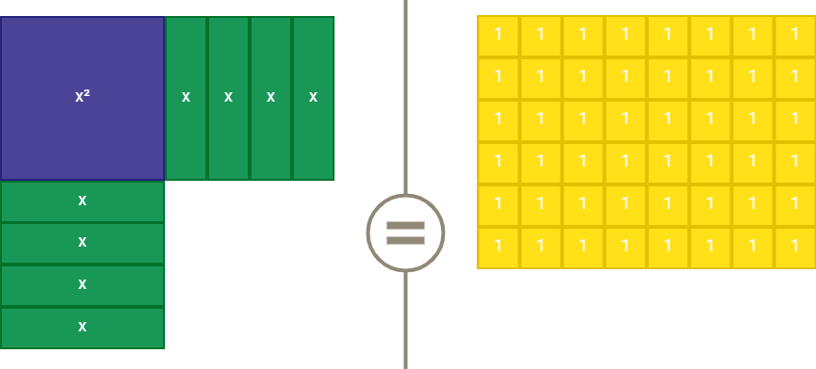
  - Lead student discussion about the quantity of 1 unit by 1 unit tiles needed to “complete the square” on the left hand side. Once they state the need for 16 tiles, point out that 16 tiles must also be added to the right to maintain equivalence then write the number 16 into both blank boxes. Students can then factor the perfect square trinomial to arrive at (𝑥 + 4)² = 64. Have student solve using square roots to find the same solutions of 𝑥 = −12 and 𝑥 = 4 (MTR.2.1, MTR.4.1, MTR.5.1).
- In many contexts, students may generate solutions that may not make sense when placed in context. Be sure students assess the reasonableness of their solutions in terms of context to check for this (MTR.6.1).
  - For example, the time it takes for a ball to drop from a height of 28 feet can be modeled by 0 = −16𝑡² + 28. Students solve this equation to find that 𝑡 ≈ ±1.32 seconds. Through discussion, students should see that −1.32 seconds does not make sense in context and therefore should be omitted.

- Enrichment of this benchmark includes determining if a quadratic is a perfect square trinomial.
  - For example, given the equation 0 = 4𝑥² − 12𝑥 + 9, students can identify 𝑎, 𝑏, and 𝑐 as 4, −12 and 9, respectively. Students should recognize that 𝑎 and 𝑐 are perfect squares; where a is 2² = 4 and c is (−3)² = 9. Since the coefficient of 𝑏 is twice the product of the square roots (−12 = 2(2)(−3)), it can be determined that the given equation is a perfect square trinomial.

Common Misconceptions or Errors
- When completing the square, many students forget to use the addition or subtraction property of equality to add or subtract values from the other side of the equation. Remind these students that additions or subtractions from one side of an equation must be replicated on the other to maintain equivalency.
- When completing the square and removing a common factor from the 𝑥² and 𝑥 term, students may forget to consider that factor when adding/subtracting from the other side of the equation.
  - For example, when solving 10 = 12𝑡² + 48𝑡 + 55, students may ultimately add 4 rather than 48 to the left side. Help students to see that there are 12 sets of 4 ultimately being added to the right and therefore, there must be twelve sets added to the left as well.
- Some students may see equations such as 𝑥² – 4𝑥 + 6 = 27 and use the number 2, −4 and 6 as 𝑎, 𝑏 and 𝑐, respectively, in the quadratic formula, arriving at incorrect solutions. In these cases, graph the related function and ask students if the solutions they calculated correspond to the roots of the parabola. Once they see they do not, have students set the equation equal to zero and recalculate.

Strategies to Support Tiered Instruction
- When solving using the quadratic formula, instruction includes separating the two possible solutions to two equations.
  - For example, when determining the values of 𝑥 in the equation 6𝑥² − 17𝑥 + 12 = 0, students can set up the two equations using the quadratic formula: $x=\frac{-\left(-17\right)±\sqrt{{\left(-17\right)}^{2}-4\left(6\right)\left(12\right)}}{2\left(6\right)}$.
- Teacher provides guided notes that show step-by-step directions for solving problems.
  - For example, teacher can use the directions below when using the quadratic formula.
Determine the value(s) of 𝑥  in the equation. | $$6x^{2} - 17x = 12$$
Identify the 𝑎, 𝑏 and 𝑐 values in the equation. | $$6x^{2} - 17x - 12 = 0$$  $$a=6, b=-17, c=-12$$
Substitute 𝑎, 𝑏 and 𝑐 into the quadratic formula. | $$x=\frac{-(-17)±\sqrt{{(-17)}^{2}-4(6)(-12)}}{2(6)}$$
- Teachers can remind students when completing the square that additions or subtractions from one side of an equation must be replicated on the other side to maintain equivalency.

- When addressing removing a common factor for completing the square, instruction includes highlighting the leading coefficient.
  - For example, when solving 10 = 12𝑡² + 72𝑡 + 55, students may add 9 rather than 108 to the left side in the completing square step. Help students to see the leading coefficient of 12 indicates there are 12 sets of 9 being added to the right and therefore, there must be twelve sets added to the left as well.
- Instruction should include equations with terms on both sides of the equation. Remind students to put the equation in standard form before using the quadratic formula.
- Teacher co-creates a graphic organizer, such as the one below, to include different methods used to solve quadratics given specific forms.
Given Quadratic | Potential Method to Solve
Standard form where 𝑎, 𝑏, 𝑐 are  large and or non-integer rational numbers | Quadratic Formula Completing the Square Loh’s Method
Standard form where one set of factors for the product of 𝑎 and 𝑐 equal 𝑏  Two term quadratic with the 𝑥²  and 𝑥 terms only | Factoring Completing the Square
Perfect Square Trinomial | Factoring  Perfect Square Trinomial
Two term quadratic with the 𝑥²  term and constant only  Vertex form | Taking Square Root

Instructional Tasks
Instructional Task 1 (MTR.2.1)
Given the equation 𝑥² + 6𝑥 = 13, what value(s) of 𝑥 satisfy the equation?

Instructional Task 2 (MTR.3.1)
Given the figure below, write an equation that could be used to determine the length and width of the rectangle.

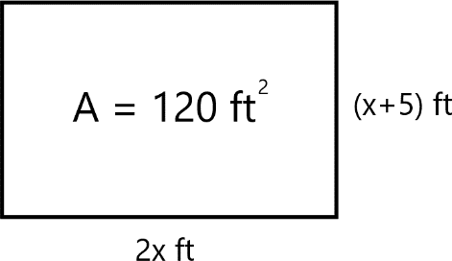
Instructional Task 3 (MTR.3.1)
Given the quadratic equation $x^{2}+6x=13.$
- Part A. Discuss the method or strategy you would use to find the solution(s). Explain why you chose that method.
- Part B. How do you determine the number of solutions for the given equation? How do you know if the solutions are real or non-real?
- Part C. Find the x-intercepts of the quadratic equation. What do the x-intercepts tell you about the equation’s graph?
- Part D. Work with a partner to create a real-world context for the equation.
- Part E. How could you rewrite the given equation so that there is only one solution?

Instructional Items
Instructional Item 1
Devonte throws a rock straight down off the edge of a cliff that overlooks the ocean. The distance (𝑑) the rock falls after 𝑡 seconds can be represented by the equation 𝑑 = 16𝑡² + 24𝑡. If the ocean’s surface is 16.4 feet below the cliff, to the nearest tenth, how many
seconds will it take for the rock to hit the ocean’s surface?

Instructional Item 2
What are the solutions to the equation −0.25𝑥² + 4𝑥 = 0.75. Round to the nearest tenth if necessary.

Instructional Item 3
What are the exact solutions to the equation $5x^{2}-\frac{17}{2}x+\frac{3}{2}$?

*The strategies, tasks and items included in the B1G-M are examples and should not be considered comprehensive.

MA.912.AR.3.4
Benchmark
MA.912.AR.3.4 Write a quadratic function to represent the relationship between two quantities from a graph, a written description or a table of values within a mathematical or real-world context.
Algebra I Example: Given the table of values below from a quadratic function, write an equation of that function.
𝑥 | -2 | -1 | 0 | 1 | 2
𝑓(𝑥) | 2 | -1 | -2 | -1 | 2

Benchmark Clarifications:
Clarification 1: Within the Algebra I course, a graph, written description or table of values must include the vertex and two points that are equidistant from the vertex.
Clarification 2: Instruction includes the use of standard form, factored form and vertex form.
Clarification 3: Within the Algebra 2 course, one of the given points must be the vertex or an 𝑥-intercept.

Connecting Benchmarks/Horizontal Alignment
- MA.912.AR.2.1
- MA.912.F.1.6
- MA.912.F.2.1

Terms from the K-12 Glossary
- Coordinate Plane
- Domain
- Function Notation
- Quadratic Function
- Range
- 𝑥-intercept
- 𝑦-intercept

Vertical Alignment
Previous Benchmarks  - MA.7.AR.4.3  - MA.8.AR.3.3 | Next Benchmarks  - MA.7.AR.3.9
Purpose and Instructional Strategies
In middle grades, students wrote two-variable linear equations in slope-intercept form. In Algebra I, students write quadratic functions from a graph, written description or table. In later courses, students will write quadratic two-variable inequalities.
- Instruction includes making connections to various forms of quadratic equations to show their equivalency. Students should understand when one form might be more useful than another depending on the context.
  - Standard Form
Can be described by the equation 𝑦 = 𝑎𝑥² + 𝑏𝑥 + 𝑐, where 𝑎, 𝑏 and 𝑐 are any rational number. This form can be useful when identifying the 𝑦-intercept.
  - Factored Form
Can be described by the equation 𝑦 = 𝑎(𝑥 − 𝑟₁)(𝑥 − 𝑟₂), where 𝑟₁ and 𝑟₂ are real numbers and the roots, or 𝑥-intercepts. This form can be useful when identifying the 𝑥-intercepts, or roots.
- Vertex Form
Can be described by the equation 𝑦 = 𝑎(𝑥 − ℎ)² + 𝑘, where the point (ℎ, 𝑘) is the vertex. This form can be useful when identifying the vertex, which is the turning point of the function where the axis of symmetry intersects.
- Instruction includes the use of 𝑥-𝑦 notation and function notation.
- Instruction includes the connection to completing the square and literal equations to rewrite an equation from standard or factored form to vertex form.
- Instruction includes comparing and contrasting between a linear function of the form 𝑦 = 𝑎(𝑥 − ℎ) + 𝑘 and a quadratic function of the form 𝑦 = 𝑎(𝑥 − ℎ)² + 𝑘. This will also extend to an absolute value function of the form $y = a \left|x-h\right|+k$. (MTR.5.1)
- When determining the value of 𝑎 in a quadratic function, this can be done by two methods described below.
  - Students may notice a pattern from the points in the graph. When 𝑎 = 1, points 1 unit to the left or right of the vertex are 1² or 1 unit above or below the vertex. Points 2 units to the left or right of the vertex are 2² or 4 units above or below the vertex. Students may look at the table and notice this relationship exists, therefore, 𝑎 = 1.
    - This process can be used for other values of 𝑎. When 𝑎 = 2, for example, points 1 unit to the left or right of the vertex are 2(1)² or 2 units above or below the vertex. Points 2 units to the left or right of the vertex are 2(2²) or 8 units above or below the vertex. Similarly, when 𝑎 = $\frac{1}{2}$ , points 1 unit
to the left or right of the vertex are $\frac{1}{2}(1)²$ or $\frac{1}{2}$ a unit above or below the
vertex. Points 2 units to the left or right of the vertex are $\frac{1}{2}(2²)$ or 2 units
above or below the vertex.
  - Students can solve for 𝑎 by substituting the values of 𝑥 and 𝑦 from a point on the parabola.
    - Ask students to consider 𝑦 = 𝑎(𝑥 + 4)² − 2 and determine what information they would need to be able to solve for 𝑎. As students express the need to know values for 𝑥 and for 𝑦, ask them if they know any combinations of 𝑥 and 𝑦 that are solutions. Students could use a table of values or a graph, if given, to determine values that could be used for 𝑥 and 𝑦. Have students pick one and substitute and solve for 𝑎. Ask for students who chose different points to share their value for a to help them see that all points, when substituted, produce 𝑎 = 1.
- Instruction includes the use of graphing software or technology.
  - For example, when determining the value of 𝑎, consider using graphing software to allow students to use sliders to quickly observe this. This provides opportunity for students to notice patterns regarding the value of a and the concavity and stretch of the parabola (MTR.5.1).

Common Misconceptions or Errors
- When writing functions in vertex form, students may confuse the sign of ℎ.
    - For example, students may see a vertex of (−1, −2) and an 𝑎 value of 3 and write the function as 𝑦 = 3(𝑥 − 1)² − 2 instead of 𝑦 = 3(𝑥 + 1)² − 2. To address this, help students recognize that because ℎ is subtracted from 𝑥 in vertex form, it will change the sign of that coordinate. Show students a graph of both functions to confirm and make the connection to transformation of functions (MA.912.F.2.1).

Strategies to Support Tiered Instruction
- Teacher emphasizes that because $h$ is subtracted from $x$ in vertex form, it will change the sign of that coordinate. For example, students may see a vertex of $(-1, -2)$ and an $a$ value of 3 and write the function as $y = 3(x - 1)² - 2$ instead of $y = 3(x + 1)² - 2$. Teachers could show students a graph (technology) of both functions to confirm and make the connection to transformation of functions (MA.912.F.2.1).
- Teacher models substituting roots into the factored form of a quadratic, $y =a(x - r_{1})(x - r_{2})$. Instruction then includes reminding students of different methods that can be used to multiply binomials to convert the quadratic into standard form, $y = ax^{2} + bx + c$.
- Instruction includes solving for $a$ by substituting the values of $x$ and $y$ from a point on the parabola. Students may need to review the order of operations to ensure they correctly isolate $a$. Provide students with a review of the order of operations.
  - Parenthesis
  - Exponents
  - Multiplication or Division (Whatever comes first left to right)
  - Addition or Subtraction (Whatever comes first left to right)
- Instruction includes recall of knowledge demonstrating when $h$ is subtracted from $x$ in vertex form, it will change the sign of that coordinate. A graph of both functions can be used to confirm and make the connection to transformation of functions.
- Teacher provides a laminated cue card of the steps required to convert from factored form to standard form.

Instructional Tasks
Instructional Task 1 (MTR.7.1)
Duane throws a tennis ball in the air. After 1 second, the height of the ball is 53 feet. After 2 seconds, the ball reaches a maximum height of 69 feet. After 3 seconds the height of the ball is 53 ft.
Part A. Write a quadratic function to represent the height of the ball, ℎ, at any point in time, 𝑡.
Part B. How long will the tennis ball stay in the air? Round your answer to the nearest tenth second.

Instructional Task 2 (MTR.4.1, MTR.5.1)
Part A. Create a quadratic function that contains the roots $\frac{3}{5}$ and 1.8.
Part B. Compare your function with a partner. What do you notice?

Instructional Items
Instructional Item 1
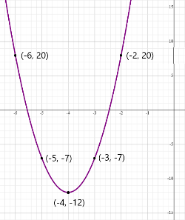
Write a quadratic function to represent the graph below.

Instructional Item 2
Given the table of values below from a quadratic function, write an equation of that function.
𝑥 | -6 | -5 | -4 | -3 | -2
𝑓(𝑥) | 2 | -1 | -2 | -1 | 2
Instructional Item 3
Jayden launches a rocket from the ground that travels in a parabolic path until it lands. After two seconds it reaches a maximum height of 100 feet. The rocket is in the air for five seconds before it hits the ground. Write the quadratic function h(t), representing the height of the rocket above the ground after t seconds.

*The strategies, tasks and items included in the B1G-M are examples and should not be considered comprehensive.

MA.912.AR.3.5

Benchmark
MA.912.AR.3.5 Given the 𝑥-intercepts and another point on the graph of a quadratic function, write the equation for the function.

Connecting Benchmarks/Horizontal Alignment
- MA.912.AR.1.3, MA.912.AR.1.7
- MA.912.F.1.6

Terms from the K-12 Glossary
- Quadratic Function
- 𝑥-intercept
- 𝑦-intercept

Vertical Alignment
Previous Benchmarks  - MA.8.AR.3.2 | Next Benchmarks  - MA.912.AR.3.4

Purpose and Instructional Strategies
In grade 8, students determined the slope in a linear relationship when given two points on the line. In Algebra I, students write the equation for a quadratic function when given the x- intercepts and another point on the graph. In later courses, students will write the equation for a quadratic function when given a vertex and another point on the graph.
- Instruction includes making connections to various forms of quadratic equations to show their equivalency. Students should understand and interpret when one form might be more useful than another depending on the context.
  - Standard Form
Can be described by the equation $y = ax^{2} + bx + c$, where $a$, $b$ and $c$ are any rational number. This form can be useful when identifying the 𝑦-intercept.
  - Factored form
Can be described by the equation $y = a(x - r_{1})(x - r_{2})$, where $r_{1}$ and $r_{2}$ are real numbers and the roots, or 𝑥-intercepts. This form can be useful when identifying the 𝑥-intercepts, or roots.
  - Vertex form
Can be described by the equation $y = a{(x - h)}^{2} + k$, where the point (ℎ, 𝑘) is the vertex. This form can be useful when identifying the vertex, which is the turning point of the function where the axis of symmetry intersects.
- Instruction includes comparing and contrasting between a linear function of the form $y = a(x - h) + k$ and a quadratic function of the form 𝑦$= a{(x - h)}^{2} + k$. This will also extend to an absolute value function of the form
$y = a \left|x-h\right|+k$. (MTR.5.1)
- Instruction includes the use of 𝑥-𝑦 notation and function notation.
- Instruction includes the use of graphing technology.

Common Misconceptions or Errors
- Similar to their work with vertex form, students may have trouble with using the correct signs for 𝑟₁ and 𝑟₂ in factored form. In these cases, show students a corresponding graph of their developed factored form functions to help them see the need for opposite signs in their factors.
- Student might multiply incorrectly when squaring a binomial. For example, (𝑥 – ℎ)² is incorrectly distributed as $x^{2}-h^{2}$instead of $x^{2}-2xh+h^{2}$.
- When rewriting their developed factored form functions into standard form, students may incorrectly multiply 𝑎 by both factors. One remedy for this is to direct students to multiply their binomials first and then multiply the product by 𝑎.

Strategies to Support Tiered Instruction
- Teacher provides instruction to show how different methods can be used to multiply
binomials after substituting the roots into factored form. Then, ask students to recall methods to multiply binomials. For example, direct students to multiply their binomials first and then multiply the product by 𝑎.

- Instruction includes converting a quadratic from vertex form to standard form.
- Instruct students to write out (𝑥 – ℎ)² as (𝑥 – ℎ)(𝑥 – ℎ). Remind students that different methods can be used to multiply binomials.
- Instruction includes an opportunity to discuss multiplicity of roots when converting from factored form to standard form. The teacher can use graphing software to build the connection between the standard form of a quadratic function with a perfect square trinomial and the resulting parabola with only one root. Students see that the root should be used for both 𝑟₁ and 𝑟₂ in factored form and confirm by converting their resulting function back to standard form.
  - For example, students could see a problem that only presents one root and express confusion on how it applies to the factored form. These cases provide an opportunity to discuss multiplicity of roots.
- Teacher models how to solve for 𝑎 by substituting the values of 𝑥 and 𝑦 from a point on the parabola.
- For students who need support evaluating functions, review the steps for evaluating a function given an input value by co-creating an anchor chart.
Given Parabola: 𝑦 = 6𝑥² − 5𝑥 + 11
Input: −4 | Output
𝑦 = 6(−4)² − 5(−4) + 11 | 𝑦 = 127
- Teacher provides opportunities to use an online graphing tool to graph an equation with the 𝑥-intercepts to help students who may have used the wrong signs in their factors.
  - For example, if the roots of a quadratic function are 2 and −4, the teacher can provide the graphs of the two functions (as shown below) to determine which equation corresponds to the roots.
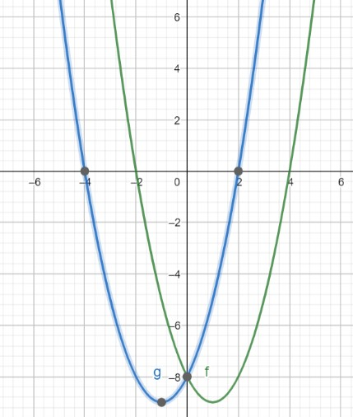
Blue graph: 𝑦 = (𝑥 − 2)(𝑥 + 4)
Green graph: 𝑦 = (𝑥 + 2)(𝑥 − 4)

Instructional Tasks
Instructional Task 1 ( MTR.7.1)
A city fountain shoots jets of water that pass back and forth through a marble wall in its center. One jet of water begins 12 feet away from the wall and passes through a hole in the wall that is 12 feet high before landing 5 feet away on the other side. Write a quadratic function that represents the path the jet of water takes.

Instructional Task 2 (MTR.3.1, MTR.6.1, MTR.7.1)
As part of a math project, you are analyzing the profit (P) of a smartphone manufacturing company based on the number of units sold (x). The company's profit can be modeled by a quadratic function. During your research, you discover that the company experiences a break-even point when no profit is made, and this occurs when no smartphones are sold. Additionally, when the company sells 1 smartphone, it makes a profit of $6.

Write the quadratic equation that represents the company's profit, using the given information about the break-even point and the profit when selling one smartphone.

Instructional Items
Instructional Item 1
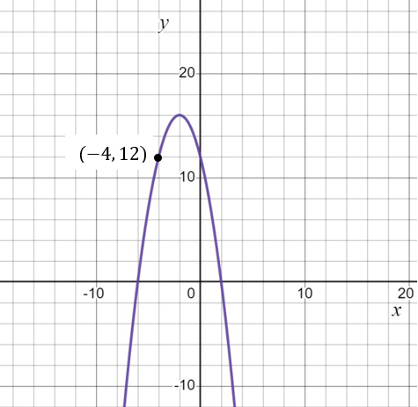
Write a quadratic function to represent the graph below.

Instructional Item 2
Write a quadratic function to represent a parabola with roots of 5 and −7 that passes through the point (−3, −128).

*The strategies, tasks and items included in the B1G-M are examples and should not be considered comprehensive.

MA.912.AR.3.6

Benchmark
MA.912.AR.3.6 Given an expression or equation representing a quadratic function, determine the vertex and zeros and interpret them in terms of a real-world context.

Connecting Benchmarks/Horizontal Alignment
- MA.912.AR.1.3, MA.912.AR.1.7
- MA.912.F.1.6

Terms from the K-12 Glossary
- Quadratic Function
- 𝑥-intercept
- 𝑦-intercept

Vertical Alignment
Previous Benchmarks  - MA.8.AR.1.2 | Next Benchmarks  - MA.912.AR.6.4, MA.912.AR.6.5
Purpose and Instructional Strategies
In grade 8, students multiplied two linear expressions to obtain a quadratic expression. In Algebra I, students transform a quadratic function to highlight and interpret its vertex or its zeroes. In later courses, students will determine key features of higher degree polynomials.
- Instruction includes making connections to various forms of quadratic equations to show their equivalency. Students should understand and interpret when one form might be more useful than another depending on the context.
  - Standard Form
Can be described by the equation 𝑦 = 𝑎𝑥² + 𝑏𝑥 + 𝑐, where 𝑎, 𝑏 and 𝑐 are any rational number. This form can be useful when identifying the 𝑦-intercept.
  - Factored form
Can be described by the equation 𝑦 = 𝑎(𝑥 − 𝑟₁)(𝑥 − 𝑟₂), where 𝑟₁ and 𝑟₂ are real numbers and the roots, or 𝑥-intercepts. This form can be useful when identifying the 𝑥-intercepts, or roots.
  - Vertex form
Can be described by the equation 𝑦 = 𝑎(𝑥 − ℎ)² + 𝑘, where the point (ℎ, 𝑘) is the vertex. This form can be useful when identifying the vertex, which is the turning point of the function where the axis of symmetry intersects.
- Instruction includes comparing and contrasting between a linear function of the form 𝑦 = 𝑎(𝑥 − ℎ) + 𝑘 and a quadratic function of the form 𝑦 = 𝑎(𝑥 − ℎ)² + 𝑘. This will also extend to an absolute value function of the form
$y = a \left|x-h\right|+k$. (MTR.5.1)
- Instruction includes the use of 𝑥-𝑦 notation and function notation.

- Most contexts for this benchmark will present functions in standard form. Depending on their perspectives, students might take several approaches to determine vertices and zeros. Have students discuss strategies they might use. Let students know they should use the approach that is most efficient for them (MTR.3.1).
  - To determine zeros, students could use the quadratic formula or convert the function into factored form, or complete the square, or use Loh’s method.
- To determine the vertex, students could convert the function into vertex form or
determine the axis of symmetry ($x =\frac{-b}{2a}$). Calculate this value from one of the previous
functions discussed and guide students to see that the vertex of each parabola falls on the line of symmetry. Considering this, they can substitute that 𝑥-value into the function to determine the corresponding 𝑦-value of the vertex.

Common Misconceptions or Errors
- Some students may have difficulty interpreting the meaning of the zeros and vertex.

Strategies to Support Tiered Instruction
- Teacher provides a graphic organizer for key terms (zeros and vertex) that can be created
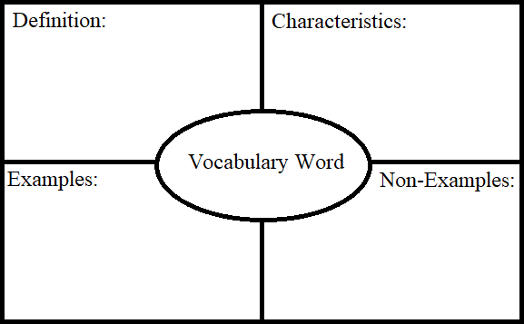
using information provided in a given problem.

- Teacher co-creates a graphic organizer to compare real-world and mathematical contexts related to quadratics.
  - For example, the chart below can be used to compare mathematical terms with real-world context.

𝒙 |  | 𝒚
Mathematical Context | Real-world Context | Mathematical Context | Real-world Context
Independent  variable or input | Time | Dependent  variable or output | Height
𝑥-values, roots, solutions | Seconds for a ball  to reach ground | 𝑦-value of vertex | Maximum  height of a ball

- Teacher provides a visual aid, including using graphing software, to interpret the zeros and vertex of a quadratic function. Students can compare definitions and examples to determine the zeros and vertex of the parabola.
  - For example, the roots of the graph shown are (2, 0) and (−4, 0). The locations on the graph that intersect the 𝑥-axis are the roots. The roots are also the solutions of the quadratic. The vertex of the graph shown is (−1, −9). The vertex is the minimum or maximum point (sometimes called the extrema) of the parabola. The vertex is also the point where the quadratic changes from decreasing to increasing or from increasing to decreasing, and is halfway between the roots.

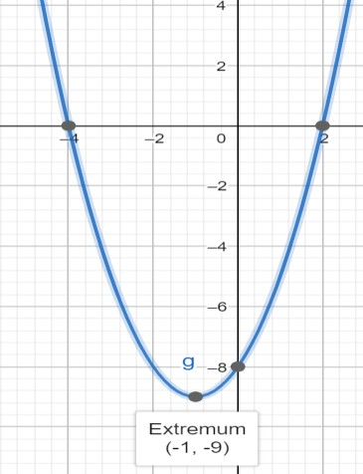

Instructional Tasks
Instructional Task 1 (MTR.3.1, MTR.6.1, MTR.7.1)
A diver jumps off a cliff 5 meters high into a lake. The diver’s position can be represented by the function ℎ(𝑡) = −4.9𝑡² + 1.5𝑡 + 5, where h represents the diver’s height relative to the
lake’s surface and t represents the time in seconds.
Part A. Determine the roots of the function described. Part B. Interpret each with respect to the situation.

Instructional Task 2 (MTR.3.1, MTR.7.1)
A local campground charges $23.50 per night per campsite. They average about 32 campsites rented each night. A recent survey indicated that for every $0.50 decrease, the number of campsites rented increases by five.
Part A. Write a quadratic equation that describes this situation. Part B. Determine the vertex and zeroes of the function described. Part C. Interpret each with respect to the situation.
Part D. What price will maximize revenue?

Instructional Items
Instructional Item 1
Marcus just purchased a Super Bouncy Ball from a local toy store. Once outside, he throws it down to see how high the ball will bounce. The function ℎ(𝑥) = −2𝑥² + 24𝑥 − 31.5 represents the height, ℎ in inches, above the ground of the ball as it relates to its horizontal distance from Marcus 𝑥, in inches. Find the zeros and vertex of this function and interpret the meaning of each.

Instructional Item 2
A hallway has an arch that is in the shape of a parabola. The arch is modeled by the function
$y=-5x^{2}+12x$, where $x$ represents the horizontal measurement, in feet, and y represents the vertical measurement, in feet. What are the zeroes of this function, and what do they represent?
      - The zeroes are (2.4,0) and (1.2, 7.2), which means these are the two places the archway touches the ground.
      - The zeroes are (0,0) and (2.4, 0), which means these are the two places the archway touches the ground.
      - The zeroes are (0,0) and (1.2, 7.2), which means that the maximum height of the arch is 7.2 feet.
      - The zeroes are (2.4, 0) and (1.2, 7.2), which means that the arch is 7.2 feet wide at the base.
*The strategies, tasks and items included in the B1G-M are examples and should not be considered comprehensive.

MA.912.AR.3.7

Benchmark
MA.912.AR.3.7 Given a table, equation or written description of a quadratic function, graph that function, and determine and interpret its key features.
Benchmark Clarifications:
Clarification 1: Key features are limited to domain; range; intercepts; intervals where the function is increasing, decreasing, positive or negative; end behavior; vertex; and symmetry.
Clarification 2: Instruction includes the use of standard form, factored form and vertex form, and sketching a graph using the zeros and vertex.
Clarification 3: Instruction includes representing the domain and range with inequality notation, interval notation or set-builder notation.
Clarification 4: Within the Algebra I course, notations for domain and range are limited to inequality and set-builder.

Connecting Benchmarks/Horizontal Alignment
- MA.912.AR.4.3
- MA.912.AR.5.6
- MA.912.F.1.6

Terms from the K-12 Glossary
- Coordinate Plane
- Domain
- Function Notation
- Quadratic Function
- Range
- 𝑥-intercept
- 𝑦-intercept

Vertical Alignment
Previous Benchmarks  - MA.8.AR.3.4 | Next Benchmarks  - MA.912.AR.4.3, MA.912.AR.5.6, MA.912.AR.6.4
Purpose and Instructional Strategies
In grade 8, students graphed linear two-variable equations given a table, written description or equation. In Algebra I, students graph quadratic functions given this same kind of information. In later courses, this work expands to other families of functions.
- Instruction includes conversations about interpreting 𝑦-intercepts; intervals where the function is increasing, decreasing, positive or negative; end behavior; and symmetry.
- When discussing end behavior, students should see a relationship between the sign of 𝑎 and the end behavior the function exhibits. Instruction presents students with the equation of a function first, before showing its graph and asking them to predict its end behavior (MTR.5.1).
  - Depending on the form the function is presented in, students may be able to predict other features as well (MTR.5.1).
- Instruction includes making connections to various forms of quadratic equations to show their equivalency. Students should understand and interpret when one form might be more useful than another depending on the context.
  - Standard Form
Can be described by the equation 𝑦 = 𝑎𝑥² + 𝑏𝑥 + 𝑐, where 𝑎, 𝑏 and 𝑐 are any rational number. This form can be useful when identifying the 𝑦-intercept.
  - Factored form
Can be described by the equation 𝑦 = 𝑎(𝑥 − 𝑟₁)(𝑥 − 𝑟₂), where 𝑟₁ and 𝑟₂ are real numbers and the roots, or 𝑥-intercepts. This form can be useful when identifying the 𝑥-intercepts, or roots.
  - Vertex form
Can be described by the equation 𝑦 = 𝑎(𝑥 − ℎ)² + 𝑘, where the point (ℎ, 𝑘) is the vertex. This form can be useful when identifying the vertex, which is the turning point of the function where the axis of symmetry intersects.
- Instruction includes comparing and contrasting between a linear function of the form 𝑦 = 𝑎(𝑥 − ℎ) + 𝑘 and a quadratic function of the form 𝑦 = 𝑎(𝑥 − ℎ)² + 𝑘. This will also extend to an absolute value function of the form
$y = a \left|x-h\right|+k$. (MTR.5.1)
- Instruction includes the use of 𝑥-𝑦 notation and function notation.

- Instruction includes representing domain and range using words, inequality notation and set-builder notation.
  - Words
If the domain is all real numbers, it can be written as “all real numbers” or “any value of 𝑥, such that 𝑥 is a real number.”
  - Inequality notation
If the domain is all values of 𝑥 greater than 2, it can be represented as 𝑥 > 2.
  - Set-builder notation
If the domain is all values of 𝑥 less than or equal to zero, it can be represented as
{𝑥|𝑥 ≤ 0} and is read as “all values of 𝑥 such that 𝑥 is less than or equal to zero.”
- Instruction includes the use of appropriately scaled coordinate planes, including the use of breaks in the 𝑥- or 𝑦-axis when necessary.

Common Misconceptions or Errors
- When describing intervals where functions are increasing, decreasing, positive or negative, students may represent their interval using the incorrect variable.
- Students may miss the need for compound inequalities in their intervals. In these cases, refer to the graph of the function to help them discover areas in their interval that would not make sense in context.

Strategies to Support Tiered Instruction
- Teacher provides the opportunity to complete a graphic organizer to compare related key features.
  - For example, students can compare domain versus range, increasing versus decreasing or positive versus negative.
- Instruction includes modeling how to sketch the graph of the function to determine where the graph is increasing or decreasing. Students must understand that graphs are read left to right.
- Instruction includes reflective questions to examine the meaning of the domain and range in the problem.
  - For example, students can ask why the range does not contain all real numbers if the domain does contain all real numbers.
  - For example, students can ask how the vertex relates to the domain and range.
- Instruction references the graph of the function to help discover areas in compound inequality intervals that would not make sense in context.
- Teacher provides a graphic organizer for key features (vertex; symmetry; end behavior; intercepts) which can be completed using information provided in a given problem.

- Teacher provides a picture of a parabola (ensure the vertex and zeros are visible) and labels the parabola with a few of the key features. Then, teacher instructs students to label the parabola with the remaining key features.
  - For example, label the parabola with the coordinates of the vertex, axis of symmetry, minimum or maximum and zeros.
𝑦 = 𝑥² − 2𝑥 − 3
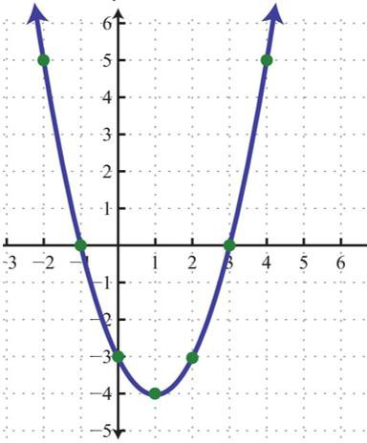

Instructional Tasks
Instructional Task 1 (MTR.3.1, MTR.7.1)
A punter kicks a football to the opposing team. The trajectory of the football can be modeled by the function ℎ(𝑡) = −16𝑡² + 64𝑡 + 3 where ℎ(𝑡) represents the height of the football at any point in time (in seconds), 𝑡. A graph of the function is below.
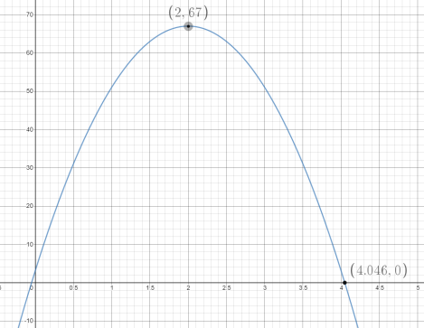
Part A. Determine the meaning of the 𝑦-intercept in this context. Part B. How high did the punt go?
Part C. Over what interval was the football increasing in height? When was the height decreasing?
Part D. What domain and range of this function is appropriate for the context?

Instructional Task 2 (MTR.6.1, MTR.7.1)
A company plans to build a large multiplex theater. The financial analyst told her manager that the profit function for their theater was 𝑃(𝑥) = −𝑥² + 48𝑥 − 512, where 𝑥 is the number of movie screens, and 𝑃(𝑥) is the profit earned in thousands of dollars.
Part A. Determine the range of production of movie screens that will guarantee that the company will not lose money.
Part B. What is the optimal number of movie screens the theater should have?

Instructional Items
Instructional Item 1
Graph the function 𝑓(𝑥) = 𝑥² + 2𝑥 − 3. Identify the domain, range, vertex and zeros of the function.

Instructional Item 2
Given the table of values, graph the function. Identify the domain, range, intervals where the function is increasing, decreasing, and the axis of symmetry.
x | -6 | -3 | 0 | 3 | 6
f(x) | -12 | -3 | 0 | -3 | -12

*The strategies, tasks and items included in the B1G-M are examples and should not be considered comprehensive.

MA.912.AR.3.8
Benchmark
MA.912.AR.3.8 Solve and graph mathematical and real-world problems that are modeled with quadratic functions. Interpret key features and determine constraints in terms of the context.

Algebra I Example: The value of a classic car produced in 1972 can be modeled by the function 𝑉(𝑡) = 19.25𝑡² − 440𝑡 + 3500, where 𝑡 is the number of years since 1972. In what year does the car’s value start to increase?

Benchmark Clarifications:
Clarification 1: Key features are limited to domain; range; intercepts; intervals where the function is increasing, decreasing, positive or negative; end behavior; vertex; and symmetry.
Clarification 2: Instruction includes the use of standard form, factored form and vertex form. Clarification 3: Instruction includes representing the domain, range and constraints with inequality notation, interval notation or set-builder notation.
Clarification 4: Within the Algebra I course, notations for domain, range and constraints are limited to inequality and set-builder.

Connecting Benchmarks/Horizontal Alignment
- MA.912.AR.4.1
- MA.912.AR.5.3
- MA.912.F.1.6

Terms from the K-12 Glossary
- Coordinate Plane
- Domain
- Function Notation
- Quadratic Function
- Range
- 𝑥-intercept
- 𝑦-intercept
Vertical Alignment
Previous Benchmarks  - MA.8.AR.3.4 | Next Benchmarks  - MA.912.AR5.6
Purpose and Instructional Strategies
In grade 8, students solved problems involving real-world linear equations. In Algebra I, students solve problems that are modeled by quadratic functions. Students additionally graph the function and determine or interpret key features of the function. In later courses, this work expands to exponential and other kinds of functions.
- This benchmark is a culmination of MA.912.AR.3. Instruction here should feature a variety of real-world contexts. Some of these contexts should require students to create a function as a tool to determine requested information or should provide the graph or function that models the context.
- Instruction includes making connections to various forms of quadratic equations to show their equivalency. Students should understand and interpret when one form might be more useful than another depending on the context.
  - Standard Form
Can be described by the equation 𝑦 = 𝑎𝑥² + 𝑏𝑥 + 𝑐, where 𝑎, 𝑏 and 𝑐 are any rational number. This form can be useful when identifying the 𝑦-intercepts.
  - Factored Form
Can be described by the equation 𝑦 = 𝑎(𝑥 − 𝑟₁)(𝑥 − 𝑟₂), where 𝑟₁ and 𝑟₂ are real numbers and the roots, or 𝑥-intercepts. This form can be useful when identifying the 𝑥-intercepts, or roots.
  - Vertex Form
Can be described by the equation 𝑦 = 𝑎(𝑥 − ℎ)² + 𝑘, where the point (ℎ, 𝑘) is the vertex. This form can be useful when identifying the vertex, which is the turning point of the function where the axis of symmetry intersects.
- Instruction includes comparing and contrasting between a linear function of the form 𝑦 = 𝑎(𝑥 − ℎ) + 𝑘 and a quadratic function of the form 𝑦 = 𝑎(𝑥 − ℎ)² + 𝑘. This will also extend to an absolute value function of the form
$y = a \left|x-h\right|+k$. (MTR.5.1)
- Instruction includes the use of 𝑥-𝑦 notation and function notation.

- Instruction includes representing domain, range and constraints using words, inequality notation and set-builder notation.
  - Words
If the domain is all real numbers, it can be written as “all real numbers” or “any value of 𝑥, such that 𝑥 is a real number.”
  - Inequality Notation
If the domain is all values of 𝑥 greater than 2, it can be represented as 𝑥 > 2.
  - Set-Builder Notation
If the domain is all values of 𝑥 less than or equal to zero, it can be represented as
{𝑥|𝑥 ≤ 0} and is read as “all values of 𝑥 such that 𝑥 is less than or equal to zero.”
- Instruction provides opportunities to make connections between the domain and range and other key features.
  - For example, a coffee shop uses the function, 𝑃(𝑥) = −80𝑥² + 480𝑥 − 540 to model the profit they can earn in thousands of dollars in terms of the price per cup of coffee, in dollars. By determining the domain and range that includes prices that yield a positive profit, one would also have to identify the vertex (or
maximum) and the roots of the function. Students should realize that they can do this by transforming the given expression into vertex form.
  - Marcus just purchased a Super Bouncy Ball from a local toy store. Once outside, he throws it down to see how high the ball will bounce. The function ℎ(𝑥) = −2𝑥² + 24𝑥 − 31.5 represents the height, ℎ in inches, above the ground of the ball as it relates to its horizontal distance from Marcus 𝑥, in inches. In order to determine domain and range that includes positive heights, one would identify the vertex (or maximum) and the roots of the function. Students should realize that they can do this by transforming the given expression into vertex form.

Common Misconceptions or Errors
- Students might not understand the connection between x-y notation and function notation.

Strategies to Support Tiered Instruction
- Teacher provides equations in both function notation and 𝑥-𝑦 notation and models graphing both forms using a graphing tool or graphing software (MTR.2.1).
o For example, 𝑓(𝑥) = (𝑥 − 2.3)² + 7 and $y$ = (𝑥 − 2.3)² + 7, to show that both
𝑓(𝑥) and 𝑦 represent the same outputs of the function.
- Instruction provides opportunities to visualize the domain and range on a graph using a highlighter.
  - For example, a coffee shop uses the function 𝑃(𝑥) = −80𝑥² + 480𝑥 − 540 to model the profit they can earn in thousands of dollars in terms of the price per cup of coffee, in dollars. If the coffee shop is only interested in prices that yield a positive profit, the highlighted domain and range are shown
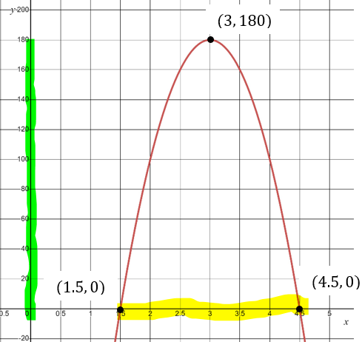

Instructional Tasks
Instructional Task 1 (MTR.4.1, MTR.912.1, MTR.7.1)
ABC Pool Company is constructing 17 feet by 11 feet rectangular pool. Along each side of the pool, they plan to construct a concrete sidewalk that has a constant width. The land parcel being used has a total area of 315 sq. ft. to construct the pool and sidewalks. The function𝑓(𝑥) = 4𝑥² + 56𝑥 − 128, represents the situation described. Transform the function to determine and interpret its zeros.

Instructional Items
Instructional Item 1
A new coffee shop wants to maximize their profit within the first year of business. They determined the function, 𝑃(𝑥) = −80𝑥² + 480𝑥 − 540, models the profit they can earn in thousands of dollars in terms of the price per cup of coffee, in dollars. What price of coffee maximizes the coffee shop’s profit?

Instructional Item 2
The value of a classic car produced in 1972 can be modeled by the function 𝑉(𝑡) =
19.25𝑡² − 440𝑡 + 3500, where 𝑡 is the number of years since 1972.

Part A. In what year does the car’s value start to increase?
Part B. After the year found in Part A, will the car’s value ever begin to decrease? Assume it follows its modeled value.

Instructional Item 3
A startup tech company aims to optimize its quarterly revenue during the initial year of operation. They have identified the function $R\left(x\right)=-2x^{2}+150x-200$, representing the revenue they can generate in thousands of dollars based on the price per software license, denoted in dollars. Graph the function and determine at what price per software license maximizes the company's quarterly revenue?
*The strategies, tasks and items included in the B1G-M are examples and should not be considered comprehensive.

MA.912.AR.4 Write, solve and graph absolute value equations, functions and inequalities in one and two variables.

MA.912.AR.4.1
Benchmark
MA.912.AR.4.1 Given a mathematical or real-world context, write and solve one-variable absolute value equations.

Connecting Benchmarks/Horizontal Alignment
- MA.912.AR.2.1
- MA.912.AR.3.1
- MA.912.F.2.1, MA.912.F.2.3

Terms from the K-12 Glossary
- Absolute Value

Vertical Alignment
Previous Benchmarks  - MA.6.NSO.1.3  - MA.6.NSO.1.4  - MA.7.NSO.2.1 | Next Benchmarks  - MA.912.AR.4.3
Purpose and Instructional Strategies
In grade 6, students solved problems involving absolute value, including context related to
distances, temperatures and finances. In grade 7, students solved multi-step order of operations with rational numbers including absolute value. In Algebra I, students write and solve absolute value equations in one variable. In later courses, students will solve and graph real-world problems that are modeled with absolute value functions.
- In Algebra I, instruction includes absolute value equations in the form $d = |ax + b| + c$ or $d = a|x + b| + c,$ where 𝑎 ≠ 0 and 𝑏, 𝑐, and 𝑑 are rational numbers. In Algebra I Honors, instruction can include other forms, such as $dx = |ax + b| + c$ or $|dx + e| = |ax + b| + c$, that may result in extraneous solutions.
- Instruction reinforces the definition of absolute value as a number’s distance from zero
(0) on a number line. Distance is expressed as a positive value; example: |3| = 3 and
|−3| = 3. The numbers 3 and –3 are each three units away from zero on a number line (MTR.2.1).
- Instruction includes asking for solutions of absolute value equation in word form.
  - For example, the equation |𝑥| = 7.1 can be read as “What values of 𝑥 have absolute value equivalent to 7.1?”

- Instruction focuses on recognizing that there are either two solutions or no solutions to an absolute value equation.
  - The equation |𝑥| = −8 has no solution because the absolute value of a number cannot be negative.
  - The equation |5𝑥 − 2| = 10 has two solutions by the definition of absolute value; one of which satisfies 5𝑥 − 2 = 10 and the other satisfies 5𝑥 − 2 = −10.

Common Misconceptions or Errors
- Students may forget that absolute value refers to a distance and is a positive number or zero.
- Students may forget many absolute value equations will produce two solutions.
- Students may forget some equations have no solutions.

Strategies to Support Tiered Instruction
- Teacher provides a three-column table with equations already sorted into two-, one-, or no-solutions. Teacher asks what is noticed about the equations in each column and class determines the headers to be used (Two Solutions, One Solution, No Solutions). Then, students sort additional equations into columns. In Algebra I Honors, equations with extraneous solutions should be included.

Two Solutions | One Solution | No Solutions
|𝑥| = 6 | |𝑥| = 0 | |𝑥| = −6
|2𝑥 − 5| = 8 | |2𝑥 − 5| = 0 | |2𝑥 − 5| = −8
$$\left|\frac{2}{3}x-7\right|=23$$ | $$\left|\frac{2}{3}x-7\right|=0$$ | $$\left|\frac{2}{3}x-7\right|=-23$$

- Teacher provides absolute value equations and has students then sort them into a three- column graphic organizer with column headers of: two solutions, one solution and no solution. In Algebra I Honors, equations with extraneous solutions should be included.
- Teacher models absolute value equations on the number line to show that absolute value is the distance from zero. By the visual representation, students will see how absolute value equations produce two solutions. Manipulatives, such as Cuisenaire rods, can be used to represent the constants in each equation
  - For example, the absolute value equation |𝑥| = 6 can be modeled as shown.
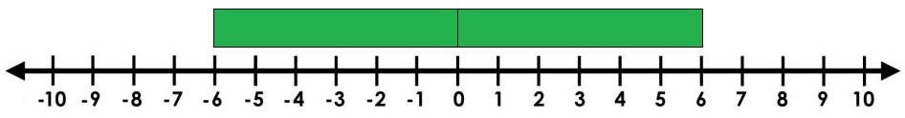
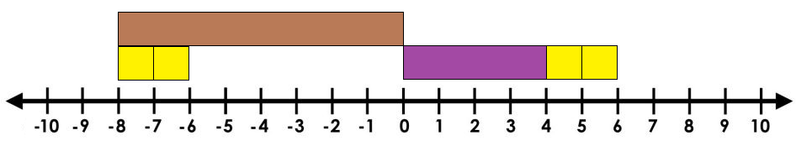
  - For example, the absolute value equation |𝑥 + 2| = 6 can be modeled as shown.

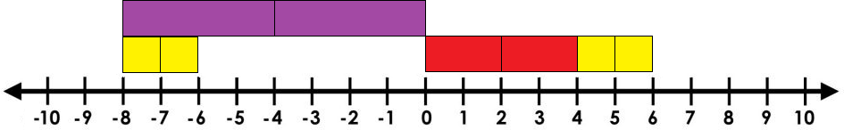
  - For example, the absolute value equation |2𝑥 + 2| = 6 can be modeled as shown.

Instructional Tasks
Instructional Task 1 (MTR.6.1, MTR.7.1)
Donna and Kayleigh both go to the same high school. Donna lives 21 miles from the school. Kayleigh lives 6 miles from Donna.
Part A. Write an absolute value equation to represent the location of Kayleigh’s house in relation to the high school.
Part B. How far could Kayleigh live from her school?

Instructional Task 2 (MTR.6.1, MTR.7.1)
Jay has money in his wallet, but he doesn’t know the exact amount. When his friend asks him how much he has he says that he has 50 dollars give or take 15.
Part A. Write an absolute value equation to model this situation. Part B. How much money could Jay have in his wallet?

Instructional Task 3 (MTR.6.1, MTR.7.1)
A car dealership is having a contest to win a new truck. In order to win a chance at the truck, you must first guess the number of keys in the jar within 5 of the actual number. The people who are within this range then get to try a key in the ignition of the truck. Suppose there are 697 keys in the jar. Write an absolute value equation that will reveal the highest and lowest guesses in order to win a chance at the truck. What are the highest and lowest guesses that will qualify for a chance to win?.

Instructional Items
Instructional Item 1
The difference between the temperature on the first day of the month, 𝑡₁, and the temperature on the last day of the month, 74 degrees, is 6 degrees. Write an equation involving absolute value that represents the relationship among 𝑡₁, 74 and 6.

Instructional Item 2
Determine the solutions of the equation below.
3|𝑥 − 2| + 14 = 14

Instructional Item 3
Determine the solutions of the equation below.
|$\frac{1}{4}$ 𝑥 − 3| = 10

Instructional Item 4
Determine the solutions of the equation below.

|$\frac{3}{2}$𝑥 + 2| + 10 =0

*The strategies, tasks and items included in the B1G-M are examples and should not be considered comprehensive.

MA.912.AR.4.2
Benchmark
MA.912.AR.4.2 Given a mathematical or real-world context, write and solve one-variable absolute value inequalities. Represent solutions algebraically or graphically.

Connecting Benchmarks/Horizontal Alignment
- MA.912.AR.2.6, MA.912.AR.2.7, MA.912.AR.2.8

Terms from the K-12 Glossary
- Absolute Value
- Compound Inequality

Vertical Alignment
Previous Benchmarks  - MA.6.NSO.1.3, MA.6.NSO.1.4  - MA.7.NSO.2.1  - MA.7.AR.2.1, MA.8.AR.2.2  - MA.912.F.1.6 | Next Benchmarks  - MA.912.AR.3.10  - MA.912.AR.9.3

Purpose and Instructional Strategies
In grade 6, students solved problems involving absolute value, including context related to distances, temperatures and finances. In middles grades, students solved linear inequalities in one variable. In Algebra I Honors, students solve absolute value inequalities in one variable. In later courses, students will solve one-variable inequalities involving other functions and systems of two- variable inequalities.
- Instruction reinforces the definition of absolute value as a number’s distance from zero
(0) on a number line. Distance is expressed as a positive value; example: |3| = 3 and
|−3| = 3. The numbers 3 and –3 are each three units away from zero on a number line (MTR.2.1).
- Instruction includes asking for solutions of absolute value equations in word form.
  - For example, the equation |𝑥| < 3 can be read as “What values of 𝑥 have absolute value less than 3?” This can be represented algebraically as −3 < 𝑥 < 3 and graphically.

- Instruction includes the connection to compound inequalities.
  - When solving the inequality |𝑥 − 1| ≤ 3, students may set up as 𝑥 − 1 ≤ 3 and
𝑥 − 1 ≥ −3.
  - When solving the inequality |𝑥 − 1| > 3, students may set up as 𝑥 − 1 > 3 or
𝑥 − 1 < −3.
- Instruction encourages students to discuss their thinking with their peers (MTR.4.1). Often students will be able to reason out their thinking, but will struggle with representing their thinking mathematically. Encourage this process and ask questions that will help with solving the task (MTR.1.1). Are their multiple ways for students to represent this problem mathematically (MTR.2.1)?

Common Misconceptions or Errors
- Students may confuse the inequality symbols.
- Students may forget that multiplication or division by a negative number will change the direction of the inequality symbol.
- Students may misrepresent the inequality symbols on a number line and/or incorrectly identify the solutions graphically.
- Students may not create two inequalities from an absolute value inequality.

Strategies to Support Tiered Instruction
- Teacher models a think-aloud to determine which direction to shade when graphing inequalities.
  - For example, “After solving for 𝑥, I need to select values for 𝑥. If the value selected creates a true statement, I will place a dot on that value. If it creates a false statement, I will place an “x” on that value. In the beginning, I may need to choose a few values before being able to accurately shade. I will replace values for 𝑥 in both inequalities and then graph solutions to both inequalities on a third number line.”
If |𝑥 − 1| ≤ 3, then 𝑥 − 1 ≤ 3 and 𝑥 − 1 ≥ −3.

𝑥 − 1 ≤ 3
𝑥 − 1 ≥ −3
|𝑥 − 1| ≤ 3

- Instruction includes opportunities to create two inequalities from an absolute value inequality using a graphic organizer.
Absolute Value Inequality | Inequality #1 | Inequality #2
- Instruction includes opportunities to create two inequalities from an absolute value inequality using partially worked examples provided in a graphic organizer.
Absolute Value Inequality | Inequality #1 | Inequality #2
|3𝑥 − 2| < 7 | 3𝑥 − 2 < 7
|3𝑥 − 2| ≥ 7 |  | 3𝑥 − 2 ≤ −7

Instructional Tasks
Instructional Task 1 (MTR.7.1)
At the Gida Farmhouse Design Company, the average starting salary for a new designer is 35,550, but the actual salary could differ as much as $1,750 depending on experience. Write an absolute value inequality that could be used to determine the salary range of a new designer.

Instructional Task 2 (MTR.7.1)
Ms. Pruitt’s candy company sells boxes of their famous chocolate-covered peanut butter bites. The candy is sold in boxes that must be within 95 grams of weighing 1,465 grams. Each piece weighs 42.5 grams and the box weighs 116 grams. Calculate and graph the possible quantities of chocolate-covered peanut butter bites that could be in a single box.

Instructional Task 3 (MTR.6.1, MTR.7.1)
Great Gardens Landscaping has been hired to build gardens around a new resort. They designed plans for two different rectangular gardens. In the first plan the length is twice the length of the width and in the second plan the length is 2 feet longer than the width. The perimeters of the gardens cannot differ more than 3 feet.
Part A. Write and solve an inequality to determine the range of the widths of the garden. Part B. What are the dimensions of the two gardens using the smallest allowable width?
Garden 1: Garden 2:
Part C. Using the largest allowable width, what is the area of the largest garden?

Instructional Task 4 (MTR.6.1, MTR.7.1)
Tom is a machinist at Ancient City Choppers. To ensure the highest reliability of the
motorcycle engines produced at the shop, Tom machines each cylinder to a 4.01’ diameter with a tolerance of 0.002”.
Part A. Write an absolute value inequality that could be used to determine the acceptable range of each cylinder’s diameter.
Part B. Express that range graphically..

Instructional Items
Instructional Item 1
There is a cloud layer centered at 4 miles above the sea that is 1,000 feet thick. At what elevations, x, given in miles, will a plane in that area be out of the clouds?

Instructional Item 2
Determine the solutions to the inequality below.
$$|2x +\frac{5}{2} | <\frac{4}{3}$$
Instructional Item 3
The thermostat at Jeff’s house is set to 71℉, but the temperature may vary by as much as 3°. Write an absolute value inequality to model this situation, and solve for the possible range of temperatures, 𝑡. Express the solutions both algebraically and graphically.
*The strategies, tasks and items included in the B1G-M are examples and should not be considered comprehensive.

MA.912.AR.4.3
Benchmark
MA.912.AR.4.3 Given a table, equation or written description of an absolute value function, graph that function and determine its key features.
Benchmark Clarifications:
Clarification 1: Key features are limited to domain; range; intercepts; intervals where the function is increasing, decreasing, positive or negative; vertex; end behavior and symmetry.
Clarification 2: Instruction includes representing the domain and range with inequality notation, interval notation or set-builder notation.
Clarification 3: Within the Algebra I course, notations for domain and range are limited to inequality and set-builder.

Connecting Benchmarks/Horizontal Alignment
- MA.912.F.2.1, MA.912.F.2.3
- MA.912.F.1.6

Terms from the K-12 Glossary
- Absolute Value
- Coordinate Plane
- Domain
- Function Notation
- Quadratic Function
- Range
- 𝑥-intercept
- 𝑦-intercept

Vertical Alignment
Previous Benchmarks  - MA.6.NSO.1.3, MA.6.NSO.1.4  - MA.7.NSO.2.1 | Next Benchmarks  - MA.912.AR.4.4  - MA.912.AR.9.10
Purpose and Instructional Strategies
In middle grades, students graphed linear equations in two variables. In Algebra I, students graph absolute value functions and determine key features. In later courses, students will solve real- world problems involving absolute value functions and piecewise functions.
- In Algebra I, for mastery of this benchmark use 𝑦 = 𝑎|𝑥 − ℎ| + 𝑘 where 𝑎 is nonzero and ℎ and 𝑘 are any real number.
  - The vertex of the graph is (ℎ, 𝑘).
  - The domain of the graph is set of all real numbers and the range is 𝑦 ≥ 𝑘 when
𝑎 > 0.
  - The domain of the graph is set of all real numbers and the range is 𝑦 ≤ 𝑘 when
𝑎 < 0.
  - The axis of symmetry is 𝑥 = ℎ.
  - The graph opens up if 𝑎 > 0 and opens down if 𝑎 < 0.
  - The graph 𝑦 = | 𝑥 | can be translated ℎ units horizontally and 𝑘 units vertically to get the graph of 𝑦 = 𝑎|𝑥 − ℎ| + 𝑘.
  - The graph 𝑦 = 𝑎| 𝑥 | is wider than the graph of 𝑦 = | 𝑥 | if | 𝑎 | < 1 and narrower if |𝑎| > 1.
- Instruction includes the understanding that a table of values must state whether the function is an absolute value function.
  - For example, if given the function 𝑦 = |𝑥| and only positive values of x were given in a table, one would only have part of the graph. Discuss the importance of providing enough points in a table to create an accurate graph.
- When making connections to transformations of functions, use graphing software to explore 𝑦 = 𝑎|𝑥 − ℎ| + 𝑘 adding variability to the parent equation to see the effects on the graph. Allow students to make predictions (MTR.4.1).

- Instruction provides opportunities to make connections to linear functions and their key features.
- Instruction includes comparing and contrasting between a linear function of the form 𝑦 = 𝑎(𝑥 − ℎ) + 𝑘, a quadratic function of the form 𝑦 = 𝑎(𝑥 − ℎ)² + 𝑘, and an absolute value function of the form $y = a \left|x-h\right|+k$. (MTR.5.1)
- Instruction includes the use of 𝑥-𝑦 notation and function notation.
- Instruction includes representing domain and range using words, inequality notation and set-builder notation.
  - Words
If the domain is all real numbers, it can be written as “all real numbers” or “any value of 𝑥, such that 𝑥 is a real number.”
  - Inequality notation
If the domain is all values of 𝑥 greater than 2, it can be represented as 𝑥 > 2.
  - Set-builder notation
If the domain is all values of 𝑥 less than or equal to zero, it can be represented as
{𝑥|𝑥 ≤ 0} and is read as “all values of 𝑥 such that 𝑥 is less than or equal to zero.”
- When addressing real-world contexts, the absolute value is used to define the difference or change from one point to another. Connect the graph of the function to the real-world context so the graph can serve as a model to represent the solution (MTR.6.1, MTR.7.1).
- Instruction includes the use of appropriately scaled coordinate planes, including the use of breaks in the 𝑥- or 𝑦-axis when necessary.

Common Misconceptions or Errors
- Students may not fully understand the connection of all of the key features (emphasize
the use of technology to help with student discovery) and how to represent them using the proper notation.

Strategies to Support Tiered Instruction
- Teacher provides opportunities for students to comprehend the context or situation by Teacher models using a graphing tool or graphing software to help students discover the key features and their connections to the absolute value equation.
- Teacher provides a colored visual of a two-variable absolute value equation and its graph.
Key Feature | Graph | Equation
Vertex  (ℎ, 𝑘) | 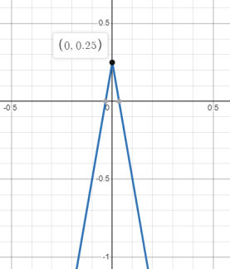  (0, 0.25) | 𝑦 = −7.5|𝑥| + 0.25
Range  𝑦 ≤ 𝑘 since 𝑎 < 0 | 𝑦 ≤ 0.25 | 𝑦 = −7.5|𝑥| + 0.25
Axis of Symmetry  𝑥 = ℎ | 𝑥 = 0 | 𝑦 = −7.5|𝑥 − 0| + 0.25

Instructional Tasks
Instructional Task 1 (MTR.3.1)
Graph the function $f(x) = \frac{1}{2}|x - 4| + 6$ and determine its domain; range; intercepts;
2 intervals where the function is increasing, decreasing, positive or negative; vertex; end behavior and symmetry.
Instructional Task 2 (MTR.3.1)
The graph, $q\left(x\right)$, is translated 5 units left and 7 units down from $f(x)=|x-2|$.
Part A. Graph the absolute value function, $q\left(x\right)$.
Part B. Identify the vertex of $q\left(x\right)$.
Part C. What is the interval that shows when the function is positive? Negative?
Part D. What is the domain of $q\left(x\right)$ when the function is increasing? How does this interval differ from the domain of $q\left(x\right)$.
Part E. How would the graph of $q\left(x\right)$ change if the $a$value was $-\frac{1}{3}$?
Instructional Items
Instructional Item 1
Given the table of values for an absolute value function, graph the function.
𝒙 | 𝒇(𝒙)
−2 | 4
−1 | 4
0 | 6
1 | 8
2 | 10

Instructional Item 2
Identify key features of the function, $h(x)=-\frac{1}{2} |x+3|-4$. Key features include when the function is positive, negative, increasing, decreasing, end behavior,$x$ and $y$-intercepts, domain, range and vertex.
*The strategies, tasks and items included in the B1G-M are examples and should not be considered comprehensive.

MA.912.AR.5 Write, solve and graph exponential and logarithmic equations and functions in one and two variables.

MA.912.AR.5.3
Benchmark
MA.912.AR.5.3 Given a mathematical or real-world context, classify an exponential function as representing growth or decay.
Benchmark Clarifications:
Clarification 1: Within the Algebra I course, exponential functions are limited to the forms
𝑓(𝑥) = 𝑎𝑏𝑥, where 𝑏 is a whole number greater than 1 or a unit fraction, or 𝑓(𝑥) = 𝑎(1 ± 𝑟)𝑥, where
0 < 𝑟 < 1.

Connecting Benchmarks/Horizontal Alignment
- MA.912.NSO.1.1
- MA.912.AR.1.1
- MA.912.F.1.6, MA.912.F.1.8

Terms from the K-12 Glossary
- Exponential Function

Vertical Alignment
Previous Benchmarks  - MA.7.AR.3 | Next Benchmarks  - MA.912.AR.5.5
Purpose and Instructional Strategies
In middle grades, students solved problems involving percentages, including percent increases and decreases. In Algebra I, students identify and describe exponential functions in terms of growth or decay rates. In later courses, students will further develop their understanding of exponential functions and how they are characterized by having a constant percent of change per unit interval.
- Provide opportunities to reference MA.912.AR.1.1 as students identify and interpret parts of an exponential equation or expression as growth or decay.
- Instruction includes the connection to growth or decay of a function as a key feature (constant percent rate of change) of an exponential function and being useful in understanding the relationships between two quantities.
- Instruction includes the use of graphing technology to explore exponential functions.
  - For example, students can explore the function 𝑓(𝑥) = 𝑎𝑏^{𝑥} and how the 𝑎-value and 𝑏-value are affected. Ask questions like “What impact does changing the value of 𝑎 have on the graph? What about 𝑏? What values for b cause the function to increase? Which values cause it to decrease?” As students explore, formalize the terms exponential growth and decay when appropriate.
  - As students explore the graph, have students choose values of 𝑎 and 𝑏 to complete a table of values. Once completed ask students what causes the value of
𝑦 to increase or decrease as the value of 𝑥 increases. Guide students to see that it’s because$b > 1$ or $b < 1$. Have students adjust the graph and repeat this exercise.
  - Once students have an understanding of what causes exponential growth and decay, both graphically and algebraically, ask students if they think the curve ever passes 𝑦 = 0. Have students extend their function table for exponential decay to include more extreme values for 𝑥 to explore if it ever does. As students arrive at an understanding that it does not cross 𝑦 = 0, guide them to understand why it
doesn’t algebraically. Once students arrive at this understanding, define this boundary as an asymptote.
  - As students explore the provided graph, they will move the slider for b to have negative values. The resulting graphs provide an interesting discussion point. Have students complete a function table using negative 𝑏 values. Students should quickly see the connection between the two “curves” and why neither is continuous. Let students know that for this reason, most contexts for exponential functions restrict 𝑏 to be greater than 0 and not equal to 1.
- As students solidify their understanding of 𝑓(𝑥) = 𝑎𝑏^{𝑥}, use graphing technology again to have them explore the form 𝑓(𝑥) = 𝑎(1 ± 𝑟)^{𝑥}. Guide students to use the sliders for 𝑎 and 𝑟 to visualize that only 𝑟 determines whether the function represents exponential growth or exponential decay.
  - Have students discuss which values for 𝑟 cause exponential growth or decay. They should observe that negative values cause exponential decay while positive values cause exponential growth.

Common Misconceptions or Errors
- Students may not understand exponential function values will eventually get larger than
those of any other polynomial functions because they do not fully understand the impact of exponents on a value.
- Students may not understand that growth factors have one constraint (𝑏 > 1) while decay factors have a compound constraint (0 < 𝑏 < 1). Some students may think that as long as
𝑏 < 1, the function will represent exponential decay.
- Students may think that if 𝑎 is negative and 𝑟 > 0 or 𝑏 > 1, the function represents an exponential decay. To address this misconception, help students understand that the negative values are growing at an exponential rate.

Strategies to Support Tiered Instruction
- Teacher provides instruction to identify exponential functions in all methods (i.e., graphs, equations and tables).
  - For example, instruction may include providing a comparison of the two forms of exponential functions. Having a side-by-side comparison of both as an equation, graph and a table of values will provide a visual aid.
- Teacher provides student with examples and non-examples of exponential functions in tables to help students visualize the growth or decay of a function.
  - For example, teacher can provide the following tables for students to determine which ones represent an exponential function.

𝒙 | 𝒚 |  | 𝒙 | 𝒚 |  | 𝒙 | 𝒚
4 | 6 |  | −1 | 2 |  | 0 | 10
5 | 36 |  | −2 | 6 |  | 1 | 17
6 | 216 |  | −3 | 18 |  | 2 | 24
7 | 1296 |  | −4 | 54 |  | 3 | 31
8 | 7776 |  | −5 | 162 |  | 4 | 38

Instructional Tasks
Instructional Task 1 (MTR.4.1, MTR.7.1)
After a person takes medicine, the amount of drug left in the person’s body changes over time. When testing a new drug, a pharmaceutical company develops a mathematical model to quantify this relationship. To find such a model, suppose a dose of 1000 mg of a certain drug is absorbed by a person’s bloodstream. Blood samples are taken every five hours, and the amount of drug remaining in the body is calculated. The data collected from a particular sample is recorded below.
Drug Absorption Data
Hours Since Drug was Administered | Amount of Drug in Body (mg)
0 | 1000
5 | 550
10 | 316
15 | 180
20 | 85
25 | 56
30 | 31
Part A. Does this data represent an exponential growth or decay function? Justify your answer.
Part B. Create an exponential function that describes the data in the table above.

Instructional Task 2 (MTR.3.1, MTR.5.1)
Given the function ℎ(𝑥) = 10^{0.2𝑥}, what is the rate of growth or decay?

Instructional Items
Instructional Item 1
Given the function 𝑓(𝑥) = 125(1 − 0.26)^{𝑥}, does it represent an exponential growth or decay function?

Instructional Item 2
Dunia is fascinated by the growth of bacteria in a controlled laboratory environment. At the beginning of the experiment, she observes that there are 10 bacteria. The population of bacteria increase by 100% every hour. Which statement describes the population of the bacteria over time?

- The population of bacteria represents a decay of two every hour.
- The population of bacteria represents growth of 10 every hour.
- The population of bacteria represents growth by doubling every hour.
- The population of bacteria represents decay by halving every hour.
*The strategies, tasks and items included in the B1G-M are examples and should not be considered comprehensive.

MA.912.AR.5.4
Benchmark
MA.912.AR.5.4 Write an exponential function to represent a relationship between two quantities from a graph, a written description or a table of values within a mathematical or real-world context.
Benchmark Clarifications:
Clarification 1: Within the Algebra I course, exponential functions are limited to the forms
𝑓(𝑥) = 𝑎𝑏^{𝑥}, where 𝑏 is a whole number greater than 1 or a unit fraction, or 𝑓(𝑥) = 𝑎(1 ± 𝑟)^{𝑥}, where
0 < 𝑟 < 1.
Clarification 2: Within the Algebra I course, tables are limited to having successive nonnegative integer inputs so that the function may be determined by finding ratios between successive outputs.

Connecting Benchmarks/Horizontal Alignment
- MA.912.NSO.1.1
- MA.912.AR.1.1
- MA.912.F.1.6, MA.912.F.1.8

Terms from the K-12 Glossary
- Exponential

Vertical Alignment
Previous Benchmarks  - MA.7.AR.3 | Next Benchmarks  - MA.912.AR.5.5, MA.912.AR.5.7

Purpose and Instructional Strategies
In middle grades, students solved problems involving percentages, including percent increases and decreases and write equations that represent proportional relationships. In Algebra I, students write exponential functions that model relationships characterized by having a constant percent of change per unit interval. In later courses, students will further develop their understanding of this feature of exponential functions.
- Provide opportunities to reference MA.912.AR.1.1 as students identify and interpret parts of an exponential equation or expression as growth or decay and connect them to key features of the graph.
- Problems include cases where the initial value is not given.
- Instruction includes guidance on how to determine the initial value or the percent rate of change of an exponential function when it is not provided.
  - For example, if the initial value of (0,3) is given, students can now write the function as 𝑓(𝑥) = 3𝑏^{𝑥}. Guide students to choose a point on the curve that has integer coordinates such as (2, 12). Lead them to substitute the point into their function to find 𝑏. Students should recognize that exponential functions are restricted to positive values of 𝑏, leading to the function 𝑓(𝑥) = 3(2)^{𝑥}.
- Instruction includes interpreting percentages of growth/decay from exponential functions expressed in the form 𝑓(𝑥) = 𝑎𝑏^{𝑥} and see that 𝑏 can be used to determine a percentage.
  - For example, the function 𝑓(𝑥) = 500(1.16)^{𝑥} represents 16% growth of an initial value.
    - Guide students to discuss the meaning of the number 1.16 as a percent. They should understand it represents 116%. Taking 116% of an initial value increases the magnitude of that value. (Students can test this in a calculator to confirm.) Taking this percentage repetitively leads to exponential growth.
  - For example, the function 𝑓(𝑥) = 500(0.72)^{𝑥} represents 28% decay of an initial value.
    - Guide students to discuss the meaning of the number 0.72 as a percent. They should understand it represents 72%. Taking 72% of an initial value decreases the magnitude of that value. (Students can test this in a calculator to confirm.) Taking this percentage repetitively leads to exponential decay.
  - For example, the function 𝑓(𝑥) = 500(1)^{𝑥} represents an initial value that neither grows nor decays as x increases.
    - Guide students to discuss the meaning of the number 1 when it comes to growth/decay factors. They should understand it represents 100%. Taking 100% of an initial value causes the value to remain the same. (Students can test this in a calculator to confirm.) Taking this percentage repetitively leads to no change in the initial value (explaining the horizontal line that shows when 𝑏 = 1 on the graph).

Common Misconceptions or Errors
  - Students may not understand that exponential function values will eventually get larger
than those of any other polynomial functions because they do not fully understand the impact of exponents on a value.
Strategies to Support Tiered Instruction
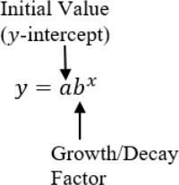
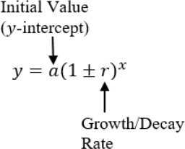
- Teacher provides students with a graphic displaying key terms within an exponential function.

- Instruction includes comparing quadratic (polynomial) to exponential functions using graphs or tables with whole-number inputs to show how exponential functions will quickly exceed quadratic (polynomial) functions.

Instructional Tasks
Instructional Task 1 (MTR.4.1, MTR.5.1, MTR.7.1)
Karl and Simone were working on separate biology experiments. Each student documented their cell population counts over time in the chart below.
Karl’s Experiment |  |  | Simone’s Experiment
# of minutes | # of cells |  | # of minutes | # of cells
5 | 2800 |  | 0 | 80
10 | 1400 |  | 1 | 120
15 | 700 |  | 2 | 180
20 | 350 |  | 3 | 270
25 | 175 |  | 4 | 405
Part A. Do the number of cells in Simone’s experiment increase at a constant percentage rate of change? If so, what is the percentage rate? If not, describe what is happening to the number of cells. Does this change represent growth or decay?
Justify your answer.
Part B. Write exponential functions to represent the relationship between the quantities for each student’s experiment. In which experiment are the number of cells changing more rapidly? Justify your answer.
Part C. Graph these functions and determine their key features.

Instructional Task 2 (MTR.2.1, MTR.7.1)
The population of J-Town in 2019 was estimated to be 76,500 people with an annual rate of increase of 2.4%.
Part A. Write an equation to model future growth.
Part B. What is the growth factor for J-Town?
Part C. Use the equation to estimate the population in 2072 to the nearest hundred people.

Instructional Items
Instructional Item 1
Write an exponential function that represents the graph below.
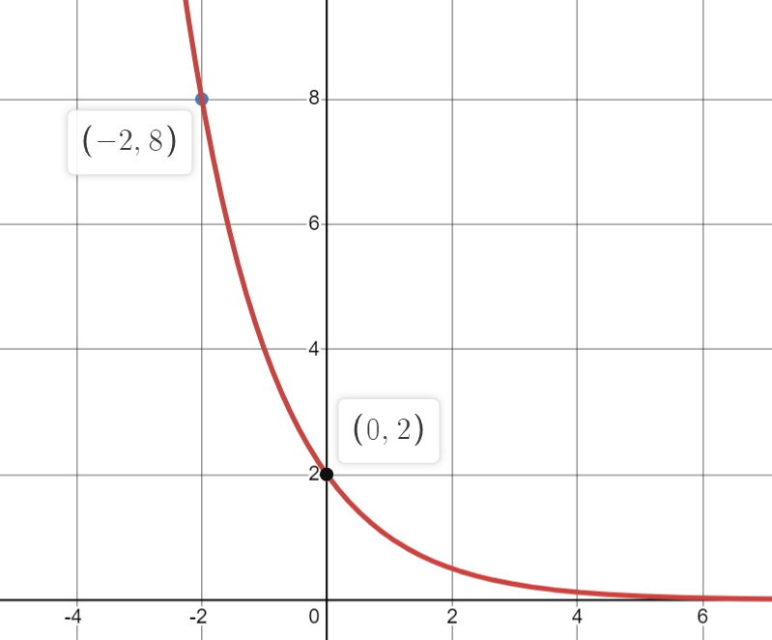

Instructional Item 2
A forester has determined that the number of fir trees in a forest is decreasing by 3% per year. In 2010, there were 13,000 fir trees in the forest. Write an equation that represents the number of fir trees, N, in terms of t, the number of years since 2010.
*The strategies, tasks and items included in the B1G-M are examples and should not be considered comprehensive.

MA.912.AR.5.6
Benchmark
MA.912.AR.5.6 Given a table, equation or written description of an exponential function, graph that function and determine its key features.
Benchmark Clarifications:
Clarification 1: Key features are limited to domain; range; intercepts; intervals where the function is increasing, decreasing, positive or negative; constant percent rate of change; end behavior and asymptotes.
Clarification 2: Instruction includes representing the domain and range with inequality notation, interval notation or set-builder notation.
Clarification 3: Within the Algebra I course, notations for domain and range are limited to inequality and set-builder.
Clarification 4: Within the Algebra I course, exponential functions are limited to the forms 𝑓(𝑥) = 𝑎𝑏^{𝑥}, where 𝑏 is a whole number greater than 1 or a unit fraction or 𝑓(𝑥) = 𝑎(1 ± 𝑟)^{𝑥}, where 0 < 𝑟 < 1.

Connecting Benchmarks/Horizontal Alignment
- MA.912.AR.1.1
- MA.912.F.1.6, MA.912.F.1.8

Terms from the K-12 Glossary
- Coordinate plane
- Domain
- Exponential Function
- Function Notation
- Range
- 𝑥-intercept
- 𝑦-intercept

Vertical Alignment
Previous Benchmarks  - MA.8.AR.3 | Next Benchmarks  - MA.912.AR.8.2
Purpose and Instructional Strategies
In grade 8, students graphed linear equations. In Algebra I, students graph exponential functions and determine their key features, including asymptotes and end behavior. Students are first introduced to asymptotes in Algebra I. In later courses, asymptotes are important in the study of other types of functions, including rational functions.
- Instruction includes defining an asymptote as a line that a curve approaches but does not meet as it heads toward positive or negative infinity.
- Instruction provides the opportunity for students to explore the meaning of an asymptote graphically and algebraically. Through work in this benchmark, students will discover asymptotes are useful guides to complete the graph of a function, especially when drawing them by hand. For mastery of this benchmark, asymptotes can be drawn on the graph as a dotted line or not drawn on the graph.
- For students to have a full understanding of exponential functions, instruction includes MA.912.AR.5.3 and MA.912.AR.5.4. Growth or decay of a function can be
defined as a key feature (constant percent rate of change) of an exponential function and useful in understanding the relationships between two.
- Instruction includes the use of 𝑥-𝑦 notation and function notation.
- Instruction includes representing domain and range using words, inequality notation and set-builder notation.
  - Words
If the domain is all real numbers, it can be written as “all real numbers” or “any value of 𝑥, such that 𝑥 is a real number.”
  - Inequality notation
If the domain is all values of 𝑥 greater than 2, it can be represented as 𝑥 > 2.
  - Set-builder notation
If the domain is all values of 𝑥 less than or equal to zero, it can be represented as
{𝑥|𝑥 ≤ 0} and is read as “all values of 𝑥 such that 𝑥 is less than or equal to zero.”
- Instruction includes the use of appropriately scaled coordinate planes, including the use of breaks in the 𝑥- or 𝑦-axis when necessary.

Common Misconceptions or Errors
  - Students may not fully understand how to use proper notation when determining the key features of an exponential function.

Strategies to Support Tiered Instruction
- Instruction includes student understanding that growth and decay is not the same as a
function increasing or decreasing.
  - For example, the exponential function 𝑦 = −2(0.5)^{𝑥} is an exponential decay function because the value of 𝑏 is in between 0 and 1. Note that it is the magnitude of the 𝑦-values that are decaying exponentially, eventually getting closer to zero. However, the value of the function increases as the value of 𝑥 increases. To help students visualize this, graph the function using graphing technology.
- Instruction includes using an exponential function formula guide like the one below.
Exponential Growth | Exponential Decay
𝑏 > 1 | 𝑏 < 1
𝑦 = 𝑎(1 + 𝑟)^{𝑡} | 𝑦 = 𝑎(1 − 𝑟)^{𝑡}

Instructional Tasks
Instructional Task 1
The bracket system for the NCAA Basketball Tournament (also known as March Madness) is an example of an exponential function. At each round of the tournament, teams play against one another with only the winning teams progressing to the next round. If we start with 64 teams going into round 1, the table of values looks something like this:
Round | 1 | 2 | 3 | 4 | 5
Number of teams left playing at end of round | 32 | 16 | 8 | 4 | 2
Part A. Graph this function.
Part B. What is the percentage of teams left after each round?

Instructional Task 2
Ashanti purchased a car for $22,900. The car depreciated at an annual rate of 16%. After 5 years, Ashanti wants to sell her car.
Part A. Write an equation that models the value of Ashanti’s car?
Part B. What would be the range of the graph of the value of Ashanti’s car?
Part C. What would be the 𝑦-intercept of that graph and what does it represent?
Part D. Will her car ever have a value of $0.00 based on your equation?
Part E. What is a reasonable domain for this function? Justify your answer.

Instructional Items
Instructional Item 1
An exponential function is given by the equation $y=-14$. What is the asymptote for the graph?

Instructional Item 2
An exponential function is given.
𝑦 = 50(1.1)^{𝑡}
Part A. Does this function represent exponential growth or decay?
Part B. What is the constant percent rate of change of 𝑦 with respect to 𝑡.
Instructional Item 3
Graph the exponential function represented by the table of values. Identify the domain, range, constant percent rate of change and end behavior.
*The strategies, tasks and items included in the B1G-M are examples and should not be considered comprehensive.

MA.912.AR.9 Write and solve a system of two- and three-variable equations and inequalities that describe quantities or relationships.

MA.912.AR.9.1
Benchmark
MA.912.AR.9.1 Given a mathematical or real-world context, write and solve a system of two- variable linear equations algebraically or graphically.
Benchmark Clarifications:
Clarification 1: Within this benchmark, the expectation is to solve systems using elimination, substitution and graphing.
Clarification 2: Within the Algebra I course, the system is limited to two equations.

Connecting Benchmarks/Horizontal Alignment
- MA.912.AR.2.1, MA.912.AR.2.2, MA.912.AR.2.3, MA.912.AR.2.4

Terms from the K-12 Glossary
- Linear Equation

Vertical Alignment
Previous Benchmarks  - MA.8.AR.4.1, MA.8.AR.4.2, MA.8.AR.4.3 | Next Benchmarks  - MA.912.NSO.4.2  - MA.912.AR.9.2, MA.912.AR.9.3, MA.912.AR.9.9
Purpose and Instructional Strategies
In grade 8, students determined whether a system of linear equations had one solution, no solution or infinitely many solutions and solved such systems graphically. In Algebra I, students solve systems of linear equations in two variables algebraically and graphically. In later courses, students will solve systems of linear equations in three variables and systems of nonlinear equations in two variables.
- For students to have full understanding of systems, instruction should
include MA.912.AR.9.4 and MA.912.AR.9.6. Equations and inequalities and their constraints are all related and the connections between them should be reinforced throughout instruction.
- Instruction allows students to solve using any method (substitution, elimination or graphing) but recognizing that one method may be more efficient than another (MTR.3.1).
  - If both equations are presented in slope-intercept form, then either graphing or substitution may be most efficient.
  - If one equation is given in slope-intercept form or solved for 𝑥, then substitution may be easiest.
  - If both equations are given in standard form, then elimination, or linear combination, may be most efficient.
Consider presenting a system that favors one of these methods and having students divide into three groups to solve them using different methods. Have students share their work and discuss which method was more efficient than the others (MTR.3.1, MTR.4.1).
- Include cases where students must interpret solutions to systems of equations.
- Various forms of linear equations can be used to write a system of equations.
  - Standard Form
Can be described by the equation 𝐴𝑥 + 𝐵𝑦 = 𝐶, where 𝐴, 𝐵 and 𝐶 are any rational number.
  - Slope-Intercept Form
Can be described by the equation 𝑦 = 𝑚𝑥 + 𝑏, where 𝑚 is the slope and 𝑏 is the
𝑦-intercept.
  - Point-Slope Form
Can be described by the equation 𝑦 − 𝑦₁ = 𝑚(𝑥 − 𝑥₁), where (𝑥₁, 𝑦₁) is a point on the line and 𝑚 is the slope of the line.
When introducing the elimination method, students may express confusion when considering adding equations together. Historically, students have used the properties of equality to create equivalent equations to solve for a variable of interest. In most of these efforts, operations performed on both sides of the original equation have been identical. With the introduction of the elimination method, students can now see that operations performed on each side of an equation must be equivalent (not necessarily identical) for the property to hold. Guide students to explore forming equivalent equations with simpler equations by adding or subtracting equivalent values. Lead them to see that the new equations they generate have the same solutions. Have them discuss why the method works: equations are simply pairs of equivalent expressions, which is why they can be added/subtracted with each other.

Common Misconceptions or Errors
- Students may not understand linear systems of equations can only have more than one solution if there are infinitely many solutions.
- Students may not understand linear systems of equations can have no solution.
- Students may have difficulty making connections between graphic and algebraic representations of systems of equations.
- Students may have difficulty choosing the best method of finding the solution to a system of equations.
- Students may have difficulty translating word problems into systems of equations and inequalities.
- Students using the elimination method may alter the original equations in a way that creates like terms that can be subtracted. When subtracting across the two equations students may have difficulty remembering to apply the subtraction to the remaining terms
  - and constants.

Strategies to Support Tiered Instruction
- Instruction includes opportunities to use graphing software to visualize the possible solutions for a system of equations. Systems of equations only produce three different types of solutions: one solution, infinite solutions and no solutions. Each type of system can be graphed for analysis of each type of solution set.
- Teacher models through a think-aloud how a system of equations can have no solutions.
  - For example, “I can algebraically solve a system with no solutions. The solution will reveal that the left and right sides of the equation cannot be equal, causing a no solution set. In addition, if I rearrange both equations to the slope-intercept form, the equations will have the same slope. I can utilize my knowledge of
parallel lines to understand that the system cannot have any solutions.”
- Teacher provides step-by-step process for solving systems.
  - For example, when solving the system below, students can use the method of elimination.
2𝑥 + 4𝑦 = −10
3𝑥 + 5𝑦 = 8
If the student chooses to eliminate the 𝑦-variable, they can multiply the first equation by 5 and the second by 4 so that both coefficients of 𝑦 are 20.
5(2𝑥 + 4𝑦 = −10) to 10𝑥 + 20𝑦 = −50
4(3𝑥 + 5𝑦 = 8) to 12𝑥 + 20𝑦 = 32
The student either subtracts the two new equations or creates additive inverses by multiplying one of the equations by −1 (as shown) and then adds the equations.
−1(10𝑥 + 20𝑦 = −50) to −10𝑥 − 20𝑦 = +50
−10𝑥 − 20𝑦 = +50
12𝑥 + 20𝑦 = 32
2𝑥 = 82
𝑥 = 41
Once students determine one of the values (𝑥 in this case), then they can substitute this back into one of the given equations to find the other value (𝑦 in this case).
2(41) + 4𝑦 = −10
4𝑦 = −10 − 82
𝑦 = −23

Instructional Tasks
Instructional Task 1 (MTR.3.1, MTR.4.1)
You and a friend go to Tacos Galore for lunch. You order three soft tacos and three burritos, and your total bill is $11.25. Your friend’s bill is $10.00 for four soft tacos and two burritos.
Part A. Write a system of two-variable linear equations to represent this situation.
Part B. Solve the system both algebraically and graphically to determine the cost of each burrito and each soft taco.
Part C. Is one method more efficient than the other? Why or why not?

Instructional Task 2 (MTR.3.1, MTR.4.1)
Part A. Determine the solution to the system of linear equations below using your method of choice.
$$0.5x - 1.4y = 5.8$$
$$y = -0.3x - \frac{1}{5}$$
Part B. Discuss with a partner why you chose that method.

Instructional Items
Instructional Item 1
Determine the exact solution of the system of linear equations below.
$$-\frac{1}{10} x+\frac{1}{2} y=\frac{4}{5}$$

$$\frac{1}{7} x+\frac{1}{3}y=- \frac{2}{21}$$
Instructional Item 2
Carla volunteered to make pies for a bake sale. She bought two pounds of apples and six pounds of peaches and spent $19. After baking the pies, she decided they looked so good she would make more. She went back to the store and bought another pound of apples and five more pounds of peaches and spent $15. Write a system of linear equations that describes her purchases, where 𝑎 represents the cost per pound of the apples and 𝑝 represents the cost per pound of the peaches.

Instructional Item 3
Which two equations form a system of linear equations that has no solution?
$$y=\frac{2}{3}x+2$$
$$4x-6y=12$$
$$(y-2)=-2/3 (x-4)$$
*The strategies, tasks and items included in the B1G-M are examples and should not be considered comprehensive.

MA.912.AR.9.4
Benchmark
MA.912.AR.9.4 Graph the solution set of a system of two-variable linear inequalities.
Benchmark Clarifications:
Clarification 1: Instruction includes cases where one variable has a coefficient of zero.
Clarification 2: Within the Algebra I course, the system is limited to two inequalities.

Connecting Benchmarks/Horizontal Alignment
- MA.912.AR.2.7, MA.912.AR.2.8

Terms from the K-12 Glossary
- Inequality

Vertical Alignment
Previous Benchmarks  - MA.8.AR.2.2  - MA.8.AR.4.1, MA.8.AR.4.2, MA.8.AR.4.3 | Next Benchmarks  - MA.912.AR.9.5, MA.912.AR.9.7, MA.912.AR.9.8
Purpose and Instructional Strategies
In grade 8, students solved determined graphically whether a system of linear equations had one determined graphically whether a system of linear equations had one solution, no solution or infinitely many solutions. In Algebra I, students solve systems of linear inequalities by graphing the solution set. In later courses, students will solve problems involving linear programming.
- For students to have full understanding of systems, instruction includes MA.912.AR.9.1 and MA.912.AR.9.6. Equations and inequalities and their constraints are all related and the connections between them should be reinforced throughout the instruction.
- Instruction includes the use of linear inequalities in standard form, slope-intercept form and point-slope form. Include examples in which one variable has a coefficient of zero such as 𝑥 < − $\frac{1}{5}$.
- Instruction includes the connection to graphing solution sets of one-variable inequalities on a number line, recognizing whether the boundary line should be dotted (exclusive -meaning not included in the solution set) or solid (inclusive – meaning included in the solution set). Additionally, have students use a test point to confirm which side of the line should be shaded (MTR.6.1).
- Students should recognize that the inequality symbol only directs where the line is shaded (above or below) for inequalities when in slope-intercept form. Students shading inequalities in other forms will need to use a test point to determine the correct half-plane to shade.
- The solution to a system of inequalities is the area where all the shading overlaps. If the areas do not overlap, it has no solution.

- Instruction includes determining whether the point of intersection of the boundary lines of the linear inequalities is within the solution set.
  - For example, if either or both of the two boundary lines are dashed (< or >), then the point of intersection is not in the solution set.
- Instruction allows students to make connections between the algebraic and graphical representations of inequalities in two variables (MTR.2.1).

Common Misconceptions or Errors
- Students may have difficulties making connections between graphic and algebraic representations of systems of inequalities.
- Students may confuse which points are in the solution set of a system that includes inequalities (including points on the lines in a system of inequalities).
- Students may shade the wrong half-plane or graph the incorrect boundary line (solid vs. dashed).

Strategies to Support Tiered Instruction
- Teacher Instruction includes making the connection between the algebraic and graphical representations of a two-variable linear inequality and its key features.
  - For example, teacher can provide a graphic organizer such as the one below.

Algebraic Representation | Graphical Representation
$$y=≥3+ \frac{4}{9}x$$ | 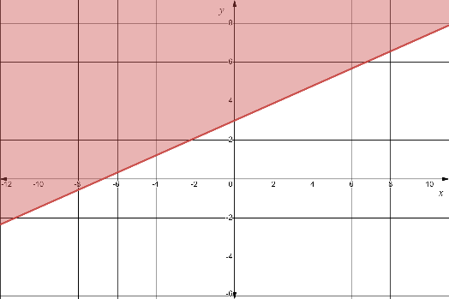
The y-intercept is located at the point (0, 3).
The slope of the boundary line is $\frac{4}{9}$. | From any point on the boundary  line, the next point can be found by moving up/down 4 units and then moving right/left 9 units.
≥ | The boundary line is solid  with the solution set shaded above the boundary line.
- Instruction includes using different colors or shapes to identify each of the solution sets of the linear inequalities.
  - For example, a student can “shade” the solution of the first inequality by highlighting in yellow on its half-plane and can “shade” the solution of the second inequality by highlighting in blue on its half-plane. Where the yellow and blue overlap represent the solution set of the system of linear inequalities.

- Teacher creates connections to solving a system of linear inequalities to determining the solution set to a single two-variable linear inequality, building on students’ knowledge from MA.912.AR.2.8.
  - For example, a student can focus first on finding the solution set of one of the inequalities by graphing the boundary line and then choosing a test point to determine where to shade. Next, the student can focus on finding the solution set of the second inequality in the same way. Students should understand that where the two shaded regions overlap is the solution set of the system.
- Instruction includes using transparencies to lay the separately graphed inequalities on top of one another to visualize the solution set of the system.
- Teacher co-creates a graphic organizer to scaffold graphing an inequality and its solution. The steps can be repeated for each inequality.
  - Example:
Symbol (s) | Graph
< and > | Dashed line,  Solution does not include points on the line
≤ and ≥ | Solid line,  Solution includes points on the line
Instructional Tasks
Instructional Task 1 (MTR.3.1)
Part A. Graph the solution set to the system of inequalities:
Part B. What is one point that is a solution to the system above?

Instructional Task 2 (MTR.7.1)
Devonte is throwing a party to watch the Stanley Cup Finals. He orders pizza that cost $11 each and cartons of wings that cost $9.99 each. With at least 34 people coming over, Devonte spends at least $72.96 and orders a minimum of 7 pizzas and cartons of wings.
Part A. Write a system of inequalities that describes this situation.
Part B. Graph the solution set and determine a possible number of pizza and cartons of wings he ordered for his party.

Instructional Items
Instructional Item 1
Graph the solution set to the system of inequalities below.
$x≥3$ $\frac{3}{5}x+y<-3$
Instructional Item 2
Graph the solution set to the system of inequalities below.
$$-y - 3x ≤ -1 2y ≥ 8x – 6$$

*The strategies, tasks and items included in the B1G-M are examples and should not be considered comprehensive.

MA.912.AR.9.6
Benchmark
MA.912.AR.9.6 Given a real-world context, represent constraints as systems of linear equations or inequalities. Interpret solutions to problems as viable or non-viable options.
Benchmark Clarifications:
Clarification 1: Instruction focuses on analyzing a given function that models a real-world situation and writing constraints that are represented as linear equations or linear inequalities.

Connecting Benchmarks/Horizontal Alignment
- MA.912.AR.2.2, MA.912.AR.2.5, MA.912.AR.2.7, MA.912.AR.2.8
- MA.912.AR.3.8

Terms from the K-12 Glossary
- Inequality
- Linear Equation

Vertical Alignment
Previous Benchmarks  - MA.8.AR.2.2  - MA.8.AR.4.1, MA.8.AR.4.2, MA.8.AR.4.3 | Next Benchmarks  - MA.912.AR.4.4  - MA.912.AR.5.7, MA.912.AR.5.9  - MA.912.AR.6.6  - MA.912.AR.7.3, MA.912.AR.7.4  - MA.912.AR.8.3  - MA.912.AR.9.7, MA.912.AR.9.10  - MA.912.T.3.3
Purpose and Instructional Strategies
in grade 8, students worked with linear equations and inequalities, and graphically solved systems of linear equations. In Algebra I, students represent constraints as systems of linear equations or inequalities and interpret solutions as viable or non-viable options. In later courses, students will solve problems involving linear programming and work with constraints within various function types.
- For students to have a full understanding of systems, instruction includes MA.912.AR.9.1 and MA.912.AR.9.4. Equations and inequalities and their constraints are all related and the connections between them should be reinforced throughout the instruction.
- Allow for both inequalities and equations as constraints. Include cases where students must determine a valid model of a function.
  - Students often use inequalities to represent constraints throughout Algebra I. Equations can be thought of as constraints as well. Solving a system of equations requires students to find a point that is constrained to lie on specific lines simultaneously.

- Instruction includes the use of various forms of linear equations and inequalities.
  - Standard Form
Can be described by the equation 𝐴𝑥 + 𝐵𝑦 = 𝐶, where 𝐴, 𝐵 and 𝐶 are any rational number and any equal or inequality symbol can be used.
  - Slope-intercept form
Can be described by the inequality 𝑦 ≥ 𝑚𝑥 + 𝑏, where 𝑚 is the slope and 𝑏 is the
𝑦-intercept and any equal or inequality symbol can be used.
  - Point-slope form
Can be described by the inequality 𝑦 − 𝑦₁ > 𝑚(𝑥 − 𝑥₁), where (𝑥₁, 𝑦₁) is a point on the line and 𝑚 is the slope of the line and any equal or inequality symbol can be used.

Common Misconceptions or Errors
- Students may have difficulty translating word problems into systems of equations and inequalities.
- Students may shade the wrong half-plane for an inequality.
- Students may graph an incorrect boundary line (dashed versus solid) due to incorrect translation of the word problem.
- Students may not identify the restrictions on the domain and range of the graphs in a system of equations based on the context of the situation.

Strategies to Support Tiered Instruction
- Instruction provides opportunities to translate systems of equations or inequalities from word problems by first creating equations, then by identifying keywords to determine the inequality symbol (i.e., no more than, less than, at least, etc.). The appropriate inequality symbols can then replace the equal signs. Students can separate and organize information for each equation or inequality.
  - Separate given information for each equation or inequality.
  - Determine the appropriate form of equation or inequality based on givens.
  - Define a variable to represent the item wanted in the equation or inequality.
  - Determine what values are constants or should be placed with the variables.
  - Write the equation or inequality.
- Teacher co-creates a graphic organizer to scaffold graphing an inequality and its solution. The steps can be repeated for each inequality.
Symbol (s) | Graph
< and > | Dashed line,  Solution does not include points on the line
≤ and ≥ | Solid line,  Solution includes points on the line
- Instruction includes opportunities to identify a test point to substitute into an inequality to determine which symbol should be used when writing the inequality. It is usually easiest to use the origin (0,0) as it makes mental calculations easier. If the point selected creates a true statement, the half plane that includes the test point should be shaded. If it creates a false statement, the half plane that does not include the test point should be shaded.

- Teacher makes connections back to students’ understanding of MA.912.AR.2.5 and MA.912.AR.3.8 and writing constraints based on a real-world context.
  - For example, Dani is planning her wedding, and the venue charges a flat rate of
$8250 for four hours. The venue can provide meals for each of the guests and charges $21.25 per plate for adults and $13.75 per plate for children if she has a minimum of 75 guests. If Dani’s budget is $38,000, students can describe this situation using the inequalities 𝑎 + 𝑐 ≥ 75 and 21.25𝑎 + 13.75𝑐 + 8250 ≤ 38000. Depending on the number of adults and children she wants to invite and the capacity of the venue, students can determine various other constraints.
- Teacher provides questions to be answered by students to aid in the identification of domain and range restrictions:
  - Does the problem involve humans, animals or things that cannot or are normally not broken into parts? If yes, you are restricted by integers.
  - Do negative numbers not make sense? If yes, you are restricted by positive numbers.
  - Was a maximum or minimum value given? If yes, the solution must not exceed the maximum or drop lower than the minimum.
- Instruction includes identifying which variable(s) the constraints apply to.

Instructional Tasks
Instructional Task 1 (MTR.3.1)
A baker has 16 eggs and 15 cups of flour. One batch of chocolate chip cookies requires 4 eggs and 3 cups of flour. One batch of oatmeal raisin cookies requires 2 eggs and 3 cups of flour. The baker makes $3 profit for each batch of chocolate chip cookies and $2 profit for each batch of oatmeal raisin cookies. How many batches of each cookie should she make to maximize profit?

Instructional Task 2 (MTR.4.1)
Amy and Anthony are starting a pet sitter business. To make sure they have enough time to properly care for the animals, they create a feeding and pampering plan. Anthony can spend up to 8 hours a day taking care of the feeding and cleaning, and Amy can spend up to 8 hours each day pampering the pets.

Feeding/Cleaning Time: Amy and Anthony estimate they need to allot 6 minutes twice a day, morning and evening, to feed and clean litter boxes for each cat, a total of 12 minutes a day per cat. Dogs will require 10 minutes twice a day to feed and walk, for a total of 20 minutes per day for each dog.

Pampering Time: Sixteen minutes per day will be allotted for brushing and petting each cat and 20 minutes each day for bathing and playing with each dog.
Part A. Write an inequality for feeding/cleaning time needed for the pets. Represent all time in the same unit (minutes or hours).
Part B. Write an inequality for pampering time needed for the pets. Represent all time in the same unit (minutes or hours).
Part C. Graph the two inequalities.
Part D. In term of this scenario, explain the meanings of the following points: (0,24) and
(30,0).
Part E. What is the greatest number of dogs they can watch if they are watching 19 cats? Part F. List two viable combinations of pets that can be watched.
Possibility 1: cats dogs
Possibility 2: cats dogs

Instructional Items
Instructional Item 1
There are several elevators in the Sandy Beach Hotel. Each elevator can hold at most 12 people. Additionally, each elevator can only carry 1600 pounds of people and baggage for safety reasons. Assume on average an adult weighs 175 pounds and a child weighs 70 pounds. Also assume each group will have 150 pounds of baggage plus 10 additional pounds of personal items per person.
Part A. Write a system of linear equations or inequalities that describes the weight limit for one group of adults and children on a Sandy Beach Hotel elevator and that represents the total number of passengers in a Sandy Beach Hotel elevator.
Part B. Several groups of people want to share the same elevator. Group 1 has 4 adults and 3 children. Group 2 has 1 adult and 11 children. Group 3 has 9 adults. Which of the groups, if any, can safely travel in a Sandy Beach elevator?

Instructional Item 2
A farmer is planning to plant two types of crops, Crop X and Crop Y. The maximum amount of field space is 6 acres, and the maximum water supply is 10 units. Each acre of Crop X requires 1 unit of water, and each acre of Crop Y requires 2 units of water. Write a system of equations or inequalities that represents the situation.
*The strategies, tasks and items included in the B1G-M are examples and should not be considered comprehensive.

Functions

MA.912.F.1 Understand, compare and analyze properties of functions.

MA.912.F.1.1
Benchmark
MA.912.F.1.1 Given an equation or graph that defines a function, classify the function type. Given an input-output table, determine a function type that could represent it.
Benchmark Clarifications:
Clarification 1: Within the Algebra I course, functions represented as tables are limited to linear, quadratic and exponential.
Clarification 2: Within the Algebra I course, functions represented as equations or graphs are limited to vertical or horizontal translations or reflections over the 𝑥-axis of the following parent functions:
𝑓(𝑥) = 𝑥, 𝑓(𝑥) = 𝑥², 𝑓(𝑥) = 𝑥³, 𝑓(𝑥) = √𝑥, 𝑓(𝑥) = 3√𝑥, 𝑓(𝑥) = |𝑥|, 𝑓(𝑥) = $2^{x}$ and 𝑓(𝑥) = ${\left(\frac{1}{2}\right)}^{x}$

Connecting Benchmarks/Horizontal Alignment
- MA.912.AR.2, MA.912.AR.3, MA.912.AR.4
- MA.912.DP.2.6

Terms from the K-12 Glossary
- Exponential Function
- Function
- Linear Function
- Quadratic Function

Vertical Alignment
Previous Benchmarks  - MA.8.F.1.1, MA.8.F.1.2, MA.8.F.1.3 | Next Benchmarks  - MA.912.AR.5, MA.912.AR.6, MA.912.AR.7  - MA.912.AR.8  - MA.912.GR.7  - MA.912.T.2
Purpose and Instructional Strategies
In grade 8, students identified the domain and range of a relation and determined whether it is a function or not. In Algebra I, students classify function types limited to simple linear, quadratic, cubic, square root, cube root, absolute value and exponential functions. In later courses, students will classify other function types.
- The purpose of this benchmark is to lay the groundwork for students to be able to choose appropriate functions to model real-world data.
- Instruction includes the connection of the graph to its parent function. See Clarification 1 for specifics of the Algebra I course.

- Students will work extensively with linear, quadratic and exponential models in the Algebra I course. Strong attention should be given to the other function types so that students can build familiarity with them. As new function types are introduced, take time to allow students to produce a rough graph of the parent function from a table of values they develop. Lead student discussion to build connections with why these function types produce their corresponding graphs (MTR.4.1).
- Instruction develops the understanding that if given a table of values, unless stated, one cannot absolutely determine the function type, but state which function the table of values could represent.
  - For example, if given the function 𝑦 = |𝑥| and only positive values were given in a table, one could say that table of values could represent a linear or absolute value function.

Common Misconceptions or Errors
- Some students may miscalculate first and second differences that deal with negative values, especially if they perform them mentally.

Strategies to Support Tiered Instruction
- Teacher provides opportunities to write out subtraction sentences next to each line of the
table when determining first and second differences.
- Instructions are provided to determine the type of function the graph represents. Knowledge on the end behavior of different types of functions may provide students with additional information to identify different types of functions. The teacher co-creates an anchor chart showing different types of functions and their end behavior.
- Teacher provides methods for calculating and/or interpreting the first and second differences given a table of values.
Exponential |  |  | Linear |  |  | Quadratic
−3 | 2 | × 2 | 3 | −20 | +3 | 1 | 7
−2 | 4 | × 2 | 4 | −17 | +3 | 2 | 13 | +6
−1 | 8 | × 2 | 5 | −14 | +3 | 3 | 23 | +10 | +4
0 | 16 | × 2 | 6 | −11 | +3 | 4 | 37 | +14 | +4
1 | 32 |  | 7 | −8 |  | 5 | 55 | +18 | +4

- Instruction includes opportunities to use graphing software to graph parent functions of different equations (i.e., square root, cubic, absolute value, etc.).
𝑦 = $\sqrt{x}$ | 𝑦 = 𝑥³ | 𝑦 = |𝑥|
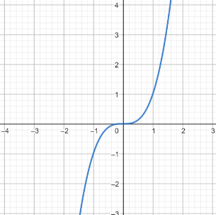
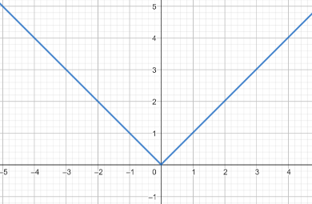
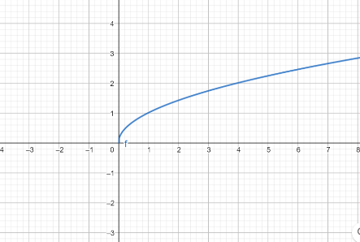

Instructional Tasks
Instructional Task 1 (MTR.3.1)
Given the graphs below, identify each type of function it represents. Justify your answer.
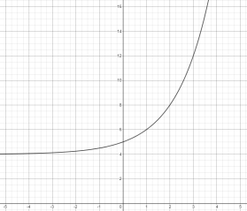 | 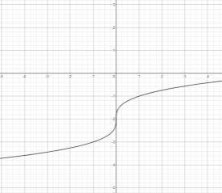
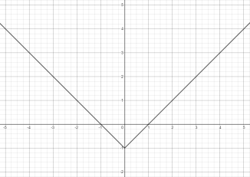 | 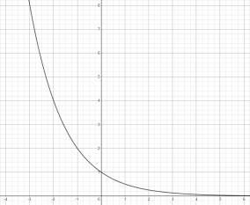

Instructional Items
Instructional Item 1
Given the table below, determine the function type that could represent it.
$$x$$ | 6 | 8 | 10 | 12 | 14
$$y$$ | -1.5 | 0 | 2.5 | 6 | 10.5

Instructional Item 2
Determine the function type of the graph below.

Instructional Item 3
Determine the function type of the equation, $f(x)=5x+2.$
*The strategies, tasks and items included in the B1G-M are examples and should not be considered comprehensive.

MA.912.F.1.2
Benchmark
MA.912.F.1.2 Given a function represented in function notation, evaluate the function for an input in its domain. For a real-world context, interpret the output.
Benchmark Clarifications:
Clarification 1: Problems include simple functions in two-variables, such as 𝑓(𝑥, 𝑦) = 3𝑥 − 2𝑦.
Clarification 2: Within the Algebra I course, functions are limited to one-variable such as 𝑓(𝑥) = 3𝑥.

Connecting Benchmarks/Horizontal Alignment
- MA.912.AR.2
- MA.912.AR.3.8
- MA.912.AR.4.3
- MA.912.AR.5.6
- MA.912.F.3.1

Terms from the K-12 Glossary
- Function Notation

Vertical Alignment
Previous Benchmarks  - MA.6.AR.1.2 | Next Benchmarks  - MA.912. F.3
Purpose and Instructional Strategies
In middle grades, students worked with 𝑥-𝑦 notation and substituted values in expressions and equations. In Algebra I, students work with 𝑥-𝑦 notation and function notation throughout instruction of linear, quadratic, exponential and absolute value functions. In later courses, students will continue to use function notation with other function types and perform operations that combine functions, including compositions of functions.
- Instruction leads students to understand that 𝑓(𝑥) reads as “𝑓 of 𝑥” and represents an output of a function equivalent to that of the variable 𝑦 in 𝑥-𝑦 notation.
- Instruction includes a series of functions with random inputs so that students can see the pattern that emerges (MTR.5.1).
  - For example,
𝑓(𝑥) = 2𝑥² + 5𝑥 − 7
𝑓(𝑘) = 2𝑘² + 5𝑘 − 7
𝑓(−2) = 2(−2)² + 5(−2) − 7
- Students should discover that the number in parenthesis corresponds to the input or x- value on the graph and the number to the right of the equal sign corresponds to the output or y-value.
- Although not conventional, instruction includes using function notation flexibly.
  - For example, function notation can be written as ℎ(x) = 4𝑥 + 7 or 4𝑥 + 7 = ℎ(𝑥).

- Instruction leads students to consider the practicality that function notation presents to mathematicians. In several contexts, multiple functions can exist that we want to consider simultaneously. If each of these functions is written in 𝑥-𝑦 notation, it can lead to confusion in discussions.
  - For example, representing the equations, $y=-2x+4$ and $y=3x+7$, in function notation allows mathematicians to distinguish them from each other more easily (i.e., 𝑓(𝑥) = −2𝑥 + 4 and 𝑔(𝑥) = 3𝑥 + 7).
- Function notation also allows for the use of different symbols for the variables, which can add meaning to the function.
  - For example, ℎ(𝑡) = −16𝑡² + 49𝑡 + 4 could be used to represent the height, ℎ, of a ball in feet over time, 𝑡, in seconds.
- Function notation allows mathematicians to express the output and input of a function simultaneously.
  - For example, ℎ (3) = 7 would represent a ball 7 feet in the air after 3 seconds of elapsed time. This is equivalent to the ordered pair (3, 7) but with the added benefit of knowing which function it is associated with.

Common Misconceptions or Errors
- Throughout students’ prior experience, two variables written next to one another indicate
they are being multiplied. These changes in function notation and will likely cause confusion for some of your students.
- Students may need additional support in the order of operations.
  - For example, for exponential functions, many students multiply 𝑎 by the growth factor and then raise the product to the value of the exponent.
  - For example, students may think that multiplication is always performed before division.

Strategies to Support Tiered Instruction
- Instruction includes discussing the meaning of function notation with students with understanding that 𝑓(𝑥) does not mean 𝑓 ∙ 𝑥.
- Instruction is provided to determine the order of operations required once a given input is placed into the function for evaluation. Students may need additional support determining the correct order of operations to perform.
- Teacher models using parentheses to help organize order of operations when evaluating functions.
  - When evaluating 𝑓(𝑥) = 4𝑥² for 𝑥 = −1, teacher can model the use of parentheses by writing the expression 4(−1)² rather than without using parentheses writing 4 ⋅ −1². This will help students visualize the operations.

- Teacher provides instruction for identifying the operations in various functions as they relate to the order of operations using a graphic organizer.
Find 𝑓(5) | 𝑓(𝑥) = 4𝑥³ − 3. 5𝑥² + 10
Substitute 5 for 𝑥. | 𝑓(5) = 4(5)³ − 3. 5(5)² + 10
Evaluate the exponents. | 𝑓(5) = 4(125) − 3.5(25) + 10
Multiply the factors within each term. | 𝑓(5) = 500 − 87.5 + 10
Perform addition and subtraction of terms from left to right. | 𝑓(5) = 412.5 + 10  𝑓(5) = 422.5

Instructional Tasks
Instructional Task 1 (MTR.3.1)
The original value of a painting is $9,000 and the value increases by 7% each year. The value of the painting can be described by the function V(𝑡) = 9000(1 + 0.07)^{𝑡}, where 𝑡 is the time in years since 1984 and 𝑉(𝑡) is the value of the painting.
Part A. Create a table of values that corresponds to this function.
Part B. Graph the function.

Instructional Items
Instructional Item 1
Evaluate 𝑓(24), when $f\left(x\right)= \frac{3}{2}x + 9$.

Instructional Item 2
Given 𝑓(𝑥) = 2𝑥⁴ − 0.24𝑥² + 6.17𝑥 − 7, find 𝑓(2).

Instructional Item 3
A shipping company charges a base fee of $20 plus an additional $5 for each package shipped. The total cost $\left(C\right)$ of shipping $p$ packages can be modeled by the function $C(p) = 20 + 5p$ where p is the number of packages. You are a small business owner looking to send out 10 packages to customers. Evaluate the function $C$for $p = 10$ to find the total cost of shipping the packages.
*The strategies, tasks and items included in the B1G-M are examples and should not be considered comprehensive.

MA.912.F.1.3
Benchmark
MA.912.F.1.3 Calculate and interpret the average rate of change of a real-world situation represented graphically, algebraically or in a table over a specified interval.
Benchmark Clarifications:
Clarification 1: Instruction includes making the connection to determining the slope of a particular line segment.

Connecting Benchmarks/Horizontal Alignment
- MA.912.AR.2.2
- MA.912.FL.3.4

Terms from the K-12 Glossary
- Rate of Change
- Slope (of a graph)

Vertical Alignment
Previous Benchmarks  - MA.8.AR.3.2  - MA.8.F.1.3 | Next Benchmarks  - MA.912.F.1.4  - MA.912.C.3.8, MA.912.C.3.9, MA.912.C.3.10
Purpose and Instructional Strategies
In grade 8, students determined the slope, constant rate of change, of a linear equation in two variables and analyzed graphical representations of functional relationships. In Algebra I, students calculate the average rate of change in real-world situations represented in various ways. In later courses, this concept leads to the difference quotient and differential calculus.
- The purpose of this benchmark is to extend students’ understanding of the rate of change to allow them to apply it in non-linear contexts.
- Instruction emphasizes a graphical context so students can see the meaning of the average rate of change. Students can use graphing technology to help visualize this.
  - Starting with the linear function 𝑓(𝑥) = 3𝑥 − 2, shown below, ask students to calculate the rate of change between two points using the slope formula. Lead students to verify their calculations visually.
  - Once students have successfully used the formula, transition to the graph of
𝑓(𝑥) = 𝑥².
  - Highlight the same two points and ask students to discuss what the rate of change might be between them (MTR.4.1). Lead students to realize that while there is not a constant rate of change, they can calculate an average rate of change for an interval. Show students that this is equivalent to calculating the slope of the line segment that connects the two points of interest.
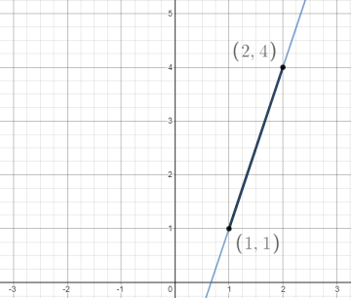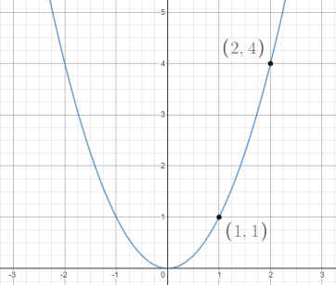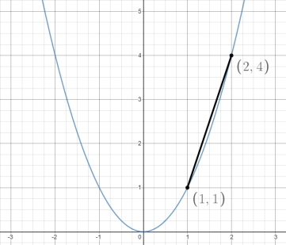
  - Once students have an understanding, ask them to find the average rate of change for other intervals, such as −2 ≤ 𝑥 ≤ −1 or 0 ≤ 𝑥 ≤ 2. As each of these calculations produce different values, reinforce the concept that non-linear functions do not have constant rates of change (MTR.5.1).
  - Look for opportunities to continue students’ work with function notation. Ask students to find the average rate of change between 𝑓(1) and 𝑓(4) for 𝑓(𝑥).

Common Misconceptions or Errors
- Some graphs presented to students will only display a certain interval of data. Some students may mistakenly interpret the rate of change for that entire interval rather than a given sub-interval.
- Students may confuse the average rate of change and constant rate of change.
- Students may be confused if the average rate of change is 0, even though the function is not constant.
  - For example, the average rate of change of the function 𝑓(𝑥) = 𝑥² from 𝑥 = −1 to 𝑥 = 1 is 0.

Strategies to Support Tiered Instruction
- When determining an average rate of change on an interval where the function only increases or only decreases, instruction includes directions to highlight the domain and range for the interval so that the change can be seen more clearly.
- Instruction includes providing the graph to visualize the change in the x- and 𝑦-values by drawing a line from the leftmost point on the graph within the interval to the rightmost point on the graph within the interval. Discuss with students how the average rate of change is the slope of the line between the two points.
  - For example, for the function 𝑓(𝑥) = 𝑥², on the interval [−2,2], the average rate of change is zero. This can be visualized by drawing a line from the point (−2,4) to (2,4) which has slope of zero (horizontal line).
- Instruction includes assistance recognizing the connection between slope (MA.912.AR.2) and rate of change for a linear function. A linear function has a constant rate of change. Regardless of the interval, the rate of change is the same (constant). For nonlinear functions rate of change is not constant, so it is not considered slope. However, the formula for slope can be used to calculate the average rate of change over an interval.
- Teacher provides instruction on assigning the ordered pairs when calculating average rate of change. The formula for slope is the change in 𝑦 divided by the change in 𝑥. The designation of the interval points as the first or second pair of coordinates does not matter.
- Teacher co-creates an 𝑥-𝑦 chart to organize information when solving real-world problems involving a graphical representation. The 𝑥-column should be labeled with the input description used for the 𝑥-axis. The 𝑦-column should be labeled with the output description used for the 𝑦-axis.

Instructional Tasks
Instructional Task 1 (MTR.3.1, MTR.4.1)
Jorge invests an amount of $5,000 in a money market account at an annual interest rate of
5%, compounded monthly. The function $f(x) = 5000 {(1 +\frac{0.05}{12})}^{12x}$ , represents the value of the investment after 𝑥 years.
Part A. Find the average rate of change in the value of Jorge’s investment between year 5 and year 7, between year 10 and year 12, and between year 15 and year 17.
Part B. What do you notice about the change in value of the investment over each interval?

Instructional Items
Instructional Item 1
The graph below represents the number of producing gas wells in Kansas from 1989 to 2017. What is the average rate of change between 2000 and 2015?
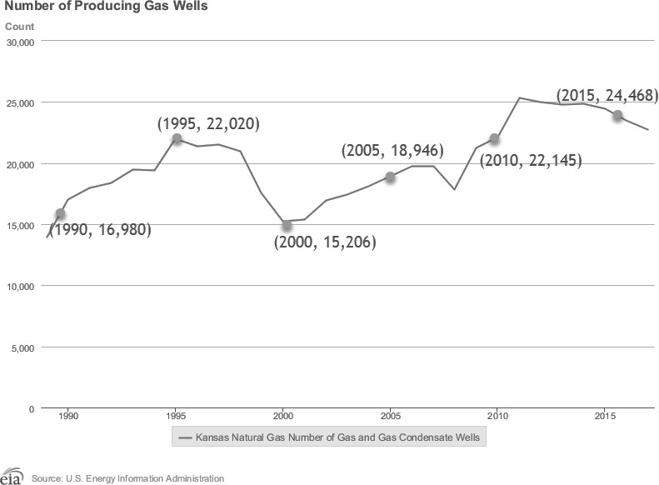

Instructional Item 2
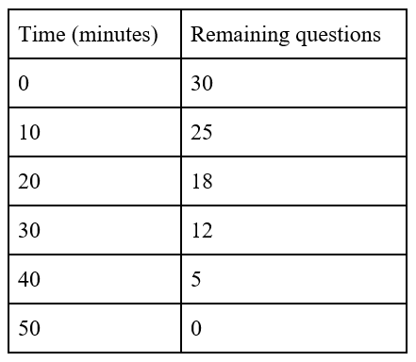
A student is taking a science test. The table shows the number of questions they have remaining and the time that has passed.

What is the average rate of change, to the nearest tenth, from 10 minutes to 40 minutes, and what does it mean?
A. On average, the student answered 0.7 questions per minute during the first 30 minutes.
- On average, the student answered 1.5 questions per minute during the first 30 minutes.
- On average, the student answered 0.7 questions per minute during those 30 minutes.
- On average, the student answered 1.5 questions per minute during those 30 minutes.
*The strategies, tasks and items included in the B1G-M are examples and should not be considered comprehensive.

MA.912.F.1.5
Benchmark
MA.912.F.1.5 Compare key features of linear functions each represented algebraically, graphically, in tables or written descriptions.
Benchmark Clarifications:
Clarification 1: Key features are limited to domain; range; intercepts; slope and end behavior.

Connecting Benchmarks/Horizontal Alignment
- MA.912.AR.2.4, MA.912.AR.2.5

Terms from the K-12 Glossary
- Domain
- Intercept
- Range
- Slope

Vertical Alignment
Previous Benchmarks  - MA.8.AR.3.5 | Next Benchmarks  - MA.912.F.1.7
Purpose and Instructional Strategies
In grade 8, students interpreted the slope and y-intercept of a linear equation in two variables. In Algebra I, students compare key features of two or more linear functions. In later courses, students will compare key features of linear and nonlinear functions.
- Instruction includes the use of various forms of linear equations. Additionally, linear functions can be represented as a table of values or graphically.
  - Standard Form
Can be described by the equation Ax + By = C, where 𝐴, 𝐵 and 𝐶 are any rational number.
  - Slope-Intercept Form
Can be described by the equation 𝑦 = 𝑚𝑥 + 𝑏, where 𝑚 is the slope and 𝑏 is the
𝑦-intercept.
  - Point-Slope Form
Can be described by the equation 𝑦 − 𝑦₁ = 𝑚 (𝑥 − 𝑥₁), where (𝑥₁, 𝑦₁) is a point on the line and 𝑚 is the slope of the line.
- Problem types include comparing linear functions presented in similar forms and in different forms, and comparing more than two linear functions.
- Instruction includes representing domain and range using words, inequality notation and set-builder notation.
  - Words
If the domain is all real numbers, it can be written as “all real numbers” or “any value of 𝑥, such that 𝑥 is a real number.”
  - Inequality notation
If the domain is all values of 𝑥 greater than 2, it can be represented as 𝑥 > 2.
  - Set-builder notation
If the domain is all values of 𝑥 less than or equal to zero, it can be represented as {𝑥|𝑥 ≤ 0} and is read as “all values of 𝑥 such that 𝑥 is less than or equal to zero.”

Common Misconceptions or Errors
- When describing domain or range, students may assign their constraints to the incorrect variable.
- Students may miss the need for compound inequalities when describing domain or
range.
- Students may confuse a negative rate of change as a lesser rate of change than a positive rate of change while comparing functions. For example, students may think that a slope of –3 is less than a slope of 2 due to comparing integers in prior grades.

Strategies to Support Tiered Instruction
- Teacher provides a laminated cue card to aid in the identification of domain and range restrictions:
  - Is the constraint on the independent or dependent variable in the context of the problem?
  - Does the constraint restrict the input or output value in the context of the problem?
  - Was the constraint shown or highlighted on the 𝑥- or 𝑦-axis?
- The use of a graph of the function to point out areas of constraints in a real-world context can help students understand the need for compound inequalities when describing the domain and range.
- Teacher provides a chart to show different terminology associated with domain and range.
Domain | Range
Independent Variable | Dependent Variable
𝑥-values | 𝑦-values
Input | Output
- Instruction includes opportunities to use a graphic organizer to chart and provide specific examples of domain and range as compound inequalities.
Compound Inequality | Example(s) | Notation
AND | Between 3 pm and 6 pm | 3 ≤ 𝑥 ≤ 6
OR | Under 10 years or at least  70 years | 𝑥 < 10 𝑜𝑟 𝑥 ≥ 70
- Instruction includes clarification on using magnitude when comparing slopes of functions and integer comparisons for y-intercepts.
- Teacher provides a graphic organizer for each of the three forms of linear equations (standard, slope-intercept and point-slope form) that can be co-created to highlight key similarities and differences.

Teacher and student write the equation that shows this form chosen. | Teacher can ask student to describe different features of the selected form or ways this form is different from other forms. Teacher asks student  what are some advantages or disadvantages of the selected form.
Teacher and student select one of the three forms and place name here.
Teacher and student show several examples. Be sure to show examples where a coefficient of $x$ or $y$ is zero,  negative or one. | Teacher and student write linear equations in other forms or in none of the forms.

Instructional Tasks
Instructional Task 1 (MTR.2.1, MTR.5.1)
Callie and her friend Elena are reading through different novels they checked out from their school library last Tuesday. Callie’s progress through her novel can be modeled by the function 𝑝(𝑑) = −25𝑑 + 318, where 𝑝(𝑑) represents the number of pages remaining to be read and 𝑑 is the number of days since receiving the book. Elena’s progress through her novel is modeled by the graph below.
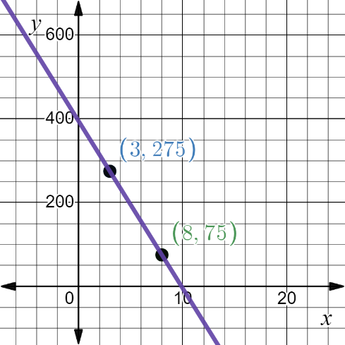
Part A. Which student’s novel has more pages to read?
Part B. Assuming they both continue to read at a constant rate, which student will complete their novel first?

Instructional Items
Instructional Item 1
Two linear functions, 𝑓(𝑥) and 𝑔(𝑥), are represented below. Compare the functions by stating which has a greater 𝑦-intercept, 𝑥-intercept and rate of change.
𝑓(𝑥) = 4𝑥 − 3
𝑥 | -3 | -1 | 1 | 3
𝑔(𝑥) | 13 | 8 | 3 | -2
Instructional Item 2
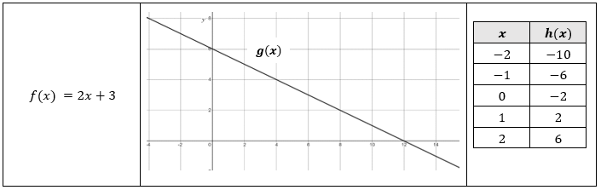
Consider three linear functions, $f\left(x\right), g\left(x\right)$ and $h\left(x\right)$:
Compare the three linear functions and draw conclusions about their behavior and characteristics.

*The strategies, tasks and items included in the B1G-M are examples and should not be considered comprehensive.

MA.912.F.1.6
Benchmark
MA.912.F.1.6 Compare key features of linear and nonlinear functions each represented algebraically, graphically, in tables or written descriptions.
Benchmark Clarifications:
Clarification 1: Key features are limited to domain; range; intercepts; intervals where the function is increasing, decreasing, positive or negative; end behavior and asymptotes.
Clarification 2: Within the Algebra I course, functions other than linear, quadratic or exponential must be represented graphically.
Clarification 3: Within the Algebra I course, instruction includes verifying that a quantity increasing exponentially eventually exceeds a quantity increasing linearly or quadratically.

Connecting Benchmarks/Horizontal Alignment
- MA.912.AR.2.4, MA.912.AR.2.5
- MA.912.AR.3.7, MA.912.AR.3.8
- MA.912.AR.4.6
- MA.912.AR.5.6

Terms from the K-12 Glossary
- Domain
- Intercept
- Range
- Slope

Vertical Alignment
Previous Benchmarks  - MA.8.AR.3.5 | Next Benchmarks  - MA.912.F.1.7
Purpose and Instructional Strategies
In grade 8, students interpreted the slope and 𝑦-intercept of a linear equation in two variables. In Algebra I, students compare key features of two or more linear or nonlinear functions. Except for quadratic and exponential functions, nonlinear functions must be represented graphically. In later courses, students will compare key features of nonlinear functions represented graphically, algebraically, or with written descriptions.
- Within this benchmark, one of the functions given must be linear and the number of functions being compared is not limited to two.
- Problem types include comparing linear to nonlinear functions represented graphically and also opportunities that present linear, quadratic and exponential functions in different forms.
- Instruction includes student exploration of linear, quadratic and exponential models to ultimately determine that a quantity increasing exponentially eventually exceeds a quantity increasing linearly or quadratically.
  - For example, provide the following context.
    - You are being contracted by a large company to provide technical services to a major engineering project. The contract will involve you advising a group of engineers for the three weeks. The company offers you a choice of two methods of payment for your services. The first is to receive $500 per day of work. The second is to receive payment on a scale: two cents for one total day of work, four cents for two total days, eight cents for three total days, etc. Which method of payment would you choose?
Have students choose a method of payment and begin a class discussion regarding the reasoning students used to make their choices (MTR.4.1). Ask if students can create a function to represent each payment method (MTR.7.1).
- Instruction includes representing domain and range using words, inequality notation and set-builder notation.
  - Words
If the domain is all real numbers, it can be written as “all real numbers” or “any value of 𝑥, such that 𝑥 is a real number.”
  - Inequality notation
If the domain is all values of 𝑥 greater than 2, it can be represented as 𝑥 > 2.
  - Set-builder notation
If the domain is all values of 𝑥 less than or equal to zero, it can be represented as {𝑥|𝑥 ≤ 0} and is read as “all values of 𝑥 such that 𝑥 is less than or equal to zero.”

Common Misconceptions or Errors
- When describing domain or range, students may assign their constraints to the incorrect
variable.
- Students may miss the need for compound inequalities when describing domain or range. When describing intervals where functions are increasing, decreasing, positive or negative, students may represent their interval using the incorrect variable.

Strategies to Support Tiered Instruction
- Teacher provides a laminated cue card to aid in the identification of domain and range restrictions:
  - Is the constraint on the independent or dependent variable in the context of the problem?
  - Does the constraint restrict the input or output value in the context of the problem?
  - Was the constraint shown or highlighted on the 𝑥- or 𝑦-axis?
- Teacher provides a chart to show different terminology associated with domain and range.
Domain | Range
𝑥-values | 𝑦-values
Input | Output
- The use of a graph of the function to point out areas of constraints in a real-world context can help students understand the need for compound inequalities when describing the domain and range.
- Where students are struggling with concepts such as when a function is increasing, decreasing, positive, negative or questions about its end behavior, ask reflective questions:
  - Imagine walking on the graph from left to right, where would you be going uphill (increasing) or where would you be going downhill (decreasing)?
  - On the left, where are you coming from (far below or far above), and on the right, would you eventually be going up forever or down forever (end behavior)?

Instructional Tasks
Instructional Task 1 (MTR.7.1)
Nancy works for a company that offers two types of savings plans. Plan A is represented by the function 𝑔(𝑥) = 250 + 3𝑥, where 𝑥 is the number of quarter years she has utilized the plan. Plan B is represented by the function (𝑥) = 250 (1.01) 𝑥, where 𝑥 is the number of quarter years she has utilized the plan.
Part A. Nancy wants to have the highest savings possible after five years, when she plans to leave the company. Which plan should she use?
Part B. What if Nancy stays for ten years? Which plan should she use?

Instructional Task 2 (MTR.3.1)
Three functions are represented below, with the table representing a linear function. Which function has the smallest x-intercept?
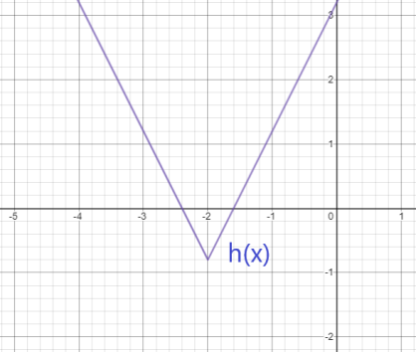
𝑓(𝑥) = 25𝑥² – 16

𝑥 | -5 | -2 | 1 | 4 | 7
𝑔(𝑥) | -8.6 | -2 | 4.6 | 11.2 | 17.8

Instructional Items
Instructional Item 1
The functions 𝑓(𝑥) and 𝑔(𝑥) are shown below, with 𝑔(𝑥) representing a linear function. Which function has the greater 𝑦-intercept?
𝑓(𝑥)
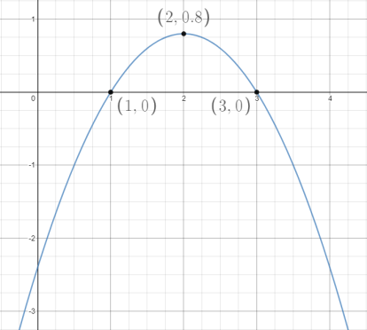

𝑥 | 3 | 7 | 11 | 15 | 19
𝑔(𝑥) | -1.1 | 0.5 | 2.1 | 3.7 | 5.3

Instructional Item 2
The function $f(x)$ can be represented by $f(x)=3{(1.06)}^{x}$. The function $g(x)$ has a slope of 7 and a $y$-intercept of -2. As $x$ increases, which function will eventually exceed the $y$ values of the other function and why?
*The strategies, tasks and items included in the B1G-M are examples and should not be considered comprehensive.

MA.912.F.1.8
Benchmark
MA.912.F.1.8 Determine whether a linear, quadratic or exponential function best models a given real-world situation.
Benchmark Clarifications:
Clarification 1: Instruction includes recognizing that linear functions model situations in which a quantity changes by a constant amount per unit interval; that quadratic functions model situations in which a quantity increases to a maximum, then begins to decrease or a quantity decreases to a minimum, then begins to increase; and that exponential functions model situations in which a quantity grows or decays by a constant percent per unit interval.
Clarification 2: Within this benchmark, the expectation is to identify the type of function from a written description or table.

Connecting Benchmarks/Horizontal Alignment
- MA.912.F.1.1, MA.912.DP.2.4

Terms from the K-12 Glossary
- Exponential Function
- Linear Function
- Quadratic Function

Vertical Alignment
Previous Benchmarks  - MA.8.AR.3.1 | Next Benchmarks  - MA.912.DP.2.8  - MA.912.DP.2.9
Purpose and Instructional Strategies
In grade 8, students determined whether a linear relationship is also a proportional relationship.
In Algebra I, students determine whether a linear, quadratic or exponential function best models a situation. In later grades, students will fit linear, quadratic and exponential functions to statistical data.
- Instruction should include identifying function types from tables and from written descriptions.
  - When examining written descriptions, guide students to see that linear functions model situations in which a quantity changes by a constant amount per unit interval; that quadratic functions model situations in which a quantity increases to a maximum, then begins to decrease or a quantity decreases to a minimum, then begins to increase; and that exponential functions model situations in which a quantity grows or decays by a constant percent per unit interval.
  - When considering tables, instruction guides students to understand that linear relationships have a common difference per unit interval (or a constant rate of change), quadratic relationships produce a common second difference, and exponential relationships produce a constant percent rate of change per unit interval (MTR.5.1).
  - Considering tables like the one below, lead students to discover that there is a common difference of 0.4 between successive 𝑦-values. Plotting these points using graphing software will verify that they are collinear.
$$x$$ | -4 | -3 | -2 | -1 | 0
$$y$$ | 1.6 | 2.0 | 2.4 | 2.8 | 3.2
1st Difference | 0.4 0.4 0.4 0.4
  - Considering tables like the one below, lead students to discover that there is a common second difference of -8 between successive 𝑦-values. Plotting these points using graphing software will verify that they form a parabola. It is important to note that using the common second difference method is not an expectation for mastery in Algebra I, as students will expand on this in Algebra 2.

$$x$$ | -2 | -1 | 0 | 1 | 2
$$y$$ | -14 | -2 | 2 | -2 | -14
1st Difference | 12 4 -4 -12
2nd Difference | -8 -8 -8
  - Considering tables like the one below, lead students to discover that there is no common difference or second difference. In this case, there is a common ratio of between successive 𝑦-values. Plotting these points using graphing software will verify that they form an exponential graph.
$$x$$ | 2 | 4 | 6 | 8 | 10
$$y$$ | 3 | 9 | 27 | 81 | 243
1st Difference | 6 18 54 162
2nd Difference | 12 36 108
Common Ratio | 3 3 3 3  1 1 1 1
  - Students should note that the search for common differences and ratios only works when the 𝑥-values are equidistant from each other. Lead them to check for this when presented with tables of values to consider.
  - It is important to note that other function types could produce these relationships, making the connection to classifying different function types in MA.912.F.1.1.

Common Misconceptions or Errors
- Students may interpret any relationship that increases/decreases at a non-constant rate as being an exponential relationship.
  - Some students may miscalculate first and second differences that deal with negative values, especially if they perform them mentally.

Strategies to Support Tiered Instruction
- Instruction includes verifying an exponential relationship by looking for common ratios. When interpreting a written description, make a sample table of values from the context to examine the type of function.
- Teacher co-creates a graphic organizer to compare exponential and quadratic functions.
  - For example, a Venn Diagram can be used with the common middle section including the non-constant rate of change.
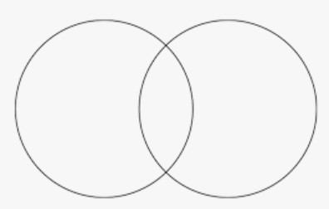
- Teacher provides opportunities to write out subtraction sentences next to each line of the table when determining first and second differences. Have students write out the subtraction expression [i.e., −14 – (−2)] so they can see that they are subtracting a negative value and should convert it to adding a positive value.
  - It is often helpful to have these students draw a blank number line with a mark for 0 to use for their calculations. Students who solve −14 + 2 to equal −16 could place their pencil tip to the left of 0 on the number line in a position that could represent −14. Ask them which direction they would move to represent adding 2. When students see movement to the right, toward zero, they should understand that the magnitude of the negative number decreases, resulting in −12 rather than −16.
Instructional Tasks
Instructional Task 1 (MTR.3.1)
A scientist is monitoring cell division and notes that a single cell divides into 4 cells within one hour. During the next hour, each of these cells divides into 4 cells. This process continues at the same rate every hour.
Part A. What type of function could be used to represent this situation?
Part B. Justify your reasoning.

Instructional Items
Instructional Item 1
Sarah is spending the summer at her grandmother’s house. The table below shows the amount of money in her bank account at the end of each week. What type of function could be used to model the total amount of money in Sarah’s bank account as a function of time?
Week # | Total $
1 | $3428
2 | $3276
3 | $3124
4 | $2972

Instructional Item 2
A rectangular garden is being expanded by planting additional rows of flowers along one of its sides. The length of the garden is currently 10 feet, and each week it is increased by 3 feet. Which type of function best models the situation?
    - Linear
    - Quadratic
    - Exponential
    - None of the above

Instructional Item 3
An investment grows over time with a fixed annual interest rate. An individual invests $1,000 in a savings account, and each year the investment grows by 5%. Identify the type of function that best models the situation.
*The strategies, tasks and items included in the B1G-M are examples and should not be considered comprehensive.

MA.912.F.2 Identify and describe the effects of transformations on functions. Create new functions given transformations.

MA.912.F.2.1
Benchmark
MA.912.F.2.1 Identify the effect on the graph or table of a given function after replacing 𝑓(𝑥) by 𝑓(𝑥) + 𝑘, 𝑘𝑓(𝑥), 𝑓(𝑘𝑥) and 𝑓(𝑥 + 𝑘) for specific values of 𝑘.
Benchmark Clarifications:
Clarification 1: Within the Algebra I course, functions are limited to linear, quadratic and absolute value. Clarification 2: Instruction focuses on including positive and negative values for 𝑘.

Connecting Benchmarks/Horizontal Alignment
- MA.912.AR.2.4
- MA.912.AR.3.7
- MA.912.AR.4.3
- MA.912. F.1.1

Terms from the K-12 Glossary
- Transformation
- Translation

Vertical Alignment
Previous Benchmarks  - MA.8.GR.2 | Next Benchmarks  - MA.912.GR.2
Purpose and Instructional Strategies
In grade 8, students performed single transformations on two-dimensional figures. In Algebra I,
students identify the effects of single transformations on linear, quadratic and absolute value functions. In Geometry, students will perform multiple transformations on two-dimensional figures. In later courses, students will work with transformations of many types of functions.
- In this benchmark, students will examine the impact of transformations on linear, quadratic and absolute value functions. Instruction includes the use of graphing software to ensure adequate time for students to examine multiple transformations on the graphs of functions.
  - Have students use graphing technology to explore different parent functions.
    - In each graph, toggle on/off the graphs for 𝑓(𝑥) + 𝑘, 𝑘𝑓(𝑥), 𝑓(𝑘𝑥) and 𝑓(𝑥 + 𝑘) to examine their impacts on the function. Use the slider to change the value of 𝑘 (be sure to examine the impacts when 𝑘 is positive and negative).
    - As students explore, prompt discussion (MTR.4.1) among them about the patterns they see as they adjust the slider (MTR.5.1).

- For 𝑓(𝑥) + 𝑘, students should discover that 𝑘 is being added to the output of the function (equivalent to the y-value) and will therefore result in a vertical translation of the function by 𝑘 units.
  - Ask students to describe what values of 𝑘 cause the graph to shift up. Which values cause it to shift down?
- For 𝑘𝑓(𝑥), students should discover that 𝑘 is being multiplied by the output of the function (equivalent to the 𝑦-value) and will therefore result in a vertical dilation (stretch/compression) of the function by a factor of 𝑘.
  - Ask students to describe what values of 𝑘 cause the graph to stretch up vertically. Which values cause it to compress? Which values for 𝑘 cause the graph to reflect over the 𝑥-axis? What is the significance of 𝑘 = −1?
- For 𝑓(𝑥 + 𝑘), students should discover that 𝑘 is being added to the input of the function and will therefore result in a horizontal translation of the function by −𝑘 units.
  - Ask students to describe what values of 𝑘 cause the graph to shift left. Which values cause it to shift right?
- For 𝑓(𝑘𝑥), students should discover that 𝑘 is being multiplied by the input of the function and will therefore result in a horizontal dilation (stretch/compression) of the function by a factor of 𝑘.
  - Ask students to describe what values of 𝑘 cause the graph to stretch horizontally. Which values cause it to compress? Which values for 𝑘 cause the graph to reflect over the 𝑦-axis? What is the significance of 𝑘 = −1?
- After students have a good understanding of the impact of 𝑓(𝑥) + 𝑘, 𝑘𝑓(𝑥), 𝑓(𝑘𝑥) and
𝑓(𝑥 + 𝑘) on graphs of functions, connect that knowledge to tables of values for a function.
  - For 𝑓(𝑥) + 𝑘, use graphing technology to display a graph of a quadratic function (like the one below) and set 𝑘 = 4. Guide students to form a table and discuss its connection to the vertical translation observed on the graph.
𝑥 | 𝑓(𝑥) | 𝑓(𝑥) + 4
1 | 6 | 10
2 | 3 | 7
3 | 2 | 6
4 | 3 | 7

  - For 𝑘𝑓(𝑥), use graphing technology to display a graph of a quadratic function (like the one below) and set 𝑘 = 0.5. Guide students to form a table and discuss its connection to the vertical compression observed on the graph.
𝑥 | 𝑓(𝑥) | 0.5[𝑓(𝑥)]
1 | 6 | 3
2 | 3 | 1.5
3 | 2 | 1
4 | 3 | 1.5

  - For 𝑓(𝑥 + 𝑘), use graphing technology to display a graph of a quadratic function (like the one below) and set 𝑘 = 2. Guide students to form a table and discuss its connection to the horizontal translation observed on the graph using the highlighted values. . For the table shown, consider 𝑥 = 5. For 𝑓(𝑥), 𝑓(5) = 6. But for 𝑔(𝑥) = 𝑓(𝑥 + 2), 𝑔(5) = 𝑓(5 + 2) which is equivalent to 18, which is equivalent to shifting 𝑓(7) two units to the left on the graph. Bridge this conversation with a graph of the two functions to help them understand the connection.

𝑥 | 𝑓(𝑥) | → | 𝑥 | 𝑔(𝑥) = 𝑓(𝑥 + 2) | 𝑔(𝑥)
1 | 6 | → | 3 | 2
2 | 3 | → | 4 | 3
3 | 2 | → | 5 | 6
4 | 3 | → | 6 | 11
5 | 6 | → | 7 | 18
6 | 11 | → | 8 | 27

  - For 𝑓(𝑘𝑥), use graphing technology to display a graph of a quadratic function (like the one below) and set 𝑘 = 3. Guide students to form a table and discuss its connection to the horizontal compression observed on the graph using the highlighted values.
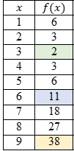
3𝑥 | $$g(x) = f(3x)$$
3 | 2
6 | 11
9 | 38
12 | 83
15 | 146
18 | 258
21 | 326
24 | 443
27 | 578

Common Misconceptions or Errors
- Similar to writing functions in vertex form, students may confuse effect of the sign of 𝑘 in 𝑓(𝑥 + 𝑘). Direct these students to examine a graph of the two functions to see that the horizontal shift is opposite of the sign of 𝑘.
- Vertical stretch/compression can be hard for students to see on linear functions initially and they may interpret stretch/compression as rotation. Introduce the effects of 𝑘𝑓(𝑥)
𝑎𝑛𝑑 𝑓(𝑘𝑥) by using a quadratic or absolute value function first before analyzing the effect on a linear function.
- Students may think that a vertical and horizontal stretch from 𝑘𝑓(𝑥) and 𝑓(𝑘𝑥) look the same.

Strategies to Support Tiered Instruction
- Instruction includes explaining to students that horizontal shifts are “inside” of the function. Additionally, the teacher provides instruction to ensure understanding that the movement of the function is opposite of the sign that effects the horizontal shift.
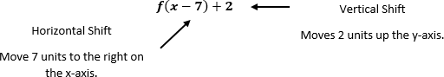
  - For example, teacher can provide the identification of the type of transformation and its effects to the below function.
- Teacher provides instruction that includes the use of a graph that displays stretch and compression (shrink) scaling. Including a visual representation will allow students to categorize their thinking.
  - For example, have students copy the graphs into their notebooks. Give students an opportunity to identify changes in both types of transformations before giving students the transformations.
  - Teachers can also introduce the effects of 𝑘𝑓(𝑥) 𝑎𝑛𝑑 𝑓(𝑘𝑥) by using a quadratic or absolute value function first before analyzing the effect on a linear function.
- Instruction includes providing a grid with a parent function and horizontal and vertical stretch on one grid, using different colors to distinguish both types of stretches (vertical and horizontal).
- Instruction includes directing students to examine a graph of the two functions to see that the horizontal shift is opposite of the sign of 𝑘.
- Instruction includes having a non-zero 𝑦-intercept to visualize the difference between scaling in the horizontal direction, 𝑓(𝑘𝑥), and scaling in the vertical direction, 𝑘𝑓(𝑥).

Instructional Tasks
Instructional Task 1 (MTR.3.1)
Part A. Given the function 𝑓(𝑥) = 𝑥², determine the vertex, domain and range.
Part B. If the function 𝑓(𝑥) is translated to the right 6 units, predict what may happen to the vertex, domain and range.
Part C. How does the graph of the function 𝑓(𝑥) = 𝑥² − 7, compare to the graph of the function in Part A?

Instructional Items
Instructional Item 1
How does the graph of 𝑔(𝑥) = 𝑓(𝑥 − 2) compare to the graph of 𝑓(𝑥) = |𝑥 + 3|?

Instructional Item 2
Describe the effect of the transformation 𝑓(𝑥) + 2 on the function table below.
𝑥 | 𝑓(𝑥)
-2 | 4
0 | 0
2 | 4
4 | 16
6 | 36

Instructional Item 3
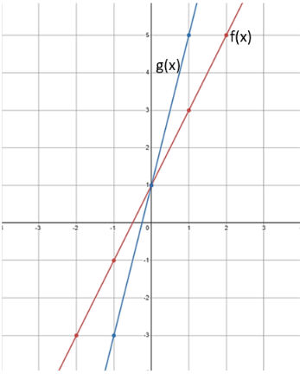
The graph of two functions is shown below.
Which of the following describes the effect on f(x) after a transformation was performed to produce g(x)?
    - The graph of $g(x)$ is reflected over the $x$-axis of the graph $f(x)$
    - The graph of $g(x)$ is a vertical shift of 2 from the graph $f(x)$
    - The graph of $g(x)$ is a horizontal shift of $\frac{1}{2}$ from the graph of $f(x)$
    - The graph of g(x) is a horizontal stretch by a factor of 2 from the graph of f(x)
*The strategies, tasks and items included in the B1G-M are examples and should not be considered comprehensive.

MA.912.F.2.3
Benchmark
MA.912.F.2.3 Given the graph or table of 𝑓(𝑥) and the graph or table of 𝑓(𝑥) + 𝑘, 𝑘𝑓(𝑥), 𝑓(𝑘𝑥) and 𝑓(𝑥 + 𝑘), state the type of transformation and find the value of the real number 𝑘.
Benchmark Clarifications:
Clarification 1: Within the Algebra I course, functions are limited to linear, quadratic and absolute value.

Connecting Benchmarks/Horizontal Alignment
- MA.912.AR.2.4
- MA.912.AR.3.7
- MA.912.AR.4.3
- MA.912. F.1.1

Terms from the K-12 Glossary
- Transformation
- Translation

Vertical Alignment
Previous Benchmarks  - MA.8.GR.2 | Next Benchmarks  - MA.912.GR.2
Purpose and Instructional Strategies
In grade 8, students performed single transformations on two-dimensional figures. In Algebra I,
students identify the effects of single transformations on linear, quadratic and absolute value functions. In Geometry, students will perform multiple transformations on two-dimensional figures. In later courses, students will work with transformations of many types of functions.
- This benchmark is only taught in Algebra I Honors.
- Instruction includes the comparison of graph to graph, table to table, and table to graph.
- For 𝑓(𝑥) + 𝑘, students should discover that 𝑘 is being added to the output of the function (equivalent to the 𝑦-value) and will therefore result in a vertical translation of the function by 𝑘 units.
  - Ask students to describe what values of 𝑘 cause the graph to shift up. Which values cause it to shift down?
- For 𝑘𝑓(𝑥), students should discover that 𝑘 is being multiplied to the output of the function (equivalent to the 𝑦-value) and will therefore result in a vertical dilation (stretch/compression) of the function by a factor of 𝑘.
  - Ask students to describe what values of 𝑘 cause the graph to stretch up vertically. Which values cause it to compress? Which values for 𝑘 cause the graph to reflect over the 𝑥-axis? What is the significance of 𝑘 = −1?
- For 𝑓(𝑥 + 𝑘), students should discover that 𝑘 is being added to the input of the function and will therefore result in a horizontal translation of the function by −𝑘 units.
  - Ask students to describe what values of 𝑘 cause the graph to shift left. Which values cause it to shift right?
- For 𝑓(𝑘𝑥), students should discover that 𝑘 is being multiplied to the input of the function and will therefore result in a horizontal dilation (stretch/compression) of the function by a factor of 𝑘.
  - Ask students to describe what values of 𝑘 cause the graph to stretch horizontally. Which values cause it to compress? Which values for 𝑘 cause the graph to reflect over the 𝑦-axis? What is the significance of 𝑘 = −1?

Common Misconceptions or Errors
- Some students may have difficulty seeing the impact of a transformation when comparing tables and graphs. In these cases, encourage students to convert the graph to a second table, using the same domain as the first table. This should aid in comparisons.
- Similar to writing functions in vertex form, students may confuse effect of the sign of 𝑘 in 𝑓(𝑥 + 𝑘). Direct these students to examine a graph of the two functions to see that the horizontal shift is opposite of the sign of 𝑘.
- Vertical stretch/compression can be hard for students to see on linear functions initially and they may interpret stretch/compression as rotation. Introduce the effects of
𝑘𝑓(𝑥) 𝑎𝑛𝑑 𝑓(𝑘𝑥) by using a quadratic or absolute value function first before analyzing the effect on a linear function.
- Students may think that a vertical and horizontal stretch from 𝑘𝑓(𝑥) and 𝑓(𝑘𝑥) look the
- same. For linear and quadratic functions, it can help to have a non-zero 𝑦-intercept to visualize the difference.

Strategies to Support Tiered Instruction
- Teacher provides opportunities to utilize graphing software to visualize the
transformations.
  - For example, instruction includes navigating the graphing software to provide visual representations of different types of transformations using non-linear functions.
- Instruction includes opportunities to convert a graph to a table, when comparing the two. The second table should have the same domain values as the first table.
- Teacher provides a graphic organizer with the different types of transformations and the effects of the transformations.
- Teacher provides the opportunity to analyze a graph of two different functions. While examining the two functions, students will focus on the effects of the horizontal shift in hopes that the student will realize the horizontal shift’s movement is opposite of the sign of 𝑘 in 𝑓(𝑥 + 𝑘).

- Teacher provides instruction that includes the use of a graph that displays stretch and compression (shrink) scaling. Including a visual representation will allow students to categorize their thinking regarding linear function transformations.
  - For example, have students copy the graphs into their notebooks. Give students an opportunity to identify changes in both types of transformations before giving students the transformations.
  - Introduce the effects of 𝑘𝑓(𝑥) 𝑎𝑛𝑑 𝑓(𝑘𝑥) by using a quadratic or absolute value function first before analyzing the effect on a linear function.
- Instruction includes the use of a foldable that has an insert with a parent function as the base. Teacher provides students with tracing paper to draw different transformations as layers. The end result should show the parent function with its transformations.
- Instruction includes having a non-zero 𝑦-intercept to visualize the difference between scaling in the horizontal direction, 𝑓(𝑘𝑥), and scaling in the vertical direction, 𝑘𝑓(𝑥).

Instructional Tasks
Instructional Task 1 (MTR.3.1)
A graph and table, which represents an absolute value function, are shown below. Describe and determine the value of the real number that defines the transformation from 𝑓(𝑥) to 𝑔(𝑥).
𝑓(𝑥)
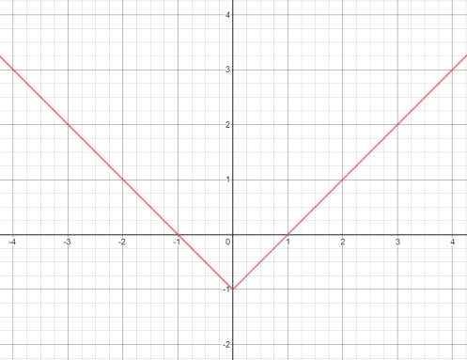

𝑥 | -2 | -1 | 0 | 1 | 2
𝑔(𝑥) | 2 | 0 | -2 | 0 | 2

Instructional Items
Instructional Item 1
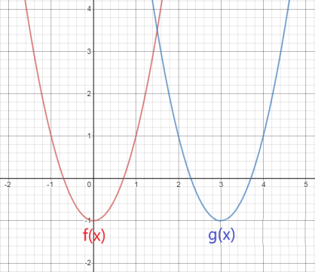
Considering the graph of 𝑓(𝑥) and 𝑔(𝑥) below, describe the transformation and determine the value of the real number, 𝑘, that defines the transformation from 𝑓(𝑥) to 𝑔(𝑥).

Instructional Item 2
Considering the table below, describe the transformation and determine the value of the real number, k, that defines the transformation from 𝑓(𝑥) to 𝑔(𝑥).
𝑥 | 𝑓(𝑥) | 𝑔(𝑥)
1 | -9 | -8.4
2 | -13.2 | -12.6
3 | -17.4 | -16.8
4 | -21.6 | -21
*The strategies, tasks and items included in the B1G-M are examples and should not be considered comprehensive.

MA.912.F.3 Create new functions from existing functions.

MA.912.F.3.1
Benchmark
MA.912.F.3.1 Given a mathematical or real-world context, combine two functions, limited to linear and quadratic, using arithmetic operations. When appropriate, include domain restrictions for the new function.
Example: The quotient of the functions 𝑓(𝑥) = 3𝑥² − 7𝑥 + 3 and 𝑔(𝑥) = 6𝑥 − 1 can be
expressed as $h\left(x\right)=\frac{{3x}^{2}-7x+3}{6x-1}$, where the domain of ℎ(𝑥) is $-∞≤x<\frac{1}{6}$ and $\frac{1}{6}<x≤∞$.
Benchmark Clarifications:
Clarification 1: Instruction includes representing domain restrictions with inequality notation, interval notation or set-builder notation.
Clarification 2: Within the Algebra I Honors course, notations for domain and range are limited to inequality and set-builder.

Connecting Benchmarks/Horizontal Alignment
- MA.912.AR.1.3, MA.912.AR.1.4

Terms from the K-12 Glossary
- Domain
- Linear Function
- Quadratic Function

Vertical Alignment
Previous Benchmarks  - MA.7.AR.1  - MA.8.AR.1 | Next Benchmarks  - MA.912.F.3.2, MA.912.F.3.3, MA.912.F.3.4
Purpose and Instructional Strategies
In middle grades, students perform operations on linear expressions. In Algebra I, students perform operations on linear and quadratic functions. In later courses, students will perform operations on other types of functions and combine functions in other ways.
- This benchmark is only taught in Algebra I Honors.
- In this benchmark, students will combine functions through addition, subtraction, multiplication, and division. This process will utilize their prior experience with polynomial arithmetic in MA.912.AR.1.
  - In mathematical contexts, combinations through addition may be represented as
(𝑓 + 𝑔)(𝑥) or as ℎ(𝑥) = 𝑓(𝑥) + 𝑔(𝑥).
  - In mathematical contexts, combinations through subtraction should be represented as (𝑓 − 𝑔)(𝑥) or as ℎ(𝑥) = 𝑓(𝑥) − 𝑔(𝑥).
  - In mathematical contexts, combinations through multiplication should be represented as (𝑓 ∙ 𝑔)(𝑥) or as ℎ(𝑥) = 𝑓(𝑥) ∙ 𝑔(𝑥).
  - In mathematical contexts, combinations through division should be represented as
$\left(\frac{f}{g}\right)$(𝑥) or as $h(x)=\frac{f(x)}{g(x)}$ where 𝑔(𝑥) ≠ 0. Additionally for division, it can be
represented using the division symbol.
- When combining functions by division, students will need to consider values in the domain of the quotient that should be restricted. Values that should be restricted are those that would cause the denominator to equal zero.
- Instruction includes representing domain, range and constraints using words, inequality notation and set-builder notation.
  - Words
If the domain is all real numbers, it can be written as “all real numbers” or “any value of 𝑥, such that 𝑥 is a real number.”
  - Inequality notation
If the domain is all values of 𝑥 greater than 2, it can be represented as 𝑥 > 2.
  - Set-builder notation
If the domain is all values of 𝑥 less than or equal to zero, it can be represented as {𝑥|𝑥 ≤ 0} and is read as “all values of 𝑥 such that 𝑥 is less than or equal to zero.”

Common Misconceptions or Errors
- When combining functions through division, some students may forget to include domain restrictions with their combinations. In these cases, ask them to evaluate their combinations for a domain value that should be restricted. When they see it leads to division by 0, guide them to understand the need for domain restrictions.
- When combining functions through division, some students may include domain restrictions for both original functions. In these cases, ask them to evaluate their combinations for a domain value that causes the numerator to equal 0. When they see it produces a real solution, guide them to understand the need for domain restrictions only for the function in the denominator.

Strategies to Support Tiered Instruction
- Instruction provides opportunities to evaluate combinations involving division for which
a domain value should be restricted. When students see it leads to division by 0, teacher guides them to understand the need for domain restrictions. Additionally, teacher asks students to evaluate their combinations for a domain value that causes the numerator to equal 0. When students see it produces a real solution, teacher facilitates students’ understanding of the need for domain restrictions only for the function in the denominator.

- Teacher models think-aloud for combining function problems through division using a graphic organizer that includes a space for domain restrictions.
Functions | 𝑓(𝑥) = 3𝑥 − 2  𝑔(𝑥) = 3𝑥² + 10𝑥 − 8
$$\left(\frac{f}{g}\right)\left(x\right)$$ | $$\left(\frac{f}{g}\right)\left(x\right)=\frac{3x - 2}{3x^{2} + 10x - 8}$$  $$\left(\frac{f}{g}\right)\left(x\right)=\frac{3x - 2}{\left(3x-2\right)\left(x+4\right)}$$  $$\left(\frac{f}{g}\right)\left(x\right)=\frac{1}{x+4}$$
𝒈(𝒙) ≠ 𝟎 | 3(0)² + 10(0) − 8 = -8
Solution | $\left(\frac{f}{g}\right)\left(x\right)=\frac{1}{x+4}$ where $g$($x$) ≠ -8

Instructional Tasks
Instructional Task 1 (MTR.3.1)
Given 𝑓(𝑥) = 8𝑥² + 3𝑥 − 7 and 𝑔(𝑥) = $\frac{4}{7}$ 𝑥 − 9.2, find (𝑓 − 𝑔)(𝑥).

Instructional Task 2 (MTR.7.1)
The sales of cell phones (in millions) in the U.S. from 2010 to 2019 can be approximated by the function 𝑆(𝑡) = −403𝑡² + 11,032𝑡 + 5168, where 𝑡 = 0 represents 2010. The U.S. population (in millions) for the same time frame can be approximated by the function 𝑃(𝑡) =2.17𝑡 + 328.2.
Part A. Write a function that represents the amount spent on cell phones per person in the
U.S. over this time frame.
Part B. How much did the average person spend on cell phones in 2011 versus 2017?

Instructional Items
Instructional Item 1
From 2009 to 2019, the sales S1 (in thousands of dollars) of one of two bakeries owned by a local businesswoman can be modeled by 𝑆1 = −0.5𝑡2 + 6𝑡 + 120, where 𝑡 = 0 represents 2009. During the same time frame, the sales for her second bakery S2 (in thousands of dollars) can be modeled by 𝑆2 = 54 + 1.24𝑡. Write a function, C(t), that models her total profit from the two bakeries over this time frame.
*The strategies, tasks and items included in the B1G-M are examples and should not be considered comprehensive.

Financial Literacy

MA.912.FL.3 Describe the advantages and disadvantages of short-term and long-term purchases.

MA.912.FL.3.2
Benchmark
MA.912.FL.3.2 Solve real-world problems involving simple, compound and continuously compounded interest.
Example: Find the amount of money on deposit at the end of 5 years if you started with $500 and it was compounded quarterly at 6% interest per year.
Example: Joe won $25,000 on a lottery scratch-off ticket. How many years will it take at 6% interest compounded yearly for his money to double?
Benchmark Clarifications:
Clarification 1: Within the Algebra I course, interest is limited to simple and compound.

Connecting Benchmarks/Horizontal Alignment
- MA.912.NSO.1.1,
- MA.912.AR.2.1, MA.912.AR.2.2, MA.912.AR.2.5
- MA.912.AR1.1, MA.912.AR1.2
- MA.912.AR.5.3

Terms from the K-12 Glossary
- Simple Interest

Vertical Alignment
Previous Benchmarks  - MA.7.AR.3.1 | Next Benchmarks  - MA.912.FL3.3, MA.912.FL.3.4
Purpose and Instructional Strategies
In grade 7, students solved problems involving simple interest. In Algebra I, students solve problems involving simple and compound interest, using arithmetic operations and graphing. In later courses, students will solve compound interest problems to determine lengths of time, including those that require the use of logarithms, and solve continuously compounded interest problems.
- In this benchmark, students will be introduced to the concepts of simple and compound interest and will solve real-world problems that feature them.
- Compound interest is a method of computing interest. This interest is computed from the (original) principal and the amount of money that has accrued.
- Instruction includes connecting student understanding of MA.912.AR.5.3 using the forms 𝑓(𝑥) = 𝑎𝑏^{𝑥} and 𝑓(𝑥) = 𝑎(1 ± 𝑟)^{𝑥} to the simple and compound interest formulas. Show students that these formulas are all the same. Explain that $b$in the standard formula is (1 ± 𝑟).
- Instruction includes connecting student understanding. Instruction compares the differences between simple and compound interest.
  - The Simple Interest Formula (𝐼 = 𝑝𝑟𝑡) calculates only the interest earned over time. Each year’s interest is calculated from the initial principal, not the total value of the investment of that point in time.
  - The Final Amounts under Simple Interest Formula (𝐴 = 𝑃(1 + 𝑟𝑡)) calculates the total value of an investment over time. The Final Amounts under Compound Interest formula ($A=P\left(1+\frac{r}{n}\right)nt$) also calculates the total value of an investment over time. Each month/year’s interest is calculated from the total value of the investment of that point in time.
- Compound interest problems presented for this benchmark may require students to generate equivalent expressions to identify and interpret certain parts of the context.
  - For example, Jason deposits $850 in an account that earns an annual interest rate of 4.8%. The interest is compounded monthly, and Jason wants to determine the total amount of interest he will earn in one year. With the given information,
derive that the value of the account is equal to 850 (1 + $\frac{0.048}{12}$)^{12t}. The expression can be rewritten as 850[(1.004)¹²]^{t} leading to 850(1.049)𝑡 to find that the total amount of interest in a year would be approximately 4.9% of his initial investment.

Common Misconceptions or Errors
- Some problems related to this standard may ask students for the interest earned over a period of time; while others may ask for the account balance or total value of the investment over a period of time. Some students may miss this distinction and may always calculate total interest for simple interest problems and total value for compound interest problems.
- Students may confuse the frequencies of interest being compounded.
- When forming interest equations, students sometimes forget to convert the interest rate from a percent value to a decimal value before substituting it into the formula.

Strategies to Support Tiered Instruction
- Teacher provides a highlighter to identify if a question is asking for the interest or the total amount. Point students back to the highlighted portions of the problem and help them assess the reasonableness of their answers (MTR.6.1) in context.
- Instruction provides a graphic organizer to identify the important information in a problem.
  - For example, given a simple interest problem, students could complete the following table.
Principal (𝑷) Interest (𝑰) Rate (𝒓) Time (𝒕) Total Value

- Teacher creates an anchor chart to clarify frequencies (annually, quarterly, bi-monthly, etc.) that interest is compounded.
- For students who need extra support in converting a percentage to a decimal, instruction includes students thinking about percent as “per one-hundred.”
- For example, when writing 8% as a decimal, ask “8% is how many per 100?” Then write $8\%=\frac{8}{100}$ which is equivalent to 0.08.

- Instruction includes the opportunity to distinguish between an expression and an equation. These should be captured in a math journal.
  - For example, when generating equivalent expressions, place an equal sign in between the expressions and label each expression and the equation.

Instructional Tasks
Instructional Task 1 (MTR.7.1)
Felipe signs up for a new airline credit card that has a 24% annual interest rate. If he doesn’t pay his monthly statements, interest on his balance would compound daily. If Felipe never pays his statements for a full year, what would be the actual percentage rate he would pay the credit card company?

Instructional Task 2 (MTR.7.1)
Gwen deposits $800 in a savings account that pays simple annual interest. After 18 months, she earns $64.80. What is the interest rate for her account?

Instructional Items
Instruction Item 1
Beatrice deposits $525 in an account that pays 4.3% simple annual interest. If she keeps the money in the account for 12 years, how much interest will she earn?

Instructional Item 2
You deposit $500 in a savings account that pays 2.2% compound annual interest. Find your account balance after 3 years.
*The strategies, tasks and items included in the B1G-M are examples and should not be considered comprehensive.

MA.912.FL.3.4
Benchmark
MA.912.FL.3.4 Explain the relationship between simple interest and linear growth. Explain the relationship between compound interest and exponential growth and the relationship between continuously compounded interest and exponential growth.
Benchmark Clarifications:
Clarification 1: Within the Algebra I course; exponential growth is limited to compound interest.

Connecting Benchmarks/Horizontal Alignment
- MA.912.AR.2.1, MA.912.AR.2.2, MA.912.AR.2.5
- MA.912.F.1.6, MA.912.F.1.8

Terms from the K-12 Glossary
- Simple Interest

Vertical Alignment
Previous Benchmarks  - MA.7.AR.3.1 | Next Benchmarks  - MA.912.FL.3.1, MA.912.FL.3.3
Purpose and Instructional Strategies
In grade 7, students solved problems involving simple interest. In Algebra I, students explain the relationship between simple interest and linear growth and the relationship between compound interest and exponential growth. In later courses, students will extend this to include continuously compounded interest.
- In MA.912.FL.3.2, students became familiar with simple and compound interest and how to use the formulas for each to solve real-world problems. In this benchmark, students will make connections between simple interest and linear growth and between compound interest and exponential growth. To help students discover this relationship, consider guiding them to form a table.
  - For example, Kianna and Samantha both receive $1,000 cash from graduation gifts from family and friends. They each decide to invest their money in an
investment account. Kianna’s investment earns 10% in simple interest.
Samantha’s investment earns 10% in compound interest annually. Guide students to create the interest formulas below and use them to create the table below to compare the growth of their investments over time.
    - Kianna’s Interest Earned would be represented by 𝐴 = 1000 ∙ 0.1 ∙ 𝑡.
    - Kianna’s Total Value would be represented by 𝐴 = 1000(1 + 0.1𝑡).
    - Samantha’s Interest Earned would be represented by
𝐴 = 1000(1 + 0.1)^{𝑡} − 1000.
Samantha’s Total Value would be represented by 𝐴 = 1000(1 + 0.1)^{𝑡}.

Years Invested | Kianna’s Interest Earned ($) | Total Value of Kianna’s Investment ($) | Samantha’s Interest Earned ($) | Total Value of Samantha’s Investment ($)
1 | 100 | 1,100 | 100 | 1,100
2 | 200 | 1,200 | 210 | 1,210
3 | 300 | 1,300 | 331 | 1,331
4 | 400 | 1,400 | 464.10 | 1,464.10
5 | 500 | 1,500 | 610.51 | 1,610.51
10 | 1,000 | 2,000 | 1,593.74 | 2,593.74
15 | 1,500 | 2,500 | 3,177.25 | 4,177.25
20 | 2,000 | 3,000 | 5,727.50 | 6,727.50
30 | 3,000 | 4,000 | 16,449.40 | 17,449.40
50 | 5,000 | 6,000 | 116,390.90 | 117,390.90

- Once completed, ask students what relationships they observe in the behavior of Kianna’s versus Samantha’s investment. Students should quickly discover
Kianna’s investment exhibits linear growth while Samantha’s shows exponential growth.
- Solidify this understanding by having students graph the two functions that represent the total value of the two investments.
- Once students make this discovery, begin a conversation with them about which type of interest would be more advantageous for long-term investments. Take this opportunity to make connection to MA.912.F.1.6 (i.e., What if Kianna received
$10,000 in gifts? Would the simple interest account be a better investing tool?).
  - Remember the expectation for this benchmark is for students to explain why these relationships occur. Be sure to discuss the equations formed and that the variation of years is used as a factor in the simple interest formula and as an exponent in the compound interest formula.

Common Misconceptions or Errors
- When forming compound interest equations, students sometimes forget to convert the interest rate from a percent value to a decimal value before substituting it into the formula.

Strategies to Support Tiered Instruction
- Instruction includes making the connection to determining linear and exponential functions (MA.912. F.1.8) from a financial context.
- For students who need extra support in converting a percentage to a decimal, instruction includes students thinking about percent as “per one-hundred.”
  - For example, when writing 8% as a decimal, ask “8% is how many per 100?”
Then write $8\% = \frac{8}{100}$ which is equivalent to 0.08.

Instructional Tasks
Instructional Task 1 (MTR.3.1, MTR.4.1, MTR.5.1, MTR.7.1)
Phoenix invests in a savings account that applies simple interest.
Part A. How will her investment grow, linearly or exponentially? Justify your answer.
Part B. If Phoenix invests $725 and earns an annual rate of 4.2%, write an equation that would represent the total amount she would have at the end of each year.
Part C. How long will it take for her initial investment to double?
Part D. If instead the savings account had interest at the same rate but was compounded annually, how much money would she have after the amount of time found in Part C?$)$

Instructional Items
Instructional Item 1
Trevarius invests in a savings account that applies compound interest annually. How will his investment grow, linearly or exponentially? Justify your answer.

Instructional Item 2
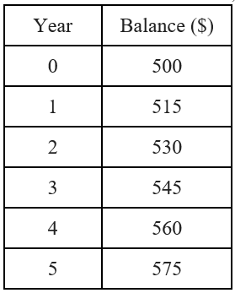
The table shows the balance, in dollars, of a bank account each year after it was opened.
Which of the following describes the interest the account earns and the function that models the balance over time?
- simple interest; linear function
- simple interest; exponential function
- compound interest; linear function
- compound interest; exponential function
*The strategies, tasks and items included in the B1G-M are examples and should not be considered comprehensive.

Data Analysis & Probability

MA.912.DP.1 Develop an understanding of statistics and determine measures of center and measures of variability. Summarize statistical distributions graphically and numerically.

MA.912.DP.1.1
Benchmark
MA.912.DP.1.1 Given a set of data, select an appropriate method to represent the data, depending on whether it is numerical or categorical data and on whether it is univariate or bivariate.
Benchmark Clarifications:
Clarification 1: Instruction includes discussions regarding the strengths and weaknesses of each data display.
Clarification 2: Numerical univariate includes histograms, stem-and-leaf plots, box plots and line plots; numerical bivariate includes scatter plots and line graphs; categorical univariate includes bar charts, circle graphs, line plots, frequency tables and relative frequency tables; and categorical bivariate includes segmented bar charts, joint frequency tables and joint relative frequency tables.
Clarification 3: Instruction includes the use of appropriate units and labels and, where appropriate, using technology to create data displays.

Connecting Benchmarks/Horizontal Alignment
- MA.912.AR.1.1 MA.912.DP.2.4, MA.912.DP.2.5, MA.912.DP.2.6
- MA.912.DP.3.1, MA.912.DP.3.2, MA.912.DP.3.3

Terms from the K-12 Glossary
- Bivariate Data
- Categorical Data
- Numerical Data

Vertical Alignment
Previous Benchmarks  - MA.6.DP.1.5  - MA.7.DP.1.5  - MA.8.DP.1.1 | Next Benchmarks  - MA.912.DP.2.2  - MA.912.DP.6.6

Purpose and Instructional Strategies
In middle grades, students used box plots and histograms to display univariate numerical data; then bar charts, circle graphs, line plots and stem and leaf plots to display univariate categorical data; and finally scatter plots and line graphs to display bivariate numerical data. In Algebra I, students display univariate data and bivariate numerical data using graphical representations from middle grades. Students are introduced to bivariate categorical data, which they represent with frequency tables and segmented bar charts. Additionally, they must choose an appropriate display when considering each of the four varieties of data. In later courses, students will build upon this foundation as students consider a variety of data distributions in greater detail, including normal and Poisson distributions.
- While the benchmark states that students select an appropriate data display, instruction also includes cases where students must create the display.
- This benchmark is closely linked to MA.912.DP.1.2, where students interpret displayed data using key components of the display.
- Instruction includes student discussions (MTR.1.1) regarding the strengths and weaknesses of each data display, and the use of appropriate units and labels (MTR.4.1).
  - Numerical univariate is data that consists of one numerical variable, and an important feature of the data is its numerical size or order. Examples include height, weight, age, salary, speed, number of pets, hours of study, etc. Displays include histograms, stem-and-leaf plots, box plots and line plots.
    - Histograms
      - Good for large sets of data.
      - Shows the shape of the distribution to determine symmetry.
      - Data is collected in suitably sized numerical bins with equal ranges.
      - Because of the bins, only approximate values of individual data points are displayed.
    - Stem-and-Leaf Plots
      - Good for small data sets.
      - Shows the shape of a data set and each individual data value.
      - Lists exact data values in a compact form.
    - Box Plots
      - Beneficial when large amounts of data are involved or compared. Used for descriptive data analysis.
      - Shows multiple measures of variation and/or spread of data.
      - Shows one measure of central tendency (median).
      - Individual data points are not shown.
      - Presents a 5-number summary of the data.
      - Can indicate if a data set is skewed or not, but not the overall shape.
      - Can be used to determine if potential outliers exist.
    - Line Plots (Dot Plots)
      - Used for small to moderate sized data sets in which the numerical values are discrete (often integers, or multiples of
½).
      - Shows the shape of the distribution and the individual data points.
      - Useful for highlighting clusters, gaps and outliers.
      - Can be used to determine measures of center and variation.
  - Numerical bivariate is data that involves two different numerical variables that have a possible relationship to each other. Displays include scatter plots and line graphs.
    - Scatter Plots
      - Good for large data sets, and for data sets in which it is not clear which variable, if any, should be considered the independent variable.
      - Good for showing trends.
    - Line Graphs
      - Good for showing trends or cyclical patterns in small or medium-sized data sets in which there is an independent variable and a dependent variable. Often the values of the independent variable are chosen in advance by the person gathering the data. Examples of independent variables may be points in time or treatment amounts and examples of dependent variables might be total sales or average growth.
  - Categorical univariate is non-numerical data of only one variable that can be categorized/grouped. Displays include bar charts, line plots, circle graphs, frequency tables and relative frequency tables.
    - Bar Charts (Bar Graphs)
      - Good for showing comparisons between categories or between different populations.
      - A bar chart may show frequencies (counts) or relative frequencies (percentages) in each category.
    - Circle Graphs
      - Good for illustrating the percentage breakdown of items and visually representing a comparison.
      - Not effective when there are too many categories.
      - Shows how categories represent parts of a whole.
      - A circle graph may show frequencies (counts) or relative frequencies (percentages) in each category.
    - Frequency Tables and Relative Frequency Tables
      - This is often the easiest way to display bivariate categorical data. The categories for one variable are listed in the header row of the table and the categories for the other variable are listed in the header column.
      - The frequencies (counts) or relative frequencies (percentages) are listed in the cells for each of the indicated joint categories. Total counts or percentages for the rows may be listed in the final column of the table and total counts or percentages for the columns may be listed in the final row.
    - Segmented Bar Charts
      - Comparison of more than one categorical data set.
- Good for showing the composition of the individual parts to the whole and making comparisons. Non-numerical data may consist of numbers if the categories are not primarily determined by the numerical size or order of the numbers.
  - For example, the data may answer the question “What is your favorite real number?” and the categories could be “Integers,” “Rational numbers that are not integers” and “Irrational numbers.”
- Using the same real-world data (MTR.7.1), encourage students to create a variety of data displays appropriate for the data given (MTR.2.1). This makes the discussion of the similarities and differences of the displays more robust and allows students to visualize and justify their responses (MTR.3.1).
  - This strategy might work best if you present the class with a set of data, group students and ask each group to create a different display using the same data.
  - Each group can then present the strengths and weaknesses of their display as compared to the others (MTR.5.1).
  - This should be repeated for each separate data category. See examples above.
- This benchmark references bar charts; however, other benchmarks and the glossary (Appendix C) reference bar graph, these terms are used interchangeably without difference.

Common Misconceptions or Errors
- Students may not know how to label displays appropriately or how to choose appropriate units and scaling.
  - For example, they may not know how to create or scale the number line for a line plot, they may confuse frequency and actual data values, or they may not understand that intervals for histograms should be done in equal increments.
- Students may not understand the meaning of quartiles in the box plot.
- Students may not know how to calculate the median with an even number of data values.
- Students may not accurately place data values in increasing order when there are many data points.
- Students may confuse bar charts (for categorical data) and histograms (for numerical data).
- Students may be confused when categorical data consists of numbers that have been categorized in ways that do not primarily reflect the numerical size or order of the numbers. In such cases, it will be helpful to have the student think about whether any of the measures of center (mean, median) or variability (quartiles, range) are meaningful for the data set. If they are, then the data can be considered numerical, because these measures are concerned with the numerical size and order of the data points. If not, then it can be considered categorical.

Strategies to Support Tiered Instruction
- Teacher co-creates anchor charts that include appropriate units of measure.
  - For example, time measurement units include seconds, minutes, hours, days, weeks, etc.
- Teacher provides numerical univariate, numerical bivariate, categorical univariate and categorical bivariate data examples. Each example should include scaling to ensure that students have experience scaling for graphs and tables that are in each category.
  - For example, employee ages for the company AdvertiseHere can be displayed using a box plot as shown.
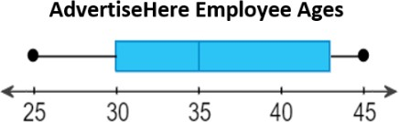
- Teacher reviews the difference between histograms and bar graphs, creating an anchor chart with properties of a histogram for students to refer to.
- Teacher reinforces how scales are represented with specific endpoints. The endpoints they chose to use, or as defined in a problem, tell them if the point is included in the bin or not. Include notation of endpoints on anchor chart to display in the classroom.
- Teacher co-constructs vocabulary guide/anchor chart with students who need additional support understanding the vocabulary for measures of center and variation.
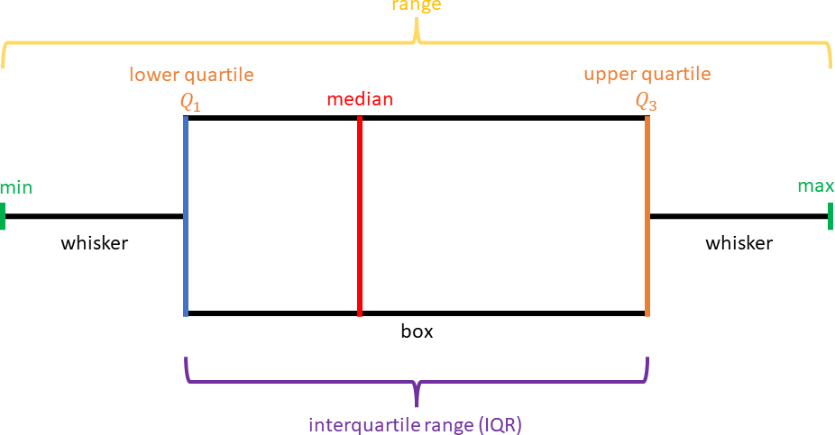
  - Examples of guides and charts are shown below.
Term | Definition | How it is found or calculated
Mean
Median
Mode
Range
Interquartile
Range (IQR)
Quartiles

- Teacher models ordering data sets in ascending order before finding a median, quartile or range.
- Teacher provides a chart to display calculating the median with an even and odd data set.

Odd Number of Data | Even Number of Data
The Middle Number | Average of the Two Middle Numbers
{1, 2, 2, 2, 3, 4, 5}  The median is 2. | {1, 2, 3, 4, 5, 6, 7, 8}  The median is the average (mean) of 4 and 5 which is 4.5.

- Instruction includes discussions about whether any of the measures of center (mean, median) or variability (quartiles, range) are meaningful for the data set. If they are, then the data can be considered numerical, because these measures are concerned with the numerical size and order of the data points. If not, then it can be considered categorical.

Instructional Tasks
Instructional Task 1 (MTR.7.1)
The following data set shows the change in the total amount of municipal waste generated in the United States during the 1990’s.
Year | Municipal Waste Generated (Millions of Tons)
1990 | 269
1991 | 294
1992 | 281
1993 | 292
1994 | 307
1995 | 323
1996 | 327
1997 | 327
Figure: Total Municipal Waste Generated in the US by Year in Millions of Tons.
Instructional Task 2 (MTR.3.1, MTR.7.1)
High school students in the United States were invited to complete an online survey in 2010. More than 1,000 students responded to this survey which included a question about a student‛s favorite sport. 450 of the completed surveys were randomly selected. A breakdown of the data by gender was compiled from the 450 surveys.
- 100 students indicated their favorite sport was soccer. 49 of those students were females.
- 131 students selected lacrosse as their favorite sport. 71 of those students were males.
- 75 students selected basketball their favorite sport. 48 of those students were females.
- 26 students indicated football as their favorite sport. 25 of those students were males.
- 118 students indicated volleyball as their favorite sport. 70 of those students were females.
Choose and create an appropriate data display to represent the information given.

Instructional Items
Instructional Item 1
The following table shows the total weight in tons of the most common types of electronic equipment discarded in the United States in 2005.
Electronic Equipment | Thousands of Tons Discarded
Cathode Ray Tube (CRT) TV's | 7591.1
CRT Monitors | 389.8
Printers, Keyboards, Mice | 324.9
Desktop Computers | 259.5
Laptop Computers | 30.8
Projection TV's | 132.8
Cell Phones | 11.7
LCD Monitors | 4.9
Figure: Electronics Discarded in the US (2005). Source: National Geographic, January 2008. Volume 213 No.1, pg 73.

Which data display would you use to represent this data? Explain your reasoning.

Instructional Item 2
The number of cars sold in a week at a large car dealership over a 20-week period is given below.
16 12 8 7 26 32 15 51 29 45 19 11 6 15 32 18 43 31 23 23
Which data display would be an inappropriate way to represent this data? Explain your reasoning.
*The strategies, tasks and items included in the B1G-M are examples and should not be considered comprehensive.

MA.912.DP.1.2

Benchmark
MA.912.DP.1.2 Interpret data distributions represented in various ways. State whether the data is numerical or categorical, whether it is univariate or bivariate and interpret the different components and quantities in the display.
Benchmark Clarifications:
Clarification 1: Within the Probability and Statistics course, instruction includes the use of spreadsheets and technology.

Connecting Benchmarks/Horizontal Alignment
- MA.912.DP.2.4, MA.912.DP.2.5, MA.912.DP.2.6
- MA.912.DP.3.1, MA.912.DP.3.2, MA.912.DP.3.3

Terms from the K-12 Glossary
- Bivariate Data
- Categorical Data
- Numerical Data

Vertical Alignment
Previous Benchmarks  - MA.6.DP.1  - MA.7.DP.1  - MA.8.DP.1 | Next Benchmarks  - MA.912.FL.4.4  - MA.912.DP.2.1, MA.912.DP.2.2
Purpose and Instructional Strategies
In grade 7, students created and interpreted different displays of univariate numerical and categorical data. They also used measures of center and variation to make comparisons and draw conclusions about two populations. In grade 8, students created scatter plots and began to interpret them by considering lines of fit. In Algebra I, students interpret the components of data displays for numerical and categorical data, both univariate and bivariate. In later courses, they will use data displays to compare distributions of data sets to one another and to theoretical distributions.
- It is the intention of this benchmark to include cases where students must calculate measures of center/variation to interpret (MTR.3.1).
- For students to have full understanding of numerical/categorical, univariate/bivariate data sets and their displays, instruction should include MA.912.DP.1.1. These benchmarks are not intended to be separated. One is reinforced by the other.
  - Numerical univariate includes histograms, stem-and-leaf plots, box plots and line plots.
  - Numerical bivariate includes scatter plots and line graphs.
  - Categorical univariate includes bar charts, line plots, circle graphs, frequency tables and relative frequency tables.
  - Categorical bivariate includes segmented bar charts, joint frequency tables and joint relative frequency tables.
- Instruction includes identifying the measures of center and spread from different scenarios.
- Instruction includes reviewing that an outlier is significantly smaller or larger than the rest of the data set. A data set may have more than one outlier.
- Teacher provides opportunities to analyze the effects on the measures of center and spread when the outlier is the minimum or maximum.
- This benchmark reinforces the importance of the use of questioning within instruction.
  - Does this display univariate or bivariate data?
  - Is the data numerical or categorical?
  - What do the different quantities within the data display mean in terms of the context of the situational data?

Common Misconceptions or Errors
- Students may not be able to properly distinguish between numerical and categorical data or between univariate and bivariate data.
- Students may misidentify or misinterpret the quantities in data displays.
- Students may not be able to distinguish between the measures of center (mean, median) and measures of spread (range, IQR).
- Students may not completely grasp the effect of outliers on the data set or incorrectly conclude a point is an outlier.
- Students may not be able to distinguish the differences between frequencies and relative frequencies.
- Students misidentify the condition that determines a conditional or relative frequency in a joint table.

Strategies to Support Tiered Instruction
- Instruction includes a graphic organizer to complete collaboratively.
  - For example, teacher can provide the graphic below and have students match the vocabulary terminology with the correct definition. Then, have students create an example that can help with remembering the vocabulary terminology.
Word Bank
Numerical  Categorical | Univariate  Bivariate
Fill in the sentence. | Example
[ ] data is measured with
real numbers.
[ ] data is described using
two numbers or two categories.
[ ] data is separated into
groups .
[ ] data is described using
one number or category.
- Teacher provides students with definitions and co-creates examples for frequency and relative frequency.
  - For example, have students draw a definition chart in their notebook. Give them the opportunity to create an example that will help them remember the definition.
Term | Frequency | Relative Frequency
Definition | The number of  data points in each category. | The number of data points in a category divided by the overall total.
Example

Instructional Tasks
Instructional Task 1 (MTR.3.1, MTR.4.1)
The histogram below shows the efficiency rate (in miles per gallon) of 110 cars.
Part A. Does this display univariate or bivariate data? Part B. Is the data numerical or categorical?
Part C. What do the different quantities within the data display mean in terms of the context of the situational data?
Part D.
- How many cars have an efficiency rate between 15 and 20 miles per gallon?
- How many cars have an efficiency rate more than 20 miles per gallon?
- What percentage of cars have an efficiency rate less than 20 miles per gallon?

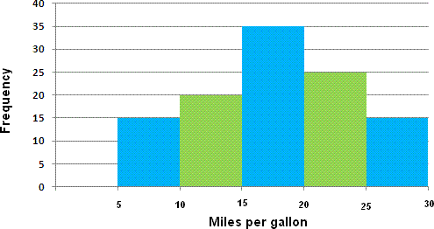
Instructional Task 2 (MTR.3.1, MTR.4.1)
A police department tracked the number of ticket writers and number of tickets issued for each of the past 8 weeks. The scatter plot shows the results.
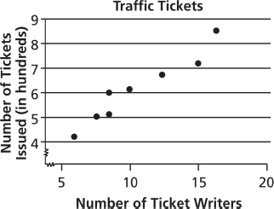
Part A. Does this display univariate or bivariate data? Is the data numerical or categorical?
Part B. What do the different quantities within the data display mean in terms of the context of the situational data?
Part C. Which statement is an appropriate interpretation of the data?
  - More ticket writers result in fewer tickets being issued.
  - There were 50 tickets issued every week.
  - When there are 10 ticket writers, there will be 600 tickets issued.
  - When there are more ticket writers, more tickets are being issued.

Instructional Items
Instructional Item 1
The scatter plot shows the amount of sleep needed per day by age.
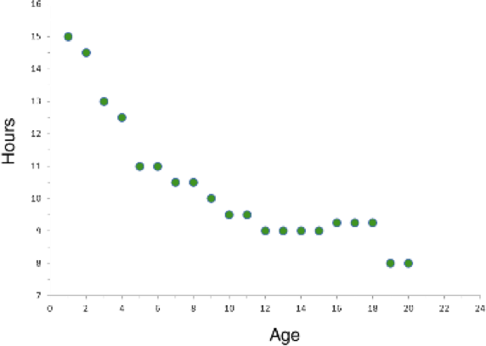

Part A. Does this display univariate or bivariate data? Is the data numerical or categorical?
Part B. What is a possible trend that is shown by the data?
Instructional Item 2
The box plot shows the scores of students for the most recent quiz.

Part A. Does this display univariate or bivariate data? Is the data numerical or categorical?
Part B. What is the maximum, minimum, lower quartile, upper quartile and median?
*The strategies, tasks and items included in the B1G-M are examples and should not be considered comprehensive.

MA.912.DP.1.3

Benchmark
MA.912.DP.1.3 Explain the difference between correlation and causation in the contexts of both numerical and categorical data.
Algebra I Example: There is a strong positive correlation between the number of Nobel prizes won by country and the per capita chocolate consumption by country. Does this mean that increased chocolate consumption in America will increase the United States of America’s chances of a Nobel prize winner?

Connecting Benchmarks/Horizontal Alignment
- MA.912.DP.2.4, MA.912.DP.2.5, MA.912.DP.2.6
- MA.912.DP.3.1, MA.912.DP.3.2, MA.912.DP.3.3

Terms from the K-12 Glossary
- Bivariate Data
- Categorical Data
- Numerical Data

Vertical Alignment
Previous Benchmarks  - MA.8.DP.1.1 | Next Benchmarks  MA.912.DP.5
Purpose and Instructional Strategies
In grade 8, students first analyzed bivariate numerical data using scatter plots. In Algebra I,
students study association between variables in bivariate data and learn that there is a difference between two variables being strongly associated and one of them having a causative effect on the other. In later courses, students will learn how to design statistical experiments that can show causation.
- The intent of this benchmark includes the ability to informally draw conclusions about whether causation is justified when two variables are correlated.
- Correlation and causation are often misunderstood. It is important for students to understand their relationship. Causation and correlation can exist at the same time; however, correlation does not imply causation. Causation explicitly applies to cases where an action causes an outcome. Correlation is simply a relationship observed in bivariate data. One action may relate to the other, but that action doesn’t necessarily cause the other to happen, because both of them may be the result of a third “hidden variable.”
  - Causation is possible, but it is also possible that correlation occurs from a third variable.
    - For example, if one states, “On days when I drink coffee, I feel more productive.” it may be that one feels more productive because of the caffeine (causation) or because they spent time in the coffee shop drinking coffee where there are fewer distractions (third variable). Since one cannot determine whether the causation or the third variable results in correlation, then causation is not confirmed.
  - Causation seems unlikely and a third variable seems likely.
    - For example, there is a strong correlation between the number of Nobel prizes won by country and the per capita chocolate consumption by country. However, there are many possibilities a third variable, such as a strong economy, that can result in this correlation so causation can be ruled out.
  - Causation is likely because there is a reasonable explanation for the causation.
    - For example, if one states, “After I exercise, I feel physically exhausted.” it is reasonable to consider this to be a cause-and-effect. Causation can be confirmed by the explanation that because one is purposefully pushing their body to physical exhaustion when doing exercise, the muscles used to exercise are exhausted (effect) after they exercise (cause).
  - When correlation is apparent in a bivariate data set, students are encouraged to seek a reasonable explanation that either identifies a hidden variable or a reasonable explanation for causation. Further investigation may be required to confirm or disconfirm causation.
- In Algebra I, the term correlation is used to describe an association between two variables and does not necessarily imply a linear relationship.
- Instruction includes asking the following questions while students investigate correlation and causation.
  - Does this correlation make sense? Is there a direct connection between these variables?
  - Will the correlation hold if I look at some new data that I haven’t used in my current analysis?
  - Is the relationship between these variables direct, or are they both a result of some other variable?

Common Misconceptions or Errors
- Even though students may not be able to reasonably explain why a causal relationship exists, they may assume that correlation implies causation.

Strategies to Support Tiered Instruction
- Instruction includes co-creating and discussing examples and non-examples of causal relationships in numerical and categorical data.
  - For example, a non-causal relationship could be a person’s shoe size and approximate number of vocabulary words they know.
  - For example, a causal relationship could be a person’s shoe size and their age.
- Teacher provides instruction to increase understanding of the relationship between correlation and causation. Teacher provides students with context that demonstrates when both correlation and causation are present. They may also provide context when only correlation is represented in the given context.

Instructional Tasks
Instructional Task 1 (MTR.3.1, MTR.4.1)
Data from a certain city shows that the size of an individual’s home is positively correlated with the individual's life expectancy. Which of the following factors would best explain why this correlation does not necessarily imply that the size of an individual’s home is the main cause of increased life expectancy?
- Larger homes have more safety features and amenities, which lead to increased life expectancy.
- The ability to afford a larger home and better healthcare is a direct effect of having more wealth.
- The citizens were not selected at random for the study.
- There are more people living in small homes than large homes in the city. Some responses may have been lost during the data collection process.

Instructional Items
Instructional Item 1
Dr. Larry has noticed that when he carries around his lucky rock, his students seem to be nicer to him. Can one conclude that this positive correlation shows a causal relationship?
- Yes, because Larry decides whether or not to put his lucky rock in his pocket before he encounters people during the day.
- Yes, because it is not a negative correlation.
- No, because lucky rocks only work for children.
- No, because it is possible that people are nice to Larry because of another factor that also causes him to put the rock in his pocket.
*The strategies, tasks and items included in the B1G-M are examples and should not be considered comprehensive

MA.912.DP.1.4
Benchmark
MA.912.DP.1.4 Estimate a population total, mean or percentage using data from a sample survey; develop a margin of error through the use of simulation.
Algebra I Example: Based on a survey of 100 households in Twin Lakes, the newspaper reports that the average number of televisions per household is 3.5 with a margin of error of ±0.6. The actual population mean can be estimated to be between 2.9 and 4.1 television per household. Since there are 5,500 households in Twin Lakes the estimated number of televisions is between 15,950 and 22,550.

Benchmark Clarifications:
Clarification 1: Within the Algebra I course, the margin of error will be given.

Connecting Benchmarks/Horizontal Alignment
- MA.912.DP.2.4, MA.912.DP.2.5, MA.912.DP.2.6

Terms from the K-12 Glossary
- Random Sampling
- Simulation

Vertical Alignment
Previous Benchmarks  - MA.7.AR.3  - MA.7.DP.1  - MA.7.DP.2  - MA.8.DP.2 | Next Benchmarks  - MA.912.DP.1.5  - MA.912.DP.2.3

Purpose and Instructional Strategies
In grade 7, students solved real-world problems involving percentages and they calculated means of numerical data sets. In grades 7 and 8, students explored the relationship between theoretical probabilities and experimental probabilities. In Algebra I, students use means and percentages from data obtained from statistical experiments to make predictions about actual means and percentages in populations and they relate the experimental data to actual values through margins of error. In later courses, students will work more formally with margins of error and use the normal distribution to estimate population percentages.
- In Algebra I, students are not expected to master the skill of estimating a margin of error using simulation. But instruction may include such an activity, to allow students to experience the need for a margin of error whenever a mean or population percentage is estimated using data.
- Instruction includes introducing examples from the media of reports of population means and percentages that include margins of error.
- Instruction includes the understanding that an actual population mean or percentage is not necessarily within the margin of error of the estimated mean or percentage. Even if the data has been carefully collected, these estimated quantities are only within the margin of error with a “high degree of confidence.” If the data has not been carefully collected, or if the situation has changed significantly since the data were collected (as is often the case with election polls), the margin of error may not be very meaningful.

Common Misconceptions or Errors
- When asked for population totals, students may forget to complete the final calculation with the margin of error and only report the mean or percentage as their final answer.
- Students may confuse three percentages: the estimated population percentage, the margin of error expressed as a percentage and the actual population percentage. Students can use a number line to visualize how the first two quantities determine an interval that is likely to contain the third quantity.

Strategies to Support Tiered Instruction
- Teacher provides a list of definitions to students to eliminate misunderstandings that may be caused by the key terms. Because it is important that students understand the meanings of the terms when interpreting sample surveys, this should be an entry in a math journal.
- Instruction includes providing multiple scenarios and asking for identification of the key terms associated with the percentages given in the context.
- Teacher models the use of a number line to visualize how the estimated population percentage and the margin of error determine an interval that is likely to contain the actual population percentage.

Instructional Tasks
Instructional Task 1 (MTR.4.1)
Based on a survey of 150 students at Long Lake High School, the average number of hours spent on social media per week is 30.5 with a margin of error of 3.25.
Part A. Give a range of values, based on this data, for the actual mean numbers of hours spent on social media.
Part B. If there are a total of 723 students at the high school, give a range of values for the total number of weekly hours spent by all students.

Instructional Items
Instructional Item 1
A packaging company prints 100,000 boxes per day. They determine that their printing machines are making a mistake on an average of 0.11% of boxes per day with a margin of error of ±0.01%. How many boxes will need to be recycled due to a printing error in one week?
*The strategies, tasks and items included in the B1G-M are examples and should not be considered comprehensive.

MA.912.DP.2 Solve problems involving univariate and bivariate numerical data.

MA.912.DP.2.4

Benchmark
MA.912.DP.2.4 Fit a linear function to bivariate numerical data that suggests a linear association and interpret the slope and 𝑦-intercept of the model. Use the model to solve real-world problems in terms of the context of the data.
Benchmark Clarifications:
Clarification 1: Instruction includes fitting a linear function both informally and formally with the use of technology.
Clarification 2: Problems include making a prediction or extrapolation, inside and outside the range of the data, based on the equation of the line of fit.

Connecting Benchmarks/Horizontal Alignment
- MA.912.DP.1.1, MA.912.DP.1.2, MA.912.DP.1.3

Terms from the K-12 Glossary
- Numerical Data
- Bivariate Data
- Line of Fit
- Scatter Plot
Vertical Alignment
Previous Benchmarks  - MA.8.DP.1.1 | Next Benchmarks  - MA.912.DP.2.7, MA.912.DP.2.8, MA.912.DP.2.9
Purpose and Instructional Strategies
In grade 8, students first worked with scatter plots and lines of fit. In Algebra I, students relate the slope and y-intercept of a line of fit to association in bivariate numerical data and interpret these features in real-world contexts. In later courses, students use the correlation coefficient to measure how well a line fits the data in a scatter plot, and they also work with scatter plots that suggest quadratic and exponential models.
- This is an extension of MA.912.DP.1.1, where students are working with numerical bivariate data (scatter plots and line graphs). It is good to review with students that a scatter plot is a display of numerical data sets between two variables.
  - They are good for showing a relationship or association between two variables.
  - They can reveal trends, shape of trend or strength of relationship trend.
  - They are useful for highlighting outliers and understanding the distribution of data.
  - One variable could be the progression of time, like in a line graph.

- In this benchmark, students are fitting a linear function to numerical bivariate data, interpreting the slope and 𝑦-intercept based on the context and using that linear function to make predictions about values that correspond to parts of the graph that lie beyond or within the scatter plot.
  - Predictions made outside of the range of data are called extrapolation and predictions made inside the range of data are called interpolation.
- Instruction includes the use of technology for students to understand the difference between a line of fit and a line of best fit. Additionally, instruction of this benchmark should be combined with MA.912.DP.2.6 and MA.912.DP.2.5, as these are extensions of this benchmark.
- During instruction is important to distinguish the difference between a “line of fit” and the “line of best fit.”
  - A “line of fit” is used when students are visually investigating numerical bivariate data that appears to have a linear relationship and can sketch a line (using a writing instrument and straightedge) that appears to “fit” the data. Using this “line of fit” students can estimate its slope and y-intercept and use that information to interpret the context of the data.
  - The “line of best fit” (also referred to as a “trend line”) is used when the data is further analyzed using linear regression calculations (the process of minimizing the squared distances from the individual data values to the line), often done with the assistance of technology.

Common Misconceptions or Errors
- Students may not know how to sketch a line of fit.
  - For example, they may always go through the first and last points of data.
- Students may confuse the two variables when interpreting the data as related to the context.
- Students may not know the difference between interpolation (predictions within a data set) and extrapolation (predictions beyond a data set).

Strategies to Support Tiered Instruction
- Teacher provides sketched lines of fit and has students identify the one that best models
the data.
- Teacher provides a sentence frame for interpreting the data in the context of the problem using two different colored highlighters to highlight the same variable in the sentence frame and table or graph.
  - Example:
Sentence frame | Table |  |  |  | 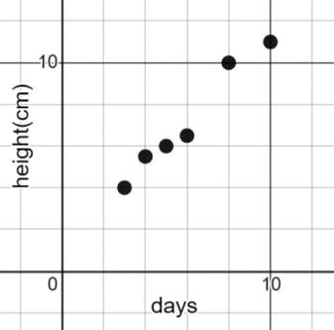  Graph
A line of fit can be  used to estimate how much the height of the plant increases  [ ] centimeters when the number of days increases by  [ ] days. |  | Days | Height (cm)
 |  | 3 | 4
 |  | 4 | 5.5
 |  | 5 | 6
 |  | 6 | 6.5
 |  | 8 | 10
 |  | 10 | 11
- Teacher models creating a scatterplot on a piece of graph paper, then has students place a piece of spaghetti on the scatterplot to model the line of best fit. Students could also use a coordinate plane peg board to plot each point creating a scatterplot and then use a rubber band to model the line of best fit.
- Instruction includes vocabulary development by co-creating a graphic organizer for interpolation and extrapolation.

Instructional Tasks
Instructional Task 1 (MTR.4.1, MTR.5.1, MTR.6.1)
Crickets are one of nature’s more interesting insects, partly because of their musical ability. In England, the chirping or singing of a cricket was once considered to be a sign of good luck. Crickets will not chirp if the temperature is below 40 degrees Fahrenheit (°F) or above 100 degrees Fahrenheit (°F). A table is given with some data collected.
Average Number of Chirps (per minute) | Temperature (◦F)
45 | 40◦
60 | 47◦
75 | 50◦
80 | 45◦
95 | 55◦
110 | 50◦
125 | 60◦
140 | 55◦
140 | 80◦
150 | 65◦
165 | 70◦
180 | 65◦
185 | 70◦
Part A. Create a line of fit based on the data. Compare your line of fit with a partner.
Part B. What is the estimated slope and 𝑦-intercept of the line?
Part C. What does the slope mean in terms of the context?
Part D. What does the 𝑦-intercept mean in terms of the context?
Part E. Using technology, determine the line of best fit. Compare this to the line of fit determined from Part A. What is the difference?
Part F. Based on this line, predict the temperature to be if you recorded 250 chirps per minute?
Part G. Based on this line, estimate the number of chirps per minute at exactly 50°F.

Instructional Items
Instructional Item 1
Data was collected from a variety of fast-food chains on their sandwiches and is represented on the scatter plot below. The equation y = 13.3x + 174 y=13.3x +174
models the line of fit.

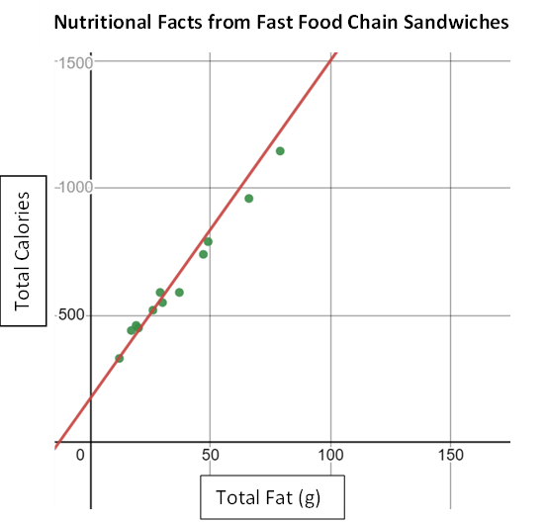

Part A. What do the slope and 𝑦-intercept tell us about the relationship of total fat and total calories in these fast-food items?
Part B. If a fast-food item has 10 grams of fat, estimate the total calories of that item.

Instructional Item 2
A police department tracked the number of ticket writers and number of tickets issued for each of the past 8 weeks. The scatter plot shows the results.

Part A. Create an equation for the line of fit based on the data.
Part B. What does the slope y-intercept mean in terms of the context?
*The strategies, tasks and items included in the B1G-M are examples and should not be considered comprehensive.

MA.912.DP.2.5

Benchmark
MA.912.DP.2.5 Given a scatter plot that represents bivariate numerical data, assess the fit of a given linear function by plotting and analyzing residuals.
Benchmark Clarifications:
Clarification 1: Within the Algebra I course, instruction includes determining the number of positive and negative residuals; the largest and smallest residuals; and the connection between outliers in the data set and the corresponding residuals.

Connecting Benchmarks/Horizontal Alignment
- MA.912.DP.1.1, MA.912.DP.1.3
- MA.912.DP.3.1, MA.912.DP.3.2, MA.912.DP.3.3

Terms from the K-12 Glossary
- Bivariate Data
- Line of Fit
- Numerical Data
- Scatter Plot

Vertical Alignment
Previous Benchmarks  - MA.8.DP.1 | Next Benchmarks  - MA.912.DP.2.8  - MA.912.DP.2.9
Purpose and Instructional Strategies
In grade 8, students informally fitted a line to a scatter plot. In Algebra I, students look more closely at lines of fit and assess their quality by looking at the signs and sizes of the residuals. In later courses, students will use the residuals to determine the correlation coefficient to assess the quality of fit.
- This benchmark is only taught in Algebra I Honors.
- For students to have a full understanding of the quality of a line of fit, this benchmark should be combined with MA.912.DP.2.4 and MA.912.DP.2.6.
- Instruction includes matching scatter plots with residual plots, matching residuals for strength/direction and considering the residual data points themselves.
- Instruction focuses on real-world contexts and includes the use of technology.
- A residual plot has the residual values on the vertical axis; the horizontal axis displays the 𝑥-variable.
  - A residual value is a measure of how far a data value is from the estimate calculated from the line of fit.

- Residuals are positive if data points are above the line of fit and negative if data points are below the line of fit. When creating a residual plot, students should understand that residuals with a positive 𝑦-value represent a data point that was above the line of fit (a value that was more than the model predicted). Residuals with a negative 𝑦-value represents a data point that was below the line of fit (a value that was less than the model predicted).
- To calculate the residual, students use the line of fit and take the difference between an input’s actual value and its predicted value (MTR.3.1). This can correspond to the equation 𝑅 = 𝐷 − 𝑃, where 𝑅 represents the residual, 𝐷 represents the 𝑦-coordinate of data value and 𝑃 represents the 𝑦-coordinate of predicted value.
- Once residuals are calculated, students can determine the number of positive and negative residuals and the largest and smallest residuals.
- Outliers, which are observed data points that are far from a line of fit, can be determined from the residual as points whose residuals have a large absolute value.
- To assess the fit of a given linear function the residual plot will show points randomly scattered around the center line of zero (𝑥-axis), with no obvious, non-random pattern (MTR.5.1).
  - If the residual plot shows a pattern, such as a u-shaped pattern, that indicates that a nonlinear model would be a better fit for the data.

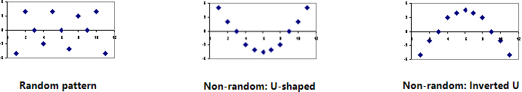

Common Misconceptions or Errors
- Students may not be able to distinguish between a scatter plot and a residual graph.
- Students may have difficulty finding the residual value if the actual 𝑦-value equals the predicted 𝑦-value.
- Students may forget that residual graphs consist of the ordered pair (𝑥-value, residual).
- Students may not be able to determine an appropriate model (linear/nonlinear) from a residual graph.

Strategies to Support Tiered Instruction
- Instruction includes vocabulary development by co-creating a graphic organizer for scatter plot and residual graph.
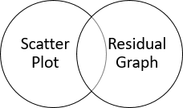

- Teacher co-creates an anchor chart that provides examples of residual graphs for linear models.
- Instruction includes the opportunity to use colors to identify the 𝑥- and 𝑦-values in the original data and the 𝑥- and 𝑦-values in the ordered pairs associated with the residual graph, and highlight the 𝑥- and 𝑦-axis of the residual graph in the same color in order to see the relationship.
  - For example, for the data point (6, −0.5), the residual point is (6, 0.85) based on the line fit being 𝑦 = −0.6𝑥 + 2.25.
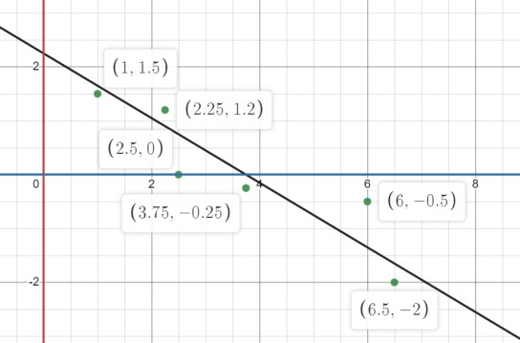

Instructional Tasks
Instructional Task 1 (MTR.8.1, MTR.912.1, MTR.7.1)
Crickets are one of nature’s more interesting insects, partly because of their musical ability. In England, the chirping or singing of a cricket was once considered to be a sign of good luck. Crickets will not chirp if the temperature is below 40 degrees Fahrenheit (°F) or above 100 degrees Fahrenheit (°F). A table is given with some data collected.
Average Number of Chirps (per minute) | Temperature (°F)
45 | 40°
60 | 47°
75 | 50°
80 | 45°
95 | 55°
110 | 50°
125 | 60°
140 | 55°
140 | 80°
150 | 65°
165 | 70°
180 | 65°
185 | 70°
Part A. Based on the data, the line of best fit can be described by the model 𝑦 = 0.214𝑥 + 32.317. Create a residual plot using technology.
Part B. What do you notice about the positive and negative residuals?
Part C. If the number of chirps is 45, what temperature is predicted by the line of best fit?
How does this compare with the data?
Part D. Write an equation that compares the residual, the predicted value and the data value.
Part E. What are the largest and the smallest residuals?
Part F. Based on the residual plot, can you determine if there are any possible outliers in the data?
Part G. Does the residual plot indicate that a linear model is appropriate for this data?

Instructional Items
Instructional Item 1
Based on the data and the use of technology, we know that the line of best fit for the relationship between grams of fat and the total calories in fast food using the given data below can be represented by 𝑦 = 11.44𝑥 + 219.89.
Sandwich | Total Fat (g) | Total Calories
Double Cheeseburger | 26 | 520
Cheeseburger (1/4 pound) | 30 | 550
Cheeseburger (1/3 pound) | 47 | 740
Bacon Burger | 79 | 1147
Bacon Cheeseburger (1/4 pound) | 66 | 960
Bacon Cheeseburger (1/3 pound) | 49 | 790
Hamburger | 37 | 590
Fried Chicken Sandwich | 29 | 590
Grilled Chicken Sandwich | 17 | 440
Spicy Grilled Chicken Sandwich | 19 | 460
Roast Beef and Cheese Sandwich | 20 | 450
Tuna Melt | 12 | 330
Part A. Calculate the residuals and plot them on a residual plot where grams of fat are the
𝑥-variable.
Part B. Which sandwiches have the residuals with the largest and smallest absolute values?
Part C. Is a linear model reasonable for this data set?
*The strategies, tasks and items included in the B1G-M are examples and should not be considered comprehensive.

MA.912.DP.2.6

Benchmark
MA.912.DP.2.6 Given a scatter plot that represents bivariate numerical data, assess the fit of a given linear function by plotting and analyzing residuals.
Benchmark Clarifications:
Clarification 1: Within the Algebra I course, instruction includes determining the number of positive and negative residuals; the largest and smallest residuals; and the connection between outliers in the data set and the corresponding residuals.

Connecting Benchmarks/Horizontal Alignment
- MA.912.DP.1.1, MA.912.DP.1.3
- MA.912.DP.3.1, MA.912.DP.3.2, MA.912.DP.3.3

Terms from the K-12 Glossary
- Bivariate Data
- Line of Fit
- Numerical Data
- Scatter Plot

Vertical Alignment
Previous Benchmarks  - MA.8.DP.1 | Next Benchmarks  - MA.912.DP.2.8  - MA.912.DP.2.9
Purpose and Instructional Strategies
In grade 8, students informally fitted a line to a scatter plot. In Algebra I, students look more closely at lines of fit and assess their quality by looking at the signs and sizes of the residuals. In later courses, students will use the residuals to determine the correlation coefficient to assess the quality of fit.
- This benchmark is only taught in Algebra I Honors.
- For students to have a full understanding of the quality of a line of fit, this benchmark should be combined with MA.912.DP.2.4 and MA.912.DP.2.6.
- Instruction includes matching scatter plots with residual plots, matching residuals for strength/direction and considering the residual data points themselves.
- Instruction focuses on real-world contexts and includes the use of technology.
- A residual plot has the residual values on the vertical axis; the horizontal axis displays the 𝑥-variable.
  - A residual value is a measure of how far a data value is from the estimate calculated from the line of fit.
- Residuals are positive if data points are above the line of fit and negative if data points are below the line of fit. When creating a residual plot, students should understand that residuals with a positive 𝑦-value represent a data point that was above the line of fit (a value that was more than the model predicted). Residuals with a negative 𝑦-value represents a data point that was below the line of fit (a value that was less than the model predicted).
- To calculate the residual, students use the line of fit and take the difference between an input’s actual value and its predicted value (MTR.3.1). This can correspond to the equation 𝑅 = 𝐷 − 𝑃, where 𝑅 represents the residual, 𝐷 represents the 𝑦-coordinate of data value and 𝑃 represents the 𝑦-coordinate of predicted value.
- Once residuals are calculated, students can determine the number of positive and negative residuals and the largest and smallest residuals.
- Outliers, which are observed data points that are far from a line of fit, can be determined from the residual as points whose residuals have a large absolute value.
- To assess the fit of a given linear function the residual plot will show points randomly scattered around the center line of zero (𝑥-axis), with no obvious, non-random pattern (MTR.5.1).
  - If the residual plot shows a pattern, such as a u-shaped pattern, that indicates that a nonlinear model would be a better fit for the data.

Common Misconceptions or Errors
- Students may not be able to distinguish between a scatter plot and a residual graph.
- Students may have difficulty finding the residual value if the actual 𝑦-value equals the predicted 𝑦-value.
- Students may forget that residual graphs consist of the ordered pair (𝑥-value, residual).
- Students may not be able to determine an appropriate model (linear/nonlinear) from a residual graph.

Strategies to Support Tiered Instruction
- Instruction includes vocabulary development by co-creating a graphic organizer for scatter plot and residual graph.
- Teacher co-creates an anchor chart that provides examples of residual graphs for linear models.
- Instruction includes the opportunity to use colors to identify the 𝑥- and 𝑦-values in the original data and the 𝑥- and 𝑦-values in the ordered pairs associated with the residual graph, and highlight the 𝑥- and 𝑦-axis of the residual graph in the same color in order to see the relationship.
  - For example, for the data point (6, −0.5), the residual point is (6, 0.85) based on the line fit being 𝑦 = −0.6𝑥 + 2.25.

Instructional Tasks
Instructional Task 1 (MTR.8.1, MTR.912.1, MTR.7.1)
Crickets are one of nature’s more interesting insects, partly because of their musical ability. In England, the chirping or singing of a cricket was once considered to be a sign of good luck. Crickets will not chirp if the temperature is below 40 degrees Fahrenheit (°F) or above 100 degrees Fahrenheit (°F). A table is given with some data collected.
Average Number of Chirps (per minute) | Temperature (°F)
45 | 40°
60 | 47°
75 | 50°
80 | 45°
95 | 55°
110 | 50°
125 | 60°
140 | 55°
140 | 80°
150 | 65°
165 | 70°
180 | 65°
185 | 70°
Part A. Based on the data, the line of best fit can be described by the model 𝑦 = 0.214𝑥 + 32.317. Create a residual plot using technology.
Part B. What do you notice about the positive and negative residuals?
Part C. If the number of chirps is 45, what temperature is predicted by the line of best fit?
How does this compare with the data?
Part D. Write an equation that compares the residual, the predicted value and the data value.
Part E. What are the largest and the smallest residuals?
Part F. Based on the residual plot, can you determine if there are any possible outliers in the data?
Part G. Does the residual plot indicate that a linear model is appropriate for this data?

Instructional Items
Instructional Item 1
Based on the data and the use of technology, we know that the line of best fit for the relationship between grams of fat and the total calories in fast food using the given data below can be represented by 𝑦 = 11.44𝑥 + 219.89.
Sandwich | Total Fat (g) | Total Calories
Double Cheeseburger | 26 | 520
Cheeseburger (1/4 pound) | 30 | 550
Cheeseburger (1/3 pound) | 47 | 740
Bacon Burger | 79 | 1147
Bacon Cheeseburger (1/4 pound) | 66 | 960
Bacon Cheeseburger (1/3 pound) | 49 | 790
Hamburger | 37 | 590
Fried Chicken Sandwich | 29 | 590
Grilled Chicken Sandwich | 17 | 440
Spicy Grilled Chicken Sandwich | 19 | 460
Roast Beef and Cheese Sandwich | 20 | 450
Tuna Melt | 12 | 330
Part A. Calculate the residuals and plot them on a residual plot where grams of fat are the
𝑥-variable.
Part B. Which sandwiches have the residuals with the largest and smallest absolute values?
Part C. Is a linear model reasonable for this data set?
*The strategies, tasks and items included in the B1G-M are examples and should not be considered comprehensive.

MA.912.DP.3 Solve problems involving categorical data.

MA.912.DP.3.1

Benchmark
MA.912.DP.3.1 Construct a two-way frequency table summarizing bivariate categorical data. Interpret joint and marginal frequencies and determine possible associations in terms of a real-world context.
Algebra I Example: Complete the frequency table below.

 | Has an A in math | Doesn’t have an A in math | Total
Plays an instrument | 20 |  | 90
Doesn’t play an instrument | 20
Total |  |  | 350

Using the information in the table, it is possible to determine that the second column contains the numbers 70 and 240. This means that there are 70 students who play an instrument but do not have an A in math and the total number of students who play an instrument is 90. The ratio of the joint frequencies in the first column is 1 to 1 and the ratio in the second column is 7 to 24, indicating a strong positive association between playing an instrument and getting an A in math.

Connecting Benchmarks/Horizontal Alignment
- MA.912.DP.1., MA.912.DP.1.2
- MA.912.DP.2.4, MA.912.DP.2.5, MA.912.DP.2.6

Terms from the K-12 Glossary
- Bivariate Data
- Categorical Data
- Joint Frequency

Vertical Alignment
Previous Benchmarks  - MA.7.DP.1  - MA.8.DP.1 | Next Benchmarks  - MA.912.DP.4.5  - MA.912.DP.4.6

Purpose and Instructional Strategies
In grades 7 and 8 students explored the relationship between experimental and theoretical probabilities. In Algebra I, students study bivariate categorical data and display it in tables showing joint frequencies and marginal frequencies. In later courses, students will study experimental and theoretical conditional probabilities.
- Instruction includes the connection to MA.912.DP.1.1 where students work with categorical bivariate data and display it in tables. A two-way frequency table is a way to display frequencies jointly for two categories.
- In order to interpret the joint and marginal frequencies, students must know the difference between the two.
  - Marginal frequencies
Guide students to understand that the total column and total row are in the “margins” of the table, thus they are referred to as the marginal frequencies.
  - Joint frequencies
Guide students to connect that the word joint refers to the coming together of more than one, therefore the term joint frequency refers to combination of two categories or conditions happening together.
- Once the two-way table is complete, students can compare two ratios to assess the association of the data.
  - Comparing Joint Frequencies
They can either compare the ratios of the two joint frequencies of each of the columns (as was done in the Benchmark Example) or they can compare the ratios of the two joint frequencies in each of the rows.
    - For example, a completed two-way frequency table is shown below and one wants to determine the association between owning a dog and being male. The ratio of the joint frequencies in the first row is 14/31, which is about 0.45, and the ratio of the joint frequencies in the second row is 18/37, which is about 0.49. Since 0.45 and 0.49 are very close to one another, one can conclude that there is no association between owning a dog and being male. But since the ratio of the first row is slightly smaller than the ratio in the second row, one could argue that there is a weak, negative association. Likewise, since the ratio of the second row is slightly larger than the ratio in the first row, one could conclude that there is a weak, positive association between owning a dog and being female.

 | Owns a  dog | Does not own a  dog | Total
Male | 14 | 31 | 45
Female | 18 | 37 | 55
Total | 32 | 68 | 100

  - Comparing Joint and Marginal Frequencies
They can either compare the ratios of a joint and a marginal frequency of each of the columns or they can compare the ratios of a joint and a marginal frequency in each of the rows.
    - For example, a completed two-way frequency table is shown below and one wants to determine the association between owning a dog and being male. The ratio of the joint frequency of males and the marginal frequency in the first column is 14/32, which is about 0.44, and the ratio of the joint frequency of males and the marginal frequency in the second column is 31/68, which is about 0.46. Since 0.44 and 0.46 are very close to one another, one can conclude that there is no association between owning a dog and being male. But since the ratio of the first column is slightly smaller than the ratio in the second column, one could argue that there is a weak, negative association. Alternately, one can compare the ratio of the joint frequency of females and the marginal frequency in the first column is 18/32, which is about 0.56, and the ratio of the joint frequency of females and the marginal frequency in the second column is 37/68, which is about 0.54. Since the ratio of the first column is slightly larger than the ratio of the second column, one could conclude that there is a weak, positive association between owning a dog and being female.

 | Owns a  dog | Does not own a  dog | Total
Male | 14 | 31 | 45
Female | 18 | 37 | 55
Total | 32 | 68 | 100

- Instruction focuses on frequency tables where each of the variables only has two categories (i.e., likes ice cream and does not like ice cream).

Common Misconceptions or Errors
- Students may not be able to properly complete the table based on the data given.
- Students may not be able to distinguish the differences between marginal and joint frequencies.
- Students may not be able to properly identify the relationships and possible associations in the data in terms of the context given.
- When determining association, students may not be able to assess whether the association is positive or negative since it is based on how you state your justification.
  - For example, in the study above about gender and owning a dog, the association between owning a dog and being male is negative which is equivalent to saying that the association between owning a dog and being female is positive.

Strategies to Support Tiered Instruction
- Instruction includes writing the definitions of joint frequency and marginal frequency vocabulary terms in interactive journals.
  - For example, students can list the definitions (shown below) inside of their notebooks.

Joint Frequency |  |  |  |  |  |  | Marginal Frequency
Category values inside of the body of a table. |  |  |  |  |  |  | Totals found in both the rows and columns in a table.
 |  | 6th  Grade | 7th  Grade | 8th  Grade | Total |  |  |  | 6th  Grade | 7th  Grade | 8th  Grade | Total
 | Cat | 7 | 3 | 10 | 20 |  |  | Cat | 7 | 3 | 10 | 20
 | Dog | 11 | 15 | 9 | 35 |  |  | Dog | 11 | 15 | 9 | 35
 | Other | 4 | 14 | 2 | 20 |  |  | Other | 4 | 14 | 2 | 20
 | Total | 22 | 32 | 21 | 75 |  |  | Total | 22 | 32 | 21 | 75

- Instruction includes the use of a key word table associated with joint and marginal frequency. Instruction also includes the use of a reading strategy that gives students the opportunity to analyze the data from the context given.
- Teacher provides additional assistance when identifying positive and negative associations. Instruction includes using categories that are relevant to students to increase interest and comfortability.
  - For example, the following context could be relevant to students. Students at a local junior high school were surveyed. The survey wanted to determine if the group of students are in an athletic club or a social club. Can you draw any associations from the given data?
 |  | In an Athletic Club
 |  | Yes | No | Total
In a Social Club | Yes | 72 | 37 | 109
In a Social Club | No | 41 | 29 | 70
 | Total | 113 | 66 | 179

Instructional Tasks
Instructional Task 1 (MTR.5.1)
A survey asked, “If you could have a new vehicle, would you want a sport utility vehicle or a sports car?” Below are the results of the survey in a joint relative frequency table.

 | Sport Utility Vehicle (SUV) | Sports Car | Total
Male |  | 42 | 67
Female | 145
Total |  | 97

Part A. Construct a frequency table.
Part B. Does this display univariate or bivariate data? Is the data numerical or categorical?
Part C. What percentage of the survey takers was female?
Part D. Did a higher percentage of the males or females choose an SUV?
Part E. Does the data show an association between being female and choosing an SUV?
If so, is it positive or negative?

Instructional Items
Instructional Item 1
Complete the frequency table below based on data collected randomly from 1000 people at the local county fair.
 | Owns a Motorcycle | Do not Own a Motorcycle | Total
Men | 506
Women | 72 |  | 375
Total

Is there an association between being a man and owning a motorcycle?

*The strategies, tasks and items included in the B1G-M are examples and should not be considered comprehensive.

MA.912.DP.3.2

Benchmark
MA.912.DP.3.2 Given marginal and conditional relative frequencies, construct a two-way relative frequency table summarizing categorical bivariate data.
Algebra I Example: A study shows that 9% of the population have diabetes and 91% do not. The study also shows that 95% of the people who do not have diabetes, test negative on a diabetes test while 80% who do have diabetes, test positive.
Based on the given information, the following relative frequency table can be constructed.

 | Positive | Negative | Total
Has diabetes | 7.2% | 1.8% | 9%
Doesn’t have diabetes | 4.55% | 86.45% | 91%

Benchmark Clarifications:
Clarification 1: Instruction includes cases where not all frequencies are given but enough are provided to be able to construct a two-way relative frequency table.
Clarification 2: Instruction includes the use of a tree diagram when calculating relative frequencies to construct tables.

Connecting Benchmarks/Horizontal Alignment
- MA.912.DP.1.1

Terms from the K-12 Glossary
- Bivariate Data
- Categorical Data

Vertical Alignment
Previous Benchmarks  - MA.7.DP.1  - MA.8.DP.1 | Next Benchmarks  - MA.912.DP.4.5  - MA.912.DP.4.6
Purpose and Instructional Strategies
In grades 7 and 8 students explored the relationship between experimental and theoretical probabilities. In Algebra I, students study associations in bivariate categorical data using conditional relative frequencies. In later courses, students will study experimental and theoretical conditional probabilities.
- This benchmark is only taught in Algebra I Honors.
- Instruction includes the understanding that relative frequencies can be represented by percentages or fractions.
- Instruction includes the connection to tree diagrams from determining sample spaces in repeated experiments from grade 8. Utilizing tree diagrams can help students to organize information while constructing relative frequency tables.
  - For example, a study shows that 12% of the population have an allergy to nuts and 88% do not. The study also shows that 90% of the people who have an allergy to nuts test positive on an allergy test while 5% of people who do have a nut allergy test positive on an allergy test. Based on the given information, a frequency table can be constructed using the tree diagram below.
90%
Tests positive on an
allergy test
12%(90%) = 10.8%
Has a nut allergy
12%
10%
Tests negative on an
allergy test
12%(10%) = 1.2%
88%
5%
Tests positive on an
allergy test
88%(5%) = 4.4%
Does not have a nut
allergy
95%
Tests negative on an
allergy test
88%(95%) = 83.6%

Based on this tree diagram, students can use this to construct a relative frequency table as shown below.
 | Positive | Negative | Total
Has a nut  allergy | 10.8% | 1.2% | 12%
Doesn’t have  a nut allergy | 4.4% | 83.6% | 88%
Total | 15.2% | 84.8% | 100%

Common Misconceptions or Errors
- Students may not be able to place the information correctly in a tree diagram in order to find the missing information.
- Students may not perform the calculations correctly needed for the completion of the two-way relative frequency table.

Strategies to Support Tiered Instruction
- Instruction includes making the connection to frequency tables and thinking about the percentages as whole numbers with the total being 100.
  - For example, teacher can model as shown below.

 | Positive |  | Negative | Total
Has a dairy  allergy | 14
Doesn’t have  a dairy allergy |  |  | 32
Total | 23 |  |  | 100

Instructional Tasks
Instructional Task 1 (MTR.5.1)
A study at a local veterinarian took a sample of 120 dogs and whether they had heartworms or not and whether they tested positive for heartworms or not. Of the 120 dogs, 21 dogs tested positive for heartworms and had heartworms; 94 total dogs did not have heartworms; and 77 dogs tested negative for heartworms.
Part A. Construct a frequency table that describes the data.
Part B. Is there an association between having heartworms and testing positive?
Part C. Construct a relative frequency table that describes the data.
Part D. What percentage of dogs that had heartworms tested negative?

Instructional Items
Instructional Item 1
In 2016, a clinical study in a small town of New Hampshire found that about 13% of its population had the flu. The study also showed that 19% of the people who had the flu tested negative while 8% of the people who did not have the flu tested positive. Based on the given information, construct a relative frequency table summarizing the data.
*The strategies, tasks and items included in the B1G-M are examples and should not be considered comprehensive.

MA.912.DP.3.3

Benchmark
MA.912.DP.3.3 Given a two-way relative frequency table or segmented bar graph summarizing categorical bivariate data, interpret joint, marginal and conditional relative frequencies in terms of a real-world context.
Algebra I Example: Given the relative frequency table below, the ratio of true positives to false positives can be determined as 7.2 to 4.55, which is about 3 to 2, meaning that a randomly selected person who tests positive for diabetes is about 50% more likely to have diabetes than not have it.

 | Positive | Negative | Total
Has diabetes | 7.2% | 1.8% | 9%
Doesn’t have diabetes | 4.55% | 86.45% | 91%

Benchmark Clarifications:
Clarification 1: Instruction includes problems involving false positive and false negatives.

Connecting Benchmarks/Horizontal Alignment
- MA.912.DP.1.1

Terms from the K-12 Glossary
- Bivariate Data
- Categorical Data

Vertical Alignment
Previous Benchmarks  - MA.7.DP.1  - MA.8.DP.1 | Next Benchmarks  - MA.912.DP.4.5  - MA.912.DP.4.6
Purpose and Instructional Strategies
In grades 7 and 8, students explored the relationship between experimental and theoretical
probabilities. In Algebra I, students study associations in bivariate categorical data using conditional relative frequencies and they apply these to real-world contexts. In later courses, students will study experimental and theoretical conditional probabilities in real-world contexts.
- This benchmark is only taught in Algebra I Honors.
- In this benchmark, students will calculate and interpret joint, marginal and conditional relative frequencies in terms of a real-world context.

- When medical studies are involved, the following terminology is used.
  - True Positive (TP) means that a person who has a disease is correctly identified as having that disease by the test.
  - False Positive (FP) means that a person who does not have a disease is incorrectly identified as having that disease by the test.
  - True Negative (TN) means that a person who does not have a disease is correctly identified as not having that disease by the test.
  - False Negative (FN) means that a person who has a disease is incorrectly identified as not having that disease by the test.
- In order to interpret the joint, marginal and conditional relative frequencies, students must know the difference between them.
  - Marginal relative frequencies
Guide students to understand that the total column and total row are in the “margins” of the table, thus they are referred to as the marginal relative frequencies.
  - Joint relative frequencies
Guide students to connect that the word joint refers to the coming together of more than one, therefore the term joint relative frequency refers to combination of two categories or conditions happening together.
  - Conditional relative frequencies
Guide students to connect that the word conditional refers imposing a constraint on one of the two variables, therefore the term conditional relative frequency refers to the percentage in a category for one variable when one has put a constraint on the other variable.
  - For example, the relative frequency table below describes whether a student completed a test review sheet or not and whether they passed the test. To determine the conditional relative frequency of those who passed the test given that they completed the review, one could take the ratio between the joint relative frequency for passing the test in the first row and the marginal relative frequency in the first row, which is $\frac{54\%}{60\%}$ which is equivalent to 90%. One could say that 90% of those who completed the review passed the test.
 | Passed test | Did not pass test | Total
Completed test review | 54% | 6% | 60%
Did not complete test review | 20% | 20% | 40%
Total | 74% | 26% | 100%

Common Misconceptions or Errors
- Students may not understand how the two-way relative frequency table connects with true positives/false positives and false negatives/true negatives.
- Students may not understand how to create the proper ratio for a given purpose.
- Students may not understand how to connect the ratio to the context.

Strategies to Support Tiered Instruction
- Teacher co-creates a graphic organizer to distinguish between the positives and negatives.
Medical Terminology | True Positive | False Positive | True Negative | False Negative
Definition | Correctly  Identified As Positive | Incorrectly  Identified As Positive | Correctly  Identified As Negative | Incorrectly  Identified As Negative
Example | John has the flu and tests positive for the  flu. | Mary does not have the flu and tests positive for  the flu. | Kate does not have the flu and tests negative for  the flu. | Tom has the flu and tests negative for the flu.
- Teacher models distinguishing between relative frequencies given basic equations.
Joint | Marginal | Conditional
$$\frac{Inside Quantity}{Grant Total}$$ | $$\frac{Columm or Row Total }{Grant Total}$$ | $$\frac{Inside Quantity}{Columm or Row Total }$$
- Teacher provides opportunity to highlight the middle of the two-way table to distinguish the conditional and joint relative frequencies from marginal relative frequencies. The teacher models a joint, conditional or marginal relative frequency given the instructional task/problem.
  - For example, when determining the conditional relative frequency given that a student is an 8th grader, that student studies on the weekend, teacher can highlight the numbers in the two-way table below. Then, students can determine the relative frequency to be 51.5% since $\frac{170}{330} = 0.5151$.
 | 7th Grade | 8th Grade | Totals
Does not study on weekend | 190 | 160 | 350
Studies on the weekend | 140 | 170 | 310
Totals | 330 | 330 | 660

- Teacher co-creates a graphic organizer for each of the types of relative frequencies (joint, marginal and conditional) and highlights key similarities and differences.

Instructional Tasks
Instructional Task 1 (MTR.8.1, MTR.912.1, MTR.7.1)
The relative frequency table below describes the members of the local sports club, showing whether they are male or female and whether they play disc golf or not.
 | Male | Female | Total
Plays disc golf | 21% | 13% | 34%
Does not play disc golf | 52% | 14% | 66%
Total | 73% | 27% | 100%
Part A. Compare the conditional relative frequency of being male given that they play disc golf and being female given that they play disc golf.
Part B. Is there an association between being female and playing disc golf?
Part C. Determine a possible reason for the association found in Part B. How do you think this may compare with any association that might exist in the general population between being female and playing disc golf?

Instructional Items
Instructional Item 1
In 2016, a clinical study in a small town of New Hampshire found that about 13% of its population had the flu and 87% did not. The study also showed that 19% of the people who had the flu tested negative while 8% of the people who did not have the flu tested positive. The relative frequency table below summarizes the data.
 | Positive | Negative | Total
Has the Flu | 10.53% | 2.47% | 13%
Do Not Have the Flu | 6.96 | 80.04% | 87%
Determine the ratio of true positives to false positives and interpret that in terms of the context.
*The strategies, tasks and items included in the B1G-M are examples and should not be considered comprehensive.

Appendix A. Summary of Changes

The purpose of this table is to provide a summary of changes from for the latest version of the B1G-M. For questions or feedback on the B1G-M, please direct them to BESTMath@fldoe.org.

Benchmark | B1G-M Component | Change Made
MA.912.NSO.1.1 | Terms from the K-12 Glossary | Added Rational Number
MA.912.NSO.1.1 | Vertical Alignment | Added Previous Benchmarks of MA.6.NSO.3.3, MA.7.NSO.1.1
MA.912.NSO.1.1 | Common Misconceptions | Added “Students may not understand operations with rational numbers.”
MA.912.NSO.1.1 | Strategies to Support Tiered Instruction | Added the use of fraction tiles
MA.912.NSO.1.2 | Purpose & Instructional Strategies | Changed third bullet to “Students should be able to fluently apply the Laws of Exponents to generate equivalent expressions in either direction.”
MA.912.NSO.1.2 | Instructional Tasks | Removed Instructional Task 1, Task 2 moved to Task 1
MA.912.NSO.1.2 | Instructional Tasks | Added new Instructional Task 2
MA.912.NSO.1.2 | Instructional Items | Added Instructional Item 3
MA.912.NSO.1.4 | Purpose & Instructional Strategies | Added Instruction may include the use of the words: radicand and index
MA.912.NSO.1.4 | Strategies to Support Tiered Instruction | Add use of prime factorization
MA.912.AR.1.1 | Instructional Items | Added Instructional Item 2
MA.912.AR.1.2 | Vertical Alignment | Added Previous Benchmark of MA.8.AR.2.3
MA.912.AR.1.2 | Purpose & Instructional Strategies | Added example of inverse operations and highlighting
MA.912.AR.1.3 | Horizontal Alignment | Added MA.912.NSO.1.1 and MA.912.NSO.1.2
MA.912.AR.1.3 | Terms from the K-12 Glossary | Added Monomial
MA.912.AR.1.3 | Common Misconceptions | Added “Students may not distribute the factor of –1 when subtracting a polynomial.”  AND added incorrectly squaring binomial
MA.912.AR.1.3 | Strategies to Support Tiered Instruction | Added modeling subtraction with algebra tiles
MA.912.AR.1.3 | Instructional Items | Changed “value” to “coefficient”
MA.912.AR.1.4 | Horizontal Alignment | Added MA.912.NSO.1.2
MA.912.AR.1.7 | Horizontal Alignment | Added MA.912.NSO.1.2
MA.912.AR.1.7 | Terms from the K-12 Glossary | Added Greatest Common Factor
MA.912.AR.1.7 | Vertical Alignment | Added Previous Benchmarks of MA.6.AR.1.4, MA.7AR.1.2
MA.912.AR.1.7 | Purpose & Instructional Strategies | Added descriptions of the Area Model/Box Method
MA.912.AR.1.7 | Instructional Items | Adjusted Instructional Item 4
MA.912.AR.2.1 | Horizontal Alignment | MA.912.AR.9.1
MA.912.AR.2.1 | Vertical Alignment | Added MA.6.AR.2.2, MA.6.AR.2.3 and MA.7.AR.2.2
MA.912.AR.2.1 | Purpose & Instructional Strategies | Added “in mathematical context”
MA.912.AR.2.1 | Purpose & Instructional Strategies | Added “of modeling the distributive property” and removed “the expression”
MA.912.AR.2.1 | Purpose & Instructional Strategies | Removed equal signs
MA.912.AR.2.1 | Purpose & Instructional Strategies | Added “of modeling combining like terms” and Removed “the expression”
MA.912.AR.2.1 | Instructional Tasks & Items | Revised Task 1, Task 2 moved to Item 3 and added a new Task 2
MA.912.AR.2.2 | Vertical Alignment | Add MA.7.AR.4.4
MA.912.AR.2.2 |  | Replaced all graphs
MA.912.AR.2.2 | Instructional Tasks | Reworded Task 2 Part B
MA.912.AR.2.3 | Vertical Alignment | Add MA.8.AR.3.2
MA.912.AR.2.3 | Purpose & Instructional Strategies | Added “with instruction of the benchmark MA.8.GR.2.1” second bullet
MA.912.AR.2.3 | Instructional Tasks & Items | Previous Task 1 moved to Instructional Item 3, Task 2 moved to Task 1, added new Task 2, and added Item 4
MA.912.AR.2.4 | Common Misconceptions | Added Students may confuse domain and range
MA.912.AR.2.4 | Strategies to Support Tiered Instruction | Added anchor chart strategy
MA.912.AR.2.4 | Instructional Items | Added new Item 3
MA.912.AR.2.5 | Horizontal Alignment | Added MA.912.AR.1.1
MA.912.AR.2.5 | Purpose & Instructional Strategies | Added “For example when a variable represents an amount of time, negative values  would not be possible and therefore be a constraint.” under the 4th bullet.
MA.912.AR.2.5 | Instructional Tasks | Previous Instructional Item 1 moved to Instructional Task 3
MA.912.AR.2.5 | Instructional Items | Added new Items 1 & 2
MA.912.AR.2.6 | Horizontal Alignment | Added MA.912.AR.1.1
MA.912.AR.2.6 | Purpose & Instructional Strategies | Added examples for ways to represent solutions
MA.912.AR.2.6 | Common Misconceptions | Move “less than” teaching support to Strategies to Support Tiered Instruction  AND Adding interchanging “At most” and “At least”
MA.912.AR.2.6 | Strategies to Support Tiered Instruction | Added “less than” strategies and anchor chart for key words
MA.912.AR.2.6 | Strategies to Support Tiered Instruction | Changed “and” to “or” in anchor chart for key words
MA.912.AR.2.6 | Instructional Items | Added new Item 3
MA.912.AR.2.7 | Purpose & Instructional Strategies | Instruction includes the connection to graphs of the solution sets of one-variable inequalities on a number line; recognizing whether the boundary line should be dotted (exclusive – meaning not included in the solution set) or solid (inclusive – meaning included in the solution set).
MA.912.AR.2.7 | Common Misconceptions | Move “less than” teaching support to Strategies to Support Tiered Instruction  AND Adding interchanging “At most” and “At least”
MA.912.AR.2.7 | Strategies to Support Tiered Instruction | Added “less than” strategies and anchor chart for key words
MA.912.AR.2.7 | Instructional Tasks | Replaced graph in Instructional Task 2
MA.912.AR.2.7 | Instructional Items | Replaced graph in Instructional Item 1 and added new Item 2
MA.912.AR.2.8 | Common Misconceptions | Moved counterexamples teaching support to Strategies to Support Tiered Instruction
MA.912.AR.2.8 | Instructional Items | Added new Item 2
MA.912.AR.3.1 | Common Misconceptions | Moved “for example..” and “standard form” teaching support to Strategies to Support Tiered Instruction
MA.912.AR.3.1 | Instructional Tasks | Added new Task 3
MA.912.AR.3.4 | Horizontal Alignment | Added MA.912.F.1.6
MA.912.AR.3.4 | Purpose & Instructional Strategies | Added compare and contrast to linear and absolute value functions
MA.912.AR.3.4 | Common Misconceptions | Moved “help students...” teaching support to Strategies to Support Tiered Instruction
MA.912.AR.3.4 | Instructional Items | Added new Item 3
MA.912.AR.3.5 | Horizontal Alignment | Added MA.912.F.1.6
MA.912.AR.3.5 | Purpose & Instructional Strategies | Added compare and contrast to linear and absolute value functions
MA.912.AR.3.5 | Common Misconceptions | Moved teaching support to Strategies to Support Tiered Instruction  AND added incorrectly squaring binomial
MA.912.AR.3.5 | Instructional Tasks | Added new Task 2
MA.912.AR.3.5 | Instructional Items | Replaced graph in Instructional Item 1
MA.912.AR.3.6 | Horizontal Alignment | Added MA.912.F.1.6
MA.912.AR.3.6 | Purpose & Instructional Strategies | Added compare and contrast to linear and absolute value functions
MA.912.AR.3.6 | Instructional Items | Revised Item 1and added new Item 2
MA.912.AR.3.7 | Horizontal Alignment | Added MA.912.F.1.6
MA.912.AR.3.7 | Purpose & Instructional Strategies | Added compare and contrast to linear and absolute value functions
MA.912.AR.3.7 | Instructional Items | Added new Item 2
MA.912.AR.3.8 | Horizontal Alignment | Added MA.912.F.1.6
MA.912.AR.3.8 | Purpose & Instructional Strategies | Added compare and contrast to linear and absolute value functions  Also replaced the “for example...”
MA.912.AR.3.8 | Common Misconceptions | Removed students stuck...  Added connection between x-y notation and function notation
MA.912.AR.3.8 | Instructional Items | Revised Item 2 & added new Item 3
MA.912.AR.4.1 | Purpose & Instructional Strategies | Added “In Algebra I, instruction includes absolute value equations in the form 𝑑 = |𝑎𝑥 + 𝑏| + 𝑐 or 𝑑 = 𝑎|𝑥 + 𝑏| + 𝑐, where 𝑎 ≠ 0 and 𝑏, 𝑐, and 𝑑 are rational numbers.”
MA.912.AR.4.1 | Instructional Tasks & Items | Previous Instructional Tasks 1 & 2 moved to Instructional Items 3 & 4
MA.912.AR.4.2 | Horizontal Alignment | Add MA.912.AR.2.7  MA.912.AR.2.8
MA.912.AR.4.3 | Horizontal Alignment | Added MA.912.F.1.6
MA.912.AR.4.3 | Terms from the K-12 Glossary | Removed “Piecewise Function”
MA.912.AR.4.3 | Purpose & Instructional Strategies | Added compare and contrast to linear and quadratic functions
MA.912.AR.4.3 | Instructional Tasks | Added new Task 2
MA.912.AR.4.3 | Instructional Items | Added new Item 2
MA.912.AR.5.3 | Instructional Tasks | Added Instructional Task 2
MA.912.AR.5.3 | Instructional Items | Added new Item 2
MA.912.AR.5.6 | Instructional Items | Added new Item 3
MA.912.AR.9.1 | Instructional Items | Added new Item 3
MA.912.AR.9.4 | Vertical Alignment | Added Next Benchmarks MA.912.AR.9.5, MA.912.AR.9.7
MA.912.AR.9.6 | Strategies to Support Tiered Instruction | Added teaching strategies for boundary line and shading
MA.912.AR.9.6 | Instructional Items | Added new Item 2
MA.912.F.1.1 | Instructional Items | Added new Items 2 & 3
MA.912.F.1.2 | Common Misconceptions | Moved “discuss the meaning...” teaching support to Strategies to Support Tiered Instruction
MA.912.F.1.2 | Instructional Items | Added new Item 3
MA.912.F.1.3 | Vertical Alignment | Added to Next Benchmarks MA.912.C.3.8, MA.912.C.3.9, MA.912.C.3.10
MA.912.F.1.3 | Common Misconceptions | Added Students confuse average rate of change and constant rate of change.
MA.912.F.1.3 | Instructional Items | Added new Item 2
MA.912.F.1.5 | Common Misconceptions | Added students may confuse a negative rate of change...
MA.912.F.1.5 | Strategies to Support Tiered Instruction | Added graph to point out constraints and clarifying magnitude with slope
MA.912.F.1.5 | Instructional Items | Added new Item 2
MA.912.F.1.6 | Strategies to Support Tiered Instruction | Added cue cards and chart
MA.912.F.1.6 | Instructional Items | Added new Item 2
MA.912.F.1.8 | Common Misconceptions | Moved “have students...” teaching support to Strategies to Support Tiered Instruction
MA.912.F.1.8 | Instructional Items | Added new Items 2 & 3
MA.912.F.2.1 | Common Misconceptions | Moved “in these cases...” teaching support to Strategies to Support Tiered Instruction
MA.912.F.2.1 | Instructional Items | Revised Item 1 and added new Item 3
MA.912.F.2.3 | Common Misconceptions | Moved “in these cases...” teaching support to Strategies to Support Tiered Instruction
MA.912.FL.3.2 | Horizontal Alignment | Added MA.912.AR.1.1, MA.912.AR.1.2, MA.912.AR.5.3
MA.912.FL.3.2 | Purpose & Instructional Strategies | Added definition of compound interest and connection to MA.912.AR.5.3
MA.912.FL.3.2 | Common Misconceptions | Moved “in these cases...” teaching support to Strategies to Support Tiered Instruction  AND Added students confuse frequencies  AND Added interest rate to decimal conversion
MA.912.FL.3.2 | Strategies to Support Tiered Instruction | Added anchor chart for frequencies and decimal conversion
MA.912.FL.3.2 | Instructional Tasks | Removed Instructional Task 3
MA.912.FL.3.2 | Instructional Items | Added Instructional Item 2
MA.912.FL.3.4 | Horizontal Alignment | Added MA.912.F.1.8
MA.912.FL.3.4 | Instructional Items | Added new Item 2
MA.912.DP.1.1 | Terms from the K-12 Glossary | Add Bivariate Data
MA.912.DP.1.1 | Instructional Tasks & Items | Moved Instructional Task 1 to Instructional Item 2
MA.912.DP.1.2 | Terms from the K-12 Glossary | Add Bivariate Data
MA.912.DP.1.2 | Instructional Items | Added new Item 2
MA.912.DP.1.2 | Vertical Alignment | Added to Previous Benchmarks MA.6.DP.1
MA.912.DP.1.3 | Terms from the K-12 Glossary | Add Bivariate Data
MA.912.DP.1.4 | Instructional Tasks & Items | Switched Task 1 and Item 1
MA.912.DP.2.4 | Terms from the K-12 Glossary | Add Bivariate Data
MA.912.DP.2.4 | Instructional Items | Revised Item 1 graph and prompt and Added Item 2
MA.912.DP.2.5 | Terms from the K-12 Glossary | Add Bivariate Data
MA.912.DP.2.6 | Terms from the K-12 Glossary | Add Bivariate Data
MA.912.DP.2.6 | Strategies to Support Tiered Instruction | Added Venn diagram
MA.912.DP.3.1 | Terms from the K-12 Glossary | Add Bivariate Data & Joint Frequency
MA.912.DP.3.2 | Terms from the K-12 Glossary | Add Bivariate Data
MA.912.DP.3.3 | Terms from the K-12 Glossary | Add Bivariate Data

