Florida’s Nita M. Lowey 21st Century
Community Learning Centers Program
2017-18 Evaluation Report

The Florida Center for Research in Science, Technology, Engineering, and Mathematics (FCR-STEM)

Learning Systems Institute
Florida State University


Zahid Kisa Melissa Dyehouse Rabieh Razzouk




For questions, please contact:
Rabieh Razzouk (rrazzouk@lsi.fsu.edu), Principal Investigator

Contents

Introduction 3
Executive Summary 6
Methods 9
Results 17
Discussion and Conclusions 34
References 38
Appendix 39

Introduction

This evaluation is one of a series of reports conducted by the Florida Center for Research in Science, Technology, Engineering, and Mathematics (FCR-STEM). This evaluation report details the 2017-18 academic year overall evaluation results of Florida’s Nita M. Lowey 21st Century Community Learning Centers (21st CCLC) program. Each individual 21st CCLC program in Florida submits formative and summative data as well as produces their own annual evaluation report. The present evaluation aggregates the data from each individual program to produce overall program results across the state of Florida.
Thus, the goal of this evaluation was to aggregate the formative and summative evaluation data collected for each of the 21st CCLC programs in the state of Florida and summarize the overall findings. Specifically, the evaluation questions are:
- What is the overall performance of the 21st CCLC programs in terms of students’ academic outcomes?
- What is the overall performance of the 21st CCLC programs in terms of students’, teachers’ and parents’ perception of the programs?
- What is the overall performance of the 21st CCLC programs in terms of students’ attendance?
- How does the performance of the programs differ among all domains?
- What are the factors associated with a higher performance of the programs in academic and non-academic domains?
The Nita M. Lowey 21st Century Community Learning Centers (21st CCLC) program is authorized by Title IV, Part B of the Elementary and Secondary Education Act, as amended by the Every Student Succeeds Act (ESSA) of 2015. The United States Department of Education (USDOE) allocates funds to state education agencies according to a formula. The Florida 21st CCLC program operates from the Florida Department of Education (FDOE). The FDOE distributes

these funds using a competitive request for proposal process to agencies that include public school districts (e.g., Broward County School District, Volusia County School District), nonprofit organizations (e.g., Boys and Girls Clubs, Cuban American National Council), private schools (e.g., North Florida Educational Institute, Kingdom Academy), cities in Florida (e.g., City of Orlando, Kids Hope Alliance-City of Jacksonville), and universities (e.g., Florida A&M University, Florida International University) following the federal grant guidelines (USDOE, 2003).
Nationally, the program serves over 1.5 million youth and in Florida, over 66,000 students are served (Afterschool Alliance, 2020).
The purpose of the 21st CCLC program is to create out-of-school programming focused on students who attend low-performing schools. These programs provide academic enrichment opportunities including tutoring services, complementary enrichment activities such as health education or music, and family educational services including opportunities for literacy in before-school, after- school, and summer programs (United States Department of Education; USDOE, 2003).
Out-of-school programs have shown benefits to students including both academic and non-academic outcomes. A review of out-of-school academic programs found that academic-focused out-of-school programs substantially improves academic achievement (Knoph, Hahn, Proia, Truman, Johnson, Muntaner et al., 2015). A meta-analysis of rigorous research studies on out-of-school programs (after-school, summer camps, vacation sessions, before school, and Saturday school) found small, positive effects on the achievement (reading and math) of at-risk students; for mathematics, the effects were largest for middle and high school students (Luer, Akiba, Wilkerson, Apthorp, Snow, & Martin-Glenn, 2006). A review of 21st CCLC programs found few significant negative effects while finding numerous positive significant improved outcomes for students, including math, ELA/reading, and science achievement, physical health, attendance/enrollment, promotion and graduation, and social/emotional competencies. Findings of 21st CCLC programs also include student improvements

on other non-academic domains such as improved behavior and homework completion (USDOE, 2018).

Executive Summary

Nita M. Lowey 21st Century Community Learning Centers (21st CCLC) programs performed moderately in terms of academic outcomes. On average, 21st CCLC programs perform at the moderate level in terms of their students’ academic performance.
  - For the end of the school year grade scores, the average mean score across all programs was 2.59 in ELA, 2.62 in math, and 2.85 in science. In terms of letter grades, these scores correspond to a grade of CB (where C=2, B=3).
  - Across all programs the mean gain score from the first quarter to the end of the school year was 0.10 in ELA, 0.13 in math, and 0.05 in science where the range of the gain scores was between -4 to +4 (one point corresponds to a gain of one letter grade).
  - In terms of FSA scores, the mean achievement level was 2.18 in ELA, 2.37 in math and 2.22 in science. These scores are slightly higher than a “satisfactory” achievement level (where “satisfactory” = 2, “proficient” = 3).
  - These findings are based on analyses using data of students who had at least one day of attendance in the program. Restricting analyses to regularly participating students or students who had a high attendance record would likely create larger overall gains.
The impact of the 21st CCLC programs on academic outcomes was comparable.
There was a small variation between the 21st CCLC programs in terms of their students’ academic outcomes.
  - For students’ gains from the first quarter to the end of school year, between program variation was 4.3 percent for ELA, 2.6 percent for math and 3.7 percent for science.
  - For students’ grade scores at the end of the school year, between program variation was slightly higher with 6.5 percent for ELA, 5.9 percent for math and 8.3 percent for science.
Students’ attendance rate is associated with higher academic performance. The average days of attendance in an academic year was lowest for students who received a grade of F and increased as grades got higher.

There was considerable variation between 21st CCLC programs in terms of students’ attendance. There were considerable differences between 21st CCLC programs in terms of the mean days of attendance among their students.
  - For academic year attendance, 31.6 percent of the variation was between programs; for summer attendance, 40.9 percent of the variation was between programs.
  - For academic year attendance, the estimated days of attendance for a student in a program at the 75th percentile (in terms of mean attendance days) was 114 days while it was 68 days for a student in a program at the 25th percentile. This corresponds to 46 days difference.
  - For summer attendance, the estimated days of attendance for a student in a program at the 75th percentile (in terms of mean attendance days) was 25 days while it was 15 days for a student in a program at the 25th percentile. This corresponds to 10 days difference.
Students, parents and school-day teachers had positive perceptions of the 21st CCLC programs. On average, perceptions of the program were high across the groups.
*21st CCLC programs performed better in non-academic domains than academic domains. Analyses comparing programs in terms of their performances in both academic and non-academic domains using the percent of students meeting the standards of success as an outcome revealed that 21st CCLC programs perform better in non-academic domains than academic domains in general.
  - Across academic domains less than 65 percent of the students in programs met the standard of success while for non-academic domains more than 80 percent of the students in programs met the standard of success.
Grade level, average perception of the programs, and benchmarks were associated with academic outcomes. Grade level, average perception of the programs, and benchmarks were associated with academic outcomes as measured by the percent of students meeting the standard of success.
  - 21st CCLC programs for elementary school students outperformed the programs for middle and high school students on academic outcomes. Further analyses suggested that attendance rate in different grade levels might contribute to this relationship. The average days of students’ attendance was lower in higher grade levels.

  - 21st CCLC programs that had higher benchmarks tend to have a higher percent of students meeting the standard of success in academic domains.
  - 21st CCLC programs for which day-to-day teachers perceived a high mean impact for students tended to have a higher percent of students meeting the success standards.
*Teachers’ average perceived impacts of the program were associated with non- academic outcomes. Only the average of teachers’ perceived impacts of the program was positively associated with non-academic outcomes.

* The percent of participants meeting the standard of success in a particular domain provided a common metric across all programs and domains. Yet, since the standards of success and assessments used to measure it varied across the 21st CCLC programs for non-academic domains, findings regarding non-academic domains should be interpreted with caution.

Methods

Data Sources and Samples

This evaluation study used three main data sources provided by the 21st CCLC program office in Florida. The student-level dataset mainly included students’ attendance records and their academic performance in English Language Arts (ELA), Math and Science. Stakeholder datasets included the perceptions of the participating students, perceptions of their school-day teachers and perceptions of their parents regarding the 21st CCLC programs. The program-level dataset included the records that were used in the calculation of the individual programs’ performance by the 21st CCLC program office. These records included the standard of the programs’ success and the percentage of students who achieved the standard of success for all academic and non-academic domains offered by the program. Using these datasets, the study team examined the overall performance of the 21st CCLC programs on the academic and non-academic outcomes. A description of each of the study outcomes is provided in the next section.
The analytical sample for each analysis varied as the outcome variables came from different datasets and inclusion criteria were varied across analyses. Thus, analytical samples are presented in the Results section. To give an overall idea, the analytical sample used for academic outcomes included about 190 programs. The analytical sample for the analyses of stakeholders’ perceptions included 195 programs for students’ perceptions, 173 programs for teachers’ perceptions, and 191 programs for parents’ perceptions. Students’ summer attendance analyses used data from 139 programs while academic attendance analyses used data from 212 programs. Finally, examination of the performance of the programs on the academic and non-academic outcomes used data from 216 programs.

Study Outcomes
Academic Outcomes
End of Year Grade Scores. The study team used student report card grade scores at the end of the year provided in the student-level dataset as a measure of student final achievement at the end of the school year. Students’ academic performance in their schools were measured by report card grades. Report card grades for ELA, math, and science were collected at four (or three) time points to monitor students’ progress throughout the school year. 21st CCLC programs reported different grade scales for the report card grade scores. The majority of the programs reported a five-point, A-F grading scale. To ensure comparability of the programs when examining academic outcomes using student report cards, the study team used data from 21st CCLC programs that used an A-F grading scale or other grading scales which were equated to the A-F grading scale. The study team converted
grade scale scores to a 0-4 scale where 0 corresponds to F and 4 corresponds to A.

Grade score gains from 1st to 4th quarter (the end of school year). The study team used the difference in students’ report card grade scores in the first quarter of the school year and at the end of the year as a measure of gain in student achievement in a given year. One limitation of this measure was that the gain in students’ performance accounted for ¾ of the school year instead of the whole school year.
Since the baseline report cards were not available to the study team, this was the best alternative to capture the gain in students’ grade scores. Utilizing gain scores along with the end of year grade scores allowed the study team to provide additional insights regarding the performances of the programs. Gain scores take into account the possible pre-existing differences of each programs’ population in terms of their students’ prior academic performance. The end of year grade scores, on the other hand, may reflect pre-existing differences in student populations in the calculation of programs’ performance on academic outcomes. To ensure comparability of the programs and fairness in gain calculation, the study team used data from 21st CCLC programs that used an A-F grading scale or other grading scales which were

equated to the A-F grading scale. The range of the gain scale was between -4 and 4 as the study team converted grade scale scores to a 0-4 scale where 0 corresponds to F and 4 corresponds to A.

Student performance on Florida's statewide assessments. The study team examined student performance on Florida's statewide assessments as supplementary to student achievement analyses. The study team did not utilize Florida statewide assessments as a primary outcome for achievement analyses since data was only available for students in tested grades. The analytical sample size further diminished in calculating the gain scores which require using state assessment test scores of 2016-17 and 2017-18. This limits the generalizability of the findings to tested grades rather than all grade levels served in the 21st CCLC program. The ELA state assessment was administered to students in grades 3 through 10. The math state assessment was administered to students in grades 3 through 8 and the science state assessment was administered in grade 5 and grade
8. Programs reported students’ performance as achievement levels. The table below provides information regarding student performance at each achievement level.

Table 1: Description of the student performance at each achievement level on Florida state assessments

Achievement Level 1 | Achievement Level 2 | Achievement Level 3 | Achievement Level 4 | Achievement Level 5
Inadequate: | Below | Satisfactory: | Proficient: | Mastery:
Highly likely to | Satisfactory: | May need | Likely to excel | Highly likely to
need | Likely to need | additional | in the next | excel in the next
substantial | substantial | support for | grade | grade
support for the | support for | the next
next grade | the next | grade
 | grade

Students, parents and school-day teachers’ perception of the program

The study team examined participating students and their adult family members and school-day teachers’ perception of the 21st CCLC program on student academic and personal development. As a requirement of the funds that support the 21st CCLC program, all programs surveyed participating students and their adult family members and school-day teachers at the end of the year. Student and teacher surveys were web-based while the parent survey was web-based and was available in a paper format. Parent surveys were available in English, Spanish, and Creole.

Students’ perception of the program. In the student survey, students were asked to respond to questions about their perceived experience with the program (e.g., whether they enjoyed the activities in the afterschool program) and their assessment of the impact of the program on their academic performance (e.g., whether the program helped improve their grades) as well as on their non-academic skills (e.g., whether the program helped them to solve problems in a positive way). There were eight questions of this nature. The rating scale for these questions ranged from 1 -“not at all” to 3-“definitely”. Exploratory factor analyses suggested that these eight items could be clustered together into a scale. The Cronbach’s alpha (α = .83) indicated consistency among the items. The mean of these eight questions constituted the composite score of students’ perceptions of the program. The eight items from this scale and descriptive statistics for each of the items are provided in Table 1 of the Appendix.

Teachers’ perceived impact of the program. At the end of the school year, day-to- day teachers of the students participating in the 21st CCLC program were asked to respond to a series of questions (11 questions) about the rate of improvement that they observed in participating students’ behaviors such as their academic performance, motivation, attendance, and engagement. The rating scale for these

questions was; 1-“declined”, 2 -“no change”, 3-“improved” and 4 –“did not need to improve”. Exploratory factor analyses suggested a one factor solution1. The Cronbach’s alpha (α = .94) indicated consistency among the 11 items in this scale. The study team utilized the mean of the 11 questions as a composite score of teachers’ perceived impact of the 21st CCLC program on their participating students. Items in the scale and their descriptive statistics are provided in Table 2 of the Appendix.

Parents’ satisfaction with the program. In the Family Member Satisfaction Survey, parents of the students who participated in the program were asked to indicate their level of satisfaction with the 21st CCLC program regarding the program’s staff, activities, and safety. The rating scale for these questions ranged from 1- “very unsatisfied” to 5- “very satisfied”. The mean of the 8 questions constituted the composite score of parents’ perceived satisfaction with the 21st CCLC program.
The Cronbach’s alpha (α = .94) indicated consistency among the items and exploratory factor analyses suggested a unidimensional scale. Items of the scale and their descriptive statistics are provided in Table 3 of the Appendix.

Parents’ perceived impact of the program. In the Family Member Satisfaction Survey, parents reported their level of satisfaction with their participating child’s improvement in academic (e.g., grades) and non-academic areas (e.g., homework completion, getting along with others, staying out of trouble). There were four questions of this nature. The rating scale for these questions ranged from 1-“very unsatisfied” to 5-“very satisfied”. Exploratory factor analyses suggested a one factor

¹ In the original survey there were 12 questions. The study team excluded one question as it was about the improvement in the parents of a participating student while the rest of the questions were directly about students’ improvement.

solution. The Cronbach’s alpha (α = .86) indicated consistency among the items. The mean of the 4 questions formed a composite score of parents’ perceived impact of the 21st CCLC program on their participating child. Items in the scale and their descriptive statistics are provided in Table 4 of the Appendix.

Students’ attendance

The study team examined the performance of the 21st CCLC programs in terms of their participating students’ attendance. The study team used days of attendance of individual students for the summer and academic year terms as outcomes for students’ attendance.

Percent of Participants Meeting the Standard of Success

The study team examined the performance of the 21st CCLC programs on academic and non-academic domains using the percent of the participants meeting the standard of success. Besides students’ academic performance, 21st CCLC programs can support students in non-academic domains including dropout prevention and college/career readiness and personal enrichment (e.g., arts and culture, health and nutrition). There were also programs supporting performance of the adult family members such as family literacy and parent involvement.
21st CCLC programs had liberty to select different forms of assessments to measure participants’ performance on these non-academic domains. Lack of common or comparable assessments created a challenge in examining 21st CCLC programs across the domains. In the program level dataset, the percent of participants meeting the standard of success in a particular domain provided a common metric across all programs and domains. Although this measure offered a common metric, it had major drawbacks in terms of the comparability of the programs especially in non-academic domains because besides assessments, the standards of success were also varied across the 21st CCLC programs and

domains. The standard of success was a specific definition for determining what level of performance was considered successful on a given measure in a specific domain. The standard of success for a program in a non-academic domain could be scoring 80 or higher on a survey administered to measure performance of the participants and for another program and domain, it could be maintaining body mass index (BMI) in a normal range (18.5 to 24.5).
In academic domains the standard of success was common across the 21st CCLC programs. It was maintaining an A/B grade or improving from a grade of C to B or a grade of D/F to C (or grading scale equivalents) using report card grade scores. For state assessment achievement levels, it was attaining an achievement level 3 (satisfactory) or higher.

Analyses

This study used two-level hierarchical linear models (HLM) to examine the overall performance of the 21st CCLC programs in terms of students’ academic outcomes, perception of students, teachers and parents about the program, and student attendance. A two-level model takes into account that students, parents or teachers are nested within the programs. These models estimated variation due to the programs after adjusting for the fact that some variation would be observed just due to random chance.
Using two-level HLM models allowed the study team to partition variation in the outcome to 1) between participants within programs and 2) between programs. This allowed us to calculate the extent of variation between programs. Higher variation between programs suggests larger differences between individual performances of the 21st CCLC programs for a given outcome. By using predicted values generated from the two-level HLM models, the study team ranked the programs from low-performing to high-performing and calculated the average scores for a student in a program at the 75th percentile and 25th percentile. This difference in average score of a student in a high-performing program (program at the 75th percentile) and in a low-performing program (program at the 25th percentile)

provided further insights into the extent of the impact of the 21st CCLC programs for a given outcome. Finally, HLM models generated the estimate of average performance across the 21st CCLC programs for a given outcome.
For the examination of the performance of the programs across all domains, the study team used mean comparisons of the percent of participants meeting the standard of success in a given domain. For the examination of the factors associated with a higher performance of the programs in academic and non- academic domains, the study team used Ordinary Least Squares (OLS) regression where the percent of participants meeting the standard of success was the outcome as the data were available at the program domain level. Since programs in academic domains were more comparable than programs in non-academic domains, the regression model was run separately for academic and non-academic domains.

Results

21st CCLC programs performed moderately in terms of academic outcomes

Findings of the analyses of the academic outcomes revealed that on average, 21st CCLC programs perform at the moderate level in terms of their students’ academic performance (See Table 2). For the end of the school year grade scores, the average mean score across all programs was 2.59 in ELA,
2.62 in math, and 2.85 in science. In terms of letter grades, these scores correspond to a grade of CB (where C=2, B=3). In terms of FSA scores, the mean achievement level was 2.18 in ELA, 2.37 in math and 2.22 in science. These scores are slightly higher than a “satisfactory” achievement level (where “satisfactory” = 2, “proficient” = 3). A satisfactory level suggests that a student may need additional support for the next grade. Finally, across all programs the mean gain score from the first quarter to the end of the school year was 0.10 in ELA, 0.13 in math, and 0.05 in science where the range of the gain scores was between -4 to +4 (one point corresponds to a gain of one letter grade).

The impact of the 21st CCLC programs on academic outcomes was comparable

The results of the HLM models revealed that there was a small variation between the 21st CCLC programs in terms of their students’ academic outcomes. For students’ gains from the first quarter to the end of school year, between program variation was 4.3 percent for ELA, 2.6 percent for math and
3.7 percent for science. For students’ grade scores at the end of the school year, between program variation was slightly higher with 6.5 percent for ELA,

5.9 percent for math and 8.3 percent for science2. Examination of the students’ performance on the statewide assessment, Florida Standards Assessment (FSA), also revealed similar results although these analyses focused only on students in the tested grades (See Table 2).

² Variation in students’ end of year grade scores account for summer and academic learning while gain scores account for learning from the first quarter to the end of the school year. The end of year grade scores may reflect pre-existing differences in student populations while gain scores take into account possible pre-existing differences in terms of academic performance of the population of the different programs. These factors might play a role in observing slightly larger between program variation on the end of year scores compared to the gain scores.

Table 2. Performance of 21st CCLC programs in terms of students’ academic outcomes
Outcomes | Average across the 21st CCLC  Programs | Percentage of variation between 21st CCLC Programs | Avg. scores of students in a program at the 75th  percentile and 25th percentileª
Grade scores at the end of the school year
(on a 0-4 scale)
ELA | 2.59 | 6.5 | 2.76 - 2.43
Math | 2.62 | 5.9 | 2.77 - 2.47
Science | 2.85 | 8.3 | 3.02 - 2.67
Grade scores gains from 1st to 4th quarter
(on a -4- 4 scale)
ELA | 0.10 | 4.3 | 0.24 - 0.03
Math | 0.13 | 2.6 | 0.23 - 0.03
Science | 0.05 | 3.7 | 0.19 - 0.07
State Assessments
(on a 1-5 scale)
ELA | 2.18 | 5.7 | 2.35 - 2.03
Math | 2.37 | 8.9 | 2.63 - 2.16
Science | 2.22 | 9.3 | 2.57 - 2.04
Note: The analytical sample for the grade score gains from 1st to 4th quarter models consisted of 32,200 students and 191 programs for ELA, 32,874 students and 192 programs for math, and 31,358 students and 192 programs for science.
The analytical sample for the end of the year grade scores consisted of 35,682 students and 191 programs for ELA, 35,181 students and 192 programs for math, and 34,407 students and 192 programs for science.
The analytical sample for the state assessment models consisted of 26,367 students in grades 3-10 from 173 programs for ELA, 23,593 students in grades 3-8 from 167 programs for math, and 5,942 students in grade 5 and grade 8 from 151 programs for science.

a. The study team calculated the average scores for a student in a program at the 75th percentile and 25th percentile using the actual rankings of the programs based on the estimated program effects.

Small between program variation suggests that the 21st CCLC programs were more alike when it comes to improving students’ scores. In other words, if a student were placed randomly in a different 21st CCLC program, their observed performance on academic outcomes would not change much as a result of being in a different program. This is reflected in the differences

between high-performing and low-performing programs on the academic outcomes. For example, the estimated ELA gain score for a student in a higher- performing program - a program at the 75th percentile - was 0.24, while it was
-0.03 for a student in a low-performing program – a program at the 25th percentile. This corresponds to a 0.27 score difference between a student in a high-performing and a student in a low-performing 21st CCLC program. For math this difference was a 0.20 score difference in a student’s gain score and for science it was a 0.26 point score difference. In terms of letter grades, these differences correspond to about a quarter of a letter grade as the gain score of 1 corresponds to one letter grade difference (e.g., score of C to score of B) in a student score from the first quarter to the end of the school year.
Distributions of the programs’ predicted mean gain scores and the end of year grade scores depicted the limited variation between 21st CCLC programs on academic outcomes and moderate performance of the programs on average (See Figure 1). The majority of the programs’ mean gain scores were between 0.0 - 0.3 across ELA, math, and science and were between 2.5 -
3.0 for the end of year grade score. One noteworthy observation was that for gain scores in science, there are spikes at both ends of the distribution. This suggests that a few 21st CCLC programs separated from others due to their relatively better performance while a few other programs separated due to their relatively poor performance.

Figure 1
Distribution of the programs’ predicted mean gain scores and the end of year grade scores

Gain score distributions
(on a -4.00 – 4.00 scale)
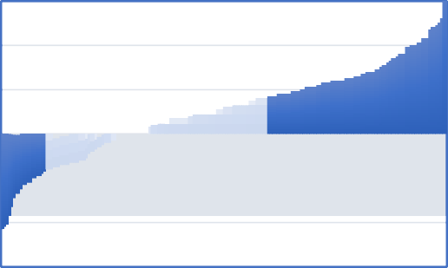

0.60

0.40

0.20

0.00

-0.20

-0.40

-0.60

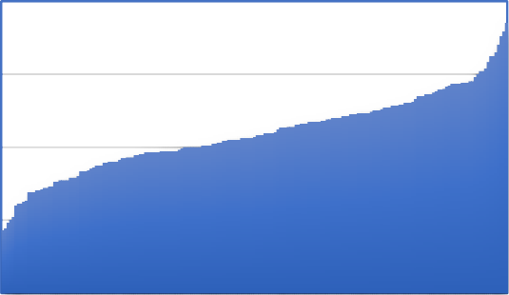

ELA
3.5

3.0

2.5

2.0

1.5

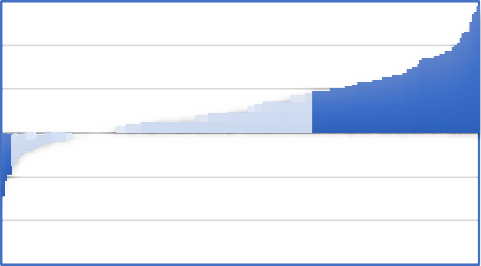

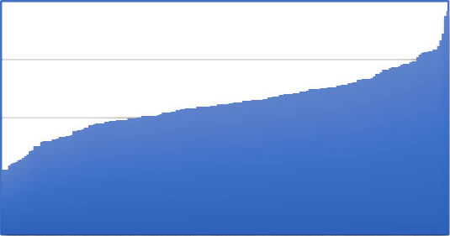

Math
0.60
0.40
0.20
0.00
-0.20
-0.40
-0.60
3.5

3.0

2.5

2.0

1.5

Science
End of year score distributions
(on a 0.0 – 4.0 scale)

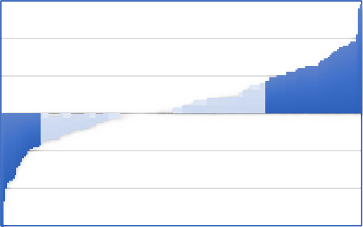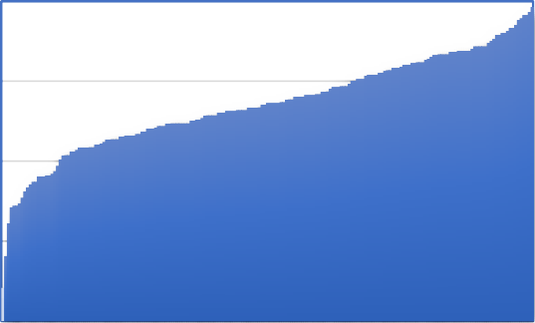
0.60

0.40

0.20

0.00

-0.20

-0.40

-0.60
3.5
3.0
2.5
2.0
1.5

Students, parents and school-day teachers had positive perceptions of the 21st CCLC programs

Analyses of the perceptions of the students, parents and teachers about the 21st CCLC programs revealed that on average, perceptions of the program were high across the groups. The mean perception of students about their program was 2.68. This means that the mean students’ satisfaction of the 21st CCLC programs was more than halfway between “somewhat” = 2 and “definitely” = 3 across all programs. Variance decomposition of the students’ perception scores revealed higher between program variation in students’ perception of the programs with 14.5 percent. On a three-point scale, the difference between a student in a program at the 75th percentile in terms of mean students’ perception of the program and a student in a program at the 25th percentile was 0.19 (see Table 3).

Table 3. Performance of 21st CCLC programs in terms of students’, parents’, and teachers’ perceptions of the programs

Outcomes | Average across the 21st  CCLC  Programs | Percentage of variation between 21st CCLC  Programs | Avg. scores of students in a program at the 75th percentile and 25th percentileª
Students’ perception of the program | 2.68  (on a 1-3 scale) | 14.5 | 2.79 - 2.60
Teachers’ perceived impact of the program | 2.96  (on a 1-4 scale) | 11.8 | 3.07 - 2.87
Parents’ perception of the program | 4.63  (on a 1-5 scale) | 8.2 | 4.72 - 4.54
Parents’ perceived impact of the program | 4.50  (on a 1-5 scale) | 7.0 | 4.60 - 4.41
Note: The analytical sample for the students’ perception of the program consisted of 25,454 students and 195 programs, the analytical sample for the teachers’ perceived impact of the program consisted of 23,416 teachers and 173 programs, the analytical sample for the parents’ perception of the program consisted of 15,973 parents and 191 programs, and the analytical sample for the parents’ perceived impact of the program consisted of 15,914 parents and 191 programs.

a. The study team calculated the average scores for a student in a program at the 75th percentile and 25th percentile using the actual rankings of the programs based on the estimated program effects.

Across the 21st CCLC programs, the mean ranking of teachers’ perceived impact of the program on students’ academic and personal development was
2.96. This suggests that on average, the day-to-day teachers of students in 21st CCLC programs assessed that students’ skills and behaviors such as their academic performance, motivation, attendance and engagement improved. For teachers’ perceived impact of the program, the percent of the between program variation was 11.8. For a 21st CCLC program with higher teachers’ perceived impact - at the 75th percentile - the mean perceived impact was 3.07 while it was
2.87 for a program with lower teachers’ perceived impact - at the 25th percentile.

Regarding parents’ perceptions of the program, parents’ average satisfaction scores (i.e., perception of the activities, safety and staff of the program) were 4.63. Parents’ scores for their perceptions of the program impacts (i.e., perceptions of how the program improved outcomes for their children) were 4.50. This means that parents were, on average, halfway between “satisfied” and “very satisfied” with the overall program as well as their child’s improvement in academic (e.g., grades) and non-academic (e.g., homework completion, getting along with others, staying out of trouble) areas.
For the percent of between program variation – that is, the extent of differences between programs - parents’ perceptions of the program were lower at 8.2 percent and 7.0 percent than the percent of between program variation for both students’ (14.5%) and teachers’ (11.8%) perceptions of the program.
This suggests that in general, the parents’ level of satisfaction was high across the 21st CCLC programs. Figure 2 shows the distribution of students’, parents’, and teachers’ perceptions of the 21st CCLC programs.

Figure 2
Distribution of the perceptions of students, parents, and teachers of the 21st CCLC programs

Students’ perception of the program
(on a 1.00 – 3.00 scale)
Teachers’ perceived impact of the program
(on a 1.00 – 4.00 scale)

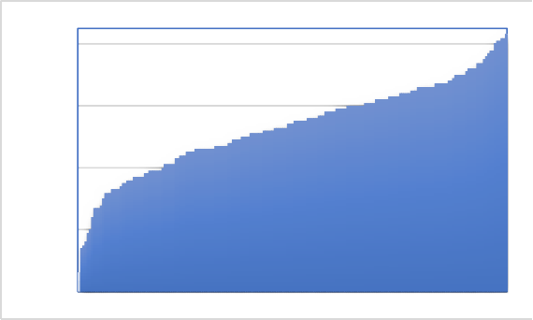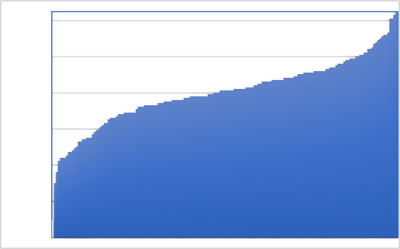

2.95

2.75

2.55

2.35

2.15
3.35
3.15
2.95
2.75
2.55
2.35
2.15

Parents’ perception of the program
(on a 1.00 – 5.00 scale)
Parents’ perceived impact of the program
(on a 1.00 – 5.00 scale)

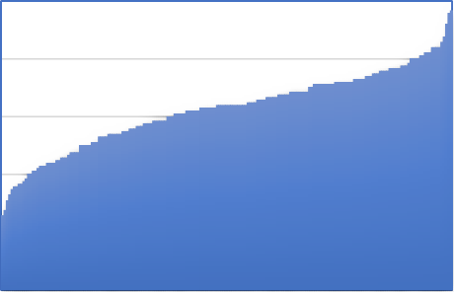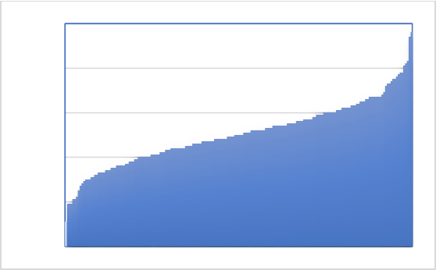
5.00

4.80

4.60

4.40

4.20

4.00
5.00

4.80

4.60

4.40

4.20

4.00

There was considerable variation between 21 ^{st} CCLC programs in terms of students’ attendance

Results of the HLM models revealed considerable differences between 21st CCLC programs in terms of the mean days of attendance among their students. For summer attendance, 40.9 percent of the variation was between programs and for academic year attendance 31.6 percent of the variation was between programs (Table 4). This suggests that while some programs were effective in

maintaining a high attendance rate among their students, other programs struggled with student attendance.

Table 4. Performance of 21st CCLC programs in terms of students’ attendance

Outcomes | Average across the 21st CCLC  Programs | Percentage of variation between 21st  CCLC Programs | Avg. attendance of students in a program at the 75th percentile  and 25th percentileª
Academic attendance days | 90 | 31.6 | 114 - 68
Summer attendance days | 20 | 40.9 | 25 - 15
Note: The analytical sample for the academic attendance days of the program consisted of 51,205 students and 212 programs, the analytical sample for the summer attendance days of the program consisted of 20,686 students and 139 programs. From the summer attendance days, attendance days of 178 and 95 were identified as outliers and removed from the analyses.

a. The study team calculated the average attendance for a student in a program at the 75th percentile and 25th percentile using the actual rankings of the programs based on the estimated program effects.

For academic year attendance, the estimated days of attendance for a student in a program at the 75th percentile (in terms of mean attendance days) was 114 days while it was 68 days for a student in a program at the 25th percentile. This corresponds to 46 days difference between attendance of a student in a high-performing program in terms of their students’ attendance and a student in a low-performing program in terms of attendance. The mean academic attendance days was 90 across the 21st CCLC programs.
For the summer attendance rate, the estimated days of attendance for a student of a program at the 75th percentile (in terms of mean attendance days) was 25 days while it was 15 days for a student in a program at the 25th percentile corresponding to 10 days difference. The mean summer attendance days was 20 across the programs. See Figure 3 for the distribution of the mean academic and summer attendance days.

Figure 3
Distribution of the mean academic and summer attendance days of the 21st CCLC programs
Academic attendance | Summer attendance

170.00
150.00
130.00
110.00
90.00
70.00
50.00
30.00
10.00
50.00

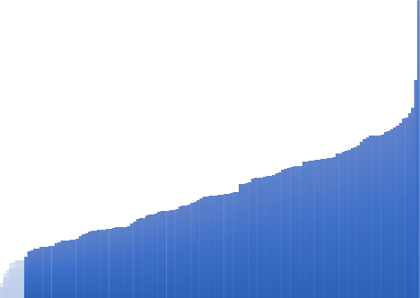
45.00
40.00
35.00
30.00
25.00
20.00
15.00
10.00
5.00

21st CCLC programs performed better in non-academic domains than academic domains

Analyses comparing programs in terms of their performances in both academic and non-academic domains using the percent of students meeting the standards of success as an outcome revealed that 21st CCLC programs perform better in non-academic domains than academic domains in general. As predicted in Figure 4, across academic domains less than 65 percent of the students in programs met the standard of success while for non-academic domains more than 80 percent of the students in programs met the standard of success. Non-academic domains included adult programs, dropout prevention and college/career readiness, and personal enrichment.

Figure 4. Percent of students meeting the standard of success in academic and non-academic domains
Percent meeting the standard of success
90.0%
85.3%
85.0%

80.0%

75.0%

70.0%

65.0%
64.0%
60.0%
61.4%
58.8%
55.0%

50.0%
Non-academic domains
Pers. Enr.
Dropout P. &
CCR
Adult Prg.
Academic domains
Science
Math
ELA
82.9%
82.2%

Students’ attendance rate is associated with higher academic performance

Analyses of students’ attendance revealed that student attendance was related with the students’ academic performance. The study team examined the average days of attendance for students who received F, D, C, B, and A at the end of the school year in ELA, science and math. As depicted in Figure 5, the average days of attendance in an academic year was lowest for students who received a grade of F (70 days for ELA, 71 days for math, and 65 days for science). With the increase in the end of the year grades on the horizontal-axis of the graph, the average days of attendance in the academic year increased (although there were slight drops in the average days of attendance for students who received a B to students who received an A in math and ELA). Students who received an A in ELA had an average of 89 days of attendance, those who received an A in math had 90 days of average attendance, and in science those

who received an A had 93 days of average attendance. This finding suggests that maintaining high student attendance has the potential to improve academic outcomes of students in the 21st CCLC programs.

Figure 5. Average days of attendance in the academic year for students who received grades of F, D, C, B, and A in ELA, science, and math
Mean academic attendance days
95

90

85

80

75

70
Science
Math ELA
65
0-(F)
1-(D)
2-(C)
3-(B)
4-(A)

Grade level, average perception of the programs, and benchmarks were associated with academic outcomes

Analyses examining the factors that were associated with the percent of students meeting the standard of success revealed that grade level, average perception of the programs, and benchmarks were associated with academic outcomes as measured by the percent of students meeting the standard of success (Table 5).
21st CCLC programs for elementary school students outperformed the programs for middle and high school students on academic outcomes.
Programs for middle school grades had a decrease of 7.4 percent of students meeting the standard of success in academic domains than programs targeting

elementary school students. Programs for high school students had a decrease of 9.5 percent of students meeting the standard of success than elementary school students. (See further follow-up analyses below).
There was a positive relationship between 21st CCLC programs’ benchmark levels and academic performance of the programs. As a part of the mandated performance evaluation of the 21st CCLC programs, along with the standard of success, programs were also required to set goals for what percent of the participants will achieve the standard of success. This percentage level was the benchmarks of the programs. Considering that programs serve students in different locations and to different populations, they had liberty to select benchmark levels for the domains based on the status of the populations they serve. Results indicated that 21st CCLC programs that had higher benchmarks tend to have a higher percent of students meeting the standard of success in academic domains. Programs that had a benchmark between 55 and 75 percent of the participating students had 16.9 percent more students meeting the standard of success than programs which had a benchmark of 50 percent or less. Programs that had 80 percent and higher benchmark levels had
22.2 percent more students who met the standard of success.

In terms of perceptions about the program, 21st CCLC programs for which day-to-day teachers perceived a high mean impact for students, tended to have a higher percent of students meeting the success standards (B = 24.20). For students’ perceptions about the program, this association was negative (B = -8.40).

Table 5. Regression outcomes of 21st CCLC programs in terms of factors associated with academic outcomes

Academic outcomes | B | Std. Error | Beta | t | Sig.
(Constant) | 33.00 | 15.70 |  | 2.102 | 0.036
Programs avg. student perception | -8.40 | 4.30 | -0.07 | -1.974 | 0.049
Programs avg. teacher perception | 24.20 | 2.90 | 0.24 | 8.341 | 0.000
Programs avg. parent’s perception | -7.00 | 3.80 | -0.06 | -1.836 | 0.067
Programs’ grade level
Middle school vs. elementary | -7.40 | 1.20 | -0.19 | -6.370 | 0.000
High school vs. elementary | -9.50 | 2.00 | -0.13 | -4.874 | 0.000
Programs’ benchmark level
Between 55 and 75 percent vs. 50 percent and lower | 16.90 | 1.20 | 0.43 | 13.654 | 0.000
80 percent and higher vs. 50 percent and lower | 22.20 | 1.70 | 0.40 | 12.900 | 0.000
Note: The analytical sample consisted of 1049 program domains.

One possible factor leading to the positive relationship between grade levels that a program serves and the percent of students meeting the standard of success in academic domains might be differences between students’ attendance in different grade levels, which we could not control for in this analysis where the data was at the program domain level. However, using student level data, we explored whether there was a relationship between students’ attendance and grade level. As seen in Figure 6, the average days of students’ attendance decreased in higher grade levels. This suggests that the attendance rate in different grade levels might explain to some extent the relationship between grade levels of the programs and their performance.

Figure 6. Average academic attendance days of students in grades 1 to 12
100
90
80
70
60
50
40
30
20
10
0
1
2
3
4
5
6
7
8
9
10
11
12
Average attendance day

Grade levels
 | 1 | 2 | 3 | 4 | 5 | 6 | 7 | 8 | 9 | 10 | 11 | 12
Avg. attendance | 78 | 86 | 86 | 85 | 79 | 60 | 60 | 55 | 35 | 31 | 29 | 26

Teachers’ average perceived impacts of the program were associated with non-academic outcomes

For non-academic outcomes, only the average of teachers’ perceived impacts of the program was positively associated with non-academic outcomes (B = 18.60). In contrast to academic outcomes, there were no differences between programs serving elementary, middle and high school students as well as programs with different benchmark levels in terms of the percent of students meeting the standard of success in non-academic domains (Table 6).

Table 6. Regression outcomes of 21st CCLC programs in terms of factors associated with non-academic outcomes

Non-academic outcomes | B | Std. Error | Beta | t | Sig.
(Constant) | -8.80 | 21.80 |  | -0.405 | 0.686
Programs avg. student perception | -0.40 | 6.10 | 0.00 | -0.058 | 0.954
Programs avg. teacher perception | 18.10 | 4.10 | 0.16 | 4.391 | 0.000
Programs avg. parent’s perception | 8.40 | 5.50 | 0.06 | 1.547 | 0.122
Programs’ grade level
Middle school vs. elementary | -1.00 | 1.60 | -0.02 | -0.624 | 0.533
High school vs. elementary | -0.90 | 2.50 | -0.01 | -0.353 | 0.724
Programs’ benchmark level
Between 55 and 75 percent vs. 50 percent and lower | 0.90 | 2.20 | 0.02 | 0.413 | 0.679
80 percent and higher vs. 50 percent and lower | 1.90 | 2.20 | 0.04 | 0.856 | 0.392
Note: The analytical sample consisted of 866 program domains.

Discussion and Conclusions

This evaluation is the first to provide an overall evaluation of the outcomes of the 21st CCLC program in the state of Florida.
The results suggest that 21st CCLC programs, on average, had a moderate level of performance concerning student letter grade scores and did not vary much across the programs. In the analyses of the students' letter grades, the study team included data of students who had at least one day of attendance in the program. Considering that analyses also revealed that student attendance was related to students' academic performance, restricting analyses to a group of students who participated in the programs regularly or students who had attendance records larger than a certain threshold would likely create larger overall gains. The study team preferred not to restrict the analytical sample considering students' attendance, as maintaining a high attendance rate is one of the programs' challenges. In fact, examining the students' attendance as an outcome revealed large between program variation, suggesting that while some programs effectively maintained a high attendance rate among their students, other programs struggled to keep their students' attendance record high.
Another observed difference between the programs was between academic and non-academic domains. Results suggested that, in general, 21st CCLC programs perform better in non-academic domains than academic domains using the percent of the students meeting the standards of success as an outcome. This is similar to other studies that have found larger effects for afterschool programs on non-academic outcomes as compared to academic outcomes (Neild et al., 2019). In the analyses of the non-academic outcomes, day-to-day teachers' perceived impact of the program was the only factor associated with the percent of students meeting the standard of success in non-academic domains. On the other hand, analyses of the academic outcomes revealed that, in addition to day-to-day teachers' perceived impact of the program, grade level and benchmarks were associated with the

percent of students meeting the standard of success in academic domains. For academic domains, assessments and standards of success were common across the programs, while in non-academic domains, both measures and standards of success varied from program to program. This variation might introduce error, which might cloud the actual systematic variation between programs. This might explain why some factors were found to be not related to the programs' performance in non- academic outcomes.
For the relationship between grade levels that a program serves and the percent of students meeting the standard of success in academic domains, further analyses suggested that attendance rate in different grade levels might contribute to this relationship. For the positive relationship between 21st CCLC programs’ benchmark levels and the percent of students meeting the standard of success, the differences between the populations of the programs that they serve might be one factor contributing to that relationship. Presumably programs set their benchmarks based on status of the population they serve. Programs that serve students with high prerequisite knowledge and skills might set high benchmarks. Besides having a high-performing population, setting high expectations for students and for program teachers by itself might contribute to better performance.

Limitations
The analytic design of this study is correlational and limited to measuring associations. Accordingly, it is not possible to identify a causal relationship in any analyses conducted in this study.
Another limitation of the study was that factors such as day-to-day teacher effect, day-to-day school effect, students’ prior achievement, students’ SES, and students’ motivation - all of which might be highly associated with academic performance of the students - were not taken into account in these analyses. Only in the analyses of the student gain from quarter-1 to the end of the school year did gain scores take into account the possible pre-existing differences of each

programs’ population in terms of their students’ prior academic performance. But these analyses still did not control for the learning happening in day-to-day school. Another limitation of the gain measure was that the gain in students’ performance accounted for ¾ of the school year instead of the whole school year. Since the baseline report cards were not available to the study team, this was the best alternative to capture the gain in students’ grade scores.
While analyses had limitations in attributing observed findings to the 21st CCLC programs, the association between the attendance of students in 21st CCLC programs and their performance provides some evidence supporting the role of the 21st CCLC program in students’ learning (although student motivation might be one confounding factor in this relationship as well).
In the program level dataset, the percent of participants meeting the standard of success in a particular domain provided a common metric across all programs and domains. Yet, since the standards of success and assessments used to measure it varied across the 21st CCLC programs, findings regarding non-academic domains should be interpreted with caution.
There might be other program features which were not examined in this study that might be associated with the programs’ performance in academic and non- academic domains such as experience (age) of the program, credentials and experience of teachers in the programs, or locations of the programs, among others.

Recommendations
These findings suggest that one way that programs can improve student outcomes can be by maintaining higher attendance rates for their participating students. Findings also revealed that while some programs were effective in maintaining a high attendance rate among their students, other programs struggled with keeping their students’ attendance record high. These results suggest that the 21st CCLC program office may find it valuable to follow up with high performing programs in terms of maintaining high student attendance. Identifying working methods that high-performing programs use can be adopted by the programs that

struggle in maintaining high attendance. Similar actions can be taken for improving outcomes in the domain of science as results suggest that a few 21st CCLC programs separated from others due to their relatively better performance while a few other programs separated due to their relatively poor performance.
The findings suggest that 21st CCLC programs that had higher benchmarks tend to have a higher percent of students meeting the standard of success in academic domains. Encouraging programs to set high expectations for their students might increase the performance of the programs.
The findings suggest that averaged across all day-to-day teachers of students in a program, their assessment of improvement in students’ behaviors provides information about programs that predicts programs’ performance in academic and non-academic domains. In light of this, obtaining more inputs throughout the school year from day-to-day teachers of the students in the 21st CCLC programs might provide valuable feedback for the programs.

References

Afterschool Alliance. (2020). Afterschool in Florida. Retrieved from: https://afterschoolalliance.org/policyStateFacts.cfm?state=FL
Knoph, J. A., Hahn, R. A., Proia, K. K., Truman, B. I., Johnson, R. L., Muntaner, C., Fielding, J. E., Jones, C. P., Fullilove, M. T., Hunt, P. C., Qu, S., Chattopadhyay,
S. K., & Milstein, B. (2015). Out-of-school-time academic programs to improve school achievement: A community guide health equity systematic review. Journal of Public Health Management and Practices, 21(6), 594-608.
Lauer, P. A., Akiba, M., Wilkerson, S. B., Apthorp, H. S., Snow, D., & Martin-Glenn, M.
L. (2006). Out-of-school time programs: A meta-analysis of effects for at-risk students. Review of Educational Research, 76(2), 275-313.
Neild, R.C., Wilson, S.J., & McClanahan, W. (2019). Afterschool programs: A review of evidence under the Every Student Succeeds Act. Philadelphia: Research for Action.
U.S. Department of Education (USDOE), Office of Elementary and Secondary Education Academic Improvement and Teacher Quality Programs. (February, 2003). 21st Century Community Learning Centers: Non-regulatory guidance. Retrieved from: https://www2.ed.gov/programs/21stcclc/guidance2003.pdf
U.S. Department of Education. (2018). 21st Century Community Learning Centers (21st CCLC) analytic support for evaluation and program monitoring: An overview of the 21st CCLC performance data: 2016–17 (13th report). Washington, DC.

Appendix

Table 1: Means and standard deviations for items about students’ perception of the program

Item  (n = 24,978) | Mean | SD
Do you enjoy the activities in your afterschool program? | 2.68 | 0.545
Does your afterschool program have adults who care about you? | 2.79 | 0.471
Do you feel safe at your afterschool program? | 2.77 | 0.485
Does your afterschool program help you get along well with others? | 2.57 | 0.622
Does your afterschool program help you understand that following rules is important? | 2.79 | 0.478
Does your afterschool program help you solve problems in a positive way? | 2.67 | 0.574
Does your afterschool program help you with your homework? | 2.68 | 0.608
Does your afterschool program help you improve your grades? | 2.62 | 0.636
Scale: 1 (not at all), 2 (somewhat), 3 (definitely)

Table 2: Means and standard deviations for items about teachers’ perceived impact of the program

Item  (n = 23,169) | Mean | SD
Turning in homework on time | 2.96 | 0.737
Completing quality homework to your satisfaction | 2.92 | 0.716
Paying attention and participating in class | 2.92 | 0.713
Volunteering (e.g., for extra credit or more responsibilities) | 2.85 | 0.747
Attending class regularly | 3.14 | 0.767
Being attentive in class | 2.95 | 0.743
Behaving well in class | 3.00 | 0.792
Academic performance (e.g., improved grades, learning gains) | 2.90 | 0.667
Coming to school motivated to learn | 2.93 | 0.724
Getting along well with other students (positive interactions) | 3.03 | 0.750
Self-efficacy (belief they can do well in school) | 2.96 | 0.674
Scale: 1 (declined), 2 (no change), 3 (improved), 4 (did not need to improve)

Table 3: Means and standard deviations for items about parents’ satisfaction with the program

Item  (n = 15,481) | Mean | SD
Indicate the level of satisfaction in the following areas:
This afterschool program as a whole | 4.70 | 0.563
Staff’s warmth and friendliness | 4.69 | 0.569
Staff’s ability to work with my child | 4.67 | 0.584
Staff’s ability to relate and reach out to me as a parent | 4.63 | 0.631
Variety of activities offered to my child | 4.61 | 0.631
Safety of the program environment | 4.68 | 0.571
My child’s happiness with the program | 4.65 | 0.610
Helping me become more involved with my child’s education | 4.58 | 0.659
Scale: 1 (very unsatisfied), 2 (unsatisfied), 3 (not sure), 4 (satisfied), 5 (very satisfied)

Table 4: Means and standard deviations for items about parents’ perceived impact of the program

Item  (n = 15,637) | Mean | SD
Indicate the level of satisfaction with your child’s improvement in the following areas since participating in this program:
Homework completion | 4.45 | 0.800
Academic performance (i.e., grades, learning gains) | 4.50 | 0.709
Getting along with others (i.e., peers, different cultures) | 4.57 | 0.648
Staying out of trouble | 4.59 | 0.642
Scale: 1 (very unsatisfied), 2 (unsatisfied), 3 (not sure), 4 (satisfied), 5 (very satisfied)

