

2021-24 American Rescue Plan
Elementary and Secondary School Emergency Relief Fund
St. Johns County School District ARP ESSER Plan,
Application and Assurances
TAPS NUMBER: 22A-175

St. Johns County School District - 55

Purpose
Florida must subgrant not less than 90 percent of its total ARP ESSER allocation to local educational agencies (LEAs) (including charter schools that are LEAs) to help meet a wide range of needs arising from the coronavirus pandemic, including reopening schools safely, sustaining their safe operation, and addressing students’ social, emotional, mental health, and academic needs resulting from the pandemic. The State must allocate these funds to LEAs on the basis of their respective shares of funds received under Title I, Part A of the Elementary and Secondary Education Act of 1965 (ESEA) in fiscal year (FY) 2020.

The purpose of this document is to guide districts to plan for the continued implementation of reopening and recovery through the utilization of the 2021-24 ARP ESSER and to assure federal requirements are met. Florida utilized the 2020-21 District Reopening Plan and the Spring 2021 Education Plan to respond to and mitigate the impact of the emergency and to promote the health, safety, and welfare of persons connected with Florida’s educational system.

The Department recognizes that the safe return to in-person instruction must be accompanied by a focus on meeting students’ academic, social, emotional, and mental health needs, and by addressing the opportunity gaps that existed before – and were exacerbated by – the pandemic. In this document, districts will describe how they will support the development of high-quality plans for the use of ARP ESSER funds to achieve these objectives for the following student groups: students from low-income families, from each racial or ethnic background, by gender, English Language Learners, students with disabilities, experiencing homelessness, in foster care, migratory students and other student groups.

Directions
Districts shall submit its ARP ESSER application to the Office of Grants Management via ShareFile on or before November 12, 2021. ShareFile access has been established for the ARP ESSER Lump Sum program for each LEA. The complete application shall include:

- LEA ARP ESSER Plan, Application and Assurances utilizing this template;
- DOE 100A Project Application Form; and
- DOE 101 Budget Narrative Form.

Each LEA developed and made publicly available on the LEA’s website a plan for the safe return of in-person learning in the Fall of 2020. This was before the enactment of the ARP Act. This plan must be updated to address the requirements of the U.S. Department of Education’s Interim Final Rule, 88 FR 21195. The requirements of the Interim Final Rule are summarized in Appendix A. Each LEA shall seek public comment on the updated plan and take such comments into account prior to the submission of the final plan to the Department. Updated plans must comply with state law, including any applicable executive order, any agency emergency action, or any agency regulation or rule. No later than 60 days from receipt of its DOE 200, Project Award Notice, each LEA shall email its updated final plan to recoveryplan@fldoe.org. The subject line of the email must include district name and Plan for the Safe Return of In-person Instruction. Upon the Department’s approval, the LEA shall post this plan on the LEA’s website within 90 days of the award.

Part I: Implementation Plan

The LEA will submit an implementation plan, outlining planned activities for each of the following uses of funds under section 2001(e) of the ARP Act. The description must be adequate to ascertain that the proposed use of funds is necessary to prevent, prepare for, or respond to the COVID-19 pandemic, including its impact on the social, emotional, mental health, and academic needs of students.
Activities should be numbered consecutively. If the LEA does not plan any activities for one or more authorized uses, please indicate that there are no planned activities. School district LEAs shall include the activities identified for charter schools within the LEA, aggregated at the district/LEA level.

Activity 1: Addressing Learning Loss (at least 20% of total allocation). Of the total amount allocated to an LEA, the LEA must reserve at least 20 percent of funds to address learning loss through the implementation of evidence-based interventions such as summer learning or summer enrichment, extended day, comprehensive afterschool programs, or extended school year programs, and ensure that those interventions respond to students’ social, emotional, and academic needs and address the disproportionate impact of COVID-19 on underrepresented student subgroups (each major racial and ethnic group, children from low-income families, children with disabilities, English learners, gender, migrant students, students experiencing homelessness, and children and youth in foster care).
  - Achieve 300) Level Set Assessment for High School students. The district will utilize the Achieve 3000 Level Set Assessment. Achieve3000 is used to diagnose the needs of our Intensive Reading students in grades 9-11. Using Lexile Frameworks for Reading, the instructional component provides the right level of challenge for each learner and continuously monitors progress towards goals. Achieve3000 is closely aligned with state standards to coordinate students’ literacy growth with the content-area knowledge they need at a customized level that each student can access. Total Cost - $77,00.00
  - Apex Learning - Apex Learning® Comprehensive Courses make it possible to offer a credit recovery program that addresses the diverse learning needs of all credit recovery students. The district utilizes credit recover for students in middle school and high school needing alternative avenues to grade level learning and course credit. Total Cost - $220,000.00
  - The district utilizes districtwide benchmark assessments to assess student understanding of concepts, track standards mastery, determine remediation teaching and learning strategies, and move students toward grade level achievement. The Certica Navigate Item Bank provides the district with a repository of standards-based assessment items utilized in the development and implementation of benchmark assessments in the elementary grades K-5. Total Cost - $50,000.00.
  - Conscious Discipline Professional Development (All K-2 grade teachers) - "Conscious Discipline’s foundation of safety, connection and problem-solving is leading a revolution of the heart as concepts initially applied in the classroom extend to every facet of our lives."- Professional Development on Site - Stipend - Mandatory (Hourly Rate Avg $37.00 per hour and 15% Benefits) - 8 hours per teacher. Total Cost - $199,474.00
  - Conscious Discipline Professional Development (All K-2 grade teachers) - "Conscious Discipline’s foundation of safety, connection and problem-solving is leading a revolution of the heart as concepts initially applied in the classroom extend to every facet of our lives."- Professional Development on Site - Professional Development on Site – Fee. Total Cost - $75,000.00
  - Certified Teachers will be placed at 6 elementary schools (OES, WES, CES, SWES, MES, KES) which are identified as district higher poverty elementary schools. Purpose is to improve learning loss for students below grade level. High Poverty Schools (PK - Grades) - 4 + 2 Elementary Schools - (3 teachers x 6 schools – 18 teachers) (2022-2023). Total Cost - $1,134,000.00
  - Certified Teachers will be placed at 6 elementary schools (OES, WES, CES, SWES, MES, KES) which are identified as district higher poverty elementary schools. Purpose is to improve learning loss for students below grade level. High Poverty Schools (PK - Grades) - 4 + 2 Elementary Schools - (3 teachers x 6 schools – 18 teachers) (2023-2024). Total Cost - $1,134,000.00
  - The Intensive Reading Response Team will work directly with teachers in the elementary, middle, and high schools to provide classroom demonstrations in rigorous standards-based teaching. The Team will provide collaborative and one-on-one instructional guidance and will facilitate teacher inquiry and related professional development. The Intensive Reading Response Team will work with administrators and teachers to align their work with district priorities. The Team will lead data sessions that look at both formative and summative assessment results and suggest and monitor intervention strategies and materials for struggling students. The Intensive Reading Response Team will focus on enhancing teachers’ abilities to provide instruction that builds students’ literacy skills, is academically rigorous, addresses the curriculum standards and enhances students’ engagement and ownership of their learning. In addition, as a member of a professional community, the Intensive Reading Response Team will participate in professional development and inquiry into his or her own practice. The primary role focus points of the Intensive Reading Response Team are:
  - Support
  - MTSS/RTI Intervention
  - Mentor
  - Train
  - Plan
  - Model
  - Provide Research and Evidence-Based Interventions and Strategies
  - Co-Teach
3 positions (2022-2023) TOA – ILC – Total Cost - $189,000.00
  - The Intensive Reading Response Team will work directly with teachers in the elementary, middle, and high schools to provide classroom demonstrations in rigorous standards-based teaching. The Team will provide collaborative and one-on-one instructional guidance and will facilitate teacher inquiry and related professional development. The Intensive Reading Response Team will work with administrators and teachers to align their work with district priorities. The Team will lead data sessions that look at both formative and summative assessment results and suggest and monitor intervention strategies and materials for struggling students. The Intensive Reading Response Team will focus on enhancing teachers’ abilities to provide instruction that builds students’ literacy skills, is academically rigorous, addresses the curriculum standards and enhances students’ engagement and ownership of their learning. In addition, as a member of a professional community, the Intensive Reading Response Team will participate in professional development and inquiry into his or her own practice. The primary role focus points of the Intensive Reading Response Team are:
  - Support
  - MTSS/RTI Intervention
  - Mentor
  - Train
  - Plan
  - Model
  - Provide Research and Evidence-Based Interventions and Strategies
  - Co-Teach
3 positions (2023-2024) TOA – ILC – Total Cost - $189,000.00
  - MTSS provides a framework for implementing evidence-based practices to meet the needs of all students, using data to guide educational decisions to improve academic, social, emotional, and behavioral outcomes. Critical to the framework are data systems aligned to provide support for: (a)High-dosage tutoring that is directly tied to classroom content – helping students succeed in their coursework – can substantially accelerate learning in both math and reading for students struggling the most. (b) Strong systems to monitor for early student warning signs paired with strong collaborative teams that work to ensure students receive effective Tier 1 and Tier 2 learning supports. Framework data systems include Performance Matters and Unified Insights – Hoonuit which work interchangeably and seamlessly with the student data systems eSchool Plus and Schoology. (2022-2023) Total Cost - $389,900.00
  - MTSS provides a framework for implementing evidence-based practices to meet the needs of all students, using data to guide educational decisions to improve academic, social, emotional, and behavioral outcomes. Critical to the framework are data systems aligned to provide support for: (a)High-dosage tutoring that is directly tied to classroom content – helping students succeed in their coursework – can substantially accelerate learning in both math and reading for students struggling the most. (b) Strong systems to monitor for early student warning signs paired with strong collaborative teams that work to ensure students receive effective Tier 1 and Tier 2 learning supports. Framework data systems include Performance Matters and Unified Insights – Hoonuit which work interchangeably and seamlessly with the student data systems eSchool Plus and Schoology. (2023-2024) Total Cost - $389,900.00
  - Provide school leaders, teachers, and district stakeholders with the resources and supplies (STEM, CTE, AVID, ARTS, remediation, acceleration) necessary to address the needs of schools. (2022-2023) Total Cost - $50,000.00
  - Provide school leaders, teachers, and district stakeholders with the resources and supplies (STEM, CTE, AVID, ARTS, remediation, acceleration) necessary to address the needs of schools. (2023-2024) Total Cost - $50,000.00
  - Provide school leaders, teachers, and district stakeholders with the software resources (STEM, CTE, AVID, ARTS, remediation, acceleration) necessary to address the needs of schools. (2022-2023) Total Cost - $50,000.00
  - Provide school leaders, teachers, and district stakeholders with the software resources (STEM, CTE, AVID, ARTS, remediation, acceleration) necessary to address the needs of schools. (2023-2024) Total Cost - $50,000.00
  - Provide school leaders, teachers, and district stakeholders with the technology resources (STEM, CTE, AVID, ARTS, remediation, acceleration) necessary to address the needs of schools. (2022-2023) Total Cost $60,000.00
  - Provide school leaders, teachers, and district stakeholders with the technology resources (STEM, CTE, AVID, ARTS, remediation, acceleration) necessary to address the needs of schools. (2023-2024) Total Cost $60,000.00
  - Summer School Recovery Programs (2022) Funding to support staff, including teachers, ESOL and Exceptional Student Education resource teachers, and bus drivers, in the implementation of the summer school program which will focus on acceleration of reading and mathematics foundational skills and enrichment programs at the elementary and middle school level, and course credit recovery to ensure on-time graduation at the high school level. Instruction and/or Transportation Summer School Recovery Programs (2022) Total Cost $250,000.00
  - Summer School Recovery Programs (2023) Funding to support staff, including teachers, ESOL and Exceptional Student Education resource teachers, and bus drivers, in the implementation of the summer school program which will focus on acceleration of reading and mathematics foundational skills and enrichment programs at the elementary and middle school level, and course credit recovery to ensure on-time graduation at the high school level. Instruction and/or Transportation Summer School Recovery Programs (2023) Total Cost $250,000.00

Total Learning Loss - $4,867,274.00

1-20 Charter Schools Allocations aligned with learning loss - $28,916.00

Activity 2 (A) Any activity authorized by the Elementary and Secondary Education Act of 1965.

2A-1 Professional Development Alternative Certification – Teacher Mentors. As evidenced through the observations and feedback gathered during a recent FLDOE VPDP site visit, the power of school-based mentoring following the updated FLDOE CET/Mentor model has a positive impact on improving instructional practice in our new teachers. Due to the expectations of mentors who truly implement the coaching practices involved in this model, we would like to provide a small stipend to both compensate for invested time of those who have willingly taken on this responsibility and to incentivize participation as one of our teacher mentors. (375 participants - $1,500.00 per participant) Total Cost - $562,500.00
2A-2 Professional Development Alternative Certification - Alternative Certification –- St. Johns County has many second career teachers known as Alternative Education Teachers. The district has applied to the Florida Department of Education to host their own Professional Development Certification Program (PDCP) to better assist, support, and retain alternative education teachers in the school district. For Alternative Education teachers to gain permanent certification, this 3-year program would provide ongoing professional development in the areas of high-quality assessments, accessing students’ academic progress, strategies to meet individual student’s needs, providing training in differentiated instruction, evidence-based activities, ELA, and Math B.E.S.T. standards, Wilson Fundations Phonics program, Schoology, Performance matters and acceleration. Funds would be used to waive the cost of the three-year program to support Alternative Teachers attending the training. Due to the expected number of Alternative Education teachers in our district, we would like to incentivize participation in the SJCSD PDCP program so we can better guide and support our new teachers to the profession. (375 Participants (50% of $1300.00 Per Teacher Cost)) Total Cost - $243,750.00
2A-3 School Level Support to include (a) Hourly Funding for teachers and other school staff to work with students. (b) Additional Collaborative Time for teachers to plan and complete data analysis on student progress. (c) Hire tutors/monitors to enable teachers to provide intervention. (d) Hire Behavior Interventionists for Tier 1 support as needed. Allocation based on Learning Loss and Needs Assessment with existing guidance from federal and state programs authorized by Every Student Succeeds Act (ESSA). (2022-2023) Total Cost $800,000.00
2A-4 School Level Support to include (a) Hourly Funding for teachers and other school staff to work with students. (b) Additional Collaborative Time for teachers to plan and complete data analysis on student progress. (c) Hire tutors/monitors to enable teachers to provide intervention. (d) Hire Behavior Interventionists for Tier 1 support as needed. Allocation based on Learning Loss and Needs Assessment with existing guidance from federal and state programs authorized by Every Student Succeeds Act (ESSA). (2023-2024) Total Cost $800,000.00
2A-5 Certification testing requirements for teachers of Exceptional Children Education and/or Gifted students. 300 (2022-2023) – Total Cost - $45,000.00
2A-6 Certification testing requirements for teachers of Exceptional Children Education and/or Gifted students. 300 (2023-2024) – Total Cost - $45,000.00
2A-7 Instructional Inservice Training days (one) - August 1, 2023 - Funds are being requested as an effort to recover professional development time lost for instructional personnel resulting from COVID. Specifically, the St. Johns County School District was closed from March 13, 2020, through June 2020 while teachers stayed at home and taught via distance learning. During the spring of 2020 and again during the 2020-2021 school year, there has been little or no time for teachers to collaborate, receive professional development or converse with each other on best practices/planning due to social distancing. The grant will provide one-time funding for instructional personnel to have one full day preceding their start of the 2023-2024 school year. This will allow the district to provide ongoing professional development on the B.E.S.T. standards in both reading and math, receive further training in the new ELA textbooks, and receive ongoing PD relevant to the needs of each instructional staff member. (2023-2024) Total Cost - $800,000.00
2A-8 Instructional Inservice Training days (two) - August 2, 2022 - Funds are being requested as an effort to recover professional development time lost for instructional personnel resulting from COVID. Specifically, the St. Johns County School District was closed from March 13, 2020, through June 2020 while teachers stayed at home and taught via distance learning. During the spring of 2020 and again during the 2020-2021 school year, there has been little or no time for teachers to collaborate, receive professional development or converse with each other on best practices/planning due to social distancing. The grant will provide one-time funding for instructional personnel to have two full days preceding their start of the 2022-2023 school year. This will allow the district to provide ongoing professional development on the B.E.S.T. standards in both reading and math, receive further training in the new ELA textbooks, and receive ongoing PD relevant to the needs of each instructional staff member. (2022-2023) Total Cost - $1,600,000.00
2A-9 Professional Development - School Level Leaders - Positive Behavioral Interventions and Supports (PBIS) is an evidence-based three-tiered framework to improve and integrate all the data, systems, and practices affecting student outcomes every day. PBIS creates schools where all students succeed. (2022-2023) Total Cost - $18,000.00
2A-10 Professional Development for Principals and Assistant Principals - Due to growth, the district continues to build schools. Through natural attrition, new administrators are selected to fill open school leadership positions. New administrators have a need for ongoing professional development as they take a deep dive into the application of practices which effective principals and assistant principals use in school leadership. One third of our principals and two thirds of our Assistant Principals are new to their role. Thus, new administrators need ongoing training in the areas of PLC process, evaluation, giving effective feedback, facilitating leadership teams, etc. As a result, two leadership days will be provided just prior to preplanning to provide the opportunity for school administrators to receive training that will help them to perform at their best. (2022-2023) Total Cost - $50,000.00
2A-11 Teacher Professional Development
• ELA/Math BEST Standards (3 summers)
• New Teacher Retention Task Force Program
• CGI K-2
• AVID - Re-implement AVID – High Poverty Schools - 4 + 2 Elementary Schools (OES, WES, CES, SWES, MES, KES) (grades 3-5)
(2022-2023) – Total Cost - $300,000.00

2A-12 Teacher Professional Development
• ELA/Math BEST Standards (3 summers)
• New Teacher Retention Task Force Program
• CGI K-2
• AVID - Re-implement AVID – High Poverty Schools - 4 + 2 Elementary Schools (OES, WES, CES, SWES, MES, KES) (grades 3-5)
(2023-2024) – Total Cost - $300,000.00

Activity 2 (B) Any activity authorized by the Individuals with Disabilities Education Act.
2B-1 Professional Development Courses (online) in certification test preparation for teachers of Exceptional Children Education and/or Gifted students. (2022-2023) Total - $12,000.00
2B-2 Professional Development Courses (online) in certification test preparation for teachers of Exceptional Children Education and/or Gifted students. (2023-2024) Total - $12,000.00

Activity 2 (C) Any activity authorized by the Adult Education and Family Literacy Act.

No Planned Activities

Activity 2 (D) Any activity authorized by the Carl D. Perkins Career and Technical Education Act of 2006.

2D-1 Career/Technical Academy Teacher will be placed at Sebastian, Murray, Rodgers Middle Schools which are identified as district higher poverty middle schools. Performance Based Learning connected to High School Academies for the 3 schools. Purpose is to improve CTE career pathways for at-risk students. (2022-2023) Total Cost - $189,000.00
2D-2 Career/Technical Academy Teacher will be placed at Sebastian, Murray, Rodgers Middle Schools which are identified as district higher poverty middle schools. Performance Based Learning connected to High School Academies for the 3 schools. Purpose is to improve CTE career pathways for at-risk students. (2023-2024) Total Cost - $189,000.00

Activity 2 (E) Coordination of preparedness and response efforts of local educational agencies with State, local, Tribal, and territorial public health departments, and other relevant agencies, to improve coordinated responses among such entities to prevent, prepare for, and respond to coronavirus.

No Planned Activities

Activity 2 (F) Activities to address the unique needs of low-income children or students, children with disabilities, English learners, racial and ethnic minorities, students experiencing homelessness, and foster care youth, including how outreach and service delivery will meet the needs of each population.

No Planned Activities

Activity 2 (G) Developing and implementing procedures and systems to improve the preparedness and response efforts of local educational agencies.

2G-1 Current employees in critical District positions have a long history of institutional knowledge as they perform their day-to-day responsibilities. As these individuals reach retirement age, it is critical to have a succession plan in place so individuals can be selected who have the knowledge, expertise, and capacity to work alongside of the more veteran staff member. Working collaboratively will allow the successor to learn the position so as an employee retires, coached individuals are waiting in the wings to step in providing a smooth transition. (2022-2023) Total Cost - $100,000.00

Activity 2 (H) Training and professional development for staff of the local educational agency on sanitation and minimizing the spread of infectious diseases.

No Planned Activities

Activity 2 (I) Purchasing supplies to sanitize and clean the facilities of a local educational agency, including buildings operated by such agency.

2I-1 Cleaning and sanitation and personal protective supplies in the schools and district to address the ongoing needs addressing the COVID-19 safe and healthy schools initiatives. Total Cost: $250,000.00
2I-2 Cleaning and sanitation professional services in the schools and district which includes cleaning equipment, (Examples - band, labs, computers, and related student use), to address the ongoing needs addressing the COVID-19 safe and healthy schools initiatives. Total Cost: $128,000.00

Activity 2 (J) Planning for, coordinating, and implementing activities during long-term closures, including providing meals to eligible students, providing technology for online learning to all students, providing guidance for carrying out requirements under the Individuals with Disabilities Education Act and ensuring other educational services can continue to be provided consistent with all Federal, State, and local requirements.

2J-1 Schoology Learning Management System - Schoology allows access to course materials anytime, anywhere, for teachers, students, and parents. Access to Schoology means students and teachers have access to course material anytime and anywhere they have an internet connection. (2022-2023) Total Cost - $160,000.00

Activity 2(K) Purchasing educational technology (including hardware, software, and connectivity) for students who are served by the local educational agency that aids in regular and substantive educational interaction between students and their classroom instructors, including low-income students and children with disabilities, which may include assistive technology or adaptive equipment.

2K-1 The pandemic has accelerated the distribution of student laptops and handheld computing devices to help students meet instructional and learning goals and objectives for online learning. (2022-2023) – Total Cost - $330,000.00
2K-3 Charter Schools activities aligned with the purchasing of technology - $57,703.00

Activity 2(L) Providing mental health services and supports, including through the implementation of evidence-based full-service community schools.

No Planned Activities

Activity 2(M) Planning and implementing activities related to summer learning and supplemental afterschool programs, including providing classroom instruction or online learning during the summer months and addressing the needs of low-income students, children with disabilities, English learners, migrant students, students experiencing homelessness, and children in foster care.

No Planned Activities

Activity 2(N) Addressing learning loss among students, including low-income students, children with disabilities, English learners, racial and ethnic minorities, students experiencing homelessness, and children and youth in foster care, of the local educational agency, including by—
(i) administering and using high-quality assessments that are valid and reliable, to accurately assess students’ academic progress and assist educators in meeting students’ academic needs, including through differentiating instruction;
(ii) implementing evidence-based activities to meet the comprehensive needs of students;
(iii) providing information and assistance to parents and families on how they can effectively support students, including in a distance learning environment; and
(iv) tracking student attendance and improving student engagement in distance education.

2N(i)-1 The district utilizes districtwide benchmark assessments to assess student understanding of concepts, track standards mastery, determine remediation teaching and learning strategies, and move students toward grade level achievement. The Performance Matters Item Bank provides the district with a repository of standards-based assessment items utilized in the development and implementation of benchmark assessments in the elementary grades K-8. Total Cost - $22,000.00
2N(ii)–1 Fundations provides research-based materials and strategies essential to a comprehensive reading, spelling, and handwriting program. Students in grades K-3 receive a systematic program in critical foundational skills, emphasizing:
- Phonemic awareness
- Phonics/ word study
- High frequency word study
- Reading fluency
- Vocabulary
- Comprehension strategies
- Handwriting
- Spelling
The instruction aligns with states’ rigorous college- and career-ready standards. (2022-2023)
Fundations is implemented daily in all K, 1, 2, classrooms as tier I explicit, systematic, multisensory phonics instruction to build a strong foundation for reading. Each year, consumable student materials need to be replaced. Student consumables include Student Notebook, Composition Book, Fundations Journal, and Desk Strip. The student consumables provide opportunities for students to interact in the multisensory strategies within the lessons.
Total Cost - $132,000.00
2N(ii)-2 Fundations provides research-based materials and strategies essential to a comprehensive reading, spelling, and handwriting program. Students in grades K-3 receive a systematic program in critical foundational skills, emphasizing:
- Phonemic awareness
- Phonics/ word study
- High frequency word study
- Reading fluency
- Vocabulary
- Comprehension strategies
- Handwriting
- Spelling
The instruction aligns with states’ rigorous college- and career-ready standards. (2023-2024)
Fundations is implemented daily in all K, 1, 2, classrooms as tier I explicit, systematic, multisensory phonics instruction to build a strong foundation for reading. Each year, consumable student materials need to be replaced. Student consumables include Student Notebook, Composition Book, Fundations Journal, and Desk Strip. The student consumables provide opportunities for students to interact in the multisensory strategies within the lessons.
Total Cost - $132,000.00
2N(iii)-1 Family and School Partnerships Program Specialist - (Enhance communication and collaboration with families to maximize student success.) (2022-2023) Total Cost - $112,470.00
2N(iii)-2 Family and School Partnerships Program Specialist - (Enhance communication and collaboration with families to maximize student success.) (2023-2024) Total Cost - $112,467.00
2N-(iv)-1 Student Information Management - eSchoolPlus eSP online enrollment – system (2022 – 2023) Total Cost - $75,000.00

Activity 2(O) School facility repairs and improvements to enable operation of schools to reduce risk of virus transmission and exposure to environmental health hazards, and to support student health needs.

No Planned Activities

Activity 2(P) Inspection, testing, maintenance, repair, replacement, and upgrade projects to improve the indoor air quality in school facilities, including mechanical and nonmechanical heating, ventilation, and air conditioning systems, filtering, purification and other air cleaning, fans, control systems, and window and door repair and replacement.

No Planned Activities

Activity 2(Q) Developing strategies and implementing public health protocols including, to the greatest extent possible and not inconsistent with state law, policies in line with guidance from the Centers for Disease Control and Prevention for the reopening and operation of school facilities to effectively maintain the health and safety of students, educators, and other staff.

2(Q)-1 Paid COVID-19 leave has been an essential element for a safe and healthy school and district environment throughout the pandemic. The district has, and continue, provided up to 8 days of paid COVID-19 paid leave during the pandemic to protect health and safety of the school community while assisting employees in lowering the financial impact of COVID-19 leave. The district will utilize this funding to offset costs associated with the provided COVID-19 leave as well future needs. (2021-2022) Total Cost - $1,025,345.00
2(Q)-2 Paid COVID-19 leave has been an essential element for a safe and healthy school and district environment throughout the pandemic. The district has, and continue, provided up to 8 days of paid COVID-19 paid leave during the pandemic to protect health and safety of the school community while assisting employees in lowering the financial impact of COVID-19 leave. The district will utilize this funding to offset costs associated with the provided COVID-19 leave as well future needs. (2022-2023) Total Cost - $1,000,000.00
2(Q)-3 Ventilation and Air Quality Control Upgrades - Upgrade and/or replace Heating, Ventilation and Air Conditioning (HVAC) Systems filtration and ventilation components in school buildings to protect against the spread as well as prevention of the COVID-19 virus. $775,000.00
Activity 2(R) Other activities that are necessary to maintain the operation of and continuity of services in local educational agencies and continuing to employ existing staff of the local educational agency.
2R-1 The district is committed to providing students with the highest quality education in a safe environment while addressing the social and emotional aspects related to student daily lives and the pandemic.
The district will utilize the following positions to continue the process of assisting students who are unaccountable and those who are at risk of becoming non-enrolled and/or unaccountable.
District School Psychologist
District Mental Health Counselors
District Nurses
District Social Worker
The district will utilize the following positions for academic acceleration and addressing learning loss. The district will work with charter schools to align their practices within the process parameters described.
District MTSS Program Specialist
District ESE Program Specialist
District Gifted Teacher on Assignment
District ELA Teacher on Assignment
District Math Teacher on Assignment
District Science Teacher on Assignment
District Behavior Specialists
District Hospital Homebound Teacher
District Visual Impaired Teacher
District ESE Behavior Specialist
District Physical Therapist
District Behavior Technician
New-Teacher Retention and Support
Part-Time Administrator on Assignment: The addition of another administrator builds capacity for accountability of the mentoring program as well as with practices related to EEE. Through our data collection, we have discovered that the number of new hires- specifically teachers initially entering the profession in SJCSD are increasingly working through alternative certification. Evidence from other Florida school districts who have implemented a Professional Development Certification Program (e.g., Orange County, Duval County, Hillsborough, and Polk) that is structured to provide District-Specific supports shows a direct correlation to retention of these new hires. To implement a state approved PDCP program, the district must demonstrate the capacity for the accountability involved in the development and maintenance of the program components. We are requesting one part-time administrator on assignment at the negotiated rate of pay. (.6)
District Mentors (Teachers-On-Assignment): Schools have the challenge of not meeting the expectations of support that is needed for new hires. In turn, the positive impact of school-based mentoring is not consistent due to the increased numbers of new hires each year in the district. The classroom teachers who are modeling their expert practices do have a limited amount of time to dedicate to mentoring while maintaining their own daily instructional responsibilities. The addition of teachers-on-assignment in the role of District Mentors would help to close the gap by alleviating some of the district-wide non-negotiable tier 1 coaching and provide school-based mentors the time to focus on the differentiated Tier 2 and Tier 3 coaching as needed for everyone. Additionally, District Mentors would also provide the capacity required by the FLDOE Professional Development Certification Program framework for alternative certification teachers pursuant to 1012.56(8), F.S.
Furthermore, the addition of District Mentors will build the capacity for providing the updated CET/Mentor training opportunities to increase the number of qualified school-based mentors in each building.
In reflecting upon the previous Peer Evaluator model and the positive feedback received from new teachers regarding this additional level of support, we are requesting five teachers-on-assignment in the role of District Mentors. (5)
Continuing the District Data Scientist position is necessary because of the changes in education during the pandemic. Teachers, students, and district leadership have a need for data disaggregation and assisting schools in determining patterns of student success and determining student learning gaps. The Data Scientist continues to be a member of the Accountability Team that assists in data review and collaboration with the schools and the district to identify and target Professional Development to address identified gaps in student achievement. The Data Scientist is a continuance of the three to five-year position vision (2021-2022 forward) to collaborate between the Planning, Assessment and Accountability Department, Curriculum Department, and K-12 schools. The vision for the position provides an overarching analysis of school and district assessment data that is the foundation for The Return on Investment (ROI) for St. Johns County.
Accountability and Intervention Coordinator - The AIS Coordinator will lead the instructional continuity of the district. Coordination duties include:
- Adjusting traditional accountability measures and processes.
- Modify and improve the process to coordinate progress monitoring data to be able to easily access subgroup data.
- Modify and adjust school plans to include strategies that close the achievement gap.
- Use disaggregated data to monitor underachieving subgroups whose learning may have been most severely impacted.
- Identifying and monitoring academic growth of at-risk students.
- Implementation of the Instructional Continuity Plan.
A Reading Program Specialist will be provided at the district level to plan, organize, and monitor the K-5 reading programs. Duties include:
- To monitor student data and adjust the interventions as needed.
- To develop and implement a parent communication plan to provide relevant information and ongoing communication with families about the reading pilot.
- To provide resources to help reinforce students’ reading skills at home
- To support the continued implementation of Florida B.E.S.T Standards in K-5 Reading and Literacy.
- To assist in the evaluation and revision of K-5 district reading curriculum and analyze trends in the instructional needs of the district.
- To assist as needed in the development, distribution, scoring, analysis, and reporting of district assessments in K-5 Reading.
- To support training and professional development as needed for district personnel, including Instructional Literacy Coaches, classroom teachers, administrators, and others in K-5 Reading and Literacy.
- To coordinate, plan, and implement Summer Reading Program.
Total Cost (2022-2023) - $2,746,390.00.00
2R-2 The district is committed to providing students with the highest quality education in a safe environment while addressing the social and emotional aspects related to student daily lives and the pandemic.
The district will utilize the following positions to continue the process of assisting students who are unaccountable and those who are at risk of becoming non-enrolled and/or unaccountable.
District School Psychologist
District Mental Health Counselors
District Nurses
District Social Worker
The district will utilize the following positions for academic acceleration and addressing learning loss. The district will work with charter schools to align their practices within the process parameters described.
District MTSS Program Specialist
District ESE Program Specialist
District Gifted Teacher on Assignment
District ELA Teacher on Assignment
District Math Teacher on Assignment
District Science Teacher on Assignment
District Behavior Specialists
District Hospital Homebound Teacher
District Visual Impaired Teacher
District ESE Behavior Specialist
District Physical Therapist
District Behavior Technician
New-Teacher Retention and Support
Part-Time Administrator on Assignment: The addition of another administrator builds capacity for accountability of the mentoring program as well as with practices related to EEE. Through our data collection, we have discovered that the number of new hires- specifically teachers initially entering the profession in SJCSD are increasingly working through alternative certification. Evidence from other Florida school districts who have implemented a Professional Development Certification Program (e.g., Orange County, Duval County, Hillsborough, and Polk) that is structured to provide District-Specific supports shows a direct correlation to retention of these new hires. To implement a state approved PDCP program, the district must demonstrate the capacity for the accountability involved in the development and maintenance of the program components. We are requesting one part-time administrator on assignment at the negotiated rate of pay. (.6)
District Mentors (Teachers-On-Assignment): Schools have the challenge of not meeting the expectations of support that is needed for new hires. In turn, the positive impact of school-based mentoring is not consistent due to the increased numbers of new hires each year in the district. The classroom teachers who are modeling their expert practices do have a limited amount of time to dedicate to mentoring while maintaining their own daily instructional responsibilities. The addition of teachers-on-assignment in the role of District Mentors would help to close the gap by alleviating some of the district-wide non-negotiable tier 1 coaching and provide school-based mentors the time to focus on the differentiated Tier 2 and Tier 3 coaching as needed for everyone. Additionally, District Mentors would also provide the capacity required by the FLDOE Professional Development Certification Program framework for alternative certification teachers pursuant to 1012.56(8), F.S.
Furthermore, the addition of District Mentors will build the capacity for providing the updated CET/Mentor training opportunities to increase the number of qualified school-based mentors in each building.
In reflecting upon the previous Peer Evaluator model and the positive feedback received from new teachers regarding this additional level of support, we are requesting five teachers-on-assignment in the role of District Mentors. (5)
Continuing the District Data Scientist position is necessary because of the changes in education during the pandemic. Teachers, students, and district leadership have a need for data disaggregation and assisting schools in determining patterns of student success and determining student learning gaps. The Data Scientist continues to be a member of the Accountability Team that assists in data review and collaboration with the schools and the district to identify and target Professional Development to address identified gaps in student achievement. The Data Scientist is a continuance of the three to five-year position vision (2021-2022 forward) to collaborate between the Planning, Assessment and Accountability Department, Curriculum Department, and K-12 schools. The vision for the position provides an overarching analysis of school and district assessment data that is the foundation for The Return on Investment (ROI) for St. Johns County.
Accountability and Intervention Coordinator - The AIS Coordinator will lead the instructional continuity of the district. Coordination duties include:
- Adjusting traditional accountability measures and processes.
- Modify and improve the process to coordinate progress monitoring data to be able to easily access subgroup data.
- Modify and adjust school plans to include strategies that close the achievement gap.
- Use disaggregated data to monitor underachieving subgroups whose learning may have been most severely impacted.
- Identifying and monitoring academic growth of at-risk students.
- Implementation of the Instructional Continuity Plan.
A Reading Program Specialist will be provided at the district level to plan, organize, and monitor the K-5 reading programs. Duties include:
- To monitor student data and adjust the interventions as needed.
- To develop and implement a parent communication plan to provide relevant information and ongoing communication with families about the reading pilot.
- To provide resources to help reinforce students’ reading skills at home
- To support the continued implementation of Florida B.E.S.T Standards in K-5 Reading and Literacy.
- To assist in the evaluation and revision of K-5 district reading curriculum and analyze trends in the instructional needs of the district.
- To assist as needed in the development, distribution, scoring, analysis, and reporting of district assessments in K-5 Reading.
- To support training and professional development as needed for district personnel, including Instructional Literacy Coaches, classroom teachers, administrators, and others in K-5 Reading and Literacy.
- To coordinate, plan, and implement Summer Reading Program.
Total Cost (2023-2024) - $3,211,075.00
Activity 2 (S) Administration. LEAs may take reasonable and necessary administrative costs, to include direct and indirect costs. Indirect costs may be taken up to the negotiated, unrestricted indirect cost rate. However, to ensure that the total administrative costs are reasonable, the total direct and indirect costs may not exceed five percent (5%) of the LEA’s total award.

2S-1 Indirect Cost recovery rate of 4.32% is a FLDOE calculated rate and is allowable under the terms and conditions of the grant. Indirect cost recovery is standard practice in grants development and allows organizations to recover cost for time central staff spend working in support of the grant application, grant management, grant reimbursement, grant compliance, accounts payable, etc. Total Cost - $958,992.00

Part II: Ensuring Effectiveness of Interventions

Please describe how the LEA will ensure that the interventions it implements, including but not limited to the interventions under section 2001(e)(1) of the ARP Act to address the academic impact of lost instructional time, will respond to the academic, social, emotional, and mental health needs of all students, and particularly those students disproportionately impacted by the COVID-19 pandemic, including students from low-income families, students of color, English learners, children with disabilities, students experiencing homelessness, children and youth in foster care, and migratory students. In your response, please include a description of interventions and strategies that are aligned to the LEA’s data (disaggregated by subgroup), and describe how the LEA will measure the effectiveness of the selected interventions.

Leadership
What is our Why?
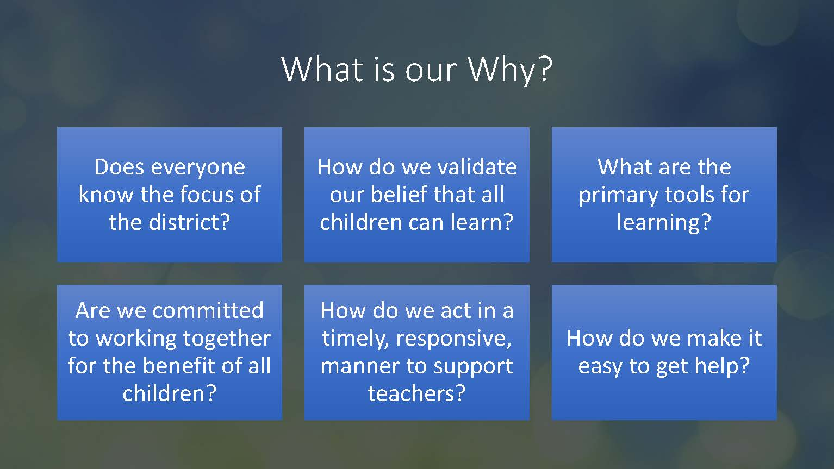
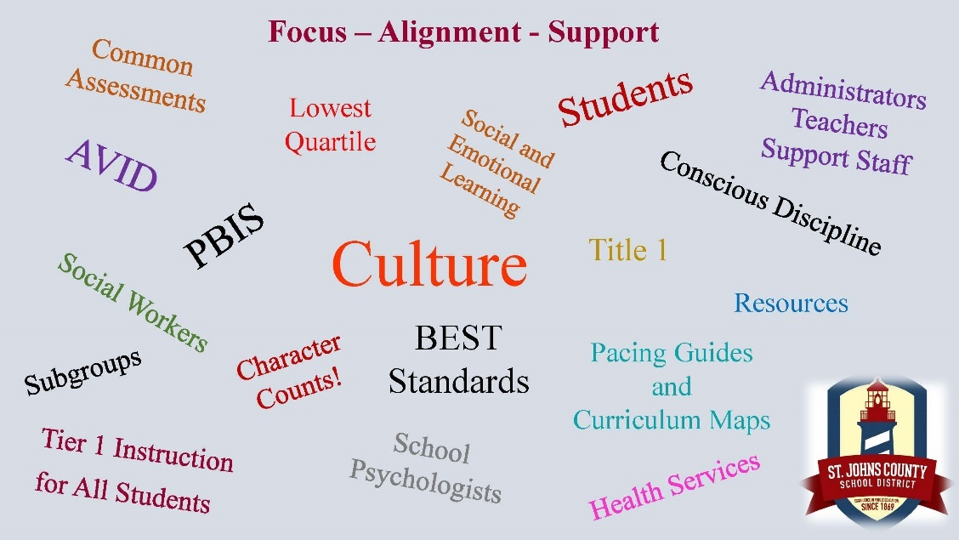
Goals
- Focus (Connect)
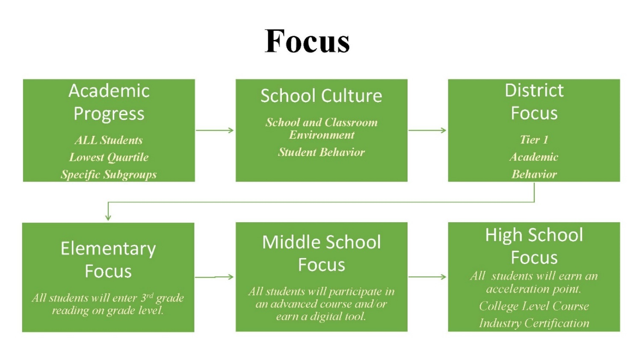

- Alignment (Accelerate)
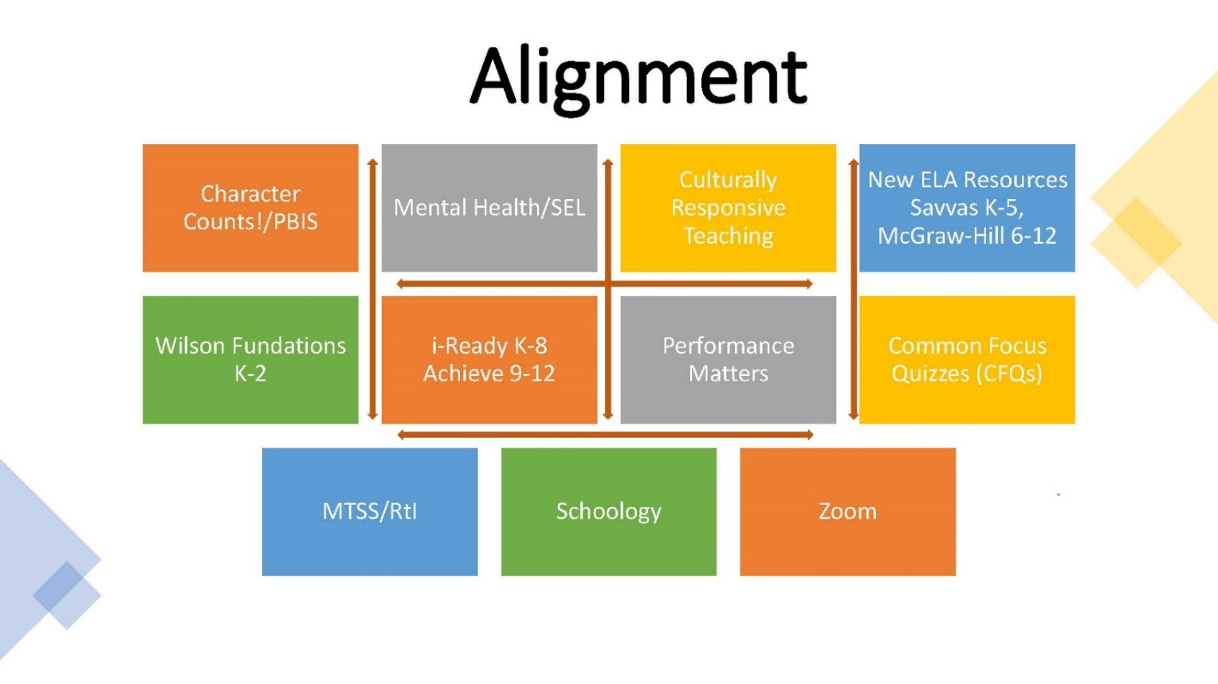

- Support (Succeed)
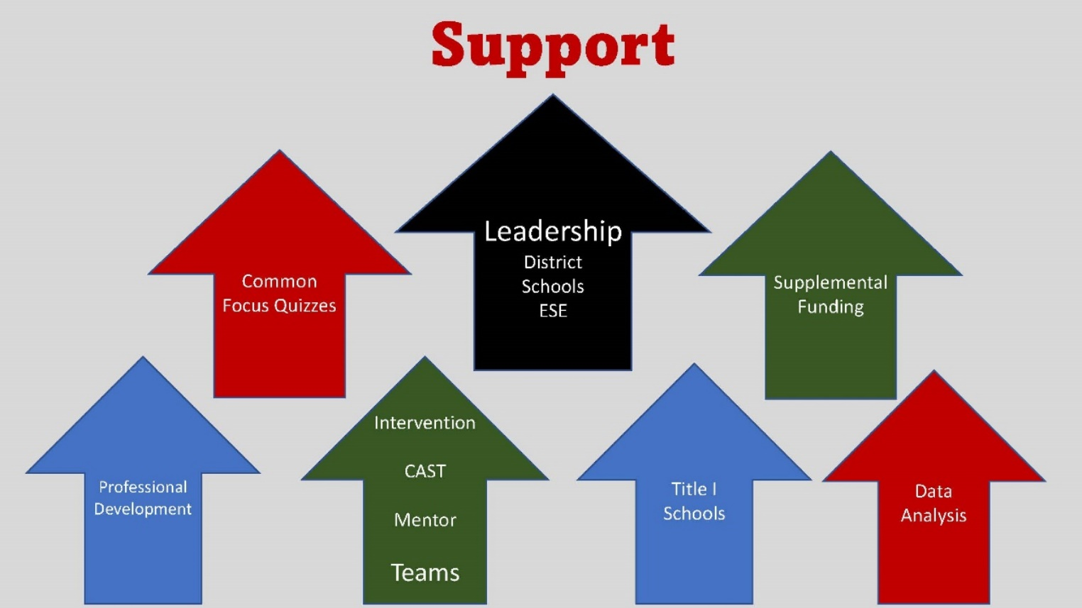

- Connection before Content
- How can we cocreate shared expectations?
- How can we focus on individual connections and be intentional with teacher presence to establish respect and rapport (Single Culture)?
- How can we foster peer-to-peer connections?
- How can we embed social and emotional learning (SEL) practices for students and adults?
- Acceleration not Remediation
“Acceleration is about front-loading students with the skills and content they will learn next instead of going back to play catch-up.”
  - What mindsets, frameworks, and practices remove barriers and allow us to meet the needs of all learners?
  - Communication
  - Choice & Autonomy
  - Promotion
  - Understanding Culture
  - How can we flip the script on questioning?
  - Plan and Design
  - Higher Order Thinking
  - Ask Questions
  - AVID Strategies
  - Could we design for inquiry with voice and choice?
  - Discover
  - Discuss
  - Demonstrate
Outcomes
- Instructional Rounds with school level administration, coaches, and specialists are routinely conducted in the Fall and Spring.
- Curriculum Area Support Team (CAST) conducts instructional rounds independently to examine instructional effectiveness and identify areas of needs improvement throughout all schools routinely. These instructional rounds include all models of instruction.
- Instructional rounds have specific school and district identified areas of focus as well as fidelity checkpoints. These focus areas and checkpoints are identified using observation, student achievement data from common benchmark assessments, i-Ready, Apex, Achieve 3000, summative and formative assessments, attendance, and related areas. Additionally, strategic plans, comprehensive school improvement plans, and prescriptive learning plans are utilized.
- The Department of Accountability and Intervention Services provide schools with leadership support and professional development through coaching, consultation, plan development, and observations data from the eProve™ Effective Learning Environments Observation Tool® (eleot®).
- Exceptional Student Services (ESE) staff and school level leaders participate in ongoing training using the Florida Inclusion Network (FIN) models of support. In addition, the district ESE staff provide monthly updates and trainings to school level leaders addressing areas of need as well as the best practices for meeting the needs of ESE students.
- District Support Team
- Goal
- Create an actionable team that guides activities, collaborations, and supports for district stakeholders. A comprehensive restructuring eﬀort aligns speciﬁc resources and evidence-based supports with the expressed goal of overcoming identiﬁed gaps in current structures, frameworks, practices, and resources to support a new educational experience.
Closing the Gap
Instructional Leadership
- Clear Vision and Expectation
  - Work collaboratively to improve student academic and social emotional learning.
  - Regular and ongoing monitoring of student progress to include subgroups.
  - Growth mindset (students and staff)
- Collective Commitments
  - Common instructional resources, pacing and assessments based on standards
  - Common student social development
  - Focus on student engagement
- Master Schedule
  - Students targeted intervention/remediation block
  - Teacher job embedded professional learning
  - PLCs to include ESE staff and interventionist
- District/school-based admin walkthroughs
  - Targeted and accountable (rubric)
Instruction
- Structure of instructional block
  - Whole groups, small group, interventions, and remediation
  - Intervention – standard focused reteaching of skills and content
  - Remediation – foundational skills and strategies
- MTSS
  - Primary focus is Tier 1 instruction, subgroups, data monitoring and action plans
  - Monitoring of targeted students with action plan
  - Focus on subgroups
- SWD
  - Students served in both intervention block by teacher/interventionist and in remediation block by ESE teacher (Tier 2/3 and IEP Goal)
  - Language instruction – imbedded
  - Expectations for ESE Teachers/General Education Teachers
    - ESE teacher planning with general education teacher (Master Schedule)
    - ESE teacher targeted instruction in small group with students (not during core instruction)
- Assessment and monitoring
  - Use of common formative/summative assessments, review of student performance, action plan for support
  - Process to support and monitor assessments
Social Emotional Development/Discipline
- School-wide PBIS as foundation
  - Conscious Discipline strategies and common language
  - Social skills as tier 1 SEL instruction
  - Monitoring of discipline data with action plan (subgroups)
- Regular an ongoing monitoring of PBIS implementation, use of Conscious Discipline and social skills instruction.
Professional Development
- Instructional coach-based job embedded professional development based on student performance results and observational data (ILC, District staff, AP, Principal)
- Title 1 Summer Institute
Parent Engagement
- Engagement vs Involvement
  - Participate in conferencing
  - Support student learning
  - Attendance
  - Student health
- Staffing
- Behavior Interventionist
  - Responsible for monitoring intervention data of student with behavior plans
  - Coordinate and facilitate intervention plans and behavior support resources
  - Coordinate and facilitate PBIS
  - Respond to student needs
- Targeted Interventionist (Paras/tutors/teachers)
  - Provided targeted intervention based on plan with research-based resources and training
- Substitutes
- Ensures continuity of instruction and interventions
- LEA/11-month AP
  - Ongoing monitoring of ESE student performance data (like RtI plans in MTSS)
  - Monitoring of ESE teaching instructional practices
  - Management of IEP meetings
  - Allows AP to provide consistent instructional leadership, monitoring, observations, and evaluations
- Incentives to work at Title 1 schools
Role of the District
- Clear expectation for monitoring
- Support, support, support
- Quarterly planning meeting focused on the following topics:
  - Instructional Support – standards, resources, specific teacher, and interventionist needs
  - Data review – progress monitoring, CFA, subgroups – SWD, minority, etc.
  - ESE – PD, instructional practices, monitoring
  - Social emotional and behavior – Discipline data, PBIS implementation, school-wide social skills program implementation, Tier 2/3 behavior plans
  - Professional development needs in each of these areas
    - Breaking down B.E.S.T standards
    - Developing effective assessments
    - Using assessment data
    - Effective SEL strategies and techniques
  - Parent engagement
- Provide district level Director of Student Success and Accountability whose responsibilities include...
  - Managing, facilitating, and monitoring this plan
  - Supporting school leadership teams
  - Coordinating communication among Title 1 schools and district departments

Return on Investment (ROI) Focus Process
Implementation Plan
Professional Activities
Collaboratively design the planning process to set expectations, schedule key milestones and outline responsibilities for SJCSD team. (Scope of Work – Timeline – Actionable Agendas)
Assess quantitative and qualitative data to uncover unaddressed needs and expectations of stakeholders. Gather teacher and student reﬂections on support they need to be successful in SY 21-22 (existing and new). (Data Collection and Analysis)
Identify existing instructional and administrative practices and explore research that highlights alternative ways to address needs (e.g., structures, frameworks, tools, PD). This process will lead to the speciﬁc design of initiatives, including:
● Progress Monitoring and Intervention
● Professional Development (Task Force Continuum)
● ESSA Subgroups
Prioritize new practices based on level of impact and eﬀort/ease. This requires an understanding of the underlying policy and ﬁnancial implications.
Create guiding principles to drive new pathways of support to staﬀ and students through SY 21-22.
A roadmap rollout plan of development that incrementally builds tools and resources for teachers, students, and families.
Deliverables:
● Strategic Plan
● Data Collection and Analysis
● Research and Evidenced Based Leading Practices
● Prioritization Matrix
● Timetable – Scope of Work
● Communication Plan and Process
Instructional Continuity Plan Coordination
Instructional Continuity Plan coordination will be conducted by identified district leadership to direct and support:
- appropriate adjustments to traditional accountability measures and processes to include pacing of curriculum implementation, intervention to reinforce standards, and interventions.
- modification and adjust school improvement plans to include strategies to close the achievement gap.
- disaggregate data to monitor underachieving subgroups whose learning may have been most severely impacted.
- progress monitor with all students and monitor instructional adaptations and adjustments to ensure the Interventions are aligned.
- the highest level of instructional excellence, professional development, analytical data decisions driven through the Return on Investment (ROI) process, embrace and monitor social and emotional learning for students and staff, and provide equitable support (academic and social-emotional) and interventions to all students.
- identification and monitoring of academic growth of at-risk students.
- implementation of the 2021-2022 Instructional Continuity Plan.
Continued Steps
- The work, vision with the District Support Team specifically address the critical success factors as outlined in the Superintendent’s Goal. The design is focused on key reading benchmark data, ELA and Reading and brings a cross-departmental approach to problem solving.
- The expansion of the progress monitoring project, Common Focus Quizzes (CFQs) and Common Summative Assessments (CSAs), is designed based on data from the FSA and EOCs and is punctuated with a rigorous reteaching model, coupled with data analysis by district, school and subgroup categories. Progress monitoring will take place four times per year growth of ESE students a particular focus.
- The critical success factors relate firstly to Social Emotional Learning and the expectation that we have a Positive Behavior Support System, PBIS, set up at every school. We also include counselors and mental health support on our District Support Team.
- Academically, the target is that all students are proficient in reading by third grade. In addition, our success will relate to our bottom quartile quotient and all our Title 1 Schools being “A” or “B” rated.
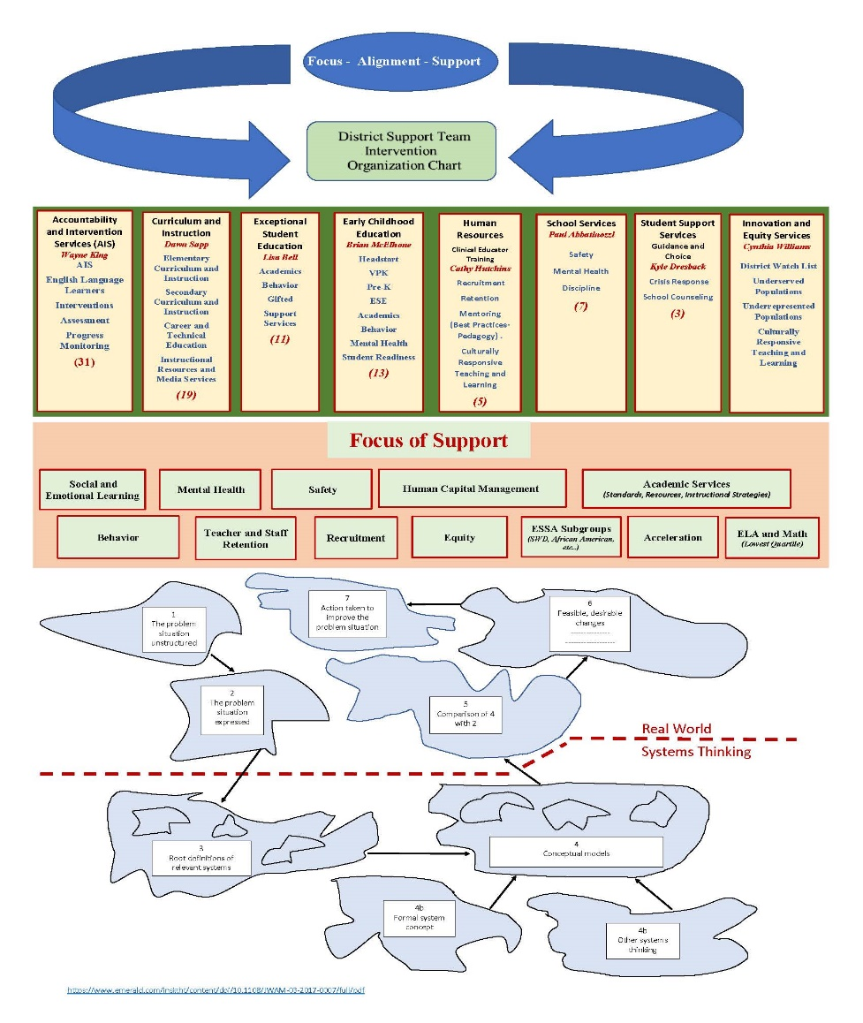
Charter Schools:
- The Director of Guidance and Choice serves as part of the cross-functional planning team and works closely with charter schools’ director and board to help them maintain or achieve high standards, preserve autonomy, protect the student and public interest and support goals consistent with the St. Johns County School District. This occurs through effective communication and monitoring practices.
- Director of Guidance and Choice is available to liaison with each charter school to support the continued instruction of students during a school shutdown. This includes the Director of Guidance and Choice coordinating with other district departments to support the continued instruction of students.
- Site visits occur annually and as needed to monitor compliance with state statute, board rule, charter contract and to review data. As a result of the site visits and monitoring, direction and support are provided by district departments as needed.
- Quarterly meetings are scheduled with charter school directors and district departments to support communication and ensure charter school directors have the tools they need to comply with statute, board rule and support students and staff.
- If a charter school falls below standards, a corrective action plan will be established, supported, and monitored.
Interventions and Support
As evidenced, we have expanded our instructional intervention services to better align our support for students enrolled in all instructional models, addressing any COVID academic slide, and utilizing data analysis for continuous adjustments and improvements based on student needs. The following model identifies the process of intervention expansion and support:
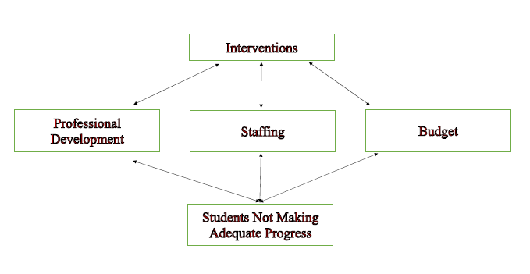
St. Johns County School District Progress Monitoring
St. Johns County School District has implemented a variety of Progress Monitoring tools for the 2020-2021 School Year and will continue in the Spring 2021. This will include a rigorous approach with our students in Innovative / Blended Synchronous and Asynchronous environments, when necessary, with the goal to determine interventions to address learning gaps extending from school closures. Our plan will include extending rigorous instructional interventions and support through summer school, after school, Lunch and Learn, push in for all struggling students. Our plan will include intervention and support for our VPK and ELL students at centralized, parent convenient sites during the summer.
Assurances:
- We will make appropriate adjustments to traditional accountability measures and processes to include pacing of curriculum implementation, intervention to reinforce standards missed during closure, Tier II and Tier III interventions within the district’s Multi-Tiered Systems of Support (MTSS).
- We will modify and adjust school improvement plans to include achievement strategies to close the achievement gap.
- We will use disaggregated data to monitor underachieving subgroups whose learning may have been most severely impacted by the school closing.
- We will use i-Ready to Progress Monitor with all students in our K-5 schools. There will be three sessions throughout the year. At each interval we will adapt and adjust to ensure the Interventions are aligned.
- We will use i-Ready with all our Level 1 and 2 students and students enrolled in standard courses in our Middle Schools (6th-8th). The expectation is to administer the progress monitoring assessment three times per year.
- We will use Achieve 3000 with our intensive reading students in our high schools (9th -12th). The expectation is to administer the progress monitoring assessment three times per year or common assessment.
- The expansion of the progress monitoring project, Common Focus Quizzes (CFQs) and Common Summative Assessments (CSAs), is designed based on data from the FSA and EOCs and is punctuated with a rigorous reteaching model, coupled with data analysis by district, school and subgroup categories. Progress monitoring will take place four times per year growth of ESE students a particular focus.
All students in Innovative / Blended Synchronous and Asynchronous Model will be progress monitored three times per year with the tools.
We are expanding our assessment repertoire to include a balance of formative assessment, criterion-based coaching and feedback, and summative assessment that is performance-centered.
Targeted Outreach
- We will provide the highest level of instructional excellence, professional development, analytical data decisions driven through the Return on Investment and MTSS processes, embrace and monitor social and emotional learning for students and staff, and provide equitable support (academic and social-emotional) and interventions to all students.
- Each school has an Instructional Literacy Coach (ILC) and a Schoology trainer to support teachers with utilizing an LMS to organize and deliver content
- Teachers will support each other through Professional Learning Communities, sharing best practices, resources and strategies which is especially important due to the number of early career teachers in our district.
- District level curriculum specialists provide guidance through curriculum maps which include pacing, links to digital resources and formative assessments
- District level specialists provide training on the integration of technology into instructional practice and various strategies to engage students with online learning
- Regular progress monitoring through the PLC will identify student needs throughout the instructional process
Expectations for all Exceptional Student Education.
Exceptional Student Education support (ESE) will provide specially designed instruction as specified on the IEP. A combination of synchronous and asynchronous computer-based learning will be the foundation for our students in the School-Based Blended Synchronous and Asynchronous model. The instructional and learning model may include work packets sent home and video or phone conferences with teachers and service providers to provide instruction and answer questions.
Required evaluations, re-evaluations, IEP meetings, etc. will also be held virtually to the extent practicable. If there is any type of delay, a plan to move as quickly as possible to prevent further delay will be documented and communicated with families. Individualized Education Program (IEP) teams will monitor each student’s progress and determine what, if any, remediation may be needed.
Social and Emotional Learning – Support and Intervention Plan
- All secondary students are engaging in EVERFI course materials for Mental Wellness. EVERFI helps teachers, schools, and districts bring real-world skills to students. (https://everfi.com/k-12/)
- High school campuses are participating in Sources of Strength. A best practice youth suicide prevention project designed to harness the power of peer social networks to change unhealthy norms and culture, ultimately preventing suicide, bullying, and substance abuse. (https://sourcesofstrength.org/)
- LINK Crew and WEB groups are still operating with modification at their school campuses. These programs are designed to assist students with transitioning from 8th grade to 9th grade and 5th grade to 6th grade respectively.
- Elementary students are all engaging in an SEL program at their school whether Conscious Discipline, Sanford Harmony, Second Step, school-created materials, and/or Capturing Kids Hearts.
MTSS – RTI Interventions and Support
The MTSS process includes this component. All students with MTSS plans (no matter the instructional delivery model) are receiving intervention and progress monitoring as part of those plans. ESE students are also receiving interventions through specialized instruction and progress monitoring as part of their IEP. Universal progress monitoring is taking places for all students via i-Ready (all K-5, lowest quartile students 6-8, reading and math) or Achieve 3000 (all lowest quartile 9-12, reading only).
The monitoring of MTSS plans adheres to these provisions and guidance. Progress monitoring data is sent home in graphical format, along with notes, from all meetings every 6-8 weeks. We would increase this, as needed. For those elementary and middle school students not on an active MTSS plan, we use the i-Ready growth measures to monitor student progress.
We have a list of approved, research-based interventions for ELA K-12. This is a combined recommendation from ESE, Curriculum, and Intervention Services. All currently used interventions are from this list. Math intervention components are built into the elementary curriculum maps. Secondary schools use Save as assessments, embedded in our adopted math materials, as a source for individualized interventions.

Part III LEA Plan for Safe Return of In-Person Instruction

Each LEA developed and made publicly available on the LEA’s website a plan for the safe return of in-person learning in the Fall of 2020. This was before the enactment of the ARP Act. This plan must be updated to address the requirements of the U.S. Department of Education’s Interim Final Rule, 88 FR 21195. The Interim Final Rule “does not mandate that an LEA adopt the CDC guidance, but only requires that the LEA describe in its plan the extent to which it has adopted the key prevention and mitigation strategies identified in the guidance.” 88 FR at 21200. Any updated LEA plan must be consistent with state law, including any applicable executive order, any agency emergency order, or any agency regulation or rule. Note specifically that LEA policies must comply with section 381.00316, Florida Statutes, and that any policies implemented after August 9, 2021 must comply with Florida Department of Health Rule 64DER21 -12, F.A.C., and any policies implemented after September 22, 2021 must comply with Florida Department of Health Rule 64DER21-15, F.A.C.

Each LEA must seek public comment on the plan and take such comments into account prior to submission of the final plan to the Department within 60 days of the award. Upon the Department’s approval, the LEA shall post this updated plan on the LEA’s website within 90 days of the award.

☒ By checking this box, the LEA acknowledges the requirement that each LEA shall update its Plan for Safe Return of In-Person Instruction to reflect the requirements stated above, shall seek public comment on the updated plan and take such comments into account prior to the submission of the final plan to the Department within 60 days of the award. Upon the Department’s approval, the LEA shall post this updated plan on the LEA’s website within 90 days of the award.

Part IV: Assurances

The district must agree to ALL of the assurances by checking the corresponding boxes.

☒ Assurance 1: LEA Periodic Plan Update with Public Comment. As required in the U.S. Department of Education’s Interim Final Rule, 88 FR 21195, the LEA must regularly, but no less frequently than every six months, review and as appropriate, revise its plan for the safe return to in-person instruction and continuity of services. In determining whether revisions are necessary, and in making any revisions, the LEA must seek public input and take such input into account. If at the time the LEA revises its plan the CDC has updated its guidance on reopening schools, the revised plan must address the extent to which the LEA has adopted policies, and describe any policies, for each of the updated safety recommendations. Significantly, the Interim Final Rule “does not mandate that an LEA adopt the CDC guidance, but only requires that the LEA describe in its plan the extent to which it has adopted the key prevention and mitigation strategies identified in the guidance.” 88 FR at 21200. Any updated LEA plan must be consistent with state law, including any applicable executive order, any agency emergency order, or any agency regulation or rule. Specifically, LEA policies must comply with section 381.00316, Florida Statutes, and any policies implemented after August 9, 2021 must comply with Florida Department of Health Rule 64DER21 -12, F.A.C., and any policies implemented after September 22, 2021 must comply with Florida Department of Health Rule 64DER21-15, F.A.C.
☒ Assurance 2: Continue progress monitoring and interventions. The district agrees to provide robust progress monitoring and requisite interventions must be extended to all students with tiered support for students who are performing below grade level and are not making adequate progress. Students who are receiving instruction through innovative teaching methods must transition to another teaching method if they fail to make adequate progress. The district agrees to provide monthly progress monitoring reports to parent/guardians for students identified as performing below grade level and/or demonstrating decline on the district’s progress monitoring system.

☒ Assurance 3: Allowable Uses of Funds. The LEA will use funds for activities allowable under section 2001(e) of the CRRSA Act.

☒ Assurance 4: Maintenance of Equity. The LEA will comply with all requirements relating to Maintenance of Equity, in accordance with section 2004(c) of the ARP Act.

☒ Assurance 5: Reporting. The LEA will comply with all reporting requirements, and submit required reports to the Florida Department of Education at such time and in such manner and containing such information as the department may subsequently require.

☒ Assurance 6: Audits, Inspections or Examinations. The LEA will cooperate with any examination of records with respect to such funds by making records available for inspection, production, and examination, and authorized individuals available for interview and examination, upon the request of (i) the Florida Department of Education, the Florida Auditor General; (ii) the Department and/or its Inspector General; or (iii) any other federal or state agency, commission, or department in the lawful exercise of its jurisdiction and authority.

Acknowledgement

Local Educational Agency Chief Executive Officer or Authorized Representative

Name and title of person responsible for completion and submission
James Forson – Superintendent
Contact information: email, phone number
tim.forson@stjohns.k12.fl.us, 904-547-7502
Superintendent signature (or authorized representative)

