

2021-24 American Rescue Plan
Elementary and Secondary School Emergency Relief Fund
Local Educational Agency ARP ESSER Plan,
Application and Assurances

[LEA and Number]

Purpose
Florida must subgrant not less than 90 percent of its total ARP ESSER allocation to local educational agencies (LEAs) (including charter schools that are LEAs) to help meet a wide range of needs arising from the coronavirus pandemic, including reopening schools safely, sustaining their safe operation, and addressing students’ social, emotional, mental health, and academic needs resulting from the pandemic. The State must allocate these funds to LEAs on the basis of their respective shares of funds received under Title I, Part A of the Elementary and Secondary Education Act of 1965 (ESEA) in fiscal year (FY) 2020.

The purpose of this document is to guide districts to plan for the continued implementation of reopening and recovery through the utilization of the 2021-24 ARP ESSER and to assure federal requirements are met. Florida utilized the 2020-21 District Reopening Plan and the Spring 2021 Education Plan to respond to and mitigate the impact of the emergency and to promote the health, safety, and welfare of persons connected with Florida’s educational system.

The Department recognizes that the safe return to in-person instruction must be accompanied by a focus on meeting students’ academic, social, emotional, and mental health needs, and by addressing the opportunity gaps that existed before – and were exacerbated by – the pandemic. In this document, districts will describe how they will support the development of high-quality plans for the use of ARP ESSER funds to achieve these objectives for the following student groups: students from low-income families, from each racial or ethnic background, by gender, English Language Learners, students with disabilities, experiencing homelessness, in foster care, migratory students and other student groups.

Directions
Districts shall submit its ARP ESSER application to the Office of Grants Management via ShareFile on or before November 12, 2021. ShareFile access has been established for the ARP ESSER Lump Sum program for each LEA. The complete application shall include:

- LEA ARP ESSER Plan, Application and Assurances utilizing this template;
- DOE 100A Project Application Form; and
- DOE 101 Budget Narrative Form.

Each LEA developed and made publicly available on the LEA’s website a plan for the safe return of in-person learning in the Fall of 2020. This was before the enactment of the ARP Act. This plan must be updated to address the requirements of the U.S. Department of Education’s Interim Final Rule, 88 FR 21195. The requirements of the Interim Final Rule are summarized in Appendix A. Each LEA shall seek public comment on the updated plan and take such comments into account prior to the submission of the final plan to the Department. Updated plans must comply with state law, including any applicable executive order, any agency emergency action, or any agency regulation or rule. No later than 60 days from receipt of its DOE 200, Project Award Notice, each LEA shall email its updated final plan to recoveryplan@fldoe.org. The subject line of the email must include district name and Plan for the Safe Return of In-person Instruction. Upon the Department’s approval, the LEA shall post this plan on the LEA’s website within 90 days of the award.

Part I: Implementation Plan

The LEA will submit an implementation plan, outlining planned activities for each of the following uses of funds under section 2001(e) of the ARP Act. The description must be adequate to ascertain that the proposed use of funds is necessary to prevent, prepare for, or respond to the COVID-19 pandemic, including its impact on the social, emotional, mental health, and academic needs of students.
Activities should be numbered consecutively. If the LEA does not plan any activities for one or more authorized uses, please indicate that there are no planned activities. School district LEAs shall include the activities identified for charter schools within the LEA, aggregated at the district/LEA level.

Activity 1: Addressing Learning Loss (at least 20% of total allocation). Of the total amount allocated to an LEA, the LEA must reserve at least 20 percent of funds to address learning loss through the implementation of evidence-based interventions such as summer learning or summer enrichment, extended day, comprehensive afterschool programs, or extended school year programs, and ensure that those interventions respond to students’ social, emotional, and academic needs and address the disproportionate impact of COVID-19 on underrepresented student subgroups (each major racial and ethnic group, children from low-income families, children with disabilities, English learners, gender, migrant students, students experiencing homelessness, and children and youth in foster care).

- [5100-120] Basic – Teacher – Intervention Teachers (19): At each middle school, the intervention teacher will assist in reviewing data, providing interventions and helping to close learning gaps related to Covid-19. = $1,065,320.81 @ 1 year
[5100-210] Retirement @10.82% = $115,267.71
[5100-220] Social Security/Medicare @7.65% = $81,497.04
[5100-230] Insurance – Flat Rate @ $8,168 x 2= $154,432.00
[5100-240] Workers Compensation @ 1.39% = $14,807.96
[5100-250] Unemployment @ .06% = $639.19

- [5100-120] Basic - Teacher – Class Coverage: Allows for teachers to teach additional minutes past contract hours for students in need of additional learning opportunities to close the achievement gap. Lee County is short staffed in crucial subject areas. The will allow students to receive additional minutes of instructional from a certified teacher to close the achievement gap in direct relation to the Covid-19 pandemic. Teachers will be compensated to work during planning while providing instruction to struggling students. = $13,843,167.05 @ 2 years
[5100-210] Retirement @10.82% = $1,497,830.67
[5100-220] Social Security/Medicare @7.65% = $1,059,002.28

- [5100-120] Basic - Teacher – Extended Day: Allows for teacher to teach an additional 30 minutes per day to close achievement gaps. In relation to surrounding counties, Lee County has the least amount of student time spent in school. This will allow students more instructional time, with certified teachers, to close the achievement gap related to Covid-19. = $48,524,400.27 @ 2 years
[5100-210] Retirement @10.82% = $5,250,340.11
[5100-220] Social Security/Medicare @7.65% = $3,712,116.62

- [5100-120] Basic - Teacher in Elementary School: Assist is remediation of learning for all students due to Covid-19 (50) = $2,803,474.22 @ 1 year
[5100-210] Retirement @10.82% = $303,335.91
[5100-220] Social Security/Medicare @7.65% = $214,465.78
[5100-230] Insurance – Flat Rate @ $8,168 x 2= $406,400.00
[5100-240] Workers Compensation @ 1.39% = $38,968.29
[5100-250] Unemployment @ .06% = $1,682.08

- [5100-120] Basic - Teacher in Middle School: Assist is remediation of learning for all students due to Covid-19 (13.5) = $756,938.31 @ 1 year
[5100-210] Retirement @10.82% = $81,900.73
[5100-220] Social Security/Medicare @7.65% = $57,905.78
[5100-230] Insurance – Flat Rate @ $8,168 x 2= $109,728.00
[5100-240] Workers Compensation @ 1.39% = $10,521.44
[5100-250] Unemployment @ .06% = $454.16

- [5100-120] Basic - Teacher in High School: Assist is remediation of learning for all students due to Covid-19 (23.5) = $1,317,633.12 @ 1 year
[5100-210] Retirement @10.82% = $142,567.91
[5100-220] Social Security/Medicare @7.65% = $100,798.94
[5100-230] Insurance – Flat Rate @ $8,168 x 2= $191,008.00
[5100-240] Workers Compensation @ 1.39% = $18,315.10
[5100-250] Unemployment @ .06% = $790.58

- [5100-120] Basic - Teacher – Academic Reading Coaches: To provide teachers and coaches for additional instruction to aid in closing the achievement gap for all students due to Covid-19 (34.5) = $3,876,173.28 @ 2 years
[5100-210] Retirement @10.82% = $419,401.95
[5100-220] Social Security/Medicare @7.65% = $296,527.26
[5100-230] Insurance – Flat Rate @ $8,168 x 2= $563,592.00
[5100-240] Workers Compensation @ 1.39% = $53,878.81
[5100-250] Unemployment @ .06% = $2,325.70

- [5100-130] Basic Other Certified – 0.5 Intervention Specialists and MTSS (Intervention Specialists), Elementary and High: To provide teachers and coaches for additional instruction to aid in closing the achievement gap for all students due to Covid-19 (40) = $3,566,753.11 @ 2 years
[5100-210] Retirement @10.82% = $385,922.69
[5100-220] Social Security/Medicare @7.65% = $272,856.61
[5100-230] Insurance – Flat Rate @ $8,168 x 2= $653,440.00
[5100-240] Workers Compensation @ 1.39% = $49,577.87
[5100-250] Unemployment @ .06% = $2,141.65

- [5100-120] Basic - Teacher – Grad Academy Teachers: Grad Academy is a program within Lee County to help academically struggling students to get back on track in order to transition back to their geographical school. These students have achievement gaps and academic learning loss directly related to Covid-19. It follows the LEA school calendar but provides extended hours of instruction split into two blocks of up to ten hours per day. (2) = $225,246.36 @ 2 years
[5100-210] Retirement @10.82% = $24,371.66
[5100-220] Social Security/Medicare @7.65% = $17,231.35
[5100-230] Insurance – Flat Rate @ $8,168 x 2= $32,672.00
[5100-240] Workers Compensation @ 1.39% = $3,130.92
[5100-250] Unemployment @ .06% = $135.15

- [5100-150] Basic - Paraprofessionals – Graduation Para: To provide graduation support to students that are recovering credits missed due to the Covid-19 Pandemic (2). = $100,235.50 @ 2 years
[5100-210] Retirement @10.82% = $10,845.48
[5100-220] Social Security/Medicare @7.65% = $7,668.02
[5100-230] Insurance – Flat Rate @ $8,168 x 2= $16,256.00
[5100-240] Workers Compensation @ 1.39% = $1,393.27
[5100-250] Unemployment @ .06% = $60.14

- [5100-160] Basic – Other Support Personnel – Supplemental Contracts: To provide Back on Track (high school) and Connect with Lee (all levels) to support students that need additional instructional time outside the normal school day with a certified teacher to close learning gaps related to Covid-19. = $4,819,285.71 @ 2 years
[5100-210] Retirement @10.82% = $521,446.71
[5100-220] Social Security/Medicare @7.65% = $368,675.36

- [5100-369] Basic – Technology Related Rentals: i-Ready Student Software is the district monitoring tool used throughout all grade levels to monitor progress made and close achievement gaps for students as related to Covid-19 learning loss. = $5,000,000.00 @ 2 years

- [6100-730] Student Support Services – Dues and Fees: ACT/SAT Testing measures college readiness and can predict future academic success. These summative assessments give a breakdown of the student’s abilities in core subject areas and provide the school with additional data. This assists in progress monitoring academic loss due to Covid-19. = $70,000 @ 2 years

- [5100-510] Basic – Supplies: The ACT and SAT measures college readiness and can predict future academic success. These test prep materials will aid in the student’s success on these summative assessments related to learning loss due to Covid-19. = $200,000 @ 2 years

- [5100-110]: Basic – Administration: Principal Coaches. To provide principal’s support, mentoring, data tracking and best practices to mitigate academic learning loss in school buildings due to the Covid-19 pandemic. = $793,022.02 @ 2 years
[5100-210] Retirement @10.82% = $85,804.98
[5100-220] Social Security/Medicare @7.65% = $60,666.18
[5100-230] Insurance – Flat Rate @ $8,168 x 2= $49,008.00
[5100-240] Workers Compensation @ 1.39% = $11,023.01
[5100-250] Unemployment @ .06% = $475.81

- [5100-393] Charter School Allocation = $8,784,267.35
See appendix A for Lee County’s process document of charter school allocations and reimbursement.

Activity 2 (A) Any activity authorized by the Elementary and Secondary Education Act of 1965.

- [6400-120] Instructional Staff Training Services: Innovation Seminar for Teacher Leaders
A customized innovation seminar will be designed and tailored for teacher leaders, aspiring assistant principals, and aspiring principals. To facilitate individual and peer learning the participants will be divided into cohorts with a target cohort size of 15. The maximum size for any single cohort would be 20. This tailored and customized professional learning program will introduce participants to the art and science of innovation and ways to systematically identify, evaluate, determine, prioritize, and work to satisfy customer needs through a combination of qualitative and quantitative methods. Participants will learn how data can be gathered and used through a structured process to map out areas that are ripe opportunities for innovation, to prioritize and select solvable problems, and then ideate on potential solutions. Additionally, collection of data, insights, and best practices from the workshops will be used to iteratively improve future workshops and potentially inform future project development. As described by a McKinsey & Company report on leadership in a crisis, “during a crisis, which is ruled by unfamiliarity and uncertainty, effective responses are largely improvised. They might span a wide range of actions: not just temporary moves…but also adjustments to ongoing business practices…, which can be beneficial to maintain even after the crisis has passed.” These innovation seminars will include behaviors and accompanying mindsets that will help participants create effective solutions in periods of unfamiliarity and uncertainty, thereby better equipping them to prepare, prevent, respond to, and otherwise navigate the coronavirus pandemic and future crises. = $135,000.00 @ 2 years

- [6400-110] Instructional Staff Training Services: Leadership Development for Principals & APs – Customized leadership development seminars to address specific SDLC needs will be designed and tailored for principals and assistant principals at different school levels (i.e. elementary and secondary), including special centers and other non-traditional locations, since the data yielded insights that show that the teacher preferences and feedback concerns are contextualized at that level of granularity. The facilitation and delivery of each grouping of specialized content will be conducted on a school-level basis to ensure contextual applicability is optimized. To facilitate individual and peer learning with level-specific applications, the level 1 seminars will have a target cohort size of 15. Level 2 seminars will include principals/assistant principals of all school levels, who have successfully completed Level 1, and will have a target cohort size of 10. = $338,000.00 @ 2 years

- [6400-120] Instructional Staff Training Services: Marzano Level HRS Academy
The pandemic created a need for leaders to re-evaluate their systems for creating a safe and supportive, collaborative environment for students, parents, faculty, and staff. The High Reliability Schools academy will provide for training, assessment, and coaching for all district schools to achieve level 1 certification through Marzano. To help schools respond to COVID-19 additional training and support is needed for school leadership teams to create a safe and supportive school-culture to promote student learning, parent/family engagement, and teacher retention. = $465,000.00 @ 2 years

- [6400-110] Instructional Staff Training Services: NISL Cohort
The pandemic created the need for leaders to design systems to create safe and supportive school cultures, provide job-embedded supports for teachers to learn new skills in new ways, and design systems to quickly identify students in need of remediation and enrichment. The NISL Program provides meaningful learning opportunities for school leaders to learn research-based practices in these areas and apply these skills through an action learning project. While the district has offered additional NISL cohorts in the past, the skill deficit identified through the pandemic creates a sense of urgency to scale up administrator practices. = $465,000 @ 2 years

- [6400-110] Instructional Staff Training Services: Professional Development – Wallace Foundation is for training and professional development for instructional staff to aid in the closing the achievement gap for all students related to Covid-19. = $100,000 @ 2 years

- [6400-120] Instructional Staff Training Services: Solution Tree PLC at Work Institute = $534,720
Professional Learning Communities are recognized as a powerful strategy for sustained, substantive school improvement. This PLC at Work Institute gives school teams the knowledge and tools to implement or refine this power process in their schools. Due to staff shortages related to Covid-19, additional training is needed for school leaders to design, develop and improve school-based PLC implementation in order to create school-wide systems to support students who are behind academically.
Breakdown of Costs for PLC at Work Institute
Location: Orlando, Florida

Dates: June 20 – 22, 2022

Rationale for out of county travel: No comparable PLC at Work Institute trainings are offered in-person within Lee County during the 21/22 school-year.

[6400-330] Registration: $629-person X 400 estimated participants = $251,600

Rationale for number of participants: Registration includes up to 4 participants per location to allow for team members to learn best practices, assess current systems, and plan PLC implementation together for the 22/23 school-year. All district schools are included in order to build capacity and ensure consistency across a high mobility district for students, teachers, staff, and leaders. In addition, Solution Tree will facilitate a School District of Lee County planning session on June 22, 2022 with a Solution Tree associate.

[6400-330] Lodging Rosen Plaza Hotel:
$185 per night X 3 nights X 300 estimated rooms needed = $166,500
*Room sharing will be utilized when possible. However, room sharing may not always be feasible due to supervisory status or health/privacy concerns of participants.

[6400-330] Mileage: $.56 per mile X 388 estimated miles round trip X 200 estimated vehicles needed = $44,620
[6400-330] Parking: $8 per night X 3 nights X 200 estimated vehicles = $4,800
[6400-330] Per diem: $56 per day X 3 days X 400 participants = $67,200

Total amount of request: $534,720

- [6400-160] Instructional Staff Training Services – Other Support Personnel: APPLES Mentor Supplements. All Lee County first-year teachers receive one year of mentoring. Mentoring the past few years have focused on multiple learning models and Covid-19 protocols. Since schools are now open under “normal” conditions, second-year teachers will need additional support to respond to this new “normal”. An additional year of mentoring is needed for second-year teachers to support their development to better meet student learning needs and be retained in the school district. = $580,901.40 @ 2 years

- Charter School Allocation =$13,176,401.03

Activity 2 (B) Any activity authorized by the Individuals with Disabilities Education Act.

- [5200-130] Exceptional – Other Certified: Speech Language Pathologist for PreK ESE (1)
The hiring of one Speech-language pathologist to respond to the backlog of evaluations that began when schools were closed due to the pandemic. This allows for the Pre-K Assessment team to maintain the operation of Child Find services at an increased rate. = $120,000.00 @ 2 years
[5200-210] Retirement @10.82% = $12,984.00
[5200-220] Social Security/Medicare @7.65% = $9,180.00
[5200-230] Insurance – Flat Rate @ $8,168 x 2= $16,336.00
[5200-240] Workers Compensation @ 1.39% = $1,668.00
[5200-250] Unemployment @ .06% = $72.00

Activity 2 (C) Any activity authorized by the Adult Education and Family Literacy Act.
No funds allocated for this activity at this time.

Activity 2 (D) Any activity authorized by the Carl D. Perkins Career and Technical Education Act of 2006.

- [5100-130] School Counseling and Mental Health Services: College & Career Specialist
These positions are designated to work with high school students in regards to career exploration and post-secondary planning to facilitate the connection from school to career. These positions are available at each high school to mitigate the number of drop outs and encourage timely graduation from high school due to loss of academic achievement due Covid-19. (3) = $151,681.12 @ 1 year
[6120-210] Retirement @10.82% = $16,411.90
[6120-220] Social Security/Medicare @7.65% = $11,603.61
[6120-230] Insurance – Flat Rate @ $8,168 x 3= $24,504.00
[6120-240] Workers Compensation @ 1.39% = $2,108.36
[6120-250] Unemployment @ .06% = $91.01

- [6500-160] Instructional Related Technology – Other Support Personnel: Lee County Apprenticeship Program. Approved by FL DOE as a sponsor of an Application Developer apprenticeship program. This initiative will allow suitable (accepted) apprenticeship candidates to be trained “the Lee County way” to support application development. Initiative success will be realized with the hiring of apprentices that successfully complete this internship program. = $159,237.40 @ 2 years

[6500-220] Social Security/Medicare @7.65% = $12,181.66
[6500-230] Insurance – Flat Rate @ $8,168 x 2 x 2 years = $32,672.00
[6500-240] Workers Compensation @ 1.39% = $2,213.40
[6500-250] Unemployment @ .06% = $95.54

- [6120-130] Guidance Services – Other Certified: Career Counselor. The school counselor will be in charge of data tracking and will ultimately aid in closing the achievement gap for all students that may not be college and career ready in relation to learning gaps due to the Covid-19 pandemic. = $102,468.90 @ 2 years
[6120-210] Retirement @10.82% = $11,087.14
[6120-220] Social Security/Medicare @7.65% = $7,838.88
[6120-230] Insurance – Flat Rate @ $8,168 x 2= $16,336.00
[6120-240] Workers Compensation @ 1.39% = $1,424.32
[6120-250] Unemployment @ .06% = $61.48

Activity 2 (E) Coordination of preparedness and response efforts of local educational agencies with State, local, Tribal, and territorial public health departments, and other relevant agencies, to improve coordinated responses among such entities to prevent, prepare for, and respond to coronavirus.

No funds allocated for this activity at this time.

Activity 2 (F) Activities to address the unique needs of low-income children or students, children with disabilities, English learners, racial and ethnic minorities, students experiencing homelessness, and foster care youth, including how outreach and service delivery will meet the needs of each population.

- [5100-120] Basic – Teacher ESOL (10)
Additional ESOL support elementary/middle schools in the district. Schools were identified based on ELL population and needs of school. ESOL Resource Teachers will provide individualized and differentiated instruction to English Language students in the four language domains (listening, speaking, reading, and writing). This instructional support will be provided throughout the year, targeting students who are in the highest need of academic language development. Collaboration of ESOL Resource Teachers and general education teachers to develop engaging, rigorous content lessons that include purposeful development of academic language of the content area is crucial for the success of English Language students during Covid-19. These opportunities will assist in closing the achievement gap and enhance instructional practices for ELs. = $434,666.73 @ 1 year
[5100-210] Retirement @10.82% = $47,030.94
[5100-220] Social Security/Medicare @7.65% = $33,252.00
[5100-230] Insurance – Flat Rate @ $8,168 x10 x 2= $81,680.00
[5100-240] Workers Compensation @ 1.39% = $6,041.87
[5100-250] Unemployment @ .06% = $260.80

- [5100-150] Basic – Paraprofessional ESOL (20)
Additional ESOL support at all grade levels in the district. Schools were identified based on ELL population and needs of the school. These paraprofessionals will work with English Language students in the content areas in classrooms under the direction of the teacher to provide linguistic and academic support to make instructional comprehensible for English Language students. The district is committed to meeting the needs of English Language students to ensure they become English proficient and are successful in the classroom and community at large. = $426,357.66 @ 1 year
[5100-210] Retirement @10.82% = $46,131.90
[5100-220] Social Security/Medicare @7.65% = $32,616.36
[5100-230] Insurance – Flat Rate @ $8,168 x 2= $163,360.00
[5100-240] Workers Compensation @ 1.39% = $5,926.37
[5100-250] Unemployment @ .06% = $255.81

Activity 2 (G) Developing and implementing procedures and systems to improve the preparedness and response efforts of local educational agencies.

No funds allocated for this activity at this time.

Activity 2 (H) Training and professional development for staff of the local educational agency on sanitation and minimizing the spread of infectious diseases.
No funds allocated for this activity at this time.

Activity 2 (I) Purchasing supplies to sanitize and clean the facilities of a local educational agency, including buildings operated by such agency.

No funds allocated for this activity at this time.

Activity 2 (J) Planning for, coordinating, and implementing activities during long-term closures, including providing meals to eligible students, providing technology for online learning to all students, providing guidance for carrying out requirements under the Individuals with Disabilities Education Act and ensuring other educational services can continue to be provided consistent with all Federal, State,
and local requirements.

No funds allocated for this activity at this time.

Activity 2(K) Purchasing educational technology (including hardware, software, and connectivity) for students who are served by the local educational agency that aids in regular and substantive educational interaction between students and their classroom instructors, including low-income students and children with disabilities, which may include assistive technology or adaptive equipment.

- [8200-369] Administrative Technology Services – Technology-Related Rentals: Cloud Pack Data Analysis. IBM Cloud Pak Data Analysis tools allow for the aggregation, processing, and display and disparate data sources into actionable information. These tools will perform multiple functions, including data aggregation, transport, visualization, trend analysis, etc. Initiative success will be realized with the successful implementation of this product and the utilization of the actionable intelligence provided to appropriate District Stakeholders. = $358,560.00 @ 2 years

- [8200-369] Administrative Technology Services – Technology-Related Rentals: Focus Power/BI for Attendance & Restorative Practices. FOCUS BI will allow the District to expand the current FOCUS SIS Analytics module from existing Discipline module to the full power BI suite, to include Attendance. This module will provide interactive data regarding attendance formatted in such a manner as to see trends in local and state discipline events. This will be beneficial tracking students returning to school after the Covid-19 pandemic. = $192,000.00 @ 2 years

- [8200-369] Administrative Technology Services – Technology-Related Rentals: Next Generation Endpoint Protection. Next Generation endpoint protection in corporates real-time analysis of user and system behavior to analyze executables – allowing users to detect file less “zero day” threats and core advanced technologies prior to and during execution, and take immediate action to block, contain, and roll back those threats. = $760,000.00 @ 2 years

Activity 2(L) Providing mental health services and supports, including through the implementation of evidence-based full-service community schools.

- [5100-120] Basic – Classroom Teacher (18). To provide additional supports to schools to address Social Emotional Learning, Behavior and Restorative Practice supports to work with students that are transitioning back to brick and mortar schools following quarantines and/or virtual models of instruction. = $2,051,741.88 @ 2 years
[5100-210] Retirement @10.82% = $221,998.47
[5100-220] Social Security/Medicare @7.65% = $156,958.26
[5100-230] Insurance – Flat Rate @ $8,168 x 2= $294,048.00
[5100-240] Workers Compensation @ 1.39% = $28,519.22
[5100-250] Unemployment @ .06% = $1,231.06

- [6120-130] Guidance Services – Other Certified: Suicide Counselor. The school counselor will implement initiatives for suicide prevention, trauma informed practices, youth mental health, first aid, etc. They will also be in charge of data tracking and will ultimately aid in closing the achievement gap for all students. With the rise in suicide attempts, involuntary hospitalizations under the Baker Act, and completion of suicide since the pandemic started, this position is critical for student safety. The focus of this position is prevention of suicide through increased mental health awareness, trauma informed practices, suicide prevention training, and other related interventions. = $102,468.90 @ 2 years
[6120-210] Retirement @10.82% = $11,087.13
[6120-220] Social Security/Medicare @7.65% = $7,838.88
[6120-230] Insurance – Flat Rate @ $8,168 x 2= $16,336.00
[6120-240] Workers Compensation @ 1.39% = $1,424.32
[6120-250] Unemployment @ .06% = $61.48

- [6140-130] Psychological Services – Other Certified: School Psychologist (6). To provide required educational psychological assessments and services for all students. These assessments and services can only be performed by a person with specialized skills and knowledge to address the needs of their individual schools. This initiative provides for an increase in the number of psychologists in response to the impact of Covid-19 that has resulted in increased mental health needs and learning loss, particularly for our most vulnerable to population which includes but is not limited to students with disabilities, students who are homeless, students who are English language learners, students in foster care, and low-income students. Psychologists administer and use high quality assessments that are valid and reliable to accurately assess student learning needs, provide psycho-educational consultation to school teams and parents, and provide mental health/social-emotional, behavioral assessment and services to advise programming/instruction to mitigate learning loss and provide access to necessary services. = $1,333,829.34 @ 2 years
[6140-210] Retirement @10.82% = $144,320.34
[6140-220] Social Security/Medicare @7.65% = $102,037.94
[6140-230] Insurance – Flat Rate @ $8,168 x 2= $98,016.00
[6140-240] Workers Compensation @ 1.39% = $18,540.24
[6140-250] Unemployment @ .06% = $800.30

- [6140-160] Psychological Services – Other Certified: Psychological Services Supplemental Contracts. To provide supplemental contracts to help with required educational psychological assessments and services for all students. These assessments and services can only be performed by a person with specialized skills and knowledge to address the needs of their individual schools. This initiative will provide for an increase in the number of hours the psychologist provides is a response to the impact of Covid-19 that has resulted in increased mental health needs and learning loss, particularly for our most vulnerable to population which includes but is not limited to students with disabilities, students who are homeless, students who are English language learners, students in foster care, and low-income students. Psychologists administer and use high quality assessments that are valid and reliable to accurately assess student learning needs, provide psycho-educational consultation to school teams and parents, and provide mental health/social-emotional, behavioral assessment and services to advise programming/instruction to mitigate learning loss and provide access to necessary services. = $100,000.00 @ 2 years
- [6140-130] Psychological Services – Other Certified: Psychological Support Specialist, Test Proctor (2). To provide required educational psychological assessments and services for all students. These assessments and services can only be performed by a person with specialized skills and knowledge to address the needs of their individual schools. This initiative provides a response to Covid-19 by supporting the virtual psychologist in the administration of valid and reliable assessments to accurately assess and identify learning loss and learning needs. The proctor provides the in-person assessment component and is necessary for the valid administration of the psycho-educational assessments conducted. = $164,230.32 @ 2 years
[6140-210] Retirement @10.82% = $17,769.72
[6140-220] Social Security/Medicare @7.65% = $12,563.62
[6140-230] Insurance – Flat Rate @ $8,168 x 2= $32,672.00
[6140-240] Workers Compensation @ 1.39% = $2,282.80
[6140-250] Unemployment @ .06% = $98.54

- [6140-369] Psychological Services – Technology-Related Rentals: Q Interactive. Q-interactive is an online testing platform with yearly licenses providing access to online cognitive, achievement and adaptive behavior assessment tools. These specific assessment tools are some of just a few that validly measure specific cognitive processing and academic achievement areas. In the original format, the evaluator is unable to maintain recommended distancing standards for safe administration. Rather than utilizing paper/pencil, physical test booklets and shared materials, assessments are administered validly through the Q-interactive platform. The assessments available in Q-interactive have been normed through this delivery format making them reliably and validly administered in this way. The evaluator and the student each have an iPad. iPad are synced so that the evaluator can deliver test items from a safe distance. Additionally, the iPads are easy to clean between administrations. The use of Q-interactive delivered through the iPads allow for more efficient assessment while providing a safer testing environment for students and staff, allow for more distance between the student and examiner, and provides quicker access to services for students in order to minimize learning loss. In addition to safer and faster administration, immediate scoring and reporting built within the system improve accuracy and efficiency for psychologists. = $30,000 @ 2 years

- [6140-391] Psychological Services – Subawards Under Sub agreements: Contracted Psychologists. Contracted psychologists provide a response to the impact of Covid-19 that has resulted in increased mental health needs and learning loss, particularly for our most vulnerable to population which includes but is not limited to students with disabilities, students who are homeless, students who are English language learners, students in foster care, and low-income students. Psychologists administer and use high quality assessments that are valid and reliable to accurately assess student learning needs, provide psycho-educational consultation to school teams and parents, and provide mental health/social-emotional, behavioral assessment and services to advise programming/instruction to mitigate learning loss and provide access to necessary services. = $25,000
[6140-392] Psychological Services – Subawards Under Sub agreements in excess of $25,000: Contracted Psychologists. Contracted psychologists provide a response to the impact of Covid-19 that has resulted in increased mental health needs and learning loss, particularly for our most vulnerable to population which includes but is not limited to students with disabilities, students who are homeless, students who are English language learners, students in foster care, and low-income students. Psychologists administer and use high quality assessments that are valid and reliable to accurately assess student learning needs, provide psycho-educational consultation to school teams and parents, and provide mental health/social-emotional, behavioral assessment and services to advise programming/instruction to mitigate learning loss and provide access to necessary services. = $1,175,000 @ 2 years

Activity 2(M) Planning and implementing activities related to summer learning and supplemental afterschool programs, including providing classroom instruction or online learning during the summer months and addressing the needs of low-income students, children with disabilities, English learners, migrant students, students experiencing homelessness, and children in foster care.

- [5100-120] Basic – Classroom Teacher: Elementary, Middle and High School Summer School Teachers. Face to face summer programming for elementary, middle and high school level students beginning for approximately 24 days of instruction, 6 hours per day. These positions account for learning loss that is occurring during the school ear based on Covid-19 absenteeism and/or quarantine. = $4,674,778.20 @ 2 years
[5100-210] Retirement @10.82% = $505,811.00
[5100-220] Social Security/Medicare @7.65% = $357,620.54

Activity 2(N) Addressing learning loss among students, including low-income students, children with disabilities, English learners, racial and ethnic minorities, students experiencing homelessness, and children and youth in foster care, of the local educational agency, including by—
(i) administering and using high-quality assessments that are valid and reliable, to accurately assess students’ academic progress and assist educators in meeting students’ academic needs, including through differentiating instruction;
(ii) implementing evidence-based activities to meet the comprehensive needs of students;
(iii) providing information and assistance to parents and families on how they can effectively support students, including in a distance learning environment; and
(iv) tracking student attendance and improving student engagement in distance education.

- [6110-391] Attendance and Social Work – Other Certified – First $25,000: Contracted Social Workers – Soliant Health Care (10). This local company will aid with licensed Social Workers to locate and identify students to restore and maintain a high-quality learning environment and to safely keep schools open and operating. = $25,000

[6110-392] Attendance and Social Work – Other Certified – In Excess of $25,000: Contracted Social Workers – Soliant Health Care (10). This local company will aid with licensed Social Workers to locate and identify students to restore and maintain a high-quality learning environment and to safely keep schools open and operating. = $1,774,509.72 @ 2 years

- [6100-391] Attendance and Social Work – Subawards Under Sub agreements: Contracted Family Initiative. To provide additional personnel to assist in attendance and social work, these positions will aid in closing the achievement gap for all students. In collaboration with community agencies who provide additional personnel to assist our most at-risk students in the areas of behavior, attendance and social work services. This will be an added layer of intensive support for student specific needs as a response to and prevention of widening the achievement gap. = $25,000
[6100-392] Attendance and Social Work – Subawards Under Sub agreements: Contracted Family Initiative. To provide additional personnel to assist in attendance and social work, these positions will aid in closing the achievement gap for all students. In collaboration with community agencies who provide additional personnel to assist our most at-risk students in the areas of behavior, attendance and social work services. This will be an added layer of intensive support for student specific needs as a response to and prevention of widening the achievement gap. = $275,000.00@ 2 years

- [6110-110] Attendance and Social Work – Administrator: Coordinator of Social Workers. Coordinator to assist with additional Social Workers who will identify and locate unaccounted for students with in the LEA related to the Covid-19 pandemic. = $185,403.60 @ 2 years
[6110-210] Retirement @10.82% = $20,060.68
[6110-220] Social Security/Medicare @7.65% = $14,183.38
[6110-230] Insurance – Flat Rate @ $8,168 x 2= $16,336.00
[6110-240] Workers Compensation @ 1.39% = $2,577.12
[6110-250] Unemployment @ .06% = $111.24

- [6110-130] Attendance and Social Work – Other Certified: Social Workers (21). 21 Social Workers have been provided to Tier III/IV schools as identified by the LEA who have both unaccounted-for students and high absenteeism due to the Vovid-19 pandemic and continued rising positive number in Lee County. The goal is to reduce the number of students missing 20% or more of school at each Tier by 10% per year. These Social Workers will be based at schools within the LEA. = $3,205,695.46 @ 2 years
[6110-210] Retirement @10.82% = $346,856.26
[6110-220] Social Security/Medicare @7.65% = $245,235.70
[6110-230] Insurance – Flat Rate @ $8,168 x 21 x 2= $343,056.00
[6110-240] Workers Compensation @ 1.39% = $44,559.18
[6110-250] Unemployment @ .06% = $1,923.42

Activity 2(O) School facility repairs and improvements to enable operation of schools to reduce risk of virus transmission and exposure to environmental health hazards, and to support student health needs.

No funds allocated for this activity at this time.

Activity 2(P) Inspection, testing, maintenance, repair, replacement, and upgrade projects to improve the indoor air quality in school facilities, including mechanical and nonmechanical heating, ventilation, and air conditioning systems, filtering, purification and other air cleaning, fans, control systems, and window and door repair and replacement.
No funds allocated for this activity at this time.

Activity 2(Q) Developing strategies and implementing public health protocols including, to the greatest extent possible and not inconsistent with state law, policies in line with guidance from the Centers for Disease Control and Prevention for the reopening and operation of school facilities to effectively maintain the health and safety of students, educators, and other staff.

- [6130-160] Health Services – Other Support Personnel: Nurses (15). To provide additional support for the screening of students related to Covid-19, educational referrals related to medical needs, medical interventions, medical referrals for student needs, assist families with resources in the community. The increased capacity of additional School Nurses will ensure that our schools will better respond to the impact of the COVID-19 pandemic including supporting our students and families with better response to health needs, and providing education and input on mitigation measures to prevent the spread of infection in our schools. = $1,761,891.26 @ 2 years
[6130-210] Retirement @10.82% = $190,636.64
[6130-220] Social Security/Medicare @7.65% = $134,784.68
[6130-230] Insurance – Flat Rate @ $8,168 x 15 x 2= $245,040.00
[6130-240] Workers Compensation @ 1.39% = $24,490.30
[6130-250] Unemployment @ .06% = $1,057.13

- [6130-160] Health Services – Other Support Personnel: Supplemental Pay for Nurses. To provide additional support for the screening of students related to Covid-19, educational referrals related to medical needs, medical interventions, medical referrals for student needs, assist families with resources in the community, possibly after working hours. The increased capacity of additional School Nurses will ensure that our schools will better respond to the impact of the COVID-19 pandemic including supporting our students and families with better response to health needs, and providing education and input on mitigation measures to prevent the spread of infection in our schools, possibly after hours.
= $42,204.78 @ 2 years
[6130-210] Retirement @ 10.82% = $3,854.62
[6130-220] Social Security/Medicare @7.65% = $2,725.30

Activity 2(R) Other activities that are necessary to maintain the operation of and continuity of services in local educational agencies and continuing to employ existing staff of the local educational agency.

- [5100-120] Basic – Classroom Teacher: More Kids, More Money. The impact of Covid-19 has affected The School District of Lee County with a reduced workforce and long-term teacher vacancies. In order to combat instructional vacancies, Lee County plans to compensate teacher if they exceed class size/ratio. District class size average is K-2: 25 students and 3-12: 30 students. = $844,095.56
@ 2 years

[5100-210] Retirement @10.82% = $91,331.14
[5100-220] Social Security/Medicare @7.65% = $64,573.32

- [7730-110] Personnel Services – Administrator: Recruitment Coordinator (1). The impact of Covid-19 has affected The School District of Lee County with the great amount of instructional vacancies. Currently, the District has 128 instructional vacancies, which is up by 53% compared to last year during this time. Due to the volume of vacancies, the number of recruitment events for the current school year has drastically increased. In addition to partnering with local colleges and universities, this individual will extend our District’s outreach through various teacher recruitment events and career fairs. Monitoring recruitment and retention data more carefully will allow our team to make intentional decisions around these efforts and increase a diverse teacher pipeline. Another aspect of this role will be the retention of new teachers to the District. Focus groups will be developed to maintain a pulse on new teacher satisfaction, which supports our goal to maintain teachers in the classroom. = $177,505.00 @ 2 years

[7730-210] Retirement @10.82% = $19,206.04
[7730-220] Social Security/Medicare @7.65% = $13,579.14
[7730-230] Insurance – Flat Rate @ $8,168 x 2= $16,336.00
[7730-240] Workers Compensation @ 1.39% = $2,467.32
[7730-250] Unemployment @ .06% = $106.50

- [5000-100] Instruction – Salaries: Stabilization Pay. This pay will assist in recruiting potential employees in critical positions as well as assist in retaining current employees. The demand for workforce is high and Lee County School District has experienced workforce shortage. Valuable employees are critical to keep schools open, operating and providing a high-quality education as well as fostering the social and emotional needs of our students. Without these employees, the achievement gap due to Covid-19 will continue to increase. The proposed plan, pending collective bargaining agreements, would provide $1,000 to all employee groups immediately after State approval. At the end of the 21-22 school year, based on employment and attendance, all employee groups will receive another $1,000. This stabilization pay will assist Lee County in continuing to recruit vacant positions, with the possibility of qualifying for stabilization pay, as well as retain current employees in their positions until the end of the school year. = $26,287,329.32 (detailed below)

Number of Employees: 11,137
$2,000 per employee = $22,274,000.00
Social Security = $3,690,356.32
Workman’s Compensation = $309,608.60
Unemployment = $13,364.40

Activity 2 (S) Administration. LEAs may take reasonable and necessary administrative costs, to include direct and indirect costs. Indirect costs may be taken up to the negotiated, unrestricted indirect cost rate. However, to ensure that the total administrative costs are reasonable, the total direct and indirect costs may not exceed five percent (5%) of the LEA’s total award.

- [6300-160] Instruction and Curriculum Development Services – Other Certified: Grant Specialist (1). ESSER grant specialist to process Charter School expenditures and district initiatives. This position is in response to the allocation(s) received from ESSER and prepare for expenditures of the grant through distribution, directly related to the Covid-19 pandemic. = $106,809.54 @ 2 years

[6300-210] Retirement @10.82% = $11,556.80
[6300-220] Social Security/Medicare @7.65% = $8,170.94
[6300-230] Insurance – Flat Rate @ $8,168 x 2= $16,336.00
[6300-240] Workers Compensation @ 1.39% = $1,484.66
[6300-250] Unemployment @ .06% = $64.10

- [6300-110] Instruction and Curriculum Development Services – Administrator: Program Administrator (1.5). 1.5 Administrator to manage and facilitate ESSER grant for district initiatives and to oversee Charter School distributions. These positions are in response to the allocation(s) received from ESSER and prepare for functions of the grant through distribution, directly related to the Covid-19 pandemic. = $203,857.66 @ 2 years

[6300-210] Retirement @10.82% = $22,057.40
[6300-220] Social Security/Medicare @7.65% = $15,595.12
[6300-230] Insurance – Flat Rate @ $8,168 x 2= $32,672.00
[6300-240] Workers Compensation @ 1.39% = $2,833.62
[6300-250] Unemployment @ .06% = $122.31

- [7200-790] General Administration (Superintendent’s Office) – Miscellaneous: Indirect Costs to Charter Schools @ 5%. = $8,294,722.00

Part II: Ensuring Effectiveness of Interventions

Please describe how the LEA will ensure that the interventions it implements, including but not limited to the interventions under section 2001(e)(1) of the ARP Act to address the academic impact of lost instructional time, will respond to the academic, social, emotional, and mental health needs of all students, and particularly those students disproportionately impacted by the COVID-19 pandemic, including students from low-income families, students of color, English learners, children with disabilities, students experiencing homelessness, children and youth in foster care, and migratory students. In your response, please include a description of interventions and strategies that are aligned to the LEA’s data (disaggregated by subgroup), and describe how the LEA will measure the effectiveness of the selected interventions.

The School District of Lee County will focus on closing the achievement gaps by identifying deficient standards through progress monitoring results. An analysis of the data will be used to determine individual learning paths to remediate standards and close achievement gaps. Students’ learning paths for remediation in iReady, ALEKS, and Compass will be adjusted and targeted to increase proficiency of math and ELA standards.
Tiered reading support is provided to all students. All elementary school students are provided daily explicit, systematic, and sequential approaches to reading instruction, developing phonemic awareness, and implementing multisensory intervention strategies through the 90-minute reading block. Students identified through progress monitoring as Tier 2 and Tier 3 receive an additional 60 minutes of individualized ELA intervention. All elementary school students are scheduled 75 minutes of daily standards-based math instruction to include a minimum of 30 minutes for individualized math intervention based on student’s individualized progress monitoring results.
All middle school students are scheduled into a tiered reading class and placement is fluid based on ongoing progress monitoring. All middle school students receive ELA and math every day to double their instructional time and provide targeted interventions and enrichment. In addition, students who are in the district’s L25 population have been scheduled into an intervention course to provide additional time for targeted instruction of standards in ELA using iReady. Tutorial Sessions, Lunch Bunch, and After School Programs are being held for students that are not successful.
In high schools, Level 1 and 2 students receive intensive reading instruction and placement into specific reading programs is fluid based on ongoing progress monitoring. Level 1 and 2 math students are double blocked into an Algebra course to engage students in mathematical concepts 84 minutes each day. Any Algebra student who showed deficiencies from Spring 2020 was double blocked into an 84-minute daily Geometry course to provide interventions and targeted instruction to close their gaps.
At all levels, additional time will be given for targeted intervention through the adjustment of schedules to allow for standards-based learning, credit retrieval, and increased intervention time during the school day. In addition, expanded before/after school tutoring is provided to allow for targeted interventions to improve academic outcomes for our at-risk students. Expanded learning, as well as Saturday learning, is offered for targeted interventions at our six lowest 300 elementary schools.
Master schedules for each school are reviewed and monitored at the district level for adherence to the expectations of academic time blocks and to ensure maximization of academic time.
Expanded learning opportunities will be afforded to all K-8 students using the iReady ELA and math individualized learning paths and data will be monitored by qualified teachers who will implement interventions and provide enrichment as the data indicates. ESE and ELL students will be provided daily individualized interventions based on their IEP goals and LEP plans.
All high school and middle school students who are credit deficient, will be provided learning opportunities through Edgenuity with a qualified instructor to close achievement gaps which will enable them to graduate on time. We will also offer science camps, ELL camps, and Algebra boot camps to provide students with experiential learning opportunities to increase proficiency of standards.
Any student who has been identified as not making adequate progress will be personally contacted by school personnel to discuss progress monitoring data, and grades.
All Kindergarten through second grade students will take the iReady ELA and Mathematics Diagnostic. All students in Kindergarten through second grade will receive daily explicit instruction in phonics and phonological awareness via one-on-one, and/or through small groups. Kindergarten through second grade will complete the Really Great Reading progress monitoring assessment to determine their individualized placement in the program.
Students will receive phonics and phonological awareness daily, instructed by the Classroom Teacher, Literacy Coach, and/or Resource Teacher. Multisensory materials will be utilized for hands-on during instruction.
Kindergarten through second grade will receive a minimum of 75 minutes daily math instruction to include 30 minutes of intervention/enrichment. All Kindergarten through second grade students will complete the iReady Math Diagnostic to determine individualized math needs.
All third to fifth grade students will take the iReady ELA and Mathematics Diagnostic. Students that are identified through the iReady ELA Diagnostic as having phonics and/or phonological awareness needs will be placed in the Really Great Reading Program and will complete the Really Great Reading progress monitoring assessment to determine their individualized placement.
Students that are identified through the iReady ELA Diagnostic as having vocabulary, and/or comprehension needs, will be placed in the Read 180 Program and will complete the Read 180 Reading Inventory.
Third to fifth grade students will receive a minimum of 75 minutes daily math instruction to include 30 minutes of intervention/enrichment. All 3-5 students will complete the iReady Math Diagnostic to determine individualized math needs.
Reading Coaches and other Academic Coaches will push in to provide targeted interventions via small group instruction. Remediation paths have been generated for each core class to provide additional learning paths to target deficient standards and assist with quarterly credit retrieval. iReady data is monitored weekly to determine which lessons from the Toolbox should be used for targeted small group instruction for math and ELA. In addition, intensive reading data will be monitored every three weeks to drive instructional decisions and adjust program placement as needed.
Students are placed into a tiered reading program based on data and the data is monitored regularly to drive instruction and inform new placement decisions. There are two placement levels in our tier three programs (Language Live or System 44 and Read 180 & supplemented with iReady), one placement for tier two (Inside with iReady) and our tier one students also receive reading to strengthen understanding of ELA standards (iReady).
ELA and math instruction have been increased to a double block this year so that students receive daily instruction and to afford teachers extra time for interventions and enrichments. Progress in ELA and math is monitored every three weeks to inform instruction.
High school students who are showing a decline in their reading proficiency, based upon their Baseline 2021 progress monitoring, will be provided an intensive reading course for the fall semester. The reading course will provide students with explicit interventions to close achievement gaps based upon targeted instruction of standards and skills. Reading Coaches will work directly with reading teachers to push in to provide additional targeted small group interventions.
For students showing a decline in mathematics (Algebra or Geometry) additional targeted learning activities will be provided via ALEKS, Math Nation, and/or Khan Academy.
In addition, all students will have their individualized ELA and mathematics learning paths adjusted after their progress monitoring.
Finally, common district formative assessments are reviewed approximately every three to four weeks to adjust learning, provide targeted interventions/enrichments, and alter program placement as needed. At the District level, formative assessment data is used to adjust scope and sequence, provide additional resources to teachers, provide school support for Professional Learning Communities (PLCs) as well as the development of remediation pathways. At the School level, individual PLC teams review formative assessment data and adjust instruction, as well as develop intervention plans for individualized support for students. In each classroom, teachers use formative assessments to adjust their daily instruction to provide interventions and enrichment to students.
Regarding social, emotional, and mental health needs of all students, Support from school social workers, school nurses, and licensed mental health professionals has been increased to assist schools with the most significant student mental health needs. One coordinator for social work services is being added for additional support to schools and to ensure appropriate levels of training and supervision for increased personnel. Additional school psychologists have been hired to address increasing needs related to mental health and student evaluations. One school counselor has been hired to monitor Baker Acts and provide training and assistance related to suicidal ideation. Materials will be purchased to allow for implementation of clinical therapy techniques to help students working through trauma and anxiety as a direct result of Covid-19. Additionally, materials are in the process of being secured that will be used to assess students who need an emotional/behavioral screening (as required by Florida Statute).

Part III LEA Plan for Safe Return of In-Person Instruction

Each LEA developed and made publicly available on the LEA’s website a plan for the safe return of in-person learning in the Fall of 2020. This was before the enactment of the ARP Act. This plan must be updated to address the requirements of the U.S. Department of Education’s Interim Final Rule, 88 FR 21195. The Interim Final Rule “does not mandate that an LEA adopt the CDC guidance, but only requires that the LEA describe in its plan the extent to which it has adopted the key prevention and mitigation strategies identified in the guidance.” 88 FR at 21200. Any updated LEA plan must be consistent with state law, including any applicable executive order, any agency emergency order, or any agency regulation or rule. Note specifically that LEA policies must comply with section 381.00316, Florida Statutes, and that any policies implemented after August 9, 2021 must comply with Florida Department of Health Rule 64DER21 -12, F.A.C., and any policies implemented after September 22, 2021 must comply with Florida Department of Health Rule 64DER21-15, F.A.C.

Each LEA must seek public comment on the plan and take such comments into account prior to submission of the final plan to the Department within 60 days of the award. Upon the Department’s approval, the LEA shall post this updated plan on the LEA’s website within 90 days of the award.

☒ By checking this box, the LEA acknowledges the requirement that each LEA shall update its Plan for Safe Return of In-Person Instruction to reflect the requirements stated above, shall seek public comment on the updated plan and take such comments into account prior to the submission of the final plan to the Department within 60 days of the award. Upon the Department’s approval, the LEA shall post this updated plan on the LEA’s website within 90 days of the award.

APPENDIX A
 | The School District of Lee County  Process Documentation
  Division: | Teaching and Learning
  Department: | Grants and Program Development
  Originator: | Sarah Rib

Process Name: | Charter School Reimbursement-SCHOOL COPY
Process Purpose: | List necessary documents to reimburse a charter school
Date of Origination: | 7/20/2021
Date of Revision: | 10/06/2021

Part A: Process Description
Description Documentation Method: | Step-by-step procedure (see table below)

Step | Description | Responsibility
1. | Before a charter school can be reimbursed, the following documents must be provided and sent to your Grant Specialist:  - Reimbursement Cover Sheet  - Purchases Orders  - Invoices  - A photocopy of the check  - A document from the bank showing the check was cleared or a copy of the pay stub for direct deposits.  *If the reimbursement amount is less than the total amount allocated, the school will only be reimbursed for the total spent on approved items on the Budget Narrative.  If the reimbursement amount is greater than the amount allocated, the school will only be reimbursed for the amount awarded. | Grant Specialist
2. | Completing the Reimbursement Cover Sheet (see example below):  - Grant type: ESSER I, II or III  - Enter the school name  - Allocation: the total amount that the school has been awarded for the year  - Account string: enter the Function code found on the Budget Narrative  - Total Spent: This is the sum of each item total and will be calculated automatically. | Grant Specialist
3. | Example of a completed Cover sheet:  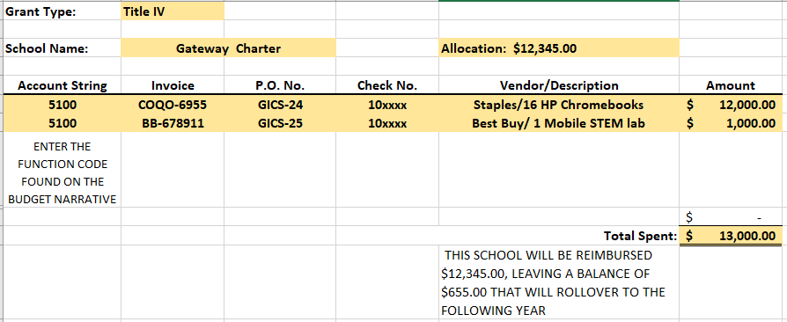 | Grant Specialist
5. | Examples of reimbursement supporting documents:  - Title IV Part A Application and Budget Narrative Form  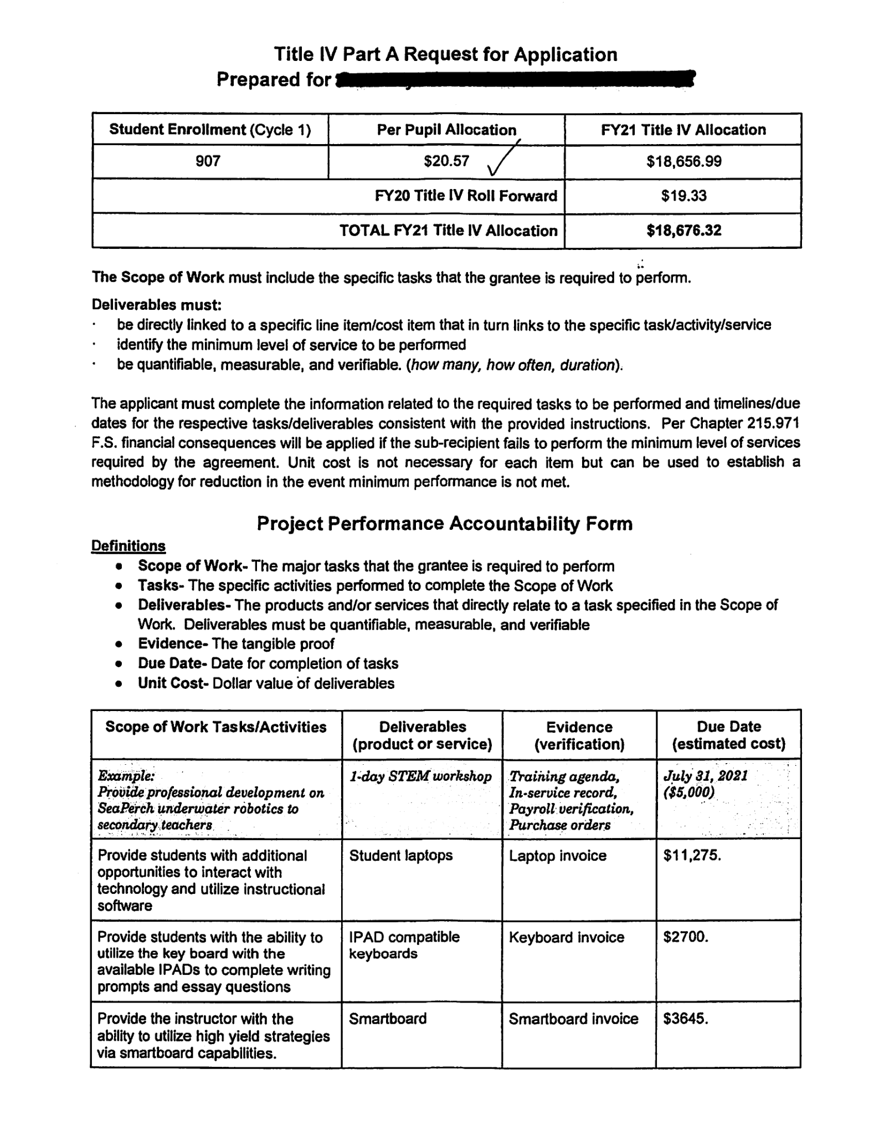  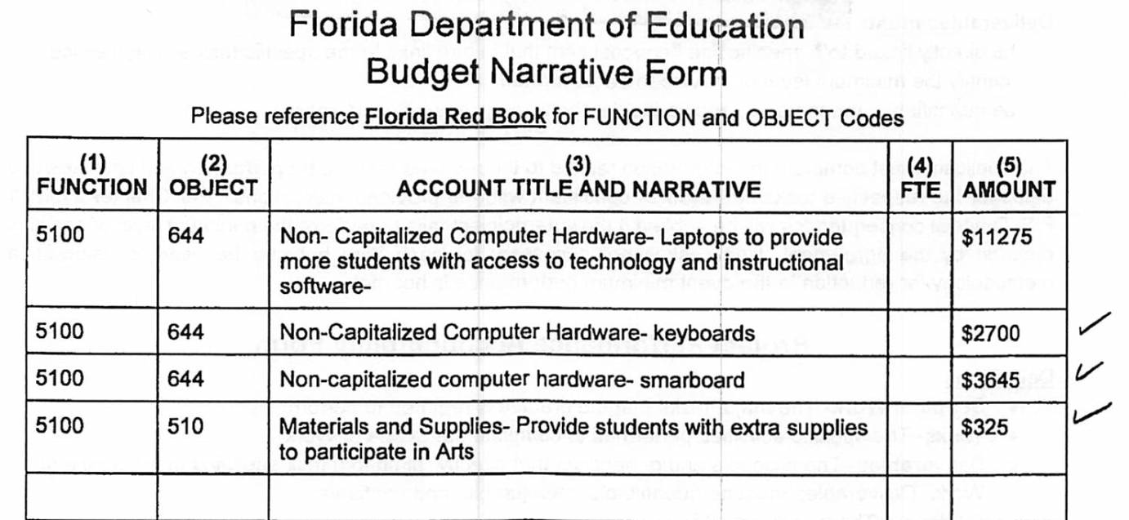  - Purchase Orders  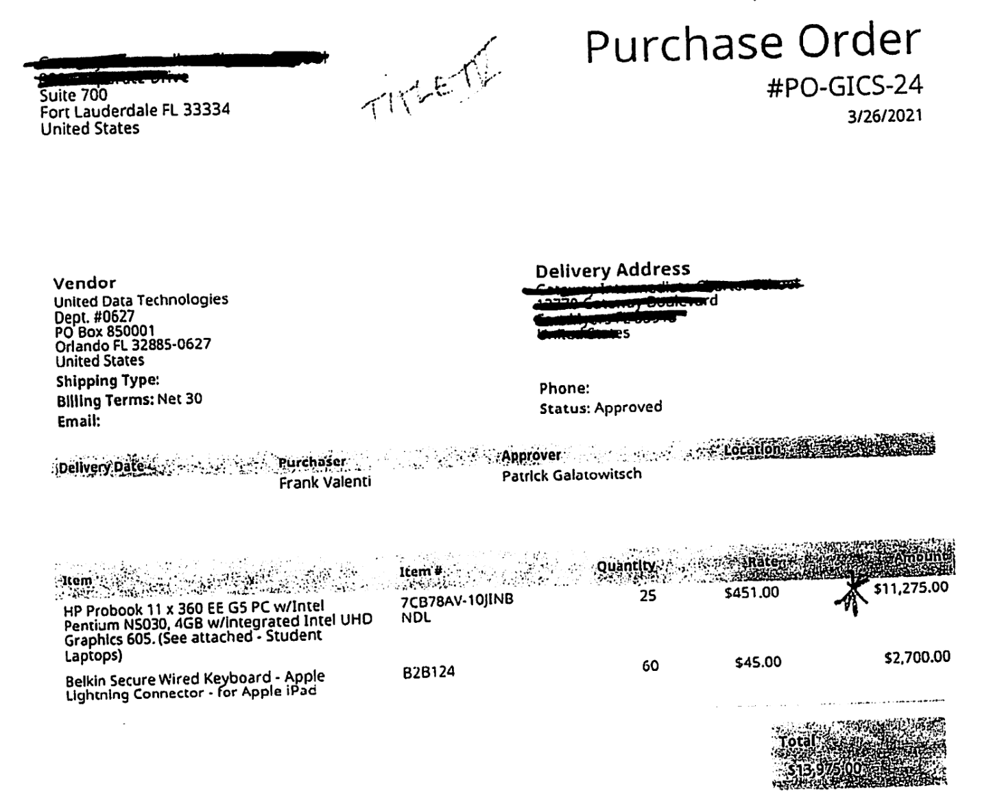  - Invoices  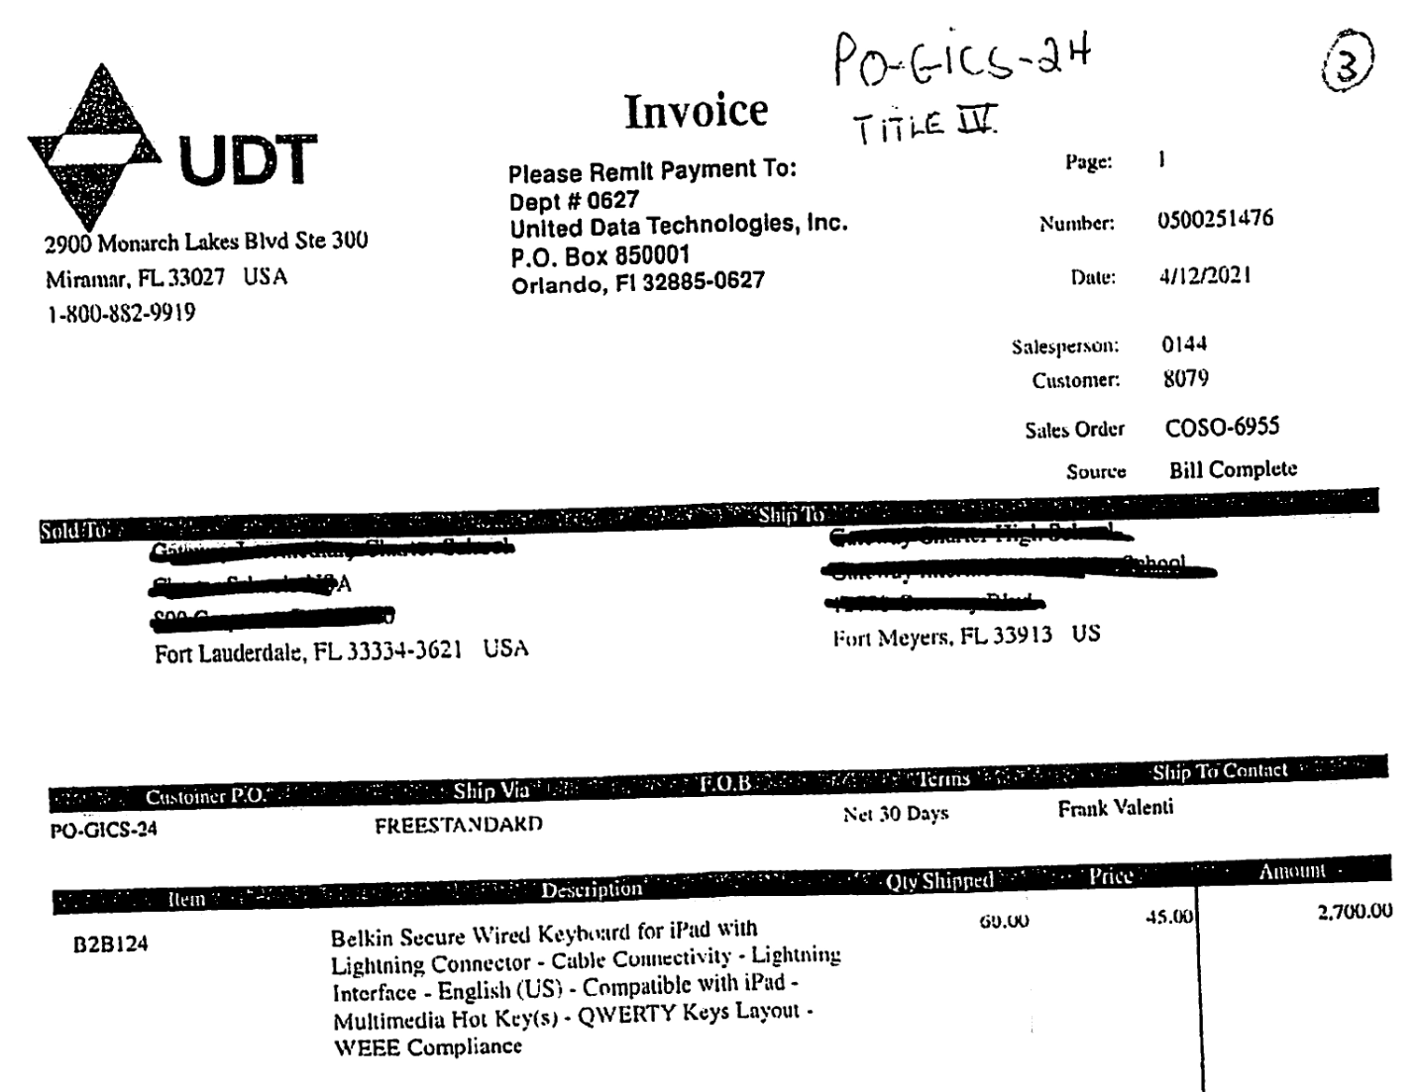  - Bank cleared check  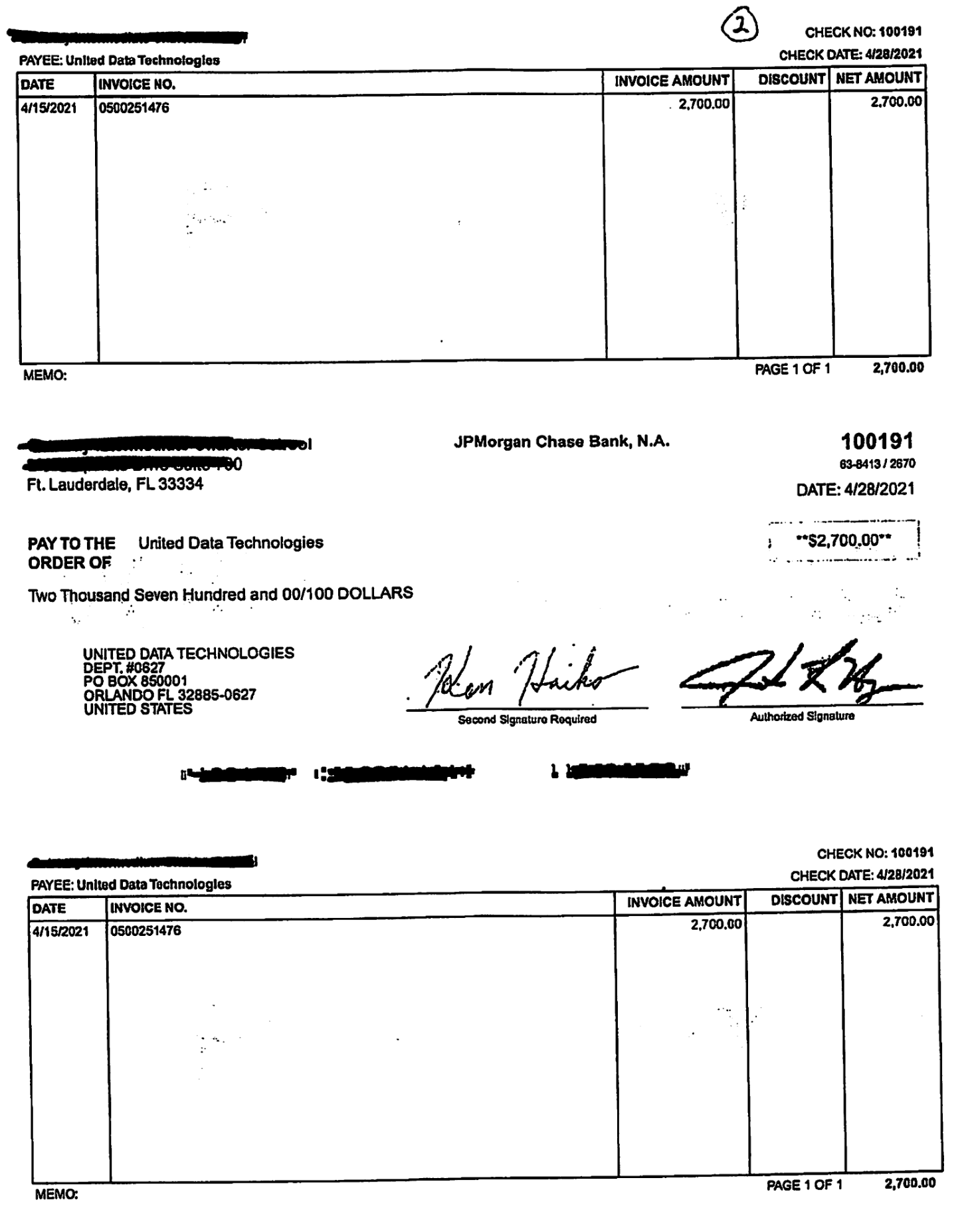  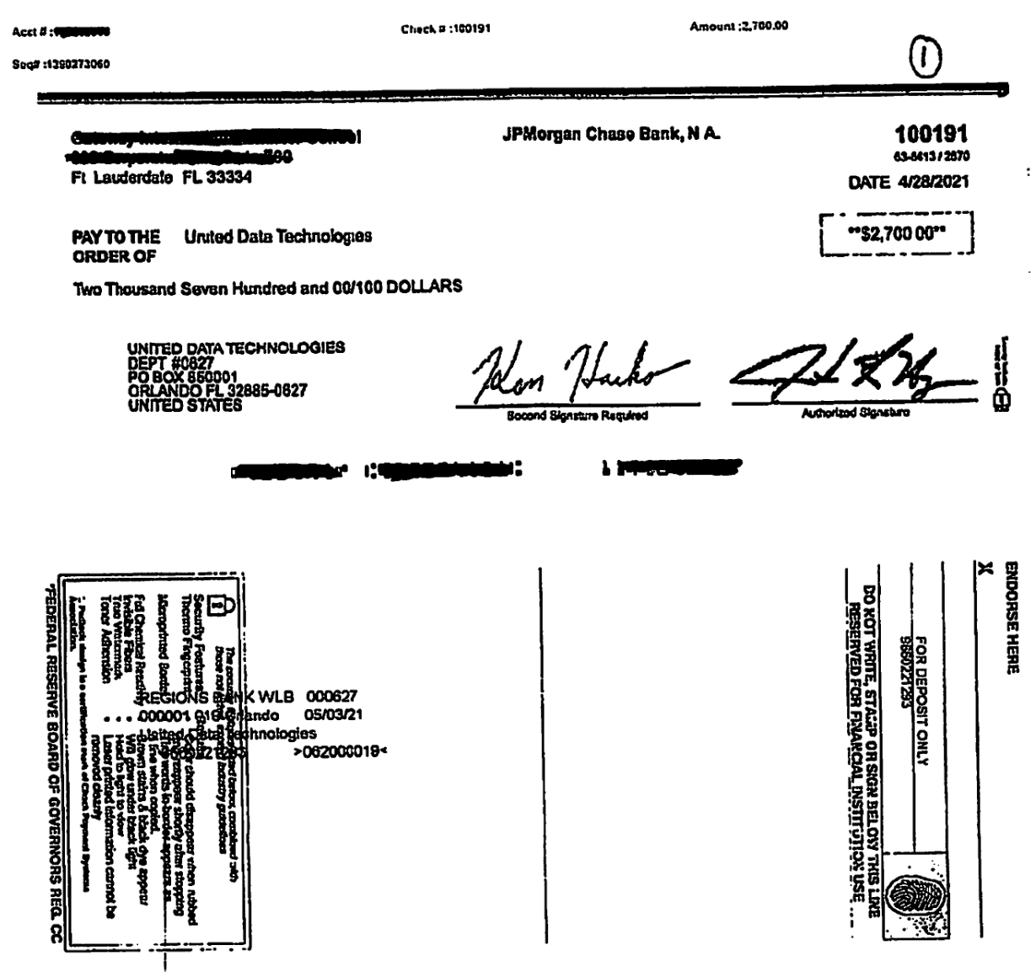 | Grant Specialist
6. | Once you have all the required documents, please send them to your Grant Specialist: Anissa Drzymala.

Part B: Process Cycle
Process Cycle | Ongoing, as needed
Start Date: | Ongoing, as needed
End Date: | Ongoing, as needed

Part C: Process Automation
Automation Status: | No automation required
Automation Target Date: | Click here to enter a date. ☒ Not applicable
Automation Completion Date: | Click here to enter a date. ☒ Not applicable

Part D: Process Authorization and Approval
Board Approval Required: | ☐ Yes ☒ No
Board Approval Date: | Click here to enter a date. ☒ Not applicable
Related Authority Type (s): | ☐ Federal law, regulation, code, rule, etc.  ☐ State law, regulation, code, rule, etc.  ☐ Board policy  ☒ District administrative regulation  ☒ Agreement or contract  ☐ Other
Related Authority Reference: | N/A
Other References: | N/A

Part IV: Assurances

The district must agree to ALL of the assurances by checking the corresponding boxes.

☒ Assurance 1: LEA Periodic Plan Update with Public Comment. As required in the U.S. Department of Education’s Interim Final Rule, 88 FR 21195, the LEA must regularly, but no less frequently than every six months, review and as appropriate, revise its plan for the safe return to in-person instruction and continuity of services. In determining whether revisions are necessary, and in making any revisions, the LEA must seek public input and take such input into account. If at the time the LEA revises its plan the CDC has updated its guidance on reopening schools, the revised plan must address the extent to which the LEA has adopted policies, and describe any policies, for each of the updated safety recommendations. Significantly, the Interim Final Rule “does not mandate that an LEA adopt the CDC guidance, but only requires that the LEA describe in its plan the extent to which it has adopted the key prevention and mitigation strategies identified in the guidance.” 88 FR at 21200. Any updated LEA plan must be consistent with state law, including any applicable executive order, any agency emergency order, or any agency regulation or rule. Specifically, LEA policies must comply with section 381.00316, Florida Statutes, and any policies implemented after August 9, 2021 must comply with Florida Department of Health Rule 64DER21 -12, F.A.C., and any policies implemented after September 22, 2021 must comply with Florida Department of Health Rule 64DER21-15, F.A.C.
☒ Assurance 2: Continue progress monitoring and interventions. The district agrees to provide robust progress monitoring and requisite interventions must be extended to all students with tiered support for students who are performing below grade level and are not making adequate progress. Students who are receiving instruction through innovative teaching methods must transition to another teaching method if they fail to make adequate progress. The district agrees to provide monthly progress monitoring reports to parent/guardians for students identified as performing below grade level and/or demonstrating decline on the district’s progress monitoring system.

☒ Assurance 3: Allowable Uses of Funds. The LEA will use funds for activities allowable under section 2001(e) of the CRRSA Act.

☒ Assurance 4: Maintenance of Equity. The LEA will comply with all requirements relating to Maintenance of Equity, in accordance with section 2004(c) of the ARP Act.

☒ Assurance 5: Reporting. The LEA will comply with all reporting requirements, and submit required reports to the Florida Department of Education at such time and in such manner and containing such information as the department may subsequently require.

☒ Assurance 6: Audits, Inspections or Examinations. The LEA will cooperate with any examination of records with respect to such funds by making records available for inspection, production, and examination, and authorized individuals available for interview and examination, upon the request of (i) the Florida Department of Education, the Florida Auditor General; (ii) the Department and/or its Inspector General; or (iii) any other federal or state agency, commission, or department in the lawful exercise of its jurisdiction and authority.

Acknowledgement

Local Educational Agency Chief Executive Officer or Authorized Representative

Name and title of person responsible for completion and submission
Contact information: email, phone number
Superintendent signature (or authorized representative)

