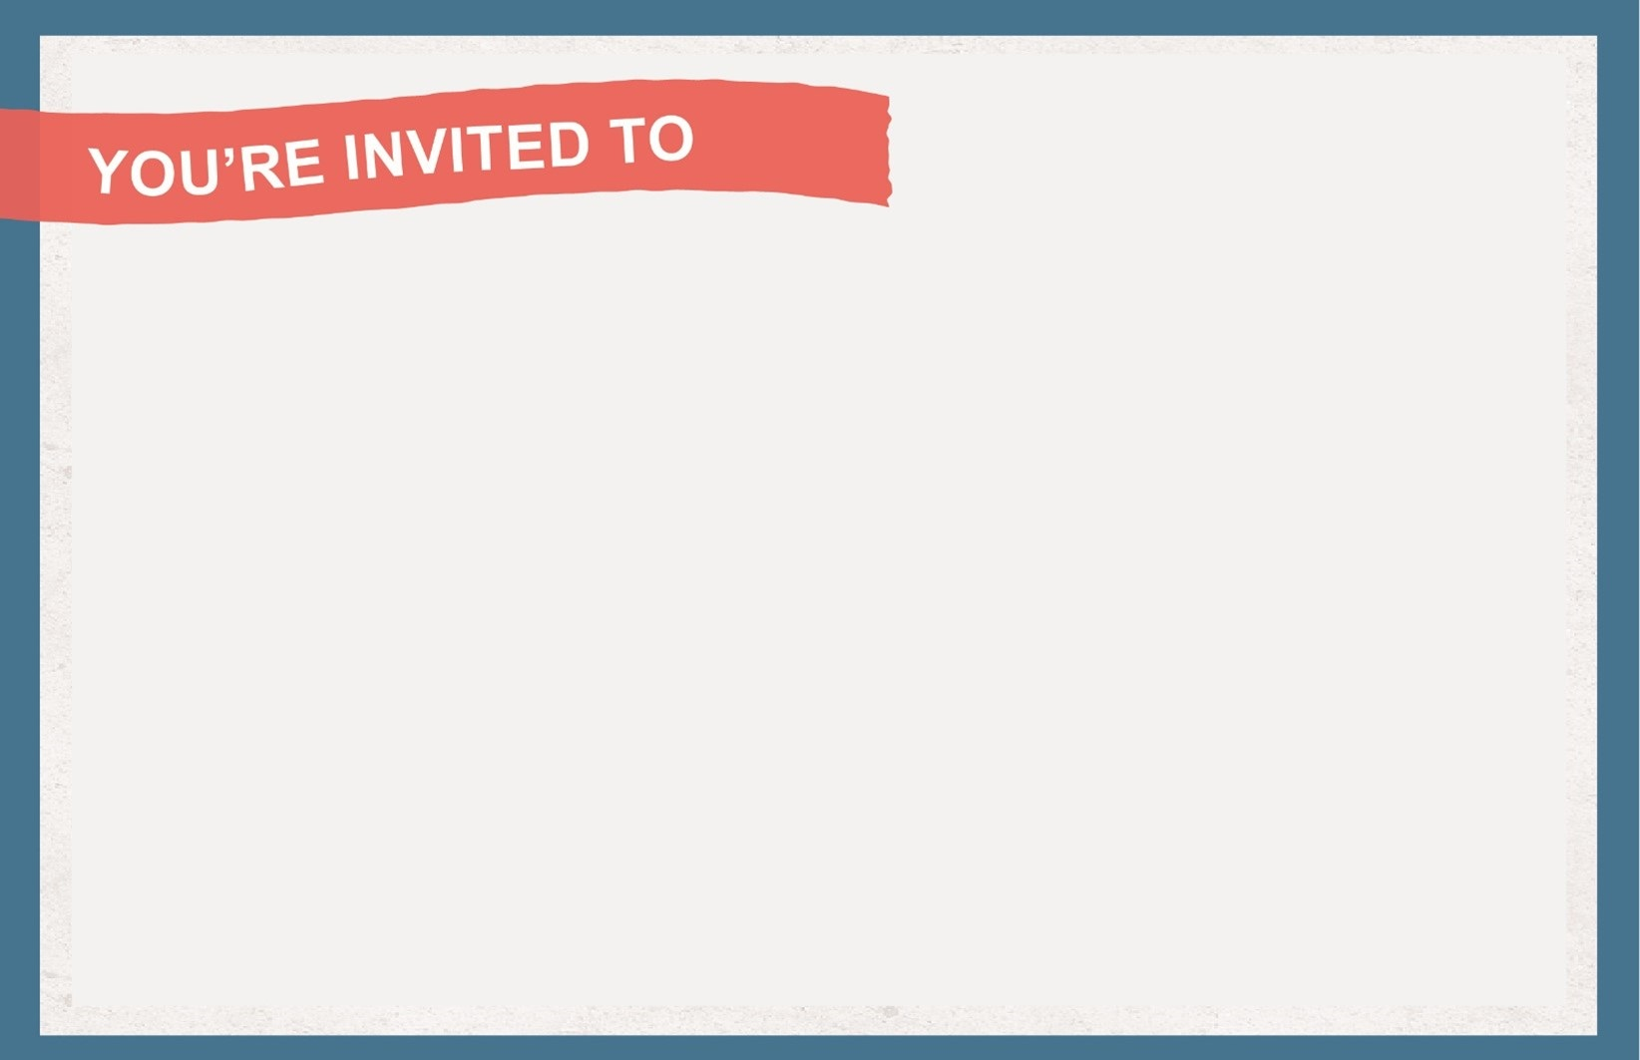
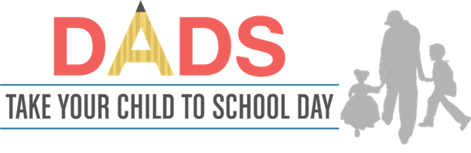
WHO: Fathers, stepfathers, grandfathers, uncles, big brothers, foster fathers and other significant male role models in our schools and classrooms
WHEN:
WHERE:
CONTACT/RSVP:
NOTES:

s
WHO: Fathers, stepfathers, grandfathers, uncles, big brothers, foster fathers and other significant male role models in our schools and classrooms
WHEN:
WHERE:
CONTACT/RSVP:
NOTES:

s

